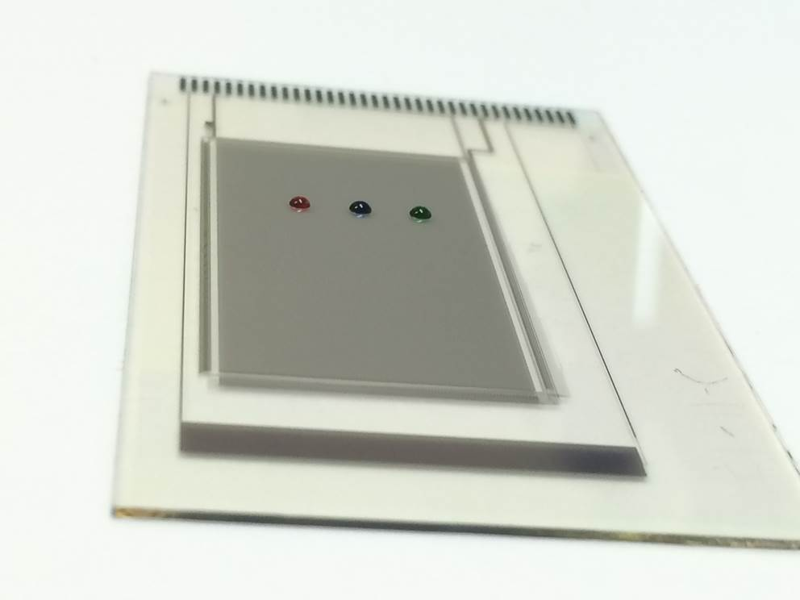
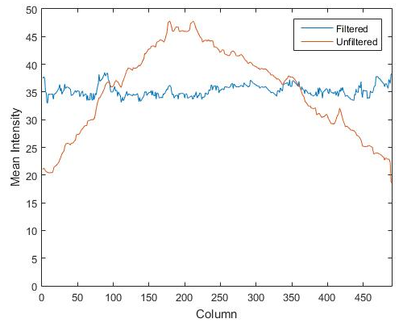

Figure S1: Mean value of intensity in each column of the image acquired by the setup shown in Fig 2. Brown colour shows the non-uniform intensity of the LED light source over the devices before MATLAB processing and blue represents the same data in a processed image (filtered).

(B)
(A)

(D)
(C)

Figure S2: Average of triplicate RPA reactions on bench top for sample containing (A) CTX-M-15 (B) NDM-1 and (C) KPC gene. Dotted line represents threshold calculated as 3 sigma of NTC. (D) Plot for Time To Positivity (TTP) against logarithm of the copies of plasmid present in the reaction.

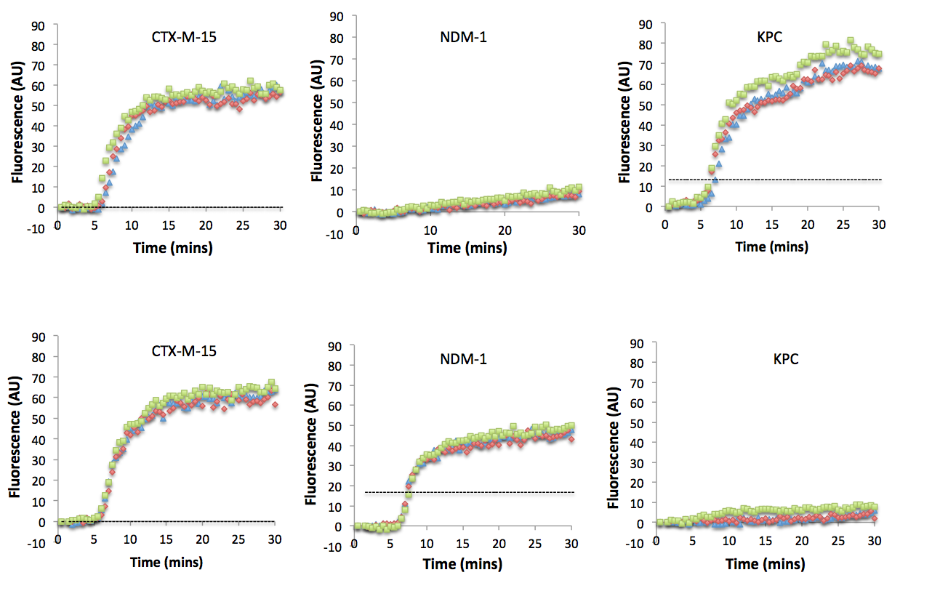
(A)

(B)

Figure S3: RPA amplification curve (in triplicates) plotted using the series of images shown in Figure 4 for samples with different genes. For the plots shown, the sample contained plasmid with genes encoding for (A) CTX-M-15 and KPC (B) CTX-M-15 and NDM-1. Dotted line represents threshold calculated as 3 sigma of NTC.

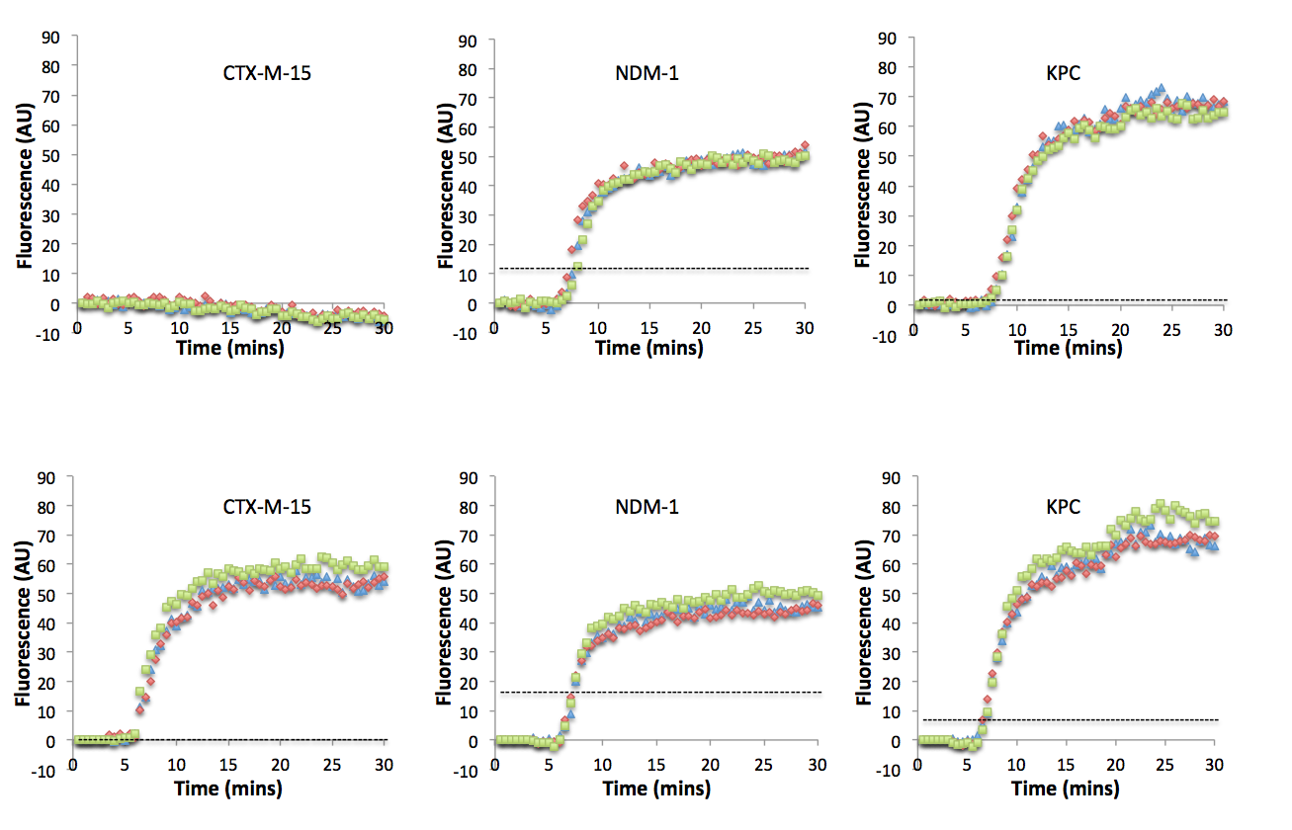
(A)

(B)

Figure S4: RPA amplification curve (in triplicates) plotted using the series of images shown in Figure 4 for samples with different genes. For the plots shown, the sample contained plasmid with genes encoding for (A) NDM-1 and KPC (B) CTX-M-15, NDM-1 and KPC. Dotted line represents threshold calculated as 3 sigma of NTC.

ESI video 1: Sequence for droplet movement to simultaneously detect three genes encoding for AMR using RPA assay on AM-EWOD platform. Green droplet (RPA mastermix , DNA and water) were dispensed slower compared to MgAc droplets. RPA mastermix is viscous and require slow dispensing for reproducible generation of daughter volume. DNA and water droplets were moved slower to time their placement on TFT array with RPA mastermix daughter droplets. Video has been sped 10x.

