Atlantic Multi-decadal Variability and the UK ACSIS Programme

Authors: Sutton, R. T.¹, McCarthy, G. D.*², Robson, J.¹, Sinha, B.², Archibald, A.³ and Gray, L. J.⁴
*Corresponding author: gerard.mccarthy@noc.ac.uk
¹National Centre for Atmospheric Science, Department of Meteorology, University of Reading, , PO Box 243, Earley Gate, Reading RG6 6BB, UK
²National Oceanography Centre, University of Southampton Waterfront Campus, European Way, Southampton SO14 3ZH, UK
³Department of Chemistry, University of Cambridge, Cambridge, UK
⁴Atmospheric, Oceanic and Planetary Physics, University of Oxford, UK

Abstract: Atlantic Multi-decadal Variability (AMV) is the term used to describe the pattern of variability in North Atlantic sea surface temperatures (SSTs) that is characterised by decades of basin-wide warm or cool anomalies, relative to the global mean. AMV has been associated with numerous climate impacts in many regions of the world including decadal variations in temperature and rainfall patterns, hurricane activity, and sea-level changes. Given its importance, understanding the physical processes that drive AMV and the extent to which its evolution is predictable is a key challenge in climate science. A leading hypothesis is that natural variations in ocean circulation control changes in ocean heat content and, consequently, AMV phases. However, this view has been challenged recently by claims that changing natural and anthropogenic radiative forcings are critical drivers of AMV. Others have argued that changes in ocean circulation are not required. Here we review the leading hypotheses and mechanisms for AMV, and discuss the key debates. In particular, we highlight the need for a holistic understanding of AMV. This perspective is a key motivation for a major new UK research programme: the North Atlantic Climate System Integrated Study (ACSIS), which brings together seven of the UK’s leading environmental research institutes to enable a broad spectrum approach to the challenges of AMV. ACSIS will deliver the first fully integrated assessment of recent decadal changes in the North Atlantic, will investigate the attribution of these changes to their proximal and ultimate causes, and will assess the potential to predict future changes.

Capsule Summary (20-30 words): Atlantic Multidecadal Variability (AMV) is a key feature of Atlantic and global climate. The ACSIS program involves a unique grouping that will advance an integrated understanding of AMV.

1. Introduction

The North Atlantic Ocean is unusual in exhibiting variations in Sea Surface Temperatures (SSTs) on decadal timescales that are larger in magnitude than typical subdecadal variations and comparable in magnitude to the centennial timescale warming trend. Atlantic Multi-decadal Variability (AMV) is the term used to describe the decadal variability of North Atlantic SSTs, broadly characterised by decades of basin-wide warm or cool anomalies, relative to the global mean.

AMV has been linked with substantial climate impacts in many parts of the world, both on the continents surrounding the North Atlantic and further afield, such as in South and East Asia. These impacts involve, for example, decadal variations in temperature and rainfall patterns, hurricane activity, and sea-level changes (e.g. Knight et al., 2005; Buckley and Marshall, 2016). In some cases the magnitude of these impacts is sufficient that, on timescales up to a few decades, the AMV influence may dominate over the influence of longer term climate change.

Given its importance, understanding the physical processes that drive AMV and the extent to which its evolution is predictable is a key challenge in climate science. It is clear from past research that interactions between the ocean and atmosphere play a key role in AMV, but the detailed interactions are poorly understood. They may involve not only ocean and atmosphere circulation, but also important aspects of atmospheric composition, notably aerosols. Furthermore, interactions with the cryosphere – both Arctic Sea Ice and the Greenland Ice Sheet - could also be involved. It is clear, therefore, that developing a full understanding of AMV requires a multi-disciplinary approach.

The 5-year (2017-2021) North Atlantic Climate System Integrated Study (ACSIS) was conceived to address the complex problems of AMV, and related research challenges. It has been designed to exploit the new opportunities presented by the unprecedented wealth of sustained, multivariate, observational records that is now available for the North Atlantic region, and the latest advances in numerical simulation. It is particularly timely because of evidence that a change in the phase of AMV may be happening now (Robson et al., 2016), creating an unprecedented opportunity to observe the processes responsible unfold.
ACSIS is being delivered by seven of the UK’s leading environmental research institutes, who together enable the multi-disciplinary approach which the science challenges demand.

This short article provides a high level review of current knowledge concerning AMV observations and mechanisms, and outstanding research questions, together with an overview of the ACSIS programme.

2. Observed characteristics of AMV

The evolution of North Atlantic mean SST anomalies over the past ~150 years, and an AMV index based on the difference between North Atlantic SSTs and SSTs averaged over the rest of the world’s oceans, is shown in Fig. 1a. The AMV index was negative (i.e. cool phase) in the periods (approx.) 1890—1920 and 1965—1995 and positive (i.e. warm phase) in 1925—1960 and 2000—present.

Although the AMV index is defined as a basin-mean index, there is considerable regional structure to the SST anomalies (Fig. 1d). The SST anomalies are largest, in terms of magnitude and variance explained, in the subtropical-to-subpolar region (30-65N). However, AMV-related SST anomalies are also found to reach down into the tropical North Atlantic in a so-called “horseshoe” pattern. Details of the pattern are, to some extent, sensitive to the exact definition of the AMV index and the dataset used; specifically, the magnitude of the tropical SST anomalies can be sensitive to the de-trending method, and to the period of data used (Trenberth and Shea, 2006). This sensitivity is not entirely surprising, given that AMV does not explain as much of the variance in this region compared to the extra-tropics. Finally, it should be noted AMV is not associated with a purely standing pattern of SST anomalies; on the contrary, the pattern evolves spatially (Hodson et al., 2014).

Changes in ocean circulation have long been hypothesized to be an important driver of AMV, but this link has not been proved directly due to a lack of deep-ocean observations. However, there are observational “proxies” of ocean circulation. Fig. 1b shows two such proxies: Labrador Sea density (Robson et al., 2014), which is a proxy for deep water that contributes to the cold, return branch of the AMOC, and a sea level index (McCarthy et al., 2015a), which relates to the strength of the circulation between the subtropical and subpolar gyres. Both indices suggest changes in ocean circulation lead changes in the phase of AMV in the latter half of the 20th Century, particularly the 1990s shift to positive AMV. Other factors that may contribute to driving AMV variability include: changes in anthropogenic SO2 emissions (Fig. 1c; Booth et al., 2012), and changes in atmospheric circulation, illustrated in Fig. 1e by the North Atlantic Oscillation (NAO) index. Persistent phases of the NAO have led AMV phase changes in the past, such as during the 1960s and 1990s.

Fig. 1 shows two of the impacts that have been linked to AMV (e.g. Zhang and Delworth, 2006). Fig. 1f shows that hurricane numbers were relatively low from 1965—1995, which corresponded to a cool phase of AMV. There is also evidence for multi-decadal variability in hurricanes further back in time, but the observations become more uncertain. Fig. 1g shows that summer (JJAS) Sahel rainfall dropped dramatically from the 1950s to the 1970s, which was also associated with the onset of the AMV cool phase. Sahel rainfall has recovered somewhat since the 1980s, as the AMV index has risen, but it still has not returned to its 1950s peak.

3. AMV Mechanisms

The evidence from proxy climate records (e.g. Chylek et al., 2011) strongly suggests that AMV is not limited to the period of instrumental observations during which there has been significant anthropogenic forcing of the climate system. Therefore, it appears that AMV is fundamentally a natural phenomenon, albeit one that may have been modified in recent times by anthropogenic forcings. This view is further supported by evidence from long unforced (“control”) simulations with global climate models, many of which exhibit modes of decadal or multi-decadal variability focused on the North Atlantic (e.g. Delworth and Mann, 2000; Knight et al., 2005). Such model simulations typically show that variability in Atlantic Ocean northward heat transport (OHT) plays a central role in the generation of AMV, although there has been some recent debate on this point (Clement et al., 2015; Zhang et al., 2016; Clement et al., 2016).

Variability in atmospheric circulation associated with the North Atlantic Oscillation (NAO) modulates air-sea fluxes, particularly over the Labrador Sea and wider subpolar gyre. The positive phase of the NAO causes enhanced cooling of the subpolar North Atlantic, which increases sea-water density and formation of deep water (e.g. Delworth et al., 2017). The subsequent ocean adjustment, involving wave and advective processes, leads to a spin up of the Atlantic Meridional Overturning Circulation (AMOC) and hence increases in OHT, warming SSTs (Fig. 2). This picture linking deep water formation and an enhanced AMOC belies some of the complexities of water mass pathways and connectivities between regions of deep convection and broader circulation (Lozier, 2012) but, nonetheless, remains a robust paradigm for understanding climate scale interactions between the NAO, AMOC and AMV (e.g. McCarthy et al., 2015a). It also includes the possibility for a delayed negative feedback as enhanced OHT leads to a warming of the subpolar gyre and hence a decrease in sea-water density. This decrease in density acts to slow the ocean circulation and reduce OHT. The detailed processes through which the ocean circulation and OHT adjust to variability in air-sea fluxes are poorly understood, but the relevant timescales are decadal, and it is likely that these processes play an important role in setting the timescale of AMV.

The OHT feedback is the simplest feedback that appears to shape AMV, but is by no means the only one. There is evidence for many other feedbacks, the relative importance of which are very uncertain. Potential feedbacks include:

1. Variability in the Atlantic Ocean northward transport of freshwater, which also affects sea-water density and hence ocean circulation; this is likely to be a positive feedback.

2. Ocean-atmosphere coupling. AMV related changes in sea surface temperatures (SST) may influence atmospheric circulation in the extra-tropics (including the NAO, see figure 3), or in the tropics, where shifts in the inter-tropical convergence zone may be an important factor. SST changes in the tropics and sub-tropics may be amplified or modified by Wind-Evaporation-SST (WES) feedback, cloud feedbacks, and feedbacks involving the lofting and transport of Saharan dust (Yuan et al., 2016).

3. Interactions with the cryosphere. Warming of the subpolar North Atlantic can accelerate the melting of Arctic Sea Ice and may have been a factor in recent accelerated melting of the Greenland Ice-sheet. The resulting fresh water can potentially modify sea-water density and hence ocean circulation, as in point 1. There is some evidence that this feedback is more important on longer timescales than those associated with AMV (Böning et al., 2016).

4. Interactions with other ocean basins. For example, there is strong evidence that transport of freshwater is an important factor for interactions with the Arctic Ocean (e.g. Jungclaus et al., 2005). Interactions with the Indian Ocean may occur through the Agulhas Current. Atmospheric teleconnections can also support interactions with the Indo-Pacific Ocean (e.g. (Timmermann et al., 1998; Dong and Sutton, 2002; McGregor et al., 2014).

As already noted, AMV may be influenced by external forcing factors (such as highlighted in Fig. 2). It has been suggested that natural forcings – volcanic eruptions and solar variability – might act as a pacemaker for AMV, possibly setting its phase and influencing its amplitude (Otterå et al., 2010; Swingedouw et al., 2015; Thiéblemont et al., 2015). Anthropogenic forcings, particularly aerosols and greenhouse gases, could play a similar role (Booth et al., 2012) but there has been some controversy about their importance (Zhang et al., 2013; Robson et al., 2016). Aerosols can modify surface radiation and hence SST but are also influenced by changing wind patterns, so it is possible that two-way interactions between the physical aspects of the North Atlantic climate system and atmospheric composition could play a role in AMV.

It is evident from this discussion that AMV is a complex phenomenon, albeit with a simple feedback at its heart. From a research perspective there are many outstanding questions, and these questions provide some of the motivation for the ACSIS programme, described in Section 5. Some of the key research questions are:
- What factors control the amplitude, timescale and phase of AMV?
- What is the strength and relative importance of the feedbacks that shape AMV?
- Which are the most important external forcing factors?
- To what extent do they influence AMV, and through what mechanisms?

4. Decadal Prediction for the North Atlantic region

Due to the important societal impacts associated with AMV, and the association of AMV with slow, potentially predictable, changes in the ocean, there has been considerable interest in predicting how the Atlantic might evolve years to decades ahead. Interestingly, the North Atlantic appears to be one of the most predictable regions at these lead times (Kirtman et al., 2013; Yeager and Robson, 2017). Several prediction systems show skill for AMV at multi-year lead-times, and there is emerging evidence that skillful prediction of AMV can lead to skill in predicting societally relevant climate impacts, such as the number of hurricanes and Sahel rainfall (Smith et al., 2010, Sheen et al, 2017). However, SSTs in the tropical North Atlantic, which appear to be important for many climate impacts, are not currently predicted as well as those at higher latitudes (García-Serrano et al., 2015). Realising the full potential of decadal prediction for the North Atlantic region is a major research challenge, and opportunity. ACSIS will undertake further detailed mechanistic analysis of state-of-the-art decadal predictions in order to understand the processes contributing to improved skill.

5. The UK ACSIS programme

The ACSIS programme is designed to address the multi-disciplinary challenges raised by AMV, and related research questions. The overarching aim is to enhance the capability to detect, attribute and predict changes in the North Atlantic Climate System. ACSIS explicitly recognizes the central role of interactions in shaping the evolution of the North Atlantic region. These interactions occur between components of the physical climate system – atmosphere, ocean and cryosphere – and between the physical climate system and aspects of atmospheric composition. There is a particular focus on decadal timescale changes that have happened recently and are ongoing (notably the AMV phase change, Robson et al., 2016), because these are the best observed changes, and understanding them is key for near-term predictions.

ACSIS involves an innovative partnership between seven UK environmental research centers, six funded by the Natural Environment Research Council (NERC), plus the UK Met Office. It was developed in response to a specific initiative from NERC to forge strategic collaborations to address major problems in environmental science. The programme is led by the National Centre for Atmospheric Science (NCAS) and involves the National Oceanography Centre (NOC), the British Antarctic Survey (BAS), the National Centre for Earth Observation (NCEO), the Centre for Polar Observation and Modelling (CPOM) and the Plymouth Marine Laboratory (PML). There are also important U.S. partners: the National Centre for Atmospheric Research (NCAR), National Oceanic and Atmospheric Administration (NOAA), Duke University (DU), University of Miami (UoM), University of Oregon (UoO), University of Texas at Austin (UTA) and Harvard University (HU). These partners collaborate on specific components of the programme, contributing complementary expertise in ocean observations and modeling (DIU, UoM, NOAA, UTA), climate modeling (NCAR), and atmospheric composition (UoO, HU).

The specific science objectives are:
- To provide a quantitative, multivariate, description of how the North Atlantic climate system is changing.
- To determine the primary drivers and processes that are shaping change in the North Atlantic climate system now and will shape change in the near future.
- To determine the extent to which future changes in the North Atlantic climate system are predictable.

To address these questions in depth requires a very diverse range of sustained observations and syntheses, together with world-leading simulation capabilities for the atmosphere, ocean, cryosphere, and the fully coupled climate system. Fig. 4 illustrates the breadth of the ACSIS observing system, stretching from the deep ocean to space.

From the top of the atmosphere to the surface of the earth, ACSIS is supporting observations and analyses of the evolving composition of the atmosphere in the North Atlantic region. These include sustained in situ measurements at Cape Verde and, in the UK, at Penlee Point — both atmospheric observatories contributing to our understanding into atmospheric composition change near the surface, and combined with bespoke modelling simulations enabling new insight into the budgets of tropospheric ozone and methane. New aircraft missions, using the Facility for Airborne Atmospheric Measurements (FAAM) modified BAe-146 Atmospheric Research Aircraft (ARA), will be used to survey changes in aerosols and trace gases in the free troposphere over the period 2017-2021. Sorties with the ARA from the UK to the Azores will provide a crucial complement and link to sustained satellite analyses and the data from in situ near-surface observatories. ACSIS aircraft missions will produce the longest record of composition change in the lower free troposphere over the North Atlantic. One of the most outstanding questions related to the composition of the atmosphere is understanding the causes for changes in the oxidizing capacity of the troposphere and how this affects trends in powerful greenhouse gases like ozone and methane (Parrish et al., 2014; Turner et al., 2017). In ACSIS, we will make sustained measurements of ozone and methane both at our ground based locations and on the ARA and use bespoke model simulations to understand the causes for changes in the observations made over time. Analyses of these exciting new data will enable improvements in our understanding of the role of anthropogenic and natural forcers within the North Atlantic basin. Linking with the NASA ATom project (Prather et al., 2017) will enable a more holistic understanding of global atmospheric composition change and impacts.

From the ocean surface to the seafloor, ACSIS will utilize existing in-situ observations and remotely sensed SST, sea surface height and sea ice concentration. The subsurface ocean is covered by a combination of the Argo float array (Freeland et al., 2010), from which ocean heat content can be derived and basin wide mooring arrays measuring ocean overturning and meridional heat transport at 26.5N, the RAPID-MOCHA-WBTS mooring array (McCarthy et al., 2015b), and in the North Atlantic subpolar gyre (the OSNAP mooring array; Lozier et al., 2016). These observations will be used in new estimates and uncertainties of ocean heat content and ocean surface forcing. ACSIS will combine earth observation satellites with in-situ measurements to provide volume estimates of Arctic Sea Ice and the Greenland Ice sheet. New technology development will be supported with the integration of a surface glider in the telemetery of near real time data from the mooring arrays.

ACSIS is also undertaking core numerical model simulations of the ocean, atmosphere (including sophisticated atmospheric chemistry) and cryosphere. The approach is to perform state of the art global simulations of ocean-ice, atmosphere and atmosphere-composition separately, and in addition to model all components together as a coupled system. All the simulations will be evaluated against the ACSIS observations and complementary datasets, such as ocean and atmospheric analysis and reanalysis datasets. A particular focus is on high-resolution simulations going well beyond that typical of models used for climate projections. Thus atmosphere-only simulations, forced by observed sea-surface temperature from 1950-present at resolutions of 60km and 25km, both with 85 levels in the vertical, allowing for good resolution of the stratosphere will be performed. Corresponding ocean-ice simulations, forced by observed surface atmospheric conditions will be run from 1958-present at ¼ and 1/12 degree resolution. Simulations of atmospheric composition will be performed in which the circulation is nudged towards the observations. Sensitivity tests will enable investigation of the role of specific processes in explaining observed changes in both atmospheric and ocean composition and circulation. ACSIS will also run high-resolution fully coupled simulations with atmosphere and ocean-ice resolutions of 25 km and ¼ degree for the period 1950-2050 and an even higher coupled simulation at 25 km and 1/12 degree. The coupled simulations will enable investigation of the relative roles of the different external forcing processes (solar and volcanic inputs, natural and anthropogenic greenhouse gases and aerosols) compared to unforced variability, in explaining observed changes on decadal timescales. All our simulations, ocean-ice (based on NEMO-CICE, Madec, 2008; Hunke et al., 2008), atmosphere-only (HadGAM3-GA, Walters et al., 2011), atmospheric composition (UKCA, Morgenstern et al., 2009) and coupled (HadGEM3-GC3 – see Williams et al., 2015) will be traceable to the UK Earth System Model (Jones et al., 2011), which will provide climate projections contributing to the 6th Climate Model Intercomparison Project, and simulation data will be made freely available to the academic research community.
To ensure the observational and modelling components of ACSIS are brought together effectively to address the science goals, management of programme is organized around four themes, each of which has a Theme Leader. The themes are: Atmospheric Composition; Ocean-Ice; Atmosphere-Climate and Synthesis. The Synthesis theme, which aims to integrate understanding of the fully coupled system, including attribution and predictability, is particularly important. One of the early synthesis activities has been a report on “Recent trends in the North Atlantic Climate System”, which will shortly be submitted for publication. Another key activity is the development of a set of “Atlantic Climate System Indicators” (ACSIs), which will be made available through the ACSIS project website (www.acsis.ac.uk). These indicators are designed to characterize the multivariate state of the North Atlantic climate system and recent changes - exploiting the diversity of sustained observations that is now available - and to provide a focal point for North Atlantic climate system research, and for communication of the science to a wide range of audiences. A simple ACSI could be the AMV index, whilst other indices will be chosen to characterize other aspects of the ocean state, atmospheric circulation and composition, and the cryosphere. By making these indicators available together, and updating them regularly, an integrated view of the changing North Atlantic climate system will be presented.

6. Concluding remarks

This brief article has aimed to illuminate the complexity and breadth of forcings, mechanisms and feedbacks that are integral to understanding AMV. ACSIS has assembled a unique group of scientists and institutions capable of delivering an innovative and integrated approach to advance understanding of AMV. AMV is of crucial societal importance in many regions of the globe, far beyond the borders of the Atlantic. Ultimately, an improved understanding will lead to better decadal predictions that can be used in preparation and mitigation in response to this climate variability. The time is ripe to advance our understanding of AMV as, in spite of ever-rising global temperatures, the Atlantic region is lagging behind. If this lag marks the onset of a new negative phase of AMV, such as occurred in the 1970s and 1980s, then droughts (and potential famine) in the Sahel, and accelerated sea level rise along the densely populated US east coast, could be some of the consequences. Furthermore, since the last negative AMV phase, climate change has continued apace: water stress levels and mean sea levels are higher, suggesting a new negative phase might have more extreme consequences than in the past. Hence, understanding AMV has never been more important. If other research organisations or scientists are interested in collaborating with ACSIS, contact can be made through the ACSIS website (www.acsis.ac.uk/contact-us).

Acknowledgments
The ACSIS programme is funded by the UK Natural Environment Research Council. The authors acknowledge the essential contributions of all the institutions and the large group of staff that are involved in delivering the programme.

For further reading

Böning, C. W., Behrens, E., Biastoch, A., Getzlaff, K., & Bamber, J. L. (2016) Emerging impact of Greenland meltwater on deepwater formation in the North Atlantic Ocean. Nature Geoscience, DOI: 10.1038/NGEO2740

Booth, B. B., Dunstone, N. J., Halloran, P. R., Andrews, T., & Bellouin, N. (2012) Aerosols implicated as a prime driver of twentieth-century North Atlantic climate variability. Nature 484, 228—232.

Buckley, M. W., & Marshall, J. (2016). Observations, inferences, and mechanisms of the Atlantic Meridional Overturning Circulation: A review. Reviews of Geophysics 54.

Chylek, P., Folland, C. K., Dijkstra, H. A., Lesins, G., & Dubey, M. K. (2011) Ice-core data evidence for a prominent near 20 year time-scale of the Atlantic Multidecadal Oscillation. Geophysical Research Letters 38.

Clement, A., Bellomo, K., Murphy, L. N., Cane, M. A., Mauritsen, T., Rädel, G., & Stevens, B. (2015) The Atlantic Multidecadal Oscillation without a role for ocean circulation. Science 350, 320—324.

Clement, A., Cane, M. A., Murphy, L. N., Bellomo, K., Mauritsen, T., & Stevens, B. (2016). Response to Comment on “The Atlantic Multidecadal Oscillation without a role for ocean circulation”. Science, 352(6293), 1527-1527.

Delworth, T. L. & Mann, M. E. (2000) Observed and simulated multidecadal variability in the Northern Hemisphere. Climate Dynamics 16, 661—676.

Delworth, T. L., Zeng, F., Zhang, L., Zhang, R., Vecchi, G. A., & Yang, X. (2017) The central role of ocean dynamics in connecting the North Atlantic Oscillation to the extratropical component of the Atlantic Multidecadal Oscillation. Journal of Climate.

Dong, B.-W. & Sutton, R. (2002) Adjustment of the coupled ocean—atmosphere system to a sudden change in the thermohaline circulation. Geophysical Research Letters 29.

Freeland, H. J., Roemmich, D., Garzoli, S. L., Traon, P.-Y. L., Ravichandran, M., Riser, S., Thierry, V., Wijffels, S. E., Belbéoch, M., Gould, J., Grant, F., Ignazewski, M., King, B. A., Klein, B., Mork, K. A., Owens, W. B., Pouliquen, S., Sterl, A., Suga, T., Suk, M.-S., Sutton, P., Troisi, A., Vélez-Belchi, P. J., & Xu, J. (2010) Argo - A Decade of Progress.

García-Serrano, J., Frankignoul, C., Gastineau, G., & De La Càmara, A. (2015) On the predictability of the winter Euro-Atlantic climate: lagged influence of autumn Arctic sea ice. Journal of Climate 28, 5195—5216.

Hodson, D. L. R., Robson, J. I. and Sutton, R. T. (2014) An anatomy of the cooling of the North Atlantic Ocean in the 1960s and 1970s. Journal of Climate, 27 (21). pp. 8229-8243.

Huang, B., Banzon, V. F., Freeman, E., Lawrimore, J., Liu, W., Peterson, T. C., Smith, T. M., Thorne, P. W., Woodruff, S. D., & Zhang, H.-M. (2015) Extended reconstructed sea surface temperature version 4 (ERSST. v4). Part I: Upgrades and intercomparisons. Journal of Climate 28, 911—930.

Hunke, E., Lipscomb, W., Turner, A., Jeffery, N., & Elliott, S. (2008) CICE: The Los Alamos sea ice model, documentation and software, version 4.0, Los Alamos National Laboratory Tech. Rep.

Hurrell, J. W., Kushnir, Y., Ottersen, G., & Visbeck, M. (2003) An overview of the North Atlantic oscillation.

Jones, C., Hughes, J., Bellouin, N., Hardiman, S., Jones, G., Knight, J., Liddicoat, S., O'Connor, F., Andres, R. J., Bell, C., & others (2011) The HadGEM2-ES implementation of CMIP5 centennial simulations. Geoscientific Model Development 4, 543—570.

Jungclaus, J. H., Haak, H., Latif, M., & Mikolajewicz, U. (2005). Arctic–North Atlantic interactions and multidecadal variability of the meridional overturning circulation. Journal of Climate, 18(19), 4013-4031.

Kirtman, B. P., Stockdale, T., & Burgman, R. (2013) Ocean Circulation and Climate: Chapter 24. The Ocean’s Role in Modeling and Predicting Seasonal-to-Interannual Climate Variations. 103.

Knight, J. R., Allan, R. J., Folland, C. K., Vellinga, M., & Mann, M. E. (2005) A signature of persistent natural thermohaline circulation cycles in observed climate. Geophysical Research Letters 32.

Landsea, C. W., C. Anderson, N. Charles, G. Clark, J. Dunion, J. Fernandez-Partagas, P. Hungerford, C. Neumann, and M. Zimmer, 2004 : "The Atlantic hurricane database re-analysis project: Documentation for the 1851-1910 alterations and additions to the HURDAT database."Hurricanes and Typhoons: Past, Present and Future, R. J. Murname and K.-B. Liu, Eds., Columbia University Press, 177-221.

Lozier, M. S., Bacon, S., Bower, A. S., Cunningham, S. A., de Jong, M. F., de Steur, L., deYoung, B., Fischer, J., Gary, S. F., Greenan, B. J., & others (2016) Overturning in the Subpolar North Atlantic Program: a new international ocean observing system. Bulletin of the American Meteorological Society.

Lozier, M. S. (2012). Overturning in the North Atlantic. Annual review of marine science, 4, 291-315.

Madec, G. (2008) NEMO ocean engine.

McCarthy, G. D., Haigh, I. D., Hirschi, J. J.-M., Grist, J. P., & Smeed, D. A. (2015a) Ocean impact on decadal Atlantic climate variability revealed by sea-level observations. Nature 521, 508—510.

McCarthy, G. D., Smeed, D. A., Johns, W. E., Frajka-Williams, E., Moat, B. I., Rayner, D., Baringer, M. O., Meinen, C. S., Collins, J., & Bryden, H. L. (2015b) Measuring the Atlantic Meridional Overturning Circulation at 26ºN. Progress in Oceanography 31, 91-111.

McGregor, S., Timmermann, A., Stuecker, M. F., England, M. H., Merrifield, M., Jin, F.-F., & Chikamoto, Y. (2014) Recent Walker circulation strengthening and Pacific cooling amplified by Atlantic warming. Nature Climate Change 4, 888—892.

Morgenstern, O., Braesicke, P., O'Connor, F. M., Bushell, A. C., Johnson, C. E., Osprey, S. M., & Pyle, J. A. (2009). Evaluation of the new UKCA climate-composition model–Part 1: The stratosphere. Geoscientific Model Development, 2(1), 43-57.

Otterå, O. H., Bentsen, M., Drange, H., & Suo, L. (2010) External forcing as a metronome for Atlantic multidecadal variability. Nature Geoscience 3, 688—694.
Parrish D.D., Lamarque J.F., Naik V., Horowitz L., Shindell D.T., Staehelin J., Derwent R., Cooper O.R, Tanimoto H., Volz‐Thomas A., Gilge S. (2014) Long‐term changes in lower tropospheric baseline ozone concentrations: Comparing chemistry‐climate models and observations at northern midlatitudes. Journal of Geophysical Research: Atmospheres; 119(9): 5719-36.

Parrish, D. D., Lamarque, J. F., Naik, V., Horowitz, L., Shindell, D. T., Staehelin, J., Derwent R, Cooper OR, Tanimoto H, Volz‐Thomas A. & Gilge, S. (2014). Long‐term changes in lower tropospheric baseline ozone concentrations: Comparing chemistry‐climate models and observations at northern midlatitudes. Journal of Geophysical Research: Atmospheres, 119(9), 5719-5736.

Prather, M. J., Zhu, X., Flynn, C. M., Strode, S. A., Rodriguez, J. M., Steenrod, S. D., Liu, J. a. L. J.-F., Fiore, A. M., Horowitz, W., L., Mao, J., Murray, L. T., Shindell, D. T., & Wofsy, S. C. (2017) Global Atmospheric Chemistry – Which Air Matters. Atmos. Chem. Phys. Discuss doi:10.5194/acp-2016-1105.

Robson, J., Hodson, D., Hawkins, E., & Sutton, R. (2014) Atlantic overturning in decline?. Nature Geoscience 7, 2—3.

Robson, J., Ortega, P., & Sutton, R. (2016) A reversal of climatic trends in the North Atlantic since 2005. Nature Geoscience.

Schamm, K., Ziese, M., Becker, A., Finger, P., Meyer-Christoffer, A., Schneider, U., Schröder, M., & Stender, P. (2014) Global gridded precipitation over land: a description of the new GPCC First Guess Daily product. Earth System Science Data 6, 49—60.

Sheen, K. L., Smith, D. M., Dunstone, N. J., Eade, R., Rowell, D. P., & Vellinga, M. (2017). Skilful prediction of Sahel summer rainfall on inter-annual and multi-year timescales. Nature Communications, 8, ncomms14966.

Smith, D. M., Eade, R., Dunstone, N. J., Fereday, D., Murphy, J. M., Pohlmann, H., & Scaife, A. A. (2010) Skilful multi-year predictions of Atlantic hurricane frequency. Nature Geoscience 3, 846—849.

Sutton, R. and Dong, B. (2012) Atlantic Ocean influence on a shift in European climate in the 1990s. Nature Geoscience, 5. pp. 788-792. ISSN 1752-0908

Swingedouw, D., Ortega, P., Mignot, J., Guilyardi, E., Masson-Delmotte, V., Butler, P. G., Khodri, M., & Séférian, R. (2015) Bidecadal North Atlantic ocean circulation variability controlled by timing of volcanic eruptions. Nature communications 6.

Thiéblemont, R., Matthes, K., Omrani, N.-E., Kodera, K., & Hansen, F. (2015) Solar forcing synchronizes decadal North Atlantic climate variability. Nature communications 6.

Timmermann, A., Latif, M., Voss, R., & Grötzner, A. (1998) Northern Hemispheric interdecadal variability: A coupled air—sea mode. Journal of Climate 11, 1906—1931.

Trenberth, K. E. & Shea, D. J. (2006) Atlantic hurricanes and natural variability in 2005. Geophysical Research Letters 33.

Turner A.J., Frankenberg C., Wennberg P.O. and Jacob D.J. (2017) Ambiguity in the causes for decadal trends in atmospheric methane and hydroxyl. Proceedings of the National Academy of Sciences. 201616020.

Walters, D. N., Best, M. J., Bushell, A. C., Copsey, D., Edwards, J. M., Falloon, P. D., ... & Roberts, M. J. (2011). The Met Office Unified Model Global Atmosphere 3.0/3.1 and JULES Global Land 3.0/3.1 configurations, Geosci. Model Dev., 4, 919–941, doi: 10.5194.

Williams, K., Harris, C., Bodas-Salcedo, A., Camp, J., Comer, R., Copsey, D., Fereday, D., Graham, T., Hill, R., Hinton, T., & others (2015) The met office global coupled model 2.0 (GC2) configuration. Geoscientific Model Development 8, 1509—1524.

Yeager, S. G. and Robson, J. I. (2017) Recent progress in understanding and predicting Atlantic decadal climate variability. Current Climate Change Reports.

Yuan, T., Oreopoulos, L., Zelinka, M., Yu, H., Norris, J. R., Chin, M., Platnick, S., & Meyer, K. (2016) Positive low cloud and dust feedbacks amplify tropical North Atlantic Multidecadal Oscillation. Geophysical Research Letters 43, 1349—1356.

Zhang, R. & Delworth, T. L. (2006) Impact of Atlantic multidecadal oscillations on India/Sahel rainfall and Atlantic hurricanes. Geophysical Research Letters 33.

Zhang, R., Delworth, T. L., Sutton, R., Hodson, D. L., Dixon, K. W., Held, I. M., Kushnir, Y., Marshall, J., Ming, Y., Msadek, R., & others (2013) Have aerosols caused the observed Atlantic multidecadal variability?. Journal of the Atmospheric Sciences 70, 1135—1144.

Zhang, R., Sutton, R., Danabasoglu, G., Delworth, T. L., Kim, W. M., Robson, J., & Yeager, S. G. (2016) Comment on “The Atlantic Multidecadal Oscillation without a role for ocean circulation”. Science 352, 1527—1527.

Figure Captions
Fig 1: a) shows Atlantic-mean (75-7.5W°W,0-65°N) sea surface temperatures (red) and global-mean excluding the North Atlantic (blue) sea surface temperatures for annual-means (thin lines) and decadal-mean (thick lines) based on the ERSST.v4 dataset (Huang et al., 2015). Units are degrees Celsius and anomalies are made relative to the entire 1855-2016 period. The AMV index is shown in black, which is the normalized difference between the 10-year smoothed Atlantic and (red) Global-mean (blue) indices. This definition follows Sutton & Dong (2012) and is close to that of Trenberth and Shea (2006). Periods where the AMV index is larger than 0.5 or smaller than -0.5 are high-lighted with red and blue filled sections respectively. b) shows ocean circulation proxies, including the sea-level dipole index (black) based on (McCarthy et al., 2015a), and the 1000-2500m Labrador Sea density index (purple) from (Robson et al., 2014). Purple shading shows the 5—95% confidence interval for the deep Labrador Sea density. c) shows the emissions of Sulphur Dioxide (SO₂) from the U.S.A. and Europe from the CMIP6 emissions dataset. d) shows the SST pattern associated with the AMV index, represented by the regression slope between the AMV index in a) and the annual-mean SST anomalies at each grid-point over the period 1990—2016. Stippling is a measure of signal-to-noise, and shows where the variance explained is >20% of the interannual variance at each grid point, after a linear-trend has been removed. e) shows the DJFM NAO station index data (Hurrell et al., 2003); Black dots show individual years, and the thick black line shows the 10-year running mean. f) shows the Accumulated Cyclone Energy from 1948-2016 form the Hurdat dataset (solid, Landsea et al, 2004), and from 1851—present (dash). g) shows JJAS rainfall anomalies over the Sahel (20°W-40°E,10-20°N) from the GPCC data set (Schamm et al., 2014); dots show the annual means and the black curve shows the 10-year running mean. All time-series are normalized by their standard deviation, apart from the blue and red curves in panel a).

Fig 2: Schematic illustrating processes involved in AMV. The left hand map shows typical NAO⁺ conditions with the Greenland Low (~1010 mbar) and the Azores High (~1020 mbar) highlighted with the storm track illustrated between (brown arrow). NAO⁺ conditions result in heat loss from ocean to the atmosphere, particularly over the Labrador and Irminger Seas (blue arrows), leading to deep convection and cool SSTs, itself indicative of AMV⁻. Increased deep convection is linked with increasing northward ocean heat transport (red arrows), associated with a strong AMOC, leading to warmer SSTs, indicative of AMV⁺, as shown in the right hand map. External forcing from natural solar and volcanic variability and man-made aerosols have been proposed as additional drivers of AMV. Ocean-atmosphere feedbacks are important in the amplification and modification of AMV patterns including interactions with tropical and subtropical clouds and wind-evaporation-SST (WES) interactions.

Fig 3: Schematic illustrating one mechanism for AMV phase reversal. (a) A cool phase of the AMV is associated with an expanded, cool subpolar gyre. Warm anomalies north of the Gulf Stream link this pattern with a weakened overturning circulation. The increased meridional gradient of SSTs is conducive to (b) NAO⁺ conditions, which, as shown in Fig. 2, spin up the overturning circulation by increasing the production of North Atlantic Deep Water (NADW). The AMV⁺ conditions resulting from the increased northward heat transport erode the meridional gradient of SST and lead to conditions favoring (d) NAO⁻. Predominant NAO⁻ conditions weaken the overturning, returning to (a).

Fig. 4: Some elements of the ACSIS observing system. ACSIS will observe Atlantic climate from space, the air, the land and sea surface and in the subsurface ocean. Cyrosat data, combined with other earth observation satellites and in-situ measurements will be used to deliver volume estimates of Arctic Sea Ice and Greenland Ice. NERC’s FAAM BAE-146 aircraft will make biannual transects from the UK to the Azores collecting gas and aerosol composition measurements. Land stations, such as that at Cape Verde, provide sustained atmospheric composition measurements. NERC’s fleet of research vessels, including the RRS Discovery, will make and support ocean observations. In-situ measurements from the international Argo program and the UK-US RAPID program will be used by ACSIS deliver ocean heat content and circulation analyses.

Figures

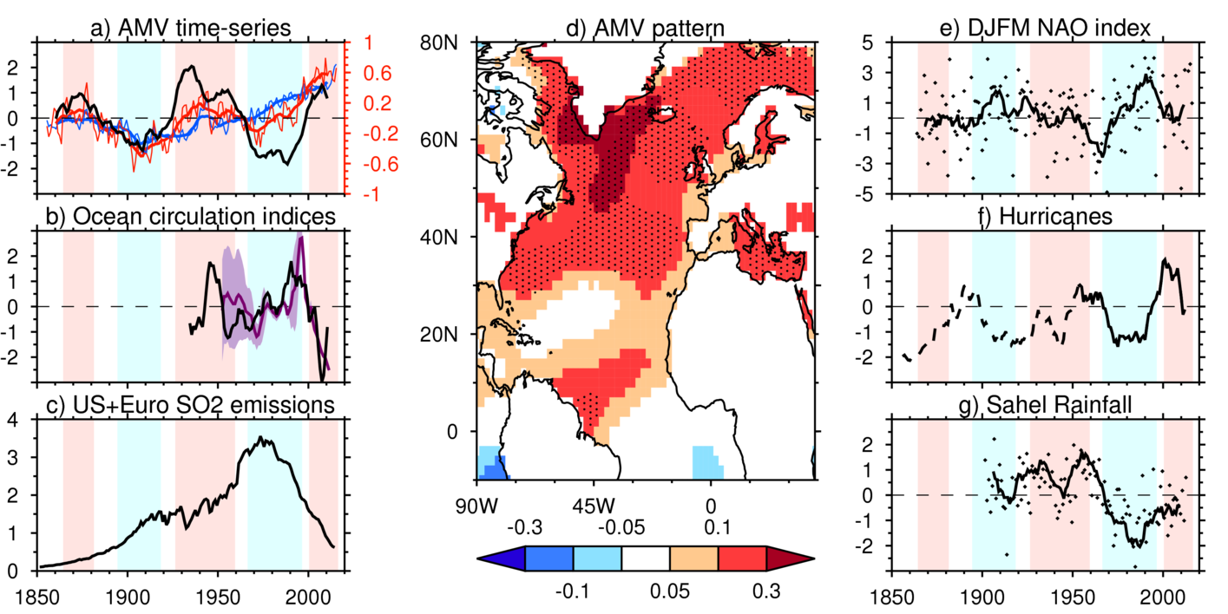

Fig 1: a) shows Atlantic-mean (75-7.5W°W,0-65°N) sea surface temperatures (red) and global-mean excluding the North Atlantic (blue) sea surface temperatures for annual-means (thin lines) and decadal-mean (thick lines) based on the ERSST.v4 dataset ( (Huang et al., (2015))). Units are degrees Celsius and anomalies are made relative to the entire 1855-2016 period. The AMV index is shown in black, which is the normalized (for visualisation) difference between the 10-year smoothed Atlantic (red) and Global-mean (blue) indices. Periods where the AMV index is larger than 0.5 or smaller than -0.5 are high-lighted with red and blue filled sections respectively. b) shows ocean circulation proxies, including the sea-level dipole index (black) based on (McCarthy et al., 2015a), and the 1000-2500m Labrador Sea density index (purple) from (Robson et al., (2014)). Purple shading shows the 5—95% confidence interval for the deep Labrador Sea density. c) shows the emissions of Sulphur Dioxide (SO₂) from the U.S.A. and Europe from the CMIP6 emissions dataset. d) shows the SST pattern associated with the AMV index, represented by the regression slope between the AMV index in a) and the annual-mean SST anomalies at each grid-point over the period 1900—2016. Stippling is a measure of signal-to-noise, and shows where the variance explained is >20% of the interannual variance at each grid point, after a linear-trend has been removed. e) shows the DJFM NAO station index data ( (Hurrell et al., (2003))); Black dots show individual years, and the thick black line shows the 10-year running mean. f) shows the Accumulated Cyclone Energy from 1948-2016 form the Hurdat dataset (solid, Landsea et al, 2004), and from 1851—present (dash). g) shows JJAS rainfall anomalies over the Sahel (20°W-40°E,10-20°N) from the GPCC data set (Schamm et al., (2014)); dots show the annual means and the black curve shows the 10-year running mean. All time-series are normalized by their standard deviation, apart from the blue and red curves in panel a).

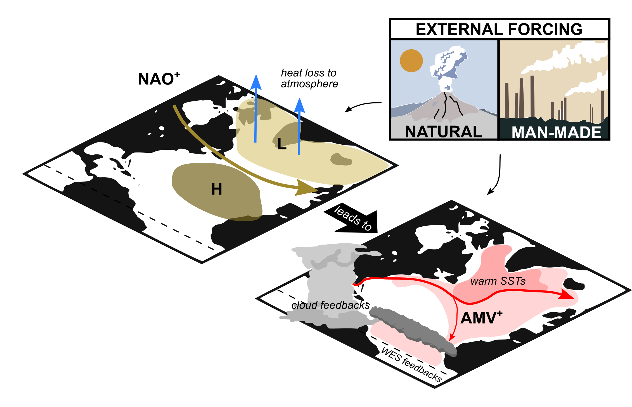

Fig 2: Schematic illustrating processes involved in AMV. The left hand map shows typical NAO⁺ conditions with the Greenland Low (~1010 mbar) and the Azores High (~1020 mbar) highlighted with the storm track illustrated between (brown arrow). NAO⁺ conditions result in heat loss from ocean to the atmosphere, particularly over the Labrador and Irminger Seas (blue arrows), leading to deep convection and cool SSTs, itself indicative of AMV⁻. Increased deep convection is linked with increasing northward ocean heat transport (red arrows), associated with a strong AMOC, leading to warmer SSTs, indicative of AMV⁺, as shown in the right hand map. External forcing from natural solar and volcanic variability and man-made aerosols have been proposed as additional drivers of AMV. Ocean-atmosphere feedbacks are important in the amplification and modification of AMV patterns including interactions with tropical and subtropical clouds and wind-evaporation-SST (WES) interactions.

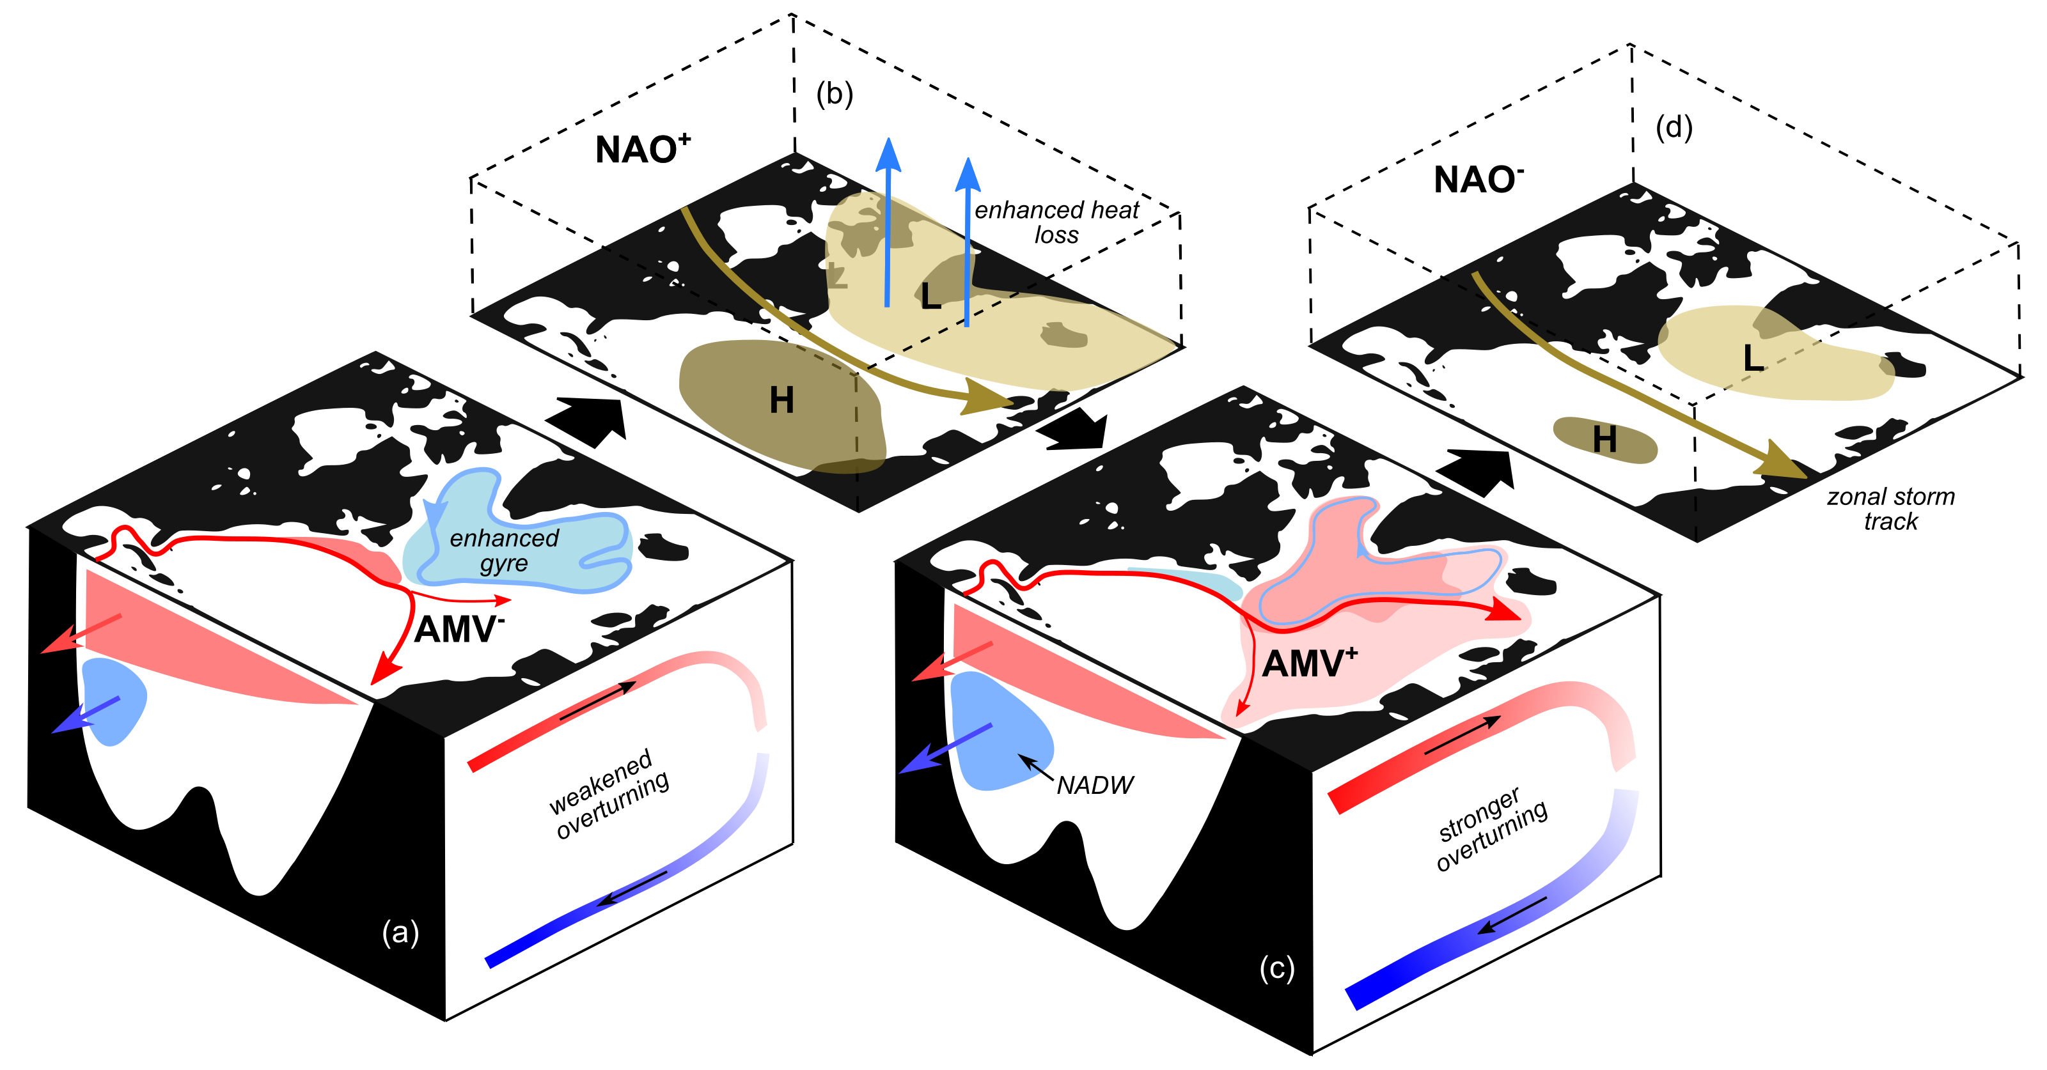

Fig 3: Schematic illustrating one mechanism for AMV phase reversal. (a) A cool phase of the AMV is associated with an expanded, cool subpolar gyre. Warm anomalies north of the Gulf Stream link this pattern with a weakened overturning circulation. The increased meridional gradient of SSTs is conducive to (b) NAO⁺ conditions, which, as shown in Fig. 2, spin up the overturning circulation by increasing the production of North Atlantic Deep Water (NADW). The AMV⁺ conditions resulting from the increased northward heat transport erode the meridional gradient of SST and lead to conditions favoring (d) NAO⁻. Predominant NAO⁻ conditions weaken the overturning, returning to (a).

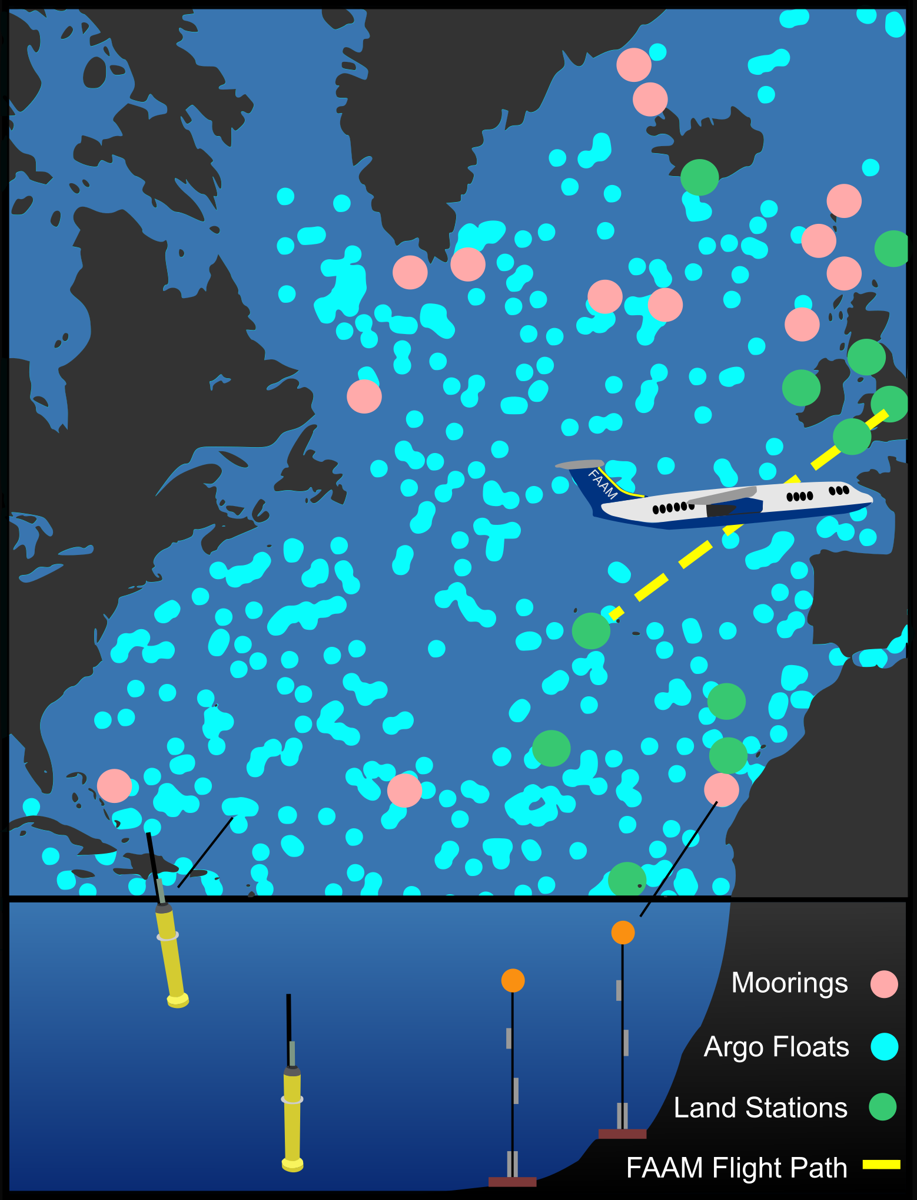
Fig. 4: Elements of the observing system utilized by ACSIS. NERC’s FAAM BAE-146 aircraft will make biannual transects from the UK to the Azores (yellow, dashed) collecting gas and aerosol composition measurements. Land stations (green circles), such as that at Cape Verde, provide sustained atmospheric composition measurements. In-situ ocean measurements from Argo floats (cyan circles) and moored instrumentation (pink circles). The UK-US RAPID program, the international OSNAP program and in-situ observations from the Greenland-Scotland Ridge will be used by ACSIS.

The term Atlantic Multidecadal Oscillation (AMO) also exists in the literature. However, to some readers the word “oscillation” implies a specific preferred timescale (i.e. spectral peak), which may or may not exist in reality. The term AMV is deliberately more generic, and – particularly at the current state of knowledge – more appropriate.

