UNIVERSITY OF SOUTHAMPTON

FACULTY OF ENGINEERING AND THE ENVIRONMENT

Engineering Materials

Algorithms for Studying Murine Airway Structure in Microfocus Computed Tomography Images
by

Nicholas Philip Udell

Thesis for the degree of Doctor of Philosophy

February 2017

UNIVERSITY OF SOUTHAMPTON
ABSTRACT
FACULTY OF ENGINEERING AND THE ENVIRONMENT
Engineering Materials
Thesis for the degree of Doctor of Philosophy
ALGORITHMS FOR STUDYING MURINE AIRWAY STRUCTURE IN MICROFOCUS COMPUTED TOMOGRAPHY IMAGES
Nicholas Philip Udell
Complex branching 3D structures, such as root systems, renal vasculature and pulmonary airways and vasculature, are prevalent throughout nature. The analysis and measurement of these structures and the development of automatic or semi-automatic algorithms to study Microfocus Computed Tomography (µCT) images is therefore an important requirement in this field.
Asthma is a prevalent chronic airway disease that is not yet fully understood. Murine models of lung diseases are used with increasing frequency. As the lung is a complex 3D structure, there are benefits to using 3D methodology to measure structural changes in these models. µCT is a valuable technique in non-destructive imaging that yields high resolution, high quality 3D images.
I describe a sphere inflation branching structure skeletonisation technique that uses radial ray-casting to detect branch points. Quantitative comparisons are made between this technique and three other algorithms: the medial axis transform, the scale axis transform, and a Hough transform for circles tracing technique, as well as manually-produced skeletons from a set of three filled lungs. The sphere growth tracer performs well against the other algorithms when compared to the manually-produced skeletons.
Mutations in A Disintegrin And Metalloprotease (ADAM) 33 gene have been linked to asthma and soluble ADAM33 causes airway remodelling in a transgenic mouse model. This work tests the hypothesis that the effects of human ADAM33 over-expression in transgenic mouse lungs are visible in µCT images as a thickening of the smooth muscle that lines the bronchi and bronchioles, resulting in thicker airway walls as well as narrower lumens than in control mice. Airways were extracted and analysed semi-autonomously for lumen radius, area and perimeter, and wall thickness at seven sites across four generations of branching in 14 murine lungs. However, in a small sample number with limited soft tissue resolution and contrast of the µCT images no significant differences in airway structure could be detected in ADAM33 overexpressing mice compared with control mice.

Contents
Contents 5
List of Tables 9
List of Figures 11
Declaration of Authorship 15
Acknowledgements 17
Definitions and Abbreviations 19
Chapter 1: Introduction 21
Chapter 2: Context and Contributions 25
2.1 Publications 26
Chapter 3: Background 27
3.1 Microfocus Computed Tomography Imaging of Organic Tissue 27
3.1.1 X-Ray Phase Contrast Imaging 28
3.1.2 Fluorescence Microscopy 31
3.1.3 Filtered Back Projection 32
3.1.4 Algebraic Reconstruction 35
3.1.5 Resolution 35
3.1.6 Sample Preparation 37
3.1.7 Application of µCT to Murine Pulmonary Structures 38
3.2 Image Processing 38
3.2.1 Data Size 38
3.2.2 Lung Segmentation 38
3.2.3 Airway Lumen Segmentation 39
3.2.4 Airway Wall Segmentation 39
3.2.5 Branching Structure Analysis 41
3.2.6 Airway Property Measurement 43
3.3 Pulmonary Structure 44
3.3.1 Murine Pulmonary Structure 46
3.4 Asthma 48
3.5 ADAM33 50
3.6 Mice as Models of Human Disease 51
Chapter 4: Rational Choice of Methodology 53
4.1 Image Acquisition and Animal Models 53
4.1.1 Animal License 53
4.2 Pulmonary Skeletonisation 53
4.3 Comparison of Airway Wall Thickness 54
Chapter 5: Pulmonary Skeletonisation 57
5.1 Sample Preparation and Image Acquisition 57
5.2 Image Analysis Method 57
5.2.1 Medial Axis Transform 57
5.2.2 Scale Axis Transform 58
5.2.3 Tracing 58
5.2.4 Hough Transform-Based Tracing 59
5.2.5 Sphere Growth-Based Tracing 61
5.2.6 Domain-Specific Knowledge 64
5.2.7 Comparison 65
5.3 Results 66
5.3.1 Comparison of skeletonisation techniques 66
5.3.2 Entire lung images 71
5.3.3 Unfilled lungs 72
5.4 Discussion 74
5.4.1 Medial Axis Transform 74
5.4.2 Scale Axis Transform 75
5.4.3 Hough Transform-based Tracing 75
5.4.4 Sphere Growth Tracing 76
5.5 Conclusion 76
Chapter 6: Comparison of Airway Wall Thickness 79
6.1 Sample Preparation and Image Acquisition 79
6.2 Method 81
6.3 Results 85
6.4 Discussion 86
6.5 Conclusion 89
Chapter 7: Summary and Further Work 91
7.1 Summary 91
7.2 Limitations 92
7.2.1 Algorithm Parameters 92
7.2.2 µCT 92
7.2.3 Tracer Branch Detection 92
7.2.3 Sample Size 93
7.2.4 Airway Wall Intersection Angle 93
7.2.3 Human Error 93
7.3 Further Work 93
Appendices 99
Appendix I: Complete ADAM33 Single/Double Transgenic Mouse Lung Parameter Comparison 99
Appendix II: Comparison of Scale Axis Transform Scale Factors 104
Bibliography 105

List of Tables
Table 1: Anatomical differences between the mouse and human lung. Reproduced and modified from [59]. 48
Table 2: Comparison of results from each of the executed algorithms. 66
Table 3: Comparison of execution time and parallelism of the executed algorithms. 66
Table 4: Comparison of skeletonisation algorithms with advantages, disadvantages and recommended usage scenarios. 74

List of Figures
Figure 1: A rudimentary diagram showing the typical setup of a fan or cone-beam µCT system. The X-ray source projects outward in a fan or cone from the source, through the object (green), and into the detector behind. The object is rotated either between image capture or during to produce a set of projections covering 360 degrees. Recreated from [20]. 28
Figure 2: The effect of imaging a ball with cone-beam projection. Above: the ball is closer to the source and the image projected onto the detector is larger, with more detector pixels used to cover the entire ball’s shape. This image is therefore of a high resolution. Below: the ball is further from the X-ray source and so fewer detector pixels are receiving x-rays which have passed through the ball, resulting in a lower-resolution image. 37
Figure 3: Diagram showing the effects of viewing a cylinder through a slice (green) that is perpendicular to the cylinder’s orientation (left), or through one that is at an oblique angle (right). Because the angle intersects a greater portion of the structure, the cylindrical cross-section (top) appears elongated when sliced at an oblique angle. 40
Figure 4: Diagram of the Full Width Half Maximum technique applied to a simple $y=x2$curve. Half the maximum value (a) is used to label the extreme points on the curve (b) and (c), between which the distance (d) is determined. 40
Figure 5: Diagram of the medial axis (black) of a 2D shape. 41
Figure 6: Left: Slice of binarized data from a murine lung showing an airway with two branch points. Right: Distance transform of the airway, brighter pixels indicate further distances. 42
Figure 7: Top-left: Skeletonisation testing image from a real data set. Top-right: Testing image after skeletonisation pre-processing using a region-growth segmentation step, median filtering and thresholding. Bottom: Testing image after skeletonisation using Fiji’s autoskeleton algorithm. The branch at the top of the skeleton is erroneous and due to the intersection of the image data with the image boundary. 42
Figure 8: Simplistic diagram of the tracing process. The tracer window (red) moves in steps along the trace path (green), reorienting itself so that it always faces perpendicular to the local orientation of the structure (black). 43
Figure 9: Diagram of the branching structure of the lung from the trachea down to the alveolar sacs, including the function of the generational zones and the different names of the branches at different generations. Reproduced by [59] from [98]. 45
Figure 10: Schematic showing cell shapes and specialised cells seen in different regions of airways and alveoli. Modified from [101]. 46
Figure 11: Diagram of the three different branch generation types active in murine lung development, domain (or side) branching, and both types of bifurcation: planar and orthogonal. The right-hand side of the image depicts the view of the branch facing towards the branching, looking down the branch itself [100]. 47
Figure 12: The result of the Hough Transform for circles on the edges of the cross-section of a murine lung airway. Each pixel’s brightness value represents the number of pixels for which a circle around said pixel intersects that position. The bright central point indicates the most likely centre for the cross-section of the airway. 60
Figure 13: Comparison between un-binned (left) and binned (right) example data in 1 dimensions. Note the highest un-binned value is the single peak on the right, but in the binned data it is the larger central mound. 60
Figure 14: Diagram illustrating the sphere inflation process. Left: An initial sphere (a) is inflated until a sphere-wall intersection occurs. A centre-correction vector (b) is determined by the mean of corrective vectors (c) from the sphere-wall intersections. Right: Diagram showing the results of iteratively applied sphere inflation and centre-correction, with the lightest circle being the final sphere position. 61
Figure 15: Diagram of the branch detection and duplicate removal steps. From top-left to bottom right: 1) Diagram of an airway branch. 2) Trace (blue) of the upper portion of the airway branch. 3) Successful ray casts (potential branch points) from the centreline (black). 4) Removal of traced area (green) removes erroneous branches oriented towards previously-traced branch. 5) Strongest branch candidate selected (red). 6) Trace (blue) of the lower portion of the airway branch. 7) Removal of newly traced area (green) removes remaining branch candidates. 8) Final trace of branch. 64
Figure 16: Manual trace of a filled lung superimposed on the extracted trace data. 65
Figure 17: Comparison images of four skeletonisation algorithms superimposed on the original lung volume. Top-Left: Medial Axis Transform. Top-Right: Scale Axis Transform (scale factor 1.25). Bottom-Left: Hough Transform Tracer. Bottom-Right: Sphere Inflation Tracer. 67
Figure 18: Comparison images of four skeletonisation algorithms produced from a whole, non-simplified lung image. Top-Left: Medial Axis Transform. Top-Right: Scale Axis Transform (scale factor 1.25). Bottom-Left: Hough Transform Tracer. Bottom-Right: Sphere Inflation Tracer. 71
Figure 19: Result of attempted trace of unfilled data using the sphere-growth based tracer. The branch detection algorithm has falsely accepted the airway as branching, and the duplicate detection and removal technique has not been able to mitigate this. This results in a large quantity of false positive branches, particularly around the branch location. Additionally, the tracing of the false positives increases execution time wastefully. 73
Figure 20: (A) Diagram of the full-length ADAM33 protein domain structure, the corresponding mRNA exonic structure and the cDNA used for cloning sADAM33 which contains the signal sequence (SS), pro-domain (PRO) and metalloprotease (MP) domain. (B-F) Plasmid constructs and steps for generation of the linearized TRES-hADAM33-SS-PRO-MP-3Flag DNA construct for microinjection into pro-nuclei from FVB/N mice. (G) Ccsp-rtTA mice line 2 were crossed with founder mice containing the tetracycline response element 2- ADAM33-PRO-MP (TRES-ADAM33-PRO-MP) to generate Doxycycline (Dox)- inducible double transgenic mice expressing human soluble ADAM33 (Ccsp/ADAM33). (H) Agarose gel electrophoresis of PCR products from CcsprtTA (440 base pairs (bp)) or ADAM33-PRO-MP (636 bp) transgenes. Results from DNA of single (STg; Ccsp-rtTA or ADAM33-PRO-MP) or double transgenic (DTg; Ccsp/ADAM33) mice, and negative (H2O) and positive control DNAs are shown. Reproduced from [8] 80
Figure 21: Diagram showing sites observed on the pulmonary tree: (a) the trachea, (b & c) the second generation (main bronchi), (d & e) the third generation, (f & g) the fourth generation. 81
Figure 22: Diagram showing cross-section extraction technique. Slices (blue) are extracted as planes whose normal (grey) is the orientation of the airway. 82
Figure 23: Diagram showing measurement definitions as follows: a) the lung wall/parenchyma boundary, b) the lung wall/lumen boundary, also where the perimeter measurement is taken, c) one of the 16 manually segmented positions on the lung wall/parenchyma boundary, d) the airway lumen, this shape defines the area measurement, e) the computed centroid of the 16 points, f) ray cast from the centroid to one of the 16 manually segmented lung wall/parenchyma boundary positions, g) automatically detected airway lumen / lung wall boundary position along the ray, h) portion of the ray representing lung wall thickness. 83
Figure 24: Diagram showing ray cast (left), with densities extracted to 1D array (right) and chosen local maximum closest to centroid (arrow). 83
Figure 25: Annotated airway slice, coloured for ease of identification of measurements. Each line represents a cast ray from the centroid to the manually-labelled lung wall edge (green). The inner point along the ray (yellow) denotes the automatically-detected lumen-wall border. 84
Figure 26: Airway slice with annotated lumen perimeter (yellow) as determined by Fijis Wand Selection Tool. 84
Figure 27: Box plots of comparisons between single transgenic and double transgenic murine whole lung airway parameters. Top-Left: Airway wall thickness of the whole lung (p = 0.1630). Top-Right: Airway lumen radius of the whole lung (p = 0.0730). Bottom-Left: Airway lumen radius of the whole lung (p = 0.1869). Bottom-Right: Airway lumen perimeter of the whole lung (p = 0.1100). 86
Figure 28: (Top-Left) Box plot of single transgenic versus double transgenic mouse lung lumen radius of the third generation (p = 0.2145). (Top-Right) Box plot of single transgenic versus double transgenic mouse lung wall thickness of the third generation (p = 0.0630). (Bottom-Left) Box plot of single transgenic versus double transgenic mouse lung lumen area of the third generation (p = 0.1727). (Bottom-Right) Box plot of single transgenic versus double transgenic mouse lung lumen perimeter of the third generation (p = 0.1185). 87
Figure 29: Diagram showing the benefits of curve-based centreline extrapolation technique versus the current linear interpolation based centreline extrapolation. Left: centreline extrapolation (dotted) from previously calculated centreline via linear interpolation. Right: centreline extrapolation (dotted) from previously calculated centreline via curve extrapolation. 94
Figure 30: Diagram of the branching structure of a filled test lung simplified to its tree representation and annotated with measured means for branch length (branch point to branch point) and lumen radius. The right-most branch (light grey) indicates that there were additional branches off of the first generation that were excluded for clarity. 96
Figure 31: Graph charting the lumen radius across two branches of a filled lung. 97
Figure 32: Box plots of single transgenic versus double transgenic mouse lung lumen radius (top-left), wall thickness (top-right), lumen area (bottom-left), lumen perimeter (bottom-right) of the whole lung (p = 0.0730, p = 0.1630, p = 0.1869, p = 0.1100 respectively). 99
Figure 33: Box plots of single transgenic versus double transgenic mouse lung lumen radius (top-left), wall thickness (top-right), lumen area (bottom-left), lumen perimeter (bottom-right) of the trachea (p = 0.3952, p = 0.7613, p = 0.4233, p = 0.6421 respectively). 100
Figure 34: Box plots of single transgenic mouse lung lumen radius (top-left), wall thickness (top-right), lumen area (bottom-left), lumen perimeter (bottom-right) of the main bronchi (second generation) (p = 0.2573, p = 0.3251, p = 0.4477, p = 0.5143 respectively). 101
Figure 35: Box plots of single transgenic versus double transgenic mouse lung lumen radius (top-left), wall thickness (top-right), lumen area (bottom-left), lumen perimeter (bottom-right) of the third generation (p = 0.2145, p = 0.0630, p = 0.1727, p = 0.1185 respectively). 102
Figure 36: Box plots of single transgenic versus double transgenic mouse lung lumen radius (top-left), wall thickness (top-right), lumen area (bottom-left), lumen perimeter (bottom-right) of the fourth generation (p = 0.7452, p = 0.4947, p = 0.8849, p = 0.7249 respectively). 103
Figure 37: Comparison of Scale Axis scale factors on the same murine lung. Top-left: Scale factor 1 (the medial axis transform). Top-right: Scale factor 1.25. Middle-left: Scale factor 1.5. Middle-right: Scale factor 2. Bottom-left: Scale factor 3. Bottom-right: Scale factor 4. 104

Declaration of Authorship

I, NICHOLAS PHILIP UDELL declare that this thesis and the work presented in it are my own and has been generated by me as the result of my own original research.

Algorithms for Studying Murine Airway Structure in Microfocus Computed Tomography Images

I confirm that:
- This work was done wholly or mainly while in candidature for a research degree at this University;
- Where any part of this thesis has previously been submitted for a degree or any other qualification at this University or any other institution, this has been clearly stated;
- Where I have consulted the published work of others, this is always clearly attributed;
- Where I have quoted from the work of others, the source is always given. With the exception of such quotations, this thesis is entirely my own work;
- I have acknowledged all main sources of help;
- Where the thesis is based on work done by myself jointly with others, I have made clear exactly what was done by others and what I have contributed myself;
- Parts of this work have been published as:
- N. Udell, I. Sinclair, et al., Sphere-growth based centreline extraction of murine airways from microfocus X-ray computer assisted tomography, The 17th Annual Conference in Medical Image Understanding and Analysis, UK 2013.
- N. Udell, I. Sinclair, et al., Tracing as a tool for determining murine airway morphology from microfocus computer assisted tomography data, 11th International Symposium, Computer Methods in Biomechanics and Biomedical Engineering, USA 2013.
- N. Udell, I. Sinclair, et al., The determination of murine airway morphology from microfocus computer assisted tomography data using tracing, 19th Congress of the European Society of Biomechanics, Greece 2013.
- N. Udell, M. S. Nixon, et al., Classification and quantification of murine lungs as 3D branching structures, 19th Annual Summer Meeting of the British Association for Lung Research, UK 2012.
Signed:

Date:

Acknowledgements
This work was supported by a University of Southampton postgraduate research scholarship to Nicholas Udell and a Medical Research Council (MRC) Clinician Scientist Fellowship to Dr. Hans Michael Haitchi.
Thanks go to my supervisors, Professor Philipp Thurner, Professor Ian Sinclair, Dr. Hans Michael Haitchi and Professor Mark Nixon for their guidance, friendship and advice through the last four years, (longer for Mark!) and to the other members of our post-graduate group: Orestis Andriotis, Orestis Katsamenis, Tom Jenkins, Tsiloon Li, and Louise Coutts for friendship, camaraderie and putting up with my bizarre talk of algorithms and constant premature assurances that ‘it will definitely work’, as well as for providing well-rounded points of view I would not have considered alone.
I would also like to thank the people at µVis, as well as Dr. Anna Edwards, who assisted with my questions on tomography, reconstruction, X-rays and sample preparation, and who imaged many of the murine lungs. Dr. Mark Mavrogordato, Dr. Dmitry Grinev, and Dr. Richard Boardman: thank you very much.
My thanks also go to the other members of the Engineering Materials research team, particularly Sam Keyes and Daniel Bull for their enthusiasm, assistance, knowledge and friendship throughout my time in Engineering Materials.
I would also like to acknowledge Professor David Bassett from Wayne State University, School of Medicine, Department of Family Medicine and Public Health Sciences, Detroit, Michigan, USA, who inflated the wild-type Balb/c mouse lungs with micro fill and then fixed them in paraformaldehyde before shipping them to Southampton for Micro CT.
Outside of the University of Southampton, I would like to thank my parents, Helen and Simon Udell, as well as my siblings, Daniel, Abigail and Rebecca, for their constant support (and occasional nagging) without which I doubt I would have gotten very far at all.
And lastly, and certainly not the least, my thanks and heart go out to my fiancée, Rebecca Farley, for her tireless optimism and expert proof-reading skills, for helping to get my rambling trains of thought back on track and sitting in silence while I unpick a difficult problem. Thank you, and I love you.

Definitions and Abbreviations
µCT Microfocus Computed Tomography
1D One Dimensional.
2D Two Dimensional.
3D Three Dimensional.
ADAM A Disintegrin And Metalloproteinase.
ART Algorithmic Reconstruction Technique.
BHR Bronchial Hyper-Responsiveness.
COPD Chronic Obstructive Pulmonary Disorder.
FBP Filtered Back Projection.
FWHM Full Width Half Maximum.
GPGPU General-Purpose computing on Graphics Processing Units.
SART Simultaneous Algorithmic Reconstruction Technique.
SIRT Simultaneous Iterative Reconstruction Technique.
srCT Synchrotron Computed Tomography.
ADAM33 A member of the ADAM (A Disintegrin And Metalloproteinase) family that has been linked to asthma.
Asthma A disorder of the conducting airways in the lung characterized by chronic airway inflammation and airway hyper-responsiveness, causing variable airflow obstruction.
Beer’s law Describes the attenuation of light through a material based on its properties.
Branch The segment of structure between two branch points
Branch point The locus of a bifurcation or side-branch in the structure.
Distance transform A process whereby a shape is converted into a field representation of the distances to the nearest edge of the shape.
Lumen The inside space of a tubular structure. In this case the space inside an airway branch through which air passes.
Medial axis The set of all maximally-enclosed balls in a structure. When the set is infinite, the Medial Axis is a completely reproducible model of the original image, when the set is finite, it is an approximation.
Parenchyma The bulk of a substance. In this work, parenchyma refers to any substance in the lungs that is not part of the currently-inspected airway branch. This can include other airway branches in proximity to the currently-inspected airway branch.
Radon transform The transform to find the integral of a function over straight lines.
Ray casting The creation of ray representations, typically used to find the nearest point that matches some condition in a specific direction. Often ray casting is performed radially, that is to say multiple rays cast from the same point at different angles to provide coverage in an expanding sphere from the central point.
Region growth Segmentation technique where a region of interest propagates from a single point, including all neighbouring points that match a specific criterion, often a threshold. When no unexamined neighbouring points remain, the algorithm terminates, segmenting unconnected structure from the designated region of interest.
Root The branch point connected to one and only one branch in the first generation of the tree. This denotes the ‘start point’ of the tree.
Skeletonisation The process of reducing a shape to its skeleton - a simplified representation consisting of the centre lines and planes of major structural features.
Thresholding The clamping of data values based on a set threshold value. This is typically used to produce a binarized image, but can be used to clamp in one direction only.
Tracing A skeletonisation technique whereby a designated ‘tracer’ iteratively moves through a shape along its centreline, recording its position as it moves.
Tree The simplified representation of a branching structure.
Wall The structure surrounding the airway lumen, defining the lumen’s boundaries.

Chapter 1: Introduction
With Microfocus Computed Tomography (µCT), assessment of detailed and complex structural systems in 3 dimensions and at high resolution has become possible. As imaging techniques and equipment improve, the ability to resolve features as small as 1 µm increases the yield of data each experiment produces. The application of µCT imaging to pulmonary structure is becoming increasingly prevalent, particularly with animal models. Manually trawling the produced data for important quantitative endpoints proves more difficult and time consuming as the resolvable structures become more intricate and complex, and this additional complexity and manual process time increases the chance of errors or operational bias.
The application of algorithmic analysis via autonomous or semi-autonomous techniques to µCT data is an obvious choice for combatting the overwhelming quantity of data produced. It is now possible to examine differences in phenotype due to specific genes in murine models, and µCT empowers us to view these structural changes in 3D non-invasively and without complete destruction of the sample.
µCT is not yet the gold standard for biological structure assessment. Images produced may suffer from a number of artefacts due to the imaging process, although techniques exist to mitigate or eliminate these. Additionally, it is generally difficult to attain good contrast in pulmonary structure without the use of a contrast agent. However, data produced by µCT imaging is three-dimensional and covers the whole structure, compared to 2D histology which typically takes slices from the lung for analysis. The benefits of seeing the pulmonary structure in its true representation are numerous: morphological parameters may be assessed throughout the entire lung structure, reducing the influence of outliers on the final result; and the relative angle of an airway to the slice cross section does not need to be taken into account, as the airway cross section can be measured perpendicular to the airway axis.
Therefore, we propose that autonomous or semi-autonomous techniques for the measurement of morphological parameters are valuable for the continued analysis of pulmonary structure, and assessment in 3D will prove increasingly important and data become larger and more complex.
Asthma is a common airway disease and affects about 235 million people world-wide [1]. It is a chronic disease of the lungs with features of airway inflammation and bronchial hyper-responsiveness (BHR). In the UK asthma affects about 5.4 million people, 4.3 million adults (1 in 11) and 1.1 million children (1 in 12) [2]. It is the most common chronic disease in children and it has been shown that 32% of a cohort of 9490 children in USA and Europe suffered from the disease [3]. Asthma is not yet fully understood, and it has been shown that in Mutations (Single nucleotide polymorphisms) in the ADAM33 gene have been linked to asthma and BHR [4], this association has been confirmed in multiple different population studies of asthma as well as COPD [5]. Asthma
ADAM33, a member of the A Disintegrin And Metalloproteinase (ADAM) family, is a gene involved in airway remodelling and is preferentially expressed in smooth muscle, myofibroblasts and fibroblasts of the airways [6], suggesting a role in airway remodelling. A soluble form of the ADAM33 protein containing the metalloprotease (MP) domain, has been shown to be upregulated in asthma [7, 8] and causes airway remodelling in a transgenic mouse model [8, 9].
We hypothesise that the effects of human ADAM33-MP over-expression on the murine lung are detectable in µCT images, particularly with respect to smooth muscle genesis. We hypothesise an increase in smooth muscle, correlated with an increase in airway wall thickness in the upper respiratory bronchi, with this difference diminishing in later branching generations. We hypothesise our results will show a morphological change due to ADAM33 overexpression that bear the hallmarks of the asthma disease.
We aimed to assess our hypotheses through the completion of the following goals:
The development of a novel method for centreline extraction in µCT images of branching pulmonary structures. Centreline extraction through sphere inflation and radial ray-casting comparisons with a cylindrical model will be applied to filled and unfilled pulmonary µCT images.
The assessment of changes to morphological parameters in airway structures of an ADAM33 transgenic mouse model via semi-autonomous methods. Airway lumen and wall thickness will be assessed and compared in single and double-transgenic mice expressing human soluble ADAM33-MP. The radius of the cross-section of the airway lumen, the area of the cross-section of the airway lumen, the perimeter of the cross-section of the airway lumen and the distance between lumen-wall and wall-parenchyma boundaries will be assessed at seven sites over four generations in the pulmonary structure, where the airway wall is thickest.
In Chapter 2, the context and contributions this body of work makes are summarised, including work made on semi-autonomous pulmonary structure extraction and analysis of the effects of ADAM33 overexpression on murine wall thickness, lumen radius, lumen area and lumen perimeter. Additionally, a list of publications arising from this work is presented.
Chapter 3 presents a literature review and discussion of important background information on the topics covering this work. Included is information on pulmonary anatomy, the ADAM33 gene, asthma and its link to ADAM33, µCT imaging and techniques, image processing techniques used for lung, airway and wall segmentation and analysis techniques.
Chapter 4 presents a justification of the tools and algorithms employed in both the skeletonisation algorithm assessment and airway wall thickness measurement techniques.
Chapter 5 presents work on semi-autonomous pulmonary structure extraction via tracing, sphere-growth and radial ray-casting for the fulfilment of goal (2). It includes a comparison of four methods investigated: the Medial Axis Transform, the Scale Axis Transform and two tracing techniques involving the Hough Transform and sphere growth respectively.
Chapter 6 focuses on the research into airway wall thickness and other airway morphological parameters influenced by the over-expression of human soluble ADAM33-MP in mouse lungs. This chapter includes the model preparation, image acquisition and processing techniques, as well as the analysis method and results, for the fulfilment of goal (1).
Lastly, Chapter 7 presents a summary of the work and impact it will have on the scientific community. Further recommended work is also laid out and an emphasis is placed on the requirement for increased research into autonomous and semi-autonomous analysis of branching structures, particularly with respect to µCT images and large data.

Chapter 2: Context and Contributions
Asthma is the most prolific childhood disease amongst humans, and environmental changes that interact with heritability of the disease are responsible for increasing of its prevalence over time. The underlying causes of asthma are not yet fully understood, including genetic causes. To further our understanding of the disease, genes such as ADAM33 must be fully explored. Animal models provide a highly valuable alternative to clinical studies with improved control over external influences and genotype.
µCT provides a non-destructive, high resolution data source that can be reused and re-examined without degradation. Images produced through µCT may be used to examine in-depth the quantitative morphological changes introduced by genetic over-expression. Increased use of this technique will improve data availability without excessive loss of animal life for medical science, and bridge the gap between clinical investigation and statistical analysis of populations.
The sheer quantity of data provided by µCT imaging is both an advantage and disadvantage. While the increased resolution allows us to measure structures with greater accuracy, it often proves time-consuming to process image data exhaustively and instead the data is sampled in representative locations. With automated or semi-automated algorithms, this requirement can be ameliorated, allowing the acquisition of data throughout the image and the automatic production of image subsets and regions of interest for human observers.
As of yet, there have been few µCT approaches to imaging mouse lungs, and those that currently exist focus either on in-vivo imaging or the vasculature and have not achieved a sufficient resolution to measure much more than airway capacity or branch length, and ordinarily not much past 5-6 generations. Smooth muscle density has not been measured using µCT, nor has lung wall thickness, although lung wall thickness has been measured in humans using Spiral CT, and only the highest generation lung branch was considered.
This thesis provides a context and evidence for the necessity for increased research into autonomous and semi-autonomous methods for analysis and measurement of high-resolution CT data, particularly with regards to µCT and pulmonary anatomy.
This thesis puts forward a novel tracing-based method for skeletonising general 3D tree structures, with the specific application to µCT images of murine lungs, and quantitively compares it with three existing techniques, as well as manual segmentation.
Additionally, this thesis provides preliminary evidence that µCT might be a useful tool to study the structural changes of the airways in mouse models of airway disease, and therefore also towards the link between ADAM33 and asthma.
This work puts forward and attempts to tests the hypothesis that the effects of human soluble ADAM33-MP overexpression in transgenic mouse lungs are visible in µCT images as a thickening of the smooth muscle that lines the bronchi and bronchioles, resulting in a larger lung wall width than in control mice.
Additionally, this work tests the hypothesis that the airway lumen is narrower in transgenic mouse lungs compared with control mice counterparts due to the thickening of the lung wall.

2.1 Publications
The work included in this thesis has resulted in the following publications:
- N. Udell, I. Sinclair, et al., Sphere-growth based centreline extraction of murine airways from microfocus X-ray computer assisted tomography, The 17th Annual Conference in Medical Image Understanding and Analysis, UK 2013 [10].
- N. Udell, I. Sinclair, et al., Tracing as a tool for determining murine airway morphology from microfocus computer assisted tomography data, 11th International Symposium, Computer Methods in Biomechanics and Biomedical Engineering, USA 2013 [11].
- N. Udell, I. Sinclair, et al., The determination of murine airway morphology from microfocus computer assisted tomography data using tracing, 19th Congress of the European Society of Biomechanics, Greece 2013 [12].
- N. Udell, M. S. Nixon, et al., Classification and quantification of murine lungs as 3D branching structures, 19th Annual Summer Meeting of the British Association for Lung Research, UK 2012 [13].

Chapter 3: Background

3.1 Microfocus Computed Tomography Imaging of Organic Tissue
Microfocus Computed Tomography (µCT) is the name given to a technique that is used to produce high resolution (micrometre range voxel size) three-dimensional data volumes non-destructively, using sets of two-dimensional X-ray projections which are reconstructed into a three-dimensional volume using a reconstruction algorithm. Unless otherwise specified, the content of this section is based on Kak-Slaney [14] and Turbell [15].
X-rays are produced in an X-ray source and penetrate through the sample and into a detector panel behind it (Figure 1). As the X-rays pass through the sample, the signal is attenuated by scattering and absorption, which can be calculated for a homogenous material with Beer’s law:

 | $$I=I_{0}e^{-μx}$$ | ($SEQ Equation \backslash * ARABIC$$1$)
where $I_{0}$ is the initial X-ray intensity, $µ$ is the linear attenuation coefficient for the material being scanned and $x$ is the length of the X-ray path through the material [16]. $µ$ can be approximated as:

 | $$μ=\frac{Z^{n}}{E^{3}}$$ | ($SEQ Equation \backslash * ARABIC$$2$)
where $Z$ is the atomic number of the material, n varies between 4 and 5, and $E$ is the beam energy. This is also known as the cross section of interaction, and describes the significance of the photoelectric effect [17].
However, in organic matter there can be multiple material types (e.g. bone, vasculature, smooth muscle, etc.) and as such the equation must be modified to take into account the different densities.

 | $$I=I_{0}e^{\sum{-μ_{i}x_{i}}}$$ | ($SEQ Equation \backslash * ARABIC$$3$)
Where each $i$ represents a single material with linear extent x and linear attenuation coefficient $µ$.
This equation can be solved directly for any well-calibrated monochromatic system, such as a synchrotron imager, however polychromatic X-ray sources require that the equation is solved over the range of the X-ray energy spectrum used [15]. Typically, this is problematic and so most reconstruction techniques solve for a single attenuation coefficient at each spatial point. $µ$ is therefore taken as an effective coefficient, rather than an absolute.
The detector panel works in a similar way to a camera, and ‘records’ an image of the attenuated X-ray light that hits it. The sample is then rotated mechanically and another image is taken, repeating the process until sufficient degrees of rotation (often 360 degrees, but imaging is possible with fewer rotations, depending on beam geometry) have been achieved [18]. Some scanners can continue rotating the sample as it is being scanned, saving imaging time at the cost of motion artefacts arising from the motion that occurs during the capture of one projection [19].
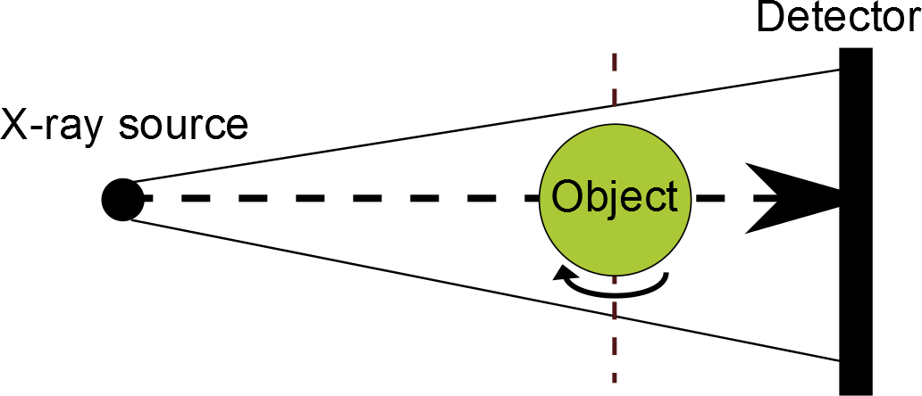
Figure 1: A rudimentary diagram showing the typical setup of a fan or cone-beam µCT system. The X-ray source projects outward in a fan or cone from the source, through the object (green), and into the detector behind. The object is rotated either between image capture or during to produce a set of projections covering 360 degrees. Recreated from [20].
Reconstruction is performed either using Algebraic Reconstruction, such as Algorithmic Reconstruction Technique (ART), Simultaneous Algorithmic Reconstruction Technique (SART) or Simultaneous Iterative Reconstruction Technique (SIRT), or - more commonly - using Filtered Back Projection (FBP), which is based on the Radon transform

3.1.1 X-Ray Phase Contrast Imaging
As well as using attenuation of the X-Ray beam, an X-ray can be considered as an electromagnetic wave, meaning an object of interest can be described by its complex refractive index [21].

$$n=1- δ+iβ$$ | ($SEQ Equation \backslash * ARABIC$$4$)

Where δ is the decrement of the real part of the refractive index, and β is the absorption index.
The total phase shift of a beam propagating by distance z can be calculated using the projection of the decrement of the real part of the refractive index in imaging direction:

$$Φ\left(z\right)= \frac{2π}{λ}\int_{0}^{z}{δ\left(z^{'}\right)dz^{'}}$$ | ($SEQ Equation \backslash * ARABIC$$5$)

Where λ is the wavelength of the X-ray beam.
There are many methods for acquiring phase contrast information for tomographic purposes, of which the four most common techniques are: Propagation-based, Analyser-based, Crystal Interferometric, and Grating Interferometric [22]. Each of these methods produce data that can be reconstructed using Filtered Back Projection.

3.1.1.1 Propagation-Based X-Ray Phase Contrast Imaging
In propagation-based X-ray phase contrast imaging, the X-ray wave front is sampled at two positions: near-field and far-field. As the wave-front propagates, phase changes due to the wave passing through the object cause interference, varying image intensity. The near-field and far-field images are compared, and the differences between them account for the propagated phase changes.
The advantages of this technique are that it requires little additional equipment, however due to the need to resolve the interference fringes, a higher resolution detector is required. This has the effect of limiting the field of view, or applying a minimum propagation distance.

3.1.1.2 Analyser-Based X-Ray Phase Contrast Imaging
There are several analyser-based techniques for X-ray phase contrast imaging, including the Schlieren method, refraction-constant radiography, phase-dispersion imaging or diffraction imaging. All analyser methods make use of monochromatic, quasi-parallel X-rays and perfect crystal analysers. The analyser crystal reflects only rays at the Bragg angle with the Bragg planes (atomic planes) of the crystal. Single images taken along the reflectivity curve of the analyser crystal contain mixed absorption and refraction signals and by recording the images from different angles, the non-deviated, refracted and scattered rays can be separated and recorded.

3.1.1.3 Crystal Interferometric X-Ray Phase Contrast Imaging
A crystal interferometer setup consists of three beam splitter crystals aligned in Laue geometry, parallel to each other. The first crystal splits the X-ray beam into two coherent beams, one of which is used as a reference beam and the other of which passes through the sample. The second crystal redirects the beams to converge towards each other, meeting at the third crystal, which creates an interference pattern that is recorded by an area detector.
To record the phase shift from the interference pattern, a wedge-shaped phase shifter is used in the reference beam to give straight interference fringes with regular intervals. These are called carrier fringes, and when the object to be scanned is placed in the other beam, the fringes bend with a displacement that corresponds to the phase shift [23].
The interferometric technique struggles from a field of view of a few centimetres, and has “extreme requirements of stability and alignment of the interferometer” [22]. Additionally, the Laue crystals filter most incoming radiation, which necessitates high beam intensities or long exposure times [23].

3.1.1.4 Grating Interferometric X-Ray Phase Contrast Imaging
Also known as Differential Phase-Contrast Imaging, grating interferometry with x-rays is based on Fresnel diffraction in periodic grating [24]. The grating image is repeated at regular distances behind the grating:

 | $$δ_{r}=\frac{2p^{2}}{λ}$$ | ($SEQ Equation \backslash * ARABIC$$6$)
where $p$ is the grating’s period.
In Grating Interferometric X-Ray Phase Contrast Imaging, a phase grating is used which produces a periodic variation in the wave front’s phase.
Given a coefficient of the change of phase:

 | $$η=2πδ/λ$$ | ($SEQ Equation \backslash * ARABIC$$7$)
Where δ is from ($6$) and λ is the X-ray wavelength $2π/K$, we can simplify to:

 | $$η=δK$$ | ($SEQ Equation \backslash * ARABIC$$8$)
And the phase difference from the grating’s grooves are described by:

 | $$ηh= δKh$$ | ($SEQ Equation \backslash * ARABIC$$9$)

Where $h$ is the depth of the groove.
When fractional distances of the half Talbot distance (the distance between periods of the self-imaging of a diffraction grating) are used for phase gratings, intensity modulation is observed. Behind a phase variation grating with groove width $\frac{p}{2}$, the following pattern of period $\frac{p}{2}$ is observed at fractional Talbot distances:

 | $$D = mp^{2}/ 8λ$$ | ($SEQ Equation \backslash * ARABIC$$10$)

where $m$ is integral.
Typically, a $\frac{p}{2}$ periodic absorption grating is placed in front of the detector, and the pattern is recorded by phase-stepping the grating across the detector, producing a first-order sinusoidal intensity variation:

 | $$I\left(X_{g}\right)=a_{0}+a_{1}\cos\left(\frac{2πx_{g}}{p_{2}}+ϕ_{1}\right)$$ | ($SEQ Equation \backslash * ARABIC$$11$)
where $x_{g}$ is the grating displacement, $ϕ_{1}$ the phase shift and $a_{0}$ is the average intensity.
When an object obstructs the beam, the wave front refracts and the intensity pattern shifts, but when no object obstructs the beam, the phase shift is zero.
During the phase-step process, three parameters, $a_{0}$, $ϕ_{1}$, and $a_{1}$ are recorded, and compared with values recorded without the object. The resulting parameters produce absorption, differential phase shift (refraction properties) and dark field (scattering) images respectively.
Grating Interferometric X-ray Phase Contrast Imaging has become a widely-used method [25, 26, 27], predominantly because it allows the use of polychromatic X-ray radiation, since the Talbot distance is inversely proportional to X-ray wavelength. The technique has predominantly been implemented using synchrotron radiation sources [28, 29, 30, 31, 32]. The phase-stepping technique requires images to be recorded at a minimum of three $x_{g}$ positions, and therefore requires precision and stability [22]. Additionally, the phase stepping technique increases imaging time.

3.1.2 Fluorescence Microscopy
Fluorescence microscopy makes use of a filtered monochromatic beam that causes a material (a fluorophore) in the object under investigation to fluoresce. The fluorescent beam is recorded by a detector. The filtered monochromatic beam can be redirected to different portions of the object under investigation, and as such the whole detector can be dedicated to small areas of the object, increasing the achievable resolution.
There are two common techniques for performing fluorescence microscopy: Confocal microscopy and light sheet fluorescence microscopy.

3.1.2.1 Confocal Microscopy
In confocal microscopy, the monochromatic laser beam is focused onto a specific area of the sample in a cone beam. At the cone’s point of focus, the fluorescent radiation is emitted and captured by a detector. Since the captured portion of the image is limited in all 3 cardinal axes, this allows planes of the sample to be captured at multiple depths, and thus the capture of 3D structural information.

3.1.2.2 Light sheet Fluorescence Microscopy
In light sheet microscopy, the beam is projected perpendicular to the direction of observation as a thin sheet. The sheet excites the fluorophores in the object, projecting a fluorescent image towards the detector. The sample can then be translated or rotated to produce full coverage of the 3D object.

Fluorescence microscopy suffers from an effect called photobleaching, where the fluorophores lose their ability to fluoresce over time [33].

3.1.3 Filtered Back Projection
The Radon transform defines the line integral $P_{θ}(t)$, where $θ$ is the angle of the line, and $t$ is the distance an X-ray beam has travelled. The Radon transform in 2D of the function $f(x,y)$ is as follows:

 | $$P_{θ}\left(t\right)= \iint_{-∞}^{∞}{f(x,y)δ(xcosθ+ysinθ-t)dxdy}$$ | ($SEQ Equation \backslash * ARABIC$$12$)

It follows that in order to reconstruct the original image from the set of line integrals, the line integrals must be calculated using the inverse of the Radon transform, however the actual reconstruction technique depends on the projection type. Each projection created by the imaging process is a set of line integrals. There are three types of projection: cone-beam, fan-beam and parallel. In parallel projection, each beam is parallel to each other, whereas with fan-beam, each line integral fans out from the source, much like light from a light-bulb. These lines are stacked to create a 3D wedge shape. Cone-beam is similar to fan-beam projection, except where fan-beam fans outwards in two dimensions, cone-beam is a 3D fanning. The result is a conical shaped projection. The imaging systems used in this project produce cone-beam projections. Cone beam reconstruction is a matter of extending fan-beam reconstruction into 3D. To reconstruct fan-beam projections, the angle of the beam from the source must be considered. This is calculated from the distance between the X-ray source and the detector, and the spacing and number of beams the detector can acquire. First, the Radon transform is modified to take into account the angle of the beam using the following formula:

$R_{βi}^{'}\left(na\right)=R_{βi}\left(na\right) ⋅\frac{D}{\sqrt{D^{2}+n^{2}{ a}^{2}}}$ ($SEQ Equation \backslash * ARABIC$$13$)

where $R_{βi}\left(na\right)$is the Radon transform of the beam at angle $nα$, $α$ is the angle between each of the beams in the fan, $n$ is the beam’s number in the fan and $D$ is the distance from the source.
The projections are further filtered using the following convolution:

$Q_{βi}=R_{βi}^{'}\left(na\right)*g(na)$ ($SEQ Equation \backslash * ARABIC$$14$)
where $g$ is defined as:

$g\left(γ\right)=\frac{1}{2}*\frac{γ}{\sin{{\left(γ\right)}^{2}h(γ)}}$ ($SEQ Equation \backslash * ARABIC$$15$)
and where $h$ is defined as:

$h\left(nr\right)= \left\{\begin{aligned}\frac{1}{4r^2} n=0 \\ 0 n even \\ -\frac{1}{n^{2}π^{2}r^{2}} n odd \end{aligned}\right.$ ($SEQ Equation \backslash * ARABIC$$16$)

This essentially defines $g$ as:

 | $$g\left(na\right)= \left\{\begin{aligned}\frac{1}{8α^2} n=0 \\ 0 n even \\ -\frac{α}{πα\sin\left( nα\right)} n odd\end{aligned}\right.$$ | ($SEQ Equation \backslash * ARABIC$$17$)

The beams are then back-projected by applying a weighted back projection of each $Q_{βi}$ along the angle of the fanned beam towards the source. The back projected value is found using:

 | $$f\left(x,y\right)≈Δβ\sum_{i=1}^{M}{\frac{1}{L^{2}\left(x,y,β_{i}\right)}Q_{βi}\left(γ^{'}\right)}$$ | ($SEQ Equation \backslash * ARABIC$$18$)
Where $γ_{0}$ is the angle of the ray through points $(x,y)$ and $Δβ-\frac{2π}{M}$ and $L$ is the distance from the X-ray source to point $(x,y)$ found using the following function:

 | $$L\left(r,η,β\right)= \sqrt{{\left(D+rsin\left(β+η\right)\right)}^{2}+{\left(rcos\left(β-η\right)\right)}^{2}}$$ | ($SEQ Equation \backslash * ARABIC$$19$)
where $(r,η)$ is a point in polar coordinates and $β$ is the angle of projection.
The result is a fully-reconstructed data-set, with voxel values essentially equalling $µ · d$ where $µ$ is defined earlier as the attenuation coefficient and $d$ is the voxel edge length.
In order to reconstruct cone beam images, one must adapt the fan beam reconstruction technique into 3D. By describing a ray in a 3D projection as the intersection of two planes:

 | $$t = xcos(θ) + y sin⁡(θ)$$ | ($SEQ Equation \backslash * ARABIC$$20$)
 | $$r= -\left(ysin\left(θ\right)-xsin\left(θ\right)\right)\sin\left(γ\right)+zcos(γ)$$ | ($SEQ Equation \backslash * ARABIC$$21$)

we can construct these planes through the following rotation:

$$\left[\begin{matrix}t \\ s' \\ r\end{matrix}\right]= \left[\begin{matrix}1 & 0 & 0 \\ 0 & cos⁡(γ) & sin⁡(γ) \\ 0 & -sin⁡(γ) & -sin⁡(γ)\end{matrix}\right]\left[\begin{matrix}cos⁡(θ) & sin⁡(θ) & 0 \\ 0 & -\sin\left(θ\right) & \cos\left(θ\right) \\ 0 & 0 & 1\end{matrix}\right]\left[\begin{matrix}x \\ y \\ z\end{matrix}\right]$$ | ($SEQ Equation \backslash * ARABIC$$22$)
where $t,θ$ represent the distance and angle in the x/y plane and $r,γ$ represent the distance and angle in the s/z plane.
We can then express a 3D parallel projection of the object as:

$$P_{θ,γ}\left(t,r\right)= \int_{-S_{m}}^{S_{m}}{f\left(t,s,r\right) ds}$$ | ($SEQ Equation \backslash * ARABIC$$23$)
where $f$ is the object being imaged.
The weight applied to a cone beam is defined as follows:

$$w=\frac{D_{so}}{\sqrt{D_{so}^{2}+ϵ^{2}+p^{2}}}$$ | ($SEQ Equation \backslash * ARABIC$$24$)
where $D_{so}$ is the distance from the source, $ϵ$ is the height of the fan above the centre of the plane of rotation, and $p$ is the distance this projection was registered from the centre of the detector.

$w$ is multiplied by the projection data $R_{β}(p,ϵ)$ to find the weighted projection, $R_{β}^{'}(p,ϵ)$:

$R_{β}^{'}\left(p,ϵ\right)=R_{β}\left(p,ϵ\right)w$ ($SEQ Equation \backslash * ARABIC$$25$)

The weighted projection is filtered by convolution with $\frac{h\left(p\right)}{2}$ , as in ($g\left(γ\right)=\frac{1}{2}*\frac{γ}{\sin{{\left(γ\right)}^{2}h(γ)}}$ ($15$)

$Q_{β}\left(p,ϵ\right)=R_{β}^{'}\left(p,ϵ\right)*\frac{h\left(p\right)}{2}$ ($SEQ Equation \backslash * ARABIC$$26$)
And finally, back projected:

$g\left(t,s,z\right)= \int_{0}^{2x}{\frac{D_{so}^{2}}{{\left(D_{so}-s\right)}^{2}}Q_{β}\left(\frac{D_{so}t}{D_{so}-s},\frac{D_{so}z}{D_{so}-s}\right)dβ}$ ($SEQ Equation \backslash * ARABIC$$27$)

Where $\frac{D_{so}t}{D_{so}-s}$ and $\frac{D_{so}z}{D_{so}-s}$ are the coordinates of a point in the object, transformed into the coordinate system of the current fan of the cone.
The result is a reconstructed image.

3.1.4 Algebraic Reconstruction
Algebraic Reconstruction considers the reconstructed image as an array of unknown variables, and produces a series of linear equations based on the rays measured in the projection data for solving these unknowns.
For algebraic reconstruction, the projected rays are assigned a width based on the width of a receptor cell in the imaging system. Then, for line integral $π$ across ray $i$ we can say:

 | $$\sum_{j=1}^{N}{w_{ij}f_{j}=p_{i}} i=1, 2,…, M$$ | ($SEQ Equation \backslash * ARABIC$$28$)
where $f_{j}$ is the reconstructed value in cell $j$, $M$ is the total number of rays in all projections and $w{}_{ij}$ is a weight that represents the proportion of the $j$th cell that is inside ray $i$.
The Kaczmarz method [34] of solving algebraic equations is then used to approximate the solution to these linear equations. The Kaczmarz method involves taking an initial guess, $f_{0}$ for all variables, projecting this initial guess on the hyperplane representing the first ray, $p_{1}$. This vector, $f_{1}$ is then projected on the hyperplane representing $p_{2}$, and the process continues until $f_{i}$ is produced as the result of projecting $f_{i-1}$ on $p_{i}$. $f_{i}$ is then projected onto $p_{1}$ and the process is repeated until the value of $f_{x}$ converges. It has been shown that if a unique solution exists to the equations represented by $p$, that $f$ will eventually reach convergence [35].
The advantages of algebraic reconstruction techniques over Filtered Back Projection are [36]:
- Prior information can be easily included, such as modelling the system optics.
- Reduced noise in the output.
- Improved results from partial tomography, such as with limited projection angles.
On the other hand, algebraic reconstruction techniques take considerably longer than Filtered Back Projection (FBP) to produce an image, particularly as the number of projections increases, due to the algebraic reconstruction technique’s high computational complexity.

3.1.5 Resolution
Modern scanners can reach ∼1µm spatial resolution [37], limited by spot size, however actually reaching that resolution is dependent on several factors, such as [38]:
- Sample placement and size.
- Detector resolution
- Size of the focal point of the X-ray beam
- Mechanical stability of the rotation system and the CT reconstruction filtering algorithm.
The distance from the sample to the X-ray gun in conical systems is a critical factor, as the spread of the X-rays has the same effect as holding your hand close to a light bulb - the ‘shadow’ is much larger than if the hand was further away, however the sample’s size may restrict how close it can be brought to the X-ray source as it must be free to rotate a full $360$ degrees without hitting the source. Thus, a larger sample, or one that is kept in a much larger container than is needed, would deliver a lower spatial resolution than a smaller sample. This effect is known as geometric magnification, see Figure 2 for a diagram of the process.
Common artefacts associated with µCT are ring artefacts and motion blurring. Ring artefacts are caused by detector pixels not recording at the same X-ray sensitivity as other pixels which, combined with the rotation of the sample, leaves anomalous ring shapes of higher or lower density than the correct value throughout slices [17, 39]. Several ring artefact correction methods have been developed, such as the generation of ‘bad’ pixel maps created by the scanner prior to a scan in which one projection image is taken with no X-rays and one is taken with X-rays but no sample. The optimal results would be one fully-black and one fully-white image respectively. Any deviations from that are considered artefacts and are compensated for during the imaging process [40].
Motion blurring is caused by the long exposure time required by the CT scanners to reduce noise combined with any motion of the sample being imaged during the procedure. Motion blurring is especially problematic in scans that require high resolution data as the blur will effectively wipe out small features or distort them to the point that they are no longer reliably measurable.
The partial volume effect is a product of the necessity to use a discrete detector on continuous data. The result is that each voxel contains multiple density values from across the voxel’s dimensions that have been averaged together. When the voxel straddles an edge, the density value will be made up of both material 1 and material 2, giving an average value between the two (Figure 2). This increases the uncertainty when measuring structure sizes, as a margin of error of $±1$ voxel must be considered [16]. However, the effect can be used to increase accuracy in some cases using sub voxel interpolation.
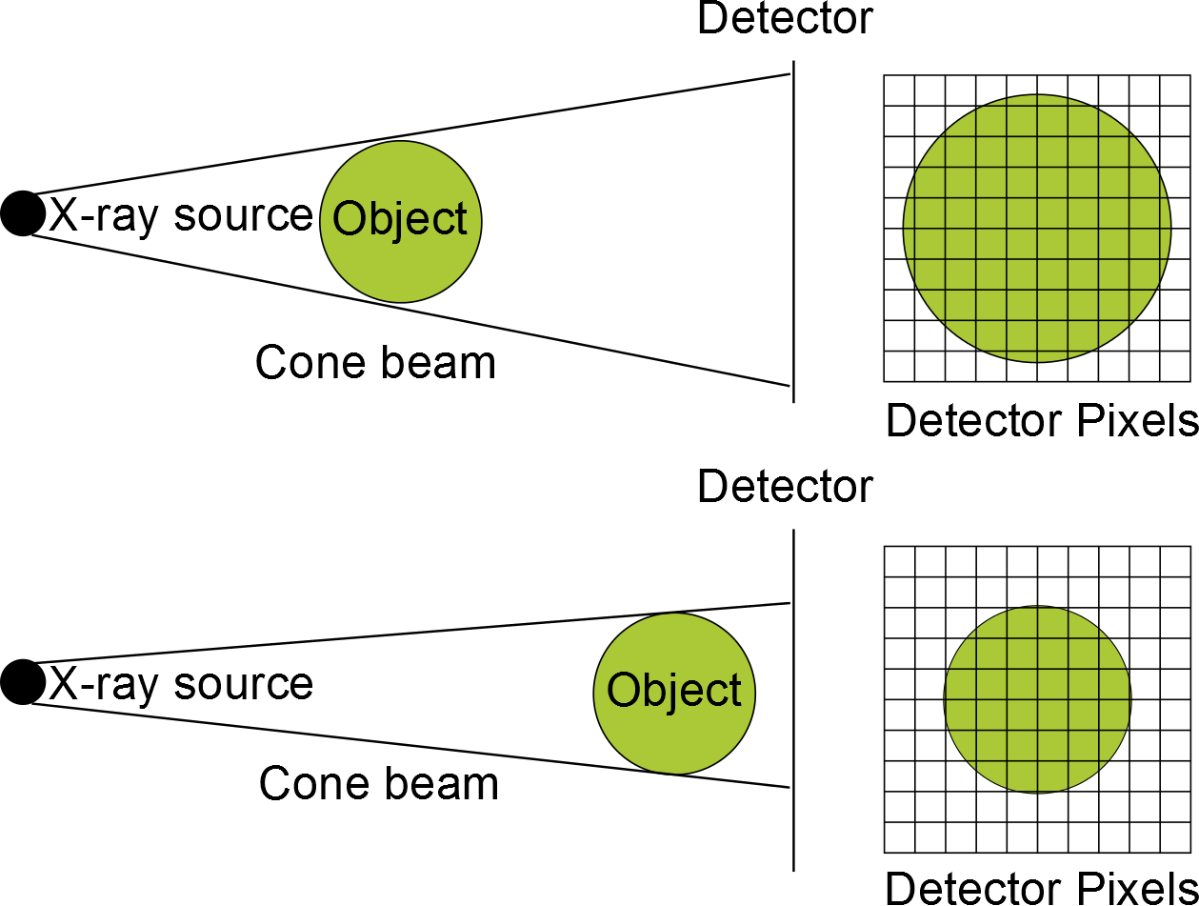
Figure 2: The effect of imaging a ball with cone-beam projection. Above: the ball is closer to the source and the image projected onto the detector is larger, with more detector pixels used to cover the entire ball’s shape. This image is therefore of a high resolution. Below: the ball is further from the X-ray source and so fewer detector pixels are receiving x-rays which have passed through the ball, resulting in a lower-resolution image.

3.1.6 Sample Preparation
Soft-tissue provides poor contrast with X-ray µCT [38] and so lung samples typically must be infiltrated with a contrast agent so as to make the airways visible and measurable. Recent work has shown it is possible to image via X-ray µCT pulmonary structure without a contrast agent, however the authors note that ‘the absence of a contrast agent results in a much lower contrast than air-inflated, fixed and dried tissue sample’ [41].
There is a major imaging artefact associated with using strong contrast agents which can cause streaks across the images with incorrect values [38], however algorithms exist to deal with this problem [42].
Formalin fixation is known to induce tissue shrinkage. This shrinkage is relatively homogenous [43], therefore it can either be ignored in the case of comparison between similarly-prepared samples, or corrected for in the case of comparison between formalin-fixed samples and samples prepared using a different methodology, or when producing absolute values for recorded morphological parameters.
The prevention of motion while imaging lungs is an additional challenge. Scott et. al reduced motion by embedding the murine samples in paraffin, although due to microscopic air bubbles some regions of the imaged lung were unmeasurable and had to be excluded [41].
Synchrotron Computed Tomography (srCT) has been shown to be successful in imaging organic tissue with good absorption contrast without a contrast agent [44] and it has been found that ‘structures with a small difference in their density/atomic mass, such as ECM [Extracellular Matrix] and cells, also image well due to the attenuation of phase boundaries.’ This is because synchrotron sources provide high-intensity, high-flux X-ray beams. Because the beam is monochromatic the accuracy of the Radon transform is improved because Beer’s law can be solved directly using an absolute coefficient of absorption instead of an effective one [45]. srCT has also been applied to murine pulmonary structures [46] where good spatial resolution was achieved without dehydration or fixation.

3.1.7 Application of µCT to Murine Pulmonary Structures
µCT has been used to image mouse lungs before [47, 41]. One report measured emphysematous changes in mice, noting that where before the authors would measure the lung at random areas and then average the results, they were now capable of measuring the entire structure, eliminating the possibility of missing patches of lung that were morphologically different [47, 48]. This measurement can be performed as long as the structure is large enough to be reliably measured at the voxel size of the scan.
A typical issue with analysis via 2D slices of complex 3D structures such as branching trees, for example the pulmonary tree, is that the structure of the airway is rarely orthogonal to the slice being measured. As such, structures may appear distorted, particularly slanted and widened, due to the imperfect angle. Analysis in 3D ‘eliminates ambiguities regarding the interpretation of a 3D structure from sections only’ [49]. See Figure 3 for an example of the consequences of analysing an airway wall at an oblique angle to the slice.

3.2 Image Processing

3.2.1 Data Size
Volumetric data generated from µCT can routinely be in the order of ${2000}^{3}$ voxels, which at a 32-bit density resolution can result in data sets larger than 20 gigabytes. This will place higher time and memory costs on most algorithms and will require expensive hardware to compute in a reasonable time [38]. Care must be taken during algorithm development to ensure memory and processing power are put to good use and that increases in execution time do not outweigh the benefits of computation over manual measurement.

3.2.2 Lung Segmentation
Many lung segmentation algorithms are based on thresholded segmentation [50, 51, 52, 53, 54, 55]. Threshold segmentation performs well for normal lungs because ‘lung parenchyma has substantially lower attenuation than the surrounding tissue’ in healthy subjects [56]. Meng et al. [57] performed an analysis of robustness of threshold-based segmentation on a set of 2,768 CT scans with various scanning protocols and physiological abnormalities. 4.4% of the lung segmentations contained errors by failing to correctly segment lung structure as confirmed by visual inspection, 62% of which were due to disease, 32.2% of which were due to artefacts and the remaining errors due to corrupted data and external factors.
Thresholding has the disadvantage of including any data within a threshold, even if it is not attached to the pulmonary structure. Region growing algorithms [58, 59] or connected components analysis algorithms [60] are thus common tools for lung segmentation [61, 62, 63, 64, 65, 66, 67, 68, 69, 70].

3.2.3 Airway Lumen Segmentation
In order to segment airway lumen there are several existing techniques. Region growth can be used to segment airways by beginning the region growth inside the airway instead of in lung matter, however it presents the issue of leakage. In images with imperfect contrasting patches with lower density or holes may appear in the lung tissue. The region grower will pass through these holes or patches and into the parenchyma. The result will include erroneous areas. Mori et al. [66] and then extended by Schlatholter et al. [71], use “explosion-controlled region growth” whereby the volume of the airway is monitored between region growth iterations. If the volume grows unusually quickly, it is deemed that the region grower has exited the airways and region growth is halted locally to the leaked area. Region growth then continues in all other areas as before. While region growth tools will remove disconnected noise, care must be taken to extract all regions of data that have been disconnected, either due to insufficient inflation, noise or airway blockage will not be included in the segmented data [56].
One technique is to map the branching structure of ocular microvasculature by detecting points of greatest and least rapid change in voxel density values using Hessian second order differential matrices per voxel, which is used to describe local curvature. The cylindrical vascular shapes have a gradient that drops off rapidly along the axis normal to its circumference, thus allowing the detection of angle and position of the vasculature at each point and removal of the rest of the data. This technique will not detect branching points, as the branch points have gradient changes in all axes. To rectify this a less-strict threshold is applied to find branch points, and this new set is merged with the cylinder data [72].
Tschirren et al. [70] adapt cylinders to pulmonary structure, which then act as regions of interest during the segmentation, allowing leakage from region growth to be detected early.
Another recurring technique is the use of adjacent vessels, which run parallel to the bronchi, to improve segmentation results. Proximity of parallel vessels is used to inform the probability of an airway’s existence during the region-growing approach [73, 68].

3.2.4 Airway Wall Segmentation
A number of techniques exist for segmenting the airway wall, both using 2D or 3D methods. 2D approaches are either applied to axial slices or the image is reformatted so that the slices are perpendicular to the airway centreline. The latter is preferable because ‘when resampling perpendicular to the airway direction, the segmentation of the airway walls can be performed throughout a segmented airway tree’ [56] (Figure 3).

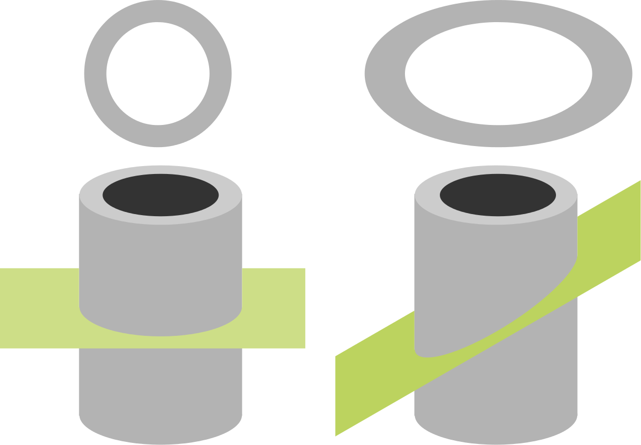
Figure 3: Diagram showing the effects of viewing a cylinder through a slice (green) that is perpendicular to the cylinder’s orientation (left), or through one that is at an oblique angle (right). Because the angle intersects a greater portion of the structure, the cylindrical cross-section (top) appears elongated when sliced at an oblique angle.
The Full Width Half Maximum (FWHM) technique is commonly used for airway wall thickness measurement. FWHM measures the length of a signal peak between the two furthest points in the signal where the signal value is half of the maximum signal value. For airway wall thickness measurements, the signal is a one-dimensional function representing airway wall density sampled along a ray that passes through the wall [74, 75]. The two extreme points that are measured are at the lumen/wall boundary and the parenchyma/wall boundary when the density value is halfway between maximum lumen density and airway wall density and halfway between maximum parenchyma density and airway wall density, respectively. See Figure 4 for a diagram describing this technique.

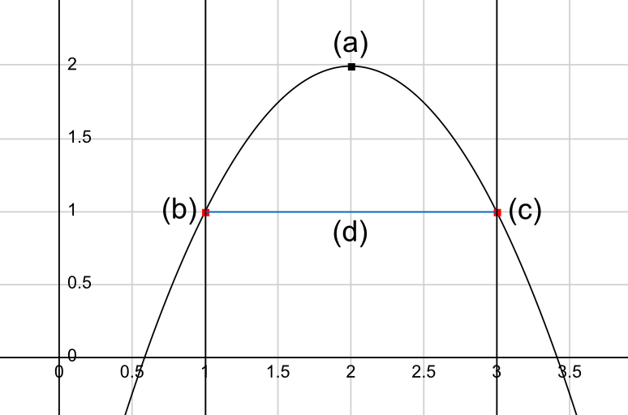
Figure 4: Diagram of the Full Width Half Maximum technique applied to a simple ${y=x}^{2}$curve. Half the maximum value (a) is used to label the extreme points on the curve (b) and (c), between which the distance (d) is determined.
However, FWHM has difficulty resolving boundaries with nearby structure in close contact with the airway wall, or in cases where there is insufficient contrast with surrounding structure and has been shown to be inappropriate for small airways [76, 74].

Additional techniques for finding the airway-wall and wall-parenchyma boundaries in a 1D ray of density values include phase congruency [76], intensity integration [77, 78], or fitting a model comprised of two cylinders to the inner and outer walls of the airway structure [79].
Regardless of methodology used, 2D airway and wall measurement techniques suffer from incapability to measure the airway and wall around branching points, due to the irregular 3D structure. As such, several 3D techniques have been proposed.
Liu et al. [80], extended by Petersen et al. [81] utilise a graph-search based on an existing airway lumen segmentation mesh in order to identify the airway wall. The graph-search algorithm is constructed by generating columns perpendicular to the surface of the lumen mesh. These columns follow non-intersecting lines that flow inwards along positive gradients and outward along negative gradients (as determined using a Gaussian convolution filter). This leads to columns that start inside the lumen area, move through the higher density airway wall and end up in the lung parenchyma, where the density falls again [81].

3.2.5 Branching Structure Analysis
In order to assess structural parameters, such as branch lengths, angles, etc., we must convert the data to a representation of a tree. This technique is known as skeletonisation and is a common analysis technique, although methodologies differ [82, 83, 84, 85].
The medial axis is the set of centres of all maximal spheres in an object. By inflating spheres at each point in the medial axis, where the value of the medial axis is the radius of the sphere, the original shape is produced. With an infinite number of spheres, it has been proven that the result will be identical to the original object, although typically this is impractical, and a finite set must be produced, resulting in an approximation [86]. See Figure 5 for a diagram of the Medial Axis Transform.

Figure 5: Diagram of the medial axis (black) of a 2D shape.
A distance transform can be used to calculate the medial axis because it returns the minimum distance between a point and the closest edge of the structure. This translates to the maximum radius of the fully-enclosed sphere inside the object at that point. See Figure 6 for an example of the distance transform used on real data, and see Figure 7 for a skeletonised bronchiole from a real dataset.
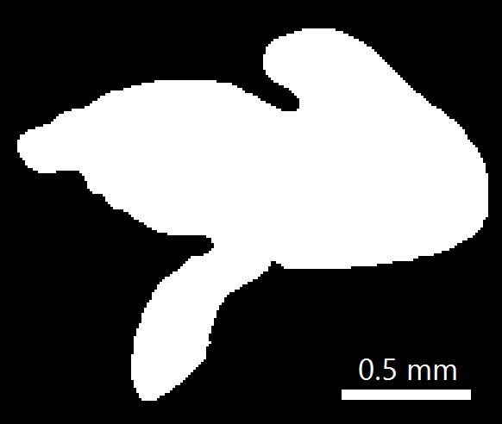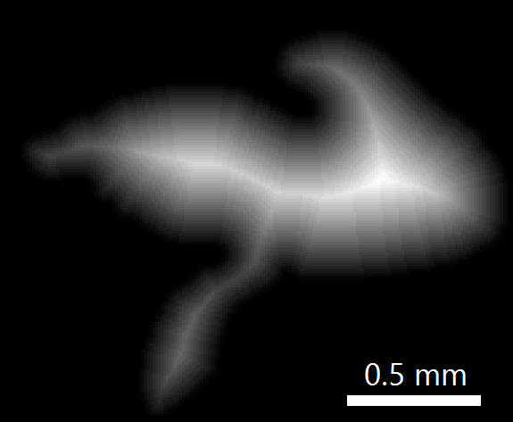
Figure 6: Left: Slice of binarized data from a murine lung showing an airway with two branch points. Right: Distance transform of the airway, brighter pixels indicate further distances.

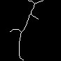
Figure 7: Top-left: Skeletonisation testing image from a real data set. Top-right: Testing image after skeletonisation pre-processing using a region-growth segmentation step, median filtering and thresholding. Bottom: Testing image after skeletonisation using Fiji’s autoskeleton algorithm. The branch at the top of the skeleton is erroneous and due to the intersection of the image data with the image boundary.
This algorithm is convenient in that the resulting data can be easily simplified to a ‘map’ of the lung data set, however such simplification could remove useful data and so it is best practice to refer to the original data when making measurements in order to ensure higher measurement accuracy.
An alternative common technique for skeleton production is tracing. With tracing, an observer moves through the airways, and iteratively calculates the centre-point at each position it moves to, using this to build a map similar to that returned by thinning-based skeletonisation techniques (Figure 8). Unlike skeletonisation, however, tracing is an iterative algorithm, each step being the product of the previous steps and the local structure surrounding the observer. As such it is more difficult to implement multithreaded or distributed versions to take advantage of the extra hardware available in modern computers, however it is easier to perform other calculations as the lung is traversed, such as measurements or simplified generation, or the incorporation of prior knowledge.

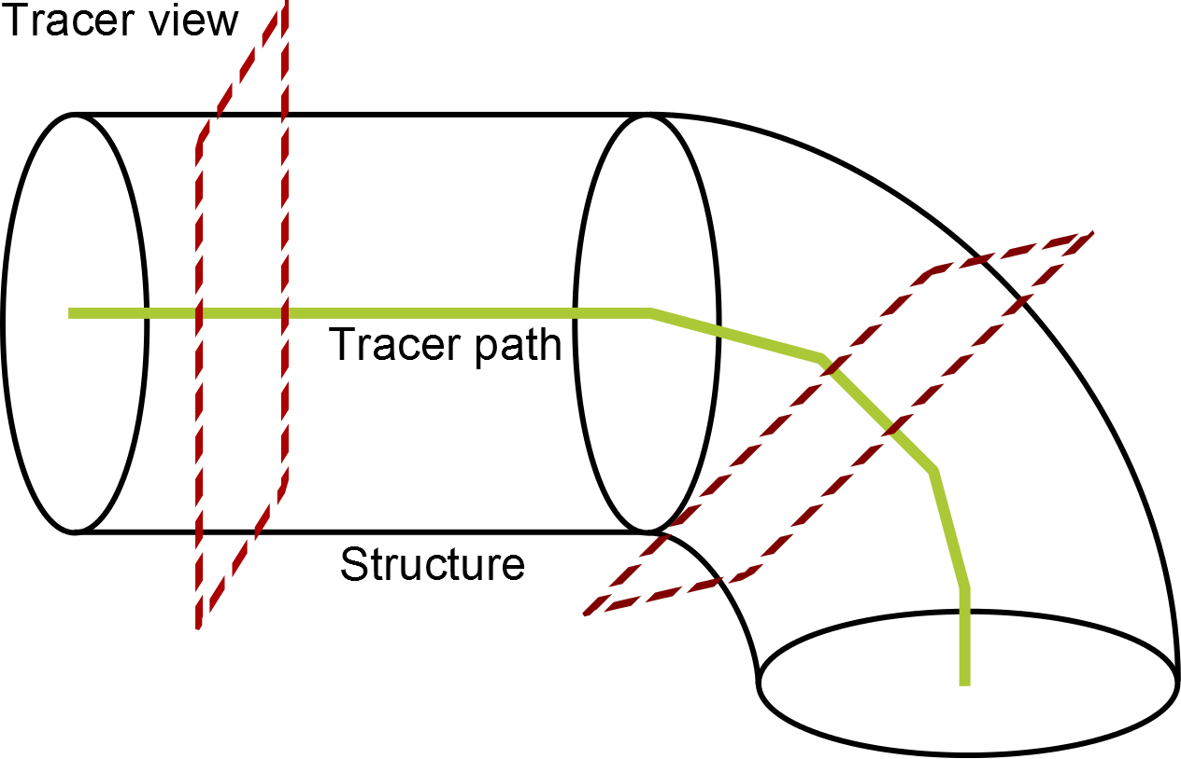
Figure 8: Simplistic diagram of the tracing process. The tracer window (red) moves in steps along the trace path (green), reorienting itself so that it always faces perpendicular to the local orientation of the structure (black).
Swift et al. [69] and Carrillo et al. [87] use spheres to trace the skeleton of the pulmonary system, but in different ways. Swift et al. use tessellated spheres to find patches of air ‘in front’ of the tracer’s current position. This is deemed to be a ‘future point’ or next step along the airway. If multiple patches are found, these are considered to be branches. Centreline positioning is found using a separate step, which uses 2D ray-casting to find contours in an oblique slice.
Carrillo et al. use inflated spheres combined with connected components analysis to find centreline positioning. An initial guess for centreline position is obtained, and a sphere grown around the point. The first intersection between airway wall and sphere is recorded and the sphere is grown until another intersection is recorded along the vector from the first towards the sphere centre. The difference in sphere radii for first and last contacts is used to move the centre point (and sphere) along the vector. Future points are detected by extending the sphere once growth is complete and detecting connected components which are inside the extended sphere and are left when the original sphere is subtracted. Similarly to Swift et al., branch points are detected by finding multiple connected components.

3.2.6 Airway Property Measurement
Airway property measurements from µCT, High-Resolution CT (HRCT) and CT images have previously been taken both using manual methods [88, 89, 90, 59] as well as automated algorithms [91, 92, 70, 93, 41]. The majority of papers have not applied these techniques to µCT data [88, 89, 90, 91, 92], which produces higher resolution images than CT or HRCT. Additionally, HRCT typically results in images that ‘represent only one tenth or less of the volume of the lung’ [94]. Furthermore, the majority of papers have not applied these techniques to murine lung data [91, 70, 95, 70, 93, 41]. Airway properties that have been measured include length, lumen radius, lumen area, wall thickness, wall area, airway lumen cross-section ellipsoid major and minor diameters, and airway cross-section centroid.
Of the automated papers, many do not measure the entire lung, and instead measure extracted segments of the airway that have been partially pre-segmented [41, 59, 93]. The most common automated technique for airway wall measurement is region growth [90, 91, 96, 93], but a number of other techniques have been assessed, including shape-fitting [59, 92, 70], morphology-based techniques [95], or mean linear intercept (‘the mean length of line segments on random test lines spanning the airspace between intersections of the line with the alveolar surface’ [97]) [41]. A common manual approach is to use electronic callipers to measure airway properties of airway segments [88, 89].

3.3 Pulmonary Structure
The lung is a branching organic structure that oxygenates the blood and removes carbon dioxide. It is essential for the survival of all air-breathing mammals. The lung also filters irritants and pollutants from the airways as well as performing metabolysis [98]. The root of the structure is the trachea, which branches into the two main bronchi. From there the lung branches further into smaller bronchi and into bronchioles, terminating in the alveoli. Bronchi and bronchioles are cylindrical structures that carry air from the mouth and nose, through the lungs and to the alveoli. See Figure 9 for a basic diagram of lung structure.

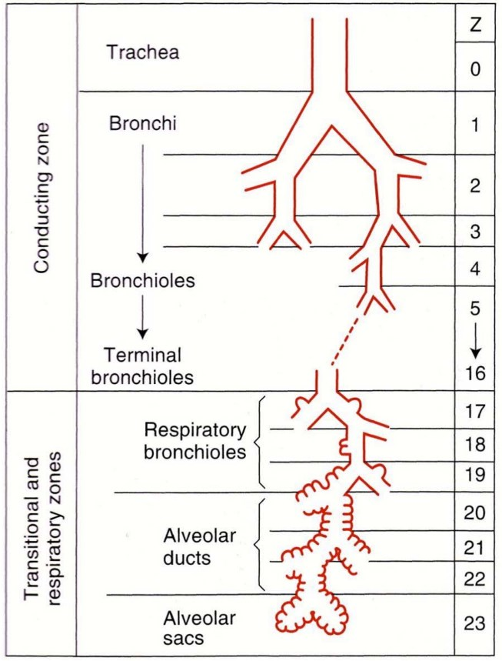
Figure 9: Diagram of the branching structure of the lung from the trachea down to the alveolar sacs, including the function of the generational zones and the different names of the branches at different generations. Reproduced by [59] from [98].
Bronchi are lined with epithelial cells, under which a network of connective tissue with extracellular matrix, vasculature, secretory glands and smooth muscle cells form the mesenchyme, which supports the epithelial cells. As the airways branch further from the trachea, the lining gradually thins with shorter columnar cells [99]. The bronchioles continue to branch for a number of generations (approximately 9 in humans and 15 in mice) before reaching the alveoli [59].
The alveolar sacs are round structures found at the end of every lung pathway. It is here that the gaseous exchange takes place and thus the lining of the structure is thin and surrounded by capillaries to accommodate this [99]. See Figure 10 for a schematic of the cell-shapes in the lung as branching continues. Due to the increasingly thin airway walls, the accuracy of wall thickness measurements will decrease as branching continues, however the thinning also reduces the quantity of smooth muscle, making the earlier branches of highest priority for smooth-muscle measurement. Due to the fact that the terminal branches of the lung are grown from the primary branches [100], it is possible that other morphological changes may be induced in the terminal bronchioles from remodelling of the bronchus and primary bronchioles, and as such measurements of the terminal branches of the airway may still prove valuable.

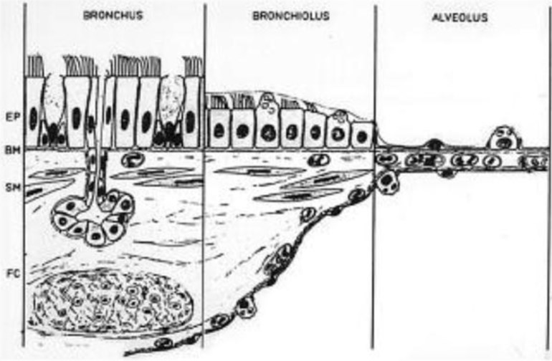
Figure 10: Schematic showing cell shapes and specialised cells seen in different regions of airways and alveoli. Modified from [101].

3.3.1 Murine Pulmonary Structure
The mouse lung is not fully understood, and ‘has typically been analysed through observational and histological techniques’ [59, 102], however some characteristics have been measured. Parenchyma make up 18% of the murine lung, compared with 11% airway [103]. Additionally, the pleura of the mouse lung is thin, but strong enough to maintain up to 80cm H₂O pressures under inflation [104].
Murine pulmonary structure differs in a number of ways from that of the human pulmonary system. In mice, air is brought through terminal bronchioles of the respiratory tree directly to the alveoli. In humans, the terminal bronchioles of the tree are the respiratory bronchioli, but no such structures exist in the mouse [59]. Branching patterns differ between murine and human lungs as well. Human lungs exhibit dichotomous branching [105], where the parent branch generally bifurcates evenly into two smaller branches. The murine lung also exhibits monopodial branching [59], where multiple branches are generated from a parent branch that retains its size, typically seen as domain branching. The murine pulmonary branching methodology is well-understood. After the primary bronchial branch, the branching process is ruled by three sets of instructions: domain branching, planar bifurcation and orthogonal bifurcation in the development of mouse lungs [100] (Figure 11).
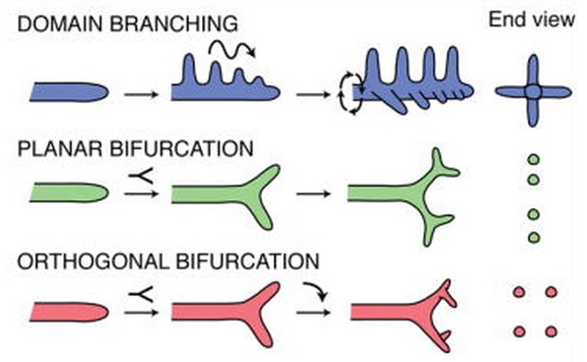
Figure 11: Diagram of the three different branch generation types active in murine lung development, domain (or side) branching, and both types of bifurcation: planar and orthogonal. The right-hand side of the image depicts the view of the branch facing towards the branching, looking down the branch itself [100].
The main secondary branches (i.e. the first branches to form using this set of algorithms) are controlled by domain branching, in which child branches grow in rows along the parent branch. After this, planar bifurcation (the splitting of a branch in two) occurs, followed by orthogonal bifurcation, which is two passes of the planar bifurcation algorithm, but with a 90◦ rotation between the two. Planar bifurcation continues until the lung finishes generating. In a mouse model this is typically after ∼ 13-17 branches [59].
The diameter of the terminal bronchiole in the mouse is ∼ 100 µm, whereas in humans this is much larger, at ∼ 600 µm [59]. The respiratory bronchioles in the human lungs are approximately ∼ 500 µm in diameter, but are non-existent in mice.
Alveolar size is similarly scaled between human and mouse pulmonary structure, with human alveoli sitting between ∼ 200 µm and ∼ 400 µm in diameter, and mice between ∼ 35 µm and ∼ 80 µm in diameter. See Table 1 for more anatomical differences between murine and human pulmonary structures.

 | Mouse | Human
Lobe Anatomy | 4 lobes on right, 1 lobe on left | 3 lobes on right, 2 lobes on left
% Parenchyma by volume | 18% | 12%
Airway generations | Approximately 13-17 | 17-21
Main bronchus diameter | 1 mm | 10-15 mm
Bronchioli diameter | 0.1-0.5 mm | <1 mm
Terminal bronchioli diameter | 0.1 mm | 0.6 mm
Respiratory bronchioli diameter | Not existent | 0.5 mm
Alveoli diameter | Varies from 35-80 µm | 0.2-0.4 mm
Table 1: Anatomical differences between the mouse and human lung. Reproduced and modified from [59].
Much like with the human lung, the branching technique for murine lungs is also well-understood. In both lungs, side branching occurs along the main bronchi for three rows. The first, the ventral row, ‘consisting of the longest which run into the ventral periphery of the lungs’, then the dorsal row of ‘smaller branches which supply the lung tissue lying adjacent to the vertebral column’ and finally the medial row, which ‘goes to the small part of the lung directed towards the posterior part of the mediastinum’ [106].

3.4 Asthma
Asthma is a disorder of the conducting airways characterised by chronic airway inflammation and airway hyper-responsiveness, causing variable airflow obstruction [107]. Those who develop chronic asthma often develop irreversible structural changes in their airways due to malfunctioning repair and remodelling processes [108].
Asthma is the most common chronic disease in children. 5.4 million people in the UK are currently treated for asthma, of which 1.1 million are children [2]. On average, 3 people in the UK die from asthma each day, and in 2014, 1216 people died from asthma in the UK [2]. The UK has among the highest prevalence of asthma in children in the world [2], however in very young children it is difficult to routinely assess either airflow limitation or airway inflammation - the principle pathological markers of the condition [109]. One study shows 32% of a cohort of 9490 children in USA and Europe suffered from the disease [3]. It is closely linked with Bronchial Hyper-Responsiveness (BHR), which is a condition whereby the ‘airways constrict too much and too easily to a range of stimuli’ [110]. In chronic severe cases both the structural changes to the lungs and the inflammation become more intense, which goes hand in hand with an increase in BHR that is ‘partially or is non-responsive to treatment with corticosteroids’ [110, 111]. Asthma has a high heritability, potentially as high as 75% [112] and the interaction between genes and environmental factors is responsible for a significant increase in asthma from 1994 to 2003 in both males and females [113]. The prevalence of asthma in children and adults is increasing, with more than 100 million people affected worldwide [114]. Genetic and environmental factors contribute greatly to the development of asthma [115].
In new-borns, the baseline airway function and bronchial responsiveness are good predictors of the disease. BHR in new-borns is ‘a predictor of the subsequent development of asthma and in ‘high-risk infants’ BHR becomes fully developed by 6 months of age’ [116, 117, 118].
Asthma encompasses two types of pathological processes: airway remodelling and airway inflammation, both contributing to airway obstruction. Airway inflammation consists of: mucosal, submucosal and adventitial oedema (swelling caused by fluid build-up in tissue) with cellular infiltration by inflammatory cells (the migration of cells as a result of the release of different chemokines and growth factors), particularly by eosinophils and, in some cases, neutrophils and activated helper T lymphocytes as well as mast cells that infiltrate smooth-muscle (all of which are types of white blood cell). This inflammation causes increased mucus secretions, lining cells that have peeled off and eosinophils within the lumen (the channel within a tube, in this case the airway inside the structure). Airway obstruction is characterised by typical symptoms of coughing, shortness of breath, chest tightness and wheezing and is caused by a combination of smooth-muscle constriction in the airway and inflammation of the bronchi [119]. Smooth-muscle constriction can be severe, leading to life-threatening narrowing and closure of airways [119], and the severity of asthma symptoms has been linked to the density of smooth muscle [120, 121]. A common feature of asthma is bronchial hyper responsiveness (BHR) (increased twitchiness of the airways to innocuous stimuli) which has been strongly associated to single nucleotide polymorphisms in the ADAM33 gene [4, 110].

3.5 ADAM33
‘The ADAM (A Disintegrin And Metalloproteinase) proteins are a fascinating family of transmembrane and secreted proteins with important roles in regulating cell phenotype via their effects on cell adhesion, migration, proteolysis and signalling’ [122, 123] and ADAM family members, including ADAM33, have been shown to be upregulated during acute or chronic inflammation [9].
The ADAM33 gene association with asthma and BHR has been reported by studying over 450 families in both the UK and the US using genome-wide screening. For those subjects with asthma that had been diagnosed by a physician, there was strong evidence that the ADAM33 gene most likely to be responsible for asthma and BHR [4]. In the meantime, susceptibility to asthma and Chronic Obstructive Pulmonary Disorder (COPD) has been linked and replicated to ADAM33 in ethnically diverse populations [124, 125, 126, 127, 128, 129]. ADAM33 is more likely responsible for altered airway function than allergic inflammation [110], although recent Iranian study suggests there may be a link between sensitivity to allergens in severe asthmatics and ADAM33 [130]. Furthermore, a meta-analysis of V4 polymorphism in the ADAM33 gene revealed ‘significant associations between the ADAM33 V4 polymorphism and risk of asthma in population- and hospital-based subgroups’ [5]. Additionally, ADAM33’s link to the progression of childhood recurrent wheeze into asthma has been recently confirmed [131].
Accelerated lung function decline in asthma [132], the general population [133], and reduced early-life lung function [134] have also been associated with alleles of ADAM33 as well as endogenous ADAM33 has been detected in bronchus tissue, bronchial smooth muscle cells and MRC-5 fibroblasts [135], all of which suggests that ADAM33 causes airway remodelling in asthma [8].
ADAM33 is preferentially expressed in smooth muscle, myofibroblasts and fibroblasts of the airways, and mesenchymal progenitor cells [136, 137], and each expression site has been linked with a role in airway remodelling that is an important pathological feature of asthma [138, 139]. ADAM33 can serve as a cell surface ‘sheddase’, to release growth factors and modify cell-surface receptor expression [47], however, the exact substrates for ADAM33 are still not known.
ADAM33 is a membrane-anchored protein, however it can also be found as soluble form (sADAM33) that is induced in lungs of new-born mouse pups by in-utero maternal allergy [140] and is increased in asthma [8], and which correlates with reduced lung function [7] and induces angiogenesis [141] and airway remodelling [124]. This was shown by assessment of a doxycycline-inducible human sADAM33 expressing transgenic mouse model (Figure 11) [8], which expresses human sADAM33 protein only in the lungs of double-transgenic mice that were fed doxycycline. It was found that $α$-smooth actin, collagen 1 and 3, and platelet/endothelial cell adhesion molecule 1 mRNA as well as airway smooth muscle and vessels were increased in the dox-fed lungs from double transgenic mice compared to single-transgenic littermates, which was independent of airway inflammation. Additionally, it was found that the airway remodelling that sADAM33 induces can be reversed by blocking sADAM33 expression [8] suggesting that ADAM33 could be a novel target as anti-remodelling therapy in asthma.

3.6 Mice as Models of Human Disease
Murine models are ‘the most widely used animal model of human disease’ [59] due to their similarities with humans in both a physiological and genetic sense, as well as the fact that their genome is fully defined and well-understood [142]. Additionally, mice are inexpensive and small, allowing multiple experiments and larger sample sizes, and their short gestation periods lend to the ability to cycle through multiple generations in short time. Due to the laboratory environment, it is easier to control for external factors that may affect pulmonary generation and performance, such as sex, age and environmental exposure that may affect pulmonary generation and performance, and which are difficult to control in humans [59].
ADAM33 is expressed during embryonic development in the mouse [143], as well as in the gestation period and into adult life [136]. It is most prominently expressed in the adult brain, heart, kidney, lung and testis [143]. Soluble human ADAM33 has been successfully expressed in transgenic mice, and has been linked to airway remodelling in mouse models. While the remodelling did not trigger inflammation or BHR in murine lungs, the remodelled lungs were shown to be more susceptible to allergen (Human Dust Mite) exposure which was suppressed in the ADAM33 knock out mouse [8]. Additionally, enzymatically active sADAM33 produced almost identical structural remodelling in the form of more smooth muscle around the airways in human foetal lung explants [8].

Chapter 4: Rational Choice of Methodology

4.1 Image Acquisition and Animal Models
X-ray microfocus computed tomography was chosen as the technique for imaging the lung samples because it is a relatively fast technique that produces 3D volumetric images at high resolution with minimal destruction to the sample. Phase contrast X-ray tomography, while it offers increased contrast in low-density media such as biological matter, increases the time required to image the samples, risking motion artefacts in the images due to temperature instability or air pocket expansion. Additionally, the material used to fill the lungs – desirable for the skeletonisation study – can incorporate a high-density material to provide sufficient contrast compared to the surrounding media and techniques exist to stain the airway walls to improve contrast. Fluorescence microscopy was discarded due to the relatively small imaging size that would make it difficult to produce intact pulmonary trees for analysis as well as the bleaching effect that reduces contrast over time, compared to the persistent contrast of stains.
In-vivo imaging was avoided as the animals would have to be intubated and breath-gated during imaging, and would reduce the attainable image resolution.

4.1.1 Animal License
For all mouse samples, Replacement, Reduction and Refinement principles (the 3Rs) were followed and experiments conducted according to the Animal Research: Reporting of In Vivo Experiments (ARRIVE) guidelines [144], the guidelines for the care and use of animals approved by the Institutional Animal Care and Use Committee at the Cincinnati Children’s Hospital Research Foundation (Cincinnati, OH, USA) and the local Southampton University ethical committee under project and personal licenses from the Home Office, UK.

4.2 Pulmonary Skeletonisation
Lungs filled with a contrast agent were chosen for this study because the filled lung provides a simpler structure than an unfilled lung, where there is no density difference between a voxel that is inside an airway and a voxel that is outside it. Additionally, in cases where the contrasting is not perfect, it will lead to disconnected airways instead of holes in the lung wall that tracing algorithms could misinterpret as branching.
In order to skeletonise murine lungs, I assess four algorithms for skeletonisation; two thinning-based techniques and two tracing-based techniques:
- The Medial Axis Transform was considered because it is a robust representation of the original shape of a feature through its centreline, it does not miss data and it is also a highly-parallelisable technique.
- The Scale Axis Transform was considered because it produces a simplified representation of the Medial Axis Transform, and is specifically designed to combat the extra branches and planes encountered due to noise or complex small features that the Medial Axis produces. Like the Medial Axis Transform it is also highly-parallelisable.
- A tracing technique using the Hough Transform for centreline and branch detection was considered because the Hough Transform is a robust circle-detection technique, and the cross-sections of the airways resemble circles. It is incorporated with a tracer because a tracer finds only connected data, and can group the resulting trace into individual branches.
- A tracing technique based on Carillo et. al., using sphere growth for centreline extraction but with radial ray-casting for branch detection was considered because, like the Hough Transform-based technique, a tracer finds only connected data, and can group the resulting trace into individual branches. Additionally, unlike the Hough Transform, sphere growth and radial ray-casting operate in three dimensions, and do not suffer from skewed cross-sections caused by slicing the image at an angle that is not exactly perpendicular to the airway.
While the tracing techniques can incorporate domain-specific knowledge to improve performance and results, all four algorithms were designed with no domain-specific knowledge in mind, so that they may operate with the same success on a mouse lung as a human, or on vasculature instead of airways, increasing the usefulness of the algorithms to the scientific community. Since murine lungs contain all three forms of branching (side and planar and orthogonal bifurcation), they actually make a good test data set for generalised branching structure skeletonisation techniques.

4.3 Comparison of Airway Wall Thickness
Lungs inflated to a constant pressure and stained with Lugol’s Iodine solution were chosen for this study because the iodine acts as a strong contrast on the cells it stains, while leaving the airway clear, and therefore producing a stark contrast between airway lumen and airway wall.
Prior to image processing, cross-sectional areas were taken to reduce manual segmentation time. These areas were taken in 5-slice gaps in order to reduce the influence of abnormalities in the surface of the airway walls on the measured parameters for the whole airway segment. Segments were taken across four different generations because the lung wall is made up of different ratios of cell types as lung generation continues, particularly through a reduction in smooth muscle density, and as such I hypothesise that sADAM33 could affect each generation to different extents. A manually-guided approach for outer wall-segmentation was used because of low outer wall boundary contrast compared to the parenchyma.
With the outer wall boundary labelled, an automated approach to inner wall boundary detection was used because the inner wall boundary was well-contrasted against the void and automated techniques reduce the influence of human error or bias. Radial ray-cast tests were chosen to measure lung wall width and airway lumen radius because this technique provides reasonable coverage of the lung wall cross section without requiring an exhaustive manual segmentation of the airway wall/parenchyma boundary. Additionally, by ray-casting inwards, the inner wall boundary can be automatically segmented using one-dimensional edge detection techniques, which are robust and quick to execute. For this technique, I chose the Sobel edge detection filter in one dimension, which is implemented via a simple convolution filter. While more complex filters such as Canny edge detection may produce better edge-detection in processed images, for picking the location of a single edge this increase in accuracy is not required, as the problem domain is simpler. Furthermore, the downside of Sobel – i.e. that it produces multiple designated edge positions is not a concern because the algorithm picks a single edge point on the density profile of the ray, and any lower-gradient edges are ignored.
Airway lumen perimeter and area measured using thresholding-based region growth. This technique was used due to the high contrast between airway lumen and wall, which improves the accuracy of threshold-based techniques.

Chapter 5: Pulmonary Skeletonisation
The following is adapted from work previously presented at the 19th Congress of the European Society of Biomechanics [12].

5.1 Sample Preparation and Image Acquisition
Skeletonisation was performed with 3 images of wild-type mice that were terminally anaesthetised and their lungs inflated with Microfill injection compound (Flow Tech, Inc. Carver, Massachusetts, USA) at a constant rate of 10 µl per second to a constant total volume.
Once the required volume had been injected, the trachea was tied off and the lung removed from the chest. It was then placed in 4% Paraformaldehyde and stored at 4$°$C. The next day, the lung was transferred to a vial filled with (Phosphate-Buffered Saline) PBS plus 6% sucrose and stored at 4$°$C.
To keep the samples in a stable position they were transferred to 15 mm Bijoux tubes filled with a 30% solution of Lutrol F68 (BASF Chemicals) and brought to room temperature, where the F68 gel thickened. The lungs were then imaged in batch in a custom 225kV Nikon Metrology HMX ST scanner at 115Kev and 85mA. Voxel size was approximately 10 µm.
Acquired image data were reconstructed into volumetric images via Filtered Back Projection using CT Pro 3D (Nikon Metrology NV, Leuven, Belgium). Images were converted to 8-bit brightness range and cropped to the bounding box of the lungs to reduce file size, before being filtered with a median filter to reduce small noise. The images were binarized using a uniform threshold determined by finding the peak with highest density from a density histogram of the image. The binarized information was then eroded and dilated to remove any remaining small structures or noise which connected structures erroneously.

5.2 Image Analysis Method
Images were processed using algorithms implemented in the C# language, which was chosen for its memory handling and threading capabilities, which were necessary to improve performance and handle the large datasets produced by µCT, combined with its ease of development and reasonably simple porting to Java, which is widely used in image processing applications.

5.2.1 Medial Axis Transform
There is more than one way to compute the Medial Axis Transform, and for assessment the local maxima of the distance transform of the data was chosen. This is because it guarantees connectedness and is simple to parallelise.
In order to compute the distance transform, an iterative grass-fire technique was applied. On a result set binarized such that structure voxels are labelled “1” and void labelled “0”, a counter representing distance from edges is initialised at 1. For each voxel in the results set that is equal to the counter and for which none of the 6-way connected voxels are less than the counter, the voxel’s label is incremented by 1. Once every voxel has been processed, the counter is incremented by 1 and the process repeats until a full pass occurs in which no voxels in the results set have changed labels.
The medial axis is extracted from the distance transform by finding all voxels in the distance transform that are greater than or equal to their 6-way connected voxels.
Due to the nature of the Medial Axis, no data (for example, disconnected data) is unprocessed and execution times are reasonable on modern processing systems, however the Medial Axis is not an ideal skeleton for purposes of measurement in systems with any noise or surface irregularities. Additionally, in three dimensions, the Medial Axis tends to not only produce extra branches when encountering noise or small features, but planes. Because the goal is a tree of thin voxel strings, each plane is considered erroneous.

5.2.2 Scale Axis Transform
In order to compute the Scale Axis Transform the Medial Axis Transform was first computed using the method described in the previous section. For every voxel in the medial axis, a ball was grown, centred on the medial axis voxel position and with radius equal to the value of the medial axis at that position, multiplied by an operator-set scale factor. Lower scale factors reduce the chances that close structures will merge into a single connected structure, but will limit the reduction of erroneous extra branches and planes. Higher scale factors will further simplify the tree, at the risk of connecting disconnected structures. This scale factor was determined by executing the Scale Axis Transform for a range of scale factors and visually inspecting the results. The Medial Axis Transform is then performed again on the grown spheres.
Due to the nature of the transform very little data was missed, but execution time was much slower due to the algorithm involving two passes of the Medial Axis Transform and one of sphere inflation. Additionally, the resulting image was dependent on the scale factor used. With higher scale factors, the resulting image produced fewer noisy branches, but at the cost of merging smaller, complex structures into single features.
Like the Medial Axis Transform, this technique is highly-parallelisable. Each of the three sequential operations were applied uniformly to each voxel and the immediately surrounding voxels, with no other iterative operations. Such a transform lends itself as well to General-Purpose computing on Graphics Processing Units (GPGPU) processing and to clustered computation as the Medial Axis Transform.

5.2.3 Tracing
The following tracing setup was utilised for both of the following techniques and is included here for brevity, with the implementations of the centreline and orientation detection, branch detection, and the determination of stopping points specified in the following sections.

The algorithm uses a single seed point, which is assumed to be the root of the branching structure. From here, an observer moves in the direction of the current branch’s orientation by a factor determined by the radius of the branch at the current position.

 | $$C_{n+1}=C_{n}+{\hat{o}}_{n}r_{n}α$$ | (29)
where $C$ is the position of the tracer in the image, $\hat{o}$is the orientation vector, $r$ is the radius of the cross section of the structure found at coordinate $C$ and $α$ is a constant accuracy factor for speed/accuracy trade-off.

5.2.4 Hough Transform-Based Tracing
The Hough Transform for circles was employed to find both centrelines and branches in a tracing setup.

5.2.4.1 Centreline Detection
The Hough Transform for circles is employed to find the centreline of airways. Given the current position and best-guess orientation, a 2D slice of data along the plane normal to the orientation, passing through and centred on the current position, is extracted. Region growth is then used to find the largest single region of data in the image. All other regions are removed from the slice. The cleaned slice is then passed through a 2D Sobel filter, which is an n-dimensional convolution filter that applies a Gaussian filter to local pixel / voxel data to find approximated first-order derivatives in density values [145]. The resulting gradient image is thresholded, with the threshold decided as follows:

 | $$t=\frac{4\sum_{n=1}^{N}{S_{n}}}{N}$$ | (30)
Where $S$ is the result of Sobel convolution on the data.
With the resulting edge data set, for a given range of plausible airway radii (determined by multiplying the last detected radius by 0.75 and 1.25 respectively, or using a user-set minimum and maximum radius range for initial orientation detection), the Hough Transform for circles of that radius is produced (Figure 12).

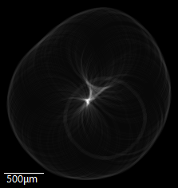
Figure 12: The result of the Hough Transform for circles on the edges of the cross-section of a murine lung airway. Each pixel’s brightness value represents the number of pixels for which a circle around said pixel intersects that position. The bright central point indicates the most likely centre for the cross-section of the airway.
The results are binned (with a bin size of 3 in this project) in order to reduce effects of noise or irregular structure – see Figure 13 for a diagram- and stored in a stack of slices, indexed by radius.

Figure 13: Comparison between un-binned (left) and binned (right) example data in 1 dimensions. Note the highest un-binned value is the single peak on the right, but in the binned data it is the larger central mound.
The centreline is found by finding the most complete circle as detected by the Hough Transform. This is found by dividing the value in Hough space by $2bπr$where $r$ is the radius, and $b$ is the bin size. If multiple circles of equal circularity exist, the circle with the greatest radius is chosen. This is because it is harder for noise and irregularity to create a false positive circle of a larger radius than the correct circle.

5.2.4.2 Orientation Detection
Orientation is detected by repeating the centreline detection steps, but centred around the updated centreline position instead of a best guess. The centreline detection is performed at multiple orientation guesses between -32 degrees and +32 degrees in yaw and roll (restricted for speed) from the current orientation guess. The best positions from each orientation are compared and the best of these is the correct orientation.

5.2.4.3 Branch Detection
Using the Hough Transform from the centreline detection run, circular points are searched for using the same technique as during centreline detection, however all points within the radius of the detected centreline are discarded. This technique finds circular shapes that are not inside the main branch, but are still connected.
The best detected branch with a radius greater than 3 (to protect against noise being counted as branches) and including greater than 25% circumference pixels is fed into the orientation detection technique, and if the updated circle circumference ratio is above 40%, the branch is added to the list of nodes to process.

5.2.4.4 Stopping Point Detection
Stopping points are detected by assessing the circle circumference ratio after centreline detection. If the circle circumference ratio is below 25% or if the detected radius is less than 5, the point is considered the end of the trace.

5.2.5 Sphere Growth-Based Tracing
The data was processed using a sphere-growth tracing method based on Carrillo et al. [87] to find cross-sectional centres and airway axes, and using a radial ray tracing method to discover branching points.

5.2.5.1 Centreline Detection
The algorithm uses a single seed point, which is assumed to be the root of the branching structure and iteratively grows spheres inside the airway until the surface of the sphere intersects with the airway wall (Figure 14).
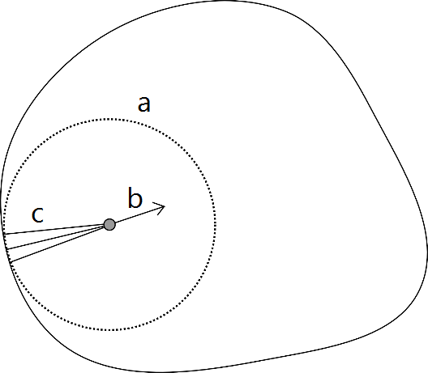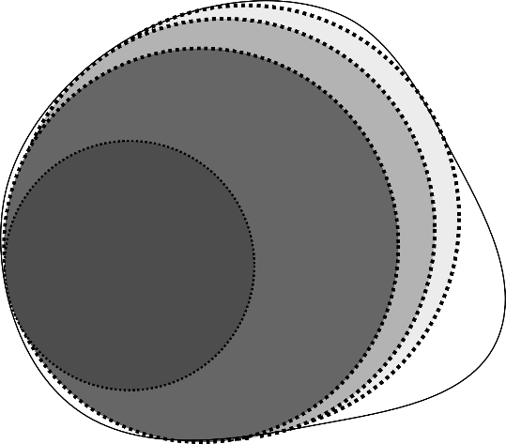
Figure 14: Diagram illustrating the sphere inflation process. Left: An initial sphere (a) is inflated until a sphere-wall intersection occurs. A centre-correction vector (b) is determined by the mean of corrective vectors (c) from the sphere-wall intersections. Right: Diagram showing the results of iteratively applied sphere inflation and centre-correction, with the lightest circle being the final sphere position.
At sphere-wall intersection, all intersection positions relative to the sphere centre are averaged and a vector from this resulting coordinate towards the centre is taken as the direction of motion required to move the sphere closer to the airway centre. This direction is transformed to be perpendicular to the orientation of the jump the tracer had just made.
 | $$s_{n+1}= s_{n}+\hat{m}$$ | (31)
where $s$ is the centre of the current sphere, $s_{0}=C_{n}$ from (29) and m is the direction vector in which to move the centre point and is defined as:

 | $$m=δ-\frac{δ∙{\hat{o}}_{n}}{{\left\|{\hat{o}}_{n}\right\|}^{2}}{\hat{o}}_{n}$$ | (32)
where o is from (29) and $δ$ is defined as:

 | $$δ=\hat{d}- {\hat{α}}_{n} \left(\frac{\hat{d}∙{\hat{α}}_{n}}{{\left\|{\hat{α}}_{n}\right\|}^{2}}\right)$$ | (33)
where ${\hat{α}}_{n}$ is the unit of the vector the tracer moved along in the last jump and d is defined as follows:
$$d=\sum_{i=1}^{n}{x_{i}}$$ | (34)
where $x$ is the set of the cardinal positions relative to $C_{n}$ of all voxels found at the end of rays of length $r$ cast outwards from the sphere’s centre such that the density value of the voxel was greater than or equal to the threshold for tissue.
The sphere is then moved by one voxel along $\hat{m}$ and the process repeats until $|d|$ is below a set threshold. For the purposes of this experiment, the threshold was set to $\frac{n}{2}$.

5.2.5.2 Orientation Detection
The airway orientation is determined by finding the plane that is least skewed. Figure 3 shows that the elongation of cylindrical cross-sections due to skew occurs when a slice is not perpendicular to the cylinder’s orientation and in these cases the 2D representation of the 3D object is elongated and has a higher area. The least-skewed plane is determined by finding the plane such that data sampled across the plane’s axes (centred around the current tracer position and limited in height and width by the radius of the airway) contains the fewest non-void voxels. The normal of this plane is the airway orientation.

5.2.5.3 Branch Detection
Branch points are detected by casting rays in 1$°$ intervals in 3D from the cross-sectional centre of the airway at every voxel in the recorded skeleton. When a ray intersects lung structure, its length is compared to the expected length of a ray cast at a cylinder model in that direction. Any ray which is greater than a constant factor $c$ times longer than expected is stored as a branch point candidate, or, more formally:
$$b=\left\{\begin{aligned}true, &l>c\frac{r}{\sin\left(\arccos\left(o_{b}∙o_{r}\right)\right)} \\ false, &otherwise\end{aligned}\right.$$ | (35)
where $l$ is the length of the ray, $r$ is the radius of the sphere grown at that point, $o_{b}$ is the unit vector between $C_{n-1}$ and $C_{n}$and $o_{r}$ is the orientation of the ray cast. In cases where the ray is cast from a position that was not directly a sphere inflation site for the tracer, $o_{r}$ and $r$ are found by linearly interpolating the values of $o{}_{r}$ and $r$ at the surrounding sphere inflation points.

5.2.5.4 Branch Duplicate Removal
At the end of a single trace run - the generation of a single line from start point to the limit of airway detectability - the airway surrounding that trace is removed from the data set. Thus, the sphere inflation and ray tracing portions of the algorithm will not penetrate these areas and only untraced areas of the lung will be explored (Figure 15). The longest of the rays in the branch point candidates that is not in removed data (due to having been traced already) is considered as the best candidate branch and the tracing process repeats.

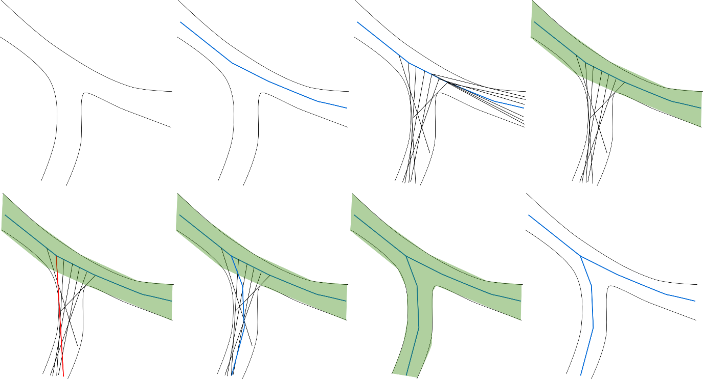
Figure 15: Diagram of the branch detection and duplicate removal steps. From top-left to bottom right: 1) Diagram of an airway branch. 2) Trace (blue) of the upper portion of the airway branch. 3) Successful ray casts (potential branch points) from the centreline (black). 4) Removal of traced area (green) removes erroneous branches oriented towards previously-traced branch. 5) Strongest branch candidate selected (red). 6) Trace (blue) of the lower portion of the airway branch. 7) Removal of newly traced area (green) removes remaining branch candidates. 8) Final trace of branch.
This technique is used because unlike the Hough Transform-based tracer, the branch detection technique for this tracer attempts branch detection in all directions, and without removal of already-traced data, the algorithm will detect previously-traced branches as potential branch points and could potentially never complete execution.

5.2.5.5 Stopping Point Detection
The tracer observer terminates a branch if it moves outside of the structure, or if it detects the airway it is currently in has a radius less than a set threshold (4 voxels for the manual trace comparison in this thesis, 10 for the full lung comparison in this thesis due to the presence of terminal airways that have merged due to low resolution). This prevents the tracer from entering the parenchyma and other small connected structures at the cost of smaller generations of branching.

5.2.6 Domain-Specific Knowledge
Both tracer systems could incorporate domain-specific knowledge to increase their accuracy in analysing specific 3D structures, however this would be done at the cost of generalising the algorithms for use in many different branching structures. As such, the algorithms presented here make use of no domain-specific knowledge, such as expected branch angles, branch lengths, average branch radii, etc., but it would be possible to add these as statistical weightings to both tracers.

5.2.7 Comparison
In order to compare effectiveness of the four algorithms assessed, one lung image was manually traced as far as the fourth generation. The traced data was then extracted from the original image manually and passed through a region-growth segmentation tool to remove any disconnected noise (Figure 16).

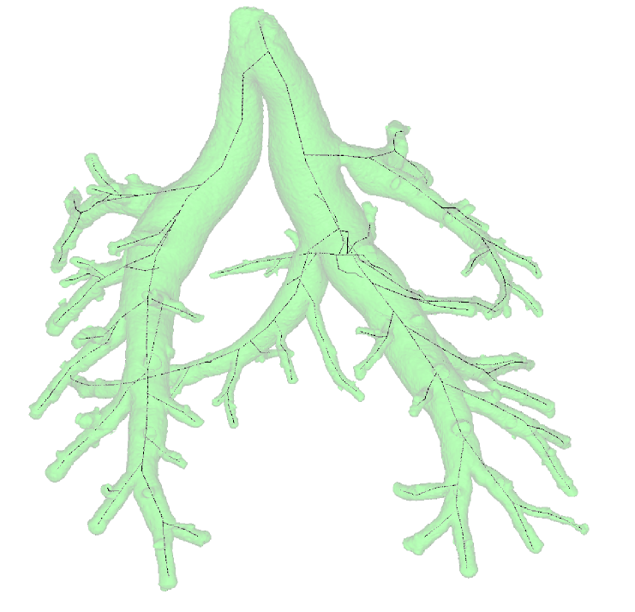
Figure 16: Manual trace of a filled lung superimposed on the extracted trace data.
The algorithms under investigation were executed on the extracted traced data and the results were compared with the manual trace automatically to determine three criteria: false positives (voxels labelled by the algorithms that do not exist in the manual trace), false negatives (voxels not labelled by the algorithms that exist in the manual trace) and branch divergence (average distance of each voxel in the recorded tree from the closest voxel on the manually traced tree). All four algorithms were executed on the same machine (Intel Core i7 4770-K, 3.50GHz CPU, 16GB DDR3 RAM, running Windows 10) and algorithm execution time was recorded.
Voxels in the model were matched to the results of the algorithms by, for each voxel in the model, finding the closest voxel in the result set such that no other voxel is closer to that point. This search is restricted to within the radius value recorded in the result set for speed.

$$f_{n}=\left\{\begin{aligned}m_{n}, &\left|m_{n}-r_{n}\right|=min_{x=1}^{X}\left|m_{n}-r_{x}\right| \\ ∅, &otherwise\end{aligned}\right.$$ | (36)
To find the false positives, we count the number of voxels on the algorithm result tree that have not been successfully registered to the model tree. In order to compare false negatives, we count the number of voxels on the model that remain unregistered to the algorithm’s output. In order to assess divergence of the resulting trace from the model, the Euclidean distance between the model voxel and the registered results voxel is recorded. Then the mean of the distances for each voxel is used to represent the amount the traced centrelines have diverged from the model. More formally:

$$δ=\sum_{n=1}^{N}{\left|m_{n}-f_{n}\right|}$$ | (37)
where $δ$ is the divergence of a results set $r$ from the model $m$.
Performance was measured using C#’s StopWatch class, beginning after the data had been loaded into memory and ending after the algorithm had completed execution. The algorithms were run with compiler optimisations enabled, and – where parallel execution occurred – the system was instructed to use 6 simultaneous threads.

5.3 Results

5.3.1 Comparison of skeletonisation techniques
See Table 2 for a comparison of the false negative count, false positive count and average branch divergence for each of the algorithms and Table 3 for a comparison of algorithm execution time.

Algorithm | False Negatives | False Positives | Average Distance (voxels)
Medial Axis Transform | 0 | 404,395 | 3.2
Scale Axis Transform | 0 | 467,046 | 3.5
Hough Transform Tracer | 3,106 | 30,484 | 10.5
Sphere Growth Tracer | 2,163 | 1,515 | 79
Table 2: Comparison of results from each of the executed algorithms.

Algorithm | Execution Time (minutes) | Parallelisation
Medial Axis Transform | 8 | Yes
Scale Axis Transform | 24 | Yes
Hough Transform Tracer | 1,902 | Partial
Sphere Growth Tracer | 49 | None
Table 3: Comparison of execution time and parallelism of the executed algorithms.

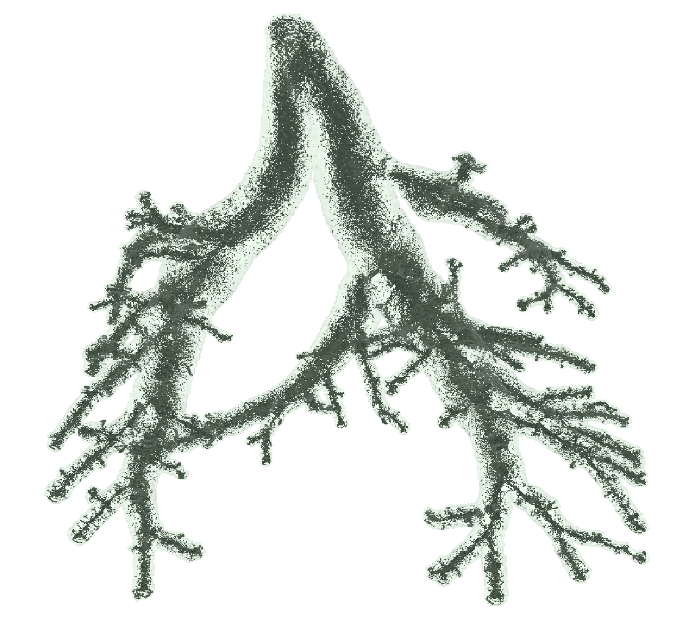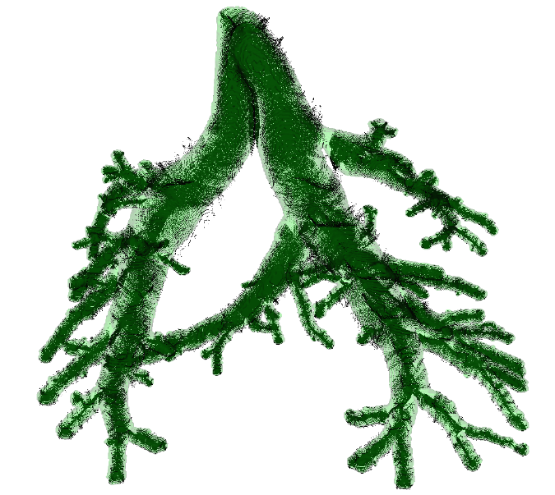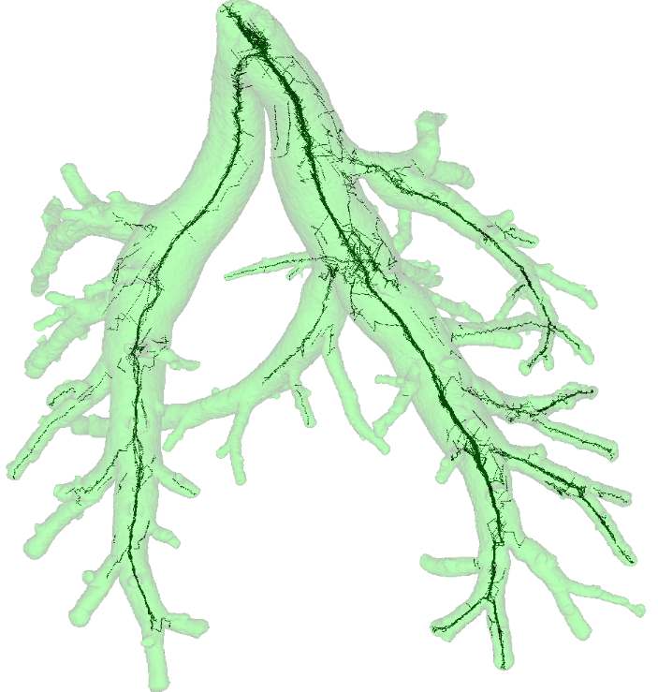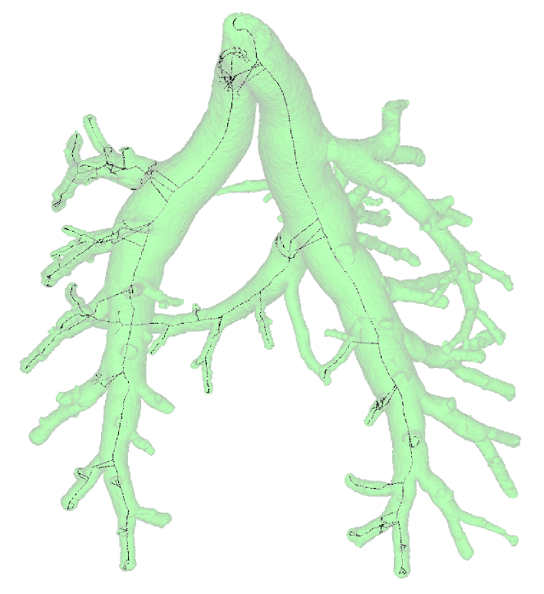
Figure 17: Comparison images of four skeletonisation algorithms superimposed on the original lung volume. Top-Left: Medial Axis Transform. Top-Right: Scale Axis Transform (scale factor 1.25). Bottom-Left: Hough Transform Tracer. Bottom-Right: Sphere Inflation Tracer.

5.3.1.1 Medial Axis Transform
The Medial Axis Transform covered the entirety of the lung structure provided, missing zero voxels. However, due to the nature of the Medial Axis Transform, i.e. that it is applied indiscriminately to every voxel in the source data, all disconnected objects are also skeletonised. This can be rectified by performing region-growth based segmentation on the data prior to execution, and was not an issue in the model data because it was extracted from a manual segmentation.
The medial axis had a high number of false positive voxels in the trace. This is due to the medial axis producing surfaces and extra branches in order to compensate for the irregularities in airway surface and for branch points (Figure 17).

Recorded branches deviated from the model by an average of 3.2 voxels, the lowest of all algorithms. This is due to the nature of the Medial Axis Transform, which uses the distance transform to find the direct centre of any structure it is in. Additionally, a low value could be as a result of the sheer quantity of voxels produced in the medial axis.
Execution time was the fastest of the algorithms but significant post-processing is required to produce a skeleton that can be used to seed measurement algorithms due to the high quantity of false positive voxels. The Medial Axis Transform ran completely in parallel, and is therefore a good candidate for cluster computing, provided sufficient memory is available to contain the data.

5.3.1.2 Scale Axis Transform
As with the medial axis, the scale axis covered the entirety of the lung structure provided, missing zero voxels, and would need the same region-growth pre-processing in order to remove disconnected noise.
Surprisingly, this transform produced more false positive voxels than the Medial Axis Transform. This could be due to the merging of nearby branches during the sphere-growth portion of the algorithm, which would yield larger, more complex structures, and in turn larger voxel surfaces and more branches to compensate. This could also contribute to the slightly higher average distance value. Additionally, it is possible to see in Figure 17 that the transform has produced skeletal points that are outside the model volume. This is due to remaining roughness on the expanded surface after sphere growth that has produced voxels in the second execution of the Medial Axis Transform.
Execution time was slower than the medial axis by a factor of 3. This is due to the necessity of two full passes of the Medial Axis Transform, and one pass of a sphere growth algorithm. Significant post-processing remains, however, to compensate for the high quantity of false positive voxels. The Scale Axis Transform was similarly highly parallelised. While the algorithm must operate as a sequence (medial axis, sphere growth and then medial axis again) iteratively, there was no major processing performed between the individual steps, each of which were fully parallelised, and as such it is also a strong contender for cluster computing.

5.3.1.3 Hough Transform-based Tracing
The Hough Transform-based tracer successfully registered 64% of the voxels on the model. Figure 17 shows that this is due to the branch detection algorithm missing a large quantity of branches. One major flaw in the branch detection algorithm is its reduced ability to detect branches that are perpendicular to the current branch. Such branches do not resemble circles in cross-section (see Figure 3 for an example). However, this technique has the advantage of only processing connected data to the seed point, as the tracer ends evaluation of a branch if it determines it has exited the structure.

This algorithm had a much lower false positive count than the previous algorithms, less than 10% of both the scale and Medial Axis Transforms, however it produced in turn 20x the false positives of the sphere growth tracer. This is due to a number of duplicate branches detected, which have been detected because of a small enough tracer step factor, such that the tracer is still sufficiently in the branch area on subsequent steps, producing duplicate detected branches. This could be rectified by choosing a larger step size, but there is a risk that the tracer will step outside of the structure and terminate prematurely, or that it will miss whole branches entirely, since it only detects branches at each step point. This would particularly be a problem for small branches off of a branch with a large radius, where the tracer could step entirely past the whole branch region and not detect the branch at all.
The average distance from registered voxels was approximately 3x that of the previous algorithms. This is partly due to the weakened constraint on finding the centre position, but could also be due to the reduction in total traced voxels. Where the scale axis and Medial Axis Transforms produced a high quantity of false positives, the registration technique had a larger number of voxels to choose from to find the closest traced voxel. In this case, with 10% of the voxel count in its trace compared to the Medial Axis Transform, there were fewer voxels to register against.
Execution time was the slowest, at 31 hours and 42 minutes. This can partly be explained by the tracer unnecessarily tracing duplicate branches, but is also due to the orientation technique of performing the Hough Transform at a large number of potential orientations in order to find the best orientation to continue the tracer. While some portions of the algorithm were parallelised, namely the orientation detection, the rest of the execution was performed sequentially. This is partly due to memory constraints, thread-construction and destruction overhead, both of which can be mitigated by a different choice in programming language or hardware, but predominantly due to the nature of a tracing algorithm as being iterative. Since the execution of the tracer depends on the state of its preceding steps, parallelisation is more complex.

5.3.1.4 Sphere Growth-based Tracing
The sphere growth-based tracer successfully registered 73% of the voxels on the model. Figure 17 shows, however that the branch detection algorithm has missed many branches. This is possible if genuine branches are discarded as being within the volume of a previous trace and explains why the missed branches are predominantly those that have significantly smaller lumen radii compared to their parent branch and once the tracer is in smaller branches, branch detection improves. Additionally, given the higher speed of this technique, it is not too costly to re-execute the tracer on missed branches, where the data can simply be added to the existing trace. Like the Hough Transform based tracer, this algorithm will also only process data that is connected to the seed point.

This technique produced the lowest number of false positive voxels, at 5% of the number produced by the Hough Transform based tracer, and less than 0.5% the number produced by the Medial Axis Transform, and the results are clearly visible in the image (Figure 17). However, some false positives remain, most likely caused by segments of data left behind by the duplicate detection and removal technique, which are each considered to be small branches. The improvement over the Hough Transform technique is likely the addition of the duplicate branch removal technique as well as the use of a 3D technique with a minimum branch length constraint to identify branches, reducing the risk of irregularities in structure being considered erroneously as branches.
The average distance from registered voxels was the highest of all the algorithms, however Figure 17 shows that the resulting skeleton was generally centrally-located. This increase over the Hough Transform-based tracing technique could be the result of a combination of how the sphere inflation decides when to stop inflating and how the plane-fitting technique operates. In order to deal with irregular structure noise, the sphere growth technique halts when both the percentage of voxels on the sphere’s surface that are outside of the structure is above a set threshold (10% for this set) and mean of the repositioning vectors from the sphere is less than a set threshold (25%). This is taken to indicate a sphere that has begun to exit the airway and for which there are intersections with the airway wall in opposing directions, and is therefore the maximum that sphere can grow to. Planes are then fitted to the intersections in order to find the best plane such that the distance between intersections is minimal, the normal of which is the orientation. However, unless in perfect circumstances (surface voxels intersecting the airway wall form a perfect circle along the circumference with no extra sphere-wall intersections), there will always be more intersections in one side of the sphere than the other. This is particularly distorting of the correct orientation in narrow airways, where the sphere surface area is smaller and there are fewer intersections. One potential solution would be to modify the plane fitting to instead find the plane such that the fewest intersect with it, which represents the least-skewed cross-section of data. As shown in Figure 3, this will be the point at which the plane is perpendicular to the airway orientation.
Execution time was 49 minutes, which was twice the time for the Scale Axis Transform, but significantly faster than the Hough Transform tracer. At no point in the execution of the tracer was this technique parallelised. It is feasible to implement a parallel solution by, for a given branch, waiting until that branch has passed a certain distance from a branch point and then beginning another tracing visitor at that branch point. By preventing branch points from being picked if they are too close to an active tracer’s starting point, multiple branches could be traced in parallel. Alternatively, individual steps of the algorithm could be executed in parallel, such as the branch detection and orientation detection steps.

5.3.2 Entire lung images
The algorithms were also executed on the lungs prior to simplification, in order to assess their performance in real data. Parameters used for each algorithm were the same as those used for the quantitative comparison, with the exception of the minimum radius parameter for the tracing algorithms, which was increased to 10 to account for the presence of terminal airways that had merged together due to insufficient resolution.

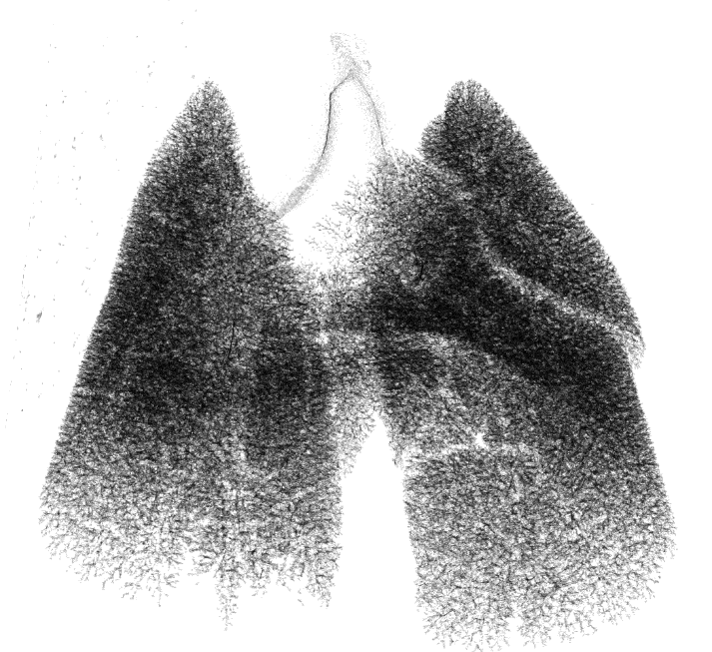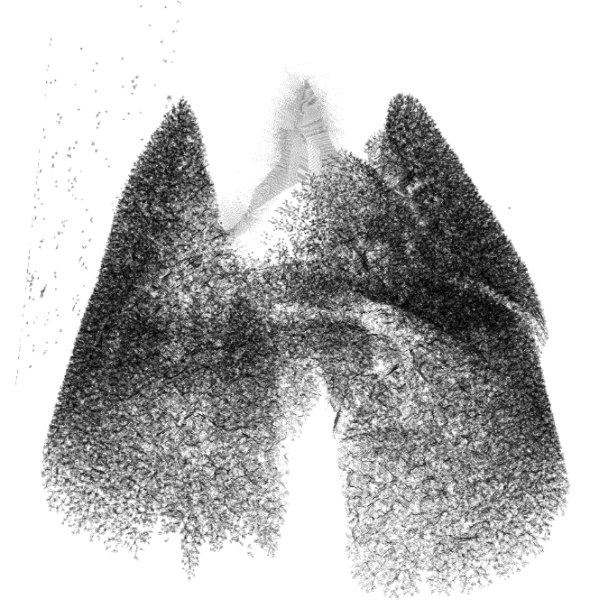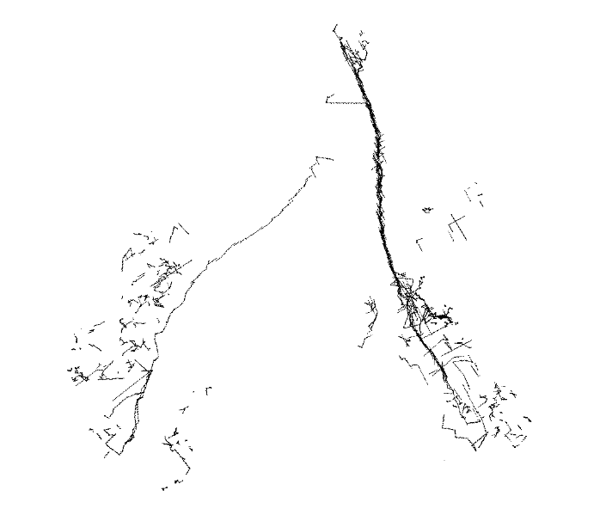
Figure 18: Comparison images of four skeletonisation algorithms produced from a whole, non-simplified lung image. Top-Left: Medial Axis Transform. Top-Right: Scale Axis Transform (scale factor 1.25). Bottom-Left: Hough Transform Tracer. Bottom-Right: Sphere Inflation Tracer.

5.3.2.1 Medial Axis Transform
The Medial Axis Transform produced a large number of voxels in the resulting skeleton. While the algorithm has not missed any branches, false positives can be clearly seen and the algorithm has produced a very complex skeleton with many false positives throughout the data, which are easiest to notice in at the trachea (Figure 18). Additionally, disconnected data, notably the noise in the top-right of the image is also skeletonised.

5.3.2.2 Scale Axis Transform
The Scale Axis Transform performed similarly to the Medial Axis Transform, with the exception of at the larger branches. Particularly noticeable in the trachea (Figure 18), the scale axis has increased the size of the planes of voxels recorded in the skeleton. This is due to the sphere inflation step merging the two main bronchi for a short distance after the bifurcation in the lung. Like with the Medial Axis Transform, disconnected data and noise are included in the skeleton, however due to the sphere-growth pass, the noise is now larger.

5.3.2.3 Hough Transform-based Tracing
The Hough Transform tracer has captured the main bronchi and followed them well to the end of the data (Figure 18), however it has missed the majority of branching in the data set and found a number of false positives, particularly near branching points and at the trachea. This is caused by the tracer stepping in sufficiently small steps such that the tracer is still inside the branch point region and can still see the branch in subsequent steps.

5.3.2.4 Sphere Growth Tracing
The sphere growth tracer produced a clean skeleton that has captured the main bronchi, but has missed the majority of branching (Figure 18). Branch positioning is predominantly central, but there are some places, such as after the initial bifurcation, where the tracer has made sudden direction changes.

5.3.3 Unfilled lungs
The sphere growth tracing algorithm was modified to accept unfilled lungs and was executed on one full lung from the lung image set described in Chapter 6 (Figure 19). The medial-axis based algorithms were not executed as they do not produce skeletons in empty areas, and would instead skeletonise the airway walls. The Hough Transform-based technique was not executed because the region-growth step would be impossible in unfilled lungs, resulting in many erroneous branches.
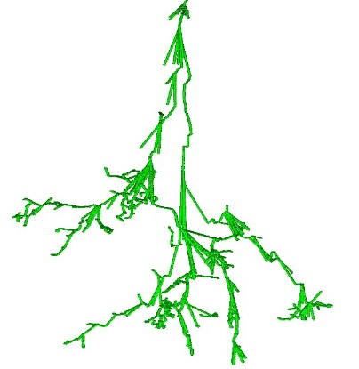
Figure 19: Result of attempted trace of unfilled data using the sphere-growth based tracer. The branch detection algorithm has falsely accepted the airway as branching, and the duplicate detection and removal technique has not been able to mitigate this. This results in a large quantity of false positive branches, particularly around the branch location. Additionally, the tracing of the false positives increases execution time wastefully.
The lack of filler material has allowed the airway to present a much less regular surface, which the branch detection algorithm has falsely accepted as branching, and which the duplicate detection and removal technique of removing already-traced areas has not been able to mitigate. This results in a large quantity of false positive branches, particularly around the branch location. Additionally, the tracing of the false positives increases execution time wastefully. Further work must be done to match the unique constraints presented by the following factors:
- The thinness of the airway wall, which can defeat boundary checks. Whereas in the filled lungs, if the lung wall is accidentally passed the next step will still be outside of the structure; in this case the wall could be passed entirely with no change in density.
- The challenge of distinguishing between void inside the lung and void that is external to the lung. This increases the risk that a tracer that jumps outside the lung structure is not caught and will continue to trace the void outside of the lung.
- The potential for holes in the airway wall, either caused by noise, poor binarization or poor contrast, allowing branch detectors to classify the void outside the lung as a potential branch to be traced.

5.4 Discussion
The algorithms presented each have their advantages and disadvantages, and are better-suited to some situations than others.

 | Medial Axis Transform | Scale Axis Transform | Hough Transform Tracing | Sphere Growth Tracing
Advantages | Includes disconnected data.  No false negatives.  Accurate centreline.  Very fast.  Parallelisable.  No prior knowledge.  No parameters. | Includes disconnected data.  No false negatives.  Accurate centreline.  Fast.  Parallelisable.  No prior knowledge.  Few parameters. | No disconnected noise.  Few false positives.  Somewhat parallel.  Groups skeleton into branches.  Can use domain-specific knowledge. | No disconnected noise.  Few false positives.  Fast  Groups skeleton into branches.  Can use domain-specific knowledge.
Disadvantages | Many false positives.  Disconnected noise. | Many false positives.  Merges close features.  Cannot reconstruct original data.  Skeleton can exit structure.  Amplifies noise. | Many false negatives.  Very slow.  Some centreline divergence.  Duplicate branch points.  Cannot reconstruct original data.  Requires circular cross-section.  Suffers from skew.  Cannot detect side-branching. | Many false negatives.  Centreline divergence.  Cannot reconstruct original data.  Prefers circular cross-section.  Many parameters.
Recommended Situations | Simple, smooth structures.  Small or cleanable datasets.  For original structure reconstruction.  Where large features neighbour small features.  For including disconnected data.  When the skeleton will not drive other algorithms.  When execution time is limited. | Simple, smooth structures.  Small or cleanable datasets.  Where features are distant.  For including disconnected data.  When the skeleton will not drive other algorithms.  When execution time is limited. | Small datasets.  Branching structures.  Where bifurcation is the primary branching technique.  Where cross-section is predominantly circular.  When the exclusion of disconnected data is important.  When simplified skeletons are important.  When the skeleton drives algorithms.  When execution time is abundant. | Large datasets.  Branching structures.  Where cross-section is predominantly circular.  When the exclusion of disconnected data is important.  When simplified skeletons are important.  When the skeleton drives algorithms.  When execution time is limited.
Table 4: Comparison of skeletonisation algorithms with advantages, disadvantages and recommended usage scenarios.

5.4.1 Medial Axis Transform
The Medial Axis Transform operates uniformly on all data in the structure. As such, if the branching structure under investigation is includes disconnected structures, these will be included in the resulting trace. This is advantageous in scenarios where image contrasting is imperfect or when differently-contrasted materials cause blockages in the structure. However, it is also disadvantageous in that disconnected noise is also included in the resulting skeleton. This can be avoided by performing seeded region growth to exclude unwanted disconnected data, but involves an additional pre-processing step. Additionally, this means that there are no false negatives in the data, however it leads to a very large number of false positives. The algorithm has no parameters, and will operate the same on all data sets, and requires no prior knowledge of the structure under investigation, meaning it can be applied generally to any structure.

The Medial Axis is not an ideal skeleton for simplifying tree structures because it produces faces and additional branches in order to preserve the reproducibility of the original data. In smaller datasets, this may be manually cleanable, but in larger and more complex data this operation will be time-consuming. In situations where reproduction of the original data is desirable, the Medial Axis Transform is the best option.
The Medial Axis Transform is the fastest algorithm assessed, is fully parallelisable and will run well on large data, provided that data is simple and easily cleaned, as previously noted. The position of correct centrelines is always central to the airway it describes.

5.4.2 Scale Axis Transform
The Scale Axis Transform has many of the advantages and disadvantages of the Medial Axis Transform, on which it is based. However, the Scale Axis Transform is not able to reproduce the original data with the same accuracy as the Medial Axis Transform, due to the ball-growth stage. It produces fewer false positives than the Medial Axis Transform and the same (no) false negatives, and is as parallelisable and, while 3x slower, is still relatively fast even on large data.
The sphere growth, while reducing false positives, produces skeletal voxels that are outside of the original dataset. This is because any irregular surface on the original data that is not smoothed by the ball growth process still produces an erroneous branch or face in the final Medial Axis Transform execution. This branch generally extends to the edge of the data, which has now inflated outside of the original structure. The ball growth also adds a parameter to the execution process, which must be selected on a case-by-case basis. This increases total execution time to produce a skeleton, as multiple executions must be performed and compared in order to find the optimal growth factor. Furthermore, the ball growth risks merging distinct features that are simply close to each other, but are not actually joined in the data. This is particularly noticeable if large-radius airways are close to small-radius airways, where the larger radius grows a relatively larger ball than the small-radius.

5.4.3 Hough Transform-based Tracing
The Hough Transform Tracer produces a low number of false positives compared to the two thinning-based transforms. This lends the algorithm to situations where post-skeletonisation clean-up is undesirable or in complex images where clean-up is difficult. Additionally, the tracer produces a tree data structure, allowing the composition of multiple skeletonisation executions, and therefore the inclusion of missed branches, however the algorithm does record duplicate branch points, which will need to be removed.
As it is a tracer, it discards disconnected data, therefore in data where there are disconnected structures that need to be investigated, a separate trace execution must be performed for each disconnected structure. On the other hand, this means that disconnected noise is entirely removed from the resulting skeleton. Furthermore, the tracer can incorporate high-level domain-specific knowledge at the branch and centreline detection stages, such as expected branch angles, branch widths and centreline curvature expectations.
Lastly, the Hough Transform included in this algorithm operates best on circular cross-sections. Structures with cross-sections that are not close to circular will lower the confidence of the Hough Transform for finding centre-lines. This can be remedied by choosing alternative Hough Transforms, however algorithm complexity or centreline accuracy will be reduced in structures where the shape of the cross-section changes dramatically. As the Hough Transform is performed in two dimensions, cross-sectional skew can reduce the effectiveness of the centreline and branch detection techniques, although the algorithm mitigates this somewhat by slicing the data perpendicular to the current airway orientation.

5.4.4 Sphere Growth Tracing
Sphere Growth Tracing shares many advantages and disadvantages with the Hough Transform Tracer. In comparison, it produces fewer false positives, and is significantly faster, making the additional execution runs caused by missed branches more desirable than with the slower Hough Transform Tracer.
Like the Hough Transform Tracer, Sphere Growth prefers circular cross-sections, however the algorithm executes in three dimensions and is not affected by skew, and as such the branch-detection algorithm is more capable of detecting domain (side) branching than the Hough Transform. It produces the simplest skeleton to clean, but the centreline estimate diverges furthest from manual traces, however it never leaves the original data, unlike with the Scale Axis Transform.
The Sphere Growth Tracer is the most difficult algorithm to parallelise as both the Sphere Growth stage and the tracer itself are sequential operations, however it is still possible to parallelise the tracer, and elements such as branch detection can be trivially parallelised.
None of the algorithms presented are a general-purpose branching structure skeletonisation technique suitable for all situations, however the sphere growth technique has shown tangible benefits over thinning-based techniques, in situations where a clean, simple skeleton is desired, and has shown to be sufficiently more performant than the Hough-transform based tracer, despite no parallel execution.

5.5 Conclusion
Skeletonisation is a powerful morphological tool for branching structures, but thinning-based skeletons have problems in this domain. Thinning tends to produce faces instead of strings in 3D data. Additionally, thinning will produce a face or string for any noise or irregularity along the surface of the structure, as the medial axis will not be able to reconstruct the original image without this. This noise can be accounted for during processing, and surface-smoothing operations can reduce the number of false positive strings and faces, however at branch points there are, necessarily, large faces of skeleton voxels produced that cannot be removed without significant manual clean-up.
Tracing allows us to circumvent these problems, at the cost of disconnected structure, which is excluded from traces and would have to be traced separately for each disconnected structure. Whether this is an advantage or disadvantage depends on the system under investigation. Additionally tracing-based algorithms are slower than the medial and Scale Axis Transforms, and are generally less parallelisable.
While tracing increases the quantity of false negatives, this can be combatted by re-execution of the tracer on the remaining untraced data, with seed-points chosen in the missed branches, at the cost of increased intervention. While this is costly in terms of time with regards to the Hough Transform based tracer, the sphere-growth tracer performs quickly enough to make this process worthwhile, compared to the cost of cleaning the results of a medial axis or Scale Axis Transform.
This work successfully demonstrates an algorithm, the sphere-growth based tracer, for spatially resolved lung morphology assessment of filled murine lungs that performs favourably compared to existing methods. Further work must be done to apply this approach to unfilled lungs, and include heuristics designed to combat false positive branch detection caused by irregularly-shaped airway cross sections.
Additionally, while more complex to parallelise than the medial axis based transforms, it is possible to modify the tracing-based algorithms to work in parallel. Once the initial trace instance has moved past a branch point, and the associated data has been removed as part of the duplicate reduction technique, a child branch trace may be started in parallel to the initial trace and, once that trace itself has traced some initial distance from the branch point such that the branch area has been removed from the data to reduce duplicates, another branch from the list may be executed. Due to the exponential way that branch counts increase as generations increase, this results in a highly-parallelised execution.
Ray casting portions of the algorithm such as the sphere generation during centreline determination, as well as branch detection are highly parallelisable. Because these rays act independently of each other and only upon a smaller subset of the data, these portions of the algorithm are suitable candidates for General-Purpose computing on Graphics Processing Units (GPGPU).
Finally, since this algorithm incorporates no pulmonary-specific prior knowledge into its execution it may be applied generically to any branching structure, including biological systems such as kidneys, blood vessels or plant roots. Assessment of the algorithm’s performance on such structures would be worthwhile in establishing the algorithm as a useful tool in biological research. Conversely, it is possible to incorporate prior knowledge into the tracer, such as expectations of branching lengths and angles, which would further improve the ability of the algorithm to determine correctly branching points and airway centrelines, and to narrow the search-space for various operations, improving execution speed.

Chapter 6: Comparison of Airway Wall Thickness

6.1 Sample Preparation and Image Acquisition
For this study, the images were obtained by imaging mice generated for a different study investigating the overexpression of human sADAM33 [8].
Founder mice were generated by injecting TRES-human-ADAM33-SS-PRO-MP-3Flag in a linearized construct into FVB/N mouse pro-nuclei. This produced founder mice that contained 2-ADAM33-PRO-MP (TRES-ADAM33-PRO-MP), a tetracycline response element that expresses human ADAM33 when exposed to a tetracycline. CCSP-rtTA mice were then crossed with the founder mice to generate a double-transgenic (dTg) mouse model that, when fed doxycycline, expressed human soluble ADAM33 in lung epithelial cells. Additionally, the single-transgenic (sTg) littermates, lacking either the tetracycline response element or the CCSP group, did not produce human soluble ADAM33 when exposed to doxycycline, making them an ideal control [8]. Figure 20 illustrates the process.
7 double and 7 single transgenic mice were euthanized and immersion fixed in 4% Para-formaldehyde in phosphate buffered saline. 48 hours prior to tomography, the lungs were contrasted using a technique adapted from [146]. They were immersed in 25% Lugol’s iodine solution (100% Lugol’s made up of 10g potassium iodide, 5g iodine in 100ml water) [147] and were imaged in a custom 225kV Nikon Metrology HMX ST scanner at 60KeV and 135mA. 3142 projections were collected through 360 degrees. While an odd number of projections typically incorporates captures additional data compared to an even projection count, here the angular step of each projection was within the precision of the rotation stage, and a slight change to the angular step by collecting an odd number of projections would not make a difference. Voxel size was approximately 8 µm.
Acquired image data were reconstructed into volumetric images via Filtered Back Projection using CT Pro 3D (Nikon Metrology NV, Leuven, Belgium). Images were converted to 8-bit brightness range and cropped to the bounding box of the lungs to reduce file size, before being filtered with a median filter to reduce small noise and binarized using a uniform threshold set to the highest intensity peak in the intensity histogram. The binarized information was then eroded and dilated to remove any remaining small structures or noise which connected structures erroneously.
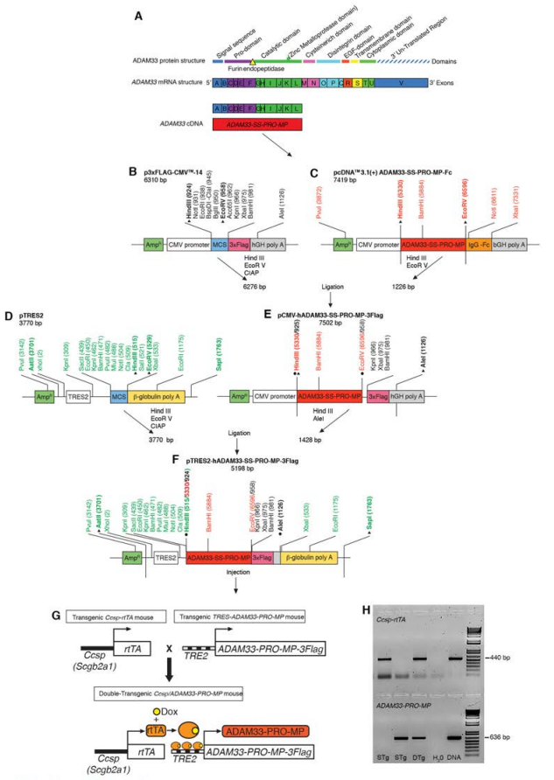
Figure 20: (A) Diagram of the full-length ADAM33 protein domain structure, the corresponding mRNA exonic structure and the cDNA used for cloning sADAM33 which contains the signal sequence (SS), pro-domain (PRO) and metalloprotease (MP) domain. (B-F) Plasmid constructs and steps for generation of the linearized TRES-hADAM33-SS-PRO-MP-3Flag DNA construct for microinjection into pro-nuclei from FVB/N mice. (G) Ccsp-rtTA mice line 2 were crossed with founder mice containing the tetracycline response element 2- ADAM33-PRO-MP (TRES-ADAM33-PRO-MP) to generate Doxycycline (Dox)- inducible double transgenic mice expressing human soluble ADAM33 (Ccsp/ADAM33). (H) Agarose gel electrophoresis of PCR products from CcsprtTA (440 base pairs (bp)) or ADAM33-PRO-MP (636 bp) transgenes. Results from DNA of single (STg; Ccsp-rtTA or ADAM33-PRO-MP) or double transgenic (DTg; Ccsp/ADAM33) mice, and negative (H2O) and positive control DNAs are shown. Reproduced from [8]

6.2 Method
Images were processed using MATLAB [148] and Fiji [72] software by a double-blinded researcher. MATLAB was chosen due to its comprehensive library of mathematical functions to speed development, as well as its common use in research. Due to the relatively light-weight processing compared to the algorithms outlined in the previous section, memory and performance concerns were not primary factors.
One section of data was taken at the 1st generation (trachea), and two sections each at the 2nd, 3rd and 4th generations (one per bisection of the lung), which were identified manually. 3D coordinates along the centre of the airway from the initial branching point for at least 25 voxels in the direction of the airway from the branching point were recorded manually. In the case of the trachea, the 3D points were recorded from the succeeding branch backwards along the trachea. For each section, the data was reoriented so that X and Y axes ran perpendicular to the airway orientation as denoted by the manually recorded coordinates and the Z axis was identical to the orientation as determined by finding the direction between the first and last of the recorded points. For each segment, five 2D image slices were produced at five-voxel increments. The slices chosen were the first contiguous slices where there was no visible side-branching in the airway (if any was present) in any of the five slices (see Figure 21 & Figure 22).

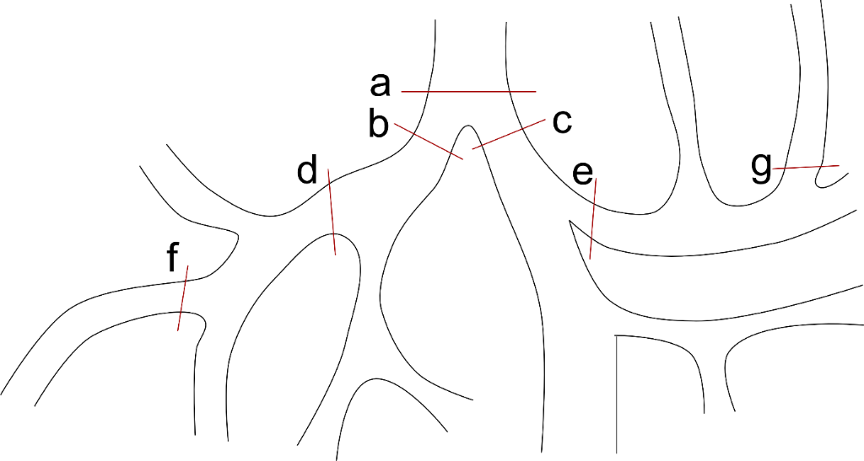
Figure 21: Diagram showing sites observed on the pulmonary tree: (a) the trachea, (b & c) the second generation (main bronchi), (d & e) the third generation, (f & g) the fourth generation.
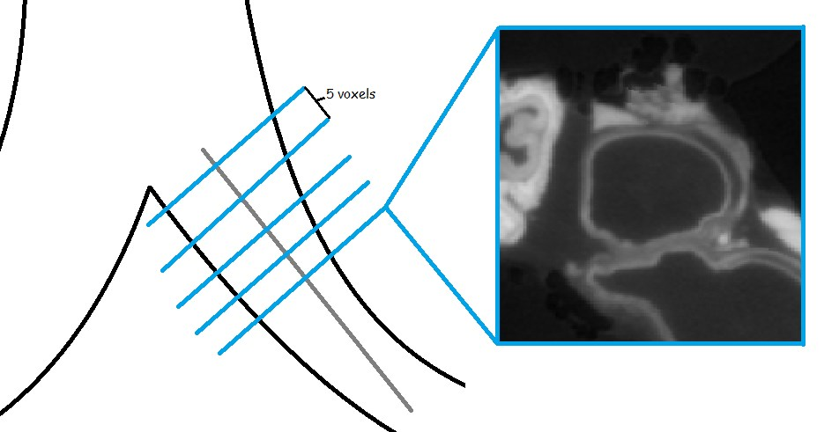
Figure 22: Diagram showing cross-section extraction technique. Slices (blue) are extracted as planes whose normal (grey) is the orientation of the airway.
For each slice, the external edge of the lung wall was manually labelled using 16 points marked on the lung wall-parenchyma edge. The points were distributed by repeated bisection of the airway cross section to produce an even coverage of the lung wall-parenchyma perimeter. Each group of points was mapped to the original data set to produce 3D coordinates in the original reconstructed data.
For each group of 16 points, the centroid was found by calculating the mean of the 3D positions. Rays were cast from this centroid to each manually designated point, extracting 16 1D arrays containing density values from the original data set at each pixel position along the ray. Each array was convolved with a 1D Gaussian edge detection filter with kernel size of 2. Local maxima were found using the findpeaks command in the MATLAB package [148] (see Figure 23 & Figure 24). Euclidean distance between the local maximum closest to the centroid and both the manually-labelled edge and the centroid were measured as lung wall thickness and airway lumen radius respectively.

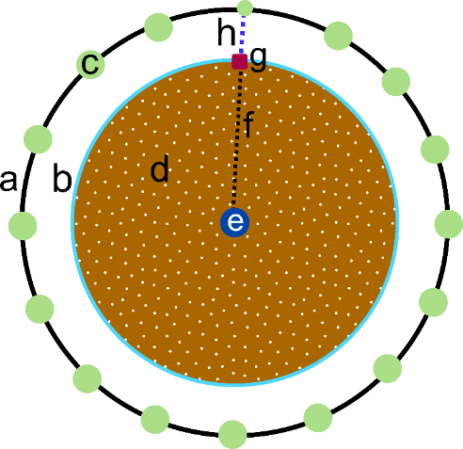
Figure 23: Diagram showing measurement definitions as follows: a) the lung wall/parenchyma boundary, b) the lung wall/lumen boundary, also where the perimeter measurement is taken, c) one of the 16 manually segmented positions on the lung wall/parenchyma boundary, d) the airway lumen, this shape defines the area measurement, e) the computed centroid of the 16 points, f) ray cast from the centroid to one of the 16 manually segmented lung wall/parenchyma boundary positions, g) automatically detected airway lumen / lung wall boundary position along the ray, h) portion of the ray representing lung wall thickness.
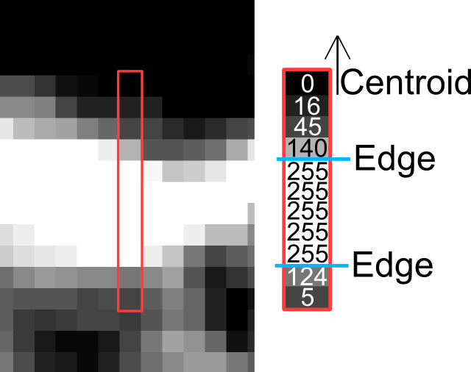
Figure 24: Diagram showing ray cast (left), with densities extracted to 1D array (right) and chosen local maximum closest to centroid (arrow).
For each group of 16 points, a 2D slice aligned with the points and centroid was annotated with the coordinates of detected edge points and ray trajectories (Figure 25). These images were visually inspected for erroneous measurements caused by rays entering the wall at oblique angles or cases when the edge detection filter had incorrectly identified the internal wall edge. Where possible, the erroneous measurements were re-measured using altered external edge positions, and measurements that continued to be erroneous were excluded.

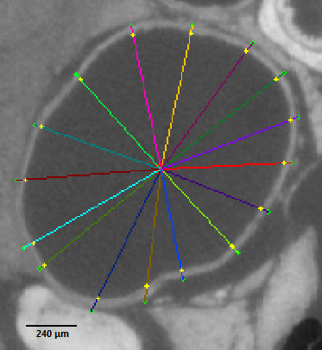
Figure 25: Annotated airway slice, coloured for ease of identification of measurements. Each line represents a cast ray from the centroid to the manually-labelled lung wall edge (green). The inner point along the ray (yellow) denotes the automatically-detected lumen-wall border.
Lumen area and circumference were found using the ‘Wand Selection’ and ‘Measurements’ tools from the Fiji package [6]. Lumen area and circumference measurements were performed on the reoriented sections produced for the airway lumen and wall width measurements. The wand tool was configured to use 8way connectivity, and tolerance was determined per lung section as the highest tolerance that did not select lung wall and surrounding structures (Figure 26).

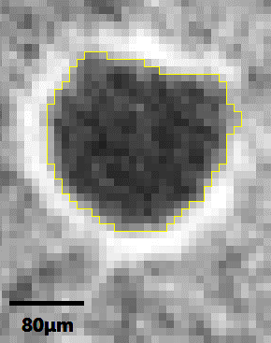
Figure 26: Airway slice with annotated lumen perimeter (yellow) as determined by Fijis Wand Selection Tool.
The means of the results were entered into GraphPad Prism [149] where they were grouped by measurement type, then by lung area. An additional whole lung amalgam was produced for each measurement type.

6.3 Results
For each measurement location, as well as for the whole lung, the mean for each measurement type was computed and compared with the means for that measurement for each lung sample. Unpaired t-tests were performed for single transgenic and double transgenic grouped lung results by an unblinded observer using GraphPad Prism [2]. Non-parametric Mann-Whitney tests (without Welch’s correction, due to the similar standard deviations in all pairs of results) were also performed using GraphPad Prism, under the suspicion that low sample size would greatly affect the outcome of the tests, but both tests produced similar results.
While comparisons have been made in this study across the generations, the effect of sADAM33 on the measured parameters was expected to be different for each generation. This is due to the differences in lung wall density at each branching generation of the lung (Figure 10), in particular the decrease in smooth muscle density as the airway branching generation increases. As such, each test was designed to evaluate an independent hypothesis. i.e. can we see morphological change in the trachea? Can we see morphological change after the first generation of branching? Etc.), Therefore, no multiple comparison correction was made. It is important, however, to not take any individual lung segment’s results as an indication of structural change in general without reducing the threshold for statistical significance, such as with Bonferroni correction.
No grouping achieved statistical significance (p < 0.05), but the wall thickness measurement for the third-generation group did approach significance (p = 0.0603), thus not being able to confirm by μCT the immunohistochemistry data from Davies et al. [8] that sADAM33 over-expression might induce increased wall thickness of the airways. Additionally, the lumen measurement across the whole of the lung approached significance (p = 0.0730) suggesting that ADAM33 over-expression might reduce airway lumen radius across the whole lung structure (Figure 27). This could possibly be explained by increased stiffness of the airways caused by increased smooth muscle, which would decrease inflatability of the airways at constant pressure.
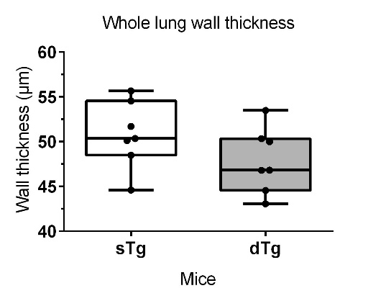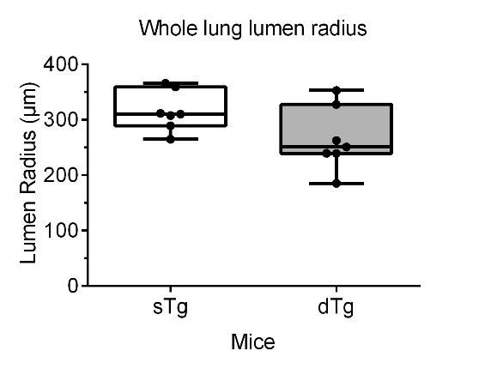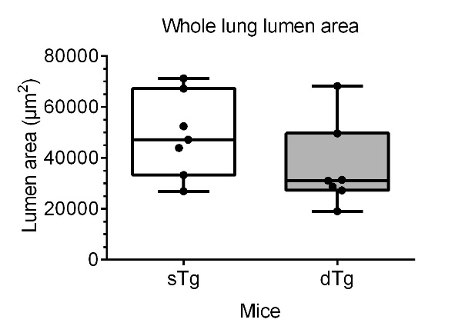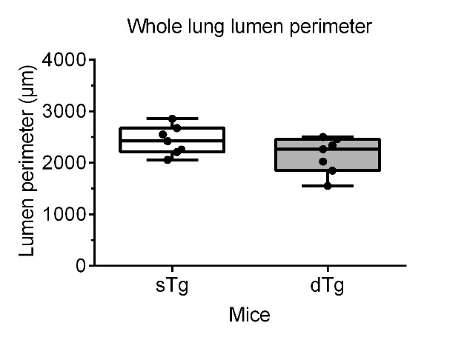
Figure 27: Box plots of comparisons between single transgenic and double transgenic murine whole lung airway parameters. Top-Left: Airway wall thickness of the whole lung (p = 0.1630). Top-Right: Airway lumen radius of the whole lung (p = 0.0730). Bottom-Left: Airway lumen radius of the whole lung (p = 0.1869). Bottom-Right: Airway lumen perimeter of the whole lung (p = 0.1100).

See Appendix I for box-plots of all sections measured in this study.

6.4 Discussion
There results suggest that sADAM33 expression causes a reduction of approximately 16% in airway lumen radius throughout the lung ($p=0.07$), which could suggest an ADAM33 induced increased stiffness of the airways, however the results are not significant enough to draw conclusions. An increase in overall airway wall thickness could not be detected in the sADAM33 expressing lungs and together with the reduction in airway wall thickness at the third branching generation ($p=0.06$) this study could not confirm the increase of smooth muscle around the airways seen by immunohistochemistry [8].
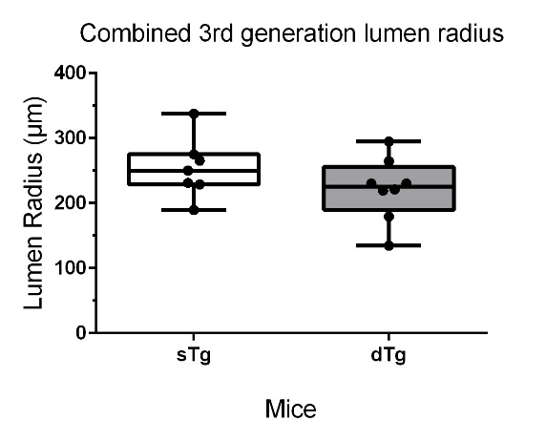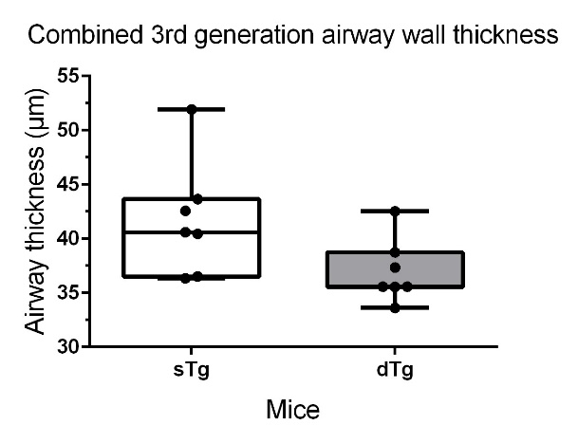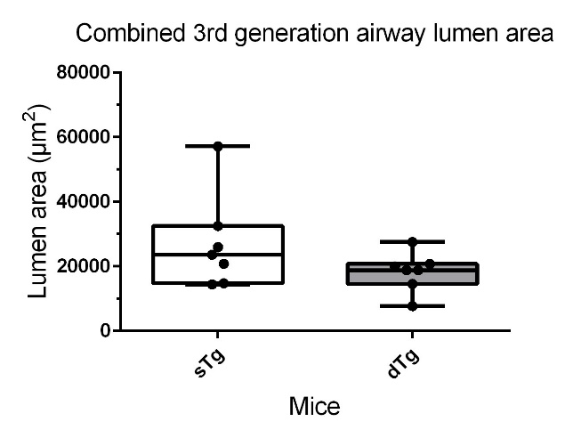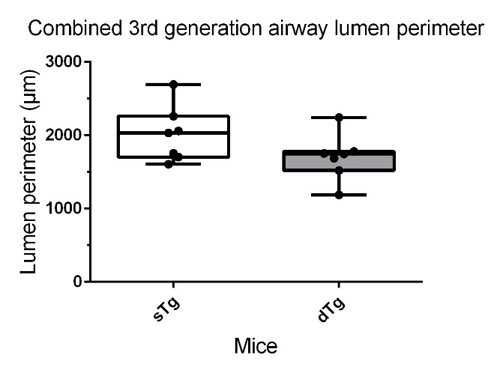
Figure 28: (Top-Left) Box plot of single transgenic versus double transgenic mouse lung lumen radius of the third generation (p = 0.2145). (Top-Right) Box plot of single transgenic versus double transgenic mouse lung wall thickness of the third generation (p = 0.0630). (Bottom-Left) Box plot of single transgenic versus double transgenic mouse lung lumen area of the third generation (p = 0.1727). (Bottom-Right) Box plot of single transgenic versus double transgenic mouse lung lumen perimeter of the third generation (p = 0.1185).
In order to determine whether sADAM33 expression causes airway remodelling in the form of more smooth muscle around the airways [8] that might result in a reduced airway lumen radius, more future work with an increased number of mouse lungs is required. The reason for a suggestive but not significant lower airway wall thickness in the 3rd generation of airways could be explained by the lack of airway smooth muscle in this generation or limitations in contrast to accurately delineate the airway wall and in particular the smooth muscles. Additionally, it has been shown that Lugol’s solution may shrink tissue [146]. While this shrinkage has been shown to be uniform, and therefore should not affect the comparison of images stained in the same way, it could explain the difference in results found in this study when compared with histology performed by Davies et al. [8], which instead used immunofluorescence staining for Alpha-actin-2 (ACTA2), which is ‘largely expressed in smooth muscle cells, pericytes and specialised fibroblasts’ [150], and Platelet Endothelial Cell Adhesion Molecule (PECAM1), which is 'expressed constitutively on the surface of adult and embryonic endothelial cells and is weakly expressed on many peripheral leukocytes and platelets’ [151] to show increased smooth muscle surrounding the airways.
The advantages of resampling the 3D data according to the orientation of the airway are evident in the fact that no branches had to be discarded from the data set for being oblique to the slice orientation. Each branch was viewed through its cross section, providing the most accurate view from which manual measurements could be taken without the necessity to correct for skew. However, reorientation did provide its own downside, due to the discretization of the data, some voxels appeared across multiple pixels in a slice. This is due to the cubic nature of the voxel, being sampled across an oblique axis. The effect is the same as that of sampling a cylinder at an oblique angle, but has less of an effect on measurements due to the single-voxel structure size. See Figure 3.6 for an example of the skewing effect.
A solution to this is to reconstruct the entire image again at different orientations. While ideal in regards to image quality, the increase in processing time due to extra reconstructions outweighs the accuracy gained in manual measurement. Additionally, this skew has no effect on autonomous measurements produced by analysis of the 3D data set, as no resampling takes place. As such, the airway wall and lumen measurements (which were performed on manually segmented airway outer wall remapped to the originally reconstructed data) do not suffer from skew.
The accuracy of the airway wall measurements varies depending on the relative angle of the ray compared to the orientation of the wall at point of contact. When the ray is perpendicular to the wall, the wall width measurement will be accurate, but as the angle diverges, the width measurement artificially increases due to skew. Measuring additional points may reduce the error from skew at the cost of increased processing time. An improvement in this area may be to detect airway wall orientation at point of contact with the ray and reorient the ray from that point such that it passes perpendicular through the airway wall. The simplest way to achieve this would be to find the closest inner-edge point to the manually-designated outer-edge. This will typically be opposite the outer-edge point on the wall. Alternatively, if better contrast on the outer-wall is available, an operator that searches for short, close parallel lines near the ray-inner-wall intersections could be used to find the correct wall orientation or an additional ray-cast from inner-wall to outer-wall boundaries could find the shortest connected straight line between the inner wall intersection and the outer. Alternatively, an analysis of the local curvature of the airway lumen/wall boundary could be used to find the normal of the curve at the point of ray intersection, and the ray re-oriented along the normal and measured between the parenchyma and lumen boundaries. If the density contrast at the parenchyma boundary is sufficient, the boundary could be detected using the same technique as the lumen boundary or, if not, the ray could be measured from the manually segmented parenchyma boundary point towards the lumen. While this would not eliminate skew, it would reduce it.
As asthma is a condition that reacts to challenges from irritants or allergens, an in-vivo study where the lungs are challenged during imaging would be valuable further work to assess the effects of ADAM33 on asthma during asthmatic attack conditions. Additionally, further parameters, such as peak and minimum lung volume could be recorded, although this would greatly increase the time it takes to manually annotate the outer lung wall borders, as well as the data size and hardware requirements for semi-automated processing.

6.5 Conclusion
The ADAM33 gene has been linked to asthma through analysis of single nucleotide polymorphisms and soluble ADAM33 is increased in asthma and caused airway remodelling in a human ADAM33 expressing mouse model [8]. It has been shown that mice expressing soluble human ADAM33 in the main airways produced a distinctive remodelling phenotype, including increased smooth muscle as seen by immunofluorescent microscopy of the large airways [8]. Therefore, we hypothesised that sADAM33 induced airway remodelling can be detected by µCT of the lungs. Analysis of airway wall thickness of µCT images of murine lungs suggests a link between sADAM33 over-expression and decreased airway lumen radius throughout the lung. As sADAM33 causes airway remodelling with more extracellular matrix protein (collagen) deposition and increased airway smooth muscle [8] the reduced airway lumen radius could be explained by increased stiffness of the airways. Additionally, the results of this study could not confirm that ADAM33 over-expression causes increased airway smooth muscle [8] that would correlate with increased lung wall thickness in mice. This might be explained by the difficulty to correctly delineate the smooth muscle that surround the airways due to insufficient contrast and image resolution.
Further work must be done to authenticate our hypothesis that sADAM33 induces airway remodelling with increase of extracellular matrix and airway smooth muscle, with larger samples sizes and increased quantities of the airway analysed per lung. Measurements obtained from the technique described here should also be compared against histology in order to validate the accuracy of the results produced. Additionally, this study conflates smooth muscle quantity with airway wall thickness. Further advances in imaging, such as improved soft tissue contrast methods that differentiate smooth muscle from the rest of the airway wall, if possible, could provide more detailed evidence to confirm that ADAM33 over-expression is responsible for changes in smooth muscle quantities.
With the increase in sample and data size, semi-autonomous or autonomous measurement techniques become increasingly valuable in order to reduce dedicated expert time consumption, as well as the effects of human error. Therefore, it is a necessity that autonomous and semi-autonomous algorithm research continues to focus on branching structures in general, and pulmonary structure in particular.
This investigation has predominantly shown that with µCT images, it is difficult to assess airway wall thickness without automated tools to acquire increased quantities of data.

Chapter 7: Summary and Further Work

7.1 Summary
This PhD thesis was concerned with the application of autonomous and semi-autonomous segmentation and analysis techniques to 3D branching structures in general, and murine pulmonary airways in particular, along with the contribution of overexpression of the ADAM33 gene in airway remodelling and asthma. This work aimed to examine common branching structure centreline extraction techniques and their application to murine pulmonary structure, as well as produce a novel technique based on the work of Carrillo et al. to find a generalised branching structure skeletonisation technique that works well in complex, 3D structure to produce clean, complete skeletons of airway trees.
This work demonstrates a branching structure centreline extraction technique based on the work of Carrillo et al. that uses radial ray-casting to detect the location of branching points throughout the structure by comparing ray lengths at ray-wall intersections with a cylindrical model fit to the current branch. The algorithm has been applied to both filled and unfilled airway structures and found the results to be encouraging for filled airways, but further work is required for unfilled lungs. The algorithm has performed favourably in quantitative comparisons against the Medial and Scale Axis Transforms in regards to producing simple, clean tree structures, and favourably against a Hough Transform tracing technique in regards to false positives / negatives produced, as well as execution times. The algorithms demonstrated require little domain-specific knowledge and as such should apply well to other problem domains, such as human lungs, plant root structures, etc. However, the branching modalities differ in these problem domains, and while the limitation of domain-specific knowledge should improve generalised algorithm performance, this has not been assessed in this study.
While the goal of a generalised branching structure skeletonisation algorithm has not yet been reached, this work provides an important step to disseminate the performance of common current algorithms, even if not 100% successful. This thesis has shown that, with the increased size of datasets produced by µCT and other imaging modalities, the necessity for automated and semi-automated measurement techniques is increasing in order to quickly and reliably measure the produced data sets. It is hoped that by building on this work, a general-purpose skeletonisation algorithm can be developed that consistently skeletonises structures with little configuration or need for domain-specific knowledge or manual clean-up.
A semi-autonomous technique for measuring airway wall thickness via a modified FWHM technique that uses first-order derivative filter in one dimension along cast rays from manually-designated points is demonstrated on unfilled murine airways stained with Lugol’s solution.

The semi-automatic wall thickness algorithm was also used to test the hypothesis that ADAM33 over-expression is affecting morphological change in pulmonary structure. We extracted airway lumen radius, wall thickness, airway lumen area and airway lumen perimeter parameters for seven sites across four generations of branching for 14 murine lungs, seven single transgenic control mice and seven double transgenic mice expressing human sADAM33 when fed doxycycline.
We have shown a suggestive trend towards decreased airway wall thickness in later generations under ADAM33 over-expression, which is contrary to the initial hypotheses, as well as an overall decrease in airway lumen radius throughout the lung, however the sample size was too low to achieve significance, and other studies have shown increased smooth muscle generation in the same double transgenic lungs. It is hypothesised that the decrease in airway lumen radius may be caused by the inflation technique (constant pressure), that would inflate the lungs less well in cases where the airway wall was stiffer and less prone to inflation, such as in cases where there was increased smooth muscle density.

7.2 Limitations
There were several limiting factors that had a potential effect on the outcome of this work, as outlined below.

7.2.1 Algorithm Parameters
The Scale Axis Transform, Hough Transform-based Tracer and the Sphere-Growth Tracer all had a number of parameters that influenced the resulting skeletons. While work was undertaken to assess the best combination of parameters, with each additional parameter, the dimensionality of the parameter space increases, and so not all combinations of parameters could be assessed (except for the Scale Axis Transform, for which you can find the assessment of multiple scale factors in Appendix II).

7.2.2 µCT
The quality of images produced via µCT is dependent on the spatial resolution achieved and the presence of artefacts such as motion blurring or ring artefacts. The images acquired for this work shows a voxel size in the range of 8-10 µm and minimal motion blurring due to the sample preparation techniques used. Murine alveoli are assessed as being between ∼ 35 µm and ∼ 80 µm in diameter. This equates to between 4 and 10 voxels. At the fourth generation, wall thicknesses as thin as ∼ 24 µm were recorded, or 2-3 voxels wide. This is at the limit of measurability and low contrast, motion blurring and the partial volume effect will greatly influence the outcome of results.

7.2.3 Tracer Branch Detection
The tracing algorithms examined in Chapter 5 both suffered from missing branching points, reducing the quality of the trees they produced. While additional traces can be performed in the remaining data and attached to the final skeleton, improvements to branch point detection must be made to reduce the amount of manual involvement is required to produce a complete airway skeleton.

7.2.3 Sample Size
Due to the cost and time required to prepare, image and analyse transgenic murine lungs, resulting sample sizes are small. As such the influence of variations in structural generation that may be unrelated to ADAM33 over-expression are noticeable in the high standard deviations of the measurements taken in Chapter 6. Increasing sample size will reduce the effect of outliers on the statistical results and hopefully improve significance in the results. Additionally, increasing the quantity of measurements made on each lung (more segments of lung, more generations, more manually segmented points on more slices) will also reduce the effect of outliers.

7.2.4 Airway Wall Intersection Angle
The airway wall thickness measurement algorithm in Chapter 6 can suffer from distorted thickness measurements caused by rays that are not perpendicular to the airway wall as they pass through it. The error induced by this can be dealt with by re-orienting the ray to be perpendicular to the airway wall at the first point of ray/wall intersection. Several techniques to perform this correction are outlined in Section 6.4.

7.2.3 Human Error
While the images in Chapter 6 were processed under double-blind protocols, the manual segmentation of the airway wall / parenchyma boundary were performed manually and as such were subject to human error in determining the correct edge positioning. This can be ameliorated by increasing the number of boundary points labelled per slice, or by fully-automating the parenchyma edge boundary detection.

7.3 Further Work
A critical site for improvement of the proposed sphere growth skeletonisation algorithm is the improvement of the centreline position guess made at the start of each trace step. Better next-step positions will not only reduce the number of iterations needed in the sphere growth portion of the algorithm in order to correctly determine the centreline, but also reduce the chance that the tracer can exit the pulmonary structure during steps where the step length is sufficiently large, allowing, step length can be increased to further improve algorithmic performance without risking centreline extraction errors.
The incorporation of domain-specific knowledge to the tracer would improve centreline estimation at the expense of generalisation. For example, utilising the vessel proximity metric of Lo, et al. [73] and Sonka et al. [68] could inform initial centreline estimates by further informing airway orientation determination. By making the assumption that the vasculature runs parallel to the airways, once identified, the orientation of the vasculature would be used to narrow the range of potential orientations the plane-fitting technique must consider. As such the plane-fitting can be performed on a more fine-grained angle step and result in a more accurate representation of airway orientation and a centreline guess that is closer to the centreline along the orientation of the current branch.
Furthermore, the prior knowledge of vasculature proximity could reduce error associated with branch detection when the vasculature has also been contrasted and segmented from the airways, as branches in the airways will typically be in proximity with branches. Further, the understanding of branch generation in human and murine lungs empower us to inform the tracer of expected branch types, such as planar bifurcation, orthogonal bifurcation or side branching and further increase the accuracy of branching point positioning and recommendations, as well as informing any branch point classification techniques involved.
An additional technique to improve the centreline guess is the incorporation of knowledge of curvature to the centreline. Prior steps along the centreline would be described by a curved string in 3D space, the constraints of which will better inform the position of the next step than the current technique of extrusion along the normal of the previous step’s orientation estimation (Figure 31).

Figure 29: Diagram showing the benefits of curve-based centreline extrapolation technique versus the current linear interpolation based centreline extrapolation. Left: centreline extrapolation (dotted) from previously calculated centreline via linear interpolation. Right: centreline extrapolation (dotted) from previously calculated centreline via curve extrapolation.
Currently, the primary issue with the sphere growth algorithm is missed branch points. Further work on branch detection and duplicate / erroneous branch remove strategies should be performed, and these can be made to work alongside the sphere growth centreline extraction technique. Additionally, further work can be performed on the current branch detection technique. The model the branch detector uses to determine the expected length of a ray cast against the walls of an airway with no branches is a straight cylinder. By incorporating knowledge of the shape of the airway cross-section at the current tracer position, as well as curvature estimates of the branch, a better estimate of correct branching points can be found.
While the algorithms have been trialled on murine lungs, differences exist between the branching patterns of these lungs and other natural structures. One such example is the uteric bud of the kidney, which can form a trifurcation (a three-way branch) [152] (although trifurcations have also been observed in the murine lung [153]). Provided that the difference in branching angles is not too severe (and therefore the branches are not too skewed), the Hough transform tracer should identify these branches as well as it identifies bifurcations. The other three algorithms should have no difficulties identifying trifurcations or any further extension of n-furcations. The scale axis transform and medial axis transforms will operate on the data regardless of branching structure, and the sphere growth tracer will detect any branch as long as a ray can penetrate it to a sufficient distance, regardless of the number of branches that have already been detected at any point in the trace. Additionally, there is a difference in branching between the pulmonary structures of humans, whose lung generation is controlled by dichotomous branching, and the mouse’s well-known branching system of domain branching, followed by alternating bifurcation and orthogonal bifurcation. While the algorithms have not been applied to human lungs, they do not encode monopodial-specific knowledge and the murine lung demonstrates three common forms of branching (domain, planar and orthogonal bifurcation) and should therefore be as effective at skeletonising dichotomous branching as they are at murine airway skeletonisation.
Performance may be improved through the use of parallelism. A tracing algorithm is typically linear, due to the requirement that steps be informed by their previous traversal of the structure, however the unique properties of tree structures, that is to say their recursive splitting and that each branch never reconnects with a parent of sibling branch, allows one to isolate the prior information at each branch point. As such, it would be possible to parallelise the branching structure tracing such that each branch is traced independently, however the commencement of child branch traces must be timed such that the child branches begin their tracing after the data surrounding the child branch point has been covered by the parent and all preceding sibling tracers’ branch duplicate reduction techniques.
Further to this, the ray-casting in the branch detection is highly parallelisable, as each ray is fully independent of the others. Additionally, since no alteration of the data the rays are cast against occurs during the ray cast, all rays can operate on the same copy of the data in memory. As such, the ray casting portions of the algorithm become good candidates for General-Purpose computing on Graphics Processing Units (GPGPU).
Beyond performance improvements, as branching structures are ubiquitous throughout nature, such as in plant roots, renal vasculature or ocular vasculature, there are many topics other than pulmonary science that make use of skeletonisation and centreline extraction in 3D branching structures which improved general centreline extraction techniques would also benefit. Additionally, experts in these fields will be able to incorporate their own prior knowledge into the tracing step, improving the applicability of the algorithm to their data as well as its performance, as noted above.
Analysis of the airway lumen radius, area and perimeter, as well as wall thickness on increased sample sizes is recommended. We hypothesise that the effect of variance in structural generation will lessen as sample size increases, and the significance of airway lumen and wall changes will improve. Additional morphological parameters, such as airway lengths, airway lumen volume, airway wall volume, total lung lumen volume and total lung wall volume are also of interest in the assessment of the effects of ADAM33 over-expression on pulmonary structure.
A similar analysis on mice that have been inflated to constant volume instead of constant pressure could eliminate the observed differences in airway lumen size. Evidence suggested a reduction in airway lumen radius due to ADAM33 over-expression, and it is hypothesised that this could be caused by the increased airway wall thickness or stiffening as a result of increased smooth muscle density due to ADAM33 that would make the double transgenic airways more resistant to inflation.
ADAM33 overexpression has also been linked to increased angiogenesis, and as such the analysis of pulmonary vasculature through µCT, such as branch counts per generation, vasculature volumes and vasculature wall and lumen measurements would provide important context and evidence towards the effect of ADAM33 on pulmonary structure. The centreline extraction technique could well be incorporated into this investigation. The vasculature image would first be filled via image processing, and then processed using the semi-autonomous centreline extraction algorithm. The resulting tree-structure could be analysed for average branch lengths, angles and volumes. See Figure 30 and Figure 31 for an example of measurements produced during the sphere inflation investigation.
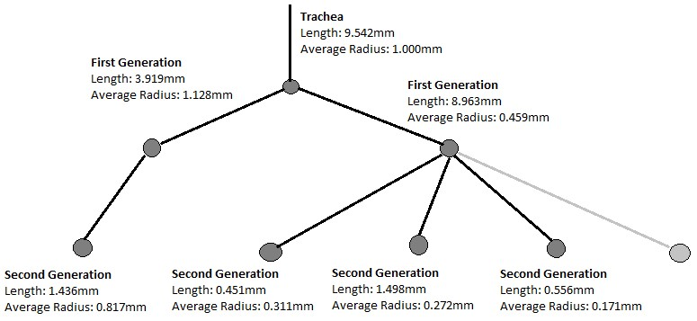
Figure 30: Diagram of the branching structure of a filled test lung simplified to its tree representation and annotated with measured means for branch length (branch point to branch point) and lumen radius. The right-most branch (light grey) indicates that there were additional branches off of the first generation that were excluded for clarity.
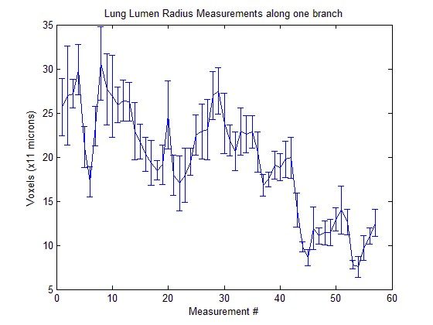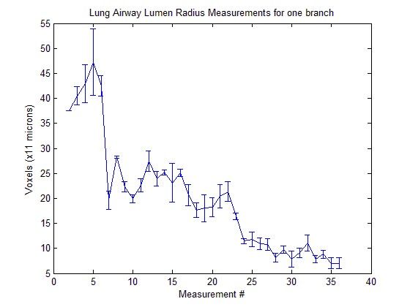
Figure 31: Graph charting the lumen radius across two branches of a filled lung.
Extension of the centre-line extraction technique to incorporate the measurements algorithm of radial ray-casting and discrete differentiation operator filtering would allow the acquisition of airway wall thickness and airway lumen measurements throughout the entirety of the extracted pulmonary structure during the skeletonisation process, provided sufficient contrast exists between airway wall and parenchyma. Figure 30 and Figure 31 show the results of initial work in this area. The increases in data acquired would greatly reduce the influence of abnormal airways on the aggregate results, but would require significant improvements in the centre-line extraction of unfilled airways. Alternatively, hole filling algorithms [154] could be used to fill unfilled lungs prior to skeletonisation. This skeleton could then be used to drive measurement algorithms on the unfilled lungs.

Appendices

Appendix I: Complete ADAM33 Single/Double Transgenic Mouse Lung Parameter Comparison
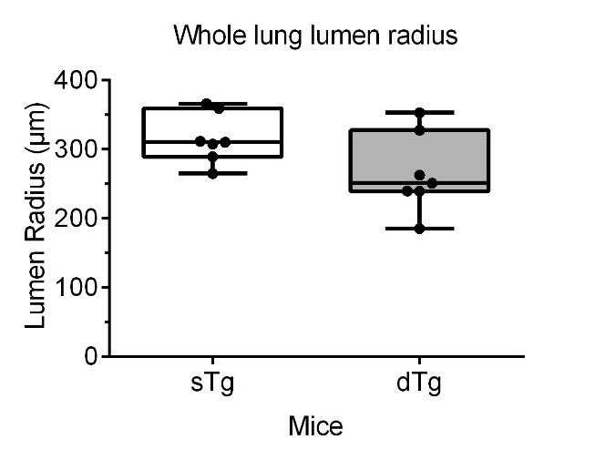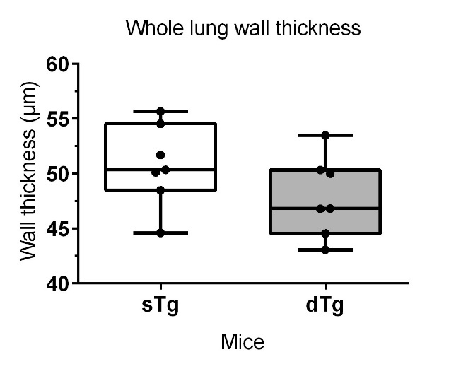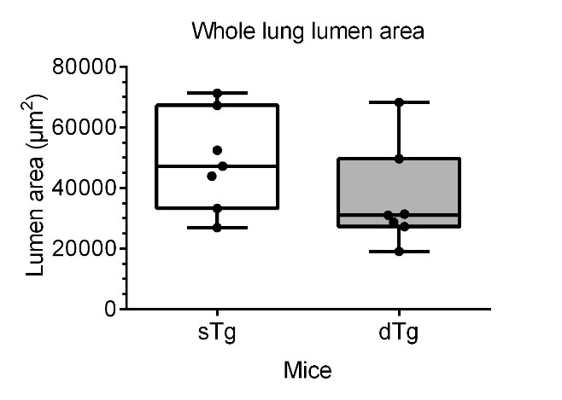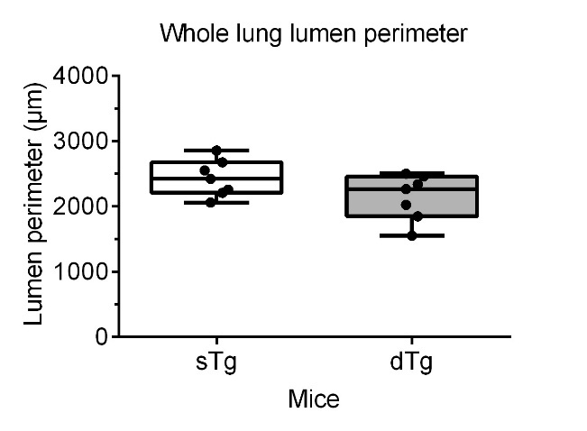
Figure 32: Box plots of single transgenic versus double transgenic mouse lung lumen radius (top-left), wall thickness (top-right), lumen area (bottom-left), lumen perimeter (bottom-right) of the whole lung (p = 0.0730, p = 0.1630, p = 0.1869, p = 0.1100 respectively).
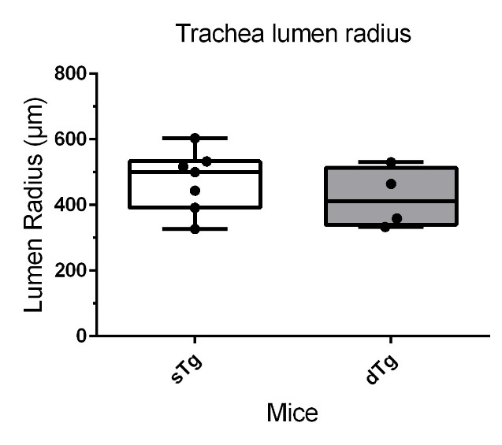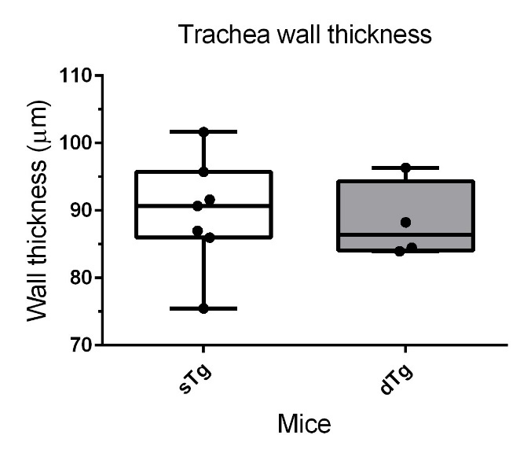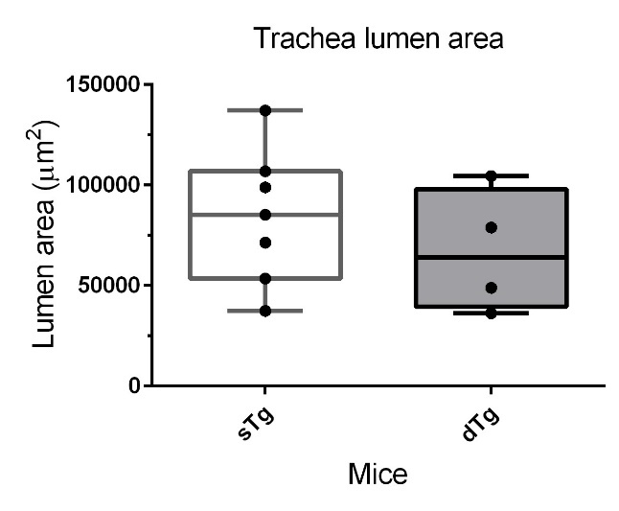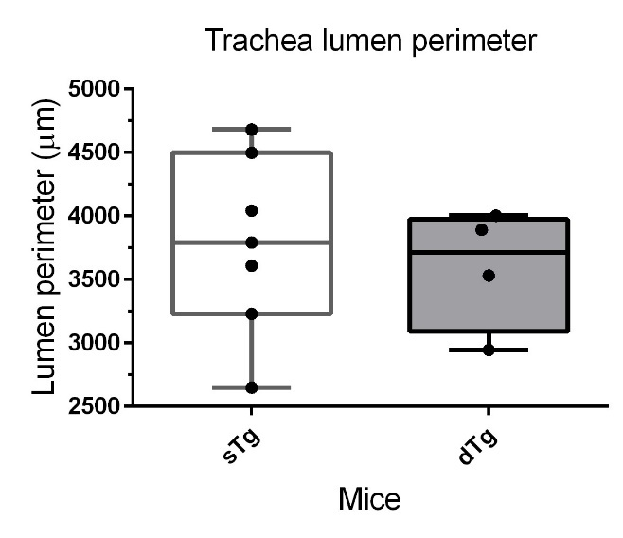
Figure 33: Box plots of single transgenic versus double transgenic mouse lung lumen radius (top-left), wall thickness (top-right), lumen area (bottom-left), lumen perimeter (bottom-right) of the trachea (p = 0.3952, p = 0.7613, p = 0.4233, p = 0.6421 respectively).
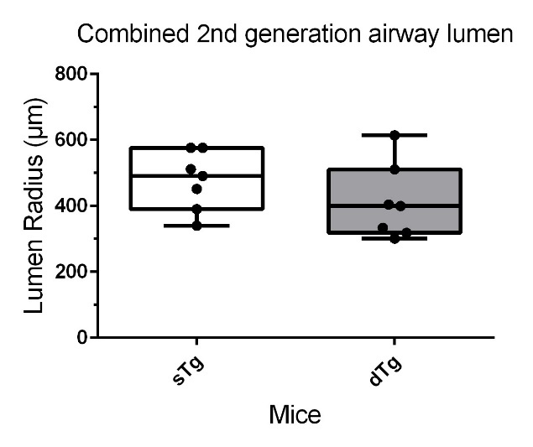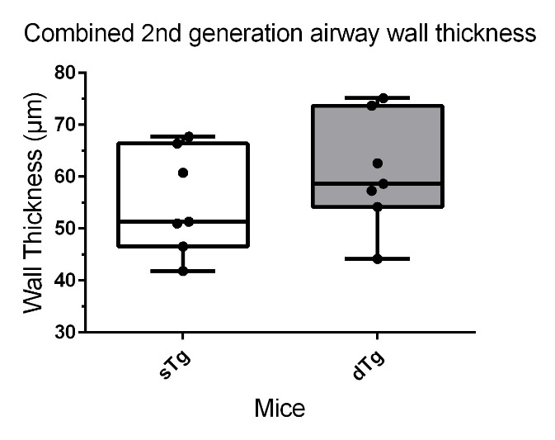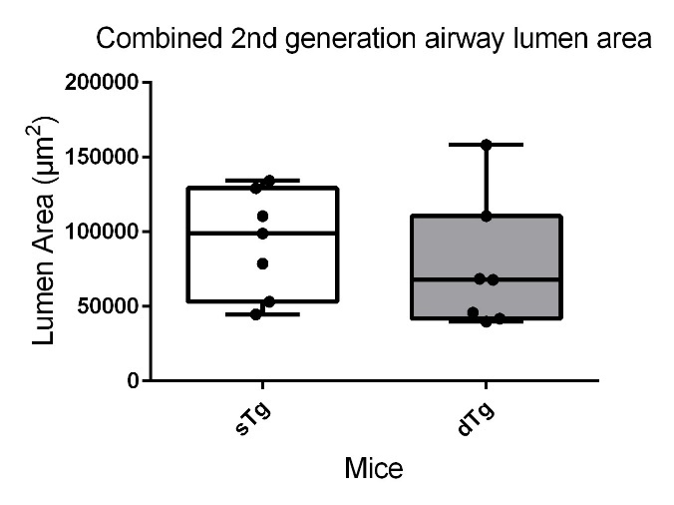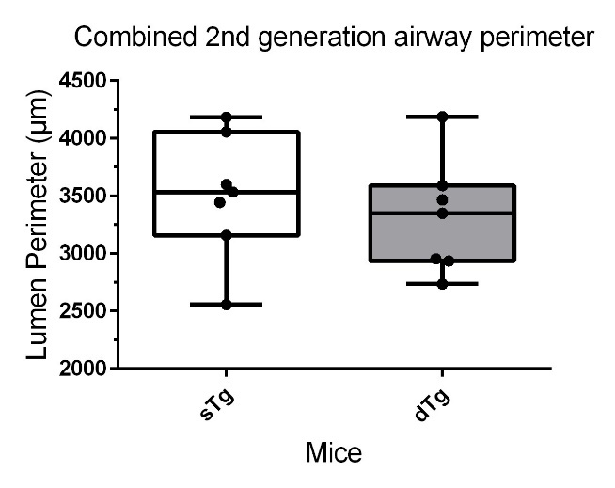
Figure 34: Box plots of single transgenic mouse lung lumen radius (top-left), wall thickness (top-right), lumen area (bottom-left), lumen perimeter (bottom-right) of the main bronchi (second generation) (p = 0.2573, p = 0.3251, p = 0.4477, p = 0.5143 respectively).
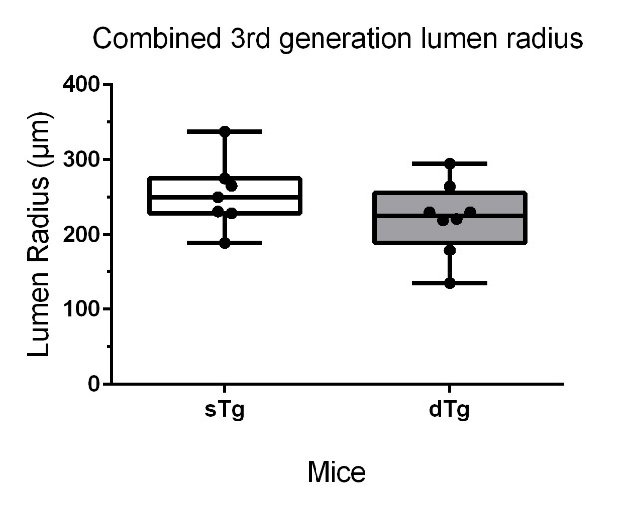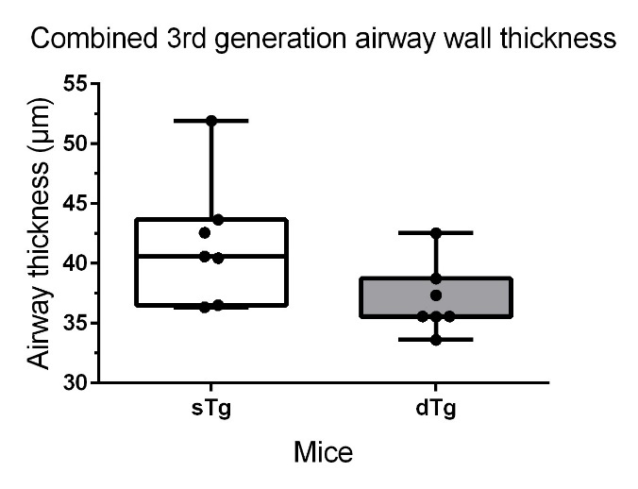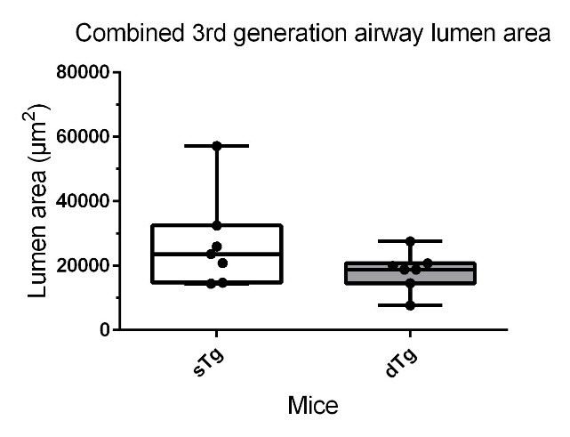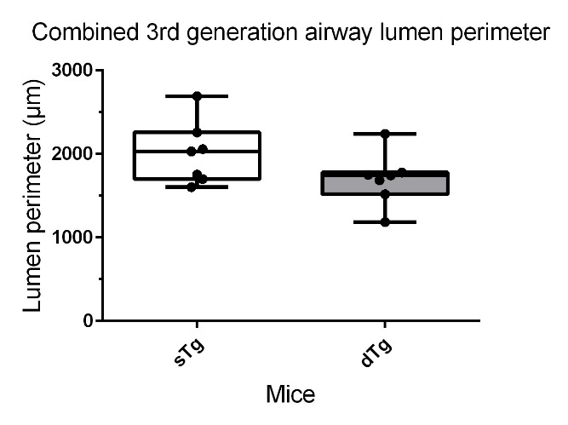
Figure 35: Box plots of single transgenic versus double transgenic mouse lung lumen radius (top-left), wall thickness (top-right), lumen area (bottom-left), lumen perimeter (bottom-right) of the third generation (p = 0.2145, p = 0.0630, p = 0.1727, p = 0.1185 respectively).
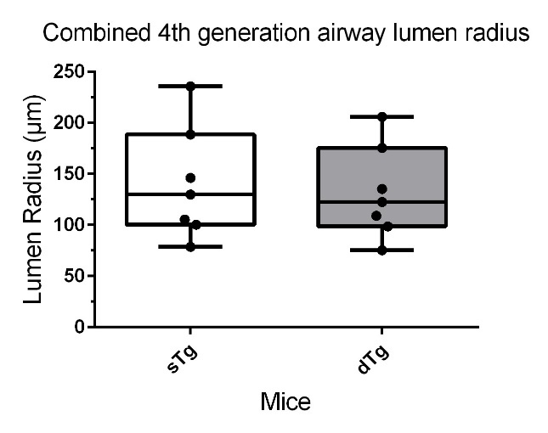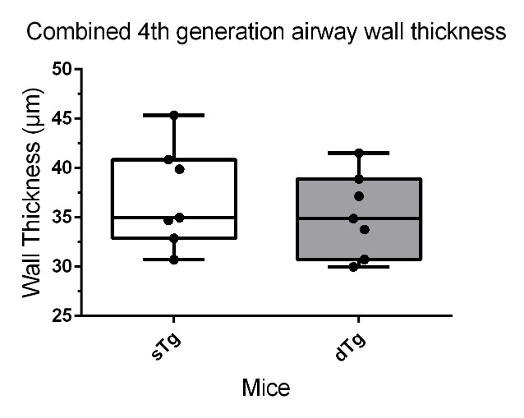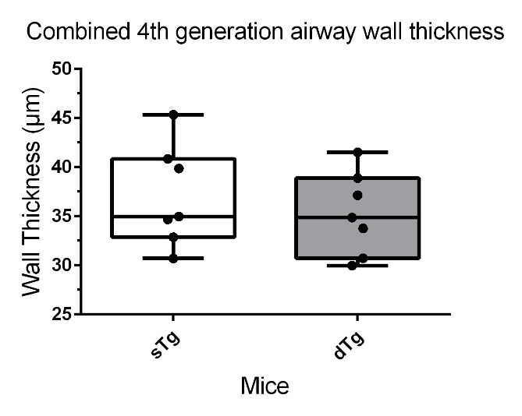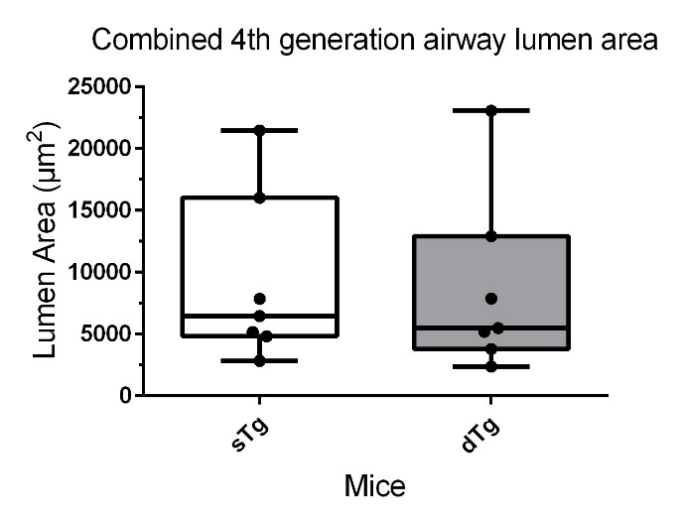
Figure 36: Box plots of single transgenic versus double transgenic mouse lung lumen radius (top-left), wall thickness (top-right), lumen area (bottom-left), lumen perimeter (bottom-right) of the fourth generation (p = 0.7452, p = 0.4947, p = 0.8849, p = 0.7249 respectively).

Appendix II: Comparison of Scale Axis Transform Scale Factors
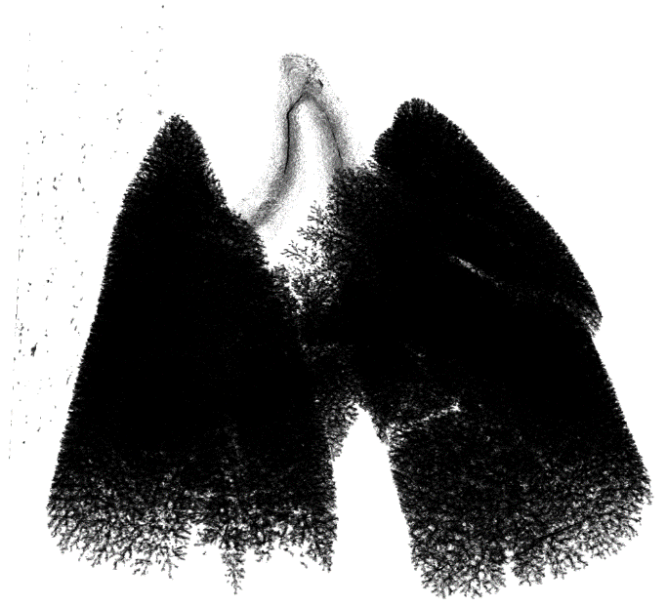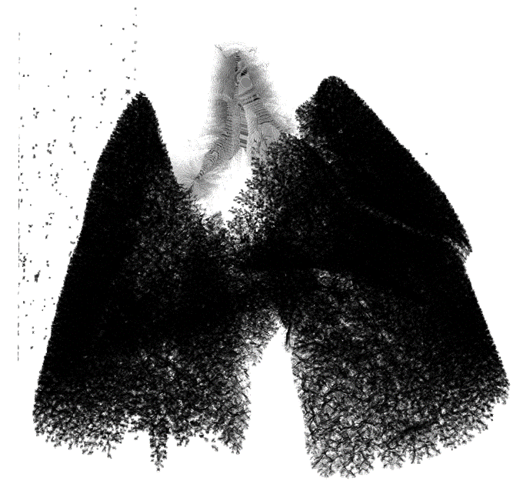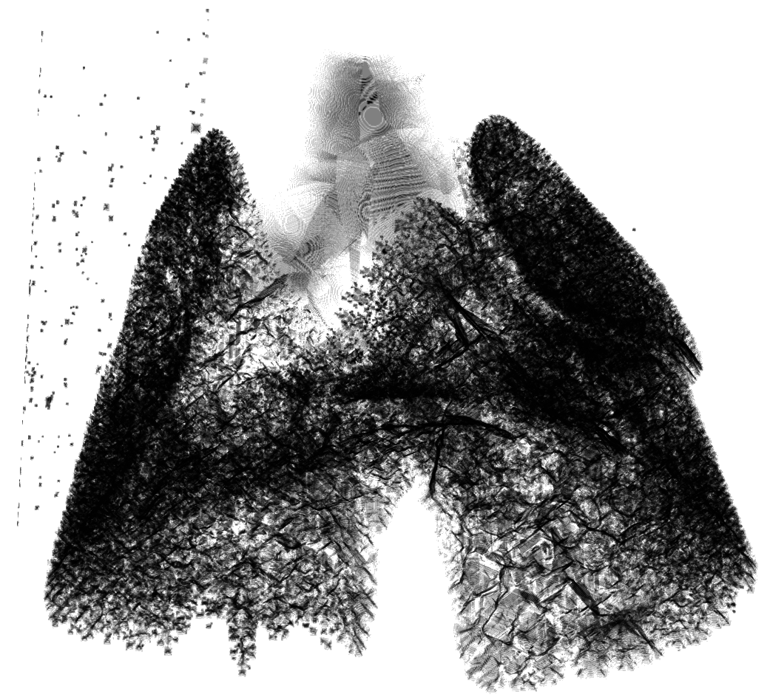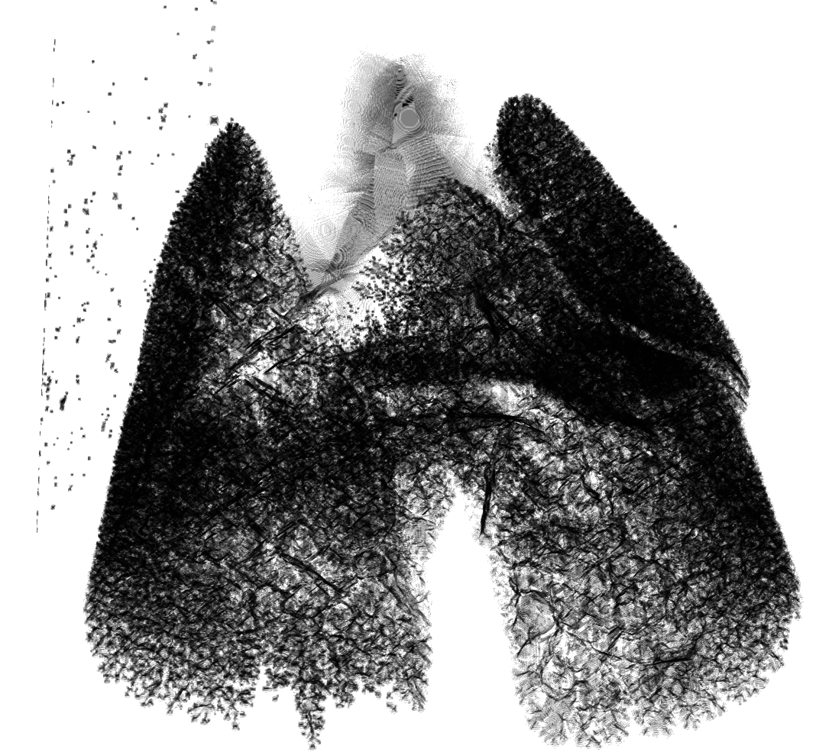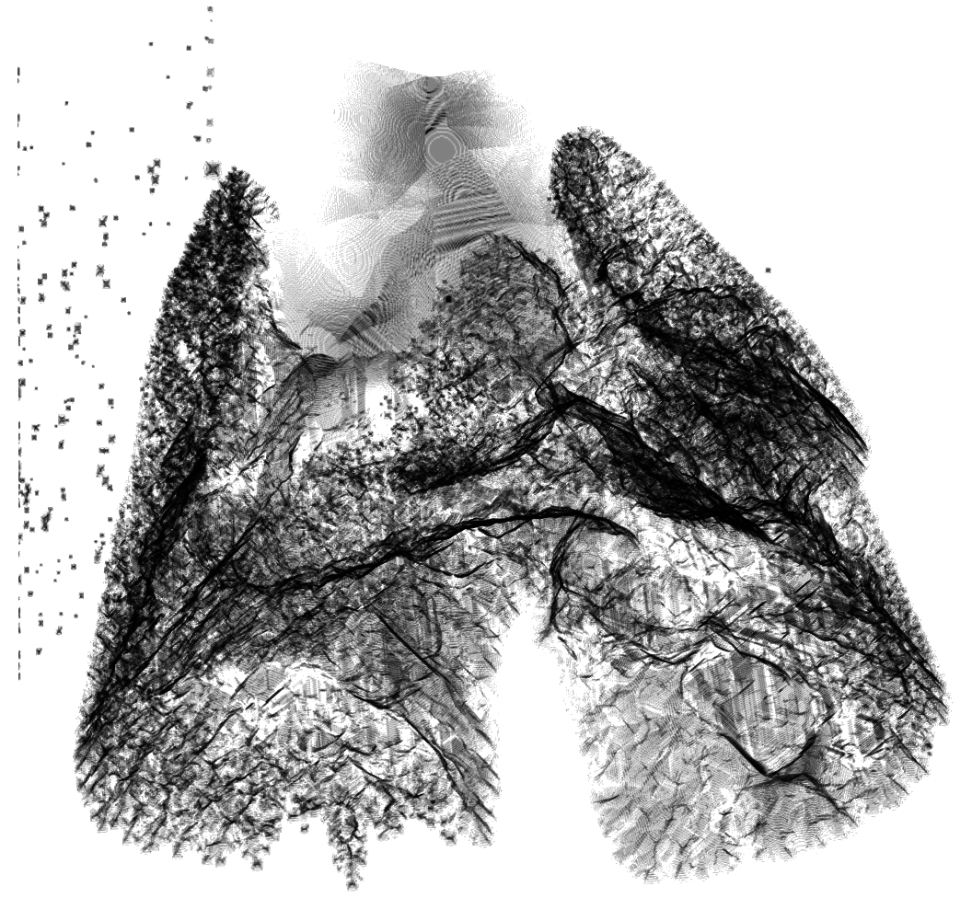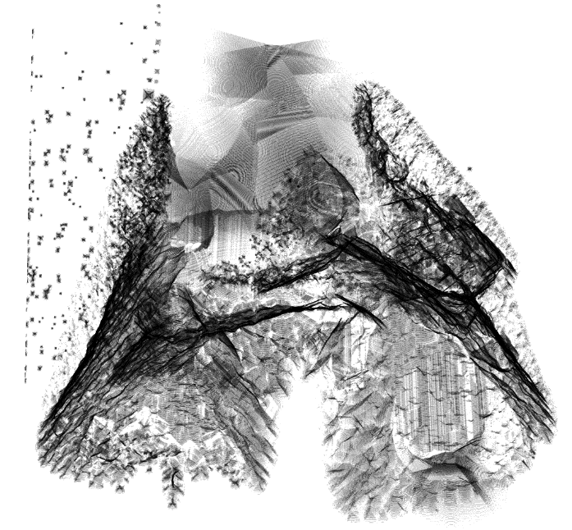
Figure 37: Comparison of Scale Axis scale factors on the same murine lung. Top-left: Scale factor 1 (the medial axis transform). Top-right: Scale factor 1.25. Middle-left: Scale factor 1.5. Middle-right: Scale factor 2. Bottom-left: Scale factor 3. Bottom-right: Scale factor 4.

Bibliography

[1] | World Health Organisation, “Asthma Fact Sheet 307,” November 2013. [Online]. Available: http://www.who.int/mediacentre/factsheets/fs307/en/. [Accessed 16 February 2017].
[2] | Asthma UK, “Asthma facts and statistics,” 10 February 2017. [Online]. Available: https://www.asthma.org.uk/about/media/facts-and-statistics/.
[3] | H. Bisgaard and S. Szefler, “Prevalence of asthma‐like symptoms in young children,” Pediatric pulmonology, vol. 42, no. 8, pp. 723-728, 2007.
[4] | P. Van Eerdewegh, R. D. Little, J. Dupuis, R. G. Del Mastro, K. Falls, J. Simon, D. Torrey, S. Pandit, J. McKenny and K. Braunschweiger, “Association of the ADAM33 gene with asthma and bronchial hyperresponsiveness,” Nature, vol. 418, no. 6896, pp. 426-430, 2002.
[5] | W. Zheng, L. Wang, X. Su and X. Hu, “Association between V4 polymorphism in the ADAM33 gene and asthma risk: a meta-analysis,” Genetics and Molecular Research, vol. 14, no. 1, pp. 989-999, 2015.
[6] | S. P. Umland, C. G. Garlisi, H. Shah, Y. Wan, J. Zou, K. E. Devito, W.-M. Huang, E. L. Gustafson and R. Ralston, “Human ADAM33 messenger RNA expression profile and post-transcriptional regulation,” American journal of respiratory cell and molecular biology, vol. 29, no. 5, pp. 571-582, 2003.
[7] | J.-Y. Lee, S.-W. Park, H. K. Chang, H. Y. Kim, T. Rhim, J.-H. Lee, A.-S. Jang, E.-S. Koh and C.-S. Park, “A disintegrin and metalloproteinase 33 protein in patients with asthma: relevance to airflow limitation,” American journal of respiratory and critical care medicine, vol. 173, no. 7, pp. 729-735, 2006.
[8] | E. R. Davies, J. F. Kelly, P. H. Howarth, D. I. Wilson, S. T. Holgate, D. E. Davies, J. A. Whitsett and H. M. Haitchi, “Soluble ADAM33 initiates airway remodeling to promote susceptibility for allergic asthma in early life,” JCI insight, vol. 1, no. 11, 2016.
[9] | D. Dreymueller, S. Uhlig and A. Ludwig, “ADAM-family metalloproteinases in lung inflammation: potential therapeutic targets,” American Journal of Physiology-Lung Cellular and Molecular Physiology, vol. 308, no. 4, pp. L325-L343, 2015.
[10] | N. Udell, I. Sinclair, H. M. Haitchi, M. S. Nixon and P. J. Thurner, “Sphere-growth based centreline extraction of murine airways from microfocus X-ray computer assisted tomography,” in The 17th Annual Conference in Medical Image Understanding and Analysis, 2013.
[11] | N. Udell, I. Sinclair, M. Nixon, H. M. Haitchi and P. J. Thurner, “Tracing as a tool for determining murine airway morphology from microfocus computer assisted tomography data,” in The 11th International Symposium Computer Methods in Biomechanics and Biomedical Engineering, 2013.
[12] | N. P. Udell, I. Sinclair, M. Nixon, H. M. Haitchi and P. J. Thurner, “The determination of murine airway morphology from microfocus computer assisted tomography data using tracing.,” in 19th Congress of the European Society of Biomechanics, Patras, 2013.
[13] | N. Udell, M. S. Nixon, M. Haitchi H, I. Sinclair and P. J. Thurner, “Classification and quantification of murine lungs as 3d branching structures.,” in 19th Annual Summer Meeting of the British Association for Lung Research, 2012.
[14] | A. C. Kak and M. Slaney, Principles of computerized tomographic imaging, IEEE press, 1988.
[15] | H. Turbell, Cone-beam reconstruction using filtered backprojection, Linköping University Electronic Press, 2001.
[16] | The University of Texas at Austin, “Essentials of Computed Tomography,” 2015. [Online]. Available: http://www.ctlab.geo.utexas.edu/about-ct/essentials-of-computedtomography. [Accessed 10 8 2015].
[17] | G. Davis and J. Elliott, “X-ray microtomography scanner using time-delay integration for elimination of ring artefacts in the reconstructed image,” Nuclear Instruments and Methods in Physics Research Section A: Accelerators, Spectrometers, Detectors and Associated Equipment, vol. 394, no. 1, pp. 157-162, 1997.
[18] | E. L. Ritman, “Micro-computed tomography—current status and developments,” Annual Review of Biomedical Engineering, vol. 6, pp. 185-208, 2004.
[19] | M. D. Bentley, M. C. Ortiz, E. L. Ritman and J. C. Romero, “The use of microcomputed tomography to study microvasculature in small rodents,” American Journal of Physiology-Regulatory, Integrative and Comparative Physiology, vol. 282, no. 5, pp. R1267-R1279, 2002.
[20] | J. L. Tremoleda, M. Khalil, L. L. Gompels, M. Wylezinska-Arridge, T. Vincent and W. Gsell, “Imaging technologies for preclinical models of bone and joint disorders,” EJNMMI research, vol. 1, no. 1, p. 1, 2011.
[21] | J. Als-Nielsen and D. McMorrow, Elements of modern X-ray physics, John Wiley & Sons, 2011.
[22] | A. Bravin, P. Coan and P. Suortti, “X-ray phase-contrast imaging: from pre-clinical applications towards clinics,” Physics in Medicine and Biology, vol. 58, no. 1, p. R1, 10 December 2012.
[23] | A. Momose, T. Takeda, Y. Itai, A. Yoneyama and K. Hirano, “Phase-contrast tomographic imaging using an X-ray interferometer,” Journal of synchrotron radiation, vol. 5, no. 3, pp. 309-314, 1998.
[24] | L. Rayleigh, “On copying diffraction-gratings, and on some phenomena connected therewith,” The London, Edinburgh, and Dublin Philosophical Magazine and Journal of Science, vol. 11, no. 67, pp. 196-205, 1881.
[25] | Y. Takeda, W. Yashiro, T. Hattori, A. Takeuchi, Y. Suzuki and A. Momose, “Differential Phase X-ray Imaging Microscopy with X-ray Talbot Interferometer,” vol. 1, no. 11, 2008.
[26] | S. A. McDonald, F. Marone, C. Hintermüller, G. Mikuljan, C. David, F. Pfeiffer and M. Stampanoni, “Advanced phase-contrast imaging using a grating interferometer,” Journal of Synchrotron Radiation, vol. 16, pp. 562-572, 2009.
[27] | T. Weitkamp, A. Diaz, C. David, F. Pfeiffer, M. Stampanoni, P. Cloetens and E. Ziegler, “X-ray phase imaging with a grating interferometer,” Optics Express, vol. 13, no. 16, pp. 6296-6304, 2005.
[28] | F. Pfeiffer, T. Weitkamp, O. Bunk and C. David, “Phase retrieval and differential phase-contrast imaging with low-brilliance X-ray sources,” Nature Physics, vol. 2, pp. 258 - 261, 2006.
[29] | J. Herzen, T. Donath, F. Pfeiffer, O. Bunk, C. Padeste, F. Beckmann, A. Schreyer and C. David, “Quantitative phase-contrast tomography of a liquid phantom using a conventional x-ray tube source,” Optics Express, vol. 17, no. 12, pp. 10010-10018, 2009.
[30] | D. Stutman, T. J. Beck, J. A. Carrino and C. O. Bingham, “Talbot phase-contrast x-ray imaging for the small joints of the hand,” Physics in Medicine and Biology, vol. 56, no. 17, p. 5697, 2011.
[31] | T. Donath, F. Pfeiffer, O. Bunk, C. Grünzweig, E. Hempel, S. Popescu, P. Vock and C. David, “Toward Clinical X-ray Phase-Contrast CT Demonstration of Enhanced Soft-Tissue Contrast in Human Specimen,” Investigative radiology, vol. 45, no. 7, pp. 445-452, 2010.
[32] | J. Zambelli, N. Bevins, Q. Zhihua and G.-H. Chen, “Radiation dose efficiency comparison between differential phase contrast CT and conventional absorption CT,” Medical Physics, vol. 37, no. 6, p. 2473, 2010.
[33] | S. M. Wilson and A. Bacic, “Preparation of plant cells for transmission electron microscopy to optimize immunogold labeling of carbohydrate and protein epitopes,” Nature protocols, vol. 7, no. 9, pp. 1716-1727, 2012.
[34] | S. Kaczmarz, “Angenäherte auflösung von systemen linearer gleichungen,” Bulletin International de l’Academie Polonaise des Sciences et des Lettres, vol. 35, pp. 355-357, 1937.
[35] | K. Tanabe, “Projection method for solving a singular system of linear equations and its applications,” Numerische Mathematik, vol. 17, no. 3, pp. 203-214, 1971.
[36] | J. Hsieh, “Computed tomography: principles, design, artifacts, and recent advances,” in SPIE, Bellingham, WA, 2009.
[37] | Nikon Metrology, “Nikon Metrology Product Information (XT H 225 X-ray and CT inspection system for industrial applications),” 2015. [Online]. Available: http://www.nikonmetrology.com/en_EU/Products/X-ray-and-CT-Inspection/Computed-Tomography/XT-H-225-Industrial-CT-Scanning. [Accessed 10 8 2015].
[38] | D. W. Holdsworth and M. M. Thornton, “Micro-CT in small animal and specimen imaging,” Trends in Biotechnology, vol. 20, no. 8, pp. S34-S39, 2002.
[39] | J. F. Barrett and N. Keat, “Artifacts in CT: recognition and avoidance 1,” Radiographics, vol. 24, no. 6, pp. 1679-1691, 2004.
[40] | C. J. A. A. M. T. S. J. R. D. J. S. J. M. C. M. C. H. A. P. P. Moore, “ Developments in and experience of kilovoltage X-ray cone beam image-guided radiotherapy,” The British journal of radiology, 2014.
[41] | A. E. Scott, D. M. Vasilescu, K. A. Seal, S. D. Keyes, M. N. Mavrogordato, J. C. Hogg, I. Sinclair, J. A. Warner, T.-L. Hackett and P. M. Lackie, “Three dimensional imaging of paraffin embedded human lung tissue samples by micro-computed tomography,” PloS one, vol. 10, no. 6, p. e0126230, 2015.
[42] | G. Wang, M. W. Vannier and P.-C. Cheng, “Iterative X-ray cone-beam tomography for metal artifact reduction and local region reconstruction,” Microscopy and Microanalysis, vol. 5, no. 1, pp. 58-65, 1999.
[43] | E. E. Weibel and R. A. Vidone, “Fixation of the Lung by Formalin Steam in a Controlled State of Air Inflation,” American Review of Respiratory Disease, vol. 84, no. 6, pp. 856-861, 1961.
[44] | R. Zehbe, A. Haibel, H. Riesemeier, U. Gross, C. J. Kirkpatrick, H. Schubert and C. Brochhausen, “Going beyond histology. Synchrotron micro-computed tomography as a methodology for biological tissue characterization: from tissue morphology to individual cells,” Journal of The Royal Society Interface, vol. 7, no. 42, pp. 49-59, 2010.
[45] | M. Salomé, F. Peyrin, P. Cloetens, C. Odet, A.-M. Laval-Jeantet, J. Baruchel and P. Spanne, “A synchrotron radiation microtomography system for the analysis of trabecular bone samples,” Medical Physics, vol. 26, no. 10, pp. 2194-2204, 1999.
[46] | T. Sera and N. Yagi, “Three-dimensional visualization of intact mouse lung by synchrotron radiation CT,” in Engineering in Medicine and Biology Society. 26th Annual International Conference of the IEEE, 2004.
[47] | H. S. Nelson, D. E. Davies, J. Wicks, R. M. Powell, S. M. Puddicombe and S. T. Holgate, “Airway remodeling in asthma: new insights,” Journal of allergy and clinical immunology, vol. 111, no. 2, pp. 215-225, 2003.
[48] | A. R. Froese, K. Ask, R. Labiris, T. Farncombe, D. Warburton, M. D. Inman, J. Gauldie and M. Kolb, “Three-dimensional computed tomography imaging in an animal model of emphysema,” European Respiratory Journal, vol. 30, no. 6, pp. 1082-1089, 2007.
[49] | A. Larrue, A. Rattner, Z.-A. Peter, C. Olivier, N. Laroche, L. Vico and F. Peyrin, “Synchrotron radiation micro-CT at the micrometer scale for the analysis of the three-dimensional morphology of microcracks in human trabecular bone,” PLoS One, vol. 6, no. 7, p. e21297, 2011.
[50] | S. G. Armato and W. F. Sensakovic, “Automated lung segmentation for thoracic CT: Impact on computer-aided diagnosis1,” Academic Radiology, vol. 11, no. 9, pp. 1011-1021, 2004.
[51] | J. K. Leader, B. Zheng, R. M. Rogers, F. C. Sciurba, A. Perez, B. E. Chapman, S. Patel, C. R. Fuhrman and D. Gur, “Automated lung segmentation in X-ray computed tomography: development and evaluation of a heuristic threshold-based scheme,” Academic radiology, vol. 10, no. 11, pp. 1224-1236, 2003.
[52] | S. Hu, E. A. Hoffman and J. M. Reinhardt, “Automatic lung segmentation for accurate quantitation of volumetric X-ray CT images,” IEEE transactions on medical imaging, vol. 20, no. 6, pp. 490-498, 2001.
[53] | X. Sun, H. Zhang and H. Duan, “3D computerized segmentation of lung volume with computed tomography,” Academic radiology, vol. 13, no. 6, pp. 670-677, 2006.
[54] | M. S. Brown, M. F. Mcnitt-Gray, N. J. Mankovich, J. G. Goldin, J. Hiller, L. S. Wilson and D. Aberie, “Method for segmenting chest CT image data using an anatomical model: preliminary results,” IEEE transactions on medical imaging, vol. 16, no. 6, pp. 828-839, 1997.
[55] | M. S. Brown, J. G. Goldin, M. F. McNitt-Gray, L. E. Greaser, A. Sapra, K.-T. Li, J. W. Sayre, K. Martin and D. R. Aberle, “Knowledge-based segmentation of thoracic computed tomography images for assessment of split lung function,” Medical physics, vol. 27, no. 3, pp. 592-598, 2000.
[56] | E. M. Van Rikxoort and B. Van Ginneken, “Automated segmentation of pulmonary structures in thoracic computed tomography scans: a review,” Physics in medicine and biology, vol. 58, no. 17, p. R187, 2013.
[57] | X. Meng, Y. Qiang, S. Zhu, C. Fuhrman, J. M. Siegfried and J. Pu, “Illustration of the obstacles in computerized lung segmentation using examples,” Medical physics, vol. 39, no. 8, pp. 4984-4991, 2012.
[58] | S.-Y. Wan and W. E. Higgins, “Symmetric region growing,” IEEE Transactions on Image processing, vol. 12, no. 9, pp. 1007-1015, 2003.
[59] | J. Thiesse Namati, “Phenotype characterization of lung structure in inbred mouse strains using multi modal imaging techniques,” University of Iowa, vol. PhD thesis, 2009.
[60] | D. G. Bailey and C. T. Johnston, “Single pass connected components analysis,” Proceedings of image and vision computing New Zealand, pp. 282-287, 2007.
[61] | D. Aykac, E. A. Hoffman, G. McLennan and J. M. Reinhardt, “Segmentation and analysis of the human airway tree from three-dimensional X-ray CT images,” IEEE transactions on medical imaging, vol. 22, no. 8, pp. 940-950, 2003.
[62] | T. Bülow, C. Lorenz and S. Renisch, “A general framework for tree segmentation and reconstruction from medical volume data,” in International Conference on Medical Image Computing and Computer-Assisted Intervention, 2004.
[63] | M. W. Graham, J. D. Gibbs and W. E. Higgins, “Robust system for human airway-tree segmentation,” in Medical Imaging, 2008.
[64] | C. I. Fetita, F. Prêteux, C. Beigelman-Aubry and P. Grenier, “Pulmonary airways: 3-D reconstruction from multislice CT and clinical investigation,” IEEE transactions on medical imaging, vol. 23, no. 11, pp. 1353-1364, 2004.
[65] | K. Mori, J.-i. Hasegawa, J.-i. Toriwaki, H. Anno and K. Katada, “Recognition of bronchus in three-dimensional X-ray CT images with applications to virtualized bronchoscopy system,” in 13th International Conference on Pattern Recognition, 1996.
[66] | K. Mori, J.-i. Hasegawa, Y. Suenaga and J.-i. Toriwaki, “Automated anatomical labeling of the bronchial branch and its application to the virtual bronchoscopy system,” IEEE Transactions on medical imaging, vol. 19, no. 2, pp. 103-114, 2000.
[67] | K. Palágyi, J. Tschirren, E. A. Hoffman and M. Sonka, “Quantitative analysis of pulmonary airway tree structures,” Computers in biology and medicine, vol. 36, no. 9, pp. 974-99, 2006.
[68] | M. Sonka, W. Park and E. A. Hoffman, “Rule-based detection of intrathoracic airway trees,” IEEE transactions on medical imaging, vol. 15, no. 3, pp. 314-326, 1996.
[69] | R. Swift, A. Kiraly, A. Sherbondy, A. Austin, E. Hoffman, G. McLennan and W. Higgins, “Automatic axis generation for virtual bronchoscopic assessment of major airway obstructions,” Computerized Medical Imaging and Graphics, vol. 26, no. 2, pp. 103-118, 2002.
[70] | J. Tschirren, E. A. Hoffman, G. McLennan and M. Sonka, “Intrathoracic airway trees: segmentation and airway morphology analysis from low-dose CT scans,” IEEE transactions on medical imaging, vol. 24, no. 12, pp. 1529-1539, 2005.
[71] | T. Schlathoelter, C. Lorenz, I. C. Carlsen, S. Renisch and T. Deschamps, “Simultaneous segmentation and tree reconstruction of the airways for virtual bronchoscopy,” in Medical Imaging, 2002.
[72] | J. Schindelin, I. Arganda-Carreras, E. Frise, V. Kaynig, M. Longair, T. Pietzsch, S. Preibisch, C. Rueden, S. Saalfeld and B. Schmid, “Fiji: an open-source platform for biological-image analysis,” Nature methods, vol. 9, no. 7, pp. 678-682, 2012.
[73] | P. Lo, J. Sporring, H. Ashraf, J. J. Pedersen and M. de Bruijne, “Vessel-guided airway tree segmentation: A voxel classification approach,” Medical image analysis, vol. 14, no. 4, pp. 527-538, 2010.
[74] | J. M. Reinhardt, N. D'Souza and E. A. Hoffman, “Accurate measurement of intrathoracic airways,” IEEE transactions on medical imaging, vol. 16, no. 6, pp. 820-827, 1997.
[75] | K. Nakamura, H. Yoshida, R. Engelmann, H. MacMahon, S. Katsuragawa, T. Ishida, K. Ashizawa and K. Doi, “Computerized Analysis of the Likelihood of Malignancy in Solitary Pulmonary Nodules with Use of Artificial Neural Networks,” Radiology, vol. 214, no. 3, pp. 823-830, 2000.
[76] | R. S. J. Estépar, G. G. Washko, E. K. Silverman, J. J. Reilly, R. Kikinis and C.-F. Westin, “Accurate airway wall estimation using phase congruency,” in International Conference on Medical Image Computing and Computer-Assisted Intervention, 2006.
[77] | O. Weinheimer, T. Achenbach, C. Bletz, C. Duber, H.-U. Kauczor and C. P. Heussel, “About objective 3-d analysis of airway geometry in computerized tomography,” IEEE transactions on medical imaging, vol. 27, no. 1, pp. 64-74, 2008.
[78] | M. Schmidt, J.-M. Kuhnigk, S. Krass, M. Owsijewitsch, B. de Hoop and H.-O. Peitgen, “Reproducibility of airway wall thickness measurements,” in SPIE Medical Imaging, 2010.
[79] | B. L. Odry, A. P. Kiraly, C. L. Novak, D. P. Naidich and J.-F. Lerallut, “Automated airway evaluation system for multi-slice computed tomography using airway lumen diameter, airway wall thickness and broncho-arterial ratio,” in Medical Imaging, 2006.
[80] | X. Liu, D. Chen, X. Wu and M. Sonka, “Optimal graph-based segmentation of 3D pulmonary airway and vascular trees across bifurcations,” in First International Workshop on Pulmonary Image Analysis, 2008.
[81] | J. Petersen, M. Nielsen, P. Lo, Z. Saghir, A. Dirksen and M. De Bruijne, “Optimal graph based segmentation using flow lines with application to airway wall segmentation,” in Biennial International Conference on Information Processing in Medical Imaging, 2011.
[82] | R. C. Atwood, P. D. Lee, M. A. Konerding, P. Rockett and C. A. Mitchell, “Quantitation of microcomputed tomography‐imaged ocular microvasculature,” Microcirculation, vol. 17, no. 1, pp. 59-68, 2010.
[83] | Y. Zhou and A. W. Toga, “Efficient skeletonization of volumetric objects,” IEEE transactions on visualization and computer graphics, vol. 5, no. 3, pp. 196-209, 1999.
[84] | C. C. Hanger, S. T. Haworth, R. C. Molthen and C. A. Dawson, “Semiautomated skeletonization of the pulmonary arterial tree in micro-CT images,” in Medical Imaging, 2001.
[85] | J. Lee, A. P. Reeves, S. Fotin, T. Apanasovich and D. Yankelevitz, “Human airway measurement from CT images,” in Medical Imaging., 2008.
[86] | N. Amenta, S. Choi and R. K. Kolluri, “The power crust, unions of balls, and the medial axis transform,” Computational Geometry, vol. 19, no. 2, pp. 127-153, 2001.
[87] | J. F. Carrillo, M. Orkisz and M. H. Hoyos, “Extraction of 3D vascular tree skeletons based on the analysis of connected components evolution,” International Conference on Computer Analysis of Images and Patterns, pp. 604-611, 2005.
[88] | S. Little, M. Sproule, M. Cowan, K. Macleod, M. Robertson, J. Love, G. Chalmers, C. McSharry and N. Thomson, “High resolution computed tomographic assessment of airway wall thickness in chronic asthma: reproducibility and relationship with lung function and severity,” Thorax, vol. 57, no. 3, pp. 247-253, 2002.
[89] | I. Orlandi, C. Moroni, G. Camiciottoli, M. Bartolucci, M. Pistolesi, N. Villari and M. Mascalchi, “Chronic obstructive pulmonary disease: Thin-section ct measurement of airway wall thickness and lung attenuation,” Radiology, vol. 234, no. 2, pp. 604-610, 2005.
[90] | A. Niimi, H. Matsumoto, R. Amitani, Y. Nakano, M. Mishima, M. Minakuchi, K. Nishimura, H. Itoh and T. Izumi, “Airway wall thickness in asthma assessed by computed tomography: relation to clinical indices,” American journal of respiratory and critical care medicine, vol. 162, no. 4, pp. 1518-1523, 2000.
[91] | G. G. King, N. L. Muller, K. P. Whittall, Q.-S. Xiang and P. D. Pare, “An analysis algorithm for measuring airway lumen and wall areas from high-resolution computed tomographic data,” American journal of respiratory and critical care medicine, vol. 161, no. 2, pp. 574-580, 2000.
[92] | O. I. Saba, E. A. Hoffman and J. M. Reinhardt, “Computed tomographic-based estimation of airway size with correction for scanned plane tilt angle,” in Medical Imaging, 2000.
[93] | P. Berger, V. Perot, P. Desbarats, J. M. Tunon-de-Lara, R. Marthan and F. Laurent, “Airway Wall Thickness in Cigarette Smokers: Quantitative Thin-Section CT Assessment,” Radiology, vol. 235, no. 3, pp. 1055-1064, 2005.
[94] | S. Worthy, “High resolution computed tomography of the lungs.,” British Medical Journal, vol. 310, no. 6980, p. 615, 1995.
[95] | F. J. Preteux, C. I. Fetita and P. Grenier, “Modeling, segmentation, and caliber estimation of bronchi in high-resolution computerized tomography,” in Optical Science, Engineering and Instrumentation, 1997.
[96] | A. McNamara, N. Muller, M. Okazawa, J. Arntorp, B. Wiggs and P. Pare, “Airway narrowing in excised canine lungs measured by high-resolution computed tomography,” Journal of Applied Physiology, vol. 73, no. 1, pp. 307-316, 1992.
[97] | C. C. Hsia, D. M. Hyde, M. Ochs and E. R. Weibel, “An official research policy statement of the American Thoracic Society/European Respiratory Society: standards for quantitative assessment of lung structure,” American journal of respiratory and critical care medicine, vol. 181, no. 4, pp. 394-418, 2010.
[98] | J. B. West, Respiratory Physiology: The Essentials, 7th ed., Lippincott Williams & Wilkins, 2004.
[99] | T. W. Shields, J. LoCicero, C. E. Reed and R. H. Feins, General Thoracic Surgery, 7th ed., Lipincott Williams & Wilkins, 2009.
[100] | R. J. Metzger, O. D. Klein, G. R. Martin and M. A. Krasnow, “The branching programme of mouse lung development,” Nature, vol. 453, pp. 745-750, 2008.
[101] | E. R. Weibel, “Design and structure of the human lung,” in Pulmonary Diseases and Disorders, McGraw-Hill, 1980, pp. 224-271.
[102] | K. Shinagawa and M. Kojima, “Mouse Model of Airway Remodeling,” American Journal of Respiratory and Critical Care Medicine, vol. 168, no. 8, pp. 959-967, 2003.
[103] | C. G. Irvin and J. H. Bates, “Measuring the lung function in the mouse: the challenge of size,” Respiratory Research, vol. 4, no. 1, p. 1, 2003.
[104] | S. E. Soutiere and W. Mitzner, “On defining total lung capacity in the mouse,” Journal of Applied Physiology, vol. 96, no. 5, pp. 1658-1664, 2003.
[105] | R. B. Schlesinger and L. A. McFadden, “Comparative morphometry of the upper bronchial tree in six mammalian species,” The Anatomical Record, vol. 199, no. 1, pp. 99-108, 1981.
[106] | K.-P. Valerius, “Size-Dependent Morphology of the Conductive Bronchial Tree in Four Species of Myomorph Rodents,” Journal of Morphology, vol. 230, no. 3, pp. 291-297, 1996.
[107] | A. E. Tattersfield, A. J. Knox, J. R. Britton and I. P. Hall, “Asthma,” Lancet, vol. 360, no. 9342, pp. 1313-22, 2002.
[108] | J. V. Fahy, “Remodeling of the Airway Epithelium in Asthma,” American Journal of Respiratory and Critical Care Medicine, vol. 164, no. Supplement 2, pp. S46-S51, 2001.
[109] | S. E. Pedersen, S. S. Hurd, R. F. Lemanske, A. Becker, H. J. Zar, P. D. Sly, M. Soto‐Quiroz, G. Wong and E. D. Bateman, “Global strategy for the diagnosis and management of asthma in children 5 years and younger,” Pediatric pulmonology, vol. 46, no. 1, pp. 1-17, 2011.
[110] | J. W. Holloway, T. P. Keith, D. E. Davies, R. Powell, H.-M. Haitchi and S. T. Holgate, “The discovery and role of ADAM33, a new candidate gene for asthma,” Expert reviews in molecular medicine, vol. 6, no. 17, pp. 1462-3994, 2004.
[111] | E. F. Juniper, P. A. Kline, M. A. Vanzieleghem, E. H. Ramsdale, P. M. O'byrne and F. E. Hargreave, “Effect of long-term treatment with an inhaled corticosteroid (budesonide) on airway hyperresponsiveness and clinical asthma in nonsteroid-dependent asthmatics,” American Review of Respiratory Disease, vol. 142, no. 4, pp. 832-836, 1990.
[112] | D. L. Duffy, N. G. Martin, D. Battistutta, J. L. Hopper and J. D. Mathews, “Genetics of asthma and hay fever in Australian twins,” American Review of Respiratory Disease, vol. 142, no. 6, pp. 1351-1358, 1990.
[113] | S. F. Thomsen, S. van der Sluis, K. O. Kyvik, A. Skytthe, L. R. Skadhauge and V. Backer, “Increase in the heritability of asthma from 1994 to 2003 among adolescent twins,” Respiratory medicine, vol. 105, no. 8, pp. 1147-1152, 2011.
[114] | Global Initiative for Asthma (GINA), “Global strategy for asthma management and prevention,” National Institutes of Health, National Heart, Lung and Blood Institute, 2002.
[115] | L. A. Pinto, R. T. Stein and M. Kabesch, “Impact of genetics in childhood asthma,” Jornal de pediatria, vol. 84, no. 4, pp. S68-S75, 2008.
[116] | L. J. Palmer, P. J. Rye, N. A. Gibson, P. R. Burton, L. I. Landau and P. N. LeSoeuf, “Airway responsiveness in early infancy predicts asthma, lung function, and respiratory symptoms by school age,” American Journal of Respiratory and Critical Care Medicine, vol. 163, no. 1, pp. 37-42, 2001.
[117] | S. W. Turner, L. J. Palmer, P. J. Rye, N. A. Gibson, P. K. Judge, M. Cox, S. Young, J. Goldblatt, L. I. Landau and P. N. Le Souëf, “The relationship between infant airway function, childhood airway responsiveness, and asthma,” American journal of respiratory and critical care medicine, vol. 169, no. 8, pp. 921-927, 2004.
[118] | S. W. Turner, S. Young, J. Goldblatt, L. I. Landau and P. N. Le Souëf, “Childhood asthma and increased airway responsiveness: a relationship that begins in infancy,” American journal of respiratory and critical care medicine, vol. 179, no. 2, pp. 98-104, 2009.
[119] | C. H. Fanta, “Asthma,” The New England Journal of Medicine, vol. 360, no. 10, pp. 1533-4406, 2009.
[120] | R. Lambert, B. Wiggs, K. Kuwano, J. Hogg and P. Pare, “Functional significance of increased airway smooth muscle in asthma and COPD,” Journal of Applied Physiology, vol. 74, no. 6, pp. 2771-2781, 1993.
[121] | D. Klinke, A. Lewis, S. Wong and C. Stokes, “Airway hyperresponsiveness: exploration of mechanisms using a dynamic, computer-based model of asthma,” American Journal of Respiratory Critical Care Medicine, vol. 163, p. A832, 2001.
[122] | D. R. Edwards, M. M. Handsley and C. J. Pennington, “The ADAM metalloproteinases,” Molecular aspects of medicine, vol. 29, no. 5, pp. 258-289, 2008.
[123] | T. Yoshinaka, K. Nishii, K. Yamada, H. Sawada, E. Nishiwaki, K. Smith, K. Yoshino, H. Ishiguro and S. Higashiyama, “Identification and characterization of novel mouse and human ADAM33s with potential metalloprotease activity,” Gene, vol. 282, no. 1, pp. 227-236, 2002.
[124] | T. Hirota, K. Hasegawa, K. Obara, A. Matsuda, M. Akahoshi, K. Nakashima, T. Shirakawa, K. Fujita, Y. Suzuki and Y. Nakamura, “Association between ADAM33 polymorphisms and adult asthma in the Japanese population,” Clinical & Experimental Allergy, vol. 36, no. 7, pp. 884-891, 2006.
[125] | M. Bijanzadeh, N. B. Ramachandra, P. Mahesh, R. S. Mysore, P. Kumar, B. Manjunath and B. Jayaraj, “Association of IL-4 and ADAM33 gene polymorphisms with asthma in an Indian population,” Lung, vol. 188, no. 5, pp. 415-422, 2010.
[126] | T. D. Howard, D. S. Postma, H. Jongepier, W. C. Moore, G. H. Koppelman, S. L. Zheng, J. Xu, E. R. Bleecker and D. A. Meyers, “Association of a disintegrin and metalloprotease 33 (ADAM33) gene with asthma in ethnically diverse populations,” Journal of allergy and clinical immunology, vol. 112, no. 4, pp. 717-722, 2003.
[127] | M.-A. Kedda, D. L. Duffy, B. Bradley, R. E. O’Hehir and P. J. Thompson, “ADAM33 haplotypes are associated with asthma in a large Australian population,” European journal of human genetics, vol. 14, no. 9, pp. 1027-1036, 2006.
[128] | S. Liang, X. Wei, C. Gong, J. Wei, Z. Chen and J. Deng, “A disintegrin and metalloprotease 33 (ADAM33) gene polymorphisms and the risk of asthma: a meta-analysis,” Human immunology, vol. 74, no. 5, pp. 648-657, 2013.
[129] | D.-C. Zhou, C.-F. Zhou, S. Toloo, T. Shen, S.-L. Tong and Q.-X. Zhu, “Association of a disintegrin and metalloprotease 33 (ADAM33) gene polymorphisms with the risk of COPD: an updated meta-analysis of 2,644 cases and 4,804 controls,” Molecular biology reports, vol. 42, no. 2, pp. 409-422, 2015.
[130] | M. R. Z. Karimi, R. Faridhosseini and M. R. Abbaszadegan, “Association of ADAM33 gene polymorphisms with allergic asthma,” Iranian journal of basic medical sciences, vol. 17, no. 9, p. 716, 2014.
[131] | E. M. Klaassen, J. Penders, Q. Jöbsis, K. D. van de Kant, C. Thijs, M. Mommers, C. P. van Schayck, G. van Eys, G. H. Koppelman and E. Dompeling, “ An ADAM33 polymorphism associates with progression of preschool wheeze into childhood asthma: a prospective case-control study with replication in a birth cohort study,” PloS one, vol. 10, no. 3, p. e0119349, 2015.
[132] | H. Jongepier, H. Boezen, A. Dijkstra, T. Howard, J. Vonk, G. Koppelman, S. Zheng, D. Meyers, E. Bleecker and D. Postma, “Polymorphisms of the ADAM33 gene are associated with accelerated lung function decline in asthma,” Clinical & Experimental Allergy, vol. 34, no. 5, pp. 757-760, 2004.
[133] | C. C. Van Diemen, D. S. Postma, J. M. Vonk, M. Bruinenberg, J. P. Schouten and H. M. Boezen, “A disintegrin and metalloprotease 33 polymorphisms and lung function decline in the general population,” American journal of respiratory and critical care medicine, vol. 172, no. 3, pp. 329-333, 2005.
[134] | A. Simpson, N. Maniatis, F. Jury, J. A. Cakebread, L. A. Lowe, S. T. Holgate, A. Woodcock, W. E. Ollier, A. Collins and A. Custovic, “Polymorphisms in a disintegrin and metalloprotease 33 (ADAM33) predict impaired early-life lung function,” American journal of respiratory and critical care medicine, vol. 172, no. 1, pp. 55-60, 2005.
[135] | C. G. Garlisi, J. Zou, K. E. Devito, F. Tian, F. X. Zhu, J. Liu, H. Shah, Y. Wan, M. M. Billah and R. W. Egan, “Human ADAM33: protein maturation and localization,” Biochemical and biophysical research communications, vol. 301, no. 1, pp. 35-43, 2003.
[136] | H. M. Haitchi, R. M. Powell, T. J. Shaw, P. H. Howarth, S. J. Wilson, D. I. Wilson, S. T. Holgate and D. E. Davies, “ADAM33 expression in asthmatic airways and human embryonic lungs,” American journal of respiratory and critical care medicine, vol. 171, no. 9, pp. 958-965, 2005.
[137] | Y. Yang, H. M. Haitchi, J. Cakebread, D. Sammut, A. Harvey, R. M. Powell, J. W. Holloway, P. Howarth, S. T. Holgate and D. E. Davies, “Epigenetic mechanisms silence a disintegrin and metalloprotease 33 expression in bronchial epithelial cells,” Journal of Allergy and Clinical Immunology, vol. 121, no. 6, pp. 1393-1399, 2008.
[138] | J. M. Drazen and S. T. Weiss, “Genetics: inherit the wheeze,” Nature, vol. 418, no. 6896, pp. 383-384, 2002.
[139] | S. D. Shapiro and C. A. Owen, “ADAM-33 surfaces as an asthma gene.,” The New England journal of medicine, vol. 347, no. 12, pp. 1533-4406, 2002.
[140] | H. M. Haitchi, D. J. Bassett, F. Bucchieri, X. Gao, R. M. Powell, N. A. Hanley, D. I. Wilson, S. T. Holgate and D. E. Davies, “Induction of a disintegrin and metalloprotease 33 during embryonic lung development and the influence of IL-13 or maternal allergy,” Journal of Allergy and Clinical Immunology, vol. 124, no. 3, pp. 590-597, 2009.
[141] | I. Puxeddu, Y. Y. Pang, A. Harvey, H. M. Haitchi, B. Nicholas, H. Yoshisue, D. Ribatti, G. Clough, R. M. Powell and G. Murphy, “The soluble form of a disintegrin and metalloprotease 33 promotes angiogenesis: implications for airway remodeling in asthma,” Journal of Allergy and Clinical Immunology, vol. 121, no. 6, pp. 1400-1406, 2008.
[142] | W. F. Dietrich, J. Miller, R. Steen, M. A. Merchant, D. Damron-Boles, Z. Husain, R. Dredge, M. J. Daly, K. A. Ingalls and T. J. O'Connor, “A comprehensive genetic map of the mouse genome,” Nature, vol. 380, no. 6570, pp. 149-152, 1996.
[143] | T. M. Gunn, A. Azarani, P. H. Kim, R. W. Hyman, R. W. Davis and G. S. Barsh, “ Identification and preliminary characterization of mouse Adam33,” BMC Genetics, vol. 3, no. 1, p. 1, 2002.
[144] | C. Kilkenny, W. J. Browne, I. C. Cuthill, M. Emerson and D. G. Altman, “Improving bioscience research reporting: the ARRIVE guidelines for reporting animal research,” PLoS Biology, vol. 8, no. 6, p. e1000412, 2010.
[145] | I. Sobel and G. Feldman, “A 3x3 isotropic gradient operator for image processing,” in Standford Artificial Intelligence Project (SAIL), 1968.
[146] | K. Degenhardt, A. C. Wright, D. Horng, A. Padmanabhan and J. A. Epstein, “Rapid 3D phenotyping of cardiovascular development in mouse embryos by micro-CT with iodine staining,” Circulation: Cardiovascular Imaging, vol. 3, no. 3, pp. 314-322, 2010.
[147] | A. W. Lange, H. M. Haitchi, T. D. LeCras, A. Sridharan, Y. Xu, S. E. Wert, J. James, N. Udell, P. J. Thurner and J. A. Whitsett, “Sox17 is required for normal pulmonary vascular morphogenesis.,” Developmental biology, vol. 387, no. 1, pp. 109-120, 2014.
[148] | I. The MathWorks, MATLAB and Signal Processing Toolbox, Natick, 2011a.
[149] | G. Software, GraphPad Prism, La Jolla, version 6.07 for Windows.
[150] | D. C. Rockey, N. Weymouth and Z. Shi, “Smooth muscle α actin (Acta2) and myofibroblast function during hepatic wound healing,” PloS One, vol. 8, no. 10, p. e77166, 2013.
[151] | IHC World, LLC, “CD31 Antibody Staining Protocol for Immunohistochemistry,” [Online]. Available: http://www.ihcworld.com/_protocols/antibody_protocols/cd31_pharmingen.htm. [Accessed 15 February 2017].
[152] | D. Iber and D. Menshykau, “The control of branching morphogenesis,” Open Biology, vol. 3, no. 9, p. 130088, 2013.
[153] | P. Blanc, K. Coste, P. Pouchin, J.-M. Azaïs, L. Blanchon, D. Gallot and V. Sapin, “A role for mesenchyme dynamics in mouse lung branching morphogenesis,” PLoS One, vol. 7, no. 7, p. e41643, 2012.
[154] | M. Janaszewski, M. Couprie and L. Babout, “Hole filling in 3D volumetric objects,” Pattern Recognition, vol. 43, no. 10, pp. 3548-3559, 2010.
[155] | C. C. Van Diemen, D. S. Postma, J. M. Vonk, M. Bruinenberg, J. P. Schouten and H. M. Boezen, “ A disintegrin and metalloprotease 33 polymorphisms and lung function decline in the general population,” American journal of respiratory and critical care medicine, vol. 172, no. 3, pp. 329-333, 2005.
[156] | J. Xu, D. A. Meyers, C. Ober, M. N. Blumenthal, B. Mellen, K. C. Barnes, R. A. King, L. A. Lester, T. D. Howard and J. Solway, “Genomewide screen and identification of gene-gene interactions for asthma-susceptibility loci in three US populations: collaborative study on the genetics of asthma,” The American Journal of Human Genetics, vol. 68, no. 6, pp. 1437-1446, 2001.
[157] | A. Simpson, F. Jury, J. Cakebread, L. Lowe, S. Holgate, A. Woodcock, W. Ollier, A. Custovic, J. Holloway and S. John, “Manchester Asthma and Allergy Study: polymorphisms in ADAM33 predict lung function at age 5 years,” Journal of Allergy and Clinical Immunology, vol. 113, no. 2, p. S340, 2004.
[158] | G. Davis and J. Elliott, “X-ray microtomography scanner using time-delay integration for elimination of ring artefacts in the reconstructed image,” Nuclear Instruments and Methods in Physics Research Section A: Accelerators, Spectrometers, Detectors and Associated Equipment, vol. 394, no. 1, pp. 157-162, 1997.
[159] | H. S. Nelson, D. E. Davies, J. Wicks, R. M. Powell, S. M. Puddicombe and S. T. Holgate, “Airway remodeling in asthma: new insights,” Journal of allergy and clinical immunology, vol. 111, no. 2, pp. 215-225, 2003.
[160] | E. M. Van Rikxoort and B. Van Ginneken, “Automated segmentation of pulmonary structures in thoracic computed tomography scans: a review,” Physics in medicine and biology, vol. 58, no. 17, p. R187, 2013.
[161] | A. P. Kiraly, J. P. Helferty, E. A. Hoffman, G. McLennan and W. E. Higgins, “Three-dimensional path planning for virtual bronchoscopy,” IEEE Transactions on Medical Imaging, vol. 23, no. 11, pp. 1365-1379, 2004.
[162] | M. W. Graham, J. D. Gibbs and W. E. Higgins, “Robust system for human airway-tree segmentation,” in Medical Imaging, 2008.
[163] | X. Liu, A. N. Primak, L. Yu, H. Li, J. D. Krier, L. O. Lerman and C. H. McCollough, “Quantitative evaluation of noise reduction algorithms for very low dose renal CT perfusion imaging,” in SPIE Medical Imaging, 2009.
[164] | H. M. Haitchi, R. M. Powell, T. J. Shaw, P. H. Howarth, S. J. Wilson, D. I. Wilson, S. T. Holgate and D. E. Davies, “ADAM33 expression in asthmatic airways and human embryonic lungs,” American journal of respiratory and critical care medicine, vol. 171, no. 9, pp. 958-965, 2005.
[165] | T.-C. Lee, R. L. Kashyap and C.-N. Chu, “Building skeleton models via 3-D medial surface axis thinning algorithms,” CVGIP: Graphical Models and Image Processing, vol. 56, no. 6, pp. 462-478, 1994.

