SiGe Bandgap Tuning for High Speed Eam

L. Mastronardiª, M. Banakarª, A. Z. Khokharª, T. Dominguez Bucioª, C. G. Littlejohns^{a,e}, N. Bernier^{b,c}, E. Robin^{b,d}, J-L Rouvière^{b,d}, H. Dansas^{b,c}, N. Gambacorti^{b,c}, G. Z. Mashanovichª, and F. Y. Gardesª

ª Optoelectronics Research Centre, University of Southampton, Southampton, SO17 1BJ, UK
^{b} University Grenoble Alpes, 38000 Grenoble, France
^{c} CEA, LETI, MINATEC Campus, 17 rue des Martyrs, 38054 Grenoble Cedex 9, France.
^{d} CEA, INAC, MINATEC Campus, 17 rue des Martyrs, 38054 Grenoble Cedex 9, France
^{e} Silicon Technologies Centre of Excellence, Nanyang Technological University, 50 Nanyang Avenue, Singapore, 639798

We report bandgap engineering of Ge rich SiGe rib waveguides between 1550 nm and 1580 nm through an annealing process. The insertion loss of the material (transmission spectrum) is analysed between 1520 nm and 1600 nm. The experimental data are elaborated by implementing the Tauc Method analysis, and the material bandgap estimation is calculated. A maximum blue shift of 38 nm, with an overall reduction of Si content, suggests that the diffusion of Si in the Ge seed layer during anneal improves the homogeneity of the growth layer. The proposed technique provides a path for tailoring the operational wavelength of devices such as electro-absorption modulators, realized on an SOI platform.

Introduction
Whilst great improvements have been achieved in integrating photonics and electronics (1), there is a constant demand for improved interconnect power consumption and bandwidth density. In order to decrease further the dimension and power consumption of devices such as modulators, CMOS compatible materials such as SiGe can be used (2). Both Si and Ge are indirect bandgap materials, but the SiGe bandgap can be tuned to obtain a Franz-Keldysh effect around 1550 nm. This effect can be exploited in low power, highly compact electro-absorption modulators (3).
Taking advantage of the SiGe band edge around 1550 nm for low Si content around 1%, and its full compatibility with the standard CMOS technology, SiGe alloys are set to play a key role in integrated photonics communication systems.
Here, we report the results of optical transmission band-edge tunability by means of rapid thermal annealing (RTA). The band edge shows a blueshift, with a maximum shift of 38 nm observed for a 20 minutes anneal at 750 °C. Therefore, this technique can be used for fine-tuning the optical properties in electro-absorption modulators for wavelength division multiplexing (WDM) (4).

Absorption model for SiGe
We implemented the Tauc method (5)(6) to evaluate the bandgap energy of the material. This estimation correlates the bandgap energy with the absorption edge for allowed or forbidden, direct or indirect transitions. In order to implement this method, the following relation is calculated numerically:

(hνα) ^{1/n} = A * (hν - E_{G}) [1]

Where h is the Planck's constant, ν is the frequency, α is the absorption coefficient, E_{G} is the bandgap energy, and A is a proportional constant. The exponent n denotes the nature of the transition, with n = ½ for direct allowed transitions and n = 2 for indirect allowed transitions. An example of the Tauc curve is shown in Figure 2. For energies below the bandgap, the material does not absorb photons and (hνα)^{1/n} has an exponential tail. Near the bandgap, the absorption coefficient raises and the Tauc curve shows a linear region. For higher energies, the saturation of the available transition states breaks the curve linearity. The linear region is used to evaluate E_{G} by taking the tangent to the point of inflection. E_{G} is the abscissa value where the tangent intersects the horizontal axis (7). This relation is valid only for parabolic bands, i.e. only if the photon energy is not much bigger than the bandgap energy.

Experimental setup
The experiment was performed on two different silicon-on-insulator (SOI) wafers with different Si overlayer thicknesses of 500 nm (platform P1) and 800 nm (platform P2). The SiGe is grown selectively, using an SiO₂ mask, in silicon recesses etched on both wafers. The trench area is kept constant (50x50 μm² for platform P1 and 50x40 μm² for platform P2), and the nominal cross-section trench depth is 400 nm for platform P1 and 700 nm for platform P2. The trenches are used to selectively grow a 100 nm Ge seed layer first, followed by a 300 nm and 600 nm nominal Si_{1.5%}Ge_{98.5%} layer in platforms P1 and P2, respectively. The SiGe and adjacent Si are then simultaneously etched to form Si waveguides butt coupled to the SiGe waveguides in the etched trenches. Si grating couplers are also etched in the same step to enable coupling of light through the SiGe waveguides. The waveguide cross-section for platform P1 is depicted in Figure 1. The measured material thicknesses are close to the design values: 80 nm for the bottom Si and 420 nm for the Ge-SiGe stack layers. The waveguide rib is 700 nm wide, with an etch depth of 165 nm. A PECVD SiO₂ cap is deposited for protection.
Apart from the cavity thickness, platform P2 differs from P1 for the waveguide design, whereas the growth recipes are the same. In P2, the measured dimensions are 107 nm for the bottom Si thickness and 755 nm for the Ge-SiGe layer stack thickness. The waveguide rib is 1380 nm wide, with an etch depth of 555 nm.

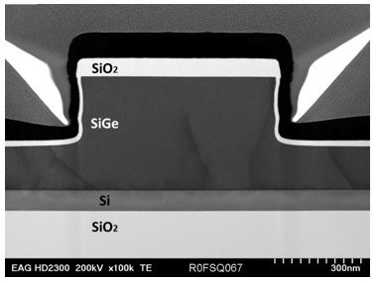
Figure 1. Waveguide cross-section TEM image for platform P1 (500 nm SOI).
To measure the transmission spectra, light from a tunable laser is coupled to the chip using a Si grating coupler. A Si waveguide butt couples the light to the SiGe waveguides. At the output, the light is coupled out of the chip using a Si grating coupler, and the output power is measured by a detector for a wavelength range of 1520 nm to 1600 nm. For both cells, we measured the transmission spectra before and after annealing.

Measurement results
The averaged data are normalized and elaborated numerically to calculate the Tauc curve with its tangent to the inflection point, as shown in Figure 2.
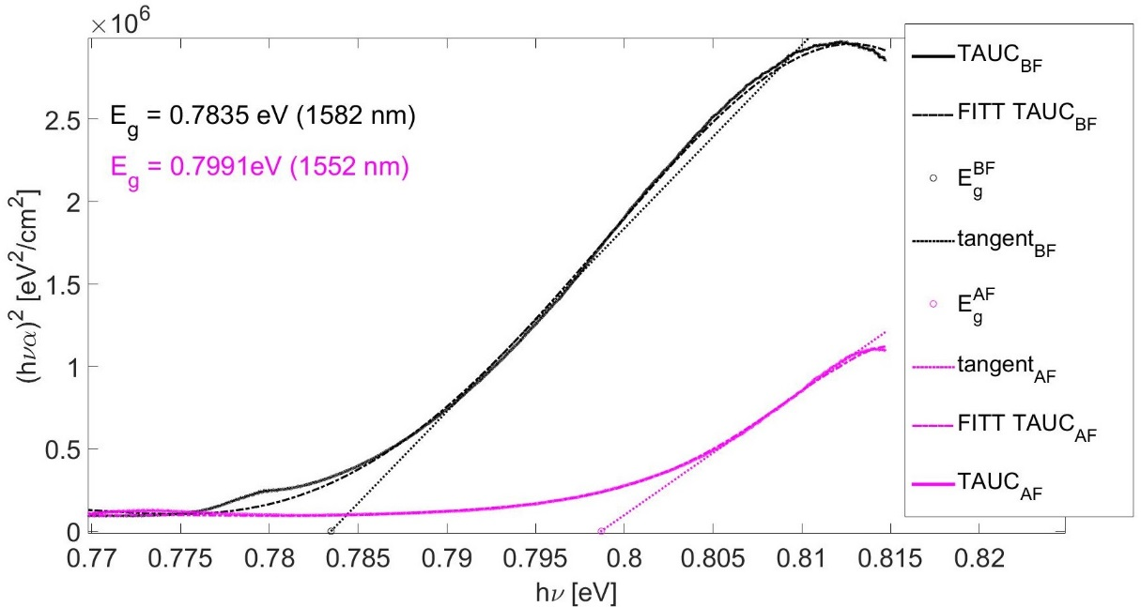
Figure 2. Tauc curve analysis before (black curve), and after (magenta curve) 10 minutes annealing at 750 °C on platform P1.
The measurement results for both platforms are summarized in TABLE I. By increasing the annealing time, the bandgap shifts exponentially in the first few minutes, and starts to saturate after just 5 minutes. The maximum-recorded shift is reached in 20 minutes.
For platform P1 (500 nm), two cells were tested. The first cell is annealed for 5 minutes at 750 °C; the resulting bandgap blueshift is approximately 25 nm. The second cell is instead annealed for 10 minutes at 750 °C, twice. After the first 10 minutes anneal, the material bandgap is blueshifted by about 30 nm, whereas after the additional 10 minutes anneal, the bandgap is blueshifted by only an additional 8 nm, resulting in a total blueshift of 38 nm. Further annealing does not change the bandgap, meaning that the shift-saturation is achieved.
For platform P2 (800 nm), two anneals were performed on the same cell. After the first anneal (5 minutes at 750 °C), the material bandgap is blueshifted by approximately 10 nm. The second anneal (10 minutes at 750 °C), instead blueshifts the bandgap by an additional 22 nm, resulting in a total blueshift of 32 nm.

TABLE I. Bandgap energy estimation for the 500 nm (P1) and 800 nm (P2) platforms versus the annealing time (at 750 °C).
Anneal Time [min] | Bandgap Energy (P1) [nm] | Bandgap Energy shift (P1) [nm] | Bandgap Energy (P2) [nm] | Bandgap Energy shift (P2) [nm]
0 | 1582 | 0 | 1579 | 0
5 | 1557 | 25 | 1569 | 10
10 | 1552 | 30 | 1547 | 32
20 | 1544 | 38 | - | -

Discussion
Annealing the samples causes a blueshift of the band edge up to 38 nm, suggesting an increase of Si in the alloy and/or a reduction of strain. A SIMS study revealed that 10 minutes anneal caused the Si in the SiGe alloy to migrate into the Ge-seed layer that agrees with the results found in (8), reducing the average Si content from 1.6% to 1.2%, but a uniform SiGe alloy was found throughout the trench. The overall Si reduction should cause a redshift of the transmission spectra, thus the measured blueshift can be only explained by the increasing of the mode absorption from the Ge-seed layer, before annealing.
Strain mapping before and after annealing has also been performed along the waveguide height, and integrated over the waveguide width using the Precession Electron Diffraction Technique (9)(10). After annealing, the tensile strain in the waveguide increases from 0.05% to 0.5%, in part due to the dislocations reduction (11). This increment should induce a redshift of the spectrum, hence the recorded blueshift should be attributed to a stronger impact of the Ge-seed layer on the material optical behaviour relative to the strain induced redshift.

Conclusion
We have demonstrated the bandgap shift of a SiGe layer after annealing on two SOI platforms (500 nm Si [P1] and 800 nm Si [P2]). For this purpose, we developed and realized passive waveguides in sites containing a nominal Si_{1.5%}Ge_{98.5%} layer grown by selective epitaxy. Transmission measurements were performed both before annealing, and after a range of annealing times, all at a temperature of 750 °C. The results show a maximum blueshift of 38 nm.
SIMS composition studies were performed both before and after annealing for the 500 nm SOI platform (P1). After annealing, we measured a 100 nm deep Si migration from the SiGe alloy to the Ge-seed layer. The measured Si content before and after annealing are 1.6% and 1.2%, respectively. We also found that after annealing, the material tensile strain increases from 0.05% to 0.5%. From our measurements, we therefore conclude that the Ge-seed layer affects the mode propagation because both the Si content decrease and the strain increase should suggest a redshift, whereas we measure a blueshift after annealing. The ability to fine-tune the material bandgap up to 38 nm can be successfully used to adjust the operational modulation wavelength of specific wafers, whilst still retaining the simplicity of only one epitaxy recipe.

Acknowledgments and contributions

This work had support from the Optoelectronic research Centre (ORC), the Southampton nanofabrication centre, EPSRC First Grant (EP/K02423X/1), EPSRC Platform Grant (EP/K02423X/1) and H2020 project COSMICC (688516).
Transmission electron microscopy experiments have been performed on the nanocharacterization platform at Minatec, Grenoble.
CGL acknowledges support from National Research Foundation of Singapore (NRF-CRP12-2013-04).

References
- D. J. Thomson, C. G. Littlejohns, S. Stanković, M. Nedeljkovic, and S. A. Reynolds, Silicon photonics, Wiley Encyclopedia of Electrical and Electronics Engineering, 1–22, John Wiley & Sons, Inc. (2015).
- C. G. Littlejohns, T. Dominguez Bucio, M. Nedeljkovic, H. Wang, G. Z. Mashanovich, G. T. Reed, and F. Y. Gardes, Scientific Reports, 5, 19425 (2016).
- D. Feng, w. Qian, H. Liang, C. C. Kung, Z. Zhou, Z. Li, J. S. Levy, R. Shafiiha, J. Fong, B. J. Lu, and M. Asghari, IEEE Journal of Selected Topics in QuantumElectronics, 19, 64-73 (2013).
- C. S. R. Murthy and M. Gurusamy, WDM Optical Networks: Concepts, Design, and Algorithms, Prentice Hall PTR (2002).
- J. Tauc, Materials Research Bulletin, 3, 37 – 46 (1968).
- E. A. Davis and N. F. Mott, Philosophical Magazine, 22, 0903–0922 (1970).
- B. D. Viezbicke, S. Patel, B. E. Davis, D. P. Birnie, physica status solidi (b), 252, 8, 1700-1710 (2010).
- S. Nagatomo, S. Kikuta, S. Hoshino and Y. Ishikawa, “NIR Laser Annealing Process for Dark Current Suppression in Selectively-Grown Ge Photodiodes on Si,” Symposium EP7.6.02 MRS Spring Meeting (2016).
- M. P. Vigouroux, V. Delaye, N. Bernier, R. Cipro, D. Lafond, G. Audoit, T. Baron, J. L. Rouvière, M. Martin, B. Chenevier, F. Bertin, Applied Physics Letters, 105, 191906 (2014).
- J. L. Rouviere, A. Béché, M. Yannick, T. Denneulin, D. Cooper, Applied Physics Letters, 103, 241913 (2013).
- H. C. Luan, D. R. Lim , K. K. Lee, K. M. Chen, J. G. Sandland, K. Wada and L. C. Kimerling, Applied Physics Letters 7(1), 2909–2911 (1999).

