The Use of a Winding Model Instead of Effective Continuum Model Can Lead to a Drastic Reduction of MQE in Superconducting Coils.
J Pelegrin, E. A. Young and Y. Yang

Abstract—Thermal stability is an essential parameter for coil design. Previous measurements in an MgB₂ solenoid have revealed a change in trend in the minimum quench energy (MQE) dependence on j = I/I_{c} showing lower values than expected for operative current close to the critical current (j ~ 0.90). The obtained MQE is comparable to the one predicted by analytical models in a single tape (1D) being of the order of 1 - 10 mJ, which indicates that propagation across winding and layers (3D) is not taking place. This reduction of MQE is not obtained in the effective continuum model because the different turns and layers are not reproduced. Obtaining 1D propagation depends on the ratio between the thermal conductivity of the conductor and insulation and on the cooling conditions at the boundary layers. A numerical model of a superconducting solenoid with full representation of the winding is used to study MQE as a function of j (0.6 – 0.99). The quench is triggered applying heat pulses of 40 ms in a region of 4 mm of the outer layer of the coil. The effect of changing the cooling boundary conditions of the coil from adiabatic to isothermal is also investigated.
Index Terms—MgB₂, Numerical modeling, quench, superconducting solenoid.

Introduction
S
uperconducting coils are developed for a wide range of applications that involve the generation of high magnetic fields. Thermal stability of the wires and tapes used in the applications is a key parameter in the design of the coils. A deeper understanding of the factors responsible for the reduction of the MQE is extremely important to design a quench protection system for superconducting coils. Although the thermal stability criterion for critical state behavior (i.e. LTS at 4.2K) is well understood, it is difficult to make predictions at intermediate temperatures, since many of the physical properties change rapidly with temperature. In addition the power law must be introduced to replace the critical state. Numerical simulations in the form of self-made codes [1]-[3], or commercial software [4], [5] can help to predict the MQE values of the coils. Experimental measurements [6] have shown that, depending on the conditions, the MQE in a solenoid can present values comparable to those of a single tape (1D) and can increase orders of magnitude (3D). A numerical model using COMSOL Multiphysics which allows varying the thermal properties of the insulating layers in order to produce 1D and 3D minimum propagation zones (MPZ) has been used. The mechanism that produce the change between 1D and 3D propagation in the coils with two different numerical methods and their predictability potential has been also investigated.

Description of the models
A solenoid coil of 0.1 m diameter, 10 layers and 10 turns has been modeled to study the quench generation and propagation. A round wire conductor similar to the one used in the experimental measurements was chosen [6]. Since the use of round wires for creating the geometry makes difficult the match of the mesh nodes between turns, the round wire is approximated by a square conductor with a width equal to the round wire diameter 5.64x10⁻⁴ m. With this assumption the physical properties of the wire are converted taking into account the ratio between the cross sections A_{square}/A_{round} = γ = 1.273. Two different models have been used in the analysis: a FULL 3D and Effective continuum model (CM).

FULL 3D model.
This model has full representation of the winding path of the coil. The superconducting wire and the insulation have a similar square cross section with a size of 5.64x10⁻⁴ m. An example of the cross section is shown in Fig. 1, where 3 turns and 3 layers of superconducting wires are surrounded by insulating layers (shadowed areas). The insulation of the experimental coil has a different thickness, however for simplification its dimensions are chosen equal to the wire in the model. The geometry is reproduced by extruding the cross section of the coil along a line created using the parametric equation of the spiral with a pitch. With the set of parameters chosen, both the superconductor and insulation are meshed with a single element across the thickness and width. When a thicker insulation is used, the number of elements in the insulation should be increased in order to model the main temperature drop over the insulation winding. A distributed mapped mesh along the winding direction is used, being narrower in the region where the heat pulse is applied.
Fig. 1. Example of the cross section of the coil with 3 turns and 3 layers of the conductor. Shaded regions represent the insulation surrounding the superconducting wires.

Effective continuum model (CM).
In this model the coil is represented by a cylinder with size 0.0113 m. The unit cell of this cylinder is formed by three parts of insulation and one part of conductor, as shown by the dashed line of Fig. 1. The physical properties of the model are averaged using that proportion. In this case a distributed mesh over all the dimensions is used, having the smallest mesh size in the region where the heat is applied.
To study the quench generation and propagation in the coil, the heat conduction equation (1) is solved in the geometry:
(1)
where d₀ is the density of the material, c_{p} the specific heat, k the thermal conductivity, G(T,I) the Joule heat dissipation of the superconductor due to the current sharing with the metal matrix, and P(r,t) the power of the heat pulse deposited in the superconductor to produce the quench.
To obtain G(T,I) in the conductor three assumptions are used:
- G(T,I) = 0 below the current sharing temperature, T_{CS}.
- Between T_{CS} and the critical temperature, T_{C}, the current in the conductor is shared between the superconducting material and the metal matrix so that I = I_{SC} + I_{MM}, I_{SC} and I_{MM} being the current in the superconductor and in the metal matrix respectively. The electric field in the superconductor is obtained using the power law, E = E₀(I/I_{c})^{n}, while for the electric field of the metal matrix a resistivity, ρ(T), is used.
- Finally, when the temperature is above T_{C} the heat generated is computed using ρ(T), in Ohm’s law to compute the Joule heating.
A 40 ms heat pulse is applied in a width of 4 mm in the conductor cross section for the FULL 3D model, while in the CM the heater has a length of 4 mm and a cross section of 1.27x10⁻⁶ m². The numerical results are also compared with those of the analytic model [7] obtained with the equation:
where A is the cross section of the conductor, j is the reduced current, η_{MQE} = 1 + √2/2 ~ 1.7 is the dimensionless MQE as explained in [7], and β is defined as β² = (je_{n})^{1/n}, being e_{n} = J_{c}ρ/E₀ ; E₀ = 1 µV/cm and n the n-number of the conductor.
In order to compare with the experimental results obtained in [6] the physical properties of the conductor where those of the MgB₂ wire used in the solenoid. Regarding the case of the insulation, the wire was surrounded by a fiberglass sleeve and the coil was impregnated with epoxy. For the model the physical properties of G10 wrap obtained from [8] have been chosen as an approximation. Moreover, all the simulations were done at T₀ = 30.5 K which corresponds to a I_{c} = 26 A, while T_{C} = 32.4 K.

Results
In the first set of simulations a study of the quench process in adiabatic conditions is done. The heat pulse is applied in the middle of the coil to reproduce a quench happening far from the boundaries of the coil. Figure 2 presents the MQE as a function of 1 - j for different thermal conductivity values of the insulation that surrounds the superconductor. It can be seen that the MQE values when k_{ins} is not multiplied by any factor (full squares) are between 1 - 4 mJ. These values are 40% higher compared to those of the analytic model (dashed line). However if we turn the model into a 1D model by switching off the thermal conductivity of the insulation (open squares) we obtain values similar to those of the analytic model. It must be noted that the reduction of MQE when 1 - j < 0.03 is due to the finite jump on G(T,I) existing at T_{CS}. Therefore we can conclude that in this case for this particular set of parameters, the quench in the coil will be produced with energies of the same order of magnitude of those in a single wire 1D. However if the thermal conductivity of the insulation is increased by a factor 3 (crossed squares), the MQE increases an order of magnitude, due to the heat spreading into a bigger volume to form the MPZ indicating a behavior similar to 3D. The transition between 1D and 3D is produced gradually for intermediate factors multiplying k_{ins}. Figure 2 displays the example of 2k_{ins} (halved squares). The previous case presents an increase to 3.5 mJ of the MQE for 1 - j = 0.01 while this value rise an order of magnitude up to 30 mJ at 1 – j = 0.3. This change in the MQE evidences a transition from values closer to 1D to values similar to the ones expected in 3D. Once again the responsible of this mechanism is the higher specific heat due to a higher increase in temperature in the hot spot when the pulse is applied for low values of operative current.
In the case of the CM the MQE values are between 6 - 26 mJ as shown in Figure 3 (full circles). The explanation to this effect can be found in the different volumes where the heat is applied. In the FULL 3D model the heat is deposited inside the conductor and then propagates to the insulation and adjacent turns, while in the CM the heat is deposited in a unit cell that includes the conductor and the insulation that is 4 times bigger. Switching off the thermal conductivity of the CM to obtain a pure 1D propagation reduces the value of the MQE for i.e. j = 0.99 to 2.03 mJ (open circle). However this value is artificial since it depends on the volume of the heater selected and it can be arbitrarily reduced which will reduce the values of MQE. In example if we multiply the heater volume by a factor H_{v} = 1/4 we obtain 0.45 mJ (crossed circle), while this value reduces to 0.12 mJ (halved circle) if H_{v} = 1/8. This effect is produced because, since there is no heat propagation in the radial direction the amount of heat needed to produce a MPZ and trigger the quench will tend to zero in the limit case of having a conductor with zero thickness.
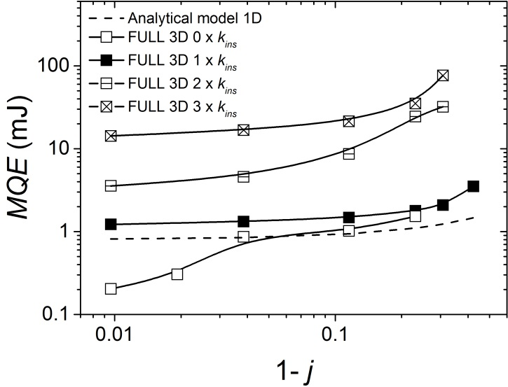Fig. 2. MQE as a function of 1 - j obtained using the FULL 3D model. Dashed line corresponds with the analytic 1D calculation, full line with square symbols corresponds to model with different factors multiplying the thermal conductivity of the insulation: open symbols (0·k_{ins}), full symbols (1·k_{ins}), halved symbols (2·k_{ins}) and crossed symbols (3·k_{ins}).
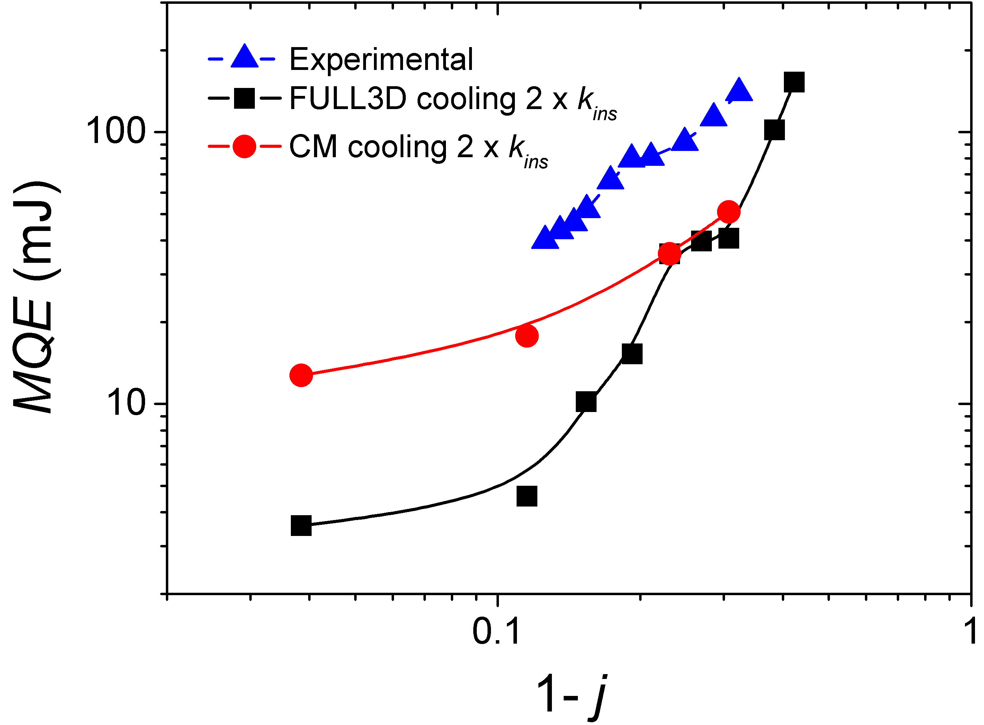Fig.4. MQE as a function of 1 - j obtained experimentally (triangles) and numerically using the FULL 3D model (squares) and CM (circles) when the heater is moved to the outer layer and a boundary layer with T = T₀ is added to the solenoid.
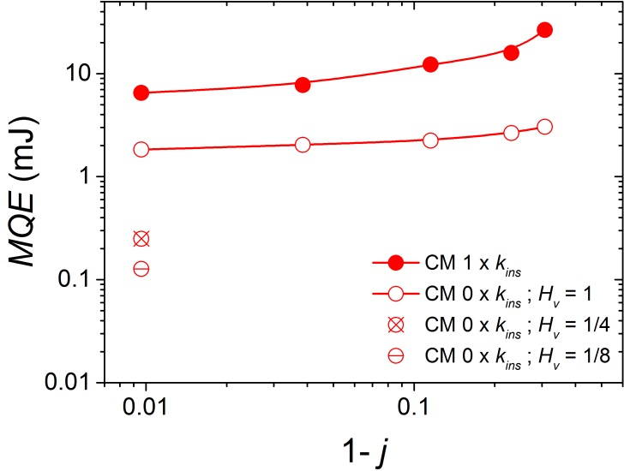Fig. 3. MQE as a function of 1 - j obtained using the CM model. Full circles correspond to a model with 1 x k_{ins}. The volume of the heater was changed in the case of radial thermal conductivity equal to zero (0 x k_{ins}) by multiplying it by a factor H_{v} = 1 (open circle), H_{v} = 1/4 (crossed circle) and H_{v} = 1/8 (halved circle).
As it has been seen the minimum quench energy values are strongly affected by the properties of the insulation, obtaining values with the set of parameters chosen closer to 1D in the adiabatic case. There is no transition observed to 3D values even at low j unless the thermal conductivity of the insulation is artificially increased. In order to trigger the transition to 3D a cooling condition is added to increase the MQE of the coil. In this case the heater is placed in the outer layer of the coil and a boundary layer with imposed T = T₀ in its outer surface is added. The thermal conductivity of the boundary layer is modified to change the amount of heat exchanged with the boundary.
The results obtained when the boundary layer has a thermal conductivity twice the one of the insulation of the coil are presented in Fig 4. The FULL 3D model (squares) presents MQE values between 3 - 4 mJ for j > 0.85. If the applied current is reduced, an increase in MQE is produced until a plateau is obtained at j ~ 0.75 with energies of 20 - 30 mJ, one order of magnitude higher than the ones at currents close to I_{c}. After the plateau the MQE rapidly increases one order of magnitude for j < 0.7. This behavior presents a transition between MQE of the order of magnitude of 1D and 3D and agrees qualitatively with the experimental findings observed in the MgB₂ solenoid (triangles) where two different MQE trends are observed separated by a plateau at j ~ 0.8. When the same conditions are simulated using the CM no drop of the MQE is produced and just one trend is found with values 4 times bigger than the FULL 3D ones for j > 0.85, and similar values for low applied currents.
The explanation of the effect can be done looking at the cross section of the coil in the FULL 3D model displayed in Figure 4. It presents the regions of the coil that are above the current sharing temperature, T_{CS}, for three different values of j. The position of the turn where the heat is applied is pointed with an arrow. The three maps are taken at different times since they display the time instant at which the quench is triggered in the coil. It can be seen how the region with higher temperature is located in the heated turn when j = 0.95 (Fig. 5 (a)), with only a small increase in temperature produced in the adjacent turns. However, when the applied current is reduced, j = 0.75 (Fig. 5 (b)), the cooling starts playing an important role in the quench process and the heat spreads to the adjacent turn of the heated one. When the quench is triggered both turns have a temperature difference of less than 1 K. This case corresponds to the plateau observed in Fig. 4. Finally when j = 0.70 (Fig. 5 (c)) the hotspot migrates to the adjacent turn of the heated one due to the effect of cooling and the quench is triggered in a turn different to the one where the heater is located. This effect produces an increase of the MQE by 2 orders of magnitude compared to the ones obtained at j = 0.95.
The change in trend of the MQE is therefore associated with turn to turn heat propagation and is not observed in the CM since the heat spreads homogeneously. The FULL 3D model is capable of obtaining more accurate results than the CM that would overestimate the MQE at currents close to the critical current of the conductor.

CONCLUSIONS
A numerical modeling analysis to study the mechanisms that change the MQE in superconducting coils has been done using two models: a FULL 3D and a CM. It has been seen that for a given set of parameters the MQE of the coil can be in the order of magnitude of that predicted by 1D analytic equation. The MQE is strongly affected by the thermal conductivity of the insulation and can increase the MQE of the coil of few orders of magnitude from 1D to 3D, due to the change in the volume of the MPZ. However the change of the thermal conductivity of the coil on its own does not explain the change in trend in the MQE observed experimentally in a solenoid coil. Only a smooth transition from 1D to 3D is observed in the simulation. The transition observed experimentally is promoted by cooling and can be reproduced in the model moving the heater to the outer layer of the coil and adding a constant temperature boundary condition. MQE values in the order of few mJ are obtained for j > 0.85, while the MQE increases 2 orders of magnitude for j < 0.7 after a plateau. The transition is associated with the movement of the hotspot to an adjacent turn of where the heat is deposited due to the effect of cooling. Only the FULL 3D model was able to produce the transition while the CM model overestimates the MQE values. Therefore, the FULL 3D model is preferable to study the quench processes even if it has a higher computational costs, since there are mechanisms that cannot be reproduced with the CM.

References
- K. Koruda et al., “Quench simulation analysis of a superconducting coil” Cryogenics 29, pp. 814-824, Oct 1989
- A.V. Gavrilin and A. A. Konyukhov, V.A. Malginov “Computer simulation and experimental study of quench in superconducting epoxy-impregnated multy-layer coil” IEEE Trans. Mag. 32, no. 4, pp. 2990-2993, Jul 1996
Fig. 5. MPZ cross sections of the FULL 3D model when the quench is triggered for (a) j = 0.95, (b) j = 0.75 and (c) j = 0.70. Arrow points the position of the heater. Only the regions with temperatures above T_{CS} are shown.
- A.V. Gavrilin and V.I. Shcherbakov “About evolution and propagation of normal zone in an adiabatic superconducting coil” Adv. Supercond. XI, Springer , Japan 1999, pp. 1467-1470.
- W. K. Chan and J. Schwartz “A hierarchical three-dimensional multiscale electro-magneto-thermal model of quenching in REBa₂Cu₃O_{7-δ} coated-conductor-based coils” IEEE Trans. Appl. Supercond. 22, no 5, p. 4706010, Oct 2012
- S. Caspi et al., “Calculating quench propagation with ANSYS®” IEEE Trans. Appl. Supercond. 13, no 2, pp. 1714-1717, Jun 2003
- E. A. Young et al., “Temperature and Background Field Dependence of Thermal Stability in a Compact MgB₂ Solenoid Coil” IEEE Trans. Appl. Supercond. 26, no 3, pp. 4702704, Apr 2016
- I. Falorio, E. A. Young amd Y. Yang. “Quench Characteristic and Minimum Quench Energy of 2G YBCO Tapes” IEEE Trans. Appl. Supercond. 25, no 3, p. 6605505, Jun 2015
- NIST Cryogenics material properties [Online]. Available: http://cryogenics.nist.gov/MPropsMAY/material%20properties.htm, Accessed on Sep. 7, 2016

J. Pelegrin is with the University of Southampton, Southampton, SO17 1BJ, UK (e-mail: jpm1c13@soton.ac.uk). E. A. Young is with the University of Southampton, Southampton, SO17 1BJ ,UK (e-mail: @soton.ac.uk). Y. Yang is with the University of Southampton, Southampton, SO17 1BJ, UK (e-mail: y.yang@soton.ac.uk).

