Abstract— We experimentally demonstrate space division multiplexed data transmission using the LP01, LP_{11a} and LP_{11b} modes over a 1 km length of elliptical-core few mode fiber (EC-FMF) at 1550 nm using 10 Gbit/s on-off keying data per spatial channel. Space division multiplexed transmission without the use of any multiple- input multiple output (MIMO) digital signal processing showed no power penalty relative to the single-mode or the back to back cases.
Elliptical Core Few Mode Fibers for Multiple-Input Multiple Output-free Space Division Multiplexing Transmission
F. Parmigiani, Y. Jung, L. Grüner-Nielsen, T. Geisler, P. Petropoulos, D. J. Richardson

Index Terms—Multiple input multiple output (MIMO); space division multiplexing (SDM); few mode fiber; intra-datacenter.

Introduction
As intra-datacenter networks (DCNs) continue to grow in scale there is a strong demand for new network infrastructures capable of keeping up with the increased amount of transmitted data in a cost- and energy-efficient manner [1-2]. Space division multiplexing (SDM), in combination with wavelength division multiplexing (WDM), has been proposed as a possible integrated solution to reduce the physical number of optical fibres [3]. SDM can be realised by sending data over different spatial cores or modes of a single multi-core or few-mode fiber (FMF)). For long-haul SDM transmission applications, the random linear mode coupling in FMFs requires the implementation of complex and costly multiple input multiple output (MIMO) digital signal processing (DSP) in order to allow successful reception of the multiple spatial channels, especially for those belonging to degenerate spatial modes of the same mode groups. However, the use of MIMO-less direct detection is imperative in short-reach high capacity DCN applications, in order to keep both the cost and the power consumption as low as possible, and this imposes stringent requirements on the tolerable inter-modal crosstalk among the guided modes. Towards this goal, the use of elliptical core (EC) FMFs has recently been proposed and demonstrated as a means of separating the spatial modes within the same modal group and, thus, ensuring negligible linear mode coupling between the individual spatial channels [4-6]. For example in [4] a 500 m-long FMF with a core-ellipticity of about 40% was used to demonstrate SDM
Manuscript received XXX.
This research is sponsored by EPSRC grant EP/I01196X, The Photonics Hyperhighway and EPSRC grant EP/P026575/1. The data for this work is accessible through the University of Southampton Institutional Research Repository (DOI http://doi.org/10.5258/SOTON/D0225). F. P., Y. J., P. P., D. J. R. are with the Optoelectronics Research Centre, University of Southampton, Southampton SO17 1BJ, U.K. (e-mail: frp@orc.soton.ac.uk); L. G.-N. is now at Danish Optical Fiber Innovation, Åvendingen 22A, 2700 Brønshøj, Denmark, T. G. is with OFS, Priorparken 680, 2605 Brøndby, Denmark.
transmission without coherent detection or MIMO-DSP. This was made possible by achieving a crosstalk level lower than -26 dB between the two degenerate spatial modes in the LP₁₁ mode group at 1300 nm. Similarly low levels of modal crosstalk were also exploited at 1550 nm over a 2 km-long EC-FMF, where only the fundamental mode and one spatial mode (LP_{11a}) of the LP₁₁ mode group were supported, to demonstrate the transmission of a 100 Gb/s dual polarization quadrature phase shit keying (QPSK) signal [4]. The same authors extended their work to demonstrate the use of a 1 km-long elliptical few-mode multicore fiber (specifically, a two-spatial mode four-core fiber) to achieve 1.2 Tb/s WDM + SDM transmission at 1.55 μm using 4 pulse-amplitude modulation (4-PAM) and on-off keying (OOK) with direct detection and no MIMO [6]. Each core had an ellipticity of about 11% and supported two spatial modes (LP₀₁ and LP_{11a}). However, these impressive results came with an increased power penalty when simultaneously exciting both spatial modes. Polarization maintaining elliptical ring core fibers (ERCFs) have been also proposed to further break the fibre symmetry and split the polarization degeneracy of the spatial modes; they were numerically investigated in [7] and subsequently used to experimentally demonstrate data transmission over six linearly polarized vector modes without the use of any MIMO or polarization division multiplexing (PDM) signal processing at the receiver [8].
In this letter we expand from [9], reporting complete sets of experimental results. We demonstrate the first SDM data transmission at 1550 nm over three distinct spatial modes without the use of MIMO using 1 km of a FMF with a core ellipticity of 10 %. The fibre supported three modes (LP₀₁, LP_{11a} and LP_{11b}) of the two lowest order mode groups at 1550 nm. The modest value of core ellipticity still guarantees a low level of modal crosstalk (below -20 dB) even for the two spatial modes within the same LP₁₁ mode group, while at the same time ensuring low polarization mode dispersion. This allows for negligible power penalty and no error floors when transmitting 10 Gbit/s OOK signals in any combination of the two selected spatial modes as compared to the back-to-back case.

experimental Set-up
The experimental set-up used for the SDM transmission employing the 1 km-long EC-FMF is shown in Fig. 1. Two 10 Gbit/s OOK signals were generated from two independent continuous wave (CW) lasers (100 kHz linewidth), both operating at a wavelength of 1550nm, using an amplitude modulator driven by 2³¹-1 pseudo-random bit sequences (PRBSs). The signals were launched into a free-space phase plate (PP)-based mode multiplexer (MMUX) after passing through the polarization controllers (PCs). With this arrangement, one signal was always launched into the LP_{11a} mode, whereas the second one was selectively launched into either the LP₀₁ or the LP_{11b} mode, by simply either removing or leaving the corresponding PP in place. High precision fiber rotators were used at each end of the EC-FMF to align the angular position of the elliptic core of the FMF with the axes of the modes defined by the PPs, while a polarization beam splitter (PBS) was used to ensure that the launched waves are all co-polarized at the input of the EC-FMF and aligned to its principal axis. This step was crucial to guarantee minimum modal crosstalk and, thus, optimum transmission performance. The signal power at the input of the FMF was about -2 dBm per channel. The FMF was a 1-km long graded-index fiber with a trench, supporting the LP₀₁ and both LP₁₁ modes, similar to the fiber described in [10]. However, unlike the fiber in [10], this had a core with an ellipticity of ~10% to effectively guarantee a break in the spatial degeneracy of the LP₁₁ mode group, thus allowing minimal linear mode coupling between the LP_{11a} and LP_{11b} modes, without breaking the polarization degeneracy of each mode [11]. The fiber loss was about 0.2 dB/km for all of the modes and the calculated effective areas of the LP₀₁ and the two LP11 modes were 89 μm² and 125 μm² at 1550 nm, respectively. A typical cross section of the fabricated fiber is shown in the inset of Fig.1, where the dark ring shows the low-index trench region. At the FMF output, the different spatial modes were extracted using a free-space PP-based mode-demultiplexer (MDMUX) and coupled into single mode fibers that fed an optical switch which was used to select and measure one MDMUX output at a time. An optically pre-amplified receiver was used to take eye diagrams and carry out bit error ratio (BER) measurements. The modal purity of each spatial mode was mainly limited by our MMUX and MDMUX and was evaluated using time-of-flight measurements [12], see Fig. 2. Figure 2(a) shows a typical impulse response measured at the output of the EC-FMF under LP₀₁ mode excitation. The main peak in the trace corresponds to the LP₀₁ mode, while the two smaller but distinct peaks on the left hand side of the main peak correspond to the LP_{11a} and LP_{11b} modes, respectively (indicating discrete mode coupling at the MMUX). The amplitudes of each peak represent the relative optical power in the excited mode and their power ratios give an indication of their corresponding mode coupling. The figure highlights that a modal purity better than 27 dB and a distributed crosstalk of about 30 dB was achieved. It is worth mentioning that typically in circular-core three-mode fibers (supporting LP₀₁, LP_{11a} and LP_{11b}) only two discrete temporal peaks are distinguishable due to the degeneracy of the LP_{11a} and LP_{11b} modes. On the other hand, in elliptical-core three-mode fibers three individual temporal peaks are distinguishable due to the effective index difference between the modes within the LP₁₁ mode group, as can be clearly appreciated in Fig. 2(a), Fig. 2(b) and Fig. 2(c). It is also worth noting that no significant mode coupling was observed while bending and twisting the fiber. In Fig. 2(a), the relative temporal positions of the peaks indicate their relative arrival time after propagation through the fiber, usually referred to as the differential mode delay (DMD). The DMD between the LP₀₁ and LP_{11a} (LP_{11b}) modes is about 500 ps/km (about 800 ps/km), while the DMD between the two modes within the same LP₁₁ mode group is about 300 ps/km. These values are fairly wavelength independent within the C-band. Also, note that we observed some photodetector ringing features (i.e. time domain oscillations or ripples) at the right side of the main peak. Figures 2(b) and 2(c) show similar temporal traces at the output of the EC-FMF, when the pulsed signal excites the LP_{11a} or the LP_{11b} mode, respectively. In both cases, we can observe a modal purity better than 20 dB and a distributed crosstalk of about 27 dB. Figure 2(d) reports the measured DMD between each supported mode pair as a function of wavelength. The modal crosstalk results are also confirmed by measuring the output power from the MDMUX. The DMD has also been modelled from the fiber refractive index profile by solving the two-dimensional scalar wave equation using a mode solver based on the finite difference method. The modelled DMD @1550 nm between the LP₀₁ and LP_{11a} (LP_{11b}) modes is 570 ps/km (870 ps/km), and 300 ps/km between the two modes within the same LP₁₁ mode group, in agreement with the measurement. The modelled effective indexes @1500 nm of LP₀₁, LP_{11a}, and LP_{11b} are 4.08∙10⁻³, 1.12∙10⁻³, and 1.01∙10⁻³, respectively, giving a splitting in effective indexes of the LP₁₁ modes of 1.1∙10⁻⁴. It is interesting to note that this relative small splitting is enough to assure the cross talk within the LP₁₁ mode group below -20 dB. Table 1 summarizes the intermodal crosstalk matrix among all spatial channels.
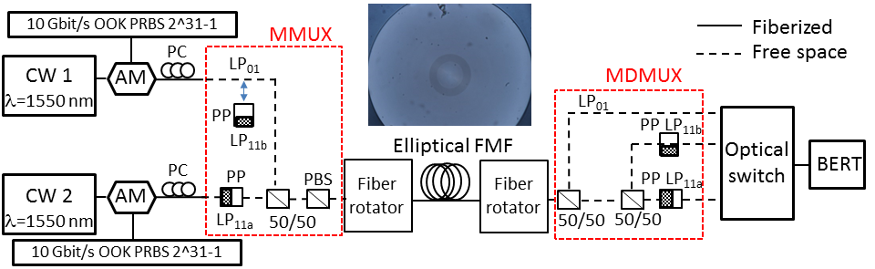
Fig.1: Experimental set-up of the MIMO-less SDM transmission. AM: amplitude modulator, PC: polarization controller, BERT: bit error ratio tester. Inset figure: cross section of the EC-FMF.
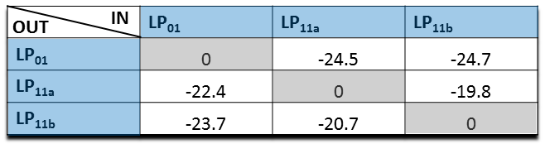
Table 1: Measured inter-modal crosstalk matrix of the three spatial modes LP₀₁, LP_{11a} and LP_{11b}. The values are given in dB.
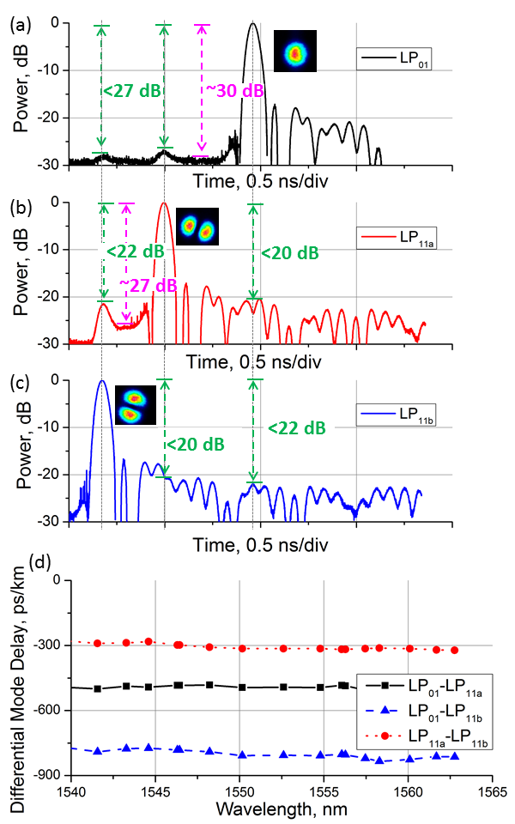
Fig.2: a-c) Impulse responses with selective mode excitation of the LP₀₁ (a), LP_{11a} (b), and LP_{11b} (c) modes, respectively, in the EC-FMF using a time of flight measurement set-up. Inset figure: mode profiles of the LP₀₁ (a), LP_{11a} (b), and LP_{11b} (c) modes, respectively, measured using a CCD camera at the end of the EC-FMF when exciting each individual spatial mode at its input. d) Differential mode delays as a function of wavelength among the three corresponding supported spatial modes.
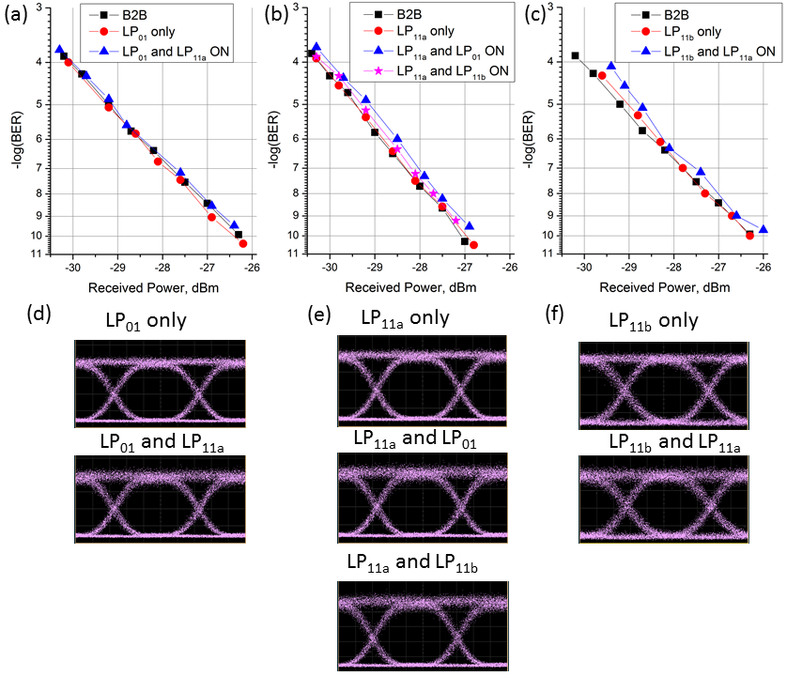
Fig.3: a-c) Measured BER curves for the LP₀₁ (a), LP_{11a} (b), and LP_{11b} (c) modes, respectively, with and without the other spatial mode on. Back-to back curves are included for references. (d-f) Typical eye diagrams of the signals transmitted in the LP₀₁ (d), LP_{11a} (e) and LP_{11b} (f) modes, respectively, with and without the other spatial mode on.

Experimental results
We measured BER curves versus received optical power for all of the three spatial modes LP₀₁, LP_{11a} and LP_{11b}, respectively, with and without the other signal transmitted in any of the other modes being present. The results are reported in Fig.3 (a)-(c). The back-to-back (B2B) BER curves, measured directly after the amplitude modulators, are also included for reference (see the square black symbols) in each graph. As can be seen, when only one signal is launched into the FMF (red circle symbols) no power penalty is observed as compared to the B2B, regardless of the mode this signal travels in. Negligible penalty is also observed when the SDM signals are launched into any pair of the modes supported by the fiber (blue triangle and pink star symbols). Importantly, no error floor is present even when the SDM signals are simultaneously launched into the modes of the same mode group, i.e. LP_{11a} and LP_{11b}. These are the results of the high modal purity and the extremely low distributed modal crosstalk. Figures 3 (d)-(f) show some typical eye diagrams of the signal launched into the LP₀₁, LP_{11a} and LP_{11b} modes, respectively, when the other SDM signals are either absent or present in the EC-FMF. Negligible signal degradation originating from the presence of the other SDM signals can be observed.
Finally, it is worth mentioning that this work can be easily scaled to many more modes by properly designing and fabricating fibers supporting such modes, see for example [7-8, 13].

Conclusions
We have experimentally demonstrated MIMO-less space division multiplex transmission at 1550 nm over 1 km of an elliptical core few mode fiber supporting the LP₀₁, LP_{11a} and LP_{11b} modes. Negligible power penalties and no error floors are observed when signals are launched in any pair of the modes in the fiber, even for modes within the same spatial mode group, which is due to the low level of modal crosstalk in the EC-FMF, below -22 dB.
As a next step, it will be important to understand the robustness of the system performance as the signal repetition rate and the transmission distances increase for a fixed fiber modal crosstalk level and polarization mode dispersion.
References
- L. Schares, B. G. Lee, F. Checconi, R. Budd, A. Rylya kov, N. Dupuis, F. Petrini, C. L. Schow, P. Fuentes, O. Mattes, and C. Minkenberg, “A throughput-optimized optical network for data-intensive computing,” IEEE Micro 34(5), 52–63 (2014).
- S. Yan, et al., “First demonstration of all-optical programmable SDM/TDM intra data centre and WDM inter-DCN communication,” in European Conference on Optical Communications (ECOC) , Cannes, France, Sept. (2014), paper PD1.2.
- D. J. Richardson, et al., “Space-division multiplexing in optical fibres”, Nature Photonics 7, 354-362, 2013.
- R E. Ip et al., “SDM transmission of real-time 10GbE traffic using commercial SFP + transceivers over 0.5km elliptical-core few-mode fiber”Opt. Express 23(13), 17120–17126, 2015.
- G. Milione, et al., “Real-time Bi-directional 10GbE Transmission using MIMO-less Space-division-multiplexing with Spatial Modes”, OFC W1F.2, 2016.
- G. Milione, et al., “1.2-Tb/s MIMO-less Transmission Over 1 km of Four-Core Elliptical-Core FewMode Fiber with 125-μm Diameter Cladding”, PD2-1, OECC/PS, 2016.
- L. Wang, et al., “Design of eight-mode polarization-maintaining few-mode fiber for multiple-input multiple-output-free spatial division multiplexing”, Optics Letters, vol. 40, no. 24, pp. 5846-5849, 2015.
- L. Wang, et al., “MIMO-Free Transmission over Six Vector Modes in a Polarization Maintaining Elliptical Ring Core Fiber”, Pare Tu2J.2, OFC 2017.
- F. Parmigiani et al. “MIMO-less Space Division Multiplexing Transmission over 1 km Elliptical Core Few Mode Fiber”, CLEO US 2017.
- L. Grüner-Nielsen, et al, “Few Mode Transmission Fiber with low DGD, low Mode Coupling, and low Loss,” Journal of Lightwave Technology, Vol. 30, no. 23, 3693-3698 (2012).
- F. Parmigiani, et al., “C- to L- band Wavelength Conversion Enabled by Parametric Processes in a Few Mode Fiber”, Th1F.4 OFC, 2017.
- J. Cheng, M. E. V. Pedersen, K. Wang, C. Xu, L. Grüner-Nielsen, and D. Jakobsen, “Time-domain multimode dispersion measurement in a higher-order-mode fiber,” Opt. Lett. 37, 347–349 (2012).
- G. Milione, et al., “Mode crosstalk matrix measurement of a 1 km elliptical core few-mode optical fiber”, Optics Letters, vol. 41 (12), 2755-2757, 2016.

