Numerical investigation of saw-toothed and sine-curved tailing edge shape of NACA0012 aerofoil
Pareecha Rattanasiri^{1,*}, Pakpong Jantapremjit¹, Alongkod Tipsiri¹, Tana arkadumnuay¹,
Wannachat Truekhakit¹ and Philip A. Wilson²
¹ Department of Mechanical Engineering, Faculty of Engineering, Burapha University,
Chon Buri Campus, Chon Buri, 20130, Thailand
² Fluid Structure Interactions Group, Faculty of Engineering and the Environment,
University of Southampton, SO16 7QF, United Kingdom
* Corresponding Author: pareecha@eng.buu.ac.th, +66(0)9-2768-7904, Fax +66(0)3839-0351
Abstract
This paper investigates the saw-toothed and sine-curved tailing edge shape of the NACA0012 aerofoil at chord Reynolds numbers of 5.25×10⁴, 1.05×10⁵ and 2.10×10⁵. Firstly, to examine the impact of the tailing edge shape to the flow behaviour and overall drag coefficient of the aerofoil. Secondly, to compare the drag coefficient for various speeds. The CFD RANS-SST with a commercial code ANSYS CFX simulation is performed for the fully submerged NACA0012 aerofoil of 150 mm chord length with three tailing edge shapes: standard straight line, saw-toothed and sine-curved shapes. The results show that a 25% increment of drag coefficient for saw-toothed tailing edge shape compared to the standard tailing edge shapes at Re = 5.25×10⁴, and the increase of 14% at Re = 1.05×10⁵ and 2.10×10⁵. At Re= 5.25×10⁴, the sine-curved tailing edge shape also caused a 16% of drag increment comparing with the standard tailing edge, while at = 1.05×10⁵ and 2.10×10⁵, the sine-curved tailing edge provided same drag results as the standard tailing edge. The result suggests that, in term of drag reduction, there is no benefit of using the alternative tailing edge shapes for NACA0012.

Keywords: NACA0012, airfoil drag, tailing edge shape, RANS-SST, ANSYS CFX

1. Introduction
For increasing human life quality, Aeroacoustics is currently applied in various industries such as wind turbine, aerospace, automobile, to create reduced or hopefully noiseless machines and mechanisms. Aerodynamic noise is noise radiated from blades or airfoil which associates the interaction between boundary layer and the solid surface. The research has shown that flow induced noise is the most important noise source, known as an airfoil self-noise. The turbulent boundary layer (TBL) trailing edge noise is the major cause of the airfoil self-noise. It occurs due to the aerodynamics fluctuating pressure of the TBL which is scattered into acoustics energy by the edge discontinuity and radiated to the far field [1]. According to the literature, recent studies have shown that a modification of the trailing edge geometry, as such saw-toothed and slotted trailing edge geometries, could reduce this noise [2]. Considering in term of the aerodynamic performance, the reduction of turbulent flow over an airfoil, may result in the drag reduction of an airfoil.
The purpose of this paper is to investigate the symmetric aerofoil with different tailing edge shapes operated in low Reynolds Number in term of aerodynamic drag. Also the aerodynamic wake will be shown.

2. Theoretical approach
Physically, there are two components of force acting on a body: pressure (P) and wall shear (τ_{w}). In the direction of resisting the movement, the aerodynamic drag can be calculated. Aerodynamic drag coefficient (C_{D}) are pressure drag coefficient (C_{P}) and skin friction drag coefficient (C_{F}).

C_{D} = C_{P} + C_{F} (1)
To predict an accurate aerodynamic drags, a steady-state Reynolds Averaged Navier Stokes (RANS) simulation has proved to provide reasonably accurate results when compared against the experimental results [3][4][5][6]. The CFD-RANS simulation with a commercial code ANSYS CFX [7] is then selected. Total drag of the model aerofoil could be predicted. The drag coefficient of aerofoil could then be estimated by:-

C_{D} = (Total drag)/ (0.5 ρ V²A) (2)
Where ρ is the fluid density, A is the aerofoil’s surface area.
The dimensionless air speed (V) in term of the Reynolds number (Re) based on chord length (L) could be calculated by:-

Re = 70000VL (3)

By assuming the flow is incompressible, the continuity equation becomes:-
$\frac{\overline{∂U_{i}}}{∂x_{i}}=0$ (4)
The momentum equation can be written as:-
$$ρ\left(\frac{\overline{∂U_{i}}}{∂t}+\frac{\overline{∂{U_{i}U}_{j}}}{∂x_{j}}\right)=-\frac{∂\overline{P}}{∂x_{i}}+\frac{∂}{∂x_{j}}\left\{μ\left(\frac{∂\overline{U_{i}}}{∂x_{j}}+\frac{∂\overline{U_{j}}}{∂x_{i}}\right)\right\}-ρ\frac{\overline{∂u_{i}^{'}u_{j}^{'}}}{∂x_{j}}+\overline{f_{i}}$$
$ρ\left(\frac{\overline{∂U_{i}}}{∂t}+\frac{\overline{∂{U_{i}U}_{j}}}{∂x_{j}}\right)=-\frac{∂\overline{P}}{∂x_{i}}+\frac{∂}{∂x_{j}}\left\{μ\left(\frac{∂\overline{U_{i}}}{∂x_{j}}+\frac{∂\overline{U_{j}}}{∂x_{i}}\right)\right\}-ρ\frac{\overline{∂u_{i}^{'}u_{j}^{'}}}{∂x_{j}}+\overline{f_{i}}$ (5)
Where, i is Cartesian co-ordinates in X, Y and Z and U_{i} are the Cartesian mean velocity components (U_{x}, U_{y}, U_{z}). The Reynolds stress tensor (${ρu}_{i}^{'}u_{j}^{'}$) is represented in the turbulence closure and ${\overline{f}}_{i}$ is the external forces. The previous three-dimensional model simulations have shown that the shear stress transport (SST) turbulence closure model is able to replicate the flow around object with a moderate computer accuracy [8]. Therefore, SST turbulence model was selected. However, to obtain a high fidelity simulation result needs an appropriate mesh strategy and mesh resolution to capture the effect of the boundary layer and the wake behind the body [9][10], therefore, it is important to introduce the mesh strategy used in the next topic.

3. Numerical modelling
3.1 Aerofoil modelling
The NACA0012 is modelled for the chord length (L) of 0.15 m and the span-width (S) is 0.29 m, the standard tailing edge shape (Figure 1 and 2) is performed to be used as the benchmark case for this study. Simulations of the saw-toothed and sine-curved tailing edge shape (Figure 1) are then performed. The surface area (A) is shown in Table 1.

3.2 Model domain and boundary condition
The dimension of the fluid domain is modelled as 0.3×0.3 m and 3.30 m long. Free slip wall conditions are used for the roof, floor, symmetry are made for both left and right side-walls. The air inlet velocity (V) is set at 5 m/s, 10 m/s and 20 m/s related to the chord Reynolds Number of interest are at 5.25×10⁴, 1.05×10⁵, and 2.10×10⁵ for a fully submerged case, with the zero relative pressure outlet boundary condition. The aerofoil is modelled by using a no slip wall condition. See Figure 3 and 4. The computational parameters are provided in Table 2. Meshing strategy is detailed in Table 3. Sample of meshing shows in Figure 5 and 6.

Table 1: Surface area of NACA0012 model
Tailing edge | standard | saw-toothed | sine-curved
A (m²) | 0.089422 | 0.083259 | 0.088246

Table 2: Computational parameters
Parameters | Setting
Mesh type | Unstructured with local refinement around airfoil and in wake regions
y+ | 1 (for 0.15 m long, 0.016 mm first layer height with 1.5 growth rate is selected)
No. of elements | 5-9 Millions with 8 prism layers in the boundary layer
Turbulence model | Shear Stress Transport
Inlet turbulent intensity | 1%
Wall modelling | Automatic Wall Function
Spatial discretisation | High Resolution
Timescale control | Auto Timescale
Convergence criteria | RMS residual < 10⁻⁶
Run type | Intel CORE i7 with 2GB RAM

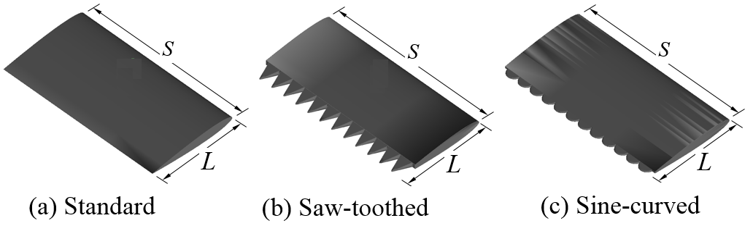
Figure 1: The NACA0012 with standard, saw-toothed and sine-curved tailing edge shape.

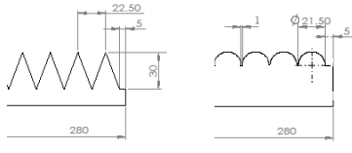
(a) saw-toothed (b) sine-curved
Figure 2: Dimension of tailing edges

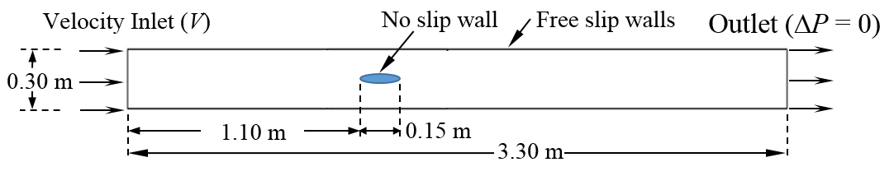
Figure 3: Fluid domain and boundary conditions

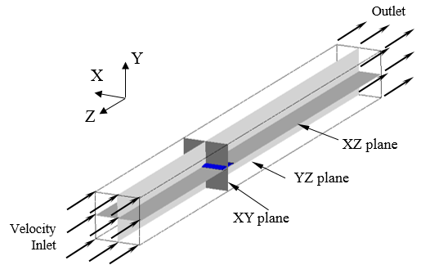
Figure 4: Isometric view of simulation domain

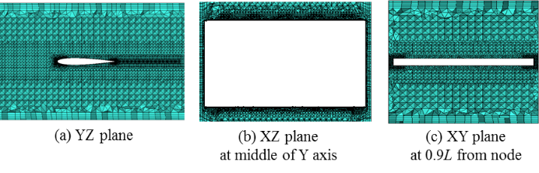
Figure 5: Fine mesh set for NACA0012 with standard tailing edge

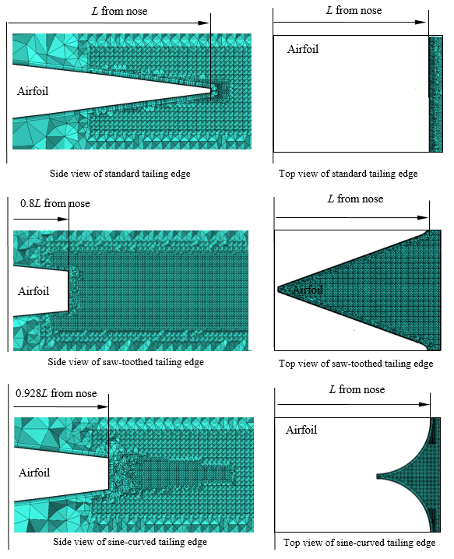

Figure 6: Fine mesh set for NACA0012 with standard tailing edge, saw-toothed tailing edge
and sine-curved tailing edge (Left) side view at YZ plane (Right) top view at XZ plane

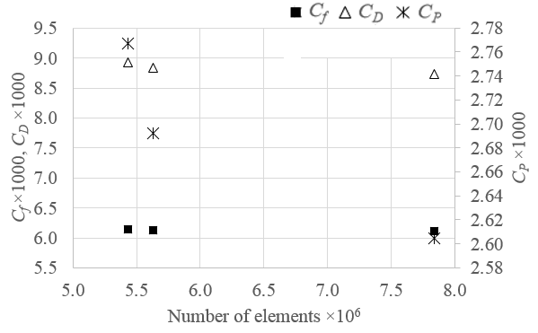
Figure 7: Mesh convergence for NACA0012 with standard tailing edge at Re=2.10×10⁵

Table 3: Mesh strategies for NACA0012 with standard tailing edge at Re=2.10×10⁵
Meshing | No. of elements ×10⁶ | Simulation time (wall clock hours) | C_{F}  ×1000 | C_{P}  ×1000 | C_{D}  ×1000 | %C_{D}
Coarse | 5.43 | 2.4 | 6.141 | 2.767 | 8.928 | -
Medium | 5.63 | 5.6 | 6.123 | 2.692 | 8.836 | 1.0
Fine | 7.84 | 7.3 | 6.112 | 2.604 | 8.738 | 1.1

4. Result

4.1 Mesh convergences
One measure of accuracy of the numerics is the effect of mesh convergence. Mesh convergences were tested as the results shown in Figure 7. The definition of %C_{D} are as following;

$\%C_{D}=\frac{C_{D,i}-C_{D,i-1}}{C_{D,i}}×100$%, (6)

Where, i is the drag coefficient of coarse, medium and fine mesh. Table 3 shows results of C_{D}, C_{F}, C_{P} and %C_{D}. Due to it is a simple geometry, there is no different results for C_{F} at different number of mesh, consequently, C_{D} which is dominated by C_{F} shows no change of results. The convergence of meshing from coarse, medium to fine mesh is found for C_{P}, due to mesh refinement at nose and tail, the pressure gradient is predicted more accurately. From accuracy and time consuming prospect, the fine mesh set up is selected in this study.

4.2 Influence of tailing edge shapes
Table 4 shows the results of drag coefficient, skin friction coefficient and pressure coefficient and percent differences for saw-toothed TE and sine-curved TE compared with standard TE, the equations are as following;
$\%C_{F}=\frac{C_{F,modified TE}-C_{F,standard}}{C_{F,standard}}×100\%$ $\%C_{P}=\frac{C_{P,modified TE}-C_{P,standard}}{C_{P,standard}}×100$%,
$\%C_{D}=\frac{C_{D,modified TE}-C_{D,standard}}{C_{D,standard}}×100$%, (7)
The physical mechanism in these flow condition can be observed from Figure 8 and 9.
The velocity drop occurs between the teeth of the saw-toothed TE, consequently, pressure around that area increases, this results in the higher pressure drag coefficient of saw-toothed TE which affects the drag increment. While the sine-curved TE shows the pressure recovery along the curves, this could lead to the reduction of approximately 7% to 9% of pressure drag compared with the standard TE. In every Re, the skin friction drag shows no different results between saw-toothed TE and sine-curved TE.
Figure 10 show the velocity profile of flow past NACA0012 at Re=5.25×10⁴, 1.05×10⁵ and 2.10×10⁵. The results show that the TE shape influence the velocity profile up to 0.2L, as seen the shape of green dash line and red dot line. The velocity profile of flow behind 0.2L show that the flow is accelerated by the saw-toothed TE shape and on the other hand, is decelerated by the sine-curved TE shape.

4.3 Impact of the Reynolds number at each tailing edge shapes
The impact of the Re to aerofoil with a standard and modified TE shape show no difference in the results. It could be seen from Figure 11 and Table 5 that for same type of TE, the higher Re, the lower C_{D}. The Re = 5.25×10⁴, NACA0012 with saw-toothed TE experienced higher drag, then the sine-curved TE, the standard TE experienced the lowest drag. At Re = 10.5×10⁴ and 21.0×10⁴, the sine-curved TE show the same drag as that of the standard TE shape. The results also show that the drag of saw-toothed TE are 26%, 14% and 15% higher than that of standard TE for Re at 5.25×10⁴, 1.05×10⁵ and 2.10×10⁵, respectively.

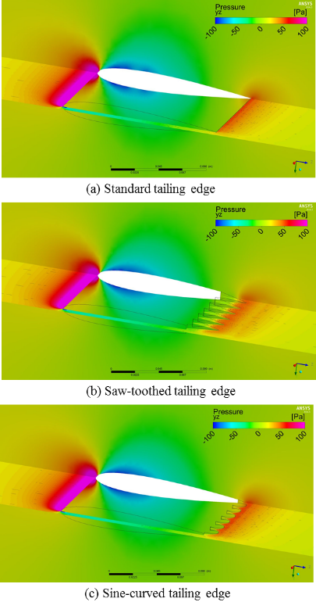
Figure 8: The pressure contour of flow past NACA0012 at Re = 2.10×10⁵

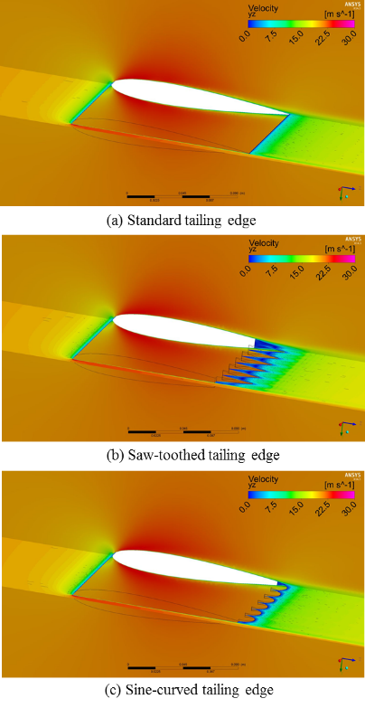
Figure 9: The velocity contour of flow past NACA0012 at Re = 2.10×10⁵

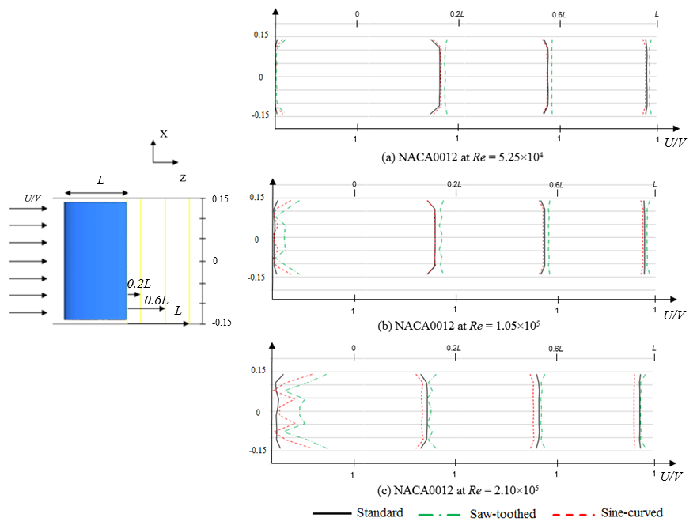

Figure 10: The velocity profile of flow past NACA0012 at Re=5.25×10⁴, 1.05×10⁵ and 2.10×10⁵

5. Conclusion and Suggestion
The CFD RANS-SST used in a commercial code ANSYS CFX simulation is performed for the fully submerged NACA0012 aerofoil of 150 mm chord length with three tailing edge shapes: standard straight line, saw-toothed and sine-curved shapes. The working section of fluid domain is modelled as 0.3×0.3 m with 3.30 m long. The investigation had been done at Re of 5.25×10⁴, 1.05×10⁵ and 2.10×10⁵. The results provided a good understanding of the flow behaviour behind the modified TE shapes. Considering the aerodynamics performance, the results also could benefit the aerofoil designer.
Firstly, to examine the impact of the tailing edge shape to the flow behaviour and overall drag coefficient of aerofoil. The results show that 25% increment of drag coefficient for saw-toothed tailing edge shape compared to the standard tailing edge shapes at Re = 5.25×10⁴, and the increase of 14% at Re = 1.05×10⁵ and 2.10×10⁵.
Secondly, to compare the drag coefficient for various speeds. At Re= 5.25×10⁴, the sine-curved tailing edge shape also caused the 16% of drag increment comparing with the standard tailing edge, while at = 1.05×10⁵ and 2.10×10⁵, the sine-curved tailing edge provided same drag results as the standard tailing edge. The result suggests that, in term of drag reduction, there is no benefit of using the alternative tailing edge shapes for NACA0012.
In conclusion, for the performance aspect, there is no benefit of using saw-toothed TE for NACA0012. The drag reduction occurs for NACA0012 with the sine-curved TE shapes.
This investigation shows the change of pressure and velocity around the curved of modify TE shape, it suggests the potential of increase the performance of an asymmetric NACA aerofoil if modify with the sine-curved TE shape.

6. Acknowledgement
The authors acknowledge the associated support services at the University of Southampton, in the completion of this work.

Table 4: The drag coefficient, skin friction coefficient and pressure coefficient and percent differences
Re=  5.25×10⁴ | C_{F} | %C_{F} | C_{P} | %C_{P} | C_{D} | %C_{D}
Standard | 8.08 |  | 3.98 |  | 12.07
Saw-  toothed | 10.37 | 28 | 4.80 | 21 | 15.18 | 26
Sine-  curved | 10.38 | 28 | 3.67 | -8 | 14.05 | 16
Re=  10.5×10⁴ | C_{F} | %C_{F} | C_{P} | %C_{P} | C_{D} | %C_{D}
Standard | 6.99 |  | 3.11 |  | 10.12
Saw-  toothed | 7.47 | 7 | 4.01 | 29 | 11.49 | 14
Sine-  curved | 7.44 | 6 | 2.87 | -7 | 10.32 | 2
Re=  21.0×10⁴ | C_{F} | %C_{F} | C_{P} | %C_{P} | C_{D} | %C_{D}
Standard | 6.11 |  | 2.60 |  | 8.74
Saw-  toothed | 6.49 | 6 | 3.54 | 36 | 10.04 | 15
Sine-  curved | 6.49 | 6 | 2.37 | -9 | 8.86 | 1

Table 5: Comparing the results of coefficient for various Re at each TE shapes
NACA0012 | Standard tailing edge (×1000)
Re×10⁻⁴ | C_{F} | C_{P} | C_{D} | %C_{D}
5.25 | 8.08 | 3.98 | 12.07
10.5 | 6.99 | 3.11 | 10.12 | 16
21.0 | 6.11 | 2.60 | 8.74 | 14
 | Saw-toothed tailing edge (×1000)
Re×10⁻⁴ | C_{F} | C_{P} | C_{D} | %C_{D}
5.25 | 10.37 | 4.80 | 15.18
10.5 | 7.47 | 4.01 | 11.49 | 24
21.0 | 6.49 | 3.54 | 10.04 | 13
 | Sine-curved tailing edge (×1000)
Re×10⁻⁴ | C_{F} | C_{P} | C_{D} | %C_{D}
5.25 | 10.38 | 3.67 | 14.05
10.5 | 7.44 | 2.87 | 10.32 | 27
21.0 | 6.49 | 2.37 | 8.86 | 14

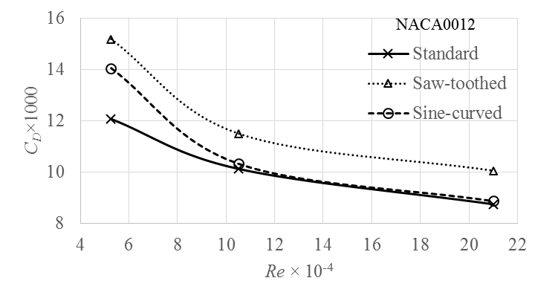
Figure 11: C_{D} for NACA0012 with different tailing edge at Re=5.25×10⁴, 1.05×10⁵ and 2.10×10⁵

7. References
[1] Zhu, W. and Shen, W. (2015) Airfoil Trailing Edge Noise Generation and Its Surface Pressure Fluctuation. Journal of Power and Energy Engineering, 3, 14-19. doi: 10.4236/jpee.2015.37003.
[2] Gruber, M. (2012) Airfoil noise reduction by edge treatments. University of Southampton, Faculty of Engineering and the Environment, Doctoral Thesis, 229pp.
[3] Phillips, A.B., Furlong, M. and Turnock, S.R. (2007). The use of computational fluid dynamics to assess the hull resistance of concept autonomous underwater vehicles. in OCEANS 2007 IEEE Aberdeen.
[4] Molland, A.F., and Utama, I.K.A.P. (1997) Wind tunnel investigation of a pair of ellipsoids in close proximity. Technical Report 98. Ship Science, University of Southampton.
[5] Larsson, L. and Baba, E. (1996). “Ship resistance and flow computations.” Advances in marine hydrodynamics. vol 5. pp. 1–75. Computational Mechanics Publications.
[6] Phillips, A. B. (2010) Cost effective hydrodynamic concept design of autonomous underwater vehicles. PhD. Thesis. University of Southampton.
[7] ANSYS, 2010. ANSYS CFX, Release 12.1. ANSYS.
[8] Eleni, D.C ., Athanasios, T. I. and Dionissios, M. P. (2012) Evaluation of the turbulence models for the simulation of the flow over a National Advisory Committee for Aeronautics (NACA) 0012 airfoil. Journal of Mechanical Engineering Research, 4(3), pp. 100-111.
[9] Rattanasiri, P, Wilson P.A. and Phillips, A.B. (2014). Numerical Investigation of a fleet of towed AUVs. Ocean Engineering. Vol. 80C: pp. 25-35.
[10] Rattanasiri, P, Wilson P.A. and Phillips, A.B. (2013). Numerical Investigation of a pair of self-propelled AUVs operating in tandem. Ocean Engineering. vol. 100, pp 126-137.

