Characterization approach on the extrusion process of bioceramics for the 3D printing of bone tissue engineering scaffolds

Gaoyan Zhonga,b,c,*,#, Mohammad Vaezib,#, Ping Liua, Lin Pand, Shoufeng Yangb,a,e,*

a*College of Engineering, Nanjing Agricultural University, Nanjing, 210031, China*

b*Faculty of Engineering and the Environment, University of Southampton, Southampton SO17 1BJ, UK*

c*State Key Laboratory for Manufacturing Systems Engineering, Xi’ an Jiao tong University, Xi’ an, 710054, China*

d*Nanjing Zhongxiangfeng Nano Technology Co., Ltd, Nanjing, 210029, China*

*ePMA, Department of Mechanical Engineering, Katholieke Universiteit Leuven (KU Leuven), Leuven 3001, Belgium*

**Abstract:** The present study proposes a characterization approach for the extrusion process of hydroxyapatite (HA) paste considering the nonlinear characteristics of bioceramics materials with the aim of printing high-resolution ceramic scaffolds using low-temperature extrusion 3D printing technology. A novel method named the three-point experimental extrapolation was executed to analyze the necessary extrusion pressure in relation to the extrusion velocity. This new approach presented a higher analytical accuracy as compared to previous methods. The optimum layout of the 3D printer was obtained by the comparative analysis of four typical topological constructions. On this basis, three main factors affecting the extrusion pressure of bioceramics materials, namely paste formulation (solvent content), nozzle length-to-diameter ratio, and the extrusion velocity, were selected as the control factors, and a series of experiments were performed using the L27 (313) orthogonal array. The results indicate that all the control factors significantly affected the extrusion pressure, of which the length-to-diameter ratio of nozzle exhibited the greatest effect. The scaffold printed using low-temperature extrusion 3D printing technology exhibited a uniform microstructure following the optimization of the printing parameters, which validated the ability of the process to accurately control the microstructure. The results of the study can be considered as a guide for the 3D printing of high-resolution bone tissue engineering scaffolds and can be employed to further compression mold bioactive polyetheretherketone/hydroxyapatite (PEEK/HA) composites.

**Key word:** Low-temperature extrusion; 3D printing; Characterization; Bioceramics; Scaffolds; Three-point experimental extrapolation

**1 Introduction**

The creation and repair of damaged tissue or end-stage organ failure is one of the most important and costly problems in human health care. Tissue engineering (TE), which was first proposed by Langer and Vacanti in 1987, applies the principles of biology and engineering to the development of functional substitutes for damaged tissue [1]. Over the past three decades, the development of materials science and manufacturing technology has resulted in the rapid growth of TE to address signiﬁcant medical requirements such as severe tissue damage repair or the displacement of failed organs [2], of which its groundbreaking medical applications have been employed in fabricated skin [3], cartilage [4, 5], bones [6, 7], neural tissue [8], the lung [9], the liver [10], and relatively complicated organoids [11]. The tissue engineering scaffold, which is among the three important elements in TE, is a permeable structure that functions as a synthetic extracellular matrix (ECM) to allow cell to develop in favorable directions and encourage cell attachment, expansion, and differentiation [12]. One of the most important challenges in TE is the design and fabrication of an ideal biodegradable scaffold [13], thereby permitting cell adherence and proliferation to allow the preservation of cell specific properties and simultaneously be suitable for surgical interventions [14].

Among the many fabrication techniques, material extrusion has been applied in a variety of important applications such as in additive manufacturing (AM) [15]. The extrusion technology of paste materials that are selectively dispensed through a nozzle or orifice has long been used as a means of achieving the desired shape of many different products [16], thereby also deeming the technology as suitable for the fabrication of hard tissue scaffolds for bone tissue engineering [17]. Yang and Vaezi proposed a novel bioactive polyetheretherketone/hydroxyapatite (PEEK/HA) composite for biomedical applications [18-21]. Porous bioactive HA scaffolds were first fabricated using extrusion-based AM technology. PEEK melt was then infiltrated into the HA scaffolds by the compression molding process. PEEK was chosen due to its excellent performance, particularly its biocompatibility and desirable mechanical properties. Scaffolds are vital in TE for their role in the growth of new tissue or the repair of defected tissue given that scaffolds provide the necessary support for cells to proliferate and maintain their differentiated functions. In addition, the scaffold architecture defines the ultimate shape of a new organ [21]. Extrusion-based AM systems are favorable for the printing of scaffolds because of their ability to process a wide range of biomaterials, great porosity control, and generation of pore interconnectivity, which is essential for proper cell in-growth.

In particular, the solvent-based extrusion freeforming (SEF) process is a typical low-cost extrusion-based AM technique. Evans and Yang first developed the SEF process as an application for the low-temperature AM of ceramic lattice structures with controlled filament/pore size and distribution to offer good macroarchitecture or microarchitecture control and to guarantee pore interconnectivity [22-25]. However, due to the lattice architectural features of scaffolds that have highly porous and interconnected three-dimensional channels, the high-resolution printing of these structures has deemed the SEF process as one of the key technologies for the material extrusion process. In 1968, Oveston and Benbow proposed a model to describe the extrusion of ceramic pastes following the assumption that the ceramic pastes exhibit perfect plasticity [26]. However, in the actual extrusion process, ceramic pastes are not perfectly plastic and exhibit nonlinear behavior such that Benbow and Bridgwater modified the model in 1993 with the addition of the power index [27]. The improved model was named the Benbow-Bridgwater model [16]. This particular approach to boundary layer modelling in paste flow has become fairly common. The extrusion process must consider parameters such as the flow properties of the material, the extrusion velocity, and the geometrical details of the extruder [28, 29].

Although studies on paste flow and extrusion have long been presented, the printing of high-resolution lattice scaffold architectural features for tissue engineering still exhibits many challenges. The accurate characterization of the extrusion pressure is the basis for optimizing both the 3D printer system and its printing parameters. Hence, the characterization of the extrusion pressure of bioceramics has been one of the key technologies for the material extrusion process. The present study proposes a new approach for the characterization of the extrusion pressure considering the nonlinear characteristics of bioceramics materials, optimizing the structural layout of the 3D printer with the aim of printing high-resolution ceramic scaffolds using low-temperature extrusion 3D printing technology. The present study aims to present results that can serve as a guide for the 3D printing of high-resolution bone TE scaffolds and can be used for the further compression molding of bioactive PEEK/HA composites.

**2 Materials and methods**

Yang and Vaezi developed a low-cost production technology to 3D print scaffolds and compression molds of bioactive PEEK/HA composites [18-21]. Table 1 depicts the process and methods of the technique as it is applied to create a bioactive PEEK/HA composite. Porous bioactive HA scaffolds were first fabricated using low-temperature extrusion freeforming 3D printing technology, after which PEEK melt was infiltrated into the HA scaffolds by the compression molding process.

Table 1 Fabricating process of HA scaffold and bioactive PEEK/HA composite for bone TE

|  |  |  |  |
| --- | --- | --- | --- |
| Step | Process | Diagram | Method |
| 1 | Preparation of ceramic paste | E:\paper\Bone Tissue Engineering Scaffolds\20170509\step1.GIF | Adhesive binder polyvinyl butyral (PVB) and plasticizer polyethyleneglycol (PEG) are fully dissolved in propan-2-ol solvent with the ratio of 75% (w/v) PVB and 25% (w/v) PEG. HA ceramic powder is then added to the solution (with 60% (v/v) of ceramic based on the dried paste), and stirred for 2 hours to achieve a well-dispersed solution. |
| 2 | Solvent evaporation | E:\paper\Bone Tissue Engineering Scaffolds\20170509\step2.GIF | Excess solvent is evaporated by fast stirring, and blowing hot air (such as using hair dryer) until a viscous ceramic paste is achieved. |
| 3 | 3D printing | E:\paper\Bone Tissue Engineering Scaffolds\20170509\step4.GIF | Ceramic paste is loaded into a syringe for 3D printing. The extrusion process forms lattice-shaped 3D scaffolds by incrementing regularly arranged 2D layers in the vertical axis. |
| 4 | Drying, debinding and sintering of the scaffold | E:\paper\Bone Tissue Engineering Scaffolds\20170509\step5.GIF | The scaffold is left at room temperature for 24 hours to allow evaporation of excess solvent, and subsequently to place the scaffold in an oven for debinding and sintering. Different heating procedures can be applied depending on the type of ceramic, such as the maximum sintering temperature for HA is 1300°C with a dwelling time of two hours. The bioceramic scaffold is then obtained. |
| 5 | Compression moulding of PEEK powder into the HA scaffold | E:\paper\Bone Tissue Engineering Scaffolds\20170509\tu\step7.PNG  Using both static and dynamic loads to produce a PEEK/HA composite. | Static loading: The mould is heated up to 250°C then load applied until the temperature reaches 400°C, maintains for a further 20 minutes (dwelling time), then heating is stopped, and the mould is left to cool under pressure.  Dynamic loading: The mould is heated up to 400℃ and maintains for 20 minutes. Load is applied for 5 seconds before heating is stopped, then the mould is left to cool under pressure. Whereby the PEEK matrix crystallized and solidified. |
| 6 | Get bioactive PEEK/HA composite | E:\paper\Bone Tissue Engineering Scaffolds\20170509\tu\step8.PNG | Composites are removed from the mould when the temperature has fallen to just below the glass transition temperature (143°C), follows by cooling to room temperature, thus mitigating thermal stress and cracking. |

According to Table 1, the characterization of the extrusion process is crucial to this technology as it determines the fabrication of high-resolution HA scaffolds. The accurate characterization of the extrusion pressure is the basis for the optimization of both the 3D printer system and its printing parameters. Therefore, the present study discusses the further development of the characterization approach to improve the presented characterization accuracy according to literature [21]. Table 2 presents the materials used to form the presented HA ceramic pastes.

Table 2 Materials being used to form ceramic pastes in this study

|  |  |  |  |  |  |
| --- | --- | --- | --- | --- | --- |
| No. | Material | Molecular formula | Melting point (°C) | Density (g/cm3) | particle size (µm) |
| 1 | HA (powder) | Ca10(PO4)6(OH)2 | 1650 | 3.156 | 1-5 |
| 2 | PVB(binder) | C14H18ClN3S | Amorphous | 1.100 | - |
| 3 | PEG(plasticizer) | HO(CH2CH2O)nH | 64-66 | 1.127 | - |
| 4 | propan-2-ol(solvent) | (CH3)2CHOH | -88.5 | 0.789 | - |

**3 Analysis of the paste extrusion process**

3.1 The paste extrusion process

The quality of bone TE scaffolds fabricated using the low-temperature extrusion 3D printing method depends on the rheological properties of the ceramic paste and the die geometry. Figure 1(a) presents the flow of the pastes in a ram extruder based on the Benbow-Bridgwater model. Paste is contained in a barrel with diameter *D*0 and is forced by a ram into a die land (capillary) with diameter *D* and length *L*. The important feature of capillary flow is its use of very small capillary diameters that exhibit laminar flow throughout with no turbulent core. With this knowledge, we can find the rheological properties of a flowing paste from the experimental measurements [16]. In proceeding from the barrel into the die land, the paste extends in the direction of flow and its cross-section decreases. The paste extrusion process is comprised of three stages [30], namely the (1) initial stage, (2) steady stage, and (3) dead zone stage, as presented in Fig. 1(b).

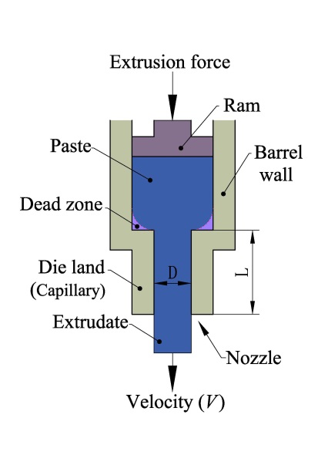 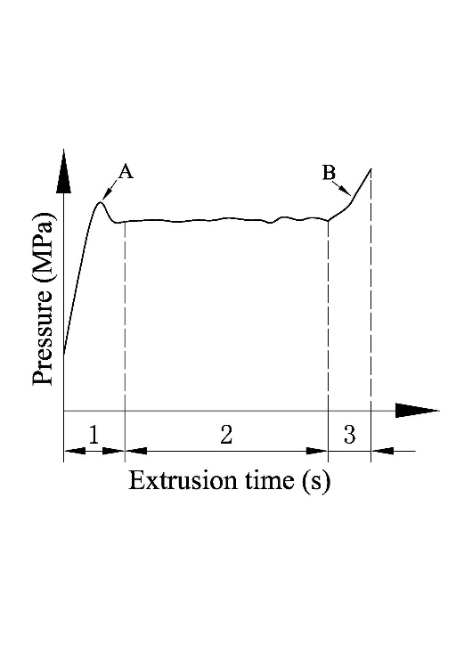 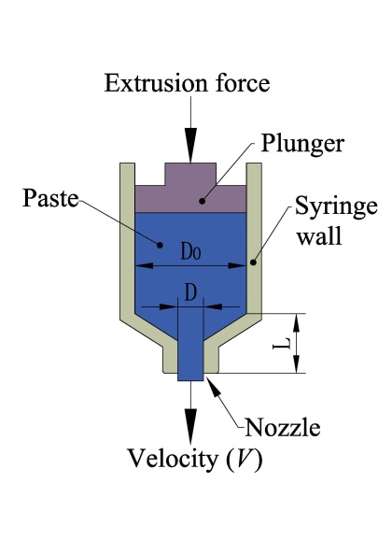

(a) (b) (c)

Fig. 1 Schematic diagram of paste extrusion: (a) cross-section of a ram extrusion, (b) pressure-time extrusion curve, where, 1 represents initial stage, 2 represents steady stage and 3 represents dead zone stage, and (c) cross-section of a syringe plunger extrusion

The initial stage encompasses the starting ram movement until the steady status of the paste extrusion process. In this stage, the application of extrusion force on the ram generates pressure build-up within the paste with decreasing paste volume, thereby allowing the excretion of entrapped air in the paste. The compression of the paste results in enhanced pressure augmentation until a peak point is reached, after which paste extrusion from the nozzle occurs. Meanwhile, the solvent of the paste quickly evaporates in the outlet of the die land. In particular, ceramic pastes that are suitable for AM applications generally have a low solvent content that allow easy evaporation following paste exposure to air. Therefore, the paste through the nozzle rapidly dried, upon which the friction pressure between the die wall and the drier paste turned into the predominant resistance. The drier paste was then expelled from the nozzle as the extrusion pressure conquered this resistance, and the paste flowed out rapidly to release the excessive pressure. This resulted in a quick pressure drop and the formation of the peak point in the extrusion pressure profile, which is presented as point “A” in Fig. 2(b). With the exception of the shear pressure at the barrel wall, the paste deformation resistance in the die entry and the flow pressure in the die land were also deemed the main paste flow resistance pressures at this stage.

After the initial stage, the paste was continuously extruded throughout the period that exhibited a stable status and relatively constant pressure remains, which is also called the “steady stage”. Despite the above-mentioned steadiness, the extrusion pressure may exhibit a little fluctuation due to the temporary inhomogeneity in the paste, which is induced by air bubbles and agglomerates. After the steady stage, the ram reached to the dead zone, where the paste is stationary at the bottom of the barrel, which yielded a rapid increase in the extrusion pressure, as presented by curve “B” in Fig. 1(b). The dead zone is dynamically changed in the paste extrusion process. The beginning of the pressure increase to the end of the extrusion process is termed the “dead zone stage”. To improve the stationary paste in the bottom of the barrel and generate an increase in the extrusion pressure, an optimized structure for the extrusion of the syringe plunger is presented in Fig. 1(c). Meanwhile, a higher ram velocity may generate a faster paste flow, thereby shortening the dead zone stage to reduce the impact of this stage on the extrusion pressure.

3.2 Analysis model of the extrusion process

Many researchers have found that paste materials often exhibit a substantial yield stress such that there is little bulk shearing of the material when flowing in a capillary, i.e. plug flow. In such cases, the extrusion velocity *V* can be used as a measurement of the volumetric flow rate [16]. The Benbow-Bridgwater model-based extrusion process has two flow zones, particularly one that is from the barrel into the die land, the extrusion pressure of which is expressed as *P*1, and another that is along the die land, the extrusion pressure of which is expressed as *P*2. Following the incorporation of the two zones, the extrusion pressure required for paste flow can be calculated by equation (1) assuming that the paste material is a perfect plastic.

 (1)

However, experimental results generally indicate the imperfect plastic state of paste materials given their nonlinear behavior. Therefore, equation (1) can be modified as follows:

 (2)

where, in equations (1) and (2), *P* is the extrusion pressure, *σ*0 is the initial bulk yield stress of the paste, *τ*0 is the initial paste-die wall shear stress, *α* is the velocity-dependent parameters of the convergent flow on the die entry, *β* is the velocity-dependent parameters of the parallel flow in the die land, *m* and *n* are exponents, *V* is the mean extrusion velocity of the paste, *D*0 is the barrel diameter, and *D* and *L* are the die land (capillary) diameter and length, respectively. Of the six characterizing parameters, namely *σ0*, *α*, *m*, *τ0*, *β*, and *n*, three are associated with the flow from the barrel into the die land and the remaining three are associated with the flow along the die land. Parameters *σ0* and *τ0* depend strongly on the paste formulation. Considering the rheological properties of the paste materials and the die geometry, equation (2) can be written as follows:

 (3)

where *f*(*V*) and *g*(*V*) are the functions of the extrusion velocity (*V*) related to the rheological properties of the paste.

3.3 Characterization method of the extrusion pressure

To enable better control on the low-temperature extrusion 3D printing process and generate high-resolution bioceramic scaffolds for the bone TE, the present study considered control factors that affect the paste extrusion pressure, specifically paste formulation (solvent content), extrusion velocity (*V*), and nozzle geometry (*L*/*D*). The characterization of the extrusion pressure has been one of the key technologies for the material extrusion process. The present study discusses the characterization method of the extrusion pressure using equation (3) as an example. From equation (3), an increase in capillary length *L* can theoretically result in an increment of extrusion pressure, which hinders high-resolution printing. When *L* tends to zero, the minimum pressure *P*0 can be obtained. However, in the actual printing process, the presence of a capillary length-to-diameter ratio tending zero generally presents very obvious entry and exit capillary effects, which affect the construction of the printed scaffolds. In addition, due to the insufficient flow of the paste in the capillary, it is impossible to obtain useful capillary flow data. Therefore, it is vital to ensure that the capillary has a suitable length *L* within the allowable range of the printer structural stiffness. The data set for *L/D*=0 can be determined either by extrapolation or estimation based on the available experimental date points [21]. Previous research [16] presented a linear relationship between the extrusion pressure and *L/D* ratio. Based on this conclusion, the data set for *L/D*=0 in literature [21] was obtained by extrapolating the data of *L/D*=32 and *L/D*=64, which is named the one-point method in this study. However, the extrusion pressure may exhibit minor fluctuations due to the presence of air bubbles and agglomerates, which results in temporary inhomogeneity in the paste even at the steady stage. The data set, which is based on the conventional one-point method to characterize *f*(*V*) and *g*(*V*) in equation (3), generates relatively large pressure errors between the experimental value and the predicted/simulation value. Therefore, the present study generated an improved valuation method named the three-point experimental extrapolation (or “three-point method”) to characterize the extrusion pressure value. To illustrate this approach, a schematic diagram is presented in Fig. 2, where the *x*-coordinate axis represents the length-to-diameter ratio *L/D* and the *y*-coordinate axis represents the extrusion pressure *P*.

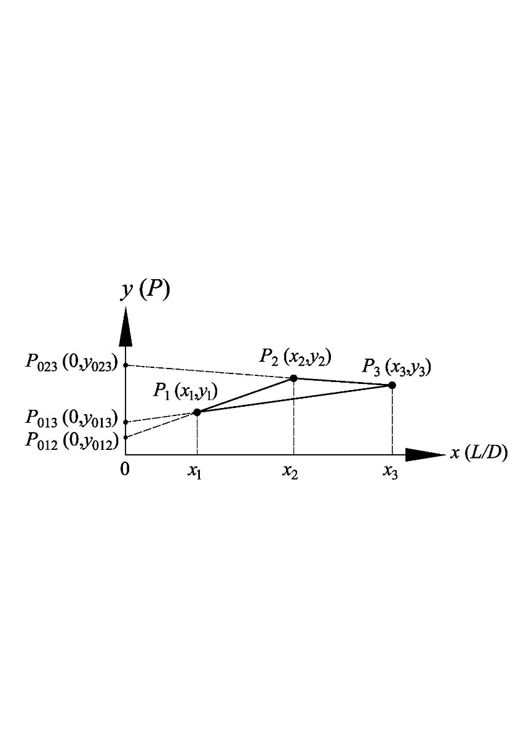

Fig. 2 Schematic diagram of three-point experimental extrapolation

The three-point experimental extrapolation proceeds as follows:

The extrusion experiment is first performed with three definite *L/D* values under a certain extrusion velocity (*V*), wherein each extrusion pressure *P*i (*i*=1, 2, 3) can be measured. The coordinate values of the three points are *P*1(*x*1, *y*1), *P*2(*x*2, *y*2), and *P*3(*x*3, *y*3), respectively, as presented in Fig. 2. The *P*2*P*1 line then extends to the *y*-axis to obtain the *P*012(0, *y*012) point, extends the *P*3*P*1 line to the *y*-axis to obtain the *P*013(0, *y*013) point, and extends the *P*3*P*2 line to the *y*-axis to obtain the *P*023(0, *y*023) point, respectively. In addition, the following geometric relationship is followed:

 (4)

By transforming the above equation, equation (4) can be written as follows:

 (5)

Similarly, the following relationships can be obtained.

 (6)

 (7)

Hence, the mean extrusion pressure value *P*0 can be obtained with the following relationship when *L*/*D*=0:

 (8)

Substituting equation (8) into equation (3), the mean *f*(*V*) value under a certain extrusion velocity (*V*) can be calculated as follows:

 (9)

Using the experimental pressure value *P*i with different *L/D* values into equation (3), the *gi*(*V*) value can then be calculated as follows:

 (10)

Consequently, the mean *g*(*V*) value under a certain extrusion velocity (*V*) can be calculated as follows:

 (11)

The extrusion experiment would be repeated according to the above steps using at least three different extrusion velocities (*V*). The discrete data of *f*(*V*) and *g*(*V*) can then be obtained in relation to each extrusion velocity (*V*). However, the discrete data of the *f*(*V*) and *g*(*V*) values cannot be directly employed because they do not provide the necessary information related with any extrusion velocity (*V*). Therefore, a set of analytical models composed of polynomial fitting curves is required to calculate the *f*(*V*) and *g*(*V*) values at an arbitrary *V* for the assessment of the extrusion pressure based on the least squares theory. The orders of the polynomials are determined by the inspection of the residual errors of approximation following the analysis of the mean squared error (MSE) [31].

**4 Experimental designs**

4.1 Topological construction of the low-temperature extrusion 3D printer

The TE scaffolds are lattice structures with highly porous and interconnected three-dimensional channels. To print these structures, the low-temperature extrusion 3D printer must exhibit four main features, specifically *x*-, *y*-, and *z*-sliding tables and a paste extrusion head. The structural layout of the printer plays a critical role in the quality of the printed scaffolds. According to the multi-body system theory [32], the low-temperature extrusion 3D printer can be considered as an open kinematic chain consisting of a series of links connected by bodies. A workbench can be placed at one end of this chain, on which a substrate can be used as support for the printed scaffolds, while an extrusion head mounted on an extrusion axis can be placed on the other end. To reduce the extrusion force, the optimum layout of the extrusion axis is in the vertical direction (i.e., *z-*direction).

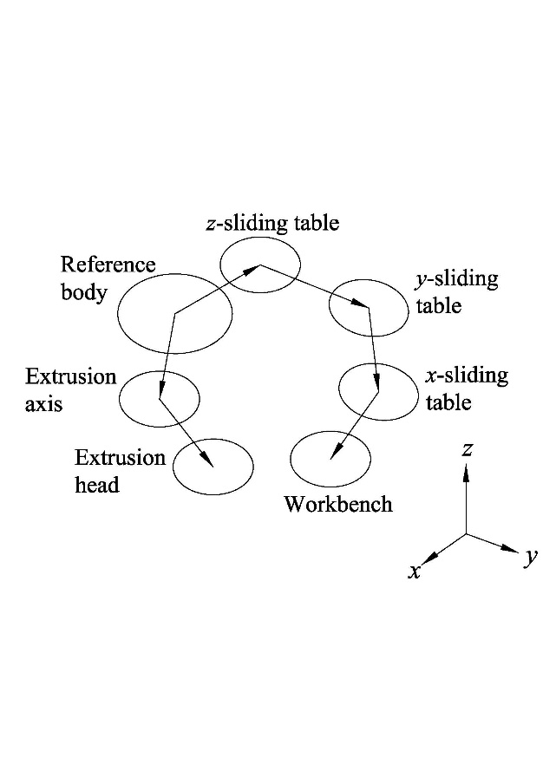 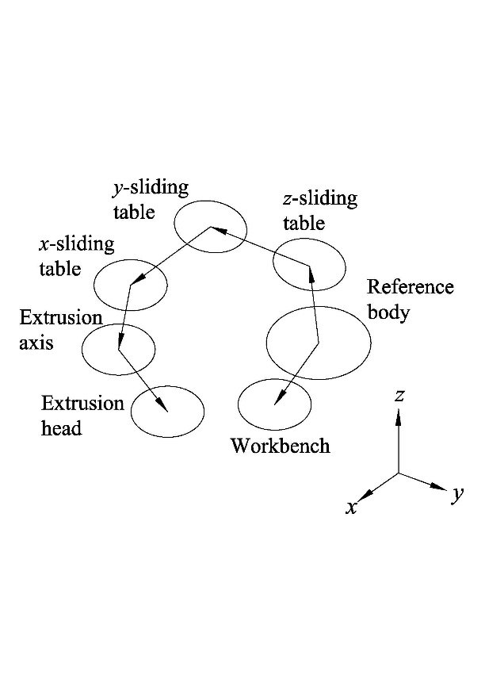

(a) (b)

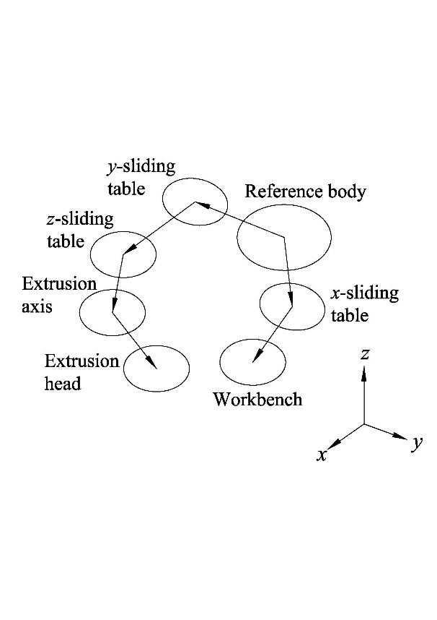 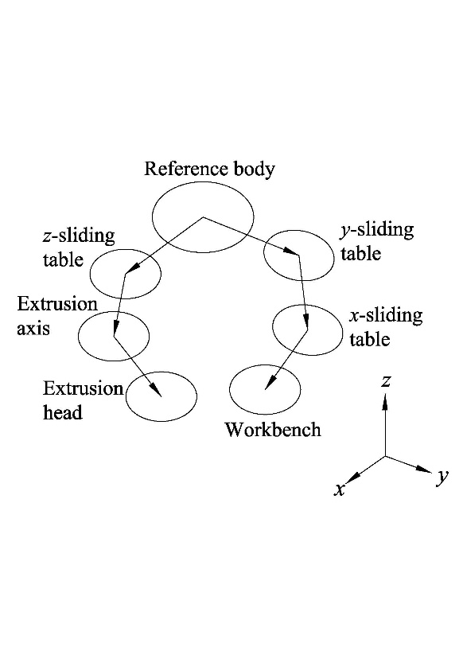

(c) (d)

Fig. 3 Four typical topological constructions: (a) layout 1, (b) layout 2, (c) layout 3, and (d) layout 4

Figure 3 presents the four typical topological constructions of the low-temperature extrusion 3D printer. In layout 1, the *x*-, *y-*, and *z-*sliding tables are placed on the workbench end, thereby resulting in a complex workbench moving structure. In layout 2, the *x*-, *y*-, and *z*-sliding tables are placed on the extrusion head end, thereby resulting in a complex extrusion head moving structure. In layout 3, the *x*-sliding table is placed on the workbench end, and the *y*- and *z*-sliding tables are placed on the extrusion head end, which also results an in complex extrusion head moving structure. As compared to above three layouts, the *x*- and *y*-sliding tables in layout 4 are placed on the workbench end, and the *z*-sliding table is placed on the extrusion head end. This advantageous layout creates relatively simple moving parts for both the extrusion head and the workbench. Therefore, the topological construction of layout 4 was chosen as the design basics for the low-temperature extrusion 3D printer.

4.2 Experimental 3D printing system

Following the application of the topological construction of layout 4, a low-temperature extrusion 3D printer was constructed by Yang et al. to create HA ceramic scaffold lattice structures, as presented in Fig. 4. Three extrusion heads (nozzles) of different length-to-diameter ratios were employed to optimize the extrusion control parameters. To ensure movement precision in the three dimensions, the geometric errors of the printer was compensated by software-based error compensation techniques [31, 33].

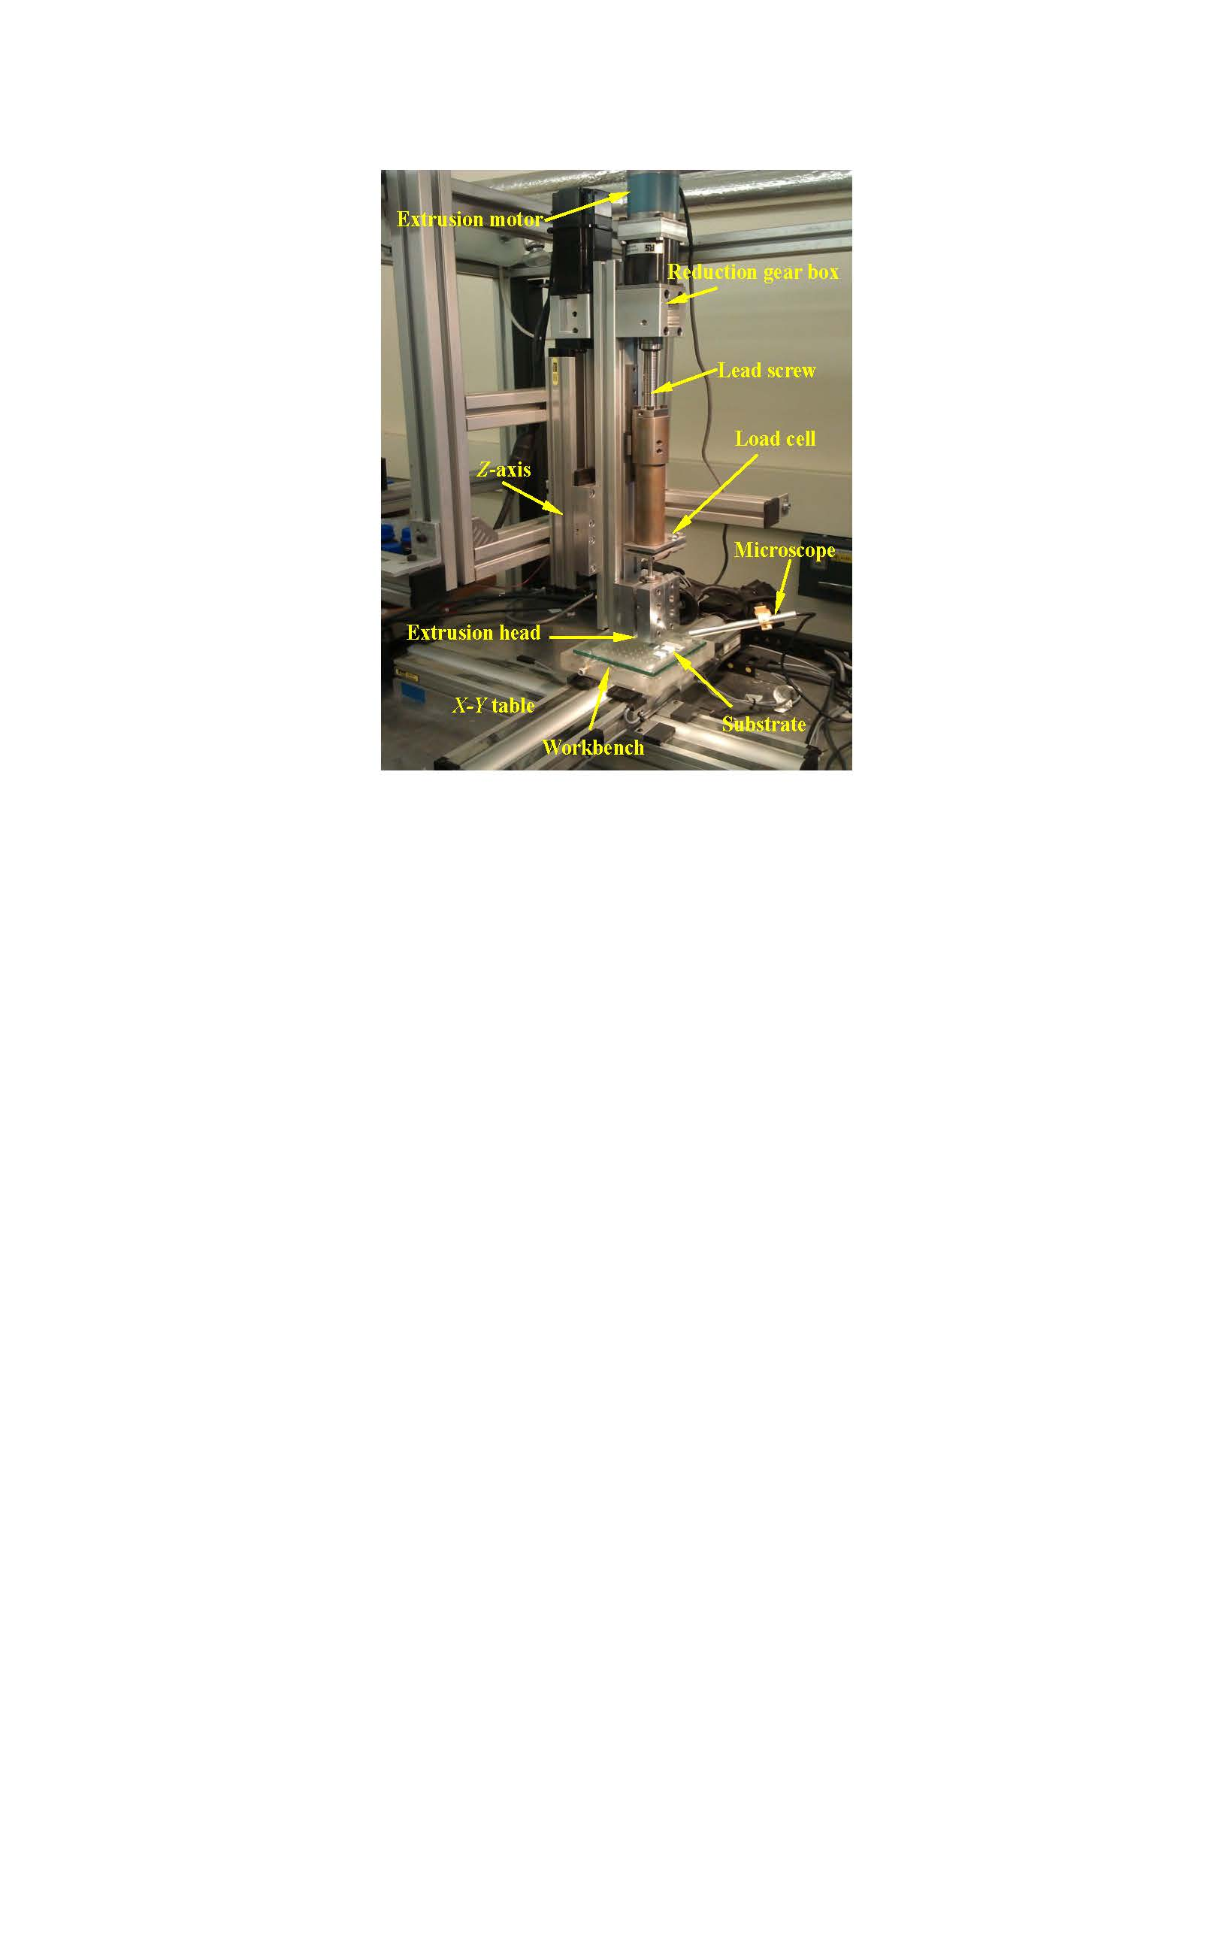 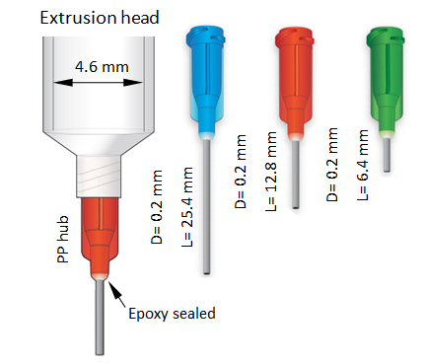

(a) (b)

Fig. 4 3D printing system: (a) self-developed low-temperature extrusion 3D printer, and (b) three extrusion heads with different length-to-diameter ratio

The paste extrusion head installed at the end of the extrusion axis, which is comprised of a stainless steel syringe, can move in the *z*-direction, whereas the substrate clamped on the workbench, which is made of glass material, can move in the *x-* and *y*-directions. The extrusion head extruded ceramic paste into the fine filaments and the movement of the *x-y* table resulted in the writing of paste on the substrate. Following the 3D printing of a layer, the extrusion head moved up for a fine pre-set amount and dispensed a new layer on the previously printed layer. By repeating this procedure, the whole lattice structure can be printed layer-by-layer.

Three linear servo motors were used to separately drive the *x-*, *y-*, and *z-*sliding tables to ensure accurate movement precision in all three dimensions, while a stepper motor drove a 2 mm-pitch lead screw (*i.e*., extrusion axis) to generate a continuous extrusion force on the syringe plunger during the extrusion process. A reduction gear box mounted between the stepper motor and lead screw was used to decrease the speed of the stepper motor to reach a smooth displacement. The extrusion pressure was measured by a load cell that was mounted on the extrusion axis. While the system was over-load, the load cell provided the alarm. The entire printing process was recorded and observed on a computer by a microscope.

4.3 Data collection

Low-temperature extrusion 3D printing offers the ability to rapidly print functional materials with complex 3D structures of different resolutions. Its resolution depends on several control factors such as the precision of the motion system, appropriate adjustment of the process parameters (*e.g.*, extrusion speed with respect to the *x*-*y* table motion), the type of material, and the paste delivery system. In particular, paste formulation is a crucial factor in determining the extrudability, extrusion pressure, and viscoelastic behavior of the paste to design and successfully print high-resolution 3D materials. Following the careful adjustment of the printer motion system and error compensation, the paste formulation (solvent content), nozzle length-to-diameter ratio (*L/D*), and extrusion velocity (*V*) at the three different levels were selected as the control factors. The Taguchi orthogonal experiment method generated statistically identical valid results using a lesser experiment number as compared to the classic experimental design. The selection of the Taguchi orthogonal array is vital in obtaining valid conclusions. The present study considered the three factors at each of the three levels and three interactions, thereby deeming the total degree of freedom as 18. The appropriate orthogonal array for this study is L27 (313), which consist of 13 columns for assigning the factors or interactions and 27 rows for designating the trials or experimental conditions. Three control factors, namely the solvent content, *L*/*D*, and *V*, were randomly placed in column 1, column 2, and column 6. Three nozzles of different length-to-diameter ratios were created from stainless steel tubes epoxy sealed to a polypropylene hub, thereby giving these the ability to work in high pressures, as presented in Fig. 4(b). For all the experiments, each extrusion pressure was read in the steady stage (after 120 s pre-extrusion as the initial stage). The pressures still exhibited fluctuations in the steady stage due to imperfections between the plunger and the syringe wall, or due to local agglomerates. The pressure value *Pi* (here, *i*=1 to 27) was calculated as the mean of the three extrusion readings to ensure the accuracy of the measurement data. The relevant factors and levels are presented in Table 3.

Table 3 Factors and their levels using L27 (313) orthogonal array

|  |  |  |  |  |  |  |  |  |  |
| --- | --- | --- | --- | --- | --- | --- | --- | --- | --- |
| Fixed factors | | |  | Control factors | | | | | |
| Factor | Value | Unit | Factor | Symbol | Level | | | Unit |
| 1 | 2 | 3 |
| D0 | 4.6 | mm |  | Solvent content | A | 10.2 | 13.4 | 15.2 | wt% |
| D | 0.2 | mm | L/D | B | 32 | 64 | 127 | - |
| Material | HA paste | | velocity (*V*) | C | 2.7 | 5.3 | 8.0 | mm/s |

A series of experiments were performed to effectively characterize HA paste extrusion and statistically analyze the contribution of each control factor on the extrusion pressure using equation (3) and the L27 (313) orthogonal array. The results were considered as a guide for the 3D printing of high-resolution bone TE scaffolds. On this basis, HA scaffolds with a range of filaments and pore sizes were printed to further compression mold bioactive PEEK/HA composites.

**5 Results and discussion**

Low-temperature extrusion experiments were implemented to determine the effect of the control factors on the extrusion pressure using the L27 (313) orthogonal array. Simultaneously, the functions of *f*(*V*) and *g*(*V*) related with the extrusion velocity (*V*) of the pastewere established by the three-point experimental extrapolation proposed in this study. The established functions of *f*(*V*) and *g*(*V*) were as follows:

 (12)

To compare the analytical accuracy between three-point experimental extrapolation proposed in this study and conventional one-point method used in literature [21], the functions of *f*(*V*) and *g*(*V*) in literature [21] were as follows:

 (13)

To verify the analytical accuracy between the three-point method proposed in this study and conventional one-point method used in literature [21], equations (12) and (13) were substituted into equation (3), respectively, and 27 experimental conditions were inserted into the two models. The data of the two models were compared with the measured values, the results of which are presented in Table 4.

Table 4 L27 orthogonal experiment results and comparison of two models for extrusion pressure

|  |  |  |  |  |  |  |  |  |  |
| --- | --- | --- | --- | --- | --- | --- | --- | --- | --- |
| No | A | B | C | Extrusion pressure (MPa) | | |  | Relative error (%) | |
| Measured value | One-point method simulation value | Three-point method simulation value |  | One-point  method | Three-point method |
| 1 | 1 | 1 | 1 | 5.4 | 5.24 | 5.38 |  | 2.92 | 0.45 |
| 2 | 1 | 1 | 2 | 6.5 | 6.61 | 6.25 |  | 1.68 | 3.82 |
| 3 | 1 | 1 | 3 | 8.1 | 7.64 | 7.92 |  | 5.63 | 2.23 |
| 4 | 1 | 2 | 1 | 7.8 | 7.71 | 7.79 |  | 1.16 | 0.16 |
| 5 | 1 | 2 | 2 | 9.3 | 9.68 | 9.41 |  | 4.05 | 1.17 |
| 6 | 1 | 2 | 3 | 11.9 | 11.13 | 11.17 |  | 6.47 | 6.11 |
| 7 | 1 | 3 | 1 | 12.5 | 12.57 | 12.54 |  | 0.53 | 0.29 |
| 8 | 1 | 3 | 2 | 15.9 | 15.72 | 15.63 |  | 1.16 | 1.73 |
| 9 | 1 | 3 | 3 | 18.1 | 17.99 | 17.58 |  | 0.58 | 2.88 |
| 10 | 2 | 1 | 1 | 4.7 | 4.54 | 4.82 |  | 3.50 | 2.63 |
| 11 | 2 | 1 | 2 | 6.3 | 5.81 | 6.31 |  | 7.72 | 0.09 |
| 12 | 2 | 1 | 3 | 6.9 | 6.83 | 6.88 |  | 1.01 | 0.29 |
| 13 | 2 | 2 | 1 | 7.2 | 6.69 | 6.77 |  | 7.14 | 5.91 |
| 14 | 2 | 2 | 2 | 9.2 | 8.53 | 8.92 |  | 7.31 | 3.01 |
| 15 | 2 | 2 | 3 | 10.4 | 10.15 | 10.12 |  | 2.42 | 2.67 |
| 16 | 2 | 3 | 1 | 10.6 | 10.92 | 10.61 |  | 3.02 | 0.14 |
| 17 | 2 | 3 | 2 | 14.2 | 13.87 | 14.08 |  | 2.33 | 0.87 |
| 18 | 2 | 3 | 3 | 16.7 | 16.68 | 16.51 |  | 0.11 | 1.16 |
| 19 | 3 | 1 | 1 | 3.5 | 3.23 | 3.59 |  | 7.79 | 2.57 |
| 20 | 3 | 1 | 2 | 5.1 | 4.45 | 5.37 |  | 12.83 | 5.36 |
| 21 | 3 | 1 | 3 | 6.4 | 5.09 | 7.02 |  | 20.54 | 9.61 |
| 22 | 3 | 2 | 1 | 5.0 | 4.61 | 4.94 |  | 7.81 | 1.26 |
| 23 | 3 | 2 | 2 | 7.2 | 6.21 | 6.84 |  | 13.78 | 4.99 |
| 24 | 3 | 2 | 3 | 9.5 | 7.02 | 8.49 |  | 26.08 | 10.67 |
| 25 | 3 | 3 | 1 | 7.5 | 7.33 | 7.59 |  | 2.27 | 1.18 |
| 26 | 3 | 3 | 2 | 9.5 | 9.68 | 9.73 |  | 1.88 | 2.42 |
| 27 | 3 | 3 | 3 | 10.9 | 10.84 | 11.38 |  | 0.59 | 4.44 |

A correlation between the measured and simulation values of the two methods are presented in Fig. 5, wherein the correlation coefficient *R* and the determination coefficient *R*2 of the one-point method is 0.9896 and 0.9794, respectively, and the correlation coefficient *R* and the determination coefficient *R*2 of the three-point method is 0.9962 and 0.9924, respectively. The ideal values of the correlation are *R* = 1 and *R*2= 1. The closer correlation gets to the ideal value, the higher analytical accuracy is.

E:\paper\Bone Tissue Engineering Scaffolds\tougao\Ceramics international\修改稿\图与表\Fig5a.emf E:\paper\Bone Tissue Engineering Scaffolds\tougao\Ceramics international\修改稿\图与表\Fig5b.emf

(a) (b)

Fig. 5 Correlation between the measured and simulation values: (a) one-point method, and (b) three-point method

According to Table 4 and Fig. 5, the analytical accuracy of the three-point experimental extrapolation method proposed in this study is significantly higher than that of the conventional one-point valuation method used in literature [21], which indicates the effectiveness of the proposed three-point experimental extrapolation method as a general method for characterizing the paste extrusion to optimize the extrusion system and process parameters.

The results of the intuitive analysis are presented in Fig. 6, and the results of analysis of variance (ANOVA) are presented in Table 5. The significance and importance of each parameter was expressed by the probability values (*i.e*., sig. value) and the percentage contribution values, respectively. A sig. value in the ANOVA table of less than 0.05 generally considers the parameter as statistically significant [34, 35].

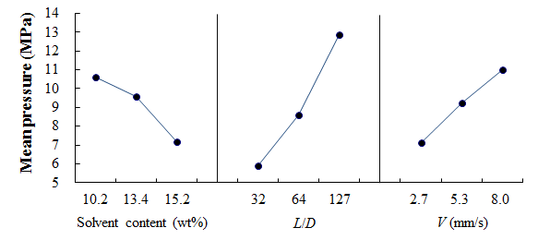

Fig. 6 Main effects plot (data means) of the extrusion pressure

Table 5 Results of ANOVA for extrusion pressure

|  |  |  |  |  |  |  |  |  |
| --- | --- | --- | --- | --- | --- | --- | --- | --- |
| Parameters | Source of variance | | | | | | | |
| A | B | C | A×B | A×C | B×C | Error | Total |
| *df* | 2 | 2 | 2 | 4 | 4 | 4 | 8 | 26 |
| *Seq.SS* | 56.53 | 224.19 | 67.79 | 19.58 | 0.54 | 4.8 | 2.72 | 376.16 |
| *Adj.MS* | 28.27 | 112.09 | 33.89 | 4.89 | 0.14 | 1.20 | 0.34 |  |
| *F* | 83.17 | 329.84 | 99.74 | 14.4 | 0.40 | 3.53 |  |  |
| *Sig.* | 0.000 | 0.000 | 0.000 | 0.001 | 0.805 | 0.061 |  |  |
| *Contribution* (%) | 15.0 | 59.6 | 18.0 | 5.2 | 0.1 | 1.3 | 0.7 |  |

Following the characterization of the HA paste, the obtained data was used as a guide for to provide the optimum conditions for printing high-resolution HA scaffolds. From the above analysis results, all the control factors exhibited significant effects. In particular, the length-to-diameter ratio of the nozzle exhibited the greatest effect on the extrusion pressure. The length-to-diameter ratio of the nozzle and the extrusion velocity need to be selected as less as possible while solvent content should be increased to have minimum effect on the extrusion pressure. Therefore, it is very important to carefully adjust the system parameters to ensure the printing of high-resolution scaffolds.

To accurately mimic the native tissue environment, the TE scaffolds must have a highly controlled 3D macrostructure and microstructure. The scaffolds may have simple or complicated macrostructures depending on the application, but its microstructure is the factor that affects the regeneration of specific tissues using synthetic substances. The purpose of accurately characterizing the extrusion pressure is through the control of the printing parameters such as the solvent content in the paste, nozzle size, paste deposition speed, and build layer thickness, etc. to determine the microstructure of the scaffolds, thereby making it beneficial for improved in vivo nutrient diffusion, removal of waste products, and more efficient vascularization. The detailed optimization method of the printing parameters will be reported in another investigation.

HA scaffolds with different filaments and pore sizes were printed following the optimization of the printing parameters. Figure 7 presents the SEM images of a sintered HA scaffold and its internal surface of the filaments.

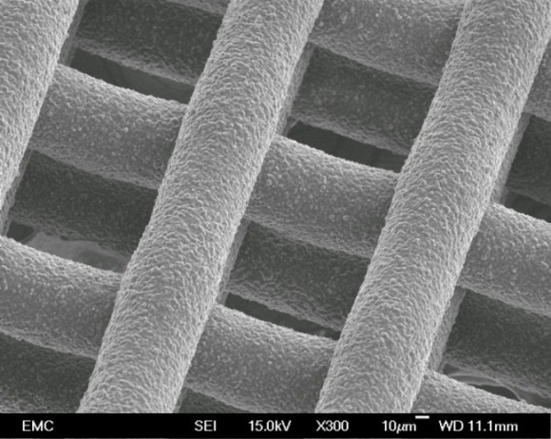 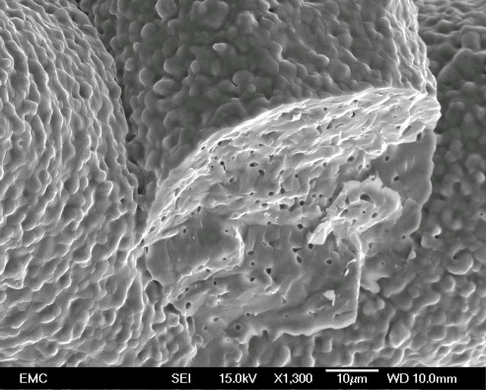

(a) (b)

Fig. 7 Typical printed scaffold following the optimization of the printing parameters: (a) SEM image of sintered HA scaffold with uniform microstructure and macroporosity (yellow rectangles), and (b) SEM image of internal surface of the filament of the HA scaffold.

According to Fig.7, the scaffold printed by low-temperature extrusion 3D printing technology exhibits a uniform microstructure following the optimization of the printing parameters. Sintering-induced micropores were observed on internal surface of the filaments, as presented in Fig. 7 (b), which is suitable for in vivo cell attachments. This validates the effectives of the process to accurately control the microstructure and generate a very consistent and repeatable overall process for further use in the PEEK compression molding process.

**6** **Conclusions**

1. To improve the characterization accuracy of low-temperature extrusion 3D printing, an improved characterization method named the three-point experimental extrapolation was introduced to analyze necessary extrusion pressure in relation to the extrusion velocity (*V*). As compared to previous methods, this new approach exhibited a higher analytical accuracy.

2. The low-temperature extrusion 3D printer must exhibit a reasonable structural layout and motion system precision to ensure the printing of high-resolution scaffolds.

3. The paste formulation (solvent content), length-to-diameter ratio of the nozzle (*L/D*), and the extrusion velocity (*V*) significant affect the extrusion pressure. In particular, the length-to-diameter ratio of the nozzle exhibited the greatest effect.

4. Scaffolds printed by low-temperature extrusion 3D printing technology exhibit a uniform microstructure following the optimization of the printing parameters, which validates the effectiveness of the process in accurately controlling the microstructure.

**Acknowledgments**

The authors are grateful to the Faculty of Engineering and the Environments, University of Southampton for their support. This study was also supported by the State Key Laboratory for Manufacturing Systems Engineering at Xi’an Jiaotong University of China (grant number: sklms2017008).

References

[1] R Langer, J P Vacanti, Tissue engineering, Science, 1993, 260, 920–926.

[2] R C Dutta, M Dey, A K Dutta, B Basu, Competent processing techniques for scaffolds in tissue engineering, Biotechnology Advances, 2017, 35, 240–250.

[3] M L Cooper, J F Hansbrough, R L Spielvogel, R Cohen, R L Bartel, In vivo optimization of a living dermal substitute employing cultured human fibroblasts on a biodegradable polyglycolic acid or polyglactin mesh, Biomaterials, 1991, 12(2), 243–284.

[4] D A Grande, C Halberstadt, G Naughton, R Schwartz, R Manji, Evaluation of matrix scaffolds for tissue engineering of articular cartilage grafts, Journal of biomedical materials research, 1997, 34(2), 211–220.

[5] A D Lantada, GF Méjica, M Peña, M Téllez, JPG Ruíz, HA Iniesta, Tissue Engineering Scaffolds for Osteochondral Repair, Microsystems for Enhanced Control of Cell Behavior, 2016, 331–349.

[6] V Griffiths, 3D printing of bioceramic tissue engineering scaffolds for bone regeneration, University of Southampton, 2013.

[7] A D Lantada, A B Romero, S V Moreno, D Curras, M Téllez, M Schwentenwein, C Jellinek, J Homa, Tissue Engineering Scaffolds for Bone Repair: General Aspects, Microsystems for Enhanced Control of Cell Behavior, 2016, 269–285.

[8] T Sudwilai, J Ng, C Boonkrai, N Israsena, S Chuangchote, P Supaphol, Polypyrrole-coated electrospun poly (lactic acid) fibrous scaffold: effects of coating on electrical conductivity and neural cell growth, Journal of Biomaterials Science, Polymer Edition, 2014, 25(12), 1240–1252.

[9] J E Nichols, J A Niles, J Cortiella, Design and development of tissue engineered lung Progress and challenges, Organogenesis, 2009, 5 (2), 57–61.

[10] R Sharma, S Greenhough, C N Medine, D C Hay, Three-Dimensional Culture of Human Embryonic Stem Cell Derived Hepatic Endoderm and Its Role in Bioartificial Liver Construction, Journal of Biomedicine and Biotechnology, 2010, 2, 36–47.

[11] M H Little, Organoids: a Special Issue, Development, 2017, 144, 935–937.

[12] E Sachlos, J T Czernuszka, Making tissue engineering scaffolds work: Review on the application of solid freeform fabrication technology to the production of tissue engineering scaffolds. European Cells & Materials, 2003, 5, 29–40.

[13] S F Yang, Z H Du, K F Leong, C K Chua, The design of scaffolds for use in tissue engineering, Part I: Traditional factors, Tissue Engineering, 2001, 7(6), 679–689.

[14] S F Yang, Z H Du, K F Leong, C K Chua, The Design of scaffolds for use in tissue engineering. Part II: Rapid prototyping techniques, Tissue Engineering, 2002, 8 (1), 1–11.

[15] Wohlers Report 2016: 3D Printing and Additive Manufacturing State of the Industry-Annual Worldwide Progress Report, 2016, ISBN 978–0–9913332–2–6.

[16] P J Martin, Mechanics of Paste Flow in Radial Screen Extruders, University of Cambridge, 2002.

[17] H Y Yang, S F Yang, X P Chi, J R G Evans, I Thompson, R J Cook, P Robinson, Sintering behaviour of calcium phosphate filaments for use as hard tissue scaffolds, Journal of the European Ceramic Society, 2008, 28, 159–167.

[18] M Vaezi, S F Yang, A novel bioactive PEEK/HA composite with controlled 3D interconnected HA network, International Journal of Bioprinting, 2015, 1(1): 66–76.

[19] M Vaezi, S F Yang, Extrusion-based additive manufacturing of PEEK for biomedical applications, Virtual and Physical Prototyping, 2015, DOI: 10.1080/17452759.2015.1097053

[20] M Vaezi, C Black, D M R Gibbs, R O C Oreffo, M Brady, M M Torbati, S F Yang, Characterization of New PEEK/HA Composites with 3D HA Network Fabricated by Extrusion Freeforming, Molecules, 2016, 21, 687

[21] M Vaezi, 3D printing of Bone Tissue Engineering Scaffolds and Production of PEEK-based Biocomposites, University of Southampton, 2017.

[22] S F Yang, H Yang, X Chi, J R G Evans, I Thompson, R J Cook, P Robinson, Rapid prototyping of ceramic lattices for hard tissue scaffolds, Materials and Design, 2008, 29 (9),1802–1809.

[23] S F Yang, M M Mohebi, J R G Evans, A novel solid freeforming method using simultaneous part and mould construction, Rapid Prototyping Journal, 2008, 14 (1) 35–43.

[24] X Lu, Y Lee, S F Yang, Y Hao, J R G Evans, C G Parini, Solvent-based paste extrusion solid freeforming, Journal of European Ceramic Society, 2010, 30, 1–10.

[25] H Yang, X Chi, S F Yang, J R G Evans, Mechanical Strength of Extrusion Freeformed Calcium Phosphate Filaments, Journal of Materials Science: Materials in Medicine, 2010, 21(5), 1503–1510.

[26] A Ovenston, J J Benbow, Effects of die geometry on the extrusion of clay-like material, Transactions of the British Ceramic Society, 1968, 67, 543–567.

[27] J J Benbow, J Bridgwater, Paste Flow and Extrusion, 1993, Oxford University Press.

[28] S Blackburn, T A Lawson, Mullite-alumina composites by extrusion, Journal of the European Ceramic Society, 1992, 74 (4), 953–957.

[29] J J Benbow, T A lawson, EW Oxley, J Bridgwater, Prediction of paste extrusion pressure, Ceram. Bull. 1989, 68 (10), 1821–1824.

[30] H J Liu, J Liu, M C Leu, R Landers, T S Huang, Factors influencing paste extrusion pressure and liquid content of extrudate in freeze-form extrusion fabrication, Journal advanced manufacturing technology, 2013, 67, 899–906.

[31] G Y Zhong, C Q Wang, S F Yang, E L Zheng, Y Y Ge, Position geometric error modeling, identification and compensation for large 5-axis machining center prototype. International Journal of Machine Tools & Manufacture, 2015, 89, 142–150.

[32] R L Huston, C E Passerello, M W Harlow, Dynamics of Multi rigid-body System. ASME Journal of Applied Mechanics, 1978, 45, 889–894.

[33] J W Fan, J L Guan, W C Wang, Q Luo, X L Zhang, L Y Wang, A universal modeling method for enhancement the volumetric accuracy of CNC machine tools, Journal of Materials Processing Technology, 2002, 129, 624–628.

[34] S Kasman, Impact of parameters on the process response: A Taguchi orthogonal analysis for laser engraving, Measurement 46 (2013) 2577–2584.

[35] G Y Zhong, J Y Xu, Y T Wu, S F Yang, Statistical Analyses and Regression Modeling for Influence of Process Parameters on Material Removal Rate in Ultrasonic Machining, Global Journal of Technology & Optimization, 2015, 6:3, 1–6.