**B cells promote pancreatic tumorigenesis**

Ali Roghanian, Christopher Fraser, Marianna Kleyman and Jianzhu Chen*

Koch Institute for Integrative Cancer Research and Department of Biology, Massachusetts Institute of Technology, Cambridge, MA 02139, USA

**\*Corresponding authors**: Jianzhu Chen at jchen@mit.edu

**Disclosure of Potential Conflicts of Interest**

No potential conflicts of interest were disclosed.

**Summary**

Three recent studies, approaching the question from different angles and using different and/or overlapping models, provide compelling evidence for the involvement of tumor-infiltrating B cells in the initiation and progression of pancreatic ductal adenocarcinoma (PDAC). These studies highlight the need for a better understanding of tumor-immune system interactions and the immunological mechanisms that promote or inhibit tumorigenesis, paving the way for better treatment strategies.

**Main text**

Treatment of pancreatic cancer has proven very difficult because of both the non-immunogenic nature of the tumor and the late stages at diagnosis. This is reflected in the abysmal 5-year survival rate of ~7% and the harsh standard-of-care (SOC) for patients. The most common treatment, aside from palliative care or surgery in eligible patients, is gemcitabine, which is a general DNA damaging agent. However, those patients healthy enough to handle strong treatment side effects are given a cocktail of four drugs called FOLFIRINOX in the hope of stalling tumor development (FDA.gov). Other FDA-approved drug combinations may be tried as the first-line treatment, but all have appalling side effects impacting patient quality of life without much measurable benefit. Although no immunotherapies are currently approved for treating pancreatic cancers, there are 16 clinical trials of various immunotherapies for pancreatic cancer (clinicaltrials.gov). These trials fall into two categories: combination therapies and vaccines. Most of the combination therapies involve adding an immunotherapy like checkpoint blockade, vaccine, or cytokines to the SOC, aiming to first make PDAC immunogenic, and then promote anti-tumor immune responses (1).

Studies in both human and animal models have now demonstrated that the immune system plays a critical role in modulating the outcome of tumor development. In general, cytotoxic CD8 T cells, Th1-type CD4 T cells, and natural killer (NK) cells exhibit anti-tumor activity while myeloid-derived suppressor cells (MDSCs) and tumor-associated macrophages (TAM) suppress anti-tumor immune responses and promote tumor progression and metastasis (2). Increasingly, B cells are also found to play a significant role in modulating the growth and progression of solid tumors (2, 3). Tumor-infiltrating lymphocytic B cells (TIL-B) are a major component of TILs in breast cancer and advanced ovarian cancer, and their presence correlates with improved survival. However, in multiple mouse models, tumor development is enhanced when B cells are present. Growth of EL-4 thymoma, MC38 colon cancer, and EMT-6 breast cancer is significantly inhibited in B cell-deficient mice. Absence of B cells is associated with increased infiltration of Th1 cells, CD8 T cells, and NK cells in the tumor. Conversely, adoptive transfer of B cells into immunodeficient mice results in increased tumor growth.

The role of B cells in neoplasia has also been evaluated in genetically modified mouse models. In K14-HPV16-induced epithelial carcinogenesis, tumor progression is decreased in immunodeficient mice with no mature B and T cells (4). Adoptive transfer of B cells into these immunodeficient mice results in increased malignancy. Interestingly, depleting B cells with anti-CD20 monoclonal antibody (mAb) alone does not inhibit tumor progression, but improves response in combination with chemotherapy (5). One suggested mechanism for TIL-B enhancement of tumor progression is through a subset of B cells that are suppressive, thereby inhibiting the anti-tumor immune responses (6). Similarly, in a transgenic metastatic, castration resistant prostate cancer model (7), progression of the disease is associated with immune infiltrates including B cells, which are recruited to the tumor by the chemokine CXCL13. Tumors are refractory to the chemotherapeutic agent oxaliplatin unless mice are depleted of B cells. B cells inhibited anti-tumor responses of CD8 T cells through regulating IL-10 and PD-L1 in that model.

To date, the role of TIL-Bs in PDAC has not been investigated. By employing different approaches in various preclinical models, the three reports in the current issue of Cancer Discovery provide compelling evidence for the involvement of TIL-Bs in supporting both early and more advanced stages of pancreatic tumorigenesis. This occurs via multiple mechanisms, including suppression of other immune cells (*e.g.*, CD8 T cells and macrophages) in the tumor microenvironment and promoting pancreatic cancer cell proliferation. Inhibition of B cell infiltration into the tumor by blocking chemokine CXCL13, inhibition of B cell activity using Bruton’s tyrosine kinase (BTK) inhibitor, or simple depletion of B cells using a specific mAb all significantly reduced tumor progression.

Pylayeva-Gupta and colleagues (8) used primary human pancreatic intraepithelial neoplasia (PanIN) and the *LSL-KrasG12D* x *p48Cre* (KC) mouse model of PDAC to demonstrate significant presence of B cells in the proximity of PanIN lesions. Using the KC model, they further demonstrated that CD1dhiCD5+ B cell subsets contribute to pancreatic pathogenesis through a paracrine mechanism (IL-35; heterodimer of subunits p35 and EB13) that promotes proliferation of the transformed epithelium. Importantly, the B cell chemoattaractant CXCL13, secreted by the fibroinflammatory stroma in human and mouse PanIN lesions, was shown to be responsible for the influx of B cells into the tumor. Treatment of tumor-bearing mice with a CXCL13 blocking mAb reduced B cell infiltration in KC mice and mice orthotopically implanted with KrasG12D-PDEC cells.

On the other hand, Lee and co-workers (9) used primary human pancreatic tumors and the KC mouse model (crossed to *HIF1αfl/fl*) to demonstrate that HIF-1α is highly expressed during the preinvasive stage of PDAC and deletion of HIF-1α accelerates PDAC development in KC mice. Unexpectedly, elimination of HIF-1α resulted in an increased secretion of B cell chemoattractants (CXCL13, CCL19, CCL20, CCL21, and CXCL12), which, in turn, promoted intratumoral accumulation of the CD19+CD43+IgMhiCD5+ subset of B1b cells during early pancreatic neoplasia. In line with these observations, depletion of B cells reduced progression of PanIN and development of invasive carcinoma in tumor-bearing mice. As above, immunohistochemical analysis of primary human pancreatic tissues also revealed a significant presence of intrapancreatic B cells, supporting the involvement of human B cells in pancreatic tumorigenesis.

Lastly, Gunderson et al. (10) used primary human pancreatic tumors, public databases, and two syngeneic murine PDAC cell lines – derived from primary pancreatic carcinomas of transgenic *KrasG12D* x *PdxCre* mice harboring *p16Ink4α* or *p53* – to demonstrate that BTK regulates B cell and macrophage-mediated T cell suppression in PDAC development. Both human and murine PDACs were shown to exhibit high BTK activation in tumor-resident B cells and macrophages. BTK inhibition with the FDA-approved inhibitor ibritinib reduced PDAC growth and abated immunosuppression *in vivo* by reprogramming macrophages towards an M1 phenotype which promoted CD8 T cell cytotoxicity.

One caveat to the three studies is that, in a number of the pre-clinical models used, the contribution of infiltrating B cells to pancreatic tumorigenesis was monitored in orthotopically engrafted tumors. As this involves a major surgery in the recipient mice, it could in turn create a local inflammatory environment that promotes a higher than normal infiltration of B cells into the tumor site and hence the data obtained from these models should be interpreted with caution. Additionally, there are conflicting reports on the role of TIL-Bs in other tumor types demonstrating the need for further study (2). Nevertheless, findings from the three studies provide compelling evidence for the involvement of tumor-infiltrating B cells in the initiation and progression of PDAC.

In addition to advancing the overall field of immuno-oncology, findings from the three studies point to novel approaches for treating PDAC. Increasing the success rate for treating PDAC is likely to require combination therapies that target both tumor cells and immune cells as well as earlier detection and intervention. Currently, T cell-centric immunotherapies are being tested in late-stage PDAC. One new therapeutic strategy for PDAC would include targeted B cell suppression, such as BTK inhibition or depletion, as part of a combination therapy. Similarly, neutralizing IL-35 and/or CXCL13 in combination therapies may increase therapeutic efficacy. Moreover, the level of B cells, IL-35, and CXCL13 in the pancreas and/or PDAC may serve as biomarkers for early diagnosis, especially in higher risk individuals who are pre-disposed to developing PDAC due to family history (*e.g.*, BRCA mutation and diabetes) or tobacco usage, helping clinicians develop earlier interventions.

**Acknowledgements and Grant Support**

AR is supported by a Bloodwise (UK) Visiting Fellowship grant (14043).

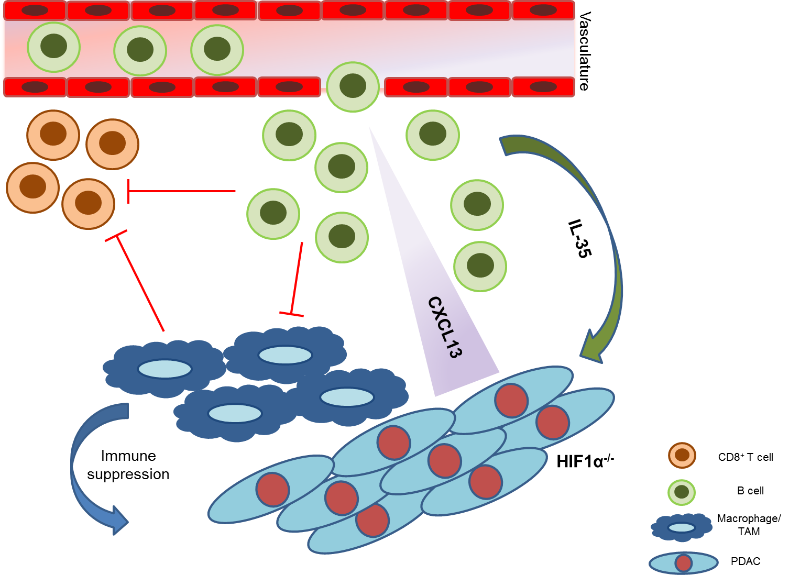

**Figure 1. Contribution of TIL-Bs to pancreatic tumorigenesis.** B cells infiltrate pancreatic tissues in response to the release of local chemokines such as CXCL13. The TIL-Bs in turn secrete IL-35 that stimulate tumor cell proliferation (Pylayeva-Gupta *et al*., 2016). On the other hand, pancreas-specific HIF1α deletion accelerates pancreatic neoplasia and results in increased secretion of B cell chemokines and B cell infiltration into the pancreas (Lee *et al*., 2016). Furthermore, PDAC growth depends on crosstalk between B cells and FcγR+ TAMs, resulting in M2 programming via BTK activation in a PI3Kγ-dependent manner (Gunderson *et al*., 2016). Inhibiting B cell infiltration, depleting B cells or upregulation of HIF1α in pancreatic tumor microenvironment stimulates immune activation and inhibits tumorigenesis.

**References**

1. Foley K, Kim V, Jaffee E, Zheng L. Current progress in immunotherapy for pancreatic cancer. Cancer letters. 2015.

2. Nelson BH. CD20+ B cells: the other tumor-infiltrating lymphocytes. Journal of immunology. 2010;185:4977-82.

3. Zhang Y, Morgan R, Podack ER, Rosenblatt J. B cell regulation of anti-tumor immune response. Immunologic research. 2013;57:115-24.

4. de Visser KE, Korets LV, Coussens LM. De novo carcinogenesis promoted by chronic inflammation is B lymphocyte dependent. Cancer cell. 2005;7:411-23.

5. Affara NI, Ruffell B, Medler TR, Gunderson AJ, Johansson M, Bornstein S, et al. B cells regulate macrophage phenotype and response to chemotherapy in squamous carcinomas. Cancer cell. 2014;25:809-21.

6. Zhang Y, Gallastegui N, Rosenblatt JD. Regulatory B cells in anti-tumor immunity. International immunology. 2015;27:521-30.

7. Shalapour S, Font-Burgada J, Di Caro G, Zhong Z, Sanchez-Lopez E, Dhar D, et al. Immunosuppressive plasma cells impede T-cell-dependent immunogenic chemotherapy. Nature. 2015;521:94-8.