# Title: A lab-on-chip analyzer for *in situ* measurement of soluble reactive phosphate: improved phosphate blue assay and application to fluvial monitoring

# Author list:

Geraldine S. Clinton-Bailey1*, Maxime M. Grand2, Alexander D. Beaton1, Adrian M. Nightingale3, David R. Owsianka1, Gregory J. Slavik1, Douglas P. Connelly2, Christopher L. Cardwell1, Matthew C. Mowlem1

Affiliations:

1 National Oceanography Centre, Southampton SO14 3ZH, United Kingdom

2 Ocean and Earth Science, University of Southampton, Southampton SO14 3ZH, United Kingdom

3 Engineering and the Environment, University of Southampton SO17 1BJ, United Kingdom

*Corresponding author

Email: [g.clinton-bailey@noc.ac.uk](mailto:g.clinton-bailey@noc.ac.uk); phone: +4423805996542

# TOC Art

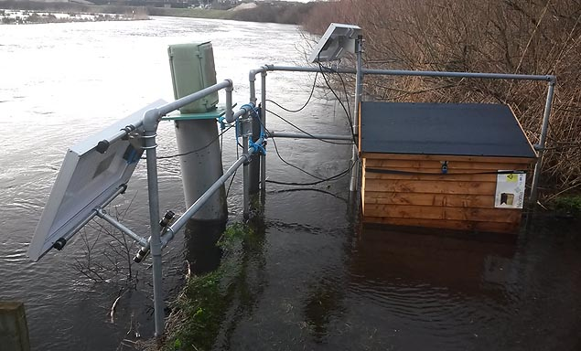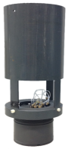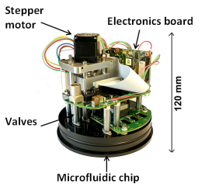

# Abstract

Here we present a new *in situ* microfluidic phosphate sensor that features an improved “phosphate blue” assay which includes polyvinylpyrrolidone in place of traditional surfactants – improving sensitivity and reducing temperature effects. The sensor features greater power economy and analytical performance relative to commercially available alternatives, with a mean power consumption of 1.8 W, a detection limit of 40 nM, a dynamic range of 0.14 – 10 µM and an infield accuracy of 4±4.5%. During field-testing the sensor was continuously deployed for 9 weeks in a chalk stream, revealing complex relations between flow rates and phosphate concentration that suggest changing dominance in phosphate sources. A distinct diel phosphorus signal was observed under low flow conditions, highlighting the ability of the sensor to decouple geochemical and biotic effects on phosphate dynamics in fluvial environments. This paper highlights the importance of high resolution *in situ* sensors in addressing the current gross under-sampling of aquatic environments.

Key words: Phosphate, Lab-on-Chip, microfluidics, *in-situ*, polyvinylpyrrolidone (PVP)

# Introduction

Phosphorus (P) is an essential nutrient for primary production, and is considered, along with nitrogen, to be a limiting nutrient in freshwater ecosystems1. Excessive anthropogenic P inputs can result in eutrophication 2, 3, and as such nutrient inputs into aqueous environments are regulated and monitored. The EU Water Framework Directive 4 specifically lists P as a contributor to declining water quality, and the USA Clean Water Act 1987 5 seeks to address inland water bodies with elevated P levels 6. Establishment and continual improvement of water quality monitoring schemes is integral to the application of legislation7, and in improving our understanding of the factors controlling P dynamics in freshwater ecosystems.

The colorimetric, phosphomolybdenum blue (PMB) method is the most widely used technique for the measurement of soluble reactive phosphorus (SRP). Briefly, orthophosphate and molybdate react in an acidic medium to form 12-molybdophosphoric acid (PMA), which is then reduced to phosphomolybdate blue (PMB), to give an intense blue color measurable at wavelengths 700 or 880 nm. Antimonyl tartrate is used to catalyse the reaction and to inhibit the formation of silicomolybdic acid, which is a common interference of this assay. The simplicity of the PMB assay, low limits of detection achievable in benchtop systems 8-10 and the availability of small, affordable and easily sourced components11, 12 make it suitable for adaptation to field deployable devices. *In situ* sensors are attractive alternatives to grab sampling. They eliminate sample handling and transport to the laboratory, which can be sources of contamination or sample degradation. They also offer the potential for long term deployment as standalone sensors or as part of a sensor network with continuous measurements in remote locations11.

Microfluidic technology miniaturises bench-top assay systems into portable and/or deployable ‘lab on a chip’ (LOC) devices12. The vanadomolybdate or the ‘phosphate yellow’ assay has been previously used in microfluidic sensors 13-15 to measure P, in part due to the long term stability of the reagent, and the simplicity afforded through the use of one reagent. However, the yellow assay is less sensitive than PMB, and use of vanadate makes the assay highly toxic. Additionally, an inter-laboratory comparison of spectrophotometric methods has shown the PMB method using ascorbic acid as the reductant to have the highest reproducibility16. For these reasons, the PMB method is better suited to *in situ* work in natural waters, where high sensitivity and precision are required. There are currently two commercially available P sensors that utilise the PMB assay: the HydroCycle-P (Sea-bird Coastal, Washington State, U.S.A.) and the Wiz Probe (Systea S.p.A. Analytical Technologies, Anagni, Italy). The newly developed stand-alone LOC phosphate analyzer presented here is an improvement on these two systems in terms of power consumption and analytical performance. We first report the addition of the dispersant polyvinylpyrrolidone (PVP) to the PMB assay, which improves analytical performance and replaces traditionally used surfactants (such as sodium dodecyl sulphate (SDS)17) that are unsuitable for *in situ* deployment at low (< 15°C) temperatures. Data from a 9 week continuous deployment is presented to demonstrate the device with the new configuration and chemistry, and further highlight that low resolution regulatory data sets (based on spot or grab sampling) struggle to identify the effects of episodic sources and/or stochastic flow events.

# Experimental

Preparation of the reagents and the standards are reported in detail in the Supporting Information (SI), section 1. Reagent 1 (Figure 1) is the molybdic acid solution and reagent 2 (Figure 1) is the reducing solution (1% (w/v) ascorbic acid solution with 0.01% (w/v) polyvinylpyrrolidone (PVP)). The standards and blank used a Milli-Q (MQ) water (Merck Millipore) matrix, and the wash solution is 0.01M sodium hydroxide in MQ water.

## Sensor description

The sensor hardware, an improvement on our previously reported nitrate sensor12, is based around a circular tinted PMMA microfluidic chip. Microfluidic channels are patterned by CNC micromilling (LPKF Protomat S100, Gerbsen, Germany) and the chip sealed using solvent bonding methods developed in-house18. All microchannels are 150 μm wide and 300 μm deep, and fluidic control is achieved using 9 micro inert solenoid valves (LFNA1250325H, The Lee Company, Connecticut, U.S.A.) mounted directly onto the chip. Pumping is achieved using a custom built syringe pump which is directly mounted onto the chip and comprises three 3.28 mm internal diameter glass syringe barrels (syringe 1 for sample/blank/standard/wash, syringe 2 for reagent 1, syringe 3 for reagent 2, Figure 1), each of which uses plungers composed of proprietary perfluoro-elastomer sliding seals bonded to a stainless steel shaft. All three pump channels are mechanically linked and operate simultaneously. Multiple absorbance measurement cells were fabricated within the chip as previously reported; multiple cells extend the dynamic range12. 700 nm LEDs (LED700-02AU, Roithner) and photodiodes (TSLG257-LF, TAOS, Texas, U.S.A.) were placed into milled recesses, aligned with a straight milled channel of known length using micromanipulators, and fixed in place using optical adhesive (OPT5012-4G, Intertronics, Kidlington, U.K.).

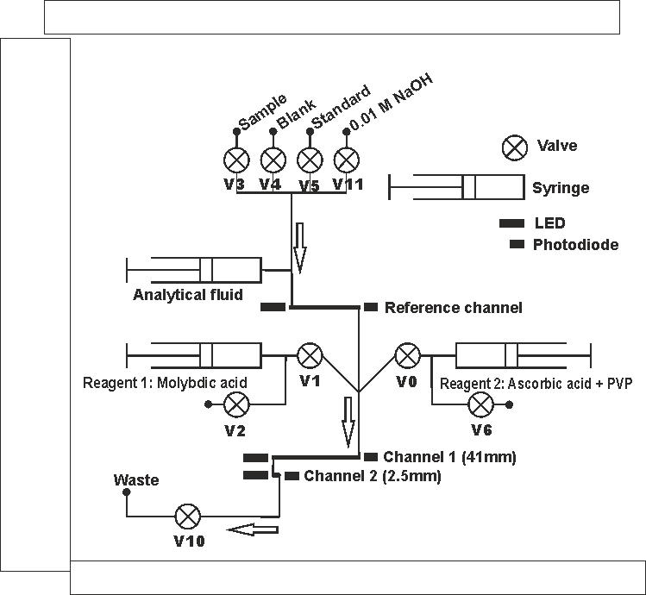

Figure 1: Fluidic pathway and control diagram**.** The valves are numbered (**V***x*) beneath each valve. Arrows indicate flow direction.

In contrast to our previously reported system, the chip also forms the endcap to the underwater housing, which reduces both the fluidic path between the chip and the ambient water and the number of fluidic interfaces required. The housing comprises a dark, water-tight PVC tube (12.5 cm diameter, 19.5 cm long), which is sealed at either end by the chip at one end and a second endcap at the other, both with o-rings, providing a watertight seal in each case. A second, larger (20 cm diameter, 45 cm long) PVC tube is mounted above the sensor housing, and this is used to store fluid bags (Flexboy, Sartorious) containing the reagent and standard solutions (Figure 2) which are connected to the chip via microbore PTFE tubing (1.6 mm O.D., 0.5 mm I.D.) and ¼”-28 UNF fluidic connectors (LT-115X, IDEX Health and Science LLC, Washington, U.S.A.). The sample inlet is also connected to the chip via a 7.5 cm length of PTFE microbore tubing which terminates with a disposable 13 mm 0.45 µm polyethersulfone (PES) Luer lock syringe filter (Merck Millipore, Massachusetts, U.S.A.). A six-pin IE55 bulkhead connector (Teledyne Impulse-PDM, Alton, U.K.) is mounted to the top of the chip for power and communications. The system is automated using a 32 bit microcontroller-based electronics package (described previously12) with 18-bit analogue to digital inputs, and can stream raw data (1 Hz) over USB, as well as store it on a 8GB flash memory card. If provided with a value for the on-board standard, the system is also capable of outputting a processed data value (µM phosphate) over RS232 or RS485 interfaces.

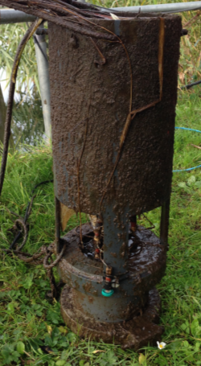

56 cm

15 cm

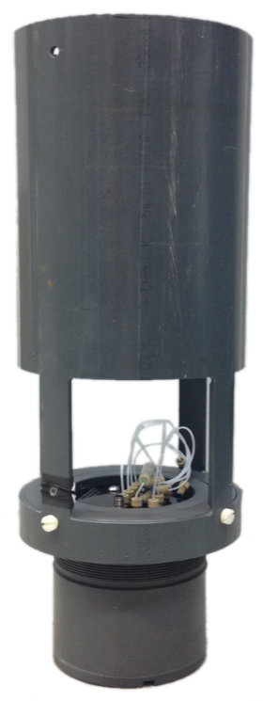

Reagent bag housing

Sensor unit

Figure 2: Photo of sensor unit before (left) and after (right) 63 days deployment at Knapp Mill, River Avon, Hampshire.

The sensor operates using a stop-flow regime whereby sample and reagents are introduced into the absorbance flow cell and then left to react (and color to develop) over a set period. The reaction time was set at 5 minutes, with the average voltage over the final 5 seconds of the development time used to determine absorbance. Each sample measurement was accompanied with a blank and a standard measurement, with a flush of 0.01 M NaOH in between to reduce carryover effects from potential sorption or interaction of the PMA and/or PMB with the PMMA surface (see SI section 2). The algorithm that determines the sensor’s operation is detailed in the SI, section 2. All solutions were mixed in the fluidic channels using a 1:1:1 (v/v) ratio (reagent 1: reagent 2: blank/sample/standard), and pumped at a combined flow rate of 300 µL min-1 (shown schematically in Figure 1). The sensor was programmed to introduce fluid into the microfluidic channels in the order: Blank–Sample–NaOH–Standard–NaOH; this sequence is repeated each time a sample is scheduled for analysis and takes a minimum of 35 minutes (see SI, section 2 for more details). Prior to mixing the analytical fluid and the reagents, the microfluidic channels and the syringe barrels required flushing with 300 µL of the analytical fluid. The sample inlet filter required additional flushing (a further 150 µL) to ensure no carry-over from dead space within the filter and the sample inlet tubing. To reduce reagent consumption, the reagents were returned to the storage bags during all but the last two flushes of the microfluidic manifold with analytical fluid. This was achieved by keeping valve 2 (reagent 1) and valve 6 (reagent 2) (Figure 1) open while the analytical fluids (blank, sample or standard) were dispensed to the channels (see the SI, section 2 for more details). Reagent consumption per full, standardised measurement was therefore 450 µL per reagent 1 & 2, 600 µL of the blank and standard solution, and 300 µL of the NaOH.

Absorbance values were calculated by applying the Beer-Lambert Law to the voltage output of the photodiodes as previously reported19. The phosphate concentration of the analytical solution ([PO4]sample) was then taken as a ratio of the on-board standard, and calculated as follows:

$${{[PO}_{4}]}_{sample}=\left[\frac{{-log}_{10}{({sample}/{blank})}}{{-log}_{10}{({standard}/{blank})}}\right]× {{[PO}_{4}]}_{standard}$$

where *blank*, *sample* and *standard* are the average photodiode voltages recorded during the last 5 seconds of the 300 sec stopped flow period, and [PO4]*standard* is the concentration of the on-board phosphate standard.

## Performance assessment and field deployment

The linear dynamic range and limit of detection for each measurement cell was determined in MQ water using a series of phosphate solutions of increasing concentrations (0, 0.1, 0.5, 1, 2.5, 5, 10, 20, 30 & 40 µM PO43-). To investigate the effect of temperature on the performance of the sensor, the sensor and all reagents were placed in an environmental chamber (fitted with a Eurotherm Type 818 controller, Worthing, U.K.) set at 10°C, 20°C or 30°C. The chamber temperature was monitored using an F250 MKII precision thermometer (Automatic Systems Laboratory, Vermont, U.S.A.). The power was supplied to the sensor during laboratory trials using a DC power supply (Aim-TTi EL302 RT triple output, Aim-TTi Instruments, Huntingdon, U.K.). Each measurement was undertaken in triplicate.

The sensor was deployed at a fluvial site (Knapp Mill, River Avon, Hampshire, 50.748N, -1.780W, (see SI, section 3, Figures S5 and S6) for nine weeks starting May 11th 2016. The River Avon is located within a designated area of phosphorus concern 20.

The sensor was suspended ~1 m below the water surface and hung from a metal arm extending ~ 1 m from the river bank; additional weights were fixed to the end of the sensor. A solar panel (SX2OU, Solavex, Maryland, U.S.A.) was used to charge a 12V battery, which powered the sensor over the deployment. The sensor has typical analysis power consumption values of 1.8 W (with a maximum current draw of 0.39 A) for a fully blank and standard bracketed sample, compared with for instance the WIZ Probe and HydroCycle-P, which have average operating power requirements of 6 W and 12 W respectively (with a maximum current draw of 1 A and 3 A respectively) in analysis mode 21. Measurements were made hourly for nine weeks and the sample inlet filter and the reagent bags replaced every 4.5 weeks during routine site visits and field equipment checks. Using the sampling and flushing routine described previously (Blank–Sample–NaOH–Standard–NaOH), and 500 mL reagent bags, the sensor would normally only require a reagent change every 7 weeks (this could be extended further by using larger reagent bags).

Concurrent sampling (grab sampling) was also undertaken. The grab samples were filtered immediately upon collection through disposable 0.45 µm PES syringe filters (Mini sart® PES 0.45, Sartorius Stedium Biotech, Goettingen, Germany) into acid washed polypropylene 50 mL tubes. The samples were immediately acidified to pH 1.8 using 5 M H2SO4 and were stored in the dark at -20°C until analysis23. The grab samples and the on-board sensor standards were analyzed using a QuAAtro Continuous Segmented Flow Analyzer (SEAL Analytical, Fareham, U.K.). Additional routine environmental monitoring data and discharge data (m3 s-1) were obtained from the Environment Agency for the Knapp Mill (River Avon) monitoring station, and rainfall data (mm) was provided by the Met Office for the Hurn (Hampshire) monitoring station. An EXO2 Sonde (YSI, Ohio, U.S.A.) was also deployed alongside the LOC sensor to monitor conductivity (µS cm-1), temperature (°C) and dissolved oxygen (mg L-1) every 10 min.

# Results and discussion

The role of surfactants employed in flow systems is to wet surfaces, decrease adsorption on conduit walls and reduce carryover 22. Little work has been undertaken to assess the effects of surfactants on the sensitivity of molybdenum based SRP assays, with many preferring to use no surfactant 22-24 and relying on the pH to reduce surface coating effects 8, or on the surfactant sodium dodecyl sulphate (SDS) 10, 17. The issue with using SDS in field deployable systems is the high Krafft temperature (15°C), which leads to surfactant precipitation within 24 h at temperatures <15°C 25. PVP has been used here for the first time as an alternative to a surfactant in the PMB assay, and compared with ascorbic acid without any surfactant added. The coulombic attraction between the PVP and the PMA aids the dispersive function of the PVP, preventing any PMB aggregation, and potentially reducing interactions of PMA and PMB with the PMMA surface (it has previously been suggested that molybdenum species interact with methyl esters26, which are the functional groups native to the PMMA surface of the chip).

Figure 3 Calibration curves for the 2.5 mm measurement cell (A & B) and the 41 mm measurement cell (C & D). A and C show data for 0.005%, 0.01% and 0.05% PVP additions. B and D show 0.001% PVP and ascorbic acid with no PVP (ascorbic acid only). Regression lines have been drawn through PVP concentrations 0.005-0.05%; 0.001% PVP and ascorbic acid (only) did not produce linear calibration curves.

The 2.5 mm measurement cell (Figure 3A) at 0.05 and 0.01% PVP demonstrated linearity up to 40 µM PO43- with precision values of 7.6% and 0.9% respectively (Table 1). Using the 41 mm measurement cell (Figure 3C) the 0.05% PVP was only linear to 5 µM with a slope of 0.02 AU µM-1 PO43-, and a corresponding relative standard error (RSE) of 9.3%. There was little difference in the performance for the 41 mm cell (Figure 3C) using PVP concentrations of 0.01% and 0.005%, with calibration slopes (AU µM-1 PO43-) of 0.02, a limit of linearity of 10 µM for both concentrations, and corresponding slope RSE’s of 2.6% and 3.2% respectively. The lowest PVP concentration, 0.001% w/v, and ascorbic acid with no additive did not produce linear calibrations (Figures 3B and 3D). Using 0.001% PVP or no PVP also produced a 6 fold and 15 fold (respectively) decrease in absorbance values at 10 µM PO43- than with the 0.01% and 0.005% PVP additions. The measurements using this assay and device have a precision of 0.7%, 4.6% and 26% for 0.005%, 0.01% and 0.05% PVP respectively at 0.5 µM PO43- for the 41mm cell (Table 1), which is an improvement upon the 13.6% at 0.4 µM reported by Legiret at el 15 using a 25 mm cell.

Table 1: Figures of merit at three PVP concentrations, at room temperature and pressure.

|  |  |  |  |  |  |  |
| --- | --- | --- | --- | --- | --- | --- |
|  | 0.005% PVP | | 0.01% PVP | | 0.05% PVP | |
| 2.5mm | 41mm | 2.5mm | 41mm | 2.5mm | 41mm |
| Limit of detection (LOD), µM* | 0.18 ± 0.02 | 0.04 ± 0.01 | 0.49 ± 3E-3 | 0.04 ± 4E-3 | 0.34 ± 0.02 | 0.11 ± 1E-3 |
| Dynamic Range, µM** | 0.61 - 20 | 0.13 - 10 | 1.62 - 40 | 0.14 – 10 | 1.14 - 20 | 0.37 - 5 |
| Precision (%) at 0.5 µM PO43- (n=4) | 23.4 | 0.7 | 46.6 | 4.6 | 18.2 | 26.2 |
| Precision (%) at 2.5 µM PO43- (n=4) | 7.9 | 4.7 | 10.9 | 1.8 | 26.7 | 6.3 |
| Precision (%) at 10 µM PO43- (n=4) | 10.1 | 0.7 | 0.7 | 2.3 | 12.6 | 8.1 |

*Error determined using the RSE of the calibration slope

**Dynamic range determined range between the limit of quantification and limit of linearity.

Table 1 details the figures of merit for each of the PVP concentrations trialled in this study. The limit of detection was determined using the method recommended by IUPAC 27, 3σ 10 blank measurements. The dynamic range falls within the limit of quantification, (defined as 10σ 10 blank measurements 28), and the limit of linearity, which is defined as the point at which the calibration curve deviates significantly from linearity (Anova, P <0.05). The figures of merit of the LOC phosphate sensor are an improvement on the detection limits of the commercially available sensors Cycle-P and the Wiz Probe of 74 nM and 65 nM respectively.

The effect of temperature on this assay is detailed in the SI (section 4). The kinetics of the PMA reduction are important to consider, particularly for field devices, as it has been found to be negatively correlated with both PO43- concentration and temperature 29. Here we found that for the 41 mm measurement cell the temperature effects were lower using 0.01% PVP than 0.005% PVP. While the 0.005% PVP loading showed the lowest LOD value at higher temperatures (≥ 20°C), the more predictable performance of 0.01% PVP is more suitable for field-deployments where fluctuating temperatures will be routinely encountered.

Interferences for the PMA recipe used here were characterised by Patey et al10. Arsenic and silicate are the two major interferences to the phosphate blue assay. The silicate interference is reduced through the alteration of the H+:Mo ratio 30, with the addition of the PVP found to further supress molybdosilicic acid formation 31. The arsenic interference is deemed insignificant considering that reduction of arsenomolybdic acid takes up to 90 minutes compared to the 5 minute color development time used here.

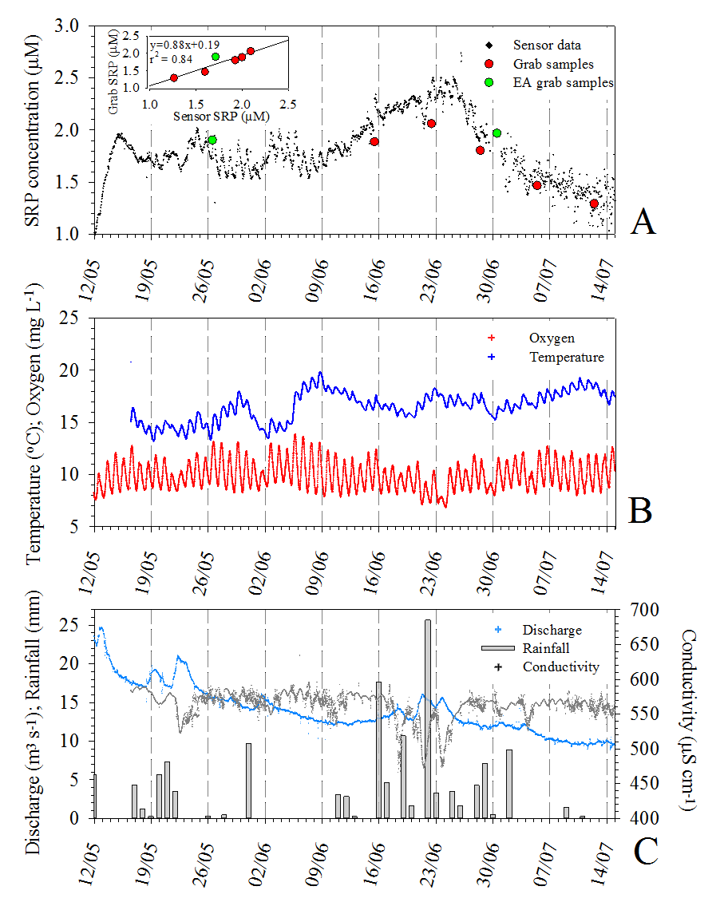

Figure 4 Field data over the 9 week deployment period. Figure 4A shows the sensor SRP data, the SRP concentration of the grab samples, and the Environment Agency SRP data, with the inset graph showing the correlation between the grab samples and the sensor SRP data. Figure 4B shows the temperature and oxygen concentrations (obtained using the EXO2), and Figure 4C shows conductivity (obtained using the EXO2), discharge (Environment Agency) and rainfall data from the Hurn (50.7789N, -1.83483W) Met Office monitoring station. The major gridlines (dashed lines) subdivide the data into weeks.

The 0.01% PVP addition to the ascorbic acid was used for the 9-week field deployment here because of the greater linear quantification range and improved temperature stability. The Environment Agency data and the additional acidified grab samples show the sensor to have an infield accuracy of 10.1% (n=1) and 4.0 ± 4.5 % (n=5) respectively. The impact of correct sample preservation and storage is discussed in the SI, Section 5. The graphical insert in Figure 4A shows a significant (P <0.01, n=6) correlation between the sensor data and the acidified grab samples plus the Environment Agency data (slope of the linear regression 0.88, and corresponding R2 value of 0.84). The mineralisation of organic material trapped in the sample inlet filter has the potential to release SRP and provide a source of sensor sampling error. This does not appear to have affected the results in this study potentially due to the frequency of the filter unit changes in conjunction with the very low sample volumes.

Figure 4 shows the SRP concentration to increase from 1 µM to 1.95 µM during the first 3 days of the deployment, followed by a decrease of 0.2 µM over the following 3 days. From the end of week 1 the SRP concentrations appear to be dominated by diurnal fluctuations, with an overall increase in concentration from weeks 4-6 from ~1.6 – 2.5 µM. From 25th June (week 7) until the end of the deployment, the SRP decreased from ~2.5 µM to ~1.2 µM. The relationship between SRP and the river flow conditions can aid determination of principle sources of SRP to the river. Figure 4 shows that there is a lag (~48 h) between discharge peaks and SRP peaks during the first 2 weeks of the deployment, and that the SRP increases during periods of rainfall (12th-17th May and 18th – 24th June in particular). Owing to this lag phase and response to rainfall events, there are only weak correlations between the discharge, conductivity and SRP.

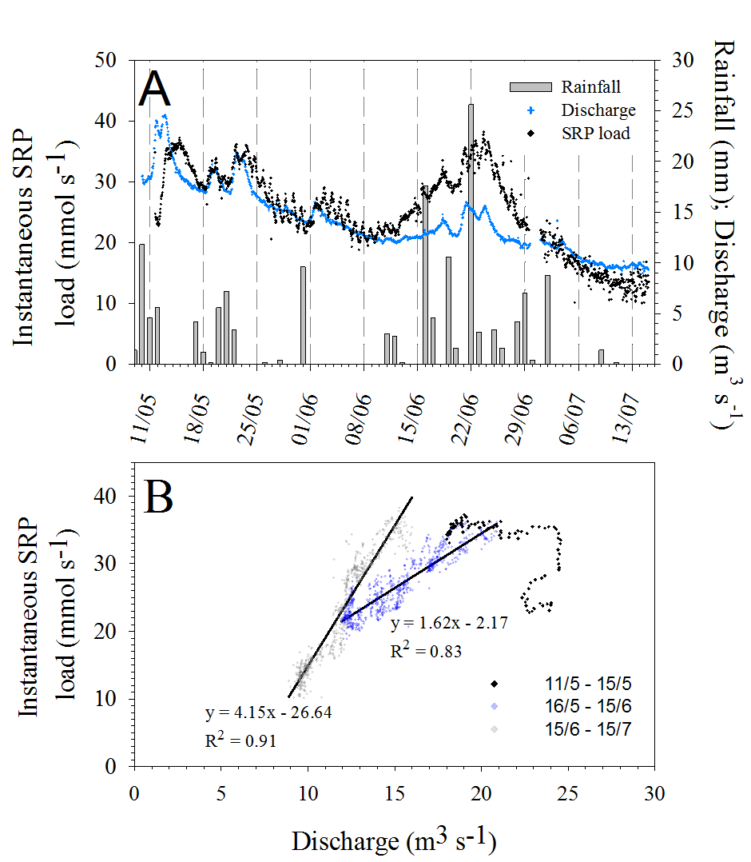

Figure 5 (A) Discharge, rainfall and SRP load plotted from 9th May over the deployment period; (B) SRP load plotted against discharge for the first discharge peak (11.05-15.05), from 16.05-15.06 and from 15.06 – 15.07.

If the instantaneous SRP load (mmol s-1) (the product of the SRP concentration (mmol m-3) and discharge (m3 s-1)) at Knapp Mill is calculated, a clearer relationship emerges between the flow conditions and the SRP discharged into the River Avon at Knapp Mill (Figure 5). Figure 5A shows fluctuations in rainfall, discharge and SRP load over the deployment period; Figure 5B shows the relationship between discharge and SRP load for three time periods with differing SRP load/discharge relationships. There is a significant correlation (P <0.01, n=702 and n=721 respectively) between SRP load and discharge from 16th May-15th June and 15th June-15th July, which is indicative of non-point P mobilisation. During the large discharge peak from 10th - 13th May (discharge increases from 18-25 m3 s-1), anti-clockwise hysteresis (differing rates of concentration change between the rising and falling limb of the hydrograph) can be observed, indicating P transport from up-stream tributaries or deeper sub-surface zones 32. The long (48 hour) lag between the SRP load peak on 13th May and the peak discharge on 11th May has also been interpreted in other studies as P mobilisation further up the catchment with surface run off into the river33. Previous work at the Knapp Mill site on the River Avon, using long term trends and low resolution sampling, found that SRP was inversely correlated with stream flow, suggesting dilution of SRP point sources due to enhanced runoff 34, 35. It may be that during the 9-week deployment period during this study there were no discharges from the up-stream point source locations (SI, Figure S6). This demonstrates that the dominant source of P can change under varying flow conditions over differing time-scales 36.

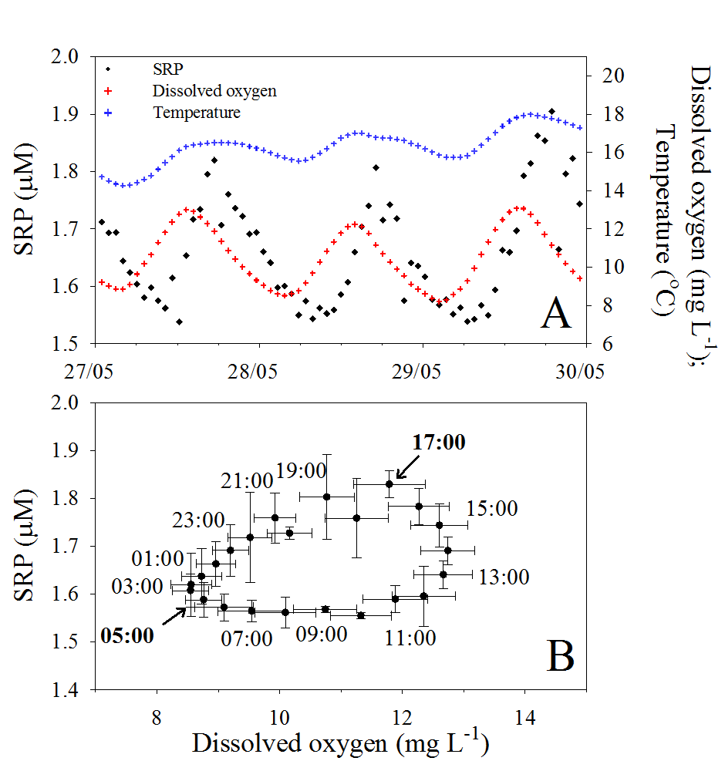

Figure 6 (A) SRP sensor data plotted with dissolved oxygen and temperature from 27th May to 30th May. The SRP is plotted with dissolved oxygen in (B) for the average of the 3 days used in this example (27th-30th May); the data labels are the time of day and the error bars are the standard deviations.

The monthly routine Environment Agency monitoring data shown in Figure 4a provides a broad over-view of SRP long term trends, but the low frequency provides little information on the biogeochemical processes that control the SRP concentration. The dissolved oxygen (DO), temperature and SRP have been plotted for a 3-day period from 27th – 30th May (Figure 6A). The diurnal DO cycling, with a maximum in the afternoon (~14:00 h) and a minimum at night (~04:00 h), is consistent with respiration/photosynthesis diurnal cycles. The DO peaks near ~ 14:00 h and SRP at ~17:00 h each day, with corresponding minima at 04:00 h and 07:00 h respectively (Figure 6B). From the early morning (~04:00) until noon, the DO concentration rises steadily from 8-12 mg L-1, while the SRP concentration remains stable at ~1.6 µM. This is followed by a ~0.2 µM SRP increase until 17:00 while the DO remains stable at 12-13 mg L-1. Following this peak at 17:00 in SRP there is a steady decline by ~0.2 µM until 04:00, at the DO minimum. This diurnal pattern is similar to that reported by Cohen et al 37 in a spring fed chalk river in Florida using the Cycle-P *in situ* sensor. Here they also observed a lag phase between the peaks and troughs of the DO and SRP, but were able to correct for calcite precipitation in order to calculate biological assimilation rates of SRP. The SRP minima occurs here at night rather than at peak primary production times during the day potentially due to autotrophic assimilation of SRP during the night for use in the day 37. This highlights the complex, non-conservative behaviour of P in fluvial systems, which is not distinguishable with low frequency measurements.

This study demonstrates that *in situ* LOC sensors are a powerful means to disentangle complex fluvial biogeochemical processes occurring over a variety of timescales. Previous work has shown that high resolution data is required to fully understand fluvial phosphorus dynamics including storm hysteresis, diurnal cycling and transfers processes 38, 39. Poor resolution coupled with issues relating to the preservation of grab samples has led to a recommendation that high resolution *in situ* measurements become routinely implemented in monitoring networks 36. Here we have demonstrated a new phosphate LOC sensor with improved sensitivity and power requirements, in a fluvial field deployment to highlight the advantages of *in situ* high resolution measurements in addressing the gross under-sampling of the aquatic environment.

# Acknowledgements

The research leading to these results has received funding from the European Union Seventh Framework Programme (FP7/2007-2013) under grant agreement n° 614141, and the UK Natural Environment Research Council (NERC) DELVE grant (NE/I008845/1).

We would like to thank: Professor Duncan Purdie, University of Southampton for providing access to the field site, and for sharing the EXO2 sonde data; and Mr Robin Brown, National Oceanography Centre, for manufacturing the deployment housing and weights.

We would also like to acknowledge the Environment agency for providing the regulatory data under the Freedom of Information Act 2000.

# Supporting Information

Reagent preparation; sensor analytical procedure optimisation and operation; field deployment location; effects of temperature on sensor performance with either 0.005% and 0.01% PVP additions to the ascorbic acid; field deployment grab sample preservation procedures.

**References**

(1) Elser, J. J.; Bracken, M. E. S.; Cleland, E. E.; Gruner, D. S.; Harpole, W. S.; Hillebrand, H.; Ngai, J. T.; Seabloom, E. W.; Shurin, J. B.; Smith, J. E., Global analysis of nitrogen and phosphorus limitation of primary producers in freshwater, marine and terrestrial ecosystems. Ecol. Lett **2007,** 10, (12), 1135-1142; DOI 10.1111/j.1461-0248.2007.01113.x.

(2) Chislock, M. F.; Doster, E.; Zitomer, R. A.; Wilson, A., Eutrophication: causes, consequences, and controls in aquatic ecosystems. Nat.Educ. Knowl. **2013,** (4), pp 10.

(3) Worsfold, P. J.; Clough, R.; Lohan, M. C.; Monbet, P.; Ellis, P. S.; Quétel, C. R.; Floor, G. H.; McKelvie, I. D., Flow injection analysis as a tool for enhancing oceanographic nutrient measurements—A review. Anal. Chim. Acta **2013,** (803), 15-40; DOI 10.1016/j.aca.2013.06.015.

(4) Council Directive 2000/60/EC Establishing a framework for Community action in the field of water policy. In Parliament, E., Ed.

(5) Federal Water Pollution Control Act (the “Clean Water Act”). In U.S.A., 1987; Vol. 33 U.S.C., pp 1251-1387.

(6) Manuel, J., Nutrient pollution: A persistent threat to waterways. Environ. Health Perspect. **2014,** 122 *(11)*, A304; DOI [10.1289/ehp.122-A304](https://doi.org/10.1289/ehp.122-A304).

(7) Kallis, G.; Butler, D., The EU water framework directive: measures and implications. Water Policy **2001,** 3 (2), 125-142; DOI 10.1016/S1366-7017(01)00007-1.

(8) Ma, J.; Li, Q.; Yuan, D., Loop flow analysis of dissolved reactive phosphorus in aqueous samples. Talanta **2014,** 123, 218-223; DOI [10.1016/j.talanta.2014.02.020](https://doi.org/10.1016/j.talanta.2014.02.020).

(9) Patey, M. D.; Rijkenberg, M. J. A.; Statham, P. J.; Stinchcombe, M. C.; Achterberg, E. P.; Mowlem, M., Determination of nitrate and phosphate in seawater at nanomolar concentrations. TrAC Trends Anal. Chem. **2008,** 27(2), 169-182; DOI 10.1016/j.trac.2007.12.006.

(10) Patey, M. D.; Achterberg, E. P.; Rijkenberg, M. J. A.; Statham, P. J.; Mowlem, M., Interferences in the analysis of nanomolar concentrations of nitrate and phosphate in oceanic waters. Anal. Chim. Acta **2010,** 673 (2), 109-116; DOI 10.1016/j.aca.2010.05.029.

(11) Nightingale, A. M.; Beaton, A. D.; Mowlem, M. C., Trends in microfluidic systems for in situ chemical analysis of natural waters. Sensors and Actuators B: Chemical **2015,** 221, 1398-1405; DOI [10.1016/j.snb.2015.07.091](https://doi.org/10.1016/j.snb.2015.07.091).

(12) Beaton, A. D.; Cardwell, C. L.; Thomas, R. S.; Sieben, V. J.; Legiret, F. E.; Waugh, E. M.; Statham, P. J.; Mowlem, M. C.; Morgan, H., Lab-on-Chip Measurement of Nitrate and Nitrite for In Situ Analysis of Natural Waters. Environ. Sci. Technol. **2012,** 46(17), 9548-9556; DOI 10.1021/es300419u.

(13) Bowden, M.; Sequeira, M.; Krog, J. P.; Gravesen, P.; Diamond, D., A prototype industrial sensing system for phosphorus based on micro system technology. Analyst **2002,** 127(1), 1-4; DOI 10.1039/b109209j.

(14) Bowden, M.; Diamond, D., The determination of phosphorus in a microfluidic manifold demonstrating long-term reagent lifetime and chemical stability utilising a colorimetric method. Sensor. Actuat. B-Chem. **2003,** 90(1–3), 170-174; DOI 10.1016/S0925-4005(03)00024-8.

(15) Legiret, F. E.; Sieben, V. J.; Woodward, E. M. S.; Bey, S.; Mowlem, M. C.; Connelly, D. P.; Achterberg, E. P., A high performance microfluidic analyzer for phosphate measurements in marine waters using the vanadomolybdate method. Talanta **2013,** 116, 382-387; DOI 10.1016/j.talanta.2013.05.004.

(16) Spivakov, B. Y.; Maryutina, T.; Muntau, H., Phosphorus speciation in water and sediments. Pure Appl.Chem. **1999,** 71 (11), 2161-2176.

(17) Nagul, E. A.; McKelvie, I. D.; Worsfold, P.; Kolev, S. D., The molybdenum blue reaction for the determination of orthophosphate revisited: Opening the black box. Anal. Chim. Acta **2015**, 890, 60-82; DOI /10.1016/j.aca.2015.07.030.

(18) Ogilvie, I. R. G.; Sieben, V. J.; Floquet, C. F. A.; Zmijan, R.; Mowlem, M. C.; Morgan, H., Reduction of surface roughness for optical quality microfluidic devices in PMMA and COC. J. Micromech. Microeng. **2010,** 20 (6), 8; DOI 10.1088/0960-1317/20/6/065016.

(19) Sieben, V. J.; Floquet, C. F. A.; Ogilvie, I. R. G.; Mowlem, M. C.; Morgan, H., Microfluidic colorimetric chemical analysis system: Application to nitrite detection. Anal. Methods **2010,** 2 (5), 484-491; DOI 10.1039/c002672g.

(20) Chapman, C. River Avon special area of conservation nutrient management plan for phosphorus; David Tyldesley & Associates, Nottingham, 2015.

(21) Moscetta, P.; Sanfilippo, L.; Savino, E.; Moscetta, P.; Allabashi, R.; Gunatilaka, A. In Instrumentation for continuous monitoring in marine environments, OCEANS 2009, 26-29 Oct. 2009, pp 1-10.

(22) Wu, C.-H.; Ruzicka, J., Micro sequential injection: environmental monitoring of nitrogen and phosphate in water using a “Lab-on-Valve” system furnished with a microcolumn. Analyst **2001,** 126 (11), 1947-1952; DOI 10.1039/B104305F.

(23) Huang, X.-L.; Zhang, J.-Z., Surfactant-sensitized malachite green method for trace determination of orthophosphate in aqueous solution. Anal. Chim. Acta **2006,** 580 (1), 55-67; DOI 10.1016/j.aca.2006.07.046.

(24) Mesquita, R. B. R.; Ferreira, M. T. S. O. B.; Tóth, I. V.; Bordalo, A. A.; McKelvie, I. D.; Rangel, A. O. S. S., Development of a flow method for the determination of phosphate in estuarine and freshwaters—Comparison of flow cells in spectrophotometric sequential injection analysis. Anal. Chim. Acta **2011,** 701 (1), 15-22; DOI 10.1016/j.aca.2011.06.002.

(25) Vautier-Giongo, C.; Bales, B. L., Estimate of the ionization degree of ionic micelles based on Krafft temperature measurements. J. Phys. Chem. B **2003,** 107 (23), 5398-5403; DOI 10.1021/jp0270957.

(26) Guibal, E.; Milot, C.; Eterradossi, O.; Gauffier, C.; Domard, A., Study of molybdate ion sorption on chitosan gel beads by different spectrometric analyses. Int. J. Biol. Macromol. **1999,** 24 (1), 49-59; DOI 10.1016/S0141-8130(98)00067-1.

(27) Limit of detection in analysis. In IUPAC. Compendium of Chemical Terminology, 2nd ed. (the "Gold Book"), McNaught , A. D.; Wilkinson, A., Eds. Blackwell Scientific Publications: Oxford, 1997.

(28) Long, G. L.; Winefordner, J. D., Limit of detection. A closer look at the IUPAC definition. Anal. Chem. **1983,** 55 (7), 712A-724A.

(29) Sjösten, A.; Blomqvist, S., Influence of phosphate concentration and reaction temperature when using the molybdenum blue method for determination of phosphate in water. Water Res. **1997,** 31 (7), 1818-1823; DOI 10.1016/S0043-1354(96)00367-3.

(30) Worsfold, P. J.; Gimbert, L. J.; Mankasingh, U.; Omaka, O. N.; Hanrahan, G.; Gardolinski, P. C. F. C.; Haygarth, P. M.; Turner, B. L.; Keith-Roach, M. J.; McKelvie, I. D., Sampling, sample treatment and quality assurance issues for the determination of phosphorus species in natural waters and soils. Talanta **2005,** 66 (2), 273-293; DOI 10.1016/j.talanta.2004.09.006.

(31) Evtodienko, Y. V.; Van Lente, M. A., Test composition, device and method for the colorimetric determination of phosphorus. Patent Number: 5,858,797, Jan. 12, 1999.

(32) Bieroza, M. Z.; Heathwaite, A. L., Seasonal variation in phosphorus concentration–discharge hysteresis inferred from high-frequency in situ monitoring. J.Hydrol. **2015,** 524, 333-347; DOI 10.1016/j.jhydrol.2015.02.036.

(33) Dupas, R.; Tavenard, R.; Fovet, O.; Gilliet, N.; Grimaldi, C.; Gascuel‐Odoux, C., Identifying seasonal patterns of phosphorus storm dynamics with dynamic time warping. Water Resour. Res. **2015,** 51 (11), 8868-8882; DOI 10.1002/2015WR017338.

(34) Jarvie, H. P.; Withers, P. J.; Hodgkinson, R.; Bates, A.; Neal, M.; Wickham, H. D.; Harman, S. A.; Armstrong, L., Influence of rural land use on streamwater nutrients and their ecological significance. J. Hydrol. **2008,** 350 (3), 166-186; DOI 10.1016/j.jhydrol.2007.10.042.

(35) Jarvie, H. P.; Neal, C.; Withers, P. J.; Wescott, C.; Acornley, R. M., Nutrient hydrochemistry for a groundwater-dominated catchment: the Hampshire Avon, UK. Sci.Total Environ. 2005, 344 (1), 143-158; DOI 10.1016/j.scitotenv.2005.02.012.

(36) Wade, A. J.; Palmer-Felgate, E. J.; Halliday, S. J.; Skeffington, R. A.; Loewenthal, M.; Jarvie, H. P.; Bowes, M. J.; Greenway, G. M.; Haswell, S. J.; Bell, I. M.; Joly, E.; Fallatah, A.; Neal, C.; Williams, R. J.; Gozzard, E.; Newman, J. R., Hydrochemical processes in lowland rivers: insights from in situ, high-resolution monitoring. Hydrol. Earth Syst. Sci. **2012,** 16 (11), 4323-4342; DOI 10.5194/hess-16-4323-2012.

(37) Cohen, M. J.; Kurz, M. J.; Heffernan, J. B.; Martin, J. B.; Douglass, R. L.; Foster, C. R.; Thomas, R. G., Diel phosphorus variation and the stoichiometry of ecosystem metabolism in a large spring-fed river. Ecol. Monogr. **2013,** 83 (2), 155-176; DOI 10.1890/12-1497.1.

(38) Bowes, M. J.; Smith, J. T.; Neal, C., The value of high-resolution nutrient monitoring: a case study of the River Frome, Dorset, UK. J. Hydrol. **2009,** 378 (1), 82-96; DOI 10.1016/j.jhydrol.2009.09.015.

(39) Bieroza, M.; Heathwaite, A.; Mullinger, N.; Keenan, P., Understanding nutrient biogeochemistry in agricultural catchments: the challenge of appropriate monitoring frequencies. Environ. Sci. Proc.Impact. **2014,** 16 (7), 1676-1691; DOI 10.1039/c4em00100a.