Pre-Publication Author Version: Accepted for publication 10 July 2017 by The Veterinary Nurse

Stress in the Veterinary Surgery: Small Mammals
E. Anne McBride
University of Southampton
Senior Lecturer: Applied Animal Behaviour and Human-Animal Interactions.
School of Psychology, University of Southampton, Highfield, Southampton, SO17 1BJ
Email: amcb@soton.ac.uk
Tel: 07771 625419 mob; Office: 02380 597483

Keywords: Stress, small mammals, welfare, behaviour

Abstract
The term ‘small mammals’ encompasses a wide range of species. Each has its own environmental, nutritional and social grouping needs. They also have species-specific activity rhythms, behaviours and communication signals. Many veterinary professionals have limited knowledge of these small, and usually prey, species. This may mean they do not take adequate practical steps to help reduce stress, and thus facilitate recovery, when these animals come to the surgery. Further, there are various long-held, if inaccurate, common beliefs about the needs, lifespans and availability of veterinary care for these small animals. These inaccurate perceptions mean many owners do not know how to reduce stress at home or recognise when the animal is showing signs of stress, ill-health or pain. It is the author’s aim to help the reader rectify this through a brief exploration of 4 aspects of these animals: size, sight, sound and scent, and how these relate to sources of stress.
Introduction
The term ‘small mammals’ encompasses a wide range of species. Each has its own environmental, nutritional and social grouping needs. They also have species-specific activity rhythms, behaviours and communication signals. Given this, and word limitations, this paper only provides a limited introduction to a few general considerations.
Small mammals comprise a large sector of the UK pet population, with rabbits, guinea-pigs and hamsters alone accounting for 1.7 million animals (PFMA, 2017). Species including degu, chinchilla, rats, mice, gerbils, chipmunk, racoons, meerkats, pygmy hedgehogs and ferrets are not included in this estimate. Through the auspices of laboratory and veterinary, psychology and ethology research, advances are being made in how we provide for their physical health and welfare (Meredith and Delany, 2014; Yeates, 2017), and our knowledge of their natural behaviour and cognitive abilities (Wolff and Sherman, 2007; Wynne and Udell, 2013; McBride, 2017). Yet, the translation and transmission of this knowledge to the public is not as effective as it should be, as evidenced by the PDSA (2017) survey which found that pet rabbits are frequently neither housed nor managed appropriately. If this is the case for the rabbit, about which there is a wide range of easily available information, including an annual UK Rabbit Awareness Week, the situation for less publicised species is likely to be worse and potentially exacerbated as the vast majority of these individuals will never be taken to a veterinary surgery, even if they are ill or in pain.
This is not because owners do not care, but due to a lack of knowledge about signs of stress, illness and pain of these species (Magnus and McBride 2017b; McBride 2017) and various long-held, if inaccurate, beliefs about the needs, lifespans and availability of veterinary care (McBride and Magnus 2017, Magnus and McBride 2017a). There is an important educational role here for veterinary nurses. However, many veterinary professionals have a limited knowledge of these species and may not know how best to advise prospective and current owners. Additionally, this limited knowledge may mean they do not take adequate practical steps to help reduce stress, and thus facilitate recovery, when these animals come to the surgery. It is the author’s aim to help the reader rectify this through a brief exploration of 4 aspects of these animals: size, sight, sound and scent, and how these relate to sources of stress.
With the notable exception of the ferret, the species considered are small prey mammals (SPM). SPM are crucial to the food chain, they are Mother Nature’s take away meal providing food to most predator birds, mammals, snakes and other reptiles. They are hunted above and below ground, even in the comparative safety of their underground homes. Indeed the elongated body of ferrets, weasels and stoats is an evolutionary adaptation enabling them to hunt efficiently below ground. You may also have seen images of mouse-pouncing foxes or cats mercilessly ‘playing’ with their prey before finally delivering the kill bite to the neck. Some predators have evolved to become specialists, hunting very few species. In our modern world this can be disastrous, a case being the Iberian (Spanish) Lynx and the rabbit. Over millennia these two species evolved together in the Iberian peninsula (Southern Spain and Portugal), the lynx developing specialist hunting behaviours resulting in it being dependent on rabbits for 90% of its diet. However, over the last 60 years there has been extensive loss of habitat to human building encroachment. This, combined with the recent devastating decline in the rabbit population due to myxomatosis and rabbit viral hemorrhagic disease, means the Lynx is now on the brink of extinction (Dybas, 2014).
Understanding how being both small and prey influences an animal’s view of the world is central to finding practical ways to reduce stress. We will consider the four Ss: size, sight, sound and scent and related stressors.
Size
Unless you are in large animal practice, the animals in your care will be substantially smaller than you. While true for dogs and cats, it is even more so for the small mammals who are only a few centimetres in height. Our adult world view is from around 1.25-2 m depending on how tall you are. We rarely think about how height changes the way the world is perceived by others, be that children or animals, nor what small animals see from their accommodation, nor how being lifted (or lowered) may be stressful, not only because of the movement involved, but because how perceptions are changed. So please try the following experiment. From where you are sitting now, look ahead and around you and note what you can see. Remember the eyes of predator species are in the front, as are yours. The eyes of prey species are located laterally, and in the SPM slightly above the midline, so they see almost all around and also above themselves. Now move your chair and get on the ground in the same place, lie down as low as possible, head close to the floor, facing the same direction as you were when you were sitting on the chair. What has changed? What can you see now, now your head is at the similar height of a rearing mouse or a guinea pig? Would you be able to see a person coming towards you, locate the source of a sudden noise? How might your vision be compromised by your having long fur around your head or by objects placed in front of your cage? How would moving the cage from floor to table, or being picked up, by a large human hand, being brought close to a person’s face feel? Safe or scary?
In fact simply being moved, as opposed to choosing to move yourself, is stressful. You too would be stressed if your home suddenly shifted: you were not warned; the movement is erratic; you do not know where you are going nor how long this will last. Those who have been involved in earthquakes or tsunamis can give testament to this.
We know that transport of farm animals is very stressful, yet we ignore this when it comes to small animals. Research shows that simply moving their home cage across the room where they normally live is so stressful to rats that it causes them to remain hyperthermic for over an hour (Dallman et al., 2006). For some, the stress of being moved may be compounded by the additional stressor of an unfamiliar carry cage.
Stress puts animals on the alert, vigilant for any threat. For all animals this may lead to stress-induced analgesia (Butler and Finn, 2009), meaning diagnostic manipulation and examination may be incorrectly interpreted. Indeed, hiding pain and weakness is a survival technique of prey species. Stress also interferes with recovery from illness or surgery. One way to help minimise stress is to keep animals in a familiar cage and keep the environment as familiar as possible. If a carry cage is used, owners should make this part of their pet’s normal home environment, lined with comfortable bedding and associated with special food treats. In the clinic, move SPM as little as possible and as far in advance as practicable, so they have the opportunity to recover from the stress of relocation. For example, can animals be moved to operating rooms an hour or more ahead of surgery? Does this mean asking owners to bring their pets in early on the day or moving SPM operations to later in the day? Also, do ask about the animal’s home accommodation and management (Figure 1). Reducing the strangeness of the veterinary ward accommodation will help reduce stress (McBride, 2013), for example, by being able to provide the animal’s normal substrate, diet, drinking arrangement (does it use a bowl or bottle at home) and importantly, somewhere (dark) in which it can hide from view and feel safe (Figure 2). Of course, animals who have been well socialised and handled, and thus trust and are confident around people (Figure 3), are going to cope better with the stress of visiting your surgery. We know the small animals recognise individual people (Davis and Balfour, 1992) and a cloth held by and thus carrying the smell of a trusted, familiar (their favourite) person may also help keep animals calm.
Sight, Sound and Scent
Most of these species live underground or in rock crevices sheltered from daylight, emerging to forage in evening and early morning when light is low, or in the darkness of the night. Some, like guinea-pigs, are diurnal but even these live in the dappled deep shade of long grasses. Basically, light is a serious stressor for small mammals. Light levels that we find not only acceptable but necessary to undertake normal behaviours, they find highly aversive and painful. It is advised that their accommodation is lit by non-flickering light of around 210 lux (McBride, 2017). A separate screened area of the waiting room with a covered place to put carry cages can reduce light exposure and visual contact with predators.
SPM hearing ranges overlap much of ours and extends beyond it into the ultrasonic range. Here is another research exercise you can undertake, to investigate the level of ultrasound in your surgery. This can easily be done by purchasing a bat detector, or asking your local wildlife or bat conservation group (www.bats.org.uk) to lend you theirs. Ultrasound is emitted from dental cleaners, when metal touches metal as in putting instruments into dishes, from water running from taps, machine or ceiling fans, and from laptops and computers. Even fluorescent lights emit ultrasound, so you may consider if you really need to have these on in your animal wards. There are also all the other noises: people walking and talking, doors opening and closing, dogs barking, cats meowing, cars outside etc. etc. Realising just how noisy our human world can be both enlightening and disturbing. Given how acute the hearing of our animal patients is compared to our own, being unable to escape from loud sonic and ultrasonic noises must be extremely stressful.
Can we do anything to reduce this? Obviously talking quietly and minimally, and shutting doors gently is a start. Moving slowly and deliberately usually means we are quieter, important around any stressed animal, and especially so when they cannot see from their cage where the noise is coming from. Consider if animals be housed in plastic or wooden cages rather than metal; on shelves or the floor as opposed to being placed in metal racks. Ultrasound does not penetrate solid surfaces, so providing sound barriers around small mammal cages in addition to dark (not translucent!) solid walled tunnels and resting areas will give the animals freedom from the stress of light and ultrasonic noise and means they can use the whole of their accommodation during the day to rest in, groom, socialise or simply move around.
Smells too can be stressful. The strength of a predator’s scent indicates that it is nearby, or has been recently, and is a signal to be vigilant (Apfelbach et al., 2005), with associated stress-induced analgesia and behaviour change, including reduced eating especially if the food source is exposed (Orrock et al., 2004). This vigilance effect is exacerbated if the scent is from a male, and it is known that the gender of a scientific researcher can affect the data collected (Sorge et al., 2014). Veterinary surgeries contain a wide array of predator scents: humans, cats, dogs, ferrets. Simple strategies can help, including housing SPM in a separate room, washing hands between handling predators and handling SPM or SPM caging. It may also be preferable for female staff to be first choice to see and care for these patients.
Scent is also central in the identification of group members. This is an important consideration, especially when working with territorial species that do not take kindly to intruders, such as chinchilla, rabbit, gerbil, degu (Tynes, 2010). Not doing so when an individual is brought to the surgery can lead to fighting and permanent breakdown of relationships when it is returned to the group. This is simply because it no longer has the group smell and thus is not recognised as a ‘friend’ but as a foe to be driven out of the vicinity. Fights can have dire outcomes, with potential for serious injury, and it is likely that an animal will end up living alone or being rehomed. Whilst this does not always occur, when it does it is extremely distressing to owners. Prevention is better than regret. Advise owners to bring the whole group to the surgery (Figure 4). If one animal is handled or operated on, then steps need to be taken by veterinary staff to ensure the scents are distributed throughout the group by handling them with the same gloves, or gently rubbing them with cloths that have been in the theatre and thus impregnated with the same smells. A further precaution to maintain a consistent scent profile, especially if cagemates have been left at home, is to share used bedding from the patient’s cage with the home cage and vice versa. Scent swopping with cloths should be done before any re-introductions are undertaken (Campbell, 2010; Buseth and Saunders, 2015).
Research, Knowledge, Outreach – how to have ‘stress-less’ animals, staff and owners.
Clearly, understanding what is stressful to animals is essential to owners as well as veterinary staff. Evidence shows that some methods of picking up or holding animals be that for simple interaction, health checks or delivering an injection can radically increase the levels of stress and pain (McBride, 2015; Roughan et al., 2015; Stuart and Robinson, 2015). There is a myth that small mammals do not clearly show when they are stressed, ill or in pain. This myth no doubt comes from our difference in size and lack of considered observation of these little animals. Not only can illness and stress be detected by changes in behaviour, body posture and vocalisations (Magnus and McBride, 2017b), but as in humans and other species, small mammals use facial expressions to indicate how much pain they are feeling. These expressions are known as Facial Grimaces. Facial Grimace Scales have been developed for a range of species including human babies, horses, pigs, cats, rabbits and mice (see e.g. Dalla Costa et al., 2014; Holden et al., 2014; Keating et al., 2012; Langford et al., 2010; Lonardi et al., 2013; McBride, 2017). Grimace scales for rats, mice and rabbits are freely available to down load from the NC3R^{s} website (see further resources below).
It is important that veterinary staff research the species they are working with, both in terms of veterinary medicine and also the species’ natural habitat and behaviour. It is also imperative that appropriate up-to-date information is shared with owners. Only in this way can they be enabled to meet the physical and psychological needs of their pets and have excellent, friendly, rewarding relationships throughout the animal’s life. However many owners are not aware of their pets’ needs (PDSA, 2017) and every year tens of thousands of rabbits and SPM are given up to rescue or interactions with them are reduced to a minimum until they die, often with shortened lifespans (Copping, 2009). This may be because the owner loses interest, or, perhaps more likely, the animal is showing undesirable behaviour, especially aggression. Aggression may be due to fear of being handled, a lack of mental stimulation or illness and pain. But we also know that simply keeping these pets in brightly lit or noisy rooms causes sleep problems that, within just a couple of weeks, can lead to ill health (Castelhano-Carlos et al., 2009) and potentially problematic behaviour, including aggression.
Veterinary staff have ethical and legal obligations to do their best to reduce stress for animals they work with directly. These ethical obligations extend to doing one’s best to enhance the lives of animals you may never see in the veterinary surgery, including birds, reptiles, amphibia, fish, even invertebrates and, of course, the small mammals. This can be done by reaching out to current and potential owners. Outreach in the form of posters and leaflets in the surgery, giving talks to schoolchildren and others are all ways of spreading good, accurate information. Reputable organisations such as the Blue Cross, PDSA, RSPCA and Rabbit Welfare Association and Fund (RWAF) have many useful downloadable resources, including e-learning resources for prospective owners (PDSA, 2017a).
I hope this article has sparked an interest to find out more about these fascinating and frequently underestimated creatures with which our human clients choose to share their homes. You may wish to look at my paper (McBride, 2017) which contains two summary tables of key points: to improve SPM behavioural welfare in veterinary practice, and to assist owners to meet SPM welfare needs. There are many other excellent, scientific sources of information in books and journal. In addition to the reference list, I have signposted some sources of further information and resources for you and your clients.

Take home messages
- Raise owner awareness by having informative displays and/or SPM friendly products and books for sale and by asking what other pets they have at home.
- A major source of stress is novelty. Reduce stress by advising owners to get their pets used to travel cages, bring cagemates and provide familiar food, water containers and substrate.
- Small prey species are mostly crepuscular or nocturnal: take steps to reduce light and noise levels.
- Predators are all around and include you! Reduce the smell of predators on your hands and clothes; consider how you pick animals up and hold them.
- Give animals a warning signal before you move cages and give as much time as possible for them to settle after being moved.
- Remember the importance of scent in individual recognition. Take steps to maintain a consistent scent profile across cagemates.

Further Sources of Information
Grimace Scales
NC3Rs: The national Centre for the Replacement, Refinement & Reduction of Animals in Research https://www.nc3rs.org.uk/grimacescales

www.degutopia.co.uk
www.rabbitwelfare.co.uk
www.ratbehavior.org
Berdoy, M. (2002) The Laboratory Rat – a natural history. Really informative video can be viewed online at RATLIFE.org
www.bluecross.org.uk see their “Pet Advice” pages
www.pdsa.org.uk see their “Taking care of your pet” pages
www.rspca.org.uk see their “Advice and Welfare” pages on pet care

References
Apfelbach, R., Blanchard, C.D., Blanchard, R.J., Hayes, R.A. and McGregor, I.S.(2005) The effects of predator odors in mammalian prey species: a review of field and laboratory studies. Neuroscience & Biobehavioral Reviews, 29(8), pp.1123-1144.
Butler, R.K. and Finn, D.P. (2009) Stress-induced analgesia. Progress in neurobiology, 88(3), pp.184-202.
Buseth, M.E. and Saunder, R.A. (2015) Rabbit behaviour, health and care CABI, Wallingford, UK
Campbell, F (2010) Bonding Rabbits Coney Publications, Ipswich, UK.
Castelhano-Carlos, M.J., Baumans, V. (2009) The impact of light, noise, cage-cleaning and in-house transport on welfare and stress of laboratory rats. Laboratory Animals,43, 311-327
Copping, J. (2009) Welfare crisis among Britain’s pet rabbits The Telegraph, 4 April 2009 http://www.telegraph.co.uk/news/health/pets-health/5105098/Welfare-crisis-among-Britains-pet-rabbits.html

Dalla Costa, E., Minero, M., Lebelt, D., Stucke, D., Canali, E. and Leach, M.C.(2014) Development of the Horse Grimace Scale (HGS) as a pain assessment tool in horses undergoing routine castration. PLoS one, 9(3), p.e92281.
Dallmann, R., Steinlechner, S., von Hörsten, S. et al. (2006) Stress-induced hyperthermia in the rat: comparison of classical and novel recording methods. Lab. Anim., 40, 186 -193
Davis, H. and Balfour, D. (1992) The Inevitable Bond: examining scientist-animal interactions New York: Cambridge University Press
Dybas, C.L. (2014) Iberian lynx in crisis: virus outbreak threatens the worlds most endangered cat. National Geographic http://voices.nationalgeographic.com/2014/06/12/iberian-lynx-in-crisis-virus-outbreak-threatens-the-worlds-most-endangered-cat/ accessed May 2017
Holden, E., Calvo, G., Collins, M., Bell, A., Reid, J., Scott, E.M. and Nolan, A.M.(2014) Evaluation of facial expression in acute pain in cats. Journal of Small Animal Practice, 55(12), pp.615-621.
Keating, S.C.J., Thomas, A.A., Flecknell, P.A. et al. (2012) Evaluation of EMLA cream for preventing pain during tattooing of rabbits: changes in physiological, behavioural and facial expression responses. PLOS-ONE dx.plos.org
Langford, D.J., Bailey, A.L., Chanda, M.L., et al. (2010) Coding of facial expressions of pain in the laboratory mouse. Nat Methods 7, 447–449.
Lonardi, C., Leach, M., Gottardo, F. and Edwards, S. 2013) The ‘Grimace Scale’: Do piglets in pain change their facial expression. In Proc. the Joint Meeting of the 5th European Symposium of Porcine Health Management and the 50th Anniversary Meeting of the Pig Veterinary Society of Great Britain, Edinburgh, UK.
Magnus, E., McBride, E.A. (2017a) The veterinary practice role in preventing undesired behaviour: what every rabbit and rodent owner should know. In: Companion animal behaviour problems: Prevention and management of behaviour problems in veterinary practice. Eds R. Casey and S. Heath. CABI, Wallingford, UK.
Magnus, E., McBride, E.A. (2017b) Behavioural First Aid: First Aid advice for common behavioural signs: rabbits and rodents. In: Companion animal behaviour problems: Prevention and management of behaviour problems in veterinary practice. Eds R. Casey and S. Heath. CABI, Wallingford, UK.
McBride, A. (2013) Help! They are taking me to the Vets Rabbiting On, Autumn 2013, 10-12
McBride A. (2015) Animals in trances: peace of mind or panic? Rabbiting On, Winter 2015, 10-12
McBride, E.A. (2017) Small prey species’ behaviour and welfare: implications for veterinary professionals Journal of Small Animal Practice DOI: 10.1111/jsap.12681
McBride, E.A., Magnus, E. (2017) Understanding the behaviour of small animals: rabbit and rodent behaviour. In: Companion animal behaviour problems: Prevention and management of behaviour problems in veterinary practice. Eds R. Casey and S.Heath. CABI, Wallingford, UK.
Meredith, A., Delaney, C. J. (2014) BSAVA Manual of Exotic Pets 5th edn. BSAVA publications, Gloucester
Orrock, J.L., Danielson, B.J. and Brinkerhoff, R.J.(2004) Rodent foraging is affected by indirect, but not by direct, cues of predation risk. Behavioral Ecology, 15(3), pp.433-437.
PDSA (2017) The People’s Dispensary for Sick Animals Animal Wellbeing Report www.pdsa.org.uk accessed May 2017
PDSA (2017a) Get PetWise Quiz https://www.pdsa.org.uk/taking-care-of-your-pet/choosing-a-pet accessed July 2017
PFMA (2017) The Pet Food Manufacturers’ Association Pet Population Survey 2017 http://www.pfma.org.uk/pet-population-2017 accessed May 2017
Roughan, J.V., Bertrand, H.G.M.J., Isles, H.M. (2015) Meloxicam prevents COX-2-mediated post-surgical inflammation but not pain following laparotomy in mice European journal of Pain doi: 10.1002/ejp.712
Sorge, R.E., Martin, L.J., Isbester, K.A. et al. (2014) Olfactory exposure to males, including men, causes stress and related analgesia in rodents Nature Methods, 11, 629-632 doi:10.1038/nmeth.2935
Stuart, S., Robinson, E. S.J. (2015) Reducing the stress of drug administration: implications for the 3Rs. Sci. Rep. 5, 14288
Tynes, V.V. Ed. (2010) Behavior of Exotic Pets Wiley Blackwell
Wolff JO, Sherman PW. Rodent Societies: An Ecological and Evolutionary Perspective. 2007. University of Chicago Press, London
Wynne, C.D., Udell, M.A.R. (2013) Animal cognition: evolution, behaviour and cognition. 2nd edn. Palgrave MacMillan, New York.
Yeates, J. (2017) Companion Animal Care and Welfare: the UFAW Companion Animal Handbook. Wiley, Oxford, UK (In press)

Conflict of Interest: no known conflicts of interest.

Figure 1: Knowing about the animal’s home accommodation (with permission from A. Balthussen)
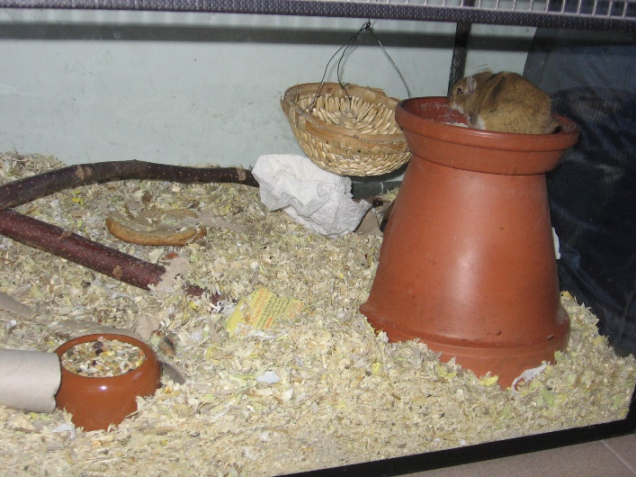

Figure 2: Rabbit ward providing physical and visual space, and retreat place (with permission from J. Chitty)

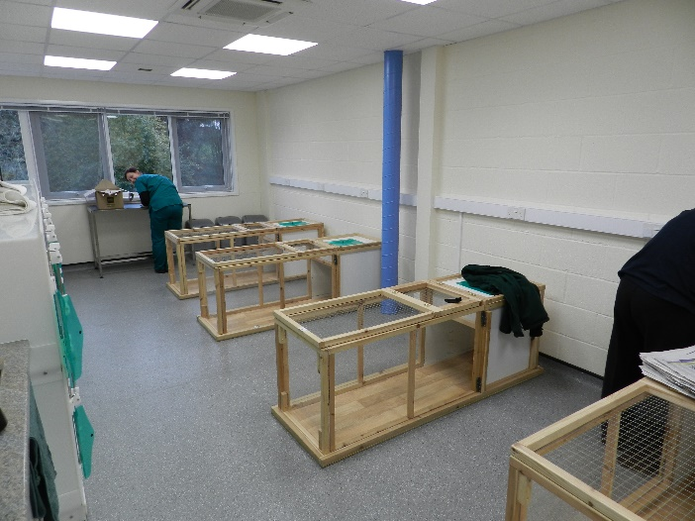

Figure 3: A well handled, trusting degu (with permission from K. Main)

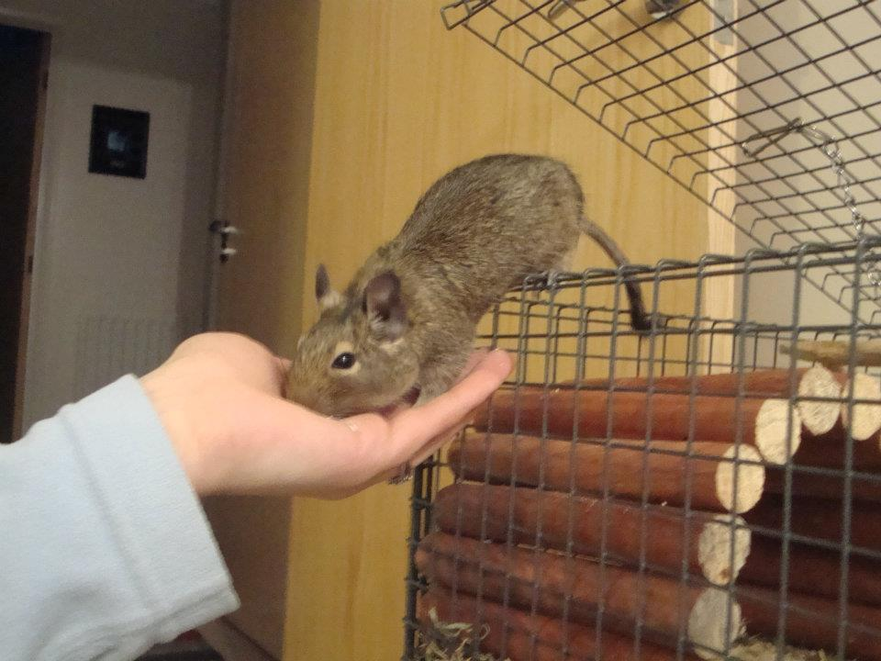

Figure 4: Rabbit patient and companion (with permission from J.Chitty)

