Growth and nutritional status, and their association with lung function: a study from the International Primary Ciliary Dyskinesia Cohort
Goutaki Myrofora¹⁻², Halbeisen Florian S¹, Spycher Ben D¹, Maurer Elisabeth¹, Belle Fabiën¹, Amirav Israel³⁻⁴ on behalf of the PCD Israeli Consortium, Behan Laura⁵⁻⁶, Boon Mieke⁷, Carr Siobhan⁸, Casaulta Carmen² on behalf of the Swiss PCD Group, Clement Annick⁹ on behalf of the French Reference Centre for Rare Lung Diseases, Crowley Suzanne¹⁰, Dell Sharon¹¹, Ferkol Thomas¹², Haarman Eric G¹³, Karadag Bulent¹⁴, Knowles Michael¹⁵, Koerner-Rettberg Cordula¹⁶, Leigh Margaret W¹⁷, Loebinger Michael R¹⁸, Mazurek Henryk¹⁹, Morgan Lucy²⁰, Nielsen Kim G²¹, Phillipsen Maria²¹, Sagel Scott D²², Santamaria Francesca²³, Schwerk Nicolaus²⁴, Yiallouros Panayiotis²⁵, Lucas Jane S⁵, Kuehni Claudia E¹

Affiliations:
- Institute of Social and Preventive Medicine, University of Bern, Switzerland
- Paediatric Respiratory Medicine, Children’s University Hospital of Bern, University of Bern, Switzerland
- Department of Pediatrics, Faculty of Medicine, Bar IIan University, Israel
- Department of Pediatrics, University of Medicine, Edmonton AB, Canada
- Primary Ciliary Dyskinesia Centre, NIHR Respiratory Biomedical Research Centre, University of Southampton, UK
- School of Applied Psychology, University College Cork, Ireland
- Department of Paediatrics, University Hospital Gasthuisberg, Leuven, Belgium
- Department of Paediatrics, Primary Ciliary Dyskinesia Centre, Royal Brompton and Harefield Foundation Trust, London, UK
- Paediatric Pulmonary Department, Trousseau Hospital APHP, Sorbonne Universities and Pierre et Marie Curie University, Paris, France
- Unit for Paediatric Heart, Lung, Allergic Diseases, Rikshospitalet, Oslo, Norway
- SickKids Hospital, Department of Pediatrics, University of Toronto, Toronto, Ontario, Canada
- Department of Pediatrics, Washington University School of Medicine, St Louis, USA
- Department of Pediatric Pulmonology, VU University Medical Center, Amsterdam, The
Netherlands
- Department of Pediatric Pulmonology, Marmara University, School of Medicine, Istanbul, Turkey
- Marsico Lung Institute and Department of Medicine, Department of Medicine, UNC School of Medicine, Chapel Hill, NC, USA
- Department of Paediatric Pneumology, University Children's Hospital of Ruhr University Bochum, Germany
- Marsico Lung Institute and Department of Medicine, Department of Pediatrics, UNC School of Medicine, Chapel Hill, NC, USA
- Host Defence Unit, Royal Brompton and Harefield NHS Foundation Trust, London, UK
- Department of Pneumonology and Cystic Fibrosis, Institute of Tuberculosis and Lung Disorders, ul.Prof.Rudnika 3b, 34-700 Rabka - Zdrój, Poland
- Department of Respiratory Medicine, Concord Hospital Clinical School, University of Sydney, Australia
- Danish PCD Centre Copenhagen, Paediatric Pulmonary Service, Copenhagen University
Hospital, Denmark
- Department of Pediatrics, University of Colorado School of Medicine, Aurora, CO, USA
- Department of Translational Medical Sciences, Federico II University, Napoli, Italy
- Clinic for paediatric pulmonology, allergiology and neonatology, Hannover Medical School, Germany
- Medical School, University of Cyprus, Nicosia, Cyprus

Acknowledgements:
We want to thank all the patients in the PCD cohort and their families, and we are grateful to the PCD patient organisations that closely collaborated with us. We thank all the researchers in the participating centres who helped collect and enter data, and worked closely with us throughout building the iPCD Cohort. We thank Dr. Zorica Zivkovic (Children’s Hospital for Lung Diseases and TB, Medical Centre “Dr Dragisa Misovic”, Belgrade, Serbia) for contributing patients from her centre. We appreciate the work of Edwige Collaud and Anna Bettina Meier (Institute of Social and Preventive Medicine, University of Bern, Switzerland) who helped us with the height and BMI z-score calculations for some countries. We also thank Kali Tal and Christopher Ritter (Institute of Social and Preventive Medicine, University of Bern, Switzerland) for their editorial suggestions.

Conflict of interest: None

Funding:
The development of the iPCD Cohort has been funded from the European Union’s Seventh Framework Programme under EG-GA No.35404 BESTCILIA: Better Experimental Screening and Treatment for Primary Ciliary Dyskinesia. PCD research at ISPM Bern is supported by the Swiss National Foundation (SNF 320030_173044) and also receives national funding from the Lung Leagues of Bern, St. Gallen, Vaud, Ticino, and Valais, and the Milena-Carvajal Pro Kartagener Foundation. CK is supported by the Swiss National Foundation (SNF32003B_162820 and SNF32003B_144068). The national PCD service in Southampton and London is funded by National Health Service (NHS) England. The researchers participate in the network of COST Action BEAT-PCD: Better Evidence to Advance Therapeutic options for PCD (BM 1407). A Swiss National Science Foundation fellowship (PZ00P3_147987) supports BDS. Swiss Cancer Research grants (KLS-3412-02-2014 and KLS-3644-02-2015) supports FB. The AAIR Charity (Reg. No.1129698) supports LB. SD, TF, MK, ML and SDS are supported by National Institutes of Health (NIH) U54HL096458. SDS is also supported by local funding CTSA NIH/NCATS Colorado UL1TR000154.

Author Contributions:
CE Kuehni and M Goutaki developed the concept and designed the study. M Goutaki and FS Halbeisen cleaned and standardised the data. M Goutaki performed the statistical analyses under the guidance of BD Spycher. All other authors participated in discussions for the development of the study and contributed data. CE Kuehni, M Goutaki, BD Spycher, FS Halbeisen, and JS Lucas drafted the manuscript. All authors contributed to iterations and approved the final version. CE Kuehni and M Goutaki take final responsibility for the contents.

Abstract

Chronic respiratory disease can affect growth or nutrition, which can influence lung function. We investigated height, body mass index (BMI), and lung function in patients with primary ciliary dyskinesia (PCD).
In this large study based on the international PCD (iPCD) Cohort, we calculated z-scores for height and BMI using World Health Organization (WHO) and national growth references, and assessed associations with age, sex, country, diagnostic certainty, age at diagnosis, organ laterality, and lung function in multilevel regression models accounting for repeated measurements.
We analysed 6402 measurements from 1609 from iPCD Cohort patients. Height was reduced compared to WHO (z-score -0.12, 95% CI -0.17 to -0.06) and national references (-0.27, -0.33 to -0.21) in male and female patients in all age groups, with variation between countries. Height and BMI were higher in patients diagnosed earlier in life (p=0.026 and <0.001, respectively) and closely associated with FEV1 and FVC z-scores (p<0.001).
Our study indicates that growth and nutrition are impaired in PCD patients from early life and are strongly associated with lung function. If supported by longitudinal studies, this suggests that early diagnosis with multidisciplinary management and nutritional advice could improve growth and delay disease progression and lung function impairment in PCD.

Word count: 200/200

Keywords: Primary ciliary dyskinesia, lung function, epidemiology, growth, nutritional status

Manuscript word count: 3255/3000
Tables and figures: 4 tables and 4 figures
Supplemental material: Yes, including 12 tables and 2 figures

Introduction
Chronic respiratory disease may delay growth and weight gain in children, and lead to reduced height and body mass index (BMI) in adults. Both a disease and its treatments may cause this delay [1,2]; children with asthma grow more slowly because of higher resting energy expenditure [3] and delayed pubertal onset [4], or because of corticosteroid medication [5]. Growth and nutrition in childhood are also associated with lung function later in life in patients with cystic fibrosis (CF) and bronchopulmonary dysplasia [6,7]. Monitoring of BMI and height is thus part of state-of-the art care of patients with chronic lung diseases such as chronic obstructive pulmonary disease and CF [8,9], just as they are used as indicators of growth and nutritional status in healthy individuals [10]. Though growth and nutrition in children with common lung diseases like asthma are well studied, we still know little about height and BMI in patients with rare pulmonary diseases such as primary ciliary dyskinesia (PCD).
The genetically heterogeneous disease primary ciliary dyskinesia affects approximately 1 in 10,000 people; though rare, it is likely underdiagnosed [11]. PCD is characterized by mutations that impair the function of motile cilia, thus affecting organs throughout the body— the respiratory system in particular [12]. The few studies published so far on growth have been contradictory: some suggest impaired growth [13-15], while others do not [16,17]. All were small, included mainly children, and came from one or only a few centres. A further limitation of existing research originates in the reference values for height and BMI. These vary between countries, yet studies have rarely used national reference values [15,17], which are necessary if the growth of PCD patients is to be compared with that of their healthy peers.
We hypothesize that height and BMI of PCD patients are already impaired in early childhood, and are associated with lung function as in other severe lung diseases. We obtained height and BMI of patients in the international PCD (iPCD) Cohort, which we compared to national and international reference values. We investigated determinants of poor growth including sex, age, country of residence, and level of diagnostic certainty. We also investigated growth in paediatric patients and its dependence on the age when patients were diagnosed with PCD, and whether their growth was associated with their lung function.

Methods
Study population and study design
The iPCD Cohort is a large, retrospective international cohort developed during the EU FP7 (Seventh Framework Programme) project Better Experimental Screening and Treatment for Primary Ciliary Dyskinesia (BESTCILIA). It includes demographic data and information on diagnostic tests, clinical symptoms, growth, lung function, and treatment. Clinical and diagnostic data from over 3000 PCD patients in 18 countries allow researchers to pose questions about clinical phenotype, natural history, prognostic factors, and effect of treatments. Details on the iPCD Cohort have been described elsewhere [18]. For this study we included all iPCD datasets that had been delivered, cleaned, and standardised by the time of analysis (April 2016), and that had cross-sectional information on height and weight. Information on ethical approval can be found in the online supplementary material.

PCD diagnosis
PCD diagnostics have evolved quickly [19]. Current recommendations include a combination of tests [20], but test availability differs between countries [19]; not all PCD patients have been diagnosed in similar ways. We divided patients in the iPCD Cohort, who all had a strong clinical suspicion, into three diagnostic subgroups based on the results of the available tests. The first subgroup included patients with definite PCD, which was defined, based on recent guidelines of the ERS PCD Diagnostics Task Force [20], by hallmark transmission electron microscopy (EM) findings and/or identified biallelic PCD genetic mutation. The second subgroup, probable PCD, included patients with abnormal high-speed video-microscopy (VM) findings and/or low nasal nitric oxide (nNO). The third subgroup included patients with clinical PCD diagnosis. The online supplement describes diagnostic details.

Height and BMI
We checked data quality to identify outliers and implausible values and contacted contributors when necessary to resolve any such matters. We calculated age- and sex-adjusted height and BMI z-scores based on international reference values from the World Health Organisation (WHO) [21], and national reference values (the sources are listed in the online supplement, Table S1).
Growth references available for height and BMI were intended for persons up to 19 years of age (or in some countries up to the age of 20). For patients aged <20 years, we calculated height and BMI z-scores based on the exact age-specific references. For patients aged ≥20 years, we calculated height z-scores based on the reference values for 19-year-olds; these describe final adult height. We also calculated BMI z-scores for adults based on the reference values for 19-year-olds because no BMI z-score references exist for adults. We defined short stature as a height z-score ≤-2, underweight as a BMI z-score ≤-2, and overweight as a BMI z-score ≥2 according to the definitions used by WHO.

Determinants of height and BMI
We investigated association of the following factors with height and BMI: sex, age, country of residence, level of diagnostic certainty, age at diagnosis, organ laterality, and lung function at time of height measurement. Growth might differ in male and female patients with PCD, and manifest as slowed growth and/or malnutrition in childhood, and decreased final adult height. Differences between countries could reveal ethnic variations or differences in disease management. In children diagnosis at younger age might improve growth since it would allow earlier introduction of optimal disease management. Patients with situs inversus might have less severe disease because they were diagnosed earlier, before symptoms develop. Details regarding how we categorised the variables chosen are in the online supplement.

Lung function
We chose forced expiratory volume in one second (FEV1), and forced vital capacity (FVC) as indicators of lung function and used the Global Lung Function Initiative (GLI) reference values to calculate age, sex, ethnicity, and height-adjusted z-scores [22]. All lung function measurements were checked for quality, and since 2005 they were performed according to the ERS/ATS guidelines [23]. Earlier measurements were performed according to national recommendations.

Statistical analysis
We compared basic characteristics (sex, age, country) of included and excluded (no available growth measurements) patients using chi-squared tests. We compared height and BMI z-scores of the overall study population to national and WHO reference values using mixed linear regression models with a fixed intercept (difference to reference population), and random intercept to account for repeated measurements of the same patient. To identify determinants of height and BMI, we additionally included fixed effects for sex, age group, country, and diagnostic certainty in these models. We tested for height and BMI differences between patient groups by performing likelihood ratio (LR) tests. We coded categorical predictor variables included in regression models using weighted effect coding. Estimated parameters for a given category thus represent mean z-score differences from the population mean [24,25]. We performed sensitivity analyses in the subgroup of patients with definite PCD diagnosis [20]. To test the robustness of our findings, we performed sensitivity analyses including one measurement (height and BMI) per patient.
We then repeated our analyses for height separately for children (age <20) and adults (age ≥20) to investigate whether the disease only slowed growth or also influenced final adult height. For BMI, we repeated our analysis in children only because BMI z-score references for ≥20-year-olds do not exist. We included age at diagnosis in the multivariable linear regression models for children to test whether age at diagnosis influenced growth and nutrition.
Finally, we assessed the association between FEV1 and FVC and height and BMI in separate multivariable linear regression models in patients with information on lung function. FEV1 and FVC were included as a linear term after visually inspecting scatter plots. We used the statistical programs STATA 14.1 and R 3.2.3 for all analyses.

Results
Population characteristics
Twenty centres had delivered data from 2675 patients at the time of analysis, and 18 of the datasets from 16 countries (2131 patients) contained information on growth (Figure S1). The information necessary to calculate z-scores (height, weight, date of measurement, sex) was available for 1609 patients (6402 measurements). Analyses of organ laterality defects and lung function included 1054 and 959 patients, respectively.
Included patients were slightly older than patients excluded because of insufficient growth data (Table S2, p<0.001), and differed in country of residence (p<0.001). Sex was almost evenly distributed, and more than half the patients (58%) came from European centres. Table 1 summarises the characteristics of the study population. Using the recent ERS PCD Diagnostics Task Force guidelines [20], 66% of patients were defined as having definite PCD, 16% as having probable PCD, and 18% as having only a clinical diagnosis. Most of the patients were diagnosed during childhood (50% at 0-9 years, 28% at 10-19 years).

Height and BMI in PCD patients compared to national and international reference values
PCD patients were shorter when compared to both national and international references (Table 2). Lower height was consistent across gender and age groups, and 146 patients (9%) had a short stature (Table 3, Figure 1). Results differed between countries, but height was usually lower than respective national references (Table 3, Figure 2). Only patients living in Cyprus, France, and Switzerland had normal height z-scores. The small difference in height between males and females did not quite reach statistical significance (LR p=0.072). We found no height difference between levels of diagnostic certainty compared to both national and WHO references (LR p=0.897, p=0.531; Tables 3 and S3). Height deficit differed between the age groups, with the larger deficit in children (LR p<0.001, Table 3).
Overall, the average BMI of PCD patients was slightly above normal when compared to national and international references (Table 2). In at least one measurement during the study period, 105 patients (6%) were underweight, while 405 (25%) were overweight. Children ≤9 years had lower BMI than normal compared to national references (Table S4, Figure 3). Results for BMI differed by age group, with increasing z-scores in older participants (LR p<0.001), and by country. In most countries, BMI was higher than national references; in a few it was similar (Table S4, Figure 2). Only patients from Cyprus had decreased BMI. BMI was higher in males than females (LR p=0.019, Table S4) but did not differ across diagnostic groups (Table S4). Results were similar when compared to the WHO references, with slightly higher z-scores in all countries except France and the Netherlands (Table S5).
Organ laterality did not predict height or BMI (Figure S2, LR p>0.698). Sensitivity analyses that included only patients with definite PCD diagnosis (1054 patients) and the ones that included only one measurement per patient (1601 patients) returned results for height and BMI that were similar to the original model (Tables 2 and S6-S9).

Growth in children and association with age at diagnosis
Analyses of the 1226 paediatric patients confirmed decreased height in children with PCD (Tables 2 and S10). The deficit differed between age groups (LR p=0.008, Table S6). Patients diagnosed later, aged ≥15 years, had a larger height deficit (LR p=0.026, Table S10). The final height of the 439 adult patients was reduced (Tables 2 and S7) in both sexes and all diagnostic groups (Table S11), and results differed by country (LR p<0.001).
BMI in children was, overall, similar to national references (Tables 2 and 4), but increased with age (LR p<0.001): preschoolers (≤4 years) had lower BMI z-scores (Table 4). Age at diagnosis was linearly associated with BMI z-score (LR p<0,001); children diagnosed earlier had higher BMI at time of measurement than children diagnosed later in life (Table 4). Children diagnosed at age ≤4 years had higher BMI z-scores than normal, while those of children diagnosed at age ≥15 years were lower.

Association with lung function
In 959 patients with available lung function data (median age 16 years, interquartile range 19), we found a positive association between height and BMI, and FEV1and FVC measured at the same time (Figure 4). Patients with higher FEV1 z-score were taller (z-score increase per additional FEV1 z-score 0.05, p<0.001; 95% CI 0.04 to 0.07) and had a higher BMI z-score (z-score increase per additional FEV1 z-score 0.17, p<0.001; 95% CI 0.15 to 0.19). Similarly, patients with higher FVC z-score had a higher height z-score (z-score increase per additional FVC z-score 0.03, p<0.001; 95% CI 0.02 to 0.05) and had a higher BMI z-score (z-score increase per additional FEV1 z-score 0.17, p<0.001; 95% CI 0.09 to 0.24).

Discussion
Summary of results
The height z-scores of the PCD patients were lower than both international and national growth references. All of the multinational age groups, including fully matured adults, were shorter than the reference population. BMI was slightly higher in the overall cohort, but was lower than normal in young children. These results were consistent across all diagnostic and organ laterality subgroups. Diagnosis at later age was associated with lower height and lower BMI in children, and lung function (FEV1 and FVC) was positively associated with both height and BMI in males and females and all age groups.

Strengths
The iPCD dataset represents most known PCD patients currently being followed in developed countries. Our study group is thus an order of magnitude larger than that of any previous study that has examined growth and nutrition in patients with PCD and their association with lung function. This has for the first time allowed study of differences in height and BMI of PCD patients between age groups, countries, and levels of diagnostic certainty.
PCD diagnosis has changed over time and varies between countries. We therefore strengthened our analysis with sensitivity tests that included only patients with a definite PCD diagnosis based on the recent diagnostic guidelines from the ERS PCD diagnostics Task Force [20]. The results are further strengthened by our use of both international and national reference values, rather than having relied solely on WHO Child Growth Standards. Paediatric associations often prefer national references, which allow growth comparison of sick children with healthy peers from the same country [26].

Limitations
The iPCD Cohort includes patients primarily from centres that have more advanced diagnostic capabilities; patients in some countries are under-represented. Growth patterns may have shifted as well in some countries in which national references have not been updated.
We compensated for the lack of references for adults as other studies have done by calculating BMI z-scores for adult patients based on the reference values for 19-year-olds [27]. This is not fully satisfactory, though, because as the Swiss Health Survey makes clear BMI increases with age [28]. We therefore think our BMI results are valid primarily for children. For adults we would need a comparison, currently beyond the scope of this study, of PCD patients with appropriate adult control groups.
Information on ethnicity was not recorded for all patients, so height and BMI z-scores were calculated using national references of countries of residence. For patients of unknown ethnicity, we calculated FEV1 and FVC z-scores using the other/mixed GLI reference values. We assume that this affected our results only marginally, particularly because patients with possible South Asian origin who are known to have different lung function reference values were less than 5% of our study population.

Comparison with other studies
Results of previous studies of growth and PCD vary considerably (Table S12). In a Belgian comparison of 168 PCD patients with national references, the PCD patients were shorter (z-score −0.53, 95% CI −0.85 to -0.22), but had normal BMI [13]. In six North American centres, most of the 118 children fell within normal parameters, but children with CCDC39 and CCDC40 mutations had lower height, BMI, and FEV1 compared to those with different mutations [16]. A comparison of the height and BMI of 158 paediatric patients at three centres in Italy, Denmark, and the UK, with UK growth references, concluded that height and BMI were normal [17]. A different, Czech comparison of PCD patients to national references found that children aged 7-13 years were shorter, though BMI in all age groups was normal. Their height z-scores declined during childhood until age 9 years, but height difference did not depend on age at diagnosis [14]. However, each of these comparisons with respective UK and Czech national references was small and lacked power.
For other respiratory diseases, associations between growth and nutrition, and lung function have been studied extensively. Taking the example of bronchopulmonary dysplasia, the nutritional status of two-year olds predicted lung function in later childhood [6]. Similarly for CF, patients with better growth and nutrition at 3 years also had better lung function when they were 6 [7]. And in a comparison of PCD and CF patients in Israel, BMI was lower in 34 PCD patients than it was in 130 CF patients (with and without pancreatic insufficiency), and BMI and FEV1 tended towards correlation (r=0.44, p=0.06) [15].

Interpretation of results
What does all this mean? It is not possible to derive the direction of the association between growth and lung function from cross-sectional data. Yet it certainly is possible, and probable, that poorer lung function resulting in increased respiratory effort and higher resting energy expenditure can affect growth in PCD patients. Impaired nutrition—caused, for example, by reduced appetite due to swallowed sputum or repeated infections—could additionally impair lung development [29]. This is supported by evidence from CF, which indicated that nutritional support helped reduce mortality [30,31].
Our data suggest more strongly than any obtained to date that growth in PCD patients starts to diverge from normal at an early age. This could imply a genetic cause. Prevalence of PCD is higher in consanguineous populations [32], and inbreeding has been reported to contribute to reduced height [33]. Primary (nonmotile) cilia play a role in mechanical signalling in bone cells, but a possible role in skeletal growth has not been tested [34]. A recent study has reported mild scoliosis in 23% of 198 UK PCD patients, which could have an additional effect that reduces height [35]. Height and BMI were lower in children with CCDC39 and CCDC40 mutations [16], which cause specific ultrastructural defects (absence of inner dynein arms and microtubular disorganisation), and account for up to 12% of PCD cases [36,37]. We had genetic data for only a few patients and could not pursue this further. However, based on their low prevalence these mutations alone could not explain our findings.
Chronic and recurrent infections, common in PCD, may negatively influence the periods of rapid growth in childhood when nutrients needed for growth might be used for immune defence [38,39]. Alternatively, oral or inhaled corticosteroids (ICS) may play a role. An earlier European survey of PCD centres reported routine use of ICS in 15% of centres, particularly in Northern Europe [40]. PCD patients might also have been misclassified as severe asthmatics and treated with systemic corticosteroids or high-dose ICS prior to their PCD diagnosis. The iPCD cohort has data on corticosteroid use for only a few patients, so we could not test this hypothesis.
Conclusions
Future research should collect longitudinal data, ideally from birth into adulthood, to evaluate changes in height, BMI, and lung function over time, and investigate the direction of their association using appropriate statistical approaches [41]. This will also allow assessing the role of different treatment strategies and recurrent infections on growth and the course of lung function. From a clinical perspective, our findings suggest that early diagnosis followed by multidisciplinary management could delay disease progression and improve growth. Monitoring height and BMI and, if necessary, early nutritional interventions should become part of routine care in PCD clinics to maximise lung growth and delay disease progression.

REFERENCES

1. Chang KC, Miklich DR, Barwise G, Chai H, Miles-Lawrence R. Linear growth of chronic asthmatic children: the effects of the disease and various forms of steroid therapy. Clin Allergy 1982;12:369-78.
2. Shohat M, Shohat T, Kedem R, Mimouni M, Danon YL. Childhood asthma and growth outcome. Arch Dis Child 1987;62:63-5.
3. Zeitlin SR, Bond S, Wootton S, Gregson RK, Radford M. Increased resting energy expenditure in childhood asthma: does this contribute towards growth failure? Arch Dis Child 1992;67:1366-9.
4. Balfour-Lynn L. Growth and childhood asthma. Arch Dis Child 1986;61:1049-55.
5. Zhang L, Prietsch SO, Ducharme FM. Inhaled corticosteroids in children with persistent asthma: effects on growth. Cochrane Database Syst Rev 2014:CD009471.
6. Bott L, Beghin L, Devos P, Pierrat V, Matran R, Gottrand F. Nutritional status at 2 years in former infants with bronchopulmonary dysplasia influences nutrition and pulmonary outcomes during childhood. Pediatr Res 2006;60:340-4.
7. Konstan MW, Butler SM, Wohl ME, Stoddard M, Matousek R, Wagener JS, Johnson CA, Morgan WJ, Investigators, Coordinators of the Epidemiologic Study of Cystic F. Growth and nutritional indexes in early life predict pulmonary function in cystic fibrosis. J Pediatr 2003;142:624-30.
8. Liou TG, Adler FR, Fitzsimmons SC, Cahill BC, Hibbs JR, Marshall BC. Predictive 5-year survivorship model of cystic fibrosis. Am J Epidemiol 2001;153:345-52.
9. van den Bemt L, Schermer T, Smeele I, Bischoff E, Jacobs A, Grol R, van Weel C. Monitoring of patients with COPD: a review of current guidelines' recommendations. Respir Med 2008;102:633-41.
10. de Onis M, Wijnhoven TM, Onyango AW. Worldwide practices in child growth monitoring. J Pediatr 2004;144:461-5.
11. Kuehni CE, Frischer T, Strippoli MP, Maurer E, Bush A, Nielsen KG, Escribano A, Lucas JS, Yiallouros P, Omran H, Eber E, O'Callaghan C, Snijders D, Barbato A. Factors influencing age at diagnosis of primary ciliary dyskinesia in European children. Eur Respir J 2010;36:1248-58.
12. Lucas JS, Walker WT, Kuehni CE, al. e. Primary Ciliary Dyskinesia. In: Courdier J-F, editor Orphan Lung diseases European Respiratory Monograph 2011:201-17.
13. Boon M, Smits A, Cuppens H, Jaspers M, Proesmans M, Dupont LJ, Vermeulen FL, Van Daele S, Malfroot A, Godding V, Jorissen M, De Boeck K. Primary ciliary dyskinesia: critical evaluation of clinical symptoms and diagnosis in patients with normal and abnormal ultrastructure. Orphanet J Rare Dis 2014;9:11.
14. Svobodova T, Djakow J, Zemkova D, Cipra A, Pohunek P, Lebl J. Impaired Growth during Childhood in Patients with Primary Ciliary Dyskinesia. Int J Endocrinol 2013;2013:731423.
15. Cohen-Cymberknoh M, Simanovsky N, Hiller N, Gileles Hillel A, Shoseyov D, Kerem E. Differences in disease expression between primary ciliary dyskinesia and cystic fibrosis with and without pancreatic insufficiency. Chest 2014;145:738-44.
16. Davis SD, Ferkol TW, Rosenfeld M, Lee HS, Dell SD, Sagel SD, Milla C, Zariwala MA, Pittman JE, Shapiro AJ, Carson JL, Krischer JP, Hazucha MJ, Cooper ML, Knowles MR, Leigh MW. Clinical features of childhood primary ciliary dyskinesia by genotype and ultrastructural phenotype. Am J Respir Crit Care Med 2015;191:316-24.
17. Maglione M, Bush A, Nielsen KG, Hogg C, Montella S, Marthin JK, Di Giorgio A, Santamaria F. Multicenter analysis of body mass index, lung function, and sputum microbiology in primary ciliary dyskinesia. Pediatr Pulmonol 2014;49:1243-50.
18. Goutaki M, Maurer E, Halbeisen FS, Amirav I, Barbato A, Behan L, Boon M, Casaulta C, Clement A, Crowley S, Haarman E, Hogg C, Karadag B, Koerner-Rettberg C, Leigh MW, Loebinger MR, Mazurek H, Morgan L, Nielsen KG, Omran H, Schwerk N, Scigliano S, Werner C, Yiallouros P, Zivkovic Z, Lucas JS, Kuehni CE, Consortium PCDI, Swiss PCDG, French Reference Centre for Rare Lung D, Genetic Disorders of Mucociliary Clearance C. The international primary ciliary dyskinesia cohort (iPCD Cohort): methods and first results. Eur Respir J 2017;49.
19. Lucas JS, Paff T, Goggin P, Haarman E. Diagnostic Methods in Primary Ciliary Dyskinesia. Paediatr Respir Rev 2016;18:8-17.
20. Lucas JS, Barbato A, Collins SA, Goutaki M, Behan L, Caudri D, Dell S, Eber E, Escudier E, Hirst RA, Hogg C, Jorissen M, Latzin P, Legendre M, Leigh MW, Midulla F, Nielsen KG, Omran H, Papon JF, Pohunek P, Redfern B, Rigau D, Rindlisbacher B, Santamaria F, Shoemark A, Snijders D, Tonia T, Titieni A, Walker WT, Werner C, Bush A, Kuehni CE. European Respiratory Society guidelines for the diagnosis of primary ciliary dyskinesia. Eur Respir J 2017;49.
21. Group WMGRS. WHO Child Growth Standards: Length/height-for-age, weight-for-age,
weight-for-length, weight-for-height and body mass index-for-age – Methods and development. . Geneva: World Health Organization; 2006.
22. Quanjer PH, Stanojevic S, Cole TJ, Baur X, Hall GL, Culver BH, Enright PL, Hankinson JL, Ip MS, Zheng J, Stocks J. Multi-ethnic reference values for spirometry for the 3-95-yr age range: the global lung function 2012 equations. Eur Respir J 2012;40:1324-43.
23. Miller MR, Hankinson J, Brusasco V, Burgos F, Casaburi R, Coates A, Crapo R, Enright P, van der Grinten CP, Gustafsson P, Jensen R, Johnson DC, MacIntyre N, McKay R, Navajas D, Pedersen OF, Pellegrino R, Viegi G, Wanger J. Standardisation of spirometry. Eur Respir J 2005;26:319-38.
24. Davis M. Contrast Coding in Multiple Regression Analysis: Strengths, Weaknesses, and Utility of Popular Coding Structures. Journal of Data Science 2010;8:61-73.
25. Wendorf C. Primer on multiple regression coding: Common forms and the additional case of repeated contrasts. Understanding Statistics 2004;3:47-57.
26. Bonthuis M, van Stralen KJ, Verrina E, Edefonti A, Molchanova EA, Hokken-Koelega AC, Schaefer F, Jager KJ. Use of national and international growth charts for studying height in European children: development of up-to-date European height-for-age charts. PLoS One 2012;7:e42506.
27. Must A, Anderson SE. Body mass index in children and adolescents: considerations for population-based applications. Int J Obes (Lond) 2006;30:590-4.
28. Eichholzer M, Bovey F, Jordan P, Schmid M, Stoffel-Kurt N. [Body weight related data: results of the 2007 Swiss Health Survey]. Praxis (Bern 1994) 2010;99:895-906.
29. Korten I, Usemann J, Latzin P. "Lung sparing growth": is the lung not affected by malnutrition? Eur Respir J 2017;49.
30. Dodge JA, Lewis PA, Stanton M, Wilsher J. Cystic fibrosis mortality and survival in the UK: 1947-2003. Eur Respir J 2007;29:522-6.
31. Stephenson AL, Mannik LA, Walsh S, Brotherwood M, Robert R, Darling PB, Nisenbaum R, Moerman J, Stanojevic S. Longitudinal trends in nutritional status and the relation between lung function and BMI in cystic fibrosis: a population-based cohort study. Am J Clin Nutr 2013;97:872-7.
32. O’Callaghan C, Chetcuti P, Moya E. High prevalence of primary ciliary dyskinesia in a British Asian population. Arch Dis Child 2010;95:51-2.
33. McQuillan R, Eklund N, Pirastu N, Kuningas M, McEvoy BP, Esko T, Corre T, Davies G, Kaakinen M, Lyytikainen LP, Kristiansson K, Havulinna AS, Gogele M, Vitart V, Tenesa A, Aulchenko Y, Hayward C, Johansson A, Boban M, Ulivi S, Robino A, Boraska V, Igl W, Wild SH, Zgaga L, Amin N, Theodoratou E, Polasek O, Girotto G, Lopez LM, Sala C, Lahti J, Laatikainen T, Prokopenko I, Kals M, Viikari J, Yang J, Pouta A, Estrada K, Hofman A, Freimer N, Martin NG, Kahonen M, Milani L, Heliovaara M, Vartiainen E, Raikkonen K, Masciullo C, Starr JM, Hicks AA, Esposito L, Kolcic I, Farrington SM, Oostra B, Zemunik T, Campbell H, Kirin M, Pehlic M, Faletra F, Porteous D, Pistis G, Widen E, Salomaa V, Koskinen S, Fischer K, Lehtimaki T, Heath A, McCarthy MI, Rivadeneira F, Montgomery GW, Tiemeier H, Hartikainen AL, Madden PA, d'Adamo P, Hastie ND, Gyllensten U, Wright AF, van Duijn CM, Dunlop M, Rudan I, Gasparini P, Pramstaller PP, Deary IJ, Toniolo D, Eriksson JG, Jula A, Raitakari OT, Metspalu A, Perola M, Jarvelin MR, Uitterlinden A, Visscher PM, Wilson JF. Evidence of inbreeding depression on human height. PLoS Genet 2012;8:e1002655.
34. Lee KL, Guevarra MD, Nguyen AM, Chua MC, Wang Y, Jacobs CR. The primary cilium functions as a mechanical and calcium signaling nexus. Cilia 2015;4:7.
35. Schlosser TPC, Semple T, Carr SB, Padley S, Loebinger MR, Hogg C, Castelein RM. Scoliosis convexity and organ anatomy are related. Eur Spine J 2017;26:1595-9.
36. Papon JF, Coste A, Roudot-Thoraval F, Boucherat M, Roger G, Tamalet A, Vojtek AM, Amselem S, Escudier E. A 20-year experience of electron microscopy in the diagnosis of primary ciliary dyskinesia. Eur Respir J 2010;35:1057-63.
37. Shoemark A, Dixon M, Corrin B, Dewar A. Twenty-year review of quantitative transmission electron microscopy for the diagnosis of primary ciliary dyskinesia. J Clin Pathol 2012;65:267-71.
38. Pammi M, JG V, SA A. Nutrition-Infection Interactions and Impacts on Human Health. Boca Raton: CRC Press 2014.
39. Stephensen CB. Burden of infection on growth failure. J Nutr 1999;129:534s-8s.
40. Strippoli MP, Frischer T, Barbato A, Snijders D, Maurer E, Lucas JS, Eber E, Karadag B, Pohunek P, Zivkovic Z, Escribano A, O'Callaghan C, Bush A, Kuehni CE, ERS Task Force on Primary Ciliary Dyskinesia in Children. ERS Task Force on Primary Ciliary Dyskinesia in Children. Management of primary ciliary dyskinesia in European children: recommendations and clinical practice. Eur Respir J 2012;39:1482-91.
41. Galea S, Riddle M, Kaplan GA. Causal thinking and complex system approaches in epidemiology. Int J Epidemiol 2010;39:97-106.

FIGURE LEGENDS

Fig 1. Height in PCD patients by age group A) compared to national references and B) compared to WHO references.
Height is presented as mean z-score (95%CI) after adjusting for sex, country, and level of diagnostic certainty.

Fig 2. Height and BMI in PCD patients by country A) compared to national references and B) compared to WHO references.
Height and BMI are presented as mean z-score (95%CI) after adjusting for sex, age group, and level of diagnostic certainty.
Patients from Serbia were included only in the analysis using the WHO references because no national growth references were available.

Fig 3. BMI in PCD patients by age group A) compared to national references and B) compared to WHO references.
BMI is presented as mean z-score (95%CI) after adjusting for sex, country, and level of diagnostic certainty.

Fig 4. Association of height and BMI with FEV1 and FVC in PCD patients, using national references.
Height and BMI are presented as z-scores after adjusting for sex, country, and level of diagnostic certainty. FEV1 and FVC are presented as z-scores calculated using the GLI references.
One measurement (the first available) per patient included.
Z-score increase per additional FEV1 z-score 1) in height: 0.05, p<0.001, 95% CI 0.04 to 0.07 and 2) in BMI: 0.17, p<0.001, 95% CI 0.15 to 0.19.
Z-score increase per additional FVC z-score 1) in height: 0.03, p<0.001, 95% CI 0.02 to 0.05 and 2) in BMI: 0.17, p<0.001, 95% CI 0.09 to 0.24.

Table 1. Characteristics of the study population (N=1609)
Characteristic | n | %
Sex
Male | 780 | 49
Female | 829 | 51
Country of residence*
Australia | 55 | 3
Northern Europe | 390 | 24
Western Europe | 405 | 25
Eastern Europe | 97 | 6
Southern Europe | 46 | 3
Western Asia | 202 | 13
North America | 414 | 26
Organ laterality
Situs solitus | 827 | 51
Situs inversus | 587 | 37
Heterotaxia | 51 | 3
Situs status not reported | 144 | 9
Date of birth
Earlier than 1976 | 252 | 16
1977-1996 | 497 | 31
1997-2015 | 860 | 53
Diagnostic information
Definite PCD diagnosis⁺ | 1,056 | 66
Probable PCD diagnosis# | 256 | 16
Clinical diagnosis only | 297 | 18
Age at diagnosis  0-9 years  10-19 years  20-29 years  30-39 years  40-49 years  ≥50 years | 800  451  129  93  72  64 | 50  28  8  6  4  4
* Based on geographical region definitions of the United Nations Statistics Division (August 2016):
Northern Europe: Denmark, Norway, United Kingdom; Western Europe: Belgium, France, Germany, Switzerland, the Netherlands; Eastern Europe: Poland; Southern Europe: Italy, Serbia; Western Asia: Cyprus, Israel, Turkey; Northern America: Canada, United States; Southern America: Argentina
+ Defined as hallmark PCD electron microscopy findings and/or biallelic gene mutation identified based on the ERS PCD Diagnostics Task Force guidelines
# Abnormal light or high frequency video microscopy finding and/or low (≤ 77nl/min) nasal NO value

Table 2. Height and BMI of PCD patients of the iPCD Cohort compared to national and WHO references (constant only models)
 |  | Reference | N | mean  z-score | 95% CI |  | p-value
Height | Overall study population | National* | 1601 | -0.27 | -0.33 | -0.21 | <0.001
 | Overall study population | WHO | 1609 | -0.12 | -0.17 | -0.06 | <0.001
 | Paediatric population (<20 y) | National* | 1226 | -0.26 | -0.33 | -0.20 | <0.001
 | Adult population (≥20 y) | National* | 439 | -0.31 | -0.42 | -0.20 | <0.001
 | Patients with definite PCD⁺ | National* | 1054 | -0.26 | -0.33 | -0.19 | <0.001
 | Overall study population¶ | National* | 1601 | -0.30 | -0.36 | -0.24 | <0.001
BMI | Overall study population | National* | 1549 | 0.06 | 0.002 | 0.13 | 0.043
 | Overall study population | WHO | 1539 | 0.21 | 0.14 | 0.27 | <0.001
 | Paediatric population (<20 y) | National* | 1184 | 0.02 | -0.05 | 0.09 | 0.582
 | Patients with definite PCD⁺ | National* | 1019 | 0.05 | -0.02 | 0.13 | 0.172
 | Overall study population¶ | National* | 1549 | 0.03 | -0.04 | 0.09 | 0.424
* Patients from Serbia were excluded from this analysis because no national references were available
+ Defined as hallmark PCD electron microscopy findings and/or biallelic gene mutation identified based on the ERS PCD Diagnostics Task Force guidelines
¶ Analysis included one measurement (the earliest available) per patient

Table 3. Height of PCD patients (N=1601) of the iPCD Cohort compared to national height references by characteristics of the study population
Characteristics | n | mean z-score | 95% CI |  | p-value¶
Sex |  |  |  |  | 0.072
male | 774 | -0.22 | -0.30 | -0.13
female | 827 | -0.32 | -0.40 | -0.24
Age group* |  |  |  |  | <0.001
0-9 y | 683 | -0.27 | -0.33 | -0.21
10-19 y | 683 | -0.31 | -0.37 | -0.25
20-29 y | 199 | -0.22 | -0.29 | -0.14
30-39 y | 119 | -0.20 | -0.29 | -0.11
40-49 y | 89 | -0.22 | -0.32 | -0.12
>50y | 79 | -0.23 | -0.35 | -0.11
Country |  |  |  |  | <0.001
Australia | 55 | -0.31 | -0.60 | -0.01
Belgium | 79 | -0.66 | -0.92 | -0.40
Cyprus | 30 | -0.14 | -0.53 | 0.26
Denmark | 91 | -0.36 | -0.59 | -0.14
France | 119 | 0.18 | -0.03 | 0.39
Germany | 94 | -0.76 | -0.99 | -0.53
Israel | 142 | -0.50 | -0.70 | -0.31
Italy | 38 | -0.41 | -0.77 | -0.06
Netherlands | 66 | -0.18 | -0.45 | 0.09
Norway | 22 | -0.64 | -1.10 | -0.17
Poland | 97 | -0.22 | -0.46 | 0.02
Switzerland | 47 | -0.01 | -0.32 | 0.29
Turkey | 30 | -1.09 | -1.51 | -0.66
UK | 277 | -0.15 | -0.29 | -0.01
USA/Canada | 414 | -0.16 | -0.30 | -0.05
Diagnostic certainty |  |  |  |  | 0.897
Definite PCD diagnosis⁺ | 1,054 | -0.28 | -0.35 | -0.21
Probable PCD diagnosis# | 254 | -0.27 | -0.42 | -0.12
Clinical diagnosis only | 293 | -0.24 | -0.37 | -0.10
Mean z-scores and 95%CI for each group after adjusting for the remaining characteristics
¶ Likelihood ratio test p-value indicating if the characteristic explains differences in height within the study population;
+ Defined as hallmark PCD electron microscopy findings and/or biallelic gene mutation identified based on the ERS PCD Diagnostics Task Force guidelines
# Abnormal light or high frequency video microscopy finding and/or low nasal NO value
* Age at measurement: n represents the unique number of patients in each group
Patients from Serbia were excluded from this analysis because no national references were available

Table 4. BMI of paediatric patients (<20 years, N=1184) of the iPCD Cohort compared
to national BMI references by characteristics of the study population
Characteristics | n | mean z-score | 95% CI |  | p-value¶
Sex |  |  |  |  | 0.605
male | 610 | 0.04 | -0.06 | 0.13
female | 574 | -0.0002 | -0.10 | 0.10
Age group* |  |  |  |  | <0.001
0-4 y | 226 | -0.24 | -0.35 | -0.13
5-9 y | 504 | -0.01 | -0.09 | 0.07
10-14 y | 475 | 0.05 | -0.03 | 0.13
15-19 y | 322 | 0.22 | 0.13 | 0.31
Country |  |  |  |  | 0.004
Australia | 44 | -0.07 | -0.42 | 0.28
Belgium | 38 | -0.33 | -0.73 | 0.07
Cyprus | 17 | -0.44 | -0.98 | 0.10
Denmark | 74 | -0.01 | -0.27 | 0.25
France | 118 | 0.09 | -0.13 | 0.31
Germany | 82 | -0.22 | -0.48 | 0.05
Israel | 100 | -0.05 | -0.30 | 0.20
Italy | 33 | 0.41 | 0.02 | 0.80
Netherlands | 50 | 0.23 | -0.10 | 0.56
Norway | 19 | -0.62 | -1.14 | -0.10
Poland | 82 | 0.02 | -0.26 | 0.30
Switzerland | 32 | -0.10 | -0.49 | 0.29
Turkey | 30 | -0.51 | -0.97 | -0.05
UK | 182 | 0.03 | -0.15 | 0.21
USA/Canada | 283 | 0.21 | 0.05 | 0.36
Diagnostic certainty |  |  |  |  | 0.829
Definite PCD diagnosis⁺ | 767 | 0.004 | -0.08 | 0.09
Probable PCD diagnosis# | 197 | 0.03 | -0.16 | 0.21
Clinical diagnosis only | 220 | 0.07 | -0.11 | 0.24
Age at diagnosis |  |  |  |  | <0.001
0-4 y | 351 | 0.24 | 0.11 | 0.38
5-9 y | 413 | 0.04 | -0.08 | 0.16
10-14 y | 272 | -0.07 | -0.22 | 0.08
15-19 y | 141 | -0.43 | -0.64 | -0.22
Mean z-scores (95%CI) for each group after adjusting for the remaining characteristics
¶ Likelihood ratio test p-value indicating if the characteristic explains differences in BMI within the study population
+ Defined as hallmark PCD electron microscopy findings and/or biallelic gene mutation identified based on the ERS PCD Diagnostics Task Force guidelines
# Abnormal light or high frequency video microscopy finding and/or low nasal NO value
* Age at measurement: n represents the unique number of patients in each group
Patients from Serbia were excluded from this analysis because no national references were available

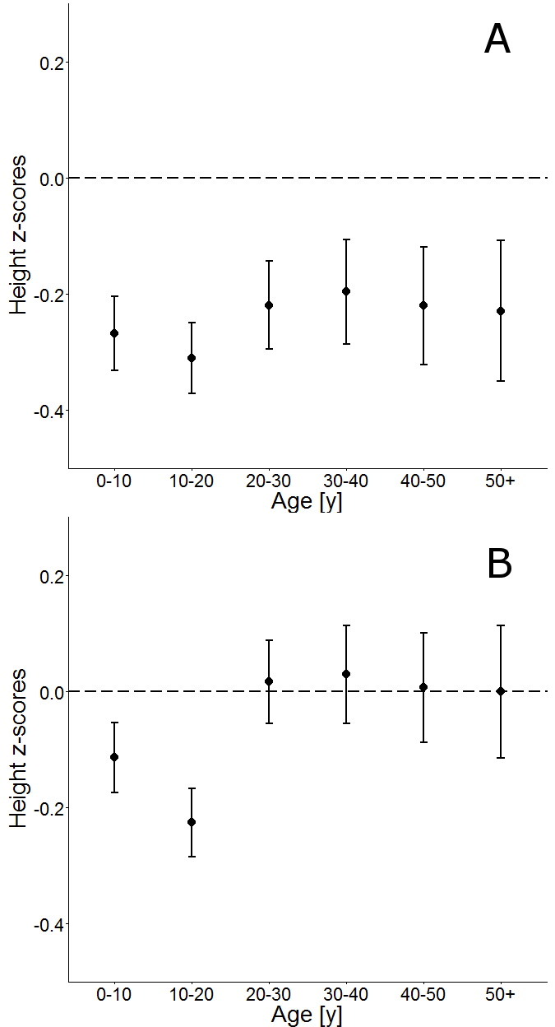

Figure 1

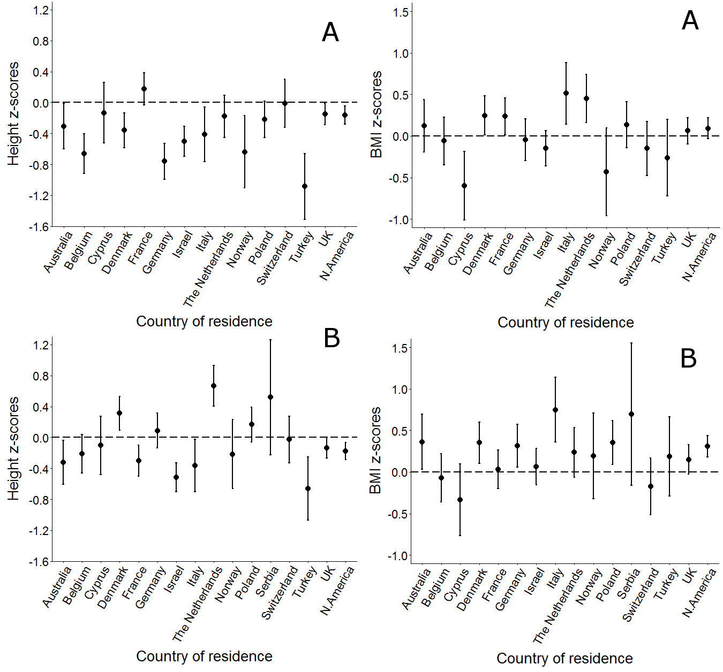

Figure 2

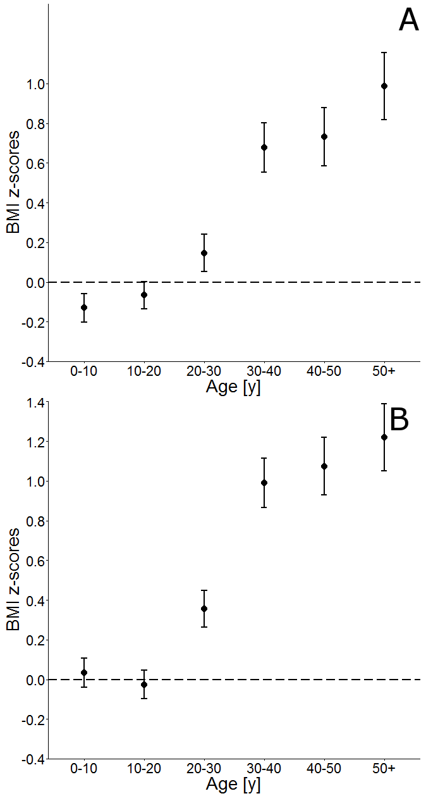
Figure 3

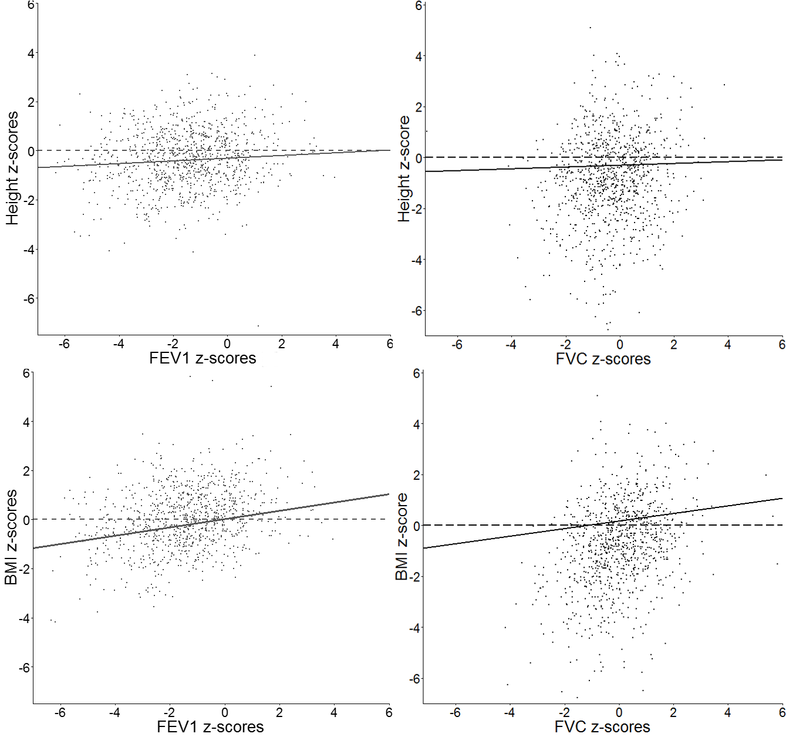
Figure 4

