Experimental investigations into the current-induced motion of a lifeboat at a single point mooring.

Catherine J. Hollyhead*, Nicholas C. Townsend, James I.R. Blake.

Faculty of Engineering and the Environment, University of Southampton, UK.

* Corresponding author: cjh1g08@soton.ac.uk

ABSTRACT

This paper presents a series of model experiments on the current-induced motions of a 1:40 scale lifeboat at a single point mooring (SPM). The influence upon vessel and buoy motion of the mooring configuration factors of (a) three mooring line (hawser) lengths, (b) four buoy shapes and (c) two buoy sizes have been investigated. A motion tracking algorithm was successfully employed and validated against data from an inertial measuring unit allowing small scale testing without the influence of instrument cabling. The results show that the dominant translational motion, of the model lifeboat at a SPM, is sway and the rotational motion is yaw, with double pendulum-like fishtailing behaviour prevalent. Increasing the hawser length, when no buoy was present, resulted in an increase in the vessel’s sway velocity. No significant effects on vessel motion were observed from changes in the shape of the 1:40 and 1:20 scale buoys. However, the presence and increasing size of the buoy was found to increase the sway velocity of the buoy and reduce the motions of the model lifeboat. These results suggest that changes in buoy size influence the motions of the model lifeboat which may enable mooring efficacy to be improved.

Key words:

Single point mooring (SPM), Moored ship responses, Buoy shape, Lifeboat, Tank testing.

# Introduction

## 1.1 Motivation

A Single Point Mooring (SPM), defined by the American Bureau of Shipping as “a system which permits a vessel to weathervane while the vessel is moored to a fixed or floating structure anchored to the seabed by a rigid or an articulated structural system or by catenary spread mooring” (ABS, 2014), allows a vessel to self-align to the prevailing waves and reduce the mooring hawser load compared to that if its heading was constrained (Schellin, 2003; Oil Companies International Marine Forum, 2008). To date, the motions of large scale tankers at SPM’s, in deep off-shore waters, has been extensively investigated, due to the expansion of offshore oil and gas extraction (Gaythwaite, 2000; Fan et al., 2017).

At the smaller scale, e.g., boat lengths of less than 20m, there is limited published data on the efficacy of SPM moorings. There are significant numbers of SPM moored boats around the world, including forty belonging to the Royal National Lifeboat Institution (RNLI) and 389 listed marinas in the U.K (Which-Marina, 2015), which employ a variety of hawser lengths and buoy shapes, including spherical, cylindrical, barrel and modular. Coupled with the numerous media reports of yachts breaking free from their moorings resulting in damage and/or rescue crews being called out (for example (BBC, 2008; Percuil River Moorings Ltd., 2010; BBC, 2012; IWCP, 2012; BBC, 2013; SeaSurveys, 2013; Yachting and Boating World, 2016a; Yachting and Boating World, 2016b). In addition the U.K’s Marine Accident Investigation Branch have reported that, in the ten year period to 2001, eighty five fishermen lost their lives of which six were due to “whiplash from failed mooring lines, mooring lines slipping from fairleads or being struck by failed mooring ropes” (Lang, 2001). There is a need to understand the motion responses of small vessels at SPM moorings.

## 1.2 Background

The displacement of a rigid floating body can be described by six degrees of freedom: the translational motions along the axes of surge, sway and heave and the rotational ones around them of roll, pitch and yaw Fig. 1. For an unconstrained vessel these can be subdivided into oscillatory (heave, pitch and roll) that invoke restoring forces due to a change in the vessel’s equilibrium displacement and non-oscillatory (surge, sway and yaw), (Van Dorn, 1974). However when a vessel is moored at a SPM the catenary mooring chain provides a restoring force and oscillations can additionally occur in surge, sway and yaw, each mode with its own natural frequency providing the potential for large amplitude motions at their resonant frequencies (Van Dorn, 1974). One of the observed behaviours in wind and current, both in experiments and from mathematical modelling, is termed “fishtailing” (e.g. Aghamohammadi and Thompson, 1990; Luai and Zhi, 2013; Schellin, 2003; Sharma *et al.*, 1988; Wang *et al.*, 2007; Wichers, 1988). This slowly varying drift motion, in the horizontal plane, is described by a combination of the oscillatory motions of surge, sway and yaw around the buoy (Fig. 2).

Experiments performed using model offshore tankers in deep water show this swinging double pendulum-like motion can be reduced by reducing the hawser length (Pinkster and Remery, 1975) or increasing the hawser tension (Sorheim, 1980). A literature review has found numerous publications detailing experimental data on the motion responses of offshore tankers at SPM but only one relating to small vessels which examined the motion of a fishing boats moored at jetties (Oosugi *et. al.*, 2007). The authors are unaware of any literature presenting experimental data on the effect of buoy shape or buoy size upon the motions of small vessels, such as those of the RNLI, stationed at catenary SPM in coastal harbours.

|  |  |
| --- | --- |
| (a) | (b) |

Fig. 1: The right handed frame of reference in the flume (a) three-dimensional and (b) two-dimensional representations.

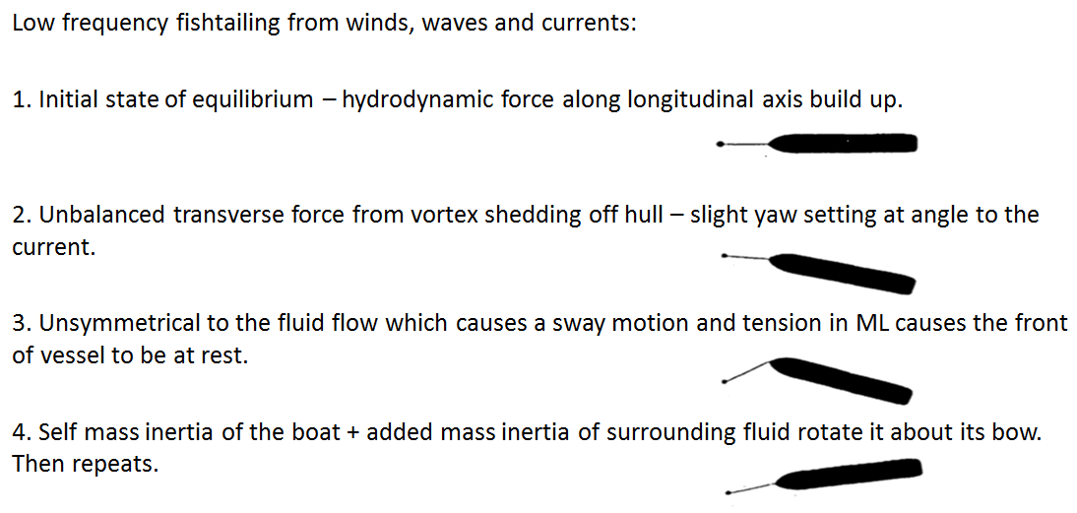

Fig. 2: Fishtailing motion of a vessel at a single point mooring adapted from Aghamohammadi and Thompson (1990).

## 1.3 Paper Contribution

This paper presents the results from a series of 1:40 model scale experimental investigations into the effect of hawser length, buoy scale and shape on small boats (considered sub 20m) with free catenary SPM configurations (i.e., without the use of fixed spring-mass-damper mooring line). The paper structure is as follows; In Section 2 the experimental setup and methodology is described. In Section 3 the experimental results are presented and discussed in Section 4. The conclusions are presented in Section 5.

# Methodology

## 2.1 Experimental Setup

A series of 1:40 model scale experimental investigations into the effect of hawser length, buoy scale and buoy shape on small boats (considered sub 20 m) with a free catenary SPM configuration were conducted in the circulatory flume at the Chilworth research laboratory, University of Southampton (21 m in length, 1.35 m width and depths up to 0.4 m). The flume is a conventional gravity fed system in which water is lifted from a large sump via three centrifugal pumps each with a radial clock valve to control the flow rates (Myers and Bahaj, 2010).

When conducting ship tank experiments it is recognised that gravity forces predominate in free-surface flows (Hughes, 2005) and Froude similitude was used to determine the model scales. The geometric scaling factor, R, was defined as the ratio of the full scale length divided by the model length which also defines the depth scaling. The flow velocity was scaled at 1/ $\sqrt{R}$. In this particular case of model testing cables in water it is usual to violate exact geometric scaling for practical reasons however the correct value for the Young’s modulus of the material should be used as its violation, in dynamic testing, is extremely significant (Papazoglou et al., 1990). The ground and riser chains were scaled using the Cauchy criterion which facilitates the similitude of the ratio of inertial to elastic forces using the Young’s modulus of the material (Hughes, 2005). Tensile tests, using an Instron E-Series Circumferential Extensometer, yielded a required diameter using the Cauchy criteria of 0.92 mm compared to a geometrically scaled diameter of 0.65 mm.

The experimental setup, a four sinker SPM configuration arrangement, as shown in Fig. 3a, was chosen to represent those of the RNLI. The model (Fig. 3b) used was chosen as representative of an RNLI lifeboat, the closest class being that of the Severn. Although not all particulars (Table 1) were an accurate match the two deemed most important for the testing conditions, *i.e.* length overall and yaw radius of gyration, were within a 2% error

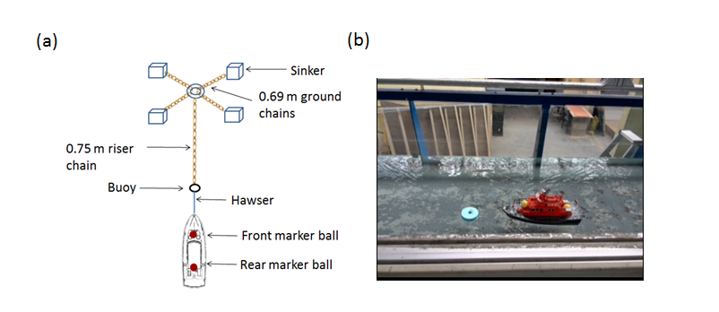

Fig. 3: (a) Aerial schematic of experimental set up. (b) Photograph of model boat in flume (1:20 scale buoy).

Table 1: Principle characteristics of RNLI Severn lifeboat and measured values of model with percentage difference of model values compared to full scale at a ratio of 1:40.

|  |  |  |  |
| --- | --- | --- | --- |
| Particular | Full scale | Model  actual | Percentage  difference to 1:40 scale |
| Length overall (m) | 17.30 | 0.443 | 2% |
| Beam (m) | 5.92 | 0.164 | 10% |
| Draught (m) | 1.78 | 0.0520 | -14% |
| Displacement (tonnes) | 42,300 | 0.856 | -23% |
| Yaw radius of gyration (m) | 4.32  (estimated) | 0.1061  (measured) | 2% |

Four hawser lengths, two buoy scales (1:20 and 1:40 scale) and four shapes (circle, octagon, hexagon and square) were investigated as summarised in Table 2 and shown in Fig. 4. The Froude scaled flow speeds and depth ranges were chosen as representative of those documented at RNLI’s SPM at full scale equivalents of 1.45 to 2.09 m/s and 8 to 10 m.

In tank tests the established assumption is that, in order that the tank walls and floor do not interfere with the fluid flow, the model’s cross-sectional area should not be more than 0.5% of the tank cross-sectional area (Molland *et al.,* 2011)). There is thus a trade-off between maximising the scale of a model in order to reduce scaling effects and reducing the blockage effect. This ratio for the 1:40 scale model at Chilworth is between 0.02 – 0.05% indicating that these blockage effects were negligible. Furthermore for a water depth to vessel draft ratio of 5 or more, the shallow water effects of increased wave-making resistance are negligible (Chakrabarti *et al.*, 1995). The shallowest depth to draught ratio for the current tests was 5 (0.2/0.04 m) indicating that the shallow water effects were negligible.

For the particular case of tank testing of moorings in current, tank wall effects on the lateral forces are considered negligible when the ratio of tank width to vessel length is 5 but have a noticeable effect when this is reduced to 3 (Chakrabarti and Cotter, 1994). The tank width to vessel length ratio for the 1:40 scale model is 3.18 (1.4/0.44 m) indicating that the experimental set up should not have a noticeable effect from the tank walls.

Table 2: Summary of flume tests performed. Figures in brackets are the hawser length (m).

|  |  |
| --- | --- |
| Test set up | Buoy shape and hawser length |
| No buoy | (0.125) |
| Normal buoy size (1:40) | circle (0.125,0.150,0.200)  octagon (0.150)  hexagon (0.150)  square (0.150) |
| Large buoy size (1:20) | circle (0.125,0.150,0.200,0.300)  octagon (0.300)  square (0.300) |
| Large buoy (1:20) and no boat | circle, octagon, hexagon, square |

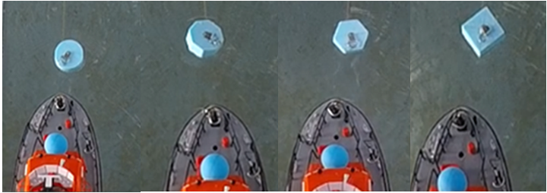

Fig. 4: 1:40 scale buoy shapes.

## 2.2 Motion capture

Motions of both the model lifeboat and buoy were captured using a GoPro Hero camera set at 30 frames per second mounted on a gantry above the tank. In order to provide an adaptable, inexpensive and portable method of tracking motion a bespoke motion tracking algorithm was created at the University of Southampton. The Matlab code uses video footage to track the centroid of an object via a mask created from its unique red, green, and blue colour combination. Three positional co-ordinates were tracked; two fluorescent markers (blue and yellow) on the centreline of the model and the buoy (blue) as depicted in Fig. 3b.

For a rigid hawser the dynamics of the vessel’s translational motions can be described by a pair of angles controlled by the hawser length (LH) and the length to a reference point along its centerline (LV) as illustrated in Fig. 5. The two degrees of freedom, double pendulum-like motion can be defined in terms of: ϕ the angle between the hawser and the vertical from the buoy and θ the angle between the vessel’s centreline and the vertical from the bow tip i.e. the yaw angle (Halliwell and Harris, 1988). From this two dimensional representation the model’s motion in relation to the flume’s fixed frame of reference were calculated as:

x = LH sinϕ+LV sinθ (1)

y = LH (1-cosϕ)+LV (1-cosθ) (2)

with small yaw angles, x ≈ surge, y ≈ sway. This method allowed for the direct measurement of displacement rather than the double integration of acceleration data from an accelerometer. Furthermore, this approach avoided the use of cabled instrumentation, which (at this 1:40 scale) was observed to have a significant impact on the motions of the lifeboat.

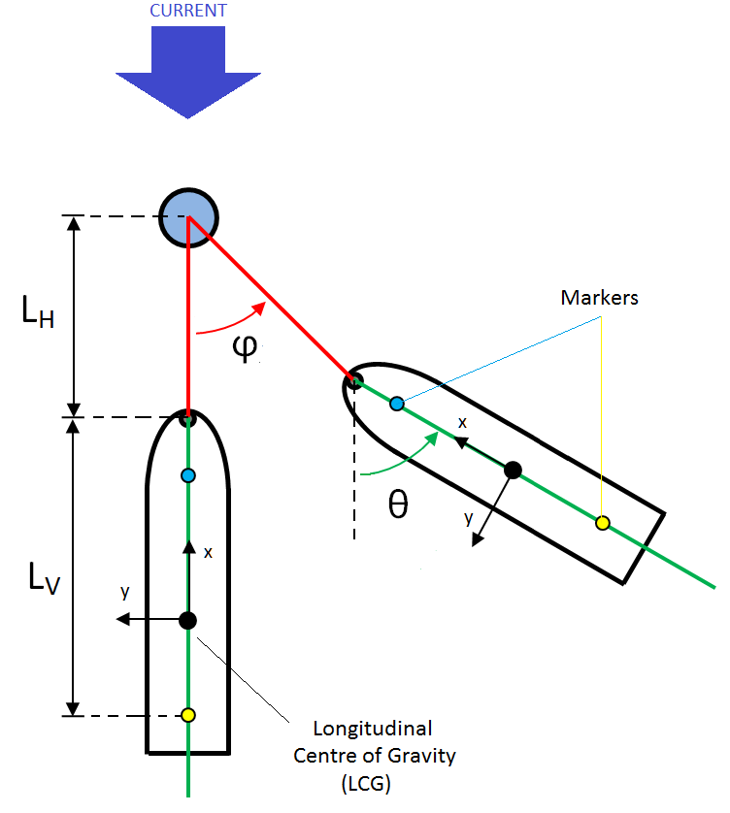

Fig. 5: Schematic of double pendulum model with fixed hawser.

# Results

## 3.1 Verification

## 3.1.1 Motion capture

In order to verify the motion capture and Matlab algorithm the yaw angle of the model was also measured using a wireless Xsens MTw-G-710 inertial motion tracker for a sample of fourteen tests. The sensor houses rate gyroscopes with an angular resolution of 0.05° which was set at a sampling rate of 120 Hz. This unit weighs 20 g adding 0.02% additional mass to the model.

The root mean square of the fourteen yaw signals, using both measurement methods, showed a maximum difference of 0.67° and a mean difference across all the tests of 9.2%. An example plot comparing the signals using both methods is presented in Fig. 6.

The fisheye distortion from the GoPro video was removed, before implementing the tracking algorithm, using GoPro Studio software. Furthermore in order to quantify the amount of parallax, in the video footage, a calibration plot of the variation in millimetres per pixel for the various object lengths on the model lifeboat and the buoy is presented Fig. 7. There was a negligible degree of parallax with a difference of 0.4 (mm per pixel) between the two marker balls which represents an error of 0.8% for a sway excursion of 5 cm. The specific pixel factor (cm per pixel) for each object in each test was used in the algorithm and so no parallax correction was deemed necessary.



Fig. 6: Comparison of yaw angles. Angles are calculated from GoPro camera and Matlab code (dotted line) and measured by Xsens triaxial accelerometer (solid line).

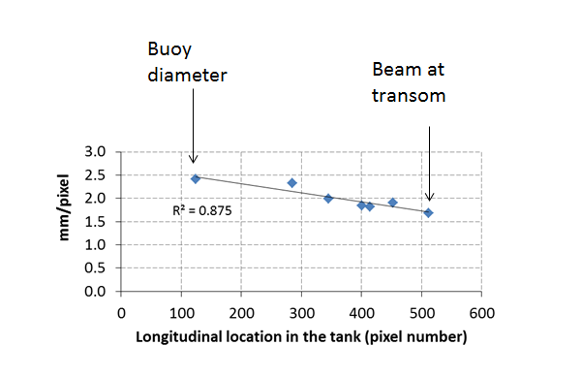

Fig. 7: Calibration plot of ratio of mm per pixel.

## 3.1.2 Mass Flow Rate

The experiments were designed to test the effect on vessel and buoy motions from changes in hawser length and buoy shape and buoy size at a constant flow speed. The test flow speeds were compared using the Mass Flow Rate ( $\dot{M}$) calculated by multiplication of the cross-sectional area (A) of the tank by the water density (ρ) and surface flow speed $(ν)$. The surface flow speed was measured ten times per test run by recording the time taken for a ping pongball to travel one meter. The standard deviations for each set of ten recordings, a measure of the steadiness of the flow, is presented in Fig. 8. The minimum value was 0.002 m/s (for a 0.27 m/s flow speed) and the maximum value was 0.014 (for a 0.30 m/s flow speed).

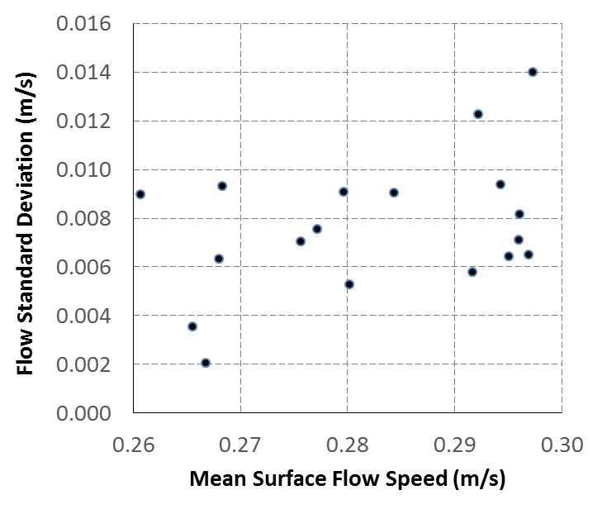

Fig. 8: Standard deviation of flow speed for ten repeat measurements for 27 tests.

The error of the $\dot{M}$ is calculated by the addition of the fractional measurement errors in quadrature (the square root of the sum of the squares):

$\dot{M} error= \sqrt{{{\left(\frac{δρ}{ρ}\right)}^{2}+ {\left(\frac{δA}{A}\right)}^{2}+\left(\frac{δν}{ν}\right)}^{2}} ($ 3)

The results were a percentage measurement error ranging between 3.02% and 3.73%. Furthermore for a range of $\dot{M}$ of 74 to 90 kg/s there was a maximum standard deviation of 2.74 kg/s when comparison is made between experiments within a specific configuration, 7.65 kg/s when comparing the effect of hawser length tests between scales and 4.38 kg/s when comparing the effect of different shaped buoys at 1:40 scale (Table 3).

Table 3: Mass flow rates of tests at Chilworth flume (a) changes in hawser length and (b) changes in buoy shape and size.

(a)

|  |  |  |  |  |  |
| --- | --- | --- | --- | --- | --- |
| Hawser length (m) | Mass flow rate (kg/s) | | | | |
|  | 1:40 scale buoy | 1:20 scale buoy | no buoy | mean | standard deviation |
| 0.125 | 77.70 | 78.87 | 89.35 | 81.97 | 6.42 |
| 0.150 | 74.46 | 80.31 | 89.63 | 81.47 | 7.65 |
| 0.200 | 79.61 | 79.08 | 89.19 | 82.63 | 5.69 |
|  |  |  |  |  |  |
| mean | 77.26 | 79.42 | 89.39 |  |  |
| standard deviation | 2.60 | 0.78 | 0.22 |  |  |

(b)

|  |  |  |  |  |  |  |  |  |
| --- | --- | --- | --- | --- | --- | --- | --- | --- |
| Buoy shape | Mass flow rate (kg/s) | | | | | | | |
|  | 1:40 scale buoy | 1:40 scale buoy | 1:20 scale buoy | 1:20 scale buoy | 1:20 scale buoy | Buoy only | mean | standard deviation |
| circle | 72.85 | 84.47 | 79.16 | 83.30 | 76.83 | 81.87 | 79.75 | 4.38 |
| octagon | 78.45 | 84.47 | 79.43 | 79.99 | 73.73 | 84.35 | 80.07 | 4.02 |
| hexagon | 78.06 | 81.65 |  |  |  | 80.69 | 80.13 | 1.86 |
| square | 78.45 | 81.25 | 79.16 | 78.61 | 74.01 | 82.90 | 79.06 | 3.02 |
| mean | 76.95 | 82.96 | 79.25 | 80.63 | 74.86 | 82.45 | 79.52 | 3.16 |
| standard deviation | 2.74 | 1.75 | 0.16 | 2.41 | 1.71 | 1.55 | 1.72 | 0.89 |

## 3.2 Typical Motion Responses

Experimental results presented are for a duration of 100 s, similar to those presented by Chakrabarti and Cotter (1994) and Huang and Lee (2012). With expected yaw and surge oscillations of a full scale tanker at a SPM subjected to steady current of 0.8 Hz (Aghamohammadi and Thompson, 1990) this should provide sufficient detail to compare the effects of changes in hawser length and buoy characteristics. Fig. 9 shows the typical motion responses of the 1:40 scale lifeboat. The dominant rotational motion was found to be yaw and the translational motion sway. The yaw angle ranged from -7.9° to +4.2° with a frequency range of 0.08 to 0.23 Hz. The maximum sway excursion was approximately 0.10 m with a frequency range of 0.05 to 0.23 Hz. Fishtailing motion was also observed for all the tests, similar to that described in the experiments and simulations of tankers at SPM.

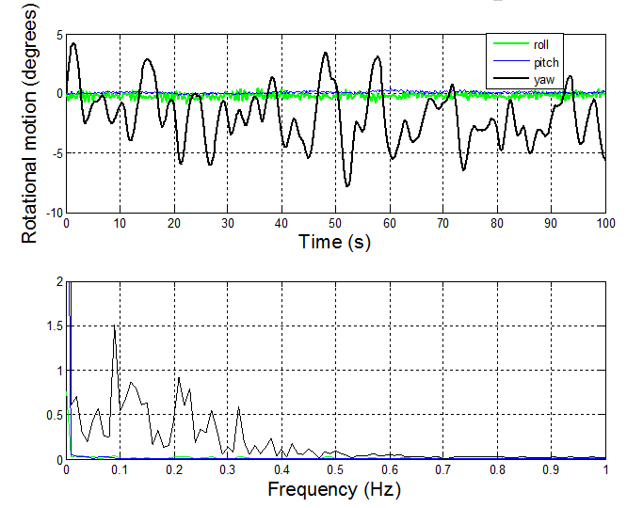



Fig. 9: 100 seconds of the motions of a 1:40 scale Severn lifeboat (1:40 scale circular buoy with a 0.15 m hawser, surface flow 0.26 m/s).

Interestingly, the correlation between the dominant motions of sway (m) and yaw (degrees) between the 1:40 and 1:20 scale buoys showed a marked difference (Fig. 10). For all three buoy shapes, at the 1:40 scale, the results showed a significant linear correlation. However, for the all buoy shapes at the larger 1:20 scale, this relationship was no longer observed: the linear correlation coefficient (R2) for the 1:40 scaled buoys ranged from 0.76 to 0.81 and for the 1:20 scale buoys fell to between 0.29 and 0.41.

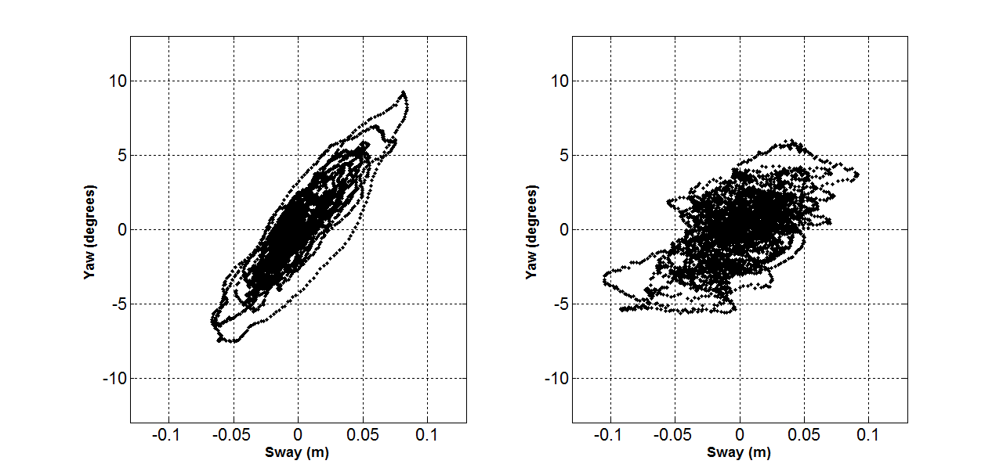

(a) R2= 0.81

(d) R2= 0.32

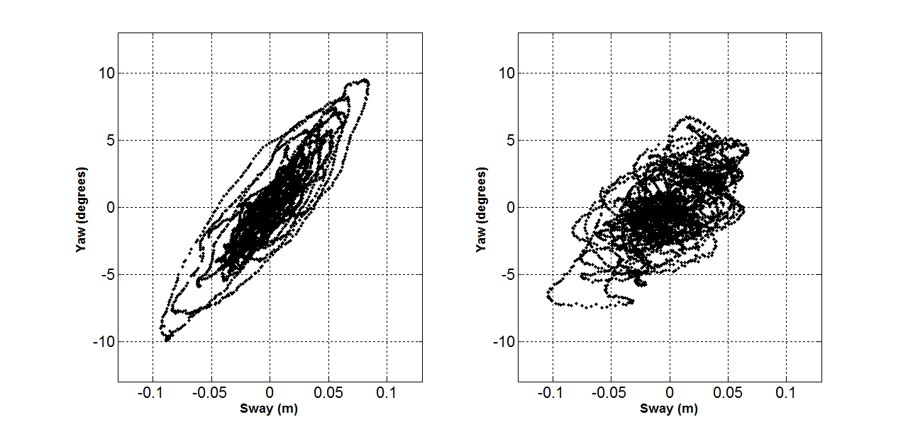

(e) R2= 0.41

(b) R2= 0.76



(f) R2= 0.35

(c) R2= 0.79

Fig. 10: Model lifeboat’s sway (m) and yaw angle (degrees) (a) 1:40 circular (b) 1:40 octagon (c) 1:40 square (d) 1:20 circular (e) 1:20 octagon and (f) 1:20 square buoy with associated coefficient of determination (R2) value indicating the closeness of fit. (Note: The hawser lengths scaled with the buoys, i.e., at the 1:40 scale the hawser length = 0.15 m, at the 1:20 scale the hawser length =0.30 m. The full scale length was 6m).

## 3.3 Effect of line length and buoy scale.

Tests were designed to investigate the effect of hawser length (three lengths at a 1:40 scale of 0.125, 0.150 and 0.200 m) and of the size of the circular buoy (three scenarios of 1:40 scale, 1:20 scale and no buoy) upon the current-induced motion of a 1:40 scale lifeboat. The results show no discernible trend for changes in line length. Though, for the tests where no buoy was present (when the lifeboat was moored to a taut 1.5 mm diameter wire rope) there was observed a decrease in the sway velocity for both the front and rear marker balls placed on the vessel (Fig. 11). The sway and yaw velocities, over the 100 second interval, show significantly higher values when there was no buoy on the mooring, reducing when a 1:40 scale buoy was introduced and further reducing when a larger 1:20 scale buoy was introduced (Fig. 11). For example, when using a 0.125 m hawser and moving from no buoy to a 1:20 scale buoy, the recorded sway velocity of the front marker reduced from 0.030 to 0.013 m/s, the rear marker from 0.210 to 0.015 m/s and the yaw angular velocity from 2.90°/s to 1.84°/s. These findings directed the future experiments towards the examination of size and shape of mooring buoy and its effect on the lifeboat’s motions.

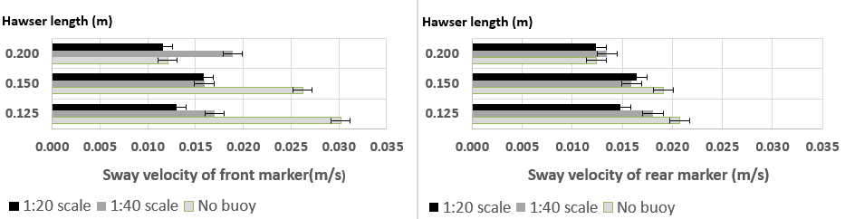

(a)

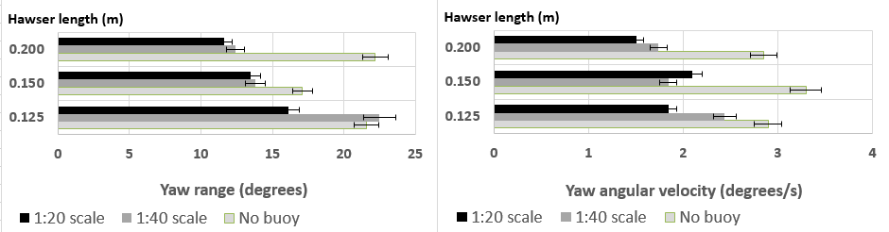

(b)

Fig. 11: Effect of change in line length on (a) sway (m) and (b) yaw range (degrees) and yaw angular velocity (degrees/s) of the vessel for a 100 second duration.

## 3.4 Effect of buoy shape at 1:40 scale with a 0.15 m hawser.

In addition to the size of the buoy, the motions of the vessel may also be influenced by the shape of the buoy. This hypothesis was tested by using four shapes, of equal immersed volume with increasing number of sides. The four 1:40 scale buoy shapes that were tested were a circle, octagon, hexagon and square (Fig. 4). For each test, the hawser length was fixed at a length of 0.15 m.

At this small scale, and within the calculated error bars, the results showed little difference between the sway velocities with different shaped buoys (Fig. 12a). Although, the results consistently showed that the sway velocity of the buoy was slower than the front marker on the model lifeboat, with the rear marker showing the fastest sway velocity.

The yaw angular velocity of the lifeboat was also compared by the use of boxplots (Fig. 12b). The plots are centered on the median value with an interquartile range box and upper and lower whiskers extending to the maximum and minimum data point that are 1.5 box heights away. Overall there is little difference between the distributions of the yaw angular velocities of the lifeboat due to a change in buoy shape, at the investigated scale. As the yaw angular velocity for each experimental data set failed a Kolmogorov-Smirnov test for a Gaussian distribution a non-parametric comparison of medians was required. The Kruskal-Wallis test performed returned a probability of 0.3013 implying that there is a significant probability that the data sets of yaw velocities come from distributions with the same medians. That is, buoy shape was found to have no significant effect on the average yaw angular velocity of the model lifeboat, at this scale.

` 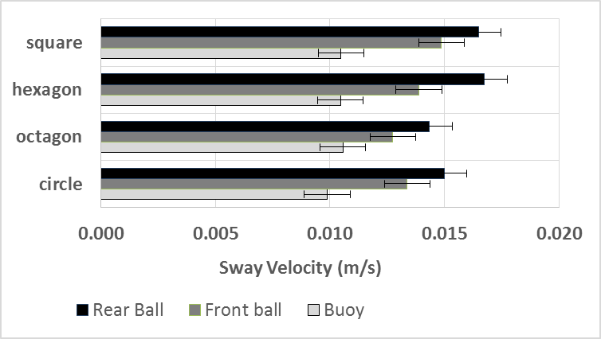 

(b)

(a)

Fig. 12: Effect of change in buoy shape at 1:40 scale on (a) sway (mean of two test runs) and (b) yaw boxplots of the first run.

## 3.5 Effect of buoy shape at 1:20 scale with a 0.3 m hawser.

Increasing the buoy and hawser scale, to 1:20, the results found the interaction between buoy and lifeboat to have changed, with the buoy now exhibiting the highest sway velocity (Fig. 13a). Compared to that of the 1:40 scale, the sway velocity of the 1:20 scale buoys increased significantly (circle 138%, octagon 73%, square 128%). Furthermore, the yaw angular velocities and range of yaw angles of the model lifeboat, were found to consistently decrease, when the scale of the buoy was increased. The percentage differences in mean values are presented in Table 4.

The boxplots (Fig. 13b) and Kruskal Wallis probability (of 0.1892), showed that the yaw angular velocities have similar distributions and equal medians, for all investigated buoy shapes, at this scale.

(a)

(b)

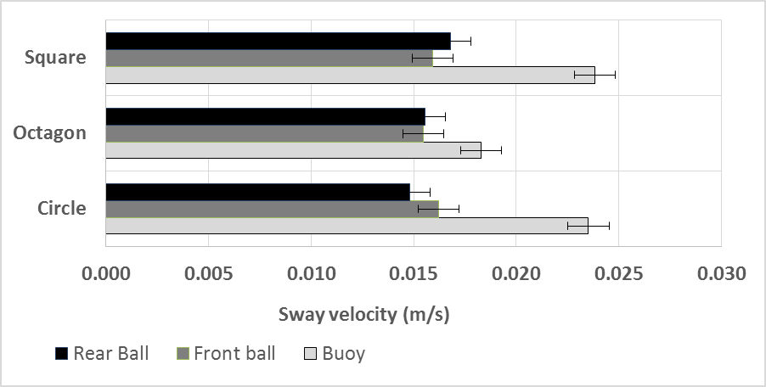

Fig. 13: Effect of change in buoy shape at 1:20 scale on (a) sway (mean of three test runs) and (b) yaw boxplots of the first run.

Table 4: Comparison of yaw for 1:40 and 1:20 scaled buoys

|  |  |  |  |  |  |  |
| --- | --- | --- | --- | --- | --- | --- |
| Shape | Yaw angular velocity (deg./s) | Yaw angular velocity (deg./s) | Difference 1:40 to 1:20 (%) | Yaw range (degrees) | Yaw range (degrees) | Difference 1:40 to 1:20 (%) |
|  | 1:40 scale buoy | 1:20 scale buoy |  | 1:40 scale buoy | 1:20 scale buoy |  |
| square | 2.19 | 1.69 | 22.9 | 17.43 | 13.60 | 21.97 |
| octagon | 1.86 | 1.40 | 24.9 | 14.15 | 12.31 | 13.00 |
| circle | 1.96 | 1.59 | 18.6 | 15.04 | 12.64 | 15.98 |

## 3.6 Effect of shape when no lifeboat attached to buoy.

The observed differences in buoy behaviour lead to a set of experiments, at a 1:20 scale, where the motion of the buoys in current were tracked when not attached to the vessel. For the tests analysed there was a difference, taking into account the error bands, in the sway velocity between the four different shapes (Fig. 14). Non dimensionalising the velocity, using the recorded surface flow velocity, and using the circle as the benchmark figure then the octagon was 6% faster, the hexagon 29% slower and the square shape 25% faster over the 100 second test.

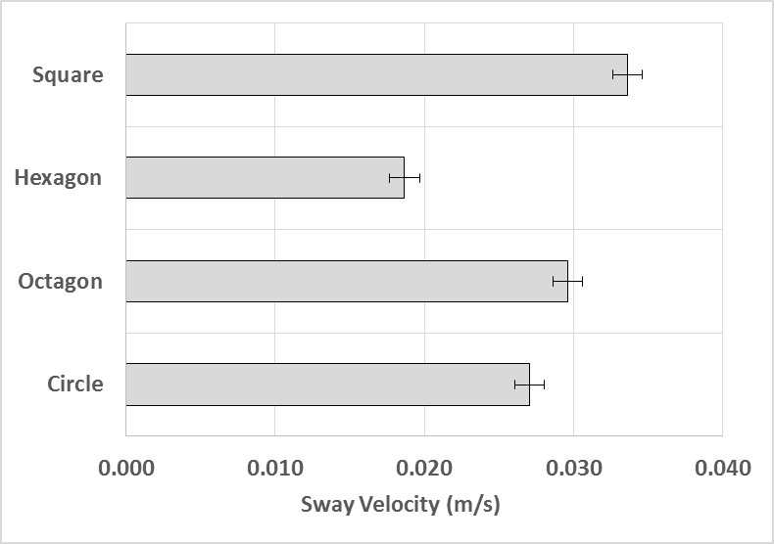

Fig. 14: Sway velocity, during 100 s, of the 1:20 scale buoys unattached to the vessel.

# Discussion

A series of free standing mooring configuration model tests investigating the effects of hawser length, buoy shape and buoy size on vessel and buoy motions, in current, were conducted in a flume. The experimental setup enabled the unrestricted motion of the mooring buoy and model lifeboat to be observed and avoided the influence of mechanical friction upon test results associated with using a towing tank (Simos et al., 2001). The motions of the model and buoy were captured, and validated against an inertial measuring unit, using an ‘off the shelf’ video camera and Matlab motion tracking code. This methodology offers an adaptable, inexpensive and portable method of motion tracking with no requirement for instrument cables and a negligible degree of parallax (at this scale).

When scaling for model ship testing it is impossible to simultaneously scale for the inertia, gravity and viscous forces. Reynolds similitude is “seldom invoked for most models“ as gravity forces are considered to dominate in free-surface flows and viscous effects can be discounted provided “Reynolds numbers (based on flow depth) are greater than 1 x 104 (Hughes, 2005). The flow depth range of Reynolds numbers for the experiments was 4.6 x 104 to 5.4 x 104 and therefore Froude scaling is deemed appropriate in this case. For comparison the range of flow speeds tested of 0.26 m/s to 0.30 m/s equates to full scale rates, using similitude of the Froude numbers, of 1.6 m/s to 1.9 m/s compared to 10 to 12 m/s using similitude of Reynolds numbers. The small scale of the buoys used (diameters of 5 and 10 cm) means that any surface roughness may lead to a higher impact of the viscous flow effects and therefore the Reynolds number may take on a greater significance for buoy motion. However the purpose of the tests was to observe any differences due to buoy shape and therefore the impact of the viscosity will have been the same for all tests. Finally, using the model beam as the length parameter, yields a Froude number range of 0.21 to 0.26 and for such values some Froude effects on the lateral force and yaw moment should be expected (Tannuri et.al. 2001) and full scale measurements are therefore required to validate the observed experimental motion responses.

The results showed that the dominant motions of the model are sway and yaw, similar to the fishtailing responses, reported in the literature, from simulations and experiments for large scale vessels at offshore SPM. The effect of reducing the hawser length, for the case when the vessel was attached to a taut wire rope (i.e. no buoy present), showed a reduction in the sway velocity of both markers on the model, agreeing with the results of experiments of Pinkster and Remery (1975) and Halliwell and Harris (1988). Also the presence of the buoy was found to reduce the sway and yaw motions of the moored vessel at a SPM when compared to moored to a rigid pole. Changing the shape of the buoy did not result in a significant change in the model’s motion, at either scale (1:40 and 1:20 scale). However, differently shaped 1:20 scale buoys exhibited different sway velocities when not attached to the lifeboat. This would suggest that shape had an impact on the buoys motions, in steady current, but the changes were not large enough, at this scale, to impact the motions of the moored vessel.

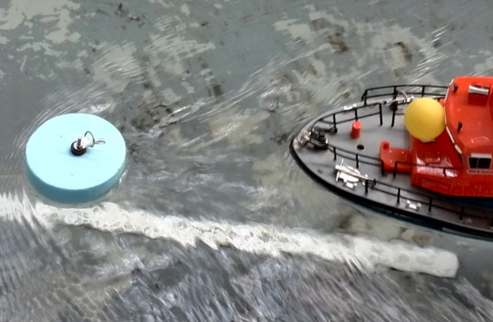

Fig. 15: Turbulent wake created by 1:20 scale buoy.

The observed linear correlation between the sway displacement (m) and yaw angle (degrees) that existed at the 1:40 scale buoy was not present at the 1:20 scale, indicating that the buoy-vessel interaction changes with buoy size. Observations showed that introducing the larger buoy and longer hawser length increased the width and vorticity of its wake (Fig. 15) and it is therefore hypothesised that this induced the larger sway excursions and reduced the yaw angle range (as shown in Fig. 10). Furthermore an increase in buoy scale resulted in a consistent decrease in the vessel’s yaw angular velocity and yaw angle range. Interestingly, at the 1:40 scale, the boat exhibited the fastest sway velocity and at the larger 1:20 scale, the buoy exhibited the fastest sway velocity, suggesting that there may be a change in mode, as depicted by the motion arrows in Fig. 16. This change in mode shape suggests that changes in buoy size can influence the motion responses of the lifeboat and may enable mooring efficacy to be improved.

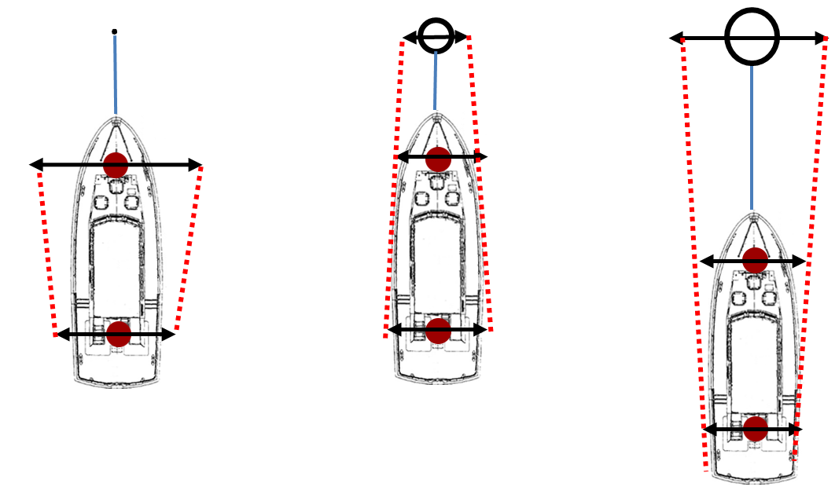

Fig. 16: Change in mode shape using no buoy, 1:40 scale buoy and 1:20 scale buoy.

An examination of which physical variables have an impact upon the mooring-induced damping experienced by an offshore floating platform, using Dimensional Analysis, is presented in Webster (1995). Simulations for a range of pre-tensions and motion amplitudes were performed testing the dimensionless parameters of scope, line drag coefficient, excitation period, stiffness and current. The excitation period was found to have a very strong effect on damping and, at low pre-tensions, shorter period produced higher damping. This would suggest that the larger scale buoys, which had a higher velocity, would produce higher damping than the smaller ones.

The size of a mooring buoy is largely governed by the buoyancy requirements to support the mooring chain, the weight of which is determined by the vessel size, water depth and sea conditions (Barltrop, 1998). Full scale diameters range from 1.24 to 1.85 m for coastal locations (and 2.4 to 4.0 m for ports and deep sea locations) (Hydrosphere, 2017). The diameter of the RNLI HIPPO buoys, at 2 m, are therefore significantly larger than the average of these harbour buoys and this series of tests were designed to assess the impact of size on the motions of a lifeboat. Increases in the horizontal motions of a moored body can cause very large instantaneous tensions and increased probability of SPM failure (Webster, 1995), these results indicate that introduction of a twice scale buoy may therefore reduce the risk of failure by a reduction of the horizontal motions of a lifeboat at a SPM.

5. Conclusion

This paper presents a series of model experiments on the current-induced motions of a 1:40 scale lifeboat at a single point mooring (SPM). The experimental set up enabled the unrestricted motions of the model and SPM buoy to be observed using a single ‘off the shelf’ video camera and a verified Matlab algorithm.

The results show the dominant motions of the lifeboat are sway and yaw and that a fishtailing motion is prevalent. The linear correlation between the sway (m) and yaw (degrees) that existed at the 1:40 scale buoy was not observed at the 1:20 scale indicating the buoy-vessel interaction had changed when the larger buoy was tested. When the buoy scale was increased the yaw angular velocities and range of yaw angles of the model lifeboat were found to consistently decrease. The sway velocity of the larger buoy, compared to the smaller one, increased resulting in a change in mode shape. The results suggest that changes in buoy size can influence the motion responses and may enable mooring efficacy to be improved.

Acknowledgements:

The provision of EngD funding from the RNLI and EPSRC (grant EP/G036896/1 the Industry Doctoral Training Centre in Transport and the Environment) is gratefully acknowledged.

The Matlab motion tracking code was written by Dr Christopher Phillips of Imperial College, University of London.

REFERENCES

ABS, 2014. Rules for Building and Classing Single Point Moorings 2014. American Bureau of Shipping, Houston, Texas.

Aghamohammadi, F., Thompson, J., 1990. An experimental study of the large amplitude fish-tailing instabilities of a tanker at a single point mooring. Applied Ocean Research 12 (1), 25-33.

Barltrop, N. D. 1998. *Floating Structures: a guide for design and analysis*, Oilfield Pubns Inc.

BBC, 2008. Four rescued as boat runs aground. Available: <http://news.bbc.co.uk/1/hi/england/kent/7272434.stm> (Accessed 21.06.17)

BBC, 2012. Yacht breaks from harbour mooring in Port St Mary. Available: <http://www.bbc.co.uk/news/world-europe-isle-of-man-18952895> (Accessed 21.06.17).

BBC, 2013. Two rescued after yacht breaks its moorings. Available: <http://www.bbc.co.uk/news/world-europe-guernsey-21739188> (Accessed 21.06.17).

Chakrabarti, S. & Cotter, D., 1994. Tank wall effects on broadside current forces on barge models. Ocean Engineering 21 (5), 489-497.

Chakrabarti, S., Libby, A., Palo, P., 1995. Small-scale testing on current-induced forces on a moored tanker. Ocean Engineering 22 (3), 271-300.

Fan, T., Qiao, D., Yan, J., Chen, C., Ou, J., 2017. An improved quasi-static model for mooring-induced damping estimation using in the truncation design of mooring system. Ocean Engineering 136, 322-329.

Gaythwaite, J.W., 2004. Design of Marine Facilities for Berthing, Mooring and Repair of Vessels, 2nd revised ed. ASCE Press, p. 560.

Halliwell, A. & Harris, R. 1988. A parametric experimental study of low-frequency motions of single point mooring systems in waves. *Applied ocean research,* 10, 74-86.

Huang, C.C. & Lee, M.F. 2012. Experimental Study on a Single-point-mooring Floating Structure. *The Twenty-second International Offshore and Polar Engineering Conference*.

Hughes, S. A. 2005. *Physical Models and Laboratory Techniques in Coastal Engineering*, World Scientific Publishing Co Pte Ltd, Singapore.

Hydrosphere, 2017. Mooring buoys. <http://hydrosphere.co.uk/datasheets/product-services-summaries/hydrosphere_mooring_buoys_v_2_01_sep_14_web.pdf> (Accessed 20.07.17).

IWCP, 2012. Boats sink in heavy seas. Available: <http://www.iwcp.co.uk/news/news/boats-sink-in-heavy-seas-44153.aspx> (Accessed 21.06.17).

Lang, S., 2001. Review of Lifeboat and Launching Systems’ Accidents. Southampton: Marine Accident Investigation Branch.

Luai, A., Zhi, Y., 2013. Comparison of laboratory and predicted motions and mooring line forces for a container ship moored to a dock. Proceedings of the 18th Offshore Symposium, Houston, Texas.

Molland, A.F., Turnock, S.R., Hudson, D.A., 2011. Ship Resistance and Propulsion: Practical Estimation of Propulsive Power Cambridge University Press.

Myers, L. E. & Bahaj, A. S. 2010. Experimental analysis of the flow field around horizontal axis tidal turbines by use of scale mesh disk rotor simulators. *Ocean Engineering,* 37, 218-227.

Oil Companies International Marine Forum, 2008. Oil Companies International Marine Forum Mooring Equipment Guidelines. Witherby Seamanship International, Livingston, United Kingdom.

Oosugi, Y., Kimura, N., Hujimori, Y. & Abeshima, N. 2007. A fundamental study concerning mooring disaster of small fishing boats at fishing ports: an interrelation between the ship motion induced by the wind and tension of mooring lines. *Journal of Japan Institute of Navigation,* 116, 249-54.

Papazoglou, V.J., Mavrakos, S. A. & Triantafyllou, M. S. 1990. Nonlinear cable response and model testing in water. *Journal of Sound and Vibration,* 140, 103-115.

Percuil River Moorings Ltd., 2010. Implementation of the Mooring Contractor Guidelines. Available: <http://www.percuilriver.co.uk/implementation-mooring-contractor-guidelines> (Accessed 21.06.17).

Pinkster, J., Remery, G., 1975. The role of model tests in the design of single point mooring terminals, Offshore Technology Conference.

Schellin, T., 2003. Mooring load of a ship single-point moored in a steady current. Marine Structures 16 (2), 135-148.

SeaSurveys, 2013. News page. Available: <http://www.turbolink.co.uk/seasurveys2011/news.html> (Accessed 21.06.17).

Sharma, S., Jiang, T., Schellin, T., 1988. Dynamic instability and chaotic motions of a single-point-moored tanker, 17th Symposium on Naval Hydrodynamic.

Simos, A. N., Tannuri, E. A., Aranha, J. A. P. & Leite, A. J. P. 2001. Theoretical analysis and experimental evaluation of the fishtailing phenomenon in a single-point moored tanker. *Proceedings of the Eleventh International Offshore and Polar Engineering Conference.*

Sorheim, H.R., 1980. Analysis of Motion in Single-Point mooring systems. Modelling Identification and Control 1 (3), 165-186.

Tannuri, E. A., Simos, A. N., Leite, A. J. & Aranha, J. A. P. 2001. Experimental validation of a quasi-explicit hydrodynamic model: Fishtailing instability of a single-point moored tanker in rigid-hawser configuration. *Journal of Ship Research,* 45, 302-314.

Van Dorn, W. G. 1974. *Oceanography and seamanship*, Dodd, Mead New York, NY, USA.

Wang, J., Li, H., Li, P., Zhou, K., 2007. Nonlinear coupled analysis of a single point mooring system. Journal of Ocean University of China 6 (3), 310-314.

Webster, W. C. 1995. Mooring-induced damping. *Ocean Engineering,* 22, 571-591.

Which-Marina, 2015. Registered UK marinas. . Available: <http://www.which-marina.com/Default.asp> (Accessed 21.06.17).

Wichers, J.E.W., 1988. A Simulation Model for a Single Point Moored Tanker. PhD Dissertation, Delft University of Technology, Delft, The Netherlands.

Yachting and Boating World, 2016a. May Dream aground in Plockton. Available: <http://www.ybw.com/news-from-yachting-boating-world/may-dream-aground-plockton-23755> (Accessed 21.06.17).

Yachting and Boating World, 2016b. Yacht smashes and sinks in Portland Harbour. Available: <http://www.ybw.com/news-from-yachting-boating-world/yacht-smashes-and-sinks-in-portland-harbour-39858> (Accessed 21.06.17).