Effect of High-Intensity Sonication on the Dispersion of Carbon-Based Nanofilaments in Cementitious Composites, and its Impact on Mechanical Performance.

S. ALREKABI ^{1,2,6}, A.B. Cundy^{3*}, A. Lampropoulos¹, Raymond L.D. Whitby⁴, I. Savina⁵,
¹ School of Environment and Technology, University of Brighton, UK
²Dept. of Civil Engineering, University of Babylon, Babylon, Iraq
³ School of Ocean and Earth Science, University of Southampton, UK
⁴School of Engineering, Nazarbayev University, Astana, Kazakhstan
⁵School of Pharmacy and Biomolecular Sciences, University of Brighton, UK
⁶Current address: Dept. of Civil Engineering, Al-Mustaqbal University College, Babylon, Iraq.

*Corresponding author: Tel: +44 2380 596179, Email: A.Cundy@soton.ac.uk
Abstract
Carbon-based nanofilaments are promising materials for improving the mechanical performance of cementitious composites. To date, the main challenge in their effective use has been controlling the dispersion of these additives in water and in the resulting mixed composites due to their strong van der Waals self-attraction and hydrophobic surfaces. This study uses high intensity sonication to disperse different nanofilament types in water, and assesses their resulting reinforcing efficiency in cementitious composites. The proportion of nanofilaments used (in this case, multiwall carbon nanotubes MWCNTs, functionalized multiwall carbon nanotubes F-MWCNTs, and carbon nanofibres CNFs) was 0.025% by weight of cement. Aqueous dispersions were examined using transmission electron microscopy (TEM) and optical microscopy, and ultraviolet-visible (UV-vis) spectroscopy. Compressive, flexural and splitting tensile strengths tests, and porosity and density measurements, were used to evaluate the mechanical properties of the composites. High-intensity sonication over short durations significantly improved the dispersion, and reinforcing and filling effects, of carbon-based nanofilaments in cementitious composites, with increases in compressive strength of 24 - 32%, splitting tensile strength of 45 – 50%, and flexural toughness factor of 30 - 40%, observed after 28 days curing. A 17-26% reduction in the porosity of the composite materials was also recorded.

Keywords— Carbon based nanofilaments, Cementitious composites, dispersion, mechanical performance, High- Intensity Sonication.

Published in Materials and Design, Volume 136, 15 December 2017, Pages 223-237.

GRAPHICAL ABSTRACT:
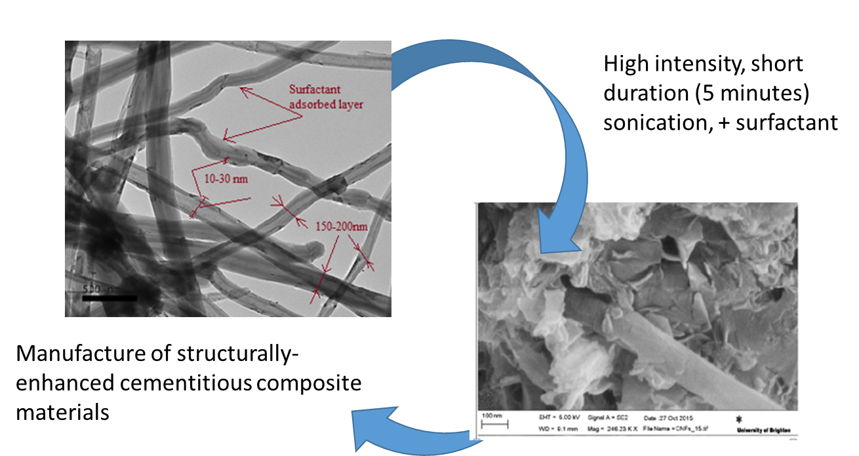

Introduction

The incorporation of carbon-based nanofilaments (such as carbon nanotubes (CNTs), and carbon nanofibres (CNFs)) into cement composites has been widely studied in recent literature. Use of nanofilaments can significantly delay the formation and propagation of cracks in cementitious materials and enhance energy absorption and ductility [1, 2], due to their remarkable mechanical and physical properties, in particular their enhanced strength (e.g. moduli of elasticity in the order of TPa and tensile strength in the range of GPa [3]).

Dispersing nanofilaments in cement and other matrices however is still a challenge due to the large van der Waals’ forces between the surfaces of the tubes/fibres [4], their poor wettability [5], and their large aspect (length-to-diameter) ratio [6]. Nanotubes/fibres tend to agglomerate and form bundles, which in turn hinders their dispersion in a liquid or in composites [6, 7]. Several studies have found that the dispersion state of nanotubes has a strong influence on the performance of the resulting nanocomposite, both as a crack retarder and when they are incorporated as a filler to strengthen the matrix, where agglomerated nanoparticles can result in weak zones or potential areas for concentrated stresses that can weaken the performance of the composite [6, 8-10].

Ultrasonication is the most commonly adopted technique used for dispersion of nanotubes for a wide range of applications. In particular, ultrasonication treatment has been reported to significantly enhance the beneficial impact of incorporated nanotubes on the mechanical strength of composite materials [11-14]. However, there have been limited attempts to examine the effect of treatment duration and sonication intensity to optimise the dispersion of carbon-based nanofilaments in cementitious composites [15, 16]. Of the studies which have addressed the effect of sonication duration, Makar et al., [17] used an ethanol/sonication treatment method for four hours to obtain a uniform dispersion of CNTs in cement-based materials, with results showing that this method was effective for dispersion and for acceleration of the cement hydration process at early curing ages. Li et al., [18, 19], reported that use of chemically functionalized CNTs, dispersed for three hours in an ultrasonic bath at a concentration of 0.5% by weight of cement, led to improvements in compressive and flexural strength of 19% and 25% respectively. Tyson et al., [20] and Abu Al-Rub et al., [6] found that the addition of nanofilaments (CNTs and CNFs) at concentrations of 0.1% and 0.2% (by cement weight) dispersed via an ultrasonic mixer with a probe for 20–30 min led to an improvement in ductility, modulus of elasticity, and modulus of toughness in the resulting composites. Extended sonication treatment however can modify suspension temperature and viscosity, and has been reported to influence nanofilament structure and reduce the tube aspect ratio, thereby reducing reinforcing effectiveness [21, 22].

To date, only two studies [23, 24] have addressed the effect of different ultrasonication energies on dispersion of functionalized multi-walled CNTs in water, and its impact on the engineering properties of the resulting cementitious composite. Chen et al., [23] optimized (theoretically) the effect of ultrasonication on length and concentration of dispersed functionalised nanotubes, at different energies (from very low (25 J/ml) to high (400 J/ml)). These authors predicted that the concentration of dispersed nanotubes in water increases with ultrasonication energy and reaches a plateau after about 250 J/ml. Lower energies (89 J/ml) were predicted to be optimal in generating higher bridging stress with a superior reinforcing effect. Zou et al., [24] experimentally investigated the effects of ultrasonication energies on the engineering properties of CNT–OPC pastes containing functionalized CNTs at 0.094%-1.88% by cement weight. The results indicated that the amount of dispersed nanotubes in water increased with ultrasonication energy until a dispersion plateau was achieved, again after about 250J/ml. The optimal ultrasonication energy for improving composite mechanical properties was found to be between 50 and 150 J/ml, depending on the dosage of nanotubes. For example, the flexural strength of cement paste containing nanotubes at 0.038% and 0.075% wt. was increased from 12% to 25%, and from 13% to 48%, respectively, with an increase in ultrasonication energy from 50 J/ml to 75J/ml. However, these studies are limited to one type of nanofilament (functionalised nanotubes), and did not investigate the combined effect of treatment duration/sonication intensity on dispersion and subsequent composite performance.

The difficulty in uniformly dispersing highly entangled bundles of nanotubes in water in a repeatable and cost-effective way limits the commercial applicability of these materials [8, 25]. While the cost-effectiveness of dispersion techniques is not explicitly discussed in many previous studies, the need for repeatable, readily scalable and cost-effective techniques to generate effective dispersions of CNTs in fluids and matrices poses a tremendous hurdle that must be overcome prior to realizing wider applications of CNTs as, for example, reinforcement components in bulk composites [13, 26].

This study examines the use of a high-intensity and short duration ultrasonication technique as a novel, scalable and repeatable method to improve the mechanical performance of cementitious composites containing low amounts of nanofilaments (0.025% by cement weight). The study assesses the effect of this technique on the dispersion and mechanical performance of a range of nanofilament types incorporated into cementitious composites, and discusses the method’s potential wider utility and scalability for practical application.

Experimental work

2.1 Materials
Ordinary Portland Cement (OPC), meeting the requirements of British Standard BS EN 197-1, and Microsilica Grade 940 with particles over 45 µm in diameter, were used as a cementitious material. Three types of commonly used nanofilaments were investigated, as follows: i) commercially available multiwall carbon nanotubes (MWCNTs); ii) functionalised multiwall carbon nanotubes – with COOH carboxyl functional groups bonded to the surface of MWCNTs (F-MWCNTs); and iii) carbon nanofibres (CNFs). MWCNTs and F-MWCNTs were purchased from Cheaptubes, Inc. (cat# sku-030102, Brattleboro, VT, USA), and CNFs were purchased from Sigma Aldrich, Inc. FLUKA. Physical properties as provided by the suppliers are presented in Table 1. A superplasticizer based on naphthalene sulfonates (NSF) was used for improving workability. NSF-based superplasticizers are commonly used as dispersion agents to de-agglomerate nanofilaments in cementitious composite systems. Molecules of NSF have long side chains in their structure and are believed to adsorb strongly to the surface of nanotubes, reducing inter-tube attraction and leading to suspensions with higher concentrations of individual nanotubes.

Table 1. Properties of the carbon-based nanofilaments used in this study (based on supplier data).

ID | Diameter  (nm) | Length (µm) | Purity (% carbon by mass) | Bulk Density (g/cm3)
MWCNTs | 8-15 (outer diameter) | 10-50 | 95 | 1.95
F-MWCNTs | 8-15 (outer diameter) | 10-50 | 95 | 1.95
CNFs | 100 | 20-200 | - | 1.90

2.2 Sonication Assisted Dispersion
For this study, a 750 W 20 KHz ultrasonic system (Model 705 Sonic Dismembrator) with a 19mm macro probe was used, as shown in Fig.1. The electrical energy delivered to the converter is transformed into mechanical energy, which can be set to a required level using an amplitude controller. Intensity is expressed by the energy delivered (Joules) per unit time (min) over the area of the probe (cm²)[27]. Intensity has a direct relationship with the amplitude settings: the low amplitude setting delivers low-intensity sonication, and the high amplitude setting delivers high-intensity sonication.
In this study, following previous work [28], high-intensity sonication over short time periods was adopted as the optimal dispersion method, in which the delivered energy to the solution ranges between 388 and 458 J/ml per min (i.e. a total of 970-1145 J/ml over 5 minutes). The specific energy delivered (under a certain intensity) usually varies between treatments due to its dependence on solution viscosity, solution temperature, positon of the probe, etc. [27, 29]. High sonication intensity was found to dramatically increase the suspension temperature over prolonged treatment durations. Thus, to avoid overheating and subsequent structural damage that may occur in the nanotubes [8, 24, 30], the treatment duration was set at a short period (i.e. 5 minutes), and energy was applied in cycles of 20 sec to prevent the suspensions from overheating. In this study, all experiments were performed in triplicate and the results reported here are the means of the three trials.

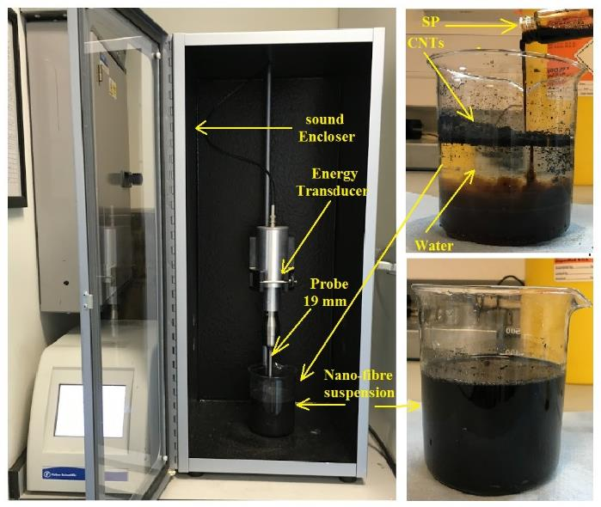
Fig.1 Sonicator used in the dispersion of carbon nanotubes/fibres suspensions.

2.3 Preparation and Characterisation Techniques of Nanofilament Suspensions

Carbon based nanofilaments (i.e. MWCNTs, F-MWCNTs, CNFs) at a percentage of 0.025 % wt. (by cement weight) were initially dispersed in the mixing water (1/4 of the mixing water quantity) in the presence of superplasticizer (NSF). A NSF-to-nanofilaments weight ratio of 10:1 was used, following [31]. The proportions of the materials used in the dispersion and mixing procedure are summarised in Table 2. The resulting mixtures were subjected to high intensity sonication with sonication duration of 5 minutes (discussed above). One of the objectives of this study was to examine whether this dispersion method effectively dispersed all of the examined types of carbon based nanofilaments (MWCNFs, F-MWCNTs, and CNFs). The changes in dispersion of the carbon based nanofilaments suspensions after pre-treatment with NSF and ultrasonic treatment were observed on a bulk scale through visual examination, and on a micrometer scale using a polarization optical microscope (AMPLIVAL Pol. D, Carl Zeiss, Tena, Germany). Suspensions containing MWCNTs/ F-MWCNTs/ CNFs were prepared by dispersing them in the aqueous solution without and with NSF, respectively. After ultrasonication treatment, a drop of the suspension was pipetted onto a slide for further microscopic examination.
The morphology of nanotubes/fibres was examined using Transmission Electron Microscopy (TEM) (Hitachi-7100 operated at 125 kV), and Scanning Transmission Electron Microscopy (STEM) (using a Zeiss model LEO 1455VP). Drops of diluted suspension were placed on a grid prior to imaging and allowed to dry in air.

Spectroscopic methods, including UV-Vis spectroscopy, can quantify nanotube dispersion by applying a light source to the suspension and correlating the amount of light absorbed or scattered with particle size [32]. A Perkin Elmer Lambda UV–vis Spectrometer using a conventional quartz cell (light path 1cm) was set to a wavelength range of 350–800 nm. Absorbance values at 500 nm [33] wavelength were used to estimate the degree and stability of dispersion of nanofilaments in the liquid, and to verify visual and microscopic observations. After sonication, three samples were taken from each suspension and diluted with pure water by a factor of 100, after which the absorbance was recorded at various durations (from the time of dilution t = 0 min, after 30 min, 180 min, 1440 min (3 days), and 10080 min (7 days)). This 100x dilution was essential due to the absorbance of the original suspension being higher than the measurement limits of the instrument used. The dilution process, whilst being identical for each sample, increases the free-path spacing between the nano particles (i.e. the distance between two adjacent particles) which, in principle, may reduce the possibility of re-agglomeration[20] compared to the original suspensions. Baseline corrections were carried out using surfactant only solutions.

2.4 Preparation and Characterisation of Nanofilament Reinforced Cementitious Composites
After dispersion, three batches of cementitious specimens with a water/cement ratio of 0.35, and containing MWCNTs, functionalised MWCNTs, and CNFs were prepared and labeled as “CT,” “CT-f,” “CF”, respectively. A reference specimen of plain cementitious paste, labeled as PC, was used as a control. The cement: sand ratio was selected as 1:1.5 (by weight), and nanofilaments were used at 0.025 wt. by cement weight, with microsilica at a ratio of 10%.[34, 35] (see Table 2).
Mixing procedures were carried out in the following sequence: all dry ingredients (cement, micro silica, and sand) were mixed together for 2 minutes using a high shear mixer (Zyklos Pan Mixer, ZZ 75 HE). The remaining mixing water and superplasticizer were added during this initial 2 minutes mixing. The nanofilament suspension was then added and mixed for a further 4 min [36, 37]. The mixture was cast and vibrated for compaction in (i) cubic moulds of 50mmx50mmx50mm for compressive strength testing in accordance with ASTMC109[38], (ii) cylindrical moulds of 100 mm diameter and 200mm height for splitting tensile strength testing in accordance with ASTM C496 [39], and (iii) a prism bar mould of 40mmx40mmx160mm for toughness measurements. Cores of 30 mm (diameter) and 80 mm (height) were used for porosity measurements. All specimens were de-moulded one day after casting and then cured in a water tank until testing.

Table 2 Proportions of materials used in the dispersion and mixing procedure. PC = control sample.
Proportion of materials used in the dispersion procedure |  |  |  | Proportion of materials remaining for cementitious mixing procedure
 | 1 | 2 | 3 | Mixing water |  | Cement paste ingredient
Mixture ID | Water | Nano-filaments (NF) | NSF: Nano-filaments | Pure Water | Nano-filaments suspension  (1+2+3) | NSF | Cement | Sand | Micro-silica
PC | - | - | - | 0.35 | - | 0.08 | 1 | 1.5 | 0.1
CT  CT-f  CF | 0.09 | 0.00025 | 0.0025 | 0.26 | 0.093 | 0.078 | 1 | 1.5 | 0.1

2.4.1 Nanofilament Reinforced Cementitious Composite Characterisation - workability

Investigating the mechanical properties of cementitious nanocomposites is a practical proxy method of evaluating the dispersion efficiency of the nanofilaments in the matrix. When improved mechanical properties are observed the dispersion is more likely to be uniform though the matrix, whereas poor dispersion leads to no improvement, or in some cases leads to a decrease in the mechanical performance relative to pure cement mortar.

The workability of the nano cementitious composites was assessed using a standard flow table test in accordance with ASTM C230/ 230m-14 [40], whereby the mixture was placed on a flow table and dropped 25 times within 15 seconds. The initial and final diameters of the mixes were recorded to calculate the mixture flow. The flow is defined as the increase in diameter divided by the original diameter multiplied by 100.

2.4.2 Mechanical characterisation

Compressive strengths of nanofilament composite specimens were examined at 3, 28, and 90 days after casting. Three specimens were examined for each test under a constant compressive load rate of 0.75 kN/s [38, 41]. Three-point bending tests were performed with the aim of characterising the toughness of the nanofilament composites [42]. For the flexural bending test, the prisms were tested under center-point loading with a displacement rate of 0.18 mm/min and span of 120 mm using an Instron Testing Machine (Intron Model 8630). Deflection was measured using two linear variable differential transducers (LVDTs).

The load-deflection curves were analysed to obtain the specimen toughness in accordance with JSCE-SF4 Japan Society of Civil Engineering, Standard for Flexural Strength and Flexural Toughness [43][43][43][43][43][43][43][42]. The Flexural toughness factor (FT_{δ}) is calculated using Eq. 1.

FT_{δ}=$\frac{\text{ (}{\text{T}}_{\text{bδ}} \text{x l)}}{\text{(δ x b x }{\text{h}}^{\text{2}}\text{)}}$ (Eq.1)

Where FT_{δ} = the flexural toughness factor at a beam displacement of δ, T_{bδ} = the area under the load-versus-deflection plot up to a deflection of δ, l = Span length, and b = width and h= depth of the beam.

Splitting tensile strength is a method used to determine the tensile strength of the composite. Tests were performed according to the standard test method for splitting tensile strength using cylindrical concrete specimens (ASTM C496/C496 M-11)[39]. The cylinders were tested using a hydraulic mechanical testing system (MTS) at a constant load rate of 1.5 kN/s.

2.4.3 Porosity Measurements
Although it is not capable of accounting for nano and gel pores, and so may give an underestimate of total porosity, bulk porosity was estimated using the method developed by Khan et al., [44] and Wilson et al., [45]. Tests were carried out for all mixtures using cylindrical cores of 80 mm length and 30 mm diameter, four for each mix. The test procedure was as follows: prior to testing, the samples were taken out of the curing tank and dried in an oven at a temperature of 105±5 ºC for approximately 24 hours, then weighed. The samples were then kept in a vacuum desiccator under 1 bar of vacuum, for 24 hours. The desiccator was then filled with distilled water so that samples were fully submerged. Following this, the samples were kept under vacuum for 24 hours and allowed to equilibrate for the next 24 hours. The specimens were then weighed in air and water. The amount of water penetrating into the sample is a measure of the porosity and is calculated as follows:

$\text{P}\text{=}\frac{\text{B-A}}{\text{B-C}}\text{ x 100 }$ (Eq.2)

Where: P is porosity (%); A is oven-dry weight; B is saturated surface dry weight; C is saturated submerged weight.

2.5 Microstructural characterization
Characterisation of the hardened composites was performed using field emission scanning electron microscopy (SEM, Zeiss; model LEO 1455VP). Prior to SEM imaging, the sample surface was sputtered with carbon to avoid any charging effects.

Results

3.1 Dispersion Characterisation

3.1.1 Visual Examination

Two sets of aqueous suspensions of MWCNTs, F-MWCNTs, and CNFs were prepared. Surfactant (NSF) was added to the first set and manually mixed for 2 min. After cessation of mixing photographs (Fig. 2) were taken immediately, and after 10 minutes settling time. The second set of suspensions underwent 5 min of high-intensity ultrasonic treatment, then clear glass vials were filled with the suspension and allowed to settle for 30 min, 180 min, 1440 min, and 10080 min, at which intervals photographs (Fig. 3) were taken. With only manual mixing and NSF addition, large clusters of nanofilaments were suspended for only a few minutes (Fig. 2), prior to their agglomeration and settling to the bottom of the glass vials. After sonication (set two), a more homogeneous suspension was obtained (Fig 3 a), with photographs taken after 180 min and 1440 min (Figs 3 b and c) showing that the suspensions remained stable for several hours (longer with functionalised nanotubes), following which the nanofilaments gradually re-agglomerated and settled due to the high Van der Waals interaction forces. Almost all of the nanofilaments had settled to the bottom of the glass vial after 10080 min (Fig 3 d). CNFs were found to be less effectively suspended than MWCNTs, which can be attributed to higher van der Waals forces between nanofibres due to (i) their greater aspect ratio (L/D ca. 1000, compared to ca. 400 for CNTs) and (ii) their greater surface area (about 1.5µm²/µm for CNF vs. about 0.095µm²/µm for CNTs).

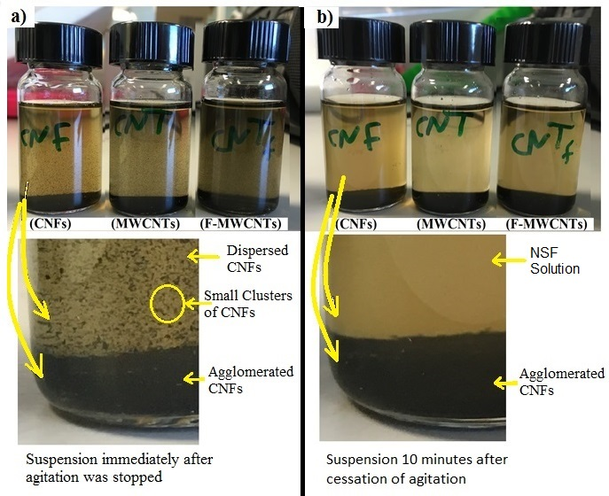
Fig. 2 Suspensions of MWCNTs, F-MWCNTs, and CNFs de-agglomerated using only NSF. a) shows suspensions directly after agitation was stopped, b) shows suspensions after agitation was stopped for 10 minutes, where all nanofilaments have settled to the bottom of the vial.

Functionalised nanotubes were found to form the longest lasting suspensions, which can be attributed to hydroxyl functional groups on the walls of the tubes hindering their re-agglomeration, leading to a more stable suspension. A short duration sonication time was chosen in this study to prevent rises in temperature, as the surfactant parameters are temperature dependent, and higher temperatures may change the suspension properties and reduce the sonication effectiveness [46, 47].

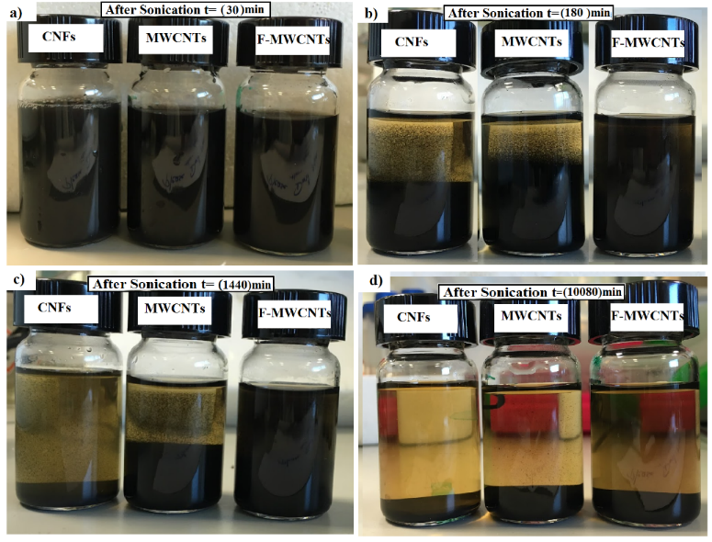
Fig.3 Suspensions of MWCNTs, F-MWCNTs, and CNFs after applying high-intensiy sonication: a) shows suspensions after 30 min, b) suspensions after 180 min, c) suspensions after 1440 min, and d) suspensions after 10080 min.

    - Optical Microscopy Measurements
Imaging of nanotubes/fibres suspensions using optical microscopy is fast and easily adaptable to a liquid sample, giving a direct indication of the degree of dispersion with no need for sample pre-preparation (e.g. dilution and/or drying of samples before testing). Unlike electron microscopy, optical microscopy images (Fig.4 and Fig.5) offer a wide field of view and can show the agglomerated state of the nanotubes/fibres suspensions in the microscale. Fig. 4a and Fig 5a show MWCNTs and CNFs in water before sonication, and large and dense clusters of the nanotubes/fibres are observed. Fig. 4b and Fig. 5b show the same suspensions after sonication in combination with NSF, and show a much greater dispersion. High-intensity sonication over a short period, combined with use of surfactant/functional groups, generates a coating of NSF on the nanotubes/fibres, providing functional groups on outer surfaces which induces electrostatic repulsion that can counterbalance the van der Waals attractive force [48], and leads to a more homogenous and stable suspension. As a high intensity ultrasonic wave passes through the solution, it rapidly generates a large number of cavitation bubbles which then collapse, and enhance surfactant penetration between the tubes/fibres.
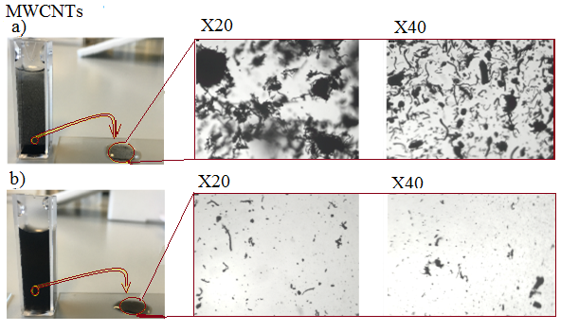
Fig.4 photographic and optical microscopic images of MWCNTs suspensions a) before sonication and b) after sonication. X20 and X40 represent the optical resolution.

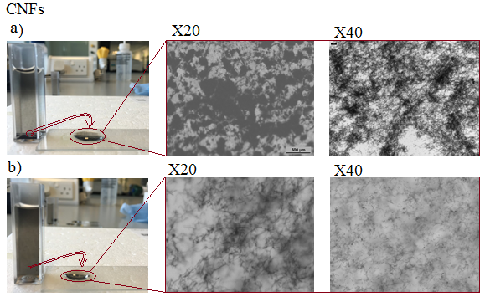
Fig.5 photographic and optical microscopic images of CNF suspensions a) before sonication and b) after sonication. X20 and X40 represent the optical resolution.

3.1.2 Transmission Electron Microscopy Characterisation (TEM)

TEM images of the carbon nanotubes, functionalised carbon nanotubes, and carbon nanofibres samples, before and after sonication treatment are shown in Fig.6, Fig.7, and Fig.8, respectively.
Repeat TEM imaging of the nanotube suspensions without ultrasonication treatment show that most of the nanotubes imaged are agglomerated and present as large clusters (Fig.6a-6b). After sonication treatment combined with NSF addition, smaller bundles and abundant individual nanotubes could be observed (Fig.6c-6f). Ultrasonication (following the proposed method) was found to significantly increase the concentrations of individual dispersed nanotubes in the suspension. Individual nanotubes were observed with varying diameters: the inner diameters were ca. 10nm (which is approximately the same as the diameter data provided by the tube suppliers, Table 1), while the outer diameters were between 25nm and 50nm which were significantly larger than those stated by the suppliers. This large difference from supplier-provided data is likely due to the presence of adsorbed surfactant (NSF) on the outer surface of nanotubes.

Chemical modification of the surface properties of MWCNTs is one of the methods previously attempted to improve the dispersion of nanotubes in water. Chemical functionalization is based on introducing carboxyl functional groups (-COOH) into the nanotube structure. These groups can be generated at the ends or at the sidewalls of the nanotubes, which have many defects[49]. Functionalisation can be achieved by a wide range of methods, including through oxidative damage to the nanotube framework by strong acids, in particular, treatment of MWCNTs with a strong acid such as HNO₃, H₂SO₄ (or a mixture of these) which leaves holes functionalized with oxygenated functional groups[50]. Figs.7a-7d show the dispersibility of functionalised nanotubes before and after sonication treatment. F-MWCNTs in the suspension before sonication remained in large clusters, revealing that the availability of functional groups alone was insufficient to obtain individual dispersed nanotubes (Fig.7a). Fig.7b-d show images of the suspensions after sonication. Differences in the structure of the functionalised nanotubes were observed, as nanotubes appeared to have defects, and be shorter compared to “as received” nanotubes (Fig6c-f). This could be attributed to the pre- functionalisation process and also the ultrasonication treatment used in this study [51, 52]. The inset image (Fig 7d) is a schematic of the molecular structure of the nanotubes showing the defect that could occur due to the functionalization (-COOH) and sonication process, leading to shortening of the nanotubes. Structural damage and shortening of the tubes following functionalization (i.e. an acidic oxidation process) and ultrasonication are probably due to the action of intensive energy delivered to the suspension (shear force) on defect areas (i.e. the bond areas with -COOH), leading to rapid shortening of the tubes and widening of the defect zones. The diameter of nanotubes was also increased after ultrasonication compared to the “as-supplied” functionalised MWCNTs, which (as discussed above) possibly relates to the introduction of a surfactant layer.
Nanofibres suspensions without ultrasonication treatment were in the form of agglomerates (Fig.8a-8b) with most of the nanofibres present as clusters, and no individual fibres can be observed. The sonication treatment combined with NSF was efficient at breaking up the agglomerates and dispersing the CNFs, and abundant individual nanotubes could be observed following treatment, in addition to smaller bundles (with an average size of 500nm). Fig.8c-8f shows the diameter (with the adsorbed layer of NSF), and length distribution of CNFs after sonication treatment. The diameter of the individual nanofibres was in the range of 150- 200nm, and the observed lengths were in the range of 20um-50um. Although dispersion using ultrasonication will inevitably reduce the length of CNFs [53], high sonication intensity over short time periods was found here to be less damaging (the measured sizes after dispersion remained in the same range as the “as supplied” CNFs). Retaining a relatively high aspect ratio for the CNFs during their dispersion in the cementitious composites is essential for obtaining an effective reinforcing agent, since the improvement in composite mechanical strength will be proportional to the amount of embedded CNFs with less damage[54].

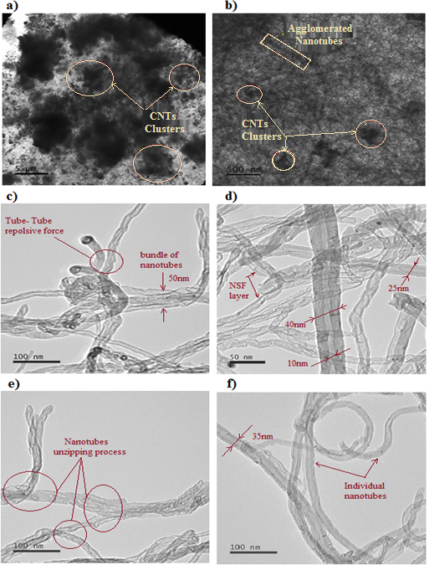
Fig.6 TEM images of carbon nanotubes (MWCNT) suspensions. a-b) show the agglomeration of nanotubes on the grid during the test (before sonication), c-d) represent bundles and individual nanotubes at progressively higher magnification, and e-f) show diameters of individual nanotubes (after sonication).

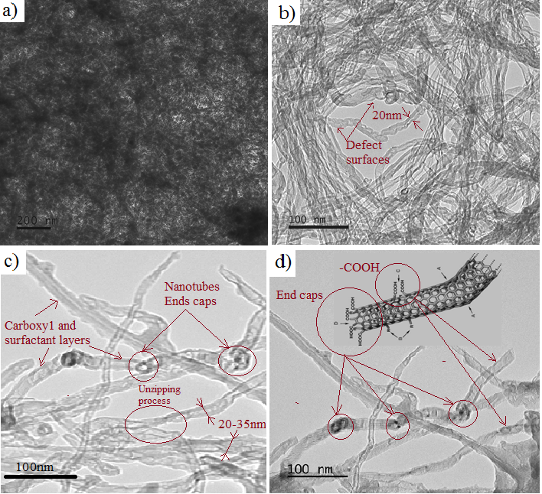
Fig.7 TEM images of hydroxyl functionalised MWCNTs. a) shows a F-MWCNTs suspension manually mixed for 2 minutes, b-d) shows the nanotubes suspensions after sonication treatment, the morphology of functionalised nanotubes, the geometry of nanotubes, and the thickness of the adsorbed layers.

Fig.8 TEM images of carbon fibre suspensions. a-b) shows the agglomeration of nanofibres on the grid during the test (before sonication), c-d) shows bundles and individual nanofibres at progressively higher magnification, and e-f) shows diameters of individual nanofibres (after sonication).

    - UV-vis Spectrometry
UV-vis spectra of nanofilament suspensions were recorded after sonication treatment (at t= 0 min, 30 min, 180 min, 1440 min, and 10080 min) as shown in Fig 9a-9c. High-intensity sonication was found to deliver the highest energy to the suspension, resulting in highest absorbance values (i.e. dispersed concentrations). From the absorbance values at a wavelength of 500 nm, a dispersion stability index (X_{st}) was obtained (as described by Eq. 3) to reflect the effect of high-intensity sonication on the dispersion stability over time after sonication treatment.

$X_{st}=\frac{( A_{t0}-A_{tn})}{A_{t0}} \%$(Eq.3)

where A_{t0}= absorbance directly after sonication treatment and A_{tn}= absorbance value after t= 30 min, t= 180 min, t= 1440 min, and t= 10080 min.

The dispersion stability indices for MWCNTs, F-MWCNTs, and CNFs suspensions were plotted as a function of time after sonication treatment, as shown in Fig.9d. Compared to those at t=0 the indices revealed that suspensions that were sonicated for 5 minutes remain stable for a few hours, and after three hours the nanotubes/fibres started to re-agglomerate (a process which was more rapid with CNFs) and settled at the bottom of the glass vials.

The electron and optical microscopy and UV-Vis spectroscopy data presented therefore indicate that the short period, high- intensity sonication method used, in combination with the use of NSF, delivered sufficient energy to produce an effective (and relatively stable) suspension with the desired dispersion level. Composite materials produced using this dispersion method were characterized using workability, porosity, and tensile strength tests, and examined under SEM.

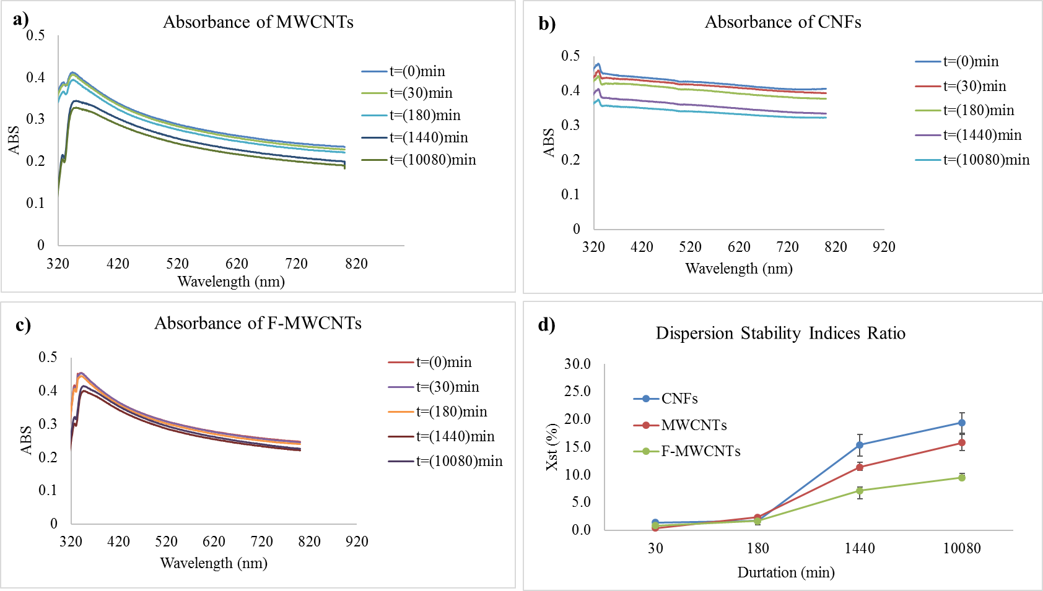Fig. 9. UV-Vis absorbance spectra recorded after different periods of sonication for a) MWCNTs suspensions, b) CNFs suspensions, c) F-MWCNTs suspensions. d) shows the dispersion stability index (X_{st}) ratio of the treated suspensions compared to the indices at t = (0min), in %.

  - Characterization of Nanofilaments Reinforced Cementitious Composites

3.2.1 Workability
In this study, the flow properties (an indicator of workability) of fresh mixtures of the produced nanocomposites were evaluated based on flow table results. The test set up is shown in Fig.10. The nanocomposite mixtures were prepared with a water to cement ratio of 0.35, with nanofilaments incorporated at dosages of 0.025% wt. by cement weight, and a NSF:nanofilament ratio of 10/1. The workability of mixtures containing MWCNTs and CNFs was slightly lower than mixtures without nanofilaments (i.e. control mixtures): flow values were 105% for the control mixture and 100% and 96 % for mixtures containing MWCNTs and CNFs respectively. These results indicated that the addition of low amounts of carbon nanotubes/fibres did not significantly impact (i.e. only slightly reduced) the workability, and higher NSF addition was not required to maintain the mixture’s workability. The rheological properties were slightly enhanced (flow value of 110%) for mixtures containing functionalised carbon nanotubes (F-MWCNTs), which can be attributed to an increased wettability caused by the functional groups present on the tube walls. The presence of functional groups (-COOH) alongside the superplasticizer (NSF) acts to increase the amphiphilic molecules in the mixture which can lead to improved wetting, dispersion and workability properties.

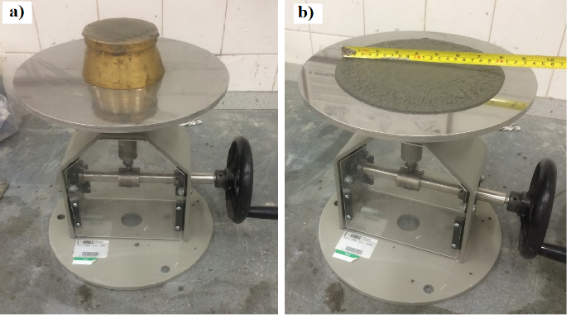
Fig. 10 Flow test of mixtures containing carbon based nanofilaments. a) shows the flow table set-up, b) shows determination of the flowability value of the matrix after the test.

    - Porosity and Density Measurement.
Porosity and density determinations of cementitious composites (with and without nanofilaments) were carried out on a range of core specimens and compressive cubes at 28 days to evaluate the effect of carbon nanotubes/fibres (Fig.11). After 28 days curing, it was evident that the incorporated nanotubes/fibres had filled internal pores and reduced composite porosity. The addition of 0.025% F-MWCNTs, MWCNTs, and CNFs resulted in a decrease in composite porosity by 17%, 21%, and 26% respectively, compared to the mixture without nanofilaments. This reduction in porosity can be attributed to the physical effect of individual nanotubes/fibres filling pores between hydration products and bridging or interrupting nano/micro capillary pores, coupled with possible hydrophobic repulsive effects on water ingress into smaller pores. Optimising the porosity of nanofilament-bearing cementitious composites is vital since porosity significantly impacts the mechanical performance, as crack propagation begins at the pores and the nanofilaments are essential in refining the pore structures [55].

In principle, the addition of nanomaterials should slightly affect the density of the cementitious composites. The average density measured on control specimens was 2.06 g.cm⁻³ with a standard deviation of 0.35, whereas with the addition of MWCNTs, F-MWCNTs, and CNFs the density was slightly increased to 2.12 g.cm⁻³ with a standard deviation of 0.27. The enhanced composite density could be attributed to a higher packing density with the addition of nanofilaments (refining/filling the structural pores). Fig.11b shows the correlation between the 28-day compressive strength (see below) and the measured density, which confirms that although there is no statistically significant effect of the incorporated nano materials on the composite density, they do enhance the mechanical strength. This is further discussed below.

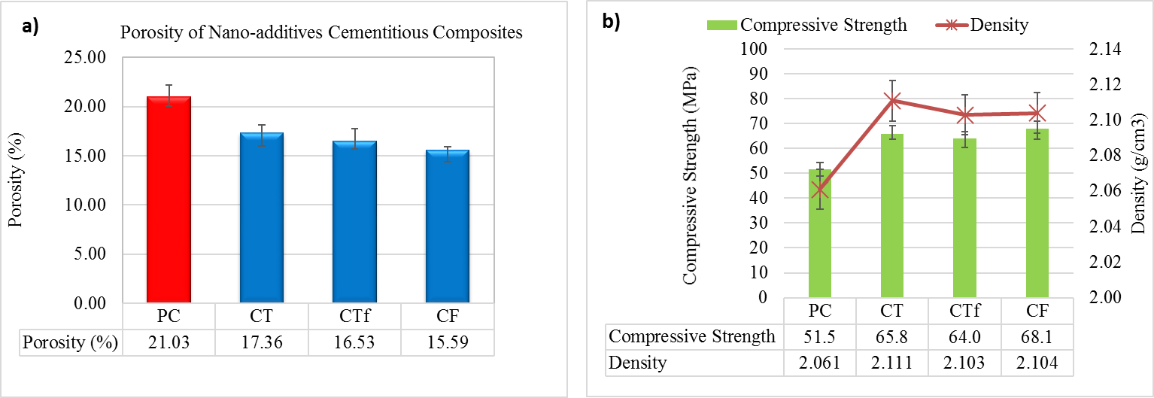

Fig.11 a) and b) show porosity (%) and density (g.cm⁻³) results for cementitious composite specimens containing MWCNTs, F-MWCNTs, and CNFs in addition to control specimens (PC) after 28 days curing.

    - Mechanical strength characteristics of hardened composites

The inclusion of nanofilaments following ultrasonication and NSF addition was found to significantly improve the composites’ mechanical strength characteristics. The obtained results, and variations observed, from compressive and splitting tensile strength tests after 3, 28, and 90 days curing compared with control specimens are presented in Fig.12. Key findings from these tests are:
- Compressive strength: Improvement in the compressive strength of the mixtures containing MWCNTs, F-MWCNTs, and CNFs at 3, 28, and 90 days of: 30%, 35%, 38%; 28%, 24%, 32%; and 11%, 15%, 20% was observed compared to the control mix (as shown in Fig.12 a).
- Tensile Strength: The results also showed a significant improvement in splitting tensile strength. A 42%, 35%, 38%; 50%, 45%, 47%; and 75%, 38%, 38% (after 3, 28, and 90 days curing, respectively) increase in the splitting tensile strength of MWCNTs, F-MWCNTs, and CNFs-containing composites was observed (Fig.12b).

The contribution of nanofilaments to increasing the strength of the composite can be attributed to:
- The increased concentration of individual nanofilaments affecting the structure of the cementitious composite by pore filling, leading to a decrease/refinement of void space and an increase in strength.
- Embedding of nanotubes/fibres into cement hydration products (such as calcium silicate hydrates (C-S-H) and ettringite), which provides more effective reinforcement and increases the tensile resistance of the composite.
- The nanotubes/fibres restrain the growth or propagation of internal cracks and thus improve the transfer of load between the fibres and the matrix, and better distribute stresses at the nano and micro scale.
- The geometry of CNFs compared to MWCNTs (i.e. their outer surfaces are conically shaped and angled with respect to the longitudinal fibre axis) can lead to improved bonding with the matrix, and bridging of cracks, improving the load carrying capacity[1]. In addition, their longer fibre length (around four times longer compared to MWCNTs) can lead to better capacity for bridging cracks and thus improve the load carrying capacity.
- The dispersion techniques used increases the density of surfactant molecules (NSF) on the surfaces of nanotubes/fibres, which act through non-covalent bonds as cross-linking agents that can enhance the bond between the cement matrix and the nanofilaments [56]. Moreover, the availability of functional groups on F-MWCNTs may lead to a better dispersion level, and improve the bond between the nanotubes and the surrounding matrix[18, 57].
- The possibility that the nanotubes/fibres form a homogenous inter-connecting entangled network of nanotubes in the matrix with some overlapping each other, such that the matrix is therefore restrained from failure until a failure in the bond or pullout/fracture in the tube/fibre occurs.

Generally, the high strength gains in compressive and splitting tensile strength (as shown above) with low data scatter demonstrated in Fig.12 confirms the efficiency of the proposed dispersion method for cement composites. These results indicate that the very low content of nanofilaments dispersed using the simple and facile method described herein can reproducibly improve the mechanical performance of cementitious composites, compared to the relatively higher content dispersed using complicated/longer methods as used in most previous studies (a range of which are summarised in Table 4).

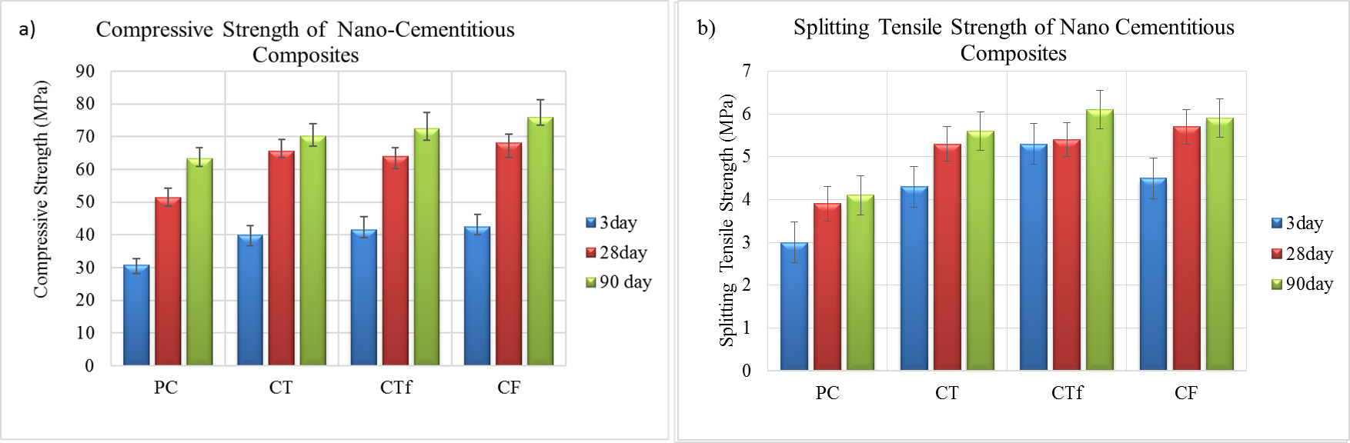
Fig.12 a) compressive strength, and b) splitting tensile strengths of cementitious mixture (PC), and cementitious composites of MWCNTs (CT), F-MWCNTs (CTf), and CNFs(CF).

3.2.3 Toughness Behaviour
The toughness of nanofilament-bearing cementitious composite specimens in three-point bending tests is typically measured by calculating the area under the corresponding load–deflection curve, which is related to the energy absorption capacity of the material. The load–deflection curve was analysed according to the Japan Society of Civil Engineers (JSCE) method [43], which yields a flexural toughness factor, FT_{δ}.

Relationships between the flexural toughness factor and different deflection values at various curing ages (3, 28, 90 days) are shown in Fig.13. Apparently, nanofilament inclusion does not prevent sudden and brittle failure when compared with the plain control mix. The control mix and the composites containing nanofilaments suddenly failed at a maximum deflection of 0.045mm at 3 days and 1.25mm at 28 and 90 days, however, composites containing nanofilaments were found to show significantly increased energy absorption (flexural toughness factor). Significant % increases in flexural toughness factor can be observed from the data in Table 3 depending on the type of nanofilament (MWCNTs, F-MWCNTs, and CNF) added to the composite, and as a function of the recorded deflection up to failure (from 0.01mm to 0.045 mm at early age, and from 0.025mm to 1.25mm at 28 and 90 days). The well-embedded nanotubes/fibres, their high aspect ratio, and improved bond with the surrounding matrix can successfully bridge nano cracks, and pulling out of these nanofilaments requires more energy, leading to an increase in the flexural toughness of the composite.

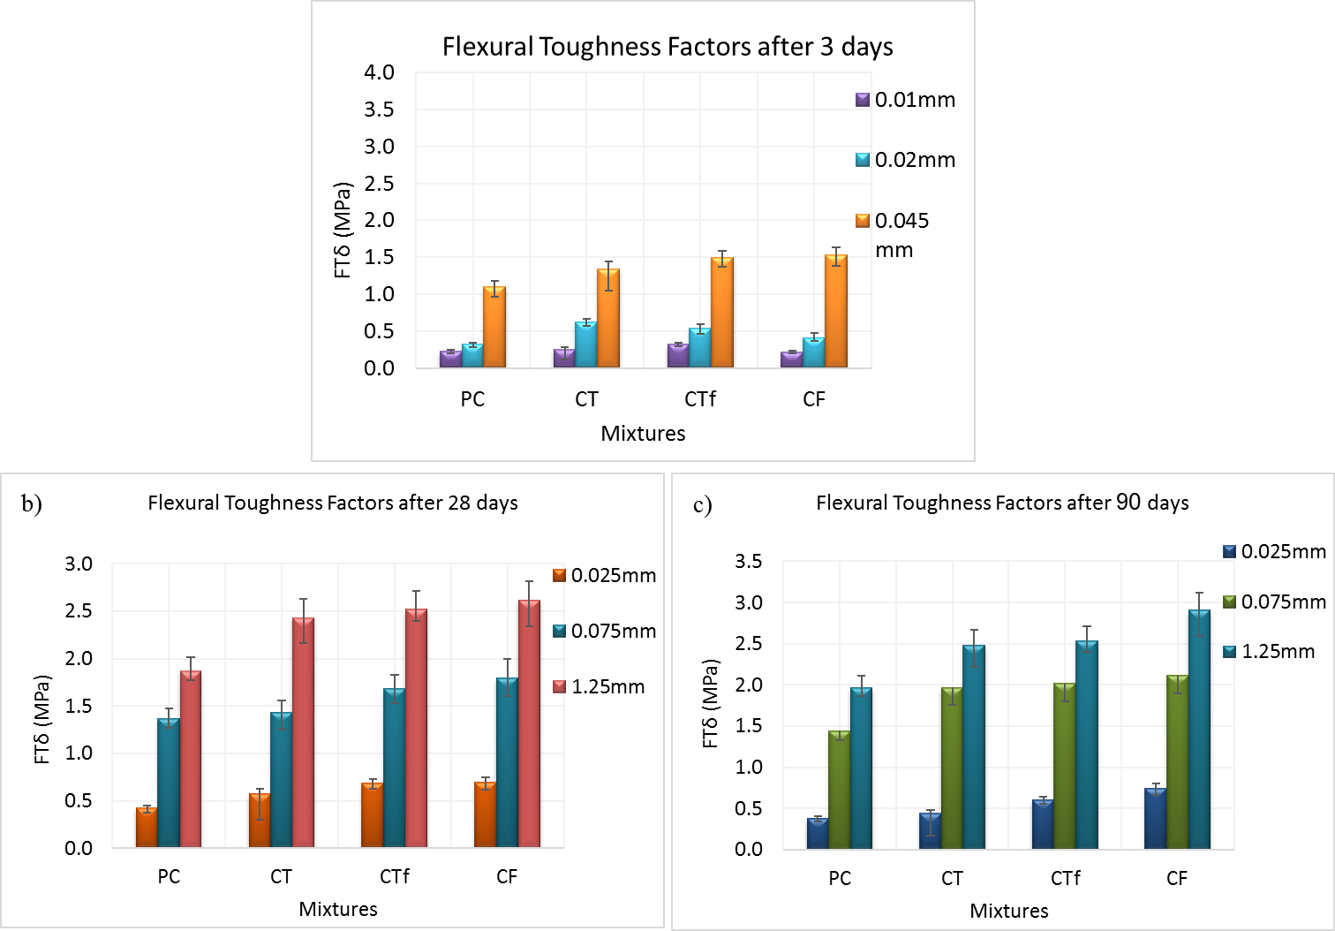
Fig13. Flexural toughness factor as a function of different deflection values, and at various curing ages (3, 28, 90 days)

Table 3 Flexural Toughness factors at 3, 28, and 90 days for control and nanofilaments composites.
Specimen designation |  | Nano filament % | Flexural Toughness |  | Flexural Toughness |  | Flexural Toughness
 |  | Nano filament % | MPa (3day) |  | MPa (28day) |  | MPa (90day)
 |  | Nano filament % | Mean | % increase | Mean | % increase | Mean | % increase
Nano filament composite | PC | - | 1.11 | 0 | 1.88 | 0 | 1.97 | 0
Nano filament composite | CT | 0.025 | 1.34 | 21 | 2.44 | 30 | 2.48 | 26
Nano filament composite | CTf | 0.025 | 1.50 | 35 | 2.53 | 35 | 2.53 | 29
Nano filament composite | CF | 0.025 | 1.53 | 38 | 2.63 | 40 | 2.91 | 48

  - Microstructural Characterisation
Cementitious composites containing the dispersed carbon-based nanofilaments were imaged to understand the relationship between the composites’ mechanical strengths and their microstructural properties. Typical images of a fractured surface of the cementitious nanocomposites containing 0.025% wt. MWCNTs, and CNFs after 28 days of curing are shown in Fig.13 and Fig.14. The SEM images show that the nanotubes/fibres are predominantly uniformly distributed and individually embedded in the composite, in almost all of the imaged areas. The nanotubes/fibres show clear interaction with the host matrix, with hydration products present on the surface of the fibres. This improves bonding strength and consequently load transfer efficiency between the cement matrix and the nano reinforcements, and their bridging effect across voids and cracks.

The key features of the images can be summarised as:
- An absence of holes/large voids, which indicates strong bonding/filling between the fibres and the surrounding matrix.
- The observed diameters of nanotubes/fibres appear to be larger than the diameters of those in the suspensions. Diameters of nanotubes and nanofibres as measured in the SEM images were around 35-100nm, as compared to 25nm or less for the MWCNTs in suspension, and around 500nm as compared to 200nm in nanofibres suspensions, respectively. Apparent large diameters on the fractured surfaces can be attributed to an attached/coating layer of cementitious hydration products (mainly calcium silicates formed by the chemical reaction of cementitious materials with the solution (water and surfactant) and functional groups (if present) on the tubes/fibres surfaces).
- Nanotubes/fibres in the cementitious composites retained their original geometry and were not squeezed or flattened due to the initiated pressure during hydration products formation.

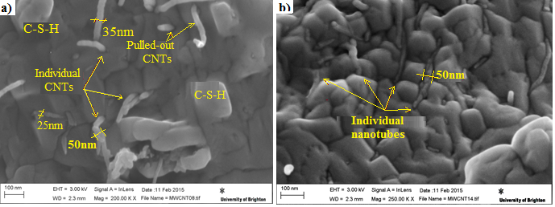
Fig.13 SEM images of carbon nanotubes (MWCNTs) embedded in the cementitous composites.

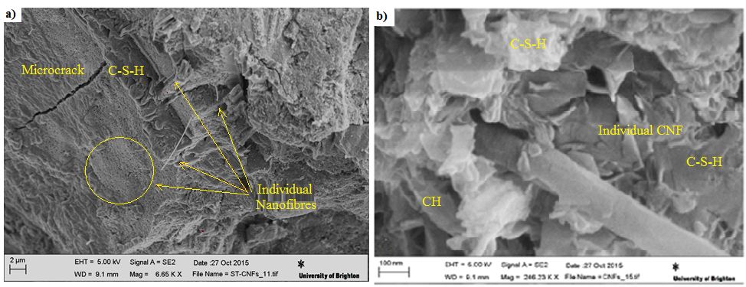

Fig.14 SEM images of carbon nanofibres (CNFs) embedded in the cementitous composites.

Discussion
Various researchers have studied the effects of ultrasonication treatment methods for carbon based nanofilaments on the strength of cement-based materials (summarised in Table 4), but no consensus has yet been reached on (a) an optimized, standard method, and (b) the detailed impacts of these methods on different types of nanofilament at a bulk and microstructural level. We observe here a significant improvement in mechanical strength over all the applied tests on composites, following effective dispersion of a low content of carbon based nanofilaments (0.025 wt% added). Individual well-dispersed nanoparticles (with less defects) provide a greater probability of nanofilaments contacting directly with the surrounding matrix, giving a higher arresting capacity with the cement hydration products. Fig.15 shows the considerable improvement in compressive strength observed in the present study, which uses a very low percentage of nanofilaments and / or shorter sonication durations, compared to previous studies (Table 4). The work presented here indicates that combining sonication treatment by high-intensity, short duration sonication with low added amounts of nanofilaments can provide a simple and rapid process for the fabrication of cementitious composites effectively reinforced with carbon nanotubes and nanofibres. Given the relatively simplicity and short duration of the dispersion method used, this should be scalable for practical industrial application, while the use of a lower wt.% of carbon nanofilament additives should reduce composite material and production costs.

Table 4 Comparison of mechanical strengths of cement-based composites reinforced with MWCNTs, F-MWCNTs, and CNFs.

Type of nanofilaments | Research and References | Matrix | Duration  Of Ultrasonication | CNT content  (wt.% by  cement) | Compressive strength increase  % | Tensile Strength increase  % | Flexural  toughness increase  %
MWCNTs | *Li et al., [34] | mortar | 3hours | 0.5 | 19 | - | 25
MWCNTs | Cwirzen et al., [58] | paste | 2.30 min+ | 0.042 | - | - | 20
MWCNTs | Konsta-Gdoutos et  al., [59] | paste | - | 0.08 and 0.048 | - | - | 25
MWCNTs | Al-Rub et al., [6] | Paste | 20-30 min | 0.2 | - | - | 81
MWCNTs | Al-Rub et al., [6] | Paste | 20-30 min | 0.1 | - | - | 65
MWCNTs | Collins et al., [15] | paste | 12 min+ | 0.5 | 25 | - | -
MWCNTs | Musso et al., [60] | paste | 4 hours | 0.5 | 10 | - | -
MWCNTs | Xu et al., [61] | mortar | 30min | 0.02 | 15.9 | - | 20.7
MWCNTs | Mohsen et al., [62] | mortar | 30 min | 0.25 | - | - | 40
MWCNTs | Chen et al., [63] | cement-based composites | 30 min | 0.067% | - | - | from 12.5 to 21.2MPa
MWCNTs | Hamzaoui et al. [64] | mortar | Pre-dispersed | 0.01 wt% | 10 | - | 24
MWCNTs | Irshidat et al., [65] | nanotubes resin | 30min | 20 wt.% | - | - | 42
MWCNTs | Present work | mortar | 5min | 0.025 | 28 | 50 | 30
CNFs | Metaxa et al., [66] | paste | - | 0.048 | - | - | 50
CNFs | Bryan et al., [53] | paste | 30min | 0.2 | - | - | 55
CNFs | Sbia et al., [37] | paste | 12-15 Stirring 10min sonication | 0.24 | 22 | - | 10
CNFs | Present work | mortar | 5min | 0.025 | 32 | 47 | 40
* surface-treated multi-walled (F-MWCNTs), + sonic-bath used in dispersion process

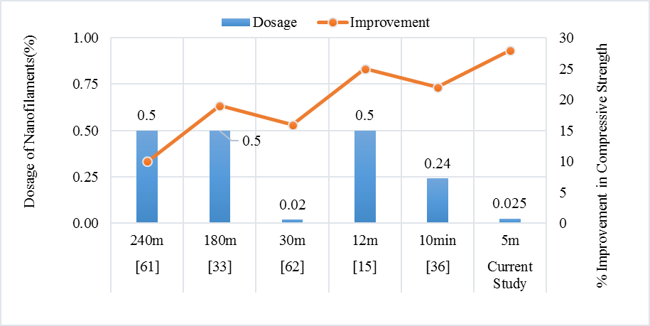

Fig.15 Comparison of improvement in compressive strength with nanofilament dosage, from the current and previously published studies. Lower numbers indicate duration of ultrasonication treatment (in minutes), and reference number (in brackets).

Conclusion

Sufficient dispersion of nanotubes is crucial if they are to enhance the mechanical properties of cement-based composites. Therefore in this paper the dispersibility in water of three different types of nanofilaments was investigated using high-intensity sonication over a short time period in the presence of surfactants, as well as the effect of this treatment on the mechanical performance of cementitious composites containing these nanofilaments. Optical microscope images show a dramatic improvement in the dispersion state of nanotubes/fibres suspensions following combined use of superplasticizer and high-intensity, short duration (5minutes) sonication. In addition, high magnification TEM images show that bundle/clusters sizes of nanotubes/fibres became smaller after sonication using this dispersion method. The observed individual nanotubes, and nanofibres, tend to have larger outer diameters (compared to the original, as provided, material) reflecting the presence of an adsorbed layer of surfactant on the wall of the nanotubes/fibres. UV-vis absorbance data, through use of stability indices, highlight that the applied sonication treatment leads to nanofilament suspensions that remained stable for several hours with the ability to withstand re-agglomeration.

Mechanical strength and toughness were significantly enhanced by the addition of low amounts of well-dispersed MWCNTs, F-MWCNTs, and CNFs. It was found that the MWCNTs and F-MWCNTs were more effective in increasing the compressive and tensile strength, while flexural toughness was significantly enhanced with the addition of CNFs at all ages. The gain in mechanical strength can be attributed to three main reasons: i) Highly dispersed nanotubes/fibres can successfully arrest cracks developing between the cement hydration products; ii) Addition of carbon nanotubes/fibres can fill internal pores and bridge or interrupt nano/micro capillary pores within the composites, indicated by a decrease in bulk porosity; iii) Improved bonding strength between the matrix and nanotubes/fibres improves the load-transfer efficiency from the cement matrix to the reinforcement across voids and cracks. Overall, using the same added percentage of the nanofilaments improved the cementitious composites’ compressive and splitting tensile strength by 24 - 32% and 45 – 50% respectively, and the flexural toughness factor by 30 - 40%, after 28 days curing. A 17-26% reduction in the bulk porosity of the cementitious composite was also observed.

From the above it can be concluded that the technique of high-intensity sonication over short time intervals is an effective (and potentially scalable) dispersion method, which can generate desired dispersion levels and be used to manufacture structurally-enhanced cementitious composite materials.

Acknowledgments
The lead author would like to thank the Iraqi Ministry of Higher Education and Scientific Research, Iraqi Culture attaché in London, and Babylon University in Iraq for the award of a Doctoral scholarship

References
1. Metaxa, Z.S., M.S. Konsta-Gdoutos, and S.P. Shah, Carbon nanofiber cementitious composites: Effect of debulking procedure on dispersion and reinforcing efficiency. Cement and Concrete Composites, 2013. 36(0): p. 25-32.
2. Yu, H., et al., Fracture toughness enhancement of cement paste with multi-walled carbon nanotubes. Construction and Building Materials, 2014. 70 (2014) 332–338.
3. Sanchez, F. and K. Sobolev, Nanotechnology in concrete – A review. Construction and Building Materials, 2010. 24(11): p. 2060-2071.
4. Zhu, P.J.M.B.a.A.P., Application of nanotechnology in construction Summary of a state-of-the-art report. RILEM TC 197-NCM: ‘Nanotechnology in construction materials’ Materials and Structures / Matériaux et Constructions, 2004. 37: p. pp 649-658.
5. Junrong, Y., et al., Controlling the dispersion of multi-wall carbon nanotubes in aqueous surfactant solution. Carbon, 2007. 45(3): p. 618-623.
6. Rashid, A.A.-R., A. Ahmad I., and T. Bryan M., On the aspect ratio effect of multi-walled carbon nanotube reinforcements on the mechanical properties of cementitious nanocomposites. Construction and Building Materials, 2012. 35(0): p. 647-655.
7. Mendoza, O., G. Sierra, and J.I. Tobón, Effect of the reagglomeration process of multi-walled carbon nanotubes dispersions on the early activity of nanosilica in cement composites. Construction and Building Materials, 2014. 54(0): p. 550-557.
8. Hanus, M.J. and A.T. Harris, Nanotechnology innovations for the construction industry. Progress in Materials Science, 2013. 58(7): p. 1056-1102.
9. Sobolkina, A., et al., Dispersion of carbon nanotubes and its influence on the mechanical properties of the cement matrix. Cement and Concrete Composites, 2012. 34(10): p. 1104-1113.
10. Yan, Y.H. and M.T. Eugene, Dispersion of Carbon Nanotubes: Mixing, Sonication, Stabilization, and Composite Properties. Polymers, 2012. 4(4): p. 275-295.
11. Irshidat, M.R., M.H. Al-Saleh, and M. Al-Shoubaki, Using carbon nanotubes to improve strengthening efficiency of carbon fiber/epoxy composites confined RC columns. Composite Structures, 2015. 134: p. 523-532.
12. Gojny, F.H., et al., Surface modified multi-walled carbon nanotubes in CNT/epoxy-composites. Chemical Physics Letters, 2003. 370(5-6): p. 820-824.
13. Kim, S.W., et al., Surface modifications for the effective dispersion of carbon nanotubes in solvents and polymers. Carbon, 2012. 50(1): p. 3-33.
14. Karabanova, L.V., et al., The role of interfacial chemistry and interactions in the dynamics of thermosetting polyurethane–multiwalled carbon nanotube composites at low filler contents. Colloid and Polymer Science, 2013. 291(3): p. 573-583.
15. Frank, C., L. John, and D. Wen Hui, The influences of admixtures on the dispersion, workability, and strength of carbon nanotube–OPC paste mixtures. Cement and Concrete Composites, 2012. 34(2): p. 201-207.
16. Vaisman, L., H.D. Wagner, and G. Marom, The role of surfactants in dispersion of carbon nanotubes. Advances in Colloid and Interface Science, 2006. 128–130(0): p. 37-46.
17. J.M. Makar, J.M., J. Luh,, Carbon nanotube/cement composites-early results and potential applications, Proceedings of the 3rd International Conference on Construction Materials: Performance,, in Innovations and Structural Implications. 2005 Vancouver, B.C., Canada, . p. pp.1-10.
18. Li, G.Y., P.M. Wang, and X. Zhao, Mechanical behavior and microstructure of cement composites incorporating surface-treated multi-walled carbon nanotubes. Carbon, 2005. 43(6): p. 1239-1245.
19. Li, G.Y., P.M. Wang, and X. Zhao, Pressure-sensitive properties and microstructure of carbon nanotube reinforced cement composites. Cement and Concrete Composites, 2007. 29(5): p. 377-382.
20. Tyson, B.M., et al., A quantitative method for analyzing the dispersion and agglomeration of nano-particles in composite materials. Composites Part B: Engineering, 2011. 42(6): p. 1395-1403.
21. Farman, A., et al., Efect of sonication conditions: solvent, time, temperature and reactor type on the preparation of micron sized vermiculite particles. Ultrasonics 21, 2014. Sonochemistry, Elsevier,: p. pp.1002-1009.
22. Adam J., B., L. Claire E., and Q. Jamie S., Parametric analysis of sonication and centrifugation variables for dispersion of single walled carbon nanotubes in aqueous solutions of sodium dodecylbenzene sulfonate. Carbon, 2011. 49(15): p. 5213-5228.
23. Chen, S.J., et al., Predicting the influence of ultrasonication energy on the reinforcing efficiency of carbon nanotubes. Carbon, 2014. 77: p. 1-10.
24. Bo, Z., et al., Effect of ultrasonication energy on engineering properties of carbon nanotube reinforced cement pastes. Carbon, 2015. 85: p. 212-220.
25. Pacheco-Torgal, F. and S. Jalali, Nanotechnology: Advantages and drawbacks in the field of construction and building materials. Construction and Building Materials, 2011. 25(2): p. 582-590.
26. Shaffer, M.S.P., X. Fan, and A.H. Windle, Dispersion and packing of carbon nanotubes. Carbon, 1998. 36(11): p. 1603-1612.
27. Fusion, H. http://www.sonicator.com/. 2017.
28. S. Alrekabi, A.B. Cundy, A. Lampropoulos, I. Savina, Experimental Investigation on the Effect of Ultrasonication on Dispersion and Mechanical Performance of Multi-Wall Carbon Nanotube-Cement Mortar Composites. International Journal of Civil, Environmental, Structural, Construction and Architectural Engineering, 2016. 10: p. 267-274.
29. Santos, H.M., Lodeiro, C. and Capelo-Martínez, J.-L., The Power of Ultrasound, in Ultrasound in Chemistry: Analytical Applications (ed J.-L. Capelo-Martínez), Wiley-VCH Verlag GmbH & Co. KGaA, Weinheim, Germany. doi: 10.1002/9783527623501.ch1. 2008.
30. Mendoza, O., G. Sierra, and J.I. Tobón, Influence of super plasticizer and Ca(OH)2 on the stability of functionalized multi-walled carbon nanotubes dispersions for cement composites applications. Construction and Building Materials, 2013. 47(0): p. 771-778.
31. Maria, K.-G., S. Zoi S, and P.S. Surendra, Highly dispersed carbon nanotube reinforced cement based materials. Cement and Concrete Research, 2010. 40(7): p. 1052-1059.
32. Jidraph Njuguna, O.A.V., and Richard Liang, A Review of Spectral Methods for Dispersion Characterization of Carbon Nanotubes in Aqueous Suspensions. Journal of Spectroscopy, 2015.
33. Rastogi, R.K., Rahul Tripathi, S. K. Sharma, Amit L. Kaur, Inderpreet Bharadwaj, Lalit M. , Comparative study of carbon nanotube dispersion using surfactants. Journal of Colloid and Interface Science, 2008. 328(2): p. 421-428.
34. Geng Ying, L., W. Pei Ming, and Z. Xiaohua, Mechanical behavior and microstructure of cement composites incorporating surface-treated multi-walled carbon nanotubes. Carbon, 2005. 43(6): p. 1239-1245.
35. Wang, B., et al., Electromagnetic wave absorbing properties of multi-walled carbon nanotube/cement composites. Construction and Building Materials, 2013. 46(0): p. 98-103.
36. Carsten, V., Ultrafine particles in concrete: Influence of ultrafine particles on concrete properties and application to concrete mix design, in School of Architecture and the Built Environment, Division of Concrete Structures, Royal Institute of Technology. 2010.
37. Peyvandi, A., et al., Effect of the cementitious paste density on the performance efficiency of carbon nanofiber in concrete nanocomposite. Construction and Building Materials, 2013. 48(0): p. 265-269.
38. C109M-16a, A.C., Standard Test Method for Compressive Strength of Hydraulic Cement Mortars (Using 2-in. or [50-mm] Cube Specimens), . ASTM International, West Conshohocken, PA, 2016, www.astm.org.
39. C496M-11, A.C., Standard Test Method for Splitting Tensile Strength of Cylindrical Concrete Specimens, ASTM International, West Conshohocken, PA, 2004, www.astm.org.
40. Şahin, Y. and F. Köksal, The influences of matrix and steel fibre tensile strengths on the fracture energy of high-strength concrete. Construction and Building Materials, 2011. 25(4): p. 1801-1806.
41. Noorvand, H., et al., Incorporation of nano TiO2 in black rice husk ash mortars. Construction and Building Materials, 2013. 47(0): p. 1350-1361.
42. Baughman RH, Z. and d. AA, Heer, Carbon nanotubesthe route toward applications. Science 2002;. 2002. 297((5582):): p. 787–92.
43. JSCE-SF4 Standard for Flexural Strength and Flexural Toughness, Method of Tests for Steel fiber Reinforced Concrete,” Concrete Library of JSCE, No. 3, June 1984, Japan Concrete Institute (JCI). pp. 58-66.
44. Mohammad Iqbal, K. A NOVEL METHOD FOR MEASURING POROSITY OF HIGH STRENGTH CONCRETE. in 7th Saudi Engineering Conference (SEC7). 2007. Department of Civil Engineering, College of Engineering King Saud University, Kingdom of Saudi Arabia.
45. P. Soroushian, A. and J.W.H. Khan, Mechanical properties of concrete materials reinforced with polypropylene or polyethylene fibers, ACI Mater. J. 89 (2) 535– 540. 1992.
46. Zhang, Z.-S., et al., Ultrasound-assisted extraction of oil from flaxseed. Separation and Purification Technology, 2008. 62(1): p. 192-198.
47. Li, H., L. Pordesimo, and J. Weiss, High intensity ultrasound-assisted extraction of oil from soybeans. Food Research International, 2004. 37(7): p. 731-738.
48. Yazdanbakhsh, A., et al., Challenges and Benefits of Utilizing Carbon Nanofilaments in Cementitious Materials. Journal of Nanomaterials, 2012. 2012: p. 1-8.
49. Chunyu Li, T.-W.C., Elastic moduli of multi-walled carbon nanotubes and the effect of van der Waals forces. Composites Science and Technology, 2003. 63(11): p. 1517-1524.
50. Barick, A.K. and D.K. Tripathy, Preparation, characterization and properties of acid functionalized multi-walled carbon nanotube reinforced thermoplastic polyurethane nanocomposites. Materials Science and Engineering: B, 2011. 176(18): p. 1435-1447.
51. In-Yup Jeon, D.W.C., Nanjundan Ashok Kumar1 and Jong-Beom Baek, Functionalization of Carbon Nanotubes, in Carbon Nanotubes - Polymer Nanocomposites, S. Yellampalli, Editor. 2011, World's largest Science, Technology & Medicine Open Access book publishe.
52. Peng-Cheng, M., et al., Dispersion and functionalization of carbon nanotubes for polymer-based nanocomposites: A review. Composites Part A: Applied Science and Manufacturing, 2010. 41(10): p. 1345-1367.
53. Tyson, B.M., et al., Carbon Nanotubes and Carbon Nanofibers for Enhancing the Mechanical Properties of Nanocomposite Cementitious Materials. Journal of Materials in Civil Engineering, 2011. 23(7): p. 1028-1035.
54. Parveen, S., S. Rana, and R. Fangueiro, A Review on Nanomaterial Dispersion, Microstructure, and Mechanical Properties of Carbon Nanotube and Nanofiber Reinforced Cementitious Composites. Journal of Nanomaterials, 2013. 2013: p. 1-19.
55. Samuel, C., et al., Nano reinforced cement and concrete composites and new perspective from graphene oxide. Construction and Building Materials, 2014. 73: p. 113-124.
56. Haghi and T. Sabu, Carbon nanotubes: Theoretical Concepts and Research Strategies for Engineers. 2015, Apple Academic Press, Inc. 3333 Mistwell Crescent, Oakville, ON L6L 0A2 Canada.
57. Dai L. and J. Sun, Mechanical Properties of Carbon Nanotubes-Polymer Composites, in Carbon Nanotubes - Current Progress of their Polymer Composites. 2016.
58. Cwirzen, A., et al., SEM/AFM studies of cementitious binder modified by MWCNT and nano-sized Fe needles. Materials Characterization, 2009. 60(7): p. 735-740.
59. Maria, K.-G., S. Zoi S, and S.P. Shah, Multi-scale mechanical and fracture characteristics and early-age strain capacity of high performance carbon nanotube/cement nanocomposites. Cement and Concrete Composites, 2010. 32(2): p. 110-115.
60. Musso, S., et al., Influence of carbon nanotubes structure on the mechanical behavior of cement composites. Composites Science and Technology, 2009. 69(11-12): p. 1985-1990.
61. Xu, S.G., LiangLi Jin, WeiJun, Production and mechanical properties of aligned multi-walled carbon nanotubes-M140 composites. Science in China Series E: Technological Sciences, 2009. 52(7): p. 2119-2127.
62. Mohsen, M.O., et al., Effect of mixing duration on flexural strength of multi walled carbon nanotubes cementitious composites. Construction and Building Materials, 2016. 126: p. 586-598.
63. Chen, Z., J.L.G. Lim, and E.-H. Yang, Ultra high performance cement-based composites incorporating low dosage of plasma synthesized carbon nanotubes. Materials & Design, 2016. 108: p. 479-487.
64. Hamzaoui, R., et al., Microstructure and mechanical performance of modified mortar using hemp fibres and carbon nanotubes. Materials & Design (1980-2015), 2014. 56: p. 60-68.
65. Irshidat, M.R., M.H. Al-Saleh, and H. Almashagbeh, Effect of carbon nanotubes on strengthening of RC beams retrofitted with carbon fiber/epoxy composites. Materials & Design, 2016. 89: p. 225-234.
66. Metaxa, Z.S., et al., Highly concentrated carbon nanotube admixture for nano-fiber reinforced cementitious materials. Cement and Concrete Composites, 2012. 34(5): p. 612-617.

