Micro-engineering of optical properties of GeO₂ glass by ultrafast laser nanostructuring

Fangteng Zhang, Ausra Cerkauskaite, Rokas Drevinskas, Peter G. Kazansky, and Jianrong Qiu*

F. Zhang and Prof. J. Qiu
State Key Laboratory of Luminescent Materials and Devices, and Institute of Optical Communication Materials, South China University of Technology, Guangzhou 510640, China
E-mail: qjr@scut.edu.cn
A. Cerkauskaite, R. Drevinskas, Prof. P. Kazansky
Optoelectronics Research Centre, University of Southampton, Southampton SO17 1BJ, United Kingdom
Prof. J. Qiu
State Key Laboratory of Optical Instrumentation, Zhejiang University, Hangzhou 310027, China

Keywords: form birefringence, GeO₂ glass, nanogratings, ultrafast laser, photonic application

Nanostructuring in glass by ultrafast laser paves the way for integrated optics. In this paper, form birefringence originated from self-assembled nanogratings induced by ultrafast laser direct writing in GeO₂ glass is systematically investigated. It is shown that the pulse energy for maximum retardance in GeO₂ glass is ~65% lower than in fused silica. The induced retardance by laser scanning is two times higher than that by stationary irradiation under the same processing conditions. The optimum pulse duration for maximum retardance in GeO₂ glass lies within sub-picosecond region, i.e. typically around 500 fs, while in fused silica it is in the picosecond regime at around 2 ps. A reversed polarization dependence of retardance at low pulse densities and low laser repetition rates is observed in GeO₂ glass. As a result, two optical applications including a radial polarization vortex converter and a computer generated hologram are demonstrated in GeO₂ glass by spatial manipulation of optical axis of the locally induced form birefringence. The Micro-engineering of optical properties of GeO₂ glass by ultrafast laser direct writing may develop new applications in near-/mid-infrared optics.
- Introduction
Ultrafast laser micromachining of transparent materials has attracted tremendous interests during the past two decades due to its ability to achieve internal three dimensional fabrication with resolution of up to sub-100 nm.^{[1,2]} Due to the complexity of nonlinear processes taking part during the femtosecond laser interaction with transparent materials, e.g. silica glass in particular, several different types of modification including isotropic refractive index change,^{[3]} self-assembled nanogratings,^{[4]} and micro-voids^{[5]} have been reported depending on the processing conditions. The self-organized nanogratings are most attractive for their unique properties including anisotropic light scattering,^{[6]} chemical etching selectivity,^{[7,8]} and form birefringence with a high stability at elevated temperatures.^{[9]} Recently, nanogratings in silica glass were successfully harnessed in several important applications such as micro/nanofluidic devices,^{[10,11]} polarization sensitive optical elements,^{[12,13]} 5D optical data storage.^{[14,15]} Meanwhile, numerous efforts have been taken to investigate the formation mechanism of nanogratings by different research groups. Physical models such as interference of bulk electron plasma waves with the incident light,^{[4]} asymmetrical evolution of nanoplasmas,^{[16,17]} and interference of self-trapping of exciton-polaritons^{[18,19]} have been proposed to be responsible for nanograting formation.
More recently, the formation of femtosecond laser-induced nanogratings has been confirmed in various glasses other than fused silica including GeO₂ glass,^{[20-22]} binary titanium silicate glass,^{[23,24]} borosilicate glasses,^{[23,25]} niobium silicate glass,^{[26]} highly porous glass,[ref] and aluminoborosilicate glass.^{[27]} Lancry et al. ^{[28]} revealed that porous nanoplanes can be formed not only in silicate glasses with anomalous density behaviour with fictive temperature, but also within glassy systems with normal density behaviour. However, except for pure GeO₂ glass, nanogratings formation in other glasses requires extremely rigorous parameters and the induced birefringence is usually much weaker than in fused silica. The drawbacks may hinder practical applications of nanogatings in those glasses. As for GeO₂ glass, it has been demonstrated that the parameter window for nanograting formation and the induced birefringence are comparable to or even more superior than fused silica, which could ensure better performance of fabricated micro-devices. In addition, GeO₂ glass exhibits higher transparency in the mid-infrared region and higher nonlinearity as compared to fused silica, which promises novel applications in the near-/mid-infrared region. Nevertheless, much fewer attempts have been carried out on implementing the femtosecond laser induced nanogratings in GeO₂ glass.
In this letter, the formation of nanogratings in GeO₂ glass and the effects of various parameters are revealed by systematically quantifying the induced retardance. It is revealed that the retardance induced by laser scanning is two times higher than that by stationary irradiation. Formation threshold of nanogratings and its relation to pulse duration under certain focusing conditions is experimentally explored. A reversed polarization dependence of form birefringence as compared to fused silica, which is repetition rate related, is observed in GeO₂ glass. Here we also demonstrate various nanograting based optical element designs including a radial polarization vortex converter and a computer generated hologram successfully imprinted in GeO₂ glass.
- Results and discussion
Femtosecond laser modification of transparent materials can be performed in stationary irradiation (dots) or in scanning mode (lines). In previous work reported by Asai et al.,^{[22]} the nanogratings and structure evolution in GeO₂ glass induced by stationary irradiation was studied. It should be noted that a large number (2.5 × 10⁶) of pulses was delivered in each spot while the induced retardance was relatively small i.e. less than 100 nm. This phenomenon raises a discussion whether the nanogratings induced by stationary irradiation and by scanning are the same. To move this further, we quantitatively compare the retardance induced in both modification regimes.
Figure 1 shows a set of dots and a corresponding set of lines imprinted with various pulse energies from 30 nJ to 600 nJ (from right to left) and same pulse density of 2500 pulses/dot for dots and 2500 pulses/μm for lines. It should be noted that in the optical microscope image (Fig. 1a) the light intensity transmitted by the dots is lower than that transmitted by the lines, indicating the higher scattering caused by the induced structures. In addition, the side view images revealed that dots consist of several separated dark regions along the laser propagation direction while the structure of the lines along the laser propagation direction is dominated by nanogratings and visually are more continuous and bright. The separated dark regions could be caused by inhomogeneous distribution of laser intensity along the propagation direction close to the focus, which is similar to the generation of void chains reported in other transparent materials.^{[29,30]} The quantitative retardance microscopy image of the same structures shows clear difference between dots and lines (Fig. 1b). Under the same processing conditions, the induced birefringence in lines is approximately two times stronger, which is further confirmed by quantifying the induced retardance as shown in Fig. 1c. The analysis of retardance indicates that the nanograting formed by the laser scanning is more uniform than that formed by stationary irradiation under similar parameters. The difference is most likely to be caused by the translation of the beam focus. The front part of the laser beam preheats the unmodified front side along the scanning direction while the rear part of laser beam could give an extra effect on the modification at a previous location when it passes by. Also, the rear part of the focus is always pre-seeded by the front part. The combination of these effects breaks the laser intensity distribution observed in stationary case and results in a more uniform structure.
Figure 1. Natural light optical microscope image (a), quantitative retardance microscopy image (b), and induced retardance as a function of pulse energy of dots and lines imprinted at pulse densities of 2500 pulses/dot and 2500 pulses/μm in GeO₂ glass (c). Repetition rate is 25 kHz, pulse duration is fixed at 600 fs.

In order to optimize the laser parameters for the induction of maximum higher birefringence by laser scanning in GeO₂ glass, dependence of retardance on different combinations of pulse duration and pulse energy was studied for GeO₂ glass as well as for fused silica at a fixed pulse density of 1000 pulses/μm and repetition rate of 200 kHz (Fig. 2). It was observed that within the same processing parameters, the induced maximum retardance values for the two glasses are similar. However, the pulse energy required to achieve maximum retardance of around 150 nm in GeO₂ glass (at ~ 200 nJ) is lower than that in fused silica (at 500-600 nJ), which makes it possible to obtain nanogratings of better resolution and higher quality when less energy is deposited into the glass. More importantly, the optimum pulse duration for maximum retardance in GeO₂ glass lies within femtosecond region (typically 500 fs) while in fused silica it lies in the picosecond region (typically 2 ps). In addition, a strong dependence of retardance on laser polarization direction is revealed. The retardance plots extracted from the set of scanned lines under the pulse density of 1000 pulses/μm show that the laser polarization parallel (E // v) to the scanning direction gives higher retardance than the polarization perpendicular (E + v) to the scanning direction (Fig. 2), which is in agreement with the previous observations reported by Gecevicius et al.^{[31]}The phenomenon could be explained by the effect of the polarization dependent Fresnel reflection at the boundaries of an induced structure.^{[30]} Moreover, it is also apparent that formation threshold of nanogratings in GeO₂ glass is lower than in fused silica, which may be associated with difference of the band-gaps of the two glasses i.e. ~4 eV for GeO₂ glass and ~ 9 eV for fused silica.
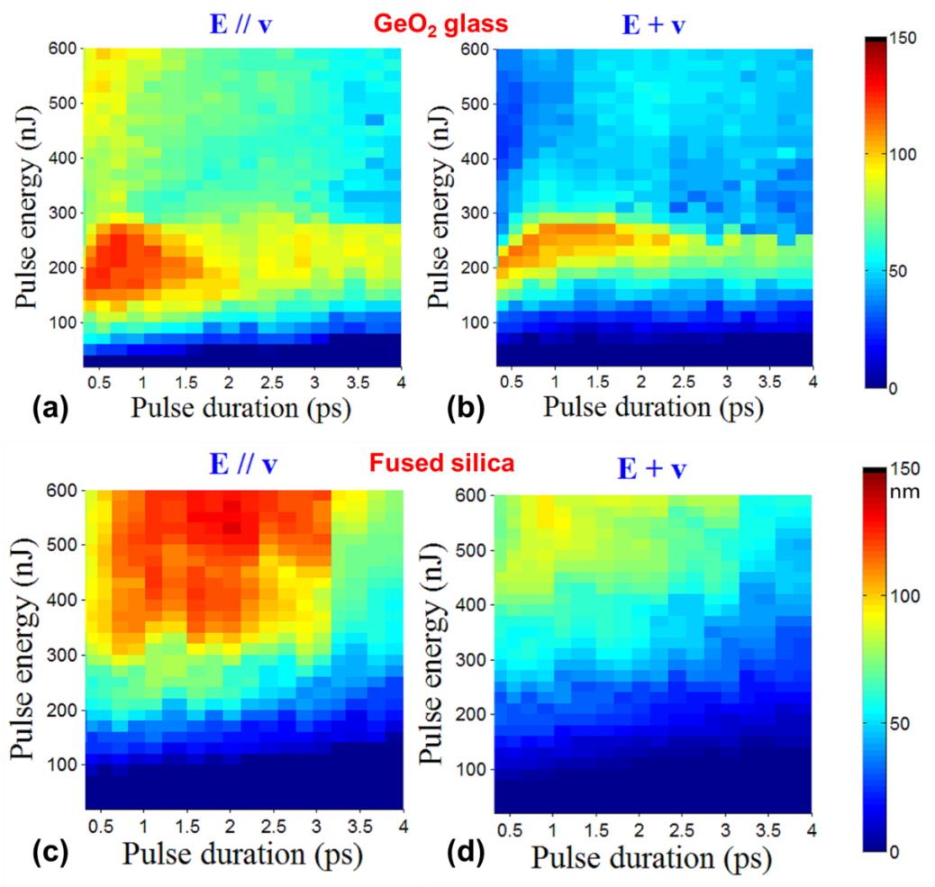
Figure 2. Pseudo colour plots of retardance induced by scanning the laser beam in two polarization states (‘//’ for parallel, ‘+’ for perpendicular to scanning direction) as a function of pulse energy and number of pulses for GeO₂ glass (a, b) and fused silica (c, d). Parameters: Pulse repetition rate is 200 kHz, and the pulse density is 1000 pulses/μm.

For the further studies of the formation threshold of nanogratings and its relation to pulse duration, lines imprinted with pulse energy varying from 10 nJ to 100 nJ at various pulse durations were analysed by the quantitative birefringence measurement system. The retardance image of the lines (Fig. 3a) shows that the minimum pulse energy sufficient to induce retardance in GeO₂ glass is of several tens of nanojoules, and is dependent on the pulse duration, i.e. the amount of energy necessary for nanogratings formation increases with increasing the pulse duration. However, evaluating the threshold by pulse energy might be inaccurate because different focusing conditions can lead to different results. Thus, the parameter widely accepted for evaluation of laser modification threshold is either fluence^{[32]} or intensity.^{[27]} For different pulse durations the laser fluence and laser intensity at which retardance was observed are extracted from Fig. 3a and plotted in Fig. 3b. The fluence threshold and intensity threshold for the typical pulse duration of 320 fs are approximately 3 J/cm² and 8×10¹² W/cm², respectively. The fluence threshold exhibits a linear increase, while the intensity threshold decreases with the first-order exponential model as a function of pulse duration. The opposed dependences of fluence threshold and intensity threshold on pulse duration indicate nonlinear processes during the formation of nanogratings, which needs to be further clarified by sophisticated experiments and calculations, which is out of the scope of this paper.
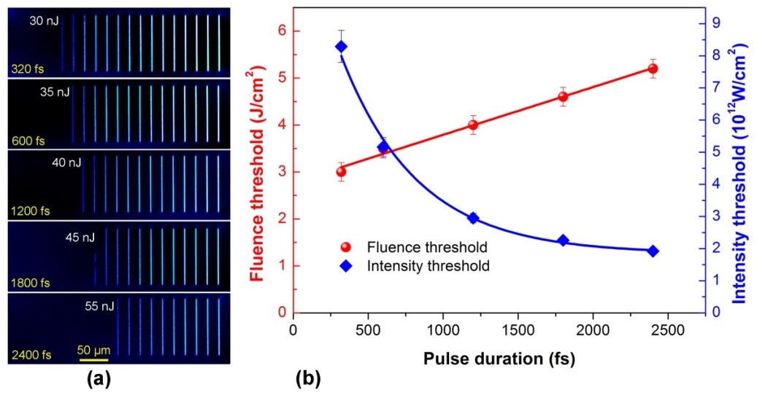
Figure 3. Quantitative birefringence microscopy image of lines imprinted by pulses of various pulse durations with pulse energy from 10 to 100 nJ (a), and dependence of nanograting threshold on pulse duration for GeO₂ glass (b). Repetition rate is 200 kHz, pulse density is 1000 pulses/μm, and laser polarization is perpendicular to writing direction.

It is well known that the repetition rate of femtosecond pulses is one of the key parameters that can affect the formation of nanogratings in glass. Previous studies have shown that the window of parameters for nanograting formation in fused silica is significantly narrowed down at higher repetition rates due to the presence of heat accumulation effect.^{[33,34]} To get better control of induced birefringence in GeO₂ glass for practical applications, evolution of retardance as a function of pulse density as well as pulse energy at various repetition rates was analysed, as shown in Fig. 4. The growth trends of retardance with respect to pulse density under all repetition rates are similar and saturated at a pulse density of ~2000 pulses/μm. The saturated retardance decreases with increasing repetition rate, and the difference is enlarged above 200 kHz, in accordance to previous observations.^{[34]} Surprisingly, the transition of dependence of retardance on polarization direction is observed at 200 kHz and 500 kHz (Fig. 4d and Fig. 4e), and a totally reversed polarization dependence of retardance is observed for lower repetition rates, i.e. ≤100 kHz (Fig. 4a-c). For 200 kHz and 500 kHz, the induced retardance in parallel polarization case is higher than that in perpendicular polarization case at a relatively low pulse density before the saturation. However, the dependence of retardance on polarization is also reversed when it reaches saturation at higher pulse densities. For lower repetition rates (≤100 kHz), the induced retardance in perpendicular polarization case is always higher than in parallel polarization case, which is against the explanation based on the effect of the polarization dependent Fresnel reflections for s- and p-polarizations at the boundaries of an induced structure.^{[35]}
It is also worth noticing that the dependence of retardance on pulse energy changes with repetition rate (Fig. 4f). At an optimized pulse density of 2500 pulse/μm, the retardance induced at 25 kHz and 50 kHz increases monotonously within the pulse energy increase in window of 50-800nJ. When the repetition rate is increased to 100 kHz and higher, the induced retardance increases firstly and then decreases with the increasing pulse energy, which can be assigned to the material thermal heating at larger pulse energies. These results indicate that the induced birefringence can be manipulated in a relatively wide range of energies with the femtosecond pulses operating at low repetition rates.
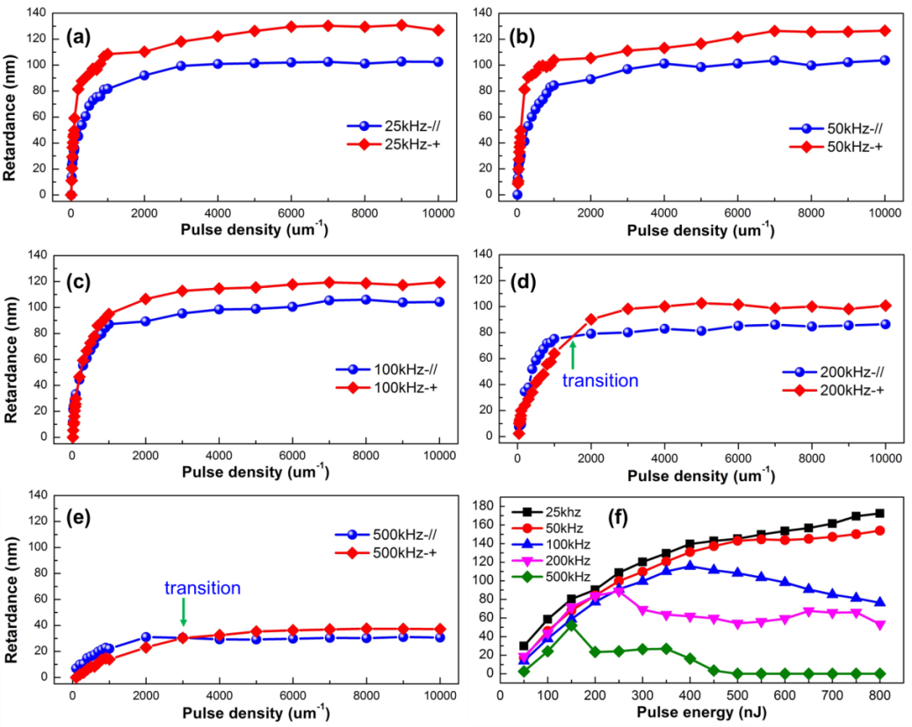
Figure 4. Dependence of laser induced retardance on pulse density at a fixed pulse energy of 0.25 μJ for various repetition rates in two polarization states (a-e), and plots of retardance versus pulse energy at a fixed pulse density of 2500 pulse/μm for different repetition rates (f). Polarization direction: ‘//’ for parallel, ‘+’ for perpendicular to scanning direction

Taking the form birefringence as an advantageous property of nanogratings induced in fused silica and other transparent materials such as semiconductor thin films have been exploited for various appliacations.^{[36-39]} Here we demonstrate that geometric phase optical elements, including a space variant polarization converter and a computer-generated hologram with phase gradients reaching up to ≈1 rad μm⁻¹, can be realised in GeO₂ glass by manipulating the induced nanogratings.
A space variant polarization converter with the diameter of 1 mm that can generate optical vortices with radial and azimuthal polarizations was imprinted in GeO₂ glass with 600 fs pulses operating at 100 kHz. The characterization results of the fabricated converter are exhibited in Fig. 5. The retardance image exhibits a relatively uniform distribution of retardance (Fig. 5a) with an average value of ~0.5π at 532 nm wavelength (Fig. 5b), which corresponds to the quarter-wave plate value. The image of azimuth of slow axis (Fig. 5c) indicates that the orientations of nanogratings are perfectly aligned along radius direction. The continuous transition of azimuth of slow axis is indicated by Fig. 5d. To verify the presence of radial/azimuthal polarization, the converter was illuminated with a circularly polarized green beam and imaged under a microscope with linear polarizer (analyser) inserted at the output. The propeller shape typical for the radial or azimuthal polarization was clearly observed (Fig. 5e, f), confirming the fabrication of the radial polarization converter. This provides an alternative way to achieve radial or azimuthal polarized optical vortexes with a piece of femtosecond laser micro-engineered GeO₂ glass, simply by controlling the handedness of the incident circular polarization.
Figure 5. Radial and azimuthal polarization optical vortex converter (diameter of 1 mm) for circular incident polarization. Imaged retardance distribution of approximately 130 nm (a) and azimuth of slow axis orientation (b) specifies imprinted element as a quarter wave plate working at wavelength of 532 nm. Pseudo colours indicate the direction of slow axis. Retardance (c) and azimuth (d) profiles measured along the white dashed line. Linearly polarized optical transmission images of polarization sensitive element illuminated by circularly polarized light (e, f).

Another application based on the manipulation of nanogratings demonstrated here is a computer-generated geometric phase Fourier hologram (CGH), which can convert the initial Gaussian beam into the target intensity distribution. The portrait of Confucius (Fig. 6b) was encoded into the 8-bit grayscale CGH element (Fig. 6c) with 0.1 megapixel and pixel spacing of 3 μm generated using the adapted weighted Gerchberg–Saxton algorithm.^{[40]} The CGH was imprinted in GeO₂ glass with pulse energy of 80 nJ. The image of azimuth of slow axis orientation (Fig. 6d) shows that the maximum relative continuous phase change of π between the two adjacent pixels was achieved. By using the setup shown in Fig. 6a, the target image was reconstructed with a 532 nm laser, as displayed in Fig. 6e. The relatively low resolution of the reconstructed image is mainly due to the slightly hygroscopic surface of the sample, which can be significantly improved by surface polishing and coating. However, this technique may extend the applications of GeO₂ glass in some new research fields.
Figure 6. Computer-generated geometric phase Fourier hologram (CGH) imprinted in GeO₂ glass. Setup for polarization filtering and target image reconstruction (a); original portrait of Confucius (b); computer-generated geometric phase Fourier hologram of the portrait (c); Orientation of slow axis of the laser-imprinted CGH (d); and the reconstructed Confucius’ portrait by the imprinted hologram illuminated with a 532 nm laser (e).

- Conclusions
In summary, form birefringence originated from nanogratings induced in GeO₂ glass by ultrafast laser pulses is systematically investigated. We observed that the retardance induced by laser scanning is two times higher than that by stationary irradiation under similar conditions. The fluence threshold exhibits a linear increase, while the intensity threshold decreases in first-order exponential model as a function of pulse duration. The favourable pulse energy for maximum retardance in GeO2 glass is ~65% lower than in fused silica. The optimum pulse duration for maximum retardance in GeO₂ glass lies within sub-picosecond region, i.e. typically around 500 fs, while in fused silica it is in the picosecond regime at around 2 ps. A reversed dependence of form birefringence on polarization direction, which is repetition rate related, is observed in GeO₂ glass. Two important optical applications including a polarization vortex converter and a computer generated hologram are successfully demonstrated in GeO₂ glass by manipulation of the induced form birefringence. The Micro-engineering of optical properties of GeO₂ glass by ultrafast laser direct-writing may develop new applications of GeO₂ glass in photonics.
- Experimental section
  - Preparation of sample
The GeO₂ glass sample was prepared from GeO₂ powder of 99.999% purity, which was melted at 1600°C in a platinum crucible for 2 hours. The melt in the crucible was then cooled to room temperature in air. The formed glass was annealed at 500°C for 3 h to release the residual stress. The prepared transparent bubble-free sample was polished for laser processing and further characterization. The sample was stored in a desiccator in between the experiments because of the hygroscopic properties of this glass. For comparison a commercially available UVSIL silica glass plate was used in the experiments.
4.2 Laser processing and characterization
The laser processing was carried out with a mode-locked regenerative amplified Yb:KGW-based femtosecond laser system (PHAROS, Light Conversion Ltd.), operating at a wavelength of 1030 nm with a pulse duration range from 300 fs to 10 ps and adjustable repetition rates from 1 kHz to 500 kHz. Pulse energy was controlled by the combination of a half-wave plate and a Glan polarizer and measured after a 0.55 numerical aperture aspheric lens that focuses the beam into glass samples at a depth of about 100 μm below the sample surface. Another half-wave plate was inserted in the light path before the focusing lens for the control of the polarization orientation of the linearly polarized laser beam. The imprinted elements were optically visualized with an optical microscope and/or further characterized with the quantitative birefringence measurement system (CRi Abrio, Olympus BX51) operating at 546 nm wavelength, which allows measurement of the absolute value of the retardance and mapping of the slow axis orientation. A Nd:YAG continuous wave laser (Spectra-Physics) frequency-doubled to 532 nm was used to characterize the Gaussian beam propagation through the imprinted optical elements.
Acknowledgements
This work is financially supported by the Natural Natural Science Foundation of China (Grants 51132004) and the Guangdong Natural Science Foundation (Grants S2011030001349, 2014A030306045). The authors acknowledge the open fund from the State Key Laboratory of High Field Laser Physics of the Shanghai Institute of Optics and Fine Mechanics of Chinese Academy of Science, State Key Laboratory of Precision Spectroscopy of East China Normal University, Science and Technology Department of Zhejiang Province, the financial support from the China Scholarship Council. The study was also supported by the Engineering and Physical Sciences Research Council (grant EP/M029042/1). All data supporting this study are openly available from the University of Southampton repository at http://doi.org/10.5258/SOTON/D0060
[1] M. E. Gattass R R, Nat. Photonics 2008, 2, 219.
[2] D. Tan, K. N. Sharafudeen, Y. Yue, J. Qiu, Progress in Materials Science 2016, 76, 154.
[3] K. M. Davis, K. Miura, N. Sugimoto, K. Hirao, Opt. Lett. 1996, 21, 1729.
[4] Y. Shimotsuma, P. G. Kazansky, J. Qiu, K. Hirao, Phys. Rev. Lett. 2003, 91, 247405.
[5] E. N. Glezer, E. Mazur, Appl. Phys. Lett. 1997, 71, 882.
[6] P. G. Kazansky, H. Inouye, T. Mitsuyu, K. Miura, J. Qiu, K. Hirao, F. Starrost, Phys. Rev. Lett. 1999, 82, 2199.
[7] C. Hnatovsky, R. S. Taylor, E. Simova, V. R. Bhardwaj, D. M. Rayner, P. B. Corkum, Opt. Lett. 2005, 30, 1867.
[8] R. Drevinskas, M. Gecevicius, M. Beresna, Y. Bellouard, P. G. Kazansky, Opt Express 2015, 23, 1428.
[9] E. Bricchi, P. G. Kazansky, Appl. Phys. Lett. 2006, 88, 111119.
[10] K. Ke, E. F. Hasselbrink, A. J. Hunt, Anal. Chem. 2005, 77, 5083.
[11] Y. Liao, J. Song, E. Li, Y. Luo, Y. Shen, D. Chen, Y. Cheng, Z. Xu, K. Sugioka, K. Midorikawa, Lab Chip 2012, 12, 746.
[12] M. Beresna, M. Gecevicius, P. G. Kazansky, Opt. Mater. Express 2011, 1, 783.
[13] M. Gecevicius, M. Beresna, R. Drevinskas, P. G. Kazansky, Opt. Lett. 2014, 39, 6791.
[14] Y. Shimotsuma, M. Sakakura, P. G. Kazansky, M. Beresna, J. Qiu, K. Miura, K. Hirao, Adv. Mater. 2010, 22, 4039.
[15] J. Zhang, M. Gecevicius, M. Beresna, P. G. Kazansky, Phys. Rev. Lett. 2014, 112, 033901.
[16] V. R. Bhardwaj, E. Simova, P. P. Rajeev, C. Hnatovsky, R. S. Taylor, D. M. Rayner, P. B. Corkum, Phys. Rev. Lett. 2006, 96, 057404.
[17] A. Rudenko, J.-P. Colombier, T. E. Itina, Phys. Rev. B 2016, 93, 075427.
[18] S. Richter, F. Jia, M. Heinrich, S. Doering, U. Peschel, A. Tuennermann, S. Nolte, Opt. Lett. 2012, 37, 482.
[19] M. Beresna, M. Gecevičius, P. G. Kazansky, T. Taylor, A. V. Kavokin, Appl. Phys. Lett. 2012, 101, 053120.
[20] Y. Shimotsuma, T. Asai, M. Sakakura, K. Miura, Femtosecond-laser Nanostructuring in Glass. J. Laser Micro. Nanoen. 2014, 9 , 31.
[21] F. Zhang, H. Zhang, G. Dong, J. Qiu, J. Opt. Soc. Am. B 2014, 31, 860.
[22] T. Asai, Y. Shimotsuma, T. Kurita, A. Murata, S. Kubota, M. Sakakura, K. Miura, F. Brisset, B. Poumellec, M. Lancry, J. Ballato, J. Am. Ceram. Soc. 2015, 98, 1471.
[23] S. Richter, C. Miese, S. Döring, F. Zimmermann, M. J. Withford, A. Tünnermann, S. Nolte, Opt. Mater. Express 2013, 3, 1161.
[24] S. Richter, D. Möncke, F. Zimmermann, E. I. Kamitsos, L. Wondraczek, A. Tünnermann, S. Nolte, Opt. Mater. Express 2015, 5, 1834.
[25] F. Zimmermann, A. Plech, S. Richter, A. Tünnermann, S. Nolte, Appl. Phys. Lett. 2014, 104, 211107.
[26] J. Cao, L. Mazerolles, M. Lancry, D. Solas, F. Brisset, B. Poumellec, Opt. Lett. 2016, 41, 2739.
[27] S. S. Fedotov, R. Drevinskas, S. V. Lotarev, A. S. Lipatiev, M. Beresna, A. Čerkauskaitė, V. N. Sigaev, P. G. Kazansky, Appl. Phys. Lett. 2016, 108, 071905.
[28] M. Lancry, J. Canning, K. Cook, M. Heili, D. R. Neuville, B. Poumellec, Opt. Mater. Express 2016, 6, 321.
[29] S. Kanehira, J. H. Si, J. R. Qiu, K. Fujita, K. Hirao, Nano Lett. 2005, 5, 1591.
[30] X. Hu, Y. Dai, L. Yang, J. Song, C. Zhu, J. Qiu, J. Appl. Phys. 2007, 101, 023112.
[31] M. Gecevicius, M. Beresna, J. Zhang, W. Yang, H. Takebe, P. G. Kazansky, Opt. Express 2013, 21, 3959.

[32] B. C. Stuart, M. D. Feit, A. M. Rubenchik, B. W. Shore, M. D. Perry, Phys. Rev. Lett. 1995, 74, 2248.
[33] S. Richter, M. Heinrich, S. Döring, A. Tünnermann, S. Nolte, Appl. Phys. A 2011, 104, 503.
[34] M. Lancry, F. Zimmerman, R. Desmarchelier, J. Tian, F. Brisset, S. Nolte, B. Poumellec, Appl. Phys. B 2016, 122, 1.
[35] V. G. Niziev,; A. V. Nesterov, 1999, 32 (13), 1455.
[36] M. Beresna, P. G. Kazansky, Opt. Lett. 2010, 35, 1662.
[37] M. Gecevicius, M. Beresna, P. G. Kazansky, Opt. Lett. 2013, 38, 4096.
[38] M. Beresna, M. Gecevičius, P. G. Kazansky, T. Gertus, Appl. Phys. Lett. 2011, 98, 201101.
[39] R. Drevinskas, M. Beresna, J. Zhang, A. G. Kazanskii, P. G. Kazansky, Adv. Opt. Mater. 2017, 5, 1600575.
[40] R. Di Leonardo, F. Ianni, G. Ruocco, Opt. Express 2007, 15, 1913.

