Research investments for UK infectious disease research 1997-2013: a systematic analysis of awards to UK institutions alongside national burden of disease
Michael G Head*^{1,2}, Rebecca J Brown¹, Stuart C Clarke¹
1 Global Health Research Institute, and Institute for Life Sciences, and Faculty of Medicine, University of Southampton, Southampton, UK
2 Farr Institute for Health Informatics, University College London, London, UK

Corresponding author – MG Head, m.head@soton.ac.uk
Keywords – funding; investments; UK; infection; infectious disease; financing

Abstract
Introduction
Infectious disease remains a significant burden in the UK and the focus of significant amounts of research investment each year. The Research Investments in Global Health study has systematically assessed levels of funding for infection research, and here considers investment alongside UK burden of individual infectious diseases.
Methods
The study included awards to UK institutions between 1997-2013 that were related to infectious disease. Awards related to global health projects were excluded here. UK burden data (mortality, years lived with disability, and disability adjusted life years ) was sourced from the Global Burden of Disease study (IHME, USA). Awards were categorised by pathogen, disease, disease area and by type of science along the research pipeline (pre-clinical, phase I-III trials, product development, public health, cross-disciplinary research). New metrics present relative levels of funding by comparing sum investment with measures of disease burden.
Results
There were 5685 relevant awards comprising investment of £2.4 billion. By disease, HIV received most funding (£369.7m; 15.6% of the total investment). Pre-clinical science was the predominant type of science (£1.6 billion, 68.7%), with the UK Medical Research Council (MRC) the largest funder (£714.8 million, 30.1%). There is a broad temporal trend to increased funding per annum. Antimicrobial resistance received (£102.8 million, 4.2%), whilst sepsis received £23.6 million (1.0%). Compared alongside disease burden, acute hepatitis C and measles typically were relatively well-funded, whilst pneumonia, syphilis and gonorrhoea were poorly-funded.
Conclusions
The UK has a broad research portfolio across a wide range of infectious diseases and disciplines. There are notable strengths including HIV, some respiratory infections and in pre-clinical science, though there was less funding for UK-relevant trials and public health research. Compared to the UK burden of disease, syphilis, gonorrhoea and pneumonia appear relatively neglected. Investment analyses can assist support policymakers to increase the equity of the UK R&D landscape.

Introduction
In the UK, prevalence and incidence of infectious diseases have broadly declined across the latter years of the 20th century and early part of the 21st century, with greater burdens being observed in chronic conditions and diseases of ageing.¹ However, there remains a significant burden attributed to the infectious aetiology and emerging health concerns ensuring issues around infection stay high up the policy agenda. Antimicrobial resistance is a priority area for the UK Chief Medical Officer,² as well as global organisations such as the World Health Organisation and political stakeholders in other high-income areas.^{3–5} There are several thousand deaths in the UK each year from acute respiratory illness attributed to viral pathogens such as influenza, respiratory syncytial virus (RSV) and bacterial pneumonias.¹ The burden of tuberculosis is particularly significant in London, and there are increasing proportions of multi-drug resistant cases, with XDR cases having been observed.⁶ The challenge of preventing and managing transmission in healthcare environments is ongoing,⁷ and further infectious outbreaks occur in institutional settings such as schools, care homes and prisons.^{8,9} The incidence of several sexually transmitted infections, such as gonorrhoea and syphilis, is increasing among the UK population,¹⁰ and rates of ongoing HIV transmission and numbers living with HIV remain high.¹¹ Enteric disease is common in primary care and community settings.¹² The annual cost of treating infection-related complications in the UK is estimated at £6 billion.¹³
The Global Burden of Disease (GBD) study estimates the burden of communicable and non-communicable diseases at international and national level. A 2013 analysis described in detail the disability-adjusted life years (DALYs) attributed to 259 causes of disease in the UK, ¹ whilst other analyses considered global burdens.^{14,15} National data relating to other measures of disease burden (including mortality and years lived with disability, YLD) can also be extracted from online data repositories (http://vizhub.healthdata.org/gbd-compare/; http://ghdx.healthdata.org/gbd-data-tool), hosted by the Institute for Health Metrics and Evaluation who carry out the GBD Study.
The Research Investments in Global Health (ResIn) study has systematically analysed public and philanthropic UK investments for infectious disease research, and compared these investments against the global burden of disease; this has provided quantification of the UK R&D portfolio, and highlighted national research strengths and gaps.^{16,17} Here, we report on UK-specific infectious disease research investment data across 1997 to 2013, and compare with metrics of UK disease burden, in order to identify relative spend of R&D funds on each infection and to gain an insight into areas of research strength and weakness in the UK.
Methods
The methods for the ResIn project are described in detail elsewhere,^{16,17} and in further publications at www.researchinvestments.org/publications. Briefly here – research investment data across 1997-2013 (inclusive) relating to human infectious disease was obtained from 586 public and philanthropic funders of health research. Award data was obtained either by direct request to the funding agency, downloaded from the funder’s website, or extracted from other openly-available sources such as the (now-archived) Department of Health National Research Register and clinicaltrials.gov. Information collected included the award title, abstract or further supplementary information such as a lay or technical summary, name of leading institution and principal investigator, amount of funding awarded, and the year of award. Each award was individually scrutinised to ascertain relevance to infection, and to assign to a number of categories. Categorisation was carried out manually by authors Head and colleague Joseph Fitchett, with further checks by a number of other colleagues, and datasets were distributed to all authors for review and comment. Categories included disease, pathogen, and discipline (e.g. modelling, economics), as well as broad areas such as antimicrobial resistance and global health. We also categorised by type of science, the position along the R&D pipeline (pre-clinical research, phase I-III trials, phase IV and product development activity, public health, and cross-disciplinary research). Cross-disciplinary research was defined as awards that clearly covered more than one type of science (e.g. pre-clinical science leading into a phase I trial, as part of the same project). This category has only been included in the 2011-2013 data and not retrospectively categorised across the rest of the dataset (due to lack of staff capacity). Awards must have been led by a UK institution. Projects with a clear zoonotic component were included; animal health projects were excluded. Where projects were awarded in international currencies, they were converted to UK pounds using the average exchange rate from the year of the award, and all included awards were adjusted for 2013 inflation.
For this UK-focused manuscript, we excluded awards related to global health since the focus of those projects would be outside of the UK. This exclusion covered all awards from the Bill & Melinda Gates Foundation. All other awards were assumed to have relevance to the UK. Burden data specific to the UK was sourced from the GBD Study online repositories (http://vizhub.healthdata.org/gbd-compare/ and http://ghdx.healthdata.org/gbd-data-tool). Burden measures integrated here were numbers of deaths, DALYs and YLDs, and new investment metrics were created to demonstrate the ‘UK pound of research investment per mortality observed’ (and similarly for DALYs and YLD), as a means of comparing relative R&D spend on infections across the ResIn dataset. For these metrics, burden measures were taken at three time-points – 2005, 2010 and 2013. For the 2005 time-point, funding from 1997-2004 was included; for the 2010 time-point, investment from 1997-2009 was included; and for 2013 time-point, investment from 1997-2012 was included. This method allows greater sums of funding to be included in each calculation and thus reduces the impact of both wide variations in annual funding and total funding across small periods of time.
To create the metric, we divided investment by number of deaths/DALYs/YLDs at each time point, and then divided again by number of years of funding included to obtain an annualised figure. This permits comparison across different time periods and across different analyses. Data shown in tables is unaltered; however, owing to the highly-skewed nature of this dataset, we present log-transformed data in figures.
For example, for assessment of HIV mortality at the 2005 time point, we took the sum of HIV research investment 1997–2004 (£158,792,599) and divided that by number of deaths reported in 2005 (244), and divided the result by 8 (the number of years of investment included) to get an ‘investment per mortality observed’ metric of £81,185. We then log-transformed this to present in figure format as £4.91 investment per mortality observed. For enteric E. coli infection, burden data was available for enterotoxigenic infection but not for enteropathogenic E. coli.
Disaggregated data for some other enteric disease pathogens were not available (including Campylobacter, norovirus and Salmonella), and so we present in the figures data on overall funding for diarrhoea disease compared to equivalent GBD Study national estimates. The pneumonia category included studies that made specific reference to pneumonia in the study title or abstract and also included studies with a focus on pneumococcal disease.
Results
There was in total £3.7 billion awarded to UK institutions across 1997-2013 for infection-related research, across 7398 awards.¹⁶ After excluding the global health-related awards there were 5685 awards (76.8% of all awards) considered here (Table 1), with sum investment of £2.4 billion (63.7% of sum investment). The median award size was £177,412 (inter-quartile range, IQR, £57,147-385,063) and the mean award was £417,328 (standard deviation, SD, £853,859). This represents a 7.7% reduction on median award size when global health awards are included (£192,143) and a 17.1% reduction on mean award size £503,524).
By individual infection, HIV received the most funding (£369.7m; 15.6% of the total investment). By disease system, respiratory infections received £447.1 million, 18.8% of the total investment). Pre-clinical science was the predominant type of science (£1.6 billion, 68.7%), whilst the UK Medical Research Council (MRC) was the single largest funder (£714.8 million, 30.1%) (Table 1). There is a broad temporal trend to increased funding per annum (Figure 1a), though there is little temporal change in the investment awarded to each type of science (Figure 1b). Funding for AMR comprised 4.2% of the overall dataset (£102.8 million), whilst sepsis received £23.6 million (1.0%) (table 1).
Across each of the three time points, YLD for infectious diseases remained broadly similar for most infectious diseases (supplementary). Infections such as syphilis, gonorrhoea and Varicella-associated disease were typically amongst those receiving the lowest relative investment (less than £500.00 per YLD observed in 2013; table 2). Among those infections receiving higher relative investment compared to YLD were acute Hepatitis C, measles and Escherichia coli-associated disease (table 2, figure 2).
Compared to investment per mortality (table 2, figure 3), pneumonia, influenza and syphilis were relatively poorly funded, whilst measles, acute Hepatitis C and chlamydia were the top 3 ranked infections (table 3). Compared to investment per DALY (table 2, figure 4), syphilis, diphtheria and pneumonia were relatively poorly funded, whilst acute hepatitis C, measles and E. coli-associated disease were the top 3 ranked infections (table 3). Among other major disease areas, HIV ranked consistently high across each burden metric (4th overall; 6th, YLD; 4th mortality; 4th DALYs), and tuberculosis ranked 5th overall (12th YLD; 7th mortality; 5th DALYs) (table 3). There are clear increases across each health metric for Clostridium difficile research.
Discussion
There is a significant portfolio of research in the UK related to infectious diseases; excluding global health research, £2.4 billion was awarded to UK institutions by public and philanthropic funders across 1997-2013. Mean and median award size was smaller for awards not related to global health. Temporal trends for the UK portfolio showed a broadly increasing trend but with significant variability between years – annual funding is unpredictable. Relative to national burdens of diseases, measles and acute hepatitis C were relatively well funded (within the confines of this dataset, where low-burden diseases can appear well-funded with small amounts of investment and where chronic burdens are not fully considered). Beyond these infections, enterotoxigenic E. coli, HIV and tuberculosis ranked highly and are arguably a UK research strength. Syphilis, Varicella disease, pneumonia and gonorrhoea appear relatively poorly-funded against their respective burdens of disease. Preclinical research received more investment than other types of science, with relatively little in the way of funding for clinical trials and public health research when the global health awards are discounted. The MRC awarded the most investment to UK institutions across the time period included here.
The wide range of funders that provide significant investment in the UK for infectious disease research, and the extensive clinical and academic skill base available, is overall a huge strength but it does means that it is difficult to establish an evidence-based overall R&D strategy. Infection is a very wide-ranging area – all clinical specialties are impacted, there are numerous very different vulnerable groups, the evolution of antimicrobial resistance results in therapeutics that are minimally effective, and the breadth of basic science required is huge. The 2006 Cooksey Report considered the health research landscape and concluded there were strengths in preclinical science but clear gaps in other types of research. The UK National Institute for Health Research (NIHR) was set up as a result of the Cooksey findings, to fund research of direct relevance to patient care and health policy that.¹⁸ The ResIn data presented here also reflect those conclusions, but highlight that once the global health studies are excluded, up to 2013 there is still a huge predominance of basic and preclinical science in infection, with relatively little of public and charitable investment in clinical trials or public health. There is uncertainty surrounding ‘Brexit’ and whether UK institutions will have access to European Commission funding sources after exit from the European Union. The majority of the Commission investments covered here are pre-clinical science, and any substantial loss of highly-skilled jobs and scientists will greatly harm public and private sector research organisations in the UK.
There is no ‘magic number’ in terms of the proportion of the research budgets that should be spent in each sector of the research pipeline; such discussions will always remain a pragmatic exercise. However, this can be discussed at cross-funder meetings to identify specific disease areas where research beyond the pre-clinical phases would be most useful but is currently lacking (and discuss the reasons behind that and potential ways forward e.g. capacity building and training to establish an appropriate skills base). The UK Collaborative on Development Sciences (http://www.ukcds.org.uk/) has been successful in facilitating such dialogue across awarding bodies and arguably it is in fora such as these, alongside other national and international stakeholders in the funding and policy environment, that evidence on the existing research base can be most usefully discussed.
The success, or impact, of research portfolios is difficult to measure on any large and systematic scale. Bibliometric analyses can be useful as quantitative approaches, and qualitative assessments of evidence-informed policymaking may highlight disease areas and types of science where the evidence base is more readily absorbed and taking up into policy. There are also numerous established research programmes in the UK that consider global health issues such as malaria or neglected tropical diseases, and these programmes and the individuals involved in leading them have a track record of successful global health research, along with relatively easy access to funders such as the Wellcome Trust. Thus, the UK output covering research outside of its borders is substantial, broadly altruistic in nature and significant employer of highly-skilled staff.
Investment for AMR has been increasing both in absolute terms and also as a proportion of the total funding available, and since the end point of this dataset has been the subject of themed calls from several of the major funders of UK research, including the NIHR, research councils, and the Wellcome Trust. There were also increases in investment for healthcare-associated infections across the time period of this project and this is reflected in the increased funding for, and decreasing burdens of, C. difficile infections. The drivers for this likely came from increased media coverage and a subsequent government focus across the first decade of the 21st century. The next update of the ResIn study, anticipated in 2018, will be able to quantify the value of those investments, along with global funding trends for AMR research. Sepsis is another disease area emerging as high-priority; without rapid treatment, mortality rates are approximately 35% and there are thought to be 150,000 cases of sepsis annually in the UK.¹⁹ However, only 1% of the research investment total was awarded to studies focusing on sepsis. It is logistically and ethically difficult to carry out research in an area involving patients who may be critically ill, and there have also been great uncertainties surrounding clinical definitions of sepsis.²⁰
Acute respiratory infections and enteric disease are two of the predominant groups of infections in primary care and other healthcare settings.^{12,21} Pneumonia is a high-burden illness but remains relatively poorly funded both overall and compared to other respiratory infections, both at a global and national level.²² There is much undiagnosed enteric disease in the community, which is costly in terms of both the health and economic burden. The difficulties in fully capturing the extent of these burdens may be reflected in the lack of national data available from the GBD Study. Efforts to reduce the burden of diarrhoea-causing pathogens such as Campylobacter are ongoing,²³ and more complete and comparable national and international surveillance data alongside a supportive structured research strategy would be helpful.
The relative paucity of UK funding for some sexually-transmitted infections, particularly syphilis and gonorrhoea, has been discussed in the global context,²⁴ and similar trends are observed here. There has been little research investment despite the knowledge resistance to gonococcal treatments has been increasing.²⁵ Interventions designed to have an impact and maintain a change on an individual’s behaviour may be expensive and have limited impact outside of controlled research environments or at later time points beyond the end of the study period;²⁶ thus there may be a perception of there being little return on investment and little incentive to invest in difficult areas such as behaviour change related to sexually transmitted infections.
Limitations are previously discussed in full.^{16,17} The lack of detailed investment from the private sector is a clear data gap in our analysis, particularly in the development of new tools such as vaccines, diagnostics and therapeutics. We did not take into account the likely application of overheads or the introduction of full economic costing (in 2005). The abstract or further information was not always available for award data obtained, so categorisation of some awards was based solely on the project title. Infrastructure investments are difficult to thematically describe as they may often be intended for research across a range of disease areas and disciplines. The categorisation process is pragmatic, but subjective; checks by at least one other author will reduce the likelihood of observer error. This study is also vulnerable to errors, inconsistencies or gaps in the GBD Study data. Resource constraints meant only one burden dataset could be considered here. Burden data specific to the UK was not available for all infectious diseases (such as Campylobacter and norovirus infections). The metrics used here to assess investment alongside disease burden can be overly-influenced by small amounts of investments for relatively low-burden diseases such as measles; a pragmatic approach to interpreting these results is required.
The UK has a broad research portfolio across a wide range of infectious diseases and disciplines. There are some notable strengths, including HIV and tuberculosis and also in pre-clinical science. There are arguments to increase public and philanthropic funding for UK-relevant research into clinical trials and public health research. Compared to the UK burden of disease, syphilis, gonorrhoea and pneumonia appear relatively poorly funded. Revisions of cross-funder strategies combined with assessments of academic and clinical capacity and skill base, can assist in increasing the equity of the UK R&D landscape.
Acknowledgements
We would like to acknowledge the input of Kieffer Balsomo and Danny Mazloum, Bournemouth Grammar School. We also acknowledge all the funders who provided us with data and colleagues at the Institute for Health Metrics and Evaluation who assisted with extraction of the burden data.
Role of the funding source
None.
Conflicts of interest
The authors have no conflicts of interest to declare.

References
1 Murray CJL, Richards MA, Newton JN, et al. UK health performance: findings of the Global Burden of Disease Study 2010. Lancet 2013; 381: 997–1020.
2 Davies SC, Fowler T, Watson J, Livermore DM, Walker D. Annual Report of the Chief Medical Officer: infection and the rise of antimicrobial resistance. Lancet 2013; 381: 1606–9.
3 World Health Organization. Antimicrobial resistance: global report on surveillance 2014. Geneva: World Health Organization, 2014 http://www.who.int/drugresistance/documents/surveillancereport/en/ (accessed June 15, 2014).
4 Centers for Disease Control and Prevention. Threat Report 2013 -Antimicrobial Resistance. Atlanta, 2013 http://www.cdc.gov/drugresistance/threat-report-2013/ (accessed Oct 14, 2013).
5 European Commission. Communication from the Commission to the European Parliament and the Council Action plan against the rising threats from Antimicrobial Resistance. 2011 http://ec.europa.eu/health/antimicrobial_resistance/policy/index_en.htm.
6 Arnold A, Witney AA, Vergnano S, et al. XDR-TB transmission in London: Case management and contact tracing investigation assisted by early whole genome sequencing. J Infect 2016; 0: 512–5.
7 Loveday HP, Wilson JA, Pratt RJ, et al. epic3: national evidence-based guidelines for preventing healthcare-associated infections in NHS hospitals in England. J Hosp Infect 2014; 86 Suppl 1: S1–70.
8 Head MG, Walker SL, Nalabanda A, Bostock J, Cassell JA. Researching Scabies Outbreaks among People in Residential Care and Lacking Capacity to Consent: A Case Study. Public Health Ethics 2015; : phv011.
9 Finnie TJR, Copley VR, Hall IM, Leach S. An analysis of influenza outbreaks in institutions and enclosed societies. Epidemiol Infect 2014; 142: 107–13.
10 Public Health England. Sexually transmitted infections and chlamydia screening in England, 2015. 2016 https://www.gov.uk/government/uploads/system/uploads/attachment_data/file/534601/hpr2216_stis.pdf (accessed Aug 22, 2016).
11 Birrell P, Brizzi F, Codere G, et al. HIV in the UK – Situation Report 2015 Incidence, prevalence and prevention. 2015 www.gov.uk/phe (accessed Aug 22, 2016).
12 Tam CC, O’Brien SJ. Economic Cost of Campylobacter, Norovirus and Rotavirus Disease in the United Kingdom. PLoS One 2016; 11: e0138526.
13 Office of Science and Innovation. Infectious diseases: preparing for the future - future threats. London, 2006.
14 Murray CJL, Barber RM, Foreman KJ, et al. Global, regional, and national disability-adjusted life years (DALYs) for 306 diseases and injuries and healthy life expectancy (HALE) for 188 countries, 1990–2013: quantifying the epidemiological transition. Lancet 2015; published online Aug. http://www.thelancet.com/article/S014067361561340X/fulltext (accessed Aug 28, 2015).
15 GBD 2013 Mortality and Causes of Death Collaborators. Global, regional, and national age–sex specific all-cause and cause-specific mortality for 240 causes of death, 1990–2013: a systematic analysis for the Global Burden of Disease Study 2013. Lancet 2014; 385: 117–71.
16 Head MG, Fitchett JR, Nageshwaran V, Kumari N, Hayward AC, Atun R. Research investments in global health: a systematic analysis of UK infectious disease research funding and global health metrics, 1997-2013. EBioMedicine 2016.
17 Head MG, Fitchett JR, Cooke MK, Wurie FB, Hayward AC, Atun R. UK investments in global infectious disease research 1997-2010: a case study. Lancet Infect Dis 2013; 13: 55–64.
18 Sir David Cooksey on behalf of HM Treasury. A review of UK health research funding. London, 2006 https://www.gov.uk/government/uploads/system/uploads/attachment_data/file/228984/0118404881.pdf (accessed Aug 22, 2016).
19 Daniels R. Surviving the first hours in sepsis: getting the basics right (an intensivist’s perspective). J Antimicrob Chemother 2011; 66 Suppl 2: ii11–23.
20 Singer M, Deutschman CS, Seymour CW, et al. The Third International Consensus Definitions for Sepsis and Septic Shock (Sepsis-3). JAMA 2016; 315: 801.
21 Berni E, Butler CC, Jenkins-Jones S, et al. Comparative estimated effectiveness of antibiotic classes as initial and secondary treatments of respiratory tract infections: longitudinal analysis of routine data from UK primary care 1991-2012. Curr Med Res Opin 2016; 32: 1023–32.
22 Head MG, Fitchett JR, Newell M-L, et al. Mapping pneumonia research: A systematic analysis of UK investments and published outputs 1997–2013. EBioMedicine 2015; published online July. DOI:10.1016/j.ebiom.2015.06.024.
23 Standards Agency F. Campylobacter contamination in fresh whole chilled UK- produced chickens at retail: January – March 2016. 2016 www.food.gov.uk/sites/default/files/campylobacter-retail-survey-jul-sept-2015.pdf (accessed Aug 22, 2016).
24 Head MG, Fitchett JR, Cassell JA, Atun R. Investments in sexually transmitted infection research, 1997-2013: a systematic analysis of funding awarded to UK institutions. J Glob Health 2015; 5: 020405.
25 Blomquist PB, Miari VF, Biddulph JP, Charalambous BM. Is gonorrhea becoming untreatable? Future Microbiol 2014; 9: 189–201.
26 Marston C, King E. Factors that shape young people’s sexual behaviour: a systematic review. Lancet 2006; 368: 1581–6.

Table 1. Total UK funding, number of studies and mean and median award size of research investment by infection 1997–2013.
SD, standard deviation. IQR, inter-quartile range. BBSRC, Biotechnology and Biological Sciences Research Council.

Disease | Number of awards | Percentage of total | Sum investment (£) | Percentage of total | Mean award, £ (SD) | Median award, £ (IQR)
Overall | 5685 | n/a | 2372511837 | n/a | 417328 (853859) | 177412 (57147-385063)
Disease areas and products
Antimicrobial resistance | 334 | 5.9% | 102797879 | 4.3% | 307778 (628177) | 127933 (23237 -306944)
Gastroenterology | 725 | 12.8% | 274033272 | 11.6% | 377976 (627030) | 219405 (82549 - 386610)
Healthcare-associated infections | 347 | 6.1% | 104492767 | 4.4% | 301131 (748930) | 71222 (10557-252393)
Hepatology | 350 | 6.2% | 110887557 | 4.7% | 316821 (652997) | 125788 (41975-288001)
HIV | 691 | 12.2% | 369786723 | 15.6% | 535147 (1297949) | 176990 (35350 -428986)
Neurology | 353 | 6.2% | 131186860 | 5.5% | 371634 (979173) | 162374 (70749 -364962)
Respiratory | 1098 | 19.3% | 447094157 | 18.8% | 407189 (683613) | 203117 (67814-411029)
Sepsis | 84 | 1.5% | 23603461 | 1.0% | 280993 (580192) | 146851 (53679-269232)
Sexually transmitted infections | 364 | 6.4% | 136983395 | 5.8% | 376328 (1001064) | 100582 (16367-251860)
Diagnostics | 441 | 7.8% | 142592469 | 6.0% | 323338 (736012) | 92078 (16367-251828)
Therapeutics | 602 | 10.6% | 311974408 | 13.1% | 518229 (1197127) | 173601 (46586-447265)
Vaccinology | 401 | 7.1% | 250637228 | 10.6% | 625030 (1300313) | 241134 (98047-605843)
Specific infection or disease
Aspergillus | 32 | 0.6% | 9381561 | 0.4% | 293173 (680033) | 68304 (23920-231642)
Campylobacter | 112 | 2.0% | 35767121 | 1.5% | 319349 (498620) | 241845 (95759-347918)
Candida | 86 | 1.5% | 31250436 | 1.3% | 363377 (463744) | 284898 (92281-416521)
Chlamydia | 118 | 2.1% | 25556459 | 1.1% | 216580 (596041) | 60733 (12590-192677)
Clostridium | 97 | 1.7% | 56061419 | 2.4% | 577952 (1089221) | 226732 (49926-475684)
Cytomegalovirus | 79 | 1.4% | 35695572 | 1.5% | 451842 (673587) | 220703 (118302-531000)
Escherichia Coli | 129 | 2.3% | 38239643 | 1.6% | 296431 (289025) | 232981 (119663-380588)
Epstein-Barr Virus | 155 | 2.7% | 51901868 | 2.2% | 334850 (479035) | 164142 (52255-389593)
Gonorrhoea | 20 | 0.4% | 1448016 | 0.1% | 72400 (99604) | 14485 (3963-146098)
Helicobacter | 101 | 1.8% | 18133658 | 0.8% | 179541 (283201) | 95736 (12624-204302)
Hepatitis A | 4 | 0.1% | 4184377 | 0.2% | 1046094 (1526965) | 459310 (20394-2071795)
Hepatitis B | 75 | 1.3% | 19187376 | 0.8% | 255831 (533588) | 70557 (20394-209412)
Hepatitis C | 270 | 4.7% | 100910119 | 4.3% | 373741 (754769) | 141135 (50360-297716)
HIV | 691 | 12.2% | 369786723 | 15.6% | 535147(1297949) | 176990 (35350-428986)
Human Papillomavirus | 159 | 2.8% | 57829054 | 2.4% | 363704 (864121) | 112770 (39141-245020)
Herpes Simplex Virus | 49 | 0.9% | 24079461 | 1.0% | 491417 (763138) | 224675 (60655-451614)
Influenza | 182 | 3.2% | 109875326 | 4.6% | 603710 (849283) | 308455 (172615-726046)
Listeria | 13 | 0.2% | 6566639 | 0.3% | 505126 (452060) | 263445 (139604-730472)
Measles | 11 | 0.2% | 5365658 | 0.2% | 487787 (450065) | 331040 (62499-777779)
Meningitis | 249 | 4.4% | 83448425 | 3.5% | 335134 (1079347) | 154484 (71382-262031)
Norovirus | 23 | 0.4% | 13181682 | 0.6% | 573116 (937560) | 218767 (61583-533797)
Pertussis | 13 | 0.2% | 4108262 | 0.2% | 316020 (250671) | 341788 (46284-539766)
Pneumonia | 117 | 2.1% | 36987412 | 1.6% | 316131 (474966) | 196000 (57918-329099)
Pseudomonas | 59 | 1.0% | 11577984 | 0.5% | 196237 (239174) | 153990 (29367-263384)
Rotavirus | 15 | 0.3% | 4657272 | 0.2% | 310484 (326238) | 186716 (163290-352758)
Respiratory Syncytial Virus | 49 | 0.9% | 17549612 | 0.7% | 358155 (436252) | 199744 (68552-527367)
Salmonella | 158 | 2.8% | 76254773 | 3.2% | 482625 (591457) | 291574 (184083-516410)
Shigella | 10 | 0.2% | 5029264 | 0.2% | 502926 (471707) | 276435 (147615-777175)
Syphilis | 3 | 0.1% | 536813 | 0.0% | 178937 (102697) | 221474 (61806-253533)
Tuberculosis | 341 | 6.0% | 164997336 | 7.0% | 483863 (797406) | 220306 (97047-481040)
Varicella Zoster Virus | 21 | 0.4% | 4721860 | 0.2% | 224850 (281832) | 152770 (50883-243513)
Type of science
Pre-clinical | 3814 | 67.1% | 1628786539 | 68.7% | 427054 (812175) | 207456 (85647-408621)
Phase I-III | 142 | 2.5% | 101772148 | 4.3% | 716705 (1221032) | 213655 (62136-898300)
Product development | 321 | 5.6% | 139129592 | 5.9% | 433425 (742435.5) | 170445 (39428-432578)
Public health | 1375 | 24.2% | 435137633 | 18.3% | 316463 (863370) | 96405 (17916-257659)
Cross-disciplinary | 33 | 0.6% | 67685923 | 2.9% | 2051089 (1792885) | 1878509 (192152-3500000)
Funder
Department of Health* | 519 | 9.1% | 182817353 | 7.7% | 352249 (406922) | 267146 (182397-402699)
Medical Research Council | 964 | 17.0% | 714855287 | 30.1% | 741551 (979750) | 403673 (218999-786187)
BBSRC | 694 | 12.2% | 242525785 | 10.2% | 349460 (370808) | 280936 (170362-420233)
Wellcome Trust | 1204 | 21.2% | 491748941 | 20.7% | 408429 (712246) | 195171 ( 110395-352966)
European Commission | 225 | 4.0% | 260107173 | 11.0% | 1156032 (2132680) | 212084 (144048-1405318)
Charity+ | 893 | 15.7% | 218135120 | 9.2% | 244272 (773494) | 94405 (33600-178264)

* Department of Health data includes in-house department awards and the National Institute for Health Research; + Charity category excludes Wellcome Trust and the Bill & Melinda Gates Foundation

Table 2. Metrics illustrating research investment compared with three UK-specific burden measure (mortality. YLD, DALYs) at three time points
Disease | £ per DALY |  |  | £ per YLD |  |  | £ per mortality
 | 2005 | 2010 | 2013 | 2005 | 2010 | 2013 | 2005 | 2010 | 2013
Chlamydia | £689.73 | £492.50 | £463.80 | £711.12 | £507.22 | £476.47 | £540,037.14 | £626,853.59 | £757,570.59
Clostridium difficile | £25.05 | £156.05 | £154.02 | £6,467.00 | £44,182.97 | £41,259.60 | £319.80 | £3,081.39 | £3,628.20
E. coli | £4,714.27 | £3,706.17 | £4,814.32 | £64,092.21 | £47,459.73 | £57,621.96 | £60,939.36 | £42,914.21 | £53,288.62
Gonorrhoea | £118.57 | £71.55 | £104.56 | £148.10 | £87.87 | £127.51 | £12,346.40 | £12,473.08 | £22,026.77
Hepatitis A | £46.18 | £29.23 | £116.25 | £93.44 | £56.37 | £203.76 | £3,904.21 | £4,023.19 | £21,569.88
Hepatitis B | £391.97 | £347.49 | £573.30 | £3,263.68 | £2,393.99 | £3,415.85 | £13,216.00 | £19,239.03 | £38,656.77
Hepatitis C | £10,660.26 | £11,002.26 | £15,486.40 | £41,084.29 | £40,100.50 | £55,276.00 | £453,126.94 | £724,126.89 | £1,231,988.99
HIV/AIDS | £1,635.43 | £1,651.25 | £1,916.44 | £12,407.88 | £11,477.03 | £12,280.65 | £81,185.12 | £132,754.39 | £187,965.22
Influenza | £354.15 | £151.06 | £154.61 | £20,657.70 | £10,054.84 | £8,985.47 | £3,961.58 | £2,529.01 | £3,012.94
Meningitis | £250.53 | £224.16 | £356.20 | £1,413.19 | £1,074.58 | £1,573.30 | £11,908.09 | £17,071.68 | £32,737.25
Pertussis | £271.13 | £268.95 | £344.55 | £856.77 | £857.00 | £1,162.13 | £27,153.50 | £43,180.72 | £67,333.92
Pneumonia | £12.87 | £31.59 | £44.88 | £2,683.66 | £7,126.97 | £8,052.96 | £140.25 | £536.04 | £888.51
Rotavirus | £124.50 | £80.44 | £113.01 | £2,046.48 | £1,056.40 | £1,245.47 | £2,243.89 | £2,160.20 | £3,920.00
Shigella | £234.15 | £297.71 | £453.09 | £4,825.66 | £4,978.70 | £6,599.39 | £3,166.99 | £6,434.63 | £11,331.25
Syphilis | £14.65 | £21.16 | £17.22 | £43.78 | £59.17 | £43.87 | £537.50 | £1,255.64 | £1,270.16
Tuberculosis | £558.79 | £712.32 | £858.99 | £2,126.71 | £2,381.31 | £2,654.62 | £15,071.77 | £30,817.11 | £43,811.75
Varicella | £77.81 | £103.91 | £86.42 | £119.98 | £157.63 | £127.87 | £4,328.74 | £9,092.95 | £9,531.15

Table 3. Sum and individual rankings of research investment for selected endemic infectious diseases in the UK compared with 2013 UK burdens
Disease | Sum ranking of all 3 burden measures | DALYs | YLDs | Deaths
Measles | 4 | 2 | 1 | 1
Acute Hepatitis C | 6 | 1 | 3 | 2
Escherichia coli | 11 | 3 | 2 | 6
HIV/AIDS | 14 | 4 | 6 | 4
Tuberculosis | 24 | 5 | 12 | 7
Hepatitis B | 26 | 7 | 11 | 8
Chlamydia | 27 | 8 | 16 | 3
Diarrhoea | 28 | 6 | 10 | 12
Pertussis | 31 | 11 | 15 | 5
Shigella | 31 | 9 | 9 | 13
Meningitis | 32 | 10 | 13 | 9
Clostridium difficile | 34 | 13 | 5 | 16
Influenza | 37 | 12 | 7 | 18
Diphtheria | 40 | 19 | 4 | 17
Hepatitis A | 42 | 14 | 17 | 11
Rotavirus | 44 | 15 | 14 | 15
Gonorrhoea | 45 | 16 | 19 | 10
Pneumonia | 46 | 18 | 8 | 20
Varicella | 49 | 17 | 18 | 14
Syphilis | 59 | 20 | 20 | 19

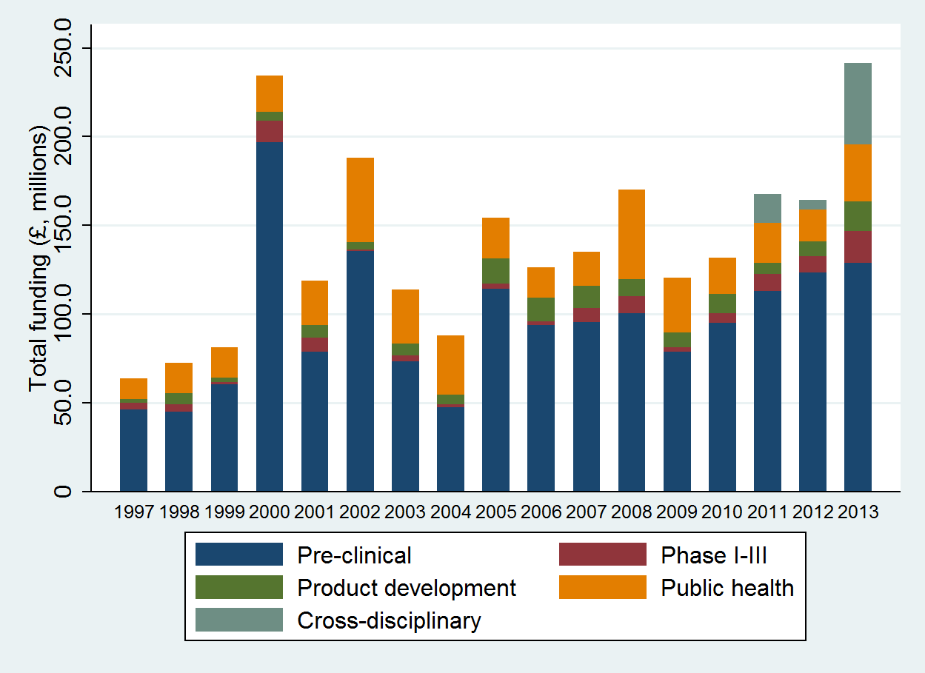
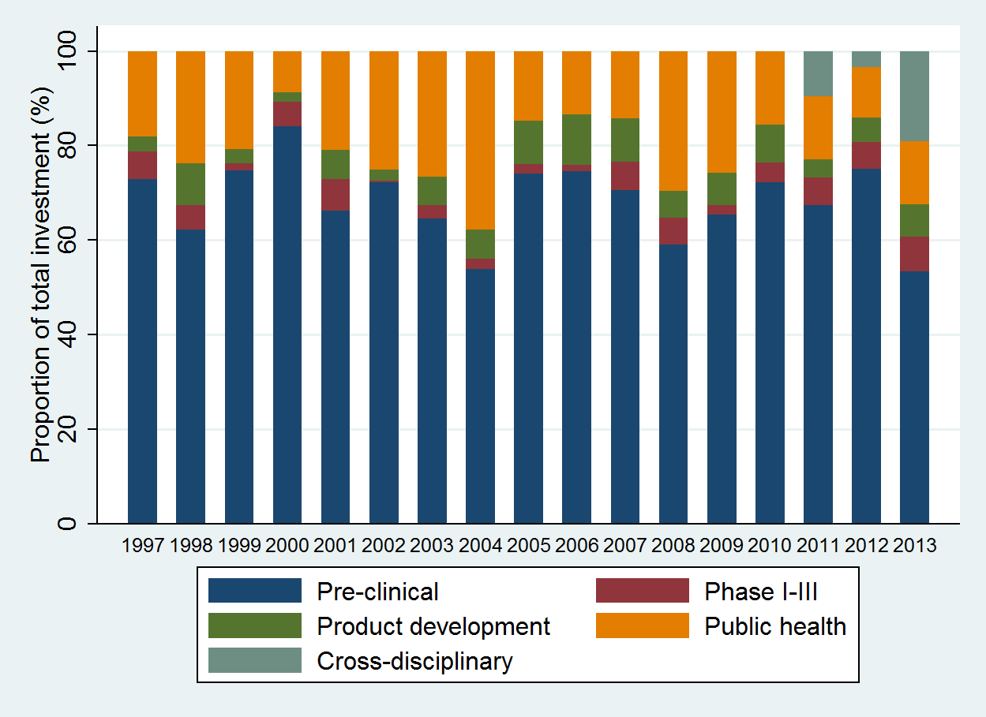
Figure 1. a) Aggregate and b) proportionate funding for UK investments in infectious disease from 1997–2013 by type of science along the research and development pipeline

Figure 2. Log-transformed UK research investment by UK years lived with disability observed for selected infections and across three time points.

Figure 3. Log-transformed UK research investment by UK mortality observed for selected infections and across three time points

Figure 4. Log transformed UK research investment by UK DALYs observed for selected infections and across three time points

