Supplementary Materials

S1 - Segmentation of soil phases from SRXCT data
The problem of segmenting soil CT data is well known (Schlüter et al. 2014), and the concept of a truly user-invariant segmentation approach is not as yet widespread. Even highly computationally sophisticated approaches to image analysis, such as the WEKA machine learning protocol (Koebernick et al. 2017), require the user to make key decisions both on the input parameters and on the final correspondence of voxels to the different phases of interest.
In this high-throughput study, the requirement to extract soil morphology from 144 SRXCT volumes necessitated a computationally simple approach which could be applied using identical parameters across all samples. These requirements contraindicated computationally expensive approaches such as the WEKA machine learning approach (Arganda-Carreras et al. 2017), and indicated the suitability of a global-histogram based approach. The selection of thresholds was based on visual inspection; for different threshold values, semi-transparent overlays were produced of resulting phase segmentations. These were then superimposed on the grey-level data for the user to check for correspondence. This process was carried out for test slices drawn from the SRXCT data of every individual sample and time-step in the study, using a batch script in FIJI (Schindelin et al. 2012). The initial thresholds were set at the minima between the histogram peaks representing textural, primary and pore phases, and the values iterated about these starting points. For each set of parameters, overlaid outputs of the test slices from all scans were generated and inspected for segmentation errors. This process was iterated, adjusting threshold values until acceptable agreement was reached on the basis of visual inspection. Figure S1 illustrates the outputs, showing a subset of each of the example slices shown in Figure 4, with a matrix of corresponding segmentation results at different threshold values also shown. The central image of each matrix shows the segmentation result generated using the finally selected parameters. The surrounding images show results produced by shifting the primary and mixed phase lower thresholds by ±5 (values on 8-bit range) from these values. The same final segmentation parameters [0,100,233,255] were used across all the SRXCT datasets.
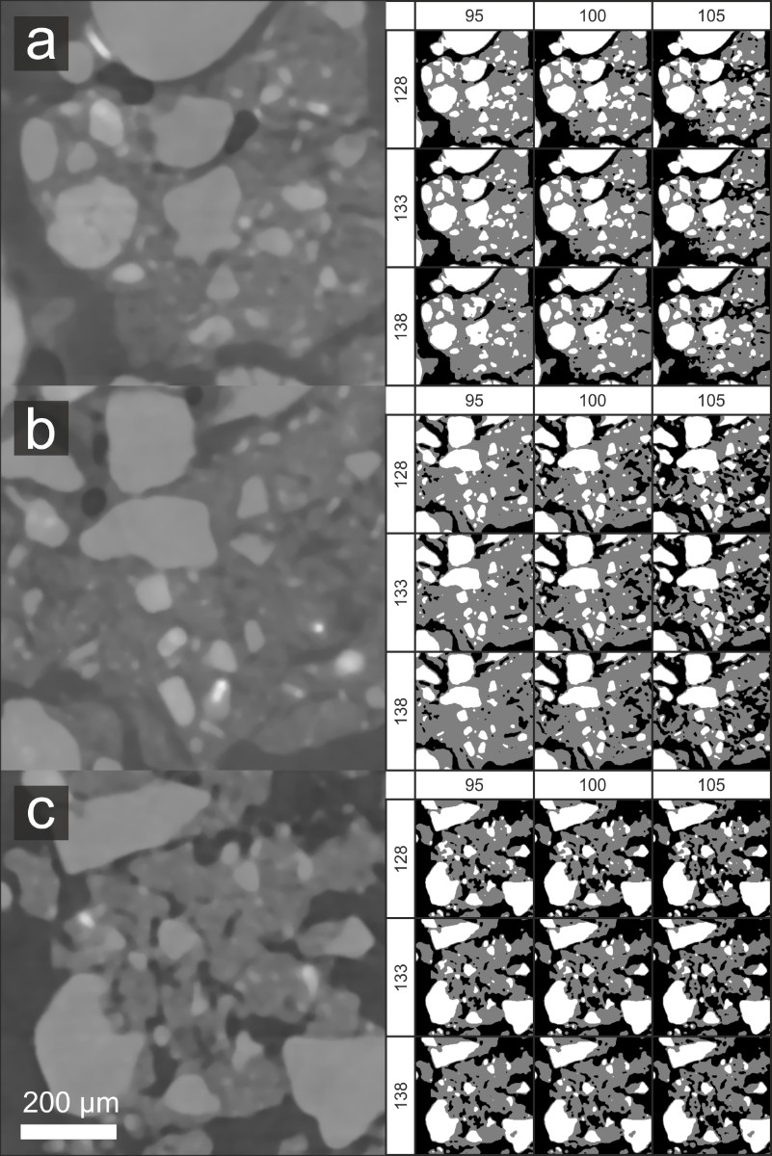
Figure S1 – Image segmentation parameters shown applied to representative subsets of a) wet loose, b) wet compacted, and c) dry compacted SRXCT data, illustrating the effect of changing threshold parameters. The left-hand image for each condition shows the spatially down-sampled and median-filtered raw data, prior to segmentation. The right-hand image shows a matrix of segmentation results, where the primary phase is shown in white, the textural phase in grey, and the pore phase in black. The horizontal and vertical axes indicate the lower threshold value for the textural and primary phases respectively. Parameters from the central image were applied in all cases (i.e. [0,100,133,255]).

S2 - Determination of DVC parameters

Selection of edge length
Determination of a suitable sub-volume edge length for the DVC study was carried out in the same manner to previous studies (Keyes et al. 2016; Gillard et al. 2014). The problem of edge length optimisation is a trade-off between spatial accuracy and measurement accuracy (White, Take, and Bolton 2003). Increasing the edge length generally increases the accuracy of the results, but reduces the spatial accuracy due to the increased degree of volume averaging, since the displacement of each sub-volume represents an average of the behaviour of all enclosed material (Liu and Morgan 2007). Figure S2a shows the relationship between sub-volume edge length and displacement measurement accuracy as quantified by the noise study, in which varying edge-length parameters were applied to an SRXCT data-pair, incorporating a vertical shift of 80 voxels in between scans. The DVC algorithm was applied using progressively smaller values of sub-volume edge length (200, 160, 120, 90, 70, 50). The offset from the input translation magnitude (i.e. 80 voxels) and the standard deviation in each deformation component represent the systematic error and the variance due to noise respectively. Results for progressively less strict correlation value thresholds ($c≥0.8$, $c≥0.6$, $c≥0.4$) were computed, by masking out values with correlation values below the threshold. A progressive worsening of systematic error and variance was clearly evident with decreasing correlation value. At the correlation value threshold of $c≥0.8$ used in this study, the variance in mean displacement and mean correlation value was seen to decrease with decreasing sub-volume edge length. Below an edge length of 60 voxels, the accuracy of the displacement measurement began to decrease. An edge length value of $≥60$ voxels was thus indicated to be optimal. However, in order to ensure that the edge length was no smaller than the maximum possible soil displacement across the entire study, and avoid potential tracking issues under the more complex deformation scenarios in the actual study (i.e. non-uniaxial displacement) an edge length of 90 voxels was in fact chosen as the parameter for the study.

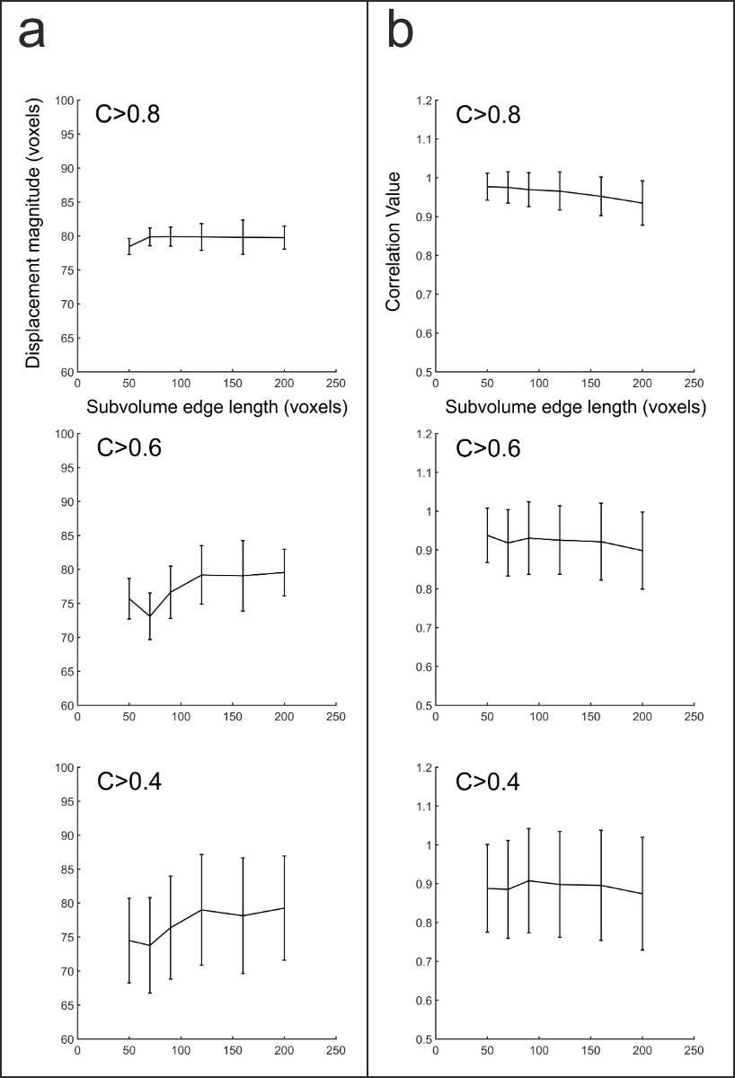
Supplementary Figure S2a – The results of the DVC calibration study to define an appropriate correlation value and sub-volume size. The left hand column shows mean displacement plotted against sub-volume edge length, relative to the input displacement of 80 voxels. The error bars show one standard deviation either side of the mean. The right hand column shows mean correlation value plotted against sub-volume edge length. The error bars show one standard deviation either side of the mean. Plots are shown for correlation value masking thresholds of c≥0.8, c≥0.6 and c≥0.4 (rows 1-3). The progressive worsening of accuracy at decreasing correlation value is evident. At c≥0.8, an edge length of 90 voxels gave optimal performance, defined by minimising the displacement error, whilst being greater than the maximum possible inter-step root displacement (equal to 80 voxels in the case of this study).

Checking of edge length under conditions of large displacement
Figure S2b shows the results of tracking a displacement of [0,0,80] voxels ([0,0,256 µm]), the largest root elongation step observed in the study, to confirm that both methods (DVC and discrete grain tracking) were able to track this order of displacement magnitude using the determined parameters. The DVC results were thresholded at a correlation value tolerance of c>0.8 to minimize error. The results indicate that there was a lower offset error in the grain tracking results compared to those of the DVC method, but that both methods were suited to capturing the magnitude and orientation of the displacement.
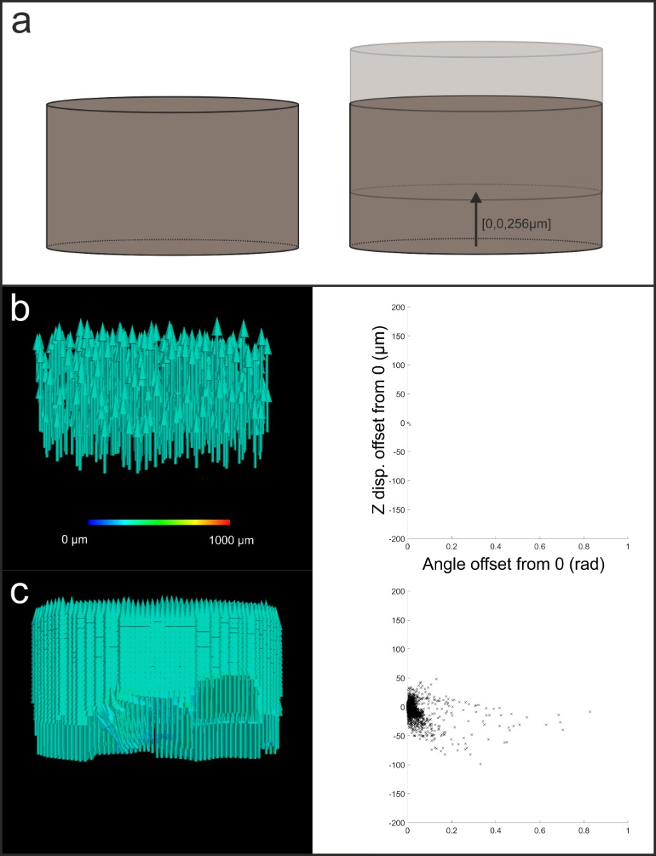
Supplementary Figure S2b – To check the toleration of the DVC and discrete grain tracking methods to large displacements equal to the maximum observed intra-step root elongation, the methods were applied to a soil sample translated by this value (a). The grain tracking results (b) show visually the result of the algorithm applied to these data (left hand side), and a scatter plot of the error in displacement ($\left|\vec{d}\right|$ ) with respect to the error in the angle ($θ_{rd}$) showing very little deviation from zero. The DVC results (c) show slightly more variation. The ‘holes’ in the vector field (left hand side) correspond to the internal regions of large primary grains, where values were masked due to the correlation values taking values in the range c<0.8. The scatter plot shows clustering around (0,0), but with a larger spread in the error in $\left|\vec{d}\right|$ and $θ_{rd}$ than seen in the grain tracking results.

S3 – Examples of qualitative observations
The data revealed the interaction of soil and the root at root tips for the first time in an SRXCT study. Discrete primary mineral grains were clearly distinguishable from the mixed phase, and complex grain-scale interactions between the root and the soil were observable. In some instances, primary mineral grains were seen to impinge upon the root, deforming the epidermal shape (S3).

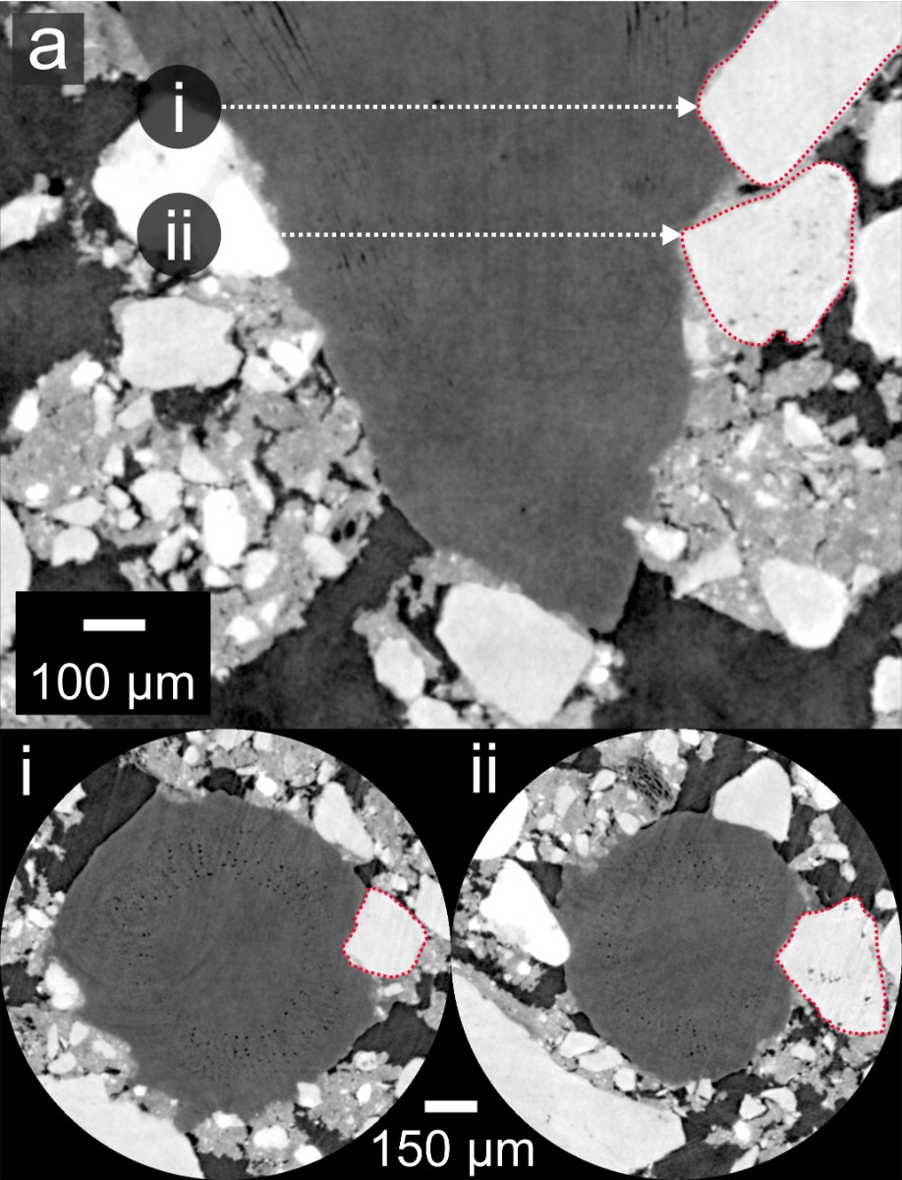
Figure S3 – (a) A digital section along the root axis of an intact root after 42 minutes of growth into dry consolidated soil. At positions (i) and (ii), the grains highlighted in red are observed to impinge on the cortex immediately behind the root cap, seen also in digital sections through the root at (i) and (ii).

S4 - Root elongation data
Figure S4 shows the full root elongation data for individual biological replicates.

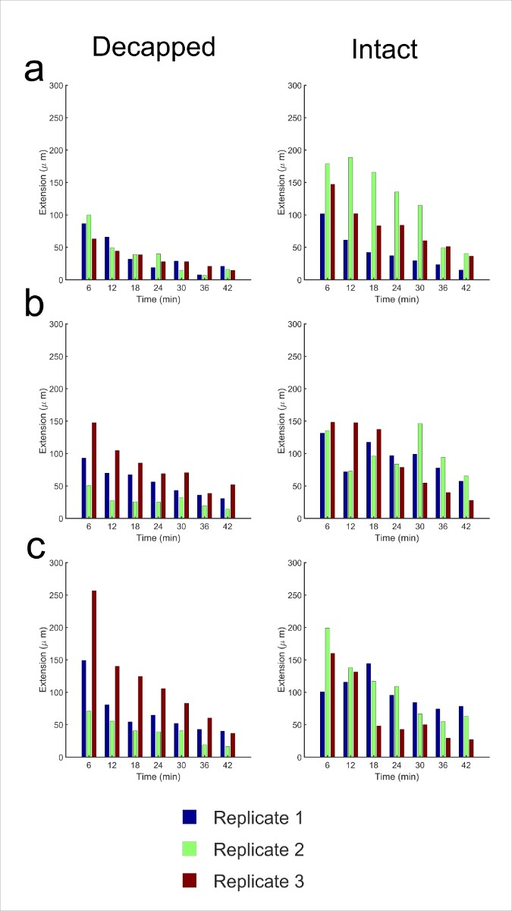
Figure S4 – The root elongation per step shown for the dry compact condition (a), the wet compact condition (b) and the wet loose condition (c). Decapped results are shown in the left column, and intact results in the right column.

S5 - Soil densification
Segmentation of the data into root, primary grains, textural phase, and pore phases (Figure 3) allowed analysis of local volume change in these phases under root ingress. Figure S5 shows scatter plots of volume change ($∆ψ_{d,l}$) against initial volume fraction ($ψ_{d,l,t_{1}}$). The degree of variability across samples precluded the drawing of any statistically significant comparisons at p<0.05, but across all samples and all phases, a general negative trend was observed in the slope of the linear equation ($∆ψ_{d,l}=mψ_{d,l,t_{1}}+c$), such that when $mψ_{d,l,t_{1}}>\frac{c}{m}$, the local volume fraction at ($d,l$) tends to decrease over the growth period, and when $mψ_{d,l,t_{1}}<\frac{c}{m}$, it tends to increase. The physical interpretation of this phenomenon is that local regions with material density above a certain threshold value ($t=\frac{c}{m}$ ) tend to decrease in density over time, and those above the threshold value tend to increase over time, with the effect being stronger with increasing offset from the threshold value.

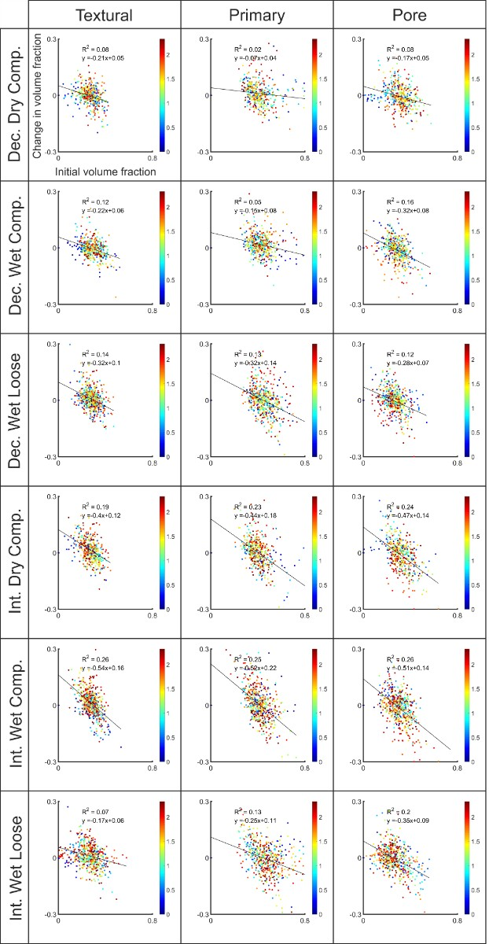
Figure S5 - The change in local volume fraction of primary, mixed and pore phases respectively, in relation to initial volume fraction. Linear regression models fitted to the data ($∆ψ_{d,l}=mψ_{d,l,t_{1}}+c$) exhibited low coefficients of determination ($\overline{r^{2}}=0.155, SD=0.073$). T-tests comparing the model slopes ($m$) did not return any significant differences at p<0.05. However, all models exhibited a negative gradient ($\overline{m}=-0.317, SD=0.134$), suggesting a weak inverse relationship between initial volume fraction of a soil phase at a given location ($ψ_{d,l,t_{1}}$), and the subsequent change in its volume fraction over the growth period ($∆ψ_{d,l}$). The colour-map indicates distance in mm of the sub-volume centroid from the root surface.

S6 – Shear strain
The average shear strain intensity with depth down the column is shown in Figure S6. The root tip position corresponds with x=0 in each case, and though the variance is substantial, the highest mean values are observed around/behind the root tip. The maxima of shear strain intensity was observed for decapped roots in the dry compacted soil condition. This supports the findings of the kinematic studies. The combination of decapped roots and dry soil was found to induce significantly more displacement proximal to the root surface than other conditions. The shear observed here is concomitant with the gradient of ${\vec{d}}_{y}$ observed with increasing lateral distance from the root surface.
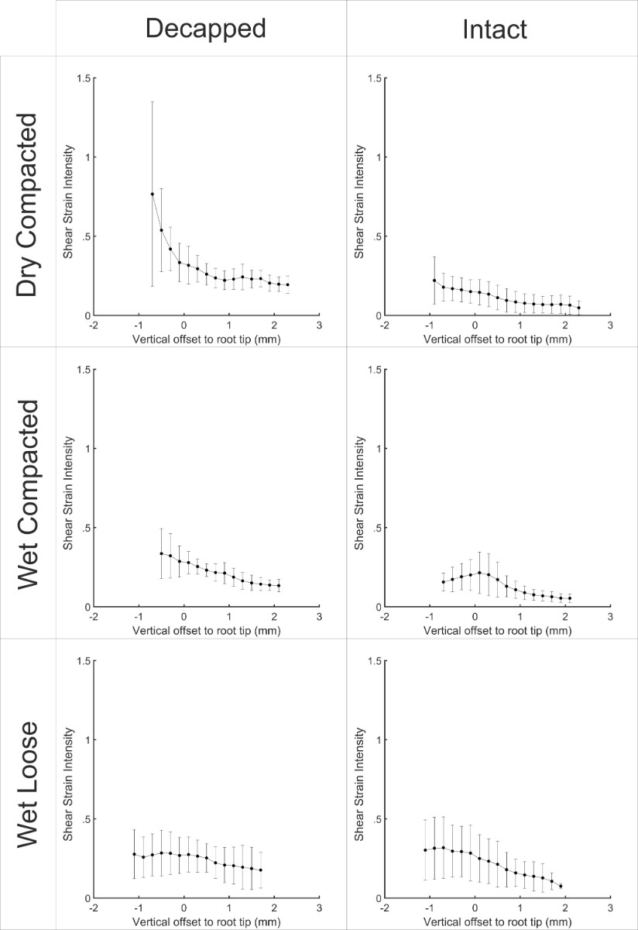
Figure S6 – The mean shear strain intensity with respect to vertical distance from the root tip. The shear strain intensity is defined as the mean shear strain divided by the root tip elongation for the given step. The values shown are the averages of 7 growth steps for 3 biological replicates, and error bars show 1 standard deviation either side of the mean.

