Spin dynamics of light-induced charge separation in composites of semiconducting polymers and PC₆₀BM revealed by Q-band pulse EPR

E. A. Lukina^{1,2}, E. Suturina³, E. Reijerse⁴, W. Lubitz⁴, L. V. Kulik^{1,2*}

¹ Voevodsky Institute of Chemical Kinetics and Combustion of Siberian Branch of Russian Academy of Sciences, Institutskaya 3, 630090 Novosibirsk, Russia
² Novosibirsk State University, Pirogova 2, 630090 Novosibirsk, Russia
³ School of Chemistry, University of Southampton, Highfield Campus, Southampton, UK
⁴ Max Planck Institute for Chemical Energy Conversion, Stiftst. 34-36, D-45470 Muelheim an der Ruhr, Germany
Author Information
Leonid V. Kulik
Address: Voevodsky Institute of Chemical Kinetics and Combustion of Siberian Branch of Russian Academy of Sciences, Institutskaya 3, Novosibirsk 630090, Russia
E-mail: chemphy@kinetics.nsc.ru
Telephone: 7-383-3332297

Abstract
Light-induced processes in composites of semiconducting polymers and fullerene derivatives are widely studied due to their usage as active layers of organic solar cells. However the process of charge separation under light illumination – the key process of organic solar cell is not well understood yet. Here we report a Q-band pulse electron paramagnetic resonance study of composites of the fullerene derivative PC₆₀BM([6,6]-Phenyl C61 butyric acid methyl ester) with different p-type semiconducting polymers (regioregular and regiorandom P3HT (poly(3-hexylthiophene-2,5-diyl)), MEH-PPV (poly[2-methoxy-5-(2-ethylhexyloxy)-1,4-phenylenevinylene]), PCDTBT (poly[N-9′-heptadecanyl-2,7-carbazole-alt-5,5-(4′,7′-di-2-thienyl-2′,1′,3′-benzothiadiazole)]), PTB7 (Poly({4,8-bis[(2-ethylhexyl)oxy]benzo[1,2-b:4,5-b′]dithiophene-2,6-diyl}{3-fluoro-2-[(2-ethylhexyl)carbonyl] thieno[3,4-b]thiophenediyl}))), resulting in a detailed description of the in-phase laser flash-induced electron spin echo (ESE) signal. We found that in organic donor-acceptor composites the laser flash simultaneously induces species of two types: a polymer^{•+}/fullerene^{•-} spin-correlated polaron pair (SCPP) with initial singlet spin state and (nearly) free polymer^{•+} and fullerene^{•-} species with non-equilibrium spin polarization. Species of the first type (SCPP) are well-known for polymer/fullerene blends and are usually associated with a charge-separated state. Also, spin polarization of long-living free species (polarons in deep traps) is affected by the laser flash, which is the third contribution to the flash-induced ESE signal. A protocol for extracting the in-phase ESE signal of the SCPP based on the dependence of the microwave nutation frequency on the strength of the spin coupling within the polaron pair was developed. Nutation experiments revealed an unusual pattern of the SCPP in RR-P3HT/PC₆₀BM composites, from which the strength of the exchange interaction between polymer^{•+} and fullerene^{•-} was extracted. In composites with low-efficient polymers the contribution of the SCPP to the in-phase ESE signal is high, while in composites with high-efficient polymers it is low. Thus finding can be used as a selection criterion of charge separation efficiency in the polymer/fullerene composites.

Introduction
There is a rapid development in the field of organic photovoltaics and some commercial applications have already been described.¹⁻⁶ Power conversion efficiencies of organic solar cells typically lie in the range of 8-9%, the largest value obtained so far is 11.2%.⁷ The active layer of organic solar cells usually is a bulk heterojunction (BHJ) ¹⁻⁶ comprising a p-type semiconducting polymer as electron donor ⁸⁻¹¹ and a fullerene derivative as electron acceptor,¹² although new promising materials, typically polycondensed heterocycles, have also been employed.^{13,14} The key process in organic solar cell operation is the charge separation process that takes place in the active layer under light illumination.¹⁵⁻¹⁷ Its mechanism is, however, not completely understood.^{18,19}
The charge separation process in organic composites is mainly studied by transient absorption spectroscopy ^{20,21} and by time-resolved (TR) EPR. ²²⁻²⁹ The following model of the charge separation process has been developed from the results of these studies. After the active layer has absorbed light, an exciton is formed. This diffuses through the material until it decays to the ground state or reaches the donor-acceptor interface where the electron is transferred from the semiconducting polymer to the fullerene. Thereby an intermediate charge transfer (CT) state is formed. In the CT state electron and hole are situated on the acceptor and the donor molecules, respectively, but they are still bound by strong Coulombic interactions. Hereafter the CT state separates into free charges with almost unity quantum yield in many polymer/fullerene blends. This description is rather simplified and, actually, the understanding of the charge separation mechanism at the organic donor/acceptor interface still remains a challenge.
One of the major problems of both transient absorption and time-resolved EPR is the difficulty of signal assignment, especially if the spectrum consists of many different contributions. In contrast, pulse EPR, in particular electron spin echo (ESE) spectroscopy, provides the opportunity to separate different contributions to the signal by varying microwave pulse sequences and pulse amplitudes. Thus, pulse EPR is a valuable technique in the investigation of the charge separation process in organic donor/acceptor composites. In such experiments the so-called flash-induced ESE signal is usually analyzed which is the difference of ESE signals obtained with the same microwave pulse sequence obtained for a short Delay After the laser Flash (T_{DAF}), and for sufficiently long T_{DAF}. It is assumed that all transient paramagnetic species decay for long T_{DAF} and only stable species remain. Previously, pulse X-band EPR spectroscopy was applied to studies of RR-P3HT (Regioregular poly(3-hexylthiophene) and PC₆₀BM ([6,6]-Phenyl C61 butyric acid methyl ester) or PC₇₀BM ([6,6]-Phenyl C71 butyric acid methyl ester) composites, and the observed out-of-phase electron spin echo envelope modulation (ESEEM) was interpreted as a feature of a singlet-born spin-correlated polaron pair (SCPP) polymer^{•+}/fullerene^{•-}.^{30,31} However, the nature of in-phase flash-induced signals is not yet completely understood.³⁰⁻³³ Since for sufficiently selective microwave pulses in-phase flash-induced ESE is proportional to the magnetization change caused by the laser flash, its magnetic field dependence (echo-detected EPR spectrum) is expected to be similar to the TR EPR spectrum. It should be noted that the evolution of the TR EPR spectrum for RR-P3HT/PC₆₀BM with the increase of T_{DAF} cannot be interpreted within the simple singlet-born SCRP framework.²² Taken together these facts show that the spin dynamics in polymer/fullerene composites is more complex than it was suggested in the earlier singlet spin-correlated radical pair (SCRP) model,³⁴ which has been successfully applied to the photosynthetic charge separation process.³⁵⁻⁴³
Here we report a Q-band pulse electron paramagnetic resonance study of composites of the fullerene derivative PC₆₀BM([6,6]-Phenyl C61 butyric acid methyl ester) with different conductive polymers (regioregular (RR) and regiorandom (RRa) P3HT (poly(3-hexylthiophene-2,5-diyl)), MEH-PPV (poly[2-methoxy-5-(2-ethylhexyloxy)-1,4-phenylenevinylene]), PCDTBT (poly[N-9′-heptadecanyl-2,7-carbazole-alt-5,5-(4′,7′-di-2-thienyl-2′,1′,3′-benzothiadiazole)]), PTB7 (Poly({4,8-bis[(2-ethylhexyl)oxy]benzo[1,2-b:4,5-b′]dithiophene-2,6-diyl}{3-fluoro-2-[(2-ethylhexyl)carbonyl] thieno[3,4-b]thiophenediyl}))) (see molecular structures on Fig. 1), resulting in a detailed description of the in-phase laser flash-induced electron spin echo (ESE) signal. Using different pulse sequences and the high spectral resolution obtained at Q-band we were able to separate several contributions to this signal. We found that in organic donor-acceptor composites the laser flash induces not only polymer^{•+}/fullerene^{•-} SCPP with an initial singlet spin state but also free or nearly free polymer^{•+} and fullerene^{•-} polaron species with non-equilibrium spin polarization, which can be either absorptive or emissive. These non-equilibrium polarized species are known to appear as a result of a separation of a geminate radical (polaron) pair to rather long distances (CIDEP mechanism)^{44,45} or by polarization transfer from SCRP to a third observer spin,^{46,47} presumably, pre-existing polarons in deep traps. We also developed a protocol for suppressing the contribution of free species to the flash-induced ESE signal. Using this protocol we estimated the strength of the exchange interaction for the CT state RR-P3HT^{•+}/PC₆₀BM^{•-}.

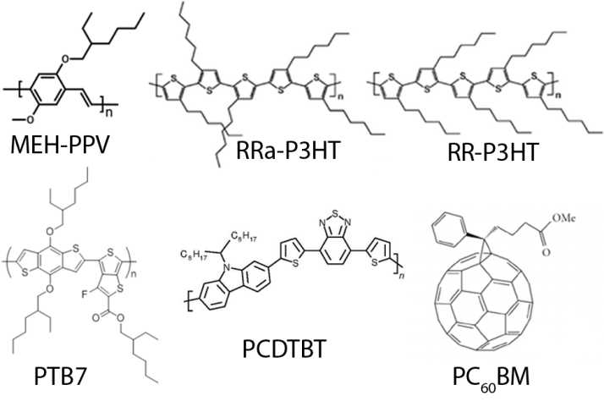
Figure 1. Molecular structures of the substances used.

Theory
Since bulk heterojunction is intrinsically disordered, the precise description of the CT state in polymer/fullerene composite would imply a broad distribution of distances between its parts, polymer^{•+} and fullerene^{•-}. This implies also a distribution of the parameters of the exchange and magnetic dipolar interaction. In the present study we consider a highly simplified model of this distribution consisting of only two subensembles. The first one (CT state) has a small fixed distance between polarons, a fixed exchange and dipolar interaction parameters and an initial singlet spin state; thus it can be treated as SCPP. The second subensemble (separated charges) has a long distance between polarons and negligible strength of magnetic interaction between them. In this case a pure singlet RP is not observable in the ESE experiments. We assume, however, that these species carry non-equilibrium spin polarization. Initially, this is CIDEP with an A/E pattern, which is gradually converted to Boltzmann polarization at longer T_{DAF} because of spin-lattice relaxation.
The theoretical description of SCRP was developed for the interpretation of photosynthetic reaction centers studies and is described in detail elsewhere.^{34,48,49} Here we will briefly outline the main aspects of this theory and then describe the modifications necessary to apply it to the simulation of our ESE experiments.
The spin Hamiltonian of a polaron pair contains the Zeeman interactions of both polarons with the external magnetic field, as well as the dipole and exchange interactions between polarons: ⁴⁹
(1)
Here μ_{B} is the Bohr magneton, B₀ is the spectrometer magnetic field, g_{1eff} and g_{2eff} are the effective g-factors of polaron 1 and 2, respectively, S₁ and S₂ are their spin operators, S denotes the total spin operator S₁+S₂, J is the exchange coupling, D is the dipolar coupling, ξ is the angle between the line connecting the polarons in the pair and the external magnetic field. The hyperfine coupling in organic photovoltaic materials is often negligible due to the strong delocalization of the spins and charges.
The spin centers in both polymer and fullerene have anisotropic g-tensors, therefore the effective g-factor is determined as
, (2)
where g_{1,2(x,y,z)} are the principal components of the g-tensor, θ_{1,2} and φ_{1,2} are the angles characterizing the orientation of the molecular frame with respect to the magnetic field orientation (z-axis of laboratory frame). In the absence of interactions between spins 1 and 2 their resonance frequencies are and .
The eigenvectors and eigenvalues of the spin Hamiltonian (1) are
(3)
The allowed EPR transitions energies are:
(4)
The sign function in the above equations is necessary for the correct assignment of the transition frequencies but it is lacking in previous treatments. It is assumed that microwave pulses are selective and that they excite only one allowed transition. This transition was treated as spin 1/2 with effective gyromagnetic ratio for the 1↔2 and 2↔4 transitions and for the 1↔3 and 3↔4 transitions, where γ₀ is the free electron gyromagnetic ratio. Every transition is broadened by a Gaussian function. We took into account that two radicals in the pair have different line widths and therefore calculated the line width of each individual line according to the relative contributions of the transition moments of polaron 1 and polaron 2 as
, (5)
where W₁ and W₂ are the individual line widths of polarons 1 and 2.
Thus we obtained
. (6)
For the case of a negligible interaction between spins (ψ = π/4) the empirical relation (6) ensures that transitions belonging to the first polaron have the linewidth W₁ and transitions of the second polaron have the linewidth W₂. For the case of strong spin coupling (ψ = 0) Eq. (6) ensures an average linewidth.
The initial level population (upon charge separation) was zero for levels 1 and 4, cos²ψ for level 2 and sin²ψ for level 3.
The ESE signal of the pair of non-interacting polarons was calculated using a similar approach. The difference from the SCPP calculation was the assumption J = 0, D = 0 and the appropriate initial population of the spin levels, representing longitudinal magnetization for spin of each polaron with equal magnitude and different sign (A/E polarization).
The line intensity of the ESE signal in t_{p}-τ-2t_{p}-τ-echo is the product of the population difference of the levels, the transition probability and sin³α, where α is the rotation angle of the first pulse , in which t_{p} is a pulse length, ω₁=γ₀B₁ with B₁ denoting the microwave amplitude, <S_{x}> is sinψ for the 1↔2 and 2↔4 transitions and cosψ for the 1↔3 and 3↔4 transitions.⁵⁰ For the case of a negligible interaction between spins the maximum echo intensity is observed for t_{p}ω₁=π/2.
The nutation experiment with a pulse sequence β-T-t_{p}-τ-2t_{p}-τ-echo can be simulated using the same model as described above. The first microwave pulse with variable length changes the level populations as follows
(7)
where β is the turning angle of the nutation pulse for isolated spin S = 1/2. The influence of the following two-pulse sequence can be calculated as described above. Thus we calculated the transitions frequencies for all possible transitions in the spectrum, then took into account line broadening with the line-width determined as in Eq. (6) and calculated the contribution of each line to the signal intensity at the chosen g-value. The extracted signal of the SCPP was determined as a difference of the ESE signal calculated with a strong pulse and the ESE calculated with a weak pulse, multiplied by , according to the above protocol.
In each case the ESE signal for a polyoriented ensemble of SCPPs was obtained by averaging over the spatial orientations of the g-tensors. For the case of non-zero dipolar interaction averaging over the angle ξ was performed. All distributions were uncorrelated. We assume that hopping of the charges is slow compared to the duration of the microwave pulse sequence, so all magnetic parameters are constant.

Experimental procedures
Sample preparation
Regioregular and regiorandom P3HT (poly(3-hexylthiophene-2,5-diyl)), MEH-PPV (poly[2-methoxy-5-(2-ethylhexyloxy)-1,4-phenylenevinylene]), PCDTBT (poly[N-9′-heptadecanyl-2,7-carbazole-alt-5,5-(4′,7′-di-2-thienyl-2′,1′,3′-benzothiadiazole)]), PTB7 (Poly({4,8-bis[(2-ethylhexyl)oxy]benzo[1,2-b:4,5-b′]dithiophene-2,6-diyl}{3-fluoro-2-[(2-ethylhexyl)carbonyl] thieno[3,4-b]thiophenediyl})) and PC₆₀BM ([6,6]-Phenyl C61 butyric acid methyl ester) (see molecular structures on Fig. 1) were purchased from Sigma Aldrich and used without further purification. One of the semiconducting polymers and PC₆₀BM (weight ratio 1:1) were dissolved in chlorobenzene (concentration of each substance approximately 6 mg/ml) and mixed using an ultrasonic mixer (QSonica Microson XL2000). Several freeze-pump-thaw cycles were performed, then the solvent was evaporated to form composite film on the inner wall of quartz sample tube (o.d. 2.8 mm). Then samples were annealed at 10⁻² torr at 150°С for about 10 minutes. This was done to remove traces of oxygen from the composite, which act as deep trap for polarons. The intensity of dark EPR signal of these samples did not increase upon exposure to air at room temperature. This testifies that the composite is stable at ambient conditions, and sealing of the samples is not necessary.

Pulse EPR experiments
EPR measurements were performed on a pulse Q-band Bruker ELEXSYS E580 EPR spectrometer (microwave frequency close to 34 GHz) at the Max Planck Institute for Chemical Energy Conversion, Muelheim an der Ruhr, Germany. The spectrometer is equipped with a homebuilt TE011 microwave cavity⁵¹ and a cryogen-free closed-cycle cryostat (Cryogenic Limited) employing a PT415 Cryomech Inc pulse tube cryocooler (1.5W@4K) maintaining a stable low temperature during long-time experiments. If not otherwise specified, the measurements were done at 40 K. This low temperature was used to ensure slow charge hopping after initial light-induced charge separation.
Light excitation was realized using an Innolas SpitLight 600 OPO laser system (700 nm, flash duration 5 ns, repetition rate 10 Hz, about 1 mJ light intensity reaching the sample) for all samples. The light absorption of the studied composites is relatively low in the infrared region, therefore the laser light penetrates deep into the sample and the resulting spatial distribution of light-induced species is expected to be homogeneous. Changing pulse excitation wavelength to 532 nm did not affect the resulting ED EPR spectral shape and nutation pattern, only signal intensity was varied. For continuous light illumination laser operating at 532 nm was used.
The following microwave pulse sequences were used in the experiments:
- A two-pulse sequence was applied to form the ESE signal at a certain T_{DAF}.

Scheme 1. Two-pulse sequence.
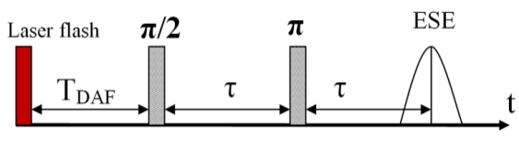
- An additional microwave pulse was added before the laser flash in order to turn the magnetization of stable species to the XY plane of the rotating frame and thus make its contribution to the resulting ESE signal zero. Amplitude and duration of the first pulse were chosen so that the ESE signal without laser flash is zero.

Scheme 2. Two-pulse ESE with pre-saturation.
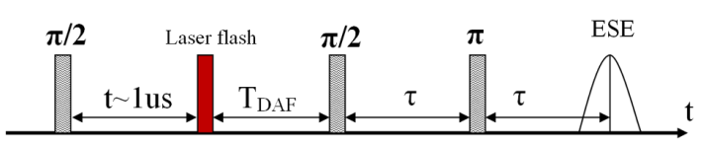
- For the measurements of ESE nutations the following pulse sequence was used: after the laser flash and delay T_{DAF} a microwave pulse with variable length t was applied. After a fixed delay time T the two-pulse sequence was applied for detection of the echo.

Scheme 3. Pulse sequence used in nutation experiments.
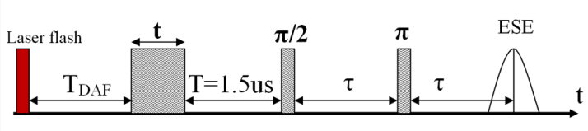

Turning angles of all microwave pulses are related to separated polarons with negligible interaction with other electron spins. This situation occurs at long T_{DAF} when the flash-generated SCPPs either recombined or dissociated. The phase of ESE was tuned by two-pulse ESE signal at long T_{DAF}, for which pure in-phase ESE is expected. In all experiments out-of-phase ESE amplitude was negligibly small.

Results and discussion
RR-P3HT/PC₆₀BM composite
We measured Q-band ED EPR spectra of RR-P3HT/PC₆₀BM in the dark and under continuous light illumination (Fig. S1). The obtained spectrum consists of two well-separated peaks, the peaks at low and high g-factor belong to PC₆₀BM^{•-} and RR-P3HT^{•+}, respectively. The signal in the dark appears due to the presence of polaron species trapped in the defects; light irradiation generates long-living thermalized polarons that contribute to the spectrum. The Q-band in-phase light-induced ED EPR spectrum of RR-P3HT/PC₆₀BM was determined as a difference of the spectrum recorded under continuous unsynchronized laser flash illumination and the spectrum measured after the light was turned off (Fig. 2). The ESE signal of the thermalized polarons accumulated after many laser flashes is measured in this experiment; this spectrum is almost equal to that under continuous light irradiation meaning that it also belongs to thermalized long-living polarons. It should not to be confused with the flash-induced ED EPR, in which the change of the ESE intensity caused by a single laser flash is measured.

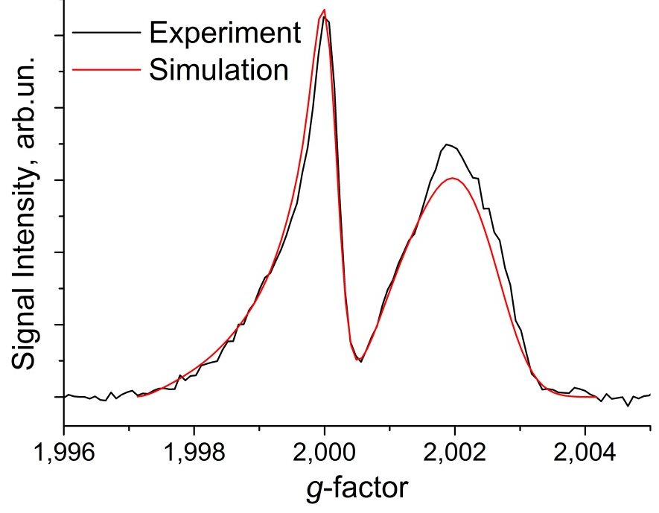
Figure 2. Light-induced ED EPR spectrum of RR-P3HT/PC₆₀BM determined as a difference between the spectrum measured under laser flashes without synchronization between laser flashes and the microwave pulse sequence and a spectrum measured in the dark after the laser light was turned off (red line). The measurements were done using the two-pulse sequence (Scheme 1). The spectrum was simulated using parameters of polaron species summarized in Table 1 and zero magnetic interactions between polarons (black line).

We measured flash induced ED EPR spectra of the RR-P3HT/PC₆₀BM composite with T_{DAF}=300 ns and 99 ms delays between the excitation laser flash and the microwave pulse sequence. The spectra of RR-P3HT^{•+} and PC₆₀BM^{•-} at Q-band are clearly separated, the low g-factor and the high g-factor peaks corresponding to fullerene and polymer polaron signals, respectively (Fig. 3). The spectrum with T_{DAF}=99ms is similar to that of thermalized free polarons, implying that at such a long T_{DAF} all flash-induced species either recombined or thermalized.
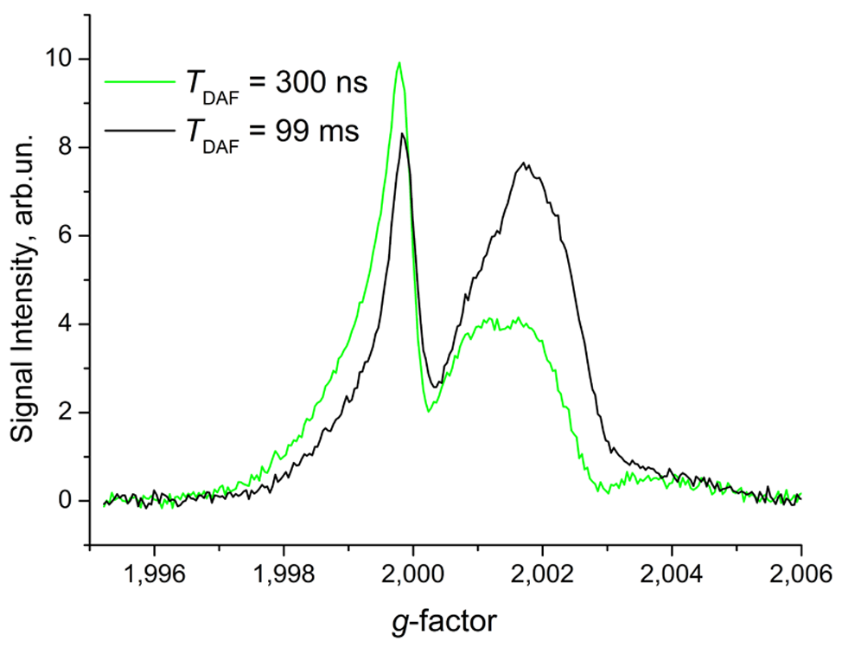
Figure 3. Echo-detected EPR spectra of RR-P3HT/PC₆₀BM measured with T_{DAF}=300 ns and 99 ms (green and black lines, respectively). A two-pulse microwave sequence with selective pulses and τ= 400 ns was used (Scheme 1).

The difference between spectra at T_{DAF}=300 ns and 99 ms corresponds to the flash-induced signal (Fig. 4), that has emissive polarization at high g-factor and very weak absorptive polarization at low g-factor, similar to previously observed flash-induced ED EPR spectra in composites of semiconducting polymers and fullerenes.³⁰⁻³³ This signal presumably comprises both ESE of the light-induced species and the changes in the signal of long-living polarons. In order to separate these two contributions we applied an additional microwave pulse prior to the laser flash, which turns the magnetization of the long-living polarons into the XY plane of the rotating frame and therefore suppresses their ESE signal (Scheme 2). The ESE signal of the flash-induced species without contribution of the long-living polarons is presented in Fig. 5
. 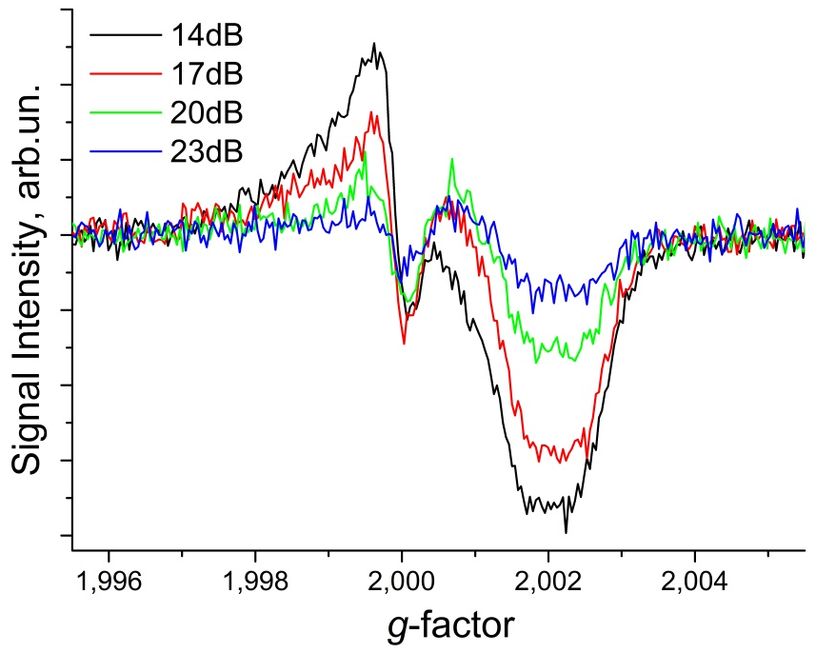
Figure 4. Echo-detected flash-induced (determined as a difference of spectra measured with T_{DAF}=300 ns and 99 ms, pulse sequence 1) EPR spectra of RR-P3HT/PC₆₀BM measured with different microwave power settings. The two-pulse microwave sequence with selective pulses (duration of the first pulse 100 ns) and τ = 400 ns was used. The numbers in the figure indicate the microwave attenuation level. Attenuation of 14 dB corresponds to the maximum ESE signal of the separated polarons.

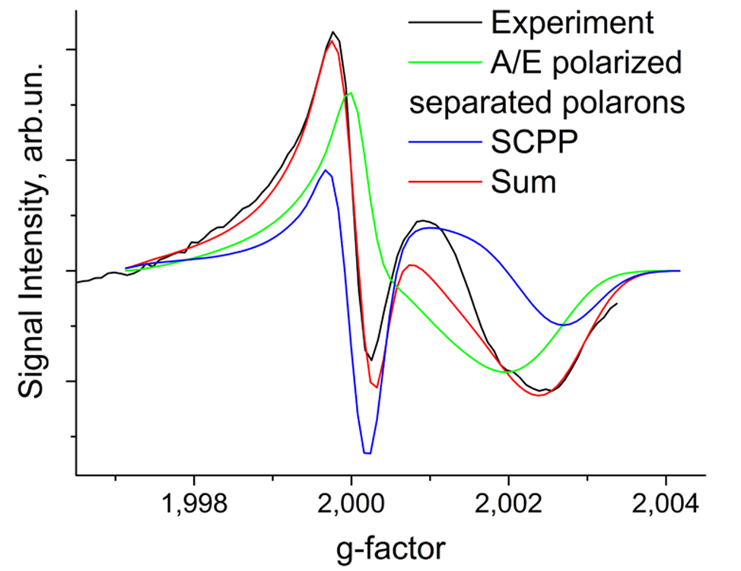
Figure 5. Echo detected flash-induced EPR spectrum RR-P3HT/PC₆₀BM measured with pre-saturation (black line). The pre-saturating microwave pulse was applied 1 μs before the laser flash and a two-pulse microwave sequence with selective pulses and τ = 400 ns was used for detection (Scheme 2). Green and blue lines show simulated curves for A/E polarized separated polarons and SCPP, respectively; the red line shows their sum. The simulation was done using the parameters of polaron species summarized in Table 1, assuming a dipolar interaction of 5 MHz and an exchange interaction of 3 MHz for SCPP and zero magnetic interactions for A/E polarized separated polarons.

The influence of the laser flash on the long-living free species (Fig. 6) was determined by subtraction of pre-saturated flash induced spectra (measured according to Scheme 2) from regular flash induced spectra (measured according to Scheme 1). The pre-saturation pulse suppresses the long-living magnetization but it does not affect the flash-induced species. Therefore the contribution of flash-induced species disappears after subtraction. As can be seen in Fig. 5 the laser flash significantly reduces the ESE signal of long-living polarons. The reason for this is not clear at present. One possibility is a polaron spin polarization change caused by exciton quenching by this polaron. Exciton quenching on polarons is an important loss mechanism in polymer/fullerene OPV devices.^{52,53} Presumably, it involves electron transfer from the exciton to a positive polaron or from a negative polaron to the exciton. Change of electron spin polarization during this process cannot be excluded, although it has not been reported up to now. The other possible mechanism of polaron spin depolarization is bi-polaron formation observed at high concentrations of the polarons on polymer molecules.⁵⁴ This scenario implies that after the laser flash the concentration of polarons increases and a significant part of these form bi-polarons that are EPR silent, while at long T_{DAF} the charge concentration decreases due to recombination and most bi-polarons separate into free charges. The third possibility is partial interconversion of singlet excitons to triplet excitons before they dissociate at the donor acceptor interface, and transfer of spin polarization from triplet excitons to polarons. Such a process is known for stable radicals in organic matrices.⁵⁵ The origin of stable polaron depolarization is unclear for our case, but it seems not to be related to the CT state at the donor-acceptor interface. For this reason we did not analyze this effect further but suppressed it by our data treatment.
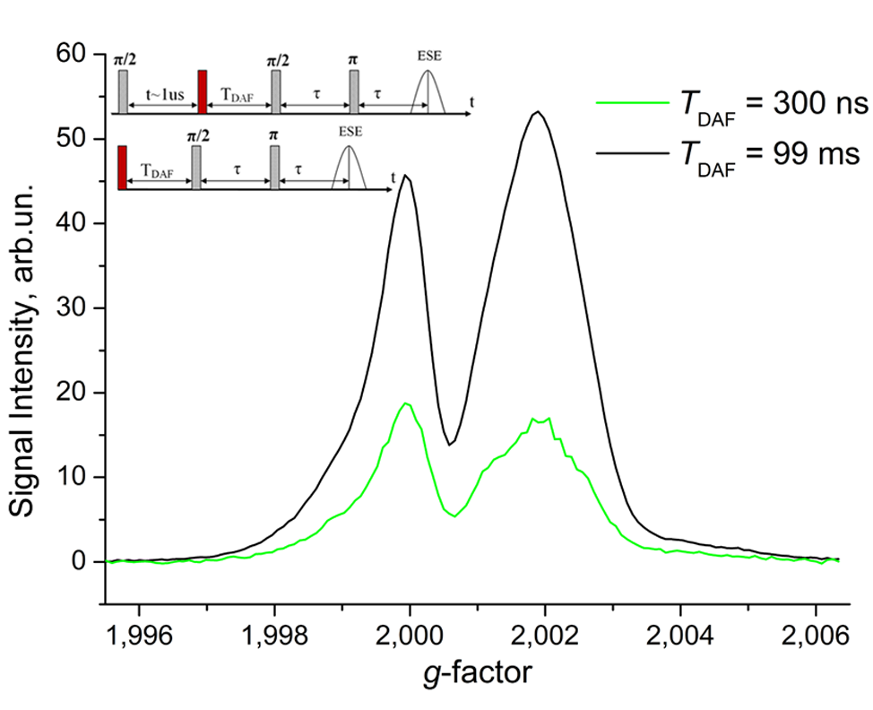
Figure 6. Laser flash influence on long-living polarons of the EPR spectrum of RR-P3HT/PC₆₀BM composite. Spectra were determined as a difference between signals measured using the two pulse sequences shown in the inset with T_{DAF}=300ns (green line) and T_{DAF}=99ms (black line).

Even with pre-saturation of long-living polarons the ESE signal of flash-induced species (Fig. 5) consists of at least two contributions. During the charge separation process short-lived SCPPs with significant magnetic interaction between polarons are formed. This suggestion is supported by the non-uniform dependence of the flash-induced spectra on microwave power (Fig. 4). The ESE signal of the SCPP depends on microwave power differently than that of the free species with spin S=1/2, which gives the opportunity to separate electron spin echo signals of different species.

As mentioned above we assume that the overall ESE signal at small T_{DAF} is a superposition of the contributions from the CT state and the separated polarons. We assume also that at long T_{DAF} the CT state either recombines or dissociates. Therefore, for T_{DAF} = 99ms only separated polarons contribute to ESE signal. Under these assumptions it is possible to filter out the contribution of separated polarons from the mixture of ESE signals using the following protocol for the experimental data treatment:
- We choose two values of the microwave amplitude for primary ESE sequence with selective microwave pulses: A₁ that is optimal for separated polarons (maximal ESE signal at T_{DAF}=99ms) and A₂=A₁/2 which corresponds to 6 dB higher microwave power attenuation than that for A₁. If the microwave amplitude is twice lower, the magnetization turning angles are also two times reduced. According to Theory section the ESE intensity for separated polarons in this case scales by compared to its maximum value, which corresponds to π/2 turning angle for the first pulse.
- We measure four echo-detected EPR spectra with a two-pulse sequence with selective microwave pulses. Two of these spectra are recorded with optimal microwave power: S(T_{DAF}=99ms, A₁), S(short T_{DAF}, A₁). The other two spectra are recorded with reduced microwave power but with the same pulse length: S(T_{DAF}=99ms, A₂), S(short T_{DAF}, A₂).
- We determine the coefficient K that describes how the signal of separated polarons changes with the decrease of the microwave power for the condition S(T_{DAF}=99ms, A₂)-K*S(T_{DAF}=99ms, A₁)=0. The experimental value of K is not exactly equal to because of some uncertainty in the choice of A₁.
- We subtract two spectra measured at short T_{DAF} with this coefficient K and thus cancel out the contribution of separated polarons to the ESE signal. Only the signal of the SCPP is left: S(short T_{DAF}, A₂)-K*S(short T_{DAF}, A₁) = CT state spectrum.
It should be noted that the signal of the CT state is slightly distorted by this protocol: the stronger is the deviation of the particular SCPP from the weak coupling limit, the stronger is its contribution to the processed signal. Further such signal will be referred to as “extracted SCPP signal”. Thus, the extracted SCPP signal is decreased at the edges of the EPR spectrum, because these correspond to a larger difference of the Zeeman frequency of the spins constituting the pair, and consequently, to a smaller extent of spin coupling (the angle of singlet-triplet mixing ψ is close to π/4). Analogously, by subtraction of the signals measured with different microwave power for short T_{DAF} (step 4 of the above protocol), it is possible to filter out the signal of isolated polarons and extract SCPP contribution not only in ED EPR spectrum, but also in ESE nutation (Scheme 3). This approach still works if the following conditions are fulfilled: measured signal is primary ESE and amplitude of all other pulses (the first microwave pulse for the case of nutation experiment) is the same in the set of measurements. The scaling coefficient K can be determined at step 3 of the above protocol from two-pulse ESE for long T_{DAF} (measurements at two different microwave powers); this two-pulse ESE sequence should be the same as detection unit in nutation sequence (the second and the third pulses in Scheme 3).
The process of the extraction of this signal from experimental data is illustrated in Fig. 7. In our conditions the precision of experimental determination of optimal microwave power is about 1 dB, which translates in deviation of scaling coefficient K from theoretical value . The value of K was in the range 0.3 – 0.4 in our experiments.
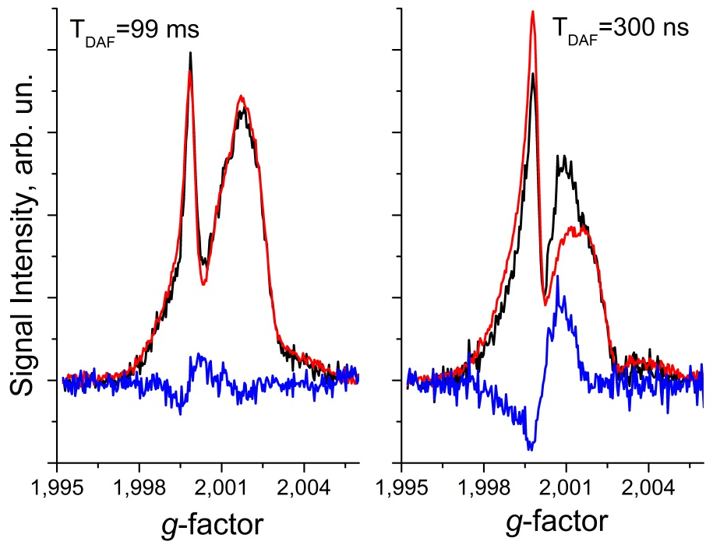

Figure 7. Echo-detected EPR spectra used for the extracted SCPP signal. The left and right side plot shows spectra measured at T_{DAF}=99 ms and T_{DAF}=300 ns respectively. The red line shows a spectrum measured at a microwave power optimal for S=1/2, the black line corresponds to the spectrum measured at the reduced microwave power. The first spectrum is multiplied with a coefficient K determined to minimize the difference (blue line) with the second spectrum for T_{DAF}=99ms. Thus the difference between the two spectra measured at T_{DAF}=300 ns (blue line) corresponds to the SCPP signal which has a microwave power dependence deviating from that of S=1/2 species.

The distortion of shape of echo-detected EPR spectrum SCPP caused by the extraction procedure is illustrated for simulated SCPP spectra in Fig S2.

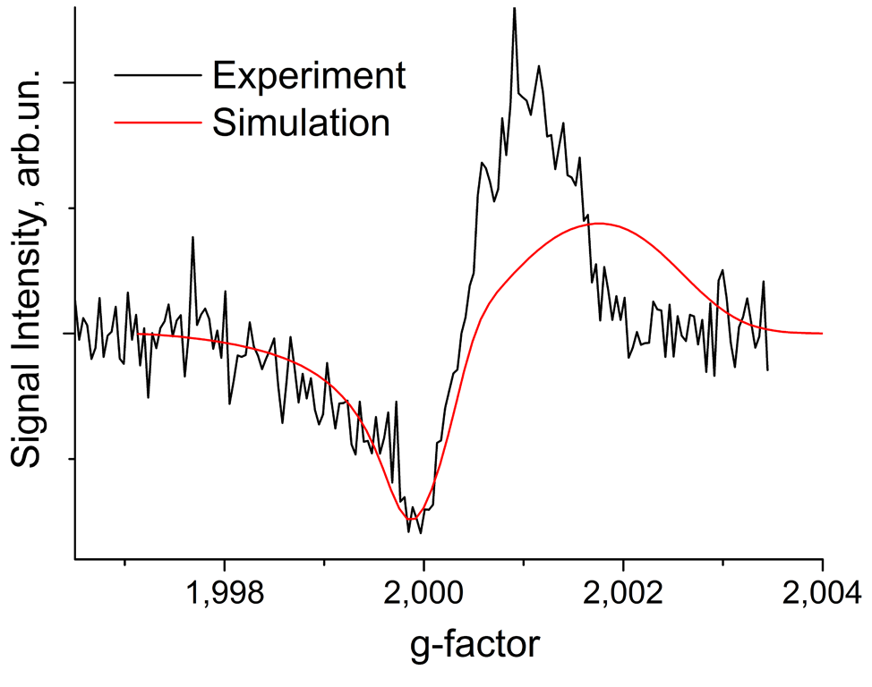
Figure 8. Echo-detected EPR spectrum of the SCPP extracted for RR-P3HT/PC₆₀BM at T_{DAF}=300ns (black line). The red line shows the simulation done using the parameters of polaron species summarized in Table 1, dipolar interaction of 5 MHz, exchange interaction of 3 MHz.

In Fig. 8 we show the extracted signal of SCPP for RR-P3HT/PC₆₀BM. We can see that the extracted SCPP signal is slightly narrower than the flash-induced ED EPR spectrum (Fig. 5). The broad spectral component in Fig. 5 seems to originate from weakly or non-interacting spins with 1/2 multiplicity. This signal presumably corresponds to separated polarons with non-equilibrium spin polarization. Such polarization can form either due to spin evolution of geminate pairs during charge separation or by polarization transfer to the long-living free species.^{46,47}

We measured the temperature dependence of the signal from the flash-induced species in RR-P3HT/PC₆₀BM composite (Fig. S3) and found that the narrow central component of the spectrum due to the SCPP disappears upon increasing the temperature. Evidently, SCPP forms at low temperature due to retardation of the charge separation process caused by the low thermal energy. The spectrum of polarized free species becomes narrower with increasing temperature because of partial averaging of the g-tensor anisotropy by fast molecular motions.

To determine the spin coupling parameters of the RR-P3HT^{•+}/PC₆₀BM^{•-} SCPP we performed nutation experiments (Scheme 3). We measured nutations of the ESE signals of the separated polarons and of the SCPP (Fig. 9) at the maximum of the extracted SCPP signal (g = 2.00105). The nutation signal of the SCPP was determined as the difference between the signal measured at T_{DAF} = 300 ns with the microwave power of echo-forming pulses (the second and the third pulses in Scheme 3) corresponding to the maximum ESE intensity and the signal measured with the microwave power reduced by 6 dB multiplied by a coefficient K determined as described above. The amplitude of the nutation pulse (the first in Scheme 3) was kept the same during these measurements. Microwave Pulse Forming Unit (MPFU) was used to keep the same amplitude of the nutation pulse and vary only the amplitude of echo-forming pulses. The nutation signal of the separated polarons was measured at T_{DAF} = 99 ms where exclusively such spins were present. We applied a cosine Fourier transformation to experimental nutation curves and determined the nutation frequency of separated polarons at T_{DAF} = 99ms and SCPP, yielding 14.7 MHz and 16.6 MHz, respectively. Prior to Fourier transformation both experimental and simulated curves were zero-filled up to 1024 points and multiplied by the Gaussian apodization function with w = 200 ns.

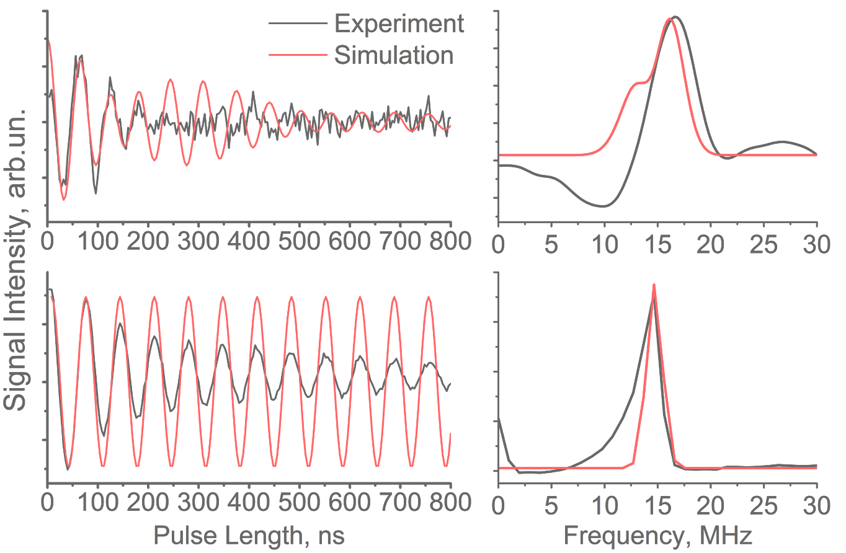
Figure 9. Nutations of ESE signals in the RR-P3HT/PC₆₀BM composite. The black lines show experimental data, the red lines correspond to simulations. Measurements were done at the maximum of the extracted SCPP (g = 2.00105) using the three-pulse microwave sequence shown in the Scheme 3. Durations of π/2 and π echo-forming pulses are 20 ns and 40 ns, respectively, interpulse separation τ = 400 ns. The upper plot shows the signal of the SCPP extracted as described in the text, the simulation was done using the parameters of polaron species summarized in Table 1, dipolar interaction D = 5 MHz, exchange interaction J = 3 MHz. The lower plot corresponds to the signal of separated polarons at T_{DAF} = 99 ms, the simulation was done using the parameters of the polarons summarized in Table 1 and zero magnetic interactions between polarons. The cosine Fourier representations of the experimental and simulated nutation curves are shown in the right part of the plot.

Spectra simulations
We simulated the spectrum of the free species assuming that this spectrum consists of the contributions of two non-interacting polarons RR-P3HT^{•+} and PC₆₀BM^{•-} (Fig. 2). For the calculation we slightly modified the g-tensor values determined in ²⁹. We obtained the best agreement with our experimental data using g_{RR-P3HT}^{•+}=[2.0028 2.0020 2.0009] and g_{PC60BM}^{•-}=[2.0001 2.0001 1.9985] and line widths of 9 MHz (3.2 G) and 4 MHz (1.4G) for RR-P3HT^{•+} and PC₆₀BM^{•-}, respectively. Also we included g-strain as Gaussian shape distribution of g_{RR-P3HT}^{•+} (y) and g_{PC60BM}^{•-} (z) with 0.0006 and 0.002 width, respectively. These values, summarized in table 1, were used for all following calculations. All simulations were done using Matlab R2012b.

Table 1. Simulation parameters for RR-P3HT^{•+} and PC₆₀BM^{•-} polarons.
 | g_{x} | g_{y} | g_{z} | Line width
RR-P3HT^{•+} | 2.0028 | 2.0020  g-strain 0.0006 | 2.0009 | 9 MHz (3.2 G)
PC₆₀BM^{•-} | 2.0001 | 2.0001 | 1.9985  g-strain 0.002 | 4 MHz (1.4G)

The simulation of the nutation experiment (Fig. 10) was done as described in the theory section in order to determine the strengths of magnetic interactions in the SCPP. The calculation was performed at the same g-value as in the experiment. From simulation of nutation traces with different J values we determined ω₁=14.7 MHz from the nutation frequency of the free paramagnetic species. We obtained that the exchange interaction in the SCPP is about 3 MHz. This result is in good agreement with the J < 10 MHz obtained by TR EPR.²⁹ Simulation of the nutation traces also allows to estimate upper and lower limits of the exchange integral in RR-P3HT^{•+}/PC₆₀BM^{•-} SCPP, yielding 1 MHz < J < 5 MHz (Fig. S4). Evidently, dipole interaction is also present in this SCPP, but its influence on the signal is much smaller than that of the exchange interaction; therefore it cannot be determined in the presence of a strong exchange interaction (Fig. S8). We assumed D = 5 MHz for the calculations, although it does not influence the result of the calculation significantly. The upper limit of the dipolar interaction of D < 10 MHz was derived previously from Q-band TR EPR [29], which allows a rough estimation of the lower limit of the distances between the polarons in SCPP giving 1.5 nm. Fast decay of the oscillations in nutation pattern for SCPP is probably caused by distribution of J which was not taken into account in the present simulation.
We simulated the flash-induced ED EPR spectrum for the RR-P3HT/PC₆₀BM composite as a sum of the spectra of non-interacting separated polarons and singlet SCPP with the interaction (Fig. 5) determined from the nutation fitting described above. The contributions of separated polarons and the SCPP to the spectrum of flash-induced species in the RR-P3HT/PC₆₀BM composite are comparable. Furthermore we calculated the theoretical “extracted SCPP spectrum” as a difference of the ESE calculated with a strong pulse and ESE calculated with a weak pulse, multiplied by (Fig. 8), mimicking the protocol described in the Theory section. We can see from both spectra that the PC₆₀BM^{•-} signal at low g-values is reproduced quite well by our simulation, while in the RR-P3HT^{•+} part (high g-values) the experimental and simulated spectra differ significantly. One of the possible reasons for this discrepancy is a correlation of the dipolar axis with the RR-P3HT^{•+} g-tensor orientation for SCPP RR-P3HT^{•+}/PC₆₀BM^{•-} which was not considered in the present calculations. Such correlation was taken into account and indeed led to a reasonable simulation of the RR-P3HT^{•+}/PC₆₀BM^{•-} TR EPR spectrum at X-band, although with a dramatically increased number of fitting parameters.²³ However, there is another possible reason for this discrepancy, which was not considered previously. It can be caused by changes of the polymer g-tensor in the SCPP induced by the presence of an opposite charge in close proximity. Such effect was observed also in nitroxide radicals.⁵⁶ This effect was confirmed by quantum chemical g-factor calculation of the hole on the thiophene oligomer in the vicinity of the electron (Fig. S6). The g-factors were computed with TPSSh functional^{57,58} and def2-SVP basis set^{59,60} using ORCA 4.0,⁶¹ the spin-orbit coupling was computed using the SOMF(1X) approximation.⁶² An increase in the spin delocalization along the chain as the point charge gets further away lead to an increase of the g-factors especially in the directions perpendicular to the polymer chain. (Fig. S7). We simulated extracted SCPP spectrum with modified RR-P3HT^{•+} g-tensor [2.0012 2.0010 2.0009], the other parameters of polaron species summarized in Table 1, dipolar interaction 5 MHz, exchange interaction 3 MHz, and obtained good agreement with the experiment (Fig. S8). However, the g-values shift is higher than that predicted by quantum chemical calculation. We suggest that while the trend of g-value change is correctly reproduced by DFT calculation, its magnitude is underestimated. It is known from high-field EPR that the largest principal g-value of RR-P3HT^{•+} is sensitive to P3HT environment: for RR-P3HT/PC₆₀BM film it is larger by 6*10⁻⁴ than for toluene solution of RR-P3HT/PC₆₀BM. ⁶³ For this reason strong change of RR-P3HT^{•+} g-tensor caused by negative PC₆₀BM polaron in vicinity is not surprising.
The significant J value for RR-P3HT^{•+}/PC₆₀BM^{•-} SCPP obtained in this work apparently contradicts the assumption of zero J in our previous study of out-of-phase ESE for this system.³⁰ We assume that this is caused by the very broad distribution of interspin distances in RR-P3HT^{•+}/PC₆₀BM^{•-} SCPP due to intrinsic disorder of the bulk heterojunction. For long distances J is close to zero and dipolar interaction prevails; these pairs give a major contribution to the out-of-phase ESE. SCPPs with small interspin distances cannot be detected in out-of-phase ESE experiments because of the high modulation frequency. In this case ESE oscillations are lost within the spectrometer dead time. However, these pairs are observable in the ED EPR and nutation experiments described in the present study.

RRa-P3HT/PC₆₀BM composite
We also measured the signal of the SCPP in a similar composite of RRa-P3HT and PC₆₀BM using the same procedure described in the Theory section. The observed signal of the extracted SCPP is significantly wider than that of the RR-P3HT/PC₆₀BM composite (thick blue line in Fig. 10). Already from this nearly symmetric spectral shape a strong coupling between RRa-P3HT^{•+} and PC₆₀BM^{•-} spins can be deduced. We found that extracted SCPP spectrum for RRa-P3HT/PC₆₀BM composite is very similar to usual flash-induced ED EPR spectrum (magenta line in Fig. 10). Since the difference between these two spectra is caused mainly by separated polarons with non-equilibrium polarization, which contribute to the latter spectrum and do not contribute to the former one, this implies that their contribution is negligible. This is not surprising since light-induced charge separation in RRa-P3HT/PC₆₀BM is relatively poor. Therefore, in contrast to RR-P3HT/PC₆₀BM composite, it was not necessary to use a special protocol for extracting the SCPP signal.
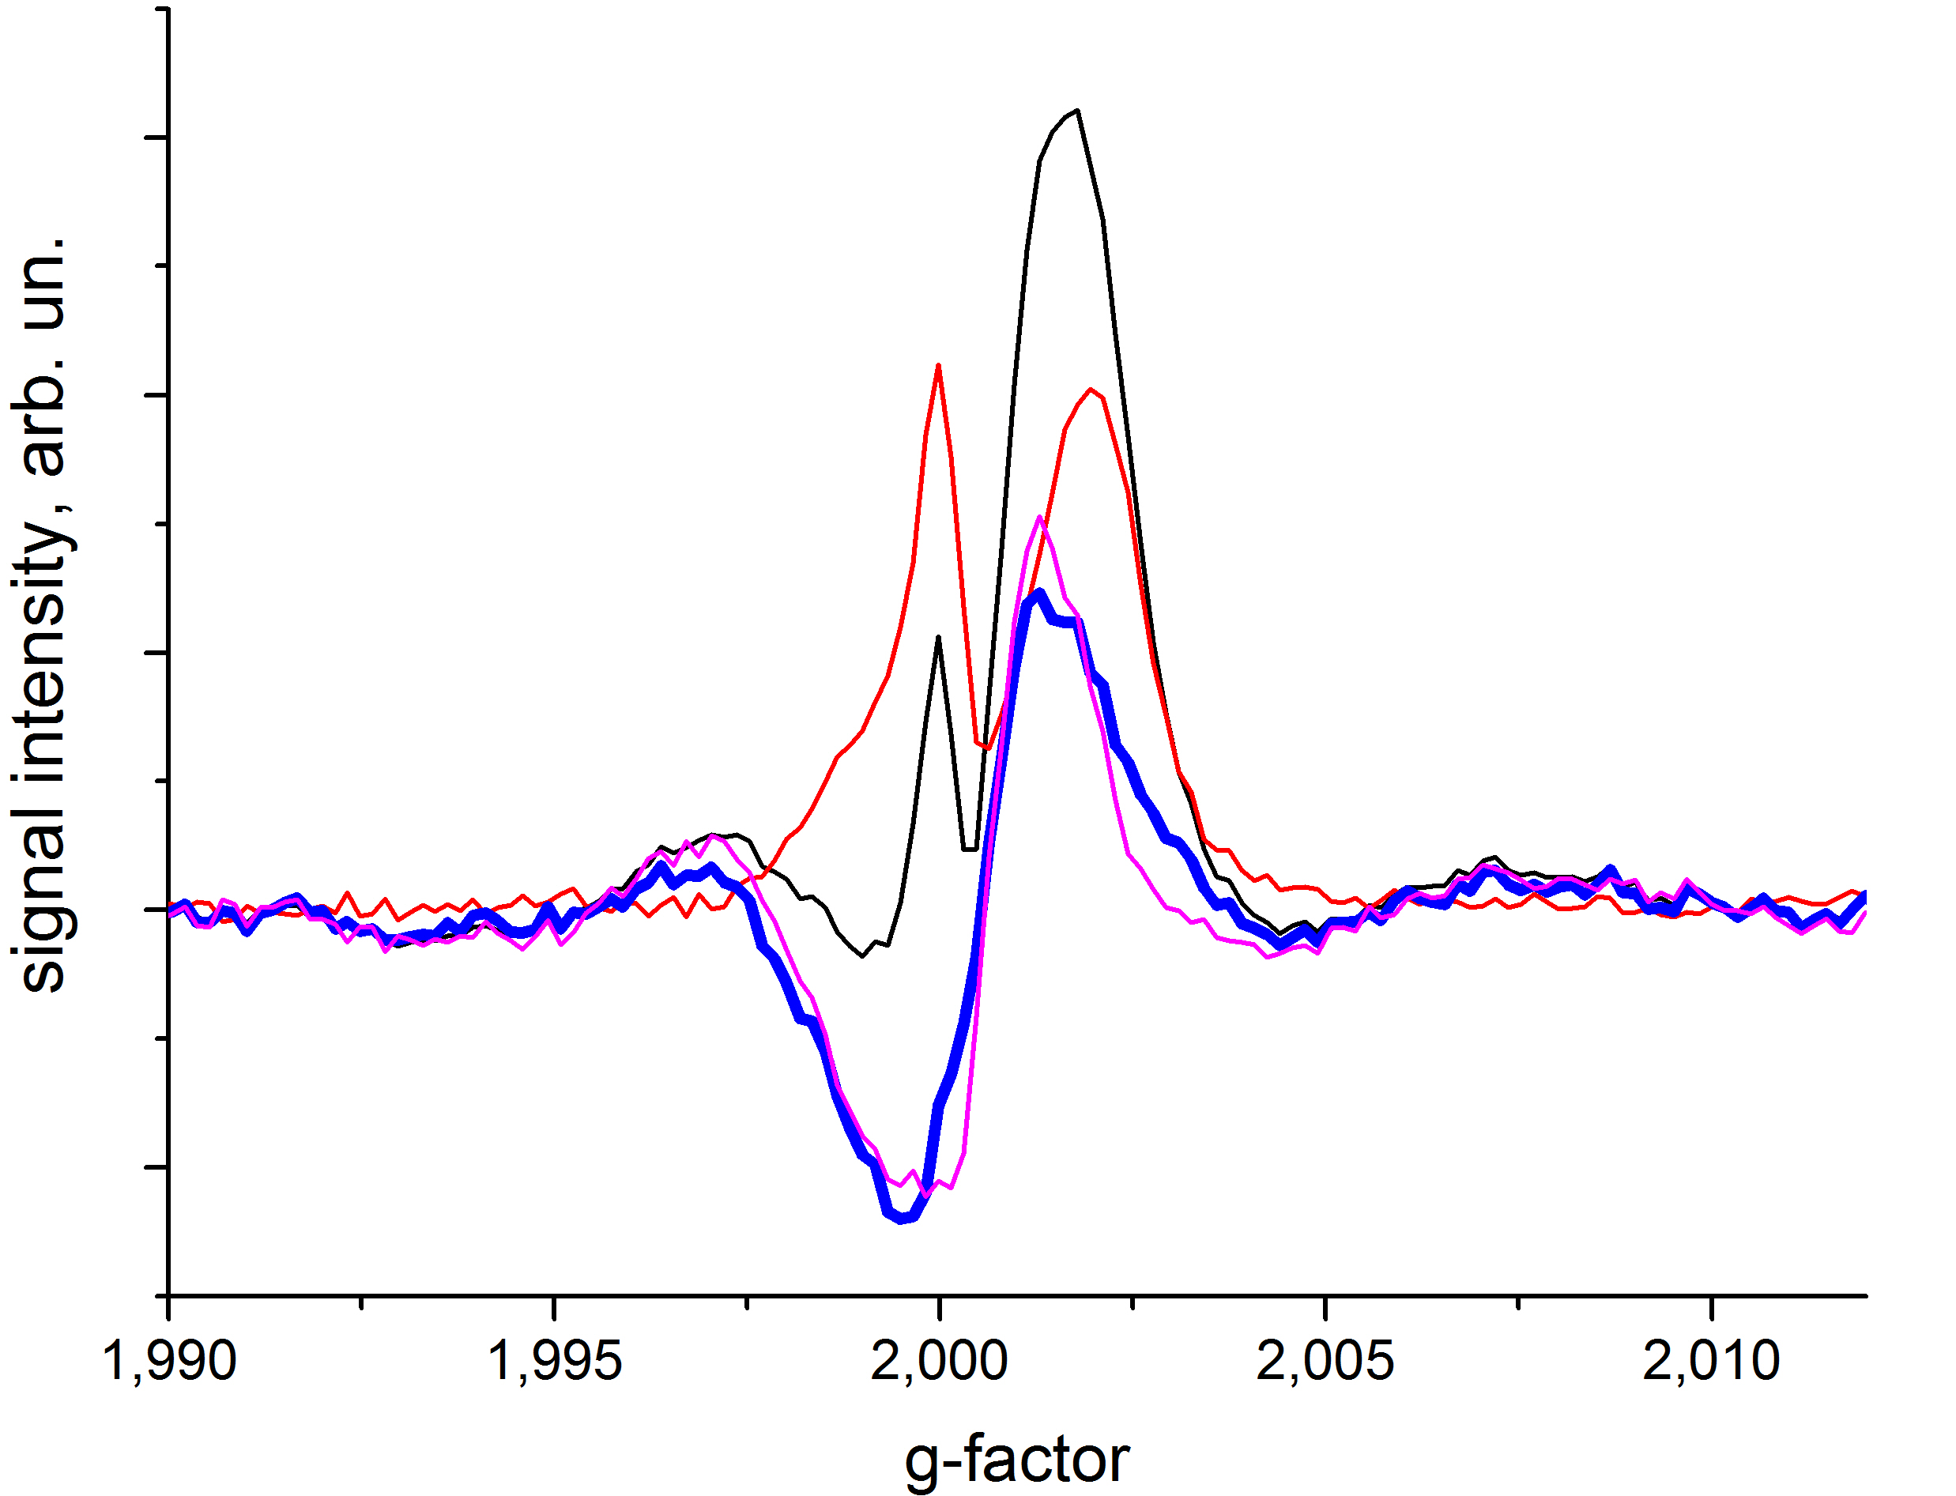

Figure 10. ED EPR spectrum of the extracted SCPP for RRa-P3HT/PC₆₀BM at T_{DAF}=300ns (thick blue line). ED EPR spectra for T_{DAF}=300 ns (black line), T_{DAF}=99 ms (red line) and flash-induced ED EPR spectrum calculated as their difference (magenta line).

In order to determine the magnetic interaction parameters in the SCPP we measured its nutation and compared it with that of the long-living polarons measured at T_{DAF}=99 ms (Fig. 11). The signal of the SCPP was simply determined as a difference between signals measured at T_{DAF} = 300ns and T_{DAF} = 99ms. In both measurements the microwave power reduced by 6 dB with respect to the optimal value for long-living polarons, to increase the relative contribution of SCPP to ESE signal. We applied cosine Fourier transformation for both curves zero-filled up to 1024 points and multiplied by the Gaussian apodization function with w = 500 ns. The nutation frequency 9.5 MHz for the SCPP and 7.2 MHz for the separated polarons were found. The nutation frequencies differ by approximately a factor of 1.32, meaning that the SCPP in this case is very similar to the purely triplet polaron pair, for which the value 1.41 is expected.⁵⁰ This means that in this composite the interaction between radicals in the pair is stronger than the typical difference of the Zeeman frequencies of RRa-P3HT^{•+} and PC₆₀BM^{•-} at Q-band, which is about 50 MHz. This result is in good agreement with the estimation of the dipolar coupling parameter (22G) for RRa-P3HT^{•+}/PC₆₀BM^{•-} derived from TR EPR data.²³ Similarly to the present ESE results, the TR EPR spectrum of RRa-P3HT^{•+}/PC₆₀BM^{•-} is much broader than that of RR-P3HT^{•+}/PC₆₀BM^{•-}. This broadening is mainly caused by the increased strength of the dipolar interaction for RRa-P3HT^{•+}/PC₆₀BM^{•-}, which reflects a smaller distance of charge separation due to a lack of regioregularity and π-conjugation loss in RRa-P3HT.
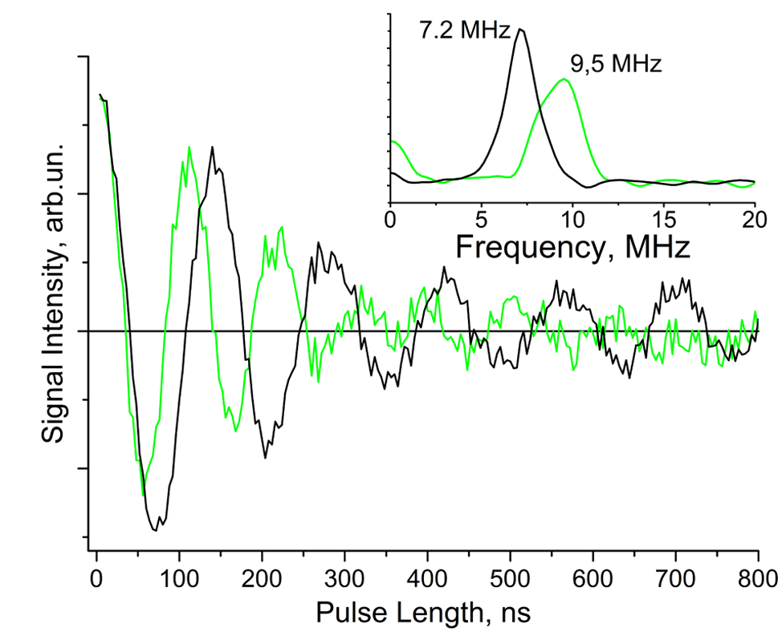
Figure 11. Nutations of ESE signals in the RRa-P3HT/PC₆₀BM composite. Black and green lines correspond to the signal of long-living polarons (T_{DAF} = 99 ms) and flash-induced species (difference of the nutation traces at T_{DAF} = 300 ns and T_{DAF} = 99 ms). Measurements were done at the maximum of the extracted SCPP signal (g=2.00105). The cosine Fourier representation of the nutations is presented in the inset. The nutation frequencies differ by a factor of 1.32.

Other composites
We compared spectra of the flash-induced species measured both in low and high-efficient polymer/PC₆₀BM composites using the pre-saturation pulse sequence (Scheme 2) to suppress the ESE signal of long-living polarons (Fig. 12). In all studied composites the flash-induced ESE signal consists of the same components (SCPP and non-equilibrium separated polarons), but the relative contributions of these species varied. The spectra of thermalized polarons in all these composited are similar: they consist of the PC₆₀BM^{•-} line at lower g-value and the polymer polaron line at higher g-value. However, flash-induced ESE spectra for these composites differ significantly. We observed that the central narrow component corresponding to the SCPP (EPR spectral region between the peaks of PC₆₀BM^{•-} and polymer^{•+}, shaded area in Fig. 12) is dominant in poorly performing MEHPPV/PC₆₀BM and RRa-P3HT/PC₆₀BM composites, comparable to the non-equilibrium separated polaron contribution in RR-P3HT/PC₆₀BM and almost zero in high-efficient PTB7/PC₆₀BM and PCDTBT/PC₆₀BM composites. Importantly, the flash-induced ESE signal for PTB7/PC₆₀BM and PCDTBT/PC₆₀BM composites is almost solely formed by absorptively polarized separated PC₆₀BM^{•-} polarons and emissively polarized separated polymer polarons. This is confirmed by the nearly zero contribution of SCPP to these spectra extracted according to the protocol in the Theory section (data not shown). Thus, the presence of the SCPP signal seems to be inversely correlated with the efficiency of the composite used as the active layer of the organic solar cell.
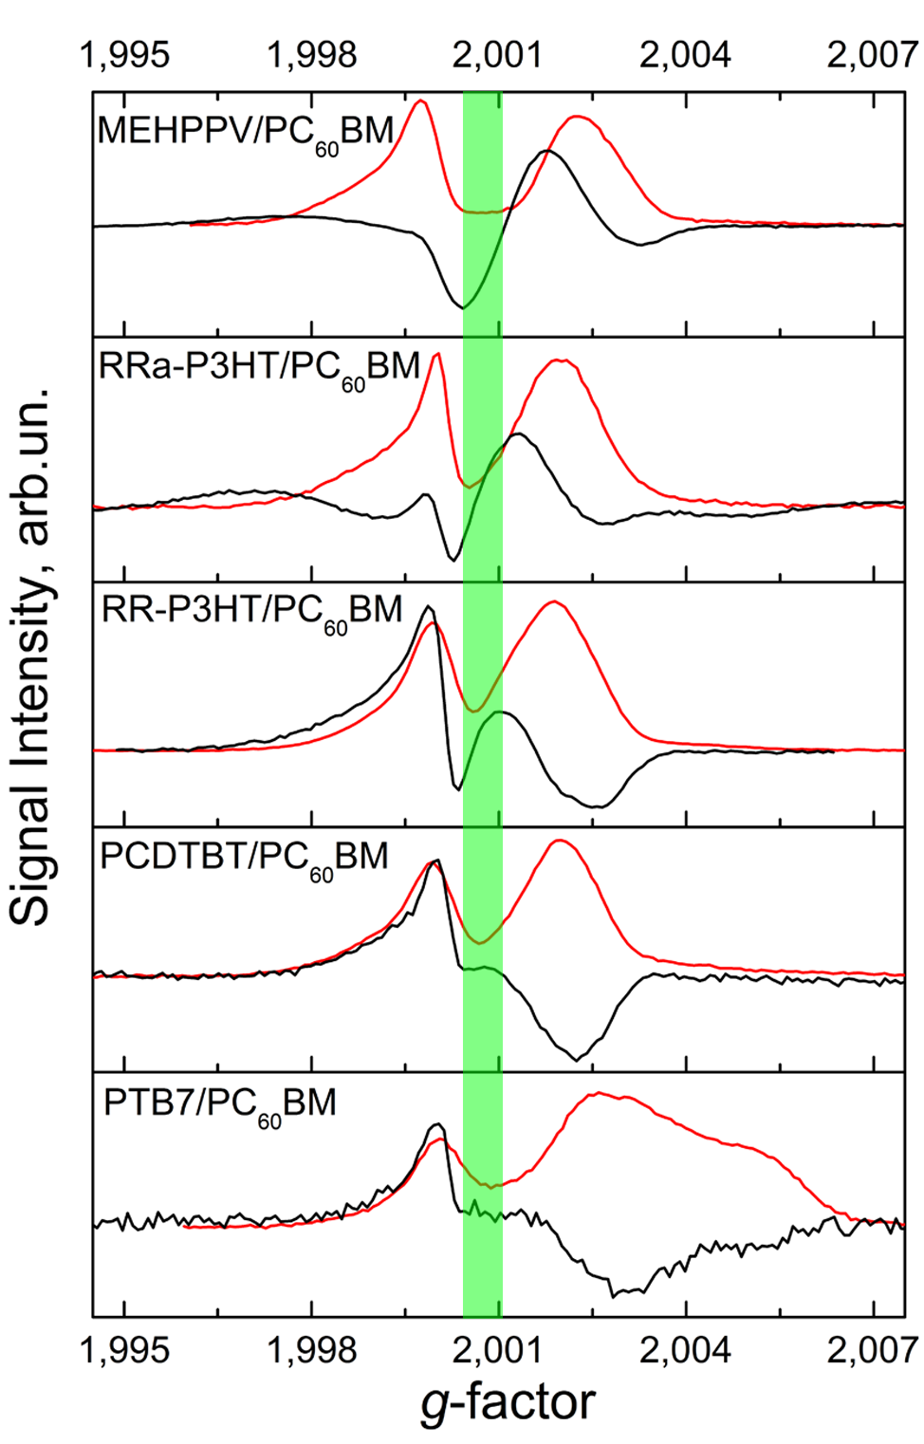
Figure 12. Echo-detected EPR spectra of flash-induced species in different polymer/fullerene composites (black lines). The red lines show spectra of thermalized polarons measured under unsynchronized laser flash irradiation. The green shaded area indicates the region where the signal of thermalized polarons is weak and SCPP signal dominates for composites of moderate efficiency.

Conclusion
The light-induced charge separation in composites of different conductive polymers as an electron donor and PC₆₀BM fullerene as acceptor was studied by pulse Q-band EPR spectroscopy at cryogenic temperatures. Since different pulse sequences can be applied and several experimental parameters can be varied (delays between microwave pulses, pulse amplitude and duration) this technique provides detailed information about the spin dynamics accompanying charge separation in such composites. Using these possibilities we managed to separate contributions of different species to the in-phase flash-induced echo-detected EPR spectra. We found that the in-phase laser flash-induced EPR spectrum consists of several contributions:
- Charge transfer state, which is the spin-correlated polaron pair polymer^{•+}/fullerene^{•-},
- Separated charges, which are the polaron pairs with negligible magnetic interaction and A/E spin polarization,
- Change of the spin polarization of pre-existing polarons in deep traps caused by the laser flash.
The latter contribution was not considered before. However, all of them are of importance for a correct interpretation of the flash-induced ESE signal in polymer/fullerene blends because they often have comparable magnitude. It is expected that all these contributions are also present in TR EPR spectra of polymer/fullerene composites, which are similar to some extent with respect to their in-phase flash-induced echo-detected EPR spectra.
A method for determination of the strength of magnetic interaction between polymer^{•+} and fullerene^{•-} spins using microwave nutation patterns is proposed. We simulated both ESE nutation pattern and ED EPR spectra of the RR-P3HT/PC₆₀BM composite and found that an average exchange integral of about J = 3 MHz for the SCPP in this composite. A nonzero dipolar interaction is expected in this case, but its value cannot be determined in the presence of a strong exchange interactions. Species with such relatively strong exchange interaction were not detected in previous out-of-phase ESE experiment on the RR-P3HT/PC₆₀BM composite. Inconsistency of the interpretation of the experimental results obtained by different techniques (TR EPR, out-of-phase ESEEM and nutations) is probably caused by a broad distribution of the initial charge transfer distances.
The contribution of the SCPPs to the flash-induced ESE signal is large in composites with low-efficient polymers, while in composites with high-efficient polymers it is low. Thus the intensity of the SCPP ESE signal can be used to predict the charge separation efficiency in such composites. To analyze the charge separation efficiency quantitatively the distribution of CT states over the distance between polarons should be reconstructed from ESE data, which is in progress now in our laboratories.

Conflicts of interest
There are no conflicts of interest to declare.
Acknowledgements
The work was supported by the Russian Foundation for Basic Research grant №15-03-07682 and №15-03-03242 and by Alexander von Humboldt Foundation research group linkage project "Light-induced processes and paramagnetic species in organic photovoltaics and photosynthesis". The authors thank Dr. A. G. Maryasov for helpful discussion of SCRP theory.
Supporting Information Available:
ED EPR spectra of RR-P3HT/PC₆₀BM composite in the dark and under continuous light illumination, ED flash-induced EPR spectra of RR-P3HT/PC₆₀BM measured with pre-saturation at different temperatures, simulations of the nutation curves for tight SCPP RR-P3HT^{•+}/PC₆₀BM^{•-} with different parameters of exchange and dipolar interactions, model system for DFT calculation and computed g-factors of the positively charged polythiophene polaron as a function of a distance to a negative point charge, simulation of extracted SCPP spectrum with modified RR-P3HT^{•+} g-tensor.

References
- C. Deibel and V. Dyakonov, Rep. Prog. Phys., 2010, 73, 096401.
- K.A. Mazzio and C.K. Luscombe, Chem. Soc. Rev., 2015, 44, 78-90.
- J. Etxebarria, R. Ajuria and R. Pacios, Org. Electron., 2015, 19, 34–60.
- L. Lu, T. Zheng, Q. Wu, A.M. Schneider, D. Zhao and L. Yu, Chem. Rev., 2015, 115, 12666–12731.
- X. Liu, H. Chen and S. Tan, Renew. Sust. Energ. Rev., 2015, 52, 1527–1538.
- O. Ostroverkhova, Chem. Rev., 2016, 116, 13279−13412.
- M.A. Green, K. Emery, Y. Hishikawa, W. Warta, E.D. Dunlop, D.H. Levi and A.W.Y. Ho-Baillie Prog. Photovolt: Res. Appl., 2017, 25, 3–13.
- B. Hemavathi, T.N. Ahipa and R.K. Pai, Eur. Polym. J., 2015, 72, 309–340.
- L. Dou, Y. Liu, Z. Hong, G. Li and Y. Yang, Chem. Rev., 2015, 115, 12633–12665.
- F. Meyer, Prog. Polym. Sci., 2015, 47, 70–91.
- L. Ying, F. Huang and G.C. Bazan, Nat. Commun., 2017, 8, 14047.
- R. Ganesamoorthy, G. Sathiyan and P. Sakthivel, Sol. Energ. Mat. Sol. Cells., 2017, 161, 102–148.
- C.B. Nielsen, S. Holliday, H.-Y. Chen, S.J. Cryer and I. McCulloch, Acc. Chem. Res., 2015, 48, 2803−2812.
- W. Chen and Q. Zhang, J. Mater. Chem. C, 2017, 5, 1275-1302.
- J.-L. Bredas, J.E. Norton, J. Cornil and V. Copopceanu, Acc. Chem. Res., 2009, 42, 1691-1699.
- T.M. Clarke and J.R. Durrant, Chem. Rev., 2010, 110, 6736-6767.
- C. Deibel, T. Strobel and V. Dyakonov, Adv. Mater., 2010, 22, 4097-4111.
- F. Gao and O. Inganas, Phys. Chem. Chem. Phys., 2014, 16, 20291-20304.
- S. Few, J.M. Frost and J. Nelson, Phys. Chem. Chem. Phys., 2015, 17, 2311-2325.
- A.J. Barker, K. Chen and J.M. Hodgkiss, J. Am. Chem. Soc., 2014, 136, 12018-12026.
- S. Gelinas, A. Rao, A. Kumar, S.L. Smith, A.W. Chin, J. Clark, T.S. van der Poll, G.C. Bazan and R.H. Friend, Science, 2014, 343, 512-516.
- J. Behrends, A. Sperlich, A. Schnegg, T. Biskup, C. Teutloff, K. Lips, V. Dyakonov and R. Bittl, Phys. Rev. B, 2012, 85, 125206.
- Y. Kobori, R. Noji and S. Tsuganezawa, J. Phys. Chem. C, 2013, 117, 1589-1599.
- L. Franco, A. Toffoletti, M. Ruzzi, L. Montanari, C. Carati, L. Bonoldi and R. Po, J. Phys. Chem. C, 2013, 117, 1554-1560.
- F. Kraffert, R. Steyrleuthner, S. Albrecht, D. Neher, M.C. Scharber, R. Bittl and J. Behrends, J. Phys. Chem. C, 2014, 118, 28482-28493.
- J., S. Beaupre, M. Leclerc, T. Xu, L. Yu, A. Sperlich, V. Dyakonov and O.G. Poluektov, J. Phys. Chem. B, 2015, 119, 7407–7416.
- Y. Kobori and T. Miura, J. Phys. Chem. Lett., 2015, 6, 113−123.
- T. Miura, R. Tao, S. Shibata, T. Umeyama, T. Tachikawa, H. Imahori and Y. Kobori, J. Am. Chem. Soc., 2016, 138, 5879−5885.
- F. Kraﬀert and J. Behrends, Mol. Phys., 2017, DOI: 10.1080/00268976.2016.1278479.
- E.A. Lukina, A.A. Popov, M.N. Uvarov and L.V. Kulik, J. Phys. Chem. B, 2015, 119, 13543-13548.
- E.A. Lukina, A.A. Popov, M.N. Uvarov, E.A. Suturina, E.J. Reijerse and L.V. Kulik, Phys. Chem. Chem. Phys., 2016, 18, 28585-28593.
- M.N. Uvarov and L.V. Kulik, Appl. Magn. Reson., 2013, 44, 97–106.
- M.N. Uvarov, A.G. Popov, E.A. Lukina and L.V. Kulik, J. Struct. Chem., 2014, 4, 644-650.
- P.J. Hore, D.A. Hunter and C.D. McKie, Chem. Phys. Lett., 1987, 137, 495-500.
- K.M. Salikhov, Y.E. Kandrashkin and A.K. Salikhov, Appl. Magn. Reson., 1992, 3, 199-216.
- J. Tang, M.C. Thurnauer and J.R. Norris, Chem. Phys. Lett., 1994, 219, 283-290.
- S.A. Dzuba, P.Gast and A.J. Hoff, Chem. Phys. Lett., 1995, 236, 595-602.
- S.G. Zech, W. Lubitz and R. Bittl, Ber. Bunsenges. Phys. Chem., 1996, 100, 2041-2044.
- H. Hara, S.A. Dzuba, A. Kawamori, K. Akabori, T. Tomo, K. Satoh, M. Iwaki and S. Itoh, Biochim. Biophys. Acta, 1997, 1322, 77-85.
- S.G. Zech, J. Kurreck, H.J. Eckert, G. Renger, W. Lubitz and R. Bittl, FEBS Lett., 1997, 414, 454-456.
- A. Kamlowski, S.G. Zech, P. Fromme, R. Bittl, W. Lubitz, H.T. Witt and D. Stehlik, J. Phys. Chem. B, 1998, 102, 8266-8277.
- S.G. Zech, J. Kurreck, G. Renger, W. Lubitz and R. Bittl, FEBS Lett., 1999, 442, 79-82.
- I.V. Borovykh, L.V. Kulik, S.A. Dzuba and A.J. Hoff, Chem. Phys. Lett., 2001, 338, 173–179.
- P.J. Hore, Mol. Phys., 1996, 89, 1195-1202.
- A.A. Popov, E.A. Lukina, L. Rapatskiy and L.V. Kulik, J. Magn. Reson., 2017, 276, 86-94.
- P.J. Hore, D.J. Riley, J.J. Semlyen, G. Zwanenburg and A.J. Hoff, Biochim. Biophys. Acta, 1993, 1141, 221-230.
- M.T. Colvin, R. Carmiely, T. Miura, S. Richert, D.M. Gardner, A.L. Smeigh, S.M. Dyar, S.M. Conron, M.A. Ratner and M.R. Wasilevski, J. Phys. Chem A, 2013, 117, 5314-5325.
- C.R. Timmel and P.J. Hore, Chem. Phys. Lett., 1994, 226, 144-150.
- A.J. Hoff, P. Gast, S.A. Dzuba, C.R. Timmel, C.E. Fursman and P.J. Hore, Spectrochim. Acta, Part A, 1998, 54, 2283-2293.
- A. Schweiger and G. Jeschke, Principles of Pulse Electron Paramagnetic Resonance. Oxford University Press: New York, USA, 2005.
- E. Reijerse, F. Lendzian, R. Isaacson and W. Lubitz, J. Magn. Reson., 2012, 214, 237-243
- J.M. Hodgkiss, S. Albert-Seifried, A. Rao, A.J. Barker, A.R. Campbell, R.A. Marsh and R. H. Friend, Adv. Funct. Mater., 2012, 22, 1567–1577.
- S. van Reenen, M.V. Vitorino, S.C.J. Meskers, R.A.J. Janssen and M. Kemerink, Phys. Rev. B, 2014, 89, 205206.
- Y. Harima, T. Eguchi, K. Yamashita, K. Kojima and M. Shiotani, Synth. Met., 1999, 105, 121-128.
- C. Corvaja, L. Franco, L. Pasimeni, A. Toffoletti and L. Montanari, Chem. Phys. Lett., 1993, 210, 355-361.
- A.F. Gulla and D.E. Budil, J. Phys. Chem. B, 2001, 105, 8056−8063.
- J. Tao, J.P. Perdew, V.N. Staroverov and G.E. Scuseria, Phys. Rev. Lett., 2003, 91, 146401.
- V.N. Staroverov, G.E. Scuseria, J. Tao and J.P. Perdew, J. Chem. Phys., 2003, 119, 12129.
- F. Weigend and R. Ahlrichs, Phys. Chem. Chem. Phys., 2005, 7, 3297-3305.
- F. Weigend, Phys. Chem. Chem. Phys., 2006, 8, 1057-1065.
- F. Neese, Wires Comput. Mol. Sci., 2012, 2, 73-78.
- F. Neese, J. Chem. Phys., 2005, 122, 034107.
- J. Niklas. K. L. Mardis, B. P. Banks, G. M Grooms, A. Sperlich, V. Dyakonov, S. Beaupre, M. Leclerc, T. Xu, L. Yu, L. and O. G. Poluektov, Phys. Chem. Chem. Phys. 2013, 15, 9562-9574.

