Supporting information

In situ determination of the nanostructure effects on the activity, stability and selectivity of Pt-Sn ethanol oxidation catalysts
Laura Calvillo^{a,b,}*, Lucila Méndez De Leo^{c}, Stephen J. Thompsonª, Stephen W. T. Price^{a,d}, Ernesto J. Calvo^{c}, Andrea E. Russell^{a,*}
ªChemistry, University of Southampton, Highfield, Southampton SO17 1BJ, UK
^{b}Dipartimento di Scienze Chimiche, Università di Padova, Via Marzolo 1, 35131, Padova, Italy
^{c}INQUIMAE, Departamento de Química Inorgánica, Analítica y Química Física, Facultad de Ciencias Exactas y Naturales, Universidad de Buenos Aires, Argentina
^{d}Diamond Light Source Ltd, Harwell Science and Innovation Campus, Didcot OX11 0DE, UK

* laura.calvillolamana@unipd.it (L. Calvillo); a.e.russell@soton.ac.uk (A.E. Russell)

Transmission Electron Microscopy (TEM) images
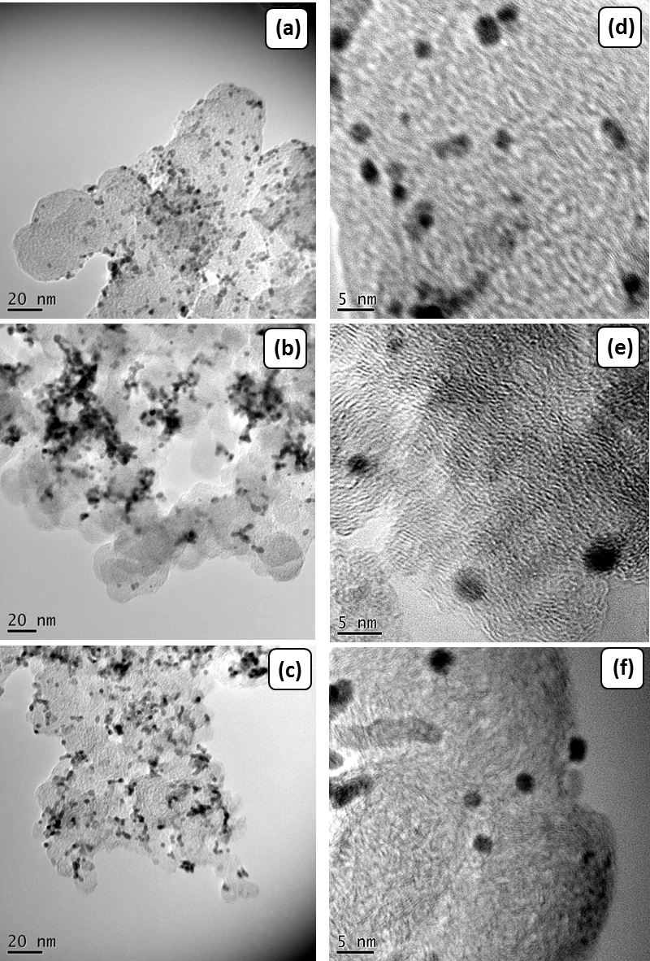
Figure S1. Low- (a,b,c) and high-magnification (d,e,f) TEM images of the Pt-Sn catalysts with different nanostructures and compositions supported on carbon: (a,d) Sn/Pt/C; (b,e) Pt₃Sn₁/C; and (c,f) Pt₁Sn₁/C.

Physicochemical properties: XRD, XPS
Table S1. Physicochemical properties of the as-prepared Pt-Sn materials supported on carbon and the commercial Pt/C catalyst from JM.
Sample | ªMetal loading /wt.% | ªPt:Sn atomic ratio | ^{b}Average crystallite size /nm | ^{b}Lattice  parameter /Å | ^{c}Sn_{al}  /%
Pt/C-JM | 21 | --- | 4.0 | 3.9175 | ---
Sn/Pt/C | 25.9 | 71:29 | 4.0 | 3.9196 | 8.0
Pt₃Sn₁/C | 19.5 | 82:18 | 3.4 | 3.9778 | 92.6
Pt₁Sn₁/C | 19.9 | 60:40 | 3.3 | 4.0260 | 66.8
ª Determined by SEM-EDX
^{b} Determined from XRD
^{c} Sn content of the alloy phase calculated from the lattice parameter using Vergard’s law

Table S2. Electronic and composition parameters of the commercial Pt/C and as-prepared Pt-Sn/C catalysts.
Sample | Binding energy / eV |  |  | Pt/Sn Atomic ratio
 | Pt 4f_{7/2} | Sn 3d_{5/2} |  | SEM-EDX | XPS
Pt/C-JM | 71.5 (62)  72.8 (24)  74.2 (14) | --- |  | --- | ---
Sn/Pt/C | 71.5 (74)  72.8 (17)  74.3 (9) | 487.43 (100) |  | 3.0 | 2.0
Pt₃Sn₁/C | 71.3 (78)  72.8 (15)  74.5 (7) | 485.7 (34)  487.5 (66) |  | 4.5 | 3.8
Pt₁Sn₁/C | 71.5 (68)  72.7 (22)  74.2 (10) | 485.6 (2)  487.5 (98) |  | 1.5 | 1.15

Ex situ XAS measurements
Ex situ XAS measurements were carried out in order to confirm the structural and electronic effects of Sn on Pt. The samples were prepared as pellets by mixing the ground sample with cellulose to form a homogenous mixture, and then compressed using a pellet press. Two different pellets of each sample were used for the Pt L₃ and Sn K edges so as to optimize the adsorption edge step of the studied element and the total adsorption.
The EXAFS data and the corresponding fitted parameters at the Pt L₃ and Sn K edges for the Pt/C-JM and Pt-Sn/C catalysts are reported in Figure S2 and Table S3. The results are in good agreement with the information obtained by XRD and XPS. For the Sn modified Pt sample, it was confirmed that the deposition of tin on the Pt surface does not cause any structural modification to the bulk of the Pt nanoparticles, since the Pt-Pt bond length in these samples is the same as that for the Pt/C-JM sample used in their synthesis. The inclusion of a first shell Pt-Sn path did not improve the quality of the fit for the Pt edge data and therefore, it was excluded. In addition, it was also confirmed that the modification of Pt nanoparticles with a monolayer of tin on the surface does not perturb the electronic structure of Pt as illustrated in the XANES shown in Figure S3. At the Sn K edge, the EXAFS is dominated by the Sn-O coordination, confirming the formation of a SnO₂ layer on the Pt NPs. The Sn-Pt interaction was not detected, which could be attributed to the fact that it is too small compared with the Sn-O signal.
Table S3. Structural parameters obtained for the Pt-Sn materials supported on carbon and the commercial Pt/C catalyst (JM) from fitting both the Pt L₃ and Sn K edge EXAFS data acquired under air.
Sample | Shell | N | R/Å | σ² x 10⁴/ Å² | ΔE₀/eV | R_{f}
Pt/C-JM | Pt-Pt₁ | 5.1 ± 0.5 | 2.754 ± 0.004 | 68 ± 7 | 10.6 ± 0.8 | 0.007
 | Pt-O₁ | 2.4 ± 0.3 | 1.998 ± 0.008 | 56 ± 19
Sn/Pt/C | Pt-Pt₁ | 6.0 ± 0.5 | 2.748 ± 0.004 | 64 ± 4 | 8.8 ± 0.8 | 0.007
 | Pt-O₁ | 2.1 ± 0.3 | 1.989 ± 0.009 | 66 ± 19
 | Sn-Sn₁ | 0.8 ± 0.3 | 3.195 ± 0.009 | 25 ± 19 | 6.1 ± 0.4 | 0.007
 | Sn-O₁ | 5.6 ± 0.2 | 2.058 ± 0.004 | 42 ± 5
Pt₃Sn₁/C | Pt-Pt₁ | 6.2 ± 0.7 | 2.766 ± 0.008 | 80 ± 6 | 7.8 ± 1.2 | 0.010
 | Pt-Sn₁ | 2.4 ± 1.3 | 2.826 ± 0.022 | 160 ± 78
 | Pt-O₁ | 1.6 ± 0.4 | 1.980 ± 0.015 | 74 ± 31
 | Sn-Pt₁ | 4.2 ± 0.8 | 2.812 ± 0.007 | 86 ± 12 | 5.8 ± 0.8 | 0.006
 | Sn-O₁ | 3.6 ± 0.3 | 2.051 ± 0.006 | 42 ± 8

In the case of the Pt-Sn alloys, the main differences compared to the Sn modified Pt sample are the increase in the Pt-Pt bond length, due to the incorporation of Sn into the fcc structure of Pt, and the modification of the Pt electronic structure, due to an electron transfer from Sn to Pt. For Pt₃Sn₁/C sample, the tendency of Sn to segregate onto the surface of the nanoparticles is reflected in the Pt-Sn₁ bond length. For a Pt-Sn alloy, the same Pt-Pt and Pt-Sn bond length would be expected; however, in this case, the Pt-Pt₁ is shorter than the Pt-Sn₁ bond length, which could be the consequence of the Sn segregation observed by XPS. The content of oxygen observed in all the samples is the consequence of the surface oxidation due to the contact with air, which is in good agreement with the oxidation state of the Pt determined from the XPS. At the Sn K edge, a significant Sn-O coordination was also obtained for the Pt-Sn alloy and is attributed to surface segregation of Sn, which may be facilitated by exposure of the catalyst to air. For the Pt₁Sn₁/C sample, it was not possible to fit the EXAFS to a single phase model. This is in agreement with the XRD, which showed that Pt₁Sn₁ nanoparticles are a mixture of the fcc phase and a considerable amount of Sn not alloyed to Pt and present as SnO₂ mainly on the surface. The quality of the data precluded fitting such a heterogeneous structure.
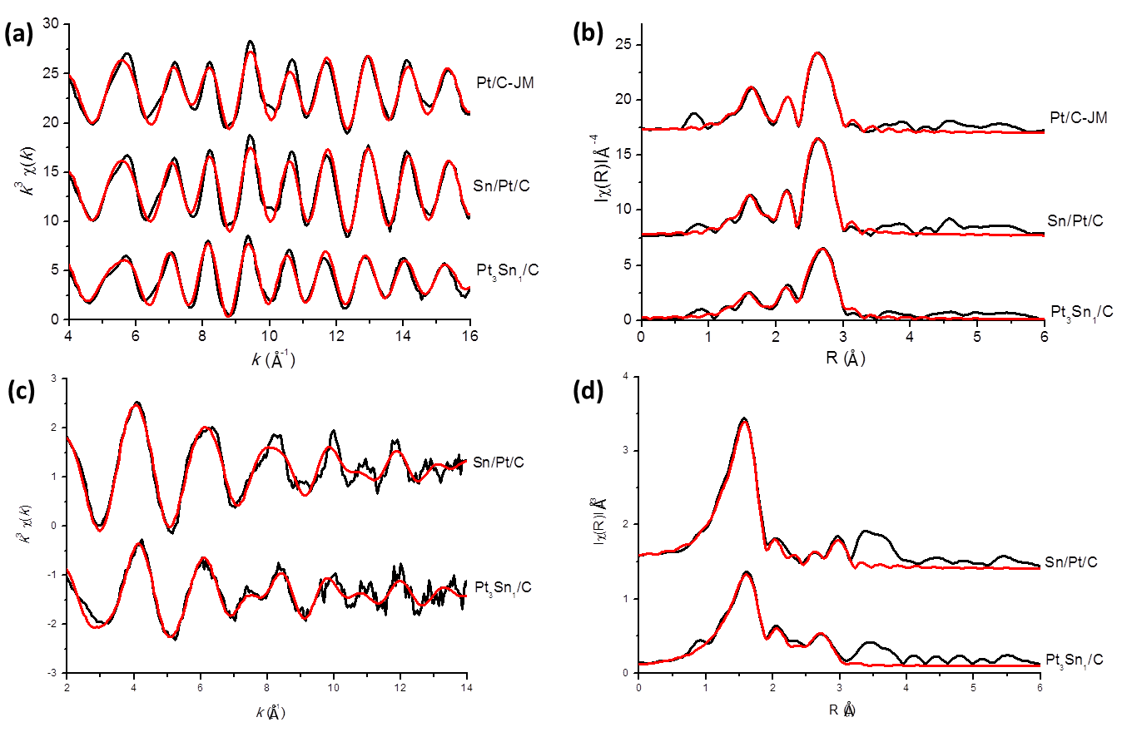
Figure S2. k³/k² weighted experimental data (black) and fit (red) with the corresponding Fourier transform for the Pt-Sn/C catalysts and for the commercial Pt/C catalyst from JM recorded at the Pt L₃ (a, b) and Sn K (c, d) edges, respectively.
Figure S3a and S3b shows the Pt L₃ and Sn K edge XANES spectra obtained ex situ for the commercial Pt/C-JM, Sn modified Pt and Pt-Sn alloy materials. At the Pt L₃ edge (11564 eV), the absorption corresponds to 2p_{3/5} – 5d electronic transitions and the magnitude of the white line (around 5 eV from the edge) is directly related to the occupancy of the 5d electronic states or the Pt oxidation state. As seen in Figure S3a, the white line of the materials studied in this work present a higher intensity than that of the Pt foil. Pt/C-JM shows the highest white line indicating that Pt is oxidized due to the contact with air, as the Pt particles are small (4 nm), a high percentage of the Pt atoms are on the surface forming platinum oxide. In the case of Sn modified Pt materials, the Sn monolayer prevents the Pt atoms to oxidize, therefore, the white line of these materials is lower than that for Pt/C-JM. The lowering of the white line observed for the Pt₃Sn₁/C could be attributed to the filling of the 5d-band due to the alloying with Sn, that is, due to an electron transfer from Sn to Pt, confirming the result obtained by XPS. The absence of this electronic effect in the XANES spectrum of Pt₁Sn₁/C could be attributed to the amorphous structure of this material and its low grade of alloying, as seen by XRD. From these results it could be stated that Sn, when is alloyed with Pt, modifies the electronic structure of Pt but, when is deposited on the Pt surface, it does not perturb the Pt electronic structure.
At the Sn K edge (29200 eV), the absorption corresponds to 1s – 5p electronic transitions. As seen in Figure S3b, the increase of the intensity of the white line for the alloy Pt₃Sn₁/C, respect to that of Sn foil, could be associated to both the electron transfer from Sn to Pt and the formation of oxidized species of Sn on the surface of the nanoparticles. The shift in the edge energy has already been observed by Mukerjee and McBreen¹; they attributed this fact to the change in the crystal symmetry from the tetragonal white Sn allotropic form to the fcc structure. The XANES spectra for the Sn modified Pt materials is very similar to that for SnO₂, confirming that tin deposited on the surface of Pt nanoparticles forms tin dioxide. Pt₁Sn₁/C shows a XANES spectrum very similar to that of SnO₂ as well. This could be the result of the segregation of Sn to the surface of the nanoparticles and its subsequent oxidation, as observed by XRD. Again, the absence of the electronic effect could reflect the presence of two different phases and the low extent of alloying.
Figure S3. XANES spectra at (a,c) Pt L₃ edge for Pt/C-JM (black), Sn/Pt/C (cyan), Pt₃Sn₁/C (red), Pt₁Sn₁/C (blue) and Pt foil (grey); and (b,d) Sn K edge for SnO₂ (black), Sn/Pt/C (cyan), Pt₃Sn₁/C (red), Pt₁Sn₁/C (blue) and Sn foil (grey).

In situ XAS characterization
Prior to the XAS measurements, three cyclic voltammograms were collected between 0.05 and 0.6 V vs RHE at 50 mV s⁻¹, starting the scan at the OCP, to clean the surface and ensure fully contact between the electrode and electrolyte. Three further cycles were recorded at 10 mV s⁻¹ to ensure that the electrode was stable. A linear scan voltammetry was run to reach the desired potential for the XAS measurements.
Table S4. Structural parameters obtained for the Pt/C-JM catalyst from fitting the Pt L₃ edge EXAFS data acquired under potential control in 0.5M H₂SO₄ and in 0.5M CH₃CH₂OH + 0.5M H₂SO₄.
Electrolyte | Potential  vs RHE | Shell | N | R  /Å | σ² x 10⁴  / Å² | ΔE₀  /eV | R_{f}
0.5M H₂SO₄ | 0.2 V | Pt-Pt₁ | 8.96 ± 0.29 | 2.747 ± 0.002 | 57 ± 2 | 6.9 ± 0.3 | 0.005
 | 0.4 V | Pt-Pt₁ | 9.07 ± 0.30 | 2.748 ± 0.002 | 58 ± 1 | 7.1 ± 0.3 | 0.006
 | 0.6 V | Pt-Pt₁ | 8.64 ± 0.32 | 2.744 ± 0.002 | 58 ± 2 | 7.1 ± 0.3 | 0.007
0.5M EtOH  + 0.5M H₂SO₄ | 0.2 V | Pt-Pt₁ | 9.27 ± 0.30 | 2.747 ± 0.002 | 60 ± 1 | 7.0 ± 0.3 | 0.005
 | 0.4 V | Pt-Pt₁ | 9.24 ± 0.34 | 2.749 ± 0.002 | 60 ± 2 | 7.0 ± 0.3 | 0.007
 | 0.6 V | Pt-Pt₁ | 9.05 ± 0.33 | 2.746 ± 0.002 | 59 ± 2 | 6.7 ± 0.3 | 0.007

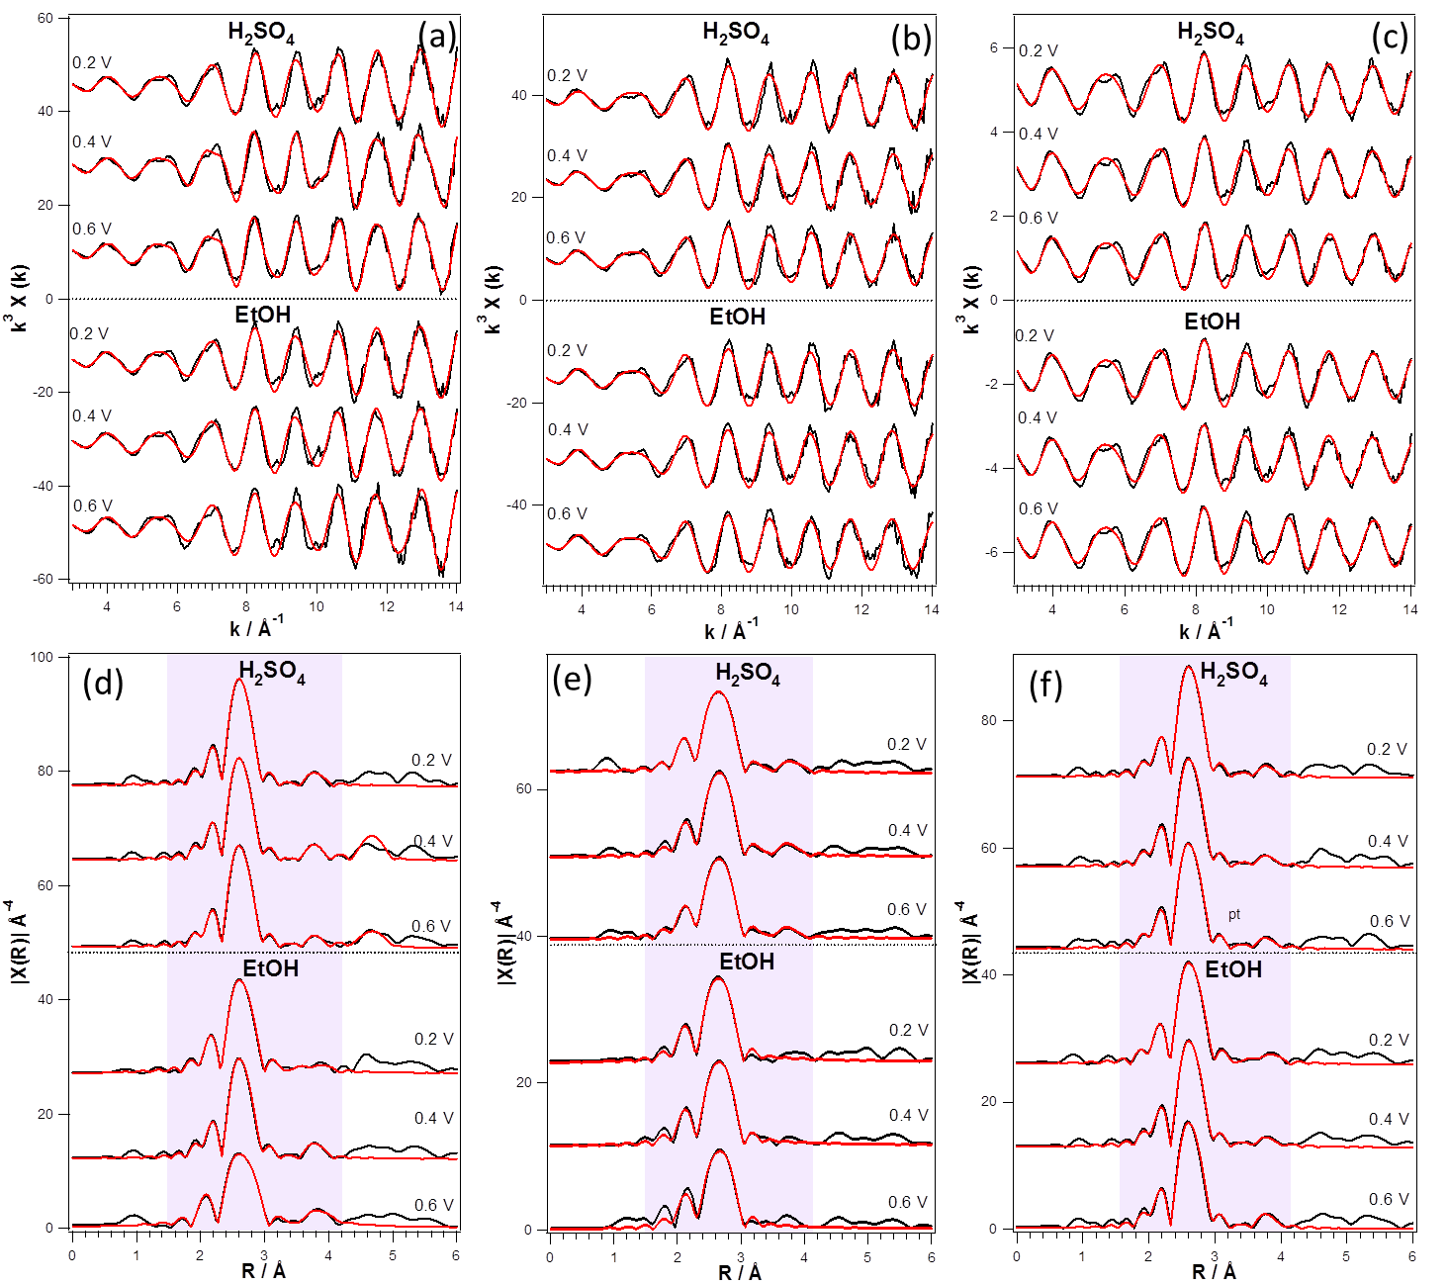
Figure S4. k³ weighted experimental data (black) and fit (red) with the corresponding Fourier transform for Sn/Pt/C (a,d), Pt₃Sn/C (b,e) and Pt/C-JM (c,f) catalysts recorded under potential control at the Pt L₃ edge in 0.5 M H₂SO₄ and 0.5 M CH₃CH₂OH + 0.5 M H₂SO₄.
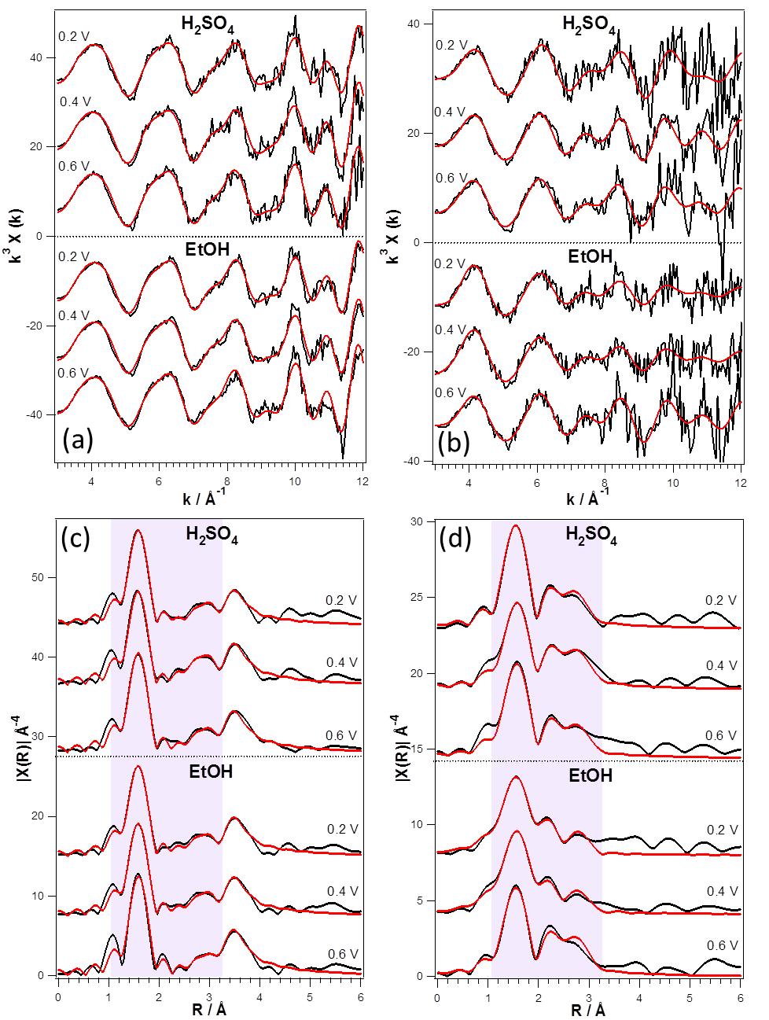
Figure S5. k³ weighted experimental data (black) and fit (red) with the corresponding Fourier transform for the Sn/Pt/C (a,c) and Pt₃Sn/C (b,d) catalysts recorded under potential control at the Sn K edge in 0.5 M H₂SO₄ and 0.5 M CH₃CH₂OH + 0.5 M H₂SO₄.

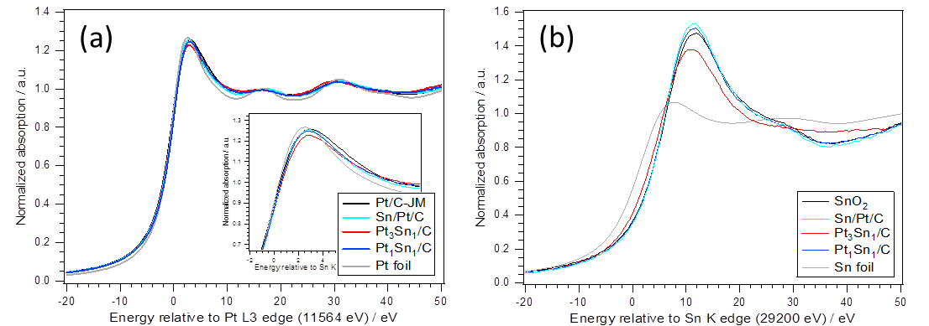
Figure S6. XANES spectra recorded in situ at 0.4 V vs RHE at (a) Pt L₃ edge for Pt/C-JM (black), Sn/Pt/C (cyan), Pt₃Sn₁/C (red), Pt₁Sn₁/C (blue) and Pt foil (grey); and (b) Sn K edge for SnO₂ (black), Sn/Pt/C (cyan), Pt₃Sn₁/C (red), Pt₁Sn₁/C (blue) and Sn foil (grey).

CO-stripping
CO (99.99 %, BOC) was bubbled at 1 atm though the electrolyte for 15 min while the potential was hold at 0.20 V vs RHE, in order to adsorb one monolayer of this gas onto the Pt surface. Then, nitrogen gas was used to purge out the CO-containing gas for 15 min. A potential scanning between 0.05 to 1.0 V vs. RHE at 0.02 V s⁻¹ was then carried out to induce the oxidation of CO for three complete scans. The electrochemical active surface area was determined from the CO oxidation peak area assuming a charge of 420 µC cm⁻² involved in the oxidation of a monolayer of linearly adsorbed CO.
In addition, this experiment gives information about the tolerance of the Pt-Sn catalysts to CO since it is known that, during the oxidation of alcohols, CO is produced and adsorbed on the surface of platinum preventing the adsorption of the reactives. Figure S4 shows the cyclic voltammograms obtained during the stripping of a monolayer of CO adsorbed on the catalysts at 0.2 V vs. RHE, as well as the third cycle (after oxidation), which corresponds to the voltammogram for the clean surface in the base electrolyte. For the commercial catalyst, the peak potential for the oxidation of CO is attained at 0.86 V vs. RHE and the onset potential at around 0.6-0.7 V. However, for the Pt-Sn catalysts, this peak, and mainly the onset potential, is shifted to more negative potentials, indicating that CO is more easily oxidized on these catalysts. It is well known that the key step in this process is the reaction of an oxidised surface atom with an adjacent adsorbed CO molecule.³⁰ For the Pt catalyst, the potential at which the oxidised Pt species start to form is around 0.7 V vs. RHE and is at that potential when the CO oxidation starts. However, tin can active the water at around 0.4 V vs. RHE, introducing oxygen to the surface that helps to oxidize the CO adsorbed on Pt sites.
Figure S7. CVs for the oxidation of a monolayer of CO adsorbed at 0.2 V vs. RHE on the Pt-Sn/C electrocatalysts and the commercial Pt/C catalyst from JM (a); and CVs in the supporting electrolyte (b). Measurements carried out at room temperature with a scan rate of 0.02 V s⁻¹.

Structural and electrochemical stability
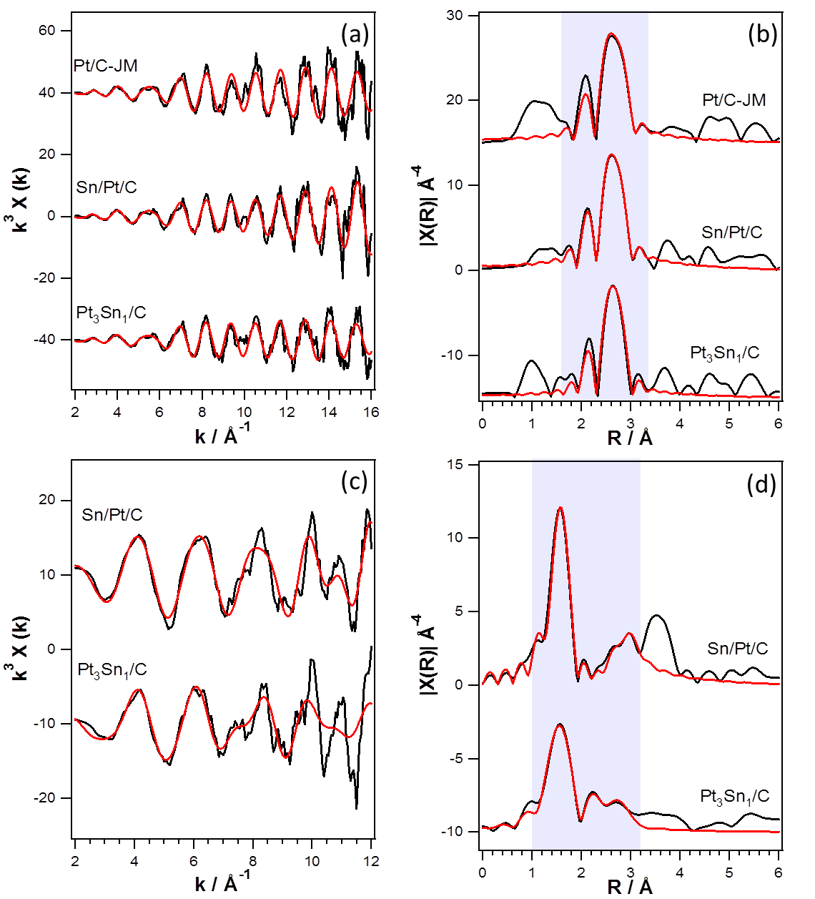
Figure S8. k³ weighted experimental data (black) and fit (red) (a,c) with the corresponding Fourier transform (b,d) for the Pt/C-JM, Sn/Pt/C and Pt₃Sn/C catalysts subjected to the AAT recorded at the Pt L₃ (a,b) and Sn K (c,d) edge in 0.5 M H₂SO₄ at 0.2 V vs RHE.

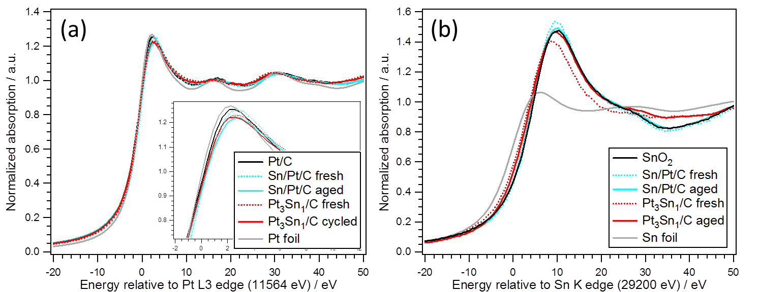
Figure S9. XANES spectra recorded in situ at 0.2 V vs RHE at (a) Pt L₃ edge for Pt/C-JM (black), Sn/Pt/C (cyan), Pt₃Sn₁/C (red), and Pt foil (grey); and (b) Sn K edge for SnO₂ (black), Sn/Pt/C (cyan), Pt₃Sn₁/C (red), Pt₁Sn₁/C (blue) and Sn foil (grey). Solid lines correspond to the aged samples and dotted lines to the fresh samples at the same potential.
At the Pt L3 edge, negligible changes are observed for both the Pt₃Sn₁/C and Sn/Pt/C samples. Pt₃Sn₁/C shows a slight increase of the white line (WL) intensity after the AAT (Figure S9.a), which can be attributed to the de-alloying of the Pt-Sn nanoparticles deduced from the EXAFS analysis (Table 3). In spite of this, the intensity of the WL is still lower than that of Sn/Pt/C confirming that the electronic effect is maintained after the ATT. At the Sn K edge (Figure S9.b), however, a significant increase of the WL and a slight shift of the edge to higher energies for Pt₃Sn₁/C confirm the increase of the amount of SnO₂ in this sample.

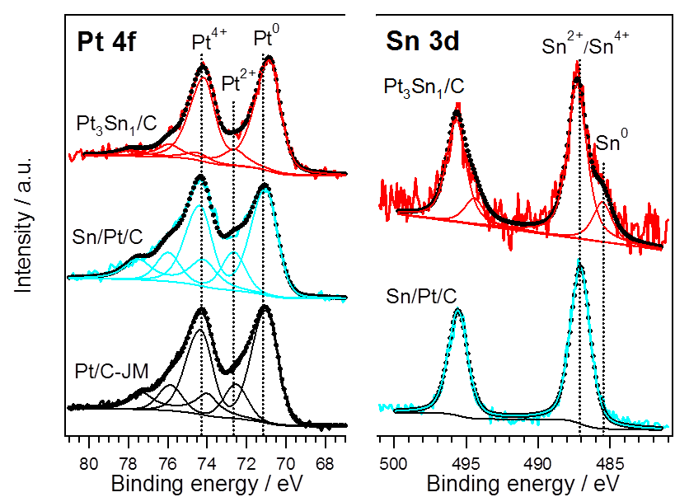
Figure S10. Pt 4f and Sn 3d photoemission lines for the commercial Pt/C, Sn/Pt/C and Pt₃Sn1/C catalysts after the AAT.

Table S5. Electronic and composition parameters of the commercial Pt/C and Pt-Sn/C catalysts after the AAT.
Sample | Binding energy / eV
 | Pt 4f_{7/2} | Sn 3d_{5/2}
Pt/C-JM | 71.1 (69)  72.6 (17)  74.2 (14) | ---
Sn/Pt/C | 71.1 (74)  72.6 (17)  74.2 (9) | 487.1 (100)
Pt₃Sn₁/C | 70.8 (81)  72.6 (13)  74.2 (6) | 485.5 (20)  487.3 (80)

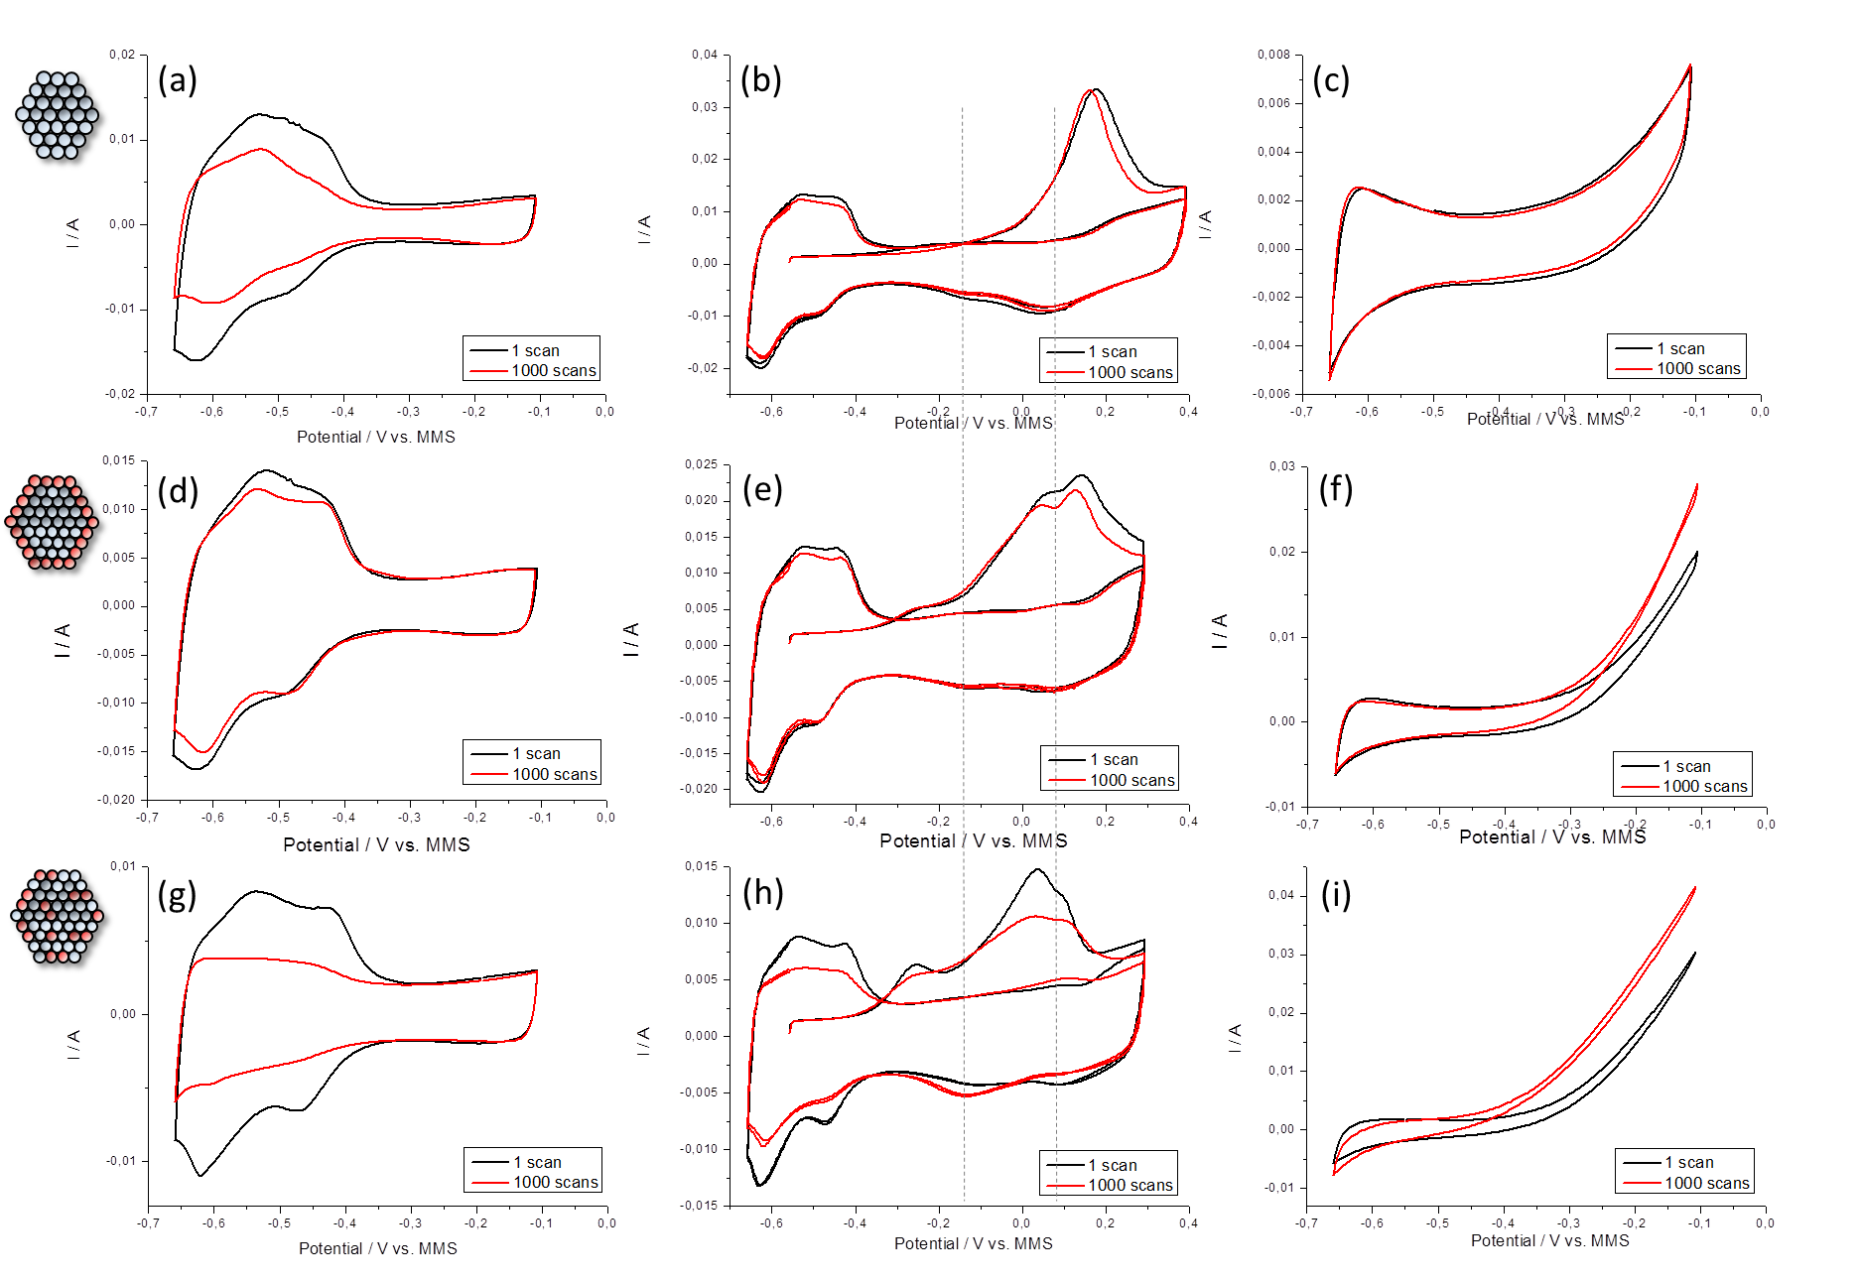
Figure S11. Comparison of the electrochemical data for the Pt/C (a,b,c), Sn/Pt/C (d,e,f) and Pt₃Sn₁/C (g,h,i) samples before (black) and after (red) the accelerated ageing treatment: CVs in 0.5 M H₂SO₄ (a,d,g); CO-stripping in 0.5 M H₂SO₄ (b,e,h); and CVs in in 0.5 M H₂SO₄ + 1M CH₃CH₂OH (c,f,i). All the measurements were performed at room temperature using a scan rate of 0.020 V s⁻¹.

