Biomechanical analysis of the shoulder of swimmers after a maximal effort test.

Felipe S. Serenza.
Student of the Graduate Program in Rehabilitation and Functional Performance, Faculty of Medicine of Ribeirão Preto -USP. Address: 3900 Bandeirantes Avenue, Ribeirão Preto-SP, zip code 14040-900, Brazil. E-mail: felipeserenza@usp.br.
Anamaria S. Oliveira.
Professor of the Graduate Program in Rehabilitation and Functional Performance, Faculty of Medicine of Ribeirão Preto -USP. Address: 3900 Bandeirantes Avenue, Ribeirão Preto-SP, zip code 14040-900, Brazil. E-mail: siriani@fmrp.usp.br.
Bruno L. S. Bedo.
Student of the Graduate Program in Rehabilitation and Functional Performance, Faculty of Medicine of Ribeirão Preto -USP. Address: 3900 Bandeirantes Avenue, Ribeirão Preto-SP, zip code 14040-900, Brazil. E-mail: bruno.bedo92@gmail.com.
Fabio P. Mariano.
Student of the Graduate Program in Rehabilitation and Functional Performance, Faculty of Medicine of Ribeirão Preto -USP. Address: 3900 Bandeirantes Avenue, Ribeirão Preto-SP, zip code 14040-900, Brazil. E-mail: fabiomariano@gmail.com.
Rodrigo Aquino.
Student of the Graduate Program in Rehabilitation and Functional Performance, Faculty of Medicine of Ribeirão Preto -USP. Address: 3900 Bandeirantes Avenue, Ribeirão Preto-SP, zip code 14040-900, Brazil. E-mail: rodrigo.aquino@usp.br.
Martin Warner.
Senior Research Fellow within the Arthritis Research UK Centre for Sport, Exercise and Osteoarthritis and the Faculty of Health Science. Address: University of Southampton, Southampton, UK, SO17 1BJ. E-mail: M.Warner@soton.ac.uk.
Corresponding author: Paulo R. P. Santiago.
Professor of the Graduate Program in Rehabilitation and Functional Performance, Faculty of Medicine of Ribeirão Preto -USP. Laboratory of Biomechanics and Motor Control (LABIOCOM). Address: 3900 Bandeirantes Avenue, Ribeirão Preto-SP, zip code 14040-900, Brazil. E-mail: paulosantiago@usp.br. Telephone +55 16 3315-0346.

ABSTRACT
Objectives: To compare the kinematics and the Electromyography of the periscapular muscles in swimmers before and after a 3-minute maximal effort test.
Participants: 16 competitive swimmers.
Main outcome measurements: Infrared cameras were used to record kinematics in the scapular plane in synchronization with the electromyography system.
Results: There was an increase in internal rotation in all angles (p < 0.05), an increase of the anterior tilt, with 120° of elevation (p = 0.04). The serratus anterior showed a decrease in the intervals of 120-90° and 60-30° (p = 0.04; p = 0.02). There was a linear relation between the variation before and after the maximal effort of the anterior tilt in relation to the variation of muscular activation of the transverse trapezius (p = 0.01) and the lower trapezius (42%, p = 0.01); an internal rotation in 120° and 90° of elevation in relation to the transverse trapezius (p = 0.01); and an internal rotation in 60° and 30° of elevation in relation to the serratus anterior (p = 0.04, p = 0.03).
Conclusion: A maximal 3-minute effort test resulted in altered scapular biomechanics. More studies are needed to verify if the changes correspond to a risk factor for injuries.

Keywords: Biomechanics. Shoulder. Swimming. Electromyography.

INTRODUCTION
Swimming is characterized by cyclic and coordinated movements between body segments. A swimmer performs up to 2500 strokes on a training day, making them susceptible to injury from repetitive microtrauma (Pink & Tibone, 2000).
Biomechanical changes in the shoulder may be related to several causes such as fatigue, strength deficit, a decrease in range of motion (ROM) or proprioceptive deficit (Matthews, Green, Matthews, & Swanwick, 2017). Fatigue during swimming may lead to non-optimal kinematics to perform the swimming stroke and can result in compensatory movement strategies (Stirn, Jarm, Kapus, & Strojnik, 2011). Specifically, 82% of swimming athletes can present with altered scapular function in the final part of the training (Madsen, Bak, Jensen, & Welter, 2011).
The effects of an exhaustive task on the kinematics and electromyographic activity of periscapular muscles in overhead sport were studied by Joshi et al. (2011), which involved a fatigue protocol for the external rotator with the participants placed prone on an adjustable table and the shoulder positioned in 90° of abduction and asked externally rotate their humerus whilst holding a weight. Participants were considered fatigued when external rotation peak force decreased by more than 25% from baseline peak force. After the fatigue there was an increase in scapular upward rotation, an increase in infraspinatus activity and decrease in the lower trapezius (LT) activity. Differently, using a fatigue protocol for the same muscle group whilst employing a Thera-band to provide resistance, Tsai et al. (2003) found an increased internal rotation, increased anterior tilt, and less upward rotation, with the authors considering them as possible risks factor for shoulder pathologies (Tsai, McClure, & Karduna, 2003).
Studies with kinematic and electromyographic analysis specifically in the scapulothoracic joint in swimmers after maximal effort were not performed. Considering the changes found after maximal effort and its repercussions on shoulder biomechanics, the objective of this study was to verify the three-dimensional kinematics and electromyographic activity of the scapula during the movement of arm elevation in the plane of the scapula before and after a maximal effort test that simulates the sporting movement of swimming. Secondly, this study aimed to analyze how the variation of muscle activity after maximal effort influences scapular kinematics.

MATERIALS AND METHODS
Characterization of the sample
Sixteen male athletes aged 15-24 years participated in the study. The recruitment was carried out in swimming teams and university athletic associations in Ribeirão Preto-SP Brazil. Athletes had participated in competitions at university, state and/or national level. The styles of swimming practiced were crawl and butterfly, in distances 50 m, 100 m, 200 m and 800 m. Demographic data of age, weight, height, time of practice and training hours per week are in Table 1.
Volunteers with ROM less than 150° of elevation in scapular plane, who had undergone shoulder surgeries, presenting severe deformity of the thoracic spine, pain and paresthesia in the upper limb (Leite, & Faloppa, 2013). Systemic joint diseases, shoulder pain (VAS > 3) or presenting Impact Syndrome (SIS), considering when found in at least two tests: Neer, Hawkins-Kennedy and Painful arc (Michener, Walsworth, & Burnet, 2004), were excluded.
The present study was approved by the Ethics and Research Committee of the School of Physical Education and Sport of Ribeirão Preto (EEFERP-USP).

Instruments
Kinematics
Kinematic data were captured using the VICON system (Contennial, CO, USA), composed of eight MX-T-40 cameras (Vicon Motion Systems, Oxford, UK) operating at a frequency of 120 Hz. ST joint rotations were obtained using the Acromion Marker Cluster (AMC) method (Warner, Chappell, & Stokes, 2015). The AMC method was validated for lifting movements up to 120° (Karduna, McClure, Michener, & Sennett, 2001; Meskers, van de Sande, & de Groot, 2007) and lowering of the arm (Warner, Chappell, & Stokes, 2012).
A wand with four markers was used to determine the position of the anatomical landmarks of the acromial angle (AA), inferior angle of the scapula (AI) and medial spine of the scapula (TS) about the AMC. The tip of the wand was positioned at the anatomical points, and 3-second collections were performed at each point. The location of the anatomical points about the AMC coordinate system was recreated during the dynamic movement. Another cluster was placed in the lateral region of the humerus to determine the movement of the arm, and collections were made with the wand for calibration of humeral points (medial and lateral epicondyle). The glenohumeral rotation center was defined according to the pivot point of the helical axis method (Veeger, 2000).
The thorax coordinate system was defined by reflex markers positioned in the xiphoid process (PX), jugular incision (IJ), C7 (spinous process of the C7 vertebra), T8 (spinous process of the T8 vertebra). Local coordinate systems for the thorax, scapula and humerus were then constructed based on the recommendations of the International Society of Biomechanics (ISB) (Wu et al., 2005).
The rotation sequence of Euler YX'Z" was used to describe the rotation of the scapula relative to the thorax with Y representing the internal/external rotation, X the upward rotation and Z the anterior/posterior tilt (Wu et al., 2005). The orientation of the humerus relative to the thorax followed the order XZY, in which X represents the elevation angle, Z the plane of elevation and Y the axial axis of rotation (López-Pascual, Cáceres, De Rosario, & Page, 2016).

Electromyography (EMG)
The electromyographic activity of the scapular muscles was performed with the EMG TrignoTM Wireless System (Delsys Trigno EMG system, Boston, MA, USA), with the frequency of acquisition of 2400 Hz. The surface sensors were bipolar, wireless, in the form of a parallel bar (size: 37 mm x 26 mm x 15 mm) and with a fixed distance between sensors of 1 cm.
The skin of the evaluated site was prepared by performing trichotomy and cleaning with 70% alcohol. Then, EMG signal checks were performed during the specific movements of the test. The placement of the sensors was performed by the same investigator in all tests and it is in table 2. (Ekstrom, Soderberg, & Donatelli, 2005; Hermens, 2000).

Maximum voluntary isometric contraction (MVIC)
Recording of the electromyographic activity of the MVIC was performed to obtain the reference value to normalize the myoelectric range of the tests. The volunteers performed three contractions for each of the muscles during 5 seconds, with a 60-second interval. The reference value for normalization is the mean of the maximum values of the EMG of the three MVICs.
The MVIC of the LT muscle was tested with the volunteer in the lying prone position on a stretcher, with shoulder abduction of 120° and external rotation. Resistance was applied in the distal region of the forearm and force was applied downward in the direction the floor. The subject was asked to perform shoulder flexion against the resistance of the researcher (Ekstrom et al., 2005). The tranverse trapezius (TT) muscle was tested with the volunteer in the lying prone position with 90° shoulder abduction and neutral rotation. Resistance was applied in the distal region of the forearm and force was applied downward in the direction the floor. The subject was asked to perform shoulder horizontal abduction against the resistance of the researcher (Ekstrom et al., 2005). The MVIC of the serratus anterior (SA) was obtained with the volunteer in the sitting position, shoulder at 120° elevation in the plane of the scapula and neutral rotation. Resistance was applied in the distal region of the forearm force was applied downward in the direction the floor. The subject was asked to perform shoulder abduction in scapular plane against the resistance of the researcher (Schüldt et al., 1988). Finally, the MVIC of the upper trapezius (UT) was obtained with the volunteer in the sitting position, shoulder 90° abducted and neutral rotation. Resistance was applied in the distal region of the forearm force was applied downward in the direction of the floor. The subject was asked to perform shoulder abduction against the resistance of the researcher (McLean, Chislett, Keith, Murphy, & Walton, 2003).

Maximal effort test
The task was performed using a swimming bench. Reflective markers of the anterior region of the thorax were removed during the test. The skin was scratched with a demographic pencil in the corresponding area to replace the reflective markers after finishing the test in the bench, to perform the post-task collection. The surface sensors of the electromyography were kept fixed to the patient, but it was not possible to collect data during the test due to the noise in the electromyographic signal caused by the quick movement of shoulders and the slight contact of the arm with the SA muscle.
Two hand paddles, attached to an elastic band (14 mm medium resistance Auriflex™) and coupled to a fixed structure to apply resistance on the upper limbs. Athletes were instructed to perform the movement of the test for familiarization. During the protocol volunteers performed multiple repetitions of the simulated pull phase of swimming at maximum intensity for 3 minutes and were encouraged by standard verbal stimulation to maintain shoulder movement in flexion and extension (Figure-1). Thus during an extension of the shoulder, there was elastic resistance, while the return to the starting position was controlled via eccentric muscle action.

Procedures
The order of the procedures is listed in Figure-6. Kinematics and electromyography were performed in the dominant arms during the movement of raising and lowering the arm in the plane of the scapula. Tests were performed in the standing position with the upper limbs initially in anatomical position. The volunteers performed three repetitions of arm elevation keeping the thumb directed upwards, avoiding rotations. The plane of the scapula was defined as 30° anterior to the coronal plane. Lines traced on the ground served as guidance for correct movement. The movements lasted four seconds (Karduna et al., 2001), of which two seconds were used to raise and two seconds to lower the arm, with verbal feedback for time control. A 1 kg halter was used during the test (Reed, Cathers, Halaki, & Ginn, 2016).
DATA ANALYSIS
Kinematics
Data were processed in the software NEXUS® 1.8, filtered with a low pass of 6Hz and exported in the form of C3D files. Then the angular values of rotation of the scapula related to the thorax were calculated using a MatLab 2014a Software (Mathworks Inc. Natick, MA, USA) and were select the initial angulation data, 30°, 60°, 90°, 120°, in the ascending and descending phases of the arm movement.

Electromyography
The electromyographic signal processing was performed with the MatLab 2014a Software (Mathworks Inc. Natick, MA, USA). The signals were filtered with a 4th order Butterworth with bandwidth frequency of 20-450 Hz.
The muscular activity was determined for each attempt in the descending phase of the movement in the windows of 120°-90°, 90°-60° and 60°-30° of arm movement. The descending part of the movement was chosen due to the greater muscular tension in the eccentric phase (Huang, Ou, Huang, & Lin, 2015; Ludewig, Cook, & Nawoczenski, 1996). After separation, the data were smoothed by using a Root Mean Square (RMS) algorithm with a 0.125 s window size and 0.0625 s overlap. Finally, for data normalization, the results were divided by the maximum value recorded in the MVIC, multiplied by 100 and referred as percentage. From the results of the three attempts of lowering of the arm, averages of the electromyographic amplitude values were obtained for each of the pre and post-task.
STATISTICAL ANALYSIS
Descriptive analysis was performed as mean and standard error (SE) for kinematic and electromyographic variables. The Shapiro-Wilk test was used to check the normal distribution of the data. After verifying the normality assumptions of the model, the kinematic variables of internal rotation, the upward rotation and anterior tilt of the scapula and the electromyographic activity of the muscles LT, UT, SA, TT were compared by Student's t-test for paired samples for detection of differences between pre and post-test conditions.
The analyses were matched for each of the angles in the ascending and descending phases of the arm movement (ascending: initial, 30°, 60°, 90°, 120°, descending: 120°, 90°, 60°, 30°) and for the electromyographic variables of the descending phase of arm movement (120°-90°, 90°-60°, 60°-30°). A significance level of 5% was adopted.
Effect size (ES) calculation was performed by Cohen's d; d = M1-M2/ DPpooled, in which M1 is the initial mean, M2 is the final mean and SDpooled is the pooled standard deviation. For the calculation of the pooled standard deviation, the following formula was used: SDpooled = √[Sd1²+SD2²) /2]. The ES was interpreted as small (< 0.5), moderate ( > 0.5 to < 0.8) and large ( > 0.8) (Cohen, 1992). A significance level of 5% was adopted.
In order to analyze the explanatory power of the muscular activation variation in the kinematic variation, six simple linear regression models were proposed: A: explanatory power of variation of muscular activation of the TT 120°-90° on the kinematic variation of the anterior tilt at 90°; B: explanatory power of the variation of muscular activation of the LT 60°-30° on the kinematic variation of the anterior tilt at 60°; C: explanatory power of variation of muscular activation of the TT 120°-90° on the kinematic variation of the internal rotation at 120°; D: explanatory power of the variation of muscular activation of the TT 120°-90° on the kinematic variation of the internal rotation at 90°; E: explanatory power of the variation of muscular activation of the TT 60°-30° on the kinematic variation of the internal rotation at 60°; and F: explanatory power of the variation of muscular activation of the TT 60°-30° on the kinematic variation of the internal rotation at 30°. The regression data were in accordance with the assumptions of homoscedasticity, normal distribution of residues, non-multicollinearity between the independent variables, and a significance level of 5% was adopted. All data analyses were performed with SPSS (Version 22, IBM Corp, Armonk, NY, USA).

RESULTS
Kinematics
There was an increase in the internal rotation of the scapula after the maximal effort test in all angles of humeral elevation analyzed with small ES (Ascending. Initial: difference = 2.19, p = 0.01, d = 0.36; 30°: difference = 2.18, p = 0.10, d = 0.26; 60°: difference = 1.78, p = 0.04, d = 0.20; 90°: difference = 1.95, p = 0.04, d = 0.21, 120°: difference 2.27, p = 0.05, d = 0.24; descending. 120°: difference = 2.45, p = 0.03, d = 0.29; 90°: difference = 2.53, p = 0.02, d = 0.29, 60°: difference = 2.79, p = 0.01, d = 0.35 and 30°: difference 2.71, p = 0.01, d = 0.32) (Figure-2).
There was an increase of 2,14° in upward rotation only at the initial angulation with small effect size (p = 0.01, d = 0.47) (Figure-3) and in the anterior tilt at 120° angles in the phase ascending of 2.31° and descending of 2.69° with small effect size (p = 0.04, d = 0.22; p = 0.04; d = 0.32) (Figure-4).
Electromyography
Statistically significant differences were found in the reduction of the electromyographic amplitude in the SA muscle in the intervals 60-30° of 4.59% (Figure-5) and 120-90° of 4.16% (Figure-6) with moderate effect size (p = 0.04, d = 0.57; p = 0.02, d = 0.56).
Explanatory power of muscular activity on kinematics
Dispersion graphs demonstrate linear relationship between the pre and post-test variation of kinematics and muscle activity during the descending phase of arm movement. The coefficient of determination showed that 38% (p = 0.01) of the kinematic variation in relation to the scapular tilt at 90° of elevation can be explained by the muscle TT in the 120-90° interval. The muscle LT in the range of 60-30° was responsible for 42% (p = 0.01) of the variation of the scapular tilt at 60° of elevation (Figure-7).
The TT in the range of 120°-90° was responsible for 38% and 42% (p = 0.01, p = 0.01) in relation to the variation of internal rotation of the scapula at 120° and 90° of arm elevation, respectively. The SA 60°-30° contributed in 25% and 31% (p = 0.04, p = 0.03) of the variation of internal rotation at 60° and 30°, respectively (Figure-8).

DISCUSSION
The aim of this study was to compare the scapulothoracic joint rotations and the electromyographic amplitude of periscapular muscles before and after a maximal effort test in swimmers. Secondarily, it aimed to analyze how the changes in the electromyographic activity influenced the kinematics of the ST joint.
The results showed an increase of the anterior tilt of the scapula at 120° of elevation and increase of internal rotation throughout the ROM. Similar results were found in subjects with pain (Ludewig & Cook, 2000; Struyf et al., 2014) and asymptomatic patients with scapular dyskinesis (Huang et al., 2015).
The present study found an increase of the anterior tilt of the scapula with 120° of elevation of the arm, both during elevation and lowering of the arm, considered a critical ROM for the occurrence of SIS (Ludewig & Reynolds, 2009). The posterior tilt elevates the anterior region of the acromion and favors the passage of the greater humeral tubercle with a lower risk of mechanical impact (Flatow et al., 1994). On the other hand, even of small magnitude (2.69°), the increase in anterior tilt was similar to that found in studies in subjects with shoulder pain (Cole Lukasiewicz et al., 1999; Endo, K., Ikata, 2001; Ludewig & Cook, 2000). The cause and effect relationship between kinematic changes and shoulder pain is unclear, but during the stroke in swimming the posterior tilt of the scapula is required during the phase that occurs maximal external rotation and elevation of the shoulder joint, and the decrease in posterior tilt may overload the GH joint (Virag, Hibberd, Oyama, Padua, & Myers, 2014).
In this work, an increase the internal scapular rotation was observed throughout the ROM. The consequence of increased internal rotation of the scapula in shoulder kinematics is uncertain due to the variability of the magnitude of this movement between subjects and the measurement errors (Warner et al., 2015). With increased internal rotation of scapula, there would be a relative increase in the external rotation of the GH joint during overhead movement, which is anatomically positive because it increases the space for the greater humeral tubercle during arm lift movements. However, this increase generates impact of RC tendons between the posterior aspect of the humeral head and the glenoid in movements that combine external rotation and GH abduction, as in the stroke of swimming (Ludewig & Reynolds, 2009; Paley, Jobe, Pink, Kvitne, & ElAttrache, 2000).
Biomechanical changes found in this work may be due to several sources. One plausible hypothesis would be shoulder muscle fatigue, which has been previously been associated with biomechanical changes (Ebaugh, McClure, & Karduna, 2006). The increase of the anterior tilt of the scapula found in this work differs from the results found by Chopp Hurley et al., 2011. Although the protocols performed were global for shoulder musculature, only in the present study, there was a decrease in SA activation. Among its functions, SA performs the posterior tilt and external rotation of the scapula and a decrease in its activation justifies the increase of the anterior tilt and the internal rotation of the scapula.
The exhaustive protocol performed in this study involved several muscle groups including the RC. The literature demonstrates that RC fatigue leads to an increase in the anterior tilt of the scapula (Ebaugh et al., 2006; Tsai et al., 2003). Therefore, it is not possible to discard RC fatigue as the cause of the kinematic changes in this work.
Of the muscles analyzed in this study, SA was the only one to present a decrease in electromyographic activity after the effort test. During the maximal effort test, the shoulder flexion movement was performed in favor of the elastic resistance, and thus the force required for the muscles to rotate the scapula superiorly was minimized. In the shoulder extension phase, which occurred against elastic resistance, because the muscles studied were primarily the superior rotators of the scapula, they did not have to perform primary torque, only synergistic activation. However, the SA, besides rotating superiorly to the scapula, acts as the main ST joint stabilizer in the thoracic wall. In this way the SA was required in the two phases of the movement, rotating the scapula superiorly during flexion of the arm and stabilizing the medial border of the scapula during extension. Thus, among the analyzed muscles, SA was the one that spent the most time activated during the test, consequently more exposed to fatigue, although we can’t ensure this information.
Another possible source of biomechanical changes is proprioceptive deficits, which can be found after exhaustive tasks (Chang, Chen, Wei, & Huang, 2006). The deterioration of the positional joint sense in the shoulder of swimmers can interfere in the muscular recruitment and cause modifications in the patterns of movement (Matthews et al., 2017).
Regarding the explanatory power of muscular activation variation in the kinematics, this study showed that volunteers with increased anterior tilt had a greater increase in LT muscle activity. In the same sense, the increase in the internal rotation of the scapula was accompanied by an increase in the muscular activity of the TT in the angulations 120°-90° and of the SA in angulations 60-30°. As the force output of a muscle increases, the firing rate in the motor units increases. However, if the increase is even greater, the contribution force from the motor unit is saturated, and thus each motor unit continues to provide energy for the EMG signal while the contribution to force remains at a constant value. This non-linear relationship causes a greater increase of the EMG signal that of the force produced (Lawrence & De Luca, 1983). The 42% relationship between the increase in anterior lift and increase in LT activation shows that in athletes with the greatest changes there was an attempt by the central nervous system to increase the LT muscle activity as a compensatory strategy to supply the reduction in the activity of the SA and control the increase of the anterior tilt. However, the muscular activation variation increase of the LT was not able to compensate for the decrease in the SA. Interestingly, despite the fact that there was no statistical difference, the LT obtained higher values in all the angulations in before and after the test.
Finally, another possible cause of biomechanical changes is central or metabolic fatigue. Kalva-Filho et al., 2017 found that after a maximum effort of 3 minutes with tethered swimming, the volunteers showed diminished strength due to fatigue. Obviously, the extrapolation of the tethered swimming to the test performed in this work is limited. The test applied in the present study focused on the movement of the shoulder, while the tethered swimming used the entire body including the lower limbs and trunk. However, the level of training of the athletes and the duration of the tests are identical, as well as their objective.
There are some limitations of our study that should be acknowledged. First, the maximal effort test was realized with volunteer lying prone and the swim bench afforded stability for the trunk and pelvis. Second, the movement of the test was a bilateral synchronous task, whereas front crawl is an alternating, asynchronous task, which may have contributed to altered recruitment patterns within the shoulder during the test.

CONCLUSION
Swimming athletes submitted a maximal 3-minute effort test had altered scapular kinematics and declined the SA muscle activity. Although the results were statistically significant, the differences found were small, and the clinical repercussions are uncertain. Longitudinal studies are needed to verify the implications of these findings over time, to determine if the changes are only acute neuromuscular adaptations of exhaustive exercise and whether their presence corresponds to a risk factor for injuries to the shoulder of swimmers.

References
Chang, H., Chen, C., Wei, S., & Huang, C.-H. (2006). Recovery of Joint Position Sense in the Shoulder After Muscle Fatigue. J Sport Rehabil., 15, 312–325.
Chopp-Hurley, J. N., O’Neill, J. M., McDonald, A. C., Maciukiewicz, J. M., & Dickerson, C. R. (2016). Fatigue-induced glenohumeral and scapulothoracic kinematic variability: Implications for subacromial space reduction. Journal of Electromyography and Kinesiology, 29, 55–63. https://doi.org/10.1016/j.jelekin.2015.08.001
Chopp Hurley, J. N., Fischer, S. L., & Dickerson, C. R. (2011). The specificity of fatiguing protocols affects scapular orientation: Implications for subacromial impingement. Clinical Biomechanics, 26(1), 40–45. https://doi.org/10.1016/j.clinbiomech.2010.09.001
Cohen, J. (1992). Statistical Power Analysis. Current Directions in Psychological Science (Wiley-Blackwell), 1, 98–101. https://doi.org/10.1111/1467-8721.ep10768783
Cole Lukasiewicz, A., McClure, P., Lori Michener, O., Praff, N., Senneff, B., Mawr Spom Medicine, B., & Maw, B. (1999). Comparison of 3-Dimensional Scapular position and Orientation Between subjects With and Without Shoulder Impingement. Journal of Orthopaedic & Sports Physical Therapy, 29(10), 574–586. https://doi.org/10.2519/jospt.1999.29.10.574
Ebaugh, D. D., McClure, P. W., & Karduna, A. R. (2006). Effects of shoulder muscle fatigue caused by repetitive overhead activities on scapulothoracic and glenohumeral kinematics. Journal of Electromyography and Kinesiology, 16(3), 224–235. https://doi.org/10.1016/j.jelekin.2005.06.015
Ekstrom, R. A., Soderberg, G. L., & Donatelli, R. A. (2005). Normalization procedures using maximum voluntary isometric contractions for the serratus anterior and trapezius muscles during surface EMG analysis. Journal of Electromyography and Kinesiology, 15(4), 418–428. https://doi.org/10.1016/j.jelekin.2004.09.006
Endo, K., Ikata, T. . (2001). Radiographic assessment of scapular rotational title in chronic shoulder impingement syndrome. Journal of Orthopaedic Science, 32, 248–259.
Flatow, E. L., Soslowsky, L. J., Ticker, J. B., Pawluk, R. J., Hepler, M., Ark, J., … Bigliani, L. U. (1994). Excursion of the rotator cuff under the acromion. Patterns of subacromial contact. The American Journal of Sports Medicine, 22(6), 779–788. https://doi.org/10.1177/036354659402200609
Heinlein, S. A., & Cosgarea, A. J. (2010). Biomechanical Considerations in the Competitive Swimmer’s Shoulder. Sports Health, 2(6), 519–25. https://doi.org/10.1177/1941738110377611
Hermens, H. J. (2000). Development of recommendations for SEMG sensors and sensor placement procedures . J Electromyogr Kinesiol Development of recommendations for SEMG sensors and sensor placement procedures. Journal of Electromyography and Kinesiology: Official Journal of the International Society of Electrophysiological Kinesiology, 10(July 2016), 361–374. https://doi.org/10.1016/S1050-6411(00)00027-4
Huang, T. S., Ou, H. L., Huang, C. Y., & Lin, J. J. (2015). Specific kinematics and associated muscle activation in individuals with scapular dyskinesis. Journal of Shoulder and Elbow Surgery, 24(8), 1227–1234. https://doi.org/10.1016/j.jse.2014.12.022
Joshi, M., Thigpen, C. A., Bunn, K., Karas, S. G., & Padua, D. A. (2011). Shoulder external rotation fatigue and scapular muscle activation and kinematics in overhead athletes. Journal of Athletic Training, 46(4), 349–357.
Kalva-Filho, C. A., Zagatto, A. M., Da Silva, A. S. R., Castanho, M. Y., Gobbi, R. B., Gobatto, C. A., & Papoti, M. (2017). Relationships among the Tethered 3-min All-Out Test, MAOD and Swimming Performance. International Journal of Sports Medicine, 38(5), 353–358. https://doi.org/10.1055/s-0043-101914
Karduna, A. R., McClure, P. W., Michener, L. A., & Sennett, B. (2001). Dynamic measurements of three-dimensional kinematics: A validation study. Journal of Biomechanical Engineering, 123(April), 184–190. https://doi.org/10.1115/1.1351892
Lawrence, J. H., & De Luca, C. J. (1983). Myoelectric signal versus force relationship in different human muscles. Journal of Applied Physiology (Bethesda, Md. : 1985), 54(6), 1653–1659.
López-Pascual, J., Cáceres, M. L., De Rosario, H., & Page, Á. (2016). The reliability of humerothoracic angles during arm elevation depends on the representation of rotations. Journal of Biomechanics, 49(3), 502–506. https://doi.org/10.1016/j.jbiomech.2015.12.045
Ludewig, P. M., & Cook, T. M. (2000). Alterations in Shoulder Kinematics and Associated Muscle Activity in People With Symptoms of Shoulder Impingement. Physical Therapy, 80(3), 276–291.
Ludewig, P. M., Cook, T. M., & Nawoczenski, D. A. (1996). Three-dimensional scapular orientation and muscle activity at selected positions of humeral elevation. The Journal of Orthopaedic and Sports Physical Therapy, 24(2), 57–65. https://doi.org/10.2519/jospt.1996.24.2.57
Ludewig, P. M., & Reynolds, J. F. (2009). The Association of scapulair Kinematics and Glenohumeral Joint Pathologies. Journal Orthopedics Sports Physical Therapy, 39(2), 90–104. https://doi.org/10.2519/jospt.2009.2808.The
Madsen, P. H., Bak, K., Jensen, S., & Welter, U. (2011). Training induces scapular dyskinesis in pain-free competitive swimmers: a reliability and observational study. Clinical Journal of Sport Medicine : Official Journal of the Canadian Academy of Sport Medicine, 21(2), 109–113. https://doi.org/10.1097/JSM.0b013e3182041de0
Matthews, M. J., Green, D., Matthews, H., & Swanwick, E. (2017). The effects of swimming fatigue on shoulder strength , range of motion , joint control , and performance in swimmers. Physical Therapy in Sport, 23, 118–122.
McLean, L., Chislett, M., Keith, M., Murphy, M., & Walton, P. (2003). The effect of head position, electrode site, movement and smoothing window in the determination of a reliable maximum voluntary activation of the upper trapezius muscle. Journal of Electromyography and Kinesiology, 13(2), 169–180. https://doi.org/10.1016/S1050-6411(02)00051-2
Meskers, C. G. M., van de Sande, M. A. J., & de Groot, J. H. (2007). Comparison between tripod and skin-fixed recording of scapular motion. Journal of Biomechanics, 40(4), 941–946. https://doi.org/10.1016/j.jbiomech.2006.02.011
Paley, K. J., Jobe, F. W., Pink, M. M., Kvitne, R. S., & ElAttrache, N. S. (2000). Arthroscopic findings in the overhand throwing athlete: evidence for posterior internal impingement of the rotator cuff. Arthroscopy : The Journal of Arthroscopic & Related Surgery : Official Publication of the Arthroscopy Association of North America and the International Arthroscopy Association, 16(1), 35–40. https://doi.org/10.1016/S0749-8063(00)90125-7
Pink, M., & Tibone, J. (2000). The Painful Shoulder in the Swimming Athlete. Orthop Clin North Am, 31(2), 246–261. https://doi.org/10.1016/S0030-5898(05)70145-0
Reed, D., Cathers, I., Halaki, M., & Ginn, K. A. (2016). Does load influence shoulder muscle recruitment patterns during scapular plane abduction? Journal of Science and Medicine in Sport, 19(9), 755–760. https://doi.org/10.1016/j.jsams.2015.10.007
Stirn, I., Jarm, T., Kapus, V., & Strojnik, V. (2011). Evaluation of muscle fatigue during 100-m front crawl. European Journal of Applied Physiology, 111(1), 101–113. https://doi.org/10.1007/s00421-010-1624-2
Struyf, F., Meeus, M., Fransen, E., Roussel, N., Jansen, N., Truijen, S., & Nijs, J. (2014). Interrater and intrarater reliability of the pectoralis minor muscle length measurement in subjects with and without shoulder impingement symptoms. Manual Therapy, 19(4), 294–298. https://doi.org/10.1016/j.math.2014.04.005
Tsai, N. T., McClure, P. W., & Karduna, A. R. (2003). Effects of muscle fatigue on 3-dimensional scapular kinematics. Archives of Physical Medicine and Rehabilitation, 84(7), 1000–1005. https://doi.org/10.1016/S0003-9993(03)00127-8
Veeger, H. E. J. (2000). The position of the rotation center of the glenohumeral joint. Journal of Biomechanics, 33(12), 1711–1715. https://doi.org/10.1016/S0021-9290(00)00141-X
Virag, B., Hibberd, E. E., Oyama, S., Padua, D. A., & Myers, J. B. (2014). Prevalence of Freestyle Biomechanical Errors in Elite Competitive Swimmers. Sports Health: A Multidisciplinary Approach, 6(3), 218–224. https://doi.org/10.1177/1941738114527056
Warner, M. B., Chappell, P. H., & Stokes, M. J. (2012). Measuring scapular kinematics during arm lowering using the acromion marker cluster. Human Movement Science, 31(2), 386–396. https://doi.org/10.1016/j.humov.2011.07.004
Warner, M. B., Chappell, P. H., & Stokes, M. J. (2015). Measurement of Dynamic Scapular Kinematics Using an Acromion Marker Cluster to Minimize Skin Movement Artifact. Journal of Visualized Experiments, (96), 1–14. https://doi.org/10.3791/51717
Wu, G., Van Der Helm, F. C. T., Veeger, H. E. J., Makhsous, M., Van Roy, P., Anglin, C., … Buchholz, B. (2005). ISB recommendation on definitions of joint coordinate systems of various joints for the reporting of human joint motion - Part II: Shoulder, elbow, wrist and hand. Journal of Biomechanics, 38(5), 981–992. https://doi.org/10.1016/j.jbiomech.2004.05.042

List of Figures

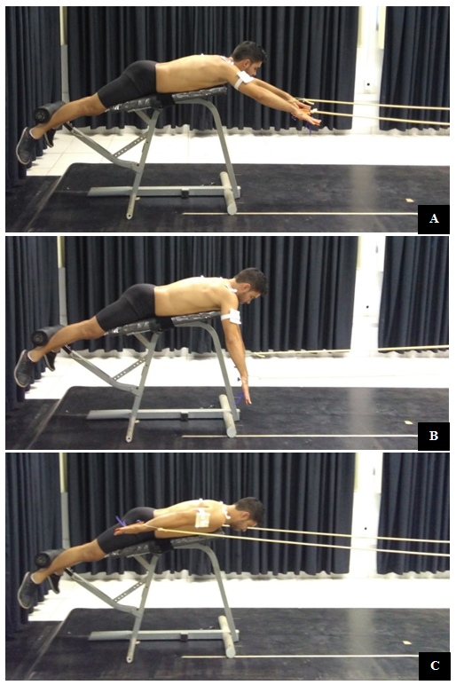
Figure-1: 3-minute maximal effort test. A= Starting position, B= Mid-position and C= Final position.

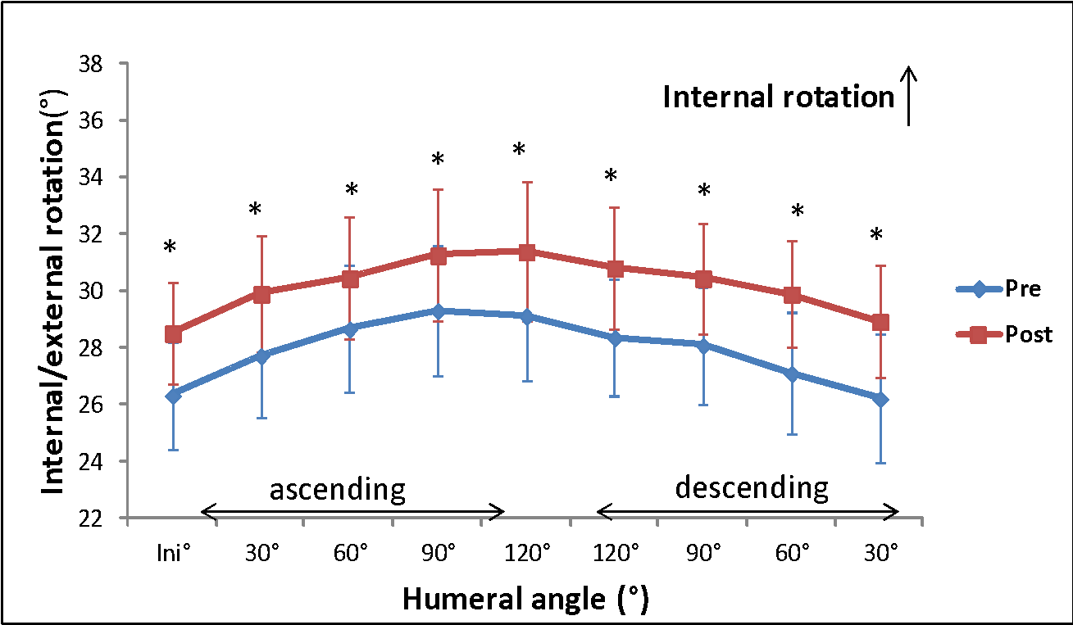
Figure-2. Pre and post 3-minute maximal effort test. Scapular internal/external rotation angles in the ascending and descending phases. Error bars represent the SE of the mean. *P<.05.
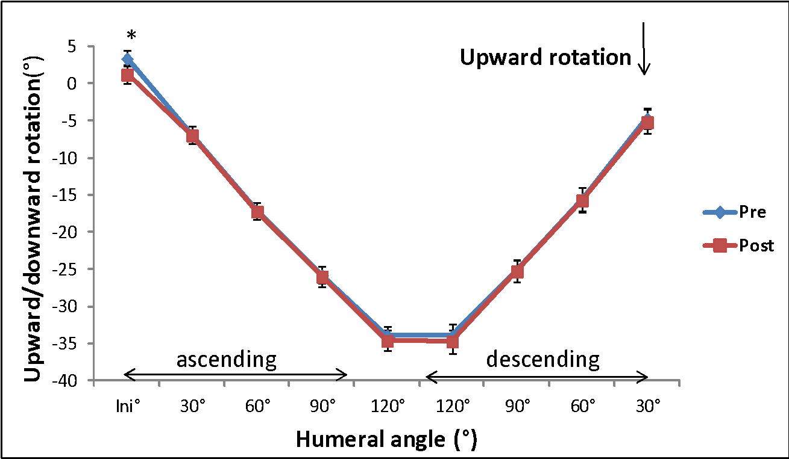
Figure-3. Pre and post 3-minute maximal effort test. Scapular Upward/downward rotation angles in the ascending and descending phases. Error bars represent the SE of the mean. *P<.05.

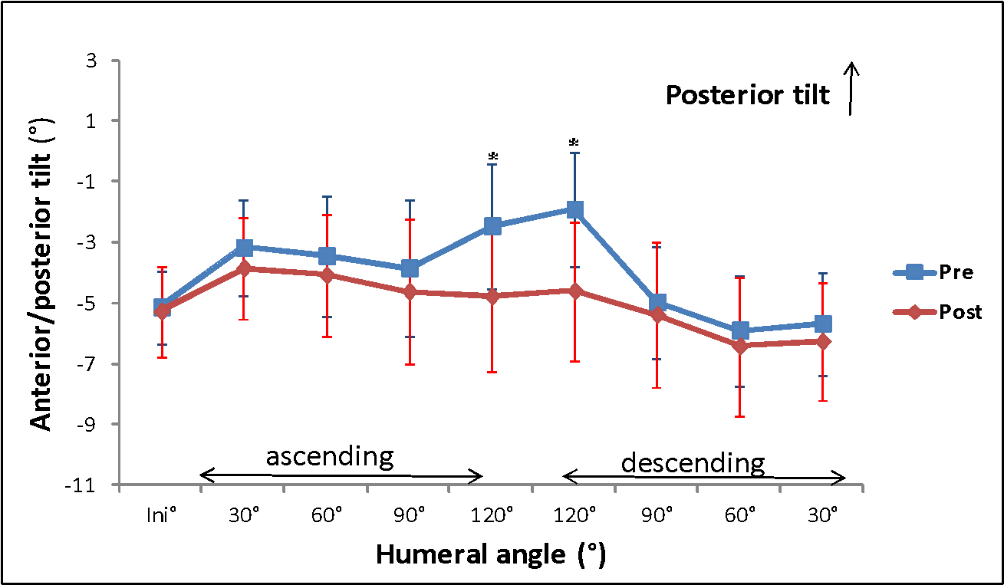
Figure-4. Pre and post 3-minute maximal effort test. Scapular anterior/posterior tilt angles in the ascending and descending phases. Error bars represent the SE of the mean. *P<.05.

Figure-5. Electromyographic activity normalized by the MVIC during the intervals of humeral elevation 60°-30° in the descending phase of arm movement.

Figure-6. Electromyographic activity normalized by the MVIC during the intervals of humeral elevation 120°-90° in the descending phase of arm movement.

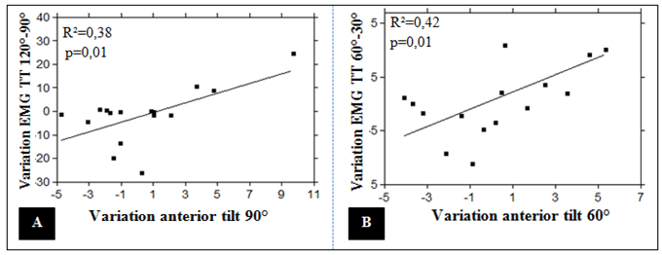
Figure-7: Kinematics variation scatter plot of the anterior tilt at 90° and 60° in relation to the muscular activation variation of the TT 120°-90° and LT 60°-30°. R² = coefficient of determination, p <0.05.

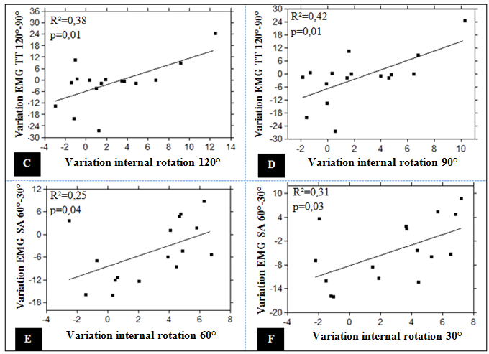1
Figure-8: Kinematics variation scatter plot of internal rotation at 120°, 90°, 60° and 30° in relation to the muscular activation variation of TT 120°-90 ° and LT 60°-30°. R² = coefficient of determination, p <0.05.

List of tables
Table 1- Characteristics of participants.
Age (years) | 18.6 ±4.1
Weight (kg) | 71 ±9.5
Height (m) | 1.78 ±4.1
Time of practice (years) | 7.3 ±3.1
Hours of training per week | 11.6 ±3.8
Results: mean ± standard deviation.

Table 2- Electromyography sensors placement.
SA | Anterior to the fibers of the latissimus dorsi muscle in the seventh intercostal space with the abducted shoulder at 90°.
LT | 2/3 of a line drawn between the root of medial spine and the eighth thoracic vertebra.
UT | Midpoint of a line between the spinous process of the seventh cervical vertebra to the AA.
TT | Midpoint between the medial border of the scapula and the spinous process of T3.
SA: serratus anterior; LT: lower trapezius, UT: Upper trapezius; TT: transverse trapezius.

