L1–L2 differences in the L2 classroom: Anticipating Anglophone learners’ difficulties with French pronoun interpretation

Elena Shimanskaya

West Virginia University

Roumyana Slabakova

University of Southampton and UiT The Arctic University of Norway

Abstract

In this article, we address the issue of targeted instruction on interpretive contrasts between native and second-language grammatical meanings. Such mismatches are predicted to create challenges for learners. We illustrate this with French and English pronouns. In French, clitic pronouns (le, la) point to human as well as inanimate referents, while English pronouns distinguish between human (him, her) and inanimate (it) referents. While other grammatical differences between English and French pronouns are taught, this interpretive mismatch attracts less attention in instructional materials. We review the pedagogical literature and report the results of a study investigating this knowledge in Anglophone learners of L2 French. We document that the mismatch is indeed challenging, particularly to beginning learners, and propose ways to overcome this difficulty.

Keywords: French as a second language, pronouns, clitics, gender, interpretive mismatch

I Introduction
Several attempts have been made in the recent years to bring closer Second Language Acquisition (SLA) research and language pedagogy. Even though most SLA researchers believe that the primary goal of SLA studies is to describe and explain second language (L2) competence, many of them would also advocate for SLA research use in setting standards for ‘evidence-based practice’ in the field of foreign language (FL) teaching (Nassaji, 2012, p. 338). A questionnaire study conducted by Nassaji (2012) revealed that most ESL and EFL teachers rarely read SLA research articles, even though most of the respondents agreed that “teachers and researchers should work together” (p. 351). There appears to be a “problem in communication” (p. 355) between teachers and researchers since 40% of the teachers in Nassaji’s study indicated that SLA research articles are too difficult to understand. Several solutions can be proposed to remedy this problem. For instance, SLA researchers could “use a simpler language” (p. 355) and “provide a careful assessment of the implications of SLA findings in order to determine their applicability to classroom teaching” (p. 358).
It is also important for SLA researchers to be aware of the topics that can potentially interest teachers and be relevant to their professional activities. The topic of first language (L1) transfer was one of the twelve major topics identified as an area of focus for SLA research in Nassaji’s survey (2012), especially by teachers in a FL context where most learners presumably share the same L1. Since the inception of SLA as a field, e.g. Lado’s contrastive analysis approach (Lado, 1957), it has been intuitively clear to researchers and practitioners that L2 learners find some aspects of L2 grammar hard when they are different from their native grammar. However, as a result of numerous L2 studies, it has become clear that the concept of “acquisitional difficulty” is not easily defined (DeKeyser, 2005) and that not all L1–L2 differences lead to acquisitional difficulties (Ellis, 2006; Slabakova, 2008).
Gradually a gap started to grow between L2 theory and L2 teaching with respect to the topic of L1 transfer. SLA theory recognizes the impact of L1 on L2 acquisition, while to this day there appears to be no straightforward way to use learners’ L1 to their advantage when teaching L2 grammar. For example, some SLA textbooks devote an entire chapter to L1 transfer research (Gass, 2013; Ortega, 2008). However, precise pedagogic recommendations based on L1 transfer effects are not readily available and FL teachers have to rely mainly on their professional experience to determine the “problematic” structures (Ellis, 2006).
Moreover, many teacher-training programs encourage future teachers to avoid translation and use of L1 in FL classes. For example, the American Council on the Teaching of Foreign Languages (ACTFL) recommends that 90% of the class is conducted in the target language (ACTFL, 2010). To give another example, using translation became associated with the Grammar Translation method and many teachers perceive translation as a practice to be completely avoided in language teaching (Kelly & Bruen, 2015). While we agree that the target language should be used as much as possible, it is easy to misconstrue such recommendations as a general ban on L1 in L2 teaching.
Previous research has demonstrated that teachers find L1–L2 comparisons useful and that students benefit from such explanations. Spada, Lightbown, and White (2005) attempted to determine whether providing information contrasting L1 and L2 rules for question formation and the use of possessive pronouns in French and English would result in better learning outcomes for Canadian ESL students. Even though the results of the study were inconclusive with respect to the impact of the contrastive information on L2 learning, overall the participants benefited from such instruction, increasing their accuracy on possessive determiners and improving their overall knowledge of these forms. González (2008) found that drawing crosslinguistic comparisons between Dutch (L1) and Spanish (L2) aspectual systems had a positive effect on adult learners’ performance on standardized tests (multiple choice and fill-in-the-blank exercises). McManus and Marsden (2016) also found positive effects when English-speaking L2 learners of French (college level) received explicit information on aspectual meanings in their L2 and L1. Those learners who received the information related to both languages outperformed the L2 only and the control groups on both on-line and off-line tasks. Horst, White, and Bell (2010) investigated whether drawing comparisons between L1 and L2 sounds, vocabulary, and grammar received a positive response from primary school ESL teachers in Quebec, Canada. While the researchers found that the teacher in the study considered the cross-linguistic awareness activities helpful, she did not apply the approach to linguistic features outside of the instructional materials provided by the researchers.
Therefore, while teachers might believe that L1–L2 comparisons are beneficial, they might need more information on what areas of grammar are especially prone to L1 transfer errors, what transfer mechanisms lead to errors, and how to effectively address these issues in their classes. In this paper, we will attempt to demonstrate how SLA research on L1 transfer can be relevant and useful to foreign language teachers and curriculum designers. We will predict transfer effects based on a theoretical hypothesis that identifies conditions and mechanisms of L1 transfer, the Feature Reassembly Hypothesis (Lardiere, 2009). We will formulate specific predictions as to what kinds of errors L2 learners are likely to make. The ability to make such predictions is vitally important for FL practitioners since it allows a systematic approach to grammar teaching and curriculum design.
We will study L2 acquisition of French direct object pronouns le_{MASC} and la_{FEM} by Anglophone learners. Acquisition of this type of pronoun in L2 French and L2 Spanish has been extensively studied from different theoretical perspectives, but the insights that have been gained from these studies rarely have an impact on how the forms are presented in Spanish and French textbooks and classrooms. Wust (2010b) attests to the persistent difficulties in teaching the rules of French pronominalization to Anglophone learners. Here, we will provide a detailed linguistic analysis of pronominal features divergent in the L1 and the L2, formulate specific predictions for L1 transfer and report the results of an experimental study that tested whether the expected L1-based errors were produced by L2 learners. We will argue that the same morphosyntactic–semantic feature mismatch problems could extend to L2 Spanish acquisition. Finally, we will provide practical advice for teachers on how to conceptualize L1 transfer and adapt teaching techniques to the specific challenges that stem from L1–L2 differences.

II English and French pronouns and their acquisition
French (and Spanish) has two kinds of pronouns: strong pronouns and clitics. Strong pronouns, such as English him/her, behave similarly to nouns. For example, direct objects expressed by nouns (1) and strong pronouns (2) are placed after the verb.
(1) Je danse avec John.
I dance with John.
(2) Je danse avec lui.
I danse with him.
Clitic pronouns behave differently in that their position in a sentence can be (and sometimes must be) different from the position of a nominal direct object. For example, compare the French equivalents of the English sentences. In (3) the nominal object John is also placed after the verb, just like it is in English (1). However, in (4), the French equivalent of English (2), him is placed before the verb. A sentence with a postverbal pronoun (*Je vois le) is not acceptable.¹
(3) Je vois John.
I see John
‘I see John.’
(4) Je le vois
I him see
‘I see him.’
French clitics present a considerable acquisitional hurdle. First, clitics emerge later than strong pronouns in learners’ production (Grüter, 2006; Herschensohn, 2004; Schlyter, 2003). Second, learners use strategies to avoid clitics when the task permits such avoidance. For example, clitics are often replaced by the demonstrative pronoun ça ‘this’ (Towell & Hawkins, 1994; Schlyter, 2003). Third, several studies have demonstrated that L2 learners of French misplace le and la at least when their French proficiency is low (Towell & Hawkins, 1994; Hawkins, 2001; Granfeld & Schlyter, 2004; Herschensohn, 2004; Prévost, 2009). American and Swedish L2 learners of French often place them after the verb, which is not an acceptable position in declarative sentences (Herschensohn, 2004; Schlyter, 1997).
Clitics’ morphosyntactic properties discussed above (i.e., non-canonical sentential position) have always been identified as the reason why clitics are hard to learn in L2 acquisition, especially for learners whose L1s do not have clitics. Most recently, however, an understanding emerged that the difficulties cannot stem solely from the fact that some languages, unlike French and Spanish, do not have clitics in their inventory. The acquisitional task is more complex than simply adding a new category into the grammar. Wust (2010b) identifies the following sources of difficulty for Anglophone learners of French with respect to pronominalization: linguistic complexity, redundancy, saliency, and L1–L2 contrasts.
In terms of linguistic complexity, French has more non-subject pronouns in its inventory than English. English has three third person singular object pronouns: him, her, and it. French has several pronominal forms that can correspond to the three English forms: direct object clitics le and la, indirect object clitic lui, two adverbial clitics y and en, and, finally, strong pronouns lui and elle. From this simple numeric comparison (3 English forms vs. 7 French forms), it becomes immediately clear that French pronouns should be able to express additional contrasts not represented in English by different forms. Indeed, in French, the choice of a pronoun depends on several factors, some of which are definiteness of the antecedent and the verb’s combinatory (subcategorization) requirements, i.e. whether the verb takes direct objects, indirect objects, or prepositional phrases (Lamiroy, 1991; Pica, 1994; Ruwet, 1990). In terms of redundancy, there are some indications that L2 learners of Romance languages might construct L2 meaning without necessarily interpreting the clitics (Wust, 2010b). Clitics are not very salient elements either, since they are monosyllabic words that can undergo further phonetic reduction and always occur in an unstressed position (Wust, 2010b).
Finally, there are meaning contrasts expressed by pronouns in French/Spanish but not in English and vice versa. Here, we will focus on the fact that French le and la can be used to talk about humans or inanimate objects, while English employs two series of forms: him/her to refer to humans and it to refer to inanimate objects.² Such “minimal contrastive elements of a word’s meaning” (Crystal 2008: 427) are called linguistic features. Linguists have observed that a multitude of features exist cross-linguistically. However, no language has different words in its inventory to show every conceivable meaning contrast. Therefore, each language selects a limited number of features to express, or encode lexically, certain meaning contrasts while other contrasts are not expressed as different words or morphemes.
In the case of French clitics le and la and English object pronouns him, her, and it, both languages distinguish between feminine and masculine. However, in English, the [$±$Human] feature is inextricably related to the feature of biological gender since no gender contrast is available for inanimate antecedents. In French, the [$±$Human]³ feature is not contrastive,⁴ i.e., there are no direct object clitics that would refer only to humans or only to inanimate objects. For example, the same form la is used to talk about Claire or a flower in (5). The English translation illustrates that the [$±$Human] feature is contrastive in English since the speaker must choose one or the other form based on the antecedent’s specification as [+Human] or [–Human].
- Je la dessine sur une feuille de papier.
I her/it draw on a sheet of paper
I draw her/it on a sheet of paper. (la = Claire/flower)
To sum up, previous research on linguistic properties of French clitics and their L2 acquisition has increased our understanding of these forms and their development in the interlanguage grammar of L2 learners. However, we must acknowledge that focusing solely on clitics’ position in a sentence is not sufficient to understand how L1 transfer hinders their L2 acquisition by speakers of cliticless languages. For instance, French clitics le and la differ from English pronouns not only in their position in a sentence, but also in the grammatical meanings, or features, that they can express.

III The Feature Reassembly Hypothesis as applied to L2 acquisition of French clitics
As described in the previous section, English object pronouns create a contrast between human (he/she) and inanimate (it) referents – they lexically encode the [$±$Human] feature. French direct object clitics le and la do not distinguish between humans and non-humans. Everyone who has ever studied a foreign language has probably come across a problem similar to the one described here: the lack of one-to-one correspondence between elements of the two languages. The Feature Reassembly Hypothesis (Lardiere, 2009) suggests that the principal difficulty of L2 acquisition consists in abandoning these L1-based meaning bundles and reconfiguring them into target-like L2 form-meaning associations.
According to the proposal, the task of an L2 learner is twofold and corresponds to two distinct stages. L1 transfer is viewed as an initial attempt by L2 learners to establish a direct mapping between L1 and L2 forms—the mapping stage. In cases when direct L1–L2 mappings fail, learners will make mistakes in attributing L1 features to L2 grammatical words and morphemes. Assuming that eventually learners start noticing that their interpretations/use of L2 forms deviate from the target norm, they will have to modify the feature combinations they have transferred from the L1. During the second, reassembly stage, L2ers might also need to acquire new features, or abandon features distinctive in the L1 but not in the L2. Based on this theoretical understanding of L1 transfer, how will Anglophone L2 learners of French map L1 forms to L2 forms and what changes in the L1 feature bundles will be necessary to correctly use and interpret French pronouns?
First, the Feature Reassembly Hypothesis predicts that native speakers of English will try to find correspondences between English and French forms. Since the [$±$Human] feature plays such an important role in the English paradigm, we can anticipate that Anglophone learners will try to establish a similar contrast in French. If we focus on four personal pronouns,⁵ two direct object clitics le_{MASC} and la_{FEM} and two strong pronouns lui_{MASC} and elle_{FEM}, Anglophone learners might detect three types of contrasts between these two types of pronouns. First, they might notice that some French pronouns are clitics and are used before the verb, while some are strong and can occur after the verb. Even though, as pointed out above, clitics are generally not salient in the input, the fact that French has two types of pronouns (preverbal vs. postverbal) in its inventory is, probably, hard to overlook, especially for instructed L2 learners of the language.
Second, the forms come in pairs based on gender. However, this gender contrast is much more pronounced in the case of strong pronouns. In the case of clitic pronouns, the gender contrast between le and la is only expressed by one vowel and is sometimes neutralized. Unlike strong pronouns, clitics are contracted/phonetically reduced when the following word starts with a vowel, which means that the remaining form (l’) is not marked for gender. Poirier (2012) studied the distribution of different direct object clitics in a corpus collected from six French teachers in immersion French classes in Montreal in 1995. He established that le_{MASC} was the most frequently used form followed by l’_{MASC/FEM}. Clitic la_{FEM} was the least often used by the French teachers in the study. He points out that in addition to the fact that the masculine form is the default form in French, it also serves a double function. It can refer to masculine antecedents (48% of all instances), as well as to antecedents that are neutral with respect to gender (52%) such as impersonal descriptions as in (6). These results, albeit limited to Canadian French immersion classrooms, could indicate paucity of clear gender marking by French direct object clitics.
(6) ... les princesses se maquillaient pour que les sourcils se rejoignent parce que c'étaient vraiment signe de beauté. Le peuple en général, à cette époque-là pouvait pas se le permettre... (Poirier, 2012, p. 55)
‘…princesses used to use make-up to make their eyebrows meet because this was considered a sign of beauty. The population in general, in those days could not afford it…’
Finally, Anglophone L2 learners of French might observe that the strong pronouns are almost exclusively used to talk about humans while clitics are not: “[Direct object pronouns] may replace nouns that refer to people, places, objects, or situations.” (Wong, Weber-Fève, Ousselin, & VanPatten, 2013, p. 254). The distributional bias towards [+Human] referents of French strong pronoun complements of prepositions (e.g. avec lui = with him) has been described in theoretical studies (Zribi-Hertz, 2000) as well as in pedagogical materials: strong pronouns “replace exclusively human nouns.” (Rochat, 2013: 50)
Therefore, if Anglophone learners try to split the French paradigm along the [+Human] vs. [–Human] divide, they will likely map English [+Human] forms to the strong pronouns. By the process of elimination, direct object clitics are the most likely candidates to be equated with the English it. If we assume this initial mapping, we can expect Anglophone learners to make one specific type of interpretation error. They should interpret French direct object clitics as [–Human]. Table 1 focuses on the three contrasts between clitics and strong pronouns discussed above, distinguishes between more and less noticeable contrasts, and outlines the predicted L1–L2 mappings.

Detectable contrasts | Clitics | Strong pronouns
Sentential position | Noticeable contrast | Noticeable contrast
Gender | Less noticeable contrast | More noticeable contrast
[$±$Human] | Both [+Human] and [–Human] in the input | Mostly [+Human] in the input
Mapping: | = it | = him/her
Table 1. Formal and semantic contrasts in French strong and clitic pronouns and their saliency.

We cannot expect the interpretation based on this L1–L2 mapping to be categorical for two reasons. First, the mapping problem we are investigating here is very complex and there is likely to be some degree of variability in the interlanguage of Anglophone L2 learners. Additionally, since we study L2 acquisition of instructed learners, they might be exposed to metalinguistic explanations that indicate that direct object clitics can take inanimate objects as referents. For instance, the quote above taken from an elementary French textbook states that clitics refer to people or objects (Wong et al., 2013). An intermediate French textbook from a different publisher offers a similar explicit rule: “Direct object pronouns le, la, and les refer to people, animals, or things.” (Mitschke, 2016, p. 408)
Therefore, when not under time pressure, instructed learners might be able to recruit this explicit knowledge and allow some [+Human] interpretations of le and la. However, if the predictions of the hypothesis are correct, we should see an initial preference for the direct object clitics to be interpreted as [–Human], not as [+Human], followed by abandonment of the [$±$Human] feature altogether and interpreting le and la as either [–Human] or [+Human] in ambiguous contexts.⁶

IV Overview of current pedagogical approaches and classroom research on teaching Romance clitics
Several SLA researchers have pointed out that many L2 textbook explanations of Romance clitic lack comprehension exercises that would help learners eschew the erroneous mappings/interpretations predicted above and establish target-like interpretations of Romance object clitics. For instance, Wust (2010a) describes a “prototypical textbook sequence: presentation of the clitic paradigm, followed by opportunities for mechanical, meaningful and communicative practice activities” (p. 65). She further stresses the importance of clitics comprehension over production for beginning L2 learners, which, according to her, is not the case in most textbook presentations of French clitics (Wust, 2010a,b). She bases her assessment on a sample of ten introductory French textbooks from three different publishers (Wust, 2010b).
Bruhn de Garavito (2013) paints a similar picture for L2 Spanish. She reviewed 15 Spanish textbooks that are widely used in North American and found that the presentation of Spanish clitics always follows the same three steps. At first, metalinguistic definitions of direct and indirect objects are given. Second, the textbook explains where to put clitics depending on the type of sentence. Finally, exercises are usually designed to help learners practice using clitics in their correct position and choosing the correct pronoun to fill in the blank or build a sentence.
Turning now to previous studies of French direct object clitic acquisition in a classroom context, it is notable that they neglect to consistently investigate learners’ comprehension of direct object clitics with respect to the [$±$Human] feature. For instance, Wust (2010a) used French-into-English translation to investigate L2 comprehension of several French clitics by Anglophone college students. In addition to direct object clitics, the students translated sentences with dative and adverbial clitics. She found that learners’ ability to correctly translate French pronouns into English improved with proficiency. She also found that the participants with more exposure to French in high-school outperformed the participants with less exposure.
The findings were not conclusive, however, with respect to the impact of the [$±$Human] feature on the accuracy of translation. Even though Wust (2010a) concludes that the participants were more accurate in translating clitics that referred to animate than inanimate objects, the experimental design conflated two variables: [$±$Human] and clitic type. All the direct object clitics used in the test were [+Human]. [–Human] antecedents were exclusively represented in the test by adverbial clitics (y, en). Therefore, it is impossible to say whether the observed difference in accuracy was due to animacy of the antecedent or the nature of the pronoun (personal clitics vs. adverbial clitics). Finally, the testing materials included both first-person, second-person, and third-person clitics, which also makes it difficult to isolate the impact of the [$±$Human] feature on pronoun translation. One could argue that first and second person pronouns are easier to interpret than third-person forms, since the former refer directly to the interlocutors.
Erlam’s study (2003) was conducted with child L2 learners of French in a New Zealand secondary school and looked at the impact of form-focused instruction on learners’ production and comprehension of French direct object clitics. Although the researcher mentions that L2 learners are “required to make a number of morphosemantic distinctions, such as gender, person, and number” when acquiring the forms and that it is possible that “students master the pronominal system by acquiring these morphosemantic features one at a time” (p. 567), L2 acquisition of specific morphosemantic distinctions was not the focus of the study. Neither of the experimental treatments (structured-input and production-based exercises) exploited the impact of the [$±$Human] feature on clitic interpretation in French. The study did demonstrate that both instructional interventions were more effective than the control group who did not receive any instruction on French direct object clitics. Similarly to Wust’s (2010a) study, the instructional and testing materials in this study also included first, second, and third person clitics that had [+Human] and [–Human] antecedents. Our literature review of classroom studies of L2 acquisition of French direct object clitics demonstrated that the impact of the [$±$Human] feature on clitic acquisition has not been thoroughly investigated in the past. The current study paves the way to bridging this gap by investigating learners’ comprehension of French clitics based on the [$±$Human] distinction.

V Current study

1 Participants
To address the current gap in the literature, we investigated whether the [$±$Human] feature indeed plays a major role in the L2 acquisition of French clitics le and la. To investigate whether the initial mapping predicted based on the Feature Reassembly Hypothesis (le/la = it) is attested in the interlanguage of instructed adult Anglophone learners of French, we designed a comprehension experiment. Sixty-eight L2 learners of French and forty-three native controls completed the picture selection task and the proficiency test. Most Anglophone participants were recruited among undergraduate college students at a large Midwestern university. Six Anglophone participants were graduate students/French instructors at the same university. The native and L2 groups were matched for key demographic characteristics, such as education level, sex, and age. All participants were university students or had a university degree. The reported mean age of the native speakers of French was almost identical to that of the learner group: 21.6 and 21.7 years respectively. Each group contained more female than male participants. Among those who reported their gender, 70% of native speakers and 74% of L2 learners were female. All participants received financial compensation for their participation.
L2 learners were asked to indicate which French class they were taking at the time of testing. Learners recruited for the study were enrolled in a variety of college-level French classes ranging from second semester of elementary French to upper-level French civilization and literature courses. Participants’ L2 proficiency was independently measured using a C-test where the last half of every other word was replaced by a blank. This design is illustrated in Figure 1. For more information about the test, our scoring criteria, and the cut-off points, the reader is referred to Shimanskaya (2015) and Renaud (2010) where the same test was used to assess participants’ L2 proficiency in French. The results of the C-test (Table 2) allowed us to classify the learners into three proficiency groups: beginners (n = 38), intermediates (n = 27), and advanced (n = 22). Even though the current C-test has not been aligned with any other standardized proficiency scales (such as proficiency guidelines of the American Council on the Teaching of Foreign Languages or proficiency levels of the Common European Framework of Reference for Languages), previous research has demonstrated that C-tests can serve as a quick and reliable instrument to assess proficiency (Tremblay, 2011).
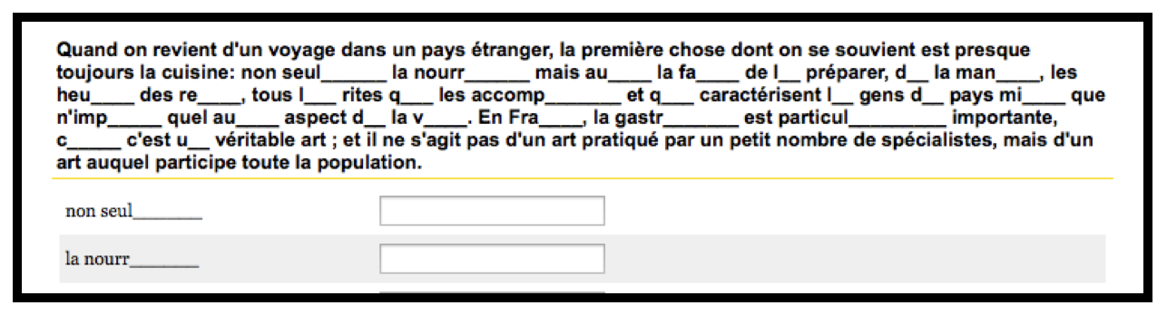
Figure 1. First text of the C-test (proficiency measure)

 | Group size | Mean (SD) | Range (max. 50)
Native speakers | 43 | 46.3 (2.1) | 41-49
Advanced L2 | 22 | 42.5 (3.9) | 36.5-49.5
Intermediate L2 | 27 | 29.6 (2.6) | 25.5-36.0
Beginners L2 | 38 | 20.3 (5.0) | 1-25.0
Table 2. Accuracy scores (1–50) of the proficiency test (C-test)

2 Materials and procedure
The picture selection task was presented to the participants as part of a fictional scenario: a schoolboy, Nicolas, was trying to make his language clearer by asking the participants to demonstrate their understanding of the sentences he produced. After reading the scenario, participants were presented with short contexts (n = 84), each followed by a test sentence. Each test sentence contained a pronoun that could potentially be ambiguous according to the preceding context. The participants then chose one of the four pictures to indicate their interpretation of the pronoun in the test sentence.
Here, we will focus on 12 experimental items that probed participants’ interpretations of direct object pronouns with respect to the [$±$Human] feature. A sample experimental item is presented in Figure 2. Each of the 12 contexts introduced an animate and an inanimate referent (e.g., Claire_{FEM} and la fleur_{FEM} ‘the flower’). The test sentence contained a direct object clitic; 6 sentences contained le and 6 sentences la. The verbs of the test sentences were carefully chosen to be semantically compatible with both animate and inanimate interpretations of the direct object pronoun: voir ‘see’, chercher ‘look for’, trouver ‘find’, surveiller ‘observe’, dessiner ‘draw’, montrer ‘show’. For example, the verb voir ‘see’ was chosen because one can easily construct an interpretation where one sees something or someone. The test sentence was followed by four pictures. The first picture depicted the [+Human] referent, in our example Claire. The second picture depicted the [–Human] referent: la fleur ‘the flower’. The third option, [$±$Human], depicted both referents separated by a line and accompanied by a caption Les deux sont possibles ‘Both are possible’. Finally, each picture set contained a fourth option [Distractor] that was not mentioned in the context, but was semantically plausible and gender-compatible. In the example below the distractor picture was la clé ‘the key’. Note that the common nouns were presented with the definite article that reflects their grammatical gender, so the participants’ lexical knowledge of the test nouns’ gender was not an issue.
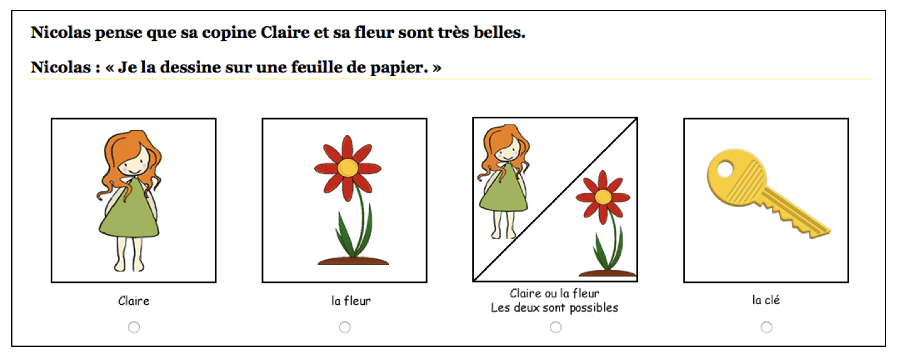
Figure 2. Sample item of the picture selection task. Context: Nicolas thinks that his friend Claire and her flower are very beautiful. Test sentence: I it/her draw on a sheet of paper. Target answer: ‘Both are possible’.

VI Results
Figure 3 presents how many times out of 12 on average (Y-axis) participants in each group chose each picture (X-axis). Visual inspection of the graph reveals that the main difference between groups had to do with how often participants chose [±Human] (‘Both are possible’) and [–Human] pictures (la fleur ‘the flower’) when they saw a test item as in Figure 2. [+Human] (Claire) and distractor pictures (la clé ‘the key’) were rarely chosen by participants in all the four groups. Returning to the results represented by the first two column clusters, a clear developmental trend can be observed, where advanced learners perform on a par with native speakers, beginner interpretations differ greatly from those of native speakers, and intermediate L2 learners appear to be in transition to target-like interpretations. While native speakers and advanced learners of French interpreted le/la as possibly pointing to [+Human] or [–Human] antecedents (‘Both are possible’), intermediate and, especially, beginning learners were much more likely than the other groups to interpret the target forms as inanimate objects, i.e. [–Human] only (la fleur ‘the flower’). On average, almost 11 pronouns out of 12 were interpreted as [±Human] (‘Both are possible’) by natives and advanced learners. The intermediate group also demonstrated a preference for [±Human] interpretations, although this preference was less categorical than in the native and the advanced groups. In the intermediate group, 8 pronouns out of 12 were interpreted as [±Human] and 4 as [–Human] only. Beginning learners, however, chose only slightly more [±Human] pictures than [–Human] only pictures. On average, beginning learners chose 6 pictures with [±Human] referents and 5 pictures with [–Human] only referents.
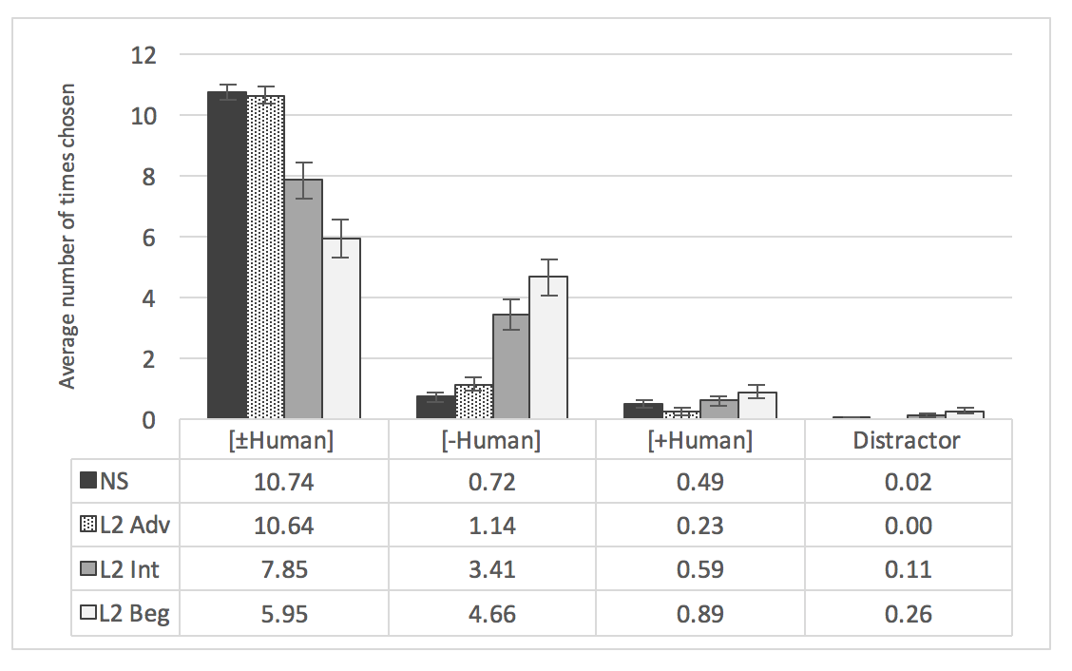
Figure 3. Average number of times each picture was chosen by each group

Statistical analysis was conducted to test whether group differences for the [±Human] and the [–Human] answers were significant. We conducted a repeated-measures ANOVA with Answer (2 levels: [±Human] and [–Human]) as the within-subjects variable and Group as the between-subjects variable (4 levels: Natives, Advanced L2, Intermediate L2, and Beginner L2). We used an alpha level of .05 for all statistical tests. The test revealed a significant Answer*Group interaction (F = 24.46, p < .001, η_{p}² = .37). Since the interaction was significant, we conducted post hoc tests for each answer using the Bonferroni correction. Looking at the expected [±Human] answer, beginners chose significantly fewer [±Human] pictures than participants in the other three groups (Table 3). The same was true for the intermediate group who chose fewer [±Human] answers than advanced L2ers or native speakers. However, advanced L2 learners were not statistically different from the native speakers. On the [–Human] answer, advanced L2 learners were not statistically different from the natives, while intermediate and beginner L2 learners differed statistically from both the native speakers and the advanced learners. The difference between beginning and intermediate groups in [–Human] answers was not significant.

 | L2 Advanced | L2 Intermediate | L2 Beginners
NS | [±Human] p = 1.00  [–Human] p = 1.00 | [±Human] p < .001  [–Human] p < .001 | [±Human] p < .001  [–Human] p < .001
L2 Adv |  | [±Human] p = .003  [–Human] p = .008 | [±Human] p < .001  [–Human] p < .001
L2 Int |  |  | [±Human] p = .04  [–Human] p = .248
Table 3. P values for post-hoc tests with Bonferroni correction for [±Human] and [–Human] answers.

VII Discussion
The results of the experiment provide an empirical confirmation of the acquisitional difficulty predicted based on the Feature Reassembly Hypothesis. This difficulty is noticeable in spite of the fact that the experimental participants were instructed learners and have most likely been exposed to explicit grammar explanations that mention the irrelevance of the [$±$Human] feature for French le and la. As we mentioned above, we could not expect learners’ judgments to be categorical. In spite of a high degree of variability in the results, the picture selection task suggests that Anglophone L2 learners of French start off by mapping their L1 pronoun it to French direct object clitics le and la. This is apparent from the pattern of interpretation errors observed in the beginning and intermediate groups. Both groups interpreted le and la as [–Human] more often than the native speakers of French. Thus, one might speculate that learners of beginning and intermediate proficiencies are at the initial mapping stage with respect to their pronominal reassembly.
The experimental results are also encouraging in the sense that ultimate reassembly seems possible: the advanced learners’ clitic interpretations tested here were statistically indistinguishable from those of the native speakers. These L2 learners had successfully reassembled the pronominal features from their L1 bundles into a new L2 configuration. In the present case, they eschewed the [$±$Human] feature since they saw the ambiguity of French direct object clitics between [+Human] and [–Human] interpretations in 11 cases out of 12.
In the next section, we consider some pedagogical implications of our results to L2 teaching of French clitics to adult Anglophone learners. We also discuss some general implications of the present study for FL teaching and the impact of L1 transfer on interlanguage development. At several points in the present article, we have pointed to the similarity between the French and Spanish pronominal systems, in terms of the grammatical features they encode. Since the contrast with the English pronominal system is along the same lines, we expect a very similar learning situation to obtain for Anglophone learners of L2 Spanish. The obvious prediction is that the same developmental pattern will be demonstrated in beginning, intermediate, and advanced learners of L2 Spanish. While we leave this prediction for future research, we note here that teachers of Spanish as a foreign or second language have to teach the same feature mismatch as the one we described for teachers of French. Furthermore, we outline some recommendations on how L2 practitioners can apply the Feature Reassembly Hypothesis to other properties and other language combinations. We focus on three benefits of feature-based L1 transfer predictions to the teaching of a foreign language grammar.

VIII Practical applications and limitations of the current study
The current discussion is especially relevant for FL classrooms where most students share the same L1. Currently, most of the teaching techniques designed for Anglophone learners of French train students to produce clitics in their correct position, thus focusing on their morphosyntactic properties, but not their semantics. However, it may be useful for teachers to keep in mind that in addition to learning a new piece of functional morphology, not available in their L1, Anglophone learners of French are also trying to match their native forms onto the French ones. It is essential to help learners see that one-to-one mapping is not possible. It might be beneficial to draw learners’ attention to the differences in meaning that are available in French, but not in English, and vice versa (McManus & Marsden, 2016). A visual aid could look like the one in Figure 4.
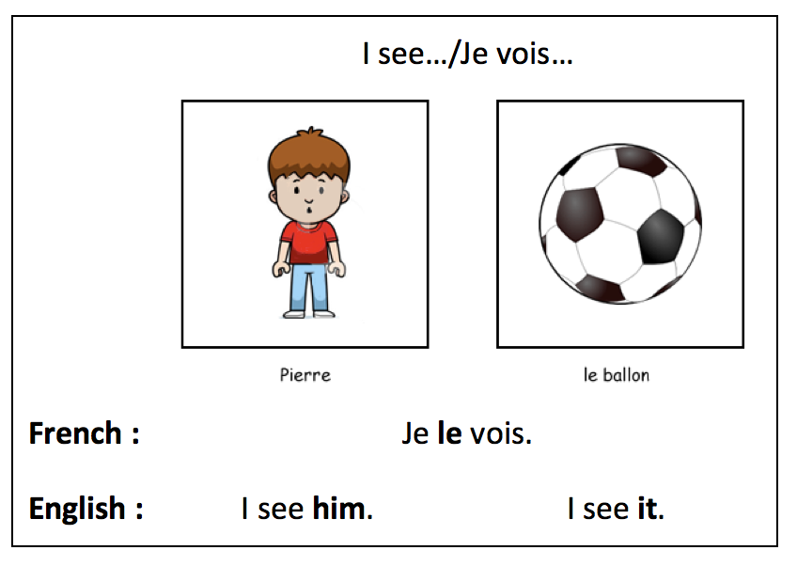
Figure 4. A visual presentation of the French-English contrast in object pronouns

Similarly to the techniques advocated by the proponents of Processing Instructions (VanPatten 2004, 2012), teachers and textbooks writers might create contexts similar to the ones utilized in the current study and train students to recognize which features are contrastive in French direct object clitics (e.g. grammatical gender) and which ones are not (e.g. [$±$Human] feature). This should first be done through comprehension and only then extended to production exercises, echoing similar recommendations by Wust (2010a,b).
Going beyond French direct object clitics, several practical recommendations can be formulated based on the present study. First, the Feature Reassembly Hypothesis helps us conceptualize L1 transfer and can help us predict specific acquisitional difficulties. Moreover, these predictions can focus on semantic transfer effects as well as syntactic ones. In line with the calls in the field of SLA to emphasize “meanings and uses of different grammatical structures” rather than “just form” (Ellis, 2006: 102), the Feature Reassembly Hypothesis allows FL practitioners to approach each specific linguistic property and language combination with a sound theoretical understanding of the issues involved in the transfer.
Taking an example from another area of the grammar, Dominguez, Arche, and Myles (2011) looked at the L2 acquisition of Spanish preterit and imperfect aspectual tenses. English past tense can express both complete and incomplete events that happened before the moment of speech, as long as the latter are viewed as continuous: He was sick all day. vs. He was sick when I saw him. Therefore, in English the meaning of incomplete and ongoing event or state are bundled together since there is no way to formally distinguish between events ongoing in the past from incomplete ongoing events. Spanish uses two types of morphemes to express the [$±$Complete] meaning: preterit verbal endings to express [+Complete] (El estuvo enfermo todo el dia. = He was sick all day) and imperfect verbal endings to express [–Complete] (El estaba enfermo cuando lo vi. = He was sick when I saw him). Again, no one-to-one mapping exists in this situation for Anglophone learners of Spanish and one can predict that beginning learners will prefer to use Spanish preterit for all ongoing events in the past by transferring their L1 feature bundle into the L2. This prediction was confirmed by Dominguez et al.’s study results.
In many cases, teachers might actually find it easy to tease apart different minimal units of meaning that distinguish words and morphemes in the L1 and the L2. For example, in the case of French direct object clitics, feature analysis allowed us to go beyond such broad recommendations as suggesting “development of oral comprehension of these forms” (Wust, 2010a, p. 65). The hypothesis allowed us to pinpoint a specific interpretation error. The ability to make such predictions makes it easier to design specific comprehension activities geared towards learners with specific L1 backgrounds. Similarly to what we did in our study, FL teachers can apply the stages of the Feature Reassembly Hypothesis to different properties and language combinations and try to predict what mappings learners might attempt and what reassembly will be required for target-like acquisition.
Second, being able to predict acquisitional difficulties allows FL practitioners to tailor metalinguistic explanations to the needs of the students. It is possible that different audiences might need different aspects highlighted in the explanations. For instance, Spanish learners of French might not need to be told explicitly that French le and la are [±Human]. As pointed out above, equivalent Spanish forms lexically encode the same feature set as the French forms and the [±Human] feature is not contrastive for Spanish direct object clitics. English speakers, by contrast, might benefit from visual aids as in Figure 4, targeted practice and not just a simple note on the role of the [±Human] feature for French le and la.
Finally, the current study brings back into focus the question of transferability of explicit grammatical knowledge to spontaneous use of different forms and structures. Even though the study was not designed to test the interaction between explicit and implicit L2 knowledge, it provides further support to the Weak Interface position where explicit knowledge can have an impact on interlanguage development (Ellis, 1994; Long, 1991). While it is clear that general metalinguistic explanations did not lead to completely target-like behavior with respect to the features investigated in our experiment, it is very likely that the learners benefited from the metalinguistic explanations they received since even beginning learners interpreted le and la as [–Human] only 6 times out of 12. This finding leaves us optimistic that meaningful focus on form exercises that take into account transfer effects might speed up acquisition and allow learners to be more efficient in noticing the featural mismatches and reassembling the features that need to be reassembled.
Finally, we would like to acknowledge that the present discussion of L1 feature transfer is based on experimental results from one experiment/task and could be strengthened by additional investigations of Romance clitic interpretations by L1 speakers of cliticless languages. It would also be interesting to see how L1 speakers of other Romance languages (e.g. Spanish) interpret French clitics with respect to the [±Human] feature at different levels of proficiency. Based on the present understanding of L1 transfer mechanism, we would not expect these learners to go through the same developmental stages as do the Anglophone learners tested in the present study.

IX Conclusions
The present study demonstrated that the process of learning an L2 starts with an attempt to impose native language categories on the new language. Careful linguistic analysis allowed us to predict transfer patterns and specific errors. Therefore, efficient grammar teaching to learners who share the same L1 should take advantage of these findings by drawing parallels and highlighting differences between the L1 and L2 grammatical meanings. Banishing the native language from classroom discourse does not have to result in its oblivion in adult FL pedagogy. As has been suggested before, adult FL learners might benefit from direct comparisons between the L1 and L2 grammars. Highlighting differences in meaning, as well as differences in form, can potentially help learners reassemble the features that do not coincide in the two languages. It remains to be shown empirically what specific teaching approaches or techniques are best suited for teaching such L1–L2 differences.

Notes
- The same contrast exists between English and Spanish pronouns: Yo veo a mi amigo ‘I see my friend’ but Yo lo veo ‘I see him’ while Yo veo lo is unacceptable.
- While gender assignment in English is mainly based on semantic criteria, it also contains some exceptions to the general rule, with the variation being especially present in colloquial language. For instance, it is common to use [+Human] he or she when referring to domestic animals, especially if they are named. In these cases, gender assignment occurs based on the biological sex of the animal. Exceptions also exist when inanimate objects can be referred to with the help of the [+Human] forms and assigned semantic gender. For instance, it is customary to refer to boats and ships as she (Corbett, 1991).
- In French linguistics, the feature has traditionally been labeled [$±$Animate]. The present study, however, makes no claims about pronominalization of [–Human, +Animate] antecedents. Since the empirical study investigates the contrast between human antecedents and inanimate objects, we are using the label [$±$Human] throughout the article.
- At least, it is not contrastive in the case of direct object clitics.
- We will leave French adverbial clitics and the indirect object clitic lui for future research. The research available today suggests that L2 acquisition of these forms is delayed compared to strong pronouns and direct object clitics (Wust, 2010a).
- When we use words like “notice” and “abandon” in this article, we are not implying that these are necessarily conscious processes of noticing the availability or unavailability of some form or meaning. Language acquisition proceeds largely unconsciously, as both usage-based and generative approaches to SLA acknowledge.

References
ACTFL. (2010). Position Statement on Use of the Target Language in the Classroom. Retrieved on July 26, 2016 from https://www.actfl.org/news/position-statements/use-the-target-language-the-classroom
Bruhn de Garavito, J. (2013). What research can tell us about teaching: The case of pronouns and clitics. In M. Whong, K., H. Gil, & H. Marsden (Eds.), Universal Grammar and the Second Language Classroom (pp. 17–34). Berlin: Springer.
Corbett, G. (1991). Gender. Cambridge: Cambridge University Press.
Crystal, D. (2008). A Dictionary of Linguistics and Phonetics (6th ed.). Malden, MA: Blackwell Publishing.
DeKeyser, R. M. (2005). What makes learning second language grammar difficult? A review of issues. Language Learning, 55(S1), 1–25.
Domínguez, L., M. J. Arche, & F. Myles. (2011). Testing the predictions of the Feature-Assembly Hypothesis: Evidence from the L2 acquisition of Spanish aspect morphology. In N. Danis, K. Mesh, & H. Sung (Eds.) BUCLD 35: Proceedings of the 35th annual Boston University Conference on Language Development. Boston University Conference on Language Development Proceedings 35 (pp. 183–196). Somerville, MA: Cascadilla Press.
Ellis, N. C. (1994). Implicit and explicit language learning. In P. Rebuschat (Ed.), Implicit and explicit learning of languages (pp. 79–114). Amsterdam: John Benjamins.
Ellis, R. (2006). Current issues in the teaching of grammar: An SLA perspective. Tesol Quarterly, 40, 83–107.
Erlam, R. (2003). The effects of deductive and inductive instruction on the acquisition of direct object pronouns in French as a second language. The Modern Language Journal, 87, 242–260.
Gass, S. M. (2013). Second language acquisition: An introductory course. New York, NY: Routledge.
González, P. (2008). Towrads effective instruction on aspect in L2 Spanish. International Review of Applied Linguistics in Language Teaching, 46(2), 91–112.
Granfeldt, J., & Schlyter, S. (2004). Cliticisation in the acquisition of French as L1 and L2. In P. Prévost & J. Paradis (Eds.), The Acquisition of French in Different Contexts: Focus on Functional Categories (pp. 333–370). Amsterdam: John Benjamins.
Grüter, T. (2006). Object clitics and null objects in the acquisition of French (Doctoral dissertation). Unpublished doctoral dissertation, McGill University, Montreal, Canada.
Hawkins, R. (2001). Second language syntax: A generative introduction. Oxford: Blackwell.
Herschensohn, J. (2004). Functional categories and the acquisition of object clitics in L2 French. In P. Prévost & J. Paradis (Eds.), The Acquisition of French in Different Contexts: Focus on Functional Categories (pp. 207–242). Amsterdam: John Benjamins.
Horst, M., White, J., & Bell, P. (2010). First and second language knowledge in the language classroom. International Journal of Bilingualism, 14, 331–349.
Kelly, N. & Bruen, J. (2015). Translation as a pedagogical tool in the foreign language classroom: A qualitative study of attitudes and behaviours. Language Teaching Research, 19(2), 150–168.
Lado, R. (1957). Linguistics Across Cultures: Applied Linguistics for Language Teachers. Ann Arbor: University of Michigan Press.
Lamiroy, B. (1991). Coréférence et référence disjointe: les deux pronoms en. Travaux de linguistique, 22, 41–67.
Lardiere, D. (2009). Some thoughts on the contrastive analysis of features in second language acquisition. Second Language Research, 25, 173–227.
Long, M. H. (1991). Focus on form: A design feature in language teaching methodology. In K. D. Bot, R. Ginsberg & C. Kramsch (Eds.), Foreign language research in cross-cultural perspective (pp. 39–52). Amsterdam: John Benjamins.
McManus, K. & Marsden, E. (2016, FirstView) L1 explicit information can improve L2 online and offline performance. Studies in Second Language Acquisition, 1–31.
Mitschke, C. (2016). Imaginez : Le Français sans Frontières. Boston, MA : Vista Higher Learning.
Nassaji, H. (2012). The relationship between SLA research and language pedagogy: Teachers’ perspectives. Language Teaching Research, 16(3), 337–365.
Ortega, L. (2008). Understanding second language acquisition. New York: Routledge.
Pica, P. (1994). On the disjoint agreement principle. Montreal: UQAM.
Poirier, J. (2012). Pronoms Clitiques Objets : Fréquence et Expression du Genre Grammatical dans le Discours Oral des Enseignants en Classes d’Immersion. Unpublished Master’s Thesis. University of Quebec in Montreal.
Prévost, P. (2009). The acquisition of French: The development of inflectional morphology and syntax in L1 acquisition, bilingualism, and L2 acquisition. Amsterdam: John Benjamins.
Renaud, C. (2010). On the Nature of Agreement in English-French Acquisition: A Processing Investigation in the Verbal and Nominal Domains. Unpublished doctoral dissertation, Indiana University.
Rochat, D. (2013). Contrastes: Grammaire du francais courant. Prentice Hall.
Ruwet, N. (1990). En et y: deux clitiques pronominaux anti-logophoriques. Langages, 97, 51–81.
Schlyter, S. (1997). Formes verbales et pronoms objets chez des apprenants adultes de français en milieu naturel. In C. Martinot (Ed.), Actes du Colloque International sur l’Acquisition de la Syntaxe en Langue Maternelle et en Langue Étrangère (pp. 273–293). Paris: Annales Littéraires de l’Université de Franche-Comté.
Schlyter, S. (2003). Development of verb morphology and finiteness in children and adults acquiring French. In C. Dimorth & M. Starren (Eds.), Information Structure and Dynamics of Language Acquisition (pp. 15–44). Amsterdam: John Benjamins.
Shimanskaya, E. (2015). Feature reassembly of semantic and morphosyntactic pronominal features in L2 acquisition. Unpublished doctoral dissertation, the University of Iowa.
Slabakova, R. (2008). Meaning in the Second Language. Berlin: Mouton de Gruyter.
Spada, N., Lightbown, P. M., & White, J. (2005). The importance of form/meaning mappings in explicit form-focused instruction. In A. Housen & M. Pierrard (Eds.), Investigations in Instructed Second Language Acquisition (pp. 199–234). Berlin: Mouton de Gruyter.
Towell, R., & Hawkins, R. D. (1994). Approaches to second language acquisition. Clevedon, UK: Multilingual matters.
Tremblay, A. (2011). Proficiency assessment standards in second language acquisition research. Studies in Second Language Acquisition, 33(03), 339-372.
VanPatten, B. (2004). Input Processing in second language acquisition. In B. VanPatten (ed.), Processing Instruction. Theory, Research, and Commentary, pp. 5–31. Mahwah, NJ: Erlbaum.
VanPatten, B. (2012). Input processing. In S. Gass, & A. Mackey (eds.), The Routledge Handbook of Second Language, pp. 268–281. London: Routledge.
Wong, W., Weber-Fève, S., Ousselin, E., & VanPatten, B. (2013). Liaisons: an introduction to French. Boston : Cengage Learning.
Wust, V. A. (2010a). L2 French learners’ processing of object clitics: Data from the classroom. L2 Journal, 2, 45–72.
Wust, V. A. (2010b). Pronominalization in French: Bridging the Gap between Research and Practice. Journal of Linguistics and Language Teaching, 1(1), 75–110.
Zribi-Hertz, A. (2000). Les pronoms forts du français sont-ils [+animés] ? Spécification morphologique et spécification sémantique. In M. Coene, W. De Mulder, P. Dendale, Y. dʼHulst (Eds.), Traiani Augusti vestigia pressa sequamur. Studia linguistica in honorem

