Figures
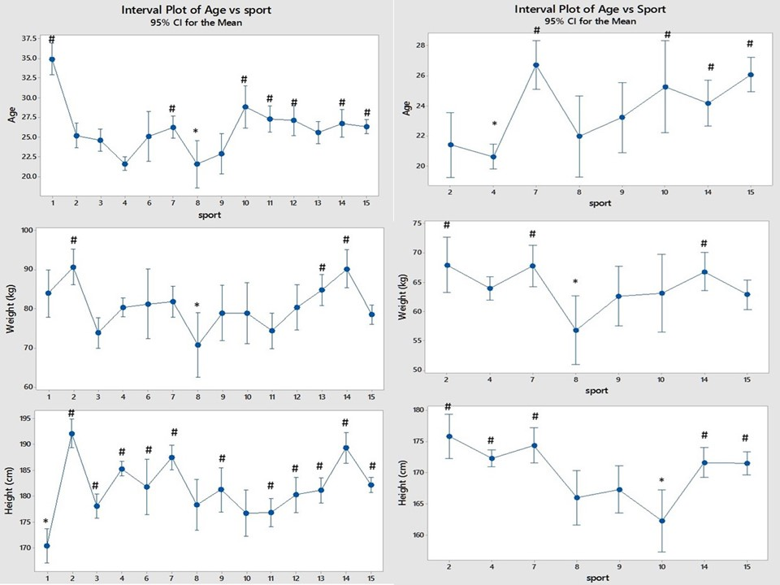
Figure 1. The differences in mean age, weight and height between sports. For all the figures data from men are shown in the left panel and those from women are in the right panel. The lowest mean for each variable is marked with * and means that are significantly higher than this by one-way analysis of variance are marked with #.
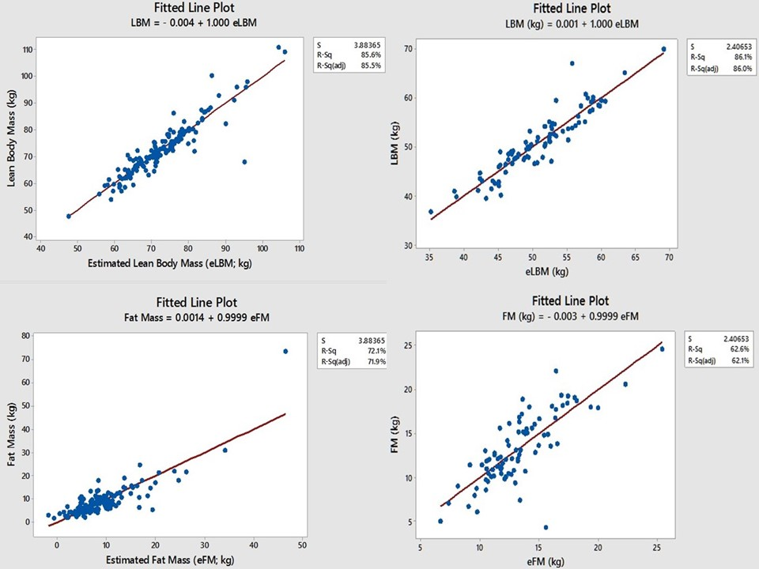
Figure 2. Lean body mass (LBM) and Fat Mass (FM) measured by bio-impedance are compared with the same variables estimated from just height and weight. R-squared values of 86, 85.5, 71.9 and 62.1% show the model to be reasonably accurate.
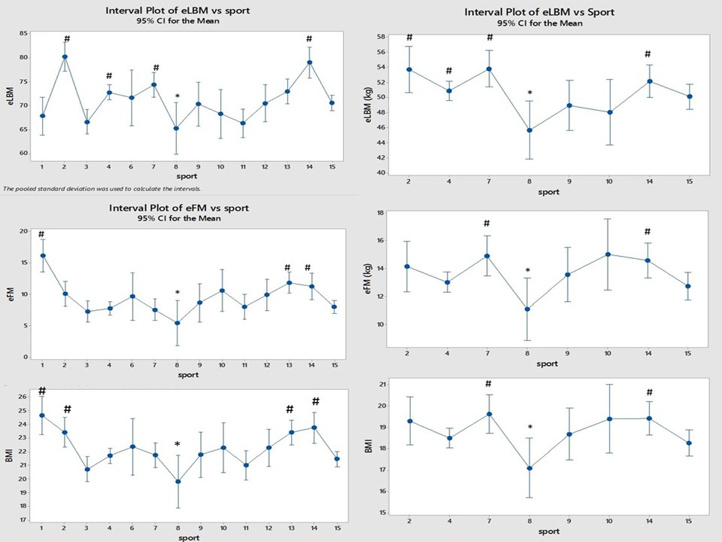
Figure 3
Comparison of eLBM, eFM and BMI between the sports and between the sexes (men on the left and women on the right).
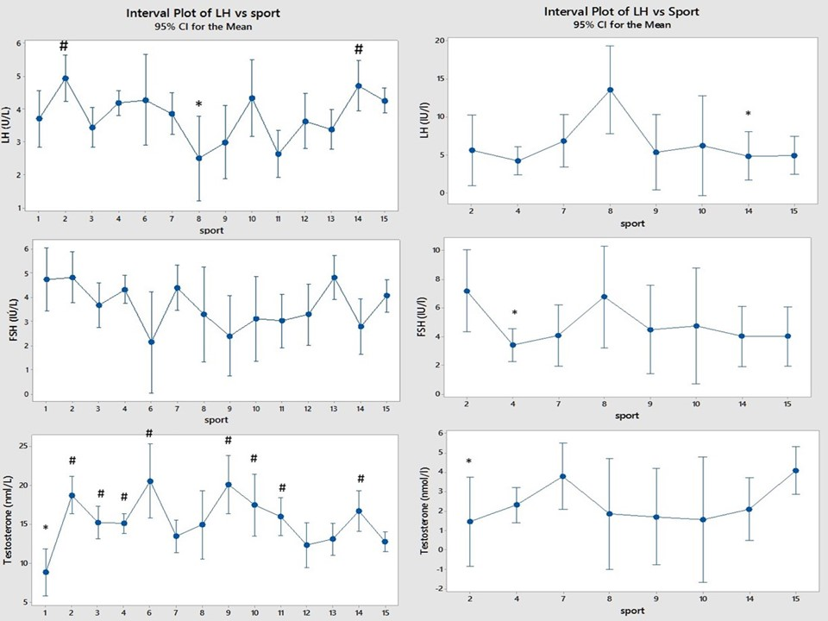

Figure 4.
Comparison of LH, FSH and Testosterone between sports and between sexes (men on the left and women on the right).

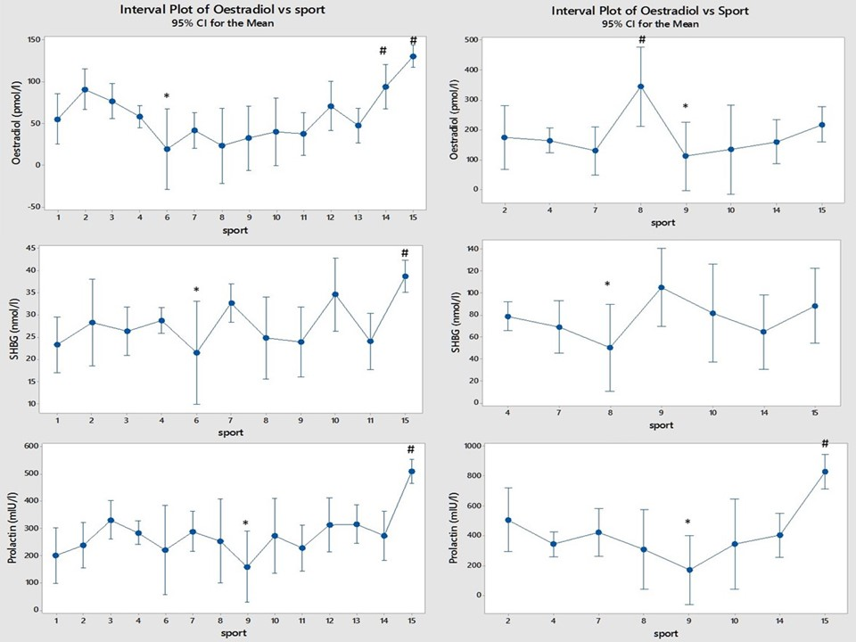

Figure 5 Comparison of Oestradiol, Sex Hormone Binding Globulin (SHBG) and Prolactin between sports, (men on the left and women on the right)
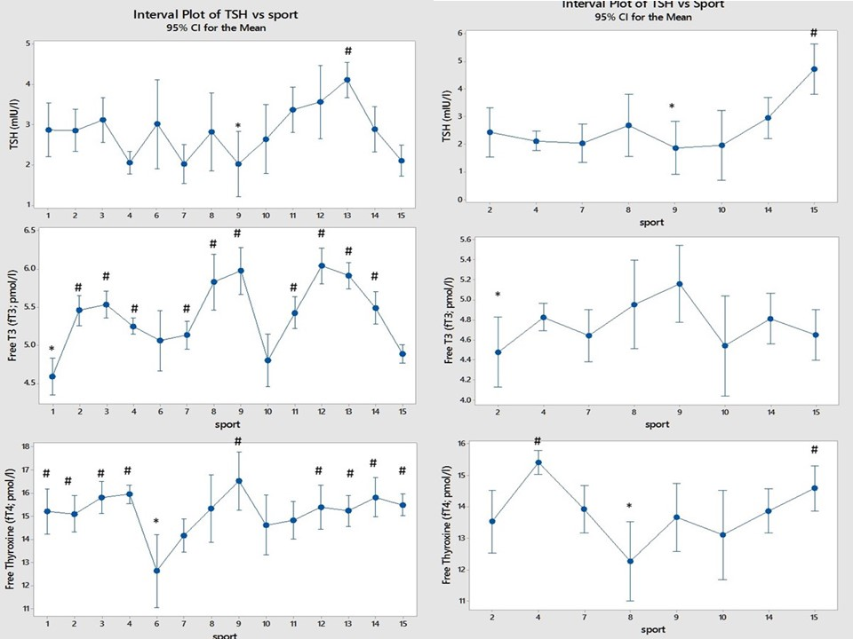

Figure 6 Comparison of thyroid function test results between sports (men on the left and women on the right).
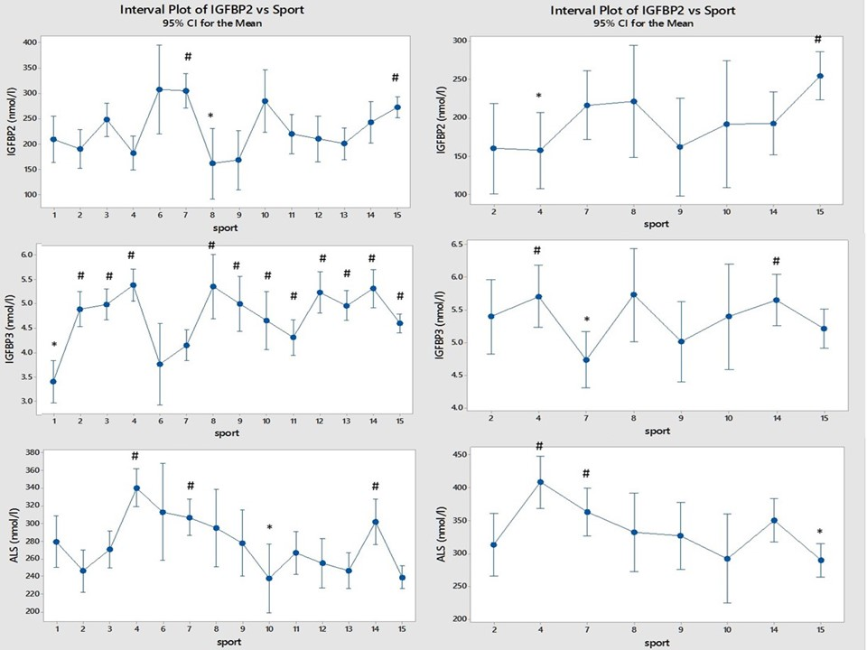

Figure 7 Comparison of IGF binding-proteins between sports (men on the left and women on the right).
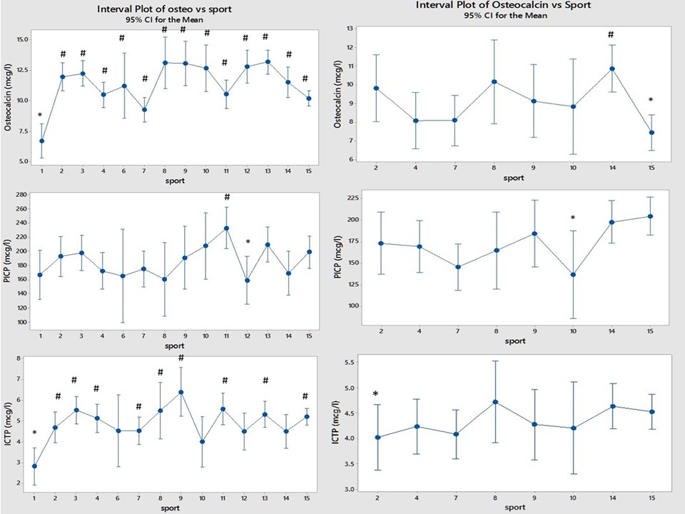

Figure 8 Comparison of Osteocalcin and the collagen peptides PICP and ICTP between sports (men on the left and women on the right).

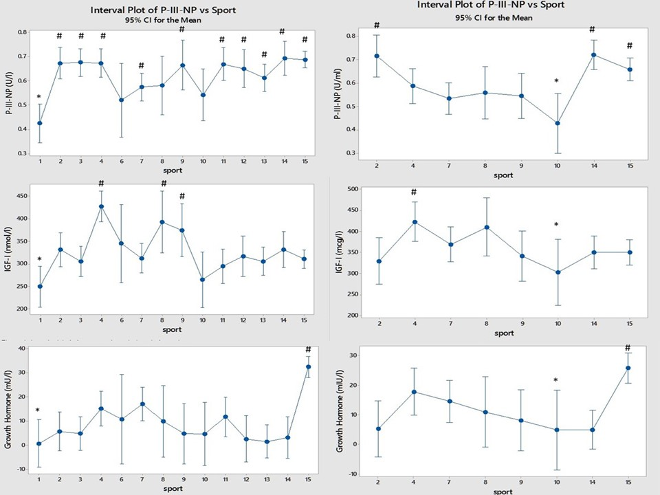

Figure 9 Comparison of Growth hormone, IGF-I and collagen marker P-III-NP between sports (men on the left and women on the right).

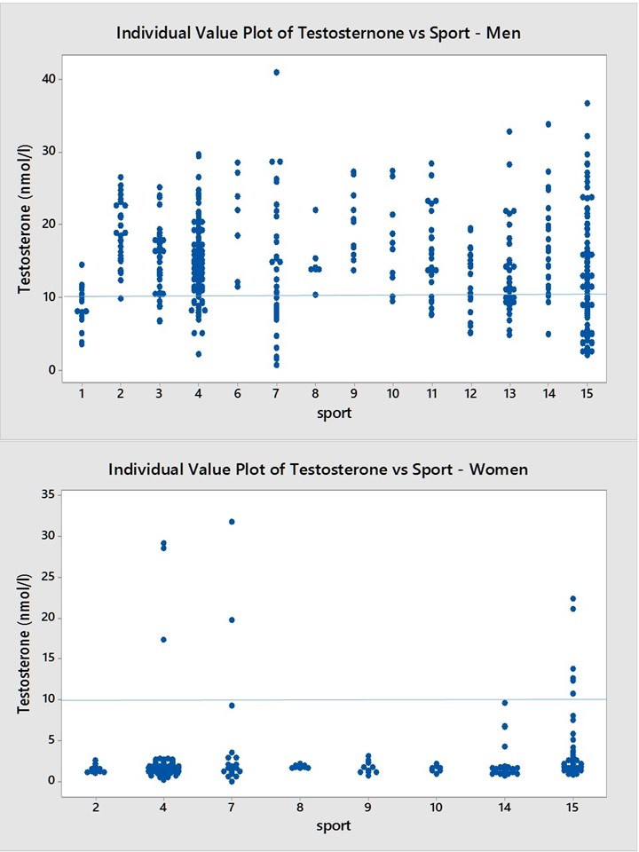
Figure 10.
Above –Serum testosterone in 445 elite male athletes. The horizontal line is at 10 nmol/l. There were 113 (25.4%) men with a testosterone value less than 10 nmol/l.
Below - Serum testosterone in 231 elite female athletes. Horizontal line is at 10 nmol/l. There were 11 of 231 (4.8%) athletes with testosterone level above 10 nmol/l; 3 of 88 swimmers, 2 of 25 rowers and 6 of 48 track and field athletes.

