R-functions theory applied to investigation of nonlinear free vibrations of functionally graded shallow shells
Tetyana Shmatko^{1*}, Atul Bhaskar²
¹ Department of Higher Mathematics, National Technical University “Kharkiv Polytechnic Institute”, 2 Kyrpychov Str., Ukraine
² Faculty of Engineering and the Environment, University of Southampton, SO16 7QF, UK
Tel.*: +380676895525
E-mail*: ktv_ua@yahoo.com
Abstract: Nonlinear free vibration of functionally graded shallow shells with complex planform is investigated using the R-functions method (RFM) and variational Ritz method. The proposed method is developed in the framework of the first–order shear deformation shallow shell theory (FSDT). Effect of transverse shear strains and rotary inertia are taken into account. The properties of functionally graded materials (FGM) are assumed to be varying continuously through the thickness according to a power law distribution. The Rayleigh-Ritz procedure is applied to obtain the frequency equation. Admissible functions are constructed by the R-functions theory. To implement the proposed approach the corresponding software has been developed. Comprehensive numerical results for three types of shallow shells with positive, zero and negative curvature with complex planform are presented in tabular and graphical forms. The convergence of the natural frequencies with increasing number of admissible functions has been checked out. Effect of volume fraction exponent, geometry of a shape and boundary conditions on the natural and nonlinear frequencies is brought out. For simply supported rectangular FG shallow shells, the results obtained are compared with those available in the literature. Comparison demonstrates a good accuracy of the approach proposed.
Keywords: functionally graded shallow shells, the R–functions theory, method by Ritz, geometrically nonlinear vibrations

Acknowledgments
This work was carried out as a part of the Erasmus Mundus post-doctoral exchange research program ACTIVE.
Introduction
In many practical applications, shallow shells are basic design elements. Advanced structural materials such as functionally graded materials are widely used for their manufacture. In recent years, investigations on FGM have received great attention from many researchers. This is due to the extensive use of functionally gradient shallow shells in many industries such as those in rocket, aerospace and nuclear industry, mechanical and civil engineering. Shells with cutouts are frequently encountered in engineering applications. For example, control surfaces in airplanes such as aileron, rudder and elevators require the provision of cutouts within the shallow shell airfoils – such as wings and stabilizers. This highlights the need for understanding the role of cutouts on the dynamics of shallow shells.
Various shell theories and numerous analytical and numerical methods were developed in the past. A number of reviews concerning FGM plate and shells have been published recently [1-3]. Nonlinear analysis of FGM plates and shells is also of great interest for many researchers [4-6]. A fairly complete survey of nonlinear vibrations of plates and shells is presented in [7-9]. Nonlinear vibrations of simply supported or clamped FG structures of rectangular, skew or circular planform have been analyzed by different numerical methods, such as Finite Element Method (FEM) [10, 11], Finite Difference Method [12], Differential Quadrature Method [13, 14]. Asymptotic approaches based on analysis of influence of FGM parameters in the problem of longitudinal rod deformations and analysis of the Maxwell Garnett formula using the two-phase composite model were presented in papers [15, 16]. Modified Fourier-Ritz approach, meshless method [17-19] were applied to free vibration of functionally graded and laminated shallow shells with general boundary conditions.
Zhao et al. [20] presented the static response and free vibration of functionally graded shell panels under mechanical and thermomechanical loading using the element-free kp-Ritz method based on the first-order shear deformation shell theory. Neves et al. [21] investigated free vibrations of FG shell including cylindrical and spherical panels with simply supported and clamped boundary conditions using radial basis functions based collocation and higher-order deformation theory. Pradyumna and Bandyopadhyay [22] analyzed the free vibration analysis of FG curved panels based on higher-order shear deformation theory. Reddy et al. [11] introduced a theoretical formulation for FGM plates using the third-order shear deformation plate theory, and advanced a corresponding finite element model that accounts for thermomechanical coupling, time dependence, and von Karman-type geometric nonlinearity. Free vibration and stability of functionally graded shallow shells according to 2D higher–order deformation theory were reported by Matsunaga [23].
The analysis of published literature on the problem of vibration of FGM shallow shells and plates shows that practically all researchers consider rectangular or circular planform and classical boundary conditions. The present study is inspired by the need to develop general and effective methods for investigation of dynamical behaviour of functionally graded shallow shells with complex planform and various boundary conditions.
The sought methods must be convenient for their application to nonlinear problems. Meshless methods satisfy these requirements. Earlier, in papers [24-28 ] the original meshless method for investigations of the laminated plates and shallow shells has been proposed. This method is based on application of the R-functions theory, variational Ritz method, Bubnov-Galerkin procedure and Runge-Kutta method.
In this paper, meshless approach using R-functions theory and variational Ritz method is proposed to study nonlinear vibration of functionally graded shallow shells of an arbitrary planform and different boundary conditions. Two shapes of cuts – rectangular and circular – within the basic rectangular planform of shallow shells are considered here. The method is developed in the framework of the first-order shear deformations of shallow shells and it takes into account transverse shear deformation and rotary inertia. It offers the unique procedures for construction of admissible functions that minimize the Lagrange’s functional and satisfy various boundary condition for an arbitrary planform of the shell. The computer code thus developed allows representing geometrical and mechanical information in an analytical form. So, a variety of geometrical parameters such as curvature of the shell, size and location of the cutout, the type of boundary conditions, the mechanical properties of material constituents, various power law exponent to describe through-the-thickness property gradients and other parameters don’t require essential changes to solution procedure. A comparative analysis of the results with those available for shells with a rectangular shape of the plan confirms the effectiveness and reliability of this method and software. Numerous vibration results for FG shallow shells with complex planform and various boundary conditions are presented.
1. Theoretical formulation
Consider a shallow shell of an arbitrary planform with radii of curvatures $R_{x}, R_{y}$ in the $\text{Ox}$,$\text{Oy}$ directions respectively (Fig.1).
Fig 1. Typical FGM square shell panel
Three types of shallow shells with regards to the character of curvature are analysed: circular cylindrical shell ($R_{x}=R, R_{y}=∞$), spherical shell $\left(R_{x}= R_{y}=R\right)$, hyperbolic paraboloid $\left(R_{x}=R, R_{y}=−R\right)$ and also flat plate $\left(R_{x}= R_{y}=∞\right)$ as shown in Fig.1. It is assumed that FGM shallow shell is made of a mixture of two material constituents: a metal and a ceramics. It is well known that constituents of FGM depend on the temperature. This dependence can be defined as [8]
$P\left(T\right)=P_{0}\left(P_{−1}T^{−1}+1+P_{1}T+P_{2}T^{2}+P_{3}T^{3}\right)$,
where P is a generic material property for Young’s modulus E, Poisson’s ratio $ν$ and mass density $ρ$. The values of constants $P_{0}, P_{−1}, P_{1}, P_{2}, P_{3}$ for different materials are presented in [8]. So, for accurate prediction of the mechanical response it is essential to take the both temperature and position dependences [9]. The volume fraction $V_{c}$ of the ceramic and $V_{m}$ of the metal are related as
$V_{c}+V_{m}=1$.
In this study Voigt’s rule for definition of material properties of the shell through-the-thickness is applied. According to this rule the volume fraction $V_{c}$is defined as
$V_{c}={\left(\frac{2z+h}{2h}\right)}^{k}$,
where h is the thickness of the shell, $k$ is the parameter that governs the material variation in the thickness direction. It varies from 0 to infinity$(0≤k<∞)$. When $k=0$, we have the whole structure made of ceramics, when $k=∞$, we have the whole structure metallic. So the Young’s modulus E, Poisson’s ratio $ν$ and mass density $ρ$ can be expressed as
$E=\left(E_{c}\left(T\right)−E_{m}\left(T\right)\right)V_{c}+E_{m}\left(T\right)$,
$ρ=\left(ρ_{c}\left(T\right)−ρ_{m}\left(T\right)\right)V_{c}+ρ_{m}\left(T\right)$,
$ν=\left(ν_{c}\left(T\right)−ν_{m}\left(T\right)\right)V_{c}+ν_{m}\left(T\right)$.
The first order shear deformation of shallow shell theory (FSDT) is applied. According to this theory the displacement field is given by
$u\left(x,y,z,t\right)=u\left(x,y,t\right)+{zψ}_{x}\left(x,y,t\right)$, (1)
$v\left(x,y,z,t\right)=v\left(x,y,t\right)+{zψ}_{y}\left(x,y,t\right)$, (2)
$w\left(x,y,z,t\right)=w\left(x,y,t\right)$, (3)
where $u,v,w$ are displacement components of middle surface in x, y and z directions, $ψ_{x}, ψ_{y}$describe the rotation of perpendicular to the mid-surface about the Oy and Ox axes respectively, t is the time variable.
Relations for deformations $\left\{ε\right\}={\left\{ε_{\text{11}}; ε_{\text{22}}; ε_{\text{12}}\right\}}^{T}$, are expressed as:
$ε_{\text{ij}}=ε_{\text{ij}}^{L}+ε_{\text{ij}}^{\text{NL}},$ $\left(i=1,2\right), \left(j=1,2,3\right)$
where
$ε_{\text{11}}^{L}=u,_{x}+w/{R_{x}} ε_{\text{22}}^{L}=v,_{y}+w/{R_{y}} ε_{\text{12}}^{L}=u,_{y}+v,_{x}$,
$ε_{\text{11}}^{\text{NL}}=\frac{1}{2}w,_{x}^{2}, ε_{\text{22}}^{\text{NL}}=\frac{1}{2}w,_{y}^{2}, ε_{\text{12}}^{\text{NL}}=w,_{x}w,_{y}$,
$ε_{\text{13}}=w,_{x}+ψ_{x}, ε_{\text{23}}=w,_{y}+ψ_{y}$. (4)
Note that in formulas (4) a comma in the subscript indicates partial differentiation with respect to the variable that follows it.
Curvature and twist changes of middle surface $\left\{χ\right\}={\left\{χ_{\text{11}}; χ_{\text{22}}; χ_{\text{12}}\right\}}^{T}$ are given by
$χ_{\text{11}}=ψ_{x},_{x}, χ_{\text{22}}=ψ_{y},_{y} χ_{\text{12}}=ψ_{x},_{y}+ψ_{y},_{x}$.
In this paper we will consider the shells with the same temperature on the top and bottom surfaces. Then for FG materials, after integration, we obtain the following elasticity relations relating stress resultants $N_{\text{ij}}, M_{\text{ij}},(i,j=1,2)$ with six mid-surface strain and curvature components:
$\begin{aligned}\left[N_{\text{11}} | \right]\left[N_{\text{22}} | \right]\left[N_{\text{12}} | \right]\left[M | \right]\left[M_{\text{22}} | \right] \\ \end{aligned}$ , (5)
where
$A_{\text{11}}=A_{\text{22}}=\int{E_{g}\text{dz}}$, $A_{\text{12}}=A_{\text{21}}=\int{E_{g}ν\text{dz}}$, $A_{\text{33}}=\frac{1}{2}\int{\frac{E}{1+ν}\text{dz}}$,
$B_{\text{11}}=B_{\text{22}}=\int{E_{g}\text{zdz}}$, $B_{\text{12}}=B_{\text{21}}=\int{E_{g}ν\text{zdz}}$, $B_{\text{33}}=\frac{1}{2}\int{\frac{E z}{1+ν}\text{dz}}$,
$D_{\text{11}}=D_{\text{22}}=\int{E_{g}z^{2}\text{dz}}$, $D_{\text{12}}=D_{\text{21}}=\int{E_{g}{νz}^{2}\text{dz}}$, $D_{\text{33}}=\frac{1}{2}\int{\frac{{\text{Ez}}^{2}}{1+ν}\text{dz}}$.
Here $E_{g}$ is defined as
$E_{g}=\frac{E\left(z,T\right)}{1−ν^{2}}$, $E\left(z,T\right)=\left(E_{c}\left(T\right)−E_{m}\left(T\right)\right){\left(\frac{z}{h}+\frac{1}{2}\right)}^{k}+E_{m}\left(T\right)$.
Transverse shear force resultants $Q_{x}, Q_{y}$, are determined as
$Q_{x}=K_{s}^{2}A_{\text{33}}ε_{\text{13}}, Q_{y}=K_{s}^{2}A_{\text{33}}ε_{\text{23}}$,
where
$K_{s}^{2}$ is a shear correction coefficient taken here as $K_{s}^{2}=\frac{5}{6}$ ,
If Poisson’s ratios are such that $ν_{m}=ν_{c}$ then the coefficients $A_{\text{ij}},B_{\text{ij}},D_{\text{ij}}$ may be calculated easily and relation (5) can be presented in the following matrix form:
$N={\left\{N_{\text{11}}; N_{\text{22}}; N_{\text{12}}\right\}}^{T}=\frac{1}{1−ν^{2}}\left[C\right]\left(E_{1}{\left\{ε\right\}}^{T}+E_{2}{\left\{χ\right\}}^{T}\right)$, (6) $M={\left\{M_{\text{11}}; M_{\text{22}}; M_{\text{12}}\right\}}^{T}=\frac{1}{1−ν^{2}}\left[C\right]\left(E_{2}{\left\{ε\right\}}^{T}+E_{3}\left\{χ\right\}\right)$, (7)
where
$\left[C\right]=\begin{aligned}\left[1 ν 0 | \right]\left[ν 1 0 | \right] \\ \end{aligned}$, $E_{1}=\left(E_{m}+\frac{E_{c}−E_{m}}{k+1}\right)h, E_{2}=\frac{\left(E_{c}−E_{m}\right){\text{kh}}^{2}}{2(k+1)\left(k+2\right)}$,
$E_{3}=\left(\frac{E_{m}}{\text{12}}+\left(E_{c}−E_{m}\right)\left(\frac{1}{k+3}−\frac{1}{k+2}+\frac{1}{4(k+1)}\right)\right)h^{3}$.
The density of the composite $ρ$ is determined as a result of the integration through the shell thickness:
$ρ=\left(ρ_{m}+\frac{ρ_{c}−ρ_{m}}{k+1}\right)h$.
The strain energy $U$and the kinetic energy T of FGM shallow shell are given by
$$U=\frac{1}{2}\iint_{Ω}{(N_{\text{11}}ε_{\text{11}}+N_{\text{22}}ε_{\text{22}}+N_{\text{12}}ε_{\text{12}}+M_{\text{11}}χ_{\text{11}}+M_{\text{22}}χ_{\text{22}}+M_{\text{12}}χ_{\text{12}}+}$$
$+Q_{x}\left(w,_{x}+ψ_{x}\right)+Q_{y}\left(w,_{y}+ψ_{y}\right))dΩ$,
$T=\frac{1}{2}\iint_{Ω}{I_{0}\left(u,_{t}^{2}+v,_{t}^{2}+w,_{t}^{2}+2I_{1}\left(u,_{t}ψ_{x},_{t}+v,_{t}ψ_{y},_{t}\right)+I_{2}\left(ψ_{x},_{t}^{2}+ψ_{y},_{t}^{2}\right)\right)dΩ}$
respectively, where
$I_{o}=\left(ρ_{m}+\frac{ρ_{c}−ρ_{m}}{k+1}\right)h$, $I_{1}=\int{ρ\left(z\right) \text{zdz}}=\frac{\left(ρ_{c}−ρ_{m}\right)k}{2\left(k+1\right)\left(k+2\right)}h^{2}$,
$I_{2}=\int{ρ\left(z\right) z^{2}}\text{dz}=\left(\frac{ρ_{m}}{\text{12}}+\left(ρ_{c}−ρ_{m}\right)\left(\frac{1}{k+3}−\frac{1}{k+2}+\frac{1}{4\left(k+1\right)}\right)\right)h^{3}$.

2. The solution method
The proposed method of investigation of geometrically nonlinear vibration of FGM shallow shells assumes the solution of linear problem at the first step [24]. The variational structural method (RFM) is applied to seek for such a solution. This approach is based on an application of the R-function theory and method by Ritz. Linear solution problem for FGM shallow shells was provided in [24, 30].
It is assumed that inertia forces in the middle surface of a shell are ignored at solving the nonlinear problem. Introduce unknown functions in the following form:
$\begin{aligned}\left\{u(x,y,t)=y_{1}(t)u_{1}^{(e)}(x,y)+y_{1}^{2}(t)u_{2}(x,y), | \right.\left\{v(x,y,t)=y_{1}(t)v_{1}^{(e)}(x,y)+y_{1}^{2}(t)v_{2}(x,y), | \right.\left\{w(x,y,t)=y_{1}(t)w_{1}^{(e)}(x,y), | \right.\left\{ψ_{x}(x,y,t)=y_{1}(t)ψ_{x1}^{(e)}(x,y)+y_{1}^{2}(t)ψ_{x2}(x,y), | \right.\end{aligned}$, (8)
where $w_{1}^{(e)}(x,y)$, $u_{1}^{\left(e\right)}\left(x,y\right)$, $v_{1}^{\left(e\right)}\left(x,y\right)$, $ψ_{x1}^{(e)}(x,y)$, $ψ_{y1}^{(e)}(x,y)$ are eigen functions corresponding to the main vibration form. Coefficients of these expansions are functions $y_{1}\left(t\right)$ depending on time. Functions $u_{2},v_{2}, ψ_{x2}, ψ_{y2}$ might be solutions of the following system of differential equations:
$\begin{aligned}\left\{L_{\text{11}}u_{2}(x,y)+L_{\text{12}}v_{2}(x,y)+L_{\text{14}}ψ_{x2}(x,y)+L_{\text{15}}ψ_{y2}(x,y)={\text{NL}}_{1}w_{1}^{(e)}(x,y) | \right.\left\{L_{\text{21}}u_{2}(x,y)+L_{\text{22}}v_{2}(x,y)+L_{\text{24}}ψ_{x2}(x,y)+L_{\text{25}}ψ_{y2}(x,y)={\text{NL}}_{2}w_{1}^{(e)}(x,y) | \right.\left\{L_{\text{41}}u_{2}(x,y)+L_{\text{42}}v_{2}(x,y)+L_{\text{44}}ψ_{x2}(x,y)+L_{\text{45}}ψ_{y2}(x,y)={\text{NL}}_{4}w_{1}^{(e)}(x,y) | \right.\end{aligned}$ (9)
where
${\text{NL}}_{1}(w)=−L_{\text{11}}(w)\frac{∂w}{∂x}−L_{\text{12}}(w)\frac{∂w}{∂y},$ ${\text{NL}}_{2}(w)=−L_{\text{12}}(w)\frac{∂w}{∂x}−L_{\text{22}}(w)\frac{∂w}{∂y},$
${\text{NL}}_{4}(w)=−L_{\text{41}}(w)\frac{∂w}{∂x}−L_{\text{42}}(w)\frac{∂w}{∂y},$ ${\text{NL}}_{5}(w)=−L_{\text{51}}(w)\frac{∂w}{∂x}−L_{\text{52}}(w)\frac{∂w}{∂y}$.
Linear operators $L_{\text{ij}}$ $(i,j=\overline{1,5})$ in equations (9) are given by
$L_{\text{11}}=A_{\text{11}}\frac{∂^{2}}{∂x^{2}}+A_{\text{33}}\frac{∂^{2}}{∂y^{2}},$ $L_{\text{12}}=L_{\text{21}}=\left(A_{\text{12}}+A_{\text{33}}\right)\frac{∂^{2}}{∂x∂y},$ $L_{\text{14}}=L_{\text{41}}=B_{\text{11}}\frac{∂^{2}}{∂x^{2}}+B_{\text{33}}\frac{∂^{2}}{∂y^{2}},$
$L_{\text{15}}=L_{\text{51}}=L_{\text{24}}=L_{\text{42}}=\left(B_{\text{12}}+B_{\text{33}}\right)\frac{∂^{2}}{∂x∂y},$ $L_{\text{22}}=A_{\text{22}}\frac{∂^{2}}{∂y^{2}}+A_{\text{33}}\frac{∂^{2}}{∂x^{2}},$ $L_{\text{25}}=L_{\text{52}}=B_{\text{22}}\frac{∂^{2}}{∂y^{2}}+B_{\text{33}}\frac{∂^{2}}{∂x^{2}},$
$L_{\text{44}}=D_{\text{11}}\frac{∂^{2}}{∂x^{2}}+D_{\text{33}}\frac{∂^{2}}{∂y^{2}}−K_{s}^{2}A_{\text{33}}ψ_{x},$ $L_{\text{45}}=L_{\text{54}}=\left(D_{\text{12}}+D_{\text{33}}\right)\frac{∂^{2}}{∂x∂y}$, $L_{\text{55}}=D_{\text{22}}\frac{∂^{2}}{∂y^{2}}+D_{\text{33}}\frac{∂^{2}}{∂x^{2}}−K_{s}^{2}A_{\text{33}}ψ_{y}$.
System (9) is supplemented by the corresponding boundary conditions. Solution of this problem is carried out by means of variational method by Ritz and RFM. Taking into account such a choice of functions $u_{2}(x,y)$, $v_{2}(x,y)$, $ψ_{x2}(x,y)$, $ψ_{y2}(x,y)$ and substituting expressions (8) in the equation of motion and applying the procedure of Bubnov-Galerkin, the following nonlinear differential equation of the second order is obtained:
${\overset{¨}{y}}_{1}(t)+ω_{L}^{2}y_{1}(t)+{βy}_{1}^{2}(t)+{γy}_{1}^{3}(t)=0$. (10)
Values for coefficients of equation (10) have been obtained in analytical form. They are expressed through the double integrals of unknown functions:
$$β=\frac{−1}{m_{1}{\left\|w_{1}^{(e)}\right\|}^{2}}\iint_{Ω}{(L_{\text{31}}u_{2}+L_{\text{32}}v_{2}+L_{\text{34}}ψ_{x2}+L_{\text{35}}ψ_{y2}+}$$
$+N_{\text{11}}^{L_{1}}\frac{∂^{2}w_{1}^{\left(e\right)}}{∂x^{2}}+N_{\text{22}}^{L_{1}}\frac{∂^{2}w_{1}^{\left(e\right)}}{∂y^{2}}+2N_{\text{12}}^{L_{1}}\frac{∂^{2}w_{1}^{\left(e\right)}}{∂x∂y})w_{1}^{(e)}\text{dxdy}$,
$γ=\frac{−1}{m_{1}{\left\|w_{1}^{(e)}\right\|}^{2}}\iint_{Ω}{\left({\text{NL}}_{\text{33}}w_{1}^{(e)}+N_{\text{11}}^{(L_{2})}\frac{∂^{2}w_{1}^{\left(e\right)}}{∂x^{2}}+N_{\text{22}}^{(L_{2})}\frac{∂^{2}w_{1}^{\left(e\right)}}{∂y^{2}}+2N_{\text{12}}^{(L_{2})}\frac{∂^{2}w_{1}^{\left(e\right)}}{∂x∂y}\right)w_{1}^{(e)}}\text{dxdy}$Here
$L_{\text{31}}=(k_{1}A_{\text{11}}+k_{2}A_{\text{12}})\frac{∂}{∂x}$, $L_{\text{32}}=(k_{1}A_{\text{21}}+k_{2}A_{\text{22}})\frac{∂}{∂y}$, $L_{\text{34}}=(K_{s}^{2}A_{\text{33}}+k_{1}B_{\text{11}}+k_{2}B_{\text{12}})\frac{∂}{∂x}$, $L_{\text{35}}=(K_{s}^{2}A_{\text{33}}+k_{1}B_{\text{12}}+k_{2}B_{\text{22}})\frac{∂}{∂y}$,
${\text{NL}}_{\text{33}}(w)=−\frac{1}{2}\left(A_{\text{11}}{\left(\frac{∂w}{∂x}\right)}^{2}+A_{\text{12}}{\left(\frac{∂w}{∂y}\right)}^{2}\right)\frac{∂^{2}w}{∂x^{2}}−\frac{1}{2}\left(A_{\text{21}}{\left(\frac{∂w}{∂x}\right)}^{2}+A_{\text{22}}{\left(\frac{∂w}{∂y}\right)}^{2}\right)\frac{∂^{2}w}{∂y^{2}}−$$−2A_{\text{33}}\frac{∂w}{∂x}\frac{∂w}{∂y}\frac{∂^{2}w}{∂x∂y}$,
$N_{\text{ij}}^{(L_{1})}$, $N_{\text{ij}}^{(L_{2})}$ $(i,j=1,2)$ are defined by the following expressions:
$\left\{N^{(L_{1})}\right\}={\left\{N_{\text{11}}^{(L_{1})}; N_{\text{22}}^{(L_{1})}; N_{\text{12}}^{(L_{1})}\right\}}^{T}=\left[A\right]{\left\{ε^{L_{1}}\right\}}^{T}+\left[B\right]\left\{χ\right\}$, $\left\{ε^{L_{1}}\right\}=\left\{\frac{∂u_{1}^{(e)}}{∂x};\frac{∂v_{1}^{(e)}}{∂y};\frac{∂u_{1}^{(e)}}{∂y}+\frac{∂v_{1}^{(e)}}{∂x}\right\}$;
$\left\{N^{(L_{2})}\right\}={\left\{N_{\text{11}}^{(L_{2})}; N_{\text{22}}^{(L_{2})}; N_{\text{12}}^{(L_{2})}\right\}}^{T}=\left[A\right]{\left\{ε^{L_{2}}\right\}}^{T}$, $\left\{ε^{L_{2}}\right\}=\left\{\frac{∂u_{2}}{∂x};\frac{∂v_{2}}{∂y};\frac{∂u_{2}}{∂y}+\frac{∂v_{2}}{∂x}\right\}$.
Method by Runge-Kutta was used for solution of equation (10).

3. Numerical results and discussion
3.1. Test linear vibration problem
In order to validate the solution structure, the software and the accuracy of the proposed method, a test problem has been solved. The numerical values of the natural frequencies for clamped and simply supported functionally graded cylindrical and spherical shell panels are compared with the published results in [21, 22].
Results are compared with those from Neves and Ferreira [21], who used radial basis functions based collocation, according to a higher-order shear deformation theory that accounts for through-the-thickness deformation and with those from Pradyumna and Bandyopadhyay [22], who used finite elements formulation and a HSDT disregarding through-the-thickness deformations.
The following material properties $\left({\text{Al}}/{{\text{Al}}_{2}}O_{3}\right)$ are us ed:
Aluminium: $E_{m}=\text{70}$GPa, $ν_{m}=0\text{.}3$, $ρ_{m}=\text{2707}$kg/m³; (11)
Alumina: $E_{c}=\text{380}$GPa, $ν_{c}=0\text{.}3$, $ρ_{c}=\text{3000}$ kg/m³. (12)
The non-dimensional frequency is given as:
$Λ={λa}^{2}\sqrt{\frac{ρ_{m}h}{D}}$, where $D=\frac{E_{m}h^{3}}{\text{12}(1−ν_{m}^{2})}$.
- Clamped and simply supported functionally graded cylindrical shell panel
The free vibration of clamped and simply supported FG cylindrical shell panels is analysed. In Table 1 the fundamental frequencies of square clamped FGM cylindrical shell panels of the ${\text{Al}}/{{\text{Al}}_{2}}O_{3}$ composite with side-to-radius ratio $R/a=\text{10}$, various side-to-thickness ratios $h/a$ and power law exponents $k$ are presented.
Table 1 Fundamental frequencies of CCCC square cylindrical shell panels $\left({\text{Al}}/{{\text{Al}}_{2}}O_{3}\right)$, R/a=10 for various h/a and $k$ ($Λ={λa}^{2}\sqrt{\frac{ρ_{m}h}{D}}$)
$$k$$ | Source | h/a=10 | h/a=20 | h/a=50 | h/a=100
 | RFM | 72.8029 | 78.6677 | 85.6286 | 102.362
0 | Ref.[21] | 72.8141 | 78.7342 | 85.7713 | 102.7871
 | Ref.[22] | 71.7395 | 77.5654 | 84.88 | 102.3351
 | RFM | 60.0817 | 64.6433 | 70.7237 | 85.7915
0.5 | Ref.[21] | 59.9353 | 64.4438 | 70.5664 | 85.9029
 | Ref.[22] | 58.5305 | 63.1381 | 69.86 | 86.5452
 | RFM | 53.3031 | 57.2635 | 62.8322 | 76.7814
1 | Ref.[21] | 53.2759 | 57.2226 | 62.8414 | 77.0381
 | Ref.[22] | 52.0173 | 56.088 | 62.2152 | 77.0774

The results of the present approach in Table 1 compare well with those found in the references.
Table 2 presents the fundamental frequency of a square simply supported FGM cylindrical shell panel with constituents ${\text{Al}}/{{\text{Al}}_{2}}O_{3}$, length-to-thickness ratio $h/a=\text{10}$, and for several length-to-radius ratio $R/a$ and for several power law exponents $k$ as well.

Table 2 Fundamental frequencies of SSSS square cylindrical shell panels $\left({\text{Al}}/{{\text{Al}}_{2}}O_{3}\right)$, h/a=10 for various R/a and $k$ ($Λ={λa}^{2}\sqrt{\frac{ρ_{m}h}{D}}$)
$$k$$ | Source | R/a=1 | R/a=5 | R/a=10 | R/a=50 | Plate
 | RFM | 53.7464 | 42.8494 | 42.4338 | 42.2996 | 42.2939
0 | Ref.[21] | 52.1101 | 42.7172 | 42.3684 | 42.256 | 42.2513
 | Ref.[22] | 51.5216 | 42.2543 | 41.908 | 41.7963 | 41.7917
 | RFM | 49.5653 | 39.1767 | 38.7832 | 38.6597 | 38.6558
0.2 | Ref.[21] | 47.859 | 38.7646 | 38.4368 | 38.3384 | 38.3368
 | Ref.[22] | 47.5968 | 40.1621 | 39.8472 | 39.7465 | 39.7426
 | RFM | 45.0048 | 35.1827 | 34.8125 | 34.6998 | 34.6975
0.5 | Ref.[21] | 43.6239 | 34.9273 | 34.6219 | 34.5365 | 34.5376
 | Ref.[22] | 43.3019 | 37.287 | 36.9995 | 36.9088 | 36.9057
 | RFM | 40.2285 | 31.1428 | 30.8022 | 30.7016 | 30.7008
1 | Ref.[21] | 39.1246 | 30.9865 | 30.7077 | 30.6355 | 30.6386
 | Ref.[22] | 38.7715 | 33.2268 | 32.9585 | 32.875 | 32.8726
 | RFM | 35.6361 | 27.7018 | 27.4087 | 27.3251 | 27.3256
2 | Ref.[21] | 34.7289 | 27.5977 | 27.3616 | 27.3055 | 27.3102
 | Ref.[22] | 34.3338 | 27.4449 | 27.1789 | 27.0961 | 27.0937
 | RFM | 29.6011 | 24.3663 | 24.1808 | 24.1291 | 24.1298
10 | Ref.[21] | 28.7611 | 24.2839 | 24.1444 | 24.1125 | 24.1171
 | Ref.[22] | 28.2757 | 19.3892 | 19.1562 | 19.0809 | 19.0778
 | RFM | 24.2852 | 19.3618 | 19.174 | 19.1133 | 19.1108
∞ | Ref.[21] | 23.5448 | 19.3008 | 19.1433 | 19.0924 | 19.0903
 | Ref.[22] | 24.1988 | 19.0917 | 18.9352 | 18.8848 | 18.8827

According to Tables 1-2, the difference between results obtained by the use of R-function method proposed here and those in [21, 22] is about 1 %, which confirms a good agreement of obtained values for the considered cases.
- Clamped and simply supported functionally graded spherical shell panel
Now the free vibrations of clamped and simply supported FGM spherical shell panels are studied. Results for free vibration of simply supported FG spherical shell panels are presented in Table 3. The fundamental frequencies of a square simply supported FG spherical shell panel composed of aluminum (11) and alumina (12) with side-to-thickness ratio $h/a=\text{10}$, considering various side-to-radius ratios $R/a$ as well as power law exponents $k$ are shown.
For graphical illustration of good agreement of obtained results with published ones [21, 22] Fig.2 is presented. For the calculation of the fundamental frequencies of square simply supported FGM cylindrical shell panel the values of power law exponents are taken as $k$=0, 0.2, 0.5, 1, 2, 10, ∞ and side-to-radius ratio is $R/a$=5.

Table 3 Fundamental frequencies of SSSS square spherical shell panels $\left({\text{Al}}/{{\text{Al}}_{2}}O_{3}\right)$, h/a=10 for various R/a and $k$ ($Λ={λa}^{2}\sqrt{\frac{ρ_{m}h}{D}}$)
$$k$$ | Source | R/a=1 | R/a=5 | R/a=10 | R/a=50 | Plate
 | RFM | 80.4992 | 44.6403 | 42.8941 | 42.3181 | 42.2939
0 | Ref.[21] | 79.0008 | 44.4697 | 42.818 | 42.2741 | 42.2513
 | Ref.[22] | 78.2306 | 44.0073 | 42.3579 | 41.8145 | 41.7917
 | RFM | 74.6887 | 40.878 | 39.2175 | 38.676 | 38.6558
0.2 | Ref.[21] | 73.0034 | 40.4211 | 38.8551 | 38.3528 | 38.3368
 | Ref.[22] | 72.6343 | 41.7782 | 42.818 | 39.7629 | 39.7426
 | RFM | 68.3253 | 36.786 | 35.2191 | 34.7139 | 34.6975
0.5 | Ref.[21] | 66.9033 | 36.4782 | 35.008 | 34.5478 | 34.5376
 | Ref.[22] | 66.5025 | 38.7731 | 37.3785 | 36.9234 | 36.9057
 | RFM | 61.4497 | 32.6222 | 31.1749 | 30.7135 | 30.7008
1 | Ref.[21] | 60.2636 | 32.4101 | 31.0572 | 30.6437 | 30.6386
 | Ref.[22] | 59.8521 | 34.6004 | 33.308 | 2.8881 | 32.8726
 | RFM | 54.2238 | 28.99 | 27.7303 | 27.3343 | 27.3256
2 | Ref.[21] | 53.2311 | 28.8329 | 27.6602 | 27.3109 | 27.3102
 | Ref.[22] | 52.7875 | 28.7459 | 27.511 | 27.1085 | 27.0937
 | RFM | 43.0442 | 25.2207 | 24.3917 | 24.1349 | 24.1298
10 | Ref.[21] | 42.2155 | 25.1038 | 24.3401 | 24.1168 | 24.1171
 | Ref.[22] | 41.6702 | 20.4691 | 19.4357 | 19.0922 | 19.0778
 | RFM | 36.3729 | 20.1709 | 19.382 | 19.1217 | 19.1108
∞ | Ref.[21] | 35.6948 | 20.0927 | 19.3464 | 19.1006 | 19.0903
 | Ref.[22] | 36.2904 | 19.8838 | 19.1385 | 18.893 | 18.8827

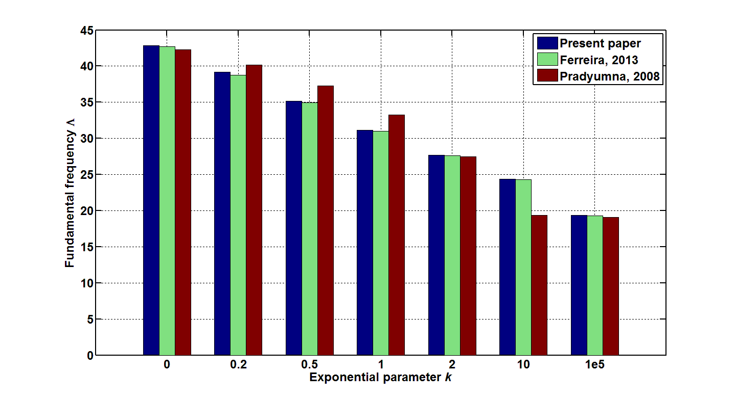
Fig.2 Comparison of obtained fundamental frequencies with known ones from papers [21, 22]
Fig.2 shows a visual comparison of obtained fundamental frequency with known results from papers [21, 22] for simply supported square cylindrical shell panel with length-to-thickness ratio $h/a=\text{10}$, length-to-radius ratio $R/a=5$ and several power law exponents $k$. It can be observed that results obtained are good agreed with published ones [21, 22].
  - Free vibration of shallow shells with a complex planform
A literature search on the topic of free vibration analysis of FGM clamped or simply supported shallow shells with complex planform shows that this problem has not received much attention. Therefore, our main task is to demonstrate the essential advantages of the RFM, since it allows the geometrical information of the boundary value problems to be taken into account in an analytical way. To illustrate the strength of the proposed method, several shells with complex planform are analyzed. The effects of boundary conditions, the shape of the plan, curvatures on the fundamental frequencies have been examined.
- Clamped FGM shell panel with rectangular cuts
Consider a clamped shallow shell with the shape shown in Fig.3.
x
-a
a
O
–b
b
y
-a₁
a₁
–b₁
b₁
z
y
x
Fig.3 FGM shell panel with rectangular cuts
Geometrical parameters are: $b/a=1$; ${a_{1}}/2a=0\text{.}\text{25}$; ${b_{1}}/2a=0\text{.}\text{35}; 0\text{.}4; 0\text{.}\text{45}$.
The shell consists of two composites: aluminum (11) and alumina (12). The boundary conditions for FSDT of this case are:
$u=v=w=ψ_{x}=ψ_{y}=0$.
The solution structure for FSDT can be taken as:
$U={ωP}_{1}$, $V={ωP}_{2}$, $W={ωP}_{3}$, $Ψ_{x}={ωP}_{4}$, $Ψ_{y}={ωP}_{5}$,
where $ω=0$ is an equation of the border of the shell planform;
$P_{1}, P_{2}, P_{3}, P_{4}, P_{5}$ - are undertermined components.
In order to realize this solution structure, we need to construct the equation of the edge $ω=0$. Using the R-operations ${}_{0}$ and ${}_{0}$ [29], we build the equation in the form:
$ω=(f_{1}∧_{0}f_{2})∧_{0}(f_{3}∨_{0}f_{4})$,
where
$f_{1}=\frac{(a^{2}−x^{2})}{2a}≥0$ - is the vertical band bounded by straight lines $x=±a$;
$f_{2}=\frac{(b^{2}−y^{2})}{2b}≥0$ - is the horizontal band bounded by straight lines $y=±b$;
$f_{3}=\frac{(x^{2}−a_{1}^{2})}{2a_{1}}≥0$ - is an outside domain of the vertical band bounded by straight lines $x=±a_{1}$;
$f_{4}=\frac{(b_{1}^{2}−y^{2})}{2b_{1}}≥0$ - is the horizontal band bounded by straight lines $y=±b_{1}$.
Here the R-operations are defined as [29]
$x∧_{0}y=x+y−\sqrt{x^{2}+y^{2}}$,
$x∨_{0}y=x+y+\sqrt{x^{2}+y^{2}}$.
An initial study was performed to ensure the convergence of the present approach and certain numbers of polynomial power to use in the computation of the vibration problems. Results are presented in Table 4 and refer to the first vibration mode of a simply supported cylindrical panel composed of ${\text{Al}}/{{\text{Al}}_{2}}O_{3}$ with rectangular cuts, side-to-thickness ratio $h/2a=\text{10}$, side-to-radius ratios $R/2a=\text{10}$, geometrical parameters ${a_{1}}/2a=0\text{.}\text{25}$ and ${b_{1}}/2a=0\text{.}3$, power law exponent $k$=1.
Table 4 Convergence of fundamental frequencies of the first vibration mode $Λ=\frac{λ{\left(2a\right)}^{2}}{h}\sqrt{\frac{ρ_{m}}{E_{m}}}$ of simply supported cylindrical shell panels $\left({\text{Al}}/{{\text{Al}}_{2}}O_{3}\right)$, (Fig.3) $\left(h/2a=0\text{.}1, R/2a=0\text{.}1, {a_{1}}/2a=0\text{.}\text{25}, {b_{1}}/2a=0\text{.}3\right)$

Power of P₁, P₂, P₃,P₄ | Power of P₅
Power of P₁, P₂, P₃,P₄ | 8 | 10 | 12 | 14 | 16
9 | 67.87 | 67.21 | 67.10 | 67.02 | 66.98
11 | 66.68 | 66.27 | 66.21 | 66.09 | 66.03
13 | 66.09 | 65.65 | 65.58 | 65.38 | 65.30
15 | 65.67 | 65.24 | 65.18 | 65.03 | 64.94

The polynomial powers $P_{1}=P_{2}=P_{3}=P_{4}=\text{14}$ and $P_{5}=\text{15}$ were chosen for the vibration problem considered.
Table 5 presents the fundamental frequency of a square clamped FGM shell panel of the ${\text{Al}}/{{\text{Al}}_{2}}O_{3}$ composite with rectangular cuts ${a_{1}}/2a=0\text{.}\text{25}$, ${b_{1}}/2a=0\text{.}\text{35}$ with side-to-thickness ratio $h/2a=\text{10}$, considering various side-to-radius ratios $R/2a$ (there are cylindrical, spherical and so-called parabolical shell panels), and several power law exponents $k$.
Table 5 Fundamental frequencies of CCCC shell panels, h/2a=10 for various $k$ and
types of shell $\left({\text{Al}}/{{\text{Al}}_{2}}O_{3}\right)$, ${a_{1}}/2a=0\text{.}\text{25}$, ${b_{1}}/2a=0\text{.}\text{35}$($Λ=\frac{λ{\left(2a\right)}^{2}}{h}\sqrt{\frac{ρ_{m}}{E_{m}}}$)
$$k$$ | Cylindrical shell | Spherical shell | Parabolical shell
 | ${R_{x}}/2a=0$, ${R_{y}}/2a=\text{10}$ | $${R_{x}}/2a={R_{y}}/2a=\text{10}$$ | ${R_{x}}/2a=\text{10}$, ${R_{y}}/2a=−\text{10}$
0 | 107.59 | 107.89 | 107.70
0.5 | 89.15 | 89.40 | 89.26
1 | 79.22 | 79.44 | 79.33
10 | 60.49 | 60.62 | 60.56
∞ | 48.62 | 48.75 | 48.66

From the numerical experiment conducted for shallow shells with different sizes of rectangular cuts $\left({a_{1}}/2a=0\text{.}\text{25} ; {b_{1}}/2a=0\text{.}\text{35}; 0\text{.}4; 0\text{.}\text{45}\right)$, it follows that for different shapes of the shell the values of the fundamental frequencies differ by less than 0.5%. This observation concurs well with the physical expectation that curvature does not have significant influence on the frequency for the case of a clamped shell.
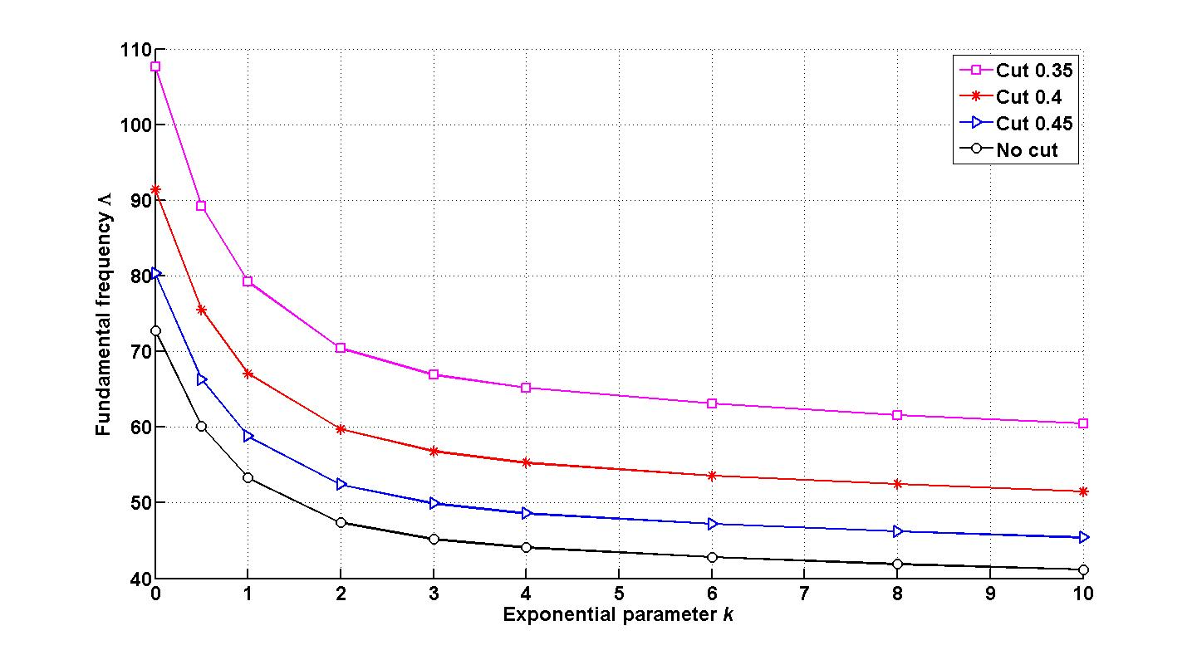
Fig.4 Fundamental frequencies for CCCC cylindrical shell panel $R/2a=\text{10}$with various cuts
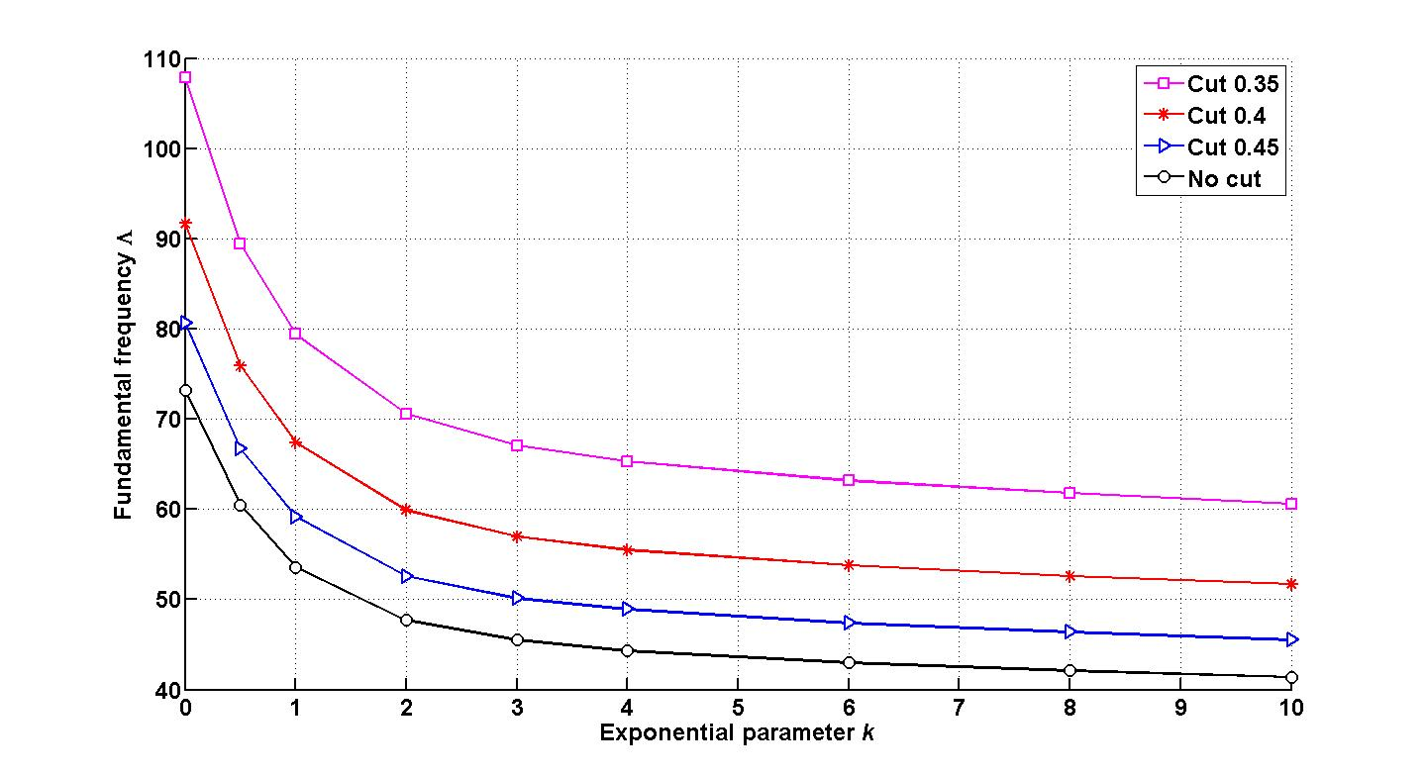
Fig.5 Fundamental frequency for CCCC spherical shell panel $R/2a=\text{10}$ with various cuts

Figures 4-5 demonstrate graphically the values of fundamental frequencies for clamped cylindrical and spherical shell panels composed of aluminum (11) and alumina (12) with side-to-thickness ratio $h/2a=\text{10}$, side-to-radius ratios $R/2a=\text{10}$, with different sizes of rectangular cuts $\left({a_{1}}/2a=0\text{.}\text{25} ; {b_{1}}/2a=0, 0\text{.}\text{35}; 0\text{.}4; 0\text{.}\text{45}\right)$, and several power law exponents $k$. We can make an important conclusion from Fig.4-5 that the fundamental frequencies increase with increasing the value of cut, which is explained by the boundary conditions and geometrical statement of problem due to stiffening effect.

b) Simply supported FGM shell panel with rectangular cuts

The free vibration of simply supported FGM shell panel with rectangular cuts is analyzed next. Geometrical parameters are the same as those for example 3.2(a). The boundary conditions for FDST are the following (contour is simply supported in tangent direction and clamped in transvers direction):
$u= ψ_{x}=0 , ∀\left(x,y\right)∈∂Ω_{1}$, $v= ψ_{y}=0 , ∀\left(x,y\right)∈∂Ω_{2}$, $w=0 , ∀\left(x,y\right)∈∂Ω$.
To satisfy the main boundary conditions, it is necessary to construct the following solution structure:
$U=ω_{1}P_{1}$, $V=ω_{2}P_{2}$, $W={ωP}_{3}$, $Ψ_{x}=ω_{1}P_{4}$, $Ψ_{y}=ω_{2}P_{5}$,
where
$ω_{1}=0$ is the equation of parts of boundary domain parallel to the axis OX;
$ω_{2}=0$ is the equation of parts of boundary domain parallel to the axis OY;
$ω=0$ is the equation of the whole domain.
Using the R-function operations we build the equations in the following form:
$ω_{1}=(f_{3}∨_{0}f_{4})∧_{0}f_{1}∨_{0}(f_{9}∨_{0}f_{\text{10}})$,
$ω_{2}=(f_{3}∨_{0}f_{4})∧_{0}f_{2}∨_{0}(f_{5}∨_{0}f_{6})∨_{0}(f_{7}∨_{0}f_{8})$,
$ω=(f_{1}∨_{0}f_{2})∧_{0}(f_{3}∨_{0}f_{4})$,
where
$f_{1}$, $f_{2}$, $f_{3}$, $f_{4}$ are the same equation as for example 3.2(a);
$f_{5}=\frac{((x+a_{1})^{2}+(y−y_{0})^{2}−r_{1}^{2})}{2r_{1}}≥0$ is the inside domain of a circle with center at the point $(−a_{1},y_{0})$ and radius $r_{1}$;
$f_{6}=\frac{((x−a_{1})^{2}+(y−y_{0})^{2}−r_{1}^{2})}{2r_{1}}≥0$ is the inside domain of a circle with center at the point $(a_{1},y_{0})$ and radius $r_{1}$;
$f_{7}=\frac{((x+a_{1})^{2}+(y+y_{0})^{2}−r_{1}^{2})}{2r_{1}}≥0$ is the inside domain of a circle with center at the point $(−a_{1},−y_{0})$ and radius $r_{1}$;
$f_{8}=\frac{((x−a_{1})^{2}+(y+y_{0})^{2}−r_{1}^{2})}{2r_{1}}≥0$ is the inside domain of a circle with center at the point $(a_{1},−y_{0})$ and radius $r_{1}$;
$f_{9}=\frac{(x^{2}+(y−b_{1})^{2}−r_{2}^{2})}{2r_{2}}≥0$ is the inside domain of a circle with center at the point $(0,b_{1})$ and radius $r_{2}$;
$f_{\text{10}}=\frac{(x^{2}+(y+b_{1})^{2}−r_{2}^{2})}{2r_{2}}≥0$ is the circle inside domain of a with center at the point $(0,−b_{1})$ and radius $r_{2}$;
where
$y_{0}=(b+b_{1})/2$, $r_{1}=(b−b_{1})/2$, $r_{2}={a_{1}}/2$.
In order to get correct results for the case considered here, the size of the cut is gradually increased. First, the domain was constructed with values ${a_{1}}/2a=0\text{.}\text{05}$ and ${b_{1}}/2a=0\text{.}\text{48}$. The shell with rectangular cuts tends quite close to the square shell panel and hence it is clear that results for square shell panel and shell with small rectangular cuts are very close as well (see values from two first columns of Table 6).
These rectangular cuts have been expanded from size of cuts ${a_{1}}/2a=0\text{.}1$ and ${b_{1}}/2a=0\text{.}\text{45}$ by gradually increasing the size of the cuts ${a_{1}}/2a=0\text{.}\text{25}$ and ${b_{1}}/2a=0\text{.}\text{25}$. Table 6 presents the fundamental frequency of simply supported FG cylindrical shell of the ${\text{Al}}/{{\text{Al}}_{2}}O_{3}$ composite with side-to-thickness ratio $h/2a=\text{10}$, side-to-radius ratios $R/2a=\text{10}$, different shapes of domain and several power law exponents $k$.
Table 6 Fundamental frequencies of SSSS cylindrical shell panels $\left({\text{Al}}/{{\text{Al}}_{2}}O_{3}\right)$ with rectangular cuts, $h/2a=\text{10}$, $R/2a=\text{10}$ for various $k$ and cut sizes ($Λ=\frac{λ{\left(2a\right)}^{2}}{h}\sqrt{\frac{ρ_{m}}{E_{m}}}$)
 | Cut | Cut | Cut | Cut | Cut
$$k$$ | $${a_{1}}/2a=0$$ | $${a_{1}}/2a=0\text{.}\text{25}$$ | $${a_{1}}/2a=0\text{.}\text{25}$$ | $${a_{1}}/2a=0\text{.}\text{25}$$ | $${a_{1}}/2a=0\text{.}\text{25}$$
 | $${b_{1}}/2a=0$$ | $${b_{1}}/2a=0\text{.}\text{49}$$ | $${b_{1}}/2a=0\text{.}\text{45}$$ | $${b_{1}}/2a=0\text{.}4$$ | $${b_{1}}/2a=0\text{.}3$$
0 | 42.43 | 42.88 | 48.13 | 60.85 | 89.08
0.2 | 38.78 | 39.28 | 44.12 | 55.76 | 81.71
0.5 | 34.81 | 35.37 | 39.74 | 50.20 | 73.65
1 | 30.80 | 31.37 | 35.27 | 44.53 | 65.38
2 | 27.40 | 27.90 | 31.36 | 39.59 | 58.10
10 | 24.18 | 24.28 | 27.19 | 34.42 | 50.19
∞ | 19.17 | 19.38 | 21.75 | 27.49 | 40.25

It is seen that values of natural frequencies of fully clamped shell are higher than the same shell with fully simply supported boundary conditions. It is clear that clamped boundary condition makes higher stiffness in the shell compared to simply supported boundary condition.

- Clamped FGM shell panel with circular cuts

Let us consider a clamped shallow shell with the shape shown in Fig.6. The geometrical parameters chosen for this problem are: $b/a=1$, $r/2a=0\text{.}2$.
The shell consists of two composites: aluminum (11) and alumina (12). The boundary condition for FSDT are:
$u=v=w=ψ_{x}=ψ_{y}=0$.
The solution structure for FSDT can be taken in the following form:
$U={ωP}_{1}$, $V={ωP}_{2}$, $W={ωP}_{3}$, $Ψ_{x}={ωP}_{4}$, $Ψ_{y}={ωP}_{5}$,
where $ω=0$ is an equation of the boundary of the shell planform.
z
y
x
x
-a
a
O
r
–b
b
y
Fig.6 FGM shell panel with circular cuts

Construct the equation of the border $ω=0$ using the R-operations in the form:
$ω=(f_{1}∧_{0}f_{2})∧_{0}f_{3}∧_{0}f_{4}$,
where functions $f_{1}$, $f_{2}$, $f_{3}$, $f_{4}$ are defined by formulas:
$f_{1}=\frac{(a^{2}−x^{2})}{2a}≥0$ is the vertical band bounded by straight lines $x=±a$;
$f_{2}=\frac{(b^{2}−y^{2})}{2b}≥0$ is the horizontal band bounded by straight lines $y=±b$;
$f_{3}=\frac{(x^{2}+(y−b)^{2}−r^{2})}{2r}≥0$ - is the outside domain of a circle with center at the point $(0,b)$ and radius $r$;
$f_{4}=\frac{(x^{2}+(y+b)^{2}−r^{2})}{2r}≥0$ - is the outside domain of a circle with center at the point $(0,−b)$ and radius $r$.
Table 7 presents the fundamental frequency of a clamped FGM shell panel with circular cuts $r/2a=0\text{.}2$ with side-to-thickness ratio $h/2a=\text{10}$, considering various types of shapes $R/2a$, and several power law exponents $k$.
Table 7 Fundamental frequencies of CCCC shell panels $\left({\text{Al}}/{{\text{Al}}_{2}}O_{3}\right)$, h/2a=10 for various $k$ and types of shell with circular cuts r=0.2 ($Λ=\frac{λ{\left(2a\right)}^{2}}{h}\sqrt{\frac{ρ_{m}}{E_{m}}}$)
$k$ | Cylindrical shell | Spherical shell | Parabolical shell
$k$ | $\frac{R_{x}}{2a}=0$, $\frac{R_{y}}{2a}=\text{10}$ | $\frac{R_{x}}{2a}=$$\frac{R_{y}}{2a}=\text{10}$ | $\frac{R_{x}}{2a}=\text{10}$, $\frac{R_{y}}{2a}=−\text{10}$
0 | 116.76 | 117.03 | 116.87
0.5 | 97.01 | 97.25 | 97.13
1 | 86.33 | 86.53 | 86.44
10 | 65.40 | 65.52 | 65.48
∞ | 52.76 | 52.88 | 52.81

From Table 7 it follows that for different shapes of shell the values of fundamental frequencies are differed starting with the third sign. It is agreed with the physical statement of problem, since the curvature does not essentially influent on the frequency for a case of clamped shell.

Table 8 First 4 modes of CCCC FGM spherical shell panel with circular cuts
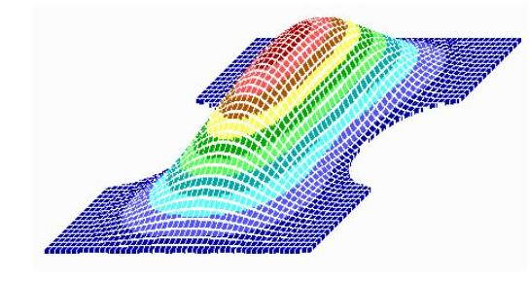 | 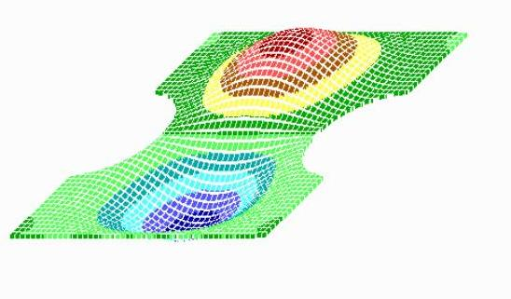
$$Λ=\text{86}\text{.}\text{53}$$ | $$Λ=\text{119}\text{.}\text{80}$$
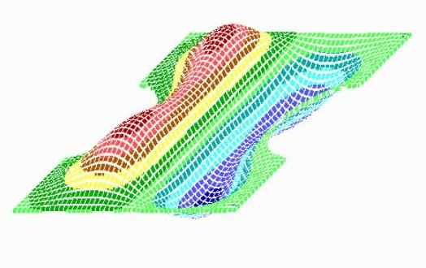 | 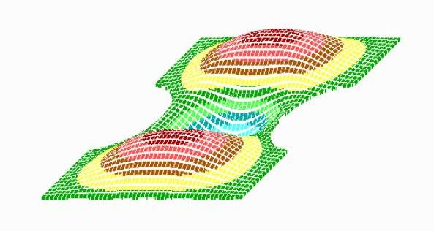
$$Λ=\text{181}\text{.}\text{19}$$ | $$Λ=\text{182}\text{.}\text{02}$$

In Table 8 the first 4 modes of CCCC spherical shell panel with circular cuts with constituents ${\text{Al}}/{{\text{Al}}_{2}}O_{3}$, ratios $h/2a=0\text{.}1$ and $R/2a=\text{10}$, $r/2a=0\text{.}2$ and power law exponent $k$=1 are shown.
3.3 Nonlinear free vibrations
Now the nonlinear free vibrations of clamped spherical shell panel with spherical cuts are investigated (geometrical shape in Fig.6) with constituents ${\text{Al}}/{{\text{Al}}_{2}}O_{3}$, ratios $h/2a=0\text{.}1$ and $R/2a=\text{10}$, $r/2a=0\text{.}2$. Fig. 7 shows the nonlinear frequency amplitude relation for different power law exponents k.
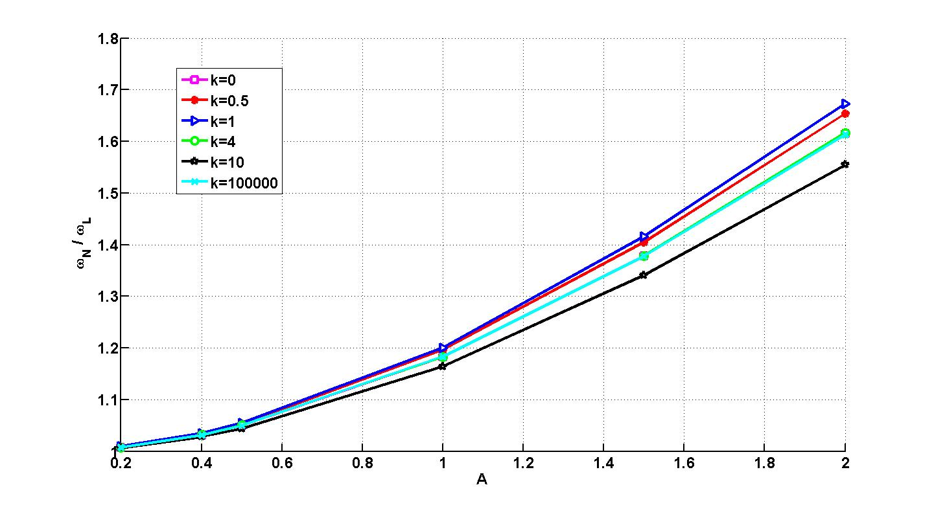
Fig. 7 Effect of volume fraction index k on the frequency ratio of CCCC spherical shell panel R/2a=10 with circular cuts
The nonlinear free vibrations of simply supported cylindrical shell panel with rectangular cuts are investigated (geometrical shape in Fig.3) with constituents ${\text{Al}}/{{\text{Al}}_{2}}O_{3}$, side-to-thickness ratio $h/2a=0\text{.}1$. Geometrical parameters are $a/b=1; {a_{1}}/2a=0\text{.}\text{25} ; {b_{1}}/2a=0\text{.}\text{35}$. Fig.8 shows the nonlinear frequency amplitude relation for different power law exponents k.
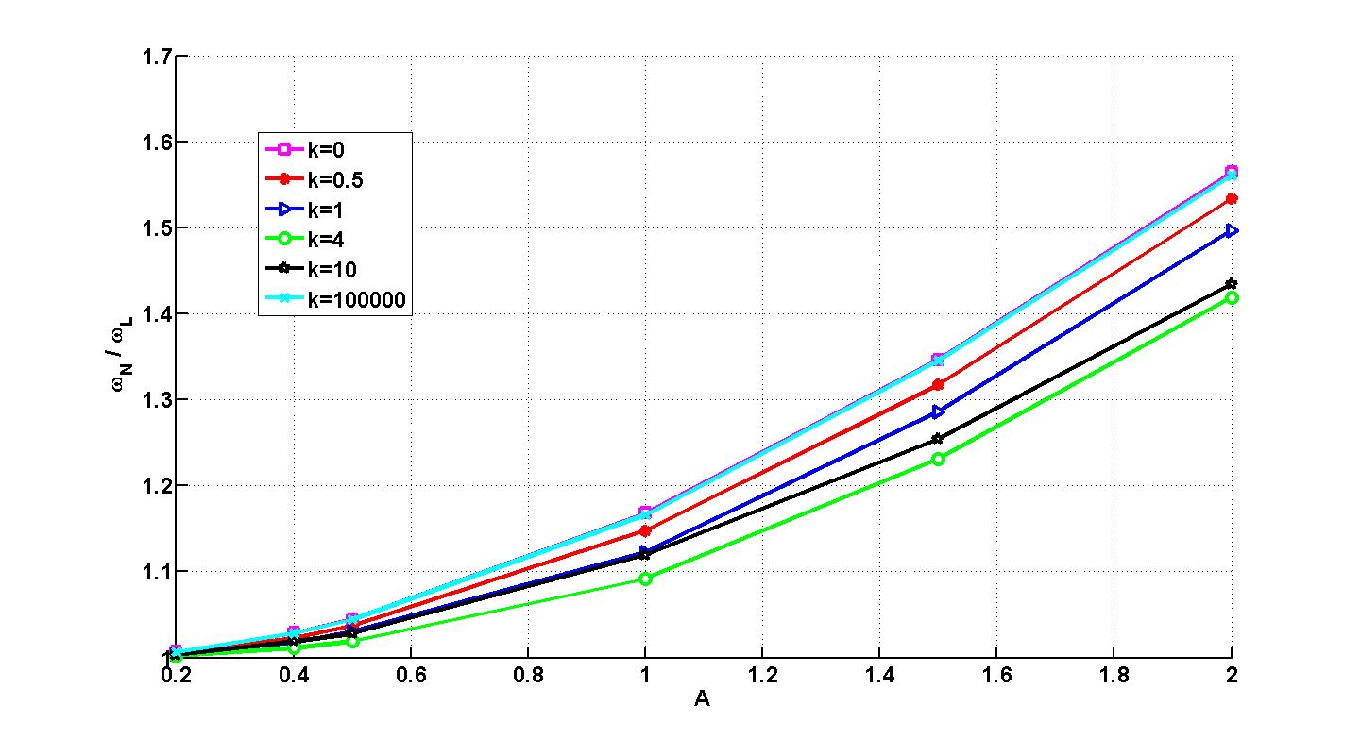
Fig. 8 Effect of volume fraction index k on the frequency ratio of SSSS cylindrical shell panel R/2a=10 with rectangular cuts
It can be noted that power-law exponent k effects on nonlinear frequencies essentially. The pure alumina (ceramics) shell has the greatest frequencies. This is due to the fact that it has the great Young’s modulus E_{c}. Even though the FGM shell (k = 4, 10) contains small volume fraction of alumina it is much stiffer than the pure aluminium shell and so their frequencies are larger than corresponding ones for metal (k = 100000).

Conclusions
This paper deals with an application of the R-functions theory and variational methods (RFM) to investigate linear and nonlinear free vibrations of functionally graded shallow shells. The proposed method is a meshless one and allows to expand modes in truncated series in basis functions constructed by the R-functions theory. Advantages of this technique are absence of mesh, constructions of basis functions in analytical form for an arbitrary planform of the shells. Test problems have been solved, they validate the constructed admissible functions, the computer code and the accuracy of the method proposed. The numerical values of the natural frequencies for clamped and simply supported functionally graded cylindrical and spherical square shell panels are compared with the published results. These comparisons have demonstrated the accuracy and validation of the developed method and worked out software. Shells of the complex planform with rectangular and circular cutouts are analysed. Various new results are presented in tabular and graphical forms. Through these data it is easy to analyse the effect of boundary conditions, the shape of the plan, curvatures and volume fraction index on the fundamental and nonlinear frequencies what have been examined.

References
1. Paulino, G.H., Jin, Z.H., Dodds, Jr. R.H.: Failure of functionally graded materials. In: Comprehensive Structural Integrity, Vol.2 (eds. B.Karihallo and W.G.Knauss), Elsevier Science, New York, 607-644 (2003)
2. Markworth, A.J., Ramesh, K.S., Parks, W.P.: Review: modelling studies applied to functional graded materials. Journal of Material Sciences 30, 2183-2193 (1995)
3. Birman, V., Byrd, L.W.: Modeling and analysis of functionally graded materials and structures. App.Mech.Reviews 60, 195-216 (2007)
4. Bich, D.H., Hao, L.Kh.: Non-linear vibration of functionally graded shallow spherical shells. Vietnam Journal of Mechanics VAST 32 (4), 199-210 (2010)
5. Woo, J., Meguid, S.A.: Nonlinear analysis of functionally graded plates and shallow shells. Int. Journal of Solids and Structures 38, 7409-7421 (2001)
6. Ganapathi, M.: Dynamic stability characteristics of functionally graded materials shallow spherical shells. Composite Structures 79, 338-343 (2007)
7. Alijani, F., Amabili, M.: Non-linear vibrations of shells: A literature review from 2003 to 2013. Int.J.Non-linear Mechanics 58, 233-257 (2014)
8. Shen, H.S.: Functionally graded materials of plates and shells, CRC Press, Florida (2009)
9. Awrejcewicz, J., Krys’ko, V.A., Krys’ko A.V.: Thermo-dynamics of plates and shells, Springer-Verlag Berlin Heidelberg (2007)
10. Bich, D.H., Dung, D.V., Nam, V.N.: Nonlinear dynamic analysis of eccentrically stiffened functionally graded cylindrical panels. Composite Structures 94, 2465-2473 (2012)
11. Reddy, J.N.: Analysis of functionally graded plates. International Journal for numerical methods in engineering 47, 663-684 (2009)
12. Awrejcewicz, J., Papkova, I.V., Krylov, E.U., Krysko, V.A.: Wavelet-based analysis of the regular ad chaotic dynamics of rectangular flexible plates subjected to shear-harmonic loading. Shock and Vibration 19, 979-994 (2012)
13. Lam, K.Y., Li, H., Ng, T.Y., Chua, CF.: Generalized differential quadrature method for the free vibration of truncated conical panels. Journal of Sound and Vibration 251, 329-348 (2002)
14. Tornabene, F., Liverani, A., Caligiana, G.: FGM and laminated doubly curved shells and panels of revolution with a free form meridian: a 2-D GDQ solution for free vibrations. Int.J Mech Sci 53, 446-470 (2011)
15. Andrianov, I.V., Awrejcewicz, J., Diskovsky, A.A.: Sensitivity analysis in design of constructions made of functionally graded materials. Journal of Mechanical Engneering Science 227(1), 19-28 (2013)
16. Andrianov, I.V., Awrejcewicz, J., Starushenko, G.A.: Asymptotic analysis of the Maxwell-Garnett formula using the two-phase composite model. International Journal of Applied Mechanics 7(2), (2015)
Igor V Andrianov
1
, Jan Awrejcewicz
2
and
Alexander A Diskovsky
3
Igor V Andrianov
1
, Jan Awrejcewicz
2
and
Alexander A Diskovsky
3
Igor V Andrianov
1
, Jan Awrejcewicz
2
and
Alexander A Diskovsky
3
Igor V Andrianov
1
, Jan Awrejcewicz
2
and
Alexander A Diskovsky
3
Igor V Andrianov
1
, Jan Awrejcewicz
2
and
Alexander A Diskovsky
3
17. Zhu, Su., Guoyong, Jin., Tiangui, Ye.: Free vibration analysis of moderately thick functionally graded open shells with general boundary conditions. Composite Structures 117, 169–186 (2014)
18. Zhu, Su., Guoyong, Jin., Tiangui, Ye., Xueren, Wang.: Free vibration analysis of laminated composite and functionally graded sector plates with general boundary conditions. Composite Structures 132, 720-736 (2015)
19. Jin, G., Shi, Sh., Su, Zh., Li, Sh., Liu, Zh.: A modified Fourier-Ritz approach for free vibration analysis of laminated functionally graded shallow shells with general boundary conditions. Int.J. Mech Sci 93, 256-269 (2015)
20. Zhao, X., Lee, Y.Y., Liew, K.M.: Thermoelastic and vibration analysis of functionally graded cylindrical shells. Int.J. Mech Sci 51, 694-707 (2009)
21. Neves, A.M.A., Ferreira, A.J.M., Carrera, E., Cinefra, M., Roque, C.M.C., Jorge, R.M.N.: Free vibration analysis of functionally graded shells by a higher-order shear deformation theory and radial basis functions collocation accounting for through the thickness deformations. Eur J Mech A/Solids 37, 24-34 (2013)
22. Pradyumna, S., Bandyopadhyay, J.N.: Free vibration analysis of functionally graded curved panels using a higher-order finite element formulation. Journal of Sound and Vibration 318, 176-192 (2008)
23. Matsunaga, H.: Free vibration and stability of functionally graded shallow shells according to a 2D higher-order deformation theory. Composite Structures 84, 132–146 (2008)
24. Kurpa, L.V.: Nonlinear free vibrations of multilayer shallow shells with a symmetric structure and with a complicated form of the plan. J. Math. Sciences 162 (1), 85-98 (2009)
25. Kurpa, L., Pilgun, G., Amabili, M.: Nonlinear vibrations of shallow shells with complex boundary: R-functions method and experiments. Journal of Sound and Vibration 306, 580-600 (2007)
26. Awrejcewicz, J., Kurpa, L., Shmatko, T.: Large amplitude free vibration of orthotropic shallow shells of complex shapes with variable thickness. Latin American Journal of Solids and Structure 10, 147-160 (2013)
27. Awrejcewicz, J., Kurpa, L., Shmatko, T.: Investigating geometrically nonlinear vibrations of laminated shallow shells with layers of variable thickness via the R-functions theory. Composite Structures 125, 575–585 (2015)
28. Kurpa, L.V., Shmatko, T.V.: Nonlinear vibrations of laminated shells with layers of variable thickness. Shell Structures: Theory and Applications, Taylor & Francis Group, London, UK, 3, 305-308 (2014)
29. Rvachev, V.L.: The R-functions theory and its some application, Kiev, Naukova Dumka (1982) [in Russian]
30. Kurpa, L.V.: R-functions method for solving linear problems of bending and vibrations of shallow shells, Kharkiv, Kharkiv NTU Press (2009) [in Russian]

