Does Kinesiology Tape Increase Trunk Forward Flexion? A Randomised Placebo Controlled Trial

Authors: Heidi Preece (BSc (Hons), MSc) & Dr. Peter White (BSc, PhD)
Affiliation: University of Southampton

University of Southampton
Faculty of Health Sciences
Highfield Campus
Southampton
SO17 1BJ
United Kingdom

The protocol for this study was approved by The University of Southampton Ethics and Research Governance Online.

Correspondence Address: Heid Preece (MSc Physiotherapist)
C/O Dr Peter White, 45/2022, Faculty of Health Sciences, University of Southampton, Highfield, Southampton, SO17 1BJ
Email: hlgsportherapy@hotmail.co.uk

Does Kinesiology Tape Increase Trunk Forward Flexion? A Randomised Placebo Controlled Trial

The authors report no conflicts of interest. They do not keep any financial or personal relationships with any persons or organisations that may inappropriately influence (bias) their work. Rock Tape UK had no involvement in the study design, data collection or interpretation of the data.

This research did not receive any specific grant from funding agencies in the public, commercial, or not-for-profit sectors

Abstract

Introduction: Non specific lower back pain is a common musculoskeletal disorder in manual labourers due to the strenuous nature of their job. Fear of pain can cause restrictions in trunk movement leading to reduced flexibility. Kinesiology Tape (KT) may be an option for treating low back stiffness. The present study investigated the immediate effect of KT on trunk flexion active range of motion.

Method: 34 male participants (mean age ± SD: 42 ±11), in physically demanding jobs, asymptomatic of pain, with a history of non specific lower back pain were randomly assigned to: 1) KT Intervention (KTI) or 2) KT Placebo (KTP). Trunk flexion data was collected at baseline and immediately following tape application. ANCOVA was used to examine the differences between groups.

Results: The KTI group demonstrated a statistically significant gain in Trunk flexion compared with baseline (2.75cm, P <0.05). Changes from pre to post treatment for the KTP were not significant (1.57cm, P = 0.062). No statistically significant differences existed between groups post-treatment (P = 0.218).

Conclusion: KTI demonstrates an immediate positive effect on trunk flexion when compared with baseline measurements. However, results suggest that KTI performs no better than a comparable placebo.

Introduction

Lumbar instability leads to lower back pain (LBP), which in turn reduces muscle strength, endurance, flexibility and range of motion (ROM) (Cho et al 2015). Patients who experience Chronic LBP for longer than 6 months often restrict their trunk movement due to fear of increased pain, which leads to loss of function, paraspinal muscle and multifidus weakening (Cho et al 2015; Ng et al 2002). Manual labourers’ have been recognised as high risk for LBP due to the nature of their work; strenuous activity, repetitive load and working in a trunk flexed position (Coenen et al 2013; Heneweer et al 2011; Hoy et al 2010; Osborne et al 2012).

It has been suggested that LBP leads to limited ROM through reluctance of the injured individual to move their trunk to the end of range due to fear of increased pain (Ng et al 2002). Long term fear avoidance leads to a lack of use and reduced flexibility, increasing the risk of limited ROM and stiffness. In order to prevent financial strain on both the UK Health service and employers, it is crucial that an effective treatment modality is devised to address stiffness and restore ROM caused by LBP.

There are a number of treatment modalities recognised by the National Institute for Health and Care Excellence (NICE 2009). However, these can be time consuming and costly, leading to prolonged symptoms and accumulating sick leave.

Kinesiology Tape (KT) may be an option for the treatment of stiffness caused by previous episodes of LBP. KT was developed in the 1970s by Japanese chiropractor, Kenzo Kase (Grześkowiak et al 2014). It has the ability to be stretched in order to facilitate rather than restrict movement (Kase et al 1996). The tape supposedly lifts the skin and increases the space between skin and muscle to enable increased blood flow and lymphatic fluid (Grześkowiak et al 2014). KT is cheap, readily available and can easily be applied by a Therapist or family member to allegedly provide immediate relief of symptoms (González-Iglesias et al 2009). KT is frequently used in the sporting environment, clinical practice and at home (Walker 2014). However, there are very few quality studies (Williams et al 2011; Joscha & Julian 2010) and conflicting evidence regarding its effectiveness (Walker 2014).

Kase proposed that KT reduces pain and normalises muscular function to increase joint ROM. The exact mechanism for increased ROM is not well understood, but there are a number of hypotheses: (1) an increase in blood circulation to the taped area, may enhance muscle function and facilitate increased ROM within the muscle (Cho et al 2015; Yoshida & Kahanov 2007), (2) sensory feedback and activation of the Pain Gate (González-Iglesias 2009; Thelen et al, 2008), (3) lifting of the skin (via convolutions) to reduce pressure on subcutaneous nocioceptors (Kahonav 2007) in turn reducing pain perception and fear of movement (González-Iglesias et al 2009).

Williams et al (2011) performed a Meta-Analysis for the effectiveness of KT, reporting on ten papers (only one involving the lumbar spine). They concluded that KT may have a small beneficial effect on active ROM of an injured area but further clarification is required. Yoshida and Kahonav (2007), Castro-Sánchez et al (2012), Lemos et al (2014) carried out randomised controlled trials, while Karatas et al (2012) and Hwang-Bo and Lee (2011) published case reports. All five studies reported a significant increase in trunk flexion following the application of KT. Similarly recent randomised controlled trials involving shoulder pain (Thelen et al 2008), whiplash (González-Iglesias et al 2009) and Osteoarthritic knees (Cho et al 2015) all reported significant improvements in ROM post KT application. However, the majority of the studies to date lack detail; with insufficient randomisation, no placebo control group, and the inclusion of “healthy individuals,” under 30 years old with no “movement problems”. Recent systematic reviews concluded no substantial evidence to support the use and treatment efficacy of KT (Bassett et al 2010; Morris et al 2013).

From the limited KT and trunk ROM literature to date it is apparent that it is lacking in both quality and detail. To date, no studies have conducted a randomised placebo controlled trial, on participants aged between 30-60 years, who are most likely to present with a previous history of LBP or ‘movement dysfunction’ (Jordan et al 2010).

The aim of the present study was to investigate the immediate effect of KT on trunk flexion in Manual labourer’s who present with a previous history of LBP. We hypothesis that there will be a difference in trunk forward flexion active ROM between participants who receive KT intervention compared to those who receive placebo taping.

Methods

Participants
Individuals working in physically demanding jobs were recruited through poster advertisements placed and circulated in local firms and gyms.
Individuals were eligible for inclusion in the study if they were 30-60 years old, worked in a manual job (a physical job, including; plumbing, building, farming, gardening/landscape design), were asymptomatic of LBP for the past 3 months but had a prior history of Non Specific LBP (defined as back pain localised between the lowest rib and gluteal creases with or without leg(s) pain and with no definitive cause.⁷ Duration of an episode more than 6 weeks or recurrent LBP lasting longer than 24 hours with at least one month pain-free before and after the episode and multiple episodes in a year) (AlBahel et al 2013; Chen et al 2012).

Volunteers were excluded if they had clinical signs of radiculopathy (paraesthesia, numbness, sensory changes, weakness or abnormal reflexes), major trauma, previous spinal surgery, pregnancy, allergy/intolerance to tape, corticosteroid treatment in the previous 2 weeks or clinical diagnosis of any of the following, lumbar stenosis, fibromyalgia, spondylolisthesis, systemic disease, cancer, osteoporosis, inflammatory disease and central or peripheral nervous disease (Added et al 2013; Castro-Sánchez et al 2012; Chen et al 2012; Paoloni et al 2011; Parreira et al, 2014).

All participants gave written informed consent and all rights were protected. Ethical approval was obtained from The University of Southampton Ethics and Research Governance Online (Ethics Number: 13831).

Sample Size Calculation
A previous KT ROM study sample calculation assumed thirty participants (fifteen in each group) (Castro-Sánchez et al 2012) an additional two per group were included to allow for ‘drop outs’. A difference in ROM between groups of 5cm, power set at 80% and an alpha level of 0.05 for significance (Castro-Sánchez et al, 2012).

Allocation
Thirty-four participants were randomly allocated into KT intervention group (KTI) (20) or KT placebo group (KTP) (14) using ‘Randomlog’ (developed by the department of medical statistics at the University of Southampton). Participants were stratified into groups; Male 30-45 years, Male over 45 years, Female 30-45 years, Female over 45 years. Unfortunately no females volunteered for this study. Participant allocation was concealed using a random numerical sequence in a sealed opaque envelope. Participants were blinded to the method of KT application but due to the nature of the intervention it was not possible to blind the therapist. Following completion of testing participants subjectively confirmed that they were unaware of their group allocation.

Study Protocol
Testing of participants was performed by the researcher. Testing took place on one occasion at either their home or place of work. Testing took a maximum of 30 minutes. Demographic data, including age and sex were recorded at baseline.
All volunteers were given a detailed subjective assessment prior to testing, ensuring the inclusion/exclusion criteria were met. Their occupation, date of previous LBP episode, duration of episode and number of LBP episodes since initial onset of symptoms were all recorded. A brief objective assessment involving; dermatome, myotome and reflex testing of the lower limb was carried out after the KT allergy testing and prior to ROM testing, to rule out radiculopathy.

Outcome Measures
Trunk ROM was measured and recorded in all participants’ pre and immediately post KT application by the researcher, using the Modified Fingertip to Floor Technique (MFTTF). Participants stood on a 24cm high platform, barefoot, with their heels together and knees straight. The participant bent forwards (toward their toes) as far as possible with fingers outstretched straight and the distance between the tip of their third finger and the floor was measured using a rigid tape measure (FIGURE 1). The participant was deemed more flexible if the measurement was smaller. The MFTTF is reported to have excellent reliability (Gauvin et al 2990; Robinson & Mengshoel 2014), excellent validity (96%) and good sensitivity (97%), comparable to radiograph findings (Perret et al 2001).

A 5cm change in ROM was considered a clinically meaningful change in this study. The primary outcome was to compare the difference in post KT application MFTTF between KTI and KTP groups.
FIGURE 1.
KT Application
Participants were taped according to their group allocation, by the same therapist, a certified BodyMaster KT practitioner. Rock Tape (a brand of KT) 5cm wide was used on both the KTI and KTP group. Shaving of the area preceded application of tape where necessary. All corners of the tape were rounded for better adhesion. Both groups received rubbing of the tape for better skin contact. The only difference between groups was the application method/direction of the tape.

The KTI group received two “I” strips of KT bilaterally along the paravertebral muscles (AlBahel et al 2013; Lemos et al 2014) from the Posterior superior iliac spine (PSIS) to level with T8 (Parreira et al 2014) (FIGURE 2). With the participant standing in their normal anatomical position, the tape was attached to the PSIS with no stretch. The participant was instructed to gradually bend forwards as far as was comfortable (Albahel et al 2013; Lemos et al 2014; Parreira et al 2014; Yoshida & Kahanov 2007). The KT was applied without stretching the tape (10-15% tension from the backing paper) while the participant was in forward flexion and fixed at T8 level with no stretch.

Participants in the KTP group received a single “I” strip of tape in a transverse direction from the left PSIS to the right PSIS (Castro-Sánchez et al 2012) at L4 level with no stretch (10-15% tension from the backing paper) (FIGURE 3) while the participant stood in their normal anatomical position.

The MFTTF was repeated and recorded post taping. The KT was then immediately removed and discarded which concluded the end of testing.
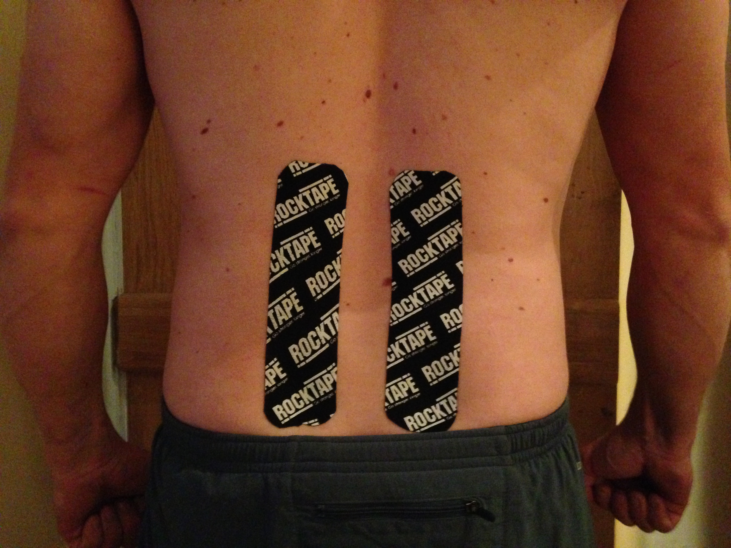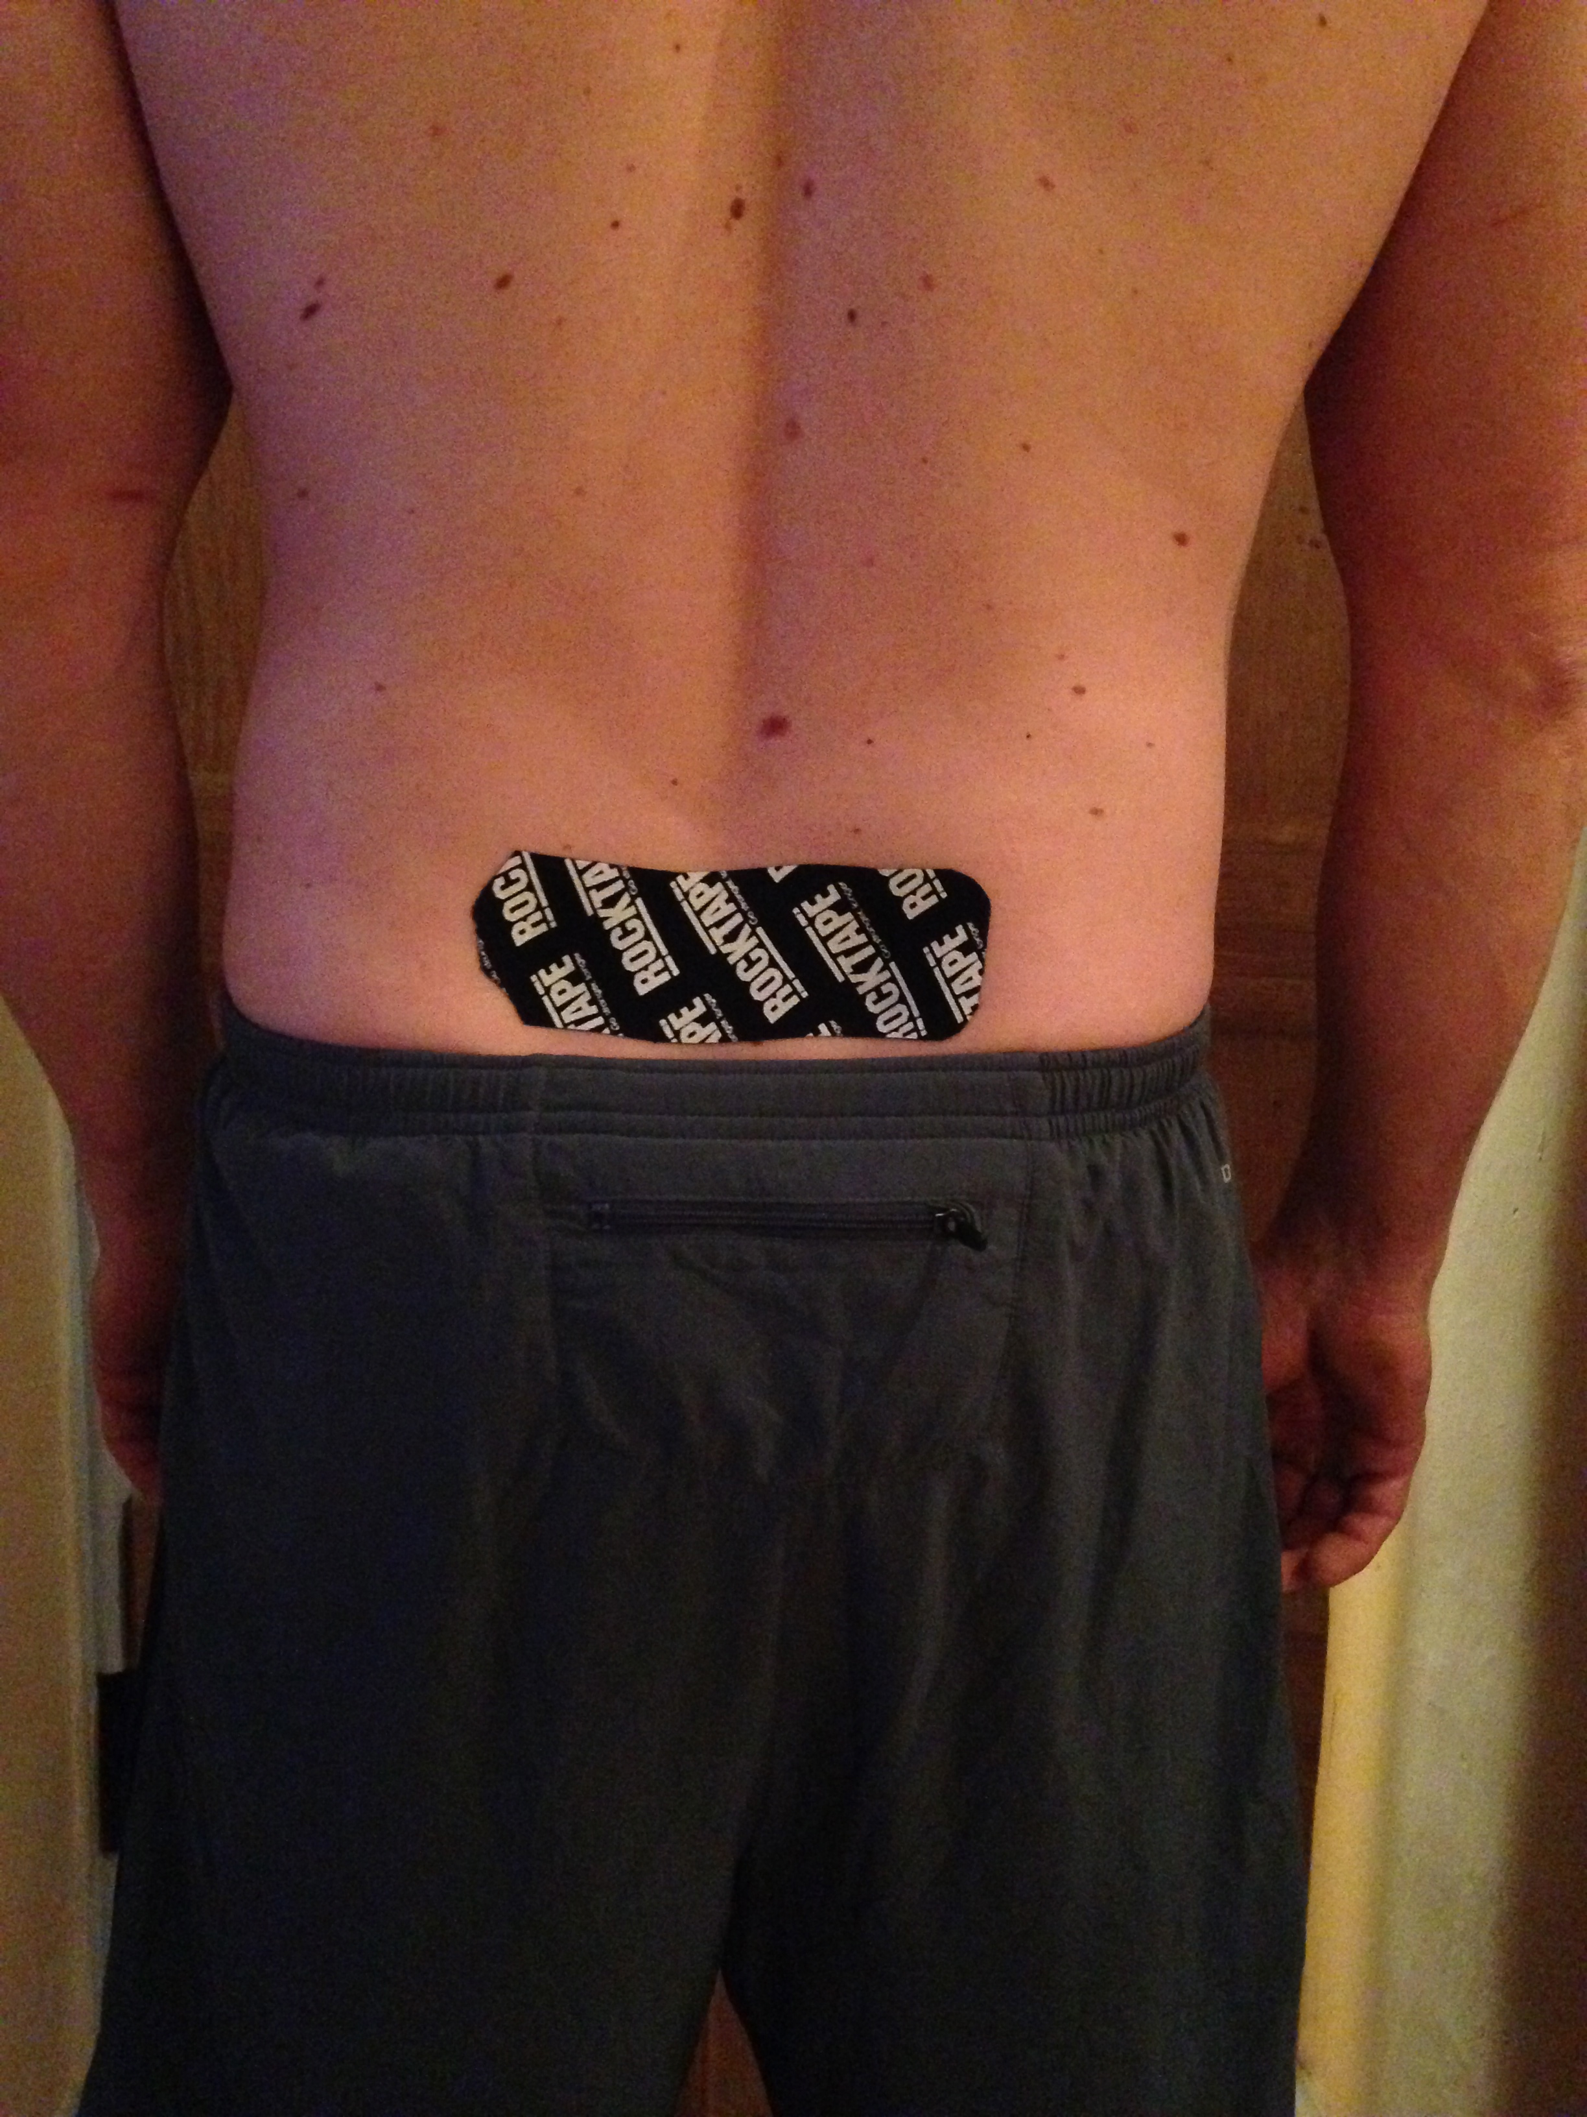
FIGURE 2. FIGURE 3.

Statistical Analysis
Data were analysed with SPSS, version 22.0 software (SPSS, Inc.: Chicago; Illinosis, America).

Key Baseline Characteristics were compared between groups using Independent t-tests for evenly distributed data and non-parametric tests (Mann Whitney U) for skewed data.

Analysis of Covariance (ANCOVA) was used to analyse between group (KTI vs. KTP) differences in post tape application MFTTF. Age, length of time since previous episode of LBP and baseline MFTTF were used as covariates.

Means and standard deviations were calculated for pre and post KTI/KTP measurements, along with the mean difference in MFTTF for each group.

The Paired Samples t-test was performed to examine ‘within group’ changes i.e. to compare the means between MFTTF pre tape application and MFTTF post tape application for KTI and KTP independently.

The significance level of p < 0.05 was used for all statistical analysis.
Results

Thirty-four participants (mean age 42 years ± SD 11; 100% male) were randomised into KTI (n = 20) or KTP (n = 14), no participants dropped out.

In order to compare Baseline Characteristics between groups (KTI vs. KTP) Histograms were used to check for normal distribution. Means and standard deviations/median and interquartile ranges were reported as appropriate. Equally distributed data (age and pre ROM) was analysed using the Independent Samples t-test, while skewed data (previous episode of LBP) was analysed using the Mann Whitney U Test to examine differences between groups (P value). Baseline characteristics between groups were similar for age, previous episode of LBP and pre tape ROM. (TABLE 1).
TABLE 1: | Baseline characteristics for both Groups
Variable | KTI Group (n=20) | KTP Group (n=14) | P Value
Gender (Male/Female) | 20/0 | 14/0 | N/A
Age (y) | 41.6 ± 9. 94* | 43.71 ± 13.05* | 0.595
Lumbar flexion ROM  Pre tape (cm)‡ | 26.83 ± 10.95* | 28.18 ± 11.39* | 0.869
Previous episode of LBP (m) | 6.5 (3 – 12)†  Max: 96 | 6.5 (6 – 12)†  Max: 37 | 0.620
Abbreviations: n, number; y, years; ROM, Range of movement; m, months; cm, centimetres.
* Data presented as mean ± SD.
† Data presented as median and interquartile range.
‡ ROM measured with Modified fingertip to floor (MFTTF). The higher the ROM score the worse the individuals baseline flexibility.
A one-way between groups ANCOVA was conducted to compare the effectiveness of KTI vs. KTP on MFTTF. The independent variable was the taping method (KTI/KTP) and the dependent variable consisted of MFTTF post tape application. Age, previous episode of LBP and pre MFTTF were used as covariates (TABLE 2).

TABLE 2: |  | Effectiveness of KT intervention vs. KT placebo on lumbar ROM (ANCOVA)
Parameter |  | Parameter estimate  (B) | 95% CI  Lower Upper |  | Significance  (P Value) | Partial Eta Squared
Intercept |  | -0.105 | -4.59 | 4.38 | 0.962 | 0.000
Age (y) |  | 0.019 | -0.08 | 0.11 | 0.967 | 0.006
Prev. episode LBP (m) |  | -0.11 | -0.07 | 0.05 | 0.712 | 0.005
Pre ROM (cm) |  | 0.922 | 0.83 | 1.01 | <0.05* | 0.939
Intervention |  | -1.203 | -3.16 | 0.75 | 0.218 | 0.052
Abbreviations: y, years; prev., previous; m, months; ROM, range of motion; cm, centimetres; CI, confidence interval.
* Indicates a statistically significant difference between groups (P = <0.05)

Preliminary checks were conducted to ensure that there was no violation of the assumptions of normality, linearity, homogeneity of variances, homogeneity of regression slopes and reliable measurement of the covariate.
After adjusting for the pre-intervention scores, there was no statistically significant difference between the two intervention groups on post tape ROM (B = -1.20, 95% CI = -3.16 - 0.75, P = 0.218). There was a strong relationship between pre ROM and post ROM, as indicated by P = <0.05 (partial eta squared value of 0.94 = 94%). When removing the non-significant covariates of age and previous LBP, there was still no statistically significant difference between groups for post tape MFTTF (B = -1.28, 95% CI = -3.144 – 0.585, P = 0.172).

The Paired Samples t-test was performed to examine ‘within group’ changes (TABLE 3).
TABLE 3: |  | Pre ROM vs. Post ROM Values  (Within group Analysis)
Taping  Method |  | Pre Tape MFTTF (cm)* | Post Tape MFTTF  (cm)* | Mean difference  Pre/post  (cm)* | 95% CI |  | Pre/post tape  Paired t-test  (P value)
 |  |  |  |  | Lower | Upper
KTI Group |  | 26.83±  10.95 | 24.08±  11.05 | 2.75±  2.59 | 1.54 | 3.96 | <0.05†
KTP Group |  | 28.18±  11.39 | 26.60±9.  94 | 1.57±  2.87 | -0.09 | 3.23 | 0.062
Abbreviations: ROM, range of motion; MFTTF, modified finger tip to floor; cm, centimetres; CI, confidence interval; KTI, Kinesiology tape intervention, KTP, Kinesiology tape placebo.
* Data presented as mean ± SD.
† Indicates a statistically significant difference between pre/post MFTTF (P = <0.05).

The Paired Samples t-test indicated that patients receiving KTI experienced a statistically significant gain in MFTTF post application (2.75cm ± 2.59 95% CI: 1.54 – 3.96, P = <0.05). The Paired Samples t-test indicated an improvement in MFTTF post KTP application, although this was not quite statistically significant (1.57cm ± 2.87 95% CI: -0.09 – 3.23, P = 0.062).

Discussion

The results of the current study demonstrate that people with a prior history of LBP who received KTI demonstrate significantly better trunk flexion ROM immediately after application when compared with baseline measures. However, it is important to note that there was no statistical significant difference between groups.

The significant increase in MFTTF post KTI is similar to the findings of previous KT ROM studies (Cho et al 2015; González-Iglesias et al 2009; Lemos et al 2014; Thelen et al 2008; Yoshida & Kahanov 2007). Although, our results contradict the findings of some studies, which found a significant difference between KTI and KTP on ROM (Castro-Sánchez et al 2012; Cho et al 2015; González-Iglesias et al 2009). Our study also concurs with the findings of Morris et al (2013) who conducted a meta analysis and reported limited to moderate evidence to suggest that KTI is more clinically effective than sham tape. It is noted however that a range of painful conditions were included in this meta analysis and the primary outcome for most of the included studies was the treatment of pain rather than reduced ROM. Only one included paper dealt with chronic LBP.

Manual labourers’ were utilised for this study because they are recognised as high risk for LBP due to the nature of their workCoenen et al 2013; Heneweer et al, 2011; Hoy et al 2010; Osborne et al 2012). Labourers’ with a prior history of LBP were included because they were assumed to present with adaptive movement faults, reduced flexibility and ROM (Cho et al 2015; Ng et al 2002).

This is the first study to look at the immediate effect of KT on lumbar flexion ROM in participants with a prior history of LBP. Previous studies have looked at healthy individuals and found a significant increase in trunk flexion ROM compared with baseline measurements using the FTTF (Lemos et al 2014; Yoshida & Hahanov 2007). Castro-Sánchez et al (2012) studied individuals with LBP and reported a borderline improvement in fleximeter readings for trunk flexion when compared to a placebo taping group. Other studies have examined the effect of KT on ROM in various joints of injured individuals and described a significant increase (Cho et al 2015; González-Iglesias 2009; Thelen et al 2008). Thelen et al (2008) reported an increase in pain free shoulder ROM in patients with shoulder impingement and a significant difference between the intervention and placebo groups on day one only. Cho et al (2015) reported a significant improvement in pain free knee ROM following KT application on osteoarthritic knees, while González-Iglesias et al (2009) reported an increase in cervical ROM in whiplash patients. Both studies described a significant difference between the intervention and placebo groups. Interestingly the studies involving injured participants demonstrated a very small increase in ROM, thus questioning the clinical effectiveness of KT on ROM.

Conversely, although Lemos et al²⁴ reported a significant increase in lumbar flexion post KT application with the FTTF test, they did not report a statistically significant difference in lumbar ROM, when measured with the Schober’s test. These findings may question the value of the FTTF test. No statisticaly significant difference existed between the intervention groups for either test.

The primary outcome to compare the difference in post KT application MFTTF between groups was not significant (P = 0.218) TABLE 2. However, it should be noted that there was a small difference of 2.52cm, with the KTI group demonstrating better ROM (KTI: 24.08cm±11.05 vs. KTP: 26.60cm±9.94) TABLE 3. These results may be explained by the fact that the KTI group demonstrated better MFTTF at baseline when compared with the KTP group (KTI: 26.83cm ± 10.95 vs. KTP: 28.18cm ± 11.39, P = 0.869) TABLE 1. From TABLE 2. it is not surprising that pre ROM is a statistically significant covariate (pre: P = <0.05) indicating that pre MFTTF naturally influences post MFTTF measures and thus will influence the results. However, by using ANCOVA, with baseline values as a covariate this potential confounding factor is negated.

Interestingly, there was a significant difference between pre and post KTI MFTTF (2.75cm ± 2.59, P = <0.05) TABLE 3. While the difference between pre and post KTP also improved (1.57cm ± 2.87, P = 0.062) it was not quite statistically significant. It is important to note that the 95% CI values for the KTP group crossed zero (-0.09 – 3.23), whereby the KTI did not (1.54-3.96). suggesting more consistant results from the KTI group. These findings suggest that KT applied in a longitudinal direction; along the paraspinal muscles may slightly influence ROM more than KT applied horizontally. Due to the simplicity of this study it is difficult to understand how the application method influences ROM. Nonetheless, authors have hypothesised; greater muscle activation (Castro-Sánchez et al 2012), fascial mobilisation (Lemos et al 2014), greater proprioception (Joscha & Julian 2010), increased blood flow and reduced pressure on mechanoreceptors (Lemos et al 2014; Yoshida & Kahanov 2007). All of these remain theoretical and there is no solid evidence to prove or disapprove them. Grześkowiak et al (2014) suggested that an increase in ROM occurs from reduced pain perception rather than from a mechanical effect. However, our participants were asymptomatic of pain and still demonstrated an increase in ROM. Possible reasons for this include; (1) the result of a placebo effect, a psychological phenomenon where by an individual alters their performance to influence a positive or negative outcome (Beedie 2007; Beedie & Foad 2009), (2) a stretch response following KTI application, where participants repeat an elongated, flexed posture during the taping procedure. This could have contributed to a false-positive effect on the results (Lemos et al 2014), (3) repeated measures of the MFTTF test, may promote a reduction in connective tissue resistance (Lemos et al 2014), (3) human error with reading the tape measure must also be considered and (4) a loss of statistical power in the KTP group (KTP group had 14 participants vs. KTI group of 20).

The clinical significance of change in ROM in this study is limited. The mean increase in ROM (KTI: 2.75cm ± 2.59) did not meet the predetermined criteria for meaningful change (5cm increase) questioning the beneficial effect of KT on ROM (Castro-Sánchez et al 2012; González-Iglesias et al 2009; Thelen et al 2008) . Four participants from the KTI group exceeded the 5cm gain in MFTTF while one individual from the KTP group gained 8cm post tape application. Generally, the placebo group should not have seen an improvement, although reasons may include; (1) a placebo effect (Beedie 2007; Beedie & Foad 2009), (2) human error, (3) reduced connective tissue resistance following repetition of the MFTTF (Lemos et al 2014), (4) a therapeutic effect of the KTP, influencing physiology through additional cutaneous input (Joscha & Julian 2010; Kase et al 2003). These findings question the importance of KT application methods and may imply that KT works via a placebo effect.

It is apparent that age and previous LBP have a minimal effect on post tape ROM TABLE 2. i.e.: the older someone is the reduced flexibility they display and the longer the time since their previous episode of LBP, the better the individuals available ROM. However, these factors are not considered significant in this case (Age: P = 0.676; LBP: P = 0.712) possibly due to the small sample size. The partial Eta squared value from TABLE 2. suggests that 94% of the variance in the post tape MFTTF value is due to the pre MFTTF value. Therefore it is not surprising that the KTI group demonstrated better ROM post taping (KTI: 24.08 ± 11.05 vs. KTP: 26.60 ± 9.94), as they demonstrated a better baseline ROM initially (KTI: 26.83 ± 10.95 vs. KTP: 28.18 ± 11.39).

The underlying physiological mechanism by which KT works remains hypothetical and is beyond the extent of this study. We can but simply speculate the possible mechanisms for increased ROM (mentioned previously). In the current study, the main difference between KT methods was the direction the tape was applied. We only applied tape once and measured the immediate outcome. We might expect greater effectiveness from the tape being worn for longer or multiple applications over a longer period. Although this was a single sex study it has been suggested that it is not ideal to have mixed samples, due to the differences in flexibility between men and women (Lemos et al 2014).

There are a number of limitations of the current study that should be mentioned. Firstly, we assumed that laborers’ with a history of LBP would present with adaptive movement faults, reduced flexibility and ROM. However, we were unable to test for this. Secondly, we did not include a ‘no tape’ control group. This makes it difficult to assess whether KT truly influences ROM or whether the KTI application method and repeated MFTTF testing influence the results (González-Iglesias et al 2009; Lemos et al 2014).
We used the MFTTF test, which is not joint specific as it involves hamstring length and pelvic tilt alongside trunk flexion. Therefore, it may not be the most reliable outcome measure for measuring lumbar flexion (Holt et al 1999). It also fails to measure the physiological changes that may occur following KT application (Yoshida & Kahanov 2007).
Human error from the assessor during tape measure readings and with tape application should also be mentioned. KT is stretchy, making it difficult to ensure each participant receives the same tension. This is important, as tensions higher than 50% can generate undesired effects and impact on results (Lemos et al 2014). There is also a risk of participants ‘cheating’ through bending their knees during the MFTTF to increase ROM and this could significantly impact on the outcome measure.
This was a single sex study (males only), involving manual labourers’, making it difficult to apply the findings to a general population. We only investigated the short-term effects of KT application and therefore can not make assumptions regarding possible long-term effects.
Notably, the Therapist applying the tape was not blinded to the group assignment, study design, objectives or outcome measures, thus increasing the risk of bias.
Due to low numbers and block randomisation, the treatment groups were unequal in number (KTI, 20 vs. KTP, 14). This may have impacted upon the power of the placebo and overall results. Smaller block sizes or recruiting larger sample sizes should be considered for future studies to ensure balance.
Participants asymptomatic of pain were used in our study. In order to determine the true benefit of KT on ROM it would be advisable to investigate individuals with significantly reduced lumbar flexion at baseline or an identified ‘movement dysfunction’. It may also be beneficial to investigate KT with tension for stability/to influence extensor muscle strength/endurance as it is well known that individuals working in flexed positions are at risk of CREEP and therefore instability can cause LBP rather than segmental stiffness.

Conclusion

KT as a treatment intervention, applied to manual labourers’ with a previous history of LBP demonstrates a statistically significant, immediate improvement in MFTTF when compared with baseline measurements. However, in terms of efficacy these results suggest that KTI performs no better than a comparable placebo, suggesting that KT may work via a placebo effect. A larger number of participants would need to be recruited to test this theory further. Clinically there appear to be no adverse responses to the use of KT.

Future studies should look at people with significant movement dysfunction, include a control of no tape and consider applying tape for longer periods prior to measuring ROM. It may also be advisable to select a more specific outcome measure in order to gage the true effect of KT on lumbar flexion ROM and to stratify for pre ROM prior to randomisation.

Key points

Findings: Manual labourers’ with a previous history of LBP demonstrate an immediate improvement in lumbar ROM (MFTTF) after a therapeutic KT application. However, the improvements are small and may not be clinically meaningful. No statistically significant differences between groups were found. While both groups improved in immediate outcome measures, KTI was no more efficacious than placebo taping.

Implications: The results of this study suggest that KT may work via a placebo effect.

Caution: The results of this study are limited to healthy, male participants with a previous history of LBP. We used a relatively small sample size and the therapist/author was not blinded. The lack of a “no tape” control group makes it difficult to determine if similar improvements in both groups were due to; natural history, placebo, and/or repeated measures design.
Acknowledgements

Acknowledgements go to the 34 participants who volunteered for this study and the organisations that allowed for data to be collected at their premises. Grateful appreciation goes to Sean Ewings for his assistance with statistical analysis, Danielle Ritson and Nicola Greenslade for their endless time spent proof reading. Thanks also go to Rocktape UK for supplying the tape for the purpose of this study.
References

Added M, Costa L, Fukuda T, Freitas D, Salomao, E, Monteiro, R, Costa, L. 2013 Efficacy of adding the Kinesio taping method to guideline-endorsed conventional physiotherapy in patients with chronic non specific low back pain: a randomised controlled trial. BMC Musculoskeletal Disorders 14:301-308.

AlBahel F, Hafez A, Zakaria A, Al-Ahaideb A, Burgadda S, Melam G. 2013 Kinesio Taping for the Treatment of Mechanical Low Back Pain. World Applied Sciences Journal 22(1):78-84.

Bassett K, Lingman S, Ellis R. 2010 The Use and Treatment Efficacy of Kinaesthetic Taping for Musculoskeletal conditions: A Systematic review. NewZealand Journal of Physiotherapy 38(2):56-62.

Beedie C. 2007 Placebo effects in competitive sport: Qualitative data. Journal of Sports Science and Medicine 6(1):21-28

Beedie C, Foad A. 2009 The Placebo effect in Sports Performance: a brief overview. Sports Medicine 39(4):313-329.

Castro-Sánchez A, Lara-Palomo C, Matarán-Peñarrocha G, Fernández-Sánchez M, Sánchez-Labraca N, Arroyo-Morales M. 2012 Kinesio Taping reduces Disability and pain slightly in chronic non specific low back pain: a randomised control trial. Journal of Physiotherapy 58(2):89-95.

Chen S, Alexander R, Lo S, Cook J. 2012 Effects of Functional fascial Taping on pain and function in patients with non-specific low back pain: a pilot randomised controlled trial. Clinical Rehabilitation 26(10):924-933.

Cho H, Kim J, Yoon Y. 2015 Kinesio Taping Improves pain, range of motion and proprioception in older patients with knee osteoarthritis: a randomised controlled trial. American Journal Physical Medicine & Rehabilitation 94(3):192-200.

Coenen P, Kingma I, Boot C, Twisk J, Bongers P, Van Dieën J. 2013 Cumulative low back load at work as a risk factor of low back pain: A prospective cohort study. Journal of Occuational Rehabilitation 23(1):11-18.

Gauvin M, Riddle D, Rothstein J. 1990 Reliability of clinical measurements of forward bending using the modified fingertip to floor method. Physical Therapy 70(7):443-447.

González-Iglesias J, Fernández-De-Las-Peñas C, Cleland J, Huijbregts P, Del Rosario Gutierrez-Vega M. 2009 Short term effects of cervical Kinesio taping on pain and cervical range of motion in patients with acute whiplash injury: A randomised control trial. Journal of Orthopaedic & Sports Physical Therapy 39(7):515-21.

Grześkowiak M, Szulc P, Szwedziak M, Lewandowski J. 2014 The effect of Kinesiology Taping on spinal motion and physiological spinal curvatures, A literature review. Ortopedia Traumatologia Rehabilitation 16(2):221-6

Heneweer H, Staes F, Aufdemkampe G, Van Rijn M, Vanhees L. 2011 Physical Activity and low back pain: A systematic review of recent literature. European Spine Journal 20(6):826-845.

Holt L, Pelham T, Burke D. 1999 Modifications to the standard sit and reach flexibility protocol. Journal of Athletic Training 34(1);43-47.

Hoy D, March L, Brooks P, et al. 2010 Measuring the global burden of low back pain. Best Practice Research Clinical Rheumatology 24(2):155–65.

Hunt T. 2003 Pain in Europe: A 2003 Report. www.painineurope.com

Hwang-Bo G, Lee J. 2011 Effects of Kinesio taping in physical therapist with acute low back pain due to patient handling: A case report. International Journal of Occupational Medicine Environmental Health 24(3):320 – 323.

Jordan K, Kadam U, Hayward R, Porcheret M, Young C, Croft P. 2010 Annual Consultation prevalence of regional musculoskeletal problems in primary care: an observational study. BMC Musculoskeletal Disorders 11:144.

Joscha K, Julian M. 2010 What is the current level of evidence and the efficacy of medical taping on circulation, muscle function, correction, pain and proprioception? (Professional assignment project). Amsterdam, The Netherlands: European School of Physiotherapy.

Kahonav L. 2007 Physician perspective to Kinesio Taping, part 1: An overview of its use in athletes. International Journal of Athletic Therapy Today 12(3):130-134.

Karatas N, Bicici S, Baltaci G, Caner H. 2012 The effect of Kinesio tape application on functional performance in surgeons who have musculoskeletal pain after performing surgery. Turkish Neurosurgery 22(1):83-89.

Kase K, Tatsuyuki H, Tomoko O. 1996 Development of Kinesio Tape. Kinesio Taping perfect manual. Kinesio Taping Association 6:117-118.

Kase K, Wallis J, Kase T. 2003 Clinical Therapeutic applications of the Kinesio taping method. Ken Ikai Co Ltd, Tokyo, Japan.

Lemos T, Gonçalves Albino A, Matheus J, Barbosa A. 2014 The Effect of Kinesio Taping in forward bending of the lumbar spine. Journal of Physical Therapy Science 26(9):1371–1375.

Maniadakis N, Gray A. 2000 The Economic burden of back pain in the UK. Pain 84(1):95-103.

Morris D, Jones D, Ryan H, Ryan G. 2013 The Clinical effects of Kinesio tex Taping: A systematic review. Physiotherapy Theory and Practice 29(4):259-270.

National Institute for Health and Care Excellence. 2009 Low Back Pain: Early Management of persistent non-specific low back pain. https://www.nice.org.uk/guidance/cg88/chapter/key-priorities-for-implementation

Ng J, Richardson C, Kippers V, Parnianpour M. 2002 Comparison of Lumbar range of movement and lumbar lordosis in back pain patients and matched controls. Journal of Rehabilitation Medicine 34(3):109-113.

Osborne A, Blake C, Fullen B, et al. 2012 Prevalence of musculoskeletal disorders among farmers: A systematic review. American Journal of Industrial Medicine 55(2):143 – 158.

Paoloni M, Bernetti A, Fratocchi G, et al. 2011 Kinesio Taping applied to Lumbar muscles influences clinical and electromyographic characteristics in chronic low back pain patients. European Journal of Physical and Rehabilitation Medicine 47(2):237-244.

Parreira P, Costa L, Takahashi R, et al. 2014 Kinesio Taping to Generate skin convulsions is not better than sham taping for people with chronic non-specific low back pain: A randomised trial. Journal of Physiotherapy 60(2):90-96.

Perret C, Poiraudeau S, Fermanian J, Colau M, Behamou M, Revel M. 2001 Validity, Reliability and responsiveness of the fingertip to floor test. Archives of Physical Medicine and Rehabilitation 82(11):1566-1570.

Poon K, Li S, Roper M, Wong M, Wong O, Cheung R. 2014 Kinesiology tape does not facilitate muscle performance: A deceptive controlled trial. Manual Therapy 20(1):130-3.

Robinson H, Mengshoel A. 2014 Assessments of lumbar flexion range of motion inter-tester reliability and concurrent validity of 2 commonly used clinical tests. Spine 39(4):270-275.

Thelen M, Dauber J, Stoneman P. 2008 The clinical efficacy of Kinesio Tape for shoulder pain: A randomised, double-blinded clinical trial. Journal of Orthopaedic & Sports Physical Therapy 38(7):389-95.

Walker, D. 2014 Product Review: Elastic Therapeutic Tape. Journal of The Acupuncture Association of Chartered Physiotherapists 123-125.

Williams S, Whatman C, Hume P, Sheerin K. 2011 Kinesio Taping in Treatment and Prevention of Sports Injuries. A Meta-Analysis of the Evidence for its Effectiveness. Sports Medicine 42(2):153-64.

Yoshida A, Kahanov L. 2007 The Effect of Kinesio Taping on Lower Trunk Range Of Motions. Research in Sports Medicine 15(2):103-112.

