RATIO OF KLEBSIELLA/BIFIDOBACTERIUM IN EARLY LIFE CORRELATES WITH LATER DEVELOPMENT OF PAEDIATRIC ALLERGY
J.S.Y. Low¹, S.-E. Soh^{2,3#}, Y.K. Lee⁴, K.Y.C. Kwek^{5#}, J.D. Holbrook^{2,6}, E.M. Van der Beek^{7,8}, L.P. Shek^{2,3#}, A.E.N. Goh^{5#}, O.H. Teoh^{5#}, K.M. Godfrey^{9#}, Y.-S. Chong^{2,10#}, J. Knol^{7,11} and C. Lay^{1,3*}

¹Nutricia Research, Danone Nutricia Early Life Nutrition, Matrix Building #05-01B, 30 Biopolis Street, 138671 Singapore, Singapore; ²Singapore Institute for Clinical Sciences, Agency for Science and Technology Research (A*STAR), 30 Medical Drive, 117609, Singapore, Singapore; ³Department of Paediatrics, Yong Loo Lin School of Medicine, National University of Singapore, National University Health System, 5 Science drive 2, 117597, Singapore, Singapore; ⁴Department of Microbiology, Yong Loo Lin School of Medicine, National University of Singapore, National University Health System, 5 Science drive 2, 117597, Singapore, Singapore; ⁵KK Women’s and Children’s Hospital, Singapore, Singapore; ⁶Human Development & Health Academic Unit, University of Southampton & NIHR Southampton Biomedical Research Centre,University of Southampton & University Hospital Southampton NHS Foundation Trust, Tremona Road, Southampton, SO16 6YD, UK; ⁷Nutricia Research, Uppsalalaan 12, 3584 CT, Utrecht, the Netherlands; ⁸Department of Pediatrics, University Medical Centre Groningen, University of Groningen, P.O. Box 30.001, 9700 RB Groningen, the Netherlands; ⁹MRC Lifecourse Epidemiology Unit, and NIHR Southampton Biomedical Research Centre, University Hospital Southampton NHS Foundation Trust and University of Southampton, Tremona Road, SO16 6YD Southampton, United Kingdom; ¹⁰Department of Obstetrics and Gynaecology, Yong Loo Lin School of Medicine, National University of Singapore, National University Health System, 5 Science drive 2, 117597 Singapore, Singapore; ¹¹Laboratory of Microbiology, Wageningen University, P.O. Box 7005, 6700 CA, Wageningen, the Netherlands; christophe.lay@danone.com; #on behalf of GUSTO Study Group

Corresponding author: Christophe Lay, PhD, Nutricia Research, Danone Nutricia Early Life Nutrition, Matrix Building #05-01B, 30 Biopolis Street, Singapore 138671. Tel: +65 6830 9421, Fax: +65 6830 9410, Email: christophe.lay@danone.com

ABSTRACT
Several studies have reported that intestinal microbial colonization patterns differ between non-allergic and allergic infants. However, the microbial signature underlying the pathogenesis of allergies remains unclear. We aim to gain insight into the development of the intestinal microbiota of healthy infants and infants who develop allergy in early life, and identify potential microbiota biomarkers of later allergic disease. Using a case-control design in a Chinese sub-cohort of a Singaporean birth cohort (GUSTO), we utilized 16S rRNA gene sequencing to assess intestinal microbial composition and diversity of 21 allergic and 18 healthy infants at 3 weeks, 3 months and 6 months of age, and correlated the microbiota with allergy at ages 18 and 36 months. Pronounced differences in intestinal microbiota composition between allergic and healthy infants were observed at 3 months of age. The intestine of healthy infants was colonised with higher abundance of commensal Bifidobacterium. Conversely, Klebsiella, an opportunistic pathogen, was significantly enriched in the allergic infants. Interestingly, infants with a high Klebsiella/Bifidobacterium (K/B) ratio (above the population median K/B ratio) at age 3 months had an odds ratio of developing allergy by 3 years of age of 9.00 (95% confidence interval 1.46 – 55.50) compared to those with low K/B ratio. This study demonstrated a relationship between the ratio of genera Klebsiella and Bifidobacterium during early infancy and development of paediatric allergy in childhood. Our study postulates that an elevated Klebsiella/Bifidobacterium ratio in early infancy could be a potential indicator of an increased risk of allergy development. This line of research might enable future intervention strategies in early life to prevent or treat allergy. Our study provides new insights into microbial signatures associated with childhood allergy, in particular, suggests that an elevated Klebsiella/Bifidobacterium ratio could be a potential early-life microbiota biomarker of allergic disease.
Abbreviations used
95% CI | 95% confidence interval
ACE | abundance-based coverage estimators
BMI | body mass index
GUSTO | Growing Up in Singapore Towards healthy Outcomes
K/B ratio | Klebsiella/Bifidobacterium ratio
NAST | Nearest Alignment Space Termination
OR | odds ratio
OTU | operational taxonomic unit
PC | principal component
PCA | principal component analysis
PCoA | principal coordinate analysis
QIIME | Quantitative Insights Into Microbial Ecology
RDP | Ribosomal Database Project
rRNA | ribosomal ribonucleic acid
SCORAD | SCORing Atopic Dermatitis

INTRODUCTION
Over recent decades the prevalence of childhood allergic diseases has been increasing worldwide, with large numbers of children suffering from asthma, rhinitis and/or food allergies (Pawankar et al., 2013). Particularly, the manifestation of allergies in early life, such as atopic eczema, could pose a risk for developing other allergies — which could persist in the individual over years or decades (Bieber et al., 2012).
The rise in allergic diseases has in large been attributed to the hygiene hypothesis. The hypothesis originated from Strachan’s observation of a link between the increased incidence of allergic diseases and improved hygiene standards and smaller family size (Strachan, 1989). The hygiene hypothesis was later revisited, and expanded to the ‘microbiota hypothesis’ which suggests that altered intestinal microbiota colonization in early life may have an impact on the maturation of the immune system and contribute to the increase in allergies (Noverr and Huffnagle, 2005). Support for the microbiota hypothesis comes from a series of epidemiological studies, demonstrating that the microbial colonization dynamics differ between allergic and healthy children (Bjorksten et al., 2001; Kalliomaki et al., 2001; Nakayama et al., 2011; Renz-Polster et al., 2005; Sjogren et al., 2009; Thompson-Chagoyan et al., 2011; Watanabe et al., 2003; Woodcock et al., 2002; Yap et al., 2014). A number of studies also reported an association between reduced intestinal microbial diversity in early life and allergic manifestations in childhood (Abrahamsson et al., 2012; 2014; Bisgaard et al., 2011; Forno et al., 2008). Collectively, these studies suggest that a compromised quality of intestinal microbial diversity and a disturbed equilibrium of microbiota composition in early life may impair host immunity and increase host vulnerability to allergy development.
Although multiple studies have described a link between the role of intestinal microbiota and allergy, to date, the key microbial signature(s) that may underlie allergy development remains unclear. Hence, in this study, we aim to gain insight into the development of intestinal microbiota of healthy infants and infants who developed childhood allergy, and identified plausible microbiological signatures associated with allergic disease later in life.

MATERIALS AND METHODS

Study Population
A subset of the Chinese population (HUBBLE cohort) from the GUSTO birth cohort (Soh et al., 2012; Soh et al., 2014) was selected to conduct a case-control study on the link between allergy and microbiota. Written informed consents were obtained from all participants prior to study enrolment, and the study was approved by local ethics committees. Twenty-one allergic cases and eighteen healthy controls (non-allergic) were selected based on availability of stool samples and the assessment of allergy outcomes at 18 months of age, and followed up until 36 months of age. Allergic infants were closely matched to the corresponding healthy controls for birth weight, gestational age, feeding pattern, weaning age and medication. The allergic infants were examined by means of cumulative incidence of allergic manifestations (i.e. allergic eczema, allergic rhinitis and asthma) up to 18 and 36 months of age; according to the study eczema workflow (see Figure E1 in the Online Repository). The severity of eczema was further assessed using SCORAD if the infant was confirmed as having eczema. Skin prick tests were also conducted in all infants at 18 months of age to assess for sensitization to common food (cow’s milk, peanut and egg) and dust mite allergens (Der f/Der p).

Sample Collection
Faecal samples were collected from infants at 3 weeks, 3 months and 6 months of age by the parents using sterile faeces containers. These samples were stored at -80°C until microbiological analysis.

DNA extraction, PCR and 454-Pyrosequencing of the 16S rRNA gene
DNA was extracted from 0.2 gram of faecal sample with QIAamp DNA stool mini kit (Qiagen, Netherlands) according to the manufacturer’s instructions, with additional bead-beating step. The V3 - V5 hypervariable regions of the bacterial 16S rRNA gene were amplified using ‘bifidobacteria-optimised’ primers 357F (5’-CCTACGGGAGGCAGCAG-3’) and 926Rb (5’– CCGTCAATTYMTTTRAGT-3’) published by Sim et al (Sim et al., 2012). Emulsion PCR and pyrosequencing assays were performed by Beijing Genomics Institute (Shenzhen, China).

Bioinformatics Analyses
A total of 1,141,656 raw sequencing reads were denoised, demultiplexed and filtered using Mothur software (version 1.31.2) to obtain high quality unique reads. The reads were then aligned with NAST-based sequence aligner to a customized reference alignment adopted from SILVA (Pruesse et al., 2007). Identified chimeric sequences via UCHIME algorithm (Edgar et al., 2011) were excluded from the denoised sequences. Classification of high-quality reads were performed utilizing Bayesian classifier with RDP database. The Operational Taxonomic Unit (OTU) numbers were calculated by Mothur software based on 97% nucleotide similarity cut-off. The distribution of OTU in various taxonomic levels were analysed by QIIME scripts (version 1.50). Indices of alpha diversity for each sample including observed species, Chao1 and ACE were generated using Mothur software. Beta diversity was assessed by weighted and unweighted unifrac distances calculated in QIIME. The differences of species diversity between samples were displayed by Principal Coordinate Analysis (PCoA) generated from unifrac distance matrices. Multivariate statistical analysis applying Principal Component Analysis (PCA) was generated by R package (R-Core-Team, 2014) while the distance based-redundancy analysis (dbRDA) was performed using CANOCO 5 software (Šmilauer and Lepš, 2014) to explain the (dis)similarities in compositional structure of the intestinal microbiota of allergic and healthy infants.

Statistical Analyses
With the aid of biostatistics software GraphPad Prism 6 (GraphPad Software, Inc., USA), differences in population characteristics between the healthy controls and allergic infants were determined by Fisher’s exact test (2 categorical data) or Chi-square test (> 2 categorical data). For continuous data, differences between the two groups were performed using non-parametric Mann-Whitney U tests. Similarly, computation of odds ratios were estimated using the GraphPad Prism 6. The statistical tests performed were regarded as significant only if the differences between the two infant groups had a P <.05.
To assess differences in relative abundances of bacterial taxa between allergic infants and healthy controls in the first six months of life, two-group Mann-Whitney U tests were applied using R software version 3.2.1 (R-Core-Team, 2014). For all statistical tests performed at phylum, class, order, family and genus level, p-value correction was applied when >10 taxa (with an average relative abundance above 1% at the same phylogenetic level) were involved. Multiple testing accounting for FDR correction was performed using the “qvalue” package (version 2.0.0) in R (Storey, 2002), with a Q value cut-off of 0.05.

RESULTS

POPULATION CHARACTERISTICS
A total of 21 allergic and 18 healthy Chinese infants were selected from HUBBLE study, a subset of the Singaporean birth cohort (GUSTO) (Soh et al., 2012; Soh et al., 2014). Some characteristics pertaining to these infants are described in Table I. Several population characteristics including gender, mode of delivery, infant-feeding patterns, gestational age, birthweight, weaning age, infants’ medication and pre-pregnancy maternal BMI were well distributed and did not differ between the two groups (P ≥ .05). Subjects with parental allergic history was marginally higher in allergic infants compared to the healthy infants (P = 0.04) (Table I).
In this study, the development of allergy typically occurred in infants at the median age of 6 months, and at times as early as in the first month of life (Table 2). The majority of the allergic infants (n = 15) developed their first allergy symptom(s) only at or after age 3 months (Supplementary Table S1). Only four infants developed allergy before age 3 months, while the information for age of allergy diagnosis was absent for two infants. Clinical symptoms of the allergic infants were relatively heterogeneous. Within the allergic group, 18 infants (85.7%) were diagnosed with eczema; with 2 of them experiencing eczema and allergic rhinitis simultaneously by 18 months of age (Table 2; Supplementary Table S1). Only one infant was diagnosed solely with allergic rhinitis at this age. Additionally, some of these allergic infants were sensitized against allergen sources such as cow’s milk (n=1), peanut (n=1), egg (n=1) and Der f/Der p (n=6). Of interest was also the follow-up of these infants at 36 months of age; all infants with positive allergy diagnosis at 18 months of age remained allergic at age 3 years, suggesting persistency of their allergic symptoms into childhood (Table 2). Moreover, approximately 50% (n = 10) of these allergic infants developed multiple allergy phenotypes by 36 months of age, including onset of asthma (Supplementary Table S1).

FAECAL MICROBIOTA PROFILE OF ALLERGIC AND HEALTHY INFANTS
A total of 117 faecal samples were collected from the 39 infants at ages 3 weeks, 3 months and 6 months. Of these 117 samples, 31 samples were excluded from the study due to inadequate amount of sample material or poor quality of DNA. Therefore, the final numbers of samples subjected to 16S rRNA amplicon sequencing were 24 samples at week 3 (n = 12 allergic, n = 12 healthy), 30 samples at month 3 (n = 18 allergic, n = 12 healthy) and 32 samples at month 6 (n = 17 allergic, n = 15 healthy).
Among the 86 samples analyzed, there were 739,575 high-quality filtered reads produced, with an average of 8,600 (range from 3,948 to 17,695) sequences per infant. These sequences were clustered with representative sequences at 97% similarity levels, and generated a total number of 611 OTUs. Relative (to total) abundances of bacterial taxa between allergic infants and healthy controls were compared at each phylogenetic level to investigate differential taxa for allergy development. The faecal microbiota of all the infants was dominated by five abundant phyla: Actinobacteria, Bacteroidetes, Firmicutes, Proteobacteria and Verrucomicrobia (Supplementary Figure S2). At 3 weeks of age, the faecal microbiota profiles of allergic infants and healthy controls were highly similar, with no significantly differential abundance in any phylum or genus (Table 3).
The most pronounced differences in the intestinal microbiota composition between allergic and healthy infants were observed at 3 months of age. Phylum Actinobacteria (42.95%, P = 0.02) was significantly more abundant in healthy controls compared to the allergic infants (25.73%) at 3 months (Table 4). Analysis at the genus level identified nine genera that differed significantly between the two groups. The predominant distinguishable genera (with average relative abundance above 1%) between allergic and healthy infants included genera Klebsiella, Actinomyces and Lachnospiraceae incertae sedis (Table 4, Figure 1A). Genus Klebsiella within the phylum Proteobacteria, was significantly over-represented in allergic infants (12.26% in allergic vs 1.66% in healthy, P = 0.02, Q = 0.04). Disproportionately high abundances of Klebsiella were identified in 50% of allergic infants (n=9/18) at 3 months, whereas this genus was almost absent in infants who did not develop allergy (n=1/12) (Figure 1B). Interestingly, investigation at species level found highest representative of the OTU corresponding to species Klebsiella pneumoniae (not shown). In contrast, genera Actinomyces (P = 0.01, Q = 0.03) and Lachnospiraceae incertae sedis (P = 0.01, Q = 0.03) were found to be significantly higher in the microbiota of healthy controls compared to allergic infants at 3 months, although it is noteworthy that these genera were identified only in a few healthy subjects. Moreover, there were (non-significant) trends for commensal Bifidobacterium and Akkermansia to be more abundant in the microbiota of healthy controls (28.84% for Bifidobacterium, 4.56% for Akkermansia) compared to allergic infants (17.08% for Bifidobacterium, 0.06% for Akkermansia) at 3 months (Figure 1A).
The compositional dissimilarities observed at 3 months did not persist at weaning age. At 6 months of age, there was no discernably abundant bacterium significantly over or under-represented. Although Butyricicoccus, a butyrate-producing bacterium was found to be significantly higher in healthy controls at 6 months (P = 0.03), this genus existed in low abundance (<1%) (Table 5).
FAECAL MICROBIAL DIVERSITY PROFILE BETWEEN ALLERGIC AND HEALTHY INFANTS
Complexity analysis of a single sample was determined using the observed species metric, Chao1 and ACE. Infants who developed allergy had significantly lower microbial richness at age 3 months (P ≤ .05), but not at 3 weeks or 6 months (Figure 2).
Based on unweighted and weighted unifrac PCoA plots, the faecal microbial composition of allergic infants and healthy controls appeared to separate along the first component at 3 months (Figure 3). No definite cluster could be identified in PCoAs of the faecal microbial composition of allergic and healthy infants for week 3 and month 6 samples (not shown). These results were in line with taxonomical results reported earlier, i.e. altered faecal microbiota profiles in allergic infants observed only at 3 months.

MULTIVARIATE ANALYSIS OF FAECAL MICROBIOTA COMPOSITION OF ALLERGIC AND HEALTHY INFANTS AT 3 MONTHS OF AGE
Multivariate cluster analysis was performed on entire 3 months faecal samples to gain further insights into microbial factors influencing the clustering pattern observed between allergic and healthy infants. To determine the associations between the abundances of specific bacterial genera and the clinical phenotype , ten genera which showed strongest loading on PC1 and PC2 were plotted on the PCA biplot. Among them, eight unique genera explaining the differences were depicted in Figure 4..
The healthy controls cluster closely towards higher PC2 scores, populating the upper quadrants of the PCA biplot (Figure 4). The principal coordinate analysis revealed that the intestinal microbiota of healthy infants was predominantly characterized by commensal Bifidobacterium, followed by Enterococcus and to a slight extent by Lachnospiraceae incertae sedis (Figure 4). Indeed, Bifidobacterium was the most abundant bacterial genus in healthy controls at 3 months of age, which accounted for 28.84% of total genera (Figure 1A).
In contrast, most of the allergic infants were widely clustered towards lower PC2 scores and higher PC1 scores (Figure 4). The segregation of the intestinal microbiota of allergic infants towards lower PC2 scores was mostly governed by Klebsiella, and to some degree by Bacteroides. Conversely, the subset of allergic infants clustered on the high PC1 and PC2 scores (upper right quadrant) were positioned in between the genus component loadings of Klebsiella and Escherichia/Shigella. In fact, allergic infants in this cluster shared common microbial community with some of the healthy controls, and were driven mainly by facultative anaerobes Escherichia/Shigella.
Among the predominant genera described, Klebsiella and Bifidobacterium were identified as the most dominant genera that seemed to drive the separation of allergic and healthy infants at 3 months. After adjustment for potential confounder (i.e. mode of delivery), Klebsiella and Bifidobacterium remained as major taxa (relative to other bacteria measured) governing the segregation of allergic and healthy infants at this age. (Supplementary Results and Supplementary Figure S3). To validate this hypothesis, we compared the abundance ratio of Klebsiella to Bifidobacterium (K/B ratio) between allergic and healthy infants at age 3 weeks, 3 months and 6 months respectively. Using Mann-Whitney U test, we observed that the differential ratio of relative abundances of Klebsiella to Bifidobacterium were significant (P = 0.01) between the two groups only at 3 months, but not at 3 weeks or 6 months (Supplementary Table S2).
RELATIONSHIPS BETWEEN K/B RATIO AND RISK OF DEVELOPING ALLERGY
To explore further whether K/B ratio could be utilized to discriminate between allergic and healthy infants at 3 months, the K/B ratio was compared across all infants in this study, independently of their clinical phenotype. The K/B ratio was derived from subjects whose stool samples were available at 3 months (n = 18 out of 21 allergic infants, n = 12 out of 18 healthy infants). Analysis at individual level showed that most allergic infants had a high K/B ratio value - with twelve of the allergic infants ranking above the median K/B ratio of this population (Table 6, Figure 4).
Consequently, we analyzed the association of K/B ratio at 3 months in relation to the risk of developing childhood allergy by ages 18 months and 36 months. Using the median K/B ratio as a cut-off, infants who had a high K/B ratio had a 6-fold increased odds of developing allergy by age 18 months (odds ratio 6.00, 95% confidence interval 1.17 – 30.74) compared to those with a low K/B ratio (Table 7). Similarly, infants with a high K/B ratio had a 9-fold increased odds of developing allergy by age 3 years (odds ratio 9.00, 95% confidence interval 1.46 – 55.50) compared to those with a low K/B ratio.

DISCUSSION
The present study investigated the development of intestinal microbiota of non-allergic and allergic infants during the first 6 months of life, with the aim of identifying potential microbiota biomarkers of allergic disease in children. We found that distinct differences of intestinal microbiota composition between non-allergic and allergic infants were evident at the age of 3 months.
To our knowledge, this is the first study to describe the inverse correlation between Bifidobacterium and Klebsiella, and its association with paediatric allergy. Particularly noteworthy was that infants who harbored a high Klebsiella/Bifidobacterium (K/B) ratio at age 3 months had higher odds of developing allergy by ages 18 months and 3 years, suggesting potential clinical relevance of the K/B ratio in prediction of allergy risk later in life.
At age 3 months, genus Klebsiella was significantly over-represented in allergic infants compared to the healthy controls. About 50% of the allergic infants remained persistently colonized with Klebsiella at age 3 months, while the abundance of Klebsiella decreased substantially in all healthy infants at this age. On the contrary, the allergic infants were colonized with a lower abundance of Bifidobacterium, Akkermansia and Lachnospiraceae incertae sedis group at age 3 months. These results supported the findings of previous studies (Bjorksten et al., 2001; Candela et al., 2012; Fujimura et al., 2016; Ismail et al., 2016; Nakayama et al., 2011; Sjogren et al., 2009; Watanabe et al., 2003; Yap et al., 2014); and confirmed results reported by Nakayama et al (Nakayama et al., 2011), which showed higher abundance of Klebsiella in the first 2 months of life before the onset of allergic symptoms. Arrieta and colleagues also recently demonstrated that infants with a depleted abundance of certain bacterial taxa, including genus Lachnospira at age 3 months, were more likely to subsequently develop asthma (Arrieta et al., 2015).
Specific alterations of intestinal microbiota have been associated with inflammatory related processes. Inflammation has been described as an important contributing factor for non-communicable diseases such as cardiovascular diseases, metabolic diseases and allergic diseases (Prescott, 2013). In the context of allergic diseases, inflammation in early life should not be trivialized as it has been perceived as the first step in the progression of “atopic march” (Bantz et al., 2014). Although the implications of intestinal colonization of Klebsiella for allergy disease are limited, it is known that bacteria belonging to genus Klebsiella are associated with induction of pro-inflammatory responses in the host. For instance, Klebsiella pneumoniae was shown to be highly correlated with coligenotic phenotype in IBD mice model (Garrett et al., 2010). A similar connection between Klebsiella and intestinal inflammation was also described in studies in infants with colic (de Weerth et al., 2013; Rhoads et al., 2009). In contrast, the intestinal microbiota of healthy infants at the age of 3 months was dominated by Bifidobacterium. This is in accordance with several previous studies in which high levels of bifidobacteria were associated with reduced risk of allergic diseases (Kalliomaki et al., 2001; Renz-Polster et al., 2005; Sjogren et al., 2009; Watanabe et al., 2003; Yap et al., 2014). Past in vitro studies have shown that Bifidobacterium species contributed to colonization resistance to several intestinal pathogens (Kondepudi et al., 2012). Also, it was demonstrated in murine models that an infant gut-associated strain of Bifidobacterium breve is associated with anti-inflammatory and anti-allergic effects by downregulating the expression of inflammatory molecules (Ohtsuka et al., 2012).
At age 6 months, these compositional differences in intestinal microbiota between allergic infants and healthy controls were not sustained. It is known that at weaning age, changes in consumption of complex carbohydrates and dietary fibres in infants induce a major transition in the intestinal microbiota composition and diversity (Edwards and Parrett, 2002). Therefore, due to the increased complexity of microbial configuration during weaning, it is conceivable that our findings at age 6 months could be limited by the sample size.
Intestinal colonization by Klebsiella is not an unfamiliar occurrence in early life, and is usually held in check by the groups of commensal bacteria in the intestinal ecosystem (Kamada et al., 2013). However, in the event of disturbance of intestinal microbial community due to antibiotic usage or pathological factors, some of the commensal bacteria may be eliminated or outcompeted by the opportunistic colonizers. Although the exact mechanism underlying the possible effects of Bifidobacterium against Klebsiella remains to be elucidated, it is hypothesized that the suppression of pathogen colonization is dictated by direct or indirect mechanisms of colonization resistance (Kamada et al., 2013). A past in vitro study supported the antimicrobial activity of Bifidobacterium strains against members of coliforms, including of the genus Klebsiella (Aloisio et al., 2012; Simone et al., 2014). Correspondingly, in our present study, allergic infants were characterized by depletion of commensal Bifidobacterium, in conjunction with proliferation of Klebsiella.
Several past studies also underscored the association between reduced intestinal microbial diversity and increased risk of allergy development (Abrahamsson et al., 2012; 2014; Bisgaard et al., 2011; Forno et al., 2008). Abrahamsson et al (Abrahamsson et al., 2012; 2014) claimed that low microbial diversity in the first month of life could play a more influential role than changes of specific bacterial taxa in predicting risk of atopic eczema and asthma development later in life. Another recent study by Nylund et al (Nylund et al., 2014) also showed that improvement of eczema symptoms in infants were correlated with higher microbiota diversity. In the current study, allergic infants had significantly lower microbial richness compared to the healthy controls at age 3 months, but not at age 3 weeks or age 6 months. This observation corresponds to compositional differences in intestinal microbiota between the two groups reported at age 3 months. However, the association between decreased microbial diversity and allergy development remains controversial. For instance, several studies support that exclusively breast-fed infants were protected against allergy (Dogaru et al., 2014; Gdalevich et al., 2001), despite lower intestinal microbial diversity in these infants (Azad et al., 2013; Praveen et al., 2015). Hence, the diversity concept still warrants further investigation, and it might be more relevant to gain insight into infants’ gut microbiomes at a functional level.
Our findings demonstrate, for the first time, the correlation of the ratio of Klebsiella/Bifidobacterium and the risk of developing early childhood allergy. The presence of specific group of intestinal microbiota before weaning appears to be critical for allergy development, although it is debatable whether the contrasting observations between allergic and healthy infants at the age of 3 months were the cause or consequence of allergic development and/or an aberrant immune response. The present study sheds light on the association between early life gut microbiota development and childhood allergic disease, and may offer further perspective on nutritional intervention strategies to manage the disease burden.
Alongside its strengths, the present study has a number of limitations. For instance, two allergic infants (Case 6 and Case 18, Table 6) who developed allergy at age 3 months had a moderate low K/B ratio of 0.04 and 0.05 (slightly below the population median K/B ratio). We acknowledge that the predictive power of the K/B ratio is modest in terms of sensitivity and specificity. The ratio of genera Klebsiella and Bifidobacterium at 3 months accurately predicted allergy in 12 out of the 18 infants who developed allergy by ages 18 months and 36 months, giving a test sensitivity (true positive rate of allergic infants) of approximately 67%. On the other hand, the specificity of this test (true negative rate of non-allergic infants) is approximately 75% (predicted non-allergy in 9 out of 12 non-allergic infants) for allergy at age 18 months and 82% (predicted non-allergy in 9 out of 11 non-allergic infants) for allergy at age 36 months. While our results suggest an association of the Klebsiella/Bifidobacterium ratio during early infancy with development of allergy in later life, larger studies are needed to confirm our putative microbial biomarker in predicting the odds. It is noteworthy to mention that there is evidence that early onset of allergy in infancy may have a different pathogenesis, for instance, the evidence for differences in eczema phenotypes from the GUSTO birth cohort (Loo et al., 2015). In further research, other risk factors of allergy could be incorporated to improve the predictive value with the Klebsiella/Bifidobacterium ratio.
Besides, due to the small sample size, the influence of potential confounding factors in allergy such as family environmental exposures, antibiotic exposures, maternal microbiota, mode of delivery and infant feeding pattern on the compositional structure of the intestinal microbiota could not be fully explored. The hypothetical contribution of the parent’s microbiota and especially the maternal microbiota legacy in predisposing their offspring to develop allergy is a relevant scientific hypothesis to address. Unfortunately, the GUSTO birth cohort was not designed to collect microbiota samples from the parents. Thus, we cannot exclude the possibility that these factors may influence the infants’ susceptibility to allergy development. We also acknowledge that the clinical characteristics of allergic subjects in the present study are quite heterogeneous, with various allergy phenotypes. In addition, faecal samples were collected from infants of Chinese ethnicity; therefore those results may not be generalized to infants of other ethnicity. To gain more conclusive answers, future studies could focus on increasing the sample size and investigate the microbiota profile of allergic infants based on well-characterized allergic phenotypes. A system biology approach encompassing microbiota/ microbiome, human genetics/ epigenetics would also be a great direction for future studies aiming to disentangle complex diseases such as allergy.

ACKNOWLEDGEMENTS
We thank all participants who took part in the HUBBLE study. We wish to thank Dr Rocio Martin, Dr Kaouther Ben Amor and Charmaine Chew for contributions in the scientific discussions. This research is a sub-study of GUSTO (Growing Up in Singapore Towards healthy Outcomes), in which it is supported by the Singapore National Research Foundation under its Translational and Clinical Research (TCR) Flagship Programme and administered by the Singapore Ministry of Health’s National Medical Research Council (NMRC), Singapore- NMRC/TCR/004-NUS/2008;NMRC/TCR/012-NUHS/2014. This sub-study was funded by Nutricia Research.
KMG is supported by the UK Medical Research Council (MC_UU_12011/4), the National Institute for Health Research (as an NIHR Senior Investigator (NF-SI-0515-10042) and through the NIHR Southampton Biomedical Research Centre) and the European Union's Seventh Framework Programme (FP7/2007-2013), projects EarlyNutrition and ODIN under grant agreement numbers 289346 and 613977.
CONFLICT OF INTEREST
The authors June S. Y. Low, Eline M. Van Der Beek, Jan Knol and Christophe Lay are employees of Nutricia Research. KMG has received reimbursement for speaking at conferences sponsored by companies selling nutritional products, and is part of an academic consortium that has received research funding from Abbott Nutrition, Nestec and Danone.

Table 1. Detailed characteristics of infants enrolled in this study.

PARAMETERS | HEALTHY CONTROLS  ( n = 18) | ALLERGIC INFANTS  ( n = 21) | P value
Gender, no. (%)
Male | 12 (66.7) | 17 (81.0) | ª0.46
Female | 6 (33.3) | 4 (19.0)
Mode of Delivery, no. (%)
Vaginal Delivery | 13 (72.2) | 18 (85.7) | ª0.43
Caesarean Section | 5 (27.8) | 3 (14.3)
Gestational age in weeks, median (range) | 39.0 (37.0 - 40.0) | 39.0 (37.0 - 40.0) | ^{c}0.67
Birthweight in grams, median (range) | 3219.0 (2740.0 - 3820.0) | 3045.0 (2205.0 - 3850.0) | ^{c}0.27
Infant-Feeding Pattern at 1 month, no. (%)
^{d}Exclusive/^{e}Predominant Breastfeeding | 5 (29.4) | 7 (35.0) | ^{b}0.73
^{f}Mixed feeding | 10 (58.8) | 12 (60.0)
^{g}Exclusive Formula Feeding | 2 (11.8) | 1 (5.0)
Missing | 1 | 1
Infant-Feeding Pattern at 3 months, no. (%)
^{d}Exclusive/^{e}Predominant Breastfeeding | 5 (27.8) | 5 (23.8) | ^{b}0.69
^{f}Mixed feeding | 7 (38.9) | 11 (52.4)
^{g}Exclusive Formula Feeding | 6 (33.3) | 5 (23.8)
Infant-Feeding Pattern at 6 months, no. (%)
^{d}Exclusive/^{e}Predominant Breastfeeding | 5 (27.8) | 4 (19.1) | ^{b}0.09
^{f}Mixed feeding | 2 (11.1) | 9 (42.8)
^{g}Exclusive Formula Feeding | 11 (61.1) | 8 (38.1)
Weaning age in months, median (range) | 6.0 (4.0 - 7.0) | 6.0 (4.0 - 8.0) | ^{c}0.28
Antibiotic exposure by 3 months, no. (%)
Yes | 1 (5.6) | 3 (14.3) | ª0.61
No | 17 (94.4) | 18 (85.7)
Antibiotic exposure by 6 months, no. (%)
Yes | 4 (22.2) | 4 (19.0) | ª1.00
No | 14 (77.8) | 17 (81.0)
Pre-pregnancy Maternal BMI, median (range) | 20.9 (18.7 - 30.3) | 22.0 (18.1 - 30.8) | ^{c}0.52
Subjects with Parental Allergic History, no. (%)
Paternal and/or Maternal Allergic History | 3 (16.7) | 11 (52.4) | *ª0.04
None | 15 (83.3) | 10 (47.6)
For categorical data, differences between the two groups were determined by ªFisher’s exact test (2 categorical data) or ^{b}Chi-square test (> 2 categorical data). For continuous data, differences between the two groups were performed using ^{c}non-parametric Mann-Whitney U test. Single asterisk (*) indicates P ≤ .05.
^{d}Infants who were solely-fed with human milk
^{e}Infants who received breast milk and liquids (including water) other than formula
^{f}Infants who were fed entirely with formula milk
^{g}Infants who received the mixtures of human milk, formula and liquids

Table 2. Clinical characteristics of infants who developed childhood allergy (n=21) by 18 months and 36 months of age.
Age of first allergy diagnosis (in months), median (range) | 6.0 (1.0 – 17.0)
Allergy Diagnosis by 18 months of age, no. (%)
Eczema | 18 (85.7)
Allergic Rhinitis | 3 (14.3)
Asthma | 0 (0.0)
Allergy Diagnosis by 36 months of age, no. (%)
Eczema | 18 (85.7)
Allergic Rhinitis | 10 (47.6)
Asthma | 3 (14.3)
Positive Skin Prick Test by 18 months of age, no. (%)
Cow's Milk | 1 (4.8)
Peanut | 1 (4.8)
Egg | 1 (4.8)
Der f/Der p | 6 (28.6)
SCORAD measurement by 18 months of age, no. (%)
SCORAD < 25 (mild eczema) | 8 (38.1)
SCORAD from 25-50 (moderate eczema) | 7 (33.3)
SCORAD > 50 ( severe eczema) | 0 (0.0)
SCORAD not available | 6 (28.6)

Table 3. Relative abundance (%) of bacterial genus (italicized) which differs significantly between allergic infants and healthy controls at 3 weeks of age.
 | Healthy Controls |  | Allergic Infants |  | P value
 | % Relative abundance | % Standard error | % Relative abundance | % Standard error
Actinobacteria | 26.26 | 6.03 | 21.74 | 5.52 | 0.76
Bacteroidetes | 12.64 | 6.69 | 11.40 | 5.33 | 0.71
Firmicutes | 33.82 | 4.29 | 33.07 | 7.26 | 0.48
Proteobacteria | 27.27 | 6.71 | 33.79 | 6.64 | 0.44
^ No significant differences were detected at bacterial genus level between healthy controls and allergic infants at 3 weeks of age

Table 4. Relative abundance (%) of bacterial genus (italicized) which differs significantly between allergic infants and healthy controls at 3 months of age.
 | Healthy Controls |  | Allergic Infants |  | P value | Q value
 | % Relative abundance | % Standard error | % Relative abundance | % Standard error
Acidobacteria | 0.00 | 0.00 | 0.01 | 0.01 | 0.17 | -
Actinobacteria* | 42.95 | 6.03 | 25.73 | 6.11 | 0.02 | -
Actinomyces** | 1.45 | 0.66 | 0.68 | 0.52 | 0.01 | 0.03
Bacteroidetes | 7.15 | 4.24 | 11.51 | 6.00 | 0.19 | -
Firmicutes | 28.14 | 4.60 | 33.82 | 5.65 | 0.85 | -
Clostridium_XlVa* | 0.78 | 0.27 | 0.06 | 0.04 | 0.00 | -
Finegoldia* | 0.05 | 0.04 | 0.01 | 0.00 | 0.04 | -
Gemella* | 0.05 | 0.02 | 0.03 | 0.02 | 0.01 | -
Lachnospiracea_incertae_sedis** | 2.91 | 2.14 | 0.02 | 0.02 | 0.01 | 0.03
Peptoniphilus* | 0.04 | 0.02 | 0.00 | 0.00 | 0.02 | -
Proteobacteria | 17.17 | 4.48 | 28.57 | 5.81 | 0.13 | -
Bilophila* | 0.04 | 0.02 | 0.00 | 0.00 | 0.01 | -
Klebsiella** | 1.66 | 0.86 | 12.26 | 4.10 | 0.02 | 0.04
Lysobacter* | 0.01 | 0.01 | 0.01 | 0.01 | 0.03 | -
TM7 | 0.01 | 0.01 | 0.00 | 0.00 | 0.38 | -
Verrucomicrobia | 4.56 | 3.13 | 0.06 | 0.03 | 0.42 | -
Unknown | 0.01 | 0.01 | 0.29 | 0.27 | 0.67 | -

Table 5. Relative abundance (%) of bacterial genus (italicized) which differs significantly between allergic infants and healthy controls at 6 months of age.
 | Healthy Controls |  | Allergic Infants |  | P value
 | % Relative abundance | % Standard error | % Relative abundance | % Standard error
Actinobacteria | 26.50 | 5.70 | 28.93 | 6.47 | 0.79
Bacteroidetes | 20.13 | 8.20 | 14.33 | 4.83 | 0.55
Firmicutes | 40.39 | 6.90 | 36.24 | 4.07 | 0.85
Butyricicoccus* | 0.06 | 0.03 | 0.00 | 0.00 | 0.03
Fusobacteria | 0.05 | 0.05 | 0.16 | 0.12 | 0.08
Proteobacteria | 9.13 | 3.27 | 19.58 | 4.87 | 0.26
Spirochaetes | 0.01 | 0.01 | 0.00 | 0.00 | 0.32
Verrucomicrobia | 3.75 | 2.40 | 0.74 | 0.68 | 0.85
Unknown | 0.02 | 0.01 | 0.01 | 0.01 | 1.00
Their respective phylum is highlighted in bold. The differences between the two groups were performed using non-parametric Mann-Whitney U test. For bacterial genera with relative abundances above 1%, P values were corrected for multiple testing (Q value). The differences are regarded as significant if P ≤ .05 and/or Q ≤ .05. Single asterisk (*) indicates P ≤ .05, and double asterisks (**) indicate P ≤ .05 and Q ≤ .05 for the differentially abundant bacterial genus between the two groups.
Table 6. Ranking of infants at age 3 months based on abundance of K/B ratio in descending order, independently of their clinical phenotype (Control – Healthy Controls, Cases – Allergic Infants).
Subject | 3 months |  |  |  | Allergy Diagnosis by 18 Months |  |  | Allergy Diagnosis by 36 months
 | Feeding pattern | Klebsiella/Bifidobacterium (K/B) ratio | Relative abundance of Klebsiella (%) | Relative abundance of Bifidobacterium (%) | Allergy Phenotype | Skin Prick Test Results (positive against allergens) | Average SCORAD Measurement
Case 19 | Mixed feeding | 2281.33 | 63.22 | 0.03 | eczema only |  | 37.9 | eczema & allergic rhinitis
Case 8 | Exclusive Formula Feeding | 11.69 | 4.13 | 0.35 |  |  | 18.23 | information not available
Case 5 | Mixed feeding | 8.91 | 22.06 | 2.48 | eczema & allergic rhinitis |  | 8.25 | eczema & allergic rhinitis
Case 14 | Mixed feeding | 5.96 | 45.73 | 7.67 | eczema only | Der p | 11.63 | eczema & allergic rhinitis
Case 13 | Exclusive/Predominant Breastfeeding | 2.20 | 24.63 | 11.18 | eczema only |  |  | eczema and asthma
Case 4 | Mixed feeding | 1.34 | 7.02 | 5.25 | eczema & allergic rhinitis |  | 17.35 | eczema & allergic rhinitis
Case 20 | Mixed feeding | 0.68 | 3.63 | 5.35 | eczema only |  |  | eczema only
Case 12 | Exclusive/Predominant Breastfeeding | 0.66 | 5.77 | 8.76 | eczema only | Cow's milk, Der f and Der p | 29.5 | eczema only
Case 10 | Exclusive Formula Feeding | 0.54 | 9.05 | 16.79 | eczema only |  | 19.15 | eczema only
Case 16 | Mixed feeding | 0.51 | 12.89 | 25.25 | eczema only | Der p | 26.73 | eczema & allergic rhinitis
Case 7 | Exclusive/Predominant Breastfeeding | 0.43 | 17.46 | 40.84 | eczema only |  |  | eczema only
Control 3 | Exclusive Formula Feeding | 0.39 | 10.84 | 27.50
Case 17 | Exclusive/Predominant Breastfeeding | 0.31 | 2.41 | 7.84 | eczema only |  | 20.18 | eczema & allergic rhinitis
Control 18 | Mixed feeding | 0.27 | 2.01 | 7.46
Control 10 | Mixed feeding | 0.12 | 0.22 | 1.88 |  |  |  | allergic rhinitis only
Control 13 | Exclusive Formula Feeding | 0.06 | 1.22 | 21.72
Case 18 | Mixed feeding | 0.05 | 1.20 | 22.24 | eczema only | Der f and Der p |  | eczema & allergic rhinitis
Control 6 | Mixed feeding | 0.05 | 1.79 | 38.19
Case 6 | Exclusive Formula Feeding | 0.04 | 0.39 | 9.33 | eczema only |  | 9.8 | eczema and asthma
Control 11 | Mixed feeding | 0.03 | 1.23 | 38.22
Control 15 | Exclusive/Predominant Breastfeeding | 0.02 | 1.42 | 69.22
Control 14 | Exclusive Formula Feeding | 0.02 | 0.35 | 19.60
Control 12 | Exclusive Formula Feeding | 0.01 | 0.74 | 55.26
Case 15 | Mixed feeding | 0.01 | 0.76 | 60.98 | eczema only | Der f and Der p | 26.8 | eczema only
Case 21 | Exclusive Formula Feeding | 0.01 | 0.25 | 34.04 | allergic rhinitis only |  |  | allergic rhinitis only
Case 2 | Exclusive Formula Feeding | 0 | 0.07 | 31.62 | eczema only |  | 25.4 | eczema only
Control 17 | Mixed feeding | 0 | 0.04 | 30.75
Case 1 | Mixed feeding | 0 | 0.01 | 8.10 | eczema only |  | 43 | eczema only
Control 9 | Exclusive Formula Feeding | 0 | 0.02 | 18.72
Control 5 | Exclusive Formula Feeding | 0 | 0.00 | 13.94
The computed median K/B ratio (range) for all infants regardless of clinical phenotype at age 3 months is 0.09 (0.00 – 2281.33) .Infants who had levels above median K/B ratio (K/B ratio > 0.09) were highlighted in bold. The characteristics of infants were included i.e. feeding pattern at 3 months, average SCORAD measurement, and allergy development by 18 months and 36 months of age.

Table 7 Computation of odds of infants developing childhood allergy by (A) 18 months and (B) 36 months of age based on K/B ratio values at age 3 months.
(A)
 | Diagnosis by 18 months |  | OR (95% CI)
 | Developed allergy | No allergy
Infants with value > median K/B ratio | 12 | 3 | 6.00 (1.17 – 30.74)
Infants with value < median K/B ratio | 6 | 9

(B)
 | Diagnosis by 36 months* |  | OR (95% CI)
 | Developed allergy | No allergy
Infants with value > median K/B ratio | 12 | 2 | 9.00 (1.46 - 55.50)
Infants with value < median K/B ratio | 6 | 9
Median K/B ratio was used as a cut-off for computation of odds ratio to measure likelihood of allergy development. “OR” represents odd ratio and “95% CI” represents the 95% confidence interval.

*Allergy information was not available from 1 case at 36 months of age.

FIGURE LEGENDS
Figure 1. (A) Relative abundance (%) of bacterial genus between allergic and healthy infants at 3 weeks, 3 months and 6 months of age as determined by 16S rRNA sequencing. Only genera with relative abundance above 1% were represented in the graph above (B) Scatter plots show the log₁₀ relative abundance (%) of genus Klebsiella between allergic infants and healthy controls at 3 weeks, 3 months and 6 months of age as determined by 16S rRNA sequencing. Each dot represents the log₁₀-transformed relative abundance of Klebsiella harbored by each infant, and lines indicate medians.
Figure 2. Boxplots show comparison of microbial richness of allergic and healthy infants at 3 weeks, 3 months and 6 months of age based on (A) Observed species (B) Chao1 (C) ACE. The boxplots are shown as median, with whiskers represent minimum and maximum values. Single asterisk (*) indicates P ≤ .05 as evaluated by Mann-Whitney U test. The differences in microbial richness are regarded as significant if P ≤ .05.
Figure 3. Principle coordinates analysis based on (A) Unweighted and (B) Weighted Unifrac metrics to compare intestinal microbiota profiles of allergic and healthy infants at 3 months of age. (Red – Healthy controls, Blue – Allergic Infants). PC1 and PC2 explain the percentage variation observed within the data.
Figure 4. PCA biplot based on the compositional structure of the intestinal microbiota of allergic infants and healthy controls at 3 months of age. The PCA biplot is explained by two principal components (PC) i.e. PC1 and PC2 which could explain 27.56% variation observed within the data. Each circle represents the composition of intestinal microbiota of a subject (Red – Healthy controls, Blue – Allergic Infants). The allergic infants who had levels above median K/B ratio (K/B ratio > 0.09) are represented by blue triangle. The eight unique genera explaining the differences are represented by the arrows. There were 2 boxes with “Bac” and “Vei” as there are two loading vectors representing similar OTUs belonging to the Bacteroides and Veillonella genera, respectively.

REFERENCES
Abrahamsson, T.R., Jakobsson, H.E., Andersson, A.F., Bjorksten, B., Engstrand, L. and Jenmalm, M.C., 2012. Low diversity of the gut microbiota in infants with atopic eczema. J Allergy Clin Immunol 129: 434-440, 440 e431-432.
Abrahamsson, T.R., Jakobsson, H.E., Andersson, A.F., Bjorksten, B., Engstrand, L. and Jenmalm, M.C., 2014. Low gut microbiota diversity in early infancy precedes asthma at school age. Clin Exp Allergy 44: 842-850.
Aloisio, I., Santini, C., Biavati, B., Dinelli, G., Cencic, A., Chingwaru, W., Mogna, L. and Di Gioia, D., 2012. Characterization of Bifidobacterium spp. strains for the treatment of enteric disorders in newborns. Appl Microbiol Biotechnol 96: 1561-1576.
Arrieta, M.C., Stiemsma, L.T., Dimitriu, P.A., Thorson, L., Russell, S., Yurist-Doutsch, S., Kuzeljevic, B., Gold, M.J., Britton, H.M., Lefebvre, D.L., Subbarao, P., Mandhane, P., Becker, A., McNagny, K.M., Sears, M.R., Kollmann, T., the CHILD Study Investigators, Mohn, W.W., Turvey, S.E. and Finlay, B.B., 2015. Early infancy microbial and metabolic alterations affect risk of childhood asthma. Sci Transl Med 7: 307ra152.
Azad, M.B., Konya, T., Maughan, H., Guttman, D.S., Field, C.J., Chari, R.S., Sears, M.R., Becker, A.B., Scott, J.A. and Kozyrskyj, A.L., 2013. Gut microbiota of healthy Canadian infants: profiles by mode of delivery and infant diet at 4 months. CMAJ 185: 385-394.
Bantz, S.K., Zhu, Z. and Zheng, T., 2014. The Atopic March: Progression from Atopic Dermatitis to Allergic Rhinitis and Asthma. J Clin Cell Immunol 5.
Bieber, T., Cork, M. and Reitamo, S., 2012. Atopic dermatitis: a candidate for disease-modifying strategy. Allergy 67: 969-975.
Bisgaard, H., Li, N., Bonnelykke, K., Chawes, B.L., Skov, T., Paludan-Muller, G., Stokholm, J., Smith, B. and Krogfelt, K.A., 2011. Reduced diversity of the intestinal microbiota during infancy is associated with increased risk of allergic disease at school age. J Allergy Clin Immunol 128: 646-652 e641-645.
Bjorksten, B., Sepp, E., Julge, K., Voor, T. and Mikelsaar, M., 2001. Allergy development and the intestinal microflora during the first year of life. J Allergy Clin Immunol 108: 516-520.
Candela, M., Rampelli, S., Turroni, S., Severgnini, M., Consolandi, C., De Bellis, G., Masetti, R., Ricci, G., Pession, A. and Brigidi, P., 2012. Unbalance of intestinal microbiota in atopic children. BMC Microbiol 12: 95.
de Weerth, C., Fuentes, S., Puylaert, P. and de Vos, W.M., 2013. Intestinal microbiota of infants with colic: development and specific signatures. Pediatrics 131: e550-558.
Dogaru, C.M., Nyffenegger, D., Pescatore, A.M., Spycher, B.D. and Kuehni, C.E., 2014. Breastfeeding and childhood asthma: systematic review and meta-analysis. Am J Epidemiol 179: 1153-1167.
Edgar, R.C., Haas, B.J., Clemente, J.C., Quince, C. and Knight, R., 2011. UCHIME improves sensitivity and speed of chimera detection. Bioinformatics 27: 2194-2200.
Edwards, C.A. and Parrett, A.M., 2002. Intestinal flora during the first months of life: new perspectives. Br J Nutr 88 Suppl 1: S11-18.
Forno, E., Onderdonk, A.B., McCracken, J., Litonjua, A.A., Laskey, D., Delaney, M.L., Dubois, A.M., Gold, D.R., Ryan, L.M., Weiss, S.T. and Celedon, J.C., 2008. Diversity of the gut microbiota and eczema in early life. Clin Mol Allergy 6: 11.
Fujimura, K.E., Sitarik, A.R., Havstad, S., Lin, D.L., Levan, S., Fadrosh, D., Panzer, A.R., LaMere, B., Rackaityte, E., Lukacs, N.W., Wegienka, G., Boushey, H.A., Ownby, D.R., Zoratti, E.M., Levin, A.M., Johnson, C.C. and Lynch, S.V., 2016. Neonatal gut microbiota associates with childhood multisensitized atopy and T cell differentiation. Nat Med.
Garrett, W.S., Gallini, C.A., Yatsunenko, T., Michaud, M., DuBois, A., Delaney, M.L., Punit, S., Karlsson, M., Bry, L., Glickman, J.N., Gordon, J.I., Onderdonk, A.B. and Glimcher, L.H., 2010. Enterobacteriaceae act in concert with the gut microbiota to induce spontaneous and maternally transmitted colitis. Cell Host Microbe 8: 292-300.
Gdalevich, M., Mimouni, D. and Mimouni, M., 2001. Breast-feeding and the risk of bronchial asthma in childhood: a systematic review with meta-analysis of prospective studies. J Pediatr 139: 261-266.
Ismail, I.H., Boyle, R.J., Licciardi, P.V., Oppedisano, F., Lahtinen, S., Robins-Browne, R.M. and Tang, M.L., 2016. Early gut colonisation by Bifidobacterium breve and B. catenulatum differentially modulates eczema risk in children at high-risk of developing allergic disease. Pediatr Allergy Immunol 27: 838-846.
Kalliomaki, M., Kirjavainen, P., Eerola, E., Kero, P., Salminen, S. and Isolauri, E., 2001. Distinct patterns of neonatal gut microflora in infants in whom atopy was and was not developing. J Allergy Clin Immunol 107: 129-134.
Kamada, N., Chen, G.Y., Inohara, N. and Nunez, G., 2013. Control of pathogens and pathobionts by the gut microbiota. Nat Immunol 14: 685-690.
Kondepudi, K.K., Ambalam, P., Nilsson, I., Wadstrom, T. and Ljungh, A., 2012. Prebiotic-non-digestible oligosaccharides preference of probiotic bifidobacteria and antimicrobial activity against Clostridium difficile. Anaerobe 18: 489-497.
Loo, E.X.L., Shek, L.P-C., Goh, A., Teoh, O.H., Chan, Y.H., Soh, S.E., Saw, S.M., Kwek, K., Gluckman, P.D., Godfrey, K.M., Chong, Y.S., Lee, B.W., Van Bever, H.P., 2015. Atopic dermatitis in early life: evidence for at least three phenotypes? Results from the GUSTO study. Int Arch Allergy Immunol 166: 273-279.
Nakayama, J., Kobayashi, T., Tanaka, S., Korenori, Y., Tateyama, A., Sakamoto, N., Kiyohara, C., Shirakawa, T. and Sonomoto, K., 2011. Aberrant structures of fecal bacterial community in allergic infants profiled by 16S rRNA gene pyrosequencing. FEMS Immunol Med Microbiol 63: 397-406.
Noverr, M.C. and Huffnagle, G.B., 2005. The 'microflora hypothesis' of allergic diseases. Clin Exp Allergy 35: 1511-1520.
Nylund, L., Nermes, M., Isolauri, E., Salminen, S., de Vos, W.M. and Satokari, R., 2014. Severity of atopic disease inversely correlates with intestinal microbiota diversity and butyrate-producing bacteria. Allergy.
Ohtsuka, Y., Ikegami, T., Izumi, H., Namura, M., Ikeda, T., Ikuse, T., Baba, Y., Kudo, T., Suzuki, R. and Shimizu, T., 2012. Effects of Bifidobacterium breve on inflammatory gene expression in neonatal and weaning rat intestine. Pediatr Res 71: 46-53.
Pawankar, R., Canonica, G.W., Holgate, S.T., Lockey, R.F. and Blaiss, M.S., 2013. The WAO white book on allergy.
Praveen, P., Jordan, F., Priami, C. and Morine, M.J., 2015. The role of breast-feeding in infant immune system: a systems perspective on the intestinal microbiome. Microbiome 3: 41.
Prescott, S.L., 2013. Early-life environmental determinants of allergic diseases and the wider pandemic of inflammatory noncommunicable diseases. J Allergy Clin Immunol 131: 23-30.
Pruesse, E., Quast, C., Knittel, K., Fuchs, B.M., Ludwig, W., Peplies, J. and Glockner F.O., 2007. SILVA: a comprehensive online resource for quality checked and aligned ribosomal RNA sequence data compatible with ARB. Nucleic Acids Res 35: 7188-7196.
R-Core-Team, 2014. R: A Language and Environment for Statistical Computing. Available from: http://www.R-project.org/.
Renz-Polster, H., David, M.R., Buist, A.S., Vollmer, W.M., O'Connor, E.A., Frazier, E.A. and Wall, M.A., 2005. Caesarean section delivery and the risk of allergic disorders in childhood. Clin Exp Allergy 35: 1466-1472.
Rhoads, J.M., Fatheree, N.Y., Norori, J., Liu, Y., Lucke, J.F., Tyson, J.E. and Ferris, M.J., 2009. Altered fecal microflora and increased fecal calprotectin in infants with colic. J Pediatr 155: 823-828.
Sim, K., Cox, M.J., Wopereis, H., Martin, R., Knol, J., Li, M.S., Cookson, W.O., Moffatt, M.F. and Kroll, J.S., 2012. Improved detection of bifidobacteria with optimised 16S rRNA-gene based pyrosequencing. PLoS One 7: e32543.
Simone, M., Gozzoli, C., Quartieri, A., Mazzola, G., Di Gioia, D., Amaretti, A., Raimondi, S. and Rossi, M., 2014. The probiotic Bifidobacterium breve B632 inhibited the growth of Enterobacteriaceae within colicky infant microbiota cultures. Biomed Res Int 2014: 301053.
Sjogren, Y.M., Jenmalm, M.C., Bottcher, M.F., Bjorksten, B. and Sverremark-Ekstrom, E., 2009. Altered early infant gut microbiota in children developing allergy up to 5 years of age. Clin Exp Allergy 39: 518-526.
Šmilauer, P. and Lepš, J., 2014. Multivariate Analysis of Ecological Data using CANOCO 5. 2nd ed. Cambridge University Press: Cambridge Books Online.
Soh, S.E., Lee, S.S., Hoon, S.W., Tan, M.Y., Goh, A., Lee, B.W., Shek, L.P., Teoh, O.H., Kwek, K., Saw, S.M., Godfrey, K., Chong, Y.S., Gluckman, P. and van Bever, H.P., 2012. The methodology of the GUSTO cohort study: a novel approach in studying pediatric allergy. Asia Pac Allergy 2: 144-148.
Soh, S.E., Tint, M.T., Gluckman, P.D., Godfrey, K.M., Rifkin-Graboi, A., Chan, Y.H., Stunkel, W., Holbrook, J.D., Kwek, K., Chong, Y.S. and Saw, S.M., 2014. Cohort profile: Growing Up in Singapore Towards healthy Outcomes (GUSTO) birth cohort study. Int J Epidemiol 43: 1401-1409.
Storey, J.D., 2002. A direct approach to false discovery rates. J R Statist Soc B 64: 479-498.
Strachan, D.P., 1989. Hay fever, hygiene, and household size. BMJ 299: 1259-1260.
Thompson-Chagoyan, O.C., Fallani, M., Maldonado, J., Vieites, J.M., Khanna, S., Edwards, C., Dore, J. and Gil, A., 2011. Faecal microbiota and short-chain fatty acid levels in faeces from infants with cow's milk protein allergy. Int Arch Allergy Immunol 156: 325-332.
Watanabe, S., Narisawa, Y., Arase, S., Okamatsu, H., Ikenaga, T., Tajiri, Y. and Kumemura, M., 2003. Differences in fecal microflora between patients with atopic dermatitis and healthy control subjects. Journal of Allergy and Clinical Immunology 111: 587-591.
Woodcock, A., Moradi, M., Smillie, F.I., Murray, C.S., Burnie, J.P. and Custovic, A.,2002. Clostridium difficile, atopy and wheeze during the first year of life. Pediatr Allergy Immunol 13: 357-360.
Yap, G.C., Loo, E.X., Aw, M., Lu, Q., Shek, L.P. and Lee, B.W.,2014. Molecular analysis of infant fecal microbiota in an Asian at-risk cohort-correlates with infant and childhood eczema. BMC Res Notes 7: 1-6.

Figure 1
(A)
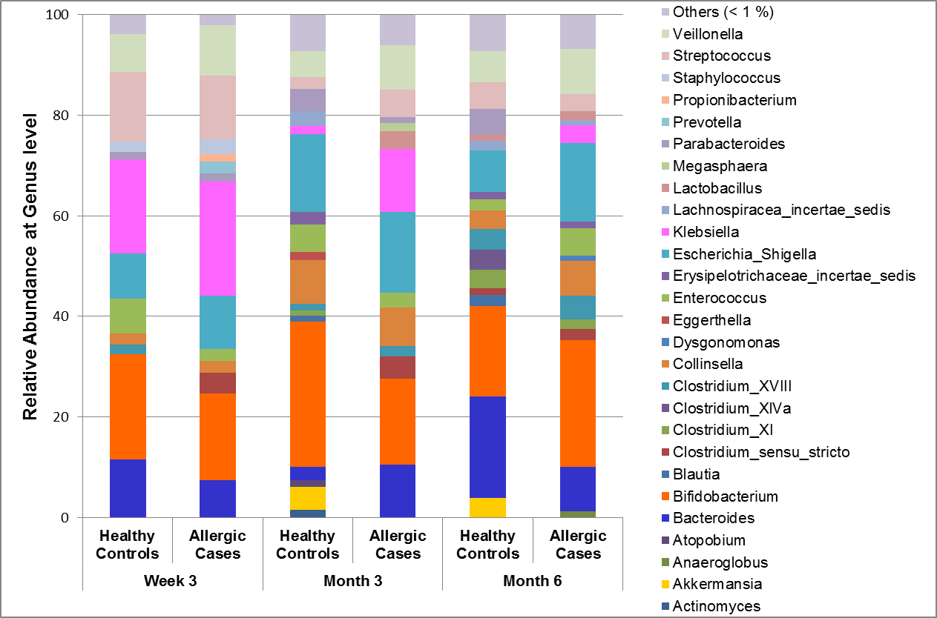
(B)
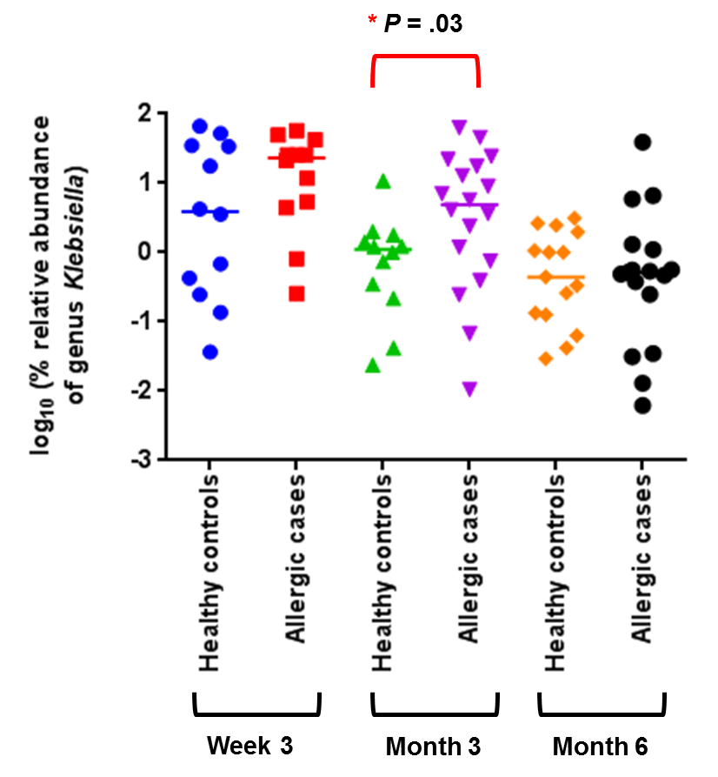
Figure 2
(A) (B)
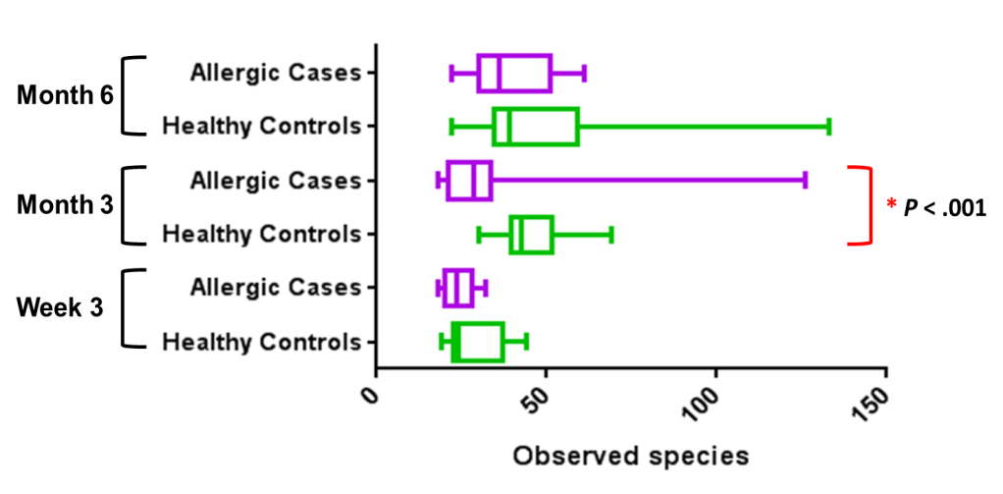  (C) | 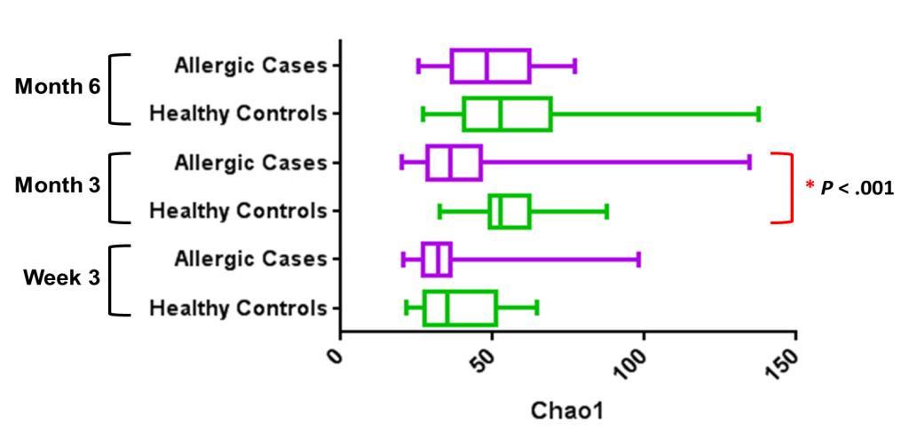
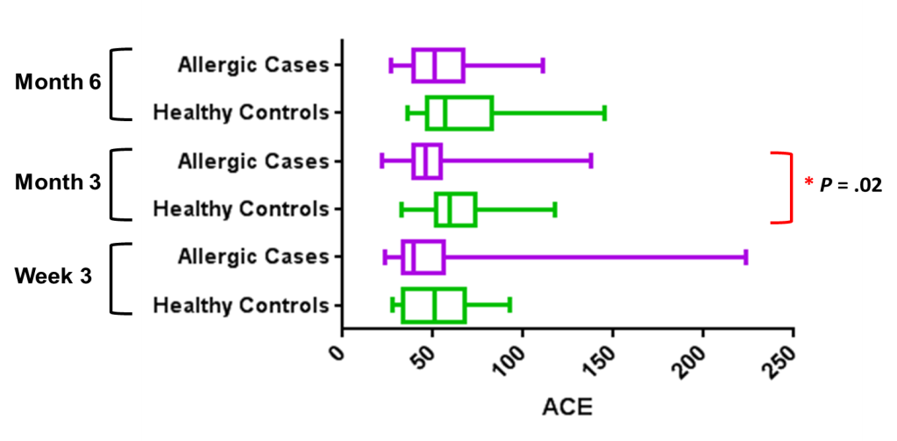

Figure 3

(A) (B)
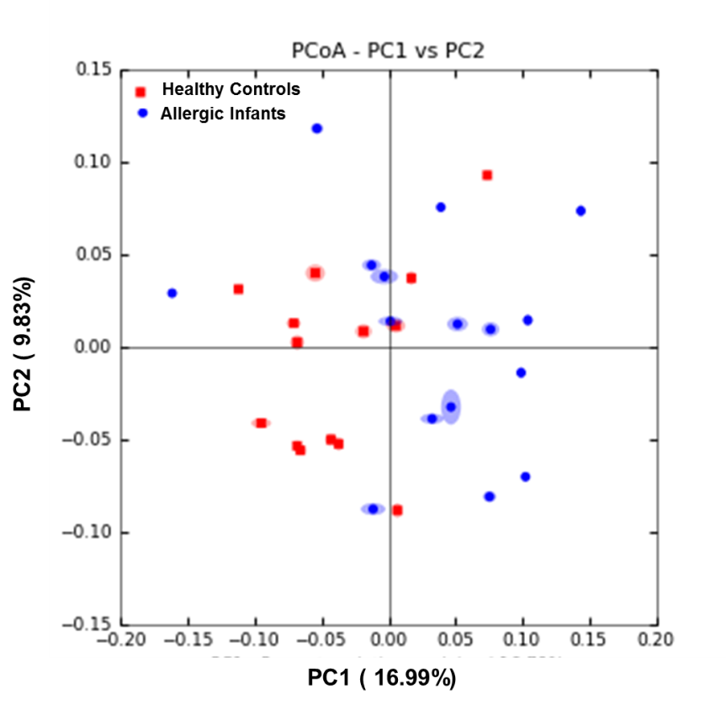 | 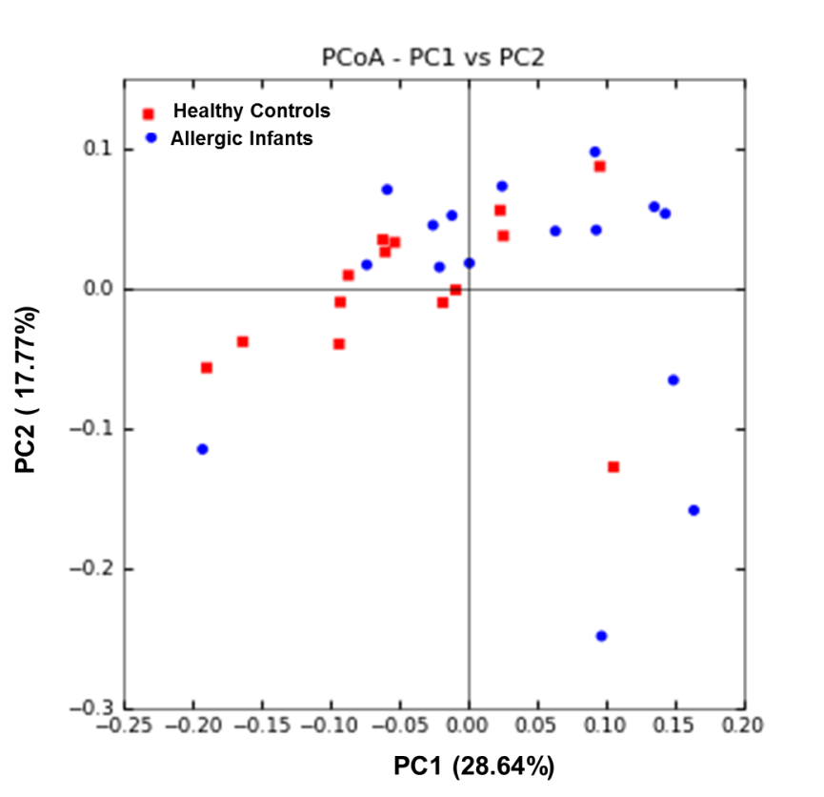

Figure 4

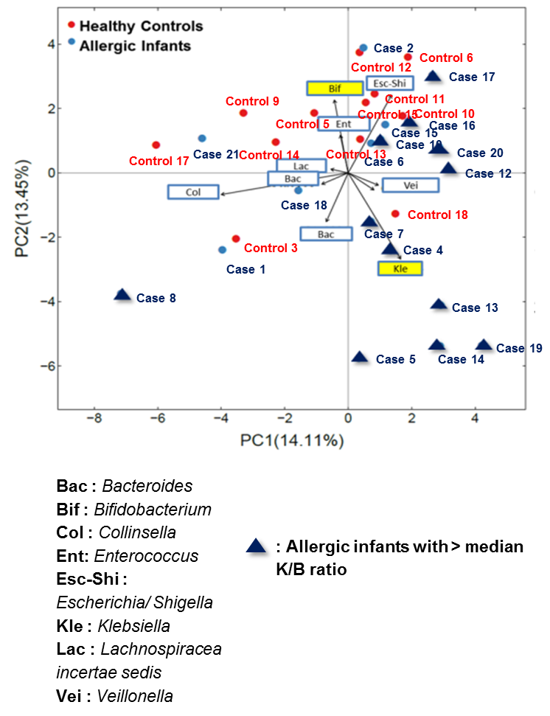

SUPPLEMENTARY TEXT
Supplementary Result
ADJUSTMENT FOR MODE OF DELIVERY ON THE CORRELATION BETWEEN BIFIDOBACTERIUM AND KLEBSIELLA AT AGE 3 MONTHS
In this case-control study, the allergic infants were closely matched to the healthy controls for birth weight, gestational age, feeding pattern, weaning age and medication, to mitigate the effects of confounders. In spite of that, we recognized some limitations during selection of matching variables. For instance, mode of delivery might pose as a potential confounding variable in the correlation between Bifidobacterium and Klebsiella, and its association with paediatric allergy.
In order to examine the effect of confounder, distance based-redundancy analysis (dbRDA) was performed with data sets acquired at 3 months of age, by adding mode of delivery as covariate to the multivariate model. The ten most dominant genera explaining the differences were plotted on the axes of dbRDA analysis. Result of dbRDA revealed that Klebsiella and Bifidobacterium remained as the most dominant genera (relative to other bacteria measured) that seemed to drive the separation of allergic and healthy infants at age 3 months, before and after adjustment by delivery mode (Supplementary Figure S3).

Supplementary Table S1 Clinical characteristics of the cohort

Subject | Average SCORAD Score by 18 months of age | Allergy Diagnosis by 18 months of age |  |  |  |  |  |  |  |  |  | Allergy Diagnosis by 36 months of age
 |  | Eczema diagnosis | Age of Diagnosis (Month) | Allergic Rhinitis diagnosis | Age of Diagnosis (Month) | Asthma diagnosis | Age of Diagnosis (Month) | Positive Skin Prick Test |  |  |  | Eczema | Allergic rhinitis | Asthma
 |  |  |  |  |  |  |  | Cow's milk | Peanut | Egg (whole) | Der f/  Der p
Allergic Case 1 | 43.00 | Yes | 6 |  |  |  |  |  |  |  |  | Yes
Allergic Case 2 | 25.40 | Yes | 14 |  |  |  |  |  |  |  |  | Yes
Allergic Case 3 | Information not available | Yes | 2 |  |  |  |  |  |  |  |  | Yes
Allergic Case 4 | 17.35 | Yes | 17 | Yes | 17 |  |  |  |  |  |  | Yes | Yes
Allergic Case 5 | 8.25 | Yes | 3.5 | Yes | 3 |  |  |  |  |  |  | Yes | Yes
Allergic Case 6 | 9.80 | Yes | 3 |  |  |  |  |  |  |  |  | Yes |  | Yes
Allergic Case 7 | Information not available | Yes | 5 |  |  |  |  |  |  |  |  | Yes
Allergic Case 8 | 18.23 | Information not available |  | Information not available |  | Information not available |  |  |  |  |  | Information not available | Information not available | Information not available
Allergic Case 9 | 45.80 | Information not available |  | Information not available |  | Information not available |  |  |  |  |  | Information not available | Information not available | Information not available
Allergic Case 10 | 19.15 | Yes | 6 |  |  |  |  |  |  |  |  | Yes
Allergic Case 11 | 11.28 | Yes | 1 |  |  |  |  |  | Yes | Yes | Yes | Yes | Yes
Allergic Case 12 | 29.50 | Yes | 6 |  |  |  |  | Yes |  |  | Yes | Yes
Allergic Case 13 | Information not available | Yes | 12 |  |  |  |  |  |  |  |  | Yes |  | Yes
Allergic Case 14 | 11.63 | Yes | 2 |  |  |  |  |  |  |  | Yes | Yes | Yes
Allergic Case 15 | 26.80 | Yes | 6 |  |  |  |  |  |  |  | Yes | Yes
Allergic Case 16 | 26.73 | Yes | 1 |  |  |  |  |  |  |  | Yes | Yes | Yes
Allergic Case 17 | 20.18 | Yes | 12 |  |  |  |  |  |  |  |  | Yes | Yes
Allergic Case 18 | Information not available | Yes | 3 |  |  |  |  |  |  |  | Yes | Yes | Yes
Allergic Case 19 | 37.90 | Yes | 4 |  |  |  |  |  |  |  |  | Yes | Yes
Allergic Case 20 | Information not available | Yes | 7 |  |  |  |  |  |  |  |  | Yes
Allergic Case 21 | Information not available |  |  | Yes | 12.5 |  |  |  |  |  |  |  | Yes
Healthy Control 1
Healthy Control 2
Healthy Control 3
Healthy Control 4
Healthy Control 5
Healthy Control 6
Healthy Control 7
Healthy Control 8
Healthy Control 9
Healthy Control 10 |  |  |  |  |  |  |  |  |  |  |  |  | Yes
Healthy Control 11
Healthy Control 12
Healthy Control 13
Healthy Control 14
Healthy Control 15
Healthy Control 16 |  |  |  |  |  |  |  |  |  |  |  |  |  | Yes
Healthy Control 17
Healthy Control 18

Supplementary Table S2 Ratio of relative abundances of Klebsiella to Bifidobacterium (K/B ratio) of allergic and healthy infants at age 3 weeks, 3 months and 6 months respectively. The values were expressed in median (range). Differences in medians of Klebsiella/Bifidobacterium ratio between the two groups were performed using non-parametric Mann-Whitney U test. Single asterisk (*) indicate P ≤ .05.

Timepoint | Klebsiella/Bifidobacterium ratio
 | Healthy Controls | Allergic Cases | P value
Week 3 | 0.23 (0.01-213.07) | 1.70 (0.01-1408.00) | 0.12
Month 3 | 0.03 (0.00-0.68) | 0.52 (0.00 – 2281.33) | *0.01
Month 6 | 0.01 (0.00-62.00) | 0.05 (0.00-910.50) | 0.26

Supplementary Figure S1 GUSTO schematic workflow of diagnosis for infants’ allergic eczema. Infants who were confirmed with eczema were assessed further on its severity by SCORAD score. The allergy diagnoses of infants were collected at 18 months and 36 months of age.

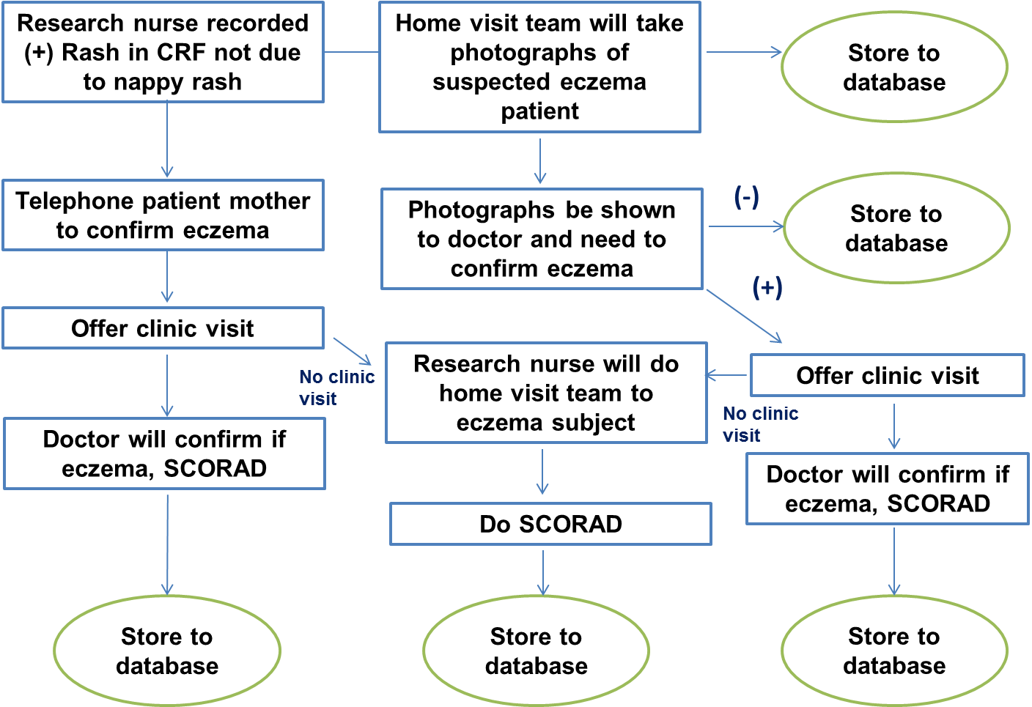

Supplementary Figure S2 Relative abundance (%) of bacterial phylum between allergic infants and healthy controls at 3 weeks, 3 months and 6 months of age as determined by 16S rRNA sequencing.

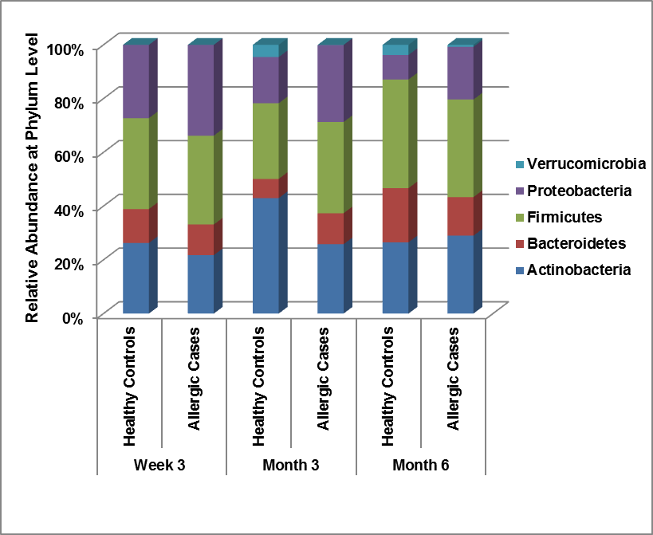
Supplementary Figure S3 dbRDA based on the compositional structure of the intestinal microbiota of allergic infants and healthy controls at 3 months of age, with mode of delivery as covariate to the multivariate model.The dbRDA axes described the percentage of fitted variation explained by each axis. Each circle represents the composition of intestinal microbiota of a subject (Red – Healthy controls, Blue – Allergic Infants). The ten most dominant genera explaining the differences are represented by the arrows.

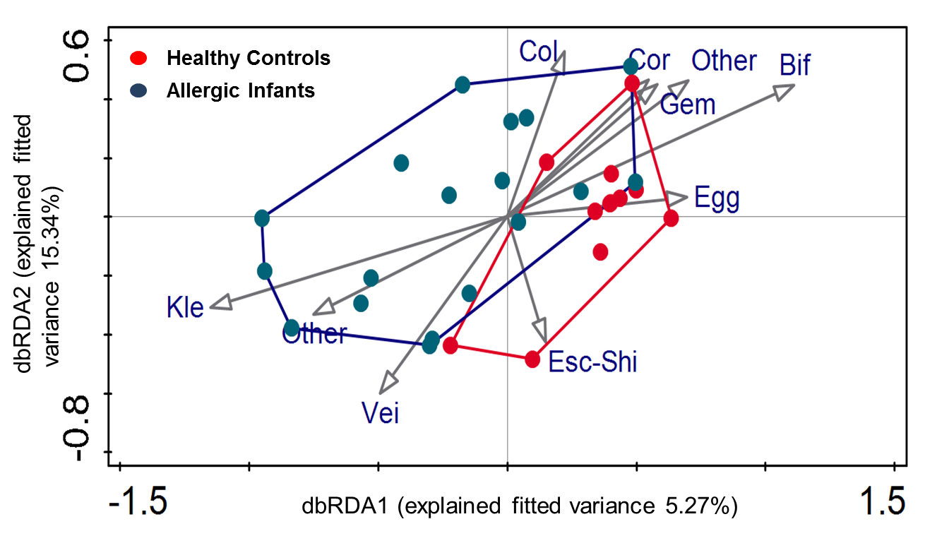

Bif : Bifidobacterium
Col : Collinsella
Cor : Corynebacterium
Egg : Eggerthella
Esc-Shi : Escherichia/ Shigella
Gem : Gemella
Kle : Klebsiella
Other : Other
Vei : Veillonella

