**Recognition Technology of Winding Deformation Based on Principal Components of Transfer Function Characteristics and Artificial Neural Network**

# Yongfen Luo, Jianqu Ye, Jiaping Gao

School of Electrical Engineering, Xi’an Jiaotong University, Xi’an, 710049, China

# George Chen

School of Electronics and Computer Science, University of Southampton, Southampton, SO17 1BJ, UK

# Guoli Wang, Lei Liu and Bin Li

State Key Laboratory of HVDC, Electric Power Research Institute, China Southern Power Grid，Guangzhou, 510080, China

# ABSTRACT

**In this paper, an intelligent identification method for winding deformation fault is proposed. The proposed method is composed of principal components of transfer function characteristics and an artificial neural network (ANN). A sequence of simulative deformation faults with different types, locations and extents are set on the winding of a 10kV transformer. The corresponding status transfer function is acquired with a winding deformation test method excited by M-Sequence. Zeros, poles and the variations of the transfer function are considered to be the features of the winding mechanical status. The principal components of feature are extracted and then used as input to a back-propagation ANN for fault recognition. The winding deformation faults are recognized using the ANN that has been trained and tested using the cross validation method. The results show that the classification method has the ability to simultaneously recognize the deformation faults with different types, locations and extents with high accuracy and is suitable for winding deformation diagnosis. The study presents an idea and a path to identify winding mechanical status intelligently though it conducts on a transformer.**

Index Terms — **Winding deformation, M-Sequence method, Principal component analysis (PCA), back-propagation ANN.**

**1 INTRODUCTION**

**POWER** transformers and reactors are the critical parts in a power system. Relevant statistics have shown that the winding faults account for about 80% of the typical faults in the transformers [1]. The mechanical defects are probably the most important causes of problems in the transformers [2]. According to the relevant investigation, the failures in the transformer winding are mainly caused by mechanical deformation due to short circuit forces and the cumulative effect gradually intensifies the deformation [3]. Therefore, the winding deformation is one of the first and the fundamental causes for a decline in the transformer condition [4]. If a deformed winding fails to be detected and repaired timely, the insulation deterioration and even the sudden catastrophic failures may occur [5].

Currently, Frequency Response Analysis (FRA) is regarded as a stable, highly repeatable, sensitive and reliable method for winding deformation diagnosis [6]. Through interpreting the modification of a frequency response curve and its characteristics, the FRA is used to identify the winding’s mechanical status in following ways: 1) Visual observation and cross-comparison with the frequency response curves directly; 2) Statistical analysis of the variations of the frequency response curves both in full and partitioned frequency bands; 3) Analysis with the transfer functions obtained indirectly by fitting the frequency response curves.

*Manuscript received on 24 February 2017, in final form 22 August 2017, accepted 24 August 2017. Corresponding author: Y. Luo.*

The FRA has made great achievements and progress in practice however it has the following drawbacks: Firstly, the graphical analysis of the current curve and the reference one are conducted manually by trained and skilled experts and the final decision is made in a subjective manner. Secondly, the different winding statuses may exhibit the same deviation in their statistical characteristics and even in their frequency response curves, which may lead to incorrect conclusion. Lastly, the transfer function obtained indirectly by fitting the frequency response curve tends to lose the poles and the zeros information that is not significant in the curve but may affects the winding deformation diagnosis. Until now, the winding mechanical status is still not completely inductive and its classification uncertainty and overlaps of characterization value may lead to confusion in interpretation. All these factors motivate for practical development of automatic explanation and intelligent identification for winding status.

In the early studies, the ANN has been used monolithically to assess the winding deformation [7, 8]. Later, practically attempts have been made to further determine the defect type, location and extent of a winding deformation [9-13]. Gandhi constructed nine statistical indicators from the deviations between the present and the reference frequency responses, and then complemented to verify the extents of the deformation with ANN [14]. An ANN classifier is trained by Ghanizadeh with two sets combined by seven features based on cross-correlation and other six mathematical patterns from the present and the reference frequency responses, and used to identify the defect types such as disk-to-disk short circuit, radial and axial displacement, and to finally determine the defect locations and extents [15]. The matched transfer function fitted by Birlasekaran contained 32 poles and zeros from the frequency response of a winding, and their real and imaginary frequency components, the natural frequencies and the damping coefficients are input to a back-propagation ANN to classify 12 winding faults [16]. Prameela acquired a transfer function with 21 poles and 19 zeros from amplitude frequency response of a winding based on subspace identification method, and the characterizing discrete parameters of the transfer function were used to train an ANN to identify 14 winding faults with different locations and extents [17]. Contin proposed a Fuzzy-Logic algorithm with two parameters namely the mean and the standard deviation over three partitioned frequency bands to automatically analyze the three defect types, i.e., turn-to-turn short circuit, radial and axial displacement [18]. While Gonzales applied fuzzy sets to detect the winding deformation with relative factor and effective deviation of partitioned frequency bands [19]. Shintemirov developed an evidential reasoning framework with the ability of combining evidence and dealing with uncertainty [20]. In the framework, the experts’ subjective judgments are aggregated and the assessment progress of the FRA is transformed into a multiple-attribute decision-making problem with seven types of hypotheses (i.e., normal, residual magnetization, poor grounding and so on) in a formalized form, and an evidential reasoning approach is presented to produce a balanced overall condition evaluation for the investigated winding. Bigdeli vector fitted rational function approximation from frequency response and took the index of frequency ratio, amplitude ratio, correlation coefficients of zeros and poles as a characteristic matrix that was inputted into the support vector machine (SVM) to classify the type, location and extent of 4 winding faults [21].

The research so far on intelligent winding deformation diagnosis is either limited to simulation or to winding deformation samples. Thus, the study of winding status and intelligent recognition still lack of complete inductive research and intelligent diagnosis of the types, locations and extents of deformation fault. In this paper, a sequence of simulative deformation faults with different type, location and extent are set on a winding of 10 kV transformer. The transfer function in corresponding mechanical status is acquired and the principal components are extracted from the characteristics of poles, zeros and their relative variations. The components are then used as inputs to a back-propagation ANN for training and testing with the cross validation method. Lastly, the ANN is used to recognize the winding status. The obtained results show that the ANN has high accuracy rate to classify the type, location and extent of deformation faults.

**2** **EXPERIMENT SETUP AND MEASUREMENT**

The test object is the side-phase high voltage winding of a three-phase and double winding transformer of type SY-30 kVA /10 kV. It can be set to the link pattern of Y/Y or Y/△, and the ratio is 10:9. The two terminals of each winding are educed from bushings.

The winding deformation experiments are conducted on the outside windings which are in the disk form. The disk sum of the outside winding in each phase is 60, while there is a made-up tap in every other disk and the tap sum is 29.

The inductance of the winding is about 108mH, its equivalent capacitance is 220 pF and its ground capacitance  is 1270 pF, so its series capacitance  is 38pF according to [22].

Figure 1 is the setup diagram of the measurement system, by which the measurements for both the M-Sequence method and FRA can be performed [23, 24]. The excitation signals were generated by an arbitrary waveform generator M2i.6011 (Spectrum Inc., German). Then, the signals are driven by a power amplifier to excite the winding. The clock and trigger signal are outputted by the generator to an acquisition card M2i.4912 (Spectrum Inc., German). The divided excitation signal and the response signal along a sample resistor () are sampled simultaneously by the acquisition card. The sample resistor is connected from the other terminal of the winding to the ground. At last, an industrial computer reads the sampled data from the two channels of the acquisition card and conducts the subsequent calculations and analyses.

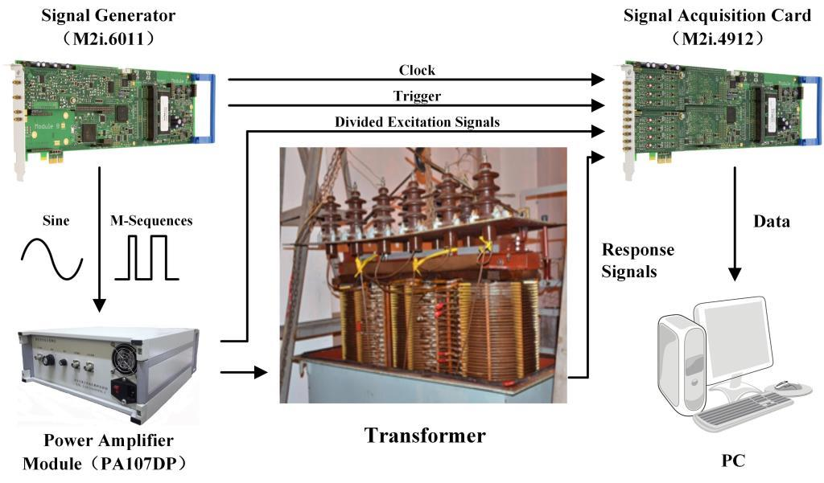

**Figure 1.** Measurement system of winding deformation.

**3 Principal components extracted from Characteristics of winding’s transfer function**

The winding’s transfer function is acquired with the M-Sequence method [23, 24], written as equation (1) in *s* domain:

 (1)

where, donates amplitude,  and  donate the real and imaginary part of the *k*th zero respectively,  and  donate the real and imaginary part of the *m*th pole respectively,  donates the continuous multiplication. For the test winding, the order  of the transfer function is chosen to 430.

Zeros and poles are calculated in normal condition without any simulated faults and are shown in Figure 2, Table A1 and A2. There are 48 zeros and 47 poles in the frequency region of 1k~1MHz. A 5-turns coil is connected in series to the winding after splitting at the first tap, which is simulated the type of winding deformation with inductance variation [30]. The inductance of single turn coil is approximately 21.2 uH. The test results are also shown in Figure 2, Table A1 and A2.

What need alludes is, as formula (1) showed, the imaginary part of a zero or a pole is related to the frequency , a zero or a pole is plotted with its real part as vertical coordinate against its imaginary part as abscissa in Figure 2.

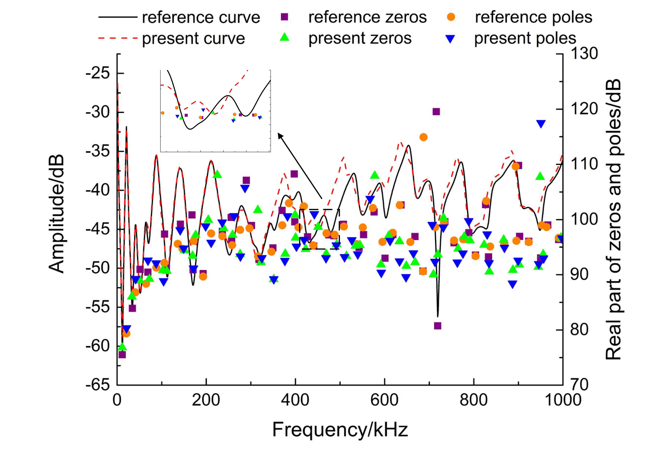

**Figure 2.** Zeros, poles and frequency responses of a winding in normal condition and in series connection with a 5-turns coil.

Zeros and poles can be seen changing with the winding mechanical status, which is also confirmed by more tests to simulative faults and literatures. Thus, zeros and poles in effective frequency region can be used as characteristics of a winding status. However, a frequency response curve is complex and a winding transfer function has many parameters such as coefficients, zeros and poles. Thus, three main types of concise features proposed to characterize the winding status are used to classify the winding deformation faults artificially or intelligently. The first type is composed of statistical parameters, such as the correlation coefficients, the standard deviations and the correlation factors, obtained by comparing the present and reference frequency response curves [25-27]. The second type is composed of the feature parameters, such as the transfer function coefficients, the imaginary and the real components of zeros and poles, the natural frequencies, and the attenuation coefficients and amplitudes, related to the transfer function with physical meaning [16, 17]. The last type combines the former two types and comprises of the statistics to the second feature type, such as the index of frequency and amplitude ratio [21].

In this paper, zeros and their variations of transfer function are used to construct a set of feature vector, which consists of frequency and amplitude of the zeros, and their respective relative variations to normal winding. Similarly, a set of feature vector  of poles is constructed. Thereafter, the feature vector of the present test winding can be given by. According to the ascending order of frequency, the feature vectors about zeros and poles can form a  feature matrix, and a  feature matrix, respectively.

However, it is still unrealistic to analyze the feature matrix visually due to its large dimensions, and in that case it is also not feasible to save data and analyze successively. In addition, some zeros and poles change infinitesimally, which indicates that they are insignificant for fault diagnosis of the winding deformation. Hence, the feature matrixes need to be pre-treated to minimize the noise, eliminate the redundancy and to reduce the inputs of the subsequent ANN.

In this work, the principal components of feature matrix are extracted with K-L transform [28]. Its flowchart is illustrated in Figure 3. The major advantage of this processing is to use only a few components to characterize most of the feature matrix’s structure and features. The main steps to extract principal components of feature vector  are listed as below:

1) Extract the covariance matrix of feature vector  from;

2) Calculate the eigenvalues and the corresponding eigenvectors of the covariance matrix. Sort the eigenvalues in descending order, namely, and write the corresponding eigenvectors as;

3) Select the eigenvectors, which correspond to the top-*m* eigenvalues whose respective accumulative contribution rate is not less than the set value, to be a transformation matrix;

4) Transform the  dimensional feature vector  into a  dimensional feature vector  by, where  denotes the principal component.

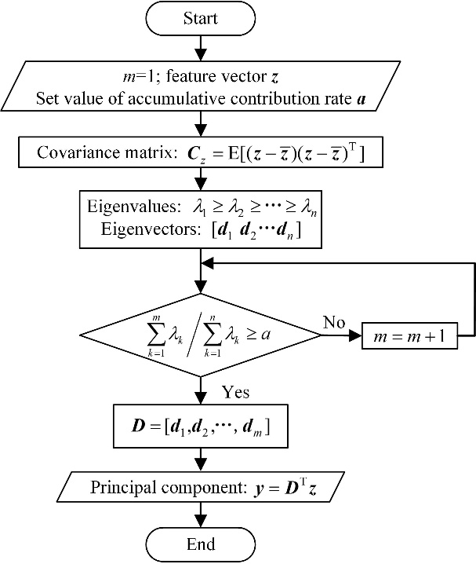

**Figure 3.** Flow chat of principal component extraction.

As , PCA can reduce the dimensions of the original data and the new acquired feature vector can preserve the structure and the features of the original data when higher cumulative contribution rate is set.

According to the above mentioned steps, the covariance matrix of poles characteristic matrix  is obtained first, which is a 47*47 square matrix with 47 eigenvalues and corresponding eigenvectors calculated and sorted in descending order. The top-*3* eigenvalues are 3.9835*1012, 2.3299*104 and 0.0018, and the rest are less than 0.0007. Therefore, the accumulative contribution rate of the first principle component is near to, while others can be regarded as “noise” or “redundancy” and be neglected. The eigenvector corresponding to the first eigenvalue 3.9835*1012 is selected as the transformation matrix. Thus, the principal components of the pole feature vector from this measured sample can be written as = [3.9917*106, 584.45 0.0658 0.2995].

The principal components of the measured zero feature matrix  can also be obtained in a similar manner. Finally, the feature principal components of the measured data can be written as a new feature vector = [3.9917*106 584.45 0.0658 0.2995 4.0098*106 590.35 0.083 0.3820].

In this way, the zero and pole feature matrixes are transformed to an 8-dimensions vector with PCA.

**4 Establishment of Back-propagation ANN**

The type, location and extent of deformation faults are not linearly related to winding features [28]. The BP ANN has been used in automatic identification of winding deformation because is well able to classify and recognize the nonlinear samples. However, the training efficiency and the subsequent classification performance of the ANN can achieve anticipative results only when its structure and parameters are properly chosen [30].

**4.1 DETERMINATION STRUCTURE OF BP ANN**

In this paper, a 3-layer BP ANN is used in order to classify and recognize the winding deformation faults. The ANN consists of input, hidden and output layers with *n*, *h* and *m* nodes, respectively, as shown in Figure 4.

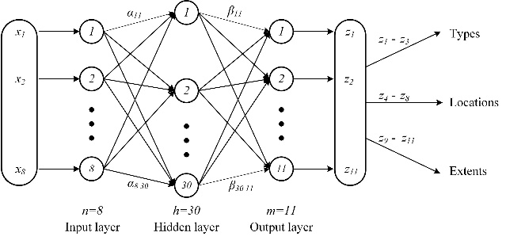

**Figure 4.** 3-layers structure of a BP ANN.

In Figure 4, is the input of the ANN, and  is the predictive output.  and  are the weights connecting input to hidden, and hidden to output layer respectively.

**4.2 PARAMETERS OF THE BP ANN**

**4.2.1 normalization of Inputs**

The zero and pole feature vector  obtained by PCA is regarded as the ANN input with input node number as 8. However, the maximum and the minimum of  differ in the magnitude of 8 orders, in order to balance their weights, converge the BP ANN fast and reduce the calculation time needed in the training process, it is necessary to normalize the input feature vector [31, 32].

The normalization transfers the original data into the interval of , and decimal scaling calibration is used to normalize  by the equation (2).

 (2)

Where index  should be chosen to be the samllest integer that satisfies the condition . For example, the first element of  is , then its index  is chosen to be 7, so it is normalized to 0.39917. Finally, the input for the given example is transferred into= [0.39917 0.58445 0.658 0.2995 0.40098 0.59035 0.830 0.3820].

**4.2.2 representation and code of outputs**

Here, the identify target of winding deformation aims to the type, location and extent of faults. Thus, the output of the BP ANN should represent and code for this purpose.

As the diversity of transformer winding deformation faults, S. M. Islam has summarized the corresponding relationship between the winding deformation faults and their equivalent parameters [33]. The faults can be classified into 3 types, namely the inductance, the grounding capacitance and the series capacitance fault. It is considered that the inductance variation is related to disk deformation, local breakdown and winding short circuits, the grounding capacitance variation is related to disk movement, bulking due to large mechanical force, moisture ingress and loss of clamping pressure, and the series capacitance variation is related to the aging of insulation. Therefore, during the experiments in this work, the increment of inductance is simulated by inserting an additional coil into the winding, the increment of grounding capacitance is simulated by connecting an additional capacitor from a made-up tap of the winding to ground, and the increment of series capacitance is simulated by connecting an additional capacitor in parrell to two successive made-up taps, as shown in Figure 5.

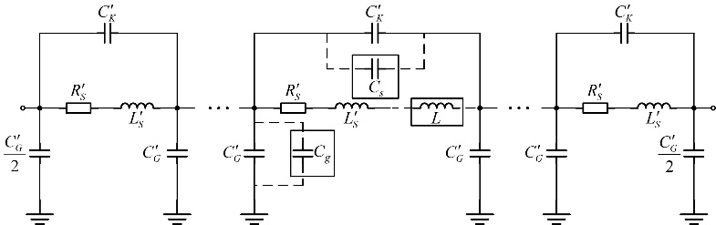

**Figure 5.** Equivalent circuit of a winding connected an additional inductor/capacitor.

The ANN output is coded by a three bit binary in order to represent the fault types, shown in Figure 4 and Table 1.

In order to investigate the relationship between features and locations of winding deformation, 14 made-up taps are set to simulate the deformation faults. The ANN output is coded by five bit binary to represent the deformation fault locations as upper, middle-upper, middle, middle-lower and lower from the head of the test winding.

The extents of a deformation fault are simulated by changing the turns of the inserted-in coil or the capacitance value connected to the made-up taps. In this paper, coil of 1~5 turns or capacitor with different values, such as 20 pF, 47 pF, 100 pF, 150 pF and 220 pF, are used. The ANN output is coded by three bit binary to represent the deformation fault extentions as slight, moderate and severe.

Above all, there are 11 nodes in the ANN output layer, and 45 combinations of winding deformation representing different types, locations and extents in the binary codes. For example, a severe deformation fault in the middle part of the test winding caused by an extra grounding capacitor can be coded by   in the ANN output.

**Table 1.** Classified information of winding deformation.

|  |  |  |  |
| --- | --- | --- | --- |
| Classified catalogue | | Output | Detail |
| Types | Inductance | 0 0 1 | L |
| Grounding capacitance | 0 1 0 | Cs |
| Series capacitance | 1 0 0 | Cg |
| Locations | Upper | 0 0 0 0 1 | 1st, 2nd, 3rd tap |
| Middle-upper | 0 0 0 1 0 | 4th, 5th tap |
| Middle | 0 0 1 0 0 | 6th, 7th, 8th, 9th tap |
| Middle-lower | 0 1 0 0 0 | 10th, 11th tap |
| Lower | 1 0 0 0 0 | 12th, 13th, 14th tap |
| Extents | Slight | 0 0 1 | 1st, 2nd disk/20, 47pF |
| Moderate | 0 1 0 | 3rd disk/100pF |
| Severe | 1 0 0 | 4th, 5th disk/150, 220pF |

The inductances and capcitances connected in the winding to simulate the deformation extents may not correspond to the actual winding deformation status. However, the authors’ proposal aims to provide an idea and a path to intelligently identify mechanical status of a winding.

**4.2.3 Network conversion function**

The function is used to convert the input of a network to its output. In order to achieve arbitrary nonlinear mapping, nonlinear and bipolar sigmoid functions are usually used as network transfer functions in ANN. Corresponding to the coded output, the sigmoid function is chosen here with range .

**4.2.4 Other STRUCTURE parameters**

The error accuracy and the training speed are set to 0.05 and 0.2, respectively, when the back-propagation ANN is trained.

**4.2.5 selection of Network training algorithm and hidden layer parameters**

The Levenberg-Marquardt (LM) optimization algorithm is selected after trying several methods. The LM is an improved Gauss-Newton algorithm that takes advantages of not only the local characteristics of Gauss-Newton algorithm but also the global characteristics of the gradient descent algorithm. Thus, it is able to determine the suitable search direction near the optimum point and greatly reduce the number of iterations [34].

The BP ANN is trained and tested by the cross validation method. 126 combinations of simulative deformation faults, consisting of three types, five locations and three extents, are set in the test winding. What need alludes is that even in a same experimental setup, electromagnetic frequency characteristics of the transformer would be changed by the variation of environment condition such as temperature, and the discharge of surrounding equipment would interfere the deformation measurement. All these will decrease the measurement repeatability, which is also one of the most important influence factors in FRA. So here for each combination, 50 independent repeated experiments are conducted in order to obtain its original data samples, in which 30 experiment samples are put in the training set and the remaining are put in the validation set to evaluate performance of the proposed ANN, and then the experimental repeatability is naturally guaranteed. The combinations are all classified and coded according to Table 1 [35]. After training, the ANN is tested by the validation set.

During the training process, the BP ANN with different hidden layer nodes is trained and validated, and then the node number in the hidden layer is determined through this mothed. The classification accuracy rates of ANN with different hidden layer nodes are presented in Figure 6. Since, the initial weights and thresholds are random, the ANN acquired by training is different even in the same parameters that leads classification accuracy rate to fluctuate within a certain range. In this paper, a single ANN is trained 10 times and their average is calculated as the final classification accuracy rate. The classification accuracy rate of ANN increases gradually with the increase of hidden layer nodes. The accuracy rate is maintained at about 80% when the node number is reached to 30. Therefore, 30 is selected as the node number of the hidden layer.

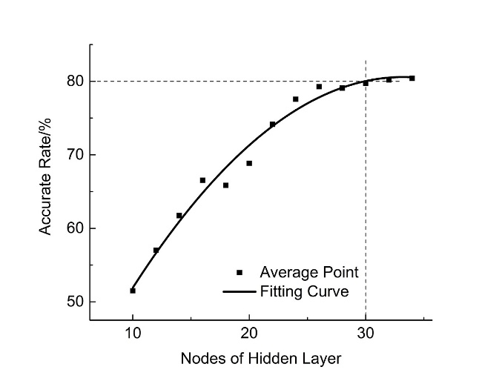

**Figure 6.** Classification accuracy rate of ANN with different hidden nodes.

**5 RESULTS OF CLASSIFICATION AND RECOGNITION**

Three simulative winding deformation fault cases consisting of different types, locations and extents are shown in Table 3. The frequency response curves, poles and zeros obtained by the M-Sequence method before and after deformation are shown in Figure 7. The figure shows that the curve and the parameters are changed once a deformation is occurred. The rough qualitative analysis to this phenomena from the equivalent circuit was presented in the literature [23, 24].

In order to accurately decribe the type, location and extent of a deformation fault, the PCA and the ANN are used to recognize the fault. The recognition results of the 3 deformation cases are presented and compared with their preset deformation statuses.

Figure 7a shows the results of a simulative deformation fault, in which a extra 220 pF capacitor is connected between 24th tap and ground. The features of this case are calculated from poles, zeros and their variations, and the input is obtained with PCA and then normalized, as shown in Table 2.

After recognized by the trained ANN, the normalized output is [100 10000 100] that presents a severe ground capacitance fault in the lower part of the test winding according to the code in Table 2. The result coincides with the preset deformation fault indicating that the recognition is correct.

Similarly, Figures 7b and 7c show the results of a simulative inductance fault in which a three-turns coil is inserted in 12th tap, and a simulative series capacitance fault in which a 20 pF capacitor is conencted in parallel between 2nd and 3rd tap, respectively. The recognition results of the two cases obtained by the PCA and the ANN are also shown in Table 3, which confirm that the results are consistent with the preset deformation faults.

The recognition statistics of all validation samples show that the classification accuracy rates for type, location and extent of winding deformation faults are up to 96.6%, 81.0% and 94.1%, respectively, and the total accuracy rate, which means the jugements to the type, location and extent of a deformation fault are simultaneously correct, is 80.5%.

**Table 2.** Recognition results of 3 winding deformation faults.

|  |  |  |  |  |
| --- | --- | --- | --- | --- |
| Preset deformation | Input | output | Output normalization | Recognition |
| Grounding capacitance  24th tap to ground  220 pF capacitor | 0.40014 0.57636 0.81391 0.27200 0.40129 0.57624 0.71751 0.30616 | 0.97018 0.04592 0.01610 0.84030 0.07641 0.15931 0.20031 0.12429 0.97675 0.04656 0.06981 | 1 0 0  1 0 0 0 0  1 0 0 | Grounding capacitance  Lower  Severe |
| Inductance  Inserted in 12th tap  3 turns coil | 0.39926 0.57408 0.85147 0.35634 0.40001 0.57396 0.93999 0.37736 | 0.18200 0.06647 0.88447 0.04156 0.13322 0.77233 0.01811 0.11789 0.34557 0.44798 0.20645 | 0 0 1  0 0 1 0 0  0 1 0 | Inductance  Middle  Moderate |
| Series capacitance  Between 2nd and 3rd tap  20 pF capacitor | 0.40121 0.58116 0.50865 0.19243 0.40332 0.58305 0.59591 0.25054 | 0.23211 0.82645 0.21475 0.05596 0.10452 0.26379 0.25302 0.53176 0.16476 0.17365 0.99112 | 0 1 0  0 0 0 0 1  0 0 1 | Series capacitance  Upper  Slight |

|  |  |  |
| --- | --- | --- |
| (a) Grounding capacitance fault | (b) Inductance fault | (c) Series capacitance fault |

**Figure 7.** Variations of frequency response curves, zeroes and poles in winding deformation experiments.

**6 DISCUSSIONS**

According to the winding structure, its equivalent circuit is established, in which two disks is considered to a unit and there are 30 units totally, as shown in Figure. 5. Then  is 3.6 mH,  is 1140 pF and  is 42 pF.

When a coil with 1-5 turns is connected to the winding in series, the relative ratio is changed from 0.6% to 2.9%, as shown in Table 3. The change of inductance is an important characteristic of winding deformation and the basis of short circuit test method.

When a capacitor  is connected to two ajacent winding tapes in parallel or a capacitor is connected from a winding tape to the earth, the relation of their relative ratios to the defined deformation extent is also listed in the table. In the view of electrostatic field, the increase of capacitance means two metal plates of the capcitor are closer to each other with its dielectric unchanged.

The table shows that though  is not big the corresponding deformation can be recognized, the reason is the distance between the adjacent disks is small and then the equivalent capacitance is large, then if the distance is changed tinily the current flow through  would increase significantly and the deformation can be detected.

While capcitance  is very small, it surely means the winding unit is farther away from the earth than its adjacent disk. Then a large percentage of the equivalent grounding capacitance  may be changed to shunt current from  and  and show physical deformation, and it means the winding unit should be significantly close to grouding componets such as core or shell then the deformation can be detected, in this case winding deformation may be easier detected according to the change of inductance. And it can also be noticed that the ratio  of winding deformation type representing change of grounding capacitance looks like a little bigger than the defined deformation extent, for example, the deformation extent which results in 47.6% increase of  is defined as “slight”, here  is the equivalent capacitance of the local winding unit. In fact the change of  is directly lead by the change of the distance (as denominator of capacitance formula) between the winding unit and grounding component, in the meantime the area (as numerator of capacitance formula) of the winding unit exposed to grounding component is reversely changed, for example the distance is decreased and then the exposed area of the winding unit is increased, summed up all these effects the distance is changed fewer than , namely the deformation extent does not appear as big as the ratio. However the defined extents of winding deformation are not relate the change of the inductances or capacitances to physical deformation rigorously in the paper.

**Table 3.** Relation of deformation extent to connected component.

|  |  |  |  |  |  |  |
| --- | --- | --- | --- | --- | --- | --- |
| /uH | /% | /pF | /% | /pF | /% | Defined Deformation Extent |
| 21.2 | 0.6 | 20 | 1.8 | 20 | 47.6 | Slight |
| 42.3 | 1.2 | 47 | 4.1 | 47 | 112 |
| 63.5 | 1.8 | 100 | 8.8 | 100 | 238 | Middle |
| 84.6 | 2.4 | 150 | 13.2 | 150 | 357 | Severe |
| 105.8 | 2.9 | 220 | 19.3 | 220 | 524 |

Due to the complexity of transformer winding structure, until now only a few literature such as [26] established the relation between a statistical parameter namely correlation coefficient and winding deformation extent, and explicitly suggested the relation as a reference. However, how to acquire the relation was not reported in-depth. In addition, the combination of the spatial structure deformation of a winding is very much, how to define the deformation extent is still disputable and worthy of further study.

Additionally, the overall assessment of the studied transformer winding is presented as accuracy rate of three types, five locations and three extents of winding deformation, the results show that the constructed ANN can automatically explain and intelligently identify mechanical status of the same transformer. However, in order to correctly apply in the actual transformer winding, further research is still plan to do for the following work.

The windings, which have similar internal structure and size, and similar external structure to other windings, iron core and the shell, are classified to a same kind of winding.

Each kind of winding is established to a finite element model and simulated to acquire its equivalent circuit and its component values. Local area of the winding FEM model is deformed and simulation is made, then a changed component value in the equivalent circuit can be acquired in turn, features of the transfer function and its variations are also acquired.

Transfer function of the actual transformer winding is measured in long term, and the transfer function and the mechanical status are compared transversely and longitudinally for the same kind of winding, especially the deformed winding which is dissected should pay attention to analyze.

With multiple feedback and correction, the criteria of deformation type, location and extent for different kind of winding is established, correspondingly the weights of the studied ANN is adjusted, and then the relations among the winding types, its deformation criteria and ANN weight are established to form a database, at last the ANN is able to apply to various practical winding.

**7 CONCLUSIONS**

In this paper, an intelligent identification method is proposed for winding deformation. The proposed methos is based on the principal components of transfer function characteristics and the ANN that can simultaneously recognize a deformation fault for its type, location and extent at high accurate rate.

A sequence of winding deformation faults with different types, locations and extents are simulated in a 10kV transformer, and their corresponding transfer functions are acquired by M-Sequence method. The principle components of poles, zeros and their variations are extracted and used as the inputs of a ANN in order to accurately diagnose the winding status and reduce the complexity of recognition.

Once the back-propagation ANN is trained and tested with cross validation method, it obtains the ability to simultaneously classify the winding deformation faults with different types, locations and extents at high accuracy rate that reaches 80% for total fault status and 96% for single fault status.

This study is carried out systematically in a specific transformer. Although some results cannot be extended to other transformers unchangeably, this study provides a path to intelligent identification and recognition of winding deformation that can promote the establishment of intelligent winding deformation diagnosis.

**APPENDIX**

**Table A1.** Sample data of zeros (a 5-turns coil inserted in the 2nd tap)

|  |  |  |  |  |  |  |  |  |
| --- | --- | --- | --- | --- | --- | --- | --- | --- |
| No. | Frequency  (kHz) | | Amplitude  (dB) | | Relative Change Ratio of frequency  (%) | | Relative Change Ratio of Amplitude  (%) | |
| 1 | 11.41 | | 76.81 | | 2.98 | | 1.74 | |
| 2 | 33.19 | | 86.02 | | 3.48 | | 2.52 | |
| 3 | 50.89 | | 88.96 | | 1.28 | | 2.20 | |
| 4 | 72.51 | | 89.22 | | 4.98 | | 1.37 | |
| 5 | 102.7 | | 90.81 | | 3.67 | | 6.74 | |
| 6 | 111.4 | | 90.67 | | 0.49 | | 0.61 | |
| 7 | 151.8 | | 94.39 | | 6.65 | | 4.80 | |
| 8 | 169.5 | | 93.41 | | 0.79 | | 7.36 | |
| 9 | 176.4 | | 97.19 | | 3.28 | | 6.92 | |
| 10 | 204.8 | | 99.92 | | 6.01 | | 10.80 | |
| 11 | 225.0 | | 108.05 | | 4.84 | | 10.42 | |
| 12 | 239.0 | | 98.40 | | 6.77 | | 1.97 | |
| 13 | 259.1 | | 97.21 | | 0.76 | | 1.08 | |
| 14 | 276.1 | | 93.70 | | 4.83 | | 12.50 | |
| 15 | 315.8 | | 101.69 | | 4.70 | | 2.81 | |
| 16 | 322.9 | | 92.26 | | 1.48 | | 0.53 | |
| 17 | 351.6 | | 89.17 | | 0.58 | | 5.99 | |
| 18 | 377.2 | | 93.78 | | 1.86 | | 7.74 | |
| 19 | 399.4 | | 100.81 | | 0.50 | | 6.86 | |
| 20 | 400.4 | | 96.70 | | 0.43 | | 2.90 | |
| 21 | 423.0 | | 94.65 | | 1.02 | | 2.29 | |
| 22 | 451.0 | | 98.66 | | 2.24 | | 3.66 | |
| 23 | 469.2 | | 93.75 | | 1.20 | | 3.59 | |
| 24 | 492.6 | | 95.50 | | 1.25 | | 1.62 | |
| 25 | 514.4 | | 93.37 | | 1.32 | | 5.81 | |
| 26 | 534.6 | | 95.22 | | 1.53 | | 0.31 | |
| 27 | 544.7 | | 95.35 | | 1.52 | | 1.96 | |
| 28 | 577.9 | | 107.91 | | 0.24 | | 6.44 | |
| 29 | 591.9 | | 91.85 | | 1.50 | | 1.22 | |
| 30 | 609.1 | | 97.05 | | 1.52 | | 0.22 | |
| 31 | 633.3 | | 96.06 | | 0.57 | | 6.41 | |
| 32 | 648.7 | | 91.59 | | 2.90 | | 5.51 | |
| 33 | 668.2 | | 92.24 | | 2.59 | | 1.75 | |
| 34 | 709.6 | | 90.03 | | 0.89 | | 24.68 | |
| 35 | 719.3 | | 93.63 | | 0.02 | | 15.99 | |
| 36 | 732.1 | | 100.30 | | 0.43 | | 0.69 | |
| 37 | 764.9 | | 94.70 | | 1.22 | | 1.10 | |
| 38 | 778.6 | | 96.89 | | 1.32 | | 0.72 | |
| 39 | 791.2 | | 96.24 | | 1.56 | | 2.88 | |
| 40 | 823.3 | | 95.41 | | 0.39 | | 7.10 | |
| 41 | 834. 8 | | 90.56 | | 0.21 | | 2.84 | |
| 42 | 867.1 | | 96.33 | | 0.12 | | 0.71 | |
| 43 | 887.7 | | 90.84 | | 1.41 | | 17.25 | |
| 44 | 901.9 | | 91.83 | | 0.13 | | 5.28 | |
| 45 | 944.8 | | 91.40 | | 2.31 | | 4.85 | |
| 46 | 948.9 | | 107.70 | | 0.12 | | 15.76 | |
| 47 | 955.6 | | 93.69 | | 1.09 | | 5.37 | |
| 48 | | 995.8 | | 96.75 | | 0.52 | 0.39 |

**Table A2.** Sample data of poles (a 5-turns coil inserted in the 2nd tap)

|  |  |  |  |  |
| --- | --- | --- | --- | --- |
| No. | Frequency  (kHz) | Amplitude  (dB) | Relative Change Ratio of frequency  (%) | Relative Change Ratio of amplitude  (%) |
| 1 | 21.10 | 80.33 | 1.00 | 1.24 |
| 2 | 41.68 | 89.25 | 1.72 | 2.82 |
| 3 | 69.17 | 92.58 | 6.38 | 4.76 |
| 4 | 87.64 | 92.07 | 0.31 | 0.87 |
| 5 | 104.4 | 88.85 | 1.59 | 3.54 |
| 6 | 141.6 | 98.09 | 3.98 | 2.60 |
| 7 | 149.5 | 94.75 | 1.81 | 0.05 |
| 8 | 171.7 | 91.15 | 0.24 | 5.18 |
| 9 | 198.8 | 98.80 | 3.01 | 10.18 |
| 10 | 211.1 | 95.82 | 0.04 | 1.70 |
| 11 | 235.9 | 99.48 | 0.16 | 2.56 |
| 12 | 262.5 | 100.63 | 1.67 | 5.53 |
| 13 | 276.7 | 93.32 | 0.23 | 4.91 |
| 14 | 286.9 | 105.77 | 3.48 | 7.46 |
| 15 | 324.7 | 93.01 | 2.58 | 0.34 |
| 16 | 351.6 | 89.20 | 1.48 | 5.27 |
| 17 | 376.3 | 92.53 | 1.58 | 6.50 |
| 18 | 382.3 | 100.62 | 0.87 | 2.29 |
| 19 | 402.4 | 95.13 | 1.09 | 3.52 |
| 20 | 419.7 | 96.34 | 0.15 | 5.92 |
| 21 | 442.4 | 101.01 | 0.54 | 5.95 |
| 22 | 468.6 | 93.02 | 0.25 | 4.61 |
| 23 | 491.7 | 95.34 | 0.77 | 1.96 |
| 24 | 510.2 | 93.21 | 0.28 | 5.61 |
| 25 | 526.5 | 96.29 | 1.99 | 0.77 |
| 26 | 539.9 | 93.71 | 2.05 | 4.94 |
| 27 | 567.6 | 103.77 | 1.07 | 1.63 |
| 28 | 592.5 | 90.37 | 0.46 | 5.82 |
| 29 | 612.1 | 96.14 | 1.00 | 1.49 |
| 30 | 633.4 | 92.43 | 0.11 | 9.91 |
| 31 | 647.9 | 89.57 | 1.48 | 6.63 |
| 32 | 664.6 | 93.90 | 3.14 | 3.63 |
| 33 | 706.9 | 99.05 | 2.84 | 13.81 |
| 34 | 712.9 | 92.36 | 0.05 | 6.36 |
| 35 | 731.5 | 98.60 | 0.22 | 0.88 |
| 36 | 762.9 | 92.23 | 0.96 | 4.12 |
| 37 | 775.5 | 93.87 | 0.08 | 2.66 |
| 38 | 788.4 | 99.73 | 1.93 | 6.81 |
| 39 | 829.9 | 97.32 | 0.24 | 5.84 |
| 40 | 834.0 | 92.11 | 0.31 | 3.14 |
| 41 | 868.8 | 94.91 | 0.03 | 0.79 |
| 42 | 887.0 | 88.41 | 0.80 | 19.34 |
| 43 | 899.5 | 92.56 | 0.44 | 3.73 |
| 44 | 945.6 | 91.94 | 2.42 | 4.15 |
| 45 | 950.7 | 117.49 | 0.22 | 18.71 |
| 46 | 956.5 | 92.97 | 0.73 | 5.75 |
| 47 | 997.9 | 96.60 | 0.74 | 0.08 |

**REFERENCES**

1. O. Aljohani and A. Abu-Siada, “Application of Digital Image Processing to Detect Short-Circuit Turns in Power Transformers Using Frequency Response Analysis,” IEEE Trans. Industrial Informatics, Vol. 12, No. 6, pp. 2062-2073, 2016.
2. M. Bagheri, M. S. Naderi, T. Blackburn and T. Phung, “Frequency response analysis and short-circuit impedance measurement in detection of winding deformation within power transformers,” IEEE Electrical Insul. Mag., Vol. 29, No. 3, pp. 33-40, 2013.
3. IEEE Guide for the Application and Interpretation of Frequency Response Analysis for Oil-Immersed Transformers, IEEE Std. C57. 149-2012, pp. 1-72, 2013.
4. L. Coffen, D. Catrelle, and J. Mango, “On-line monitor tracks transformer heath: NEETRAC develops a new frequency-response analysis tool for on-line substation transformer condition assessment,” Transmission & Distribution World, Vol. 59, No. 10, pp. 62-70, 2007.
5. N. Hashemnia, A. Abusiada, and S. M. Islam, “Improved power transformer winding fault detection using FRA diagnostics-Part 1：Axial displacement simulation,” IEEE Trans. Dielectr. Electr. Insul., Vol. 22, No. 1, pp.556-563, 2015.
6. J. W. Kim, B. K. Park, S. C. Jeong, and W. K. Sang, “Fault diagnosis of a power transformer using an improved frequency-response analysis,” IEEE Trans. Power Del., Vol. 20, No. 1, pp.169-178, 2005.
7. D. K. Xu, C. Z. Fu and Y. M. Li, “Application of artificial neural network to the detection of the transformer winding deformation,”1999 Eleventh International Symposium on High Voltage Engineering, London, Vol. 6, pp. 220-223, 1999.
8. J. Zhijian, L. Jingtao, and Z. Zishu, “Diagnosis of transformer winding deformation on the basis of artificial neural network,” *Proceedings of the* 6th Int’l. Conf. Properties and Applications of Dielectric Materials (Cat. No.00CH36347), Xi'an, Vol. 1, pp. 173-176, 2000.
9. E. Rahimpour, J. Christian, K. Feser and H. Mohseni, “Transfer function method to diagnose axial displacement and radial deformation of transformer windings,” IEEE Trans. Power Del., Vol. 18, No. 2, pp. 493-505, 2003.
10. P. Karimifard, and G. B. Gharehpetian, “A new algorithm for localization of radial deformation and determination of deformation extent in transformer windings,” Electric Power Systems Research，Vol. 78, No. 10, pp. 1701-1711, 2008.
11. E. Rahimpour, and S. Tenbohlen, “Experimental and theoretical investigation of disc space variation in real high-voltage windings using transfer function method,” IET Electr. Power App., Vol. 4, No. 6, pp. 451-461, 2010.
12. L. Satish, and S. K. Sahoo, “Locating faults in a transformer winding：an experimental study,” Electric Power Systems Research, Vol. 79, No. 1, pp. 89-97, 2009.
13. K. Ragavan, and L. Satish, “Localization of changes in a model winding based on terminal measurements：experimental study,” IEEE Trans. Power Del., Vol. 22, No. 3, pp.1557-1565, 2007.
14. K. R. Gandhi, and K. P. Badgujar, “Artificial neural network based identification of deviation in frequency response of power transformer windings, Annual Int’l. Conf. Emerging Research Areas: Magnetics, Machines and Drives (AICERA/iCMMD), Kottayam, pp. 1-8, 2014.
15. A. J. Ghanizadeh, and G. B. Gharehpetian, “ANN and cross-correlation based features for discrimination between electrical and mechanical defects and their localization in transformer winding,” IEEE Trans. Dielectr. Electr. Insul., Vol. 21, No. 5, pp.2374-2382, 2014.
16. S. Birlasekaran, Yu Xingzhou, F. Fetherstone, R. Abell and R. Middleton, “Diagnosis and identification of transformer faults from frequency response data,” 2000 IEEE Power Engineering Society Winter Meeting. Conference Proceedings (Cat. No.00CH37077), Vol. 3, pp. 2251-2256, 2000.
17. M. Prameela, G. R. Murthy and P. M. Nirgude, “Diagnosis and identification of transformer winding faults from frequency response data by the application of ANN technique,” IEEE 10th Int’l. Conf. Properties and Applications of Dielectric Materials, Bangalore, pp. 1-4, 2012.
18. A. Contin, G. Rabach, J. Borghetto, M. D. Nigris, R. Passaglia and G. Rizzi, “Frequency-response analysis of power transformers by means of fuzzy tools,” IEEE Trans. Dielectr. Electr. Insul., Vol. 18, No. 3, pp. 900-909, 2011.
19. J. C. Gonzales Arispe, and E. Esteban Mombello, “Power Transformer Diagnosis Using FRA and Fuzzy Sets,” IEEE Latin America Transactions, Vol. 13, No. 9, pp. 2991-2997, 2015.
20. A. Shintemirov, W. H. Tang and Q. H. Wu, “Transformer winding condition assessment using frequency response analysis and evidential reasoning,” IET Electr. Power App., Vol. 4, No. 3, pp. 198-212, 2010.
21. M. Bigdeli, M. Vakilian and E. Rahimpour, “Transformer winding faults classification based on transfer function analysis by support vector machine,” IET Electr. Power App., Vol. 6, No. 5, pp. 268-276, 2012.
22. A. Greenwood. *Electrcal Transients in Power System* (Second Edition). A Wiley-Interscience Publication: New York, ch. 11.
23. Y. Luo, J. Gao, P. Chen, L. Hu, Y. Shen and L. Ruan, “A test method of winding deformation excited by pseudorandom M-Sequences — Part I: Theory and simulation,” IEEE Trans. Dielectr. Electr. Insul., Vol. 23, No. 3, pp. 1605-1612, 2016.
24. Y. Luo, J. Gao, P. Chen, L. Hu, Y. Shen and L. Ruan, “A test method of winding deformation excited by pseudorandom M-Sequences — Part II: Experiments and outlook,” IEEE Trans. Dielectr. Electr. Insul., Vol. 23, No. 3, pp. 1613-1619, 2016.
25. P. M. Nirgude, D. Ashokraju, A. D. Rajkumar and B. P. Singh, “Application of numerical evaluation techniques for interpreting frequency response measurements in power transformers,”  IET Science, Measurement & Technology, Vol. 2, No. 5, pp. 275-285, 2008.
26. Frequency Response Analysis on Winding Deformation of Power Transformers, People’s Republic of China, Electric Power Industry Standard, DL/T 911-2004, ICS27.100, F24, Document No. 15182-2005, June 1, 2005 (in Chinese).
27. M. Bagheri, M. S. Naderi, T. Blackburn and T. Phung, “Frequency response analysis and short-circuit impedance measurement in detection of winding deformation within power transformers,”  IEEE Electr. Insul. Mag., Vol. 29, No. 3, pp. 33-40, 2013.
28. H. Abdi, and L. J. Williams, “Principal component analysis,” Wiley Interdisciplinary Reviews Computational Statistics, Vol. 2, No. 4, pp. 433-459, 2010.
29. S. Pramanik, and L. Satish, “Localisation of discrete change in a transformer winding: a network-function-loci approach,”  IET Electr. Power App., Vol. 5, No. 6, pp. 540-548, 2011.
30. M. T. Hagan, H. B. Demuth, and M. Beale, *Neural Network Design*. China Machine Press, 2002.
31. J. Sola and J. Sevilla. Importance of Input Data Normalization for the Application of Neural Networks to Complex Industrial Problems. IEEE Transactions on Nuclear Science, Vol. 44, No. 3, pp. 1464-1468, 1997.
32. Y. LeCun, L. Bottou, G. B. Orr, and K.-R. Muller, “Efficient backprop,” in Neural Networks: Tricks of the Trade. Berlin, Germany, pp. 9–48, 2012.
33. S. M. Islam, “Detection of shorted turns and winding movements in large power transformers using frequency response analysis,”  IEEE Power Engineering Society Winter Meeting. Conf. (Cat. No.00CH37077), Vol.3, pp. 2233-2238, 2000.
34. J. J. Moré, *The Levenberg-Marquardt algorithm: Implementation and Theory*. *Numerical Analysis*. Springer Berlin Heidelberg, 1978.
35. S. Arlot, and A. Celisse, “A survey of cross-validation procedures for model selection,” Statistics Surveys, Vol. 4, No. 2010, pp. 40-79, 2009.

**Yongfen Luo** was born in Jiangxi, China in 1968. He received the M.Sc. degree and the Ph.D. degree in 2000 and 2006, respectively, from Xi’an Jiaotong University, Xi’an, China. Currently, he is an associate professor of the High Voltage Institute at Xi’an Jiaotong University. He is engaged in the research on status assessment of power devices. And his current research interests are in the detection of winding deformation and Partial Discharge in transformers.

**Jianqu Ye** was born in Guangdong, China in 1993. He received the B.Sc. degree from Harbin Institute of Technology, Harbin, China in 2015. Currently, he is pursuing the M.Sc. degree from the High Voltage Institute, Xi’an Jiaotong University, Xi’an, China. His current research interest is in the detection of winding deformation in transformers.

**Jiaping Gao** was born in Jiangsu, China in 1990. He received the B.Sc. degree and the M.Sc. degree in 2013 and 2016, respectively, from Xi’an Jiaotong University, Xi’an, China. His current research interest is in the detection of winding deformation in transformers.

**George Chen** was born in China in 1961. He received the B.Sc. (1983) and M.Sc. (1986) degrees in electrical engineering from Xi'an Jiaotong University, China. After he obtained the Ph.D. degree (1990) from the University of Strathclyde, UK, on the work of permanent changes in electrical properties of irradiated low-density polyethylene. He joined the University of Southampton as postdoctoral research fellow and became a senior research fellow subsequently. In 1997 he was appointed as a research lecturer and promoted to a Reader in 2002. Over the years, he has developed a wide range of interests in high voltage engineering and electrical properties of materials and published over 200 papers.

**Guoli Wang** was born in Shandong, China in 1975. He received the Ph.D. degree from Xi’an Jiaotong University, Xi’an, China. Currently, he works in Electric Power Research Institute of China Southern Grid. His current research interest is experimental research on high voltage technology.

**Lei Liu** was born in Henan, China. He received the Ph.D. degree from [North](app:ds:North) [China](app:ds:China) [Electric](app:ds:Electric) [Power](app:ds:Power) [University](app:ds:University), China. Currently, he works in Electric Power Research Institute of China Southern Grid. His current research interest is electromagnetic environment and electromagnetic compatibility in power system.

**Bin Li** was born in Hubei, China. He received the M.Sc. degree from Wuhan University of Technology, China. Currently, he works in Electric Power Research Institute of China Southern Grid. His current research interest is characteristic study on new type conductors of overhead transmission line.