University of southampton
Department of Electronics and Computer Science
Fabric Based Supercapacitor
BY SHENG YONG

Completed at 21th September 2012

A dissertation submitted in partial fulfilment of the degree of MSc. Micro-electromechanical Systems
By examination and dissertation

Supervisor: Dr Steve Beeby
Examiner: Dr John Tudor

Abstract
Nowadays flexible, light weight and wearable microelectronic device has received many interests due to increasing demand in modern society. To power up such device, integrated energy storage device based on wearable martial like textile are important. This thesis outline a wearable supercapacitor device based on normal textile martial via simple “dipping and hand printing” process using carbon paste. The textile carbon electrode achieves resistivity of 22.9 Ωcm⁻² with good uniformity profile of carbon compounds. Supercapacitor made by these electrodes gives high areal capacitance of 0.246Fcm⁻² with Specific capacitance over 100 Fg⁻¹. These conductive textiles are able to give new possibility for wearable electronics and energy storage devices.

Acknowledgement
I would like to thank my project supervisor, Prof. Steve Beeby, for his valuable support and friendship throughout the MSc project.
I would also like thanks to Dr John Tudor, Mr Ahmed S Almusallam and Mr Madsen Alex for their kindly support and advice during the project period.

Contents
Abstract 1
Acknowledgement 1
1 Introduction 3
1.1 Supercapacitor 3
1.2 Textiles based energy storage device 3
1.3 Thesis structure 4
2 Backgrounds 5
2.1 From capacitor to Supercapacitor 5
2.11 Electrostatic Capacitor 5
2.12 Electrolytic capacitors 6
2.13 Supercapacitor 7
2.14 Electric double layer mechanism 8
2.15 Pseudo-capacitance mechanism 9
2.2 Implementations 9
2.3 Martial selection 10
2.31 Carbon electrode 10
2.32 The electrolyte 11
3 Experimental works 12
3.1 Martial preparation 12
3.2 The carbon paste 13
3.3 Carbon textile 14
3.4 Supercapacitor formation 15
4 Result and improvement 20
4.1 Impedance characteristic of conductive textile 20
4.2 Supercapacitor frequency response 19
4.3 Supercapacitor transient response 24
5 Cost and time analysis 28
6 Result analysis further improvements 30
6.1 Carbon paste improvements 30
6.2 Charge Separator 30
6.3 Device implementation 31
6.4 Test methods improvement 31
7 Conclusions 32
Appendix 33
Reference: 41

Chapter 1 Introduction
Energy is an important issue for all society, the research and development of energy system in particularly efficient energy storage device has attracted many interests from both scientific communities and the commercial companies. [1] One such device, the supercapacitor has been well developed over last decades that prove to be the potential energy storage device for further energy system. [2]

1.1 Supercapacitor
Supercapacitor, known as Ultracapacitors, consist of electrode plates made with high surface area martial, very thin electrolytic dielectrics and charge separator [1], it is designed to obtain very high capacitance than conventional capacitors. At the meanwhile supercapacitor can achieve fast charge/discharge rate like conventional capacitors that fill up the gap between batteries and conventional capacitors. [2]
Generally the performance of electric energy storage device can be mainly characterized by its energy density and power density. Energy density indicates how much energy can be stored in the device and power density represents the maximum rate of energy that can be release from device. [3] [4] In the past Electro-chemical batteries was the most appropriate electrical energy storage device since it is possible to achieve high energy density by varying the size of device or reaction martial in the device, however the fixed chemical reaction rate in the battery limit the rate of energy delivery from battery. [5] Therefore for some application requires instantaneous high power release like regenerated breaking, battery is not the best case for this kind of systems. On the other hand it is possible to apply capacitors can be used as energy storage device but it will be limit by its low energy density due to martial properties of the dielectric martial in the capacitors. [4]
Supercapacitor can be applied in many applications with various energy and power requirements, such as the power capture and supply source of general electronic devices that seeking for high energy density property, or some specific power source that need high power density and quality and some applications like back up safety system of electrical system.[3] [5]

1.2 Textiles based energy storage device
Electronic textile also known as e-textiles or smart textile, it is similar to normal flexible fabrics but with built-in functions like sensing, data processing, energy harvesting and storage.[6] It is wearable and has the potential to utilise various sensing/actuation, medical monitoring and personal electronic based on fabric martial like textiles. It is essential to develop a light weight and wearable energy storage device that suitable for e-textiles applications since conventional energy storage devices is too bulky and limit by various shortages. [7] [8] Supercapacitor is one of the option for energy storage in e-textile; it can be made very small in physical size but able to store enough energy for various applications.
Recently the research and development of energy storage devices has attract many interesting to meet the power requirement of lightweight, flexible, and wearable electronics in modern society. In particular the textiles based supercapacitor has the advantages benefit from its martial property. This project is to design and make a prototype textiles based supercapacitor in series tube fittings using carbon martial and aqueous electrolytic. [9]

1.3 Thesis structure
The corresponding theories behind of supercapacitor will be illiterate in chapter 2. This chapter will start with a brief description of the development of capacitive device. Then the next part of this chapter will outline the reason why supercapacitor is able to achieve high energy/ power density than conventional capacitor from martial perspective. Finally some pervious work about supercapacitor based on different implementation methods and martial system will be summarised at the last bit of this literature review.
The fabrication work of supercapacitor will be concluded in chapter three. The reason for different fabrication procedures will be discussed in detailed and all of the martial formula of carbon paste will be list in the appendix.
In Chapter four, the performance measurements of supercapacitor will be outlined. Such testing processes involved the impedance characteristic of single piece of electrode, supercapacitor frequency and transient response. The obtained frequency/transient response of supercapacitor will be discussed in chapter four and list in the appendix.
Finally chapters five and six conclude the results come from pervious chapter with evidence of time and resource management from the project cost and time analysis. Then suggestions on future improvement will be outlined based on pervious results to improvement of supercapacitor

Chapter 2 Backgrounds
Supercapacitor also known as Ultracapacitor or electrochemical capacitors, it is an energy storage device with high capacity and low internal series resistance. It been proved to achieve high power density and high capacitance several order higher than the conventional parallel plate capacitors. [11] In order to realize this property supercapacitor using high surface area electrode, thin electrolytic dielectric and adopted electric double layer structure to achieve high energy density as well as high power density.

2.1 From capacitor to Supercapacitor
Capacitors are the most basic element of electrical circuit; it is designed to be frequency selective that can be to realize some filtering functions. At the mean time capacitor can be also use to store electric energy applied in the buffer circuit. [10] Electrostatic capacitor is the beginning of capacitive device, it store energy storage via charge separation in the solid dielectric. Electrolytic capacitors are the improvement of traditional electrostatic capacitors. It share similar idea on cell construction with electrochemical batteries but apply same martial as the anode and cathode. [12] The third generation of the capacitive device is supercapacitor. It can achieve higher energy density than conventional parallel plate capacitors and higher power density, long life cycle than electrochemical batteries. In the recent research and development of energy storage devices, the combination of supercapacitor and electrochemical batteries will lead to hybrid batteries that resent as the most advanced energy storage device [10]
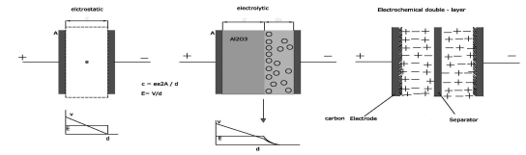
Figure 1: schematic of three types of capacitors [10]

2.11 Electrostatic Capacitor
Electrostatic Capacitor was first invented by Leiden Jar in 18th century. [10] It is made by two plates of metallic electrodes as conductor that separated by a dielectric layer. As energy storage devices the energy density or the capacitance of an Electrostatic Capacitor is follow the relation below:
$C=\frac{εA}{d}$(1)
In equation (1) C represent the capacitance of Electrostatic Capacitor, $ε$ is the dielectric constant of the dielectric layer that equation to the product of the free space dielectric constant $ε_{0}$ and the relative dielectric constant$ε_{r}$ of dielectric layer. Where A is the effective surface area of electrode and d is the distance between two electrodes. When voltage difference occurs between the top and bottom of electrodes, an electrostatic field will be introduced across the dielectrics that will effectively result in charge separation to store electric energy. In order to increase the capacitance of Electrostatic Capacitor, the surface area of metallic electrodes and the dielectric constant of marital in between the two electrodes need to be improved.

2.12 Electrolytic capacitors
The next improvement of capacitors is the electrolytic capacitors in particular aluminium electrolytic capacitors. It consists of an electrolytic paper that used to contain boric acid solution electrolyte, two piece of aluminium foil as cathode and anode electrodes with one of the electrode is coated with aluminium oxide foil. [12] The detailed cross section view of and electrolytic capacitors can be seen in figure 2.
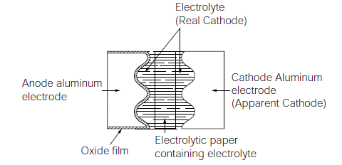
Figure 2: cross section view of and electrolytic capacitors [12]
In electrolytic capacitors, the thin oxide film provides very good dielectric value and single direction insulation property when contract with the real cathode martial (liquid electrolyte), [12] then by combine with the large surface area aluminium electrode via etch process, electrolytic capacitors are able to provide large aerial capacitance in compare with electrostatic capacitors.[12] However the area of etched aluminium electrode is limited since aluminium are metallic martial, the improvement in aerial capacitance of electrolytic capacitors is still limited. [10] Before the invention of supercapacitor Aluminium electrolytic capacitors serve as the majority of the application of big capacitors, it been widely adopted in many electronic circuits as well as some electric application like the power supply decoupling process.

2.13 Supercapacitor
Supercapacitor represents the most state of art energy storage devices. It store energy in electrochemical forms based on two types of capacitive observations: the electrical double layer capacitance (EDLC) and the pseudo-capacitance. EDLC based on both electrostatic charge accumulation and release at the electrode/electrolytic interfaces and diffusion capacitance occur in the electrolyte. Pseudo-capacitance arises from the fast reversible Faradaic redox reactions process. [13]Generally these capacitive mechanisms function together in supercapacitor
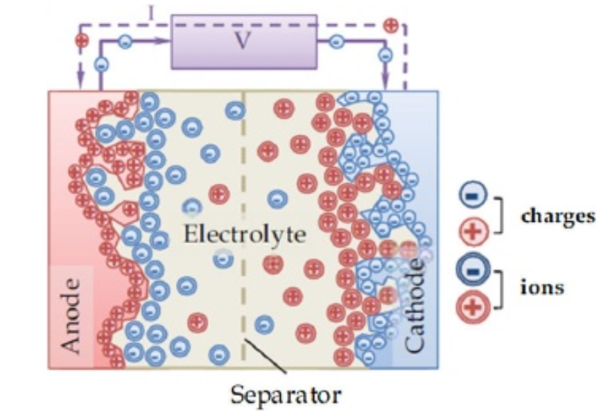
Figure 3: schematic description of a charged supercapacitor [14]
In supercapacitor the accumulation and release of electrostatic charge occur via the balance of ion at the interface between electrode and electrolyte, which introduce internal potential difference across between both electrodes. Both opposite charged surfaces are charge balanced by the accumulation of counter-ions from electrolyte forming a pair of electrical double layer (EDL) at the inner surface of electrodes. The pair of double layer structure is causing charges separation but with no electron travel through the electrolyte. [15] The potential difference applied between the electrodes is restricting by the thermodynamic stability of electrolyte used in the supercapacitor. Generally the physical requirements contribute to EDLC include: [14]
-Large accessible electrode effective surface area with electrolyte.
-Lowest electric resistivity that can be applied to overcome the power loss in effective series resistance of device
-The pore size distribution in electrode martial for ion mobility, accessibility and diffusion length
-Electrode surface wettability

2.14 Electric double layer mechanism
Generally supercapacitor based on electric double layer (EDL) mechanism can store much more energy than conventional capacitor. It is due to large interfacial area and the actual tiny distance of charge separation.[13] The concept of EDL was first summered by Von Helmholtz, he propose that in electrolyte solution, when immerse charged conducting solid into the electrolyte solution it will attract ion with opposite charge to form an opposite charged layer on its surface, combine the layer of ion already exist on the surface of charged conducting solid, these two layers of opposite charged ion so called double layer.[14] The double layer will remain electrostatic until the charged solid reverse its polarity. This model is similar to the mechanism of parallel plate capacitor which is not an accurate modelling of EDL effect. Gouy and Chapman improvement the modelling of EDL based on continues distribution of the ions in the electrolyte and thermal fluctuations. They suggest that EDL is a diffuse layer driven by thermal motion. [15] However this model will only valid at low potential and overestimate the energy can be store in diffusion layer. [13] Later, Stern further improve the EDL model by combine these two models together via adopt two reign of ion distribution to describe the behaviours of EDL. In Stern model, ions are compact attach to the surface of charged surface. [14] The inner Helmholtz plane (IHP) and outer Helmholtz plane (OHP) are used to differentiate two types of ions, these two planes so call stern layer that is parallel to the charged surface.[15] On the other hand the diffuse layer is defining as Gouy and Chapman model.
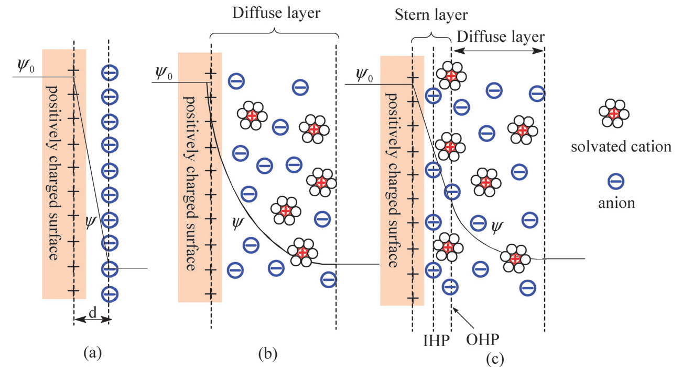
Figure 4: model of electrical double layer for positive charged surface: (a) the Helmholtz model, (b) the Gouy–Chapman model, and (c) the Stern model
Therefore based on Stern model the capacitance of a pair of EDL can be described as two types of capacitance connect in series. The first type of capacitance is double layer capacitance ($C_{dl})$ arise from the pair of stern layer, where the second type of capacitance is called diffusion capacitance ($C_{diff})$ occur in the diffusion layer relate with surface charge and electric surface potential. Therefore the capacitance of a pair of EDL ($C_{edl})$ can be expressed as: $\frac{1}{C_{edl}}=\frac{1}{C_{diff}}+\frac{1}{C_{dl}}$(2) [13]
On the other hand the capacitance of a pure EDL capacitor can be approximate as the capacitance of parallel-plate capacitor: $C=\frac{εA}{d}$(3) [15]
Where now the area A of capacitor is the total specific area of the electrode in contract with electrolyte and the electrode separation distance d is the Debye length or the thickness of EDL.

2.15 Pseudo-capacitance mechanism
Pseudo-capacitance is another energy storage mechanism can occur in supercapacitor. It involves fast reversible Faradaic redox reactions like electrosorption, REDOX reactions, and intercalation processes at the interface of electrolyte and active electrode.[14] The most common known material for pseudocapacitor like ruthenium oxide, manganese oxide, or some electrically conducting polymer such as polyaniline. [15]In a specific designed supercapacitor pseudo-capacitance can be much higher than EDL capacitance. However pseudocapacitor will also suffer the same drawbacks of batteries like poor power density and cycling stability. [15]

2.2 Implementations
Supercapacitor is sandwich structured device, it consist of two plates of carbon electrodes separate by non-conducting separator that contain electrolyte solution. The basic structure of supercapacitor can be seen in figure 5
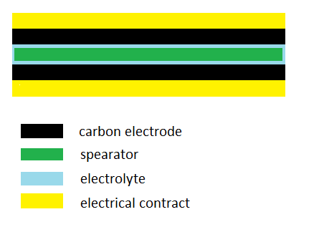
Figure 5: structure of supercapacitor
The way to implement supercapacitor is important since it is partly responds the statistical stability of end devices. [13] Generally supercapacitor can be implementing via dipping process, screen printing and inkjet deposition process. V.Conedera et.al [23] demonstrate the possibility about implement supercapacitor via inject deposition. In their work activated carbon powder was mix with ethylene glycol was used (thinner) and alcoholic PTFE (binder) to achieve low viscosity, uniform paste that suitable for inject deposition. Kaempgen, M et.al [24] print single walled carbon nanotube on the PET substrate as the bottom electrode of supercapacitor, after print the gel electrolyte and top electrode their sandwich structured supercapacitor achieve specific capacitance of 36 F/g with high power density.

2.3 Martial selection
Supercapacitor mark as the next generation energy storage device, originally it designed to enhance the power density of energy system based on electrical chemical battery. However supercapacitor itself has the potential to function as power supply of electrical system, so its power density, energy density and repeatability will be specified for varies power supply system. Therefore basic supercapacitor design will not suffice the requirement of modern wearable microelectronic system, and the section of material is strict and crucial.

2.31 Carbon electrode
Generally Carbon and its relatives are the most appropriate material for supercapacitor electrode. It is because carbon can fulfil most of the requirements of supercapacitor electrode: namely: low electrical resistivity, high specific surface area, controllable pore size and distribution and possibility of mixing with different carbon material. [15]
Activated carbon known as engineered carbon; it is the most popular material for supercapacitor electrode due to its large specific surface area, moderate low electric resistivity and relative low cost in compare with carbon nanotube. [16] Traditionally Carbonaceous marital like wood, coal and nut shell can be used to make activated carbon via activation, the activation process involve both thermal and/or chemical treatment that remove the ‘disorganized’ carbon in the interstices of original Carbonaceous marital and create addition pore to increase its surface area.[14] In the past time many people attempt to use activated carbon to make supercapacitor electrode, Subramanian V et.al [18] proposed a supercapacitor based on activated carbon from banana fibre. In their work the chemical treated activated carbon electrode can achieve specific capacitance of 74 F/g with excellent reversibility. K. Jost et.al [22] implements supercapacitor based on activated carbon and carbon onion. The supercapacitor is constructing in an assembly cell with PTFE separator, the electrode is carbon textile achieved by dipping and screen printing process. In result the textile based supercapacitor achieve specific capacitance of 65 F/g
The inversion of carbon nanotube is an important breakthrough in research and development of carbon industry. [16] Supercapacitor electrode made by carbon nanotube gets benefit from its unique properties about pore structure, excellent electrical conductivity, fine specific surface area and good thermal/mechanical stability. [16] In the past time both single walled carbon nanotube and muti-walled nanotube has attracted mangy research interests on supercapacitor electrode. Chen, P et.al [21] makes a supercapacitor via ink injection based on single walled carbon nanotube. As result the supercapacitor achieve specific capacitance of 138 F/g with high power/ energy density. Hu, L et.al [19] Demonstrate the possibility to integrate the entire structure of supercapacitor on a single piece of paper, at the end their paper supercapacitor can achieve specific capacitance of 3 F/g with electrode made with single walled carbon nanotube martial. Hu, L. B et.al [21] present a supercapacitor design based on conductive energy textile. In their work the electrode is a piece of conductive textile carry signal walled nanotube via dipping process to soak carbon martial into textile to make it conductive. In result the textile based supercapacitor achieve specific capacitance of 80 F/g at current density 20 mA/cm²
On the other hand Carbon black or carbon onion was a choice as additive material to the carbon electrode.[14] They are dense spherical carbon nanoparticles and able to provide excellent electrical conductivity to reduce the internal resistive power consumption within supercapacitor electrode

2.32 The electrolyte
The performance of supercapacitor is not dominated by the performance of electrode but also influence by the characteristic of electrolyte. In supercapacitor the type of electrolyte will decide its maximum operating voltage as well as how much energy can be stored that lead to the variation of energy density and power density. [16]
Aqueous electrolyte is the most common type of electrolyte for supercapacitor design; it has very low resistivity and viscosity that significantly enhance the supercapacitor charge/discharge rate for high power density. The most common aqueous electrolyte is 6M/L KOH and 1M/L H₂SO₄. [13] However the maximum operating voltage of aqueous electrolyte based supercapacitor is limit by the electrolysis of water to (1.229V), [13] therefore the total amount of energy that can be stored in the device is limited.
Organic electrolyte is another type of electrolyte it allows relative high operating voltage up to 3V that increase the energy density of supercapacitor. However the effective series resistance of organic electrolyte is high due to its relative poor conductivity in compare with aqueous electrolyte. [15]

Chapter 3 Experimental works
The practical work consists of three steps. Firstly the carbon paste is achieved by mix up two types of carbon powder with suitable amount of binder and thinner. The carbon paste need to suitable for soaking and/or printing process. Then the carbon paste will be soaked into the fabric to form the conductive carbon fabric, this objective is obtained by immerse the fabric into the carbon paste plus use the hand printer to ensure the uniformity of carbon paste before curing process. After these a piece of conductive fabric material will be present for next step of this experiment. Finally the supercapacitor will be constructing in the Tube Fitting for tests

3.1 Martial preparation
Fabric based supercapacitor are made from two pieces of conductive fabric and separator that immersed with aqueous ionic solution. The fabric used in this experiment is woven textile that produced by spinning raw fibres like wool, glass fibre and cotton. It is a flexible and wearable martial and has high absorbability of aqueous and oily solutions.
In supercapacitor the thickness of the dielectric layer is very small to achieve high capacitance value. However at high pressure, the top and bottom electrode will contract with each other to create short circuit. It is necessary to introduce a piece of separator in between the electrodes to avoid the short circuitry, therefore in this project class GF/F microfiber filter paper from VWR international will be used as separator and aqueous electrolyte holder. [25] This filter paper is very dense inside that has very high retention for filtering fine partials; originally it is design for clarification of protein solutions and filtering samples and solvents. [25]In fabric based supercapacitor the filter paper will provide the ability of hold enough dielectric solution, and prevent the contract of carbon compounds between top and bottom electrode that will short circuit the device. The profile of textile and separator paper can be seen figure 6.
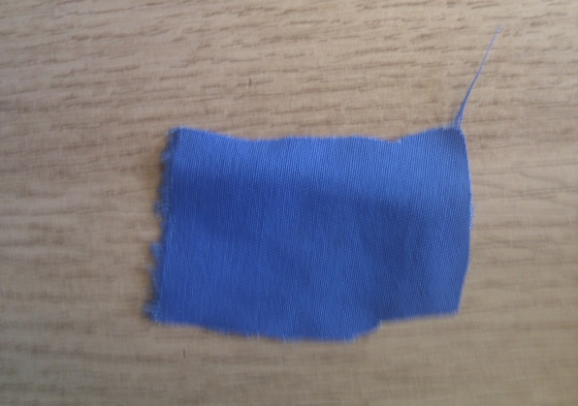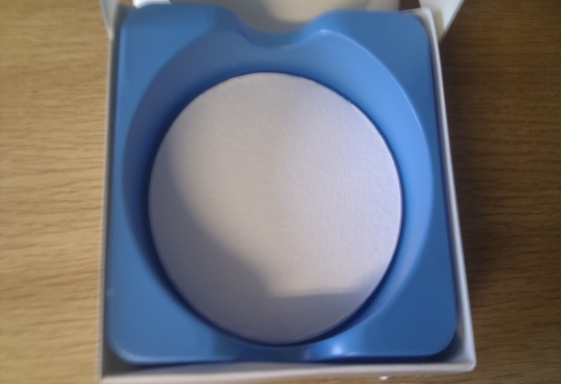
Figure 6: top view of textile (left) and separator paper (right).
In this project the electrolyte will be 6M Potassium hydroxide solution. It is because high concentrate aqueous Potassium hydroxide solution has excellent conductivity and has many free ions for the formation of diffuse layer in EDLC. On the other hand high concentrate acid solution can support even more free ions and has higher conductivity, but it will damage the surface of textile due to its high oxidation property. [15] Therefore in compare with acid dielectric solution high concentrate alkali solution will be in used since it is relative chemical friendly towards textile martial by causing less oxidation damage.

3.2 The carbon paste
The main difference between conventional capacitors and supercapacitor is the electrode martial. Supercapacitor employ carbon as its electrode martial since it can have high effective surface area and high conductivity. Theoretically The performance of supercapacitor will be determined by the effective surface area and conductivity, therefore in this project the carbon textile will contain two types of carbon powers, the first one is activated carbon (Norit GSX standard) that used to support large effective surface area, this powder is from VWR international and has effective surface area of 950 m² g^{−1,} average pore size of 3nm with density of 2 g/cm³ at 20°C. [26] The second carbon powder is carbon black from the Chevron Phillips Chemical Company; it has effective surface area of 75 m² g⁻¹, and density of 1.75 g/cm³, [27]the carbon black powder aim for enhance the electrical conductivity of electrode and reduce the internal power consumption to achieve high quality factor.
However there are several problems regards with carbon textile. Firstly it is difficult to set pure carbon particles into the fabric martial directly. Secondly due to the nature of martial, discrete carbon particle in the textile will not make the textile conductive, it create most of problem in carbon textile; at high pressure the discrete carbon compounds will leave the textile electrode and move into the aqueous electrolyte contained in the separator, these carbon compounds has the potential to decrease the capacitance value of supercapacitor by degrade the surface area of electrode and short circuit the device via penetrate the separator. Thirdly the uniformity of carbon compounds in the textile needs to be concerned. In case the distribution of carbon in the textile is not uniform, by compress the textile electrode in measurement the effective surface area of carbon in the textile will not in an controlled range over the entire textile. In result the capacitance tolerance of the final supercapacitor from same piece of carbon textile will be very large that is not suitable for further performance test
In order to overcome these shortages, the carbon powders need to be mix with something into paste form. On the other hand carbon paste need to have high adhesion that after curling process so that the carbon compounds will not fall off from the fibre in the textile easily, and also the paste need to be water resist since the dielectric layer of device is aqueous alkali solution. At the mean while the carbon paste need to be has low viscosity, it is because in soaking or printing process high viscosity paste will less penetrate into the textile substrate and cannot guarantee the uniformity of carbon compounds in the textile. In conclusion the carbon paste need to be low viscosity, high adhesion and has high degree of uniformity. Therefore binder and thinner are necessary for making up the carbon paste that has these properties mentioned above.
The function of binder is to act as the inter-medium to bond the carbon compounds with textile fibre, in other word by adding binder into the carbon paste, extra adhesion can be introduced. In this project the binder is ER2218 epoxy resin from RS components, ER2218 is a flame retardant, low viscosity high adhesion and good chemical and water resist two part potting and encapsulating compound. [28] This resin need to be mixed before added into carbon paste, the mixed resin need to be used as soon as possible, it is because the mixed epoxy resin will start to cure once the they mixed up.
Textile has the ability to absorb lot of aqueous solution or oily like solution. Therefore the thinner used in this project are water and pine oil (V400 Vehicle oil) from ESL Europe. Pine oil is an essential oil refined from needles, twigs and cones of pine, its water resist relative low viscos in compare with the epoxy and can be used to dissolve carbon/epoxy compounds to further improve the adhesion of carbon paste. To use water as thinner for carbon paste is different from the pine oil application. The carbon/epoxy compounds will not dissolve in to water, However water has very low viscosity and textile has the ability to absorb lots of water, therefore to use water as thinner for soaking process, lot of the carbon compounds can be soaked into the textile to improve the uniformity of carbon compounds.
After the mechanical mix the two types of carbon powder, binder and thinner for more than 10 minutes. Magnetic tablet will be put into the paste and the paste need to be put on to the magnetic shaker for 4 hours at 60°C shown in figure 7. This step is essential for the paste formation since epoxy binder may be sticking a big group of carbon powder that degrade the uniformity of the carbon paste. After magnetic mixing, low viscos uniform carbon paste will be present for textile soaking process.
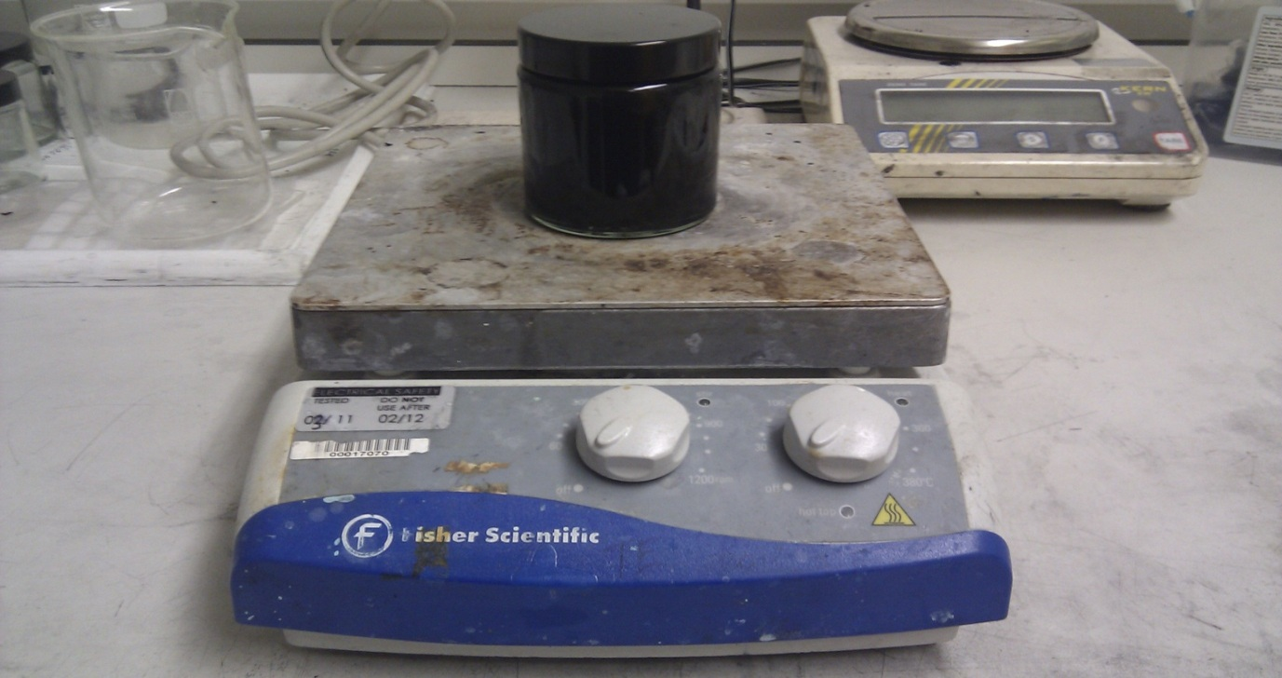
Figure 7: carbon paste on the shaker

3.3 Carbon textile
After finish the carbon paste, the next step is to soak textile into the paste to make the carbon textile. The socking process takes about 20 hours; it is because the self-curing time for epoxy resin at room temperature is about 24 hours, after the epoxy is cured it is difficult for carbon paste immersing in to the textile that will affect the uniformity of carbon textile.
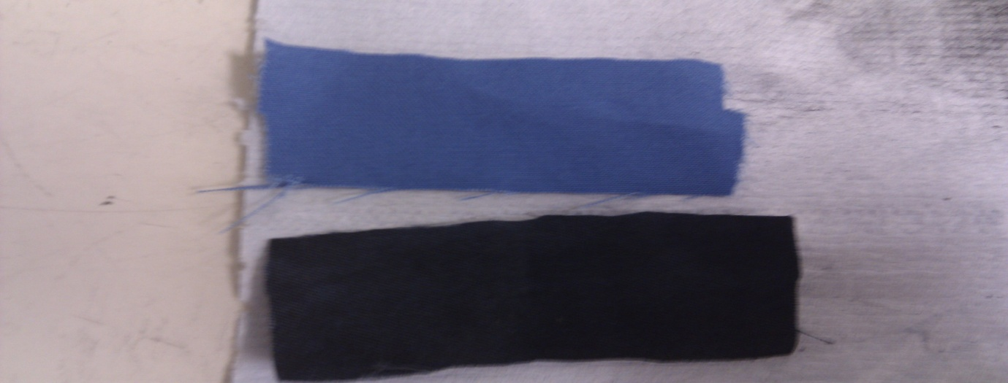
Figure 8: original textile (up) and carbon textile (down)
In curing process the soaked textile will cured on the bridge structure shown in figure 9; it will allow air access to the bottom of textile to cure it completely. The soaked textile with water as thinner will be cured at room temperature for 24 hours to evaporate the water, and for pine oil case the curing process will take two hours at 120 °C in the box oven. Then the cured textile will be cut into half inch circular pieces to form the electrode of supercapacitor
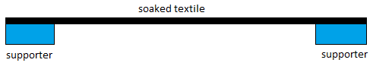
Figure 9 carbon textile curing set up

3.4 Supercapacitor formation
Supercapacitor need to be compressed from top to bottom to achieve thin dielectric layer. It is achieve in PFA Tube Fittings from Swagelok London with three pieces of silver steel rods and stainless steel spring. The PFA Tube Fittings is a set of thimbles made by chemical resist plastics, by cutting through the salient bit in the main thimble it allow to compress and hold the sample contained in the Tube Fittings. [27] The sample PFA Tube Fittings is can be seen in figure 9
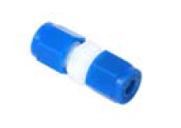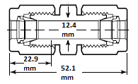
Figure 9: half inch PFA Tube Fittings from Swagelok Company [27]
The silver steel rods is use for electric connection and compress the supercapacitor in the Tube Fittings, there is two set of rods act as the top and bottom contract, and the third piece of steel cap together with spring are used for compress the Supercapacitor. The detailed Supercapacitor formation in the PFA Tube Fittings can be seen in figure 10 and the section view of fabric based supercapacitor in the tube fittings can be seen in figure 11
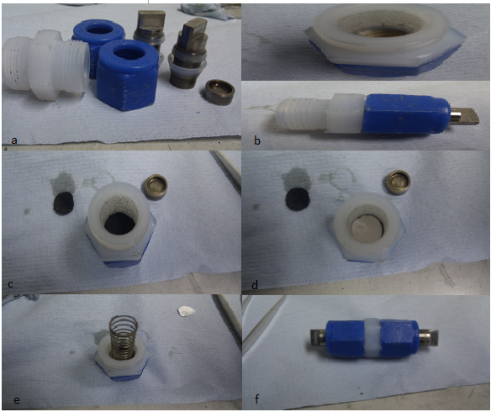
Figure 10: Supercapacitor formation a): PFA Tube Fittings with steel rods, b): close bottom fittings (blue) with steel rods fixed inside of fittings, c): place the bottom carbon textile electrode into the main tube fitting (white), d): place the separator into the fittings and drop aqueous electrolyte on the top separator, e): put the top electrode, steel cap and stainless spring into the fittings one on another, f): close the top fitting and use spanner to screw down the PFA Tube Fittings
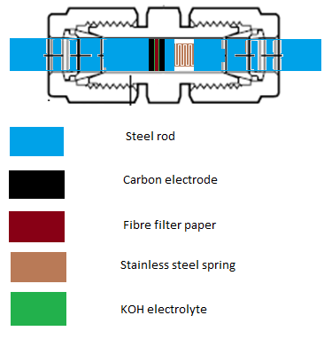
Figure 11: section view of fabric based supercapacitor in the tube fittings

4 Result and improvement
The performance of textile based supercapacitor will be assessed by following methods. Firstly the impedance characteristic of single piece of conductive textile will be tested by multimeter. Then the frequency response of supercapacitor is obtained by Precision Impedance Analysers 6500B. Finally the transient response of Supercapacitor will be figure out by oscilloscope via capacitor discharge experiment

4.1 Impedance characteristic of conductive textile
The impedance characterise of the textile based electrode will influence the performance of supercapacitor; generally the electrode with lower impedance can effectively minimize the power loss of capacitor and hence reduce its powder dispersion factor to achieve high quality factor.
Pure textile is not conductive; however by adding carbon powder in to the textile martial, the textile itself will behave like conductor under compression. The aim of this experiment is to obtain the relationship between conductivity and the percentage of carbon powder in the textile electrode.
Figure 12: SEM cross-section view of carbon textile via soaking process
According to figure 12 the cross-section view of carbon textile indicates that the discrete carbon powder/epoxy compounds are stick on the fibre of textile. When the textile is not been compressed, there will be a gap between each piece of fibre and hence the carbon powder/epoxy compounds is not in touch with each other, therefore no current can flow cross the textile and the textile is not conductive . However by compress the carbon textile in the TFA tube fittings, the fibres in the textile will be squeezes together that the carbon compounds will contract with each other, then the textile will behave like a piezoresistor above certain pressure value, the resistance across the textile will decrease as cross-sectional pressure increase. It is achieved by hold carbon textile in between two pieces of steel rods in TFA tube fittings, by screws down the tube fittings, the electrode will be compressed for measurement.
In this test 5 types of half inch circular carbon electrodes will be tested. The textile electrode is obtained by sock textiles in to 5 different paste, each paste contain 2 gram of activated carbon, 0.5 gram of carbon black, some binder ER2218 and 12 gram of water thinner that will evaporate completely after curling process, the variable ingredient in the carbon paste is the amount binder epoxy ER2218. For example the textile electrode with 40% carbon powder is achieved by curl the carbon textile soaked by the carbon paste contain 2.5 gram carbon powder with 3.6 gram of epoxy binder (2.5/(2.5+3.6)=40%). Then after screws down the tube fittings the resistance of electrode will be obtained by multimeter, it mark as position 1. The second resistance reading is obtained when apply extra pressure on electrode, it is achieved by add one piece of stainless steel in between the electrode and top steel rod, it remark as position 2. The textile has area about 1.26cm², in addition the cross-sectional resistance of curled carbon paste that has similar thickness with carbon textile will also be measured for compression.
 | 40% carbon | 50% carbon | 60% carbon | 70% carbon | 80% carbon
Resistance  /unit area  at Position 1 /Ωcm⁻² | 104 | 96.9 | 90.8 | 85.6 | 70.2
Resistance  /unit area  at Position 2 /Ωcm⁻² | 22.9 | 18.2 | 15.4 | 11.8 | 10.2
Resistance/unit of paste / Ωcm⁻² | 21.0 | 17.9 | 15.5 | 13.7 | 9.1
Table 1 cross-sectional resistance of carbon textile
Table 1 suggest that the cross-sectional resistance of carbon textile will decease as the amount of carbon increased in the paste. It is because the epoxy itself has resistivity, and the more carbon compounds exist in the electrode the less resistivity the electrode will be. Therefore the electrode with high carbon concentration will be tested first in further tests. However as pervious discussed the adhesion of carbon/ epoxy compounds is important for the performance of supercapacitor, the lowest resistive electrode (80% carbon) cannot be used since the adhesion of carbon compounds is very poor due to high carbon percentage.

4.2 Supercapacitor frequency response
The frequency response of capacitor is important; it can be used for characterise some of the important factors of capacitor at high frequency like dispersion factor, self-resonate frequency and device effective series resistance. Generally the capacitance of a supercapacitor are strongly depends on its operating frequency that it will decay rapidly as frequency increase. [29]The experimental result is carry out by impedance analysers 6500B Series from Wayne Kerr Electronics, in this test the frequency range is from 20Hz to 10MHz with AC input of 1 Volt that is within the stabilize voltage of aqueous potassium hydroxide.
In this experiment 5 different carbon pastes will be in used to made carbon textile electrodes, each paste will produce 16 pieces of electrodes, therefore 8 supercapacitors will be tested to take the mean value. The capacitance of supercapacitor at 20Hz can be seen in table 2
Test No | Carbon percentage  /% | Thinner | Areal carbon loaded weight  / mgcm⁻² | Carbon: carbon fabric ratio | Mean capacitance at 20Hz/uF | Capacitance Stand  Deviation/uF | Tolerance /%
1 | 70 | Pine oil | 3.85 | 16.7% | 885.8 | 645.1 | +120~-87
2 | 50 | Pine oil | 2.46 | 10.9% | 308.3 | 309.9 | +96~-55
3 | 50 | Water | 0.90 | 4.62% | 274.6 | 259.2 | +194~-58
4 | 45 | Water | 0.72 | 3.74% | 562.6 | 233.9 | +54~-79
5 | 40 | Water | 0.61 | 2.58% | 514.8 | 145.6 | +37~-44
Table 2 statistical result of the capacitance of supercapacitor
Generally commercial capacitors will has tolerance about +/-20% of designed value. According to table 2, the capacitance of fabric supercapacitor with oil as thinner is not stable but has big stand deviation and tolerance. However as reduce the percentage of carbon in the textile and change the thinner from oil to water, the capacitance stand deviation and tolerance of supercapacitor get reduced significantly.
On the other hand by compare the water like paste and oil like paste, the most significant difference is that the viscosity of oil like paste is much higher than the water like paste. In most of the case the paste with high viscosity will degrade the uniformity of the carbon compounds in the textile; it will also result in a big decrease in effective surface area of carbon material in the textile under compression since carbon compounds will stick together due to viscosity. As result the capacitance of supercapacitor made by oil like carbon paste has big stand deviation that is not statically stable. Therefore by using water as the thinner and decrease the percentage of carbon in the textile electrode. The capacitance tolerance of supercapacitor reduces significantly. On the other hand table 2 also indicated that the capacitance of designed textile supercapacitor is not proportional to the amount of carbon stick on the textile.
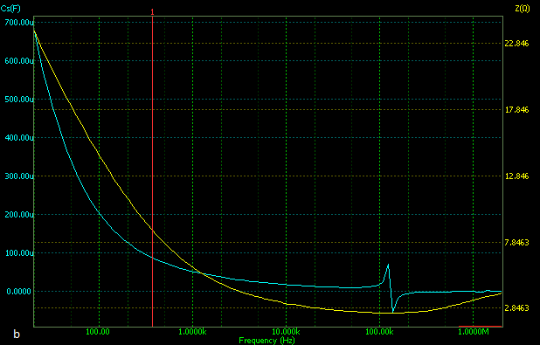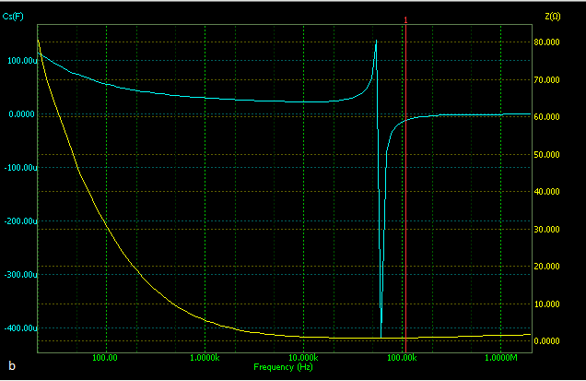
Figure 13: frequency response of supercapacitor (a: 75%carbon (oil thinner), b: 40%carbon (water thinner))
According to figure 13, the capacitance of supercapacitor will resonate around 100k Hz, the percentage of capacitance overshoot at resonate frequency of oil like paste is smaller than water like paste. It is because the adhesion of oil like paste is much higher than water like paste. In curing process the paste at the textile surface will cured first that will fall off from textile at high pressure and high frequency. In this case the carbon compounds that fall off from textile will affect the capacitance at particular frequency since they no longer stick on the fibre of textile. In order to solve this issue the obvious methods is to increase the adhesion of paste, However it will also increase the viscosity of paste that degrade the uniformity and surface area of carbon in the textile.
On the other hand in case these weak bonded carbon compounds at the surface of textile can be removed, ideally resonate effect will be eliminated. Therefore a simple method can be applied to remove the weak bonded carbon compounds at the surface of textile; this method is to polish the surface of carbon textile by sand paper.
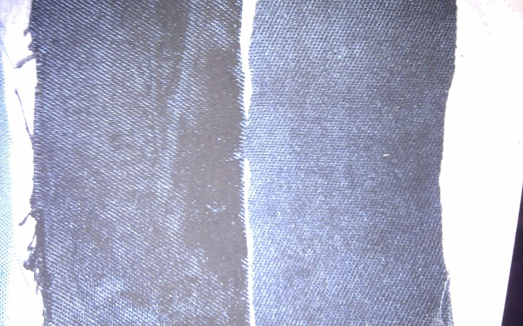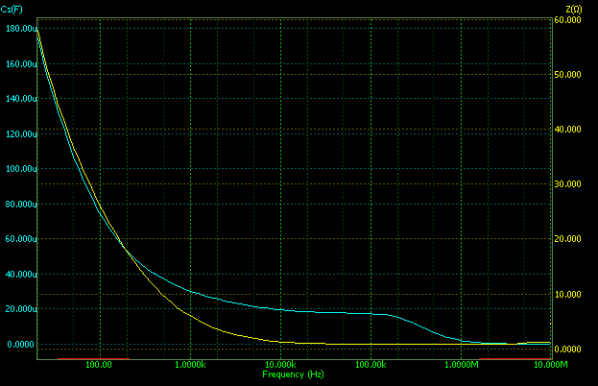
Figure 14: unpolished carbon textile (left) and polished carbon textile (right) and frequency response of supercapacitor with the surface of electrode polished by sand paper
From figure 14 the polished textile looks more uniform than the unpolished textile and the capacitance of supercapacitor will not resonate alone frequency domain after polish the surface of carbon textile electrode.
Therefore by repeat the experiment with paste contain 40% of carbon material and chose water as thinner, and polish the surface of textile electrode the result can be seen in table 3.
Carbon percentage/% | Thinner | Mean capacitance at 20Hz/uF | Capacitance Stand  Deviation | Tolerance /%
40 | water | 120.8 | 49.3 | +17.2%~16.4%
Table 3: statistical result of the capacitance of supercapacitor
Figure 15: SEM surface view of carbon textile (75% of carbon (oil thinner))
Figure 16: SEM surface view of carbon textile (40% of carbon (water thinner))
According to figure 15, in the surface view of electrode made by paste with high carbon concentration and oil thinner, lots of individual fibres are not coated by carbon compounds, it indicate that the uniformity of this type of paste is poor; on the other hand big amount of carbon compounds are sticks together that significantly reduce its effective surface area at high pressure, it is because the pine oil is a viscos solution and cannot be evaporated completely in the textile. As result the electrode is non-uniformly coated by sticky carbon compounds, therefore the supercapacitor made by this type of electrode will not statistically stable (Test No 1 in table). Where from figure 16 the electrode is soaked by carbon paste made with low percentage of carbon compounds and chooses water as thinner. In this electrode carbon compounds are uniformly distributed alone each pieces of fibre. It effectively maintains the big effective surface area of carbon compounds and leaves enough gaps for compress the textile for higher capacitance. In conclusion the supercapacitor made up by this type of paste will has low tolerance which shown in table 3
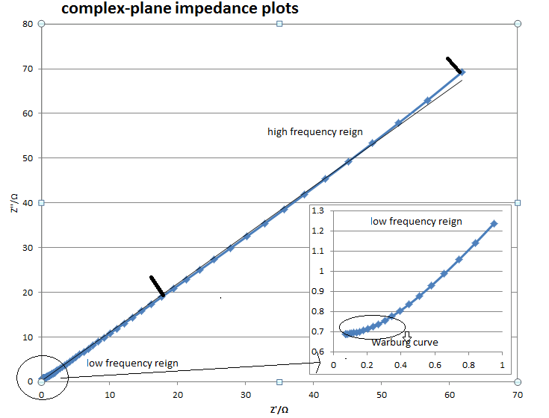
Figure 17: Nyquist plot of the textile based Supercapacitor complex impedance
In figure 17 the Nyquist plot of the textile based Supercapacitor complex impedance suggests a straight line in the low frequency reign and a little curved arc in the high frequency. The plot is the imaginary impedance against the series resistance at particular frequency. The curve response at high frequency indicates that the cross–sectional electronic resistance of the dielectric is low. On the other hand the short Warburg curve (the curve which rotate 45°) [30] indicate that the fabric based Supercapacitor has short diffusion path that the electrolyte ion are efficient access into the electrode surface. However the effective series resistance of fabric based Supercapacitor cannot be obtained in this set of experiment since the impedance curve will not intersect with the real impedance axis. It possibly because in tube fittings, the top/bottom electrical contracts (steel rods) separated by Supercapacitor will introduce another small nonlinear capacitor Ce shown in figure 18; this capacitor will have even high self-resonate frequency that disturb the performance of Supercapacitor.
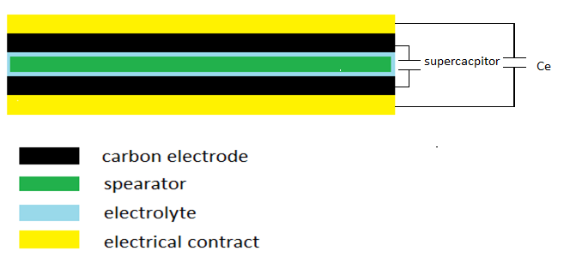
Figure 18: imaginary nonlinear capacitor Ce

4.3 Supercapacitor transient response
Before taken any measurement, the capacitance of designed device without electrolyte needs to be calculated and tested. Assume capacitor now is parallel plate capacitor that follow the relation stated in equation(1), assume the dielectric layer of capacitor is paper that has relative dielectric about 3.85, and after compression the filter paper will be squeeze down to 1nm. The capacitance of device contained in the tube fitting with area of 1.26cm² is calculated to be 43nF before drop in electrolyte. However the capacitance of device obtained discharge test is 391nF. It is because there is some capacitance in between the top and bottom electrical contract shown in figure, this capacitor using top/ bottom electrode contract as electrodes and the whole supercapacitor is dielectric.
Also the approximated value of supercapacitor transient capacitance can calculate from equation (3). In this case carbon electrodes have area of 1.26cm² and contain 40% of carbon compounds with 80% of activated carbon and 20% of carbon black. Base on the results from test number 5 in table the effective surface area of this carbon electrode can be attain as:
Area = $0.61×1.26×{10}^{-3}×80\%×C+0.61×1.26×{10}^{-3}×20\%×D$(4)
Where C is the surface area of activated carbon and D is the specific surface of carbon black. Therefore the effective surface area of this carbon electrode is 0.0589m². By assume the diffusion length of DEL is 0.01 nm and the relative dielectric constant of aqueous KOH solution is 5.6 (from CRC Handbook). The capacitance of supercapacitor is equal to 0.292F
After obtain the most statistical stable paste which will cause the least tolerance in the capacitance of supercapacitor. The next step in to test its transient capacitance or low frequency capacitance. This type of capacitance is particular important for capacitor used as energy storage device since energy normally work under low frequency. The transient capacitance of supercapacitor is obtained by the discharge characteristics of capacitor: this theory state when switch off the power supply of a fully charged capacitive device, the time taken for the output voltage of capacitor fall below 36% is equal to the product of the series connected resistance and the transient capacitance of capacitor, this time also called the time constant of capacitor. In this test the DC power supply is 1 volte and the series connected resistance is 2.17 Ω, therefore the time need to be measured is the time taken for output voltage of Supercapacitor drop just below 360mV, and the carbon compounds within the electrode of Supercapacitor contain 20% of carbon black powder(80% of activated carbon powder). This capacitor mark as CB 20%
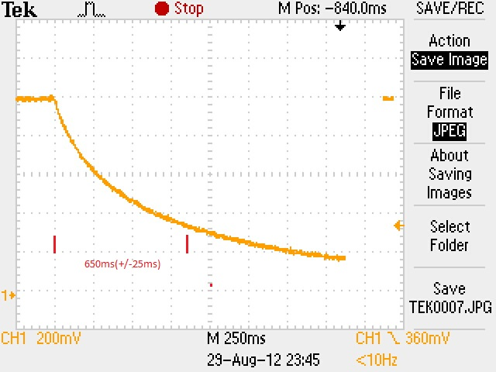Figure 19: supercapacitor discharge graph for CB20%
As figure 19 indicated the time constant of this type of Supercapacitor is 650ms with uncertainty of +/-25ms come from of oscilloscope (half of the minimum horizontal scale). Therefore this Supercapacitor has capacitance of 0.3F.
Generally supercapacitor has high capacitance and low effective series resistance; therefore by increase the concentration of carbon black in the electrode ideally will improve the value of capacitance. On the other hand more carbon black also means less activated carbon that will reduce its effective area surface area theoretically that influence the capacitance of supercapacitor.
The experimental results are obtained by repeat capacitor discharge measurement 4 times with different supercapacitor. Each group of results will be based on same paste with fixed concentration of carbon black powder, all the electrode has area of 1.26cm² (0.5 inch diameter circular shape), the results can be seen in table 4
Carbon black percentage | Test  No 1  /F | Test  No 2  /F | Test  No 3  /F | Test No 4  /F | Mean | Stand deviation | Specific capacitance/  Cg⁻¹ | Areal capacitance/  Ccm⁻²
20% | 0.301 | 0.299 | 0.324 | 0.315 | 0.310 | 0.0103 | 100.64 | 0.246
40% | 0.737 | 0.727 | 0.691 | 0.652 | 0.707 | 0.0380 | 229.55 | 0.561
60% | 1.014 | 1.023 | 0.922 | 0.875 | 0.958 | 0.0623 | 311.0 | 0.760
80% | 3.667 | 1.843 | 1.325 | 0.553 | 1.847 | 1.1467 | 599.67 | 1.466
Table 4: statistical result of the capacitance of Supercapacitor
According to table 4, the expected capacitance value of supercapacitor and its stand deviation of fabric based Supercapacitor are increasing as the percentage of carbon black increasing. It is because the conductivity of electrode is also proportional to the concentration of carbon black. On the other hand as the concentration of carbon black increased the concentration of activated carbon will decreased. Theoretically it will reduce the effective surface area of carbon electrode which will reduce the capacitance of textile based capacitor. However the experimental result is not agreed with theoretical proposition that equation (3)no longer valid for this case, it may be due to the difference between textile based carbon electrode and pure carbon electrode that needs further investigation on the behaviours of textile based carbon electrode.
The stand deviation of the carbon electrode contain 80% of carbon black is much higher that all the other. It indicates that the Supercapacitor with high carbon black contrition electrode cannot support stable results from the same piece of carbon textile. The reason for this observation can be working out from their SEM surface in figure 20 and 21.
Figure 20: SEM surface view of carbon textile (carbon compounds include 20% of carbon black (water thinner))
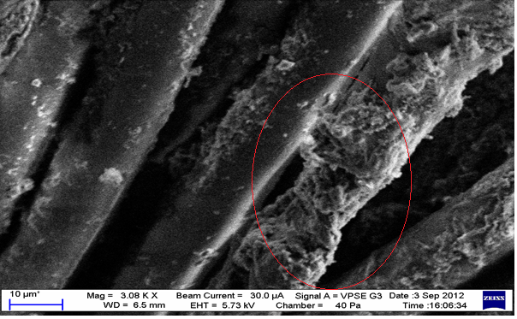
Figure SEM 21: surface view of carbon textile (carbon compounds include 80% of carbon black (water thinner))
By compare the figure 20 and figure 21. It indicates that for carbon paste contain large amount of carbon black, it is possible that large amount of carbon compounds will stick together on the single piece of fibre shown in figure 21, where it is not happen in the surface of electrode with low carbon black concentration in figure 20. In this case the uniformity of carbon compounds in the textile cannot be guaranteed that will degrade the effective surface area of carbon textile electrode. In result the capacitance of Supercapacitor made by high carbon black concentration is floating due to non-uniform profile of its textile electrode.

5 Cost and time analysis
Items | Quantity | Cost/GBP
Activated carbon powder | 100g | 15.96
Carbon black powder | 10g | N/A⁽¹⁾
Pine oil | 100ml | N/A⁽²⁾
Epoxy binder ER2218 | 1(bag) | 11.91
6M Potassium hydroxide solution | 80ml | N/A⁽²⁾
Glass fibre filter paper | 25 | 58.68
Tube fittings | 3 | 68.40
Sliver steel rod | 3*30cm*1.26cm² | 20.84
Stainless steel spring | 6 | 12.31
(1): provide by chemical department
(2): provide by Southampton nanofabrication centre
Table 5: cost analysis
Week #  week beginning : | 1  13/6 | 2  20/6 | 3  27/6 | 4  4/7 | 5  11/7 | 6  18/7 | 7  25/7 | 8  1/8 | 9  8/8 | 10  15/8 | 11  22/8 | 12  29/8 | 13  5/9 | 14  12/9 | 15  19/9
Activities and milestones
Background Research
Literature review
Paste preparation
Soaking textile
Electrode resistivity test
Supercapacitor formation
Week #  week beginning : | 1  13/6 | 2  20/6 | 3  27/6 | 4  4/7 | 5  11/7 | 6  18/7 | 7  25/7 | 8  1/8 | 9  8/8 | 10  15/8 | 11  22/8 | 12  29/8 | 13  5/9 | 14  12/9 | 15  19/9
Device Performance test
Paste improvement
Writing up
Milestone – demonstrate to sub/examiner
Milestone – dissertation draft complete
Final corrections
Milestone – hand in
Table 6: time analysis

6 Result analysis further improvements
The aim of this project is to design and build fabric based supercapacitor. In result sandwich structured supercapacitor with big capacitance with acceptable performance has been be constructed in tube fittings from Swagelok. However this device is a prototype design that needs lots of improvement to become single layer fabric energy storage devices.

6.1 Carbon paste improvements
In supercapacitor electrode, the carbon paste plays the most important role. Traditionally carbon electrode will made with pure carbon powder and binder, the paste with high carbon percentage will have good conductivity and will enhance the performance of supercapacitor. However in textile electrode the situation is different. According to table 4 high carbon concentrate textile electrode will lead to large capacitance tolerance of final device. It is because of the huge reduction in effective surface area of electrode after device compression, it is due to non-uniform distribution of carbon compounds in the textile which is cause by the high viscos of carbon paste. It is necessary to reduce the viscosity of binder and thinner in the paste
The reason to make carbon powder into paste form is to transfer carbon powder uniformly into the textile and stick with individual fibre in the textile. Therefore the carbon paste required to be low viscosity, high adhesion and high uniformity, at the mean while since the dielectric of supercapacitor is aqueous KOH solution the carbon paste also need to be water resist.
As table 2 suggested, the percentage of carbon that can stick on the textile is very low, which the electrode tends to has high resistance that is not good for supercapacitor application, it indicate that the adhesion of additive material in the carbon paste is not very high, therefore different water resist liquid binder can applied for further improvement. On the other hand in the future development of carbon electrode the thinner in the carbon paste need to be changed, it is because water does not promote adhesion to the carbon paste. Therefore it is worth to try adding some other thinner like alcoholic solution, Lipids compounds and other organic solution as the thinner of carbon for soaking or printing process.

6.2 Charge Separator
In supercapacitor the separator in particular charge separator are used for prevent the physical contract between top and bottom electrodes. So the separator needs to be dense enough that can block the penetration of carbon compounds to create short circuit. In order to build supercapacitor on single piece of fabric material, part of the fabric material will be use as the separator. According to figure 22, the surface of textile material is much loose than glass fibre filtering paper. The supercapacitor with original textile as separator will be short circuits that no longer behave like a capacitor. Therefore chemical treatments need to be applied with fabric material to improve its wettability and reduce its effective pore size.
Figure 22: SEM pictures of textile (left) and microfiber filter paper (right)

6.3 Device implementation
The test structure used to hold and compress the supercapacitor to achieve thin dielectric layer. In reality the test tube fittings from Swagelok Company does introduce some capacitance into the result. These parasitic capacitances will disturb the performance of main supercapacitor at high frequency. Therefore it is worth to do this experiment with tube fittings that has small area and redesigns the top and bottom metal contact; it will reduce the parasitic capacitance of test structure and consume less textile electrode at each performance test. On the other hand in the future printing methods should replace soaking method on making these carbon electrodes since printing method

6.4 Test methods improvement
In this experiment the test methods of supercapacitor is inaccurate and not appropriate for electrochemical device, according to most of paper about supercapacitor, Cyclic voltammetry , galvanostatic cycling and chemical impedance spectroscopy are necessary for obtain the performance of supercapacitor in the future.

7 Conclusions
This report presents the use of carbon conductive textile as a platform for energy storage device applications. Overall the project was finished on time with fine result: the designed supercapacitor achieve transient capacitance of 0.31 F which is slightly more than expected value about 0.292F. At the mean while this MSc project also gives author the experience about supercapacitor device such as structure design, martial selection, paste mixing and practical fabrication, device testing and maintaining the cost throughout the project periods.
However the paste formation and implementation methods need to be further improved to achieve better, stable fabric based supercapacitor, which will boost the development and application of future wearable electronics.

Appendix
Appendix A carbon paste formulas
Test No | Carbon black weight/g | Activated  Carbon weight/g | Carbon percentage  /% | Binder  Weight  /g | Thinner | Thinner  Weight  /g | Mean  Capacitance at 20 Hz/F
1 | 0.5 | 2 | 70 | 1.07 | Pine oil | 12 | 885.8
2 | 0.5 | 2 | 50 | 2.5 | Pine oil | 12 | 308.3
3 | 0.5 | 2 | 50 | 2.5 | Water | 14 | 274.6
4 | 0.5 | 2 | 45 | 3.06 | Water | 14 | 562.6
5 | 0.5 | 2 | 40 | 3.6 | Water | 14 | 514.8
6{1} | 0.5 | 2 | 40 | 3.6 | Water | 14 | 120.8
7{1} | 1 | 1.5 | 40 | 3.6 | Water | 18 | 112.3
8{1} | 1.5 | 1 | 40 | 3.6 | Water | 24 | 103.7
9{1} | 0.5 | 2 | 40 | 3.6 | Water | 32 | 451.3{2}
{1}: the curled textile is polished by sand paper
{2}: the statically result is unstable
Table 7: carbon paste formulas

Appendix B frequency response of supercapacitor
Figure 23: Frequency response of supercapacitor made with paste of 70% of carbon (20% carbon black 80%activated carbon) and oil thinner (refer to test No 1 in table 7)
Figure 24: Frequency response of supercapacitor made with paste of 50% of carbon (20% carbon black 80%activated carbon) and oil thinner (refer to test No 2 in table 7)
Figure 25: Frequency response of supercapacitor made with paste of 50% of carbon (20% carbon black 80%activated carbon) and water thinner (refer to test No 3 in table 7)
Figure 26: Frequency response of supercapacitor made with paste of 45% of carbon (20% carbon black 80%activated carbon) and water thinner (refer to test No 4 in table 7)
Figure 27: Frequency response of supercapacitor made with paste of 40% of carbon (20% carbon black 80%activated carbon) and water thinner (refer to test No 5 in table 7)
Figure 28: Frequency response of supercapacitor made with paste of 40% of carbon (20% carbon black 80%activated carbon) and water thinner (refer to test No 6 in table 7) with sand paper polished
Figure 29: Frequency response of supercapacitor made with paste of 40% of carbon (40% carbon black 60%activated carbon)and water thinner (refer to test No 7 in table 7) with sand paper polished
Figure 30: Frequency response of supercapacitor made with paste of 40% of carbon (60% carbon black 40%activated carbon) and water thinner (refer to test No 8 in table 7) with sand paper polished

Figure 31: Frequency response of supercapacitor made with paste of 40% of carbon (80% carbon black 20%activated carbon) and water thinner (refer to test No 9 in table 7) with sand paper polished

Appendix C transient response of supercapacitor
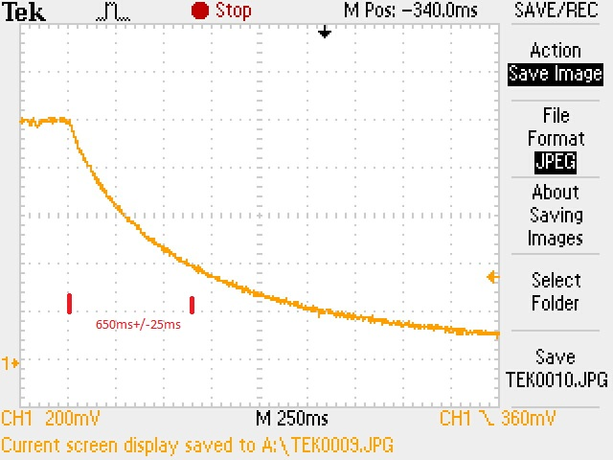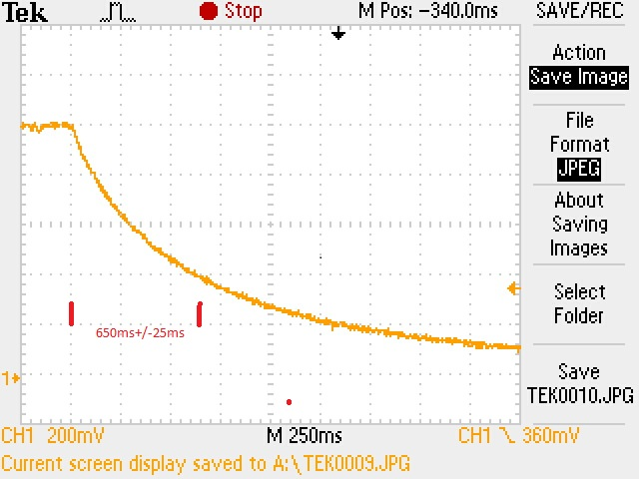
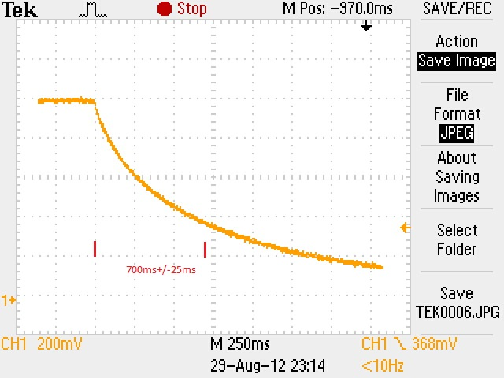
Figure 32: Transient response of supercapacitor made with paste of 40% of carbon (20% carbon black 80%activated carbon) and water thinner (refer to test No 6 in table 7) with sand paper polished
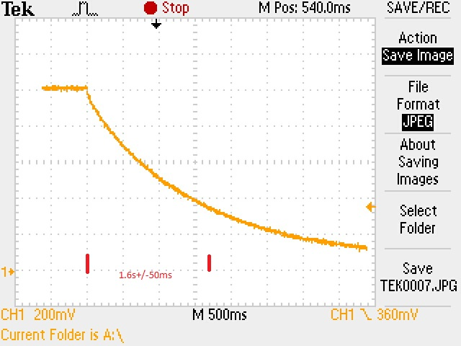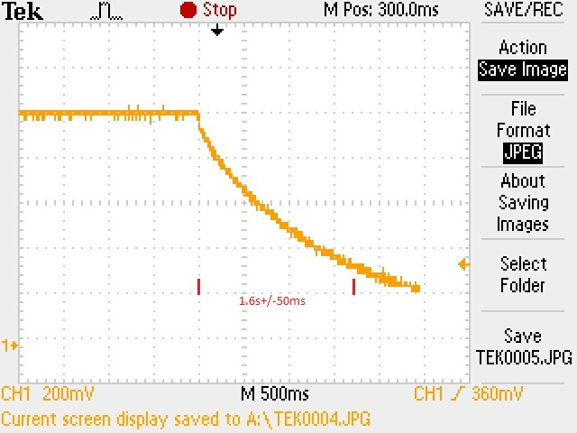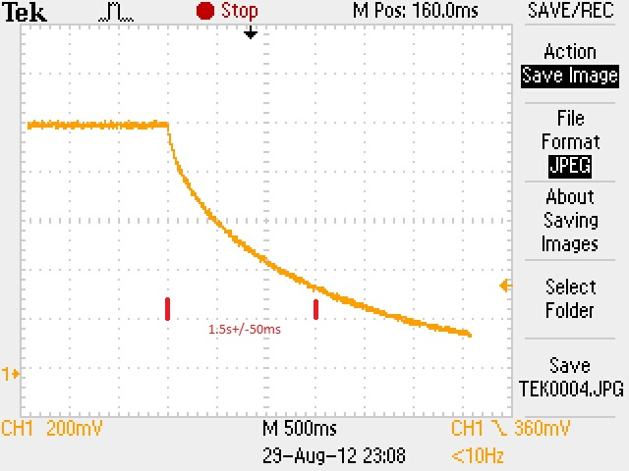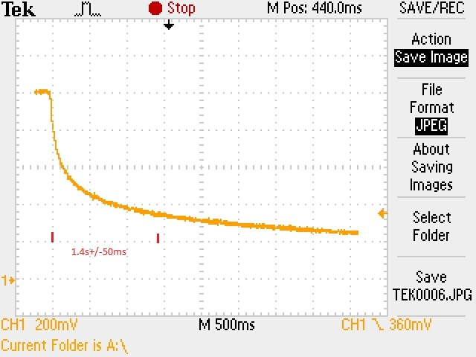
Figure 33: Transient response of supercapacitor made with paste of 40% of carbon (40% carbon black 60%activated carbon)and water thinner (refer to test No 7 in table 7) with sand paper polished
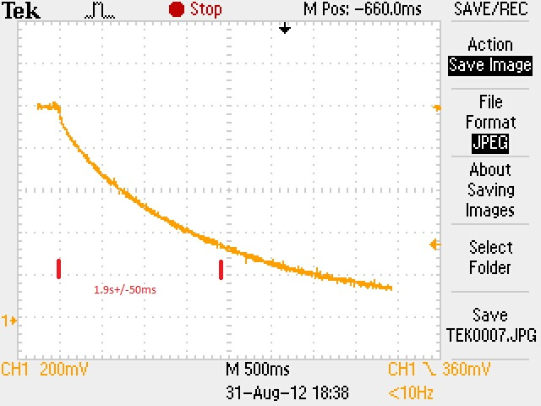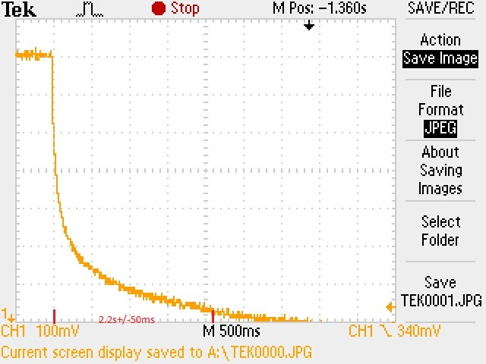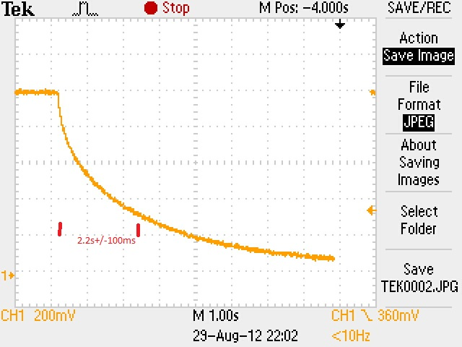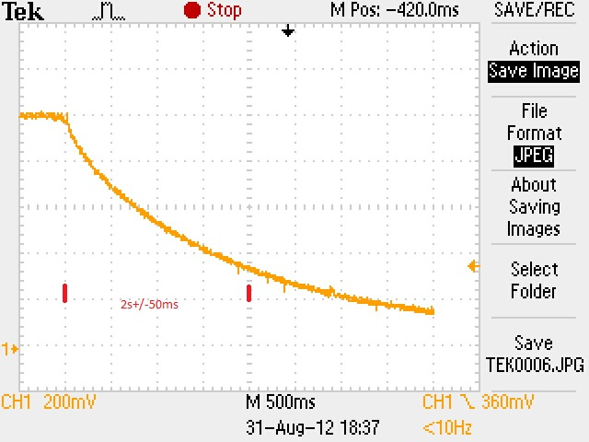
Figure 34: Transient response of supercapacitor made with paste of 40% of carbon (60% carbon black 40%activated carbon) and water thinner (refer to test No 8 in table 7) with sand paper polished
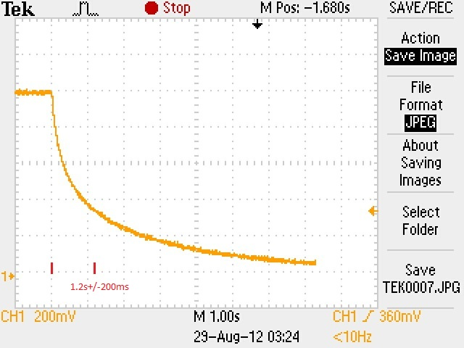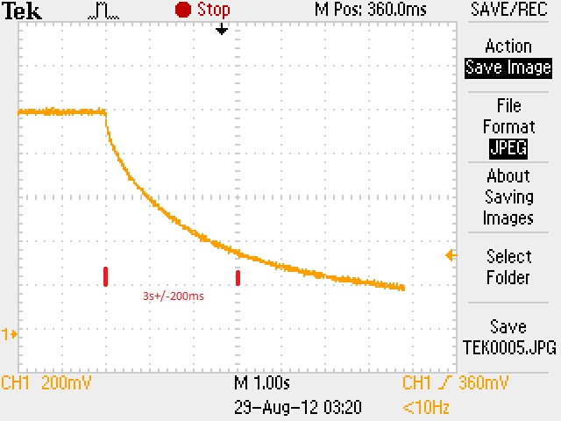
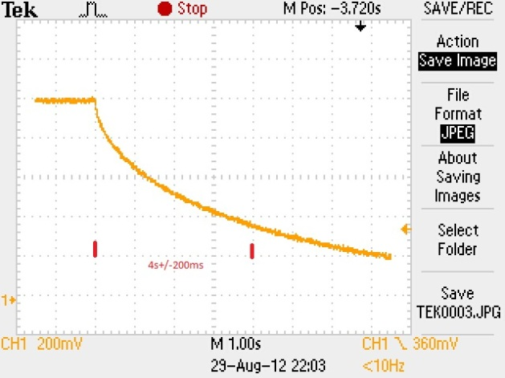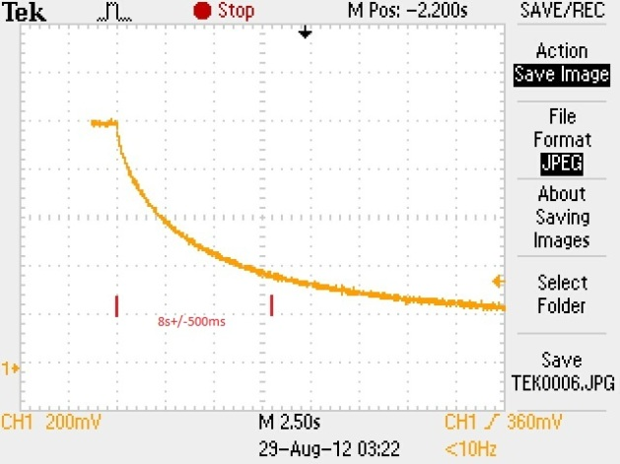
Figure 35: Frequency response of supercapacitor made with paste of 40% of carbon (80% carbon black 20%activated carbon) and water thinner (refer to test No 9 in table 7) with sand paper polished

Reference:
[1]: M. S. Halper and J. C. Ellenbogen, Supercapacitor: A Brief Overview, Mar. 2006. [Online]. Available: http://www.mitre.org
[2]: Illinois Capacitor, inc, supercapacitor, [Online]
Available: http://www.illinoiscapacitor.com/pdf/papers/supercapacitors.pdf
[3]: Kuldeep Sahay and Bharti Dwivedi, “Supercapacitors energy storage system for power quality improvement: an overview”, J. Electrical Systems, Vol.10, No.10, pp.1-8, 2009
[4]: Michael A. Everett, “overview: Ultracapacitor and Ultracapacitor Application”, Kilofarad International, 31 March 2009
[5]: K. Sahay and B. Dwidevi, “Supercapacitors Energy Storage System for Power Quality Improvement: An Overview”, J. Elec. Systems, 5, P8 (2009).
[6]: Z. S. Nakad. “Architectures for e-Textiles”. PhD thesis, Bradley Department of Electrical and Computing Engineering, Virginia Tech, 2003.
[7]: Buechley, L. and Eisenberg, M. Fabric PCBs, “Techniques for e-textile craft”. Personal and Ubiquitous Computing, 2007
[8]: Hu, L.; Pasta, M.; Mantia, F. L.; Cui, L.; Jeong, S.; Deshazer, H. D.; Choi, J. W.; Han, S. M.; Cui, Y.” Aqueous supercapacitors on conductive cotton” Nano Lett. 10, 708, 2010,
[9]: K. Wang, P. Zhao, X. Zhou, H. Wu and Z. Wei, J. Mater. Chem., Flexible supercapacitors based on cloth-supported electrodes of conducting polymer nanowire array/SWCNT composites 21, 16373, 2011;
[10]: M. Jayalakshmi, K. Balasubramanian,” Simple Capacitors to Supercapacitors - An Overview” Int. J. Electrochem. Sci. 3 (2008) 1196.
[11]: J.M. Boyea, R.E. Camacho, S. P. Turano, W. J. Ready, “Carbon nanotube-based supercapacitors: technologies and markets”, Nanotechnology Law & Business, 2007
[12]: NICHICON CORPORATION, General Description of Aluminium Electrolytic capacitor, TECHNICAL NOTES CAT.8101E
[13]: P J. Hall, M Mirzaeian, S. I Fletcher , F B. Sillars , A J. R. Rennie , G. O. Shitta-Bey , G.Wilson , A. Cruden and R Carter, “Energy storage in electrochemical capacitors: designing functional materials to improve performance site”, Energy Environ. Sci., 2010, 3, 1238-1251, 2010
[14]:A.Davies, Y, and Aiping.” Material advancements in supercapacitors: From activated carbon to carbon nanotube and grapheme”, Can. J. Chem. Eng. 89(6), 1342. 2011
[15]: Z, Li Li, X.S.Zhao,” Carbon-based materials as supercapacitor electrodes”, Chem. Soc. Rev., 38, 2520–25312009.
[16]: Pandolfo, A. G. & Hollenkamp, A. F. Carbon properties and their role in supercapacitors.
J. Power Sources 157, 11–27 (2006).
[17]: Pushparaj, V. L.; Shaijumon, M. M.; Kumar, A.; Murugesan, S.; Ci, L.; Vajtai, R.; Linhardt, R. J.; Nalamasu, O.; Ajayan, P. M. Flexible Energy Storage Devices Based on Nanocomposite Paper. Proc. Natl. Acad. Sci. U.S.A.104, 13574–13577, 2007.
[18] Subramanian V, Luo C, Stephan AM, Nahm KS, Thomas S, Wei B. Supercapacitors from activated carbon derived from banana fibers. J Phys Chem C; 111:7527–31, 2007.
[19] Hu, L., Wu, H. and Cui, Y.: Printed energy storage devices by integration of electrodes and separators into single sheets of paper, Appl. Phys. Lett. 96(18), 2010.
[20]Chen, P.; Chen,H.;Qiu, J.; Zhou, C. Inkjet Printing of Single-Walled Carbon Nanotube/RuO2 Nanowire Supercapacitors on Cloth Fabrics and Flexible Substrates Nano Res. 3, 594–603,2010.
[21] Hu, L. B.; Pasta, M.; La Mantia, F.; Cui, L. F.; Jeong, S.; Deshazer, H. D.; Choi, J. W.; Han, S. M.; Cui, Y. Stretchable, Porous, and Conductive Energy Textiles. Nano Lett. 10 (2), 708–714, 2010.
[22] K. Jost, C. R. Perez, J. K. McDonough, V. Presser, M. Heon, G. Dion and Y. Gogotsi, Carbon coated textiles for flexible energy storage, Energy Environ. Sci. 4(12), 5060–5067 2011.
[23]V.Conedera, F.Mesnilgrente, M.Brunt, and N.Fabre,”Fabrication of activated carbon electrode by inject deposition, “Processing of ICQNM conference, Cancun, 2009
[24] Kaempgen, M.; Chan, C. K.; Ma, J.; Cui, Y.; Gruner, G. Printable Thin Film Supercapacitors Using Single-Walled Carbon Nanotubes. Nano Lett. 9 (5), 1872–1876, 2009.
[25] VWR international,” Glass microfiber filter datasheet” [online]
https://uk.vwr.com/app/catalog/Product?article_number=513-5248
[26]: Harris, P., Liu, Z., Suenaga, K., Imaging the Atomic Structure of Activated Carbon. J. Phys,: Condens. Matter 20, 2008.
[27]: Shawinigan Black carbon black powder, datasheet, [online] available:
http://www.trademarkia.com/shawinigan-black-71603464.html
[28]: ER2218 epoxy resin, datasheet, [online] available:
http://www.electrolube.com/products/tds/ER2218.pdf
[29]: Piegari, L. Tironi, E.” New Full-Frequency-Range Supercapacitor Model With Easy Identification Procedure” Industrial Electronics, IEEE Transactions on Page(s): 112 – 120, 2012
[30]Liu C G, Liu M, Li F and Cheng,” Frequency response characteristic of single-walled carbon nanotubes as supercapacitor electrode material”, Appl. Phys. Lett. 2009

