Peter Middleton

Unknowns

When researchers meet they often ask, “What are you working on”? For a long time I had no prepared answer, so I’d say, “I’m working on the unknown”. A long pause. Was this clever banter? You ask me what I’m working on and I answer literally: of course I’m working on the unknown! That’s what researchers do, they search the limits of knowledge. “What are you working on?” Now I have a fuller answer: I’m writing a book about how our culture imagines its unknowns, a book about cosmology, the frontier mentality of science, the medical body, autism, codes, and the poetics of difficulty. Again the conversation is in trouble. Has the entirety of the universe become my space of inquiry? Have I given way to investigative paranoia? “What are you working on?” I’m writing a research memoir about the unknowns in late capitalist society. At this my friend might snap out with the satisfaction of a poker player given the opportunity to play a run of aces, Donald Rumsfeld’s notorious lines, as if to say, “I know what you’re working on – the politics of energy wars, quantum weaponry and secret surveillance.” What am I working on? Recursive splice sites, correlated disorder.

*

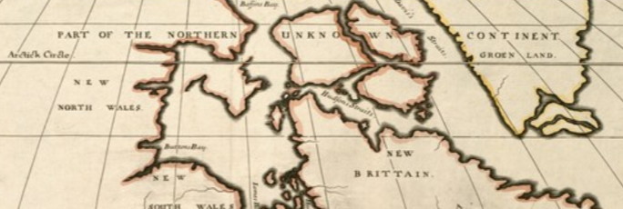

Early maps show the “parts as yet unknown” as blanks. Writers located stories there, explorers responded to what Fridtjof Nansen felt was “the call of the unknown.” Today any “call from the unknown,” says anthropologist Kirsten Hastrup, putting pluripotent scare quotes around the phrase, “now comes from cracks in the modern social imaginary.” Geography cannot make that call, cannot embody our imagination of the unknown.

Early human societies valued their unknowns: they thought of distance as what Mary Helms calls an “esoteric resource”. Leaders were experts in elsewhere, chosen because they had, in her words, a “general understanding of the exceptional forces and expressions of the universe regardless of location”. Our planet had many far-storied places over the edges of the world: “in contrast to our own encompassing global perspective where virtually no portion of the earth remains a mystery, traditional societies were well aware of the existence of unknown and therefore mysterious realms beyond the geographical borders of their worlds”. Are we no longer well aware of the existence of the unknown realms, no longer living in consciousness of their co-existence with us?

Where or what might those zones be now? Vannevar Bush claimed a new “endless frontier” had been opened up by the sciences. J. Robert Oppenheimer, a brilliant manipulator of other people's metaphors, thought of science as taking place on melancholy horizons where unknown realms begin: “The frontiers of sciences are separated now by long years of study, by specialized vocabularies, arts, techniques, and knowledge from the common heritage even of a most civilized society; and anyone working at the frontier of such science is in that sense a very long way from home, a long way too from the practical arts that were its matrix and origin, as indeed they were of what we today call art.” Are these esoteric resources of distance now so far from comprehension they are only available to scientists?

Theodor Adorno worried that the banalities of self-improvement were hiding our unknowns, that “terror before the abyss of the self is removed by the consciousness of being concerned with nothing so very different from arthritis or sinus trouble”. Even Oppenheimer sometimes recognised that these depths were not only distant territories of science. He acknowledges an intimate distance, falling away from us on all sides: “The problem of doing justice to the implicit, the imponderable and the unknown is always with us in science, it is with us in the most trivial of personal affairs, and it is one of the great problems of all forms of art.” Always with us – like what? the poor, death, limitations, our humanity?

*

Is the unknown lurking down in the unimaginably small enfolded quantum world? Or are our unknowns swaggering offworld perhaps? We walk up a hilly road in rural southwest France looking for darkness. We want to see the Milky Way on this moonless night, and the centre of the village is too brightly lit. Out at the edge of the houses we reach the last of the street lamps and cross their terminator into shadow. An infinitely deep, fragile blackness makes us momentarily dizzy, dazzled by the crowd of planets, stars and island universe, silenced by the beauty of this intimate farness. So much seen unseen, so many worlds we’ll never visit, never know. Yet Edwin Hubble, who stared at the universe more than almost anyone else, saw not crowding but emptiness, & searched for patterns to the chaos of light and dark.

Back in 1931 Hubble was news: “Youth who left Ozark Mountains to Study Stars Causes Einstein to Change His Mind”. Einstein only saw an unchanging universe; Hubble noticed signs that the universe was bursting out on all sides, spraying galaxies out across unknown territories so fast that the many colours of their white light were reddened by speed. He thought of his telescope at Mount Wilson as a starship, using metaphors of travel when he talked of gazing out through the telescope. With it, he says, “we know that we are reaching out into space, farther and ever farther, until, with the faintest nebulae that can be detected with the greatest telescope, we arrive at the frontiers of the known universe.” What a journey, worth its rigors for this arrival at the borders of the known. Galaxies were nebulae for him, he never used the modern term, too conscious they were barely there, tiny signals of light falling away into the invisible at the horizon of knowledge.

Gazing at thousands of photographic plates enabled him to break the cosmological code. Between the endless searches for patterns in the black and white he played solitaire to keep his decoding skills sharp. The game, says his biographer, “freed his mind, allowing him to make the proper connections between the myriad blurred dots on the photographic plates and the chasm from which their light had sprung before life put in an appearance on Earth”. Chasms, abysses, voids, gulfs – spatial impossibles.

The early twentieth century universe communicated with Hubble by light. In following decades astronomers tuned in to stellar radio. Karl Jansky discovered in 1933 that the Milky Way broadcast short wave signals. Then in the winter of 1964-65, Bell Telephone researchers Arno Penzias and Robert Wilson used a new antenna, a flaring Anish Kapoor-like horn, to scoop up these extra-terrestrial radio waves in the heavens above New Jersey, for a project to improve telecommunications with space satellites by eliminating unwanted interference.

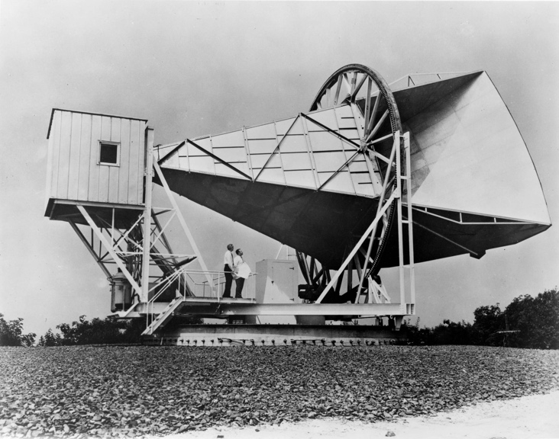

When they finally cleaned out all the noise they recognised they were left with radio waves “of unknown origin entering the antenna.” Was this a coded radio communication from outer space? They expressed themselves cautiously in technical jargon: “Measurements of the effective zenith noise temperature […] have yielded a figure about 3.5 degrees K higher than expected. This excess temperature, is, […] isotropic, unpolarized, and free from seasonal variations.” The New York Times explained what they meant: “radio waves […] appear to be flying in all directions through the universe.” "Fossil radiation” or CBR, cosmic background radiation, is now assumed to be junk lying around in the void left over from the hypothetical Big Bang origin of the entire cosmos. No code.

*

Science fiction’s central myth of a future where faster than light star travel enables planetary federations to span the galaxy, and where alien civilisations develop wierd forms of life and unprecedented technologies, provides a cosmological backdrop of recognisable unknowns, the unattainable stars and galaxies that we can see through our telescopes. Many writers contributed to the genre myth. In Isaac Asimov's Foundation Trilogy the galaxy, repeatedly named, is a constant reminder of this ready image of the unknown.

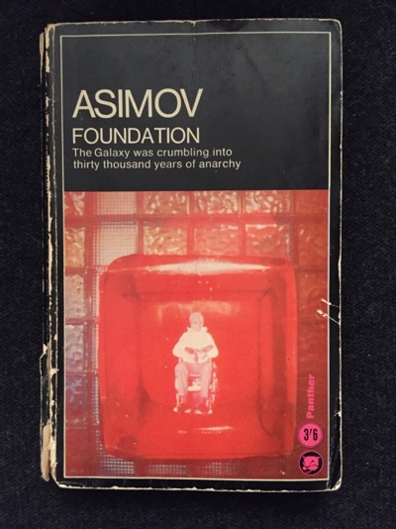

But although Asimov tells a story about galactic politics and travel, his real theme is another unknown, the future. As the novel gathers headway we realise that he has little interest in astrophysics. The voids of space, the light years, the stars and starships are all expressions of another distance, the distance between present certainty and unknowable future. Kant showed philosophers that our lack of knowledge of the future, its contingency, makes ethical life possible. “Moral actions must be free actions, and freedom turns out to depend on limits: Not knowing whether your moral actions will be rewarded is crucial to morality.”. Asimov’s scientists are determined to overcome these limits, to rig contingency, to derisk history, by replacing sociology with hard science. Paul Krugman blames Asimov for his decision to become an economist.

Asimov may have taken from Edwin Hubble the idea of this attempt to control the future of a future galactic civilisation. Hubble throws down a gratuitous challenge to sociologists near the start of his lectures on the nebulae: “Attempts to extend scientific method to the study of society are therefore misguided” - “the calculus of values, if it is ever formulated, will probably have little in common with the calculus of science”. Asimov thought differently.

In the Foundation trilogy social scientists use a new calculus, invented by a genius called Hari Selden, to predict the behaviour of large populations without their knowledge. Two Foundations use this mathematics to alter the course of all human civilization. One foundation is an encyclopedia research team that will become the germ of a new civilisation; the other, or Second Foundation, is an ultra-secret group of surveillance analysts who develop new methods of communication. Asimov appears to predict the acronymic organisations, NSA and GCHQ, of today.

All goes well until the appearance of a historical force that could not have been predicted, a man who takes advantage of another new science, genetics, whose radical genetic abnormality wrecks the Selden Plan to guide the human future for a thousand years. The Mule as he is called, uses coercive telepathy to control other minds, quickly builds an unbeatable space navy, and is only defeated when the Second Foundation, who it turns out have themselves developed an even more powerful telepathic capability, risk exposure of their secret intelligence. One of their leaders explains their reasons for advancing their cognitive powers: “Speech, originally, was the device whereby Man learned, imperfectly, to transmit the thoughts and emotions of his mind. […] but one which in its clumsiness and thick-numbed inadequacy degenerated all the delicacy of the mind into gross and guttural signalling. […] all the suffering that humanity ever knew can be traced to the one fact that no man in the history of the Galazy, until Hari Seldon, and very few men thereafter, could really understand one another. Every human being lived behind an impenetrable choking mist within which no other but he existed.”

Our existential condition is solipsism. Aetiology in a universal genetic lack of innate ability to read the emotions of others might be a poetic version of the textbook description of high-functioning autism or what used to be called Asperger syndrome. In the words of a medical paper summarising diagnostic criteria: “Individuals diagnosed with Asperger syndrome have all or some of the following difficulties: impairments in non-verbal behaviour such as eye contact, a lack of social reciprocity, or repetitive behaviours which result in clinically significant impairments in social or occupational functioning”. Telepathy would seem a good solution to autistic bafflement at the difficulties of intersubjective recognition, the other as the face of the unknown.

*

Why am I, a spectrally unremarkable small body geology, working on the unknown?. Unknowns proliferated in my childhood and youth, but then many people have similar information processing performance. Transplanted between British towns and American cities, other people knew what to say, how things worked, while I had not yet fully learned the stratigraphic codes.

Or I might see the unknown edge into view on the exteriors of older buildings.
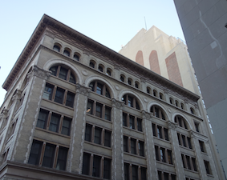

Abruptly a roof geometry or a sculptural façade would hold my attention fast.

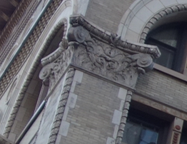

What did the ornamentation mean? If I reasoned with the adhesion of this moment, tried to decipher the building’s qudit style, even consult a book of architectural history, the moment would slip out of sight.

Easy to explain this constant tinnitus of the unknown as family history. My father Harry (not Hari) Middleton was a man of secrets. He worked in Cheltenham at a high security intelligence agency, blandly titled Government Communications Headquarters, or GCHQ, in a collection of ugly buildings rising up Battledown Hill behind several barbed wire fences. Looking up at their prefab sprawl I imagined climbing these barriers, finding a way across the spiked overhang, dropping down onto the concrete and finding out what was going on. When I asked my father what he actually did, he answered literally: I write letters, answer the telephone and go to meetings. Deliberately dull, no hint of secrets, spying, surveillance, codes or ciphers.

His job twice required him to leave England and take his family to live in America where he officially worked at the British Embassy, while actually car pooling to Fort Meade, Maryland, to the NSA, the National Security Agency, so secret its nickname used to be the No Such Agency. We were away for five years on two tours of duty. After each move we children had to start over and learn a different culture, uninvent our previous world. Perhaps the secrecy, the life in different nations, would not have had the same impact if not for a third more elusive influence. Even now this inner disturbance eludes words. An un-or-dis-ease settled on the inside of my life. Tiredness, trembling, headaches that sloshed around my skull, rapid mental fatigue, created an internal weather of poor visibility, lost days, ruined memories.

*
The Personal Poem

Lying flat, I was loaded head first
into the MRI scanner, a launch tube
to eternity, and each of my hydrogen atoms
flicked its dipoles back and forth.
My brain was palped by electric fields
patterned to a Steve Reich rhythm.
White scientists in a periscope controlled me.

Thought is a measurable field of fat
and magnetism. The fat that remembered
then let the atoms of inner thought
fall back relaxed into non-alignment.
I is an invariant element to this physics.
Forms for consciousness and stop
all too measurably afterimages.

High pitches enter the right ear
and cross through the perilymph
in search of an audience. I register
the fairing scored with manufacture.
Opening sounds hash, informe.
Channel panic. Each sound is a hit.
Each word of this anachronism it.

*

The past is a midden of the unknown, history has nominal aphasia, as the African Burial Ground National Monument to the pre-revolutionary slaves, lost, stolen, and not forgotten, asn inscription reminds us. "Burial 189 - adult of undetermined age and gender."

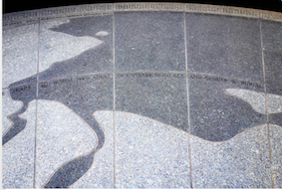

Even our ancestors’ names fade into a blur of middletons, leighs, middle distances and unknown leas, leaving behind bones, portraits, texts, locks of hair, bubbles in glass, pathways and roads, hedges and fields, stone buildings for work and worship, a repeating pattern of leaves, a wrought iron balustrade. When working at NYU I would always walk up the fire stairs at 244 Greene Street to have the pleasure of holding something made by the artisans who sculpted the iron in this former office block, the beautiful twists of metal strip that form a bannister concluded at the turn of each stair case with an amusing finial, a neat spiral of fist-sized metal. Thick black paint poured over the iron by renovators is a reminder of the gulf of time between those unknown artisans and the university that now awkwardly houses its English faculty there.

*

I wrote "Portrait of an Unknown Man" in a scrapbook begun during a trip to Greece, the island of Poros. It was published in Lee Hickman’s magazine Temblor. A later submission was returned because he was dying of AIDS.

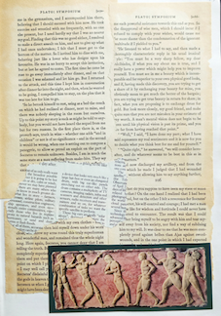

The poem is a composite portrait of left wing activists in the 1980s, now from some future themselves become no longer unidentifiable. Thinking of the belief that Greece was the cradle and childhood of European civilization. Part I opens with an allusion to Poussin’s enigmatic painting, “Et in Arcadia Ego,” words on a tomb for a lost friend, a reminder that alongside life in Arkady there is also death, that time has passed irrevocably.

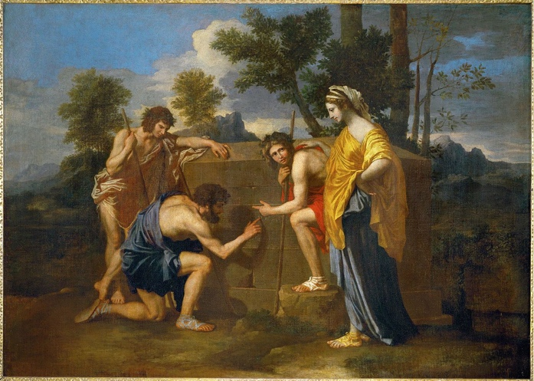

and he too was in arkady
where contiguous wars
plague slavery sexism
hemlocked minds
and the achievement of constant heteroglossia
dialectics and juries
are now dismembered parts
enabling parallels between otherwise thoughts
the structure does not possess a single straight line
of any length the deflection
creating an unusual dialogic
subtle convexity of columns
seen from either end
he was what i called a friend
anonymous and social as language
you’re straight? never mind
it was contestable plato
said he was the morning
star now lights our evenings
there’s a lot going down my friend
said he disappeared in the past i’ve also been
dismayed dead entombed graven latin
picture assuming
it’s simply emotions i’m talking about
this is not an elegy
the boatman will always tell you when the last boat leaves
for your return journey

*

Once we stop thinking of the unknown as located in space, we realise it has many approaches: it can be a moment of explosive annihilation leaving behind stencilled outlines of bodies, a low untraceable hum in everyday life, a beckoning skyline in the sciences, traces of labor in the walls. Or it unexpectedly gazes back at us from the inks and mouths of poetry.

Kirsten Hastrup sees it in cracks in the social imaginary. But why are those cracks there, who or what made them? I’m never quite sure what is meant by the “social imaginary”, by that Y in imagination. Here is one possibility. Nancy Fraser finds cracks in the socialist imaginary. “We are,” she says, “living through a capitalist crisis of great severity without a critical theory that could adequately clarify it.” Our lack of understanding results from our failure to be aware of new unknowns: “While Marx looked behind the sphere of exchange, into the ‘hidden abode’ of production, in order to discover capitalism’s secrets, I shall seek production’s conditions of possibility behind that sphere, in realms that are more hidden still.” Hidden territories of social reproduction, ecology, and political institutions – unknown to those inattentive to reproductive labour, or vetch under their feet. What makes them realm-like, what hides them?

What is the relation between the hidden and the unknown? I don’t have an answer. Malcolm Bull insists that the unknown and the hidden are not the same, the unknown can only become hidden by first becoming known. But I wonder. Isn't there an interference complex? If we look hard for the unknowns that exist around us, we are as likely to see them in forms of hiddenness, illegibility, poetic opacity, in codes as much or more than the vast unvisitable cosmos. Myself I keep coming back to the vast amounts of scientific knowledge hidden by governments and increasingly by corporations, to all the communications we cannot understand because they are encrypted, and above all to our culture’s fascination with codes. Is encryption the way we mark the blanks on the maps of the social imaginary?

*

the aesthetic code
the bibliographic code
the binary code
the civil code
the cultural code
the Da Vinci code
the digital code
the epigenetic code
the fashion code
the flashing code
the genetic code
the hermeneutic code
the highway code
the honour code
the impersonal code
the incompatible code
the mediatory code
the moral code
the ordinary code
the penal code
the postmodernist code
the proairetic code
the representational code
the sacred code
the secret code
the semiotic code
the tacit code
the triplet code
the underlying code
the zip code

*

Are codes another name for cracks in the social imaginary? Perhaps I want to think this because I come from a line of code workers. My parents met as code breakers, hunting for patterns in transcriptions of intercepted wartime enemy communications. My father’s father was a linotype operator. My mother’s father was a telegraphist. As the son of a cryptographer I have spent much of my life interpreting poetry at the very edge of or beyond intelligibility.

Grandfather Harry Middleton worked on the shop floor as a printer. During the first world war he was a linotype operator excused military service for forgotten medical reasons. All day long he sat at a keyboard with 90 keys, each of which selected a different brass character the machine then assembled along a thin channel ready to mould hot lead into a row of type. Materiality was everywhere in the noisy machinic arms shoving scalding metal letters into lines ready for printing.

My maternal grandfather Cyril Leigh worked a much smaller machine, the wireless telegraph. He was not excused service,; his gap years were spent in Mediterranean Great War zones. In the late summer of 1915 he was living on Sulva beach, a Turkish coast in Gallipoli, mostly sleeping on the open ground, or under a large rock, and only rarely in a tent. Sulva was a beachhead for invading the Ottoman Empire. Offshore, British warships fired at Turkish trenches up on the heights; Turkish taubles or monoplanes dropped bombs, while Turkish mortars shelled the beach. Several times Cyril was almost killed. “Imagine me sitting in front of a bush, the sun almost overhead, and a telephone receiver strapped round my head” as a shell falls into the bush, all its lethal shrapnel fortunately netted by roots and twigs.

I know this because he gave me a purple inked mimeograph copy of a short typed memoir of that summer before he went to manage a telegraph station for two years on the Golan heights above Jerusalem, a city he was never able to visit.

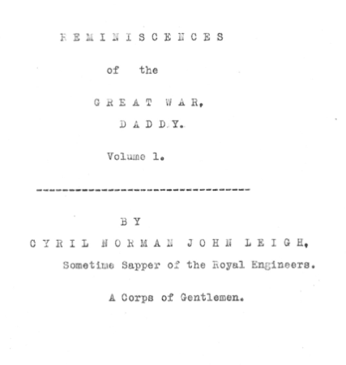

“This not a diary,” he writes, “but a collection of reminiscences, commenced after being nine months on Active Service. […]

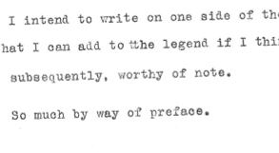
I was an English Literature student and didn’t think much to this one-sided writing. How could death be comic? “The first week or so that I was at Lala Baba there was noticeable a putrid smell coming up to the cook-house, every evening as the breeze came in from the sea. It was several dead Turks and English who had been buried just below us, but not deep enough. Indeed, one so far forgot himself as to stick his foot out of the ground. We objected to him turning up his toes in this fashion, so we remade his bed and gave him a border of stones and a cross made of pieces of white marble.” They also gave a can of rotten beef a hero's funeral. I buried the typescript in a drawer and forgot it.

“Every day we got a strafing”. How could he not be outraged at such pointless slaughter? I didn't understand how twenty year old Cyril was caught between a confusing excess of different media, different codes. He was a telegraph operator in civilian life; here in battle he was part of an international signals team, British and Anzac troops equipped with radio transmitters, telephones, motorcycle couriers, and signal lamps. Instead of the modern wireless morse code in which he was skilled, the navy insisted a “leading signalman […] worked visual,” the old system of flashing lamps across the water. He knew all about remediation.

“The Naval Observer used to search out good targets for the guns of the battleships in the bay, and when these were fired on, used to make correction of the shots, by reporting where they fall in relation to the object aimed at, by stating they were so many yards to the left or right, short or over. This information was passed down my line and should have been transmitted from the wireless station to the ships, with the visual station as a standby in case the wireless broke down. But alas! It was the wireless that was the standby. The following is a type of the message we got.

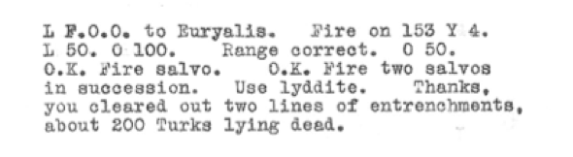

Thanks? Thanks for working the code? Thanks for killing the enemy. Thank you thank you for reminding us of our need for mutual recognition. “So every day we got a strafing”

*

Photographs of my parents in wartime look nothing like the people I remember; my father looks haunted, and my mother wears her hair in bird wings.

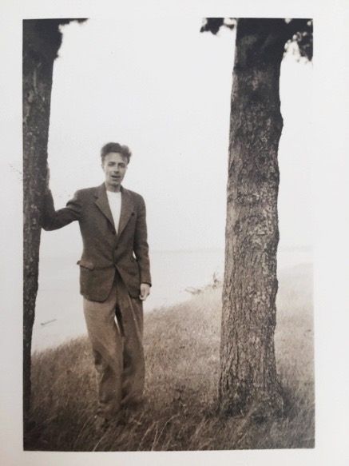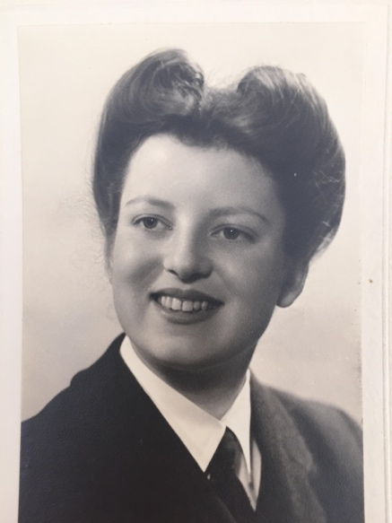

Bletchley was a top secret cryptography centre based in the grounds of a country house estate about fifty miles from London, so secret that it would not be discussed in print until thirty years later. My father's letter of appointment has had the name of the place carefully cut out.

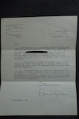

A storm of electromagnetic radiation from military transmitters across the northern hemisphere sent ciphered messages back and forth between governments and troops. Nazi ciphers were generated by Enigma machines, pataphysical typewriters. Press a letter and it would produce a different letter illuminated on a panel above. The German operator would copy the message letter by ciphered letter to be passed to the morse code operator for transmission. Every day the Enigma machines were reset to change the key that determined the exact system of encipherment. To decipher these pataphysically written messages the code breakers had to be ingenious, use mathematics, linguistics and invent makeshift computers to figure out how the Engima machines worked.

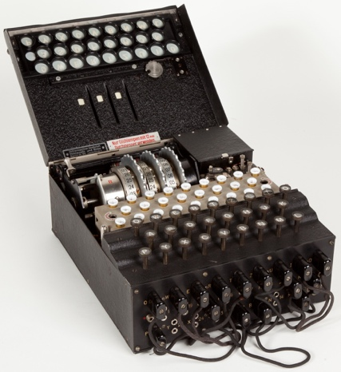

Mavis Lever, who worked at Bletchley Park, thought deciphering German Engima code was exhilarating: “sometimes you would have to spend the whole night, assuming every position that there could be on the three different wheels. […] But then of course, the magic moment comes when it really works and there it all is, the Italian, or the German, or whatever it is. […] There is nothing like seeing a code broken. That is really the absolute tops”. An erotics of code? The whole night, assuming every position, snarled up in it, seeing a code.

*

Some of the earliest modern computers, or “bombes” as they were then called, a name first adopted by Polish cryptographers, were built to solve this task. Gordon Welchman, Alan Turing and others at Bletchley Park, along with American counterparts such as Claude Shannon and Norbert Weiner, laid the foundations for our theories of Artificial Intelligence, computing, information theory, postmodernism, and the ubiquity of codes.

After the war, Gordon Welchman went on to work with NSA on a system for ensuring communications secrecy between American troops, planes, officers and Pentagon, still in use today. Looking back on his work at Bletchley he argues that what really enabled them to produce useful decryptions was we now call metadata – geographical and temporal details on where messages came from, who they were addressed to, and when they were sent. He called this traffic analysis. Welchman approached ciphered messages like a Pragmatist would, thinking about the roles of the speaker and the recipient in interpreting the signs. Security agencies tried to silence Welchman because they wanted the public to believe that reading enciphered communications is simply a matter of decoding the message – where in fact the code is only meaningful if you have the metadata, you know who is saying what to whom and where. Codes require more than interpretation, they require a spatio-temporal map of media and the subjects who communicate with them. The betweenness of words.

*

When these code-breakers started work on an encrypted message they could assume that it had a meaning. This signal was not radio waves from outerspace, not random arrangements of letters generated by a machine, not avant-garde lettrism; there was a human intelligence behind the message. After he left the intelligence world Alan Turing began to wonder how you could know whether there was a mind behind an utterance.

His essay on what he calls the Imitation Game introduces what is now simply known as the Turing Test, the test of whether a machine can pass as human. It's also a moving example of a high-functioning autistic person attempting to think deeply about human communication. For him solipsism is the norm, or as he says, “It may be the most logical point of view but it makes the communication of ideas difficult”.

A few years later Turing was arrested for cottaging, was prosecuted, and chose chemical castration instead of jail. He committed suicide - or accidentally inhaled cyanide - soon afterwards. In early 2016 Robert Hannigan, the head of GCHQ made a public apology for the way the intelligence agencies treated Turing after the war, telling a Stonewall event: “ GCHQ now relies on those who ‘dare to think differently and be different’". Now, he added, GCHQ "deliberately hires those on the autistic spectrum, with Asperger’s or other syndromes, because they are “precious assets” for protecting national security.” Without autism our cyber security would be endangered. Code - autism - computing - surveillance - hidden - unknown: how should we decipher these equations?

*

Are we living amongst codes, fossil remnants of a world at war when recognition of humanity gave way to the hostile secrecies of cipher? After 1945 the wartime code-breakers went forth and found codes everywhere. Code became a central concept for cybernetics, genetics, structuralism, computing, and eventually postmodernist theory. Life itself depends on a code because the genetic code enables all living organisms to pass instructions to future generations on how to make and sustain themselves. Or as Lily Kay witheringly comments, analogies became ontologies.

The postmodernist is a code-breaker catching electromagnetic radiation out of the air and finding encrypted messages within. Linda Hutcheon says that postmodernist artists “from Umberto Eco to Karlheinz Stockhausen” resist the elitism of their modernist predecessors; they can do this because postmodernists have a “more generally shared collective aesthetic code.” Fredric Jameson puts it more succinctly: “Modernist styles thereby become postmodernist codes” Jameson loves codes: they proliferate in his argument, attracting all sorts of adjective: architectural, mediatory, philosophical, representational and more. Even “theoretical discourse” is a code. Antonio Damasio sees code deep inside the mind: “our knowledge base is implicit, encrypted, and unconscious”. Have we encrypted ourselves?

*

When a hearing aid was first inserted into my ear I was amazed at how noisy the world is, how much sound enters from beyond vision, from outside: running water, a murmur of conversation in the road, rustles and knocks of other lives not visible from the room. Life-long partial deafness means you never know precisely how loud the world is. I became interested in poetry performance because it was often hard to hear. Now I think of autistics as having a similar dilemma: how loud is ordinary mutual awareness of emotion and intent? A strange news story tells of an autistic man given transcranial magnetic stimulation, electrotherapy which stimulates his brain so that he becomes increasingly aware of the emotional states of others. Soon the affect volume is deafeningly loud and he has to improvise ways to turn down other people’s emotional messages.

Another way of describing Asperger is to say that it manifests itself as a continuous state of bafflement, especially about the human world. David Finch has written a memoir of life as an autistic. For him, much about the world is unknown: “My problem is that I can’t seem to learn and apply the rules properly, though not for lack of trying. One is simply supposed to know the right way to respond to people or initiate conversations, but my attempts rarely pass muster.” His line manager calls him for a glowing appraisal of Finch’s work over the past year. Finch can’t figure out what is being said, and starts to think like a poet: “instead of processing the point he was trying to make, I concentrated on the sound of his voice, its timbral qualities and the severely Iowan way in which he formed his vowels.”

Very little is known about Asperger Syndrome or high-functional autism in adults. Is it emotional blindness or communication malfunction? Involuntary skepticism? - like Turing’s question about whether a person is on the other end of the exchange? There is little agreement about whether certain artists, scientists and writers were Aspergish. Einstein? Beckett? Isaac Asimov, Agnes Martin? Perhaps some poets? Another Asperger candidate, physicist Paul Dirac described his inner thoughts as “geometrical”. Does the population divide between those who have geometric thoughts and those who dance with feeling? What would the implications be of saying this or that poet has Asperger’s – and is it something one can “have” as one has a virus or a gammy leg? What is this expression on the face of the unknown?

Autism researchers talk as if Aspergers were a form of poetic difficulty: “Disordered expressive prosody is reported to occur in people with autism […] described as exaggerated, monotonous or singsong but few studies exist to quantify this disorder […] Prosody serves a variety of communicative functions including affective, pragmatic and grammatical.”

*

Knowledge today has new relations to various unknowns: political, moral, metaphysical, phenomenological, and even linguistic. Is poetic difficulty an aesthetic investigation of these changing horizons of knowledge? What sort of cognitive bootstrapping do the new unknowns require? Late modernist poetry is an aesthetic reclamation of the experience of inquiry into what remains mysterious, without either the old explanations of its sources as numinous sublimity, or the official line issued by institutions ranging from high-minded sciences to paranoid security agencies. Difficulty in poetry can be wholly patascientific or earnestly standing at the elbow of the researchers.

In an unsent letter Paul Celan writes: “one can never pretend to comprehend completely--: that would be disrespect in the face of the Unknown that inhabits – or comes to inhabit – the poet; that would be to forget that poetry is something one breathes; that poetry breathes you in.” Temptation to ignore correlated disorder.

*

Explorers, scientists, and Faustian geniuses talk as if the unknown needs to be renovated, cleaned up, properly lit with understanding, habitable and limited. Intolerable to have demons, wilderness, risks, lurking nearby. Others feel a need to protect it. Raymond Queneau advises us: “Rather than harrying the ineffable to who knows where, shouldn’t we first examine the reasons for the persistence of the sonnet?”

Next Gen - 13/ The Sonnet

Did the Russian philosopher really
smoke his manuscript.
Is it likely the text was never written
the supposed destruction of two copies an alibi?

With no institutional backing
just the moral integrity of assertion
the angel of formalism wrestles
with the angel of sociology.

A tone of scholarly surprise at error
is highly effective.
Winter afternoon light attenuates the blue.
I stare into this sun without filters.

Temporary meaning will have to be enough,
smoke that gets in your eyes

*

Susan Howe watches poet-ranger Emily Dickinson respectfully patrolling the boundaries of the lyric: “At the edge of the unknown, the sacred inaccessible unseen—Lyric ‘I’ is both guard and hunter.” (70) Poem as national park with paths to infinity. Adam Phillips thinks psychoanalysis has a similar responsibility: “How can psychoanalysis keep the unknown in the picture?” Edouard Glissant thinks that poetry must not try to wall off the unknown. “Transparency no longer seems like the bottom of the mirror in which Western humanity reflected the world in its own image. There is opacity now at the bottom of the mirror, a whole alluvium deposited by populations, silt that is fertile but, in actual fact, indistinct and unexplored even today, denied or insulted more often than not, and with an insistent presence that we are incapable of not experiencing.” Unknowns cluster on the inside of the poem.

The unknown. The unknown? Divergent meanings bend back and inflect each other as intense field-sculpted, ultrafast optical waveforms.

Sources Theodor Adorno, Minima Moralia Isaac Asimov, Second Foundation Malcolm Bull, Seeing Things Hidden ( R.H. Dicke, P.J.E. Peebles, P.G. Roll and D.T. Wilkinson, ‘Cosmic Black-Body Radiation,’ Astrophysical Journal 142 (1) (1965), 414-19 CHECK Mary Helms, Ulysses Sail Edwin Hubble The Realm of the Nebulae J. Robert Oppenheimer, “The Open Mind,” The Nation, February 1949 Mary Helms, Ulysses Sail, 81, 92, 129.
Theodor Adorno, Minima Moralia, 65.
In ‘The Open Mind’cited by Lincoln Barnett in Life, 10 October 1949, p.124.
Edwin Hubble The Realm of the Nebulae, .
Edwin Hubble biography, 227.
R.H. Dicke, P.J.E. Peebles, P.G. Roll and D.T. Wilkinson, ‘Cosmic Black-Body Radiation,’ Astrophysical Journal 142 (1) (1965), 414-19.
Penzias and Wilson, Astrophysical Journal 142 (1) (1965), 419. CHECK
(Moral Clarity, 235)
Edwin Hubble, The Realm of the Nebulae, 2.
Second Foundation, 83.
(Griffith, 533).
Nancy Fraser, 56.
Malcolm Bull, Seeing Things Hidden
Station X, 56
Michael Smith, The Secrets of Station X: How Bletchley Park Helped Win the War (London: Biteback Publishing, 2011), 56. From an oral interview with Mavis Batey, 1998.
Turing, A.M. (1950). Computing machinery and intelligence. Mind, 59, 433-460.
(Guardian, 16 April, 2016)
Poetics of Postmodernism, 24.
Postmodernism, 17.
Damasio, Self Comes to Mind (2010), 144
John Elder Robison, Switched On – report on NPR http://www.npr.org/sections/health-shots/2016/04/21/475112703/electric-currents-and-an-emotional-awakening-for-one-man-with-autism
David Finch, The Journal of Best Practices, 10, 42.
Georges Poulet, Journal of the History of Ideas 15:1 (1954): 3-22, 3
(Selections, ed. Joris. p. 184).
Susan Howe, My Emily Dickinson, 70.
(Terrors and Experts, 96)
Édouard Glissant, Poetics of Relation, trans. Betsy Wing (Ann Arbor, MI: The University of Michigan Press, 1997), 111.

