**Sarcopenia**

*NR Fuggle, SC Shaw, EM Dennison, C Cooper*

**Nicholas Fuggle** *BSc MBBS PgCert HBE MRCP*, MRC Lifecourse Epidemiology Unit, Tremona Road, Southampton UK, nrf@mrc.soton.ac.uk

**Sarah Shaw** *BSc*, MRC Lifecourse Epidemiology Unit, Tremona Road, Southampton UK, ss@mrc.soton.ac.uk

**Elaine Dennison** *MB BChir MA FRCP MSc PhD*, MRC Lifecourse Epidemiology Unit, Tremona Road, Southampton UK, emd@mrc.soton.ac.uk

**Cyrus Cooper** *OBE MA DM FRCP FFPH FMedSci*, MRC Lifecourse Epidemiology Unit, Tremona Road, Southampton UK, cc@mrc.soton.ac.uk

**Corresponding author:**

Professor Cyrus Cooper, MRC Lifecourse Epidemiology Unit (University of Southampton), Tremona Road, SO16 6YD

Tel +44 (0)23 8077 7624

Fax +44 (0)23 8070 4021

cc@mrc.soton.ac.uk

**Disclosures:** None

**Abstract**

Sarcopenia is a condition which is characterized by loss of muscle mass, muscle strength and muscle functional impairment with ageing. The definition of sarcopenia has been through various permutations, however, an enormous recent breakthrough is the inclusion of the condition in the ICD-10 classification of diseases. This chapter will cover the background issues regarding definition before describing the epidemiology of the disease according to human and environmental factors. It will then provide a practical guide for the assessment of sarcopenia in a clinical setting and finish with advice on present treatment and the exciting frontiers of future therapies.

**Key words**

*Sarcopenia, muscle, strength, function, ageing*

**Introduction**

Sarcopenia is characterized by generalized and progressive loss of muscle mass, reduction in muscle strength and resultant functional impairment. The condition is associated with poor health outcomes, premature death [1, 2] and has recently been included under a single code in the International classification of disease (ICD-10) [3]. Sarcopenia is associated with a significant burden on the global health economy, calculated at $18.5 billion in the US in 2004, but more recently calculated to cost £2 billion in the UK [4]. The prevalence varies with location and definition, however it is estimated to be up to 29% of older persons in the setting of community healthcare and between 14-33% for those in long-term care [1]. This emphasizes the importance of this condition, and the need to increase awareness of the condition amongst clinicians, researchers, health economists and policy-makers.

This chapter will highlight the scientific narrative which has led to the current definition of sarcopenia and discuss the epidemiology of the condition. We will provide information regarding the assessment of sarcopenia in both clinical and research contexts and provide a summary of current therapeutic options.

**Definition**

The description of muscle mass loss in extreme old age was first made by Critchley in 1931, with a particular observation that this was most marked at the hands and feet. However, the term ‘sarcopenia’ was first coined in 1984 by Rosenberg who used it in the context of the age-related loss of muscle mass (ICD1). This definition was used and built on by Baumgartner and colleagues, who defined muscle mass as appendicular lean mass divided by height and showed that, using this parameter, future adverse events and poor health could be predicted [5, 6].

Work by Edwards and colleagues revealed that although muscle mass was associated with muscle strength, there was only a weak association with disability and function [7]. It was also demonstrated that muscle quantity was not equivalent to muscle quality [8], further questioning the use of muscle mass alone in the definition of sarcopenia. From here the concept of dynapenia, or loss of muscle power was born [9]. This term forms one element of the disability cascade by which ‘dynapenia’ (loss of muscle power), keratopenia (loss of muscle force) and sarcopenia (loss of muscle) leads to disability (or loss of the ability to perform usual activities) and the physical phenotype of frailty, defined according to the Fried or Rockwood criteria.

In 2010, at the European Working Group on Sarcopenia in Older People (EWGSOP), there was consensus of opinion in support of the extension of the ‘mass’ definition of sarcopenia, to also include muscle strength (measured by grip strength) and muscle performance (measured by 6 minute walking speed) [10]. This move was echoed and supported within the field [11, 12].

There are currently a number of slightly differing definitions of sarcopenia, with most including measures of muscle function and mass.

Muscle mass is measured by the EWGSOP and International Working Group on Sarcopenia (IWGS) as skeletal mass index [13, 14], with the Foundation of the National Institute of Health (FNIH) sarcopenia project recommending dividing muscle mass by BMI, thus providing a measure of muscle mass relative to a measure of adiposity [15]. Threshold levels are defined as SMI of <7.23kg/m2 for men and <5.67kg/m2 for women [14] with the EWGSOP utilizing similar DXA thresholds [13]. The FNIH uses the measure of ALM/BMI and states that values <0.789 for men and <0.512 for women would indicate a low muscle mass [15].

In terms of muscle function, the IWGS uses a gait speed of <1m/s for the threshold level of poor muscle function [14], which is slightly higher than the more stringent <0.8m/s used by the EWGSOP [13]. The European group state that grip strength can also be used, which is the chosen measure of muscle function in the FNIH definition, with values of <26kg for men and <16kg for women being consistent with low grip status. A summary of the pertinent differences between definitions is seen in table 1.

Although there is increasing harmonization in the definition of sarcopenia, a water-tight consensus would greatly boost the comparability of research studies in this field, and the ‘NIA and FNIH Sarcopenia project 2’ aims to achieve this [16]. However, there has been a huge breakthrough in the field as, in September 2016, sarcopenia was assigned an ICD-10-CM code (M62.84) [10]. It is hoped that this will provide a similar breakthrough to that seen with osteoporosis in the 1990s, with increased awareness of the condition in diagnosis and considerable therapeutic development.

*Practice point*

*Sarcopenia is defined by the triad of loss of muscle mass, loss of muscle strength and loss of physical function.*

**Clinical development**

Sarcopenia can be precipitated by a number of factors, including age, nutrional deficiencies, hormonal changes, metabolic disturbance, comorbidities, inflammation, drug adverse effects, genetic predisposition and the effect of early environment. This results in reduction in muscle mass and strength, leading to sarcopenic status. This in turn leads to weakness and a reduced mobility, with downstream deconditioning and reduced physiological reserve. This in turn leads to propensity for reduced physical exercise and activity which leads to further wasting of muscle and loss of muscle strength, and so completing a downward spiral into sarcopenia (figure 1).

**Epidemiology**

Under this sub-heading we will explore the effect of epidemiological parameters on the individual facets of sarcopenia; muscle mass, muscle strength and physical function.

**Age and Sex**

*Muscle Mass*

The effect of age on muscle mass has been long-recognized and was included in Rosenberg’s definition of sarcopenia as an age-related reduction in muscle mass which was associated with a negative impact on health outcomes.

It has been observed, using magnetic resonance imaging (MRI), that muscle mass, similar to bone mineral density, begins to decline in the third decade of life, however, this reduction is not notable until the fifth decade [17]. Similar findings were reported by Silva and colleagues, who discovered that the age of 27 years was the turning point between muscle gain and muscle loss [18] (shown in figure 2).

As regards sex differences, the aforementioned MRI study noted significantly greater muscle mass in males than females (p<0.001) [17]; echoing a study which measured lean body mass sex differences and found that the lean mass of men, 56.9 ±7.8kg was higher than that of women 37.7±5.4kg (p<0.001).

In terms of loss of appendicular skeletal mass (ASM), the story is more mixed, with a 2 year study demonstrating a 0.8% reduction in men, with no change observed in women. This is at odds to a study with a follow-up of 4 years which showed a 1.58% loss of ASM in men but a greater loss of 2.02% in women. Although the findings differ, it should be noted that the time to follow-up for both studies was relatively short and the difference between percentages is rather small. Further, longer-term follow-up studies are required to more effectively identify sex differences regarding the change in ASM.

*Muscle Strength*

Work by Dodds and colleagues mapped out the changes in grip strength across the lifecourse [19]. They found that the strength of grip increased to a peak at the advent of adulthood, was maintained through middle-age before reducing in the twilight of old age, seen in figure 2. Age-related loss of strength appears to increase with increasing age [20].

Reduced muscle strength with increasing age was observed in the ageing Italian, ‘InCHIANTI’ cohort. Participants were subject to grip strength and knee extension torque (measuring quadriceps strength) analysis which was found to be 50% lower in the oldest age group [21].

Not only are sex differences in muscle strength observed at baseline with men having greater strength than women, but also the rate of decline is greater in males than females [20]. This phenomenon could be due to the fact that men have higher baseline strength, however, a study within the Health ABC cohort demonstrated a 3.6% decline in leg strength in men and a 2.8% decline in women, even after accounting for the higher strength of men at baseline [22]. Other possible explanations include selective mortality in females and the effect of regression to the mean.

*Physical Function*

The HALCyon study has demonstrated that, as might be expected, physical capability, in the majority of tests, is greater in younger participants [23]. Work within the same study demonstrated that males performed better than females in the majority of tests of physical function, except, interestingly, gait speed when adjusted for body habitus. Data from the Quebec Longitudinal Study on Nutrition and Successful Aging, including healthy older adults aged between 68 -82 years demonstrated a reduction in physical function over a 3 year period which was greater in women (11% decline) than men (9.6% decline) [24]. Cumulative analysis of 3 female cohort studies has shown that the rates of decline in physical function were highest in those women who were ‘more functional’ at baseline [25].

*Practice point*

*Grip Strength peaks in early adulthood, whence it begins a gradual decline before decreasing more rapidly form the 5th decade onwards*

*Physical function declines with age and this decline appears to occur at a greater rate in those with high baseline functionality*

*MRI measurements of muscle mass suggest that the zenith is reached in the third decade, with a subsequent decline from that point*

*Men are likely to have a greater muscle mass than women*

*Research agenda*

*The relationship between appendicular skeletal mass and sex is area in which current evidence is lacking and requires further investigation*

**Ethnicity**

*Muscle Mass*

Three studies performed in the United States have investigated the effect of ethnicity on muscle mass.

The Boston Area Community Health and Bone Survey found that the lean mass index (LMI) was significantly higher in black than white individuals (p<0.001). A trend towards Hispanic individuals having a greater LMI than white individuals was observed though this failed to reach statistical significance [26]. In the Health ABC cohort, appendicular lean mass (ALM) was higher in black than white participants [22]. In the NHANES III cohort, fat-free mass and fat-free mass index were higher in black compared to white women but equal levels were seen in black and white men [27].

Further data on the issue of ethnicity and muscle mass showed that ASM was lower in Chinese compared to American individuals (though this finding was attenuated following adjustment for height) [28].

*Muscle Strength*

With regard to strength, findings from Health ABC have demonstrated greater muscle strength in white compared to black individuals, and have also shown that the age-related reduction in muscle strength is more marked in black than in white ethnicities [22]. Muscle strength is lower in the Chinese/Asian populus than other ethnicities [28].

A meta-analysis investigating the global variation in grip strength found large variation with geography, with mean grip strength being significantly higher in low/middle-income compared to high-income nations [29]. However, despite the global variation, the lifecourse profile of grip strength was found to be similar to that described by Dodds and colleagues [19] (seen in figure 3).

*Physical Functio*n

In comparison to their findings regarding muscle mass, Araujo and colleagues [26] found that physical function was equivalent in white, black and Hispanic ethnicities. This is somewhat different to findings from a separate study in the US which found, in women aged 45-79 years, black females were significantly more likely to have a gait speed less than 1.0 meters/second than white females (OR=2.9, 95% CI 2.0-4.1) [30]. This findings is partially supported by a separate US study showing that Mexican-Americans and non-Hispanic whites had better physical function than non-Hispanic black Americans [31]. The authors hypothesized that the causes could include socio-economic class, health status and medical care factors. In a far eastern, elderly Chinese population, decline in physical function appears to be greater [28] than in an ethnically white population [32].

*Practice point*

*Grip strength is greater in developed than developing countries, however, the trend of lifecourse variation is similar*

*Research agenda*

*Further work is required to elucidate the lifecourse variation in physical function and the effect of ethnicity*

**Body composition**

*Muscle Mass*

The process of ageing has profound effects of body composition with a recognized reduction in muscle mass, height and increase in fat mass [33]. It should be noted that although weight may remain stable, this is due to an increase in fat mass concurrent to a reduction in lean mass [34]. The propensity for increasing the proportion of fat to lean mass is borne out in the finding that when older adults lose weight they are able to recover weight but this is with a reduction in muscle mass [35]. Interestingly, a study of 70-77 year old men and women who were followed up for 8 years were found to have increases in fat and muscle mass, though the muscle mass specific to the legs was significantly reduced (0.02kg/year, p<0.01) [36]. Encouragingly, this weight loss-induced muscle wasting can be attenuated through resistance training [37].

*Muscle Strength*

The European Prospective Investigation into Cancer has demonstrated that, when dividing participants into quartiles according to body mass index (BMI), those in the highest quartile had a greater mean grip strength than those in the lowest quartile (2.7kg in men and 1.5kg in women) [38]. A similar relationship was observed when using waist circumference as the measure of body build, however this was not robust to adjustment for BMI. Further analysis of the relationship between waist circumference and BMI in the same model demonstrated a negative association between waist circumference and grip strength in a model adjusting for BMI and waist circumference. This emphasizes the adverse effect of centripetal obesity in an elderly population with regard to strength parameters.

*Physical function*

It has been shown that adiposity exacerbates the natural course of ageing-related decline in physical function [33]. As part of the Australian longitudinal study of ageing those with a higher waist circumference (>102cm in men, >88cm in women) were analysed over a 2 year follow-up period. At the end of 2 years, those with the higher defined waist circumferences had a significantly increased risk of limitations in physical function (OR 1.86, 95% CI 1.30 to 2.65) [39]. In the HALcyon cohort, increasing BMI was associated with reducing physical function though, this was a non-linear association due to the poor physical performance associated with pathologically low BMI. This was also observed by Rejeski [40] was a curvilinear relationship saw recorded between BMC and physical performance, in keeping with a detrimental effect of the extremes of body composition.

*Practice points*

*The ratio of fat mass to lean mass increases with age*

*Weight loss leads to muscle wasting, though this can be attenuated by resistance training*

*There is a trend toward greater BMI being associated with greater grip strength, though this is not seen with waist circumference (possibly because this is associated with centripetal obesity)*

*A curvilinear relationship between physical function and BMI, with both high BMI and pathologically low BMI being associated with reduced functionality*

**Physical Activity**

*Muscle Mass*

Studies have investigated the relationship between physical activity and muscle mass. The MINOS study [41] investigated the effect of past and present physical activity as part of employment, and found that a greater level of activity was associated with greater upper limb muscle mass (p<0.001 for trend). It should be noted that this relationship was not replicated in the lower limbs. A similar finding was uncovered in a Japanese cross-sectional study which found the mid-life physical activity was associated with lean mass in older age [42], suggesting that, similar to bone mineral density, the determinants of geriatric muscle mass begin to be mapped much earlier in the lifecourse. Studies have also investigated contemporaneous physical activity level in relation to lean mass. Park and colleagues [43] found that, in older adults in Japan, moderate to vigorous physical activity was associated with higher muscle mass compared to lower levels of activity. Accelerometry has been used to more effectively characterise the intensity of physical activity, and has shown that sedentary activity is associated with a lower percentage lean mass, and higher physical activity levels is associated with ALM, but only in men [44].

*Muscle strength*

There has been much interest in the relationship between strength and physical activity which have provided sufficient data for the production of meta-analyses and comprehensive review articles. A Cochrane review [45] investigating the relationship between progressive resistance training in older adults in 73 studies, found that there was a moderate to large effect on lower limb strength (SMD 0.84, CI: 0.67-1.00). Other studies have found that resistance training, rather than multi-component training, increases isokinetic strength in an elderly population[46]. A broad meta-analysis which explored the interaction between physical activity and muscle strength found a moderate effect of physical activity on grip strength in a middle-aged population (40-65 years) (SMD 0.54, CI 0.38-0.70), with specific resistance training having a greater effect size [47].

The above appear to suggest that it is not simply the level of physical activity which is relevant to muscular strength, but also the type, with resistance (weight) training being more advantageous than aerobic exercise.

*Physical function*

Although individual studies have drawn associations between increased physical activity and increased physical function [48], a 2009 Cochrane review of over 2000 individuals in 33 studies, found this association to be far more modest that the effect on isolated muscle strength (SMD 0.15 CI: 0.05-0.22) [45]. Similar to muscle mass, it seems that physical activity levels in mid-life are associated with better physical performance in later life, as shown in the InCHIANTI study [49].

*Practice points*

*Increased physical activity is positively associated with muscle mass, though this may be due to the effect of physical activity earlier in the lifecourse*

*Progressive resistance training in older adults leads to lower limb strengthening*

*Increased physical activity in mid-life is associated with higher physical performance in later life*

**Diet**

Dietary composition and food intake are hot topics in the elderly population. Oral consumption is recognized to reduce in the elderly due to social, psychological and physiological factors. This therefore leads to a reduction in the consumption of the nutrients which are vital constituents of a healthy diet. Indeed, ‘a healthy diet’ (including high consumption of vegetables, fruit, oily fish and whole-grains) has been associated with a stronger grip in older adults [50]. A Mediterranean diet in particular has been associated with faster gait speed [51] and a reduced risk of the frailty syndrome [52].

Within the context of this sub-chapter, we will focus on three dietary elements which are of particular interest in Sarcopenic development and therapy; protein, vitamin D and micronutrients.

**Protein**

*Muscle mass*

There appears to be an association between low protein intake and low muscle mass. This has been observed within the Health ABC cohort in the US, in which DXA-assessed lean mass loss over 3 years was shown to be 40% greater in the lowest quintile of baseline protein intake compared to the highest [53]. In the Tasmanian Aging Cohort it was shown that those failing to meet the current recommended daily intake for protein had a statistically significantly lower ALM at both baseline and follow-up [54]. This finding prompts the question ‘How much protein intake should be recommended?’. Is the current recommendation of 0.8g/kg body mass sufficient or should a 1.0-1.2g/kg recommendation be made to ensure that muscle mass is maintained? [55]. Indeed, there is not consistent evidence that amino acid and protein supplementation improves muscle mass with some studies demonstrating benefit [56] and others showing no effect [57]. Meta-analysed data has demonstrated a positive effect on fat-free mass [58]. There is no definitive answer at the time of writing but research is on-going.

*Muscle strength*

Although data from the Hertfordshire Cohort Study has demonstrated associations between increased metrics of protein intake and grip strength [50] these associations were not replicated in the TASMAN cohort [54]. A Cochrane review pertaining to the subject, analysed a total of 7 studies and 593 individuals and found no effect of protein supplementation on hand grip (WMD 0.06, CI: -0.60 to 0.72).

This mixed picture, which leans towards a null effect, is particularly interesting given that protein supplementation is considered as a potential therapeutic intervention for sarcopenia, and this area will be re-visited in the therapeutics section of the chapter.

*Physical function*

Similar to muscle strength, the evidence of a beneficial effect of protein intake on physical function is mixed. In a cohort of Australian women, no effect was found after 2 year follow-up for protein supplementation [59]. However a trial of protein supplementation in frail older adults did demonstrate an improvement in physical performance measures [56]. A Cochrane review performed in 2009 showed no effect of protein supplementation on functional measures.

*Practice points*

*Increased protein intake may increase muscle mass, though the literature is currently mixed in this regard*

*Physical function and muscle strength do not appear to be strongly influenced by protein intake*

*Research agenda*

*Further research is required to elucidate if the current recommendations for protein intake are adequate*

**Vitamin D**

*Muscle mass*

A positive association between ALM and 25-OH-vitamin D has been observed in a cohort of frail elderly participants [60] and was replicated in the Tasmanian Aging Cohort at both baseline and follow-up. It should be noted, however, that 25-OH-vitamin D did not predict %ALM at 2.6 year follow-up [61]. A systematic review of 6 25-OH-vitamin D supplement trials found no association with muscle mass [62].

*Muscle Strength*

In a cohort of Argentinian females of 65 year or older, a 25-OH-vitamin D of ≥70 (indicating repletion) was associated with increased strength of hip abduction and knee extension muscle compartments [63]. When investigating grip strength, data from the Longitudinal Aging Study Amsterdam showed that those participants with a baseline 25-OH-vitamin D of <25 had a significantly increased risk of being in the lowest 15 percentiles of grip strength (2.57, CI: 1.40 to 4.70) [64]. A meta-analysis of trials of 25-OH-vitamin D supplementation showed a very mild positive effect on muscle strength (SMD 0.17, CI 0.03 to 0.31, p=0.02) [62].

*Physical Function*

Observational data has suggested the presence of a relationship between low 25-OH-vitamin D and impaired physical function in elderly populations [65]. A study by Wicherts and colleagues comparing those with 25-OH-vitamin D levels greater than 30 with those with lower levels found an increased odds of decline in longitudinal physical function over a 3 year period [66]. These included an odds ratio of 2.21 (CI: 1.00 to 4.87) for those with a 25-OH-vitamin D <10 and an odds ratio of 2.01 (CI: 1.06 to 3.81) for those with a 25-OH-vitamin D of 10-20.

A systematic review investigating 25-OH-vitamin D supplementation found an improvement in timed up and go, as well as balance testing for those receiving the supplements [67].

*Practice points*

*Appendicular lean mass is positively associated with 25-OH-vitamin D, though trails of supplementation appear not to have an effect.*

*A greater effect is seen on muscle strength*

*Low vitamin D appears to predict poor physical function*

**Micronutrients**

Within this section we will look at three main micronutrients of interest; vitamin C, β-carotene and omega-3.

The relationship between anti-oxidants and body composition was investigated in the InCHIANTI cohort, with vitamin C and β-carotene being positively associated with skeletal muscle mass [68] and β-carotene in particular being protective against a natural tendency to decline in gait speed [69].

Omega-3 is an anti-oxidant, with oil fish being a rich source of this micronutrient. Within the Hertfordshire Cohort it was found that, for each portion of oily fish consumed, grip strength increased by 0.43kg in men and 0.48kg in women. This finding is further supported by an 8 week, randomized controlled trial of omega-3 supplementation in the elderly, which found an increased rate of muscle protein synthesis in the supplement group[70].

*Practice points*

*Vitamin C and β-carotene appear to have a positive association with muscle mass*

*β-carotene is associated with an attenuated decline in gait speed*

*Omega-3 is associated with an increased grip strength*

**Smoking**

To date, the data for an increased risk of sarcopenia related to smoking seems to be most apparent in those that are currently smoking rather than ex-smokers. A study by Szulc and colleagues [41] found a significantly reduced appendicular skeletal mass index in male smokers compared to those who had never smoked (-3.2%, p<0.003) [41]. A meta-analysis of smoking and sarcopenia found a very modest effect of smoking on the risk of sarcopenia (defined by muscle mass) [71].

The sarcopenic parameter of muscle strength seems to be more associated with smoking, with cross-sectional studies demonstrating an association with reduced strength in older adults [72]. This appears to be mirrored and replicated in younger adults with regard to lower limb strength specifically [73].

Physical function, measured by chair rise speed, timed up and go and balance assessment was reduced in smoking member of the HALCYON cohort, which the strongest association observed when comparing current smokers to never smokers [72].

*Practice points*

*Current smoking is associated with all 3 facets of sarcopenia*

**Alcohol**

A meta-analysis of the relationship between alcohol and sarcopenia found no significant association, however, the authors do temper their conclusions due to the difficulty with measuring alcohol consumption and homogenizing the definitions of sarcopenia in the studies analysed [74]. Further prospective work is required to further investigate the interaction.

*Research agenda*

*The relationship of alcohol with sarcopenia is less clear than that of current smoking. Further studies with robust methods of quantifying alcohol intake are required.*

**Combined lifestyle factors**

Smoking and alcohol are both lifestyle risk factors and there is evidence, presented by Robinson and colleagues, that there is a cumulative effect of the number of lifestyle risk factors on reducing physical function, one of the constituents of sarcopenia [75]. Similar effect has been observed in the Whitehall II study with regard to grip and walking speed [76]. It is worth acknowledging this phenomenon when considering the contentious relationships seen with smoking and alcohol.

**Co-morbidity**

It has been shown that the prevalence of sarcopenia increases in those with co-morbidity [77]. Cancer, cardiovascular disease and chronic obstructive airways disease have been associated with reduced muscle mass [78]. It is important here to clarify the definition of cachexia which is muscle wasting specifically due to a chronic illness, and so differs from sarcopenia.

An interesting study of Taiwanese older adults found that grip strength and physical performance reduced with increasing number of co-morbidities [79], emphasizing the importance of concurrent disease in the development of sarcopenia. In addition to those conditions highlighted above, type 2 diabetes has been associated with reduced muscle mass [80], reduced muscle strength [80] and impairment of physical performance [81].

*Practice point*

*It is important to note that cachexia is defined a muscle wasting secondary to a chronic disease, and so differs from sarcopenia.*

**Early life programming**

*Mass*

The effect of early life on adult disease has been established for many conditions and there is data to suggest that sarcopenia is one such condition.

Regarding body composition, it has been shown that birthweight and weight at one year predict fat free mass in adulthood [82]. In a Finnish cohort in Helsinki, it has been observed that a 1kg increase in birthweight is associated with a 4.1kg increase in lean mass in adult men and a 2.9kg increase in lean mass in adult women.

*Muscle strength*

Birthweight appears associated with adult muscle strength, with a meta-analysis of 13 studies and 20481 individuals suggesting a relationship, such that a 1kg increase in birthweight predicts a 0.86kg increase in muscle strength in adulthood [83] after adjustment for age, gender and height.

*Physical function*

Using the Short Form-36 (SF-36) questionnaire as a measure of physical function, those with birthweights ≤2.5kg were found to have a lower SF-36 score than those with a birthweight between 3.0-3.5kg (OR 2.73, 95% CI 1.57 to 4.72) [84]. Additionally reduced birthweight has been associated with poorer performance in assessments of balance [85].

*Practice point*

*Early life programming, as demonstrated by birthweight, seems to affect later life muscle mass, strength and function. Further studies are required to investigate not only to delineate these associations, but also to develop appropriate, preventative interventions*

**Screening**

Formal assessments may not be appropriate for the screening of patients in primary care due to availability of equipment, expertise and cost. In this context, screening tools are necessary to filter out those patients requiring specialist consultation and assessment.

These screening tools include the ‘Red Flag’ approach, which uses clinician-observed or patient-reported parameters to assess the degree of risk of sarcopenia. This include general weakness, visible muscle loss, reduced walking speed, a mini-nutrition assessment, body weight as recorded by the physician and weight loss, weakness, reduced muscle strength, fatigue, impaired mobility, falls, low energy and difficulty in performing activities of daily living as reported by the patient [86].

The SARC-F questionnaire uses 5 components to screen for sarcopenia; strength, assistance in walking, rise from chair, climbing stairs and falls. Each component is scored from 0-2 and an overall score of 4 or more is indicative of sarcopenia. It is a validated tool for the prediction of poor outcomes in the US and China yet its sensitivity is an area of controversy [87].

Such screening tools can be used to filter patients who should be referred for formal assessment.

*Practice point*

*Screening should be performed in primary care and those at risk should be referred to specialists for assessment.*

**Assessment**

In order to be able to diagnose or comments on the extent of sarcopenia, robust methods for assessment are required. This sub-section of the chapter will pertain to the methodologies used for the assessment of sarcopenia in both clinical and research contexts and a summary is shown in table 2.

**The assessment of muscle mass**

Methods of body composition analysis include dual X-ray absorptiometry, anthropometry, bio-electrical impedance, MRI and CT scanning and, more rarely, measurement of urinary metabolites, isotope dilution, and in vivo neutron activation (see table 3).

Dual X-ray absorptiometry is the most widely accepted method of assessing corporeal muscle mass in terms of balancing factors of feasibility, availability, complexity and cost. It delivers a low radiation burden and provides a measure of appendicular lean mass [88]. Appendicular lean mass is equal to the sum of non-bone mass of all four limbs and non-muscle mass of all 4 limbs [86]. The skeletal mass index (SMI) can be calculated by dividing the ALM by the square of the individual’s height. It should be noted that accuracy may vary particularly with age and a potential limitation is the inability to differentiate intra-muscular fat (which is visible on magnetic resonance imaging [89].

Anthropometric measures of body composition can allow the calculation of muscle mass and are used broadly in clinical practice. They include body mass index (BMI), calf circumference, mid-upper arm circumference and skinfold thickness. Although these are relatively easy to perform in a normal clinical setting, the accuracy of these measures for the determination of body composition (particularly skinfold thickness) becomes less with increasing age of the patient. This is due to a decline in collagen leading to increasing skin elasticity and variation in the location of fat storage with increasing age [90]. However, calf and mid-arm circumferences have been demonstrated to correlate with global health and, particularly nutrition status in older individuals [91]. One practical issue with using anthropometry is that threshold values for sarcopenia have yet to be defined as they have using DXA parameters.

In order to use muscle mass as a contributory parameter for the diagnosis of sarcopenia, a threshold needed to be defined. Similar to the bone mineral density definition of osteoporosis, a low SMI is defined as lower than 2 standard deviations below that expected of a young male or female [13]. 7.26kg/m2 for men and 5.5kg/m2 for women [92]. This was reduced to a threshold of 7.25kg/m2 for men and 5.67kg/m2 for women [93].

Bioimpedance analysis utilizes sensors to calculate electrical resistance in order to measure fat mass and LBM. It is operationally simple though has been shown to overestimate muscle mass [94] and underestimate fat mass [86].

**The assessment of muscle strength**

Although muscle strength can be measured using a chest press or isokinetic dynamometry, grip strength is the preferred and most widely used method to the assessment of strength. Although it only measures strength in the upper limb, levels have been shown to correlate well with measures of leg strength including lower extremity power, knee extension torque and calf cross-sectional area [21]. Chair rises have been shown to provide a reliable measure of lower limb strength [95].

The method of measuring grip strength involves using a hydraulic dynamometer, Jamar being a commonly used model. Under controlled environmental conditions, the dynamometer should be adjusted so that it sits comfortably within the hand of the participant, with the proximal interphalangeal joints able to flex to 90 degrees. Regarding arm position, the elbow should be flexed to 90 degrees and the arm held at the patient’s side. The device is then zeroed and the participant is asked to squeeze as hard as they can for 3 seconds. This is repeated three times on each side, alternating between left and right to allow recovery. The highest reading is recorded.

One major limitation of the measurement of grip strength with a dynamometer is that performance in the test could potentially be affected by the presence of hand deformity, pain or stiffness [96] and a rubber-ball model dynamometer (Martin Vigorimeter) could be more acceptable in these cases.

**The assessment of physical performance**

Of all the measures of clinical performance, gait speed is the most widely used, with 63% of physicians using it in preference to other methods [86]. Gait speed is equivalent to walking speed and can be measured over varying distances including 4m which is recommended by the EWGSOP. The same body has defined less than 0.8m/s as a ‘poor performance’ for men and women [21]. Gait speed can be used in isolation on as one facet of a short performance physical battery (SPPB) test with balance and chair rise assessments. SPPB has been shown to correlate with disability, mobility level and other clinical parameters including mortality. It is measured out of a total score of 12 with a score less than or equal to 8 being defined as poor. The so-called ‘Timed up and go’ can also be used as can the 6 minute walk distance or 400m walk time, however the thresholds for these are yet to be defined by EWGSOP. The stair climb can also be used and provides a gauge of power [97].

**Summary recommendations**

As described above, there are multiple way to assess muscle mass, strength and physical function, however the recommended methods include DXA for the assessment of muscle mass, grip dynamometry for the assessment of muscle strength and gait speed for the assessment of function.

*Practice points*

*Recommendations for assessment would include:*

*DXA for muscle mass*

*Grip dynamometry for muscle strength*

*Gait speed, potentially as part of a short performance physical battery test, for physical function*

**Therapy**

The basic therapeutic options for the management of sarcopenia include resistance exercise, increasing protein intake and 25-OH-viatmin D supplementation if required. However, new discoveries regarding the pathogenesis of sarcopenia have led to the development of novel therapeutic agents. This subsection of the chapter will cover the essentials element of treatments for sarcopenia, and a summary of these is seen in figure 4.

**Resistance exercise, protein supplementation and vitamin D supplementation**

These topics have previously been covered in the epidemiology subsection of this chapter, but warrant further attention here, with regard to the specifics of their roles as the key triad of sarcopenia therapy.

Resistance exercise is the first line treatment for sarcopenia, with a significant evidence base to support its use [98]. A recommendation by Cruz-Jentoft and colleagues recommends that exercise prescription be for at least 3 months duration and should include supervised resistance training [1].

Protein supplementation in the form of leucine-enriched or ‘whey’ protein has been shown to be particularly effective in increasing muscle mass and, to a lesser extent, function [99]. Bauer and colleagues [55] recommend to increase protein intake to 1.2g/kg/day and increase this to be between 1.2-1.5g/kg/day for the frail or those with a comorbidity. A study combining when protein with vitamin D supplementation found that functional parameters including stair climb were improved, in addition to muscle mass [100].

Vitamin D supplementation in isolation has been shown to increase muscle strength [62] though has no effect on muscle mass. The advice at present would include supplementing the elderly and those with deplete levels of vitamin D, and it has been shown to reduce falls within this patient group [101].

Practice points

*Therapeutic interventions*

*Resistance exercise (performed for at least 3 months)*

*Increase in protein consumption*

*Vitamin D reduces falls and may have an effect on sarcopenia when used in conjunction with protein supplementation*

**Drug therapy**

Muscle is a tissue which is vital for movement, and obviously plays a key role in the musculoskeletal system. In addition to this it is a major determinant of insulin sensitivity and calorific requirement, as well as actively producing systemic cytokines including interleukin-6 (IL-6). Let us examine the process of muscle homeostasis.

Normal muscle tissue is maintained in a state of flux with continual synthesis and degradation occurring. This is necessary because it allows the tissue to respond to changes in load demand by allowing the muscle to increase or decrease in size. In addition muscle is a major repository of protein, meaning that when protein is required elsewhere, muscle tissue undergoes a process of catabolism to allow this need to be met. This process of building up and breaking down is governed by anabolic factors, including insulin-like growth factor-1 (IGF-1), β-adrenoceptor agonism and androgenic hormones, and catabolic factors, including myostatin, activin and inflammatory mediators. When homeostasis becomes deranged, either due to a reduction in anabolism or increase in catabolism, the result will be sarcopenia.

Factors that can lead to a reduction in anabolic stimuli include those affecting the neuromuscular chain, hormonal deficiencies and lifestyle factors. Communication between the central nervous system and muscle can be affected by loss of α-motor units, deranged neuromuscular junction function as well a cellular causes, including the senescence of satellite cells and intracellular causes including deranged mitochondrial function. Hormonal deficiencies may vary depending on gender, but include declines in testosterone, growth hormone and oestrogen secretion. Lifestyle factors which affect anabolism of muscle include poor sleep, insufficient dietary protein intake and reduced physical activity or exercise.

Elements leading to an increase in catabolic stimuli include altered IL-6 production, the low-level, indolent increase in inflammatory state with age (referred to as ‘Inflammaging’) and obesity, which too is associated with an increased inflammatory cytokine and adipokine profile.

Manipulation of the above factors, such that anabolism is maximized and catabolism is minimized could lead to therapeutic interventions to prevent and treat sarcopenia.

It should be noted that some drugs increase muscle mass by causing muscle hypertrophy. Within the context of normal physiology, with muscle training and adaptation to increasing physical load leads to an increase in function initially, which is then followed (weeks to months later) by muscle hypertrophy [102]. With the pharmacological agents which induce muscle hypertrophy, the process is reversed. This was seen in the HORMA study which used growth hormone and testosterone in elderly males. They demonstrated that peak lean mass was observed at week 8, but peak strength was not seen until week 17 [103]. It is also yet to be apparent if hypertrophy stimulating agents will counter age-related muscle decline as they have been in disease specific (COPD, cancer, CVD) muscle catabolism [104].

The current recommendations are for anabolic agents to be used in consort with adequate protein intake, a satisfactory diet and sufficient physical activity.

*Practice points*

*Muscle homeostasis is maintained in a state of balanced anabolism and catabolism. Unopposed increases in catabolism or reductions in anabolism lead to sarcopenia*

*Research agenda*

*Does disease-specific muscle decline reverse with hypertrophy stimulating agents?*

**Anabolic or Androgenic steroids**

Testosterone supplementation has been used as a therapeutic intervention for over half and century. Endogenous production of testosterone decreases by approximately 1% per year from the age of 30 years [105] with a subsequent reduction in muscle mass and strength [6]. The effects of supplementation differ between the sexes, with increased weight and lean body mass in males and increased weight, largely due to increased fat mass, in females [104]. In both men and women, testosterone supplementation has been observed to increase muscle strength [106]. Dose-associated difference are also seen with low dose administration associated with increased muscle mass due to increased protein synthesis and decreased fat mass. High doses, due to a subsequent increase in satellite cell development, demonstrate a predisposition toward both greater muscle mass and power. A major concern regarding testosterone supplementation pertains to the adverse effect profile. Re-assuring a meta-analysis demonstrated no increase in the risk of mortality from the use of testosterone supplements [107] and, in the context of diabetes mellitus, it have been shown to decrease mortality [108]. There is, however, concern regarding cardiovascular adverse effects early in treatment, however, present evidence is conflicting and further work is required to better elucidate the issue [109].

Nandrolone decanoate is a 19-nortestosterone preparation which is delivered via subcutaneous injection and is similar, in action, to oxymetholone, an oral agent. Both are currently approve for the management of anaemia, however, they have been shown to have positive effects on muscle, with nandrolone treatment on fiber area and mass.

Despite the adverse effect profile, testosterone supplementation is still considered to be the safest and most efficacious drug therapy for sarcopenia at present [109].

*Research agenda*

*Robust studies investigating the risk to benefit ratio of testosterone, with regard to cardiovascular adverse events in particular, are required*

**Selective androgen receptor modulators (SARMs)**

This group of medications potentiate their action through effects on androgen receptors and are either steroidal or non-steroidal in structure.

MK0773 (TFM-4AS-1) is a dual selective androgen receptor modulator as well as manifesting inhibition of 5α-reductase, and is structurally, a 4-azasteroid. In a female study group it was shown to increase IGF-1 with subsequent increases observed in gait speed and speed on stair climbing. Unfortunately, there was a concomitant rise in cardiac failure [110].

Ligandrol or LDG-4033 is a non-steroidal, oral preparation for which phase I trials have demonstrated an increase in muscle mass [111]. An increase in total lean mass was seen in a 12 week study of enobosarm with an increase in function seen through an improvement in stair climbing [112].

At present there is no evidence for a therapeutic advantage in the use of SARMs compared to testosterone [109], though it is hoped that the adverse effect profile may be more advantageous.

**Protein anabolic agents**

Recombinant human growth hormone (rHGH) caused release of hepatically stored IGF-1 with significant effects on weight gain and increased lean body mass [113] though not on muscle strength [114]. Sumatriptan is an agent which is currently licensed for use in AIDS-wasting syndrome [104]. The HORMA trial demonstrated a beneficial, though tardy, response of muscle strength and mass to the administration of growth hormone with testosterone [103]. Adverse effects related to recombinant growth hormone include increased nitrogen concentrations [115], arthralgia, myalgia, oedema, loose motions [104], carpel tunnel syndrome, gynaecomastia and hyperglycaemia [109]. Given that the effect of rHGH is mediated by IGF-1, it would be assumed that IGF-1 should be used directly, however, at present there is very little evidence of efficacy [109].

**Appetite stimulants**

Ghrelin is synthesized by the stomach and causes a synergistic rise in growth hormone with additional increase in appetite. The latter causes an increase in oral intake and so a ghrelin agonist, anamorelin, was produced as an appetite stimulant. This has been trialed in cancer patients, where it was found to successfully increase oral intake and muscle mass though with an equivocal effect on muscle strength [116]. Ghrelin itself has been shown to increase body mass and muscle mass in a group of cancer patients [117].

Megestrol acetate (a synthetic progestogen) and dronabinol (a synthetic delta-9-tetrehydrocannabinol) have been used to treat HIV-associated anorexia with cyproheptadine utilized in HIV-associated weight-loss with good effect. The evidence to support their use in an elderly population for the treatment of sarcopenia is scant.

**Myostatin inhibitors**

Myostatin is produced by muscle and acts to prevent muscle anabolism and satellite cell synthesis [118](More146). Levels of myostatin are reduced by resistance training. It is therefore associated with reduced muscle gain, and a child with a homozygous deletion of the myostatin gene had a significantly increased muscle mass [118]. Myostatin inhibitors have been developed to harness this effect. MYO-029 or stamulumab, is a monoclonal antibody to myostatin, which has been used in the context of muscular dystrophy to increase muscle mass [109]. LY2495655, similarly is a myostatin monoclonal antibody which neutralizes myostatin. It has been used, in the context of prostate cancer [119], to increase muscle mass and may be of therapeutic use in the context of sarcopenia given the results of recent trials in elderly individuals with a predisposition to falling [120].

**Activin II receptor drugs**

There are two activin II receptors, activin II-A and activin II-B and are receptors for the ligands which constitute the transforming growth factor-β superfamily. These include myostatin.

Bimagramab is a fully-humanized, monoclonal antibody to activin II receptors and though trials have failed at the IIb/III stage for the treatment of inclusion body myositis, there is interest in whether this agent could be used in in the management of sarcopenia. It increases muscle volume, lean muscle mass and functional status, in the form of 6 minute walk distance [109].

In addition to the above, ACE-031, a soluble form of the activin II-B receptor, has been shown to increase lean mass and thigh muscle volume in a group of 48 post-menopausal women after a single dose [121]. The widespread utility of this drug may be influenced by the adverse effect profile which includes; telangiectasia, epistaxis and deranged gonadotropin levels.

**β receptor blockers, ACE inhibitors and Troponin activators**

Due to the effect on musculature, espindolol has been successfully used to increase muscle mass and grip strength [108]. In a small cell lung cancer and colorectal cancer study of cachexia, high dose espindolol was found to reverse weight loss, increase fat-free mass and maintain fat mass, as well as increasing grip strength compared to placebo (p = 0.0134) [122].

The ACE inhibitor ‘perindopril’ has been shown to increase walking distance in a heart failure group [123] but also in an elderly population [124].

Terasemtiv, a troponin activator has been shown to increase muscle function and performance in a murine model [125].

*Research agenda*

*Many of the medical interventions described above are in relative infancy and further development and, in some cases, later phase trials, are required before they can be recommended for wider use.*

*Drugs used in HIV-associated muscle disorders may prove useful in sarcopenia, but specific trials in this clinical scenario and age-group are required.*

**Summary**

Sarcopenia is a condition which is defined by the presence of loss of muscle mass, muscle strength and physical function with ageing. Although the exact levels differ slightly between published definitions the disease it has recently been included in the ICD-10. It can be effectively screened for in primary care, and assessment of the defining features should occur under the supervision of specialists to allow diagnosis. Treatments currently include resistance exercise, vitamin D supplementation and protein supplementation but it is hoped that, with the advent of the ICD-10 definition, therapeutic trials and intervention development will gain momentum.

**Acknowledgements**

The authors are supported by funding from the Medical Research Council, National Institute of Health Research and the University of Southampton.

**Conflicts of interest**

None to declare

**References**

1. Cruz-Jentoft, A.J., F. Landi, S.M. Schneider, C. Zuniga, H. Arai, Y. Boirie, et al., *Prevalence of and interventions for sarcopenia in ageing adults: a systematic review. Report of the International Sarcopenia Initiative (EWGSOP and IWGS).* Age Ageing, 2014. **43**(6): p. 748-59.

2. Janssen, I., D.S. Shepard, P.T. Katzmarzyk, and R. Roubenoff, *The healthcare costs of sarcopenia in the United States.* J Am Geriatr Soc, 2004. **52**(1): p. 80-5.

3. Cao, L. and J.E. Morley, *Sarcopenia Is Recognized as an Independent Condition by an International Classification of Disease, Tenth Revision, Clinical Modification (ICD-10-CM) Code.* J Am Med Dir Assoc, 2016. **17**(8): p. 675-7.

4. L.D. Westbury, R.P.V., H. E. Syddall, M. T. Sanchez‑Santos, E. M. Dennison, S. M. Robinson, C. Cooper, *Economic burden associated with sarcopenia: estimations from an English cohort study*, in *World Congress on Osteoporosis, Osteoarthritis and Musculoskeletal Diseases*. 2017: Florence, Italy.

5. Morley, J.E., R.N. Baumgartner, R. Roubenoff, J. Mayer, and K.S. Nair, *Sarcopenia.* J Lab Clin Med, 2001. **137**(4): p. 231-43.

6. Baumgartner, R.N., D.L. Waters, D. Gallagher, J.E. Morley, and P.J. Garry, *Predictors of skeletal muscle mass in elderly men and women.* Mech Ageing Dev, 1999. **107**(2): p. 123-36.

7. Edwards, M.H., K.A. Ward, G. Ntani, C. Parsons, J. Thompson, A.A. Sayer, et al., *Lean mass and fat mass have differing associations with bone microarchitecture assessed by high resolution peripheral quantitative computed tomography in men and women from the Hertfordshire Cohort Study.* Bone, 2015. **81**: p. 145-51.

8. Barbat-Artigas, S., Y. Rolland, B. Vellas, and M. Aubertin-Leheudre, *Muscle quantity is not synonymous with muscle quality.* J Am Med Dir Assoc, 2013. **14**(11): p. 852.e1-7.

9. Manini, T.M. and B.C. Clark, *Dynapenia and aging: an update.* J Gerontol A Biol Sci Med Sci, 2012. **67**(1): p. 28-40.

10. Anker, S.D., J.E. Morley, and S. von Haehling, *Welcome to the ICD-10 code for sarcopenia.* J Cachexia Sarcopenia Muscle, 2016. **7**(5): p. 512-514.

11. Cooper, C., R. Fielding, M. Visser, L.J. van Loon, Y. Rolland, E. Orwoll, et al., *Tools in the assessment of sarcopenia.* Calcif Tissue Int, 2013. **93**(3): p. 201-10.

12. Cooper, C., W. Dere, W. Evans, J.A. Kanis, R. Rizzoli, A.A. Sayer, et al., *Frailty and sarcopenia: definitions and outcome parameters.* Osteoporos Int, 2012. **23**(7): p. 1839-48.

13. Cruz-Jentoft, A.J., J.P. Baeyens, J.M. Bauer, Y. Boirie, T. Cederholm, F. Landi, et al., *Sarcopenia: European consensus on definition and diagnosis: Report of the European Working Group on Sarcopenia in Older People.* Age Ageing, 2010. **39**(4): p. 412-23.

14. Fielding, R.A., B. Vellas, W.J. Evans, S. Bhasin, J.E. Morley, A.B. Newman, et al., *Sarcopenia: an undiagnosed condition in older adults. Current consensus definition: prevalence, etiology, and consequences. International working group on sarcopenia.* J Am Med Dir Assoc, 2011. **12**(4): p. 249-56.

15. Studenski, S.A., K.W. Peters, D.E. Alley, P.M. Cawthon, R.R. McLean, T.B. Harris, et al., *The FNIH sarcopenia project: rationale, study description, conference recommendations, and final estimates.* J Gerontol A Biol Sci Med Sci, 2014. **69**(5): p. 547-58.

16. Bhasin, S., *The NIA and FNIH sarcopenia project 2: Project updates and preliminary results*, in *International Conference on Frailty and Sarcopenia Research*, M. Cesari, Editor. 2017: Barcelona, Spain. p. 3.

17. Janssen, I., S.B. Heymsfield, Z.M. Wang, and R. Ross, *Skeletal muscle mass and distribution in 468 men and women aged 18-88 yr.* J Appl Physiol (1985), 2000. **89**(1): p. 81-8.

18. Silva, A.M., W. Shen, M. Heo, D. Gallagher, Z. Wang, L.B. Sardinha, et al., *Ethnicity-related skeletal muscle differences across the lifespan.* Am J Hum Biol, 2010. **22**(1): p. 76-82.

19. Dodds, R.M., H.E. Syddall, R. Cooper, M. Benzeval, I.J. Deary, E.M. Dennison, et al., *Grip strength across the life course: normative data from twelve British studies.* PLoS One, 2014. **9**(12): p. e113637.

20. Shaw, S.C., E.M. Dennison, and C. Cooper, *Epidemiology of Sarcopenia: Determinants Throughout the Lifecourse.* 2017.

21. Lauretani, F., C.R. Russo, S. Bandinelli, B. Bartali, C. Cavazzini, A. Di Iorio, et al., *Age-associated changes in skeletal muscles and their effect on mobility: an operational diagnosis of sarcopenia.* J Appl Physiol (1985), 2003. **95**(5): p. 1851-60.

22. Goodpaster, B.H., S.W. Park, T.B. Harris, S.B. Kritchevsky, M. Nevitt, A.V. Schwartz, et al., *The loss of skeletal muscle strength, mass, and quality in older adults: the health, aging and body composition study.* J Gerontol A Biol Sci Med Sci, 2006. **61**(10): p. 1059-64.

23. Cooper, R., R. Hardy, A. Aihie Sayer, Y. Ben-Shlomo, K. Birnie, C. Cooper, et al., *Age and gender differences in physical capability levels from mid-life onwards: the harmonisation and meta-analysis of data from eight UK cohort studies.* PLoS One, 2011. **6**(11): p. e27899.

24. Payette, H., N.R. Gueye, P. Gaudreau, J.A. Morais, B. Shatenstein, and K. Gray-Donald, *Trajectories of physical function decline and psychological functioning: the Quebec longitudinal study on nutrition and successful aging (NuAge).* J Gerontol B Psychol Sci Soc Sci, 2011. **66 Suppl 1**: p. i82-90.

25. Peeters, G., A.J. Dobson, D.J. Deeg, and W.J. Brown, *A life-course perspective on physical functioning in women.* Bull World Health Organ, 2013. **91**(9): p. 661-70.

26. Araujo, A.B., G.R. Chiu, V. Kupelian, S.A. Hall, R.E. Williams, R.V. Clark, et al., *Lean mass, muscle strength, and physical function in a diverse population of men: a population-based cross-sectional study.* BMC Public Health, 2010. **10**: p. 508.

27. Obisesan, T.O., M.H. Aliyu, V. Bond, R.G. Adams, A. Akomolafe, and C.N. Rotimi, *Ethnic and age-related fat free mass loss in older Americans: the Third National Health and Nutrition Examination Survey (NHANES III).* BMC Public Health, 2005. **5**: p. 41.

28. Auyeung, T.W., S.W. Lee, J. Leung, T. Kwok, and J. Woo, *Age-associated decline of muscle mass, grip strength and gait speed: a 4-year longitudinal study of 3018 community-dwelling older Chinese.* Geriatr Gerontol Int, 2014. **14 Suppl 1**: p. 76-84.

29. Dodds, R.M., H.E. Syddall, R. Cooper, D. Kuh, C. Cooper, and A.A. Sayer, *Global variation in grip strength: a systematic review and meta-analysis of normative data.* Age Ageing, 2016. **45**(2): p. 209-16.

30. Kirkness, C.S. and J. Ren, *Race Differences: Use of Walking Speed to Identify Community-Dwelling Women at Risk for Poor Health Outcomes--Osteoarthritis Initiative Study.* Phys Ther, 2015. **95**(7): p. 955-65.

31. Al Snih, S., V. Kaushik, K. Eschbach, and K. Markides, *Ethnic differences in physical performance in older Americans: data from the Third National Health and Nutrition Examination Survey (1988-1994).* Aging Clin Exp Res, 2008. **20**(2): p. 139-44.

32. White, D.K., T. Neogi, M.C. Nevitt, C.E. Peloquin, Y. Zhu, R.M. Boudreau, et al., *Trajectories of gait speed predict mortality in well-functioning older adults: the Health, Aging and Body Composition study.* J Gerontol A Biol Sci Med Sci, 2013. **68**(4): p. 456-64.

33. Kalyani, R.R., M. Corriere, and L. Ferrucci, *Age-related and disease-related muscle loss: the effect of diabetes, obesity, and other diseases.* Lancet Diabetes Endocrinol, 2014. **2**(10): p. 819-29.

34. Waters, D.L. and R.N. Baumgartner, *Sarcopenia and obesity.* Clin Geriatr Med, 2011. **27**(3): p. 401-21.

35. Newman, A.B., J.S. Lee, M. Visser, B.H. Goodpaster, S.B. Kritchevsky, F.A. Tylavsky, et al., *Weight change and the conservation of lean mass in old age: the Health, Aging and Body Composition Study.* Am J Clin Nutr, 2005. **82**(4): p. 872-8; quiz 915-6.

36. Koster, A., J. Ding, S. Stenholm, P. Caserotti, D.K. Houston, B.J. Nicklas, et al., *Does the amount of fat mass predict age-related loss of lean mass, muscle strength, and muscle quality in older adults?* J Gerontol A Biol Sci Med Sci, 2011. **66**(8): p. 888-95.

37. Frimel, T.N., D.R. Sinacore, and D.T. Villareal, *Exercise attenuates the weight-loss-induced reduction in muscle mass in frail obese older adults.* Med Sci Sports Exerc, 2008. **40**(7): p. 1213-9.

38. Keevil, V.L., R. Luben, N. Dalzell, S. Hayat, A.A. Sayer, N.J. Wareham, et al., *Cross-sectional associations between different measures of obesity and muscle strength in men and women in a British cohort study.* J Nutr Health Aging, 2015. **19**(1): p. 3-11.

39. Bannerman, E., M.D. Miller, L.A. Daniels, L. Cobiac, L.C. Giles, C. Whitehead, et al., *Anthropometric indices predict physical function and mobility in older Australians: the Australian Longitudinal Study of Ageing.* Public Health Nutr, 2002. **5**(5): p. 655-62.

40. Rejeski, W.J., A.P. Marsh, E. Chmelo, and J.J. Rejeski, *Obesity, intentional weight loss and physical disability in older adults.* Obes Rev, 2010. **11**(9): p. 671-85.

41. Szulc, P., F. Duboeuf, F. Marchand, and P.D. Delmas, *Hormonal and lifestyle determinants of appendicular skeletal muscle mass in men: the MINOS study.* Am J Clin Nutr, 2004. **80**(2): p. 496-503.

42. Nishiguchi S, Y.M., Kajiwara Y, Sonoda T, Yoshimura K, Kayama H, *Effect of physical activity at midlife on skeletal muscle mass in old age in community-dwelling older women: A cross-sectional study. .* J Clin Gerontol Geriatr, 2013. **5**: p. 18–22.

43. Park, H., S. Park, R.J. Shephard, and Y. Aoyagi, *Yearlong physical activity and sarcopenia in older adults: the Nakanojo Study.* Eur J Appl Physiol, 2010. **109**(5): p. 953-61.

44. Foong, Y.C., N. Chherawala, D. Aitken, D. Scott, T. Winzenberg, and G. Jones, *Accelerometer-determined physical activity, muscle mass, and leg strength in community-dwelling older adults.* J Cachexia Sarcopenia Muscle, 2016. **7**(3): p. 275-83.

45. Liu, C.J. and N.K. Latham, *Progressive resistance strength training for improving physical function in older adults.* Cochrane Database Syst Rev, 2009(3): p. Cd002759.

46. Carvalho, J., E. Marques, J.M. Soares, and J. Mota, *Isokinetic strength benefits after 24 weeks of multicomponent exercise training and combined exercise training in older adults.* Aging Clin Exp Res, 2010. **22**(1): p. 63-9.

47. Ferreira, M.L., C. Sherrington, K. Smith, P. Carswell, R. Bell, M. Bell, et al., *Physical activity improves strength, balance and endurance in adults aged 40-65 years: a systematic review.* J Physiother, 2012. **58**(3): p. 145-56.

48. Cooper, R., G.D. Mishra, and D. Kuh, *Physical activity across adulthood and physical performance in midlife: findings from a British birth cohort.* Am J Prev Med, 2011. **41**(4): p. 376-84.

49. Patel, K.V., A.K. Coppin, T.M. Manini, F. Lauretani, S. Bandinelli, L. Ferrucci, et al., *Midlife physical activity and mobility in older age: The InCHIANTI study.* Am J Prev Med, 2006. **31**(3): p. 217-24.

50. Robinson, S.M., K.A. Jameson, S.F. Batelaan, H.J. Martin, H.E. Syddall, E.M. Dennison, et al., *Diet and its relationship with grip strength in community-dwelling older men and women: the Hertfordshire cohort study.* J Am Geriatr Soc, 2008. **56**(1): p. 84-90.

51. Shahar, D.R., D.K. Houston, T.F. Hue, J.S. Lee, N.R. Sahyoun, F.A. Tylavsky, et al., *Adherence to mediterranean diet and decline in walking speed over 8 years in community-dwelling older adults.* J Am Geriatr Soc, 2012. **60**(10): p. 1881-8.

52. Bollwein, J., R. Diekmann, M.J. Kaiser, J.M. Bauer, W. Uter, C.C. Sieber, et al., *Dietary quality is related to frailty in community-dwelling older adults.* J Gerontol A Biol Sci Med Sci, 2013. **68**(4): p. 483-9.

53. Houston, D.K., B.J. Nicklas, J. Ding, T.B. Harris, F.A. Tylavsky, A.B. Newman, et al., *Dietary protein intake is associated with lean mass change in older, community-dwelling adults: the Health, Aging, and Body Composition (Health ABC) Study.* Am J Clin Nutr, 2008. **87**(1): p. 150-5.

54. Scott, D., L. Blizzard, J. Fell, G. Giles, and G. Jones, *Associations between dietary nutrient intake and muscle mass and strength in community-dwelling older adults: the Tasmanian Older Adult Cohort Study.* J Am Geriatr Soc, 2010. **58**(11): p. 2129-34.

55. Bauer, J., G. Biolo, T. Cederholm, M. Cesari, A.J. Cruz-Jentoft, J.E. Morley, et al., *Evidence-based recommendations for optimal dietary protein intake in older people: a position paper from the PROT-AGE Study Group.* J Am Med Dir Assoc, 2013. **14**(8): p. 542-59.

56. Tieland, M., O. van de Rest, M.L. Dirks, N. van der Zwaluw, M. Mensink, L.J. van Loon, et al., *Protein supplementation improves physical performance in frail elderly people: a randomized, double-blind, placebo-controlled trial.* J Am Med Dir Assoc, 2012. **13**(8): p. 720-6.

57. Eliot, K.A., A.W. Knehans, D.A. Bemben, M.S. Witten, J. Carter, and M.G. Bemben, *The effects of creatine and whey protein supplementation on body composition in men aged 48 to 72 years during resistance training.* J Nutr Health Aging, 2008. **12**(3): p. 208-12.

58. Cermak, N.M., P.T. Res, L.C. de Groot, W.H. Saris, and L.J. van Loon, *Protein supplementation augments the adaptive response of skeletal muscle to resistance-type exercise training: a meta-analysis.* Am J Clin Nutr, 2012. **96**(6): p. 1454-64.

59. Zhu, K., D.A. Kerr, X. Meng, A. Devine, V. Solah, C.W. Binns, et al., *Two-Year Whey Protein Supplementation Did Not Enhance Muscle Mass and Physical Function in Well-Nourished Healthy Older Postmenopausal Women.* J Nutr, 2015. **145**(11): p. 2520-6.

60. Tieland, M., E.M. Brouwer-Brolsma, C. Nienaber-Rousseau, L.J. van Loon, and L.C. De Groot, *Low vitamin D status is associated with reduced muscle mass and impaired physical performance in frail elderly people.* Eur J Clin Nutr, 2013. **67**(10): p. 1050-5.

61. Scott, D., L. Blizzard, J. Fell, C. Ding, T. Winzenberg, and G. Jones, *A prospective study of the associations between 25-hydroxy-vitamin D, sarcopenia progression and physical activity in older adults.* Clin Endocrinol (Oxf), 2010. **73**(5): p. 581-7.

62. Beaudart, C., F. Buckinx, V. Rabenda, S. Gillain, E. Cavalier, J. Slomian, et al., *The effects of vitamin D on skeletal muscle strength, muscle mass, and muscle power: a systematic review and meta-analysis of randomized controlled trials.* J Clin Endocrinol Metab, 2014. **99**(11): p. 4336-45.

63. Mastaglia, S.R., M. Seijo, D. Muzio, J. Somoza, M. Nunez, and B. Oliveri, *Effect of vitamin D nutritional status on muscle function and strength in healthy women aged over sixty-five years.* J Nutr Health Aging, 2011. **15**(5): p. 349-54.

64. Visser, M., D.J. Deeg, and P. Lips, *Low vitamin D and high parathyroid hormone levels as determinants of loss of muscle strength and muscle mass (sarcopenia): the Longitudinal Aging Study Amsterdam.* J Clin Endocrinol Metab, 2003. **88**(12): p. 5766-72.

65. Bischoff-Ferrari, H.A., T. Dietrich, E.J. Orav, F.B. Hu, Y. Zhang, E.W. Karlson, et al., *Higher 25-hydroxyvitamin D concentrations are associated with better lower-extremity function in both active and inactive persons aged > or =60 y.* Am J Clin Nutr, 2004. **80**(3): p. 752-8.

66. Wicherts, I.S., N.M. van Schoor, A.J. Boeke, M. Visser, D.J. Deeg, J. Smit, et al., *Vitamin D status predicts physical performance and its decline in older persons.* J Clin Endocrinol Metab, 2007. **92**(6): p. 2058-65.

67. Muir, S.W. and M. Montero-Odasso, *Effect of vitamin D supplementation on muscle strength, gait and balance in older adults: a systematic review and meta-analysis.* J Am Geriatr Soc, 2011. **59**(12): p. 2291-300.

68. Cesari, M., B.W. Penninx, M. Pahor, F. Lauretani, A.M. Corsi, G. Rhys Williams, et al., *Inflammatory markers and physical performance in older persons: the InCHIANTI study.* J Gerontol A Biol Sci Med Sci, 2004. **59**(3): p. 242-8.

69. Lauretani, F., R.D. Semba, S. Bandinelli, M. Dayhoff-Brannigan, F. Lauretani, A.M. Corsi, et al., *Carotenoids as protection against disability in older persons.* Rejuvenation Res, 2008. **11**(3): p. 557-63.

70. Smith, G.I., P. Atherton, D.N. Reeds, B.S. Mohammed, D. Rankin, M.J. Rennie, et al., *Dietary omega-3 fatty acid supplementation increases the rate of muscle protein synthesis in older adults: a randomized controlled trial.* Am J Clin Nutr, 2011. **93**(2): p. 402-12.

71. Steffl, M., R.W. Bohannon, M. Petr, E. Kohlikova, and I. Holmerova, *Relation between cigarette smoking and sarcopenia: meta-analysis.* Physiol Res, 2015. **64**(3): p. 419-26.

72. North, T.L., T.M. Palmer, S.J. Lewis, R. Cooper, C. Power, A. Pattie, et al., *Effect of smoking on physical and cognitive capability in later life: a multicohort study using observational and genetic approaches.* BMJ Open, 2015. **5**(12): p. e008393.

73. Kok, M.O., T. Hoekstra, and J.W. Twisk, *The longitudinal relation between smoking and muscle strength in healthy adults.* Eur Addict Res, 2012. **18**(2): p. 70-5.

74. Steffl, M., R.W. Bohannon, M. Petr, E. Kohlikova, and I. Holmerova, *Alcohol consumption as a risk factor for sarcopenia - a meta-analysis.* BMC Geriatr, 2016. **16**: p. 99.

75. Robinson, S.M., K.A. Jameson, H.E. Syddall, E.M. Dennison, C. Cooper, and A. Aihie Sayer, *Clustering of lifestyle risk factors and poor physical function in older adults: the Hertfordshire cohort study.* J Am Geriatr Soc, 2013. **61**(10): p. 1684-91.

76. Sabia, S., A. Elbaz, N. Rouveau, E.J. Brunner, M. Kivimaki, and A. Singh-Manoux, *Cumulative associations between midlife health behaviors and physical functioning in early old age: a 17-year prospective cohort study.* J Am Geriatr Soc, 2014. **62**(10): p. 1860-8.

77. Beaudart, C., R. Rizzoli, O. Bruyere, J.Y. Reginster, and E. Biver, *Sarcopenia: burden and challenges for public health.* Arch Public Health, 2014. **72**(1): p. 45.

78. Wust, R.C. and H. Degens, *Factors contributing to muscle wasting and dysfunction in COPD patients.* Int J Chron Obstruct Pulmon Dis, 2007. **2**(3): p. 289-300.

79. Shankar, A., A. McMunn, and A. Steptoe, *Health-related behaviors in older adults relationships with socioeconomic status.* Am J Prev Med, 2010. **38**(1): p. 39-46.

80. Park, S.W., B.H. Goodpaster, J.S. Lee, L.H. Kuller, R. Boudreau, N. de Rekeneire, et al., *Excessive loss of skeletal muscle mass in older adults with type 2 diabetes.* Diabetes Care, 2009. **32**(11): p. 1993-7.

81. Sinclair, A.J., S.P. Conroy, and A.J. Bayer, *Impact of diabetes on physical function in older people.* Diabetes Care, 2008. **31**(2): p. 233-5.

82. Sayer, A.A., H.E. Syddall, E.M. Dennison, H.J. Gilbody, S.L. Duggleby, C. Cooper, et al., *Birth weight, weight at 1 y of age, and body composition in older men: findings from the Hertfordshire Cohort Study.* Am J Clin Nutr, 2004. **80**(1): p. 199-203.

83. Dodds, R., H.J. Denison, G. Ntani, R. Cooper, C. Cooper, A.A. Sayer, et al., *Birth weight and muscle strength: a systematic review and meta-analysis.* J Nutr Health Aging, 2012. **16**(7): p. 609-15.

84. von Bonsdorff, M.B., T. Rantanen, S. Sipila, M.K. Salonen, E. Kajantie, C. Osmond, et al., *Birth size and childhood growth as determinants of physical functioning in older age: the Helsinki Birth Cohort Study.* Am J Epidemiol, 2011. **174**(12): p. 1336-44.

85. Martin, H.J., H.E. Syddall, E.M. Dennison, C. Cooper, and A.A. Sayer, *Physical performance and physical activity in older people: are developmental influences important?* Gerontology, 2009. **55**(2): p. 186-93.

86. Beaudart, C., E. McCloskey, O. Bruyere, M. Cesari, Y. Rolland, R. Rizzoli, et al., *Sarcopenia in daily practice: assessment and management.* BMC Geriatr, 2016. **16**(1): p. 170.

87. Malmstrom, T.K. and J.E. Morley, *SARC-F: a simple questionnaire to rapidly diagnose sarcopenia.* J Am Med Dir Assoc, 2013. **14**(8): p. 531-2.

88. Visser, M., T. Fuerst, T. Lang, L. Salamone, and T.B. Harris, *Validity of fan-beam dual-energy X-ray absorptiometry for measuring fat-free mass and leg muscle mass. Health, Aging, and Body Composition Study--Dual-Energy X-ray Absorptiometry and Body Composition Working Group.* J Appl Physiol (1985), 1999. **87**(4): p. 1513-20.

89. Mitsiopoulos, N., R.N. Baumgartner, S.B. Heymsfield, W. Lyons, D. Gallagher, and R. Ross, *Cadaver validation of skeletal muscle measurement by magnetic resonance imaging and computerized tomography.* J Appl Physiol (1985), 1998. **85**(1): p. 115-22.

90. Heymsfield, S.B., C. McManus, J. Smith, V. Stevens, and D.W. Nixon, *Anthropometric measurement of muscle mass: revised equations for calculating bone-free arm muscle area.* Am J Clin Nutr, 1982. **36**(4): p. 680-90.

91. Landi, F., G. Onder, A. Russo, R. Liperoti, M. Tosato, A.M. Martone, et al., *Calf circumference, frailty and physical performance among older adults living in the community.* Clin Nutr, 2014. **33**(3): p. 539-44.

92. Baumgartner, R.N., K.M. Koehler, D. Gallagher, L. Romero, S.B. Heymsfield, R.R. Ross, et al., *Epidemiology of sarcopenia among the elderly in New Mexico.* Am J Epidemiol, 1998. **147**(8): p. 755-63.

93. Janssen, I., S.B. Heymsfield, and R. Ross, *Low relative skeletal muscle mass (sarcopenia) in older persons is associated with functional impairment and physical disability.* J Am Geriatr Soc, 2002. **50**(5): p. 889-96.

94. Kim, M., S. Shinkai, H. Murayama, and S. Mori, *Comparison of segmental multifrequency bioelectrical impedance analysis with dual-energy X-ray absorptiometry for the assessment of body composition in a community-dwelling older population.* Geriatr Gerontol Int, 2015. **15**(8): p. 1013-22.

95. Jones, C.J., R.E. Rikli, and W.C. Beam, *A 30-s chair-stand test as a measure of lower body strength in community-residing older adults.* Res Q Exerc Sport, 1999. **70**(2): p. 113-9.

96. Bean, J.F., D.K. Kiely, S. Herman, S.G. Leveille, K. Mizer, W.R. Frontera, et al., *The relationship between leg power and physical performance in mobility-limited older people.* J Am Geriatr Soc, 2002. **50**(3): p. 461-7.

97. Bean, J.F., D.K. Kiely, S. LaRose, J. Alian, and W.R. Frontera, *Is stair climb power a clinically relevant measure of leg power impairments in at-risk older adults?* Arch Phys Med Rehabil, 2007. **88**(5): p. 604-9.

98. Valenzuela, T., *Efficacy of progressive resistance training interventions in older adults in nursing homes: a systematic review.* J Am Med Dir Assoc, 2012. **13**(5): p. 418-28.

99. Gryson, C., S. Ratel, M. Rance, S. Penando, C. Bonhomme, P. Le Ruyet, et al., *Four-month course of soluble milk proteins interacts with exercise to improve muscle strength and delay fatigue in elderly participants.* J Am Med Dir Assoc, 2014. **15**(12): p. 958.e1-9.

100. Bauer, J.M., S. Verlaan, I. Bautmans, K. Brandt, L.M. Donini, M. Maggio, et al., *Effects of a vitamin D and leucine-enriched whey protein nutritional supplement on measures of sarcopenia in older adults, the PROVIDE study: a randomized, double-blind, placebo-controlled trial.* J Am Med Dir Assoc, 2015. **16**(9): p. 740-7.

101. !!! INVALID CITATION !!!

102. Frontera, W.R., V.A. Hughes, L.S. Krivickas, S.K. Kim, M. Foldvari, and R. Roubenoff, *Strength training in older women: early and late changes in whole muscle and single cells.* Muscle Nerve, 2003. **28**(5): p. 601-8.

103. Schroeder, E.T., J. He, K.E. Yarasheski, E.F. Binder, C. Castaneda-Sceppa, S. Bhasin, et al., *Value of measuring muscle performance to assess changes in lean mass with testosterone and growth hormone supplementation.* Eur J Appl Physiol, 2012. **112**(3): p. 1123-31.

104. Meriggioli, M.N. and R. Roubenoff, *Prospect for pharmacological therapies to treat skeletal muscle dysfunction.* Calcif Tissue Int, 2015. **96**(3): p. 234-42.

105. Morley, J.E., *Should frailty be treated with testosterone?* Aging Male, 2011. **14**(1): p. 1-3.

106. Morley, J.E. and H.M. Perry, 3rd, *Androgens and women at the menopause and beyond.* J Gerontol A Biol Sci Med Sci, 2003. **58**(5): p. M409-16.

107. Corona, G., E. Maseroli, G. Rastrelli, A.M. Isidori, A. Sforza, E. Mannucci, et al., *Cardiovascular risk associated with testosterone-boosting medications: a systematic review and meta-analysis.* Expert Opin Drug Saf, 2014. **13**(10): p. 1327-51.

108. Muraleedharan, V., H. Marsh, D. Kapoor, K.S. Channer, and T.H. Jones, *Testosterone deficiency is associated with increased risk of mortality and testosterone replacement improves survival in men with type 2 diabetes.* Eur J Endocrinol, 2013. **169**(6): p. 725-33.

109. Morley, J.E., *Pharmacologic Options for the Treatment of Sarcopenia.* Calcif Tissue Int, 2016. **98**(4): p. 319-33.

110. Papanicolaou, D.A., S.N. Ather, H. Zhu, Y. Zhou, J. Lutkiewicz, B.B. Scott, et al., *A phase IIA randomized, placebo-controlled clinical trial to study the efficacy and safety of the selective androgen receptor modulator (SARM), MK-0773 in female participants with sarcopenia.* J Nutr Health Aging, 2013. **17**(6): p. 533-43.

111. Basaria, S., L. Collins, E.L. Dillon, K. Orwoll, T.W. Storer, R. Miciek, et al., *The safety, pharmacokinetics, and effects of LGD-4033, a novel nonsteroidal oral, selective androgen receptor modulator, in healthy young men.* J Gerontol A Biol Sci Med Sci, 2013. **68**(1): p. 87-95.

112. Dalton, J.T., K.G. Barnette, C.E. Bohl, M.L. Hancock, D. Rodriguez, S.T. Dodson, et al., *The selective androgen receptor modulator GTx-024 (enobosarm) improves lean body mass and physical function in healthy elderly men and postmenopausal women: results of a double-blind, placebo-controlled phase II trial.* J Cachexia Sarcopenia Muscle, 2011. **2**(3): p. 153-161.

113. Rudman, D., A.G. Feller, H.S. Nagraj, G.A. Gergans, P.Y. Lalitha, A.F. Goldberg, et al., *Effects of human growth hormone in men over 60 years old.* N Engl J Med, 1990. **323**(1): p. 1-6.

114. Kim, M.J. and J.E. Morley, *The hormonal fountains of youth: myth or reality?* J Endocrinol Invest, 2005. **28**(11 Suppl Proceedings): p. 5-14.

115. Kaiser, F.E., A.J. Silver, and J.E. Morley, *The effect of recombinant human growth hormone on malnourished older individuals.* J Am Geriatr Soc, 1991. **39**(3): p. 235-40.

116. Garcia, J.M., R.V. Boccia, C.D. Graham, Y. Yan, E.M. Duus, S. Allen, et al., *Anamorelin for patients with cancer cachexia: an integrated analysis of two phase 2, randomised, placebo-controlled, double-blind trials.* Lancet Oncol, 2015. **16**(1): p. 108-16.

117. Argiles, J.M. and B. Stemmler, *The potential of ghrelin in the treatment of cancer cachexia.* Expert Opin Biol Ther, 2013. **13**(1): p. 67-76.

118. Elkina, Y., S. von Haehling, S.D. Anker, and J. Springer, *The role of myostatin in muscle wasting: an overview.* J Cachexia Sarcopenia Muscle, 2011. **2**(3): p. 143-151.

119. Padhi, D., C.S. Higano, N.D. Shore, P. Sieber, E. Rasmussen, and M.R. Smith, *Pharmacological inhibition of myostatin and changes in lean body mass and lower extremity muscle size in patients receiving androgen deprivation therapy for prostate cancer.* J Clin Endocrinol Metab, 2014. **99**(10): p. E1967-75.

120. Becker, C., S.R. Lord, S.A. Studenski, S.J. Warden, R.A. Fielding, C.P. Recknor, et al., *Myostatin antibody (LY2495655) in older weak fallers: a proof-of-concept, randomised, phase 2 trial.* Lancet Diabetes Endocrinol, 2015. **3**(12): p. 948-57.

121. Attie, K.M., N.G. Borgstein, Y. Yang, C.H. Condon, D.M. Wilson, A.E. Pearsall, et al., *A single ascending-dose study of muscle regulator ACE-031 in healthy volunteers.* Muscle Nerve, 2013. **47**(3): p. 416-23.

122. Stewart Coats, A.J., G.F. Ho, K. Prabhash, S. von Haehling, J. Tilson, R. Brown, et al., *Espindolol for the treatment and prevention of cachexia in patients with stage III/IV non-small cell lung cancer or colorectal cancer: a randomized, double-blind, placebo-controlled, international multicentre phase II study (the ACT-ONE trial).* J Cachexia Sarcopenia Muscle, 2016. **7**(3): p. 355-65.

123. Hutcheon, S.D., N.D. Gillespie, I.K. Crombie, A.D. Struthers, and M.E. McMurdo, *Perindopril improves six minute walking distance in older patients with left ventricular systolic dysfunction: a randomised double blind placebo controlled trial.* Heart, 2002. **88**(4): p. 373-7.

124. Sumukadas, D., M.D. Witham, A.D. Struthers, and M.E. McMurdo, *Effect of perindopril on physical function in elderly people with functional impairment: a randomized controlled trial.* Cmaj, 2007. **177**(8): p. 867-74.

125. Hwee, D.T., A. Kennedy, J. Ryans, A.J. Russell, Z. Jia, A.C. Hinken, et al., *Fast skeletal muscle troponin activator tirasemtiv increases muscle function and performance in the B6SJL-SOD1G93A ALS mouse model.* PLoS One, 2014. **9**(5): p. e96921.

**Table 1** Differing definitions of sarcopenia. Reproduced with authors permission [20]**.**

|  |  |  |  |
| --- | --- | --- | --- |
| **Study Group** | **Criteria** | | |
| **Muscle Mass** | **Muscle Strength** | **Physical Performance** |
| ESPEN Special Interest Groups | Percentage of muscle mass >2 SDs below mean in individuals aged 18–39 y in the NHANES III cohort | X | Walking speed <0.8 m/s in the 4-min test or reduced performance in any functional test used for the comprehensive geriatric assessment |
| European Working Group on Sarcopenia in Older People | ALM/ ht2  - Men ≤7.23 kg/m2  -Women ≤5.67 kg/m2 | Grip Strength  -Men <30kg  OR  -Women <20kg | Gait speed <0.8m/s |
| International Working Group on Sarcopenia | ALM  - Men ≤7.23 kg/m2  -Women ≤5.67 kg/m2 | X | Gait speed ≤1 m/s |
| Society of Sarcopenia, Cachexia and Wasting Disorders | ALM/ ht2 of >2 SDs below the mean of healthy persons aged between 20 and 30 y of the same ethnic group | X | Gait speed ≤1 m/s or Walking Distance <400m during a 6- min walk |
| Foundation of NIH Sarcopenia Project | ALMBMI  - Men <0.789  - Women <0.512 | Grip Strength  -Men <26kg  -Women <16kg | X |

**Figure 1** Flow diagram depicting demonstrating the development and propagation of sarcopenia.

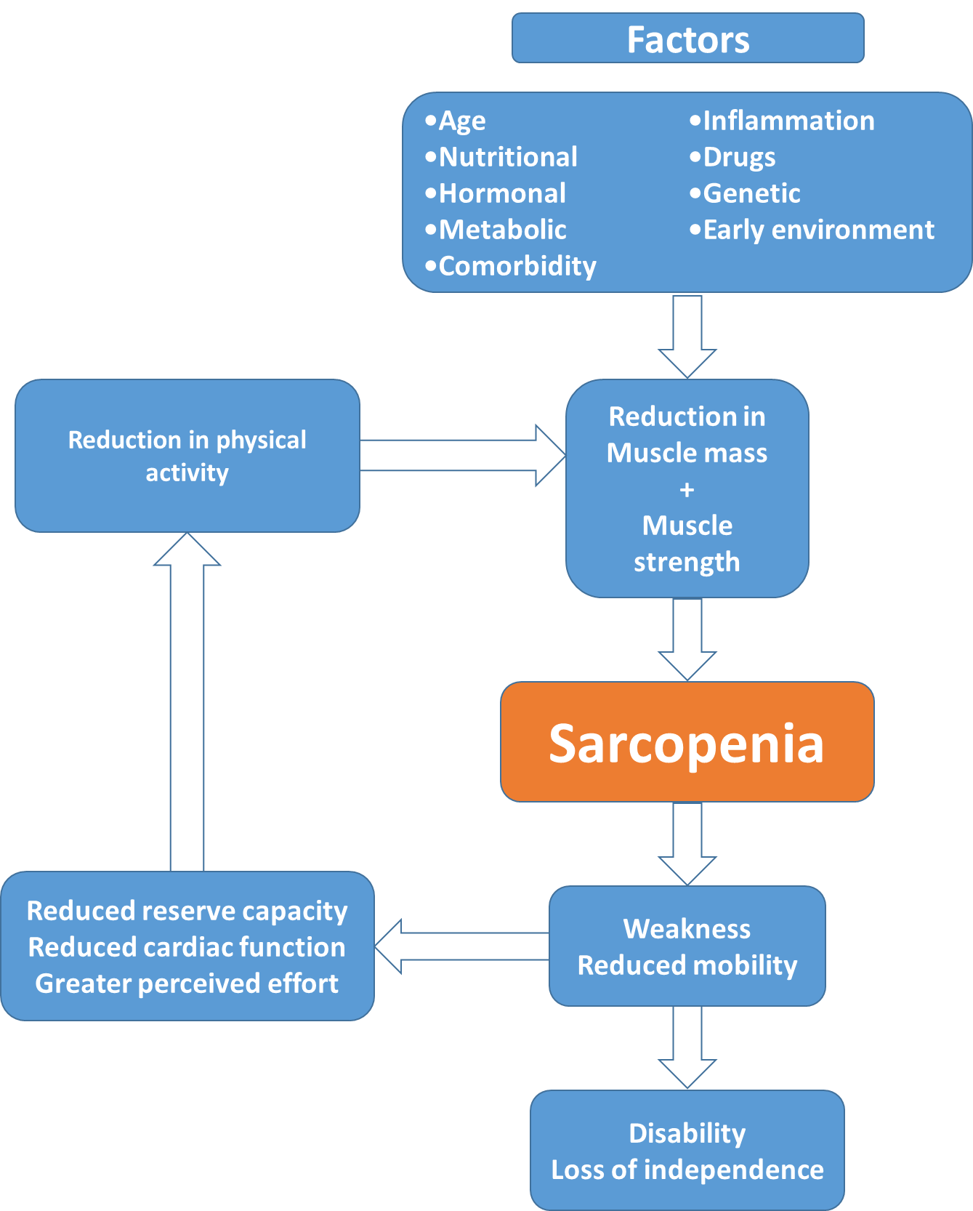

**Figure 2** Used with author permission [19]. Cross-cohort centile curves for grip strength. Centiles shown 10, 25th, 50th, 75th and 90th. ADNFS Allied Dunbar National Fitness Survey, ALSPAC Avon Longitudinal Study of Parents and Children, ELSA English Longitudinal Study of Ageing, HAS Hertfordshire Ageing Study, HCS Hertfordshire Cohort Study, LBC1921 and LBC1936 Lothian Birth Cohorts of 1921 and 1936, N85 Newcastle 85+ Study, NSHD Medical Research Council National Survey of Health and Development, SWS Southampton Women’s Survey, SWSmp mothers and their partners from the SWS, T-07 West of Scotland Twenty-07 Study, UKHLS Understanding Society: the UK Household Panel Study.

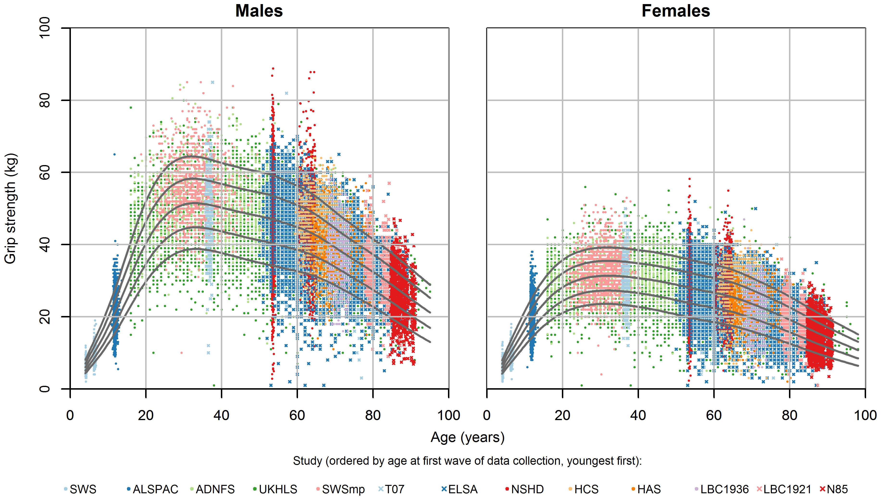

**Figure 3** Used with author permission[29].Grip strength mean values from included samples, by UN region. Each point represents the mean value of grip strength for each item of normative data, plotted against the mid-point of the age range it relates to. Values from the same sample are connected. Data from developing and developed regions are shown with triangles and circles, respectively. For comparison, the grey curve shows the mean values from our normative data for 12 British studies.



**Table 2** Adapted from Beaudart and colleagues [86] showing the applicability of assessment modalities in research, clinical practice and primary care. SPPB – Short Physical Performance Battery

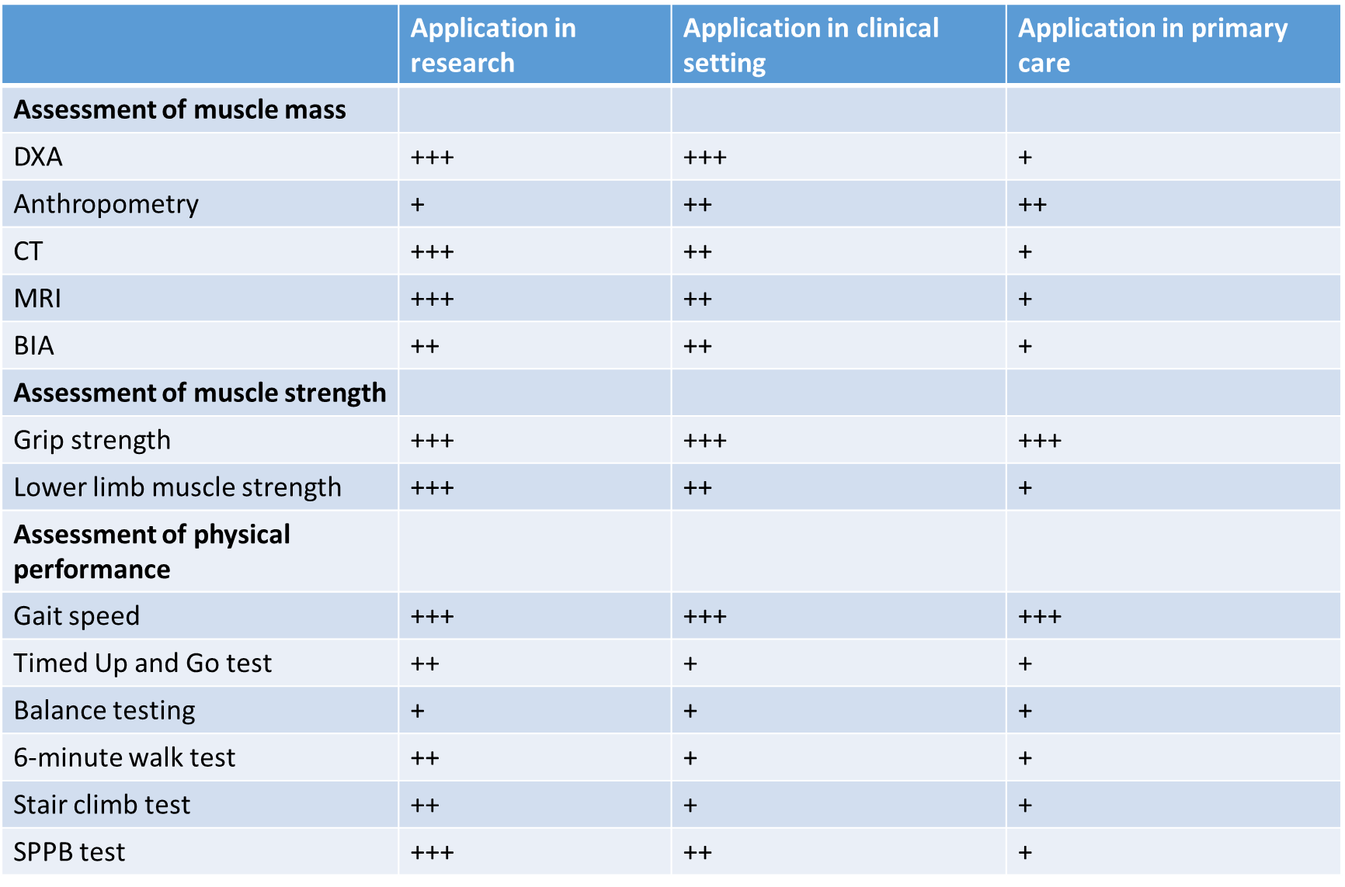

*Key: +++ (best recommended tool) or ++ (best alternative tool) or + (less recommended tool) based on the availability and the costs of the tool, the required time for the examination and the availability of robust cut-off points*

**Table 3** Depiction of methods of muscle mass, strength and physical function assessment and the composite assessments required for a short performance physical battery test. Adapted from Cooper and colleagues [11] *CSA – cross-sectional area*

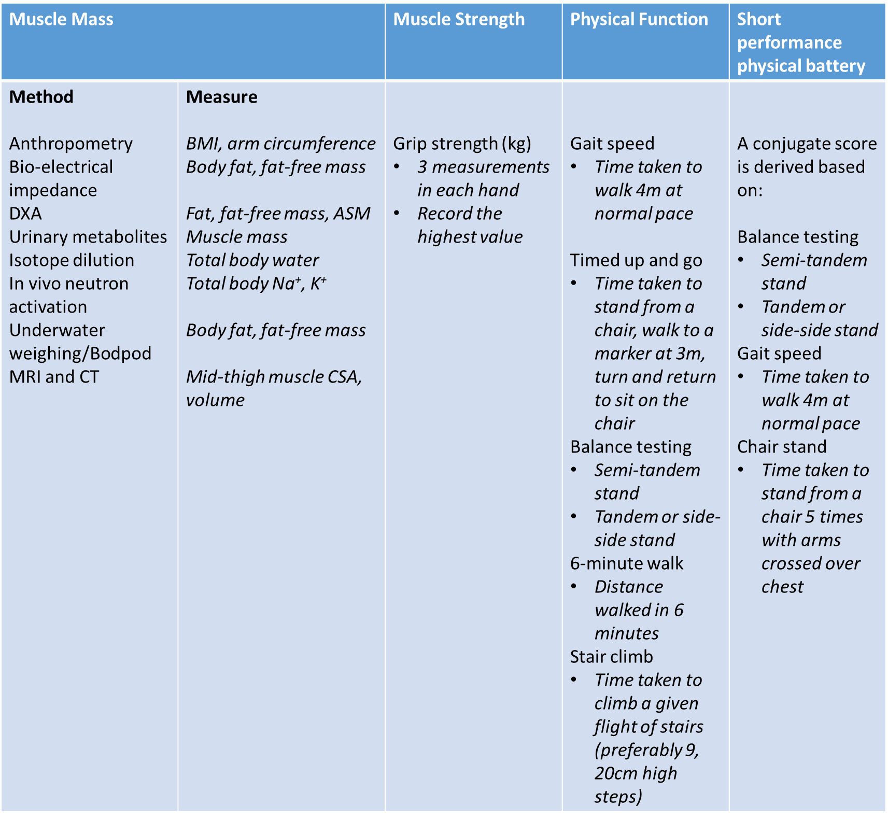

**Figure 4** A schema depicting the anabolic and catabolic factors influencing the development of sarcopenia and the interventions which could influence each factor

