Numerical Modelling on Partial Discharge in HVDC XLPE Cable

Abstract
Purpose - High voltage direct current (HVDC) cable is an important part in the electric power transmission and distribution systems. However, very little research has been carried out on partial discharge under DC conditions. Niemeyer’s model has been widely used under AC conditions. This paper intends to modify the Niemeyer’s model considering both electric field and charge dynamics under DC conditions, and therefore propose a numerical model describing partial discharge characteristics in HVDC cable.
Findings - Electrical conductivity is important in determining the characteristics of partial discharge under DC conditions and discharges tend to happen in short when the cavity field exceeds the inception level under the parameter values studied in the paper.
Research limitations – Building the numerical model is the purpose of the paper, and there is lack in experiment and the comparison between the simulation results and experiment.
Practical implications – The proposed model provides the numerical model describing partial discharge in HVDC cable and helps understand the partial discharge mechanism under DC voltage.
Value - To the best of the author’s knowledge, this paper is a very early research on the numerical modelling work on partial discharge under DC voltage.
Keywords HVDC XLPE cable, partial discharge, charge decay, electrical conductivity
Paper type Research paper

- Introduction
HVDC cable, which was first used in 1882 [Krueger, 1995; Mazzanti and Marzinotto, 2013], is an important part in the electric power transmission and distribution system [1-4]. It is becoming increasingly attractive in electric power transmission and distribution, especially in the open sea or in metropolitan areas due to its much less visual and environmental impact [Krueger, 1995; Mazzanti and Marzinotto, 2013; Zha et al., 2016; Fazal et al., 2016]. The HVDC cable is the best choice and a flexibly technical solution in long-distance sea-crossing power transmission lines in transmitting offshore power to the mainland, which helps to reduce traditional fuel consumption, limits the greenhouse gas emission and enhances the use of renewable energy.
Defects and cavities can be presented in polymeric cable insulation during two processes. First, the cavity or the defect may appear in the cross-linked polyethylene (XLPE) manufacturing or fabrication process [Jain and Bajaj, 2004]. Second, new defects can be generated during operation under the impacts of various stresses. Under high electric fields (over 15 $kV/{mm}^{}$ for polyethylene [Crine, 1997]), electrons injected into the insulation obtain energy from the applied field. When the energy of these electrons exceeds the level high enough to vaporise the Van der Waals bonds, submicrocavities appear in the insulation. The presented submicrocavities tend to coalesce, and microcavities eventually appear: inside the microcavity. Electrons can possibly obtain the kinetic energy which is strong enough to break the intermolecular bond [Shibuya et al., 1977] and produce deterioration [Morshuis and Smit, 2005]. Presence of a microcavity is harmful to the insulation, and finally results in insulation failure.
The term ‘partial discharge (PD)’ and the associated research are mainly for the activities under AC voltages [Morshuis and Smit, 2005]. The term ‘PD at DC voltage’ was proposed in the 1960s for the first time [Morshuis and Smit, 2005], and the mechanisms behind the DC PD was discussed in [Bartnikas and McMahon, 1979]. There is a lack of research on DC PD [Kim et al., 2012] in terms of theoretical understanding and tools in identifying defect types inside systems and separating noise from PD impulses. With an increasing trend of using the HVDC transmission systems, the PD research under DC voltages becomes important in helping to understand the aging process, enhance system reliability, reduce system failure, and limit the energy loss in operation in HVDC systems.
Modelling or simulation work can help to understand the effect of external factors on discharge characteristics (repetition rate and discharge magnitude) in an easier way. For PD under AC voltages, there are models, such as Pedersen’s model [Crichton et al. 1989] and Niemeyer’s model [Niemeyer, 1995; Gutfleisch and Niemeyer, 1995], published and widely accepted. On the other hand, under DC voltages, however, there is, so far, no model available for describing PD characteristics. However, considering the same mechanism of PD for both AC and DC voltage conditions, one of the possible solutions is to use the existing model for AC PD but place more emphasis on charge dynamics under DC conditions.
Recently, DC PD attracts many research interests. Many efforts are undergoing on this topic. However, until now, very few experimental observations and data of DC PDs have been acquired. Therefore, one of the major aims of this paper is to establish a preliminary model for understanding the DC PDs, which can further contribute to the experimental design and utilization by the useful guidance that are provided by the DC PD model. The Niemeyer's model has been widely accepted for AC PDs. And in this paper, the authors would like to further explore it to DC PDs by considering the charge dynamics under DC field. The differences in the processes between the internal discharge at DC voltage and that at AC voltage are discussed. Niemeyer’s model is referred to, and equations describing the calculation of electric field, amount of charge induced during the PD event and decaying between two PD activities, and the discharge occurrence probability are given. Partial discharge simulation results with the different load currents in the cable conductor are also discussed in the paper. The experimental works and validations will be addressed in future works.
- Partial Discharge Processes
Processes of partial discharge at AC voltage have been researched and published in [Niemeyer, 1995, Van Brunt, 1991] in a stochastic way. Electric field inside the cavity, or the cavity field ($\vec{E_{cav}}$), is calculated as [Niemeyer, 1995;, Bodega et al., 2002]
$$\vec{E_{cav}}=\vec{E_{app}}+\vec{E_{q}}$$ | (1)
where $\vec{E_{app}}$ is the field produced by the externally applied field inside the cavity without the discharge occurrence. At DC voltage, especially at DC steady state, $\vec{E_{app}}$ tends to be resistively distributed, and the resistance of air and XLPE surrounding the cavity are important in determining $\vec{E_{app}}$. $\vec{E_{q}}$ is the field induced by charge on the cavity surface. When the absolute magnitude of the $\vec{E_{cav}}$ exceeds the inception level, and there is at least one starting electron available inside the cavity to trigger the electron avalanche, PD happens [Morshuis and Smit, 2005; Bodega et al., 2002; Chaudhari et al., 2013].
$\vec{E_{cav}}$ drops from the occurrence field (at which PD happens) to the residual level (below which sustainable avalanche cannot be kept) [Patsch and Berton, 2001] across the discharge. $\vec{E_{cav}}$ recovers to the inception field through the combination of varying $\vec{E_{app}}$ and the charge decay between two consecutive PD activities. If the conditions for the discharge occurrence are satisfied, the process repeats.
Mechanism of PD at DC voltage with the constant magnitude and polarity is different from that at AC voltage. Firstly, the effect of $\vec{E_{q}}$ is different. Voltage polarity change takes place constantly at AC voltage, and it makes $\vec{E_{q}}$ on the cavity field more complex: it can be with the reduction effect on the cavity field if $\vec{E_{q}}$ is opposite to $\vec{E_{cav}}$ , while it is with enhancement effect when $\vec{E_{q}}$ is in the same direction as $\vec{E_{cav}}$. At DC voltage, $\vec{E_{q}}$ keeps reducing the cavity field due to the constant magnitude and polarity of the applied field.
Secondly, the charge decay process between two consecutive activities is different. At AC voltage, surface charges decay in three ways [Illias, 2011], namely the charge recombination on the cavity wall, charge trap on the cavity surface and charge propagation into the insulation bulk, and recombination is dominant. At DC voltage, however, charge recombination due to charge propagation along the cavity wall can hardly happen as $\vec{E_{cav}}$ is always in the same direction as $\vec{E_{q}}$. $\vec{E_{q}}$ in Equation (1) therefore represents the field vector induced by charge on the cavity surface and accumulated in the insulation bulk. The absolute magnitude of $\vec{E_{q}}$ decreases as field strength produced by the charge is reversely related to the square of distance from the cavity centre.
Thirdly, the variation in $\vec{E_{cav}}$ is different. The absolute magnitude of $\vec{E_{app}}$ at DC voltage is constant, and the change in $\vec{E_{q}}$ is therefore the only source recovering the cavity field from the residual level at the end of the previous event to the inception level to trigger the following event. DC PD activities are consequently much less frequent.

- Numerical Calculation
There is still no published model describing PD at DC voltage, and it is therefore expected that the published AC PD model is applicable in describing the internal PD characteristics at DC voltage: the cavity is always in a transition stage with the PD occurrence.
L. Niemeyer produced and published a numerical model, namely Niemeyer’s Model, in 1995 [Niemeyer, 1995]. With proper settings of the parameter values, simulation results agree with those from the experiments in PD patterns, discharge magnitude and discharge repetition rate. Niemeyer’s Model is applicable for both fresh or long-time aged insulators [Niemeyer, 1995; Gutfleisch and Niemeyer, 1995]. The model has been selected for our simulation in this paper.
A single air-filled spherical cavity is located in the insulation layer. Temperature and gas pressure of the cavity are assumed to vary little with PD activities as the time interval is long. In the following part, the important equations involved in the modelling work are listed.
Inception field calculation
The inception field ($E_{inc}$) is given as [Niemeyer, 1995]
$$E_{inc}={(E/p)}_{cr}p[1+\frac{B}{{(2pR_{c})}^{n}}]$$ | (2)
where ${(E/p)}_{cr}$ is the critical value of pressure reduced electric field, $p$ is the gas pressure, and $B$ and $n$ are parameters in streamer criterium [Niemeyer, 1995; Gutfleisch and Niemeyer, 1995]. $R_{c}$ is the cavity radius. As both gas pressure and cavity size are assumed to be constant, the inception level is set to be equalling to 3$kV/{mm}^{}$, the breakdown strength of air at atmosphere pressure [Góngora-Nieto et al., 2003].
$\vec{E_{q}}$ calculation
Electric field produced by charges on the cavity surface is calculated as [Gutfleisch and Niemeyer, 1995]
$$E_{q}=\frac{q_{s}}{ε_{0}π{R_{c}}^{2}[1+ε_{r}(K-1)]}$$ | (3)
where $q_{s}$ is the amount of charges on the cavity surface, and $K$ is the geometry coefficient [Crichton et al., 1989; Gutfleisch and Niemeyer, 1995]. $ε_{r}$ is the relative permittivity value of the dielectric surrounding the cavity.
Residual field calculation
Residual field level is dynamic: it is lower under higher cavity field as electrons obtain higher kinetic energy from the field, and avalanche extinguishes at lower level.
$$∆v=v\left(θ\right)-v_{s∞}$$ | (4)
$$v_{r}=v_{rmin}+(v_{s∞}-v_{rmin})exp⁡(\frac{-∆v}{v_{s∞}-v_{rmin}})$$ | (5)
where $∆v$ and $v_{r}$ represent over-voltage and dynamic residual voltage. $v\left(θ\right)$ is the cavity voltage at the phase angle $θ$, $v_{s∞}$ is the inception voltage and $v_{rmin}$ is the minimum residual voltage [Hikita et al., 1990]. As the electric field strength inside the cavity is nearly uniformly distributed, and the cavity geometry is assumed unchangeable, all voltage parameters in
Equation (5) can be replaced by the associated field factor:
$$E_{r}=E_{rmin}+(E_{s∞}-E_{rmin})exp⁡(\frac{-E_{over}}{E_{s∞}-E_{rmin}})$$ | (6)
Charges associated with the partial discharge
Real charge induced inside the cavity is calculated as [Gutfleisch and Niemeyer, 1995]
$$q=πε_{0}{R_{c}}^{2}[1+ε_{r}(K-1)]∆E$$ | (7)
where $∆E$ is the electric field collapsed in discharge.
Another process leading to the variation of amount of charges on the cavity surface is the charge decay between two consecutive activities. Fig. 1(a) shows the charge propagation in the bulk at DC voltage taking the positive charges as the example, and Fig. 1(b) illustrates the variation in the amount of charge in each layer. In the modelling work, a region with two times the cavity radius is selected out for analysis. The region is uniformly divided into 20 layers of the same thickness.
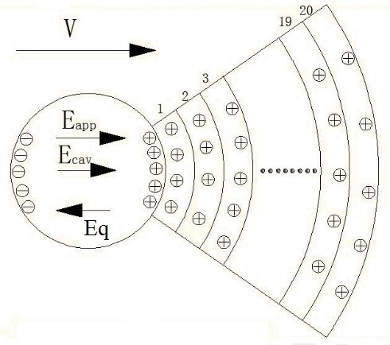
(a)
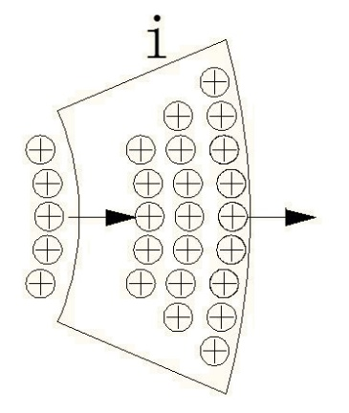
(b)
Fig. 1. (a) Charge migration into bulk of insulation. (b) Charge accumulation at a single layer.
The number of charges on each layer is the sum of charges accumulated on the layer before the charge decay process at the time point and the amount of charge decayed from the previous layer (or from cavity surface for the first layer) subtracting the charge migrating into the next layer [shown in Fig. 1(b)]. The amount of charge of the $ith$ layer at time t, $Q_{t}$, is calculated as [Van Brant, 1994]
$$Q_{t}=Q_{t-∆t}+j_{i-1}S_{i-1}∆t-j_{i}S_{i}∆t$$ | (8)
and charge on the cavity wall is calculated as
$$Q_{t}=Q_{t-∆t}-j_{1}S_{1}∆t$$ | (9)
where $Q_{t-∆t}$ is the number of charges prior to the decay process. $j$ is the average current density of the layer, and the value can be extracted from COMSOL. $S$ is the area of surface between the two consecutive layers. The importance of electrical conductivity and resistance of XLPE in determining charge decay phenomenon at DC voltage is seen from Equations (8) and (9) as electrical conductivity determines the current density level.

Partial discharge occurrence probability calculation
Starting electron generation is two-folds, namely surface emission and volume generation. Considering surface emission, including electrons detrapped from traps inside the insulation, released via ion impact, field emission from the electrode and surface photo effect, surface emission is satisfied with the Richardson-Schottky scaling. [Crichton, et al., 1989]:
$$N_{e1}=N_{∆t}f_{p}exp⁡(-\frac{ϕ-\sqrt{E/{(4πε_{0})}}}{k_{b}T})$$ | (10)
where $N_{e1}$ is the surface emission rate, $N_{∆t}$ is the number of detrapped electrons, $f_{p}$ is the fundamental phonon frequency, $ϕ$ is the work function, $E$ is cavity field, $k_{b}$ is the Boltzmann constant and $T$ is the temperature inside the cavity.
The probability of electron generation per second from volume generation, including electron detachment from negative ions and radiative gas ionization, is calculated as follows [Crichton, et al., 1989]:
$$N_{e2}=η_{i}pV_{eff}(1-\frac{η}{α})$$ | (11)
where $N_{e2}$ is the generation rate of the first starting electron from the volume generation, $η_{i}$ is the function describing radiative ionisation mechanism, and $V_{eff}$ is the effective ionisation volume. $η$ is gas attachment coefficient and $α$ is the gas ionisation coefficient.
Consequently, PD occurrence probability is expressed as follows [Van Brant, 1994]:
$$probability=1-exp⁡(-N_{e}Δt)$$ | (12)
where $Δt$ is the time period since the last discharge. $N_{e}$ is the starting electron generation rate, which is the sum of $N_{e1}$ and $N_{e2}$. To indicate the occurrence of partial discharge, the value of probability is compared with a positive random number between 0 and 1: if the probability value is higher, discharge happens.

- Electrical Conductivity Expression
At DC voltage, electrical conductivity is important in determining the electric field distribution at steady state as it is resistively graded [He et al., 2016]. The value is field- and temperature-dependent [Boggs et al., 2001]:
 | $$σ\left(E,T\right)=Aexp(\frac{-φq}{k_{b}T})\frac{sinh⁡(B\left|E\right|)}{E}$$ | (13)
where A and B are constants in the units of $A/m^{2}$ and $m/V^{}$, $φ$ is the thermal activation energy in eV, and $q$ is the elementary charge. $T$ is the local temperature (K) and $E$ is the field strength ($V/m^{}$). All parameters are practically measured for both fresh XLPE and long-time degraded XLPE.
- Simulation Processes
COMSOL is a software used for solving the model via finite element analysis (FEA). Partial differential equation (PDE) solutions are first found, and the solutions are rendered into equivalent ordinary differential equations to be solved via standard techniques, such as the Newton-Raphson iteration method.
The voltage profile used has a constant magnitude and polarity after a linear ramping stage. Time interval in the ramping stage should be different from that in the constant stage as PD tends to happen much more frequently due to the increase in $\vec{E_{app}}$ magnitude. Time interval in the ramping stage should be much shorter than that in the constant stage. For the balance between the modelling accuracy and the simulation time consumption, partial discharge duration is short, and it is set to be 10 micro-seconds. The whole simulation time length is 10 hours (36000s) to make sure that the cable is at steady state for sufficiently long.
The flow chart is illustrated in Fig. 2. $t_{_ramp}$ is the time length of the ramping stage and $t_{_simulation}$ is the time length of the whole simulation process. $t_{_ramp_step}$ is the time step used in the ramp stage without PD occurrence, $t_{_step}$ is the time step in the constant voltage stage without PD occurrence, and $t_{_PD_step}$ is the time step used across the discharge. The parameter q includes the charge induced across the discharge (discharge magnitude) and charge on the cavity surface.
For the sake of simplicity, the thermal model used in this work is Joule heating model, the cable conductor is modelled as the heat source and the outer temperature of the cable is fixed to the ambient temperature. The temperature gradient across the cable insulation is calculated according to the parameters of the materials based on Joule heating model.

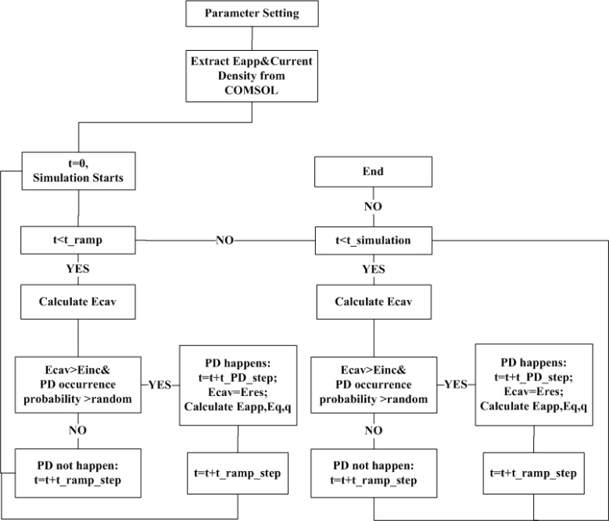
Fig. 2. Flow chart for the modelling work.
- Data list
Values of the parameters used in the simulation are listed in
Table. 1. Time interval between two PD events is long, and the present discharge event is therefore with little influence on the gas temperature and pressure of the following event. Electrical conductivity of air is therefore assumed to be constant [He et al., 2016; Alisov et al., 2005; Alisov et al., 2004].
Table. 1. Parameters used for DC PD simulation [Gutfleisch and Niemeyer, 1995; He et al., 2016; Boggs et al., 2001; ABB’s high voltage cable unit Sweden, 2006; Johansson and Sandberg, 2010]
Name | Value | Description
$$V$$ | 150 | Applied voltage. Unit: kV
Ramp | 5.3 | The ramp value. Unit: $kV.s^{-1}$
$$R_{i}$$ | 18 | Inner insulation radius. Unit: mm
$$R_{o}$$ | 27 | Outer insulation radius. Unit: mm
$$R_{c}$$ | 1 | Cavity radius. Unit: mm
$$t_{_ramp_step}$$ | 0.01 | Time step in the ramp stage. Unit: s
$$t_{_step}$$ | 1 | Time step in the constant voltage stage. Unit: s
$$t_{_PD_step}$$ | $${10}^{-8}$$ | Time step across the discharge. Unit: s
$$T_{o}$$ | 301.15 | Outer temperature. Unit: K
$$L$$ | 1 | Cable length. Unit: m
$$ε_{r}$$ | 2.3 | Relative permittivity.
$$f_{p}$$ | $${10}^{14}$$ | Fundamental phonon frequency. Unit: Hz
$$ϕ$$ | 1 | Effective work function.  Unit: eV
$$σ_{air}$$ | $$1×{10}^{-16}$$ | Conductivity of air without PD occurrence. Unit: $S.m^{-1}$
I | 1, 2, 4 | Current through conductor. Unit: kA
$$A$$ | 3.2781 | Constant Unit: $A.m^{-2}$
$$B$$ | $$2.7756×{10}^{-7}$$ | Constant Unit: $m.V^{-1}$
$$φ$$ | 0.56 | Thermal activation energy  Unit: eV
- Results
Electrical conductivity tends to be the key factor influencing the PD characteristics. Located in the middle of insulation, $\vec{E_{cav}}$ at steady state is nearly constant and the level is nearly independent of the current through the conductor (shown in Fig. 3) [He et al., 2016; Fothergill, 2014]. Effect of $\vec{E_{cav}}$ is greatly reduced, and the influence of electrical conductivity is explored.
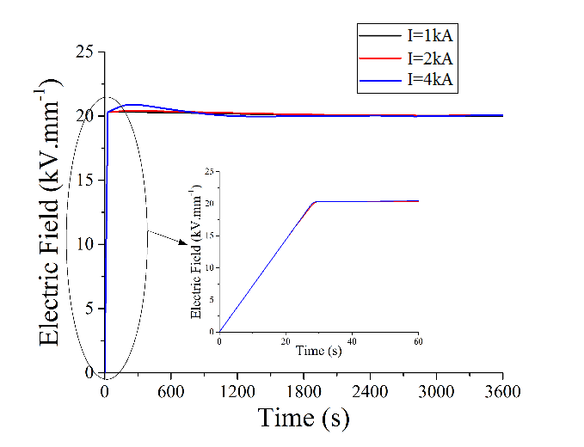
Fig. 3. Variation of cavity field with time.
Fig. 4 shows the cavity field variation with time when the conductor current is 2 kA. It seems that the discharge tends to happen once the cavity field exceeds the inception field. It is due to the high starting electron generation probability. Field produced by the charges on the cavity surface and in the insulation bulk can be around 17$kV/{mm}^{}$ at the inception level, and the number of charges available for the starting electron generation is large [Gutfleisch and Niemeyer, 1995].
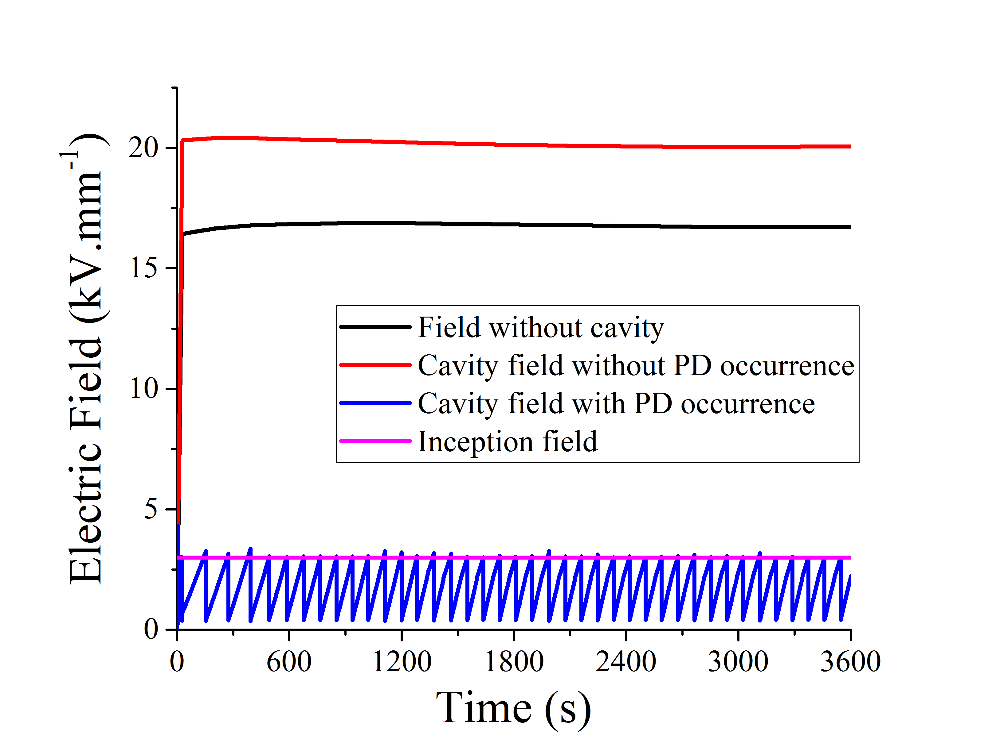
(a)
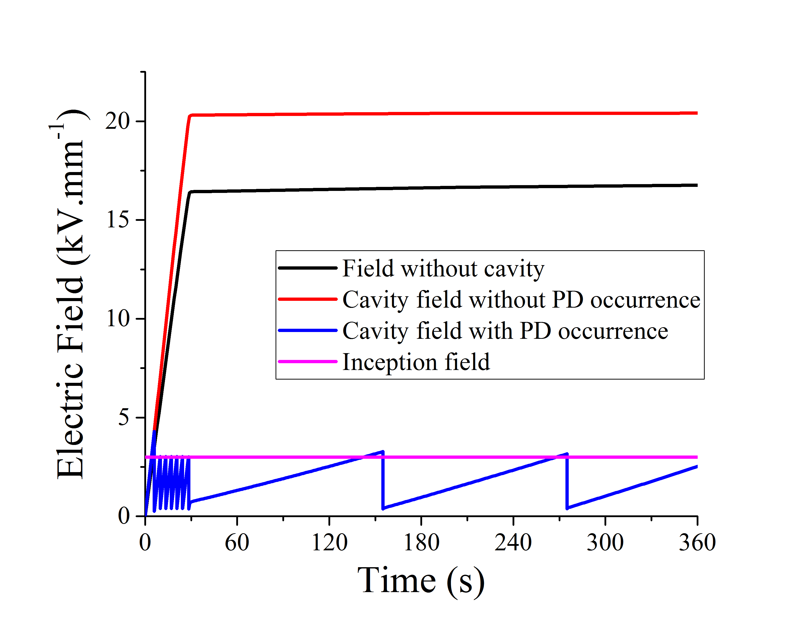
(b)
Fig. 4. Cavity field across the simulation process ($I=2kA$) for (a) 3600s, and (b) 360s.
The number of discharge activities is 421. Time interval between two activities at steady state is around 86.54s (maximum at 126.62s and minimum at 82s), which is much longer and the rate at DC voltage is lower. The reason for the long time interval is the constant applied field and slow charge decay between two activities at DC steady state.
The relationship between the discharge magnitude and time is plotted in Fig. 5. The induced charge with a high discharge magnitude (628.60 pC) is created across the first event. It agrees with the phenomenon given in [Christophorou and James, 1994] that the first discharge at AC voltage happens at the time point of the quarter of AC period, where the both the applied voltage magnitude and discharge magnitude reach the peak value. The reason is that lag time for the first discharge is long due to no charge on cavity surface available for the starting electron generation, and the occurrence field is the highest.
From the 6 mins figures (Fig. 4(b)) or 1 min figure (Fig. 5(b)) that discharge tends to happen much more frequently at the ramping stage. The reason is that in the ramping stage, E_{app} in Equation (1) keeps increasing and it helps in recovering the cavity field to the inception level. In steady state, E_{app} in Equation (1) is constant, and the variation in E_{q} in Equation (1), which is slow, is the only reason for the cavity field recovery.
Another interesting point is that except for the first event, PD tends to happen nearly instantly once the cavity field exceeds the inception field. The reason is that E_{app} in Equation (1) is nearly constant at a high level (around 20kV/mm), and the level of E_{cav} cannot exceed inception field (3kV/mm) for long with discharge taken into consideration. Therefore, E_{q} can be as high as 17kV/mm. Accordingly, there are huge amount of charge available for being the starting electron. According to Equations (10)-(12), probability in PD occurrence probability is with high possibility in exceeding the random value. Therefore, PD tends to happen instantly once the cavity field level is higher than the inception field level.
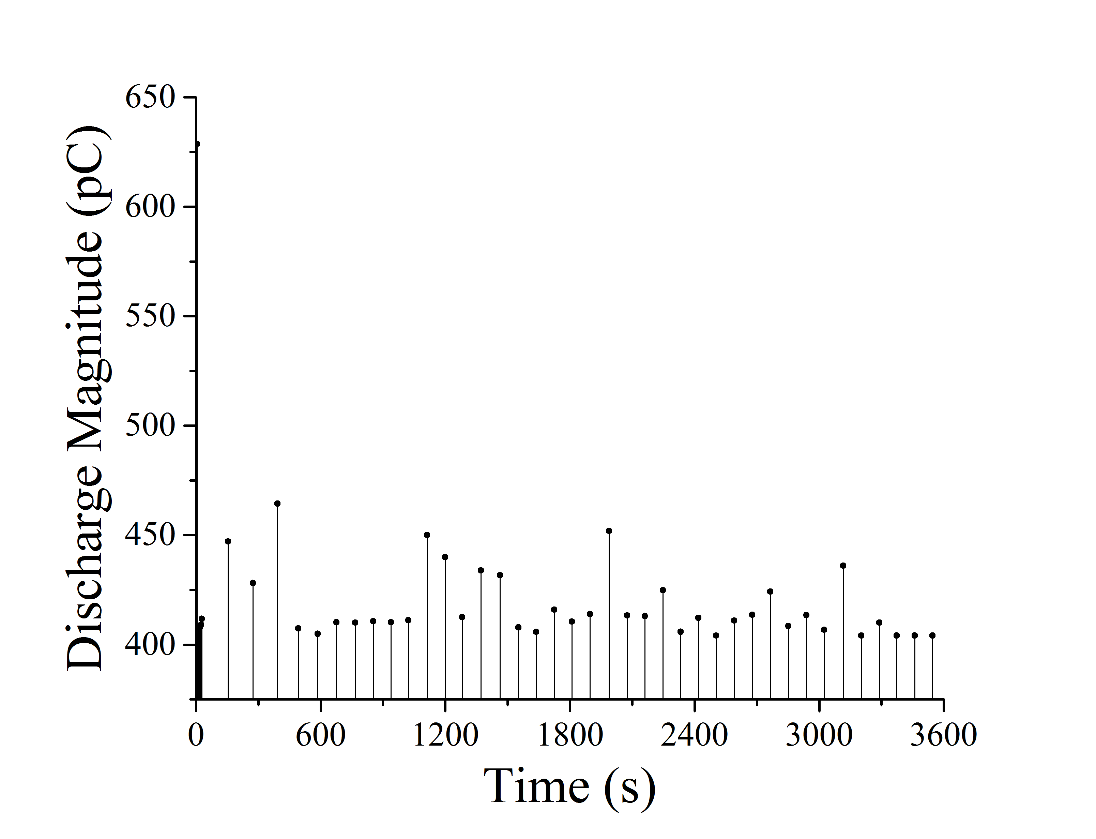
(a)
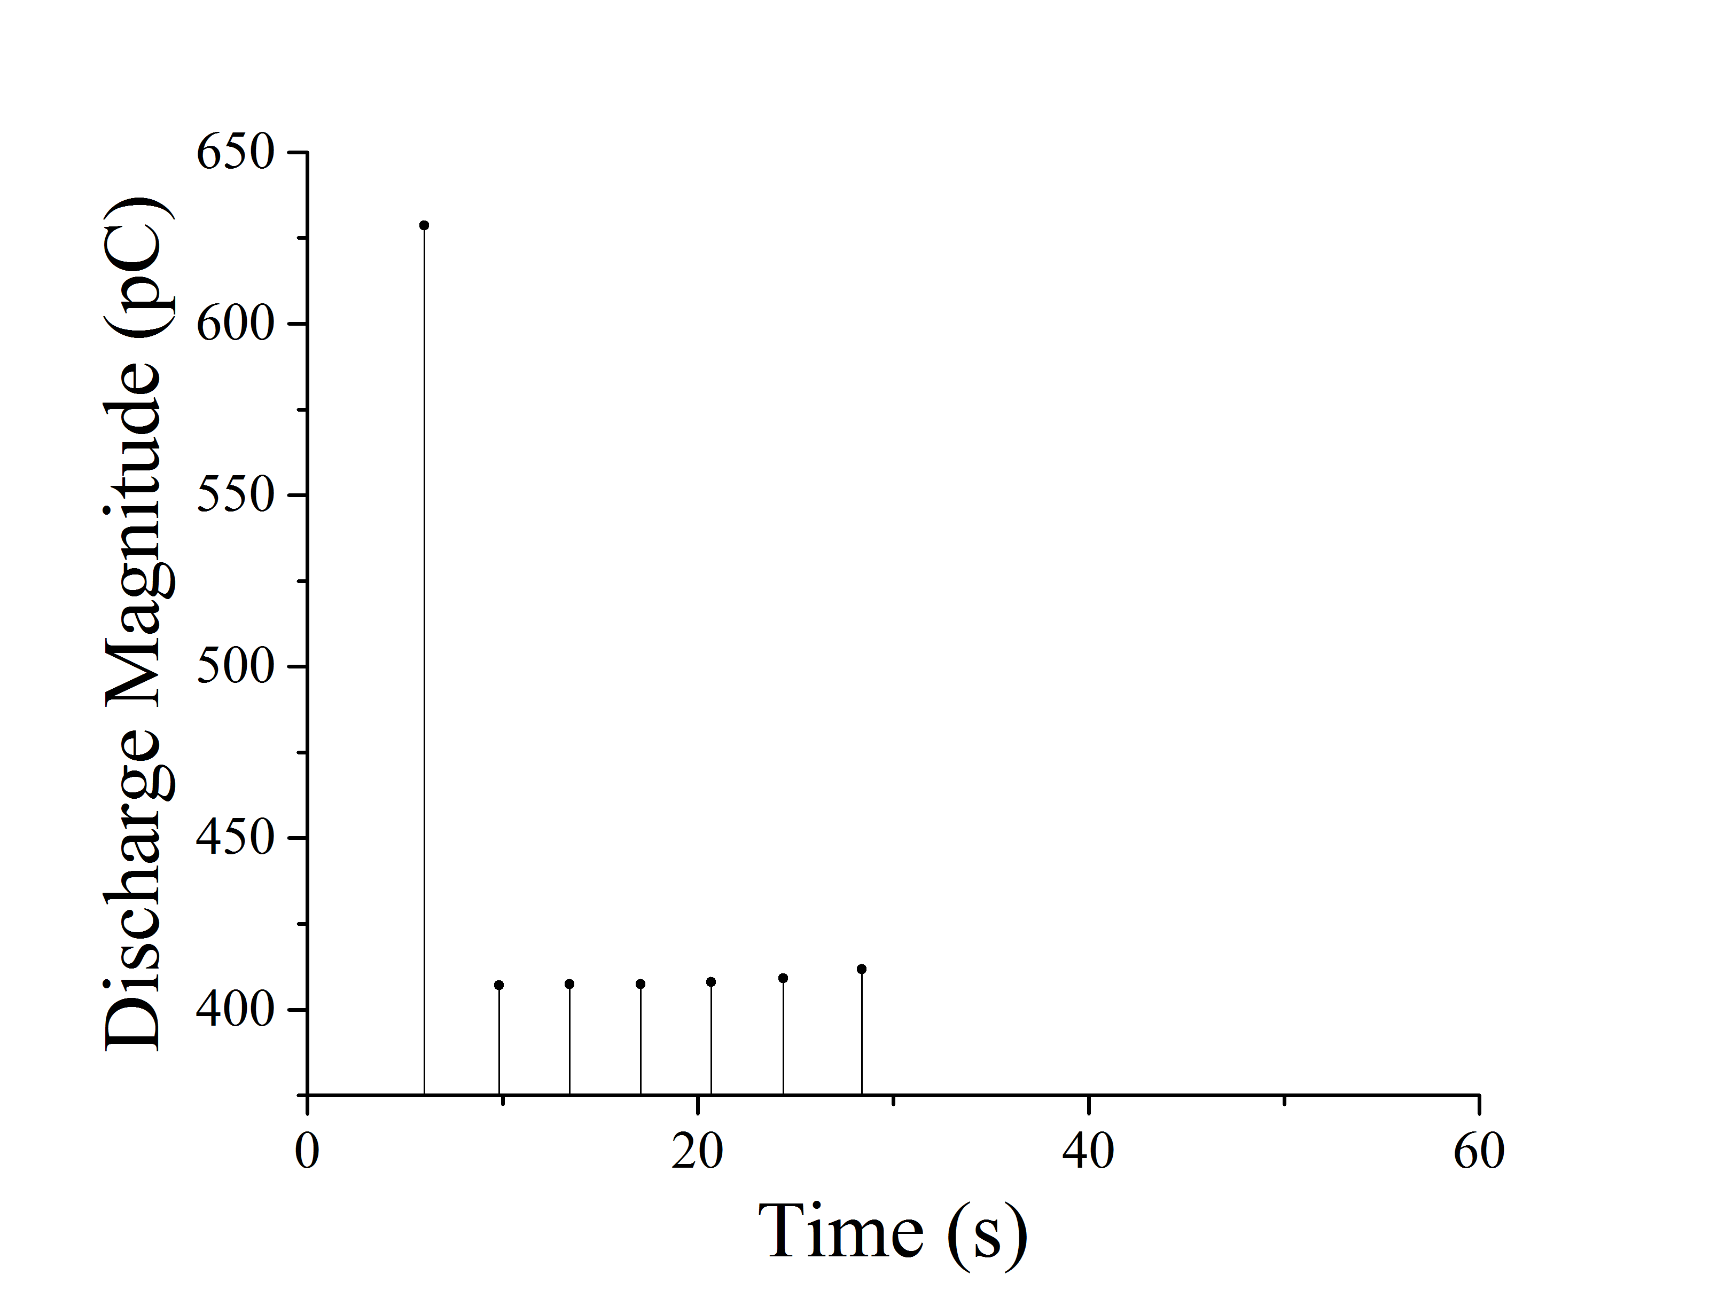
(b)
Fig. 5. Discharge magnitude across the simulation process ($I=2kA$) for (a) 3600s, and (b) 60s.
Discharge characteristics variation with current is listed in Table. 2. PD becomes much more frequent under higher current level. As the value of $\vec{E_{cav}}$ is nearly constant, electrical conductivity, whose level determines the charge decay rate, tends to be the key factor. The reason that conductor current is with effect on discharge magnitude is its influence on electrical conductivity. The higher the current is, the warmer the insulation can be. Electrical conductivity of insulation is an electric field- and temperature-dependent factor, and higher current leads to higher electrical conductivity. Under higher current and therefore higher electrical conductivity, charge decay faster, and the cavity field increases faster. Discharge occurrence is random, and the occurrence probability is calculated when the cavity field is higher than the inception field. Time interval for simulation is 1s at DC steady state. Therefore, PD occurrence field can be higher if the charge decay time equals. For example, assuming that discharge happens after 3s after the cavity field exceeds the inception level, PD occurrence field of the higher current is higher than that of lower current, and discharge magnitude is higher. It can be seen from Table. 2 that the average magnitude is highest for $I=4$kA.
Table. 2. PD Characteristics with current variation
 | $$1kA$$ | $$2kA$$ | $$4kA$$
PD Number in Constant Stage | 312 | 421 | 1199
Average Time Interval at Constant Stage (s) | 117.8 | 86.7 | 30.2
Average Discharge Magnitude (pC) | 407.8 | 408.2 | 411.36

- Conclusions
A preliminary modelling work is studied in this paper. The difference between the partial discharge at DC voltage and that at AC voltage is mainly due to the effect of the field produced by the charge on the cavity surface, charge decay processes and the way through which the cavity field recovers to the inception field from the residual field: at DC voltage, the field produced by the charge on the cavity surface keeps reducing the cavity field, charge migration through the insulation bulk is the source of charge decay, and charge decay is the only method through which the cavity field exceeds the inception field again to trigger the discharge.
Niemeyer’s model, which is published and accepted at AC voltage, is expected to be applicable for partial discharge at DC voltage. COMSOL is the software through which the cavity field without PD occurrence, and the current density is extracted.
Results of the paper indicate that electrical conductivity, and therefore the current density, is the key factor determining the discharge characteristics at DC voltage. Discharge tends to happen in a short time once the cavity field is higher than the inception field. Higher electrical conductivity value results in higher discharge repetition rate, shorter time interval, and higher average discharge magnitude. However, compared to the time interval at AC voltage, the value at DC voltage is much longer. Further works will also focus on the experimental validation of this proposed model.
References
ABB’s high voltage cable unit Sweden (2006), “HVDC Light Cables: Submarine and land power cables”, pp.5.
Alisoy, G., Alisoy, H., Rustamov, S. and Arkan. M. (2004) “Internal ionization process in polymer dielectrics in strong electrical field” Journal of Physica A: Statistical Mechanics and its Applications, Vol. 335 No. 1–2, pp. 59-69.
Alisoy, G., Alisoy, H., and Koseoglu, M. (2005) "Calculation of electrical field of spherical and cylindrical gas voids in dielectrics by taking surface conductivity into consideration", Journal of COMPEL, Vol. 24 No. 4, pp.1152-1163.
Bartnikas, R. and McMahon, E. (1979), Engineering dielectrics (1st ed.), ASTM, Philadelphia.
Bodega, R., Cavallini, A., Morshuis, P. and Wester, F. (2002) "The effect of voltage frequency on partial discharge activity", in 2002 Annual Report Conference on Electrical Insulation and Dielectric Phenomena (CEIDP2002) in Cancun, Quintana Roo, Mexico, 2002, pp. 685-689.
Boggs, S., Damon, D., Hjerrild, J., Holboll, J. and Henriksen, M. (2001), "Effect of insulation properties on the field grading of solid dielectric DC cable", Journal of IEEE Transactions on Power Delivery, Vol. 16 No. 4, pp. 456-461.
Chaudhari, Y., Bhosale, N. and Kothoke, P. (2013), "Composite Analysis of Phase Resolved Partial Discharge Patterns using Statistical Techniques," Journal of International Journal of Modern Engineering Research (IJMER), Vol. 3 No. 4, pp. 1947-1957.
Christophorou, L. and James, D. (1994), Gaseous dielectrics VII (1st ed.), Plenum Press, New York.
Crichton, G., Karlsson, P. and Pedersen, A. (1989), "Partial discharges in ellipsoidal and spheroidal voids", Journal of IEEE Transactions on Electrical Insulation, Vol. 24 No. 2, pp. 335-342.
Crine, J. (1997), "A molecular model to evaluate the impact of aging on space charges in polymer dielectrics", Journal of IEEE Transactions on Dielectrics and Electrical Insulation, Vol. 4 No. 5, pp. 487-495.
Fazal, A., Hao, M., Vaughan, A., Chen, G., Cao, J. and Wang, H. (2016), "The effect of composition and processing on electric characteristics of XLPE in HVDC cable applications", in IEEE Electrical Insulation Conference (EIC) in Montréal, Québec, 2016, pp. 440-443.
Fothergill, J. (2014), "The coming of Age of HVDC extruded power cables", in 2014 IEEE Electrical Insulation Conference (EIC) in Philadelphia, USA, 2014, pp. 124-137.
Góngora-Nieto, M., Pedrow, P., Swanson, B. and Barbosa-Cánovas, G. (2003), "Impact of air bubbles in a dielectric liquid when subjected to high field strengths", Journal of Innovative Food Science & Emerging Technologies, Vol. 4 No. 1, pp. 57-67.
Gutfleisch, F. and Niemeyer, L. (1995), "Measurement and simulation of PD in epoxy voids", Journal of IEEE Transactions on Dielectrics and Electrical Insulation, Vol. 2 No. 5, pp. 729-743.
He, M., Chen, G. and Lewin, P. (2016), "Field distortion by a single cavity in HVDC XLPE cable under steady state", Journal of High Voltage, Vol. 1 No. 3, pp. 107-114.
Hikita, M., Yamada, K., Nakamura, A., Mizutani, T., Oohasi, A. and Ieda, M. (1990), "Measurements of partial discharges by computer and analysis of partial discharge distribution by the Monte Carlo method", Journal of IEEE Transactions on Electrical Insulation, Vol. 25 No. 3, pp. 453-468.
Illias, H. (2011), “Measurement and simulation of partial discharges within a spherical cavity in a solid dielectric material.”, Doctoral Thesis, Electronics and Computer Science School, University of Southampton, 236pp.
Jain, V. and Bajaj, A.(2004), A textbook of design of electrical installations (1st ed.), LAXMI PUBLICATIONS(P) LTD, New Delhi.
Johansson A. and Sandberg, A. (2010), “Detection of Electrical Treeing in XLPE Exposed to AC and DC Stress”, Diploma work in the Master programme of Electric Power Engineering, Department of Materials and Manufacturing Technology Chalmers University of Technology, pp. 70.
Kim, J., Kim, D., Nam, K., Choi, W., Lee, B. and Koo, J. (2012), "Characteristics of partial discharge by AC and DC", in 2012 IEEE International Conference on Condition Monitoring and Diagnosis in Bali, Indonesia,2012, pp. 489-492.
Kimbark, E. (1971), Direct current transmission (1st ed.), iley-Interscience, New York.
Krueger, F. (1995), Industrial High DC Voltage, Delft University Press, Delft.
Mazzanti, G. and Marzinotto, M. (2013), Extruded cables for high-voltage direct-current transmission (1st ed), IEEE Press , Piscataway, NJ.
Morshuis, P. and Smit, J. (2005), "Partial discharges at dc voltage: their mechanism, detection and analysis", Journal of IEEE Transactions on Dielectrics and Electrical Insulation, Vol. 12 No. 2, pp. 328-340.
Niemeyer, L. (1995), "A generalized approach to partial discharge modeling", Journal of IEEE Transactions on Dielectrics and Electrical Insulation, Vol. 2 No. 4, pp. 510-528.
Patsch, R. and Berton, F. (2001), "Pulse Sequence Analysis - a diagnostic tool based on the physics behind partial discharges", Journal of Physics D: Applied Physics, Vol. 35 No. 1, pp. 25-32.
Shibuya, Y., Zoledziowski, S. and Calderwood, J. (1977), "Void formation and electrical breakdown in epoxy resin", Journal of IEEE Transactions on Power Apparatus and Systems, Vol. 96 No. 1, pp. 198-207.
Van Brunt, R. (1991), "Stochastic properties of partial-discharge phenomena", Journal of IEEE Transactions on Electrical Insulation, Vol. 26 No. 5, pp. 902-948.
Van Brunt, R. (1994), "Physics and chemistry of partial discharge and corona. Recent advances and future challenges", Journal of IEEE Transactions on Dielectrics and Electrical Insulation, Vol. 1 No. 5, pp. 761-784.
Zha, J., Wu, Y., Wang, S., Wu, D., Yan, H., and Dang, Z. (2016) "Improvement of space charge suppression of polypropylene for potential application in HVDC cables", Journal of IEEE Transactions on Dielectrics and Electrical Insulation, Vol. 23 No. 4, pp. 2337-2343.

