Analysis of driver roles: Modelling the changing role of the driver in automated driving systems using EAST

Victoria A. Banks¹ and Neville A. Stanton*²
¹Human Factors Research Group, University of Nottingham, UK.
²Transportation Research Group, Boldrewood Innovation Campus, Faculty of Engineering and the Environment, University of Southampton, Burgess Road, Southampton, SO16 7QF, UK.
* corresponding email: n.stanton@soton.ac.uk

The purpose of this paper is to analyse the role of the driver within automated driving systems using the Event Analysis of Systemic Teamwork (EAST) method. We already know that as the level of automation increases within the driving task, the role of the driver shifts from that of an active operator (i.e. a Driver Driving) to more of a passive monitor (i.e. a Driver Monitoring). Task, social and information networks were constructed using the Hierarchical Task Analysis of Driving and evidence from driver verbalisations collected during a previous study to further explore the changing role of the driver using network analysis. A ‘broken links’ approach was conducted to show that momentary engagement in non-driving related secondary tasks within an automated driving system can dramatically change the structure of driving system.
Key words: Automation; driver roles; event analysis of systemic teamwork; network analysis.

Introduction
There have been rapid developments in automotive automation over the past decade whereby partial and fully automated vehicles are reaching a point where widespread deployment is feasible (National Highway Traffic Safety Administration; NHTSA, 2016). It is expected that by the end of 2016, NHTSA will publish best-practice guidelines on establishing principles of safe operation for vehicles operating at Level 4 ‘full’ automation. Fully autonomous cars promise to deliver abundant socioeconomic advantages (Casner et al, 2016) including improvements to traffic flow, mobility and significantly improve road safety. With 90% of accidents being attributable to driver error (Smiley and Brookhuis, 1987; Stanton and Salmon, 2009), vehicle manufacturers may have good reason to remove drivers from active control. There are of course other benefits of ‘driverless’ vehicles and this is to give vehicle occupants time to engage in other tasks not related to driving (Fagnant and Kockelman, 2015). This is seen as one of the main drivers for market implementation to improve comfort and convenience. According to the Department for Transport (2015), UK drivers spend, on average, 235 hours a year behind the wheel. This equates to approximately six working weeks where the driver has no spare capacity to engage in other tasks. The advent of fully automated vehicles could therefore completely transform our experience of driving and provide the driver with additional productive time (making the journey similar to taking public transport – without the drawbacks).
The human factors issues pertaining to vehicle automation have been speculated about since the 1970’s (Sheridan, 1970). Simply removing the driver from the control-feedback loop and eliminating their responsibility over safe vehicle operation does not however warrant human factors completely redundant. Instead, vehicles operating at increased levels of autonomy with “self-driving” capabilities open up new avenues of investigation. Some of these avenues are explored within this paper.
Levels of automation and the role of the driver
Automation of the driving task brings with it a shift in the role and responsibilities of the human driver. Within the literature, Kaber & Endsley (2004) captured this idea eloquently by explaining that the role of the driver shifts from one of active operation to more of a passive monitor as the level of automation increases. Within industrial practice, the role and responsibilities of the driver are alluded to, but not explicitly described, in automation taxonomies. The Society for Automotive Engineers (SAE; 2015), National Highway Traffic Safety Administration (NHTSA, 2013) and BASt Expert Group (Gasser, 2014) have all developed their own versions of automated driving taxonomies. These are often used interchangeably within the literature which can lead to confusion about what the driver can and can not do under different levels of automation within the driving system. SAE went some way in trying to standardise these descriptions (SAE J3016). Even so, in any instance whereby a Take-Over Request is issued or indeed possible, the driver is expected to be able to regain control of the vehicle and resume their traditional driving role. As long as the driver remains in the control-feedback loop, which would be the case for any system whereby control transitions may be made between the automated system and driver, an acknowledgement of their role and how they can be supported back into their traditional driving role remains an important area of investigation (Eriksson and Stanton, 2017). Thus, we cannot assume that at higher levels of automation, the driver or human element will no longer be required. This is because any potential for a take-over request to be issued implies that: 1) the vehicle does not offer full “self-driving” functionality and 2) the driver should be able to regain control of the vehicle as maybe required by the situation and/or operational limits of the system.
We also cannot overlook the fact that individuals may even want to resume control from the vehicle at some point. Thus, increasing levels of autonomy in driving does not eliminate all of the human factors issues that are typically associated with lower levels e.g. Level 2 and 3. We already know from the literature that automation within the driving task can lead to decreased situation awareness (Stanton and Young, 2005; Stanton et al, 2011), erratic changes to driver workload (Stanton et al, 1997; Young and Stanton, 2002, 2004; de Winter et al, 2014, 2016), skill degradation (Stanton and Marsden, 1996) and issues relating to trust (Walker et al, 2016), overreliance and complacency (Stanton, 2015). It seems likely that some, if not all of these, will remain enduring challenges for systems designers as long as the driver remains within the control-feedback loop to some extent. This means that strategies for transferring control back to the driver after prolonged periods of autonomous driving must be carefully designed to ensure that they have appropriateness levels of situation awareness and are deemed capable of regaining control of the vehicle. The entire spectrum of driver responsibilities and workload should be considered in delivering an effective ‘hand-over’ between the driver and autonomous vehicle.
With this in mind, it is becoming increasingly important to acknowledge the role of the driver within an automated driving system. There are many lessons that can be taken from the field of aviation as we increasingly see the role of the driver becoming analogous to the role of a pilot (Stanton and Marsden, 1996). In aviation, Hutchins (1995) described two roles in which the pilot can serve; Pilot Flying (PF) and Pilot Not Flying (PNF). Whilst the PF is responsible for overall control of the plane, the PNF is responsible for communicating with Air Traffic Control and aircraft systems as well as completing all of the checklists that are required during each phase of flight. Thus the burden of responsibility simply changes rather than being reduced. In recognition of the changing responsibilities of the PNF, the Federal Aviation Administration (FAA; 2003) altered the terminology of PNF to that of Pilot Monitor (PM). In the same way, a Driver Driving (DD) would be responsible for overall control of the vehicle and represents the traditional role of the driver, whilst a Driver Monitor (DM) would assume a similar role to that of Pilot Monitor. The latter role is to monitor the behaviour of the vehicle and automated subsystems to ensure safe and normal driving practice is maintained. However, the introduction of automation into the driving task does not necessarily mean that the driver will assume the role of Driver Monitor (DM). We already know that the perception of increased reliability can lead drivers vulnerable to becoming complacent and over-reliant on automated functionality (Parasuraman et al, 1993; Lee and See, 2004). Without active vehicle control, a DM for example, could become vulnerable to the onset of boredom or fatigue (e.g. Molloy & Parasuraman, 1996; Stanton et al, 1997; Young and Stanton, 2002). Thus, DM’s may unintentionally drift in and out of the Driver Not Driving (DND) role. This becomes particularly problematic in instances whereby the automated systems are not able to adequately resolve a scenario without human intervention. If the driver should be in the role of DM (i.e. during partial automation) but is in fact behaving in a manner more akin to the role of DND, active control of the vehicle may be transferred to a DND (rather than a DM who is prepared to resume the role of DD) who may fail to respond appropriately due to either a sudden increase in driver workload, reduced situation awareness (Dozza, 2012) or as a result of startle (Sarter et al, 1997).

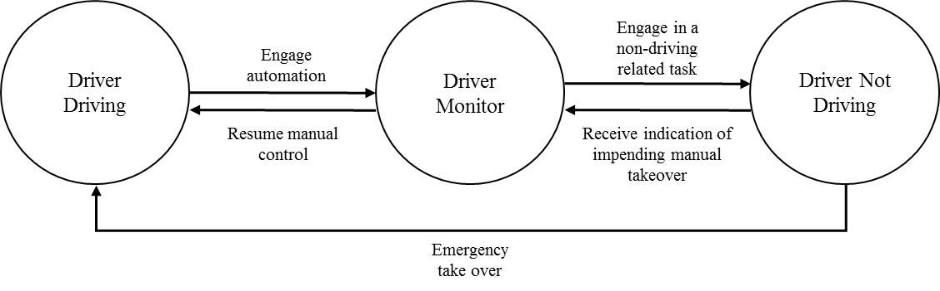
Figure 1. Driver mode transition network

We therefore need to better understand the impact that automation implementation has upon the role of the driver. One way to do this is to adopt the theoretical underpinnings of Distributed Cognition (DCOG) that acknowledges that both human and non-human agents can work together in pursuit of a common goal (Hutchins, 1995). In driving, this essentially reflects the relationship between the human driver and automated subsystems that become increasingly capable of performing the traditional roles of the driver (Banks et al, 2014). The DCOG paradigm, provides the necessary foundations and methods to explore how the role of the driver changes within the complex socio-technical systems in which they are involved (Walker et al, 2010; Walker et al, 2015).
Method
This paper explores the changing role of the driver within automated driving systems using the Event Analysis of Systemic Teamwork (EAST: Stanton et al, 2006, 2013; Walker et al, 2006, 2010) framework. EAST is a descriptive method and proposes that the performance of a system can be described using three inter-linked network representations; task, social and information (Walker et al, 2006; 2010). Whilst it was originally developed for understanding command and control activities, it has since been applied to transportation domains including aviation (Walker et al, 2010; Stanton and Harvey, 2017), rail (Walker et al, 2006), driving (Banks and Stanton, 2016) and maritime (Stanton et al, 2006; Stanton 2014; Baber et al, 2013).
Task networks are used to provide a summary of system goals (Salmon et al. 2014) and offer a description of the sequences and interdependencies that exist between individual subtasks that must be completed to attain these goals. Social networks are used to analyse the structure of the system in terms of the communications that take place between different system ‘agents’. Finally, information networks show the information that is used by and communicated by system agents during a task (Walker et al, 2010). They therefore detail aspects of communication that underpin the completion of a task and the relationships between informational nodes. This paper uses the representations afforded by EAST to explore the differences between the DD and DM roles using network metrics. These networks can then be subjected to quantitative analysis using the Applied Graphic and Network Analyses tool (AGNA, version 2.1; Benta, 2005). AGNA is a platform-independent freeware application that can be used to analyse social networks. Nodes within the network can be analysed individually to assess agent centrality/prominence or as a whole. In driving research, network metrics can be used to identify key agents, key tasks and key informational elements required to complete the task. The following metrics have been chosen due to their previous application to the driving task (see Banks and Stanton, 2016; Salmon et al, 2009, Walker et al, 2011);
Density represents the level of interconnectivity between system agents. It is expressed as a value between 0 and 1, where 0 represents a network that has no connections between system agents and 1 indicates that the network is fully connected (Kakimoto et al, 2006). It is calculated using the following formula;
Network density = 2e / n (n-1)
where e = number of links in the network and n = the number of information elements within the network (Walker et al. 2012).
Diameter is used to analyse the connections and pathways between different system agents within the network (Walker et al, 2011). Denser networks (i.e. the route through the network is shorter and more direct) have smaller values. It is calculated using the following formula;
Diameter = max_{uy}d(n_{i},n_{j})
Cohesion represents the number of reciprocal connections divided by the total number of possible connections (Stanton, 2014)
Sociometric status is also of interest because it gives an indication of agent prominence as a communicator. Agents with high sociometric values are highly connected (Salmon et al, 2012). It is calculated using the following formula;
Sociometric Status = $\frac{1}{g-1 }\sum_{j=1}^{g}{(}x_{ji}, x_{ij})$
where g is the total number of nodes in the network, i and j are individual nodes and are the egde values from node i to node j (Salmon et al. 2012).

Results

Task networks
The driving task itself is said to be made up of approximately 2500 subtasks (see Hierarchical Task Analysis of Driving, HTAoD; Walker et al. 2015). These are divided into pre- drive, basic, operational, tactical, strategic and post- drive tasks. Whilst a DD would be involved in all of these tasks, the implementation of automation into the driving task would see the role of the human operator reduced. For this reason, the analysis focusses upon some of the basic, and strategic subtasks of driving as it is in these categories that the changing role of the driver is most visible. Table 1 shows the terminologies, taken directly from the HTAoD (Walker et al. 2015), and categorised into task type that were chosen to construct the task networks presented in this paper. Notably, both networks should be considered as continuous processes that are performed as long as the vehicle is in operation. Figure 1a reflects the linkages between these subtasks of driving from the perspective of a DD. A DD would be physically be responsible for completing all of the basic subtasks of driving as well as solely responsible for completing the strategic subtasks. However, as automation is introduced into the driving task, the task network evolves. Figure 1b represents the task network from the perspective of a DM. Whilst the tasks within the network remain largely the same, the emphasis upon physical input is removed. Instead, a DM would be responsible for monitoring the completion of basic tasks as well as strategic tasks. There is therefore no removal of tasks within the DM task network, simply the burden of responsibility changes from a physical input to a monitoring input.

Table 1. Basic and strategic subtasks of driving (Walker et al. 2015)
Basic tasks | Strategic tasks
Perform steering actions  Control vehicle speed  Undertake directional control  Negotiate bends  Negotiate gradients | Perform surveillance  Perform navigation  Comply with rules  Respond to environmental conditions

(a)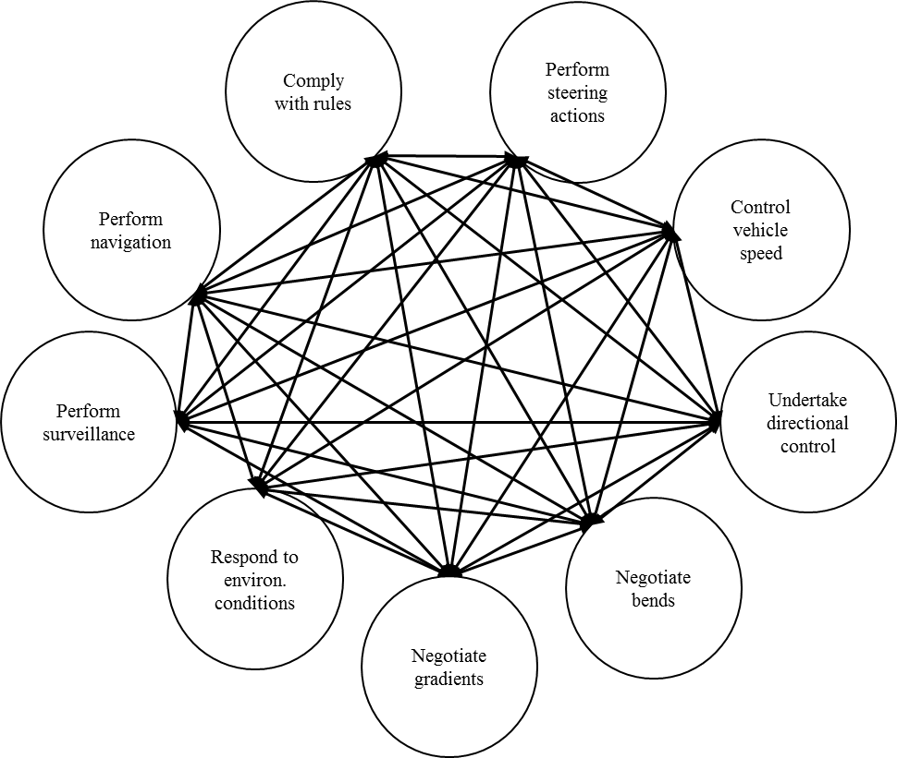
(b)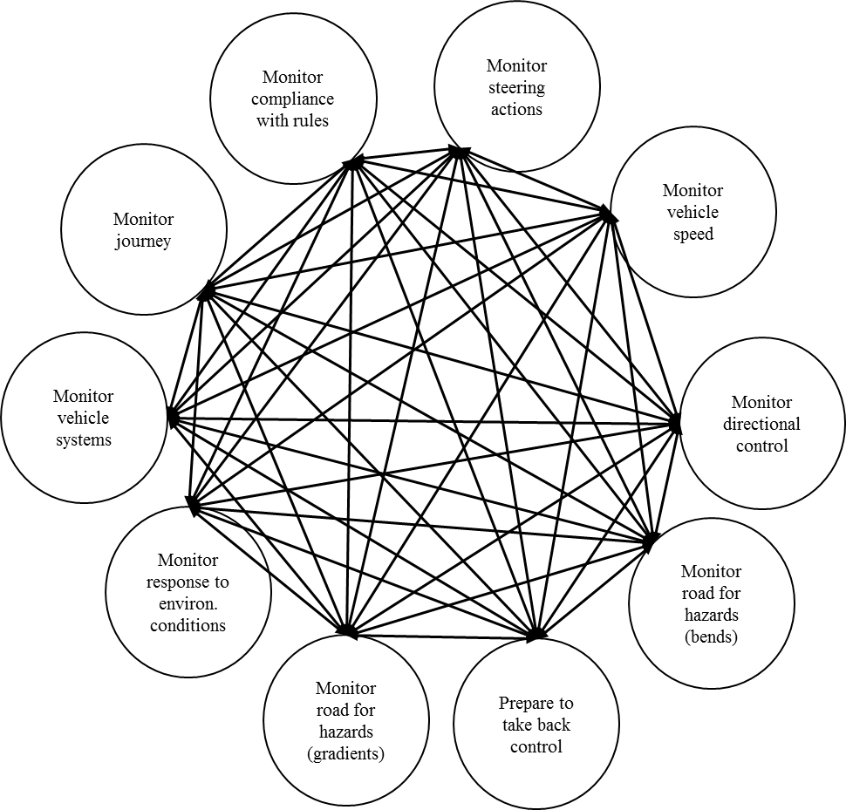
Figure 1. Task networks for (a) the role of DD and (b) the role of DM

Analysis of the whole networks given their all-connected nature (Leavitt, 1951) render more sophisticated network metrics redundant as they would elicit the same score. For this reason, only a basic description of the networks is presented in Table 2. It shows that whilst one additional task is added to the DM task network (‘Prepare to take back control’) in comparison to the DD network, the number of edges increases by 26. This suggests that the level of task demand actually increases in a system whereby the driver adopts the role of DM. This is supported by empirical literature on mental workload, showing greater demand for semi-automated driving (Stanton et al, 2007; de Winter et al, 2014) Therefore, we must acknowledge that the DM role is likely to be more mentally demanding than the DD role - by way of an analogy, monitoring another driver (particularly a learner driver where there is a real possibility of having to intervene) can be more demanding than driving oneself. This is essentially what the DM role consists of – monitoring the behaviour of the automated system, road environment and anticipating the behaviour of other road users as well as being prepared to regain control of the vehicle if necessary.

Table 2. Description of DD and DM task networks
 | DD | DM
Number of Nodes | 9 | 10
Number of Edges | 144 | 160

Social Networks
In order to further our understanding of how the role of the driver affects network dynamism, high level social networks were constructed. The authors identified 5 system agents relating to the DD network (Figure 2a) whilst 8 system agents were identified for a DM social network (Figure 2b). The 3 additional agents within the DM network represent nodes associated with automated functionality. Banks & Stanton (2016) identified the Longitudinal and Lateral Controllers as separate system agents given their differing capabilities. The same viewpoint has been taken in the social network representation shown in Figure 2b.
Taken at face value, it is clear that the social network associated with the role of DM is more complex than that of DD. This is likely to be attributed to the increased communication and coordination that is required within the system network to maintain the goal of safe and normal driving practice following automation implementation. Thus, the transition between DD and DM appears to bring with it, a change in overall system dynamism.
These social network representations were transformed into association matrices to enable further analysis using network metrics. Both networks can be defined as binary (i.e. it can be represented by a zero-one matrix) and non-symmetric (i.e. directed). The results the social network analysis using network density, diameter and cohesion calculation, are shown in Table 3. The results show that the DM social network is denser than the DD network. This is unsurprising considering that the DM role is only made possible by the introduction of automation into the driving system. This brings with it the creation of new links and interactions between system agents. The analysis also revealed that the DM social network is more cohesive than the DD social network. No difference was found in network diameter between the DD and DM social networks.

(a)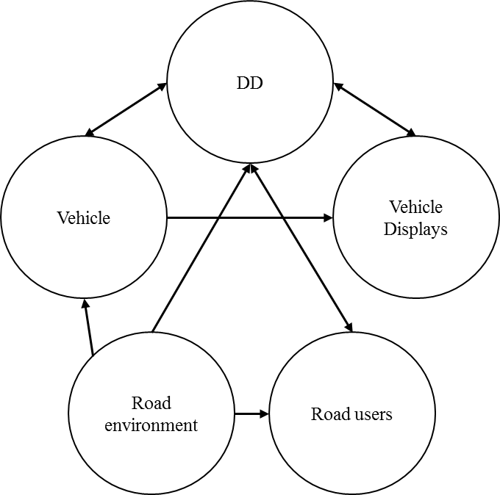 (b)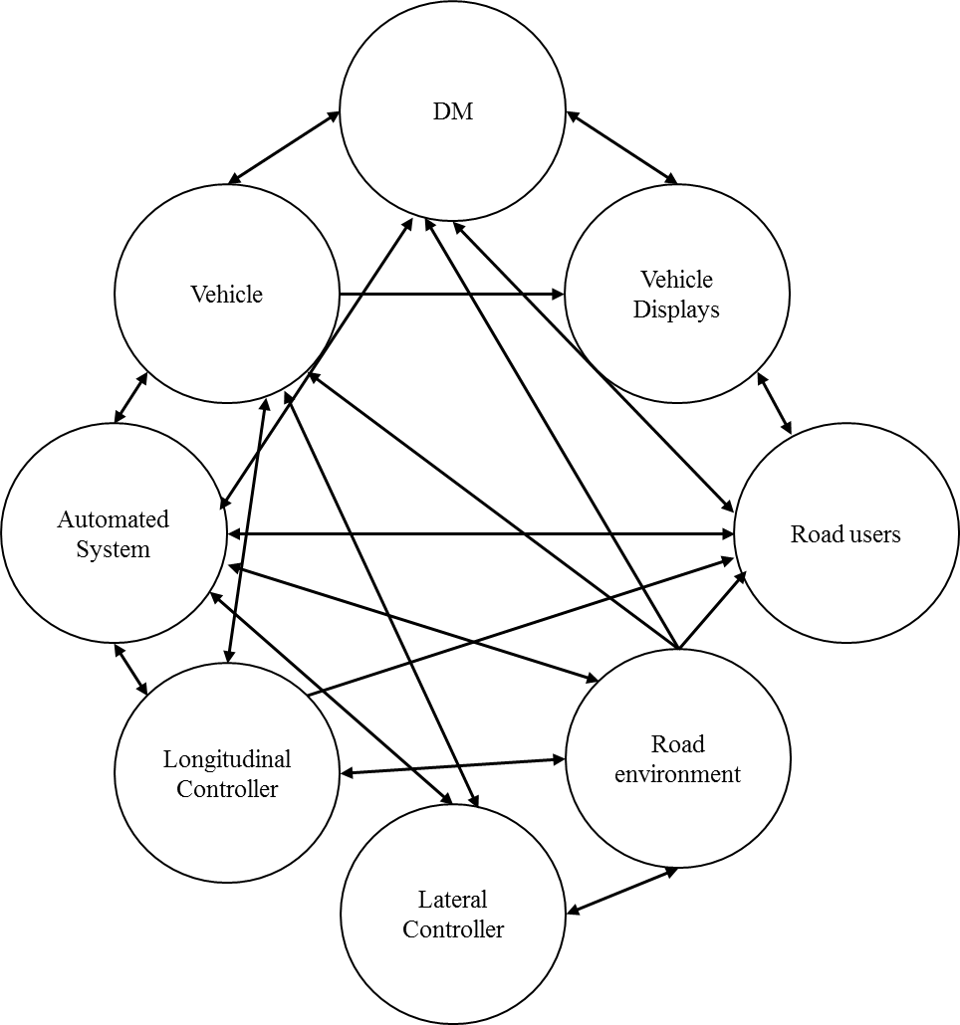
Figure 2. Social network diagrams for (a) the role of DD and (b) the role of DM

Table 3. Basic description of the DD and DM social networks
 | DD | DM
Number of Nodes | 5 | 8
Number of Edges | 10 | 37
Network Density | 0.50 | 0.70
Network Diameter | 2.00 | 2.00
Network Cohesion | 0.30 | 0.54

In addition, sociometric status was calculated for both DD and DM social networks (see Table 4). The identification of key agents (denoted by asterisks) is based upon the rule that any value above the mean sociometric status value reflects network dominance (Salmon et al, 2009). Unsurprisingly the DD role is considered to be the most dominant agent in a system whereby full responsibility of the driving task lies with the human operator. In an automated system where the driver adopts the role of DM, both the DM and Automated System become the most prominent system agents (see Table 4). Notably, the Automated System ranks highest in sociometric status which is unsurprising given its role within the system of vehicle operation. Even so, this representation demonstrates that as long as the driver adheres to their responsibilities of monitoring system behaviour, they maintain a central role within the control-feedback loop.

Table 4. Sociometric status for the roles of DD and DM
Node | DD | DM
Driver | 1.75* | 1.57*
Vehicle | 1.00 | 1.00
Vehicle Displays | 0.75 | 1.00
Road Users | 0.75 | 1.14
Road Environment | 0.75 | 1.29
Automated System | - | 2.00*
Longitudinal Controller | - | 1.14
Lateral Controller | - | 1.00
Mean | 1.00 | 1.32
* denotes key system agents based upon the rule that any value above the mean sociometric status value reflects dominance (Salmon et al, 2009)

Of course, ensuring that drivers actually adhere to their changing responsibilities is important because if a driver transitions to a DND problems may arise. It is difficult to predict and understand the behaviour of a DND because they could be engaged in any task of their choosing. For example, let’s assume that a DM becomes engaged in a non-driving related secondary task that keeps their eyes averted from the road environment for approximately 26 seconds (Eriksson & Stanton, 2017). This essentially would signal the breaking of links between the driver, vehicle displays, road users and road environment within Figure 2b. A ‘broken links’ analysis can be used to demonstrate how momentary lapses in efficient monitoring could impact upon overall network dynamism. This approach essentially represents communication breakdowns between system agents (Stanton & Harvey, 2017) similar to that of removing nodes from the network altogether (e.g. Baber et al. 2013). ‘Broken links’ have typically been used by EAST analysts to analyse accidents post event to explore vulnerabilities within the system (e.g. Griffin et al. 2010; Rafferty et al. 2012). In this instance, reciprocal relationships occurring between the DM and other social agents, shown in Figure 2b, are rescinded. The consequence of this are clearly shown in the results of a social network analysis (see Table 5 and 6). As to be expected, network density and cohesion is rapidly reduced. The prominence of the driver within this network also reduces rapidly (see Table 6). This places further pressure on systems designers to ensure that their systems are safe, reliable and failsafe, especially given the prominence of the Automated System and Vehicle under these circumstances. Providing that remaining system agents have the information required to function effectively and are able to use this information to perform appropriately in any given context, safety should be maintained (Salmon et al, 2012) even if the DM transitions to a DND for short periods. There is evidence that individual agents are able to compensate for each other, enabling the system to maintain safe operation (Stanton et al, 2006; Stanton, 2016). For example, if a driver fails to respond to system warnings, some autonomous systems can bring the vehicle to a ‘safe stop’ without any human input. Similarly, an Autonomous Emergency Brake system operates in the background and will only activate if activation thresholds are met. However, this is only possible if system agents have all of the information required. This implicates the ‘information network’.

Table 5. Results of a ‘broken links’ analysis whereby links are broken between the DM, vehicle displays, road users and environment

 | DM (Complete network) | DM (Broken links indicative of DND mode transition)
Number of Nodes | 8 | 8
Number of Edges | 37 | 30
Network Density | 0.70 | 0.54
Network Diameter | 2.00 | 2.00
Network Cohesion | 0.54 | 0.39

Table 6. Sociometric status in a ‘broken links’ network
Agent | DM (Complete network) | DM (Broken links indicative of DND mode transition)
DM | 1.57* | 0.86
Vehicle | 1.00 | 1.43*
Vehicle Displays | 1.00 | 0.71
Road Users | 1.14 | 0.86
Road environment | 1.29 | 1.14
Automated System | 2.00* | 2.00*
Longitudinal Controller | 1.14 | 1.14
Lateral Controller | 1.00 | 1.00

Information networks

According to Walker et al. (2010) information networks show the information that is used by and communicated by agents during a task. Their work specifically explored systemic situation awareness of air traffic control using observational notes, interview and live audio feeds. The following information networks were created by analysing driver verbalisations collected as part of another study by Banks and Stanton (2015) that utilised the Critical Decision Method (Klein & Armstrong, 2005) to elicit information relating to driver decision making. In total, 48 verbal transcripts were analysed to construct the DD and DM information networks. The DD information network was constructed using evidence from verbal transcripts collected during Manual driving (i.e. no automation) whilst the DM information network was constructed using evidence from verbal transcripts collected during a drive in which the basic and strategic subtasks of driving (Table 1) were automated.
Each ‘informational node’ within the transcripts was identified and paired with its closest relation (i.e. nodes from the same sentence). This strategy was used to build up a network of information concepts relating to the driving task. The network representations were presented to subject matter experts for verification. Figure 3 presents a schematic overview of the DD information network including 42 nodes and 46 connections. Sociometric status was calculated to identify key concepts. The results indicate that for a DD, the following information nodes were most prominent:
- Traffic Type including vehicles, pedestrians and public transport or services
- Traffic considers the properties of road users, such as speed and route
- Infrastructure considers physical aspects such as road type, capacity and lane markings
- Risk Assessment including hazard type, previous experience and environmental conditions
- Signage considers the meaning and information presented on road signs including speed, warnings and instruction
The informational nodes coming off these key nodes within Figure 3 provide greater detail pertaining to specific situations and contexts within driving (Stanton, 2013).
In contrast, the DM information network, presented in Figure 4, includes 53 nodes and 61 connections. Sociometric status was once again calculated and revealed that in addition to the key nodes outlined above for a DD, a DM must also consider the following;
- Autonomous driving features considering system limits and system controlled responses
- System mode considers the state of the system; active or inactive
- Feedback includes the modalities in which information is fed back to the driver

Figure 3. Schematic overview of the DD information network

Figure 4. Schematic overview of the DM information network (grey boxes indicate ‘new’ nodes within the information network as a result of automation implementation)

Thus, despite the intention of autonomous driving features to reduce the burden of responsibility placed upon the driver, it actually increases the amount of information that a driver must consider in order to maintain safe driving practice. In order to further understand how this additional information requirement impacts upon network dynamism, the information networks as presented in Figures 3 and 4 were further analysed using the AGNA software tool. The results of this analysis are shown in Table 5.
Table 5. Information network metrics for the roles of DD and DM
Metric | DD | DM
Number of Nodes | 42 | 53
Number of Edges | 84 | 112
Network Density | 0.05 | 0.04
Network Diameter | 6.00 | 7.00
Network Cohesion | 0.04 | 0.03

Discussion
This paper shows how the application of EAST, and the representations afforded it, can be used to analyse the changing role of the driver. The application of quantitative network metrics to analyse these networks enables us to see how the changing role of the driver impacts upon overall system structure. Importantly, these representations are intended to provide a foundation to the basis of discussion surrounding the role of the driver within automated driving systems. The findings do go a long way in explaining why the empirical research shows high levels of mental workload with driving automation that requires constant monitoring (Stanton et al, 1997; Young and Stanton, 2004; de Winter et al, 2014). It is a paradox that this level of automation actually results in more, rather than less, work for the driver (Stanton, 2015).
From a theoretical modelling perspective, the DND role is particularly problematic. Driver disengagement from the primary driving task is a serious concern. The literature is cluttered with instances whereby engagement in secondary tasks can lead to performance decrements (Eriksson and Stanton, 2017). For example, Merat et al (2014) found that if an automated system disengaged at the point where drivers attention was diverted away from the road centre, resumption of manual control was erratic for up to 40 seconds after the transfer of control. The main concern for the DND role is that it is not possible to construct a task, social or information network for the DND role. This is because drivers are free to participate in any task of their choosing. This makes it difficult to predict and understand the behaviour of a DND. A ‘broken links’ analysis however points to a dramatic shift in system structure when a DM transitions to a DND role. Whilst some may argue that the DM role becomes redundant at higher levels of autonomy (e.g. Gasser, 2014), the authors caution that this is not strictly the case. The Department for Transport’s report (2015), for example, recognizes that some Level 4 systems may still offer a full set of controls that enable manual driving. This means that at some point the DND could be required to regain control of the vehicle whether this be due to a ‘forced’ transfer of control due to some form of mechanical failure (e.g. sensor failure), choice (e.g. the driver may want to abort or change the destination of travel or they may simply want to be in control) or simply because autonomous driving features only operate in some driving modes at Level 4. For this reason, the DND will need to adopt the role of DM during the exchange of control between them and the autonomous vehicle. The success of this transition of control will however be based upon a number of interacting psychological constructs including situation awareness, workload, trust and skill (Stanton and Young, 2000; Heikoop et al, 2016). If vehicle manufacturers are to handle this transition effectively, a greater understanding of how drivers appraise and make use of higher level autonomy is needed (Richards and Stedmon, 2016). Thus, whilst less emphasis is placed upon the driver as the level of automation increases, vehicle manufacturers still need to think about ways in which the driver can be supported if and when they choose to regain control of the vehicle especially during early versions of highly automated driving systems. This is because the DD, DM and DND are closely related and likely to be adopted interchangeably throughout the duration of a drive especially during the intermediate phases of automation.
Whilst the DND role represents the aspiration of many OEM’s, there are no such systems that exist on the market today that allow this to happen. If a driver does find themselves in the role of DND, they should be supported back into the role DM to ensure that the overall goal of the system network can be appropriately maintained. For contemporary vehicle automation systems, the role of DND could be seen as a form of automation misuse (Parasuraman and Riley, 1997) given the functional limits of automated architecture. Much more research is needed to further populate these network representations for the varying role of the driver to validate the networks proposed in this paper. The hypothetical representations presented in this paper do however provide an avenue for discussion as they represent how an “ideal” network may function. Realistically however, the authors acknowledge that prolonged exposure to high levels of automation (and driver inactivity) could result in issues surrounding boredom or fatigue (e.g. Stanton et al, 1997; Young and Stanton, 2002). Strategies to support the role and maintenance of the DM role are therefore important avenues for further research. We already know from the literature that the level and type of automation can have a direct effect on driver engagement (Stanton et al, 1997; Merat et al, 2014), changes to driver workload (Stanton et al, 1997; Young and Stanton, 2002; de Winter et al, 2014), situation awareness (Stanton et al, 2011; Dozza, 2012) and decision making (Banks and Stanton, 2015).

Conclusions
The qualitative models of DD and DM support and explain the findings from empirical studies on driver workload changes with automated systems. The increase in workload associated with monitoring automated systems may be explained by the fact that there is simply more tasks to undertake. These qualitative insights are supplemented with the quantitative network statistics, showing the importance of the role change when driving with an automated system (i.e. from the human driver to the computer driver). Modelling future systems is an important step for Ergonomics as a discipline, as it allows us to anticipate the likely behaviour of future technologies and the role for humans. In this way, we can compare alternative designs to identify which are likely to have the better outcomes. Future research should seek to extend and validate the models presented in this paper using empirical data generated from observational studies exploring driver behaviour at varying levels of automation. In particular, prolonged exposure to high levels of autonomy may elicit DND behaviours that enable us to properly understand the complexities associated with bringing a driver in such a role back into the control-feedback loop.

Acknowledgements
Professor Neville A Stanton was funded by the European Marie Curie International Training Network project on the Human Factors of Automated Driving (PITN-GA-2013-605817) and the EPSRC/JLR TASCC project (Human Interaction: Designing Autonomy in Vehicles – HI:DAVe - Grant number: EP/N011899/1).

References
Baber, C., Stanton, N. A., Atkinson, J., McMaster, R. and Houghton, R. J. (2013) Using social network analysis and agent-based modelling to explore information flow using common operational pictures for maritime search and rescue operations. Ergonomics, 56 (6), 889-905.
Banks, V. A. and Stanton, N. A. (2015) Contrasting models of driver behaviour in emergencies using retrospective verbalisations and network analysis. Ergonomics, 58 (8), 1337-1346.
Banks, V. A., & Stanton, N. A. (2016). Driver-centred vehicle automation: Using network analysis for agent-based modelling of the driver in highly automated driving systems. Ergonomics, DOI: 10.1080/00140139.2016.1146344.
Banks, V. A., Stanton, N. A. and Harvey, C. (2014) Sub-systems on the road to vehicle automation: Hands and feet free but not ‘mind’ free driving. Safety Science 62, 505-514.
Benta, M. (2005) Studying communication networks with AGNA 2.1. Cognition Brain Behaviour, 9, 567-574.
Casner, S. M., Hutchins, E. L., and Norman, D. (2016) The challenges of partially automated driving. Communications of the ACM, 59 (5), 70-77.
Department for Transport. (2015) The pathway to driverless cars: Summary report and action plan. Available at https://www.gov.uk/government/uploads/system/uploads/attachment_data/file/401562/pathway-driverless-cars-summary.pdf [Accessed 19.09.2016].
de Winter, J. C. F., Happee, R., Martens, M. H. and Stanton, N. A. (2014) Effects of adaptive cruise control and highly automated driving on workload and situation awareness: a review of the empirical evidence. Transportation research part F: Traffic Psychology and Behaviour, 27, 196-217.
de Winter, J. C. F., Stanton, N. A., Price, J. S. and Mistry, H. (2016) The effects of driving with different levels of unreliable automation on self-reported workload and secondary task performance. International Journal of Vehicle Design, 70 (4), 297-324.
Dozza, M. (2012) What factors influence drivers’ response time for evasive maneuvers in real traffic? Accident Analysis & Prevention, 58, 299–308.
Endsley, M. R. and Kaber, D. B. (1999) Level of automation effects on performance, situation awareness and workload in a dynamic control task. Ergonomics, 42 (3), 462-492.
Eriksson, A. and Stanton, N. A. (2017) Take-over time in highly automated vehicles: transitions to and from manual control. Human Factors, DOI: 10.1177/0018720816685832
Fagnant, D. J. and Kockelman, K. (2015) Preparing a nation for autonomous vehicles: Opportunities, barriers and policy recommendations for capitalising on self-driven vehicles. Transportation Research Part A, 77, 167-181.
Federal Aviation Administration. (2003). Standard operating procedures for flight deck crew members. AC No: 120-71A, 27.2.03.
Gasser, T. (2014) Vehicle automation: Definitions, legal aspects, research needs. UNECE Workshop: German Federal Highway Research Institute: Towards a new transportation culture: technology innovations for safe, efficient and sustainable mobility. Brussels, 17-18 November 2014.
Heikoop, D. D., de Winter, J. C. F., van Arem, B. and Stanton, N. A. (2016) Psychological constructs in driving automation: a consensus model and critical comment on construct proliferation. Theoretical Issues in Ergonomics Science, 17 (3), 284-303.
Hutchins, E. (1995) How a cockpit remembers its speed. Cognitive Science, 19 (3), 265-288.
Kaber, D. B., and Endsley, M. R. (2004) The effects of level of automation and adaptive automation on human performance, situation awareness and workload in a dynamic control task. Theoretical Issues in Ergonomics Science, 5 (2), 113-153.
Kakimoto, T., Kamei, Y., Ohira, M. and Matsumoto, K. (2006) Social network analysis on communications for knowledge collaboration in OSS communities. In: Proceedings of The 2nd International Workshop on Supporting Knowledge Collaboration in Software Development (KCSD’06), Tokyo, Japan, pp. 35–41.
Leavitt, H. J. (1951) Some effects of certain communication patterns on group performance. Journal of Abnormal and Social Psychology, 46, 38-50.
Lee, J. D. and See, K. A. (2004) Trust in automation: Designing for appropriate reliance. Human Factors, 46, 50–80.
Merat, N., Jamson, A. H., Lai, F. C., Daly, M. and Carsten, O. M. (2014) Transition to manual: Driver behaviour when resuming control from a highly automated vehicle. Transportation research part F: Traffic Psychology and Behaviour, 27 (B), 274-282.
National Highway Traffic Safety Administration (2013) Preliminary Statement of Policy Concerning Automated Vehicles System. Washington, DC.
National Highway Traffic Safety Administration (2016) Update to “Preliminary Statement of Policy Concerning Automated Vehicles”. Available at http://www.nhtsa.gov/Research/Crash+Avoidance/Automated+Vehicles [Accessed 19.09.2016].
Nowakowski, C., Shladover, S. E., and Tan, H. S. (2015). Heavy vehicle automation: Human factors lessons learned. Procedia Manufacturing, 3, 2945-2952.
Parasuraman, R., Molloy, R. and Singh, I. L. (1993) Performance consequences of automation-induced ‘complacency’. The International Journal of Aviation Psychology, 3, 1-23.
Parasuraman, R. and Riley, V. (1997) Humans and automation: Use, misuse, disuse, abuse. Human Factors: The Journal of the Human Factors and Ergonomics Society, 39 (2), 230-253.
Richards, D. and Stedmon, A. (2016) To delegate or not to delegate: A review of control frameworks for autonomous cars. Applied Ergonomics, 53 B, 383-388.
Salmon, P. M., Stanton, N. A. and Young, K. L. (2012) Situation awareness on the road: review, theoretical and methodological issues, and future directions. Theoretical Issues in Ergonomics Science, 13 (4), 472-492.
Salmon, P.M., Stanton, N.A., Walker, G.H. and Jenkins, D. P. (2009) Distributed Situation Awareness: Advances in Theory, Measurement and Application to Teamwork. Ashgate: Aldershot, UK.
Salmon, P.M., Walker, G.H. and Stanton, N. A. (2016) Pilot error versus sociotechnical systems failure: a distributed situation awareness analysis of Air France 447. Theoretical Issues in Ergonomics Science, 17 (1), 64-79.
Sarter, N. B., Woods, D. D. and Billings, C. E. (1997) Automation surprises. Handbook of Human Factors and Ergonomics, 2, 1926-1943.
Sheridan, T. B. (1970) Big brother as driver: New demands and problems for the man at the wheel. Human Factors: The Journal of the Human Factors and Ergonomics Society, 12, 95–101.
Smiley, A. and Brookhuis, K. A (1987) Alcohol, drugs and traffic safety. In: J. A. Rothengatter and R. A. de Bruin (Eds.), Road Users and Traffic Safety. Assen: Van Gorcum pp. 83-105.
Smith, B. W. (2013) SAE levels of driving automation. Retrieved from http://cyberlaw.stanford.edu.loda [Accessed: 11.04.2016].
Society for Automotive Engineers (2015). Taxonomy and Definitions for Terms Related to On-Road Motor Vehicle Automated Driving Systems. Available at: http://standards.sae.org/j3016_201401/. [Accessed 12.10.2015].
Stanton, N. A. (2014) Representing Distributed Cognition in Complex Systems: How a submarine returns to periscope depth. Ergonomics, 57 (3), 403-418.
Stanton, N. A. (2015) Responses to autonomous vehicles, Ingenia, 62, 9.
Stanton, N. A. (2016) Distributed situation awareness, Theoretical Issues in Ergonomics Science, 17 (1), 1-7.
Stanton, N. A., Dunoyer, A. and Leatherland,A. (2011) Detection of new in-path targets by drivers using Stop and Go Adaptive Cruise Control, Applied Ergonomics, 42 (4), 592-601.
Stanton, N. A. and Marsden, P. (1996) From fly-by-wire to drive-by-wire: safety implications of automation in vehicles. Safety Science, 24 (1), 35-49.
Stanton, N. A. and Harvey, C. (2017). Beyond human error taxonomies in assessment of risk in sociotechnical systems: A new paradigm with the EAST ‘broken-links’ approach. Ergonomics, DOI: 10.1080/00140139.2016.1232841.
Stanton, N. A. and Salmon, P. M. (2009). Human error taxonomies applied to driving: A generic driver error taxonomy and its implications for intelligent transport systems. Safety Science, 47 (2), 227-237.
Stanton, N. A., Salmon, P. M, Rafferty, L., Walker, G. H., Baber, C. and Jenkins, D. P. (2013) Human factors methods: A Practical Guide for Engineering and Design. Ashgate: Aldershot, UK.
Stanton, N. A., Stewart, R., Harris, D., Houghton, R.J., Baber, C., McMaster, R., Salmon, P., Hoyle. G., Walker, G., Young. M.S., Linsell, M., Dymott, R. and Green, D. (2006) Distributed situation awareness in dynamic systems: theoretical development and application of an ergonomics methodology. Ergonomics, 49 (12-13), 1288-1311.
Stanton, N. A. and Young, M. (2000) A proposed psychological model of driving automation. Theoretical Issues in Ergonomics Science, 1 (4), 315-331
Stanton, N. A. and Young, M. (2005) Driver behaviour with Adaptive Cruise Control. Ergonomics, 48, 1294 ­ 1313.
Stanton, N. A., Young, M. and McCaulder, B. (1997) Drive-by-wire: the case of mental workload and the ability of the driver to reclaim control. Safety Science, 27 (2-3), 149-159.
Walker, G. H., Gibson, H., Stanton, N. A., Baber, C., Salmon, P. and Green, D. (2006) Event analysis of systematic teamwork (EAST): A novel integration of ergonomic methods to analyse C4i activity. Ergonomics, 49 (12-13), 1345-1369.
Walker, G. H., Stanton, N. A., Baber, C., Wells, L., Gibson, H., Salmon, P. and Jenkins, D. (2010) From ethnography to the EAST method: A tractable approach for representing distributed cognition in Air Traffic Control. Ergonomics, 53 (2), 184-197.
Walker, G. H., Stanton, N.A. and Salmon, P. M. (2011) Cognitive compatibility of motorcyclists and car drivers. Accident Analysis & Prevention, 43, 878–888.
Walker, G. H., Stanton, N. A. and Salmon, P. M. (2015) Human Factors in Automotive Engineering and Technology. Ashgate: Aldershot, UK.
Walker, G. H., Stanton, N. A. and Salmon, P. M. (2016) Trust in vehicle technology. International Journal of Vehicle Design, 70 (2), 157-182.
Walker, G. H., Stanton, N. A., Salmon, P. M., Jenkins, D. P. and Rafferty, L. A. (2010) Translating concepts of complexity to the field of ergonomics. Ergonomics, 53 (10), 1175-1186.
Young, M. S. and Stanton, N. A. (2002). Malleable Attentional Resources Theory: A new explanation for the effects of mental underload on performance. Human Factors, 44 (3), 365-375.
Young, M. S. and Stanton, N. A. (2004) Taking the load off: investigations of how Adaptive Cruise Control affects mental workload. Ergonomics, 47 (8), 1014-1035.

About the authors
Dr Victoria Banks is a postgraduate research fellow in the Human Factors Research Group at the university of Nottingham. She was awarded her Engineering Doctorate by the University of Southampton in 2016. Dr Banks has published over ten papers on vehicle automation and has a forthcoming book on the topic to be published by CRC Press.
Professor Neville A Stanton, PhD, DSc, holds a chair in Human Factors Engineering in the Transportation Research Group at the University of Southampton. He has published over 30 books and 250 journal papers over the past 30 years. Prof Stanton has conducted research into vehicle automation for over 25 years.

