**Historical trace element accumulation in marine sediments from the Tamaulipas shelf, Gulf of Mexico: an assessment of natural vs anthropogenic inputs.**

**Celis-Hernandez, Omara,b*; Rosales-Hoz, Leticiaa; Cundy, Andrew B.b; Carranza-Edwards, Arturoa ; Croudace Ian Wb.; Hernandez-Hernandez Hectorc.**

aInstituto de Ciencias del Mar y Limnología, Universidad Nacional Autónoma de México, Circuito Exterior, Ciudad Universitaria, Coyoacan, C.P. 04510, Ciudad de México, México.

bOcean and Earth Science, National Oceanography Centre (Southampton), University of Southampton, Southampton, SO14 3ZH, United Kingdom.

cPosgrado en Ciencias del Mar y Limnología, Universidad Nacional Autónoma de México, Circuito Exterior, Ciudad Universitaria, Coyoacan, C.P. 04510, Ciudad de México, México.

*Corresponding author

Email address: [celis0079@yahoo.es](mailto:celis0079@yahoo.es)

**Published in *Science of the Total Environment*, Volume 622-623, pp 325-336, 2018.**

**Abstract**

The Gulf of Mexico is considered one of the world’s major marine ecosystems, supporting important fisheries and habitats such as barrier islands, mangrove forests, seagrass beds, coral reefs etc. It also hosts a range of complex offshore petroleum exploration, extraction, and refining industries, which may have chronic or acute impacts on ecosystem functioning. Previous work on the marine effects of this activity is geographically incomplete, and has tended to focus on direct hydrocarbon impacts, while impacts from other related contaminants (e.g. heavy metals, salt-rich drilling muds) which may be discharged from oil facilities have not been widely assessed. Here, we examine historical trace element accumulation in marine sediments collected from four sites in the Tamaulipas shelf, Gulf of Mexico, in the area of the Arenque oil field. Dated sediment cores were used to examine the sources, and historical and contemporary inputs, of trace metals (including those typically present in oil industry discharges) and their potential biological impact in the Tamaulipas aquatic environment over the last 100 years. CaO (i.e. biogenic component) normalized data showed increasing V, Cr, Zn, Cu, Pb, Zr and Ba towards the sediment surface in three of the four cores, with Ba and V (based on an Adverse Effect Index) possibly associated with adverse effects on organisms. Dated Ba/CaO profiles show an increase of 30 – 137% after opening of oil installations in the study area, and can be broadly correlated with increasing oil industry activities across the wider Gulf of Mexico. Data do not record however a clear enhancement of Ba concentration in sediment cores collected near to oil platforms over more distal cores, indicating that any Ba released from drilling platforms is incorporated quickly into the sediments around the drilling sites, and once this element has been deposited its rate of resuspension and mobility is low.

1. **Introduction**

Many coastal and shelf sea areas around the world are heavily impacted by anthropogenic activities. The oil industry in particular can generate significant ecosystem damage through tanker and well-head accidents (Payne et al. 2008, Moreno et al. 2011, Qu et al. 2016, Jung et al. 2017), and routine operation and discharges. Hydrocarbon-derived pollutants can cause direct mortality of benthic organisms or can modify the structure of benthic communities (Abdalah et al. 2016); causing impaired larval development, changes in oxygen consumption, nutrition, and growth, as well as molecular, biochemical and physiological modifications (Fokina et al. 2014). In addition non-benthic organisms such as fish, seabirds, and aquatic mammals may suffer habitat loss or death due to oil coating or ingestion (Zhou et al. 2014).

Due to a high dependence on petroleum as an energy source, and the use of hydrocarbon-derived feedstocks in a wide variety of industries, the oil industry has increased its global production (notwithstanding oil crises, overproduction or price crashes) dramatically over recent decades. In 2014 global oil and gas production were 76,061 thousand barrels per day and 124, 444 billion cubic feet respectively (PEMEX, 2014) – 130 % and 53,000 % more than in 1989 (PEMEX, 1999). Around 30% of production is offshore (U.S. EIA, 2015): for example there are 800 offshore oil and gas platforms in the Arabian Gulf (Albano et al. 2016), 500 in the continental shelf of the North Sea (Fuji, 2015), 420 in the northern Gulf of Mexico and 258 in the southern Gulf of Mexico (PEMEX, 2014).

The Gulf of Mexico is considered one of the world’s major marine ecosystems, supporting important fisheries and habitats such as barrier islands, mangrove forests, seagrass beds, coral reefs, river deltas and estuaries (Yañes and Day 2004 a). In the north, south-west and south of the Gulf of Mexico however a range of complex offshore petroleum exploration, extraction, shipping, service, construction and refining industries have developed (Yañes and Day, 2004 b). Along the coasts of the Gulf of Mexico, a number of authors have reported adverse impacts on foraminiferal, *Polychaete* annelid, coral reef and benthic communities near to oil platforms or other oil installations (Hernandez et al. 2005, Carriquiry et al. 2010, Sen Gupta et al. 2013, Magallanes et al. 2015, Qu et al. 2016). Current information is geographically incomplete however, and has tended to focus on direct hydrocarbon impacts, while impacts from other related contaminants (e.g. heavy metals, salt-rich drilling muds) which may be discharged from oil facilities have not been widely assessed. For example, the Tamaulipas coasts have supported a significant oil industry for the last 100 years, but there is little information on oil industry impacts in benthic systems in this area, particularly how sedimentary trace and major elements have increased or decreased in the last 100 years in relation to oil industry, and to other anthropogenic, activities (including urban and industrial development of the adjacent coastline and river drainage catchments). This article aims to partly fill this knowledge gap, via analysing dated sediment cores to examine the historical and contemporary inputs of trace metals (including those typically present in oil industry discharges), and their potential biological impact, in the Tamaulipas aquatic environment over the last 100 years.

1. **Study area**

The study area covers approximately 1,612 km2 of seafloor near to the Mexican state of Tamaulipas, within the third most important hydrocarbon field in the Mexican part of the Gulf of Mexico (Figure 1). Its coordinates are 22° 27.03’ to 22° 5.99’ north latitude and 97° 56.99’ to 97° 21.04’ west longitude. The area receives discharges from the Panuco River, which has the largest catchment area (85,956 km2 CONAGUA, 2016) emptying into the western Gulf of Mexico, although only 16,499 km2 of this catchment are in Tamaulipas state (INEGI, 2010). The coastal currents in this region vary seasonally, running southward from September to March and northward from May to August, and between each season there is a transition period that starts from late March to April and from late August to September (Zavala et al. 2003). The main anthropogenic influences consist of 11 point sewage discharges, 6 water treatment plants, the Madero oil refinery, the Altamira and Tampico ports located in the urban area formed by Altamira, Madero City and Tampico (INEGI, 2010), and the Arenque marine oil field (PEMEX, 2012).

The Panuco River has an annual discharge of 20,330 Mm3 (CONAGUA, 2016) and crosses 13 municipalities from Tamaulipas with a population of 957,227 inhabitants (based on 2010 data), of which 73.8% are concentrated in the municipalities of Altamira, Madero city and Tampico (INEGI, 2010). The urban area formed by these three sites is considered the main industrial region of the Tamaulipas coastal zone (Ortiz et al. 2000), containing 1 major oil refinery (PEMEX, 2014), 2 of 13 ports in the western Gulf of Mexico, and other manufacturing industries (INEGI, 2010). Agriculture and livestock activities are also common in the catchment, with livestock production representing 27.7% of all state livestock production, and an agricultural production making up 33.6% of the total state agricultural produce value (based on 2011 data) (INEGI, 2010). The Tamaulipas Panuco catchment lithology mainly consists of 1) Cenozoic and Mesozoic clastic (sandstone, siltstone and shale) and calcareous (limestone) sedimentary rocks, and Quaternary alluvium. 2) Cenozoic volcanic rocks of mafic and intermediate composition and 3) metamorphic rocks comprising schist and gneiss of Paleozoic and Precambrian age (Armstrong- Altrin et al. 2015, Moran-Zenteno, 1994 and Ortega-Gutierrez et al. 1995).

1. **Materials and methods.**

Four cores labelled as C17, C47, C53 and C93 were taken from the Tamaulipas shelf at water depths of 58, 38, 70 and 60 m respectively (Figure 1). Coring locations were selected to sample bottom sediments in the area of the Arenque oil field, at locations proximal and more distal to the Panuco River mouth, and north and south of the oil field, to allow assessment of potential variations in sediment geochemistry caused by (a) different sediment sources (e.g. terrestrial vs biogenic); (b) inputs from oil exploitation activities in the Arenque field; and (c) inputs from industrial and other activities in the Panuco River catchment. The core lengths were 19, 27, 15 and 25 cm respectively. Cores were collected at 12.2 (C47), 30.1 (C93), 32.5 (C53) and 34.5 (C17) km from the Panuco River Mouth.

Cores were collected using a box corer and subsampled with a PVC pipe (10 cm inner diameter) aboard the O/V Justo Sierra, during the Panuco II campaign in February 2002. The cores were extruded and subsampled at 1 cm intervals. All analyses, except grain size, were applied to finely ground (i.e. ground to the consistency of fine flour and sieved through a 200 µm mesh) samples stored in polyethylene bags. All concentrations are expressed with reference to dry weight. Particle size distribution within sediment samples was determined using a Coulter Model LS-230 laser diffraction analyzer. Five grams of homogenized sediment was mixed with 50 mL of a dispersant solution of sodium hexametaphosphate (100 gL-1). The mixture was allowed to stand for 24 h, after which it was stirred and a small portion was taken for analysis. For other analyses, sediment samples were dried at 55 °C for 48 h and homogenized in an 8000 SPEX MIL. All glassware was pre-washed with a solution of EXTRAN (20%) and rinsed several times with distilled water before use. Organic carbon content was determined by oxidation with K2Cr2O7. A reverse titration was performed to remove excess K2Cr2O7 not consumed in the oxidation of the organic matter (Gaudette et al. 1974). Carbonates were determined by titration (Hesse, 1971), in which excess HCl that did not react with the carbonate was reverse titrated with sodium hydroxide. Major and trace element concentrations were determined using a Siemens SRS 3000 XRF spectrophotometer. For the major element analysis, 1 g of each sample was fused with 9 g of a 1:1 mix of Li2B4O7: LiBO2.Trace elements were analyzed in pressed powder briquettes, prepared by adding 10% of Wax-C. The accuracy of this method was evaluated using the ILG standard (from the Geology Institute of the Universidad Nacional Autonoma de Mexico (UNAM)), and was 100 ± 2 % for all the oxides except for Fe2O3, MnO, K2O and P2O5 which showed values of 94.3, 92.7, 95.0 and 93.9 % respectively. The precision for all major elements was between 0.2 and 1.5 %, except for P2O5 which was 3.79%. For trace elements (Rb, Sr, Ba, Y, Zr, Nb, V, Cr, Co, Ni, Cu, Zn, Th and Pb) the accuracy was between 95 and 108.4 %, except Y, Th and Pb which showed values of 87.4, 133.3 and 125 % (Table S1). Precision was better than 6 % for all trace elements except for Cr, Th and Pb (Table S1).

Cores were dated using the 210Pb and/or 137Cs methods. For cores C17, C47 and C93, subsamples of approximately 3.5 g (dry weight) were counted on a Canberra well-type, high resolution HPGe gamma ray spectrometer to determine the activities of 210Pb and 137Cs (at the University of Brighton, UK). Calibration was carried out using a matrix and geometry-matched IAEA mixed radionuclide standard. All samples were counted for a minimum of 40,000 seconds. Counting errors were in the order of 30% (2σ) for both 210Pb and 137Cs (due to the low activities observed for 137Cs and the low energy of the 210Pb gamma emission line (46keV)). Detection limits depend largely on count time but are nominally 10 Bqkg-1 for 210Pb, and 0.5 Bqkg-1 for 137Cs. For core C53, 210Pb activity was determined by a proxy method through -spectrometric measurement of its granddaughter nuclide 210Po (at the University of Southampton, UK). The method employed was based on Flynn (1968), using double acid leaching of the sediment with 209Po as an isotopic tracer and autodeposition of the Po isotopes in the leachate onto silver disks. Detection limits were 1 Bqkg-1.

The results were interpreted using descriptive and multivariate statistical tools, and geochemical indices (Enrichment Factor (EF), Pollution Load Index (PLI), Adverse Effect Index (AEI) and Sediment Quality Guidelines (SQG)). In order to test the relationships between variables a Pearson’s Correlation Analysis was performed. To evaluate the main parameters controlling the characteristics of the sediment cores and identify the causes of variation between samples in each core a Factor Analysis by Principal Components was carried out, and to identify associations between the four sediment cores studied a Cluster Analysis was performed. Every statistical analysis was carried out using 42 subsamples from the four sediment profiles and with α=0.05.

1. **Results and discussion**
   1. **Textural analysis**

Textural parameters, and their correlation with major and trace element data, are important tools in determining the composition and the origin of marine sediments, i.e. as cosmogenic, lithogenic (terrigenous), biogenic or hydrogenic (Li and Shcoonmaker 2003), and support analysis of whether trace element enrichments are related to sediment source variability or to anthropogenic processes. Textural parameters were characterized here using Shepard’s classification (1954), which showed that the predominant texture in the samples was mud in C93, sandy mud in C47 and C17 and mud + gravel + sand in C53 (Figure S1). The gravel found in C17 and C53 consisted dominantly of shell and coral fragments, possibly reflecting a biogenic influence from the Isla Lobos reef located 73 km from C17 and 90 km from C53 (to the southwest).

Sand content varied from 7.2 to 44.9%, with core C93 showing the lowest sand concentration. There is no apparent relationship between sand content and distance from the Panuco river mouth, indicating that turbidity and coastal currents affect the accumulation of sand rather than submarine relief, and shows the southwest of the study area as a region where there are typically high energy levels. All cores showed an increase in sand content in their upper 10 cm (Figure S2, although this is less marked in core C93). Negative correlations of sand content with Al2O3 (-0.90) and Fe2O3 (-0.93), and positive correlations with CaO (0.69) and CO3 (0.67), indicate that the sand has a biogenic origin, and so this increase in sand % likely results from changes in biogenic sediment supply routes or characteristics. In contrast, positive correlations of silt and clay with Al2O3 (0.96, 0.90), TiO2 (0.93, 0.83), Fe2O3 (0.92, 0.80) indicate a terrigenous origin, from the Panuco River. Higher silt and clay concentrations in cores C93 and C47 compared to cores C53 and C17 (Figure S2) indicate that the Panuco River influence is prevalent more in the north of the study area, and near to the river mouth, than in the southeast.

* 1. **Geochemical composition**

Geochemical analysis of core sediments is an important tool to identify if a compositional change occurring in a sediment column is generated by geological, biological, chemical or by human factors (Borrego et al. 2004; Garcia et al. 2004; Sanchez et al. 2010). Here, we use sediment geochemical analysis to examine variations in the input of major and trace elements, sources of sediment, and (in subsequent sections) natural vs anthropogenic trace element input. Table 1 shows the range and average data for major elements in the four sediment cores studied.

Carbonate contents varied from 12.6 to 48.6%. Higher carbonate concentrations were present in cores C17 and C53 with an average of 37.9 and 39.0%. Positive correlations between CaO (0.99) and Sr (0.98) reflect the substitution of Sr for Ca in the calcareous shells of marine organisms (Basaham et al. 2009; Martins et al. 2012), and negative correlations with SiO2, Al2O3, Fe2O3, Na2O and K2O (Table S3) indicate that these components are derived mainly from biogenic rather than terrigenous sources.

Organic carbon contents ranged between 0.15 and 0.90 %. Higher average organic carbon concentrations were found in cores C47 (0.78%) and C93 (0.60%) (Figure S1). These averages, and a positive correlation with silt content (Table S3), indicate that organic matter distribution is controlled largely by fine particle sedimentation and is associated with continental sources; at least near to the Panuco river mouth and in the north of the study area where a higher average % of fine sediment was deposited.

Major element concentrations in the four cores varied within the following ranges: 33.1-62.5 % for SiO2, 6.00-12.7 % for Al2O3, 6.71-26.8 % for CaO and 2.00 to 4.50 % for Fe2O3 (Table 1). The highest concentrations of almost all major elements were found in core C93 (except for SiO2 and CaO) (Table 1). Here, the uniform distributions of SiO2, CaO, Al2O3, MnO, P2O3, and TiO2 indicate a more homogenous mineral composition than in cores C47, C17 and C53 (Figure S5) and less variation in input between biogenic and terrigenous sources. This core has the highest average concentration of Al2O3 (12.5%), Na2O (2.72%), and K2O (2.47%), indicating higher clay mineral content than in other cores (Table 1).

Concentration ranges for the studied trace metals and their average concentrations are presented in Table 1. Core C93 exhibited the highest average concentrations of Rb, V, Cr, Ni, Cu, Zn, Pb, Y, Nb and Th. C47 showed the maximum average concentrations for Zr, Ba, and Co, and C53 had the highest average concentration of Sr. The lack of (or lower) positive correlations of Zr, Ba and Co with almost all major elements and textural indicators suggests that anthropogenic sources may be more important for these elements (Table S3, further discussed below). In contrast, the positive correlations of V, Cr, Ni, Zn, Pb, Rb, Y and Nb with Al2O3, Fe2O3, Na2O, K2O, silt and clay (Table S3) indicate a continental origin rather than an anthropogenic source (although normalized data do show a potential anthropogenic influence for V and Cr, see below), via input on clay minerals. Negative metal correlations with CaO and CO3 (Table S3) indicate that carbonates have diluted the metal concentration in the sediment profile and have modified the metal vertical distributions of cores C17 and C53, which is why these cores showed lower concentrations of V, Cr, Zn and Pb, specifically in the lowest 10 and 11 centimeters where carbonate content was higher (Figure S3); Sr was the only element with the same tendency as % carbonates which indicates its marine (biogenic) origin.

* 1. **Geochemical normalization**

In order to more clearly analyze the distribution pattern of metals along the cores, normalization to CaO was carried out. CaO was used to normalize geochemical variations generated by variations in biogenic carbonate that was present as a significant compositional fraction in all cores, normalizing for variations in biogenic element supply, and to more clearly discriminate anthropogenic metal contamination. For completeness, the results of normalization to the classical proxy Al2O3 are also shown (in Figure S6), which show similar, although in many cases not as well-defined, trends as discussed for CaO-normalized data below.

The CaO-normalized values in C17, C53 and C93 showed a clearer tendency of V, Cr, Zn, Cu, Pb, Zr and Ba to increase from the core base to the surface. In core C47 the first four of these elements had an opposite trend (slightly decreasing from core base to the surface), and Pb showed relatively erratic behavior (Figure 2). The Gulf of Mexico is one of the most important offshore oil production areas in the world (Turner et al 2004, Carriquiry and Horta, 2010), and metals such as V, Cr and Ba are associated with crude oil, residual fuel oils, accidental oil spills, and oil drilling (Fiedler et al 2009, Karageorgis et al. 2005, Zhang et al. 2015).

Zirconium, due to its high chemical and physical weathering resistance, can be used as a proxy for terrigenous inputs as its relative proportion in marine sediments reflects the source rock characteristics without any significant alteration (Arafa et al. 2015, Acharya et al. 2015). The normalized values of Zr showed enrichments from the core base to the surface in the four profiles (Figure 2), indicating an increase in detrital Zr in the area. A positive correlation with SiO2 (0.96) suggest that Zr was supplied mainly as zircon (ZrSiO2), a detrital mineral present in the sedimentary rocks of the Tamaulipas Panuco catchment (INEGI, 2010). This indicates that the more distal cores (C93, C53 and C17) are still influenced by continental sediment inputs, i.e. supplied by the Panuco River, which may supply trace element contaminants derived from the Panuco catchment.

Strontium shows two contrasting trends in the cores: the first one observed in C17 and C53 exhibited a clear decrease from the core base to the surface, and the second one seen in C47 and C93 was characterized by a slight increase upcore towards the sediment surface (Figure 2).The Sr/Ca ratio can be used to identify the dominant species that supplies biogenic carbonate to the sediment column; as this ratio is characteristic of each species and it is controlled by organism physiology and uptake kinetics (Schöene, 2008, Gillikin and Dehairs, 2013). Stoll and Schrag (2001) reported Sr/Ca ratios in coccolith-derived carbonates of 2-2.5 mmol mol-1 and in foraminiferal carbonate of 1.2-1.4 mmol mol-1 while Anadon et al. (2002) gave average values of 2.9 and 3.4 from oligo and mesohaline ostracods and mollusks. Palma et al. 2013 (supported by Stoll and Schrag’s results) found ratios from 0.87 to 1.8 with an average of 1.3 mmol mol-1 which confirmed the predominance of foraminiferal carbonate (oozes) in the Azores Platform. In this work, we determined ratios from (1.9-2.1) mmol mol-1 and average of 2.0 mmol mol-1 in C47 and C93, and from (2.4-3.5) mmol mol-1 and average of 2.9 in C17 and C53. These results suggest at least that coccoliths were probably the dominant species supplying carbonate to the C47 and C93 cores, while cores C17 and C53 may show a more mixed biogenic carbonate source, incorporating carbonate-secreting organisms (e.g. mollusks, corals) with higher Sr/Ca ratios.

* 1. **Factor and Cluster analysis of sediment cores**

A factor analysis was performed to evaluate the main parameters controlling the geochemical and textural characteristics of the sediment cores studied, and identify the causes of variation between the geochemical profiles observed. Two factors explained 84 % of the variance in the four cores. Both factors were associated with the sediment origin (Table S2). The first factor was linked with terrigenous sources, showing interaction between fine particles, organic carbon and almost all major and trace elements (Figure 3), explaining 46 % of the total variance. The second factor which explained 38 % of the total variance, grouped gravel, sand, CO3, CaO and Sr, and therefore was related to the biogenic fraction. These results indicate that natural sources have a greater influence over sediment geochemistry in the area than anthropogenic activities.

In order to identify associations between the four sediment cores studied, a cluster analysis was also performed. This analysis was made using 42 subsamples from the four profiles. The cluster diagram exhibited two main groups (A and B figure 4). Group A (cores C47 and C93) was characterized by higher content of silt, clay, O.C, SiO2, Al2O3, NaO2, K2O, Rb, Ba, Zr, V, Cr, Co, Ni, Pb and Zn and group B (Cores C17 and C53) was constituted by higher concentrations of gravel, sand CO3, CaO and Sr. Similar to the factor analysis, these associations between cores show  two distinct geochemical groupings according to the sediment origin; the first association was dominated by terrigenous sediments, the other by biogenic sediments. While both factor and cluster analyses are useful in broadly grouping the sediments by terrestrial or biogenic origin based on their geochemical composition, and identifying dominant geochemical and textural proxy indicator “elements” or element groupings, it is difficult to fully draw out clear anthropogenic influence and sources from the dataset using these methods.

* 1. **Pollution Indices**

Usually use of metal concentration data alone in sediment core studies is not enough to evaluate pollutant origin, environment quality and possible adverse effect on organisms. Therefore, here the geochemical data are examined in relation to enrichment factors, pollution load index and adverse load index, in order to disentangle and evaluate possible anthropogenic element sources and impacts.

* + 1. **Enrichment factor**

The enrichment factor (EF) is usually applied to sedimentary geochemical data to reduce variations generated by mineralogy and texture. It also helps to discriminate between natural or anthropogenic sources and infer the degree of pollution by metals in bottom and core sediments (Hanif et al 2015, Hamdoun et al 2015, Zhang et al. 2015).

This proxy is calculated using the following equation (1):

$\text{EF = }\frac{\left[\frac{X_{sample}}{M_{sample}}\right]}{\left[\frac{X_{background}}{M_{background}}\right]} …….. (1)$

where Xsample and Xbackground are the concentrations of any metal analyzed and Msample and Mbackground are the concentrations of any conservative element used to normalize the data. Although there are many conservative elements such as Rb, Li, Fe2O3, Al2O3 and others which can be used to normalize the data, here we use Al2O3 because it represents the clay fraction in the sediment and it is not greatly affected by anthropogenic sources or post-depositional changes in the sediment (over the timescales and depths examined). We use the Upper Continental Crust (UCC) as background because it allows comparison between samples, as well as with EFs reported in other coastal areas where the lithology is different. Celis et al. (2013) noted however that interpretations from use of UCC background values have to be handled with caution when the value of the reference is considerably lower than the study data, because the interpretation could be overestimated or misunderstood.

According to Birth (2003), the enrichment factor can be classified into ranges to assess the level of metal enrichment in sediment. An EF of 0 to 1 indicates no enrichment, from 1 to 3 indicates minor enrichment, from 3 to 5 indicates moderate enrichment and from 5 to 10 indicates moderately severe enrichment. Based on this classification, Sr exhibited varying degrees of enrichment (Figure 5), although these enrichments reflect varying biogenic, rather than anthropogenic, inputs of this element. Rb, Y, Th, Zr, V, Zn, Pb and Ba (except in C93) showed a minor enrichment in all the profiles (Figure 5 ); Ni and Cr recorded no enrichment and Co displayed results from no enrichment to minor enrichment. Higher EFs for some metals were seen in core C47 for Y (EF= 2.1) at 7 cm, Zr (EF= 2.5) and Co (EF= 3.0) at the sediment surface; Pb (EF= 2.6) was higher in C53 at 5 cm (Figure S6). The variable and minor metal enrichments observed for almost all metals suggest however that anthropogenic discharges are mostly dispersed by marine currents prior to deposition at the sites studied.

* + 1. **Pollution Load Index**

The Pollution Load Index (PLI) is a proxy that can aggregate all the pollutants analyzed in sediment samples into one indicative number. It provides a method to easily compare the environmental quality in a point sample, specific area or site (Tomlinson et al. 1980, Huerta et al. 2008 and Qiao et al. 2013).

The proxy is calculated from the following equations, depending on whether the index in a sample, site or area is being examined (Tomlinson et al. 1980):

$$\text{CF= }\left[\frac{C_{mS}}{C_{mB}}\right]………. (1)$$

${\text{PLI}}_{\text{sample}}=\sqrt[\text{n}]{{\text{CF}}_{\text{metal 1}}*{\text{CF}}_{\text{metal 2}}*…{\text{CF}}_{\text{n}}}………. (2)$

$${\text{PLI}}_{\text{site}}=\sqrt[\text{n}]{{\text{PLI}}_{\text{sample 1}}\text{*}{\text{PLI}}_{\text{sample 2}}\text{*…}{\text{PLI}}_{\text{sample n}}} ………. (3)$$

${\text{PLI}}_{\text{area}}= \sqrt[\text{n}]{{\text{PLI}}_{\text{site 1}}*{\text{PLI}}_{\text{site 2}}*…{\text{PLI}}_{\text{site n}}}………. (4)$

Where “CF” is the contamination factor, “CmS” is the metal concentration in the sample, “CmB” is the metal concentrations in background samples and “n” represents the metals, samples and sites number. In this work, in the absence of a reliable local geochemical background value from deeper (pre-industrial) sediments, we use minimum elemental values as an estimate of the background concentration. While this method is clearly an approximation, it gave similar PLIs to using the UCC as a background. According to Tomlinson et al. 1980, PLI values of zero, one or higher than one suggest absence of pollutants, presence of pollutants or progressive deterioration of sediment quality respectively.

The PLI calculated for samples, sites and areas show values higher than 1. This means there is in general a slight deterioration of sediment quality in the coastal zone near to the Panuco River. Core C17 had the highest values for sites and samples (1.44, 1.61) while C53 had the lowest index (1.20, 1.11) (Figure 6). While these results indicate some degree of anthropogenic impact (i.e. PLI > 1), the values observed are relatively low and not greatly in excess of background concentrations.

In comparison with other shelf sea regions in the world, while the coastal area of the Panuco River mouth shows some evidence for some trace element contamination, it cannot be considered heavily contaminated. For example, PLI values in excess of 2.5 have been reported for the Ulhas estuary in India and the Ensenada estuary in Mexico (Huerta et al. 2008, Chakraborty et al. 2014). However the PLIs for the study area do exceed those observed in the Caspian Sea (Iran) and Guanabara Bay (Brazil), despite these latter areas having been reported as facing serious environmental degradation due to heavy metal contamination (Bastami et al. 2015 and Carvalho et al. 2016).

* + 1. **Adverse Effect Index**

The adverse effect index (AEI) can be applied to evaluate by how many times the metal concentration in sediment has exceeded the Threshold Effect Level (TEL) (developed by Long et al. 1995), allowing inference of whether observed metal concentrations in sediment could produce adverse effects on benthic biota (Muños et al. 2012, Hamdoun et al. 2015). An AEI < 1 means that the metal concentration in the samples is not high enough to produce adverse effects in biota; but if AEI ≥ 1 the metal concentration in the sample could produce adverse effects (Muños et al. 2012). Although TEL information has not been generated for all metals, the AEI remains a strong proxy tool with which to assess potential adverse effects of sediment contamination on organisms.

This proxy is calculated using the equation:

$$\text{AEI=}\frac{\left[\text{MC}\right]}{\left[\text{SQGs}\right]}$$

Where MC is the metal concentration in the sediment sample, and SQGs is any sediment quality guideline such as Effect Range Low (ERL), Threshold Effect Level (TEL) and others. SQGs are based on the collection, revision and the integration of a range of studies performed in North America using laboratory bioassays, equilibrium-partitioning modeling and field studies on the toxicity of metals in sediment on benthic composition (Long. et al 1995). In this work, we used the Threshold Effect Level (TEL) and the Analogous Effect Threshold (AET). Both were obtained via the Screening Quick Reference Tables (SQuiRts) supplied by NOAA 2016.

Figure 7 shows the average AEI values for Ba, V, Cr, Co, Ni, Cu, Zn and Pb found in this study. Average values for Ba and V in the four cores were higher than 1: therefore, they are likely to be associated with adverse effects on organisms in the sediment from all of the areas sampled. Co and Ni had values higher than 1 also, but only in cores C47 and C93, while Cr slightly exceeds 1 in C93. Cu, Zn and Pb concentrations should not produce an adverse effect on organisms because their indexes were lower than 1.

4.5.4 Ecological status of the area

Considering the various pollution indices together, while geochemical data indicate only a slight degree of anthropogenic impact on bulk geochemical sediment composition, Ba and V (and, less consistently, other trace metals) are enriched to levels that may be associated with adverse effects on organisms in the local sediments. Geochemical normalization noted a clear tendency of Ba, V, Cr, Zn, Cu, Zr and Pb to increase from the core base to the surface in cores C17, C53 and C93, while the PLI indicated that there is some degree of anthropogenic impact in the area. The EF and the AEI highlighted that at least Ba and V were sufficiently enriched to cause adverse effects in benthic organisms. Concentrations observed however are generally close to natural background values, and factor analysis indicates that the geochemical variability in the samples is caused mainly by biogenic and textural factors, rather than anthropogenic activities. Further work is needed on assessing local ecological diversity and contaminant bioavailability to fully assess ecological status in the area, and any detrimental contaminant impacts. The analyses presented however give a useful first approximation to contaminant risk in sediments from the study area.

* 1. **Radiometric Dating – trace metal trends with time**

The activities of 210Pb and/or 137Cs were determined in sediment samples from cores C17, C47, C53 and C93, in order to examine sediment accumulation processes and sediment age. 210Pb dates were calculated using the (CF: CS) or “simple” model proposed by Appleby and Oldfield, 1992, which is based on the assumption that both the input flux of 210Pb and the sedimentation rate remain constant over time. Dating is based on performing a least squares fit on a plot of the natural logarithm of the 210Pbexcess (or unsupported) activity with depth, and assumes that 210Pb activity in the sedimentary column decays quasi-exponentially (a non-exponential profile indicates variations in sedimentation rate, or physical or biological mixing or disturbance of the sediment column).

Activity concentrations of 210Pbexcess were calculated using the differences between 210Pb and 214Pb activity. Activity concentrations (for 210Pbexcess) in C17 ranged from 1 to 164 Bqkg-1, in C47 from 43 to 97 Bqkg-1, in C53 from 12 to 111 Bqkg-1 and in C93 from 62 to 228 Bqkg-1. 210Pb activity-depth profiles for cores C17, C53 and C93 show the typical quasi-exponential decay curve expected for a uniformly accreting or undisturbed sediment column, while C47 showed a more linear decline with depth (Figure 8) (correlation coefficients between the natural logarithm of the 210Pbexcess activity and depth for C17, C93, C53 and C47 were 0.87, 0.90, 0.89 and 0.67 respectively), suggesting that each core sampled had not been significantly altered by biological and physical processes and had experienced relatively uniform sedimentation (although in the case of C47, accumulation rates are higher and result in a more linear profile, e.g. Cundy et al 2003), allowing calculation of age and sedimentation rates in these four cores.

Sedimentation rates were calculated by multiplying the decay constant of 210Pb (λ=ln (2)/t1/2) by the slope of the equation of the line obtained through linear least square regression of the natural logarithm of the activity of 210Pbexcess versus depth. The 210Pb-derived sedimentation rates for C17, C53, C47 and C93 were 1.3 mm yr-1 (2σ range 0.9-2.6 mm yr-1), 1.1 mmyr-1 (2σ range 0.9-1.4 mm yr-1), 15.9 mm yr-1 (2σ range 9.4-52.5 mm yr-1) and 6.8 mm yr-1 (2σ range 5.4-8.9 mm yr-1) respectively. Sedimentation rates from cores C47 and C93 were higher than those reported by Ruiz et al 2012 and Celis et al. 2017 for the coastal areas adjacent to the Antigua (2.9 and 3.7 mmyr-1) and Coatzacoalcos (4.2 and 5.9 mmyr-1) Rivers, located approximately 360 and 565 km south of the Panuco River. These higher sedimentation rates reflect the higher sediment supply from the Panuco River, which influences mainly the northern part of the study area and the area near to the river mouth. It is important to note that this river has the largest catchment (with 85,956 km2) and is the second most important freshwater source (with 20, 330 million m3, CONAGUA, 2016) in the southern Gulf of Mexico and is likely to be one of the most important sediment suppliers to the whole Gulf, after the Mississippi (USA) and Usumacinta (Mex) Rivers.

137Cs was below detection limits (3-6 Bq kg-1) for most samples (trace 137Cs activities were recorded in deeper sediments from cores C47 and C93). With such low 137Cs activities, it was not possible to use this radionuclide to verify the 210Pb results. It was apparent that the Panuco coastal area contains no significant record, within its sedimentary sequences, of atomic weapons testing or nuclear accidents, and as reported by previous authors (Paez et al. 1985, Rosales et al. 2003, Ruiz. et al. 2012 and Celis et al. 2017) we record low 137Cs activity in these sediment cores.

1. **Evidence of historical oil industry inputs and impacts**

Many authors have used Ba as a proxy for oil industry discharges, as it is a principal component in oil well drilling muds, it is inert, and has a relativity low solubility, which indicates that Ba will be rapidly incorporated in sediments around drilling sites (National Research Council Marine Board, 1983). Chan et al. 1977, Chan and Hanor, 1982 and Bruland et al 1983 noted that since the (regional) oil industry started operations, Ba levels in sea water had increased in the Gulf of Mexico. Deslarzes et al. 1995 argue that dissolved Ba concentrations on the shelf and open Gulf of Mexico were about two times higher than in the Atlantic or Pacific Oceans, and that the Ba/Ca ratio recorded in corals from the Flower Gardens Bank (in the northwestern Gulf of Mexico) increased significantly after 1960, which they attributed to the increasing amounts of barite used in oil drilling operations. Carriquiry and Horta, 2010 found that Ba/Ca ratio in corals from the Veracruz Reef System (South Gulf of Mexico) increased from 7.6 % (during the 1952-1974 period) to 8.18 %, and argued that this could be explained by the incorporation of Ba released from barite used in oil drilling activities particularly after 1975 in the North Gulf of Mexico. Turner et al. 2004 compared Ba concentrations in core sediments and Ba consumption (as barite) from the continental shelf in front of the Mississippi river delta, and showed how Ba concentration began rising in the late 1940s, with a peak in the early 1980s and a decline thereafter.

Given the prevalence of oil industry infrastructure in the sample area, 210Pb and Ba/CaO ratios data were used to examine the historical and current influence of the oil industry on sediment composition. The oil industry has a long history in Mexico and in the study area, even before the expropriation of this industry by the Mexican government in 1938. The Waters Pierce Oil Company built the “Arbol Grande” Refinery in the Panuco River mouth near to Tampico City in 1896 (PEMEX, 2016); and the Mexican Eagle Oil Company (El Aguila) opened a second refinery (“Doña Cecilia”) on the banks of the Panuco River in 1914 (PEMEX, 2016). After 1938, the PEMEX Oil Company, like its predecessors, built in Tampico Tamaulipas the refinery “Francisco I. Madero” in 1960 with a process capacity of 125,000 barrels per day (PEMEX, 2016), and later Pemex started oil well drilling in the Arenque oil field 31 km east of Tampico City in 1968, and established the drilling platforms Arenque A and B in 1970 (PEMEX, 2012).

Dated Ba/CaO profiles for the four cores show an increase in Ba/CaO towards the sediment surface, although this increase is much less well-defined in core C53 (Figure 8). The increase (in cores C17 and C93) pre-dates the onset of local oil platform activity in the Arenque field. Core C47, which had the highest rate of sediment accumulation and also is relatively close to oil drilling activity and the Panuco mouth/discharges, showed the most significant increase in Ba/CaO (although this core only records the period from 1986 onwards). The Ba/CaO data can be broadly correlated with increasing oil industry activities across the wider Gulf of Mexico (Figure 8), although the data do not record (a) a clear enhancement in Ba concentration near to oil platforms from the Arenque field (C47, C53) over more distal cores (C17, C93), and (b) the peak generated by the maximum consumption of barite in the North Gulf of Mexico, reported in the early 1980s by Turner et al. 2004. The data presented indicate that any Ba released from drilling platforms is incorporated quickly into the sediments around the drilling sites, and once this element has been deposited on the sea bed its rate of resuspension and mobility is low. The cores instead record a general, gradual increase in Ba over time, consistent with the coral data presented by Carriqui et al, (2010) (at least for the earlier part of the time period represented by these cores) and Deslarzes et al. 1995. Ba is clearly enriched to levels which may have adverse biological impacts, based on Adverse Effect Index calculations (figure 7, section 4.5.3).

1. **Conclusions**

Normalized data show increasing V, Cr, Zn, Cu, Pb, Zr and Ba concentrations towards the sediment surface in three of four cores analyzed from the Tamaulipas Shelf, Gulf of Mexico. Dated Ba/CaO profiles show an increase in Ba/CaO of 30 – 137% after the opening of oil installations in the study area, and Ba/CaO data can be broadly correlated with increasing oil industry activities across the wider Gulf of Mexico. There is not, however, a clear enhancement in Ba concentration near to oil platforms from the Arenque field over that in more distal cores, indicating that any Ba released from drilling platforms is incorporated quickly into the sediments around the drilling sites, and once this element has been deposited on the sea bed its rate of resuspension and mobility is low. Factor analysis indicated that sediment origin and composition explained 84% of the trace element variance in the four sediment cores, and pollution indices indicated some trace element contamination, with Ba and V (based on an Adverse Effect Index) possibly associated with adverse effects on organisms.

**Acknowledgements**

OCH is grateful to the Consejo Nacional de Ciencia y Tecnologia (CONACYT), Mexico for funding through the scholarship program (No. 209683). This research project was supported by The Instituto Mexicano del Petroleo (IMP) through project FIES 98-19-IV. Thanks are due to the crew of R/V Justo Sierra. We are grateful to Q.F.B Susana Santiago and Msc Eduardo Morales for their technical assistance with analyzing the samples and to the University of Brighton for 210Pb analysis. The authors thank three anonymous reviewers for helpful and constructive comments which improved the manuscript.

**References**

Abdallah R.I., Khalil N. M., Roushdy M. I., 2016. Monitoring of pollution in sediments of the coasts in Egyptian Red Sea. Egypt. J. Pet. 25, 133-151.

Acharya S. S., Paniagrahi M. K., Gupta A.K., Tripathy S., 2015. Response of trace metal redox proxies in continental shelf environment: The Eastern Arabian Sea scenario. Cont. Shelf Res. 106, 70-84.

Albano P.G., Filippova N., Steger J., Kaufman D. S., Tomasovych A., Stachowitsch M., Zuschin M., 2016. Oil platforms in the Persian (Arabian) Gulf: Living and death assemblages revel no effects. Cont. Shelf Res. 121, 21-34.

Anadón P., Ghetti P., Gliozzi E., 2002. Sr/Ca, Mg/Ca ratios and Sr and stable isotopes of biogenic carbonates from the Late Miocene Velona Basin (central Apennines, Italy) provide evidence of unusual non-marine Messinian conditions. Chem. Geol. 187, 213-230.

Appleby P.G., Oldfield F., 1992. Application of lead-210 to sedimentation studies, In: Ivanovich M., Harmon R.S. (eds), Uranium-series disequilibrium, 2nd ed.: Application to earth, marine and environmental sciences. Oxford Science, Oxford, pp. 731-778.

Arafa W.M., Badawy W.M., Fahmi N.M., Ali K., Gad M.S., Duliu O.G., Frontasyeva M.V., Steinnes E., 2015. Geochemistry of sediments and surface soils from the Nile Delta and lower Nile valley studied by epithermal neutron activation analysis. J. Afr. Earth. Sci. 107, 57-64.

Armstrong Altrin J.S., Machain Castillo M. L., Rosales Hoz L., Carranza Edwards A. Sanchez Cabeza J. A., Ruiz Fernandez A. C., 2015. Provenance and depositional history of continental slope sediments in the Southwestern Gulf of Mexico unravelled by geochemical analysis. Cont. Shelf Res. 95, 15-26.

Basaham A.S., 2009. Geochemistry of Jizan shelf sediments, southern Red Sea coast of Saudi Arabia. Arab. J. Geosci. 2, 301-310.

Bastami K. D., Neyestani M. R., Shemirani F., Soltani F., Haghparast S., Akbary A., 2015. Heavy metal pollution assesment in relation to sediment properties in the coastal sediments of the southern Caspian Sea. Mar. Pollut. Bull. 92, 237-243.

Birth G., 2003. A scheme for assessing human impacts on coastal environments using sediments; In: Woodcoffe, C.D., Furness, R.A (Eds.), Coastal GIS 2003. Wollongong University Papers in Center for Maritime Policy. 14, Australia.

Borrego J., Lopez N., Carro B., 2004. Geochemical signature as paleoenvironmental markers in Holocene sediments of the Tinto river estuary (southwestern Spain). Estuarine. Coast. Shelf Sci. 61, 631-641.

Bruland K., W., 1983. Trace metals in sea-water. In Chemical Oceanography (vol. 8) J.P. Riley & Chester (eds). P.p 157-220. Academic Press, London, UK.

Carriquiry J.D., Horta G., 2010. The Ba/Ca record of corals from the Southern Gulf of Mexico: Contributions from land-use changes, fluvial discharge and oil-drilling muds. Mar. Pollut. Bull. 60, 1625-1630.

Carvalho V.M., Nunes M., Coutinho R., Ferreira P., Baptista J.A., Vargas H., Calor V., 2016. Ecological risks of trace metals in Guanabara Bay, Rio de Janeiro, Brazil: An index analysis approach. Ecotoxicol. Environ. Saf. 133, 306-316.

Celis O., Rosales L., Carranza A., 2013. Heavy metal enrichment in Surface sediments from the SW Gulf of Mexico. Environ. Monit. Assess. 185, 8891-8907.

Celis O., Rosales L., Cundy A., Carranza A., 2017. Sedimentary heavy metal(loid) contamination in the Veracruz shelf, Gulf of Mexico: A baseline survey from a rapidly developing tropical coast. Mar. Pollut. Bull. 119, 204-213. <http://dx.doi.org/10.1016/j.marpolbul.2017.03.039>

Chakraborty P., Ramteke D., Chakraborty S., Nagender B., 2014. Changes in metal contamination levels in estuarine sediments around India-An assessment. Mar. Pollut. Bull. 78, 15-25.

Chan L. H., Drummond D., Edmond J. M., Grant B., 1977. On the barium data from the Atlantic GEOSECS expedition. Deep-Sea Res. 24, 613-649.

Chan L. H., Hanor J. S., 1982. Dissolved barium in Louisiana offshore waters; problems in stablishing baseline values. Contrib. Mar. Sci. 25, 149-159.

Conagua, 2016. Rios principales. Comision Nacional del Agua (in Spanish) http://conagua.gob.mx/atlas/mapa/20/index_svg.html (accessed on September 2016)

Cundy A.B., Croudace I.W., Cearreta A., Irabien M.J., 2003. Reconstructing historical trends in metal input in heavily-disturbed, contaminated estuaries: studies from Bilbao, Southampton Water and Sicily. App. Geochem. 18, 311-325.

Deslarzes K. J. P., Boothe P. N., Presley B. J., Steinmetz G. L., 1995. Historical Incorporation of Barium in the Reef Building Coral Montastrea annularis at the Flower Garden Banks, North-West Gulf of Mexico. Mar. Pollut. Bull. 30, 718-722.

Fiedler S., Siebe C., Herre A., Roth B., Cram S., Stahr K., 2009. Contribution of oil industry activities to environmental loads of heavy metals in the Tabasco Lowlands, Mexico. Water Air Soil Pollut. 197, 37-47.

Flynn W. W., 1968. Determination of low levels of polonium-210 in environmental materials. Anal. Chim. Acta. 43, 221-227.

Fokina N. N., Bakhment I. N., Shklyarevich G. A., Nemova N. N., 2014. Effect of seawater desalination and oil pollution on the lipid composition of blue mussels Mytilus edulis L. from the White Sea. Ecotoxicol. Environ. Saf. 110, 103-109.

Fujii T., 2015. Temporal variation in environmental conditions and the structure of fish assemblages around an offshore oil platform in the North Sea. Mar. Environ. Res. 108, 69-82.

García R. Ravenne C., Maréchal B., Moutte J., 2004. Geochemical variability induced by entrainment sorting: quantified signals for provenance analysis. Sediment. Geol. 171, 113-128.

Gaudette H. E., Flight W. R., Toner L., Folger D. W., 1974. An inexpensive titration method for determination of organic carbon in recent sediments. J. Sediment. Petrol. 44, 249-253.

Gillikin D. P., Dehairs F., 2013. Uranium in aragonitic marine bivalve shells. Palaeogeogr. Palaeoclimatol. Palaeoecol. 373, 60-65.

Hamdoun H., Van E., Basset B., Lemoine M., Coggan J., Laleyter L., Baraud F., 2015. Characterization of harbor sediments from the English Channel: assessment of heavy metal enrichment, biological effect and mobility. Mar. Pollut. Bull. 90, 273-280.

Hanif N., Shah S. A., Ali S. M., Cincinelli A., Ali N., Katsoyiannis I. A., Tanveer Z. I., Bokhari H., 2016. Geo-accumulation and enrichment of trace metals in sediments and their associated risks in the Chenab River, Pakistan. J. Geochem. Explor. 165, 62-70.

Hernández H. A., Warwick R. M., Attrill M. J., Rowden A. A., Gold G., 2005. Assessing the impact of oil-related activities on benthic macroinfauna assemblages of the Campeche shelf, southern Gulf of Mexico. Mar. Ecol. Prog. Ser. 289, 89-107.

Hesse P., 1971. Insoluble carbonates and sulphur requirement: Soils Chemical Analysis: John Murray; USA.

Huerta M. A., Delgadillo F., Hernández M., Segovia J. A., García Z., Lopez H., Siqueiros A. Galindo S., 2008. Diagnosis of trace contamination in sediments: The example of Ensenada and El Sauzal, two harbors in Baja California, Mexico. Mar. Environ. Res. 66, 345-358.

INEGI, 2010. Anuario Estadístico de los Estados Unidos Mexicanos; Instituto Nacional de Estadistica, Geografía e Informatica (In Spanish).

Jung D., Jung K., Uh Y., Kyungho C., 2017. Human health and ecological assessment programs for Hebei Spirit oil spill accident of 2007: Status, lessons, and Future challenges. Chemosphere. 173, 180-189.

Karageorgis A. P., Kaberi H., Price N. B., Muir G. K. P., Pates J. M., Lykousis V., 2005. Chemical composition of short sediment cores from Thermaikos Gulf (Eastern Mediterranean): Sediment accumulation rates, trawling and winnowing effects. Cont. Shelf Res. 25, 2456-2475.

Li Y. H., Schoonmaker J.E., 2003. Chemical composition and mineralogy of marine sediments. In: Treatise on Geochemistry (Vol 7). Mackenzie F.T (Ed). Elsevier. Ltd.

Long E., MacDonald D., Smith S., Calder F., 1995. Incidence of adverse biological effects within ranges of chemical concentrations in marine and estuarine sediments. Environ. Manage. 19, 81-87.

Magallanes V. R., Marmolejo A. J., Rodríguez G. M., Sanchez A., Aguínaga S., Arreguín F., Zetina M., Tripp A., Romo J.A., 2015. Characterization of lithogenic and biogenic zones and natural enrichment of nickel in sediments of the Terminos Lagoon, Campeche, Mexico. Estuarine. Coast. Shelf Sci. 156, 116-123.

Martins R., Azevedo M. R., Mamede R., Sousa B., Freitas R., Rocha F., Quintino V., Rodrigues A. M., 2012. Sedimentary and geochemical characterization and provenance of the Portuguese continental shelf soft-bottom sediments. J. Mar. Syst. 91, 41-52.

McLennan S. M., 2001. Relationship between the trace element composition of sedimentary rocks and upper continental crust. Geochem. Geophys. Geosyst. Doi: 10.1029/200G000109.

Moran Zenteno D., 1994. The Geology of the Mexican Republic (AAPG Studies in Geology). The American Association of Petroleum Geologist U.S.A.

Moreno R., Jover Ll., Diez C., Sanpera C., 2011. Seabird feathers as monitors of the levels and persistence of heavy metal pollution after the Prestige oil spill. Environ. Pollut. 159, 2454-2460.

Muñoz A., Gutierrez E. A., Daesslé L. W., Orozco M. V., Segovia J. A., 2012. Relationship between metal enrichments and a biological adverse effects index in sediment from Todos los Santos Bay, northwest coast of Baja California, Mexico. Mar. Pollut. Bull. 64, 405-409.

National Research Council Marine Board, 1983. Biollogical effects of drilling discharges in the marine environment. In Drilling Discharges in the Marine Environment. p.p. 75-128 National Academy Press, Washington, DC., USA.

NOAA, 2016.Screening Quick Reference Tables. National Oceanic and Atmospheric Administration. http://response.restoration.noaa.gov/sites/default/files/SQuiRTs.pdf (Accessed on September 2016)

Ortega Gutierrez F., Ruiz J., Centeno Garcia E., 1995. Oaxaquia, a Proterozoic Microcontinent accreted to Nort America during the late Paleozoic. Geology. 23, 1127-1130.

Ortiz L., Solís V., Granados A., 2000. Scientific research in the Tamaulipas Coastal Zone, Mexico: implications for its coastal managemnts. Ocean Coast. Manag. 43, 927-936.

Paéz F., Mandeli E. F., 1985. Pb-210 in a tropical coastal lagoon sediment core. Estuarine. Coast. Shelf Sci. 20, 374-376.

Palma C., Oliveira A., Valenca M., Cascalho j., Pereira E., Lillebo A. I., Duarte A.C., Pinto M., 2013. Major and minor element geochemistry of deep-sea sediments in the Azores Platform and southern seamount region. Mar. Pollut. Bull. 75, 264-275.

Payne J., Driskell W., Short J., Larsen M., 2008. Long term monitoring for oil in the Exxon Valdez spill region. Mar. Pollut. Bull. 56, 2067-2081.

PEMEX, 1999. Anuario Estadistico. (in Spanish). Petroleos Mexicanos.

PEMEX, 2012. Producción Historica Área contractual Altamira-Pánuco-Arenque (in Spanish). Petroleos Mexicanos. http://contratos.pemex.com/noticias/eventos/Documents/taller_mar01_2012/20120229_produccion_por_bloque_2.pdfhttp://contratos.pemex.com/noticias/eventos/Documents/taller_mar01_2012/20120229_produccion_por_bloque_2.pdf (accessed on September 2016).

PEMEX, 2014. Anuario Estadistico. (in Spanish). Petroleos Mexicanos.

PEMEX, 2016. Cronología de la refinación (in Spanish). http://www.ref.pemex.com/index.cfm?action=content&sectionID=1&catID=6 (accessed on September 2016).

Quiao Y. Yang Y., Zhao J., Tao R., Xu R., 2013. Influence of urbanization and industrialization on metal enrichment of sediment cores from Shantou Bay, South China. Environ. Pollut. 182, 28-36.

Qu F., Nunnally C. C., Lemanski J. R. Wade T. L., Amon R. M. W., Rowe G. T., 2016. Polychaete annelid (segmented worms) abundance and species composition in the proximity (6-9 km) of the Deep Water Horizon (DWH) Oil Spill in the Deep Gulf of Mexico. Deep-Sea Res. II. 129, 130-136.

Rosales L., Cundy A. B., Bahena J. L., 2003. Heavy metals in sediment cores from a tropical estuary affected by anthropogenic discharges: Coatzacoalcos estuary, Mexico. Estuarine. Coast. Shelf Sci. 58, 117-126.

Ruiz A. C., Sanchez J. A. Alonso C., Martinez V., Hascibe L., Preda M., Hillaire C., Gastaud J., Quejido A., 2012. Effects of land use change and sediment mobilization on coastal contamination Coatzacoalcos River, Mexico. Cont. Shelf Res. 37, 57-65.

Sanchez L., Ramon J., Martín J. A., 2010. Geochemical signature in off-shore sediments from the Gulf of Cadiz inner shelf sources and spatial variability of major and trace elements. J. Mar. Syst. 80, 191-202.

Schöne B. R., 2008. The curse of physiology challenges and oppotunities in the interpretation of geochemical data from mollusk shells. Geo-Mar. Lett. 28 (5-6), 269-285.

Sen Gupta B. K., Smith L. E., 2013. Foraminifera of petroleum platforms, Louisiana shelf, Gulf of Mexico. Mar. Micropaleontol. 101, 161-179.

Shepard F. P., 1954. Nomenclature based on sand-silt-clay ratios. J. sediment. Petrol. 24, 151-158.

Stoll H. M., Schrag D. P., 2001. Sr/Ca variations in Cretaceous carbonates: relation to productivity and sea level changes. Palaeogeogr. Palaeoclimatol. Palaeoecol. 168, 311-336.

Tomlinson D. L., Wilson J. G., Harris C. R., Jeffrey D. W., 1980. Problems in the assessment of heavy-metal levels in estuaries and the formation of a pollution index. Helgol. Mar. Res. 33, 566-575.

Turner R. E., Milan C. S., Rabalais N. N, 2004. A retrospective analysis of trace metals C, N, and diatom in sediments from the Mississippi River Delta shelf. Mar. Pollut. Bull. 49, 548-556.

U.S.EIA, 2017. Offshore Production of global crude oil. Energy Information Administration.

<http://www.eia.gov/todayinenergy/detail.php?id=28492> (accessed on January 2017)

Yáñez A., Day J .W., 2004a. The Gulf of Mexico: towards an integration of coastal managment with large marine ecosystem management. Ocean Coast. Manag. 47, 537-563.

Yáñez A., Day J. W., 2004b. Environmental sub-regions in the Gulf of Mexico coastal zone: the ecosystem approach as an integrated management tool. Ocean Coast. Manag. 47, 727-757.

Zavala J., Morey S. L., O´Brien J. J., 2003. Seasonal circulation on the western shelf of the Gulf of Mexico using a high-resolution numerical model. J. Geophys. Res. 108, NO. C12, 3389.

Zhang Z., Wang J. J., Tang C., Delaune R. D., 2015. Heavy metals and metalloids content and enrichment in Gulf Coast sediments in the vicinity of an oil refinery. J. Geochem. Explor. 159, 93-100.

Zhou R., Qin X., Peng S., Deng S., 2014. Total petroleum hydrocarbons and heavy metals in the surface sediments of Bohai Bay, China: Long-term variations in pollution status and adverse biological risk. Mar. Pollut. Bull. 83, 290-297.

**Tables and figures**

Table 1 Range and average concentration of textural and chemical parameters in the four cores studied.

|  |  |  |  |  |  |  |  |  |  |  |  |  |  |
| --- | --- | --- | --- | --- | --- | --- | --- | --- | --- | --- | --- | --- | --- |
| **Core** |  | **C17** |  |  | **C93** |  |  | **C53** |  |  | **C47** |  | **UUC** |
|  | **Range** | | **Aver.** | **Range** | | **Aver.** | **Range** | | **Aver.** | **Range** | | **Aver.** | **Aver.** |
| **Gravel (%)** | 4.00 | 24.4 | **10.3** | 0.0 | 0.0 | **0.0** | 15.7 | 44.5 | **26.2** | 0.0 | 0.0 | **0.0** | **-** |
| **Sand (%)** | 34.0 | 44.9 | **38.8** | 7.20 | 10.8 | **8.80** | 26.7 | 40.3 | **34.8** | 24.8 | 36.9 | **31.2** | **-** |
| **Silt (%)** | 19.8 | 44.2 | **35.2** | 60.6 | 68.4 | **63.3** | 22.3 | 31.6 | **28.7** | 45.3 | 50.4 | **47.7** | **-** |
| **Clay (%)** | 8.50 | 20.3 | **15.6** | 22.3 | 31.4 | **27.9** | 6.50 | 15.0 | **10.2** | 17.8 | 24.8 | **21.0** | **-** |
| **O.C (%)** | 0.15 | 0.53 | **0.36** | 0.29 | 0.74 | **0.60** | 0.33 | 0.59 | **0.44** | 0.62 | 0.90 | **0.78** | **-** |
| **CO3 (%)** | 28.9 | 48.6 | **37.9** | 12.6 | 17.0 | **14.5** | 32.0 | 47.9 | **39.0** | 13.3 | 15.5 | **14.4** | **-** |
| **SiO2 (%)** | 40.5 | 48.0 | **45.3** | 53.2 | 55.4 | **54.3** | 33.1 | 40.6 | **38.0** | 58.9 | 62.5 | **60.6** | **65.9** |
| **TiO2 (%)** | 0.25 | 0.40 | **0.34** | 0.57 | 0.60 | **0.59** | 0.32 | 0.42 | **0.39** | 0.49 | 0.53 | **0.51** | **0.68** |
| **Al2O3 (%)** | 6.00 | 8.50 | **7.60** | 12.1 | 12.7 | **12.5** | 6.30 | 8.20 | **7.50** | 9.40 | 10.8 | **10.2** | **15.2** |
| **Fe2O3 (%)** | 2.00 | 3.00 | **2.70** | 4.20 | 4.50 | **4.40** | 2.70 | 3.30 | **3.00** | 3.10 | 3.60 | **3.40** | **5.0** |
| **MnO (%)** | 0.04 | 0.07 | **0.05** | 0.06 | 0.11 | **0.07** | 0.05 | 0.07 | **0.06** | 0.05 | 0.07 | **0.06** | **0.07** |
| **MgO(%)** | 1.64 | 1.92 | **1.82** | 2.12 | 2.31 | **2.23** | 1.95 | 2.11 | **2.04** | 1.38 | 1.78 | **1.60** | **2.2** |
| **CaO (%)** | 16.1 | 24.4 | **19.3** | 6.71 | 8.20 | **7.49** | 20.2 | 26.8 | **22.3** | 7.60 | 8.46 | **8.10** | **4.2** |
| **Na2O (%)** | 1.43 | 2.14 | **1.78** | 2.35 | 3.30 | **2.72** | 1.47 | 1.88 | **1.68** | 2.09 | 2.24 | **2.15** | **3.9** |
| **K2O (%)** | 1.35 | 1.81 | **1.66** | 2.40 | 2.53 | **2.47** | 1.30 | 1.70 | **1.54** | 2.16 | 2.32 | **2.25** | **3.3** |
| **P2O5 (%)** | 0.09 | 0.12 | **0.11** | 0.13 | 0.15 | **0.13** | 0.11 | 0.12 | **0.12** | 0.11 | 0.12 | **0.12** | **0.16** |
| **Rb (mgkg-1)** | 48.0 | 70.0 | **61.8** | 100.0 | 106.0 | **102.9** | 52.0 | 64.0 | **59.9** | 79.0 | 89.0 | **83.8** | **112** |
| **Sr (mgkg-1)** | 684.0 | 1245.0 | **878.8** | 222.0 | 245.0 | **234.6** | 936.0 | 1142.0 | **1039.6** | 248.0 | 260.0 | **254.2** | **350** |
| **Ba (mgkg-1)** | 256.0 | 400.0 | **321.6** | 323.0 | 372.0 | **346.8** | 242.0 | 293.0 | **276.4** | 323.0 | 388.0 | **370.8** | **550** |
| **Y (mgkg-1)** | 14.0 | 22.0 | **18.4** | 25.0 | 35.0 | **30.8** | 17.0 | 21.0 | **18.5** | 23.0 | 32.0 | **27.2** | **22** |
| **Zr (mgkg-1)** | 89.0 | 130.0 | **115.8** | 176.0 | 204.0 | **188.9** | 88.0 | 108.0 | **98.3** | 201.0 | 301.0 | **233.8** | **190** |
| **Nb(mgkg-1)** | 5.00 | 10.0 | **8.10** | 13.0 | 15.0 | **14.6** | 8.00 | 10.0 | **9.30** | 12.0 | 13.0 | **12.2** | **12** |
| **Th (mgkg-1)** | 4.00 | 8.00 | **6.10** | 4.00 | 13.0 | **9.60** | 3.00 | 9.00 | **5.10** | 4.00 | 11.0 | **8.20** | **10.7** |
| **V (mgkg-1)** | 47.0 | 84.0 | **70.6** | 98.0 | 113.0 | **107.0** | 68.0 | 79.0 | **73.1** | 65.0 | 89.0 | **80.1** | **107** |
| **Cr (mgkg-1)** | 8.00 | 35.0 | **26.2** | 52.0 | 63.0 | **57.1** | 20.0 | 34.0 | **26.1** | 36.0 | 56.0 | **43.0** | **83** |
| **Co (mgkg-1)** | 7.00 | 14.0 | **10.0** | 8.00 | 18.0 | **12.5** | 6.00 | 10.0 | **7.00** | 7.00 | 32.0 | **13.9** | **17** |
| **Ni (mgkg-1)** | 10.0 | 18.0 | **14.5** | 20.0 | 25.0 | **22.9** | 11.0 | 18.0 | **14.9** | 14.0 | 21.0 | **17.5** | **44** |
| **Cu (mgkg-1)** | 12.0 | 16.0 | **13.2** | 10.0 | 18.0 | **15.9** | 11.0 | 18.0 | **14.3** | 11.0 | 16.0 | **13.2** | **25** |
| **Zn (mgkg-1)** | 37.0 | 60.0 | **51.5** | 84.0 | 91.0 | **87.4** | 46.0 | 59.0 | **54.1** | 64.0 | 78.0 | **71.8** | **71** |
| **Pb (mgkg-1)** | 10.0 | 20.0 | **15.1** | 18.0 | 27.0 | **24.6** | 13.0 | 19.0 | **15.5** | 17.0 | 25.0 | **21.8** | **17** |

Note: Texture, Organic carbon, Carbonates, Trace elements and Major elements (n=10 (C17), n=14 (C93), n=8 (C53), n=13 (C47)) and UCC (Upper Continental Crust) McLennan (2001)

Figure 1 Study area and sampling location. Urbanised areas, major cities and water bodies are shown on the left of the diagram, oil platforms of the Arenque field are marked, and C17, C47, C53 and C93 show coring locations for sediment cores discussed in this study. See text for further details. Abbreviation Cd. = City.



Figure 2 Variation of Ni, V, Zn, Cu, Co, Pb, Y, Rb, Zr, Ba and Sr normalized to CaO (wt%) in core profiles. Vertical dashed lines show average values over entire core depth.

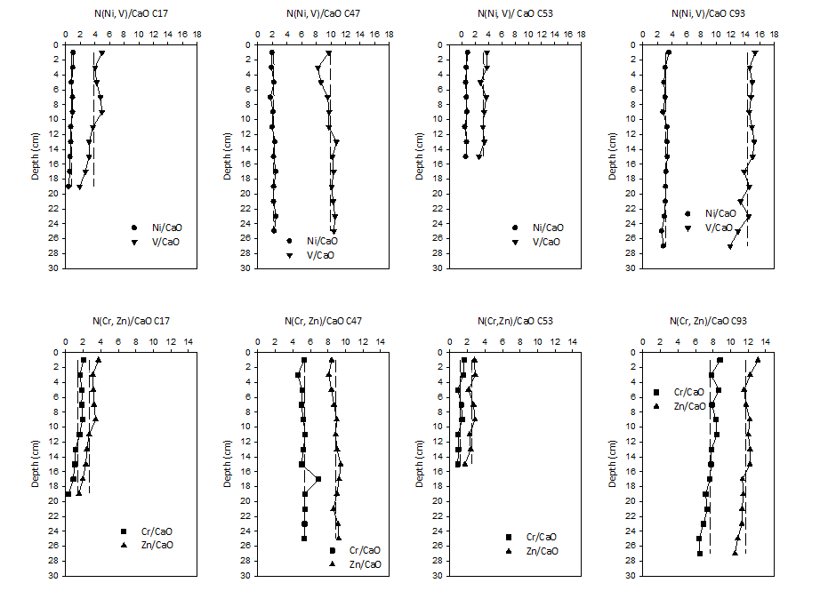

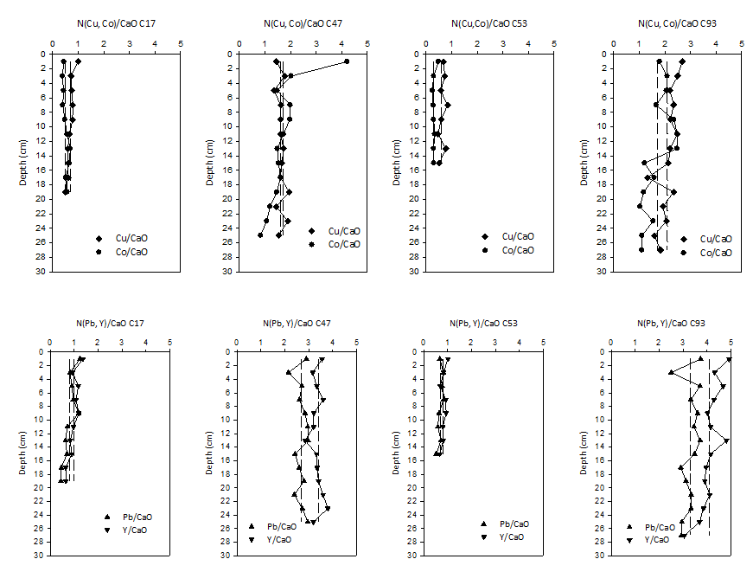

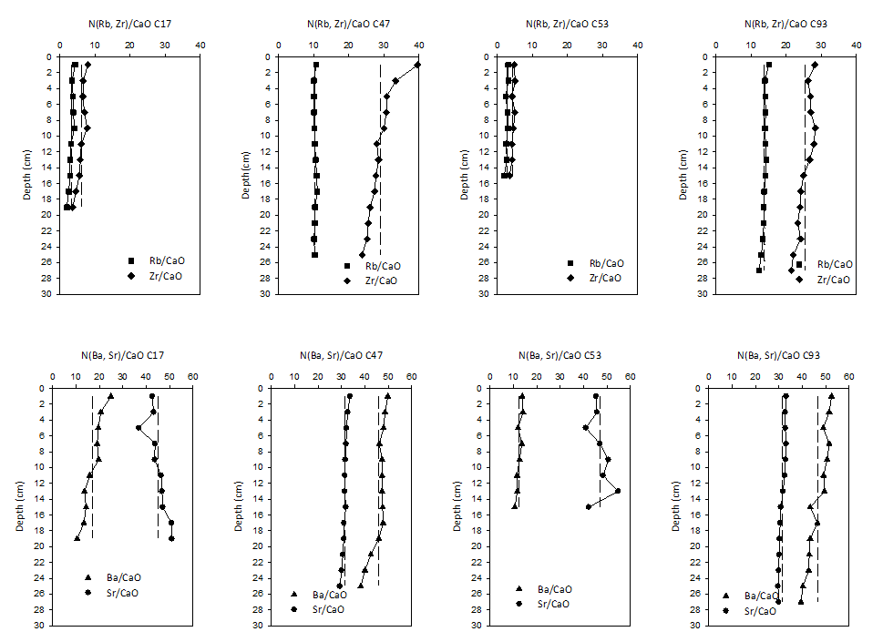

Figure 3 Factor Analysis



Note: Rotation Varimax raw, Extraction: Principal components. n = 42

Figure 4 Tree diagram from cluster analysis.



Note: n= 42 cases, Complete Linkage, City-Block (Manhattan) distances.

Figure 5 Enrichment Factor (EF) for all cores.





Figure 6 Pollution Load Index (PLI) for all cores



Figure 7 Adverse Effect Index (AEI) for all cores.





Figure 8 Variation of 210Pb activity concentrations vs depth and Ba/CaO vs year (derived from 210Pb dating) in C17, C47, C53 and C93 core profiles.



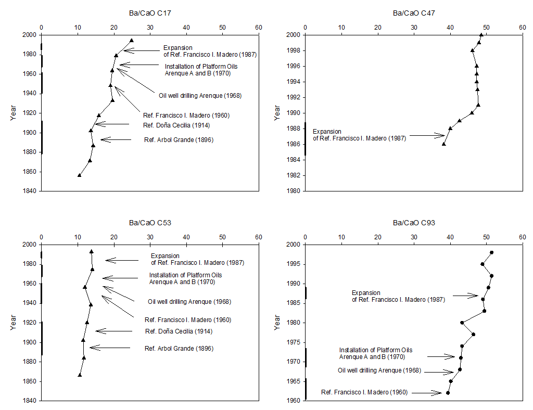

Error on dates based on 2 standard deviation uncertainties on 210Pb dating-derived sediment accumulation rates are: C17: 1990 = ± 6 years, 1970 = ± 15 years; C47: 1990 = ± 8 years, 1970 = ± 22 years; C53: 1990 = ± 3 years, 1970 = ± 7 years; C93: 1990 = ± 3 years, 1970 = ± 8 years.