Structural Basis of Membrane Disruption and Cellular Toxicity by α-Synuclein Oligomers

Giuliana Fusco^{1,2}, Serene W Chen^{1,2}, Philip T Williamson³, Roberta Cascella⁴, Michele Perni¹, James A Jarvis², Cristina Cecchi⁴, Michele Vendruscolo¹, Fabrizio Chiti⁴, Nunilo Cremades⁵, Liming Ying⁶, Christopher M Dobson^{1,*} and Alfonso De Simone^{2,*}
¹Department of Chemistry, University of Cambridge, Cambridge CB2 1EW, UK
²Department of Life Sciences, Imperial College London, London SW7 2AZ, UK
³Centre for Biological Sciences/Institute for Life Sciences, University of Southampton, Southampton SO17 1BJ, UK.
⁴Department of Experimental and Clinical Biomedical Sciences, Section of Biochemistry, University of Florence, 50134 Florence, Italy.
⁵Biocomputation and Complex Systems Physics Institute (BIFI)-Joint Unit BIFI-IQFR (CSIC), University of Zaragoza, 50018 Zaragoza, Spain.
⁶Molecular Medicine, National Heart and Lung Institute, Imperial College London,
London SW7 2AZ, UK

*Correspondence to: cmd44@cam.ac.uk or adesimon@imperial.ac.uk

One Sentence Summary: Structural properties and membrane interactions of α-synuclein oligomers unravel a mechanism of neuronal toxicity.

Abstract: Oligomeric species populated during the aggregation process of α-synuclein have been linked to neuronal impairment in Parkinson’s disease and related neurodegenerative disorders. By using solution and solid-state NMR techniques in conjunction with other structural methods, we have identified the fundamental characteristics that enable toxic α-synuclein oligomers to perturb biological membranes and generate cellular toxicity, including a highly lipophilic element that promotes strong membrane interactions and a structured region that inserts into lipid bilayers and disrupts their integrity. We provide support for these conclusions by showing that mutations targeting the region promoting strong membrane interactions by α-synuclein oligomers dramatically suppress their toxicity in neuroblastoma cells and in primary cortical neurons.

The aggregation of α-synuclein (αS) into amyloid fibrils within Lewy bodies has been associated with Parkinson’s disease (PD) and a range of other debilitating neurodegenerative disorders (1-9). The primary pathogenic agents in these conditions are thought to be the oligomeric species populated in the self-assembly of αS, particularly through their aberrant interactions with biological membranes (10-16). We have investigated here two types of stabilized αS oligomers with significantly different toxicities (17, 18), which we designated as type-A* and type-B*, as their Förster resonance energy transfer (FRET) signatures (Fig. 1A) match closely those of the previously identified transient forms of non-toxic (type A) and toxic (type B) αS oligomers (19).
The two oligomeric forms of αS have similar sizes and morphologies (Fig. 1B-C), yet exhibit very different abilities to disrupt lipid bilayers. When incubated in vitro with small unilamellar vesicles (SUVs), type-A* oligomers induce only a marginal release of encapsulated calcein, comparable to that induced by αS monomers and mature fibrils (Fig. 1D). By contrast, type-B* oligomers induce over ten times more calcein release, indicating that these oligomers generate significant disruption of acidic lipid bilayers (Fig. 1D). We observe similar loss of membrane integrity in vivo upon incubation of type-B* αS oligomers with human neuroblastoma SH-SY5Y cells and rat primary cortical neurons (Fig. 1E), and only marginal effects upon incubation with type-A* oligomers, monomers and mature fibrils of αS.
The significant disruption of synthetic and cellular membranes by type-B* αS oligomers, compared to type-A* species, was found to be strongly correlated with their ability to generate cellular toxicity. Thus type-B* αS oligomers, but not monomers, type-A* oligomers and αS fibrils, were found to reduce significantly the mitochondrial activity in neuronal cells (MTT, Fig. 1F) and to induce very significant increases of intracellular reactive oxygen species (ROS, Fig. S1A). The damage that type-B* αS oligomers induce in this manner reproduces a variety of patho-physiological effects observed in neuronal models of PD obtained by inducing pluripotent stem cell-derived neurons from a patient with triplication of the αS gene (20-22).
To probe the structural properties of the two types of αS oligomers, we used solid-state NMR (ssNMR) spectroscopy. Correlations between carbon atoms of residues located in rigid regions of the oligomers were detected using ¹³C-¹³C dipolar-assisted rotational resonance (DARR) correlation spectra, measured using magic angle spinning (MAS). ¹³C-¹³C-DARR spectra of type-A* and type-B* oligomers revealed fundamental differences in the nature of the two species (Fig. 2A), with a significant content of β-sheet identified in the rigid regions of the type-B* oligomers (Fig. 2A and S2) and negligible secondary structure content associated with the rigid regions of type-A* oligomers. The assignment of the ¹³C-¹³C-DARR peaks was performed using an approach (23-25) that combines information from solution-state chemical exchange saturation transfer (23, 26, 27) (CEST, see Methods and Fig. S3) with known assignments of fibrillar (5) and monomeric (25) states of αS, which reveal that the resonances in the ¹³C-¹³C-DARR spectra of the two types of oligomers belong to specific regions spanning residues 3-36 and 70-88 in type-A* and type-B* species, respectively (Table S1).
Highly mobile regions of the two forms of αS oligomers were detected using INEPT measurements in MAS ssNMR (Fig. 2B). The spectra indicate that both types of oligomers are characterized by a significant number of highly mobile residues (45 in type-A* and 67 in type-B*, Table S1), whose resonances overlap with those in the ¹H-¹³C-HSQC spectra of disordered monomeric αS in solution (Fig. S4). In particular, although both oligomeric species possess a flexible C-terminal region (43 and 40 highly mobile C-terminal residues for type-A* and type-B*, respectively), the N-terminal region of αS is highly dynamical only in the type-B* oligomers (0 and 26 highly mobile N-terminal residues for type-A* and type-B*, respectively). Another major difference between the two oligomeric species is that the mobile regions of the type-A* αS oligomers also include residues from the NAC region (Fig 2B), a finding consistent with the low FRET efficiency observed for the type-A* relative to the type-B* oligomers when the fluorophores are attached to residue 90, itself located in the NAC region (Fig. 1A).
The ssNMR characterization of the two types of αS oligomers is supported by Fourier transform infrared (FT-IR) measurements (Fig. S5), showing signals characteristic of both random-coil and β-sheet structure in the case of the type-B* αS oligomers, but indicating a predominantly unstructured conformation for the type-A* species. Further indication of the association with the core of the oligomers in type-A* and type-B* species is provided by CEST experiments (Fig. S3), which in the case of type-A* oligomers reveal extensive saturation in the 40 N-terminal residues of the protein, indicating a significant degree of association of this region with the core of the oligomers. In the case of type-B* oligomers, CEST experiments show a generally lower degree of saturation transfer throughout the sequence, with no saturation associated with either the N- or C- terminal regions of the protein or with residues of three of the four major hydrophobic segments of the αS sequence (residues 36-41, 47-56, 88-95), in contrast to the significant saturation observed for the hydrophobic segment 70-79. Finally, the identification of highly dynamical regions in the two types of αS oligomers is consistent with a dot blot analysis using antibodies targeting the N- and C- terminal regions of the protein (Fig. S6).
We next probed the interaction of the two types of αS oligomers with SUVs composed of DOPE:DOPS:DOPC lipids in a ratio of 5:3:2 (see Methods), which are good mimics of synaptic vesicles for composition and physical properties (24, 25). In particular, fluorescence correlation spectroscopy (FCS) in combination with confocal microscopy show that both types of oligomers bind the SUVs with high affinity, with stronger binding being observed for the type-B* oligomers relative to the type-A* species (Fig. 3A and S7). The high affinity for biological membranes of type-B* αS oligomers is also shown by their strong colocalization with the plasma membrane of primary cortical neurons (Fig. 3B).
We then carried out paramagnetic relaxation enhancement (PRE) experiments using MAS ssNMR, in which small quantities of lipid molecules labeled with a paramagnetic centre (PC) were incorporated into the bilayers (24, 25). When the PC was located in the hydrophilic head groups of the lipid molecules (see Methods), selective quenching of a number of ¹³C-¹³C-DARR resonances was observed in the spectra of both types of αS oligomers (Fig. S8), indicating in both cases strong interactions with the polar head groups of the SUVs. By contrast, when the PC was positioned within the interior of the lipid bilayer, enhanced relaxation of the NMR signals in the ¹³C-¹³C-DARR spectra was observed only for the type-B* oligomers (Fig. 3C), indicating that they can insert into the hydrophobic interior of the lipid bilayer while the type-A* oligomers remain bound exclusively to the membrane surface. In addition, the dynamical regions of the type-B* oligomers showed quenching of ¹H-¹³C-INEPT resonances only in PRE experiments performed when the paramagnetic center was located in the lipid head groups (Fig. S9).
To characterize the structural nature of the regions of αS that are tightly bound to these lipid bilayers in the two types of oligomers, we measured ¹³C-¹³C-DARR spectra at -19 °C (Fig. 3D), a condition that enhances the protein signals at the interface with this type of acidic lipid membrane (24, 25). In the case of the type-A* oligomers, these experiments revealed a set of additional peaks having low intensities and broad linewidths, indicating the absence of a specific and well-defined region of the protein that is tightly bound to the membrane, and suggesting that the interactions involve lysine-rich segments located randomly throughout the first 97 residues of the αS sequence. By contrast for the type-B* species these experiments revealed a set of additional resonances that match closely those of the N-terminal 25 residues of monomeric αS bound to SUVs, where this region of the protein adopts an amphipathic α-helical conformation (12, 25, 28), indicating that the N-terminal region in the toxic oligomers is involved in promoting strong interactions with acidic lipid bilayers.
We next examined the effects that mutations in the N-terminal region of αS exert on the ability of type-B* oligomers to disrupt biological membranes and induce cellular toxicity. We chose the A30P αS variant (αS_{A30P}) associated with an early onset form of PD, which has been shown to reduce significantly, but not completely, the membrane affinity of the N-terminal region (24), and also a truncated form of the protein lacking residues 2-9 (αS_{Δ2-9}), a key region shown to be involved in anchoring the N-terminal region of αS to lipid membranes (25, 29). In vitro measurements of calcein release showed intermediate and negligible levels of membrane disruption by type-B* oligomers formed from αS_{A30P} and αS_{Δ2-9}, respectively, compared to the effects of wild type αS (αS_{WT}) type-B* oligomers (Fig. S10A). Similar trends were observed in the disruption of cellular membranes by these species (Fig. S10B) and in their colocalization with the plasma membrane (Fig. S10D-E). The partial and a total impairment of the binding and disruption of cellular membranes by type-B* oligomers of αS_{A30P} and αS_{Δ2-9}, respectively, is highly correlated with the levels of cellular toxicity generated upon incubation with these species (MTT and ROS, Figs. S10C and S1B).
In conclusion, we have identified two structural elements that determine the ability of toxic αS oligomers to generate permeability of biological membranes (Fig. 4, Fig. S11), which in primary neurons and astrocytes leads to an increase in basal intracellular Ca²⁺ and of ROS, with consequent loss of cellular viability (20, 21). The first structural element is an exposed highly lipophilic region of the protein in the oligomers that promotes strong interactions with the membrane surface, and the second is a rigid oligomeric core that is rich in β-sheet structure and is able to insert into the lipid bilayer and disrupt the membrane integrity. These conclusions are supported by the introduction of specific mutations to suppress partially (A30P) and completely (Δ2-9) the membrane affinity of the N-terminal sequence of the protein, which show that the ability of the accessible N-terminal region of αS to bind strongly to lipid bilayers is a vital step in enabling oligomers to disrupt both synthetic and cellular membranes and consequently to induce neuronal toxicity.

References and Notes
1. F. Chiti, C. M. Dobson, Protein misfolding, amyloid formation, and human disease: A summary of progress over the last decade. Annu Rev Biochem 86, 27-68 (2017).
2. V. N. Uversky, D. Eliezer, Biophysics of Parkinson's disease: structure and aggregation of alpha-synuclein. Curr Protein Pept Sci 10, 483-499 (2009).
3. E. S. Luth, I. G. Stavrovskaya, T. Bartels, B. S. Kristal, D. J. Selkoe, Soluble, prefibrillar alpha-synuclein oligomers promote complex I-dependent, Ca²⁺-induced mitochondrial dysfunction. J Biol Chem 289, 21490-21507 (2014).
4. H. A. Lashuel, C. R. Overk, A. Oueslati, E. Masliah, The many faces of alpha-synuclein: from structure and toxicity to therapeutic target. Nat Rev Neurosci 14, 38-48 (2013).
5. M. D. Tuttle et al., Solid-state NMR structure of a pathogenic fibril of full-length human alpha-synuclein. Nat Struct Mol Biol 23, 409-415 (2016).
6. M. Vilar et al., The fold of alpha-synuclein fibrils. Proc Natl Acad Sci U S A 105, 8637-8642 (2008).
7. J. A. Rodriguez et al., Structure of the toxic core of alpha-synuclein from invisible crystals. Nature 525, 486-490 (2015).
8. L. Bousset et al., Structural and functional characterization of two alpha-synuclein strains. Nat Commun 4, 2575 (2013).
9. G. Comellas, L. R. Lemkau, D. H. Zhou, J. M. George, C. M. Rienstra, Structural intermediates during alpha-synuclein fibrillogenesis on phospholipid vesicles. J Am Chem Soc 134, 5090-5099 (2012).
10. B. Winner et al., In vivo demonstration that alpha-synuclein oligomers are toxic. Proc Natl Acad Sci U S A 108, 4194-4199 (2011).
11. M. Grey, S. Linse, H. Nilsson, P. Brundin, E. Sparr, Membrane interaction of alpha-synuclein in different aggregation states. J Parkinsons Dis 1, 359-371 (2011).
12. N. Lorenzen, L. Lemminger, J. N. Pedersen, S. B. Nielsen, D. E. Otzen, The N-terminus of alpha-synuclein is essential for both monomeric and oligomeric interactions with membranes. FEBS Lett 588, 497-502 (2014).
13. K. M. Danzer et al., Different species of alpha-synuclein oligomers induce calcium influx and seeding. J Neurosci 27, 9220-9232 (2007).
14. S. Campioni, et al, F. Chiti, A causative link between the structure of aberrant protein oligomers and their toxicity. Nat Chem Biol 6, 140-147 (2010).
15. P. K. Auluck, G. Caraveo, S. Lindquist, alpha-Synuclein: membrane interactions and toxicity in Parkinson's disease. Annu Rev Cell Dev Biol 26, 211-233 (2010).
16. J. H. Soper, V. Kehm, C. G. Burd, V. A. Bankaitis, V. M. Lee, Aggregation of alpha-synuclein in S. cerevisiae is associated with defects in endosomal trafficking and phospholipid biosynthesis. J Mol Neurosci 43, 391-405 (2011).
17. S. W. Chen et al., Structural characterization of toxic oligomers that are kinetically trapped during alpha-synuclein fibril formation. Proc Natl Acad Sci U S A 112, E1994-2003 (2015).
18. D. E. Ehrnhoefer et al., EGCG redirects amyloidogenic polypeptides into unstructured, off-pathway oligomers. Nat Struct Mol Biol 15, 558-566 (2008).
19. N. Cremades et al., Direct observation of the interconversion of normal and toxic forms of alpha-synuclein. Cell 149, 1048-1059 (2012).
20. P. R. Angelova et al., Ca2+ is a key factor in alpha-synuclein-induced neurotoxicity. J Cell Sci 129, 1792-1801 (2016).
21. E. Deas et al., Alpha-synuclein oligomers interact with metal ions to induce oxidative stress and neuronal death in Parkinson's disease. Antioxid Redox Signal 24, 376-391 (2016).
22. M. J. Devine, et al, T. Kunath, Parkinson's disease induced pluripotent stem cells with triplication of the alpha-synuclein locus. Nat Commun 2, 440 (2011).
23. G. Fusco et al., Direct observation of the three regions in alpha-synuclein that determine its membrane-bound behaviour. Nat Commun 5, 3827 (2014).
24. G. Fusco et al., Structural basis of synaptic vesicle assembly promoted by alpha-synuclein. Nat Commun 7, 12563 (2016).
25. G. Fusco et al., Structural ensembles of membrane-bound alpha-synuclein reveal the molecular determinants of synaptic vesicle affinity. Sci Rep 6, 27125 (2016).
26. P. Vallurupalli, G. Bouvignies, L. E. Kay, Studying "invisible" excited protein states in slow exchange with a major state conformation. J Am Chem Soc 134, 8148-8161 (2012).
27. J. Milojevic, V. Esposito, R. Das, G. Melacini, Understanding the molecular basis for the inhibition of the Alzheimer's Abeta-peptide oligomerization by human serum albumin using saturation transfer difference and off-resonance relaxation NMR spectroscopy. J Am Chem Soc 129, 4282-4290 (2007).
28. C. R. Bodner, C. M. Dobson, A. Bax, Multiple tight phospholipid-binding modes of alpha-synuclein revealed by solution NMR spectroscopy. J Mol Biol 390, 775-790 (2009).
29. K. Vamvaca, M. J. Volles, P. T. Lansbury, Jr., The first N-terminal amino acids of alpha-synuclein are essential for alpha-helical structure formation in vitro and membrane binding in yeast. J Mol Biol 389, 413-424 (2009).

Acknowledgments.
This research was supported by Parkinson’s UK (G-1508 to G.F., M.V., C.M.D., A.D.), the UK Medical Research Council (MR/N000676/1 to G.F., M.V., C.M.D., A.D.), the Wellcome Trust (104933/Z/14/Z to A.D.), the Leverhulme Trust (RPG-2015-350 to A.D. and RPG-2015-345 to L.Y.), the British Heart Foundation (PG/14/93/31237 to A.D. and PG/11/81/29130 to L.Y.), the UK Biotechnology and Biological Sciences Research Council (BB/M023923/1 to A.D. and BB/G00594X/1 to L.Y.), the Agency of Science, Technology and Research of Singapore (to S.W.C.), the Ministry of Economy and Competitiveness of Spain (MINECO RYC-2012-12068 and MINECO/FEDER EU BFU2015-64119-P to N.C.) and the Centre for Misfolding Disease of the University of Cambridge.

The data supporting the findings of this study are available within the article and its Supplementary Materials.

Supplementary Materials
www.sciencemag.org
Materials and Methods
Figs. S1 to S11
Tables S1 to S2
References (30-43)

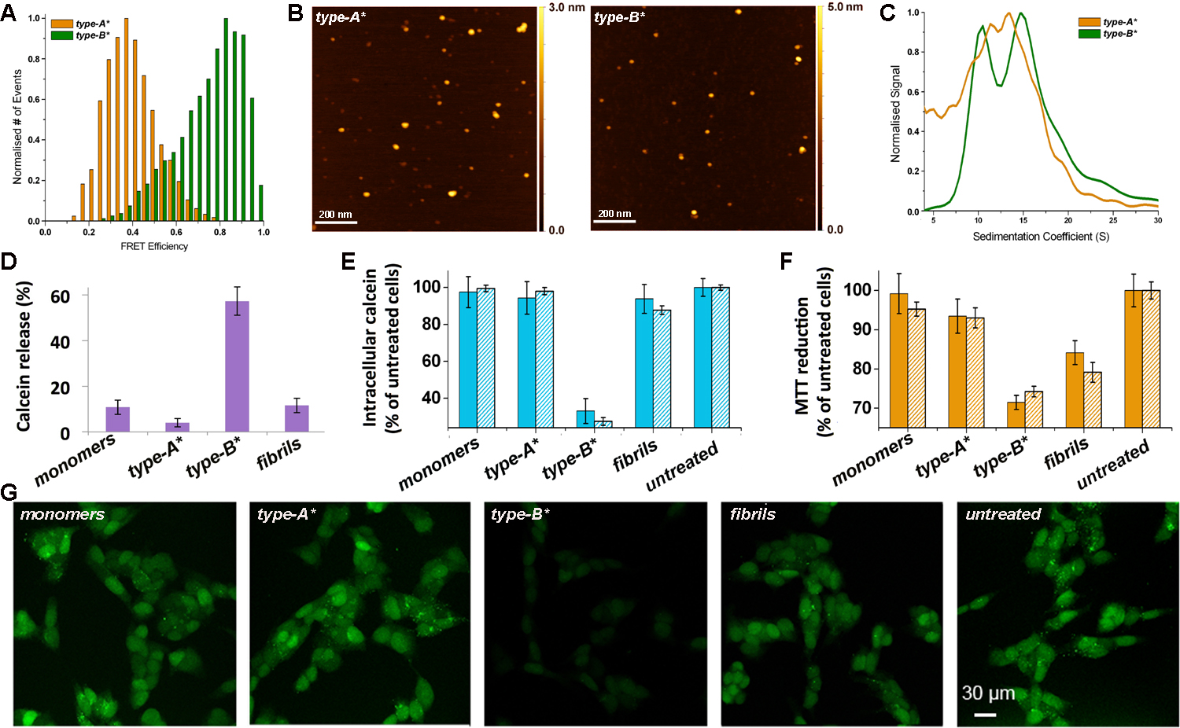
Figure 1. Properties of the two types of αS oligomers. (A) Intermolecular FRET efficiencies from measurements of type-A* (orange) and type-B* (green) αS oligomers. (B) Images of the type-A* and type-B* samples of αS oligomers probed by AFM (scale bar 200 nm). (C) Sedimentation coefficients of the type-A* (orange) and the type-B* (green) oligomers measured using AU. (D) In vitro calcein release assay from POPS SUVs (see Methods). (E-F) Intracellular calcein-induced fluorescence (E) and mitochondrial activity monitored by the reduction of MTT (F) measured on human neuroblastoma SH-SY5Y cells (filled bars) and rat primary cortical neurons (striped bars) upon incubation with the various αS species. (G) Representative confocal scanning microscopy images of SH-SY5Y cells (scale bar 30 μm). P values for the data shown in panels D-F are reported in Table S2.

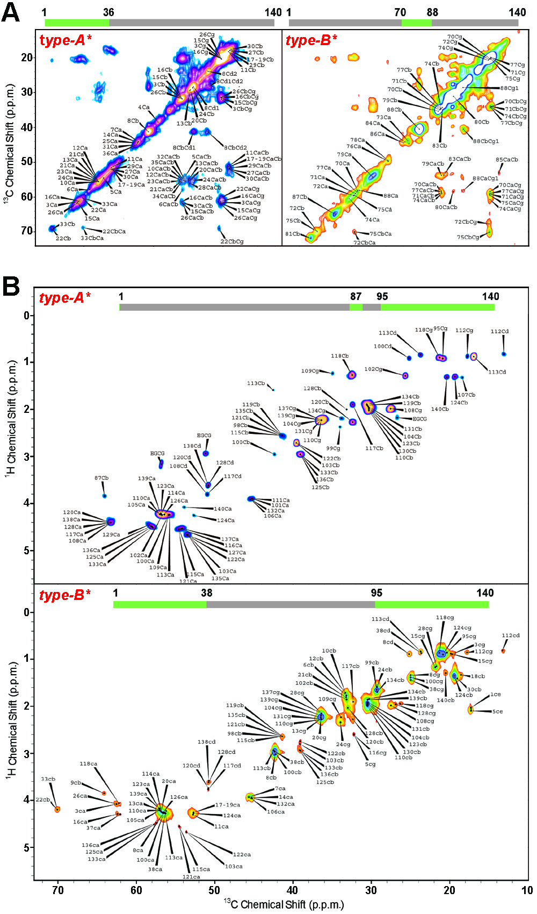
Figure 2. MAS ssNMR spectra of αS oligomers. (A) ¹³C-¹³C DARR correlation spectra (aliphatic regions) of type-A* and type-B* αS oligomers (left and right panels, respectively). (B) ¹H-¹³C correlations via INEPT transfer. The labels ca, cb, cg, cd and ce indicate C^{α}, C^{β}, C^{γ}, C^{δ} and C^{ε} atoms, respectively. The regions of the protein sequence detected in the spectra are highlighted in green in the bars at the top of the spectra.

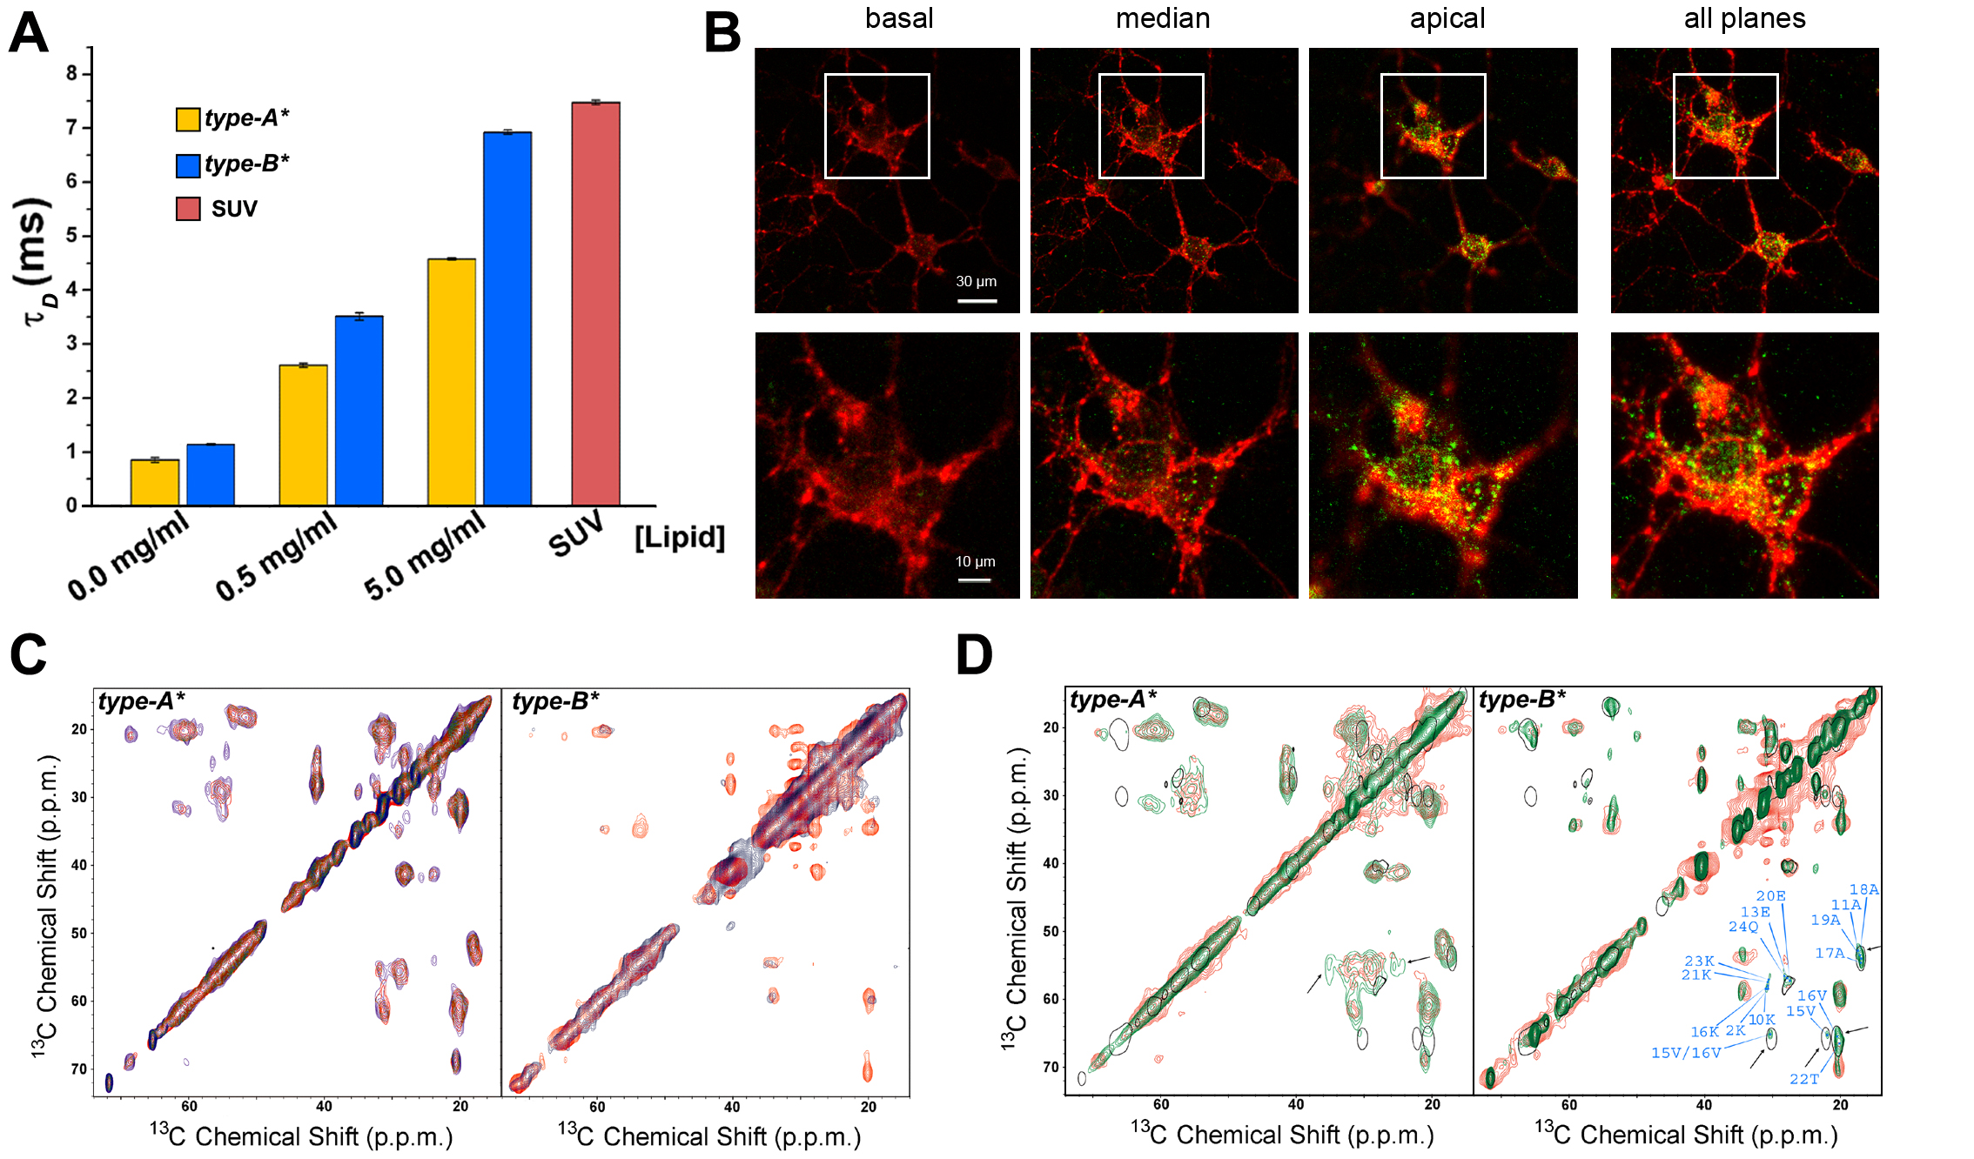
Figure 3. Interactions of αS oligomers with lipid bilayers. (A) Diffusion times, τ_{D}, from FCS experiments of type-A* and type-B* αS oligomers in the presence of variable quantities of small unilamellar vesicles of DOPE:DOPS:DOPC lipids (SUV, see Methods and Fig. S8). (B) Representative confocal scanning microscope images of basal, median, apical planes and their combination (fourth column) of type-B* αS oligomers incubated with primary cortical neurons for 15 min. Red and green fluorescence indicates the plasma membrane and the αS oligomers, respectively. (C) PRE effects measured using MAS ssNMR for type-A* (left) and type-B* (right) αS oligomers using SUVs with a paramagnetic centre at the position of carbon 16 of the lipid chain. ¹³C-¹³C-DARR spectra measured in the presence and absence of the paramagnetic labeled lipids are shown in blue and red, respectively. (D) ¹³C-¹³C-DARR spectra of isolated type-A* (left) and type-B* (right) αS oligomers (red) compared with spectra measured at -19 °C in the presence of DOPE:DOPS:DOPC SUVs (green) and of monomeric αS bound to the same type of vesicles (24) (black contour lines). The arrows identify the signals of residues in the rαS oligomers arising from the membrane-bound protein regions. In the case of type-B* αS oligomers these regions were assigned from a previous study of the monomeric state of αS bound to SUVs (24).
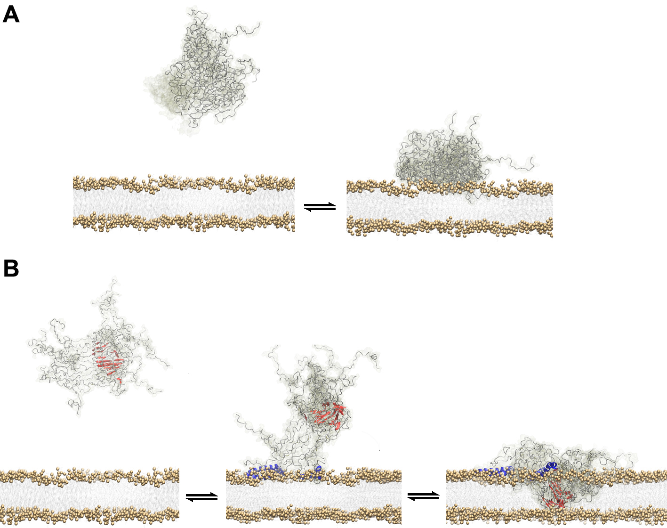

Figure 4. Structural basis of membrane binding of αS oligomers. Schematic summary of the findings of this investigation (further details in Fig. S11). (A) The non-toxic type-A* αS oligomers, represented in disordered conformations using grey ribbons, bind to the surface of acidic lipid bilayers via various lysine rich segments randomly exposed on their surfaces. (B) The toxic type-B* αS oligomers feature both structured (red) and disordered (grey) regions, and bind to the surfaces of the lipid bilayers via the exposed N-terminal regions of αS molecules in the oligomer, which fold into amphipathic α-helices (blue) upon membrane binding, with the rigid core of the oligomers inserting into the bilayer.

