Supplementary Table. Risk ratios for developing allergic airway disease in subjects with eczema or aeroallergen sensitization
 | Asthma at 4 years  (RR [95% CI]) |  | Asthma at 10 years  (RR [95% CI]) |  | Asthma at 18 years  (RR [95% CI]) |  | Rhinitis at 4 years  (RR [95% CI]) |  | Rhinitis at 10 years  (RR [95% CI]) |  | Rhinitis at 18 years  (RR [95% CI])
Eczema at 1 year  (n = 1364 ) | 2.29 | (1.70 to 3.09) | 0.85 | (0.55 to 1.32) | 1.06 | (0.74 to 1.53) | 3.08 | (1.86 to 5.10) | 1.68 | (1.24 to 2.31) | 1.12 | (0.90 to 1.38)
Eczema at 2 years  (n = 1227 ) | 1.74 | (1.29 to 2.36) | 1.07 | (0.76 to 1.51) | 0.74 | (0.51 to 1.06) | 2.34 | (1.42 to 4.35) | 1.79 | (1.36 to 2.38) | 1.25 | (1.04 to 1.49)
Eczema at 4 years  (n = 1214 ) | 2.19 | (1.63 to 2.95) | 1.56 | (1.07 to 2.27) | 1.35 | (0.94 to 1.93) | 3.17 | (1.93 to 5.21) | 2.43 | (1.83 to 3.24) | 1.63 | (1.37 to 1.96)
Eczema at 10 years  (n =1358 ) | NA |  | 1.27 | (0.88 to 1.84) | 1.05 | (0.73 to 1.52) | NA |  | 1.87 | (1.40 to 2.49) | 1.28 | (1.06 to 1.54)
Eczema at 18 years  (n = 1307 ) | NA |  | NA |  | 0.85 | (0.55 to 1.30) | NA |  | NA |  | 1.49 | (1.26 to 1.78)
AAS at 1 and 2 years  (n = 563 ) | 1.72 | (1.20 to 2.44) | 1.41 | (0.82 to 2.43) | 1.20 | (0.67 to 2.16) | 1.83 | (0.93 to 3.57) | 1.89 | (1.28 to 2.80) | 1.25 | (0.95 to 1.67)
AAS at 4 years  (n = 980) | 3.31 | (2.53 to 4.32) | 1.14 | (0.75 to 1.71) | 0.72 | (0.46 to 1.11) | 4.45 | (2.76 to 7.18) | 3.42 | (2.62 to 4.48) | 1.95 | (1.66 to 2.29)
AAS at 10 years  (n = 1035) | NA |  | 0.85 | (0.60 to 1.26) | 0.93 | (0.66 to 1.31) | NA |  | 4.28 | (3.28 to 5.59) | 2.68 | (2.30 to 3.12)
AAS at 18 years  (n = 851) | NA |  | NA |  | 3.17 | (2.35 to 4.28) | NA |  | NA |  | 1.00 | (0.82 to 1.23)
AAS: aeroallergen sensitization
# Italicized values indicate significant risk ratios.

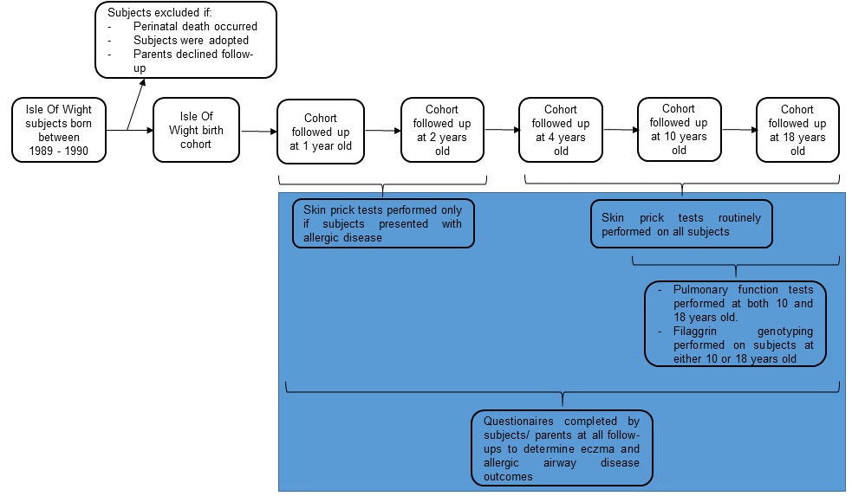
Supplementary Figure 1. Protocol design for the original Isle Of Wight Cohort Study up till 18 years. The shaded area indicates the main variables to be analyzed for this current study.

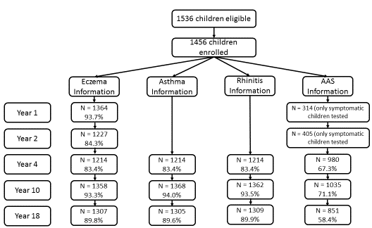
Supplementary Figure 2. Participation data/information availability for allergic diseases and aeroallergen sensitization at follow-up ages in the IOW cohort (data expressed as n (%)).

