A new procedure for the template synthesis of metal nanowires

J.E. Graves^{a*}, M.E.A. Bowker^{b}, A. Summer^{b}, A. Greenwood^{b}, C. Ponce de León^{c}, F.C. Walsh^{c}

a) Centre for Manufacturing and Materials Engineering, Coventry University, CV1 5FB
b) Faculty of Health and Life Sciences, Coventry University, CV1 5FB
c) Energy Technology Research Group, University of Southampton SO17 1BJ
*Corresponding author E-mail address: j.graves@coventry.ac.uk
Abstract
A new procedure for the fabrication of metal nanowires by template assisted electrodeposition using porous polycarbonate templates is described. A thin sputtered film of silver (≤15 nm) was deposited onto one side of the template. The silver seed layer was used to catalyse electroless copper deposition and a copper layer was grown on top (300 - 500 nm) in less than 10 min. The copper layer served to seal the pores of the template and to form an electrode of high electrical conductivity. The copper layer was easily removed with a chemical etchant to aid the release of the nanowires from the template mask after growth. To demonstrate the process, copper nanowires were prepared by controlled potential deposition and characterised by SEM and TEM. This new procedure has the ability to be applied to the preparation of a wide range of metallic nanostructures over a wide range of scales. It avoids the need for an extended vacuum deposition step and has the advantage of using low cost metals in a combined short vacuum / wet chemical process so as to form the critical electrode layer for nanowire growth.
Keywords:
Electroless copper, nanostructures, nanowires, template synthesis.
1. Introduction
Metal nanowires are promising materials for many applications [1-7]. Research into the preparation of metal nanostructures has been ongoing for a number of years and a number of processes have been developed [8-10]. Template assisted electrodeposition of metal nanowires is one such technique and is the focus of this paper. The technique has attracted much attention since its first demonstration in 1970 [11] and is limited only by the size of the pores present in a template film (typically ion tracked etched polymers or porous aluminium oxide templates).
A critical part of the process which is often overlooked is the deposition of an electrode layer onto one side. This layer plays a vital role and should be uniform and highly conductive so as to ensure excellent current or voltage distribution across the template for subsequent electroplating. Two procedures are usually employed; either (a) the electrode layer is prepared by sputtering or using e-beam evaporation to deposit a thick (200 nm – 1000 nm) metal film onto the template [2,12-14]; or (b) a thin film is sputtered onto the template ( < 200 nm) and the layer is reinforced by plated copper up to 10 µm in thickness [15,16]. This second process is more robust, but it is difficult to make electrical connection to the thin, fragile sputtered film in order to grow the reinforcing layer. Moreover, if the nanowires need to be released it is difficult to remove the electrodeposited layer.
This paper describes for the first time a new procedure for forming the electrode layer. The key steps of the proposed approach are the deposition of a thin layer of sputtered silver (≤15 nm) which can then be used to catalyse the electroless deposition of copper and grow a copper layer (≈ 300 - 500 nm) on the surface of the template. Other workers have used a non-selective tin / palladium catalysed electroless copper deposition process to form nanotubes [17,18] but, it would seem that no workers have used a combination of sputtered silver and electroless copper deposition to form the electrode layer for subsequent bottom-up nanowire growth. This work demonstrates the new procedure for preparing the electrode layer.

2. Materials and Methods
Pre-fabricated polycarbonate templates, in pore sizes of 60 nm, 100 nm and 200 nm, thickness 25 µm, were purchased from it4ip or Fisher Scientific. In a typical procedure, see Figure 1, the template was (a) first washed gently in a 1 v./v. % of Neutracon at 40 ºC for 5 min, rinsed, air-dried and (b) sputter coated with silver, 3 min (Polaron Range SC7620 Mini Sputter Coater, Ar bombardment gas, 15 mA current). The template was suspended in an electroless copper bath at 46ºC for 10 min (CIRCUPOSIT™ 3350-1, A-GAS Electronic Materials) to form the electrode layer, (c) rinsed and carefully air dried. Copper electrodeposition (d) was carried out in an adapted PEEK electroplating cell [19]. The electrolyte for copper electrodeposition is described in [12]. A deposition potential of -75 mV vs. saturated calomel electrode (SCE) was applied for 120 min to grow the nanowires using a Voltalab potentiostat in a three-electrode cell. A titanium/ mixed metal oxide mesh was used as a counter electrode. The template was removed from the plating cell, rinsed and air dried. The nanowires were freed from the template by etching away the bottom electrode layer (e) with a 3 v./v.% solution of hydrogen peroxide/sulphuric acid and then (f) by dissolving the template in dichloromethane. Micrographs were recorded using a Carl Zeiss 1530 VP field emission gun scanning electron microscope (FEGSEM). ICP-OES (Perkin-Elmer Optima 5300 DV) was used to determine the quantity of silver applied to the template. The thinnest nanowires were analysed by transmission electron microscopy (TEM) with a JEOL JEM 2100.

3. Results and Discussion
3.1 Characterisation of silver seed layer
Silver is known to be an effective catalyst for electroless copper deposition [20,21]. Sputtered silver coatings have a small grain size that should act as an ideal seed layer.
Polycarbonate templates (100 nm pores) were covered with different thicknesses of sputtered silver by varying the sputtering time between 0.5 and 60 min. Figure 2 shows high magnification micrographs for sputtering times of 0.5 and 3 min. After 0.5 min (a) the coating is non-continuous and has a ‘cracked-mud’ appearance. As the coating time is increased to 3 min, the breaks in the coating become less apparent, and a more uniform layer is deposited (b). Pores are covered and closed after a full 60 min only of sputter coating.
A deposition rate of ≈ 5 nm min⁻¹ was determined from ICP-OES results. Therefore at 3 min and 60 min; ≈ 15 nm and ≈ 300 nm coatings respectively are being deposited. The latter result confirms the findings in the literature that a >250 nm film is required to close the pores of a 100 nm template. As a general rule, for the polycarbonate template used, the coating thickness needs to be 2.5 times the pore size. The loading of silver was found to be 0.015 and 0.361 mg cm⁻² at 3 and 60 min respectively.

3.2 Formation of electroless copper electrode layer
With an understanding of the morphology and loading of the sputtered layers an investigation of electroless copper plating parameters was undertaken. It was anticipated that the largest pore size would take the longest time to cover, and so 200 nm pores were chosen for this study. Sputtering (0.5 – 3min) and electroless immersion (5 – 10 min) times were varied.
Figure 3(a) shows micrographs of a template after 0.5 min of sputter coating and (b) and (c); 5 min immersion in an electroless copper bath. Patchy coverage of the template and voids in the coating are observed after plating. After 3 min in the sputter coater (d) and a 10 min electroless copper immersion full coverage is observed; the pores are sealed (e) and (f) and the coverage is excellent. However, it should be noted that extended times (>10 min) in the plating bath can lead to blistering of the copper layer.
The reverse side of the electrode layer was also examined after dissolving the template. Figure 3(g) shows the electroless copper layer starts to fill the bottom of the pores and thus forms the base of the nanowire. The electroless copper structures are ≈1µm in height (h). Clearly, the sputtering process also directs silver atoms into the pores where they adhere to the side wall and trigger copper deposition. This structure provides an ideal base for the subsequent electroplating step where the nanowires are extended in length. Plating into the pores also has the additional advantage of mechanically keying the electrode layer to the smooth surface of the template.
In summary, excellent coverage has been achieved with a thin, low loading of silver.

3.3 Nanowire growth with electroless copper electrode layer
Templates sputter coated for 3 min and plated in electroless copper for 10 min were prepared and used to grow copper nanowires. Figure 4 shows typical I-t curves for copper deposition at an applied potential of -75 mV vs. SCE (low to avoid side reactions). All curves show typical behaviour as described in [15]. Curve (i) shows the response observed from a template with the pores sealed on both sides using the new procedure. The average plating current between 20 and 120 min is 3.65 mA, which corresponds to a plating current density of 2.1 mA cm⁻² and a plating rate of ≈ 3 µm h⁻¹ of copper. Curves (ii) and (iii) show the I-t curves for 200 nm and 100 nm pores respectively. Reduced currents in the growth phase are observed, 0.63 mA for the 200 nm pores and 0.27 mA for the 100 nm pores, which is as expected due to the significantly reduced electrode surface.
Calculating surface area porosities [22], values of 18 % (200 nm) and 7% (100 nm) are obtained for the two templates. Using the average plating current of 3.65 mA observed for the fully sealed template; currents of 0.66 mA and 0.26 mA would be expected. The averaged experimental values observed are in good agreement and suggest that uniform nanowire growth is taking place.

Figure 5(a) shows a typical SEM image of nanowires illustrating uniform growth of the wires from the electrode layer. Figure 5(b) shows the electroless copper and sputter coated silver layers, and the bottom of the nanowires. The interconnection between the electroless copper and electroplated copper layer is good. If required, the electrode layer at the bottom of the template can be removed using a chemical etchant by flipping the template in the electroplating cell and exposing the fine grained electroless Cu face to the etchant. The template can then be dissolved to free the nanowires.
The thinnest wires were characterised by TEM, see Figure 5(c). A Fast Fourier Transform (FFT) image (d) confirms the polycrystalline nature of the nanowire in the analysed area, as observed in previous work [15], and corresponds to the (111) plane of FCC copper. Images (e-f) confirm the good bond between the electroless and electrodeposited copper layers.

4. Conclusions
A new, simple procedure is described for preparing the electrode layer for template assisted electrodeposition of nanowires. Using a thin (≤15 nm) low cost silver seed layer, it is possible to initiate electroless copper deposition and apply a thicker (300-500 nm) uniform, highly conductive copper layer for subsequent nanowire growth. The advantages of this new procedure include; reduced vacuum processing times; low precious metal consumption; and the ability to remove the electrode layer easily using a chemical etchant. The electrodeposited nanowires show uniform growth; good adhesion of the electroless layer to the electroplated layer; and structure similar to that grown by standard techniques.
References
1. Z.Wang, X. Pan, Y. He, Y. Hu, H. Gu, Y. Wang, Piezoelectric nanowires in energy harvesting applications, Adv. Mater. Sci. Eng. 2015 (2015) Article ID 165631.
2. T. Chang, S. Cho, J. Kim, J. Schoenleber, C. Frantz, N. Stein, C. Boulanger, W. Lee, Individual thermoelectric properties of electrodeposited bismuth telluride nanowires in polycarbonate membranes, Electrochim. Acta 161 (2015) 403-407.
3. J. Mohapatra, A.Mitra, H. Tyagi, D. Bahadur, M. Aslam, Iron oxide nanorods as high-performance magnetic resonance imaging contrast agents, Nanoscale 7 (2015) 9174-9184.
4. S. Ye, A.R. Rathmell, Z. Chen, I.E. Stewart, B.J. Wiley, Metal Nanowire Networks: The next generation of transparent conductors, Adv. Mater. 26 (2014) 6670-6687.
5. X. Duan, Y. Huang, Y. Cui, J. Wang, C.M. Lieber, Indium phosphide nanowires as building blocks for nanoscale electronic and optoelectronic devices, Nature 409 (2001) 66-69.
6. B.J. Plowman, S.K. Bhargava, A.P. O'Mullane, Electrochemical fabrication of metallic nanostructured electrodes for electroanalytical applications, Analyst 136 (2011) 5107-5119.
7. F. C. Walsh, C. Ponce de Leon, D. V. Bavykin, C. T. J. Low, S. C. Wang, C. Larson, The formation of nanostructured surfaces by electrochemical techniques: a range of emerging surface finishes. Part 2: examples of nanostructured surfaces by plating and anodising with their applications, Transactions of the IMF 93 (2015) 241.
8. S. Ye, A.R. Rathmell, Z. Chen, I. Stewart, Metal nanowire networks: The next generation of transparent conductors, Adv. Mater. 26 (2014) 6670-6687.
9. G. Cao, D. Liu, Template-based synthesis of nanorod, nanowire and nanotube arrays, Advances in Colloid and Interface Science 136 (2008) 45-64.
10. R.Inguanta, S. Piazza, C. Sunseri, Novel procedure for the template synthesis of metal nanostructures, Electrochemistry Communications 10 (2008) 506-509.
11. G.E. Possin, A method for forming very small diameter wires, Review of Scientific Instruments 41 (1970) 772.
12. T. Chowdhury, D.P. Casey, J.F. Rohan, Additive influence on Cu nanotube electrodeposition in anodised aluminium oxide templates, Electrochemistry Communications 11 (2009) 1203-1206.
13. C. Schönenberger, B.M.I Van Der Zande, L.G.J. Fokkink, M. Henny, C. Schmid, M. Krüger, A. Bachtold, R. Huber, H. Birk, U. Staufer, Template synthesis of nanowires in porous polycarbonate membranes: Electrochemistry and Morphology, Journal of Physical Chemistry B 101 (1997) 5497-5505.
14. T.Gao, G.W. Meng, J. Zhang, Y.W. Wang, C.H. Liang, J.C. Fan, D.L. Zhang, Template Synthesis of Single-Crystal Cu Nanowire Arrays by Electrodeposition, Applied Physics A 73, (2001) 251-254.
15. M.E. Toimil Molares, J. Brotz, V. Buschmann, D. Dobrev, R. Neumann, R. Scholz, I.U. Schuchert, C. Trautmann, J. Vetter, Etched heavy ion tracks in polycarbonate as template for copper nanowires, Nuclear Instruments and Methods in Physics Research B 185 (2001) 192-197.
16. I. Enculescu; Z. Siwy, D. Dobrev, C. Trautmann, M.E. Toimil Molares, R. Neumann, K. Hjort, L. Westerberg, R. Spohr, Copper nanowires electrodeposited in etched single-ion track templates, Applied Physics A: Materials Science and Processing 77 (2003) 751-755.
17. W. Wang, N. Li, X. Li, W. Geng, S. Qiu, Synthesis of metallic nanotube arrays in porous anodic aluminium oxide template through electroless deposition, Materials Research Bulletin 41 (2006) 1417-1423.
18. B. Bercu, I. Enculescu, R. Spohr, Copper tubes prepared by electroless deposition in ion track templates, Nucl. Instrum. Methods Phys. Res. Sect. B 225 (2004) 497-502.
19. M. Guan, Electrochemical fabrication of AuCo nanostructures (2008). LSU Doctoral Dissertations. 1048. http://digitalcommons.lsu.edu/gradschool_dissertations/1048 (accessed 6th November 2017).
20. K.A.Wills, K. Krzyzak, J. Bush, R. Ashayer-Soltani, J.E. Graves, C. Hunt, A.J. Cobley, Additive process for patterned metallized conductive tracks on cotton with applications in smart textiles, The Journal of The Textile Institute 2017 DOI: 10.1080/00405000.2017.1340822
21. J.E. Graves, M.T. Goosey, D. Hirst, M.A. Poole, An electrochemical pre-treatment and catalysation process for ABS utilising silver(II) chemistry, Trans. Inst. Metal Finish. 79 (3) (2001) 90–94.
22. M. Webb, A comparison of nanowire production methodologies: Copper electrodeposition into etched ion-track polycarbonate and porous anodised aluminium oxide templates, 2013. https://www.research.manchester.ac.uk/portal/files/54542517/FULL_TEXT.PDF (accessed 6th November 2017).

Figure Captions
Figure 1. Schematic of the new procedure.
Figure 2. SEMs of polycarbonate templates (pore size 100 nm) after sputtering times of (a) 0.5 min and (b) 3 min.
Figure 3. SEMs of 200 nm pore templates after (a) Ag sputter coating 0.5 min; (b) and (c) after electroless Cu deposition, 5 min; (d) Ag sputter coating 3 min; (e) and (f) after electroless Cu deposition, 10 min; (g) reverse and (h) side view.
Figure 4. I vs t curves for Cu deposition for (i) fully coated (ii) 200 nm (iii) 100 nm pore templates, step potential -75mV vs. SCE.
Figure 5. SEM and TEMs of Cu nanowires (a) fixed to the electrode layer (b) magnified image (c) TEM of wire (d) FFT image (e,f) electroless / electrodeposited Cu interconnect.

Figure 1.
- Polycarbonate template (b) Application of sputtered Ag
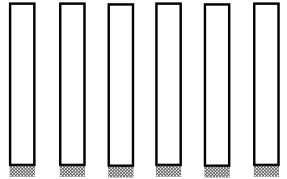

(c) Electroless Cu deposition (d) Cu electrodeposition
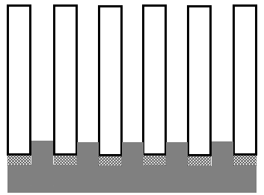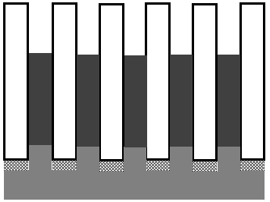

(e) Electrode removal (f) Dissolution of membrane
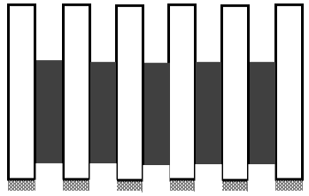

Figure 2.
Figure 3.
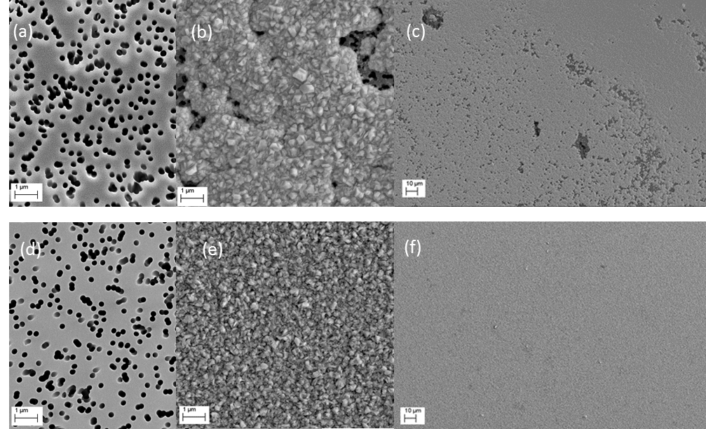

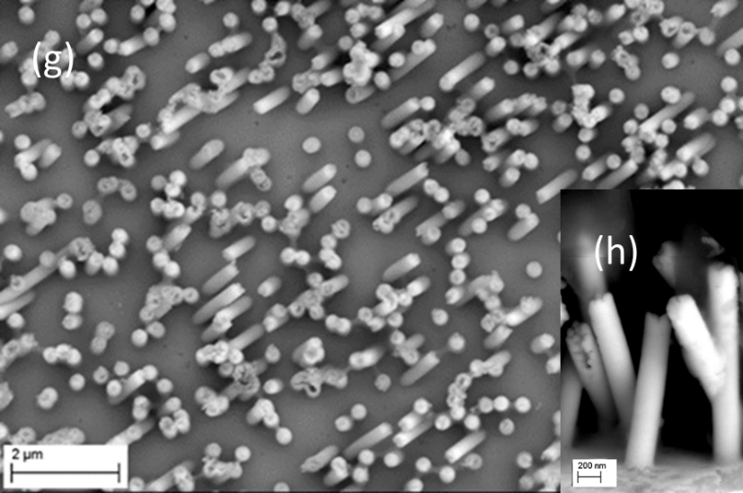

Figure 4.
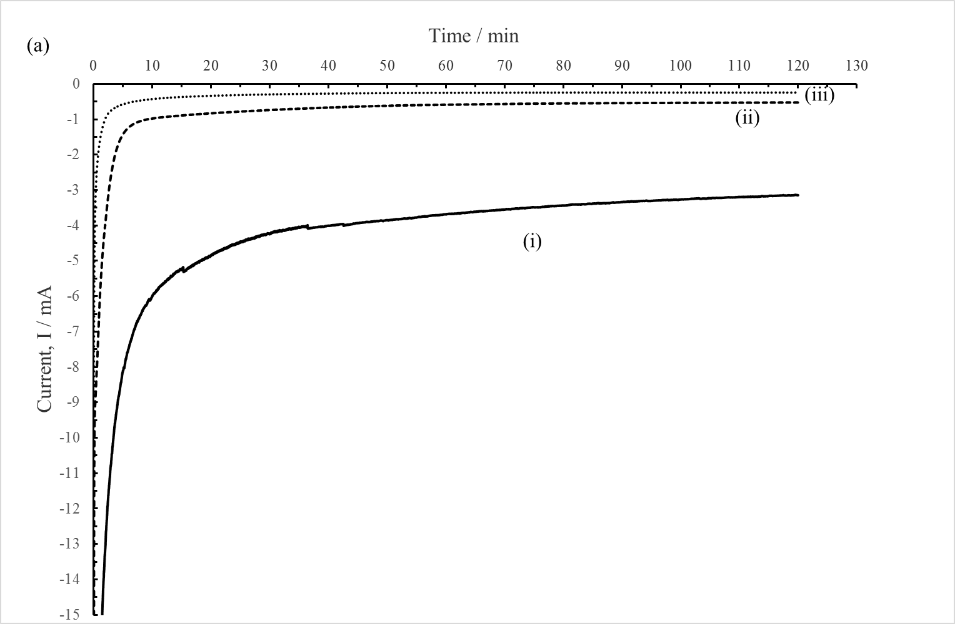

Figure 5.
