Electro-polymerisation and characterisation of PEDOT in
Lewis basic, neutral and acidic EMImCl-AlCl₃ ionic liquid
T. Schoetz^{a,}*, C. Ponce de Leonª, A. Bund^{b} and M. Ueda^{c}

ª Faculty of Engineering and the Environment; University of Southampton; Highfield Southampton SO17 1BJ; United Kingdom
^{b} Electrochemistry and Electroplating Group; Technische Universität Ilmenau;
Gustav-Kirchhoff-Straße 6; 98693 Ilmenau; Germany
^{c} Faculty of Engineering; Hokkaido University; Kita-13, Nishi-8, Kita-ku, 060-8628 Hokkaido, Sapporo; Japan

Abstract
This work studied the electro-polymerisation of 3,4-ethylenedioxythiophene (EDOT) and its electrochemical behavior in Lewis acidic, neutral and basic chloroaluminate ionic liquid 1-ethyl-3-methylimidazolium chloride aluminum chloride (EMImCl-AlCl₃) by cyclic voltammetry. It was found that the electro-polymerisation on vitreous carbon only occurs in Lewis neutral EMImCl-AlCl₃ as a dark blue-violet film whereas the electro-polymerisation in a Lewis acidic or basic compositions is not possible due to the interactions between the conductive polymer and the ionic liquid as well as the potential stability limits of the electrolyte. PEDOT films synthesised in Lewis neutral ionic liquid were tested in monomer-free Lewis acidic, basic and neutral EMImCl-AlCl₃ and show different doping and de-doping behavior for chloride ionic species. The PEDOT films in a Lewis neutral composition showed higher doping levels due to the higher potential stability window, up to 2.6 V vs. Al|Al(III) than in a Lewis acidic and basic solutions. Furthermore, it was shown that the doping and de-doping levels are predefined during the electro-polymerisation of PEDOT. The anion doping and de-doping reaction reached 97% reversibility in the neutral composition, which suggests that PEDOT is a suitable electrode material to store charged species in this media and could be used in rechargeable energy storage devices.

Keywords
Conductive polymers; electro-polymerisation; EMImCl-AlCl₃; ionic liquids; PEDOT

- Introduction
Conductive polymers such as poly-(3,4-ethylenedioxythiophene) (PEDOT) have high potential as electrode materials for high performance energy storage devices due to their low costs, low weight, high electrochemical stability and reversibility as well as conductivity of up to 1000 S cm⁻¹ [1]. PEDOT is characterised by its ability to store a large amount of charges, working as capacitor and battery at the same time. The charge storage occurs due to the doping of anions into the conductive polymer backbone while the polymer is oxidised. The oxidation causes positive charged centers (sulfur or carbon) in the polymer structure, which are compensated by the doping anions [2], [3].

High performance energy storage devices require high capacities and high cell potentials, which can only be reached in non-aqueous systems like ionic liquids. The combination of a conductive polymer electrode in an ionic liquid electrolyte offers the advantages of a stable potential window from 4.5 to 6 V, high chemical stability, conductivity and safe electrode reactions [4], [5].

PEDOT films can be formed by a simple electrochemical synthesis due to their low oxidation potential at in aqueous (~1 V vs. SHE) and non-aqueous (~1.5 V vs. Al|Al(III)) solutions. The electro-polymerisation of PEDOT films in several ionic liquids by cyclic voltammetry (CV), chronoamperometry (CA) and chronopotentiometry (CP) has been already reported in several studies (Table 1).

A great variety of ionic liquids have been tested in which the polymerisation resulted in films with different electrochemical and structural characteristics. PEDOT films obtained in BMIm-BF₄, EMIm-AlCl₃ and EMIm-PFSI show a very high cycle stability and no degradation or detachment from their substrates. PEDOT can be doped by anions (p-doping) and cations (n-doping) either in the oxidised or reduced state [1]. However, PEDOT films in BMMMAm-TFSA and BMPy-OTF show only anion doping. Electro-polymerised EDOT appears as agglomerated surface structure in aqueous, organic and also ionic liquid electrolytes. Highly porous structures were obtained in EMIm-PFSI offering a high number doping positions and consequently potential high storage capacities.

The doping reaction of PEDOT in a chloroaluminate ionic liquid like 1-ethyl-3-methyimidazolium chloride-aluminum chloride (EMImCl-AlCl₃) (Equation 1) [17] is suggested because the doping anions Al₂Cl₇⁻, AlCl₄⁻ or Cl⁻ present in the electrolyte have a smaller ion radius than the organic anions like TFSI, TFSA and OTF with complex and bulky structure, which can be reversible doped into the conductive polymer. In addition, solutions with the imidazolium cation EMIm⁺ are characterised by a high conductivity (order of 10 mS cm⁻¹) and low viscosity (10 to 50 mPa s at 20 to 30 ºC) among other ionic liquids [4], [18]. The type of the chloroaluminate doping anion X⁻ depends on the Lewis acidity of the ionic liquid.

${\text{EDOT}}_{1/α}+{\text{X}}^{-}\begin{matrix}doping \\ ⇌ \\ dedoping\end{matrix}[EDOT]_{1/α}\text{X + }{\text{e}}^{-}$ (1)

X⁻ = Cl⁻, AlCl₄⁻, Al₂Cl₇⁻ | α = degree of doping: 0 to 1

This study investigates the electro-polymerisation of EDOT in EMImCl-AlCl₃ with different Lewis acidities by cyclic voltammetry. Furthermore, the influence of the doping anion species on the conductive polymer performance was investigated in monomer free Lewis acidic, neutral and basic EMImCl-AlCl₃. Furthermore, the open question whether the doping and de-doping levels of the conductive polymer are predefined during the electro-polymerisation or the levels are formed during cycling in the electrolyte with present doping anions.

- Experimental
  - Ionic liquid preparation
A Lewis acidic, neutral and basic imidazolium based ionic liquid was prepared using the two components; 1-ethyl-3-methylimidazolium chloride (EMImCl; Merck, purity ≥ 98%, water ≤ 1.0%) and aluminum chloride (AlCl₃; Alfa Aesar, anhydrous, ultra-dry, packed in glass ampule under argon gas, metal basis 99.99%). The Lewis acidity of the ionic liquid was controlled by the molar ratio of EMImCl to AlCl₃ (Table 2).

The components EMImCl and AlCl₃ were dried before use in a vacuum oven at 60 ºC for 24 h and subsequently transferred into a glove box (MBraun, Workstations UNIlab Plus/Pro - SP/DP) with nitrogen atmosphere (< 0.5 ppm water and < 0.5 ppm oxygen).
The amount of AlCl₃ (m_{A}) (Equation 2) and EMImCl (m_{E}) (Equation 3) for the synthesis of a Lewis acidic, neutral and basic ionic liquid was calculated based on the molar ratio (χ), molar mass (M) of AlCl₃ and EMImCl and density (ρ) as well as volume (V) of the binary solution.

$m_{A}=\frac{χ_{A}∙M_{A}∙ρ∙V}{χ_{A}∙M_{A}+χ_{E}∙M_{E}}$ (2)

$m_{E}=\left(ρ∙V\right)-m_{A}$ (3)

The density of the solution (ρ) (Equation 4) was determined by using the reported density (a) and corrected by a temperature dependent density coefficient (b) at 30 ºC (Table 3) [20].

$ρ=a+b∙(T-60)$ (4)

The calculated amount of EMImCl and AlCl₃ was weighted inside the glove box with a scale (Ohaus, ± 0.001 g) and transferred into a clean and dry beaker, respectively. The ionic liquid was prepared by adding slowly AlCl₃ to EMImCl under continuous stirring and cooling in a Peltier controlled cooling device with ceramic-coated beads (Techne, Bibby Scientific, Nº ICE, 0-40 °C) (Figure 1 a). The ionic liquid reached temperatures between 20 °C to 40 °C during the mixing. Afterwards, the solution was transferred into a glass bottle and stirred for further 24 h, resulting in translucent yellowish solutions (Figure 1 b). The electro-polymerisation solutions were prepared using the previous synthesised Lewis acidic, neutral and basic ionic liquid and 0.1 mol dm⁻³ 3,4-ethylenedioxythiophene (EDOT; Alfa Aesar, purity 97%), which was dried in vacuum at 60 ºC for 24 h previously. The Lewis basic, neutral and acidic solution resulted in a light yellow, red-brown and dark brown color, respectively (Figure 1 c).

  - Electro-polymerisation of EDOT in ionic liquid
The electro-polymerisation of the monomer EDOT was performed in a PTFE-cell with a vitreous carbon disk working electrode (Micro-to-Nano, high purity, surface area 0.8 cm²), which faced a counter electrode of the same material and area at an inter electrode-distance of 2 mm. The cell was equipped with an aluminum-tip reference electrode (<1 mm) located very close to the working electrode (~ 0.5 mm). The vitreous carbon electrode surfaces were polished with aluminum oxide suspension (Alfa Aesar, particle size 0.3 μm), cleaned with ethanol (Fluka, absolute, analytical reagent grade) and dried under vacuum at 60 ºC for 24 h before use them in the glove box. The tip of reference electrode was polished with very fine abrasive paper inside the glove box in order to remove possible oxides on the aluminum surface.

The Lewis acidic, neutral and basic ionic liquid electrolyte each containing 0.1 mol dm⁻³ EDOT were tested as polymerisation solution. The polymerisation was performed by cyclic voltammetry (BioLogic SP-150 potentiostat and Ivium Vertex) from -0.5 V to 2.6 V vs. Al|Al(III) for 20 cycles, 100 mVs⁻¹ at ~ 25 ºC. Polymerised PEDOT films were rinsed with acetonitrile (Arcos organics, purity ≥ 99.9%, extra dry), which was previously dried at 60 ºC for 24 h before been transferred into the glove box. The acetonitrile rinsing only removed residual ionic liquid containing EDOT. The PEDOT film remained attached to the vitreous carbon disk.

  - Characterisation of PEDOT
The same three-electrode cell used for the electro-polymerisation, was employed for the determination of the stability potential windows of the Lewis acidic, neutral and basic ionic liquid and for the doping/de-doping characterisations of the polymerised PEDOT films in Lewis acidic, neutral and basic ionic liquid. The potential stability windows were studied by increasing the potential window of the cyclic voltammetry measurement in anodic and cathodic direction, respectively. The PEDOT films were characterised by cyclic voltammetry in different potential windows from -0.5 V to 2.6 V vs. Al|Al(III) in monomer-free ionic liquid. The characterisations focused on the determination of the anion doping and de-doping levels of the polymer, the transferred charges and reversibility of the anion intercalation. All cyclic voltammetry measurements were performed at 100 mVs⁻¹ and ~ 25 ºC.

The morphology of PEDOT films, obtained at different polymerisation potential windows (-0.5 V to 1.5 V, 2.0 V and 2.6 V vs. Al|Al(III)) in Lewis neutral EMImCl-AlCl₃ by cyclic voltammetry at 100 mVs⁻¹ and 20 cycles, were investigated by scanning electron microscopy (SEM; LEO 1450VP).

- Results and Discussion
  - Electro-polymerisation of EDOT
The electro-polymerisation of EDOT on vitreous carbon substrates was performed in Lewis acidic, basic and neutral EMImCl-AlCl₃ ionic liquid electrolyte with 0.1 mol dm⁻³ EDOT by cyclic voltammetry.
    - Electro-polymerisation of EDOT in Lewis acidic EMImCl-AlCl₃
In a first step, the potential stability window of the monomer-free Lewis acidic EMImCl-AlCl₃ was determined by cyclic voltammetry. The aluminum deposition and dissolution occurs from -0.2 to -0.5 V and -0.2 V to 0.1 V vs. Al|Al(III) on a vitreous carbon substrate, respectively, in a monomer-free Lewis acidic EMImCl-AlCl₃. The decomposition of the cation species EMIm⁺ on a vitreous carbon electrode was observed below -0.5 V vs. Al|Al(III) and the oxidation of the chloroaluminate anion to chlorine gas takes place over ~ 1.5 V vs. Al|Al(III) (Figure 2, dashed line).

The addition of 0.1 mol dm⁻³ EDOT to the Lewis acidic EMImCl-AlCl₃ caused a dark brown and very viscous solution immediately (Figure 1 c). It is assumed that a very stable complex is formed between EDOT and AlCl₃ [13]. The solution was tested to electro-polymerise EDOT on a vitreous carbon electrode of 0.8 cm² surface area from 0 V to 2 V vs. Al|Al(III) (Figure 2, solid line).

The cyclic voltammetry of the Lewis acidic ionic liquid with 0.1 mol dm⁻³ EDOT showed a steadily increasing current at anodic potentials until 1.5 V vs. Al|Al(III). It is assumed that the current slope is caused by the high viscosity of the ionic liquid solution that increases the electrical resistance of the electrolyte. The solution decomposed to chlorine gas at applied potentials higher than 1.5 V vs. Al|Al(III). A polymer film was not deposited on the vitreous carbon substrate, instead EDOT and AlCl₃ formed a stable complex in solution, preventing a further electro-polymerisation on the vitreous carbon substrate. However, a small peak around 1 V vs. Al|Al(III) in the backward scan is visible, which might be an indication of a de-doping reaction of a thin polymer film attached on the electrode surface.

    - Electro-polymerisation in Lewis basic EMImCl-AlCl₃
The potential stability window of a monomer-free Lewis basic EMImCl-AlCl₃ is similar to a Lewis acidic composition shown in the previous section. The anodic and cathodic limits are below 1.5 V and -0.8 V vs. Al|Al(III), respectively (Figure 3, dashed line).

The addition of 0.1 mol dm⁻³ EDOT to the light-yellow Lewis basic EMImCl-AlCl₃ ionic liquid did not cause any colour changes but the electro-polymerisation of EDOT on the electrode using this solution was not observed. The ionic liquid decomposed to chlorine gas from 1.5 V vs. Al|Al(III) before EDOT could have been polymerised, although the anodic stability potential window is ~0.5 V wider with EDOT than the bare Lewis basic ionic liquid (Figure 4, solid line). In addition, the conductivity of a Lewis basic chloroaluminate ionic liquid is lower (2.07 mS cm⁻¹ at 21.4 ºC [20]) than a Lewis acidic (14 mS cm⁻¹ at 22.2 ºC [20]) or neutral (21 mS cm⁻¹ at 21.9 ºC [20]) composition, which is represented in the lower current density of the cyclic voltammogram (Figure 3, solid line).

    - Electro-polymerisation in Lewis neutral EMImCl-AlCl₃
The monomer-free Lewis neutral solution has the widest potential stability window of 4 V from -2V to +2V vs. Al|Al(III) (Figure 4, inset CV).

The Lewis neutral ionic liquid with 0.1 mol dm⁻³ EDOT changed their colour from translucent yellowish two dark-orange within 48 h. The cyclic voltammogram of the electro-polymerisation from -0.5 to 2.6 V vs. Al|Al(III), recorded from 0 V vs. Al|Al(III), shows a continuous growth of the polymer film on the vitreous carbon surface with every cycle (Figure 4, main CV). The two first cycles show a clear peak > 2.0 V vs. Al|Al(III), which is related to the nucleation of a polymer film on the vitreous carbon surface. Cycle three to twenty are characterised by the growth of polymer on previously polymerised polymer. The anodic potential stability window of the Lewis neutral ionic liquid with 0.1 mol dm⁻³ EDOT seems to reach up to 2.8 V vs. Al|Al(III), which is ~0.8 V wider than the bare Lewis neutral ionic liquid.

The predominant anion in the Lewis neutral chloroaluminate ionic liquid is AlCl₄⁻. The doping of the anion into the conductive polymer occours simultaneously during the polymerisation of EDOT on the vitreous carbon electrode surface. The oxidation/polymerisation and doping process is charcaterised by four anodic peaks at 0.75 V, 1.1 V, 1.7 V and 2.2 V vs. Al|Al(III), which overlap each other. The de-doping reaction shows two clear peaks at 1.6 V and 0.9 V vs. Al|Al(III).
The anodic (Q_{a}) and cathodic (Q_{c}) transferred charges from cycle 1 to 20 increased from 35 mC to 74 mC and 19 mC to 66 mC, respectively, due to polymer growth and the formation of more doping positions in the polymer films, which allows a higher number of transferred doping anions. If it is assumed that the cathodic transferred charges indicate the de-doping of AlCl₄⁻ (Q_{c} = Q_{dedop}), the same proportion of anodic charges (Q_{a}) will correspond to the intially amout of doped charges AlCl₄⁻ (Q_{dop} = Q_{dedop}). The difference between the transferred charges of the doping reaction and the measured overall anodic value corresponds to the charge of the polymerisation reaction (Q_{pol} = Q_{a} - Q_{dop}). The ratio Q_{pol}/Q_{a} decreases from 45% to 10%, indicating that the polymerisation reaction reaches a limit and the doping reaction becomes dominant. At the same time, the ratio Q_{c}/Q_{a} increases from 54% to 89%, which suggest a reversible doping and de-doping of AlCl₄⁻ into PEDOT.

  - Characterisation PEDOT films
The doping and de-doping behavior of PEDOT were studied in monomer-free Lewis acidic, basic and neutral ionic liquid by cyclic voltammetry (Figure 5). The PEDOT films were previously electro-polymerised in Lewis neutral EMImCl-AlCl₃ with 0.1 mol dm⁻³ EDOT by cyclic voltammetry for 20 cycles, at 100 mV s⁻¹ and 25 °C. The PEDOT films were rinsed once with acetonitrile after the electro-polymerisation in order to remove residual polymerisation solution.

The cyclic voltammogram of the PEDOT film in Lewis acidic ionic liquid (Figure 5 a) shows three doping processes at 0.5 V, 1.5 V and 2 V as well as two de-doping peaks at 1.2 V and 0.8 V vs. Al|Al(III) (Table 4). The doping anions in this Lewis acidic ionic liquid are AlCl₄⁻ and Al₂Cl₇⁻, showing a doping/de-doping reversibility (Q_{c}/Q_{a}) of 43 % into the polymer film. On the PEDOT surface a viscos and dark orange-brown film was formed after a few cycles. The color and consistence of the film was comparable with Lewis acidic EMImCl-AlCl₃ solution with EDOT (Figure 1 c). It is assumed that this viscos film increased the electrolyte resistance, which was observed as increasing slope of the cyclic voltammogram.

The PEDOT film in Lewis neutral EMImCl-AlCl₃ (Figure 5 b) shows one pair of doping and de-doping peaks at higher potentials. Two clear separated de-doping peaks at 1.6 V and 0.8 V vs. Al|Al(III), respectively. The peak at ~0.8 V vs. Al|Al(III) was observed for all PEDOT films characterised in Lewis acidic, basic and neutral EMImCl-AlCl₃. The doping peaks in the Lewis neutral composition appear at 1.2 V, 1.7 V and 2.3 V vs. Al|Al(III) (Table 4).
The anodic peak at 1.2 V vs. Al|Al(III) describes a lower doping level, whereas the anodic peak at 1.7 V vs. Al|Al(III) shows an intermediate doping level. The increase of the energy level due to oxidation and the gradual formation of more doping points enables consequently a higher degree of anion doping. The doping peak at 2.3 V vs. Al|Al(III) is the maximum value for PEDOT in Lewis neutral EMImCl-AlCl₃. An even higher doping potential of PEDOT cannot be investigated in this solution. A further increase of the anodic potential would cause the decomposition (≥ 2.6 V vs. Al|Al(III)) of the Lewis neutral ionic liquid and degradation of the PEDOT film.. Furthermore, the formation of a higher degree of doping contributes also to higher conductivity of PEDOT, which can be observed as increasing peak current density at higher potentials.

The PEDOT film in Lewis basic EMImCl-AlCl₃ (Figure 5 c) is characterised by a wide cathodic peak at ~0.8 V vs. Al|Al(III) with 157 mA s transferred de-doping charge (Table 4). In contrast, the transferred doping charges are 29 mA s between around 0.8 V and 1.5 V vs. Al|Al(III). The cyclic voltammogram clearly indicates that the de-doping is dominant, pointing to an inefficient doping and de-doping of both the Cl⁻ ions of the Lewis basic ionic liquid and AlCl₄⁻ ions doped in the previously polymerised PEDOT film. The viscosity of the Lewis basic composition (~306 mPa s at 20.7 ºC [21]) is 27 to 19 times higher than a Lewis acidic (~11.5 mPa s at 20.0 ºC [21]) and neutral solution (~16 mPa s at 20.0 ºC [21]). Therefore, the anion doping might be mass transport controlled. Furthermore, the PEDOT film shows a low stability at high anodic potentials. The decomposition starts already at 1.8 V vs. Al|Al(III).

    - Reversibility PEDOT film
The reversibility of the doping and de-doping reaction in the Lewis neutral composition was studied by cyclic voltammetry with 240 cycles (Figure 6).

The cyclic voltammogram is characterised by two main anodic and cathodic peaks, which current density decreases while the number of cycles increases. However, the reversibility of the doping and de-doping reaction (Q_{c}/Q_{a}) reached 97 %. It is assumed, that the decrease of current density was caused by an initial structural change of the PEDOT film during doping and de-doping with AlCl₄⁻ [22], [23]. The high reversibility shows that the doping anion AlCl₄⁻ does not remain trapped into the conductive polymer, which makes it suitable for a charge storage material in energy storage devices.

    - Formation of doping and de-doping levels
The formation of the doping and de-doping levels of the polymer was studied by cycling and increasing the anodic polymerisation potential window in monomer-free Lewis neutral EMImCl-AlCl₃ from -0.5 V to 2.6 V vs. Al|Al(III). This experiment refers to the question of whether the doping and de-doping levels of the conductive polymer are predefined during the electro-polymerisation or that the levels are formed during cycling in the monomer-free ionic liquid electrolyte in the presence of doping anions.

The cyclic voltammograms of the electro-polymerisation obtained from -0.5 V to 1.5 V (Figure 7 a), 2.0 V (Figure 7 b) and 2.6 V (Figure 7 c) vs. Al|Al(III) show an increasing amount of doping and de-doping levels. PEDOT polymerised from -0.5 V to 1.5 V vs. Al|Al(III) is characterised by one clear doping level at 0.85 V and de-doping level at 0.8 V vs. Al|Al(III), whereas PEDOT obtained from -0.5 V to 2.0 V vs. Al|Al(III) shows merged doping levels without clear peaks between 0.8 V and 1.8 V and de-doping levels between 1.6 V and 0.3 V vs. Al|Al(III). PEDOT polymerised in the widest polymerisation window from -0.5 V to 2.6 V vs. Al|Al(III) has four doping levels at 0.75 V, 1.1 V, 1.7 V and 2.2 V vs. Al|Al(III), which overlap each other and two clear de-doping levels at 1.6 V and 0.9 V vs. Al|Al(III).

The PEDOT film obtained from -0.5 V to 1.5 V vs. Al|Al(III) (Figure 7 a) shows, in monomer-free Lewis neutral EMImCl-AlCl₃, from -0.5 V to 2.6 V vs. Al|Al(III) (Figure 7 d) the same doping and de-doping levels observed already during polymerisation plus an additional doping wave at 1.75 V vs. Al|Al(III) (Table 5). The doping and de-doping levels in monomer-free Lewis neutral EMImCl-AlCl₃ of PEDOT polymerised from -0.5 V to 2.0 V vs. Al|Al(III) (Figure 7 e) has the same doping potential window comparable during polymerisation (Figure 7 b). However, the de-doping level appears as wide but clear peak at 0.9 V vs. Al|Al(III) in monomer-free ionic liquid (Table 5). The PEDOT film obtained from -0.5 V to 2.6 V vs. Al|Al(III) (Figure 7 c) shows three doping levels at 0.5 V, 1.5 V and 2 V as well as two de-doping peaks at 1.2 V and 0.8 V vs. Al|Al(III) (Figure 7 f, Table 5).

The PEDOT films characterised in monomer-free Lewis neutral EMImCl-AlCl₃ show clearly that the doping and de-doping levels are predefined during electro-polymerisation. Doping or de-doping levels of PEDOT films in monomer-free ionic liquid, which are higher than the initial polymerisation potential window, were not observed. The characteristic doping and de-doping levels are similar to the doping and de-doping levels, which are formed during polymerisation in a certain polymerisation potential window. Additional doping levels are not formed during cycling in monomer-free Lewis neutral EMImCl-AlCl₃.
The formation of the doping and de-doping levels equals to the generation of energetic conducting states of the polymer, which increase with the polymerisation potential window. Clear doping and de-doping levels were formed at polymerisation windows from -0.5 V to 1.5 and 2.6 V vs. Al|Al(III). The polymerisation potential window from -0.5 V to 2.0 V indicates the formation on an intermediate energetic level because of the merged wide doping and de-doping peak.

The polymerised PEDOT appear as dull dark blue-violet films on the vitreous carbon substrates. The SEM images of the PEDOT surfaces (Figure 8) show porous structures of agglomerated granules (≤ 1 μm), which are similar for electro-polymerised PEDOT in ionic liquids reported in the literature [11], [12], [24].

The polymerisation potential window has a clear influence on the density of the agglomerated granules. The PEDOT film obtained at the lowest polymerisation potential window from -0.5 V to 1.5 V vs. Al|Al(III) shows the lowest granule density (Figure 8 a and d). The increase of the polymerisation potential window to 2.0 V (Figure 8 b and e) and 2.6 V vs. Al|Al(III) (Figure 8 c and f) causes an increase of the granule density.

The increase of grain density results from the growth of the chain length of PEDOT with a wider polymerisation potential window [1], forming a cross-linked network of polymer chains. It is assumed that a highly cross-linked polymer network generates more accessible doping levels for AlCl₄⁻, which are accessible at higher potentials.

- Conclusions
In this work, the electro-polymerisation of EDOT in EMImCl-AlCl₃ ionic liquid with different acidities were studied. The polymerised PEDOT films were characterised by cyclic voltammetry in EDOT free Lewis acidic, basic and neutral EMImCl-AlCl₃.
It has been shown that:
- A Lewis basic solution decomposes at around 1.8 V vs. AlAl(III) before EDOT can be polymerised. In a Lewis acidic solution, the excess of the oxidising compound AlCl₃ causes an interaction with EDOT to a stable and highly viscos complex, which also prevents the electro-polymerisation. The electro-polymerisation of EDOT is only feasible in Lewis neutral EMImCl-AlCl₃ with AlCl₄⁻ as the predominant doping anion.
- PEDOT films synthesised in Lewis neutral ionic liquid show different doping and de-doping behavior in monomer-free Lewis acidic, basic and neutral EMImCl-AlCl₃. PEDOT films in a Lewis neutral composition describe a higher doping level due to the higher potential stability window over 2.6 V vs. Al|Al(III) than the Lewis acidic and basic solutions.
- The doping and de-doping reaction of AlCl₄⁻ into the PEDOT film reaches a reversibility of 97% in a Lewis neutral EMImCl-AlCl₃.
- The doping and de-doping levels are predefined during electro-polymerisation and does not seem to form during cycling in ionic liquid with present doping anions.
- A wider polymerisation potential window generates a cross-linked surface structure and higher doping and de-doping levels.

As a general conclusion, the combination of the conductive polymer PEDOT as electrode material and a chloroaluminate ionic liquid as electrolyte has a potential use for rechargeable energy storage devices like batteries and capacitors with high stability, reversibility and high energetic performance.

Acknowledgement
This study was supported by the Centre for Doctoral Training in Sustainable Infrastructure Systems from the University of Southampton [EP/L01582X/1] and the International Consortium of Nanotechnology of the Lloyd’s Register Foundation. We thank Dr Richard Pearce from the National Oceanography Centre of the University of Southampton for the assistance of the scanning electron microscopy measurements.

Figure captions
Figure 1: (a) Synthesis of EMImCl-AlCl₃ ionic liquid in cooling bath. (b) Resulting Lewis basic, neutral and acidic solution. (c) Image of the solutions in (b) after addition of 0.1 mol dm⁻³ EDOT and resulting Lewis basic, neutral and acidic solutions for electro-polymerisation.
Figure 2: Cyclic voltammograms of a bare Lewis acidic (dashed line, cycle 15) and with 0.1 mol dm⁻³ EDOT (solid line, cycle 15) EMImCl-AlCl₃ ionic liquid at 100 mV s⁻¹ and 25 °C.
Figure 3: Cyclic voltammograms of a bare Lewis basic (dashed line, cycle 3) and with 0.1 mol dm⁻³ EDOT (solid line, cycle 3) EMImCl-AlCl₃ ionic liquid at 100 mVs⁻¹ and 25 °C.
Figure 4: Cyclic voltammograms of a bare Lewis neutral (inset CV, cycle 3) and with 0.1 mol dm⁻³ EDOT (main CV, 20 cycles) EMImCl-AlCl₃ ionic liquid at 100 mVs⁻¹ and 25 °C.
Figure 5: Cyclic voltammograms of PEDOT films in monomer-free Lewis (a) acidic (cycle 7), (b) neutral (cycle 15) and (c) basic (cycle 7) EMImCl-AlCl₃ ionic liquid at 100 mV s⁻¹ and 25 °C.
Figure 6: Cyclic voltammograms of PEDOT film in monomer-free Lewis neutral EMImCl-AlCl₃ ionic liquid at cycle 1, 75 and 240, 100 mVs⁻¹ and 25 °C.
Figure 7: Cyclic voltammograms of PEDOT films polymerised from -0.5 V to (a) 1.5 V, (b) 2.0 V and (c) 2.6 V vs. Al|Al(III) in Lewis neutral EMImCl-AlCl₃ with 0.1 mol dm⁻³ EDOT at 20 cycles. Cyclic voltammograms of PEDOT films polymerised to (d) 1.5 V, cycle 15, (e) 2.0 V, cycle 7 and (f) 2.6 V, cycle 15 in monomer-free Lewis neutral EMImCl-AlCl₃ at 100 mV s⁻¹ and 25 °C.
Figure 8: SEM images of PEDOT surfaces at (a,b,c) 1000-fold and (d,e,f) 5000-fold magnification obtained in Lewis neutral EMImCl-AlCl₃ with 0.1 mol dm⁻³ EDOT from -0.5 V to (a,d) 1.5 V, (b,e) 2.0 V and (c,f) 2.6 V vs. Al|Al(III) at 100 mV s⁻¹, 20 cycles and 25 °C.

Table captions
Table 1: Studied ionic liquid solutions and methods used for the polymerisation of EDOT to PEDOT.
Table 2: Molar ratio (χ) of EMImCl to AlCl₃ and the resulting Lewis acidity and dominant anion species in a binary mixture of EMImCl-AlCl₃ ionic liquid [19].
Table 3: Density of EMImCl-AlCl₃ binary solution (ρ) depending on the acidity at 30 ºC [20].
Table 4: Doping and de-doping levels of PEDOT films characterised in Lewis acidic, neutral and basic EMImCl-AlCl₃.
Table 5: Doping and de-doping levels of PEDOT films polymerised at different potential windows.

References
[1] J. Heinze, B.A. Frontana-Uribe, and S. Ludwigs, ‘Electrochemistry of conducting polymers-persistent models and new concepts’, Chemical Reviews, pp. 4724–4771, 2010.
[2] J.H. Park and O.O. Park, ‘Hybrid electrochemical capacitors based on polyaniline and activated carbon electrodes’, Journal of Power Sources, pp. 185–190, 2002.
[3] P. Damlin, C. Kvarnström, and A. Ivaska, ‘Electrochemical synthesis and in situ spectroelectrochemical characterization of poly(3,4-ethylenedioxythiophene) (PEDOT) in room temperature ionic liquids’, Journal of Electroanalytical Chemistry, vol. 570, pp. 113–122, 2004.
[4] M. Galiński, A. Lewandowski, and I. Stępniak, ‘Ionic liquids as electrolytes’, Electrochimica Acta, vol. 51, pp. 5567–5580, 2006.
[5] D.R. MacFarlane, J.M. Pringle, P.C. Howlett, and M. Forsyth, ‘Ionic liquids and reactions at the electrochemical interface’, Physical Chemistry Chemical Physics, vol. 12, pp. 1659–1669, 2010.
[6] A.A. Tsegaye, T.T. Waryo, S. Admassie, and E.I. Iwuoha, ‘Poly(3-methoxythiophene/ 3,4-ethylenedioxythiophene) films electrodeposited in two hydrophilic/ hydrophobic imidazolium ionic liquids: voltammetric, UV/Vis spectroelectrochemical, and AFM morphology comparisons’, International Journal of Electrochemical Science, vol. 9, pp. 4840–4853, 2014.
[7] M. Döbbelin, C. Pozo-Gonzalo, R. Marcilla, R. Blanco, J.L. Segura, J.A. Pomposo, and D. Mecerreyes, ‘Electrochemical synthesis of PEDOT derivatives bearing imidazolium-ionic liquid moieties’, Journal of Polymer Science: Part A: Polymer Chemistry, vol. 47, pp. 3010–3021, 2009.
[8] W. Lu, A.G. Fadeev, B. Qi, E. Smela, B.R. Mattes, J. Ding, G.M. Spinks, J. Mazurkiewicz, D. Zhou, G.G. Wallace, D.R. MacFarlane, S.A. Forsyth, and M. Forsyth, ‘Use of ionic liquids for pi-conjugated polymer electrochemical devices’, Science, vol. 297, pp. 983–987, 2002.
[9] A.P. Sandoval, J.M. Feliu, R.M. Torresi, and M.F. Suárez-Herrera, ‘Electrochemical properties of poly- (3,4-ethylenedioxythiophene) grown on Pt(111) in imidazolium ionic liquids’, RSC Advances, vol. 4, pp. 3383–3391, 2014.
[10] S. Ahmad, J.-H. Yum, Z. Xianxi, M. Graetzel, H.-J. Butt, and M.K. Nazeeruddin, ‘Dye-sensitized solar cells based on poly (3,4-ethylenedioxythiophene) counter electrode derived from ionic liquids’, Journal of Materials Chemistry, vol. 20, pp. 1654–1658, 2010.
[11] A. Ispas, R. Peipmann, A. Bund, and I. Efimov, ‘On the p-doping of PEDOT layers in various ionic liquids studied by EQCM and acoustic impedance’, Electrochimica Acta, vol. 54, pp. 4668–4675, 2009.
[12] K. Wagner, J.M. Pringle, S.B. Hall, M. Forsyth, D.R. MacFarlane, and D.L. Officer, ‘Investigation of the electropolymerisation of EDOT in ionic liquids’, Synthetic Materials, vol. 153, pp. 257–260, 2005.
[13] L. Janiszewska and R.A. Osteryoung, ‘Electrochemistry of polythiophene and polybithiophene films in ambient temperature molten salts’, Journal of the Electrochemical Society, vol. 134, pp. 2787–2794, 1987.
[14] N.S. Hudak, ‘Choroaluminate-doped conducting polymers as positive electrodes in rechargeable aluminium batteries’, The Journal of Physical Chemistry, vol. 118, pp. 5203–5215, 2014.
[15] D. Gligor, F. Cuibus, R. Peipmann, and A. Bund, ‘Novel amperometric sensors for nitrite detection using electrodes modified with PEDOT prepared in ionic liquids’, Journal of Solid State Electrochemistry, vol. 21, pp. 281–290, 2017.
[16] H. Randriamahazaka, C. Plesse, D. Teyssié, and C. Chevrot, ‘Electrochemical behaviour of poly(3,4-ethylenedioxythiophene) in a room-temperature ionic liquid’, Electrochemistry Communication, vol. 5, pp. 613–617, 2003.
[17] T. Schoetz, C. Ponce de Leon, A. Bund, and M. Ueda, ‘Preparation and characterization of a rechargeable battery based on poly-(3,4-ethylenedioxythiophene) and aluminum in ionic liquids’, Journal of Solid State Electrochemistry, 2017.
[18] C. Badre, L. Marquant, A.M. Alsayed, and L.A. Hough, ‘Highly conductive poly(3,4-ethylenedioxythiophene):poly (styrenesulfonate) films using 1-ethyl-3-methylimidazolium tetracyanoborate ionic liquid’, Advanced Functional Materials, vol. 22, pp. 2723–2727, 2012.
[19] H. Ohno, ‘Electrochemical aspects of ionic liquids’, John Wiley & Sons, Hoboken, New Jersey, 2005.
[20] A.A. Fannin Jr., D.A. Floreani, L.A. King, J.S. Landers, B.J. Piersma, D.J. Stech, R.L. Vaughn, J.S. Wilkes, and J.L. Williams, ‘Properties of 1,3-dialkylimidazolium chloride-aluminum chloride ionic liquids. 2. phase transitions, densities, electrical conductivities and viscosities’, Journal of Physical Chemistry, vol. 12, pp. 2614–2621, 1984.
[21] P. Wasserscheid and T. Welton, Ionic liquids in synthesis, vol. 2. Weinheim: WILEY-VCH, 2008.
[22] M. Dobbelin, R. Marcilla, M. Salsamendi, C. Pozo-Gonzalo, P.M. Carrasco, J.A. Pomposo, and D. Mecerreyes, ‘Influence of ionic liquids on the electrical conductivity and morphology of PEDOT:PSS films’, Chemistry of Materials, vol. 19, pp. 2147–2149, 2007.
[23] V. Armel, J. Rivnay, G. Malliaras, and B. Winther-Jensen, ‘Unexpected interaction between PEDOT and phosphonium ionic liquids’, Journal of the American Chemical Society, vol. 135, pp. 11309–11313, 2013.
[24] K. Liu, Z. Hu, R. Xue, J. Zhang, and J. Zhu, ‘Electropolymerization of high stable poly(3,4-ethylenedioxythiophene) in ionic liquids and its potential applications in electrochemical capacitor’, Journal of Power Sources, vol. 179, pp. 858–862, 2008.

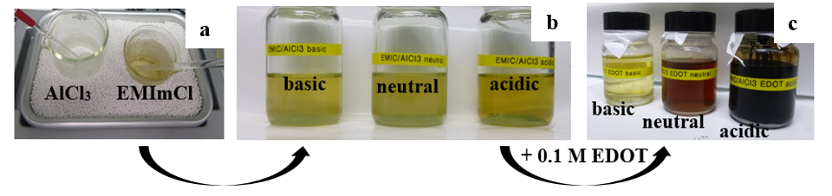
Figure 1

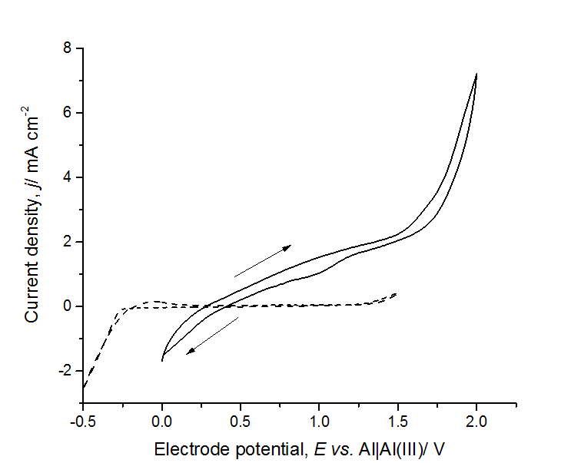
Figure 2

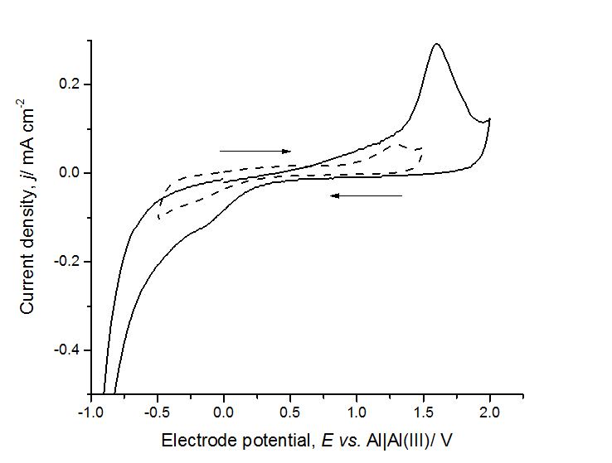
Figure 3

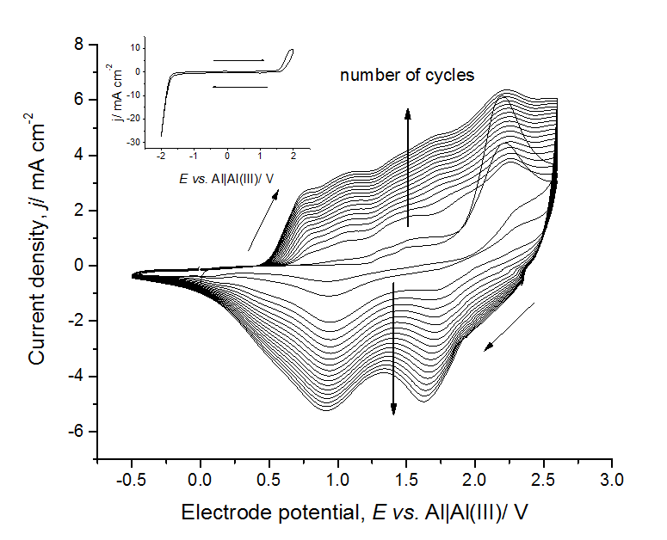
Figure 4

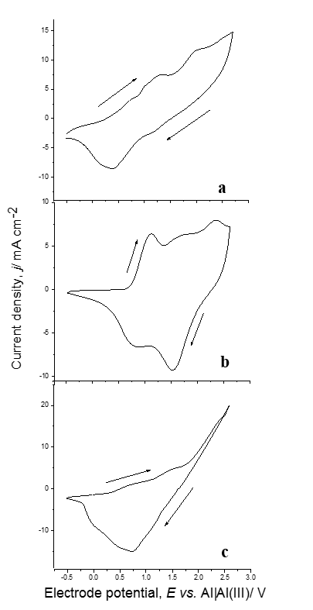
Figure 5

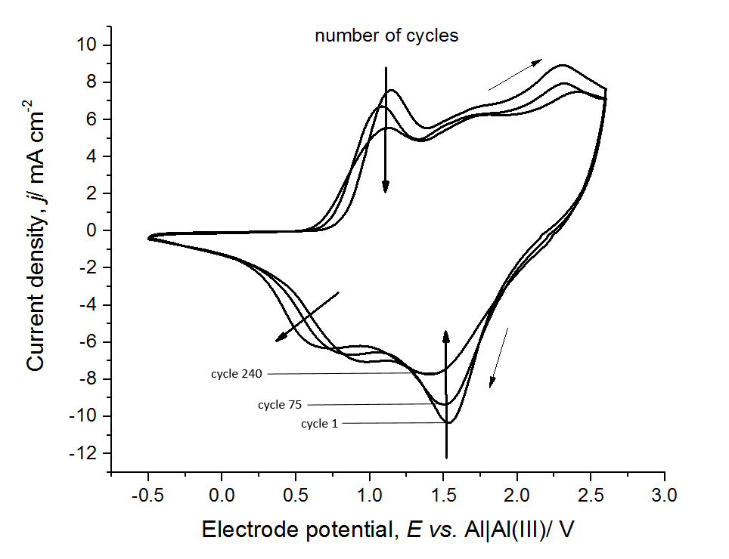
Figure 6

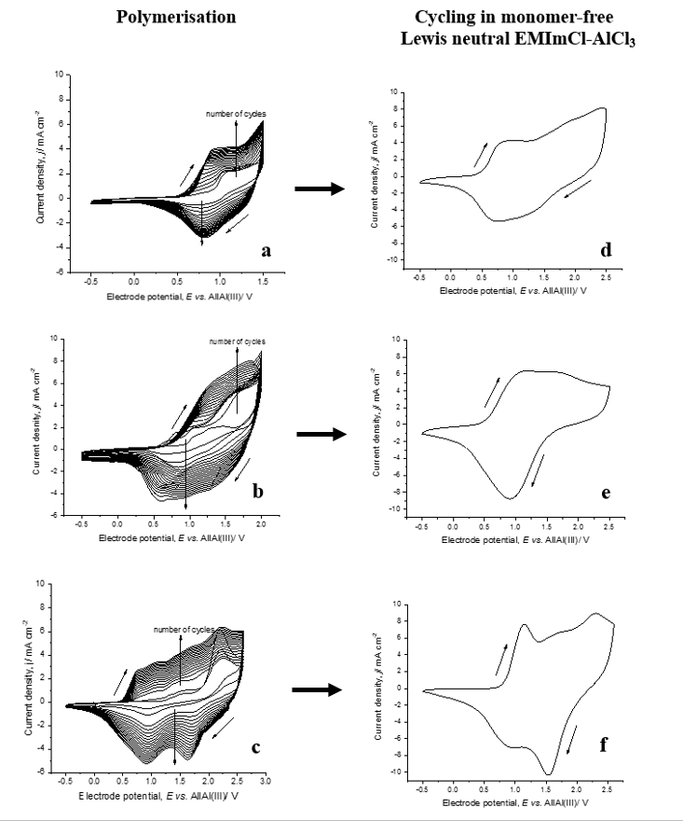
Figure 7

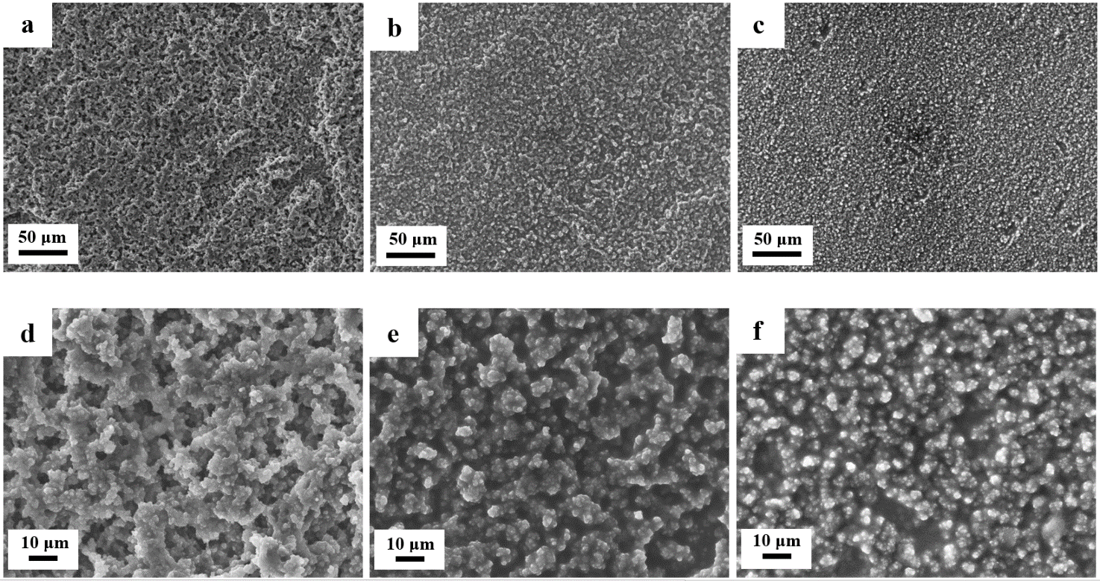
Figure 8

Table 1
Name ionic liquid (abbreviation) | Methods | Properties | Ref.
1-Butyl-3-methylimidazolium- tetrafluoroborate (BMIm-BF₄) | CV, CA | High cycle stability and degree of doping | [3], [6]–[8]
1-Butyl-3-methylimidazolium- trifluoromethanesulfonate (BMIm-OTF) | CV, CA | Medium to low conductive films, high ion exchange rate | [9]
1-Butyl-3-methylimidazolium- hexafluorophosphate (BMIm-PF₆) | CV | Multi-responsive properties, high degree of doping | [3], [7], [8]
1-Butyl-3-methylimidazolium-bis(trifluoromethylsulfonyl)imide (BMIm-TFSI) | CV, CA | Highly stable films, porous and granular structure | [10]
Butyltrimethylammonium- bis(trifluoromethylsulfonyl)amide (BMMMAm-TFSA) | CV | Only anion doping, difficult electro-polymerisation, nodular structure | [11]
1-Butyl-1-methylpyrrolidinium- trifluoromethanesulfonate  (BMPy-OTF) | CV | Only anion doping | [11]
1-Butyl-1-methylpyrrolidinium-bis(trifluoromethanesulfonyl)amide (BMPy-TFSA) | CV | High electro-chemically active films, slow electro-polymerisation, only anion doping, nodular structure | [11], [12]
1-Ethyl-3-methylimidazolium-aluminum chloride (EMIm-AlCl₃) | CV, CA, CP | Highly stable films, granular and porous structure | [13], [14]
1-Ethyl-3-methylimidazolium-  trifluoromethanesulfonate  (EMIm-OTF) | CV | Only anion doping, highly porous structure | [11]
1-Ethyl-3-methylimidazolium-bis(trifluoromethanesulfyl)amide  (EMIm-TFSA) | CV | Limited reversibility anion doping, fast film growth | [11], [12], [15]
1-Ethyl-3-methylimidazolium- bis(trifluoromethylsulfonyl)imide  (EMIm-TFSI) | CV, CA | Cation-doping, highly conductive films, compact and open structure films | [7], [9], [16]
1-Ethyl-2,3-dimethylimidazolium- bis(trifluoromethylsulfonyl)imide  (EMMIm- TFSI) | CV, CA | Medium to low ion exchange rate | [9]
1-Octyl-3-methylimidazolium- bis(trifluoromethylsulfonyl)imide  (OMIm-TFSI) | CV | Fast polymerisation, high degree of conjugation | [6]

Table 2
χ(EMImCl)  /mol% | χ(AlCl₃)  /mol% | Lewis acidity | Predominant anions in solution
33.3 | 66.7 | Acidic | Al₂Cl₇⁻, AlCl₄⁻
50 | 50 | Neutral | AlCl₄⁻
66.7 | 33.3 | Basic | AlCl₄⁻, Cl⁻

Table 3
Lewis  acidity | b·10⁻⁴  /g cm⁻³ ºC⁻¹ | a  /g cm⁻³ | ρ  /g cm⁻³
acidic | 9.18 | 1.36 | 1.36
neutral | 8.03 | 1.27 | 1.27
basic | 6.86 | 1.21 | 1.21

Table 4
Lewis acidity polymerisation solution | Doping level  /V | De-doping level  /V
acidic | 0.5 | 1.5 | 2.0 | 0.8 | 1.2
neutral | 1.2 | 1.7 | 2.3 | 0.8 | 1.6
basic | 0.6 | 1.3 | 0.8

Table 5
Polymerisation potential window  /V | Doping level  /V | De-doping level  /V
-0.5 to 1.5 | 0.85 | 1.75 | 0.8
-0.5 to 2.0 | 0.8 to 1.8 | 0.9
-0.5 to 2.6 | 0.5 | 1.5 | 2.0 | 0.8 | 1.2

* Corresponding author. E-mail: T.Schoetz@soton.ac.uk.de, Tel: +44 (0) 2380 5989 31, Fax: +44 (0) 2380 5970 51

