All-optical mode and wavelength converter based on parametric processes in a three-mode fiber

F. Parmigiani1*, P. Horak1, Y. Jung1, L. Grüner-Nielsen2, T. Geisler3, P. Petropoulos1, D. J. Richardson1

1 Optoelectronics Research Centre, University of Southampton, Southampton SO17 1BJ, U.K.

2Danish Optical Fiber Innovation, Åvendingen 22A, 2700 Brønshøj, Denmark

3 OFS, Priorparken 680, 2605 Brøndby, Denmark

[*frp@orc.soton.ac.uk](mailto:*frp@orc.soton.ac.uk)

**Abstract:** We demonstrate, both experimentally and numerically, all-optical mode and wavelength conversion both within the C-band and between the C- and L-bands. This is achieved by exploiting phase-matched inter-modal four-wave-mixing processes among the spatial modes of a three-mode fiber. By increasing the number of spatial modes supported by the fiber and tailoring their dispersion profile, it is envisaged that broadband operation over widely separated wavelength bands can be achieved in a single multi-mode fiber using this method.

© 2017 Optical Society of America under the terms of the [OSA Open Access Publishing Agreement](https://doi.org/10.1364/OA_License_v1)

**OCIS codes:** (060.4370) Nonlinear optics, fibers; (190.4380) Nonlinear optics, four-wave mixing; (190.4410)   Nonlinear optics, parametric processes.

References and links

1. Li Zhao, W. Suna, W. Hua, C. Baib, “Wavelength contention resolution in WSS based ROADMs,” Optical Switching and Networking, Volume **15**, 67-74 (2015).
2. H. N. Tan, T. Inoue, K. Solis-Trapala, S. Petit, Y. Oikawa, K. Ota, S. Takasaka, T. Yagi, M. Pelusi, S. Namiki “On the Cascadability of All-Optical Wavelength Converter for High-Order QAM Formats,” IEEE J. Lightw. Technol. **34** (13), 3194-3205 (2016).
3. S. Radic and C. J. McKinstrie, “Optical amplification and signal processing in highly-nonlinear optical fiber,” IEICE Trans. Electron. **E88C**, 859–869 (2005).
4. S. Radic, C. J. McKinstrie, A. R. Chraplyvy, G. Raybon, J. C . Centanni, C. G. Jorgensen, K. Brar and C. Headley, “Continuous-wave parametric-gain synthesis using nondegenerate-pump four-wave mixing,” IEEE Photon. Technol. Lett.**14**, 1406–1408 (2002).
5. J. Hansryd, P. A. Andrekson, M. Westlund, J. Li and P. O. Hedekvist, “Fiber-based optical parametric amplifiers and their applications,” IEEE J. Sel. Top. Quantum Electron. **8**, 506–520 (2002).
6. Víctor J. F. Rancaño, F. Parmigiani, P. Petropoulos, and D. J. Richardson, "100-GHz Grid-Aligned Multi-Channel Polarization Insensitive Black-Box Wavelength Converter," *Lightwave Technology Journal of*, vol. **32**, 3027-3035, (2014).
7. J. Demas, L. Rishøj, X Liu, G. Prabhakar, and S. Ramachandran., “High-power, wavelength-tunable NIR all-fiber lasers via intermodal four-wave mixing,” JTh5A.8, CLEO US (2017).
8. J. Demas, P. Steinvurzel, B. Tai, L. Rishøj, Y. Chen and S. Ramachandran, “Intermodal nonlinear mixing with Bessel beams in optical fibers,” Optica **2**, 14-17 (2015).
9. J. M. Chavez Boggio, J. R. Windmiller, M. Knutzen, R. Jiang, C.-S. Brès, N. Alic, B. Stossel, K. Rottwitt, and S. Radic, “730-nm optical parametric conversion from near- to short-wave infrared band,” Opt. Express **16** (8), 5435–5443 (2008).
10. J. Hansryd, and P. A. Andrekson, “Broad-band continuous-wave-pumped fiber optical parametric amplifier with 49-dB gain and wavelength-conversion efficiency,” IEEE Photon. Technol. Lett. **13** (3), 194-196 (2001).
11. D. Nodop, C. Jauregui, D. Schimpf, J. Limpert, and A. Tünnermann, “Efficient high-power generation of visible and mid-infrared light by degenerate four-wave-mixing in a large-mode-area photonic-crystal fiber,” Opt. Lett. **34**, 3499 (2009).
12. F. Parmigiani, Y. Jung, P. Horak, L. Grüner-Nielsen, T. Geisler, P. Petropoulos, and D. J. Richardson, “C- to L- band Wavelength Conversion Enabled by Parametric Processes in a Few Mode Fiber,” Th1F.4, OFC 2017.
13. S. M. M. Friis, I. Begleris, Y. Jung, K. Rottwitt, P. Petropoulos, D. J. Richardson, P. Horak, and F. Parmigiani, “Inter-modal four-wave mixing study in a two-mode fiber,” Opt. Expr., **24**, (26), 30338-30349 (2016).
14. R.-J. Essiambre, M. A. Mestre, R. Ryf, A. H. Gnauck, R. W. Tkach, A. R. Chraplyvy, Y. Sun, X. Jiang, and R. Lingle, “Experimental Investigation of Inter-Modal Four-Wave Mixing in Few-Mode Fibers,” IEEE Photon. Technol. Lett. **25**, 539–542 (2013).
15. M. Esmaeelpour, R.-J. Essiambre, N. K. Fontaine, R. Ryf, J. Toulouse, Y. Sun and R. Lingle, "Power Fluctuations of Intermodal Four-Wave Mixing in Few-Mode Fibers," J. Lightwave Technol., vol. **35**, 2429-2435 (2017).
16. D. J. Richardson, J. M. Fini, and L. E. Nelson, “Space-division multiplexing in optical fibers,” Nat. Photon. **7**, 354-362 (2013).
17. C. J. McKinstrie, S. Radic, and A. R. Chraplyvy, “Parametric amplifiers driven by two pump waves,” IEEE J. Sel. Top. Quantum Electron. **8**, 538–547 (2002).
18. L. Grüner-Nielsen, S. Herstrom, S. Dasgupta, D. Richardson, D. Jakobsen, Carl Lundström, Peter Andrekson, M.E.V. Pedersen, B. Pálsdóttir, ‘Silica-based highly nonlinear fibers with a high SBS threshold,’ IEEE Winter Topicals, WTM 2011, 171-172. (2011)
19. F. Parmigiani, Y. Jung, L. Grüner-Nielsen, T. Geisler, P. Petropoulos, and D. J. Richardson, “Elliptical Core Few Mode Fibers for Multiple-Input Multiple Output-free Space Division Multiplexing Transmission,” IEEE Photon. Technol. Lett. (2017).
20. Jacob G. Koefoed, Søren M. M. Friis, Jesper B. Christensen, and Karsten Rottwitt, "Spectrally pure heralded single photons by spontaneous four-wave mixing in a fiber: reducing impact of dispersion fluctuations," Opt. Express **25**, 20835-20849 (2017).
21. M. Guasoni, F. Parmigiani, P. Horak, J. Fatome and D. J. Richardson, "Intermodal Four-Wave-Mixing and Parametric Amplification in km-long Multi-Mode Fibers," IEEE Early Access Articles in Journal of Lightwave Technology (2017).
22. M. Karlsson, ‘Four-wave mixing in fibers with randomly varying zero dispersion wavelength,’ J. Opt. Soc. Am. B **15**, 2269-2275 (1998).
23. Introduction

The capability to generate signals at a desired frequency by all-optical wavelength conversion offers interesting prospects for many different applications, including telecommunications, sensing, medicine and defense. For example, in telecommunications, wavelength converters are an indispensable means for avoiding wavelength contention, i.e. ensuring that different signals always occupy different wavelengths in the same optical fiber [1]. Flexible all-optical means to achieve this functionality are of great interest [2-6], even though the implementation requirements associated with possible adoption in real systems are not to be underestimated. The signal wavelengths of interest are typically within the C- band (1530-1565 nm) or in the C- and L-bands (1530-1625 nm). Similarly, the capability of wavelength converting cheap and reliable optical sources (e.g. in the C-band) to generate sources at new colors, potentially within very different frequency bands as compared to the original, is also extremely attractive [7-9].

Parametric processes, such as four wave mixing (FWM), have been proven a very powerful means for frequency conversions [3-6, 10]. They inherently preserve the phase information of the signal and are not tied to any atomic or molecular energy levels, and so in principle can work in any spectral region as long as phase matching is satisfied, i.e. if the propagation constants of the interacting waves are properly matched. In a single-mode fiber, phase matching can typically be achieved either over a relatively broad spectral region (for example up to hundreds nanometers at 1550 nm) around the pump wavelength(s) [9-10], or at discrete (but narrow) bands that can potentially be far away from the pump wavelength(s) [11]. On the other hand, multi- (or few-) mode fibers offer an extra degree of freedom by allowing phase matching between different spatial modes and thereby, the potential for achieving broadband operation at any desired spectral band [7-8, 12-13]. Thus, inter-modal FWM processes have regained interest in recent years [7-8, 12-15], primarily driven by developments in space division multiplexing communications [16]. In this letter, expanding from our previous work [12], we consider a multi-pump configuration with each pump exciting a different spatial mode of a three-mode fiber. After explaining its operational principle, we numerically and experimentally investigate inter-modal FWM-based wavelength conversion both around and further away from phase matching. The C-band signals are converted into newly generated idler waves at frequencies located within the C- and/or the L- bands. Depending on the particular nonlinear process, namely Modulation Instability (MI), Bragg Scattering (BS) or Phase Conjugation (PC) [17], the generated idlers will appear at the appropriate phase-matched wavelengths in the same mode as the signal (for MI) or in different modes (for BS and PC). The results highlight the impact of inhomogeneity with the 1-km long fiber caused by the fabrication process and the impact of the resulting stochastic variations of the key fiber parameters (e. g. random core-radius fluctuations) that cause the relative inverse group velocities (RIGVs) of the modes to vary along the length, leading to a “blurring” of the phase matched wavelengths. This proof-of-principle study demonstrates the feasibility of simultaneously achieving mode and wavelength conversion of broadband signals between different and potentially widely separated spectral regions by exciting phase matched and dispersion tailored modes of a single multi-mode nonlinear fiber (or indeed any other nonlinear multi-mode optical waveguide).

1. Operation principle and experimental set-up

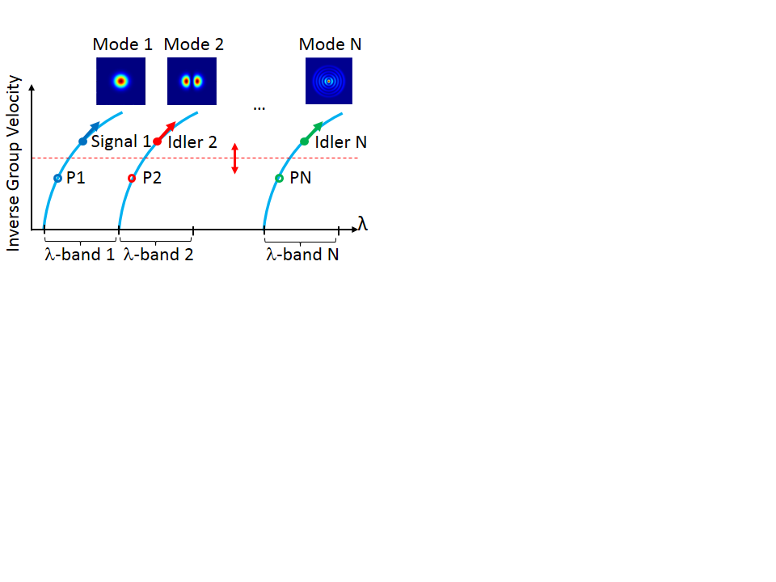

Fig. 1. Schematic of the relative inverse group velocities versus wavelength of the modes supported by a multi-mode waveguide, where the dotted red line highlights inter-modal phase matching among the pump(s), signal(s) and BS idler(s) in a multi–pump configuration. Broadband operation is guaranteed if the IGV curves of the modes are identical shifted replicas of each other in the band of interest. Inset: corresponding simulated intensity profiles of the modes.

The operational principle of the broadband wavelength converter working across many different frequency bands and exciting various spatial modes of a multi-mode nonlinear optical waveguide is illustrated in Fig. 1. The figure shows the RIGV curves of the various modes supported by the multi-mode waveguide as a function of wavelength. Phase matching is achieved when the propagation constants of the interacting waves satisfy conservation of momentum (as well as conservation of energy). This occurs when the value of IGVs of the various modes evaluated at the average wavelength of the waves in the same mode (pump-signal and pump-idler pairs in this instance) are equal [7-8]. For example, for the BS process, which is the one illustrated in the figure, Idler 2 is generated in mode 2 through mixing with pump P2 in the same mode and the signal-pump pair (Signal 1 – P1) in mode 1. Its wavelength, given by the energy conservation, is such that the IGV of mode 2, evaluated at the average wavelength of Idler 2 and P2, lies on the very same horizontal line that intercept the IGV of mode 1 at average wavelength between Signal 1 and P1. This is illustrated by the red dotted line in Fig. 1. Then, by exciting the appropriate spatial mode N of the fiber, it is possible to convert the signal to any discrete (far away) frequency band. Furthermore, for the BS process, broadband operation is guaranteed if the IGV curves of the modes are engineered such that they are identical but shifted replicas of each other in the bands of interest. Indeed, as shown in Fig. 1, as the signal wavelength moves to longer wavelengths, the idler



Fig. 2. a) Experimental set-up of the inter-modal four-wave mixing based mode and wavelength converter using a three-mode EC-FMF, supporting the LP01 and LP11 mode groups. b) Corresponding measured relative IGV curves of the supported LP01, LP11a and LP11b with their measured intensity profiles.

wavelength will change accordingly, conserving both the overall energy and the momentum, only if the slope of their IGV curves is the same.

The inter-modal FWM-based mode and wavelength converter was demonstrated in a three-spatial-mode fiber using the experimental set-up shown in Fig. 2(a), where the arrangement of the pumps, signal and idlers was as outlined in Fig. 1. In order to ensure the presence of three independent modes and, thus, three well-separated IGV curves corresponding to each of the supported spatial modes, a graded index (GI) elliptical core (EC) two-spatial-mode-group fiber was used. The EC- few mode fiber (FMF) supports only the LP01 and LP11 mode groups, but its core ellipticity of about 10% effectively breaks the degeneracy of the LP11 spatial mode (and not the polarization degeneracy of the modes), guaranteeing minimal linear coupling between the LP11a and LP11b modes and the presence of different propagation constants. Note that a circular fiber supporting a total of three spatial mode groups could have also been used. Figure 2(b) shows the measured relative IGV of the modes using a time of flight measurement, confirming the break in degeneracy of the LP11 spatial mode. From the curves, it is possible to estimate the phase matching between any two modes of the EC-FMF. In our case, the LP01 and LP11a (LP11b) modes are phase matched if the waves exciting them have a wavelength separation, , of about 25 nm (40.6 nm).

The used pumps (P1, P2 and P3) and signal (S) waves are continuous-wave tunable laser sources that are gated with a 10% duty cycle at a repetition rate of 10 MHz (not shown in Fig. 2(a)) to increase the peak power into the fiber and to increase the stimulated Brillouin scattering threshold. Indeed, while several other methods of increasing the SBS threshold have been proposed in the literature [2, 18], the approach we pursued allowed us to increase the overall effective nonlinearity by a factor of 10, which is critical due to the relatively modest nonlinear coefficient of the fiber we employed (about 0.7/W/km) [13]. The signal and one pump (P1) excite the LP01 mode, whereas a second pump (either P2 or P3) can be selectively launched into either the LP11a or LP11b mode by using a free-space mode-multiplexer (MMUX) based on bulk phase plates (PPs). Polarization controllers (PCs) and a polarization beam splitter (PBS) are used to ensure that the launched waves are co-polarized at the fiber input. Two single-mode optical amplifiers (OAs) are used to achieve about 20.5 dBm average power in each pump at the input of the 1 km long EC-FMF, with a signal to P1 ratio of about -10 dB. The other key fiber properties are as follows: the optical loss is about 0.2 dB/km for all of the modes, the calculated effective areas of the LP01 and the two LP11 modes are 89 m2 and 125 m2 at 1550 nm respectively, and the chromatic dispersions estimated from Fig. 2(b) are D(01) = 18.5 ps/(km nm), D(11a) = 18 ps/(km nm) and D(11b) = 16.3 ps/(km nm) with a dispersion slope of about 0.066 ps/nm2/km at 1550 nm for all modes. High precision fiber rotators (FRs) are used at the input/output end of the FMF to align the angular position of the elliptic fiber core with the input LP11a (LP11b) phase plates, enabling high modal purity excitation of about 20 dB and distributed crosstalk among any two spatial modes of better than 27 dB [19]. At the EC-FMF output, we extract the different spatial modes using a free-space mode-demultiplexer (MDMUX) based again on bulk PPs, and launch each demultiplexed mode into separate single-mode fibers. An optical switch enables the selection and independent measurement of each of the MDMUX output ports on an optical spectrum analyzer (OSA).

1. Experimental results

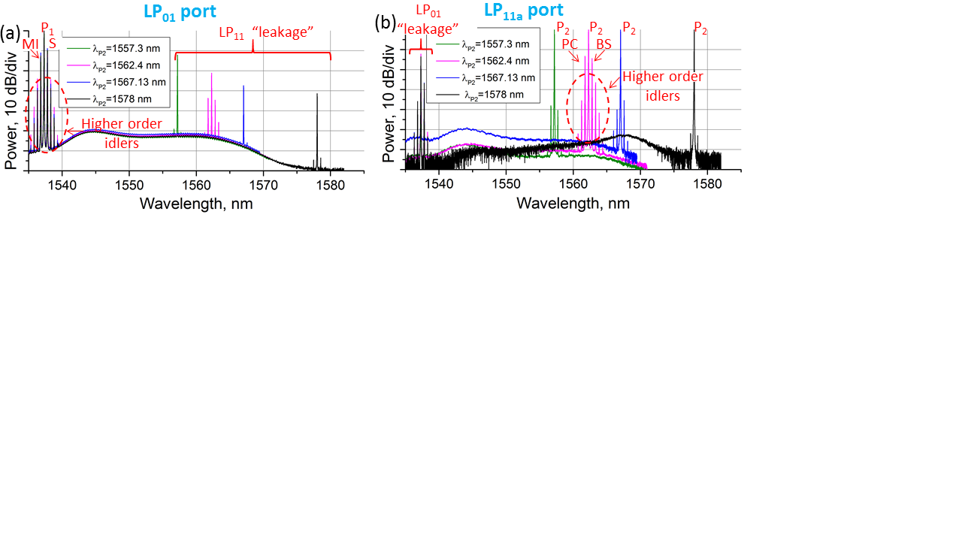

Fig. 3. MDMUX spectra of LP01 port (a) and LP11a port (b) for P1 and S equal to 1537.4 nm or 1537.9 nm, respectively, and P2 equal to 1557.3 nm, 1562.4 nm, 1567.13 nm, and 1578 nm, respectively, when P1 and S excite the LP01 mode of the fiber and P2 excites the LP11a mode.

Figure 3 shows some typical spectra obtained on the LP01 (Fig. 3(a)) and LP11a (Fig. 3(b)) output ports, when P1 and S are launched in the LP01 mode of the fiber and P2 in the LP11a mode. For these measurements, P1 and S are set to 1537.4 nm and 1537.9 nm, respectively, and P2 is varied among 1557.3 nm, 1562.4 nm, 1567.13 nm or 1578 nm, respectively. All the spectra are normalized to the LP01 and LP11 pump output powers (assumed to be equal due to their similar modal losses and neglecting any pump depletion effects) in each graph, respectively. From the spectral traces, we observe that each port of the MDMUX extinguishes the other mode (labelled as leakage in the corresponding figures) with efficiency between -15 dB and -30 dB. Figure 3(a) highlights the generation of the intra-modal FWM idler (labelled as MI on the graph), together with the (cascaded) higher order FWM idlers in the fundamental mode. The conversion efficiency (CE), defined as the ratio between the idler and the output signal powers, of the MI idler was about -2 dB in all reported spectra. It is worth noting that if the dispersion of each individual mode was engineered to be normal, this intra-modal FWM would be drastically suppressed with only the inter-modal FWM phase matched processes occurring. On the other hand, Fig. 3(b) shows that efficient inter-modal FWM idlers (labelled as BS and PC idlers in the figure) can be achieved in the LP11a mode only when P2 is set to 1562.4 nm (i.e. P2 - P1 =~ 25 nm), pink trace, corresponding to the phase matching (PM) case as predicted by Fig. 2(b). At this pump wavelength, the inter-modal FWM PC and BS idlers can be observed symmetrically about the P2 wave with a CE of about -5 dB for both cases. Higher order intra- and inter- modal FWM idlers can also be observed in the figure. When moving away from phase matching, i.e. moving P2 from 1562.4 nm while keeping P1 constant, the generated inter-modal FWM idlers decrease in power, and both their CEs are reduced to -40 dB at P2=1578 nm. The measured CEs of the PC and the BS processes as a function of signal wavelength for three different P2 values around the phase matching condition (about ± 1 nm from phase matching) are shown in Fig. 4. For the PC case, the 6 dB bandwidth is different for the three reported cases with a maximum measured bandwidth of about 1 nm for P2 = 1562.4 nm (phase matching) and a maximum CE of -3 dB, see blue

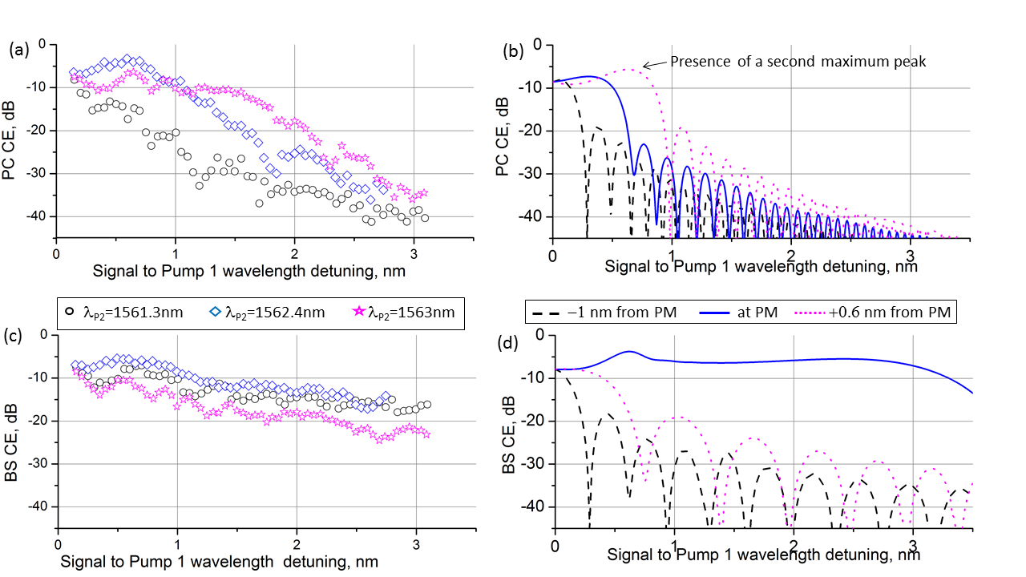

Fig. 4. Measured ((a) and (c)) and simulated ((b) and (c)) conversion efficiencies of the PC (top line) and BS (bottom line) processes versus Signal to Pump 1 wavelength detuning, when the other pump excites the second mode (LP11a) of the fiber at different wavelengths around the phase matching condition, i.e. P1=1537.4 nm, while P2=1561.3 nm (-1 nm from PM), P2=1562.4 nm (at PM) and P2=1563 nm (+0.6 nm from PM).

diamond symbols in Fig. 4(a). The CE then quickly reduces to -40 dB as the signal wavelength is detuned from the pump by 3 nm, demonstrating a narrow band operation at the phase matching [13-14]. This is perfectly mirrored by the simulation results obtained by solving the multi-mode generalized nonlinear Schrödinger equations (MM-GNLSEs) [7], which are reported as the inset in Fig. 4(a). At phase matching (solid blue line) a -6 dB bandwidth of narrows, while at longer wavelengths of P2 (dotted pink line) we observed the presence of two separated and narrow peaks that get more and more separated as P2 increases (see also bottom left graph of Fig. 5) [7]. For the BS case, Fig. 4(b) while a relatively narrow bandwidth of 1.3 nm is measured at -6 dB at phase matching (P2 = 1562.4 nm), it can be noted that the CE stays relatively constant to about -15 dB across all signal wavelengths considered (spanning 3 nm). These small P2 changes mainly affect the maximum achievable CE, while the trend of constant CEs at larger signal detunings is still observable. These results imply that precise phase matching conditions are not required (P2 can span of about 1.6 nm). On the other hand, the simulation results for the BS case, shown in Fig. 4(d), highlight the relatively broadband conversion efficiency of the process which can however only be achieved for a very narrow range of wavelengths P2 . Indeed, at phase matching a maximum bandwidth of 4.3 nm at -6 dB is predicted, however any detuning of P2 causes a drastic reduction of the BS bandwidth to less than 0.5 nm. We believe the discrepancy between the measured and simulated curves to be due to fiber inhomogeneity along its length caused by the fabrication process, an effect that was not included in the simulations. The impact of stochastic variations of the fiber parameters, for example random core-radius fluctuations will cause the RIGVs of the modes to vary along the length, which leads to a “blurring” of the phase matched wavelengths [13, 20-21]. As a consequence, broad wavelength conversion is observed for a wider range of P2, albeit at the cost of a narrower CE bandwidth. This is

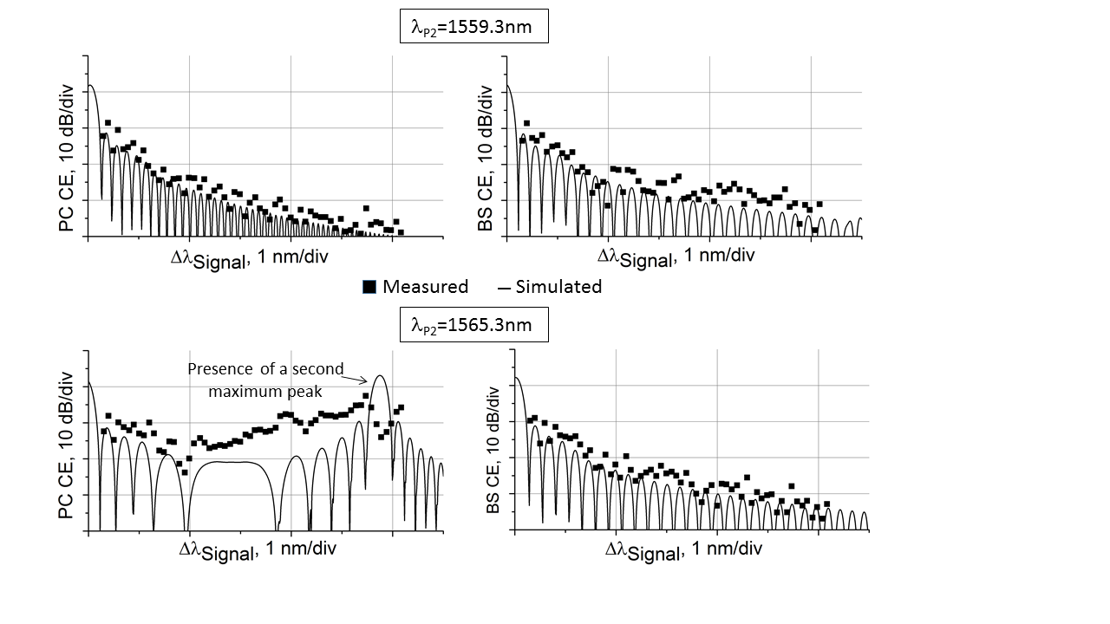

Fig. 5. Measured and simulated conversion efficiencies of the BS and PC processes versus signal to P1 wavelength detuning, when the other pump excites the second mode (LP11a) of the fiber detuned of about -3 nm (top row) and +3 nm (bottom row) from the phase matching condition (i. e. P2=1562.4 nm).

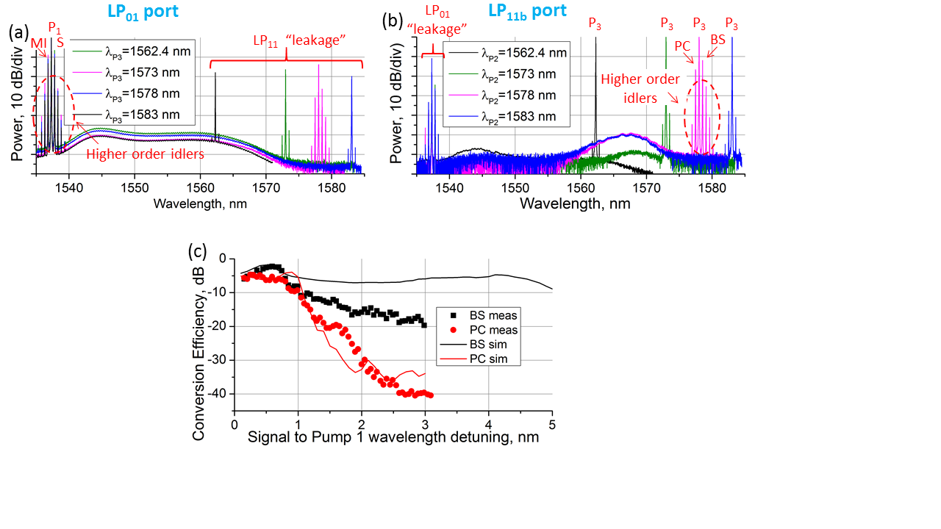

Fig. 6. MDMUX spectra of LP01 port (a) and LP11b port (b) for P1 and S equal to 1537.4 nm and 1537.9 nm, respectively, and P2 equal to 1562.4 nm, 1573 nm, 1578 nm or 1583 nm, respectively, when P1 and S excite the LP01 mode of the fiber and P2 excites the LP11b mode. c) Conversion efficiency of the BS and PC processes at the phase matched wavelengths versus the signal to Pump1 wavelength detuning.

directly analogous to the randomly varying zero dispersion wavelength in single mode fibers that strongly affects the overall bandwidth of parametric processes when the pump wavelength is close to it [22]. It is also worth noting that the wavelength conversion range of 4.9 nm (in the simulation) is mainly due to the relatively small range over which the two corresponding RIGV curves have the same slope. However, much broader bandwidths are to be expected for dispersion engineered fibers designed and fabricated with the RIGVs of the different modes having the same slope across much wider wavelength ranges. Furthermore, CE plots of the PC and BS at detuning wavelengths further away from phase matching (±3 nm) are also shown in Fig. 5, where good agreement between measurements and simulations can be observed. At these PM detunings, both bandwidths and CEs have been drastically reduced. Further experiments were carried out with one pump and the signal exciting again the LP01 mode, with the second pump exciting the third mode of the fiber, LP11b. Figures 6(a) and (b) show typical normalized spectral traces of the LP01 and LP11b output ports of the MDMUX; P1 and S are set still to 1537.4 nm and 1537.9 nm, respectively, while P2 is varied between 1562.4 nm, 1573 nm, 1578 nm or 1583 nm, respectively. Similar values of intra- and inter-modal FWM idlers are observed as compared to Fig. 3, with highest conversion efficiency when P3=1578 nm, i.e. at  nm, corresponding to the phase matching case between mode 1 and mode 3, see Fig. 2(b). Measured and simulated CEs of the BS and PC processes are reported in Fig. 6(c), showing comparable results to those reported in Fig. 4. Here, a -6 dB bandwidth of 1 nm (1 nm) is measured for the BS (PC) case, while simulations predict about 4.9 nm (1.1 nm).

1. Conclusion

We have experimentally demonstrated the feasibility of converting C-band signals to wavelengths in either the C- or L- bands, by exciting different phase matched modes within the same few-mode fiber. Simulations predict that conversion bandwidths up to about 4.9 nm should be possible with the current fiber, provided its geometry is maintained along its entire 1-km length. Much broader bandwidths are expected in optimized fibers where different modes exhibit inverse group velocity curves with the same slope across a very broad wavelength range. Conversion bands that are even further away could also be targeted by increasing the number of modes supported by the fiber.

Funding

This research is sponsored by EPSRC grant EP/P026575/1.

Acknowledgments

The data for this work is accessible through the University of Southampton Institutional Research Repository (DOI http://doi.org/xxx).