New insights on the dominance of cryptophytes in Antarctic coastal waters: a case study in Gerlache Strait

Carlos Rafael Borges Mendes^{a,b*}; Virginia Maria Tavano^{a,b}; Tiago Segabinazzi Dotto^{b,1}; Rodrigo Kerr^{b}; Márcio Silva de Souza^{a,b}; Carlos Alberto Eiras Garcia^{b}; Eduardo Resende Secchi^{c}

ªLaboratório de Fitoplâncton e Microorganismos Marinhos, Instituto de Oceanografia, Universidade Federal do Rio Grande (FURG), Av. Itália, km 8, Rio Grande, RS 96203-900, Brazil
^{b}Laboratório de Estudo dos Oceanos e Clima, Instituto de Oceanografia, Universidade Federal do Rio Grande (FURG), Av. Itália, km 8, Rio Grande, RS 96203-900, Brazil
^{c}Laboratório de Ecologia e Conservação da Megafauna Marinha, Instituto de Oceanografia, Universidade Federal do Rio Grande (FURG), Av. Itália, km 8, Rio Grande, RS 96203-900, Brazil
¹Present address: Ocean and Earth Sciences, University of Southampton, National Oceanography Centre Southampton, Southampton, UK

*Corresponding author: Tel. + 55 53 3233 6746; E-mail: crbmendes@gmail.com

Running Head: Cryptophytes in Antarctic coastal waters

Abstract

Changes in phytoplankton composition from large diatoms to small cryptophytes and their implications to the food web have been previously associated with rapid warming of surface waters in the western Antarctic Peninsula (WAP). However, ecological and physiological attributes that favor dominance of these flagellates in the region have not been fully explored. The overall aim of this work was to characterize the phytoplankton pigments and assemblages in relation to environmental conditions during three successive summer cruises (2013, 2014 and 2015) in the Gerlache Strait − a coastal area in the northern WAP. Data on phytoplankton (through HPLC/CHEMTAX pigment analysis) and associated physical (water column structure) and chemical (macronutrients) parameters were determined. Cryptophytes were conspicuously found in shallow mixed layers, under stratified conditions, as the main contributors to total phytoplankton biomass. Their greatest contributions were associated with warmer surface waters at the northwestern sector of the strait. Other phytoplankton groups (Phaeocystis antarctica in 2013 and small diatoms in both 2014 and 2015) were also important components. Photoprotective carotenoids (mainly alloxanthin), with an important role in preventing photodamage caused by excess light, were closely linked with the dominance of cryptophytes at surface layers. The results of this study suggest that the prevalence of cryptophytes in WAP coastal waters can be, to a great extent, due to a particular ability of those small flagellates to successfully grow in highly illuminated conditions in shallow upper mixed layers and strong water column stratification.

Keywords: Southern Ocean, Northern Antarctic Peninsula, regional warming, phytoplankton functional groups, cryptophytes, photophysiology.

1. Introduction

The Southern Ocean environment is rapidly changing, although the magnitude and direction of changes vary regionally. The western Antarctic Peninsula (WAP) is amongst the world’s most sensitive regions to climate change (e.g. Turner et al., 2005; Steig et al., 2009). The WAP area is distinctive among Antarctic regions due to its NE-SW geographic orientation and direct exposure to prevailing westerly atmospheric and oceanic circulation (Ducklow et al., 2013). It also responds distinctly to climate change, with observed significant sea ice decreases and rapid winter warming over the last decades (Stammerjohn et al., 2012; Ducklow et al., 2013; Saba et al., 2013). Its NE-SW coastal orientation produces a strong latitudinal climate gradient in both temperature and sea ice cover and is characterized by a shorter/longer ice season and more maritime/continental conditions in the northern/southern areas, respectively (Stammerjohn et al., 2008; Montes-Hugo et al., 2009; Ducklow et al., 2013). Additionally, climate variability in the WAP is strongly influenced by the El Niño Southern Oscillation (ENSO) and the Southern Annular Mode (SAM), two main climate patterns that have an effect on environmental variability in the Southern Ocean (Stammerjohn et al., 2008). As life histories of most polar organisms are attuned to sea ice seasonality, recent warming and consequent decline in sea ice cover have been associated with changes in key food web trophic levels in the northern WAP region, including reduction in phytoplankton biomass, shifts in phytoplankton community composition from large diatoms to small flagellated cryptophytes, and decrease in the abundance of Antarctic krill (Moline et al., 2004; Ducklow et al., 2007; Montes-Hugo et al., 2009; Mendes et al., 2013).
Phytoplankton blooms around the WAP are typically associated with development of a shallow surface mixed layer, which promotes phytoplankton growth by increasing light availability, and by taking advantage of iron inputs from glacial melt water into the upper water column (e.g. Prézelin et al., 2000; Mendes et al., 2012; Venables et al., 2013). Although Antarctic blooms are commonly dominated by diatoms, some studies have noted the increasing importance of cryptophytes that can prevail over diatoms in the WAP region. This is particularly true in areas of glacial ice melting water discharge and/or associated with low surface salinities and highly stable water column, where those organisms stay by active swimming (Moline and Prézelin, 1996; Moline et al., 2004; Mendes et al., 2013). Shifts from diatoms to cryptophytes dominance have been previously attributed to sedimentation of large diatoms (Castro et al., 2002), advection (Moline and Prézelin, 1996), grazing (Garibotti et al., 2003), and even to preference/physiological tolerance of cryptophytes to lower salinity waters (Moline et al., 2004). A recurrent transition from diatoms to cryptophytes represents a fundamental decrease in the size spectrum of the phytoplankton community, which can impact grazing efficiencies of different zooplankton species, enhancing microbial activity in the region and, consequently, promoting changes in carbon fluxes within the water column (Rodríguez et al., 2002; Ducklow et al., 2013). In addition, these organisms are generally less efficient in absorbing and exporting carbon, as compared to diatoms (e.g. Schloss et al., 2007), and, therefore, less capable to contribute with lowering CO₂ partial pressure in surface layers, leading to CO₂ outgassing in our study region (Kerr et al., this issue). As phytoplankton supports oceanic food webs and plays a key role on the resilience of the WAP marine ecosystem, changes in abundance and composition of phytoplankton assemblages may have a direct effect on the structure and functioning of the entire regional ecosystem.
In other Antarctic coastal areas, particularly in the Ross Sea, where diatom-dominated blooms are found in summer and Phaeocystis antarctica prevails in spring, ambient light has been hypothesized as one of the key drivers of seasonal shifts in phytoplankton community composition (Smith et al., 2010). Those observed patterns in the Ross Sea have been attributed to decreases in surface mixed layer depths along the growing season, since deeper mixed layers favor P. antarctica more than diatoms (Arrigo et al., 1999; Smith et al., 2006), apparently due to its photosynthetic plasticity (Kropuenske et al., 2009). However, in the WAP region, to our knowledge, no experimental/field investigations are available on the responses of marine phytoplankton assemblages under different light conditions. It should be considered that early retreat of sea ice, together with observed increase in sea surface temperature in the WAP region, may lead to development of a shallow mixing layer and strong vertical water column stratification, confining planktonic organisms near the surface and, thus, exposed to high irradiance (Moreau et al., 2010). Under such conditions, marine microorganisms can be inept for photorepair (Kaiser and Herndl, 1997) and may not recover from high irradiance exposure. We hypothesize that the gradual dominance of cryptophytes in coastal waters of the WAP is associated with their ability to grow under high irradiance exposure in strongly stratified shallow mixing surface layers, due to pigment protection capability. In this context, the main goal of the present study was to characterize the phytoplankton assemblages (through pigment composition) and hydrographic parameters associated with coastal waters where cryptophytes have been shown to dominate or have a significant biomass contribution. To reach this goal, three oceanographic surveys were conducted in a coastal region of the northern WAP (Gerlache Strait) during late summer (February) of 2013, 2014 and 2015.

2. Material and methods

2.1. Study area and sampling
The coastal region of the WAP is punctuated by islands, promontories, and small peninsulas, and includes a complex network of straits, bays, and passages between islands and the continental mainland. Here, physical, chemical and biological sampling were undertaken during three consecutive oceanographic cruises carried out within the coastal and sheltered waters of the Gerlache Strait (Fig. 1), during late summers of 2013 (12–15 February), 2014 (8–11 February) and 2015 (8–10 February). The Gerlache Strait, a relatively confined region, separates the Antarctic Peninsula from Brabant and Anvers Islands (Fig. 1). The main surface circulation pattern within the strait is driven by the Gerlache Strait Current, which flows northeastward along the strait (Zhou et al., 2002). This current carries the Gerlache waters into the Bransfield Strait, where its main flow joins the Bransfield Strait Current along the northeastern margin of the Bransfield Strait (Zhou et al., 2002, 2006).
- Hydrographic data (temperature and salinity) and water samples were collected using a combined Sea-Bird CTD/Carrousel 911+system® equipped with 24 five-liter Niskin bottles. Surface water samples were taken in all CTD (conductivity–temperature–depth) stations for dissolved nutrient and phytoplankton pigments analyses (Fig. 1). At some stations, chosen according with the fluorescence profiles (WetLabs® profiling fluorometer), seawater samples were taken from several depths (between the surface and 100 m) to better characterize the vertical distribution of phytoplankton communities. However, due to the absence of deep chlorophyll maximum (DCM) layers, seawater samples at these selected stations were generally collected at regular depths: 5, 15, 25, 50, 75 and 100 m.

2.2. Water column stability/stratification parameters
The potential density (ρ, kg m^{–3}) was calculated based on temperature, salinity and pressure data in order to evaluate the physical structure of water column. The upper mixed layer depth (UMLD) was determined based on density profiles, according to the criteria established by de Boyer Montégut et al. (2004), i.e., the depth at which potential density deviate from its 10 m depth value by a threshold of Δρ = 0.03 kg m^{–3}. The water column stability (E; hereafter referred to as stability) was estimated using vertical density variations, as function of the buoyancy or the Brunt-Väisälä frequency (N²), which is determined by:
$$N^{2}=- \frac{g}{ρ} \frac{∂ρ}{∂z} ({rad}^{2}s^{-2})$$
where g is gravity and ρ is the potential density of seawater. Stability was further estimated from:
$$E=\frac{N^{2}}{g}({10}^{-6} {rad}^{2}m^{-1})$$
Average stability values (between 0 and 100 m depth) were used in the statistical analyses.

2.3. Nutrient analysis
Surface water samples were filtered through cellulose acetate membrane filters to determine dissolved inorganic nutrients (DIN: nitrate, nitrite and ammonium; phosphate and silicic acid). Nutrients were analyzed onboard using a FEMTO® spectrophotometer, following the analytical recommendations in Aminot and Chaussepied (1983). Orthophosphate was measured by reaction with ammonium molybdate, with absorption readings at 885 nm. Silicic acid measurements, in the form of reactive Si, were corrected for sea salt interference.

2.4. HPLC−CHEMTAX analysis
For phytoplankton pigment analysis, seawater samples (0.5–2.5 L) were filtered under low vacuum through GF/F filters and filters were immediately frozen in liquid nitrogen for later HPLC pigment analysis. In the laboratory, the filters were placed in a screw-cap centrifuge tube with 3 mL of 95% cold-buffered methanol (2% ammonium acetate) containing 0.05 mg L^{–1} trans-β-apo-8'-carotenal (Fluka) as internal standard. Samples were sonicated for 5 min in an ice-water bath, placed at –20°C for 1h, and then centrifuged at 1100 g for 5 min at 3°C. The supernatants were filtered through Fluoropore PTFE membrane filters (0.2 μm pore size) to separate the extract from remains of filter and cell debris. Immediately prior to injection, 1000 µL of sample was mixed with 400 µL of Milli-Q water in 2.0 mL amber glass sample vials, which then were placed in the HPLC cooling rack (4°C). Methodological procedures for HPLC analysis (using a monomeric C8 column with a pyridine-containing mobile phase) are fully described in Zapata et al. (2000). The limit of detection and limit of quantification of this method were calculated and discussed in Mendes et al. (2007). Pigments were identified from both absorbance spectra and retention times from the signals in the photodiode array detector (SPD-M20A; 190 to 800 nm; 1 nm wavelength accuracy) or fluorescence detector (RF-10AXL; Ex. 430 nm/Em.670 nm). Peaks were integrated using LC-Solution software, but all peak integrations were manually checked and corrected, when necessary. The HPLC system was previously calibrated with pigment standards from DHI (Institute for Water and Environment, Denmark). For correction of both losses and volume changes, the concentrations of pigments were normalized to the internal standard.
The CHEMTAX v1.95 matrix factorization software routine (Mackey et al. 1996) was used to determine phytoplankton community composition from HPLC pigment concentrations. The CHEMTAX estimates the relative contribution of microalgal groups to the overall biomass concentration, calculated from the class-specific accessory pigments and total chlorophyll a (Chl a). Although concentration of Chl a is not an absolute measure of algal biomass, such as carbon, it can be used as a biomass “indicator” or “index” (Huot et al. 2007). Therefore, in this work, we use the term Chl a referring to either total biomass or relative biomass attributed to the corresponding taxonomic groups, as has been widely applied with the CHEMTAX approach. This software package has been extensively and successfully used in Southern Ocean studies (e.g. Wright et al., 2010; Kozlowski et al., 2011; Mendes et al., 2015) to determine the distribution of phytoplankton functional groups. The basis for calculations and procedures is fully described in Mendes et al. (2012). Based on identified diagnostic pigments, six algal groups were loaded on CHEMTAX: diatoms, dinoflagellates-1 (peridinin-containing dinoflagellates), "Phaeocystis antarctica", cryptophytes, green flagellates (chlorophyll b containing) and "chemotaxonomic group" (a group including peridinin-lacking autotrophic dinoflagellates and other algal groups such as Parmales and chrysophytes). Data from each cruise were run separately in order to take into account potential variations in optimization of CHEMTAX procedures. Pigment-based estimates were verified by microscope (the dominant phytoplankton taxa for each sampling year are listed in Table S1; see Supplementary Material).
As phytoplankton may alter their pigment composition based on environmental conditions (Higgins et al., 2011), photo-pigment indices were derived to assess the changing contribution of chlorophylls and carotenoids to the total pigment (TP) pool. The carotenoids were separated into photosynthetic carotenoids (PSC) and photoprotective carotenoids (PPC). In this study, the PSC included 19’−butanoyloxyfucoxanthin, 19’−hexanoyloxyfucoxanthin, fucoxanthin and peridinin, while the PPC were composed by alloxanthin, diadinoxanthin, diatoxanthin, β,β-carotene and β,ε-carotene. Accordingly, three photo-pigment indices were derived and used here following Barlow et al. (2007): Chla_{TP} (chlorophyll a to total pigments), PSC_{TP} (photosynthetic carotenoids to total pigments) and PPC_{TP} (photoprotective carotenoids to total pigments). These indices were used to investigate phytoplankton pigment adaptations in response to environment light regimes.

2.5. Statistical analysis
Relationships between biomass of phytoplankton groups and environmental variables at surface (first CTD sampling depth, 5-10 m; except for determining water column structure, where data from the upper 100 m were used) were explored by Canonical Correspondence Analysis (CCA; Ter Braak and Prentice, 1988) using CANOCO for Windows 4.5 software. This analysis was performed in order to identify the main patterns of the phytoplankton community structure, with respect to environmental variables. Biotic variables were represented by the CHEMTAX-derived taxonomical groups' biomass (mg m^{–3} of Chl a). Environmental variables included water column stability (Stability), upper mixed layer depth (UMLD), sea surface temperature (T), sea surface salinity (Salinity), dissolved inorganic nitrogen (DIN), phosphate and silicic acid. All variables were log-transformed before analysis to reduce the influence of different scales in the data sets. Monte-Carlo tests were run based on 499 permutations under a reduced model (p<0.05) in order to evaluate the significance of the CCA.

3. Results

3.1. Environmental setting
The mean sea surface temperature showed slight differences among years, although generally higher and maximum values were registered in 2013 (1.32 ± 0.45 ºC) and lowest in 2015 (1.12 ± 0.42 ºC; Table 1). Mean sea surface salinity (Fig. 2) was very similar in both 2014 and 2015, but markedly lower than in 2013, when the highest surface salinity values were observed (33.93 ± 0.15; Table 1). This can also be observed in the 0-150 m T/S diagram from the three studied years (Fig. S2 in Supplementary Material), where no typical water masses could be identified in the upper 150 m.
- The high salinity values observed in 2013 led to a significant decrease in water column stability, accompanied by higher values of UMLD, i.e., deeper mixed layer (see Table 1). Relatively shallow mixed layers, with average depths less than 25 m, were recorded during the three summers. Spatial oceanographic features in Gerlache Strait were similar among years, with a conspicuous region at the northwestern sector of the strait characterized by an upper layer of warmer water (see surface distribution values in Fig. 3). At St. 4, in the channel between Brabant and Anvers Island (see Fig. 1), there was also a relatively warm surface layer. A marked hydrographic front at the northeastern end of the Gerlache Strait was also depicted (Sts. 15, 16 and 17), influenced by cooler and more saline waters from the Bransfield Strait.
Surface nutrient concentrations showed high interannual variation (Table 1). DIN ranged from 13.56 to 40.15 µM, with the lowest mean values recorded in 2014 (19.62 ± 3.26 µM) and highest in 2015 (30.45 ± 7.51 µM). Silicic acid varied from 26.54 to 96.31 µM, with maximum mean values observed in 2015 (75.09 ± 10.67 µM). Phosphate varied between 0.31 and 2.14 µM, with minimum mean values observed in 2014 (0.64 ± 0.23 µM).

3.2. Phytoplankton biomass and community composition
During the study period, surface Chl a concentration values, used here as phytoplankton biomass index, ranged between 0.24 and 2.29 mg m^{–3} (see Table 1; and Fig. S1 in Supplementary Material). The higher mean surface Chl a concentrations were recorded in 2014 (1.54 ± 0.39 mg m^{–3}) (Table 1), although the highest value was observed in 2013 (2.29 mg m^{–3} at St. 12). The main phytoplankton groups in the region were cryptophytes, diatoms and P. antarctica, contributing to, on average, more than 70% of the total Chl a. Although those three phytoplankton groups together comprised most of the biomass in the region, cryptophytes were the dominant group at the surface (Fig. 4) and the greatest contributions (>75% in 2013; >65% in 2014; >50% in 2015) were observed in association with warmer surface waters at the northwestern sector of the Gerlache Strait (Fig. 3). In addition, cryptophytes were conspicuously found in the upper layer (0–25 m), above the pycnocline, as the main contributors to total phytoplankton biomass (Fig. 5). Apparently, the distribution of cryptophytes biomass in the Gerlache Strait was mostly associated with the sea surface temperature (Fig. 6), rather than salinity (Fig. S3 in Supplementary Material). P. antarctica appeared as the second most representative taxonomic group in 2013 (Fig. 4a), being replaced by diatoms in 2014 (Fig. 4b) and 2015 (Fig. 4c); both groups surpassing the cryptophytes below 25 m depth, where their contributions were always below 20% of the total Chl a. Green flagellates, dinoflagellates and the “chemotaxonomic group” showed much lower biomass and were combined and hereafter presented as “others” (Fig. 4), except for the statistical analyzes (CCA), where the individual groups were used separately.

3.3. Photo-pigment indices
There was a parallel variability in photo-pigment indices with changes in community structure at stations along the Gerlache Strait (Fig. 7). The Chla_{TP} index varied between 0.4 and 0.6, with highest values found in the surface layers and associated with a community dominated by cryptophytes. Similarly to Chla_{TP}, the PPC_{TP} at the surface increased, following the higher proportion of cryptophytes (Fig. 7a). In contrast, increases in surface PSC_{TP} were mainly associated with higher proportions of both diatoms (Fig. 7b) and P. antartica (Fig. 7c), declining to ~0.1 in samples with dominance of cryptophytes. The photo-pigment indices in deeper layers (Figs. 7d-f) were generally constant, and no particular trend was associated with any phytoplankton group. It is also noteworthy that the PSC_{TP} was generally greater in deep than surface layers, while PPC_{TP} was higher at the surface, especially in regions with a clear dominance of cryptophytes (> 60% of total Chl a), where PPC_{TP} exceed PSC_{TP} (Fig. 7a).

3.4. Phytoplankton response to environmental drivers
Relationships between phytoplankton and environmental variables showed that the seven selected variables significantly contributed (p<0.01) to explain the spatial distribution of phytoplankton groups, based on a Monte Carlo test on F-ratio. The multivariate analysis showed a strong association between phytoplankton groups and seawater physical and chemical properties (Fig. 8). The CCA explained 90.6% of the variance associated with the phytoplankton-environment relationship. The first canonical axis alone explained 65.2% of the variance. Cryptophytes were found to be strongly associated with high values of temperature, stability and Chl a, and negatively associated with nutrient concentrations, UMLD and salinity. P. antarctica had an opposite trend with respect to these environmental variables, being strongly associated with high magnitudes of salinity, UMLD, DIN and phosphate concentrations, and negatively associated with temperature, Chl a and stability. The diatoms and other minor groups were associated with low values of both temperature and Chl a, high silicic acid concentrations, and intermediate values of other variables such as stability, salinity and UMLD.

In order to visually illustrate the effects of environmental drivers on cryptophytes abundance in the region, spatial variations (along sampling stations) in both cryptophytes biomass (mg m⁻³ Chl a) and physical parameters (temperature, UMLD and stability) are shown in Fig. 9 for the 2013 sampling year. At both ends of the strait, deeper UMLD were associated with lower temperature and stability values, where biomass levels were also low. In contrast, between stations G09 and G13, significantly higher cryptophytes biomass levels were coupled with warm and stable waters, and shallow UMLD (10-20m).

4. Discussion

A recent long-term study (Moreau et al., 2015), based on satellite-derived data, evaluated the impact of climate change on primary production (PP) in the WAP area covered in this work. It was concluded that climate changes had an overall positive impact on PP, mainly due to decrease in sea ice spatial and temporal extent, which, in turn, increases the length of the phytoplankton production season and, therefore, enhances annual PP rates. Scarcity of in-situ data, however, leaves open questions regarding the effects of climate change on composition/structure of phytoplankton communities.
Stratification is a primary condition for seasonal development of algal blooms (Margalef et al., 1979), mainly after a turbulent condition, as it creates a stable surface layer that allows for the maintenance of phytoplankton in a favorable light regime. On the other hand, physical gradients in coastal waters under contrasting stratification conditions are important environmental factors controlling the size structure and species composition of Antarctic phytoplankton (e.g. Rodríguez et al., 2002; Mendes et al., 2012). It has been suggested that the critical depth, or the depth at which water-column net growth equals respiration, ranges from 50 to 80 m in the Southern Ocean during the growth season (Nelson and Smith, 1991; Boyd et al., 1995). In the present work, shallower mixed layers (< 25 m; Table 1) than those critical-depth estimates were found throughout the Gerlache Strait and cryptophytes emerged as the most important phytoplankton group in the three years period (Fig. 4), and were mainly confined within the relatively warm waters in the surface layers (Fig. 3). Particularly, the highest cryptophytes biomass was associated with strong water column stratification, indicated by a strong stability (see CCA results in Fig. 8) at the northwestern sector of the Strait, characterized by a warmer upper layer. A generally negative association with salinity (see Fig. 8), was probably due to an influence of this variable on water column stratification, as suggested by the close relation between salinity and density profiles (see Fig. S4 in the Supplementary Material), although a direct negative relationship of cryptophytes with salinity was not possible to demonstrate for the three studied years (Fig. S3 in the Supplementary Material). Opposite association with nutrient levels (Fig. 8), on the other hand, is an indication of consumption within the relatively dense cryptophyte patch. However, the generally high concentrations of N, P and Si in the surface layer (see Table 1) do not suggest a limitation by those macronutrients. Although cryptophytes were the major group contributing to total phytoplankton biomass (Chl a) in the region, during the studied years, P. antarctica occurred associated with more saline, nutrient-rich waters, in 2013, while diatoms were moderately correlated with both water column stability and high silicic acid concentrations that prevailed particularly in 2015. Those different patterns between groups (P. antarctica vs. diatoms) may be related to different stages in phytoplankton development and succession in the 3-year period.
Part of the upper ocean warming in the region is thought to be due to atmospheric conditions, with heat transfer facilitated by greater amounts of ice-free waters from spring to autumn (Ducklow et al., 2013). The WAP has been pointed out amongst the regions with the highest rates of regional warming anywhere (+7ºC in air temperature since 1950; Turner et al., 2013). In addition, a significant source of heat input to the WAP region is due to intrusions of warm mid-depth Upper Circumpolar Deep Water from the Antarctic Circumpolar Current along the glacially scoured canyons in the inner shelf regions (Martinson and McKee, 2012). Based on data presented here, including results in Moreau et al. (2015), we believe that the Gerlache Strait region is being affected by several environmental factors (e.g. early retreat of sea ice and increase in sea surface temperature) that may lead to widespread upper water column stratification. This certainly favors opportunistic small-sized and motile species, such as cryptophytes (this study and Mendes et al., 2013). In order to summarize the conditions leading to cryptophytes domination in the Gerlache Strait, a conceptual graph is shown for the region, evidencing the main processes observed in the present work (Fig. 10).
Under shallow mixed layers and stratified conditions, marine organisms are confined to surface waters that are highly exposed to irradiance, as observed in early spring of 2006 in the WAP (Moreau et al., 2010). Due primarily to a greater exposure to direct incoming irradiance, including a particularly high exposure of the WAP region to the atmospheric ozone hole, photoinhibition by both PAR and UVB radiation have apparently increased during the austral spring, affecting photosynthesis (Moreau et al., 2015). Although a connection of cryptophytes with stratified conditions along the WAP has been previously discussed (e.g. Moline and Prézelin, 1996; Moline et al., 2004; Mendes et al., 2013), an association of this group with high light exposure has not been explicitly addressed, partly due to difficulty in quantifying their photosynthetic responses in the environment. Here, we hypothesize that cryptophytes would bear photophysiological plasticity to tolerate high irradiances in the upper layers of the Antarctic coastal waters and thrive under such conditions. In order to optimize aquatic photosynthesis, light capture has to be carefully balanced with the photoprotective capacity to avoid over-excitation of the photosystems. Several protective mechanisms can be activated when light absorption exceeds its utilization in photosynthesis. One of these is non-photochemical quenching (NPQ), a feedback mechanism by which excessive light irradiation is dissipated as heat (Horton et al., 2005). This fast response to high light stress consists of two major components: energy quenching (qE), activated within seconds to minutes, and inhibitory quenching (qI) which is slower and relaxes within 1–2 h in the dark (Niyogi, 1999). The mechanisms of NPQ operation vary among different phototrophs; for instance, in green algae, qE activation requires the conversion of violaxanthin to zeaxanthin by the enzyme violaxanthin de-epoxidase (VDE) in the so-called xanthophyll cycle. On the other hand, the main xanthophyll cycle in most chromalveolates (with chlorophyll c-containing plastids, e.g. diatoms) involves the conversion of diadinoxanthin to diatoxanthin (Lohr et al., 2001; Goss et al., 2010). However, NPQ in cryptophytes significantly differ from other chromalveolates, in the following ways: i) they lack a light induced xantophyll cycle; ii) their NPQ is similar to the qE of higher plants, which is flexible and presents a fast recovery; and iii) they show a direct antennae protonation in NPQ mechanism, similarly to higher plants (discussed in detail by Kaňa et al., 2012). In addition, unlike other chromalveolate microalgae, they use both chlorophyll a/c proteins and phycobiliproteins (acquired from a red algae symbiotic ancestral), as light harvesting pigment complex. In addition to NPQ, some cryptophytes have also been shown to display state transitions, which are also an important mechanism for balancing the excitation energy between photosystems, either under light limitation or as a protection against photoinhibition, therefore optimizing photosynthetic capacity (Cheregi et al., 2015). Those characteristics confer to cryptophytes a unique effective and flexible mode of photoprotection mechanism, which could explain their biomass level within the Gerlache Strait and other similar coastal sites around the WAP.
Regarding effects of irradiance on accessory pigment ratios associated with the chlorophyll a/c antennae, the role of alloxanthin in cryptophytes has been recognized as a photoprotective pigment. For instance, increases in alloxanthin:Chl a ratio have been observed in cultures of cryptophytes acclimated to high light (e.g. Funk et al., 2011). Additionally, in 2014, high irradiance exposure resulted in increasing ratios of alloxanthin to Chl a, during a trial incubation experiment with natural populations dominated by cryptophytes in the region (data not shown). This also suggests a photoprotective function. Thus, although cryptophytes do not possess a xanthophyll cycle, they are able to induce synthesis of the protective carotenoid alloxanthin under light stress, presumably enhancing NPQ capacity. In agreement with this argument, in this study we found alloxanthin to be the major carotenoid that contributed to the increase in PPC proportions at surface (see Fig. S5 in Supplementary Material), in close association with the dominance of cryptophytes. Further, both Chla_{TP} and PPC_{TP} indices increased concomitantly with an increase in the proportion of cryptophytes (Fig. 7a). Although those indices may have been somewhat under/over-estimated by not including phycobiliprotein concentrations, there is biochemical evidence that NPQ in cryptophytes occur mainly in the chlorophyll a/c antennae and not mediated by phycobiliproteins (MacIntyre et al., 2002). Therefore, results with pigment indices indicate an optimization of light-harvesting capability, since Chl a increase is normally associated with increase in the number of photosystems (MacIntyre et al., 2002), while providing photoprotection against both excitation pressure on the photosynthetic apparatus and light induced reactive oxygen species damages (Kirk, 2011) through increases in PPC. All those adaptive strategies probably contribute in allowing cryptophytes to grow and dominate over other phytoplankton groups at stratified surface layers in the WAP coastal waters. Other organisms have also shown photophysiological advantages under high light exposure, due to a high concentration of photoprotective pigments, such as the diatom Fragilariopsis cylindrus, which dominates in highly stratified conditions in the Ross Sea (Arrigo et al., 2010), suggesting that light is a major factor in shaping phytoplankton communities in the region. In fact, in the present work, cryptophytes abundance showed a notable association with Fragilariopsis concentration (see Fig. S6 in Supplementary Material), suggesting an adaptation of those organisms to the prevailing light conditions in the region. However, further information on cryptophytes photoacclimation is needed to clarify whether special features in light utilization capabilities, as suggested here, are responsible for the observed dominance of cryptophytes in Antarctic coastal waters. Moreover, ecophysiological studies (both in situ and in vivo) on cryptophytes are still scarce, and photosynthetic characterization of these organisms are available only for a very few studied species.
In short, this study shows that the recurrent growth and dominance of cryptophytes, previously documented in the WAP region (e.g. Moline et al., 2004; Mendes et al., 2013; Gonçalves-Araujo et al., 2015), can be attributed to their abilities to grow and thrive under stratified conditions, where they have to withstand extreme light levels normally found in confined stratified upper layers. Such conditions are becoming more frequent and intense in coastal waters of the WAP and will probably have significant implications to the regional food web and biodiversity patterns.

Acknowledgments
This is a multidisciplinary program as part of the GOAL (Brazilian High Latitudes Oceanography Group) activities in the Brazilian Antarctic Program (PROANTAR). Financial support was provided by CNPq (National Council for Research and Development) and CAPES (Coordination for the Improvement of Higher Education Personnel). This study was conducted within the activities of the POLARCANION (CNPq grant number 556848/2009-8), PRO-OASIS (CNPq grant number 565040/2010-3), INTERBIOTA (CNPq grant number 407889/2013-2), NAUTILUS (CNPq grant number 405869/2013-4) and CMAR2 (CAPES grant number 23038.001421/2014-30) projects. The authors thank to the crew of the Polar Vessel “Almirante Maximiano” of the Brazilian Navy and several investigators participating in the cruises for their valuable help during samples’ collection. We are grateful to Simon Wright, from the Australian Antarctic Division, for providing CHEMTAX v.1.95 and to Ricardo Pollery for performing all nutrient analysis. C.R.B. Mendes and M.S. de Souza acknowledge financial support from the CAPES Foundation. T.S. Dotto acknowledges support by the CNPq (grant 232792/2014-3). V.M. Tavano, R. Kerr, C.A.E. Garcia and E.R. Secchi are granted with research fellowships from CNPq.

References

Aminot, A., Chaussepied, J., 1983. Manuel des Analyses Chimiques en Milieu Marin. CNEXO, Brest, 395 pp.

Arrigo, K.R., Mills, M.M., Kropuenske, L.R., van Dijken, G.L., Alderkamp, A.C., Robinson, D.H., 2010. Photophysiology in two major Southern Ocean phytoplankton taxa: photosynthesis and growth of Phaeocystis antarctica and Fragilariopsis cylindrus under different irradiance levels. Integr. Comp. Biol. 50, 950–966.

Arrigo, K.R., Robinson, D.H., Worthen, D.L., Dunbar, R.B., DiTullio, G.R., van Woert, M., Lizotte, M.P., 1999. Phytoplankton community structure and the drawdown of nutrients and CO₂ in the Southern Ocean. Science 283, 365–367.

Barlow, R., Stuart, V., Lutz, V., Sessions, H., Sathyendranath, S., Platt, T., Kyewalyanga, M., Clementson, L., Fukasawa, M., Watanabe, S., Devred, E., 2007. Seasonal pigment patterns of surface phytoplankton in the subtropical southern hemisphere. Deep-Sea Res. I 54, 1687–1703.

Boyd, P.W., Robinson, C., Savidge, G., Williams, P.J.leB., 1995. Water column and sea-ice primary production during Austral spring in the Bellingshausen Sea. Deep-Sea Res. II 42, 1177–1200.

Castro, C.G., Ríos, A.F., Doval, M.D., Pérez, F.F., 2002. Nutrient utilisation and chlorophyll distribution in the Atlantic sector of the Southern Ocean during Austral summer 1995–96. Deep-Sea Res. II 49, 623–641.

Cheregi, O., Kotabová, E., Prášil, O., Schröder, W. P., Kaňa, R., Funk, C., 2015. Presence of state transitions in the cryptophyte alga Guillardia theta. J. Exp. Bot. 66, 6461−6470.

de Boyer Montégut, C., Madec, G., Fischer, A.S., Lazar, A., Iudicone, D., 2004. Mixed layer depth over the global ocean: An examination of profile data and a profile based climatology. J. Geophys. Res. 109, C12003.

Ducklow, H.W., Baker, K., Martinson, D.G., Quetin, L.B., Ross, R.M., Smith, R.C., Stammerjohn, S.E., Vernet, M., Fraser W., 2007. Marine pelagic ecosystems: the West Antarctic Peninsula. Phil. Trans. R. Soc. B 362, 67–94.

Ducklow, H.W., Fraser, W.R., Meredith, M.P., Stammerjohn, S.E., Doney, S.C., Martinson, D.G., Sailley, S.F., Schofield, O.M., Steinberg, D.K., Venables, H.J., Amsler C.D., 2013. West Antarctic Peninsula: An ice-dependent coastal marine ecosystem in transition. Oceanography 26, 190–203.

Funk, C., Alami, M., Tibiletti, T., Green, B.R., 2011. High light stress and the one-helix LHC-like proteins of the cryptophyte Guillardia theta. Biochim. Biophys. Acta 1807, 841–846.

Garibotti, I.A., Vernet, M., Kozlowski, W.A., Ferrario, M.E., 2003. Composition and biomass of phytoplankton assemblages in coastal Antarctic waters: a comparison of chemotaxonomic and microscopic analyses. Mar. Ecol. Prog. Ser. 247, 27–42.

Gonçalves-Araujo, R., de Souza, M.S., Tavano, V.M., Garcia, C.A.E., 2015. Influence of oceanographic features on spatial and interannual variability of phytoplankton in the Bransfield Strait, Antarctica. J. Mar. Syst. 142, 1–15.

Goss, R., Jakob, T., 2010. Regulation and function of xanthophyll cycle-dependent photoprotection in algae. Photosynth. Res. 106, 103–122.

Higgins, H.W., Wright, S.W., Schlüter, L., 2011. Quantitative interpretation of chemotaxonomic pigment data. In: Roy, S., Llewellyn, C.A., Egeland, E.S., Johnson, G. (Eds.), Phytoplankton Pigments: Characterization, Chemotaxonomy and Applications in Oceanography. Cambridge University Press, United Kingdom, pp. 257–313.

Horton, P., Wentworth, M., Ruban, A., 2005. Control of the light harvesting function of chloroplast membranes: The LHCII-aggregation model for non-photochemical quenching. FEBS Lett. 579, 4201–4206.

Huot, Y., Babin, M., Bruyant, F., Grob, C., Twardowski, M.S., Claustre, H., 2007. Relationship between photosynthetic parameters and different proxies of phytoplankton biomass in the subtropical ocean. Biogeosciences 4, 853–868.

Kaiser, E., Herndl, G.J., 1997. Rapid recovery of marine bacterioplankton activity after inhibition by UV radiation in coastal waters. Appl. Environ. Microbiol. 63, 4026–4031.

Kaňa, R., Kotabová, E., Sobotka, R., Prášil, O., 2012. Non-photochemical quenching in cryptophyte alga Rhodomonas salina in located in chlorophyll a/c antennae. PLoS ONE 7, e29700.

Kerr, R., Goyet, C., da Cunha, L.C., Orselli, I.B.M., Lencina-Avila, J.M., Eidt, R.T., Mendes, C.R.B., Mata, M.M., Tavano, V.M., this issue. Carbonate system properties in the Gerlache Strait, Northern Antarctic Peninsula (February 2015): I. CO₂ sea-air fluxes. Deep-Sea Res II.

Kirk, J.T.O., 2011. Light and Photosynthesis in Aquatic Ecosystems, third ed. Cambridge University Press, United Kingdom.

Kozlowski, W.A., Deutschman, D., Garibotti, I., Trees, C., Vernet, M., 2011. An
evaluation of the application of CHEMTAX to Antarctic coastal pigment data.
Deep-Sea Res. I 58, 350–364.

Kropuenske, L.R., Mills, M.M., van Dijken, G.L., Bailey, S., Robinson, D.W., Welschmeyer, N.A., Arrigo, K.R., 2009. Photophysiology in two major Southern Ocean phytoplankton taxa: photoprotection in Phaeocystis antarctica and Fragilariopsis cylindrus. Limnol. Oceanogr. 54, 1176–1196.

Lohr, M., Wilhelm, C., 2001. Xanthophyll synthesis in diatoms: quantification of putative intermediates and comparison of pigment conversion kinetics with rate constants derived from a model. Planta 212, 382–391.

Mackey, M.D., Mackey, D.J., Higgins, H.W., Wright, S.W., 1996. CHEMTAX – a program for estimating class abundances from chemical markers: application to HPLC measurements of phytoplankton. Mar. Ecol. Prog. Ser. 144, 265–283.

MacIntyre, H.L., Kana, T.M., Anning, T., Geider, R.J., 2002. Photoacclimation of photosynthesis irradiance response curves and photosynthetic pigments in microalgae and cyanobacteria. J. Phycol. 38, 17–38.

Margalef, R., Estrada, M., Blasco, D., 1979. Functional morphology of organisms involved in red tides, as adapted to decaying turbulence. In: Taylor, D.L., Seliger, H.H. (Eds.), Toxic Dinoflagellate Blooms, Proceedings of the Second International Conference on toxic dinoflagellate blooms. Elsevier, New York, pp. 89–94.

Martinson, D.G., McKee, D.C., 2012. Transport of warm upper circumpolar deep water onto the western Antarctic Peninsula continental shelf. Ocean Sci. 8, 433–442.

Mendes, C.R., Cartaxana, P., Brotas, V., 2007. HPLC determination of phytoplankton and microphytobenthos pigments: comparing resolution and sensitivity of a C18 and a C8 method. Limnol. Oceanogr. Methods 5, 363–370.

Mendes, C.R.B., de Souza, M.S., Garcia, V.M.T., Leal, M.C., Brotas, V., Garcia, C.A.E., 2012. Dynamics of phytoplankton communities during late summer around the tip of the Antarctic Peninsula. Deep-Sea Res. I 65, 1–14.

Mendes, C.R.B., Kerr, R., Tavano, V.M., Cavalheiro, F.A., Garcia, C.A.E., Dessai, D.R.G., Anilkumar, N., 2015. Cross-front phytoplankton pigments and chemotaxonomic groups in the Indian sector of the Southern Ocean. Deep-Sea Res. II 118, 221–232.

Mendes, C.R.B., Tavano, V.M., Leal, M.C., de Souza, M.S., Brotas, V., Garcia, C.A.E., 2013. Shifts in the dominance between diatoms and cryptophytes during three late summers in the Bransfield Strait (Antarctic Peninsula). Polar Biol. 36, 537–547.

Moline, M.A., Claustre, H., Frazer, T.K., Schofield, O., Vernet, M., 2004. Alteration of the food web along the Antarctic Peninsula in response to a regional warming trend. Glob. Change Biol. 10, 1973–1980.

Moline, M.A., Prézelin, B.B., 1996. Palmer LTER 1991–1994: long-term monitoring and analyses of physical factors regulating variability in coastal Antarctic phytoplankton biomass, in situ productivity and taxonomic composition over sub-seasonal, seasonal and interannual time scales. Mar. Ecol. Prog. Ser. 145, 143–160.

Montes-Hugo, M., Doney, S.C., Ducklow, H.W., Fraser, W., Martinson, D., Stammerjohn, S.E., Schofield, O., 2009. Recent changes in phytoplankton communities associated with rapid regional climate change along the western Antarctic Peninsula. Science 323, 1470–1473.

Moreau, S., Bélanger, S., Schloss, I.R., Vancoppenolle, M., Demers, S., Ferreyra, G.A., 2015. Climate change enhances primary production in the western Antarctic Peninsula. Glob. Change Biol. 21, 2191–2205.

Moreau, S., Ferreyra, G.A., Mercier, B., Lemarchand, K., Lionard, M., Roy, S., Mostajir, B., Roy, S., van Hardenberg, B., Demers, S., 2010. Variability of the microbial community in the western Antarctic Peninsula from late fall to spring during a low ice cover year. Polar Biol. 33, 1599–1614.

Nelson, D.M., Smith Jr., W.O., 1991. Sverdrup revisited: Critical depths, maximum chlorophyll levels, and the control of Southern Ocean productivity by the irradiance-mixing regime. Limnol. Oceanogr. 36, 1650–1661.

Niyogi, K.K., 1999. Photoprotection revisited: genetic and molecular approaches. Annu. Rev. Plant Physiol. Plant Mol. Biol. 50, 333–359.

Prézelin, B.B., Hofmann, E.E., Mengelt, C., Klinck, J.M., 2000. The linkage between Upper Circumpolar Deep Water (UCDW) and phytoplankton assemblages on the west Antarctic Peninsula continental shelf. J. Mar. Res. 58, 165–202.

Rodríguez, J., Jiménez-Gómez, F., Blanco, J.M., Figuerosa, F.L., 2002. Physical gradients and spatial variability of the size structure and composition of phytoplankton in the Gerlache Strait (Antarctica). Deep-Sea Res. II 49, 693–706.

Saba, G.K., Fraser, W.R., Saba, V.S., Iannuzzi, R.A., Coleman, K.E., Doney, S.C., Ducklow, H.W., Martinson, D.G., Miles, T.N., Patterson-Fraser, D.L., Stammerjohn, S.E., Steinberg, D.K., Schofield, O.M., 2013. Winter and spring controls on the summer food web of the coastal West Antarctic Peninsula. Nat. Commun. 5, 4318.

Schloss, I.R., Ferreyra, G.A., Ferrario, M.E., Almandoz, G.O., Codina, R., Bianchi, A.A., Balestrini, C.F., Ochoa, H.A., Pino, D.R., Poisson, A., 2007. Role of plankton communities in sea–air variations in pCO2 in the SW Atlantic Ocean. Mar. Ecol. Prog. Ser. 332, 93–106.

Smith Jr., W.O., Dinniman, M.S., Tozzi, S., DiTullio, M.S., Mangoni, O., Modigh, M., Saggiomo, V., 2010. Phytoplankton photosynthetic pigments in the Ross Sea: patterns and relationships among functional groups. J. Mar. Syst. 82, 177–185.

Smith Jr., W.O., Shields, A.R., Peloquin, J.A., Catalano, G., Tozzi, S., Dinniman, M.S., Asper, V.A., 2006. Interannual variations in nutrients, net community production, and biogeochemical cycles in the Ross Sea. Deep-Sea Res. II 53, 815–833.

Stammerjohn, S.E., Martinson, D.G., Smith, R.C., Yuan, X., Rind, D., 2008. Trends in Antarctic annual sea ice retreat and advance and their relation to El Niño Southern Oscillation and Southern Annular Mode variability. J. Geophys. Res. 113, C03S90.

Stammerjohn, S.E., Massom, R., Rind, D., Martinson, D.G., 2012. Regions of rapid sea ice change: An inter-hemispheric seasonal comparison. Geophys. Res. Lett. 39, L06501.

Steig, E.J., Schneider, D.P., Rutherford, S.D., Mann, M.E., Comiso, J.C., Shindell, D.T., 2009. Warming of the Antarctic ice-sheet surface since the 1957 International Geophysical Year. Nature 457, 459–463.

Ter Braak, C.J.F., Prentice, I.C., 1988. A theory of gradient analysis. Adv. Ecol. Res. 18, 271–317.

Turner, J., Colwell, S.R., Marshall, G.J., Lachlan-Cope, T.A., Carleton, A.M., Jones, P.D., Lagun, V., Reid, P.A., Iagovkina, S., 2005. Antarctic Climate Change during the last 50 years. Int. J. Climatol. 25, 279–294.

Turner, J., Maksym, T., Phillips, T., Marshall, G.J., Meredith, M.P., 2013. The impact of changes in sea ice advance on the large winter warming on the western Antarctic Peninsula. Int. J. Climatol. 33, 852–861.

Venables, H.J., Clarke, A., Meredith, M.P., 2013. Wintertime controls on summer stratification and productivity at the western Antarctic Peninsula. Limnol. Oceanogr. 58, 1035–1047.

Wright, S.W., van den Enden, R.L., Pearce, I., Davidson, A.T., Scott, F.J., Westwood, K.J., 2010. Phytoplankton community structure and stocks in the Southern Ocean (30–80ºE ) determined by CHEMTAX analysis of HPLC pigment signatures. Deep-Sea Res. II 57, 758–778.

Zapata, M., Rodríguez, F., Garrido, J.L., 2000. Separation of chlorophylls and carotenoids from marine phytoplankton: a new HPLC method using a reversed phase C8 column and pyridine-containing mobile phases. Mar. Ecol. Prog. Ser. 195, 29–45.

Zhou, M., Niiler, P.P., Hu, J.H., 2002. Surface currents in the Bransfield and Gerlache Straits, Antarctica. Deep-Sea Res. I 49, 267–280.

Zhou, M., Niiler, P.P., Zhu, Y., Dorland, R.D., 2006. The western boundary current in the Bransfield Strait, Antarctica. Deep-Sea Res. I 53, 1244–1252.

Figure captions

Figure 1: Location of hydrographic stations sampled during 2013, 2014 and 2015 summer cruises. The black box in the inset shows the Gerlache Strait close to the northern Antarctic Peninsula (AP). Other abbreviations are as follows: Drake Passage (DP), South Shetland Islands (SSI), Bransfield Strait (BS), Weddell Sea Shelf (WSS), Brabant Island (BI) and Anvers Island (AI). The bathymetry is represented by the color scale bar at the right.

Figure 2: Sea surface salinity values at individual sampling stations for the three sampling years in the Gerlache Strait during early February.

Figure 3: Surface distribution of both relative percentage contribution of cryptophytes to total chlorophyll a (contour lines) and potential temperature (ºC; color scale) for (a) 2013, (b) 2014 and (c) 2015.

Figure 4: Average and standard deviation of depth distribution of phytoplankton groups' biomass (as Chl a concentration) calculated through the CHEMTAX software at the Gerlache Strait in late summer of (a) 2013, (b) 2014 and (c) 2015. Note the different scales in chlorophyll a concentration.

Figure 5: Relationship between values of cryptophytes’ biomass (as Chl a concentration) and total chlorophyll a at the surface in the Gerlache Strait during the three sampling years.

Figure 6: Relationship between cryptophytes’ biomass (as Chl a concentration) and sea surface temperature (ºC) for the Gerlache Strait during the three sampling years.

Figure 7: Relationships between selected photo-pigment indices and proportions of major phytoplankton groups for surface (a-c) and deep (d-f) samples. Cha_{TP} = total chlorophyll a / total pigments; PSC_{TP} = photosynthetic carotenoids / total pigments; PPC_{TP} = photoprotective carotenoids / total pigments. See text for more details.

Figure 8: Canonical Correspondence Analysis ordination diagram of absolute contributions of different phytoplankton groups at sea surface. The first two ordination axes represent 54.6% of the total phytoplankton group’s variance and 90.6% of phytoplankton groups-environment relationships. Arrows indicate environmental variables [water column stability (Stability), upper mixed layer depth (UMLD), and sea surface temperature (T), salinity (Salinity) and dissolved inorganic nitrogen (DIN), phosphate (PO4) and silicic acid (SiO2)]. Blue crosses refer to absolute contributions of phytoplankton groups. Chemo. group = “chemotaxonomic group” and P. antarctica = “Phaeocystis antarctica”. Stations are separated according to sampling year (blue circles = 2013; green triangles = 2014; yellow squares = 2015). St. 10 (2013), 14 (2015) and 16 (2013) are labeled because they represent distinct environmental and biological conditions, and their vertical profiles are shown in Fig. S4 (see Supplementary Material).

Figure 9: Absolute contributions (mg m^{–3} Chl a) of cryptophytes to total chlorophyll a estimated by CHEMTAX at individual sampling stations, using HPLC pigment data in 2013, and respective sea surface temperature, upper mixed layer depth and stability values.

Figure 10: Schematic representation of conditions found in this work along the Gerlache Strait, where dominance of cryptophytes was observed in the summers of 2013, 2014 and 2015.

Table 1: Average, standard deviation (in parentheses), minimum and maximum (in square brackets) values of environmental properties at surface (except UMLD and Stability) in the three sampling years (2013, 2014 and 2015).
Environmental properties | 2013 (n=16) | 2014 (n=16) | 2015 (n=15)
Temperature (°C) | 1.32 (0.45) [0.86; 2.14] | 1.21 (0.32) [0.68; 1.78] | 1.12 (0.42) [0.33; 1.81]
Salinity | 33.93 (0.15) [33.59; 34.21] | 33.62 (0.18) [33.30; 34.02] | 33.69 (0.24) [33.33; 34.20]
UMLD (m) | 24.3 (12.8) [10; 48] | 18.6 (8.5) [10; 39] | 16.1 (5.4) [10; 27]
Stability (10⁻⁶ rad² m⁻¹) | 4.29 (1.52) [2.19; 7.92] | 6.77 (1.49) [3.58; 9.00] | 6.32 (2.01) [1.89; 8.83]
DIN (µM) | 28.07 (1.32) [25.82; 30.98] | 19.62 (3.26) [13.56; 25.08] | 30.45 (7.51) [20.41; 40.15]
Phosphate (µM) | 1.59 (0.27) [1.17; 2.14] | 0.64 (0.23) [0.31; 1.08] | 1.65 (0.32) [1.10; 2.13]
Silicic acid (µM) | 40.38 (1.74) [37.95; 44.25] | 30.49 (1.76) [26.54; 32.60] | 75.09 (10.67) [59.37; 96.31]
Chlorophyll a (mg m⁻³) | 1.22 (0.38) [0.66; 2.29] | 1.54 (0.39) [0.95; 2.12] | 1.01 (0.42) [0.24; 1.87]

Figure 1

Figure 2
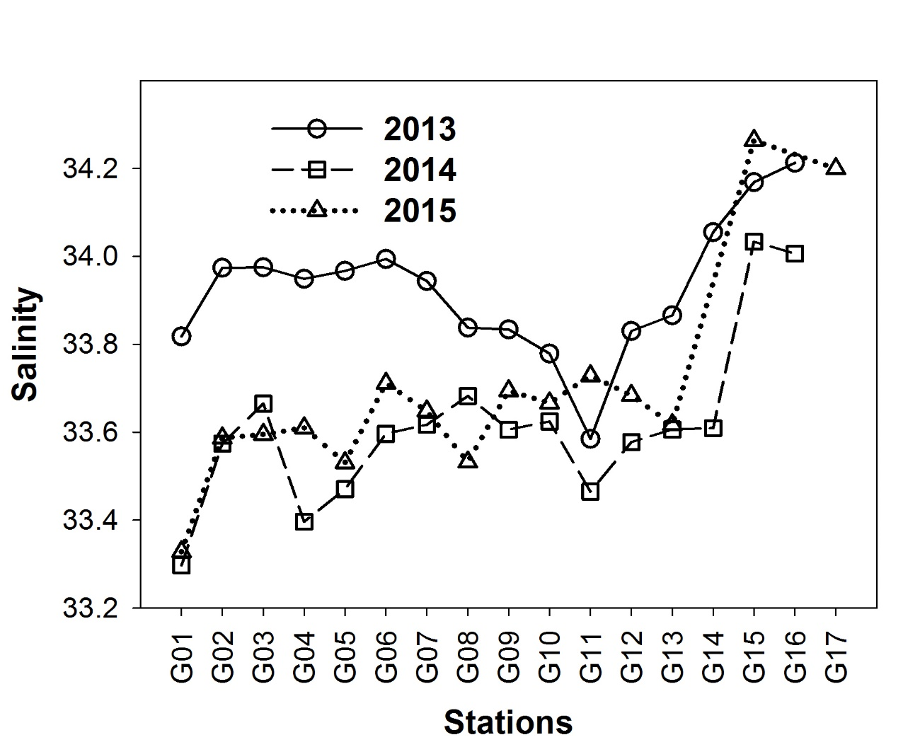

Figure 3
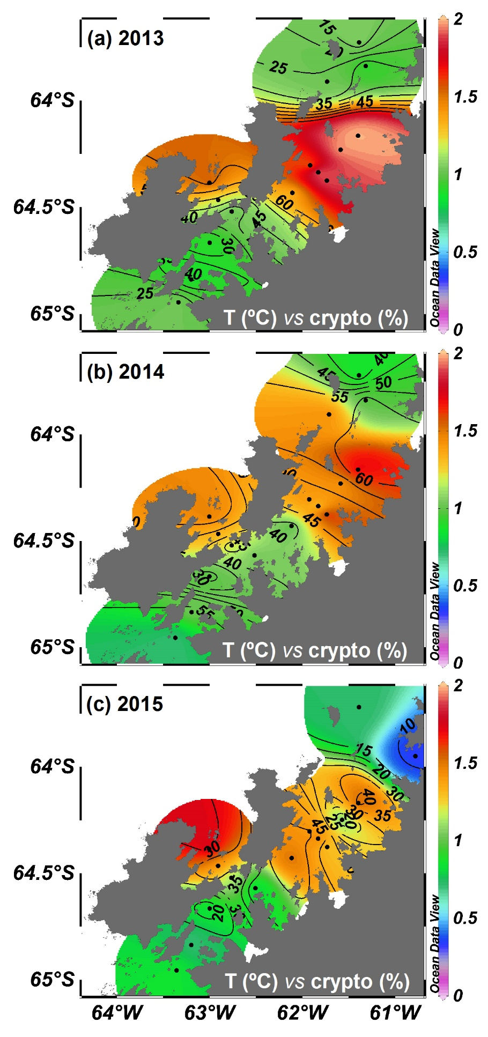
Figure 4
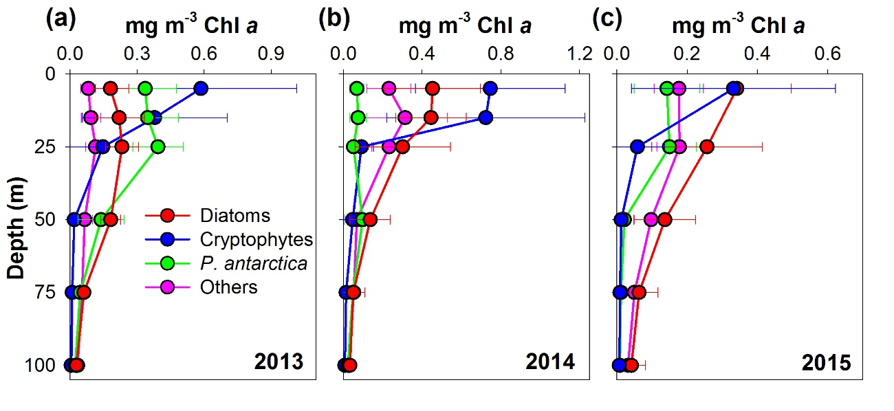

Figure 5
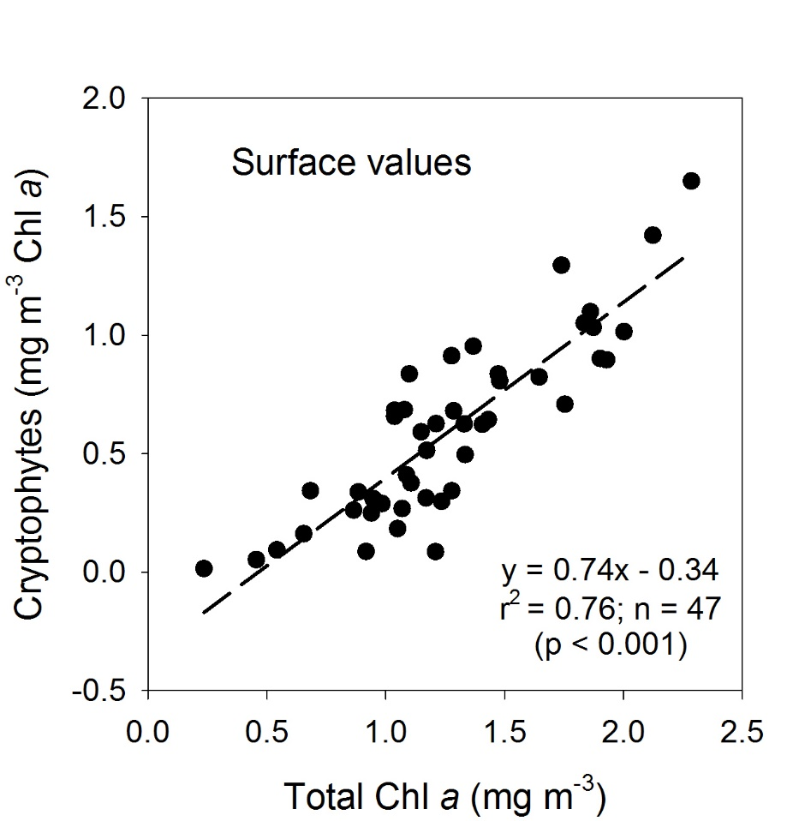

Figure 6
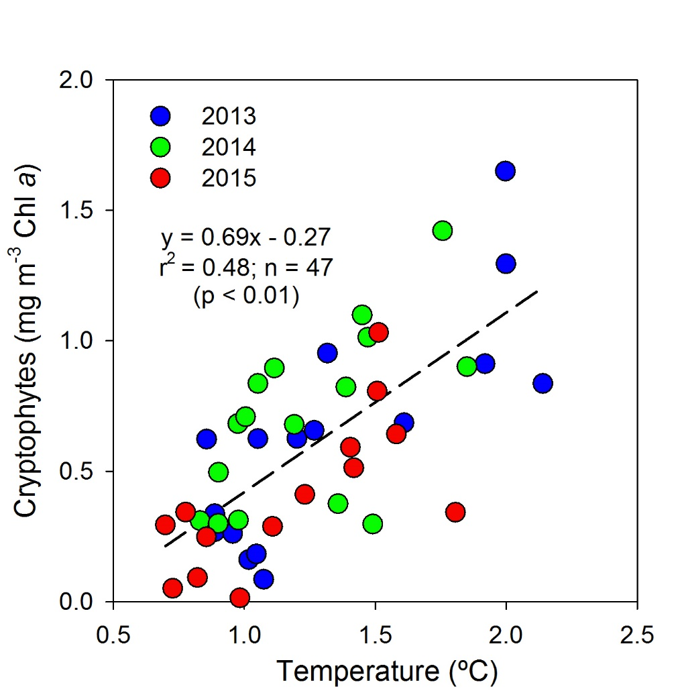

Figure 7
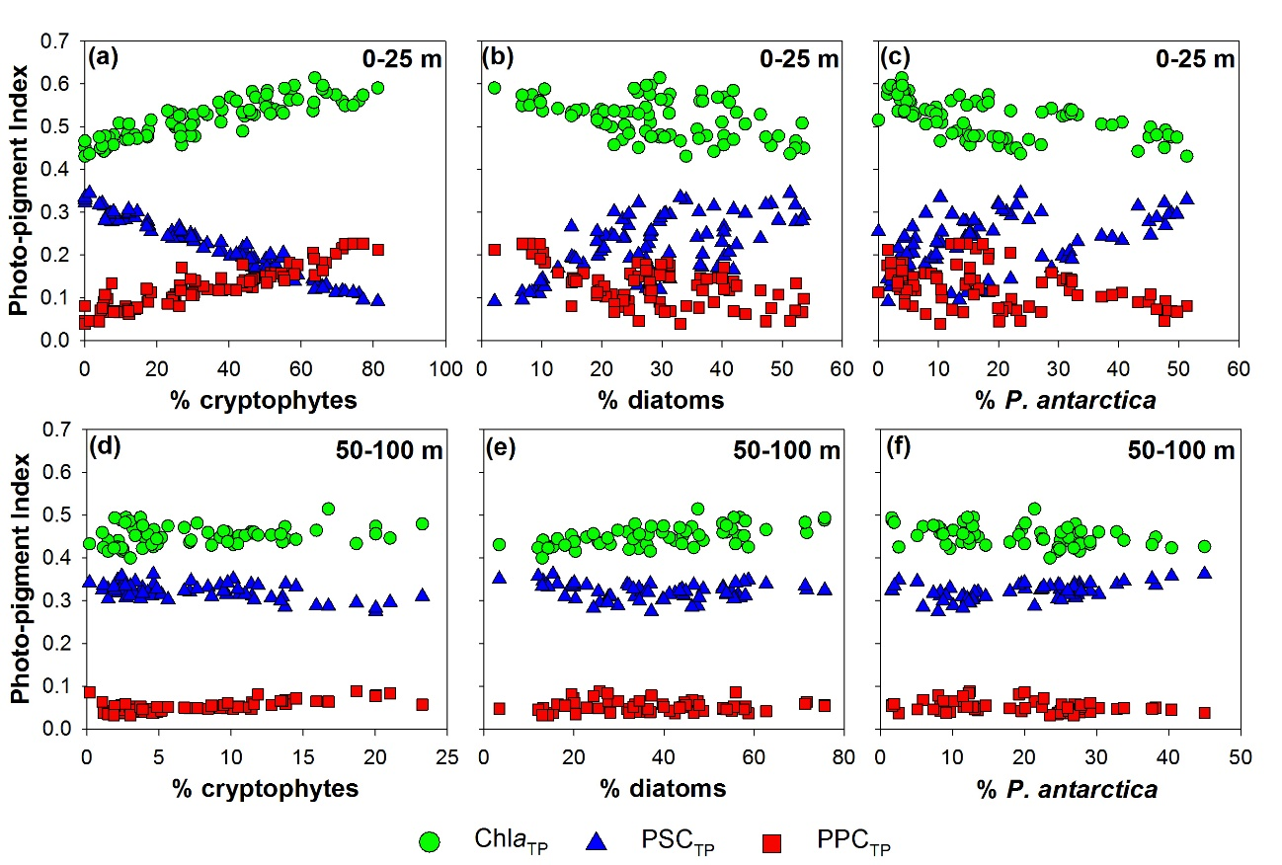

Figure 8
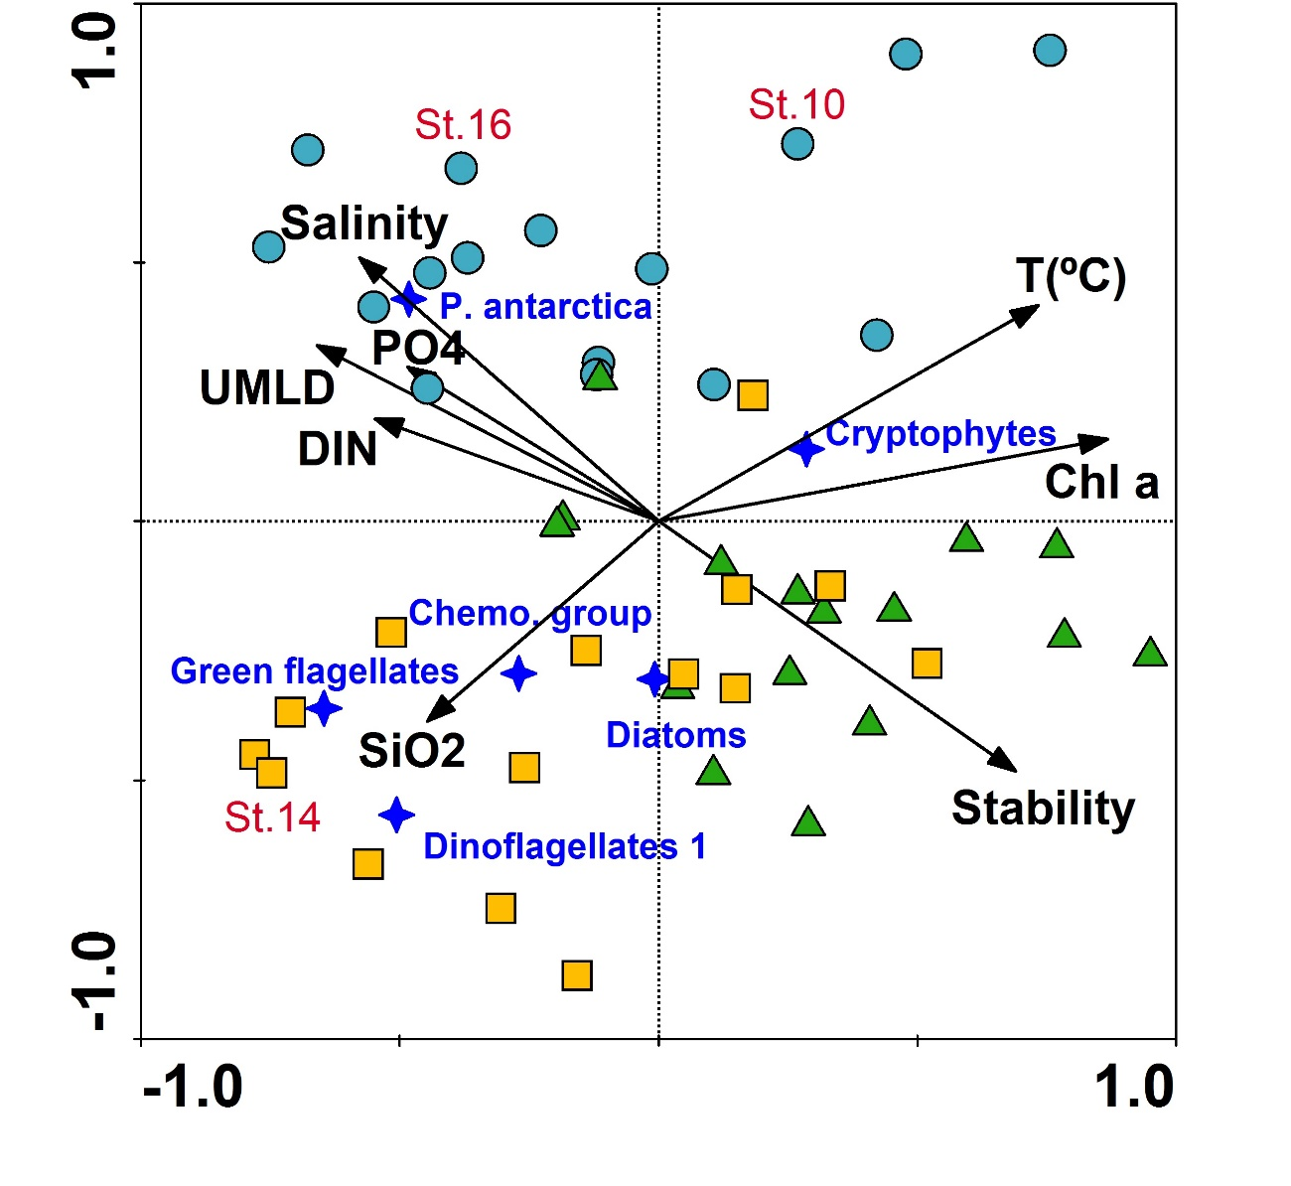

Figure 9
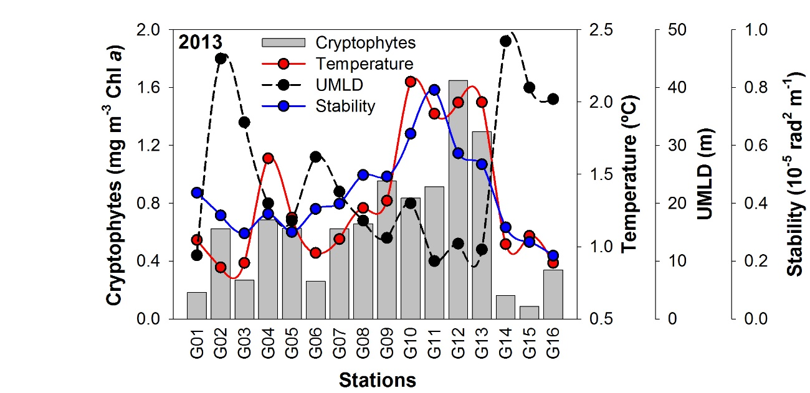

Figure 10

