Impact of sea ice on the structure of phytoplankton communities in the northern Antarctic Peninsula

Carlos Rafael Borges Mendes^{a,b*}; Virginia Maria Tavano^{a,b}; Rodrigo Kerr^{b}; Tiago Segabinazzi Dotto^{b,1}; Tiago Maximianoª; Eduardo Resende Secchi^{c}

ªLaboratório de Fitoplâncton e Microorganismos Marinhos, Instituto de Oceanografia, Universidade Federal do Rio Grande (FURG), Av. Itália, km 8, Rio Grande, RS 96203-900, Brazil
^{b}Laboratório de Estudos dos Oceanos e Clima, Instituto de Oceanografia, Universidade Federal do Rio Grande (FURG), Av. Itália, km 8, Rio Grande, RS 96203-900, Brazil
^{c}Laboratório de Ecologia e Conservação da Megafauna Marinha, Instituto de Oceanografia, Universidade Federal do Rio Grande (FURG), Av. Itália, km 8, Rio Grande, RS 96203-900, Brazil
¹Present address: Ocean and Earth Science, University of Southampton, National Oceanography Centre, Southampton, UK

*Corresponding author: Tel. + 55 53 3233 6746; E-mail: crbmendes@gmail.com

Abstract

The seasonal advance and retreat of sea ice around the northern Antarctic Peninsula can have a significant impact on phytoplankton, mainly due to alterations in the availability of ice-free areas, micro-nutrient inputs by meltwater and variations in water column structure. The aim of this work was to evaluate the effect of sea ice conditions on phytoplankton biomass and community composition in an area off the northern Antarctic Peninsula, a region undergoing important warming processes. In two consecutive summer cruises (2013 and 2014), seawater samples were analysed for nutrients and phytoplankton (through HPLC-CHEMTAX approach), and measurements were made for water column physical structure evaluation. Two contrasting conditions were studied: a strong environmental gradient around the sea ice edge, with a marked meltwater signal (summer 2013) and the same area with little indication of meltwater and no detectable sea ice conditions (summer 2014). In the first year, the phytoplankton communities were massively dominated by nanoflagellates such as cryptophytes, small dinoflagellates and Phaeocystis antarctica, but with differences between stations with less influence of meltwater (dominance of dinoflagellates type B, mainly Gymnodinium spp., mean chlorophyll a = 1.37 mg m⁻³) and stations closer to the sea ice edge (dominance of cryptophytes, mean chlorophyll a = 0.98 mg m⁻³). In the second year, cryptophytes were apparently replaced by diatoms type B (mainly Pseudonitzschia spp., 24% contribution, mean chlorophyll a = 0.93 mg m⁻³), although dinoflagellates were also important. Therefore, there was a clear distinction between the phytoplankton communities under sea ice influence, where mainly cryptophytes were associated with shallow mixed layers and high water column stability in 2013 and an important presence of diatoms in 2014, associated with deeper mixed layers, lower silicic acid concentrations and higher magnitudes of both salinity and temperature, under very little sea ice influence. Gymnodinioid dinoflagellates were an important component in both years, apparently occupying sites/conditions less favourable to cryptophytes. These results support previous suggestions that climate factors leading to shortening of the sea ice season in the region do have an important impact particularly in shaping the dominance of the main phytoplankton functional groups in the region.
Keywords: Antarctic Peninsula, sea ice, phytoplankton, HPLC pigments, CHEMTAX, cryptophytes, peridinin-lacking autotrophic dinoflagellates.

1. Introduction
The Antarctic Peninsula (AP) is experiencing one of the fastest warming rates on Earth, with an increase in the mean atmospheric temperature of 2°C (6°C in winter; > 5× the global average) since 1950 (Ducklow et al., 2007). Along with atmospheric and ocean surface warming in the region (Meredith and King, 2005), increased heat due to intrusions of warm mid-depth Upper Circumpolar Deep Water from the Antarctic Circumpolar Current onto the continental shelf (Moffat et al., 2009; Couto et al., 2017) has caused a 0.6°C increase in temperature of the upper 300 m of the water column (Meredith and King, 2005; Martinson and McKee, 2012; Turner et al., 2014). Consequently, 87% of the AP glaciers are in retreat, the annual sea ice season has shortened by 90 days, and perennial ice is no longer a feature of the northern AP (Cook et al., 2005; Martinson et al., 2008; Stammerjohn et al., 2008; Peck et al., 2010; Cook et al., 2016).
The Southern Ocean is generally a high-nutrient and low-chlorophyll (HNLC) area due to limitation of primary production by low concentrations of micronutrients, mainly iron (Boyd et al., 2007), light limitation through deep mixing (Mitchell and Holm-Hansen, 1991; Nelson and Smith, 1991), and/or grazing (Dubischar and Bathmann, 1997; Smetacek et al., 2004). However, high phytoplankton biomass has been observed in particular regions, especially at ocean frontal systems, marginal ice zones and nearshore straits, bays, and lees of islands (Prézelin et al., 2000 and references therein). Phytoplankton blooms in those regions, normally dominated by diatoms or haptophytes, such as Phaeocystis antarctica, are generally associated with the development of a shallow mixed layer and/or iron availability (Smith and Nelson, 1986; Prézelin et al., 2000).
The Antarctic sea ice zone constitutes, through seasonal sea ice retreat and advance, a key component of the Southern Ocean dynamics, with regards to both energy transfer between atmosphere and ocean and food-web dynamics (Deppeler and Davidson, 2017). In the AP region, meltwater conditions are likely to become more prevalent in surface waters because of the warming trend in the area (Dierssen et al., 2002; Moline et al., 2004).
In the areas around the AP, decreased salinity levels have been associated with a transition from a diatom-dominated system to one dominated by smaller cryptophytes (Moline et al., 2004; Montes-Hugo et al., 2009; Mendes et al., 2013, 2017). As diatoms are more efficiently grazed by Antarctic krill than cryptophytes, this shift may affect food web trophic interactions (Haberman et al., 2003). Since phytoplankton supports oceanic food webs and plays a key role on the AP marine ecosystem’s resilience, changes in the abundance and composition of phytoplankton groups may have a direct effect on the whole regional ecosystem. Therefore, studies on the influence of environmental constraints upon species/groups composition are relevant to evaluate potential ecosystem changes, both at short and long-term scales.
Studies of phytoplankton community through chemotaxonomic methods based on High Performance Liquid Chromatography (HPLC) pigment analysis (e.g. Mendes et al., 2015) rely on the relative concentration of pigments that are characteristic of distinct algal taxonomic groups (Wright and Jeffrey, 2006; Higgins et al., 2011). A common approach involves using the software CHEMTAX (CHEMical TAXonomy) on HPLC pigment ratios signatures (Mackey et al., 1996) to determine the relative contribution of phytoplankton groups to total biomass. The HPLC-CHEMTAX approach has been extensively and successfully used in many worldwide investigations (e.g. Wright et al., 2010; Schlütter et al., 2011; Mendes et al., 2011; 2015; Araujo et al., 2017), including in the AP (Rodriguez et al., 2002; Kozlowski et al., 2011; Mendes et al., 2012), to determine the distribution and biomass of phytoplankton functional groups. This approach provides valuable information about the whole phytoplankton community, including small-size species, which are normally difficult to identify by light microscopy.
The present work evaluates phytoplankton community changes during two consecutive late-summer oceanographic surveys (February 2013 and 2014) conducted in the same region at the Weddell-Scotia Confluence zone, under contrasting sea ice situations: the first year was strongly influenced by the presence of sea ice, while in the second sampling year there was practically no sea ice melting condition. In this context, the study aims to address the impact of sea ice processes on the in situ structure of phytoplankton communities, at both horizontal and vertical (0−100m) scales, at that area of the northern Antarctic Peninsula (NAP).

2. Material and methods

2.1. Environmental context and cruise design
The data set in this work was collected during two oceanographic cruises conducted on board the RV Almirante Maximiano of the Brazilian Navy in the northwestern Weddell Sea (Fig. 1), during late summers of 2013 (25 February to 01 March; 34 stations) and 2014 (23−24 February; 15 stations). The study region is located near the tip of the Antarctic Peninsula, with the Clarence Island to the southwest, the Powell Basin/Weddell Sea to the southeast and the Scotia Sea to the north (Fig. 1). This region is part of the Weddell-Scotia Confluence (WSC; Patterson and Sievers, 1980), where surface/intermediate waters from the Weddell and Scotia seas merge.
In February 2013, particularly, the development of a high-pressure system over the Antarctic Peninsula intensified the cold, southerly winds, which advected and apparently agglomerated together a great amount of sea ice northwards (http://nsidc.org/arcticseaicenews/2013/02/). That particular scenario contributed to the higher than average sea ice concentration in that region during the first sampling period, which did not occur in the following year. Thus, the 2013 station grid comprised an area further northward than expected. However, the well-defined sea ice boundary allowed the accomplishment of the proposed project goals. Therefore, the sampling strategy was then defined, taking into account the position of the sea ice boundary. The stations along the longitudinal transects were conducted at 10 nm intervals, with closer intervals (~ 1 nm) approaching the sea ice border and further south (see Fig. 1). The sampling was conducted from the sea ice boundary northward and from west to east. In the following year, due to time limitation and no anomalous sea ice distribution in the region, some of the previous stations were reoccupied from north to south, allowing investigation of the phytoplankton community distribution in the study region with (2013) and without (2014) the sea ice effects.

2.2. Sampling collection
Hydrographic data (temperature and salinity) and water samples were collected using a combined Sea-Bird CTD/Carrousel 911+system® equipped with 24 five-litre Niskin bottles. Surface water samples were taken in all CTD (conductivity–temperature–depth) stations for both dissolved nutrients and phytoplankton pigments analyses (Fig. 1). At some stations, chosen based on the downcast fluorescence profiles (WetLabs® profiling fluorometer), seawater samples were taken from several depths (between the surface and 100 m) to characterize the vertical distribution of phytoplankton communities. However, due to the absence of deep chlorophyll maximum (DCM) layers, seawater samples at these selected stations were generally collected at regular depths: 5, 15, 25, 50, 75 and 100 m.

2.3. Water column stability/stratification parameters
The potential density (ρ, kg m^{–3}) was calculated based on temperature, salinity and pressure data in order to evaluate the physical structure of water column. The upper mixed layer depth (UMLD) was determined based on density profiles, according to the criteria established by de Boyer Montégut et al. (2004), i.e., the depth at which potential density deviate from its 10 m depth value by a threshold of Δρ = 0.03 kg m^{–3}. The water column stability (E; hereafter referred to as stability) was estimated using vertical density variations, as function of the buoyancy or the Brunt-Väisälä frequency (N²), which is determined by:
$$N^{2}=- \frac{g}{ρ} \frac{∂ρ}{∂z} ({rad}^{2}s^{-2})$$
where g is gravity and ρ is the potential density of seawater. Stability was further estimated from:
$$E=\frac{N^{2}}{g}({10}^{-6} {rad}^{2}m^{-1})$$
Average stability values (between 0 and 100 m depth) were used in the statistical analyses.

2.4. Meltwater percentage estimation
To evaluate the effects of sea ice melting on the structure of phytoplankton communities, following Rivaro et al. (2014), we calculated the meltwater percentage (MW%), as the difference between the salinity measured, on the same station, at surface (S_{meas}) and at a greater depth (S_{deep}; i.e., at 300 m), which was presumably not influenced by sea ice dilution, assuming an average sea ice salinity of 6 (Ackley et al. 1979):
$$MW\%=\left(1-\frac{S_{meas}-6}{S_{deep}-6}\right)×100$$

2.5. Nutrient analysis
Surface seawater samples were filtered through cellulose acetate membrane filters to determine dissolved inorganic nutrients (DIN: nitrate, nitrite and ammonium; phosphate and silicic acid). Nutrients were analysed onboard using a FEMTO® spectrophotometer, following the analytical recommendations in Aminot and Chaussepied (1983). Orthophosphate was measured by reaction with ammonium molybdate, with absorption readings at 885 nm. Silicic acid measurements, in the form of reactive Si, were corrected for sea salt interference.

2.6. HPLC pigment analysis
For phytoplankton pigment analysis, seawater samples (0.5–2.5 L) were filtered under low vacuum through GF/F filters and these were immediately frozen in liquid nitrogen for later HPLC pigment analysis. In the laboratory, the filters were placed in a screw-cap centrifuge tube with 3 mL of 95% cold-buffered methanol (2% ammonium acetate) containing 0.05 mg L^{–1} trans-β-apo-8'-carotenal (Fluka) as internal standard. Samples were sonicated for 5 min in an ice-water bath, placed at –20°C for 1h, and then centrifuged at 1100 g for 5 min at 3°C. The supernatants were filtered through Fluoropore PTFE membrane filters (0.2 μm pore size) to separate the extract from remains of filter and cell debris. Immediately prior to injection, 1000 µL of sample was mixed with 400 µL of Milli-Q water in 2.0 mL amber glass sample vials, which then were placed in the HPLC cooling rack (4°C). The pigment extracts were analysed using a Shimadzu HPLC constituted by a solvent distributor module (LC-20AD) with a control system (CBM-20A), a photodiode detector (SPDM20A) and a fluorescence detector (RF-10AXL). The chromatographic separation of the pigments was performed using a monomeric C8 column (SunFire; 15 cm long; 4.6 mm in diameter; 3.5 μm particle size) at a constant temperature of 25 °C. The mobile phase (solvent) and respective gradient followed the method developed by Zapata et al. (2000), discussed and optimized by Mendes et al. (2007), with a flow rate of 1 ml min⁻¹, injection volume of 100 μl, and 40 min runs. All the studied pigments were identified from both absorbance spectra and retention times, and the concentrations were calculated from the signals in the photodiode array detector in comparison with commercial standards obtained from DHI (Institute for Water and Environment, Denmark). The peaks were integrated using LC-Solution software, and all of the peak integrations were checked manually and corrected when necessary. A quality assurance (QA) threshold procedure, through application of quantification limit (LOQ) and detection limit (LOD), was applied to the pigment data as described by Hooker et al. (2005) to reduce the uncertainty of pigments found in low concentrations. The LOQ and LOD procedures were performed according to Mendes et al. (2007). In order to correct for losses and volume changes, the concentrations of the pigments were normalized to the internal standard.

2.7. CHEMTAX analysis of pigment data
The relative contribution of microalgal groups to the overall biomass was calculated from the class-specific accessory pigments and total chlorophyll a (Chl a) using CHEMTAX v1.95 chemical taxonomy software (Mackey et al. 1996). CHEMTAX uses a factor analysis and steepest descent algorithm to best fit the data onto an initial matrix of pigment ratios (the ratios between the respective accessory pigments and Chl a). The procedures and calculations are fully described in Mackey et al. (1996).
Seven taxa were selected for CHEMTAX analysis, based on identified diagnostic pigments and previous experience in the region (Mendes et al., 2012; 2013; 2017). Two types of diatoms were defined: Type A, containing typical diatom pigmentation (chlorophylls c₁, c₂, fucoxanthin, diadinoxanthin), and Type B, where chlorophyll c₃ replaces chlorophyll c₁ (typified by Pseudonitzschia sp., which were commonly observed in these samples). Two types of dinoflagellates were also defined: Type A, containing peridinin (unambiguous marker), and Type B, containing gyroxanthin esters and fucoxanthin derivatives (the latter type was associated with high densities of small Gymnodinium sp. < 20 µm, which is known to contain carotenoids other than peridinin). Categorisation of taxa containing fucoxanthin (Fuco), 19’-hexanoyloxyfucoxanthin (Hex-Fuco), and 19’-butanoyloxyfucoxanthin (But-Fuco) was somewhat problematic due to the multiple possibilities (eight types of haptophytes, chrysophytes, including Parmales, and some dinoflagellates – Zapata et al., 2004; Wright and Jeffrey, 2006), coupled with the inability to identify many of the taxa containing such pigments by light microscopy. After several trials of different models and a comprehensive analysis, we have included one type of haptophyte (representing Haptophyte type 8 – mainly Phaeocystis antarctica –, as defined by Zapata et al., 2004), as well as a category of Hex-fuco-containing dinoflagellates (Gall et al., 2001; Carreto et al., 2001), as stated above. Cryptophytes and “green flagellates” were recognized by the unambiguous markers alloxanthin and chlorophyll b, respectively. The microscopy cell number data supported most of these groupings (see Fig. S1 in Supplementary material). However, some groups, containing only few specimens, were not discriminated in the microscopy among small flagellates and, therefore, no comparisons are available with the CHEMTAX approach. All methods and procedures for cell counts and microscopic identification are detailed in Mendes et al. (2012). The microscopy data were used in this study just to validate the CHEMTAX results.
The initial pigment ratios of major algal classes used here were compiled from Higgins et al. (2011), with chemotaxonomic groups being identified according to Jeffrey et al. (2011) (see Table 1(a)). The same initial ratios were used in data from both study years, but data from each cruise were run separately in order to detect potential variations in optimization of CHEMTAX procedures. In order to account for pigment ratios’ variation with irradiance and/or nutrient availability, data from each cruise were also split into three bins according to sample depth (0–25 m, 25–50 m and > 50 m). A series of 60 pigment ratio matrices were generated by multiplying each ratio from the initial matrix by a random function to optimize the matrix, and 10% (n=6) of the generated ratios with lowest root-mean-square residual were averaged [see Wright et al. (2009) for further procedure details]. The optimized pigment ratio matrix derived from CHEMTAX for the 0–25 m is presented in Table 1(b) and 1(c) (data from 2013 to 2014, respectively).

2.8. Photo-pigment indices
Photo-pigment indices were derived to assess the contribution of chlorophylls and carotenoids to the total pigment (TP) pool. The chlorophylls were partitioned into chlorophyll a (Chla) and the sum of chlorophyll b and all chlorophylls c (Chlbc). The carotenoids were separated into photosynthetic carotenoids (PSC) and photoprotective carotenoids (PPC). In this study, the PSC included 19’−butanoyloxyfucoxanthin, 19’−hexanoyloxyfucoxanthin, fucoxanthin and peridinin, while the PPC were composed by alloxanthin, diadinoxanthin, diatoxanthin, β,β-carotene and β,ε-carotene. Four photo-pigment indices were derived and used here following Barlow et al. (2004): Chla_{TP} (chlorophyll a to total pigments), Chlbc_{TP} (chlorophyll b and chlorophylls c to total pigments), PSC_{TP} (photosynthetic carotenoids to total pigments) and PPC_{TP} (photoprotective carotenoids to total pigments). These indices were used to investigate phytoplankton pigment acclimations in response to different environmental light regimes.

2.9. Statistical analysis
Relationships between biomass of phytoplankton groups and environmental variables at surface (first CTD sampling depth, 5-10 m; except for determining water column structure, where data from the upper 100 m were used) were explored by Canonical Correspondence Analysis (CCA; Ter Braak and Prentice, 1988) using CANOCO for Windows 4.5 software. This analysis was performed in order to identify the main patterns of the phytoplankton community structure with respect to environmental variables. Biotic variables were represented by the CHEMTAX-derived taxonomical groups' biomass (mg m^{–3} of Chl a). Environmental variables included water column stability (Stability), upper mixed layer depth (UMLD), meltwater percentage (MW%), sea surface temperature (T), sea surface salinity (Salinity), dissolved inorganic nitrogen (DIN), phosphate and silicic acid. All variables were log-transformed before analysis to reduce the influence of different scales in the data sets. Monte-Carlo tests were run based on 499 permutations under a reduced model (p<0.05) in order to evaluate the significance of the CCA.

3. Results

3.1. Environmental setting
The physical-chemical properties in 2013, due to the presence of sea ice, showed great spatial variability throughout the study area (Fig. 2); while in 2014 (no sea ice) a relative homogeneity of the hydrographic properties was observed. However, in this second year it was possible to observe a typical north-south surface temperature gradient (Fig. 2e), which was relatively masked in 2013 (Fig. 2b) by the effect of the sea ice melting. In order to better evaluate the effect of sea ice on the phytoplankton communities, the sampling stations in 2013 were split, according to the meltwater (MW) percentage, into two data sets: (i) stations under a greater influence of sea ice melting (>2.25% of MW) and (ii) stations further away from this influence (<2.25% of MW) (Fig. 2c). The stations sampled during 2014 showed lower and more homogeneous values of meltwater percentage (1.21 ± 0.25% MW; Fig. 2f), always lower than this threshold, and were considered as a third data set.
The mean sea surface temperature showed noticeable differences among data sets, with higher values registered in 2014 (0.31 ± 0.58 ºC) and much lower near the sea ice boundary in 2013 (−0.90 ± 0.24 ºC; Table 2). Mean sea surface salinity showed a similar pattern, i.e., lower values (33.68 ± 0.09) near the sea ice boundary in 2013; intermediate values (33.98 ± 0.04) at stations with lower MW% during 2013; and highest surface salinity values in 2014 (34.14 ± 0.07; Table 2). The low salinities observed at stations with higher MW% (>2.25) in 2013 led to a significant increase in water column stability, accompanied by shallower UMLD (see Table 2). Relatively deep mixed layers, with an average depth around 50 m, were recorded in 2014.
The surface nutrient concentrations, during both sampling periods, were relatively high throughout the study area (Table 2). However, there was considerable variability, mainly in the silicic acid concentrations, whose average values were substantially lower during 2014 (Table 2), when diatoms contributions were much higher (see Fig. 3c).

3.2. Phytoplankton biomass and community composition
During the study period, surface Chl a concentration ranged between 0.27 and 2.15 mg m^{–3} (Table 2). Higher mean surface Chl a concentrations (1.37 ± 0.35 mg m^{–3}) were recorded in 2013 at stations with lower MW% values, i.e., in the northern area, farther from the sea ice boundary (see Fig. S2 in the Supplementary material).
- The main phytoplankton groups in the region during 2013 were cryptophytes, dinoflagellates type B (represented mainly by the genus Gymnodinium; see Fig. S1 in the Supplementary material) and the haptophyte P. antarctica, contributing, altogether with more than 75% of the total Chl a, on average (Fig. 3). Although those three groups together comprised most of the biomass in the region during 2013, cryptophytes were the dominant group at stations with higher MW% values (Fig. 3a); while dinoflagellates type B dominated the stations with lowest influence of sea ice melting (Fig. 3b). Overall, cryptophytes were replaced by diatoms type B (represented mainly by the genus Pseudonitzschia; see Fig. S1 in the Supplementary material) in 2014 (Fig. 3c). The spatial distribution of relative contributions of the main phytoplankton groups to total Chl a in surface waters, derived from CHEMTAX, are shown in Figs. S2 and S3 (see Supplementary material).
Vertical distributions of the phytoplankton groups (contribution to Chl a) for a transect along a gradient, from open water to the sea ice edge, are shown in 2013 (Fig. 4). As shown in Fig. 4, in 2013, the thickness of the low-salinity layer increased with proximity to the ice-edge, as a result of fresh water input from sea ice melting (higher values of MW%). On the other hand, the density profiles show that the UMLD (stratification) decreased (increased), respectively, toward the sea ice edge and was influenced primarily by an increasingly thick layer of fresher water. The phytoplankton community composition displayed an orderly succession along this gradient (see Fig. 4): Dinoflagellates type B were dominant at open-water stations (Sts. 21 and 20), accompanied by a significant contribution of diatoms type B, mainly at St. 21, and were gradually replaced by cryptophytes at stations closer to the sea ice boundary. In addition, cryptophytes were conspicuously found in shallow upper mixed layers (0–25 m), above the pycnocline, at stations under well-stratified conditions. The lowest phytoplankton biomass, as indicated by Chl a values, were recorded at two stations closest to the sea ice edge.
The 2014 transect showed an extremely different pattern from that observed in 2013 (see Fig. 5). Increased water column stratification, accompanied by the establishment of a deeper mixed layer, was generally observed from northern to southern stations (Fig. 5). A north-south gradient was also observed for both overall phytoplankton biomass and the relative distribution of taxonomic groups, with higher Chl a concentration at the southern stations and decreasing northwards. The highest biomass levels within the UML were generally characterized by a major contribution of dinoflagellates and diatoms (both type B). Cryptophytes, moderately abundant in the surface layers (0–25 m), were always below 15% of the total Chl a.

3.3. Photo-pigment indices
There was a concomitant variability in photo-pigment indices with changes in dominance of key phytoplankton groups across the study region (Fig. 6). The Chla_{TP} index varied between 0.4 and 0.6, with highest values found in the surface layers (Fig. 7a) and associated with a cryptophytes-dominated community (Fig. 6a). Similarly to Chla_{TP}, the PPC_{TP} at the surface increased following the higher proportion of cryptophytes (Fig. 6a). In contrast, increases in surface PSC_{TP} were associated with higher proportions of dinoflagellates type B (Fig. 6b), declining to values ~0.1 in samples with dominance of cryptophytes. The photo-pigment indices in deeper waters, i.e., below the UMLD, were generally constant, and no particular trend was associated with any phytoplankton group (Fig. 7). It is also noteworthy that the PSC_{TP} was generally greater in deep than in surface layers, while PPC_{TP} was higher at the surface, especially in regions with a clear dominance of cryptophytes, where PPC_{TP} exceed PSC_{TP} (Fig. 7a). Chlbc_{TP} was relatively constant throughout the study area and at collected depths, ranging between 0.1 and 0.2 (see Figs. 6 and 7).

3.4. Phytoplankton response to environmental drivers
A Canonical Correspondence Analysis (CCA) was used to investigate the response of the phytoplankton community (derived from CHEMTAX) to the environmental variables observed in this study (Fig. 8). The relationships showed that the nine selected variables significantly contributed (p<0.01) to explain the spatial distribution of phytoplankton groups. The multivariate analysis showed a strong association between phytoplankton groups and seawater physical and chemical properties. By using all data from both cruises (Fig. 8a), the CCA explained 93.9% of the variance associated with the phytoplankton−environment relationship. The first canonical root, explaining almost all the phytoplankton variation (74.1%), revealed a notable separation between 2013 (circles in Fig. 8) and 2014 (triangles in Fig. 8a) stations. Cryptophytes, which were dominant in 2013, were found to be strongly associated with high values of MW%, stability, silicic acid and phosphate concentrations, and negatively associated with UMLD, salinity and temperature. Diatoms type B and dinoflagellates type A, particularly associated with 2014 conditions, showed an opposite trend with respect to these environmental variables, being strongly associated with high salinity, UMLD, and temperature, and negatively associated with MW% and stability. The dinoflagellates type B and P. antarctica, two important and representative groups in both years, were associated with intermediate values of most variables, such as stability, salinity, MW% and UMLD.
A Canonical Correspondence Analysis (CCA) was also used to investigate the response of the phytoplankton groups to the environmental variables using only data from 2013 (Fig. 8b). In this case, the CCA explained 95.9% of the variance associated with the phytoplankton−environment relationship. The first canonical axis alone explained 88.1% of the variance. The diatoms type B were found to be strongly associated with high values of temperature and salinity, and negatively associated with stability and MW%. It is worth noting that at the stations with higher values of MW% (near the sea ice edge; yellow circles in Fig. 8b) a gradient as a function of the UMLD was observed. Dinoflagellates type B were positively associated with the UMLD, while cryptophytes were found to be associated with low values of UMLD (also illustrated in Fig. 9a). Consequently, an increased contribution of cryptophytes over dinoflagellates type B was observed at stations with shallower UMLD (see Fig. 9b).

4. Discussion
The geographical setting of this study is the vicinity of the Weddell-Scotia Confluence (WSC) at the northwestern Weddell Sea. This region is one of the few areas in the Southern Ocean where the open ocean, seasonal sea ice and permanent pack ice occur altogether, reflecting the complex patterns of water circulation and the annual cycle of sea-ice formation and ablation (Hofmann et al., 1996; Hewitt, 1997). The annual cycle of sea ice extent in the region is marked by a minimum in February, and most of the sea ice remaining until summer is found eastward of the Antarctic Peninsula (Cavalieri and Parkinson, 2008). However, there is considerable interannual variability on the sea ice extent associated with the meteorological and oceanographic conditions around the continent (Turner et al., 2013).
- In general, the WSC is characterized by a mixture of surface/intermediate waters between the warm water masses (temperature higher than 0°C) originated in the Weddell and Scotia seas, and cold (less than 0°C), fresher waters from the continental shelves of the tip of the Antarctic Peninsula (Patterson and Sievers, 1980). The region is also characterized by generally weak water column stratification, being one of the main deep passages allowing Weddell Sea deep waters to be exported (Franco et al., 2007; Ferreira and Kerr, 2017), and vulnerable to the displacement of the Antarctic Circumpolar Current fronts (Patterson and Sievers, 1980; Orsi et al., 1995).
The upper water column within the WSC is characterized by the Antarctic Surface Water (AASW), which displays a wide range of both temperature and salinity, located southward of the Polar Front. The western WSC is also characterized by high nutrient concentrations, reflecting the influence of the nutrient-rich surface Weddell Sea shelf waters (Holm-Hansen et al., 1997). Those water masses flow along the continental slope driven by the Antarctic Slope Front (ASF) towards the southern Scotia Sea (Heywood et al., 2004; Thompson et al., 2009) and this flow is considered a key factor for the enhancement of surface chlorophyll levels in the region (Thompson and Youngs, 2013). In fact, dissolved macronutrient concentrations at surface, during both sampling periods in this work (see Table 2), were high and unlikely to have limited phytoplankton growth, indicating that other processes were driving the patchy distribution of phytoplankton biomass (Chl a) and composition over the study area. In open waters of the Southern Ocean, high nutrient and low chlorophyll (HNLC) conditions prevail in most areas, due to iron scarcity (De Baar et al., 2005; Jickells et al., 2005), elevated grazing (Burkill et al., 1995), and/or light limitation (Smith et al., 2000; van Oijen et al., 2004), where chlorophyll concentrations are consistently below 0.5 mg m⁻³ and phytoplankton are frequently characterized by small motile organisms (Morel et al., 1991; Smith and Lancelot, 2004; Thomson et al., 2010). Although in our study region Chl a concentrations have almost always exceeded this value (mean around 1 mg m⁻³), indicating some degree of iron supply, the phytoplankton communities were massively dominated by nanoflagellates, including cryptophytes, small dinoflagellates and Phaeocystis antarctica (more than 75% of total Chl a) – a typical HNLC phytoplankton assemblage.
Our samplings took place during the late summer, when the existing phytoplankton community results from the succession associated with timing and extent of ice melting during the summer (e.g., Moline and Prézelin 1996; Garibotti et al., 2005). Diatom blooms are generally observed in early summer, under sea ice retreating process. Later, flagellate blooms, such as cryptophytes, replace diatoms (Ducklow et al. 2007). In a final succession stage, the community is dominated by diatoms and other unidentified phytoflagellates (Moline and Prézelin 1996; Garibotti et al. 2005). Although in the present study a seasonal variation was not evaluated, the distinct conditions (presence/absence of sea ice) observed between both years adds a different perspective to phytoplankton community dynamics in the NAP, providing an ideal scenario for studying changes and adaptations of phytoplankton communities to distinct environmental conditions.
The two contrasting summer conditions, 2013 strongly influenced by the presence of sea ice, and 2014 with practically no sea ice melting condition, reflected in the water physical-chemical properties. In the first year, a great spatial variability was recorded throughout the study area, while in the second a relative homogeneity in the hydrographic properties was observed. The low surface water salinities at stations near the sea ice boundary in 2013 led to a significant increase in water column stability, accompanied by shallower UMLD. The phytoplankton community composition displayed a straight succession pattern along this environmental gradient: dinoflagellates type B were dominant at stations with less influence of meltwater and were gradually replaced by cryptophytes at stations closer to the sea ice boundary (see Fig. 4). Even within stations with higher contributions of meltwater (near the sea ice edge) it was possible to observe a gradient as a function of the UMLD, i.e., dinoflagellates type B positively associated with deeper UMLD, and cryptophytes associated with shallower UMLD (see Fig. 9). Therefore, an increased contribution of cryptophytes over dinoflagellates type B was observed at stations with shallower (0-25 m) UMLD, under stratified conditions, above the pycnocline, although with lower biomass (chlorophyll a) close to the sea ice edge, probably as a result of melt water dilution processes.
Several studies have highlighted the increasing importance of cryptophytes in coastal regions of the AP, especially in shallower mixed layers and lower chlorophyll a in summer, associated with lower diatom abundances (Mendes et al., 2013; Rozema et al., 2017; Schofield et al., 2017). Shifts from diatoms to cryptophytes dominance have been previously attributed to sedimentation of large diatoms (Castro et al., 2002), advection (Moline and Prézelin, 1996), grazing (Garibotti et al., 2003), iron availability (Mendes et al., 2013), and preference/physiological tolerance of cryptophytes to lower salinity waters (Moline et al., 2004). Cryptophytes in Antarctic coastal waters are often confined to surface layers that are highly exposed to potentially inhibiting irradiance and yet they appear to thrive. The association of this group with high light exposure has been recently explored (Mendes et al. 2017, this issue). It was suggested that the gradual dominance of cryptophytes in coastal waters of the AP in strongly stratified and shallow mixing surface layers is associated with their pigment protection capability. In the present study, in a relatively open ocean area, cryptophytes followed the same pattern, suggesting that even in offshore regions of the NAP, where the conditions favour the development of a shallow upper mixed layer and strong water column stratification, e.g. by the effect of sea ice melting, they can emerge as an important component of the algal communities. The dominance of cryptophytes, in place of other groups, such as diatoms, may influence the trophic webs in the region, as cryptophytes are more efficiently grazed by salps than by Antarctic krill (Moline et al., 2004), threatening the long-term viability of krill-dependent species (e.g. Seyboth et al., 2016).
In opposition to the distribution of cryptophytes, the dinoflagellates type B (mainly small Gymnodinium spp. < 20 µm) were positively associated with UMLD (see Figs. 8 and 9) indicating an adaptation/preference to deeper mixed layers. The occurrence and dominance of dinoflagellates type B, especially Gymnodinium spp., is of particular interest because they include toxic species adapted to disperse in coastal currents and frontal systems (Smayda, 2002). Although autotrophic dinoflagellates (Gymnodinium spp.) have already been reported as important contributors to total Chl a biomass in some well−stratified Antarctic waters (Savidge et al., 1995; Kang et al., 2001; Mendes et al., 2012, 2013), an ecological approach to explain the distribution patterns of this group in Antarctic environments has not yet been explicitly addressed. In this study, there were apparently opposing environmental conditions, favourable to either those dinoflagellates or cryptophytes, as suggested in Fig. 9 (under contrasting UMLD) and also in Fig. S2. Therefore, an apparent complementary spatial distribution is seen between those two groups suggesting different niche adaptations. In this context, a finer taxonomic identification of both gymnodinoid dinoflagellate species and cryptophytes is needed in the NAP region. Difficulties in identifying those groups in light microscopy of preserved samples could be overcome by the analysis of living cells and their molecular structure (Hoppenrath et al., 2009).
In this work, similarly to that proposed by Mendes et al. (2017, this issue), we hypothesize that cryptophytes would bear photophysiological plasticity to tolerate high irradiances in the upper layers of the Antarctic waters in summer and thrive under such conditions. The relative replacement of major phytoplankton groups across the study area resulted in changes in pigment composition, as reflected by the photo-pigment indices (as illustrated in Figs. 6 and 7). These proportions are similar to those in Mendes et al. (2017, this issue) for the Gerlache Strait – a coastal region of the NAP where cryptophytes have been shown to dominate – with the ratios of photoprotective carotenoids to total pigments (PPC_{TP}) increasing concomitantly with an increase in the proportion of cryptophytes (Fig. 6a). Although this group do not possess a xanthophyll cycle, they are able to induce synthesis of the photoprotective carotenoid alloxanthin under light stress, presumably enhancing non-photochemical quenching (NPQ) capacity (discussed in detail by Mendes et al. 2017, this issue). Similar physiological adaptions to irradiance, i.e., an increase in photoprotective pigments content, have been previously reported in Ross Sea phytoplankton assemblages (e.g. Arrigo et al., 2010; Tozzi and Smith, 2017), suggesting that light is a major factor in shaping phytoplankton communities in the region. In contrast, the photosynthetic carotenoids (PSC) were more prominent at dinoflagellate-dominated stations (Figs. 6b and 7b), mainly driven by high concentration of fucoxanthin and its derivatives. Photosynthetic carotenoids have a significant role in extending the phytoplankton light-harvesting spectrum, thus ensuring optimal absorption efficiencies (Kirk, 2011). Therefore, it appears that the dinoflagellates were not subjected to excess irradiance physiological stress, probably by being associated with generally deeper UMLD conditions, leading to shorter time exposure to light inhibiting levels.
Although our results indicate an optimization of light-protection capability of cryptophytes for prevailing in the highly illuminated shallower mixed layers, other factors such as adaptability to iron limiting conditions and/or mechanisms for alleviation micro-zooplankton grazing cannot be discarded as possible causes for the success of cryptophytes in the NAP surface waters.

5. Concluding remarks
Stratification is a primary condition for seasonal development of algal blooms (e.g. Margalef et al., 1979), mainly after a turbulent condition, as it creates a stable surface layer that allows for the maintenance of phytoplankton in a favourable light regime. In our study area, stratification (causing water column stability) induced by meltwater coupled with the depth of the mixing layer seem to be the most important factors influencing the phytoplankton community composition and spatial distribution. Contrasting water column conditions, particularly in 2013, determined the dominance of either cryptophytes confined to shallow surface layers, with apparently efficient photo-protection traits or dinoflagellates under less light stress in deeper surface mixing layers. In 2014, under no ice conditions, diatoms replaced cryptophytes, but dinoflagellates were again a very important group. Other biological adaptations such as iron stress tolerance or grazing avoidance mechanisms may also play a role in the structuring of phytoplankton communities in the NAP. Understanding the physical regulation and biological traits and adaptations of phytoplankton communities along the NAP is critical to understanding the regional ecology and biogeochemistry. Such phytoplankton monitoring procedures are vital to fully understand the function of marine food webs, particularly in regions extremely sensitive to global climate change, as the NAP region.

Acknowledgments
This is a multidisciplinary program as part of the GOAL (Brazilian High Latitudes Oceanography Group) activities in the Brazilian Antarctic Program (PROANTAR). Financial support was provided by CNPq (National Council for Research and Development) and CAPES (Coordination for the Improvement of Higher Education Personnel). This study was conducted within the activities of the POLARCANION, PRO-OASIS, INTERBIOTA, NAUTILUS (CNPq grant numbers 556848/2009-8, 565040/2010-3, 407889/2013-2, 405869/2013-4) and CMAR2 (CAPES grant number 23038.001421/2014-30) projects. The authors thank to the crew of the RV “Almirante Maximiano” of the Brazilian Navy and several investigators participating in the cruises for their valuable help during samples’ collection. We are grateful to Simon Wright, from the Australian Antarctic Division, for providing the CHEMTAX v.1.95 software and to Ricardo Pollery for performing all nutrient analysis. The assistance of Márcio Silva de Souza with microscopic analysis is also gratefully acknowledged. C.R.B. Mendes acknowledge financial support from the CAPES Foundation. T.S. Dotto acknowledges support by the CNPq PhD scholarship (grant number 232792/2014-3). V.M. Tavano, R. Kerr, and E.R. Secchi are granted with research fellowships from CNPq. We are thankful for the constructive criticism of two anonymous reviewers, which helped to improve the manuscript.

References
Ackley, S.F., Buck, K.R., Taguchi, S., 1979. Standing crop of algae in the sea ice of Weddell Sea region. Deep-Sea Res. I 26, 269–281.

Aminot, A., Chaussepied, J., 1983. Manuel dês Analyses Chimiques en Milieu Marin. CNEXO, Brest, 230 pp.

Araujo, M.L.V, Mendes, C.R.B., Tavano, V.M., Garcia, C.A.E., Baringer, M.O.N., 2017. Contrasting patterns of phytoplankton pigments and chemotaxonomic groups along 30ºS in the subtropical South Atlantic Ocean. Deep-Sea Res. I 120, 112–121.

Arrigo, K.R., Mills, M.M., Kropuenske, L.R., van Dijken, G.L., Alderkamp, A.C., Robinson, D.H., 2010. Photophysiology in two major Southern Ocean phytoplankton taxa: photosynthesis and growth of Phaeocystis antarctica and Fragilariopsis cylindrus under different irradiance levels. Integr. Comp. Biol. 50, 950–966.

Barlow, R.G., Aiken, J., Moore, G.F., Holligan, P.M., Lavender, S., 2004. Pigment adaptations in surface phytoplankton along the eastern boundary of the Atlantic Ocean. Mar. Ecol. Prog. Ser. 281, 13–26.

Boyd, P.W., Jickells, T., Law, C.S., Blain, S., Boyle, E.A., Buesseler, K.O., Coale, K.H., Cullen, J.J., de Baar, H.J.W, Follows, M., Harvey, M., Lancelot, C., Levasseur, M., Owens, N.P.J., Pollard, R., Rivkin, R.B., Sarmiento, J., Schoemann, V., Smetacek, V., Takeda, S., Tsuda, A., Turner, S., Watson, A.J., 2007. Mesoscale Iron Enrichment Experiments 1993–2005: Synthesis and Future Directions. Science 315, 612–617.

Burkill, P.H., Edwards, E.S., Sleigh, M.A., 1995. Microzooplankton and their role in controlling phytoplankton growth in the marginal ice zone of the Bellingshausen Sea. Deep-Sea Res. II 42, 1277–1290.

Carreto, J.I., Seguel, M., Montoya, N.G., Clément, A., Carignan, M.O., 2001. Pigment profile of the ichthyotoxic dinoflagellate Gymnodinium sp. from a massive bloom in southern Chile. J. Plankton Res. 23, 1171–1175.

Castro, C.G., Ríos, A.F., Doval, M.D., Pérez, F.F., 2002. Nutrient utilisation and chlorophyll distribution in the Atlantic sector of the Southern Ocean during Austral summer 1995–96. Deep-Sea Res. II 49, 623–641.

Cavalieri, D.J., Parkinson, C.L., 2008. Antarctic sea ice variability and trends, 1979–2006. J. Geophys. Res. 113, C07004.

Cook, A.J., Fox, A.J., Vaughan, D.G., Ferrigno, J.G., 2005. Retreating Glacier fronts on the Antarctic Peninsula over the past half-century. Science 308, 541–544.

Cook, A.J., Holland, P.R., Meredith, M.P., Murray, T., Luckman, A., Vaughan, D.G., 2016. Ocean forcing of glacier retreat in the western Antarctic Peninsula. Science 353, 283–286.

Couto, N., Martinson, D.G., Kohut, J., Schofield, O., 2017. Distribution of upper circumpolar Deep Water on the warming continental shelf of the West Antarctic Peninsula. J. Geophys. Res. Oceans. Doi:10.1002/2017JC012840.

de Baar, H.J.W, Boyd, P.H., Coale, K.H., Landry, M.R., Tsuda, A., Assmy, P., Bakker, D.C.E., Bozec, Y., Barber, R.T., Brzezinski, M.A., Buesseler, K.O., Boyé, M., Croot, P.L., Gervais, F., Gorbunov, M.Y., Harrison, P.J., Hiscock, W.T., Laan, P., Lancelot, C., Law, C.S., Levasseur, M., Marchetti, A., Millero, F.J., Nishioka, J., Nojiri, Y., van Oijen, T., Riebesell, U., Rijkenberg, M.J.A., Saito, H., Takeda, S., Timmermans, K.R., Veldhuis, M.J.W., Waite, A.W., Wong, C.S., 2005. Synthesis of iron fertilization experiments: From the Iron Age in the Age of Enlightenment. J. Geophys. Res. 110, C09S16.

de Boyer Montégut, C., Madec, G., Fischer, A.S., Lazar, A., Iudicone, D., 2004. Mixed layer depth over the global ocean: An examination of profile data and a profile based climatology. J. Geophys. Res. 109, C12003.

Deppeler, S.L., Davidson, A.T., 2017. Southern Ocean Phytoplankton in a Changing Climate. Front. Mar. Sci. 4, 40.

Dierssen, H.M, Smith, R.C, Vernet, M., 2002. Glacial meltwater dynamics in coastal waters west of the Antarctic Peninsula. PNAS 99, 1790–1795.

Dubischar, C.D., Bathmann, U.V, 1997. Grazing impacts of copepods and salps on phytoplankton in the Atlantic sector of the Southern Ocean. Deep-Sea Res. II 44, 415–433.

Ducklow, H.W., Baker, K., Martinson, D.G., Quetin, L.B., Ross, R.M., Smith, R.C., Stammerjohn, S.E., Vernet, M., Fraser W., 2007. Marine pelagic ecosystems: the West Antarctic Peninsula. Phil. Trans. R. Soc. B 362, 67–94.

Ferreira, M.L.C., Kerr, R., 2017. Source water distribution and quantification of North Atlantic Deep Water and Antarctic Bottom Water in the Atlantic Ocean. Prog. Oceanogr. 153, 66–83.

Franco, B.C., Mata, M.M., Piola, A.R., Garcia, C.A.E., 2007. Northwestern Weddell Sea deep outflow into the Scotia Sea during the austral summers of 2000 and 2001 estimated by inverse methods. Deep-Sea Res. I 54, 1815–1840.

Gall, M.P., Boyd, P.W., Hall, J., Safi, K.A., Chang, H., 2001. Phytoplankton processes. Part 1: Community structure during the Southern Ocean Iron Release Experiment (SOIREE). Deep-Sea Res. II 48, 2551–2570.

Garibotti, I.A., Vernet, M., Kozlowski, W.A., Ferrario, M.E., 2003. Composition and biomass of phytoplankton assemblages in coastal Antarctic waters: a comparison of chemotaxonomic and microscopic analyses. Mar. Ecol. Prog. Ser. 247, 27–42.

Garibotti, I.A., Vernet, M., Smith, R.C., Ferrario, M.E., 2005. Interannual variability in the distribution of the phytoplankton standing stock across the seasonal sea-ice zone west of the Antarctic Peninsula. J. Plankton Res. 27, 825–843.

Haberman, K.L., Ross, R.M., Quetin, L.B., 2003. Diet of the Antarctic krill (Euphausia superba Dana): II selective grazing in mixed phytoplankton assemblages. J. Exp. Mar. Biol. Ecol. 283, 97–113.

Hewitt, R.P., 1997. Areal and seasonal extent of sea-ice cover off the northwestern side of the Antarctic Peninsula: 1979 to 1996. CCAMLR Sci. 4, 65–73.

Heywood, K.J., Garabato, A.C.N., Stevens, D.P., Muench, R.D., 2004. On the fate of the Antarctic slope front and the origin of the weddell front. J. Geophys. Res. Oceans 109, C06021.

Higgins, H.W., Wright, S.W., Schlüter, L., 2011. Quantitative interpretation of chemotaxonomic pigment data. In: Roy, S., Llewellyn, C.A., Egeland, E.S., Johnson, G. (Eds.), Phytoplankton Pigments: Characterization, Chemotaxonomy and Applications in Oceanography. Cambridge University Press, United Kingdom, pp. 257–313.

Hofmann, E.E., Klinck, J.M., Lascara, C.M., Smith, D.A., 1996. Water mass distribution and circulation west of the Antarctic Peninsula and including Bransfield Strait. Antarct. Res. Ser. 70, 61–80.

Holm-Hansen, O., Hewes, C.D., Villafañe, V.E., Helbling, E.W., Silva, N., Amos, T., 1997. Distribution of phytoplankton and nutrients in relation to different water masses in the area around Elephant Island, Antarctica. Polar Biol. 18, 145–153.

Hooker, S.B., Van Heukelem, L., Thomas, C.S., Claustre, H., Ras, J., Schlüter, L., Perl, J., Trees, C., Stuart, V., Head, E., Barlow, R., Sessions, H., Clementson, L., Fishwick, J., Llewellyn, C., Aiken, J., 2005. The Second Sea-WiFS HPLC Analysis Round-Robin Experiment (SeaHARRE-2). NASA Tech. Memo. 2005–212785. NASA Goddard Space Flight Center, Greenbelt, Maryland.

Hoppenrath, M., Elbrachter, M., Drebes, G., 2009. Marine Pytoplankton: Selected microphytoplankton species from the North Sea around Helgoland and Sylt. Kleine Serckenerg – Reihe 49, E. Schweizerbart Science Publishers, Stuttgart, Germany, 264 pp.

Jeffrey, S.W., Wright, S.W., Zapata, M., 2011. Microalgal classes and their signature pigments. In: Roy, S., Llewellyn, C.A., Egeland, E.S., Johnsen, G. (Eds.), Phytoplankton Pigments: Characterization, Chemotaxonomy and Applications in Oceanography. Cambridge University Press, United Kingdom, 3–77.

Jickells, T.D., An, Z.S., Andersen, K.K, Baker, A.R., Bergametti, G., Brooks, N., Cao, J.J., Boyd, P.W., Duce, R.A., Hunter, K.A., Kawahata, H., Kubilay, N., laRoche, J., Liss, P.S., Mahowald, N., Prospero, J.M., Ridgwell, A.J., Tegen, I., Torres, R., 2005. Global iron connections between desert dust, ocean biogeochemistry, and climate. Science 308, 67–71.

Kang, S.H, Kang, J.S., Lee, S., Chung, K.H., Kim, D., Park, M.G., 2001. Antarctic phytoplankton assemblages in the marginal ice zone of the northwestern Weddell Sea. J. Plankton Res. 23, 333–352.

Kirk, J.T.O., 2011. Light and Photosynthesis in Aquatic Ecosystems third ed.. Cambridge University Press, United Kingdom.

Kozlowski, W.A., Deutschman, D., Garibotti, I., Trees, C., Vernet, M., 2011. An
evaluation of the application of CHEMTAX to Antarctic coastal pigment data.
Deep-Sea Res. I 58, 350–364.

Mackey, M.D., Mackey, D.J., Higgins, H.W., Wright, S.W., 1996. CHEMTAX – a program for estimating class abundances from chemical markers: application to HPLC measurements of phytoplankton. Mar. Ecol. Prog. Ser. 144, 265–283.

Margalef, R., Estrada, M., Blasco, D., 1979. Functional morphology of organisms involved in red tides, as adapted to decaying turbulence. In: Taylor, D.L., Seliger, H.H. (Eds.), Toxic Dinoflagellate Blooms, Proceedings of the Second International Conference on toxic dinoflagellate blooms. Elsevier, New York, pp. 89–94.

Martinson, D.G., McKee, D.C., 2012. Transport of warm upper circumpolar deep water onto the western Antarctic Peninsula continental shelf. Ocean Sci. 8, 433–442.

Martinson, D.G., Stammerjohn, S.E., Iannuzzi, R.A., Smith, R.C., Vernet, M., 2008. Western Antarctic Peninsula physical oceanography and spatio–temporal variability. Deep-Sea Res. II 55, 1964–1987.

Mendes, C.R., Cartaxana, P., Brotas, V., 2007. HPLC determination of phytoplankton and microphytobenthos pigments: comparing resolution and sensitivity of a C18 and a C8 method. Limnol. Oceanogr. Methods 5, 363–370.

Mendes, C.R.B., de Souza, M.S., Garcia, V.M.T., Leal, M.C., Brotas, V., Garcia, C.A.E., 2012. Dynamics of phytoplankton communities during late summer around the tip of the Antarctic Peninsula. Deep-Sea Res. I 65, 1–14.

Mendes, C.R.B., Kerr, R., Tavano, V.M., Cavalheiro, F.A., Garcia, C.A.E., Dessai, D.R.G., Anilkumar, N., 2015. Cross-front phytoplankton pigments and chemotaxonomic groups in the Indian sector of the Southern Ocean. Deep-Sea Res. II 118, 221–232.

Mendes, C.R., Sá, C., Vitorino, J., Borges, C., Garcia, V.M.T., Brotas, V., 2011. Spatial distribution of phytoplankton assemblages in the Nazaré submarine canyon region (Portugal): HPLC-CHEMTAX approach. J. Mar. Syst. 87, 90–101.

Mendes, C.R.B, Tavano, V.M., Dotto, T.S., Kerr, R., de Souza, M.S., Garcia, C.A.E, Secchi, E.R., 2017. New insights on the dominance of cryptophytes in Antarctic coastal waters: A case study in Gerlache Strait. Deep-Sea Res. II. Doi:10.1016/j.dsr2.2017.02.010

Mendes, C.R.B., Tavano, V.M., Leal, M.C., de Souza, M.S., Brotas, V., Garcia, C.A.E., 2013. Shifts in the dominance between diatoms and cryptophytes during three late summers in the Bransfield Strait (Antarctic Peninsula). Polar Biol. 36, 537–547.

Meredith, M.P, King, J.C., 2005. Rapid climate change in the ocean west of the Antarctic Peninsula during the second half of the 20th century. Geophys. Res. Lett. 32, 1–5.

Mitchell, B.G., Holm-Hansen, O., 1991. Observations of modeling of the Antartic phytoplankton crop in relation to mixing depth. Deep-Sea Res. I 38, 981–1007.

Moffat, C., Owens, B., Beardsley, R.C., 2009. On the characteristics of Circumpolar Deep Water intrusions to the west Antarctic Peninsula Continental Shelf. J. Geophys. Res. 114, C05017.

Moline, M.A., Claustre, H., Frazer, T.K., Schofield, O., Vernet, M., 2004. Alteration of the food web along the Antarctic Peninsula in response to a regional warming trend. Glob. Change Biol. 10, 1973–1980.

Moline, M.A., Prézelin, B.B., 1996. Palmer LTER 1991–1994: long-term monitoring and analyses of physical factors regulating variability in coastal Antarctic phytoplankton biomass, in situ productivity and taxonomic composition over sub-seasonal, seasonal and interannual time scales. Mar. Ecol. Prog. Ser. 145, 143–160.

Montes-Hugo, M., Doney, S.C., Ducklow, H.W., Fraser, W., Martinson, D., Stammerjohn, S.E., Schofield, O., 2009. Recent changes in phytoplankton communities associated with rapid regional climate change along the western Antarctic Peninsula. Science 323, 1470–1473.

Morel, F.M.M., Rueter, J.G., Price, N.M., 1991. Iron nutrition of phytoplankton and its possible importance in the ecology of ocean regions with high nutrient and low biomass. Oceanography 4, 56–61.

Nelson, D.M., Smith Jr., W.O., 1991. Sverdrup revisited: Critical depths, maximum chlorophyll levels, and the control of Southern Ocean productivity by the irradiance-mixing regime. Limnol. Oceanogr. 36, 1650–1661.

Orsi, A.H., Whitworth III, T.W., Nowlin Jr., W.D., 1995. On the meridional extent and fronts of the Antarctic Circumpolar Current. Deep-Sea Res. I 42, 641–673.

Patterson, S.L., Sievers, H.A., 1980. The Weddell Scotia Confluence. J. Phys. Oceanogr. 20, 1584–1610.

Peck, L.S., Barnes, D.K.A., Cook, A.J., Fleming, A.H., Clarke, A., 2010. Negative feedback in the cold: Ice retreat produces new carbon sinks in Antarctica. Glob. Change Biol. 16, 2614–2623.

Prézelin, B.B., Hofmann, E.E., Mengelt, C., Klinck, J.M., 2000. The linkage between Upper Circumpolar Deep Water (UCDW) and phytoplankton assemblages on the west Antarctic Peninsula continental shelf. J. Mar. Res. 58, 165–202.

Rivaro, P., Messa, R., Ianni, C., Magi, E., Budillon, G., 2014. Distribution of total alkalinity and pH in the Ross Sea (Antarctica) waters during austral summer 2008. Polar Res. 33, 20403.

Rodriguez, F., Varela, M., Zapata, M., 2002. Phytoplankton assemblages in the Gerlache and Bransfield Straits (Antarctic Peninsula) determined by light microscopy and CHEMTAX analysis of HPLC pigment data. Deep-Sea Res. II 49, 723–747.

Rozema, P.D., Venables, H.J., van de Poll, W.H., Clarke, A., Meredith, M.P., Buma, A.G.J., 2017. Interannual variability in phytoplankton biomass and species composition in northern Marguerite Bay (West Antarctic Peninsula) is governed by both winter sea ice cover and summer stratification. Limnol. Oceanogr. 62, 235–252.

Savidge, G., Harbour, D., Gilpin, L.C., Boyd, P.W., 1995. Phytoplankton distributions and production in the Bellingshausen Sea, Austral spring 1992. Deep-Sea Res. II 42, 1201–1224.

Schlüter, L., Henriksen, P., Nielsen, T.G., Jakobsen, H.H., 2011. Phytoplankton composition and biomass across the Southern Indian Ocean. Deep-Sea Res. I 58, 546–556.

Schofield, O., Saba, G., Coleman, K., Carvalho, F., Couto, N., Ducklow, H., Finkel, Z., Irwin, A., Kahl, A., Miles, T., Montes-Hugo, M., Stammerjohn, S., Waite, N., 2017. Decadal variability in coastal phytoplankton community composition in a changing West Antarctic Peninsula. Deep-Sea Res. I 124, 42–54.

Seyboth, E., Groch, K.R., Dalla Rosa, L., Reid, K., Flores, P.A.C., Secchi, E.R., 2016. Southern Right Whale (Eubalaena australis) Reproductive Success is Influenced by Krill (Euphausia superba) Density and Climate. ‎Sci. Rep. 6, 28205.

Smayda, T.J., 2002. Turbulence, watermass stratification and harmful algal blooms: an alternative view and frontal zones as “pelagic seed banks”. Harmful Algae 1, 95–112.

Smetacek, V., Assmy, P., and Henjes, J., 2004. The role of grazing in structuring Southern Ocean pelagic ecosystems and biogeochemical cycles. Antarct. Sci. 16, 541–558.

Smith, W.O., Lancelot, C., 2004. Bottom-up versus top-down control in phytoplankton of the Southern Ocean. ‎Antarct. Sci. 16, 531–539.

Smith, W.O., Marra, J., Hiscock, M.R., Barber, R.T. 2000. The seasonal cycle of phytoplankton biomass and primary productivity in the Ross Sea, Antarctica. Deep-Sea Res. II 47, 3119–3140.

Smith, W.O.J., Nelson, D.M., 1986. Importance of Ice Edge Phytoplankton Production in the Southern Ocean. BioScience 36, 251–257.

Stammerjohn, S.E., Martinson, D.G., Smith, R.C., Yuan, X., Rind, D., 2008. Trends in Antarctic annual sea ice retreat and advance and their relation to El Niño Southern Oscillation and Southern Annular Mode variability. J. Geophys. Res. 113, C03S90.

Ter Braak, C.J.F., Prentice, I.C., 1988. A theory of gradient analysis. Adv. Ecol. Res. 18, 271–317.

Thompson, A.F., Heywood, K.J., Thorpe, S.E., Renner, A.H.H., Trasviña, A., 2009. Surface circulation at the tip of the Antarctic Peninsula from drifters. J. Phys. Oceanogr. 39, 3–26.

Thompson, A.F., Youngs, M.K., 2013. Surface exchange between the Weddell and Scotia Seas. Geophys. Res. Lett. 40, 5920–5925.
Thomson, P.G., Davidson, A.T., van den Enden, R., Pearce, I., Seuront, L., Paterson, J.S., Williams, G.D., 2010. Distribution and abundance of marine microbes in the Southern Ocean between 30 and 80ºE. Deep-Sea Res. II 57, 815–827.

Tozzi, S., Smith, W.O., 2017. Contrasting photo-physiological responses of the haptophyte Phaeocystis antarctica and the diatom Pseudonitzschia sp. in the Ross Sea (Antarctica). AIMS Geosciences 3, 142–162.

Turner, J., Barrand, N.E., Bracegirdle, T. J., Convey, P., Hodgson, D. A., Jarvis, M., Jenkins, A., Marshall, G., Meredith, M.P., Roscoe, H., Shanklin, J., French, J., Goosse, H., Guglielmin, M., Gutt, J., Jacobs, S., Kennicutt, M.C., Masson-Delmotte, V., Mayewski, P., Navarro, F., Robinson, S., Scambos, T., Sparrow, M., Summerhayes, C., Speer, K., Klepikov, A., 2014. Antarctic climate change and the environment: an update. Polar Record 50, 237–259.

Turner, J., Maksym, T., Phillips, T., Marshall, G.J., Meredith, M.P., 2013. The impact of changes in sea ice advance on the large winter warming on the western Antarctic Peninsula. Int. J. Climatol. 33, 852–861.

van Oijen, T., van Leeuwe, M.A., Granum, E., Weissing, F.J., Bellerby, R.G.J., Gieskes, W.W.C., de Baar, H.J.W., 2004. Light rather than iron controls photosynthate production and allocation in Southern Ocean phytoplankton populations during austral autumn. J. Plankton Res. 26, 885–900.

Wright, S.W., Ishikawa, A., Marchant, H.J., Davidson, A.T., van den Enden, R.L., Nash, G.V., 2009. Composition and significance of picophytoplankton in Antarctic waters. Polar Biol. 32, 797–808.

Wright, S.W., Jeffrey, S.W., 2006. Pigment markers for phytoplankton production. In: Volkmann, J.K. (Ed.), Marine Organic Matter: Biomarkers, Isotopes and DNA. Spring-Verlag, Berlin, pp. 71–104.

Wright, S.W., van den Enden, R.L., Pearce, I., Davidson, A.T., Scott, F.J., Westwood, K.J., 2010. Phytoplankton community structure and stocks in the Southern Ocean (30–80ºE) determined by CHEMTAX analysis of HPLC pigment signatures. Deep-Sea Res. II 57, 758–778.

Zapata, M., Jeffrey, S.W., Wright, S.W., Rodríguez, F., Garrido, J.L., Clementson, L., 2004. Photosynthetic pigments in 37 species (65 strains) of Haptophyta, implications for oceanography and chemotaxonomy. Mar. Ecol. Prog. Ser. 270, 83–102.

Zapata, M., Rodríguez, F., Garrido, J.L., 2000. Separation of chlorophylls and carotenoids from marine phytoplankton: a new HPLC method using a reversed phase C8 column and pyridine-containing mobile phases. Mar. Ecol. Prog. Ser. 195, 29–45.

Figure captions

Figure 1: Study area and stations’ locations during 2013 and 2014 summer cruises. The solid white line represents the sea ice boundary in 2013. The bathymetry is represented by the color scale bar on the right. An inset map in the upper left corner shows a larger area that pinpoints where the main map is located.

Figure 2: Surface distributions of salinity (a, d), temperature (b, e) and meltwater percentage (c, f) in 2013 (a−c) and 2014 (d−f). The dashed white line in (c) represents a meltwater contribution of 2.25%. Black dots represent stations' location.

Figure 3: Surface averages of relative contribution of phytoplankton groups (CHEMTAX-allocated) to total chlorophyll a at (a) stations under a greater influence of sea ice melting (>2.25% of MW) in 2013; (b) stations further away from influence of sea ice melting (<2.25% of MW) in 2013; and (c) stations sampled in 2014.

Figure 4: Vertical profiles of water column salinity, temperature, density and fluorescence (top panel), and depth distribution of phytoplankton groups’ biomass (as chlorophyll a concentration) calculated by CHEMTAX (bottom panel) along a north-south transect, from open water to the sea ice edge, in 2013 (see inset map on the top right).

Figure 5: Vertical profiles of water column salinity, temperature, density and fluorescence (top panel), and depth distribution of phytoplankton groups’ biomass (as chlorophyll a concentration) calculated by CHEMTAX (bottom panel) along the same north-south transect shown in Fig. 4, but for 2014 condition, i.e., no detected sea ice (see inset map on the top right).

Figure 6: Relationships between photo-pigment indices and proportions of (a) cryptophytes and (b) dinoflagellates type B. Chla_{TP}=total chlorophyll a/total pigments; PSC_{TP}=photosynthetic carotenoids/total pigments; Chlbc_{TP}=sum of chlorophyll b and c/total pigments; PPC_{TP}=photoprotective carotenoids/total pigments. See text for more details.

Figure 7: Vertical profiles of photo-pigment indices at the (a) four selected cryptophytes-dominated (> 60% of total Chl a) stations (St. 11, 12, 16 and 17) and (b) four selected dinoflagellates type B-dominated (>55% of total Chl a) stations (St. 7, 8, 21 and 30). The density profiles of each station (gray continuous lines), with the respective mean value of the UMLD (gray horizontal dashed lines), are also shown. Chla_{TP}=total chlorophyll a/total pigments; PSC_{TP}=photosynthetic carotenoids/total pigments; Chlbc_{TP}=sum of chlorophyll b and c/total pigments; PPC_{TP}=photoprotective carotenoids/total pigments. See text for more details and Fig. 1 for stations’ locations.

Figure 8: Canonical Correspondence Analysis ordination diagram of absolute contributions of different phytoplankton groups at sea surface (a) using all data from both cruises and (b) using only data from 2013. The first two ordination axes represented 50.2 and 68.6% (all data and only 2013 data, respectively) of the total phytoplankton variance, and 91.2 and 95.9%, respectively, of the phytoplankton–environment relationships. Arrows indicate explanatory variables [water column stability (Stability), upper mixed layer depth (UMLD), and sea surface temperature (T), salinity (Salinity), chlorophyll a (Chl a), meltwater percentage (%MW) and dissolved inorganic nitrogen (DIN), phosphate (PO4) and silicic acid (SiO2)]. Blue crosses refer to absolute contributions of phytoplankton groups. Crypto = cryptophytes; Dino-A = dinoflagellates type A; Dino-B = dinoflagellates type B; Diat-A = diatoms type A; Diat-B = diatoms type B; P. ant. = Phaeocystis antarctica; G. flag. = green flagellates. Symbols and colors represent stations from different data sets (yellow circles = 2013 stations with MW >2.25%; blue circles = 2013 stations with MW <2.25%; red triangles = 2014 stations). Stations 16 and 30 in (b), both in 2013, are labeled because they represent very distinct environmental and biological conditions and their vertical density profiles and phytoplankton composition are shown in Fig. 7b.

Figure 9: (a) Relationship between surface contributions of cryptophytes and dinoflagellates type B at stations under a great influence of sea ice melting (>2.25% of MW) during 2013 (r² = 0.92; p<0.001). Inset: relationship between upper mixed layer depth (UMLD) and surface proportions of cryptophytes (red circles; r² = 0.58; p<0.001) and dinoflagellates type B (blue circles; r² = 0.67; p<0.001) at stations under a great influence of sea ice melting (>2.25% of MW) during 2013. (b) Vertical profiles of density at the two selected stations (see Fig. 6b) under a great influence of sea ice melting during 2013, and respective relative contribution of taxonomic groups in the upper mixed layer. See Fig. 3 for color representations of different phytoplankton groups in the pie charts. Crypto = cryptophytes; Dino-B = dinoflagellates type B.

Table 1: Pigment to chlorophyll a ratios used for CHEMTAX analysis. Initial ratios before analysis (a); 2013 optimized ratios (for 0–25 m bin) after analysis (b); and 2014 optimized ratios (for 0–25 m bin) after analysis (c). Chl c₃ = chlorophyll c₃; Chl c₁ = chlorophyll c₁; Perid = peridinin; But-Fuco = 19’-butanoyloxyfucoxanthin; Fuco = fucoxanthin; Hex-Fuco = 19’-hexanoyloxyfucoxanthin; Hex-kfuco = 19’-hexanoyloxy-4-ketofucoxanthin; MGDG-Chl c₂ = Chl c₂-monogalactosyldiacylglycerol ester; Gyro-e = gyroxanthin diester; Allo = alloxanthin; Chl b = chlorophyll b; Chl a = chlorophyll a.
 | Chl c₃ | Chl c₁ | Perid | But-Fuco | Fuco | Hex-Fuco | Hex-kfuco | MGDG-Chl c₂ [18/14] | MGDG-Chl c₂ [14/14] | Gyro-e | Allo | Chl b | Chl a
(a) Input matrix
Diatoms-A | 0 | 0.087 | 0 | 0 | 0.775 | 0 | 0 | 0 | 0 | 0 | 0 | 0 | 1
Diatoms-B | 0.083 | 0 | 0 | 0 | 0.998 | 0 | 0 | 0 | 0 | 0 | 0 | 0 | 1
Dinoflagellates-A | 0 | 0 | 0.804 | 0 | 0 | 0 | 0 | 0 | 0 | 0 | 0 | 0 | 1
Dinoflagellates-B | 0.205 | 0 | 0 | 0.079 | 0.219 | 0.135 | 0 | 0 | 0.005 | 0.043 | 0 | 0 | 1
Phaeocystis antarctica | 0.118 | 0 | 0 | 0.116 | 0.185 | 0.393 | 0.036 | 0.047 | 0 | 0 | 0 | 0 | 1
Cryptophytes | 0 | 0 | 0 | 0 | 0 | 0 | 0 | 0 | 0 | 0 | 0.253 | 0 | 1
Green flagellates | 0 | 0 | 0 | 0 | 0 | 0 | 0 | 0 | 0 | 0 | 0 | 0.911 | 1
(b) Ouput matrix: 0-25 m (2013 data)
Diatoms-A | 0 | 0.084 | 0 | 0 | 1.239 | 0 | 0 | 0 | 0 | 0 | 0 | 0 | 1
Diatoms-B | 0.174 | 0 | 0 | 0 | 1.134 | 0 | 0 | 0 | 0 | 0 | 0 | 0 | 1
Dinoflagellates-A | 0 | 0 | 1.279 | 0 | 0 | 0 | 0 | 0 | 0 | 0 | 0 | 0 | 1
Dinoflagellates-B | 0.145 | 0 | 0 | 0.154 | 0.232 | 0.059 | 0 | 0 | 0.034 | 0.009 | 0 | 0 | 1
Phaeocystis antarctica | 0.177 | 0 | 0 | 0.068 | 0.244 | 0.556 | 0.025 | 0.071 | 0 | 0 | 0 | 0 | 1
Cryptophytes | 0 | 0 | 0 | 0 | 0 | 0 | 0 | 0 | 0 | 0 | 0.360 | 0 | 1
Greenflagellates | 0 | 0 | 0 | 0 | 0 | 0 | 0 | 0 | 0 | 0 | 0 | 1.284 | 1
(c) Ouput matrix: 0-25 m (2014 data)
Diatoms-A | 0 | 0.128 | 0 | 0 | 0.912 | 0 | 0 | 0 | 0 | 0 | 0 | 0 | 1
Diatoms-B | 0.073 | 0 | 0 | 0 | 0.683 | 0 | 0 | 0 | 0 | 0 | 0 | 0 | 1
Dinoflagellates-A | 0 | 0 | 0.912 | 0 | 0 | 0 | 0 | 0 | 0 | 0 | 0 | 0 | 1
Dinoflagellates-B | 0.138 | 0 | 0 | 0.172 | 0.387 | 0.027 | 0 | 0 | 0.012 | 0.010 | 0 | 0 | 1
Phaeocystis antarctica | 0.341 | 0 | 0 | 0.167 | 0.299 | 0.730 | 0.017 | 0.112 | 0 | 0 | 0 | 0 | 1
Cryptophytes | 0 | 0 | 0 | 0 | 0 | 0 | 0 | 0 | 0 | 0 | 0.313 | 0 | 1
Greenflagellates | 0 | 0 | 0 | 0 | 0 | 0 | 0 | 0 | 0 | 0 | 0 | 1.184 | 1

Table 2: Average, standard deviation (in parentheses), minimum and maximum (in square brackets) values of environmental properties at surface (except UMLD and Stability) for the three data sets considered in this study: (i) stations under a greater influence of sea ice melting (>2.25% of MW) in 2013; (ii) stations further away from influence of sea ice melting (<2.25% of MW) in 2013; and (iii) stations sampled in 2014. % MW = meltwater percentage; UMLD = upper mixed layer depth; DIN = dissolved inorganic nitrogen.

Environmental variables | 2013 (n=18) >2.25% MW | 2013 (n=15) <2.25% MW | 2014 (n=13)
% MW | 2.99 (0.34) [2.31; 3.47] | 1.99 (0.17) [1.61; 2.24] | 1.21 (0.25) [0.84; 1.62]
Temperature (°C) | -0.90 (0.24) [-1.26; -0.30] | 0.17 (0.45) [-0.44; 1.12] | 0.31 (0.58) [-0.33; 1.32]
Salinity | 33.68 (0.09) [33.55; 33.89] | 33.98 (0.04) [33.93; 34.08] | 34.14 (0.07) [34.00; 34.21]
UMLD (m) | 24 (10) [13; 47] | 39 (19) [16; 83] | 51 (24) [18;103]
Stability (10⁻⁶ rad² m⁻¹) | 4.55 (0.82) [3.26; 6.20] | 2.26 (0.58) [0.95; 3.13] | 1.55 (0.71) [0.29; 2.99]
DIN (µM) | 25.94 (1.56) [22.69; 28.00] | 28.48 (3.31) [25.39; 36.24] | 27.50 (1.25) [25.06; 29.58]
Phosphate (µM) | 1.92 (0.38) [1.48; 2.89] | 1.87 (0.17) [1.37; 2.05] | 1.37 (0.11) [1.15; 1.51]
Silicic acid (µM) | 38.20 (3.54) [33.44; 43.90] | 42.64 (8.10) [33.15; 54.42] | 29.30 (3.78) [21.27; 34.08]
Chlorophyll a (mg m⁻³) | 0.98 (0.29) [0.53; 1.63] | 1.37 (0.35) [0.82; 2.15] | 0.93 (0.42) [0.27; 1.57]

Figure 1

Figure 2

Figure 3
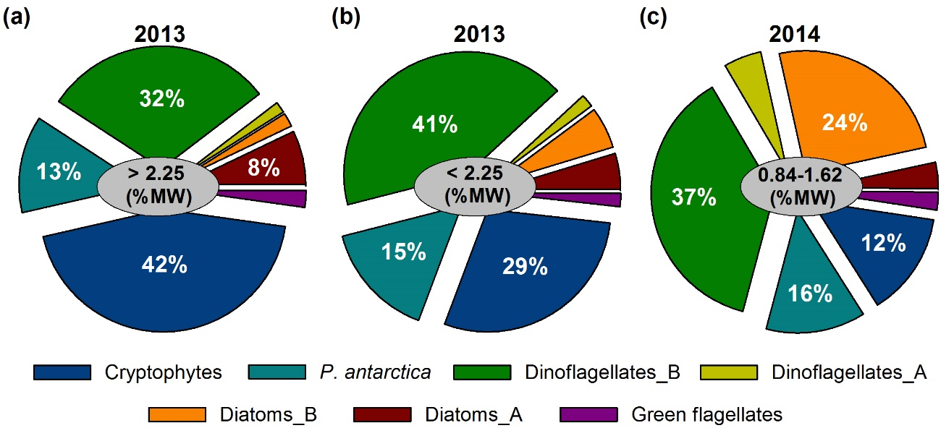

Figure 4
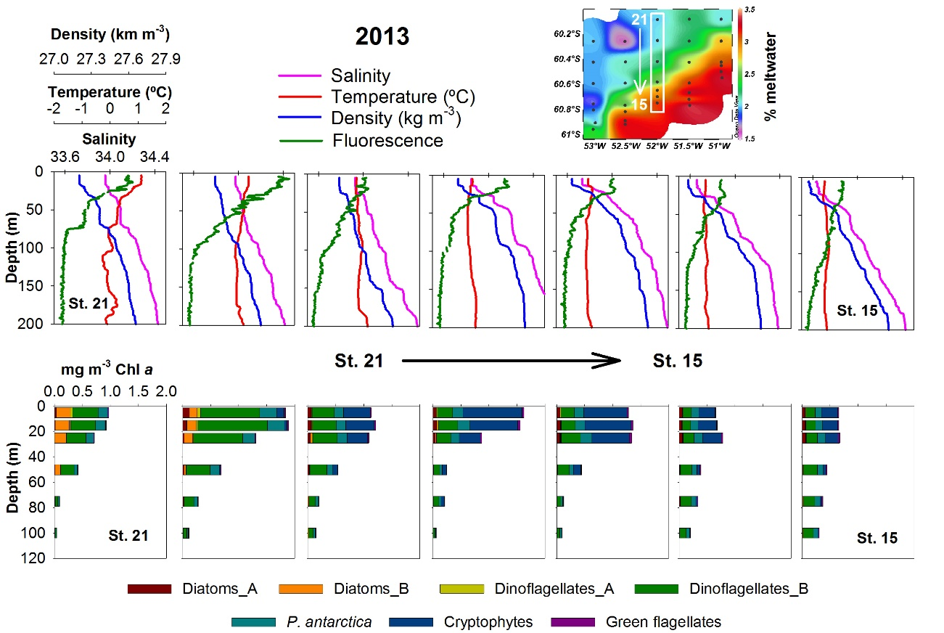

Figure 5
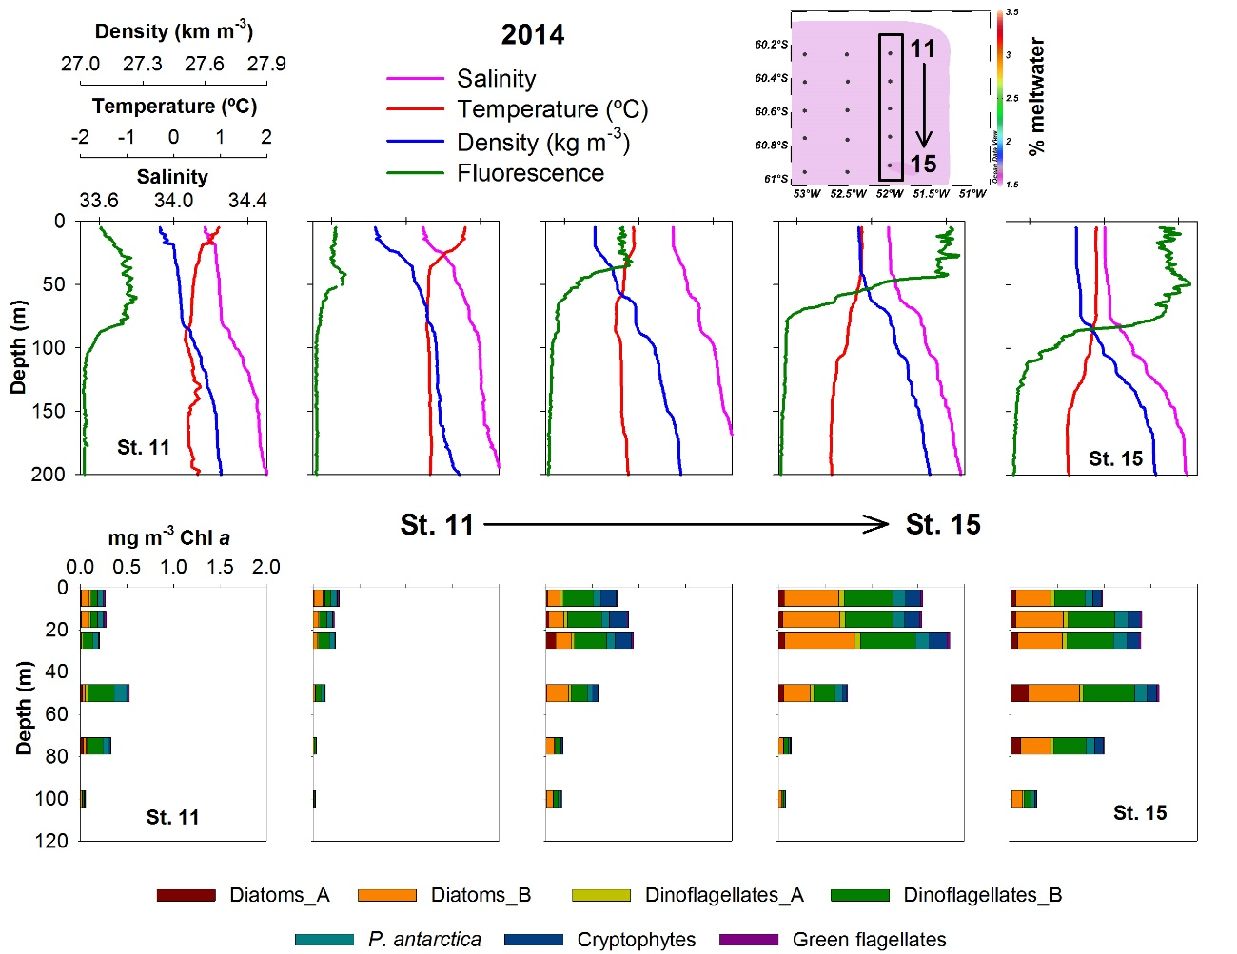

Figure 6
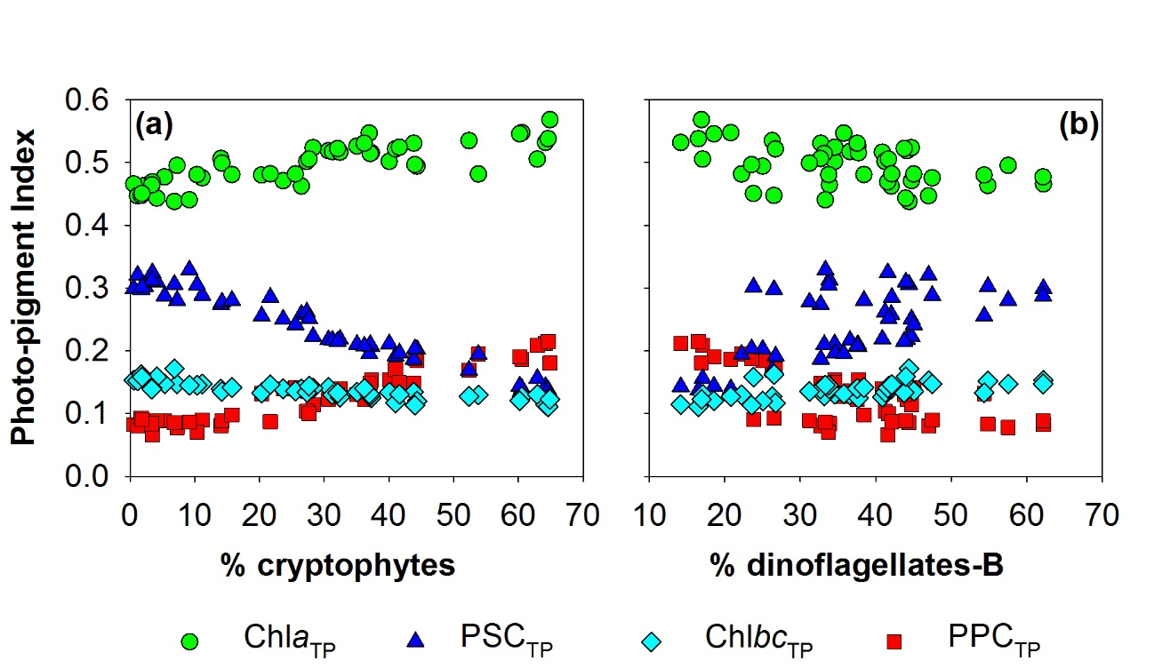

Figure 7
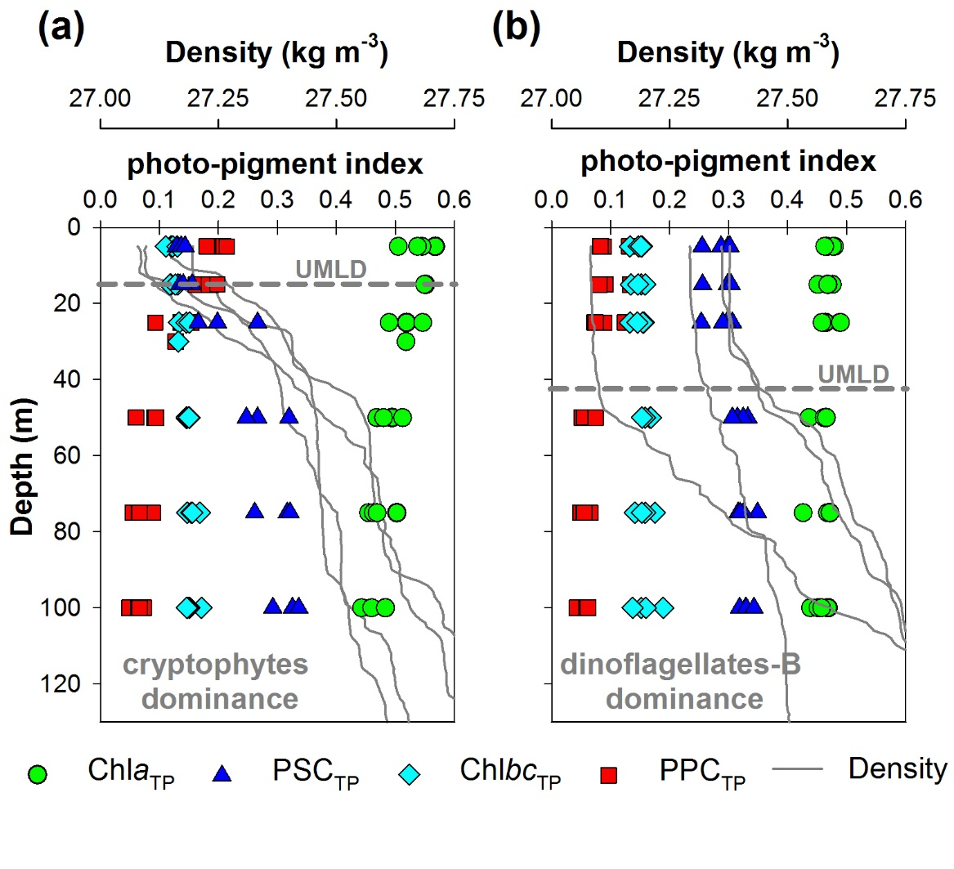

Figure 8
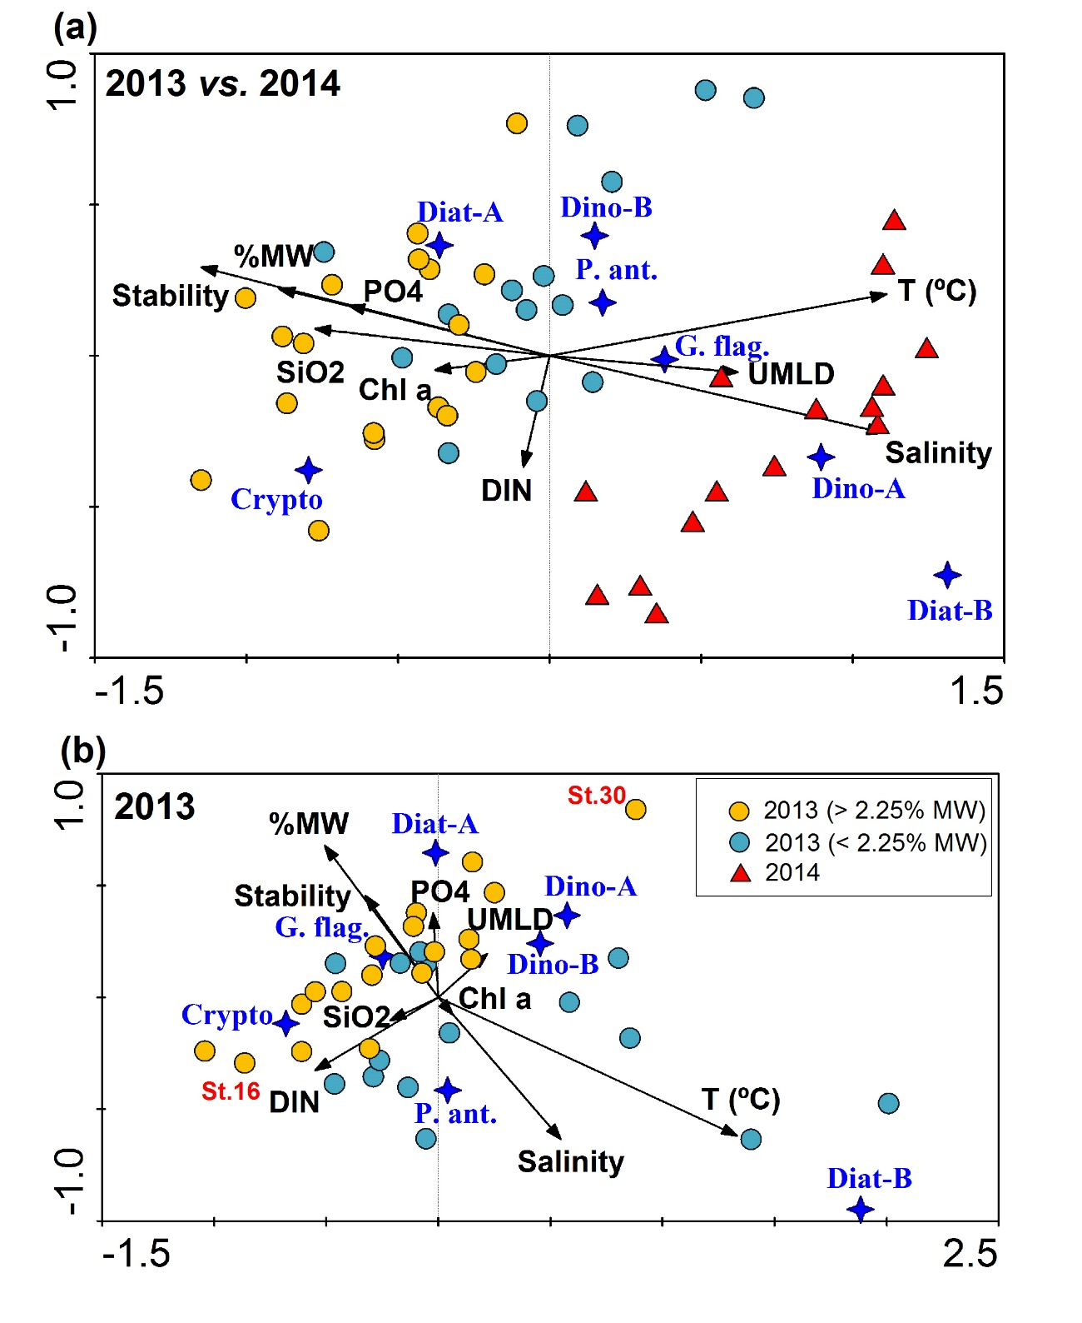

Figure 9
