DOI.org/10.5258/SOTON/D0321
Article type: (Full paper)

Solid-State Supercapacitor Fabricated in a Single Woven Textile Layer for E-Textiles Applications

Sheng Yong^{1*}, John Owen², Stephen Beeby¹

S. Yong, Prof. S. Beeby
Electronic &Electrical Engineering Group, Electronics and Computer Science, University of Southampton, Southampton, SO17 1BJ, UK
E-mail: sy1v16@soton.ac.uk
Prof. J. Owen
Electrochemistry, Chemistry, University of Southampton, Southampton, SO17 1BJ, UK

Keywords: single layer textile supercapacitor, activated carbon, vacuum impregnation, mechanical durability test

Abstract
This paper presents for the first time a solid-state supercapacitor fabricated in just a single woven cotton textile layer. The controlled spray coating process enables the depth of the activated carbon electrodes to be precisely controlled from both sides of the textile. This leaves an uncoated region within the cotton textile layer that acts as the separator and also minimizes the effect of the added functional materials on the feel of the textile. The cotton electrode is then vacuum impregnated with the gel electrolyte to ensure good coverage of the electrode by the electrolyte. After drying, the single textile layer supercapacitor has been fully characterised and demonstrates good capacitance and excellent electrochemical cycling stability even after mechanically straining the textile.

- Introduction
Electronic textiles, also known as e-textiles or smart fabrics, can be defined as textiles that incorporate electronic functions such as sensing, data processing, energy harvesting and storage.[1] Potential applications of e-textiles include medical patient monitoring and personal electronics.[2] Powering such e-textile systems is a consistent challenge and one solution is to realize a flexible textile based supercapacitor with high energy, power density and good long term stability for energy storage. A supercapacitor is an electrochemical energy storage device that stores energy via two types of capacitive mechanisms: the electrical double layer capacitance (EDLC) and redox pseudocapacitance.[3⁻5] Supercapacitors have been used as a power supply or energy storage buffer in smart sensor networks^{[6]}, energy harvesting powered systems^{[7]} and power backup systems.^{[1]}

Given the increasing interest in e-textiles and the associated challenge of supplying power, there have been many recent examples of textile supercapacitors in the literature. Yarn based supercapacitors that can be woven into a textile have been demonstrated in many papers with different electrode materials ^{[8-10]}. The lack of standardized metrics and experimental details in the papers describing these yarns (e.g. fiber dimensions and ESR per unit length) makes interpretation and comparison of the results difficult. An alternative approach is to functionalize a standard textile by coating it with suitable particles in order to realize a textile electrode. Textile supercapacitors fabricated in this manner with electrodes made from carbon nanotubes (CNT)^{[11-15]}, graphene fibre^{[16, 17]}, graphene oxide^{[18-21}] and redox materials such as PANI^{[22, 23]} have demonstrated specific capacitances over 200 F.g⁻¹ and specific area capacitances of between 8 to 88.2 mF.cm⁻². Carbon cloth (also known as carbon fiber cloth) is woven from carbon microfibers producing a conductive textile that is a suitable electrode material for textile supercapacitors. After electrochemical activation by immersing in an HNO₃ + H₂SO₄ acid solution, the carbon cloth electrode demonstrated a specific area capacitance of 765 mF.cm⁻² ^{[24]}. However, such materials are prohibitively expensive with regard to the large-scale manufacture of textile-based supercapacitors.

In addition to the electrode properties, the supercapacitor structure and electrolyte characteristics also influence the overall electrochemical performance. Existing textile supercapacitors demonstrated to date have consisted of two layers/pieces of textile electrode sandwiching either a layer of dried gel electrolyte^{[25]} or a polymer separator layer immersed with an aqueous^{[14]} or gel electrolyte. [26] The use of multiple textile layers adds complexity to the fabrication process requiring different layers to be bonded together, which may not be suitable for the application and is not compatible with applications where only a single textile layer is used (e.g. most items of clothing). E-textiles based on multiple textile layers face additional fabrication complexity such as aligning and bonding and this can be avoided by using a single textile layer. The different electrolyte types also present challenges. Gel electrolytes have wettability issue between the dried gel electrolyte and the electrode materials which can reduce the effective area of the electrode and hence the capacitance. Aqueous electrolytes require the textile supercapacitor to be hermetically sealed to prevent evaporation and protect the environment or user from potentially harmful solutions.

In this paper, we report for the first time the integration of a fully solid-state supercapacitor cell, including top and bottom electrodes, separator and electrolyte, into a single textile substrate. The textile electrodes are made using a controlled spray coating technique and a low cost blend of activated carbon and carbon black mixed with a liquid binder. This approach presents a practical method for realizing highly stable supercapacitors in a wide range of standard textiles. The use of a single textile layer makes this simple to fabricate and suitable for any textile based application. Spray coating is a flexible, area selective process that allows the carbon solution to be uniformly deposited with a very well controlled amount of carbon being deposited onto the textile. The carbon is quickly absorbed into the textile where it forms a conductive network resulting in a porous textile electrode. The amount of solution reaching the surface of the fabric substrate can be controlled by the spray nozzle size, spray pressure, distance between nozzle and textile, and duration. The rheology of the sprayed solution can be readily adapted to enable penetration into the textile. Printing methods such as screen printing require more viscous inks that do not penetrate into the textile. Inkjet printing could be suitable but the print nozzles require precisely controlled ink rheology and are prone to blocking by the particles. Another essential consideration is the wettability of the textile substrate. The carbon solution is based on activated carbon which is conductive and has a large specific surface area that makes it suitable for use in a supercapacitor electrode.^{[27, 28]} In comparison with other commonly used materials, activated carbon is available at a much lower cost and can provide comparable electrochemical performance to CNT in large scale supercapacitor applications.^{[29,}3^{0]}

This work also presents the first use of vacuum impregnation in a textile supercapacitor. This is a potential method for improving the infiltration of the gel electrolyte solution into the porous carbon coated textile structure in order to maximise capacitance and achieve better device cycling stability. Vacuum impregnation has been used in conventional supercapacitors ^{[31]} and will reduce the number of air voids in the porous carbon coated textile structure and improve the electrolyte distribution.^{[32]}

- Result and Discussion
Figure 1a illustrates the fabrication process for the single textile layer solid state supercapacitor, which is achieved by spray coating from both sides of the textile. During the spray coating process, carbon vapor penetrates into the selected part of the textile substrate and uniformly adheres to the textiles yarns and fibres. Controlling the process allows the top and bottom carbon electrodes to be formed on the surface of the textile ensuring the carbon does not penetrate too far and meet the other electrode. This leaves a thin layer of uncoated textile fibres at the center of the textile that forms an effective charge separator.
Spray coating

Vacuum impregnation

Plain poly-cotton/cotton textiles

Spray coated textile electrode

Single layer solid-state textile supercapacitors during bending

(a)

(b)

Figure 1. a) Schematic of the single layer solid-state textile supercapacitor fabrication process. b) Photographs of the plain-woven poly-cotton and cotton textiles, the textile electrodes (1cm diameter) and single layer solid-state textile supercapacitor during bending.

Single layer supercapacitors were fabricated using two different woven textiles, polyester-cotton and cotton, both of which are commonly used fabrics in the clothing industry. The polyester-cotton and cotton textiles shown in Figure 1b demonstrated high absorbance of the carbon solution, this being an advantageous property when the printing and dyeing. Electrodes were sprayed through a circular mask resulting in a surface area of 0.785 cm² with the carbon mass loading quantities given in Table 1.
Table 1. Spray-coated textile electrodes information.
Electrode type | Poly-cotton | Cotton
Original weight (mg.cm⁻²) | 27.1 | 69.8
Thickness (µm) | 300 | 500
Carbon loading per electrode (mg.cm⁻² ) | 0.91 | 1.27
Carbon: textile ratio (%wt) | 3.34 | 2.57

  - Evaluation of carbon coated textile electrode
The carbon particles coatings were examined using a scanning electron microscope (SEM) shown in Figure 2. The uncoated woven poly-cotton and cotton textiles are shown in Figure 2a and 2b respectively. The plan views of the coated textiles after spray coating are shown in Figures 2c, 2d, 2 e and 2f. In order for the carbon particles to stick to the textile fibres, 0.4% by weight of Ethylene-vinyl acetate binder material was added to the carbon solution. The excellent long-term stability of the supercapacitors indicates the carbon particles are strongly adhered to the textile fibres.

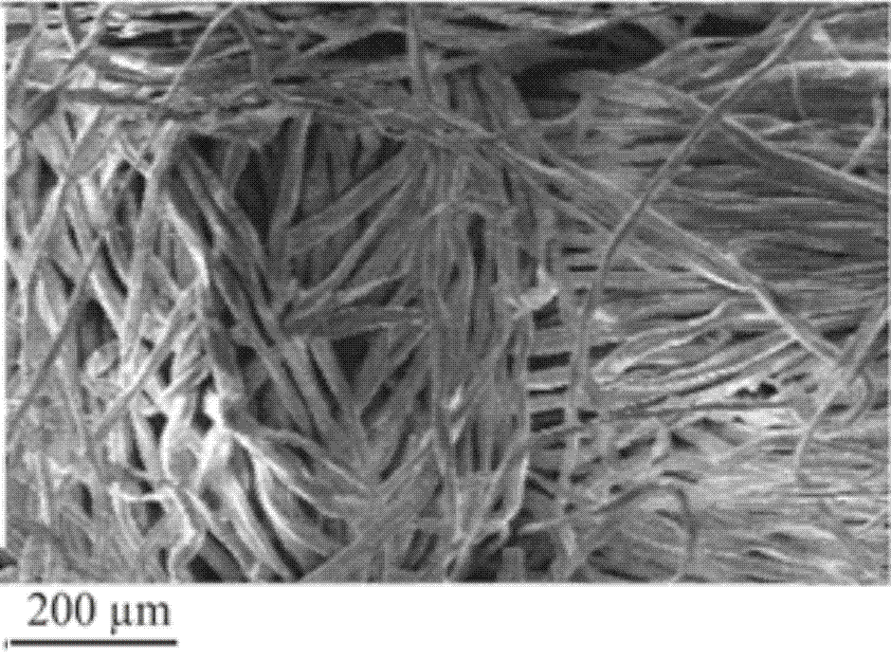
(b)

(d)

(c)

(a)

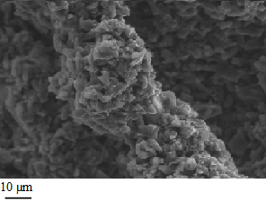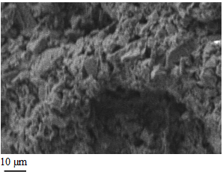
(f)

(e)

Figure 2. The SEM images of the textile electrodes: (a) poly-cotton textile before spray coating, (b) cotton textile before spray coating, (c), (e) poly-cotton textile after coating, and (d), (f) cotton textile after coating.

Figures 3a and 3b show the SEM images of the cross-sectional view of the polyester cotton and cotton supercapacitor. The darker parts at the bottom and the top of the images show where the carbon solution has been absorbed by the textile forming the electrodes and the lighter part at the center of each textile is the region of uncoated fibres covered with the gel electrolyte. In both images the gap between the carbon electrodes is clearly visible and this forms a well-defined, stable charge separator within the textile.
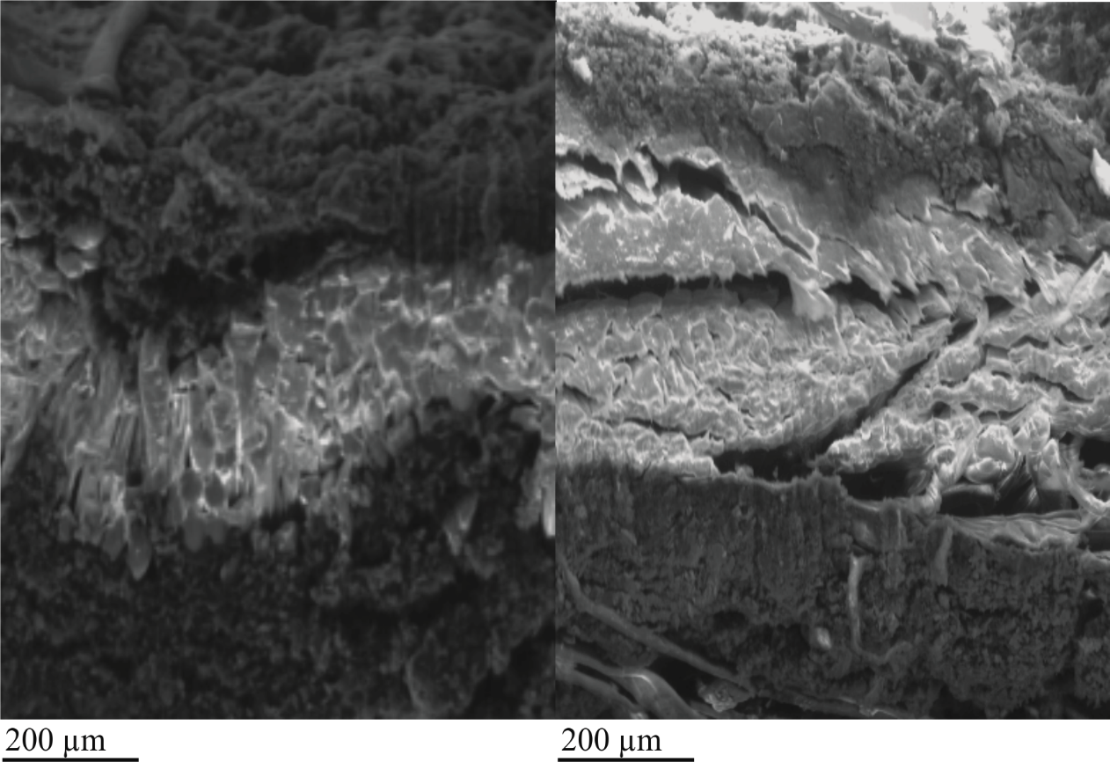
Figure 3. SEM micrograph of the cross-sectional view of the supercapacitor made with: (a) poly-cotton electrode, (b) cotton electrode.

  - Electrochemical performance of single layer solid-state supercapacitor
Figure 4a show that the single layer supercapacitor made from standard poly-cotton and cotton textiles function correctly up to 0.8 V, which is the maximum operating voltage for the poly-cotton device (see below). According to figure 4b, in the high frequency regions (> 10 Hz), the Nyquist plots of both single layer textile supercapacitors show a pure capacitive behaviour as indicated by the small semicircle that is a typical Randles circuit response and is due to a small charge transfer reaction. The pure capacitive behaviour is also shown in the low frequency regions (< 10 Hz) by the straight lines that are close to vertical. The results indicate the cotton supercapacitor is more capacitive than the poly cotton device. The equivalent series resistance (ESR) is obtained at the point where the imaginary impedance of the plots was equal to zero and this occurred at frequencies approaching 200 kHz. ESR includes the electrode, electrolyte and/or electrode/electrolyte contact interface resistances and the ESR values for the poly cotton and cotton supercapacitors are very close to each other being 10.5 Ω and 11.5 Ω respectively.
(a) | (b)

Figure 4. Electrochemical performance of the single layer textile supercapacitor: (a) CV plots between +/- 0.8 V at scan rates of 100 mV.s⁻¹ for poly-cotton and cotton textiles (b) Nyquist plots of the single layer poly-cotton and cotton supercapacitor between 20 mHz−200 kHz, (c) Galvanostatic cycling tests of single layer cotton supercapacitor (test current 1.5 mA.cm⁻²) between 0 - 0.8 V to 0 - 1.5 V, (d) CV tests of single layer cotton supercapacitor between +/-0.8 V to +/-1.5 V at 25 mV.s⁻¹, (e) GCD derived area capacitance of single layer cotton supercapacitor at increasing current densities (0.5 - 5 mA.cm⁻²) tested at 0.8 and 1.5 V, (f) GCD derived Ragone plot of single layer cotton supercapacitor at increasing current densities between (0.5 - 5 mA.cm⁻²) tested at 0.8 and 1.5 V.
Figure 4c shows the single layer cotton supercapacitor can be charged up to 1.5 V, without short circuit. The single layer poly-cotton supercapacitor can be only charged up to 0.813V in the GC test with 1.5 A.cm⁻² test current. Both supercapacitors used the same gel electrolyte and vacuum impregnation process and therefore the difference in the maximum voltage is due to variations in distribution of the carbon particles and electrolyte which is in turn due to the different to weave patterns of the two textiles. Further tests on the cotton supercapacitor show its specific capacitance increased from 19.3 F.g⁻¹ (0.8 V) to 39.8 F.g⁻¹ (1.5 V) and its area capacitance increased from 24.5 mF.cm⁻² (0.8 V) to 49.1 mF.cm⁻² (1.5 V). The CV curve in figure 4d shows the cotton supercapacitor did not exhibit any chemical reaction or instability in both positive and negative scan directions. The amount of electrical energy stored in the single layer cotton supercapacitor (the area enclosed inside the CV curve) increases with increasing test voltage. At test voltages above 1.2 V, electrolysis of the water in the gel electrolyte produces H+ that reduces the PH level of the electrolyte. This can further increase the surface area of the carbon particles and introduce a hydroxide bond to the particles that improves electrode conductivity. Furthermore, according to figure 4(d), at a test voltage of 1.5 V the CV curve demonstrates some semi-redox reaction, which suggests the ionised species may cause some pseudocapacitance that would increase the overall measured capacitance. The GCD tests between 0.8 V and 0 V demonstrate an area capacitance of 53.1 mF.cm⁻² and this increases by 29% to 84.9 mF.cm⁻² when tested between 1.5 V and 0 V at 0.5 A.cm⁻² as shown in figure 4e. This difference in area capacitance increases with increasing current density. The asymmetry of the GCD curves is due to the electrolysis of the gel electrolyte at the potential close to 1.5 V that introduces a parasitic current that influence the supercapacitor test time in the current controlled test like GCD. The Ragone plot in figure 4f shows the area energy density of the single layer cotton textile supercapacitor increases from 9.84 µWh.cm⁻² to 44.6 µWh.cm⁻² when the test voltage increases from 0.8 V to 1.5 V at current densities of 0.5 mA.cm⁻². The area power density is at least 3 mW.cm⁻² at the current densities of between 0.5 and 5 mA.cm⁻² for both 0.8 and 1.5 V test voltages.

Table 2. Electrochemical performance of single cotton layer supercapacitor with different carbon loading mass.
Mass loading | Area capacitance (mF.cm⁻²) | Energy density  (µWh.cm⁻²) | Power density (mW.cm⁻²)
0.99 | 17.6 | 7.04 | 2.7
1.27 | 24.5 | 9.8 | 3
1.53 | 16.4 | 6.68 | 3.2
2.93 | 13.5 | 5.42 | 3.5

Table 2 shows the electrochemical performance of the single layer cotton supercapacitor with different carbon mass loading. The device area capacitance and energy density are influenced by the amount of carbon material that is spray coated onto the cotton textile. This indicates that there is an optimum carbon mass load and that increasing carbon content beyond this inhibits the electrolyte from wetting all of the carbon.”
Table 3. Electrochemical performance of textile supercapacitor with different inexpensive carbon material.
Reference | Electrode material | Electrolyte | Substrate | Area capacitance (mF.cm⁻²) | The volumetric energy density (mWh.cm⁻³) | The volumetric power density (mW.cm⁻³)
This paper | Activated carbon | PVA/ADP | Cotton | 36.75 | 0.094 | 66.2
Lam ^{[33]} | Calligraphic ink | PVA/LiCl | Silver coated cotton | 36 | 0.04 | 20
Wang ^{[34]} | Activated carbon cloth | PVA/H₂SO₄ | Activated carbon cloth | 31 | 0.045 | 1
Zopf ^{[35]} | Activated carbon | EMI TCB | Nylon | 12.9 | N/A | N/A
Zhang^{[36]} | MnO2-coated hollow carbon microspheres | PVA/H₃PO₄ | Silk | 19.2 | 0.112 | 12.5

Table 3 compares the electrochemical performance of the fabric supercapacitors fabricated with various inexpensive carbon electrodes in the recent 4 years. The device presented in this work achieved the highest area capacitance and volumetric power density, and the second best volumetric energy density. The superior electrochemical performance is due to the 80/20 blend of activated carbon and carbon black that fills in the gaps between the activated carbon particles and improves the carbon electrode conductivity on the cotton textile.

  - Stability test of single layer solid-state supercapacitor
Figure 5 shows the results of CV tests exploring the flexibility and stability of the single layer cotton supercapacitor. The shape of the CV plots in figure 5a indicates the supercapacitor is electrochemically stable at scan rates from 50 to 200 mV.s⁻¹. The capacitance at 50 mV.s⁻¹ is 30% greater than measured at 200 mV.s⁻¹. The cyclical stability is shown in figure 5b where the CV plots obtained during the 1st and 15,000th cycles show negligible change. This again demonstrates the electrochemical stability of the supercapacitor.
(c)
Figure 5. CV tests between +/- 0.8 V at a scan rate of 200 mV.s⁻¹ unless otherwise stated investigating the flexibility and stability of the single layer solid state cotton textile supercapacitor: (a) CV test results at scan rates of 200, 100, 50 mV.s⁻¹, (b) CV test results for 1 and 15000 cycles (c) CV stability test over 15000 cycles, where C_{o} is the initial area capacitance of the device measured at cycle 1. (d) CV test of the device before and after bending (200 cycles).

As shown in figure 5c, the capacitance of supercapacitor increased by about 5% in the first 2500 test cycles, after which there is less than 1% capacitance variation. The initial increase in capacitance, which is typical for gel electrolytes, is due to an increase in the coverage of the electrode by the electrolyte caused by the cyclical variation in temperature during testing. All of these results indicate excellent device stability, which is due to excellent adhesion between the carbon particles/binder and the textile fibres. The spray coating process has successfully created a stable and uniform conducting network in the textile and the vacuum impregnation process has maximized the contract between the electrode and electrolyte forming an effective double layer interface. Figure 5d shows the CV plots obtained from the supercapacitors before and after bending the device 200 times around a diameter of 3.2 mm. The shape and values of the supercapacitor current density plots show a small difference after bending with the capacitance falling by 2.6% after 200 bending cycles. This indicates that the electrochemical performance of the supercapacitor is not greatly affected by the application of repeated bending strains.

- Conclusion
The single layer solid state cotton textile supercapacitor presented here achieved specific area capacitances of 49.1 mF cm ⁻² (or 0.98 F cm⁻³ or 39.8 F g ⁻¹), an energy density of 205 μW h cm ⁻² at a power density of 14.2 μW cm ⁻² at 0.12 mA cm ⁻² when charged up to 1.5 V. When cyclically tested the stability of the supercapacitor was found to be good, with an initial increase of 5% followed by a variation of less than 1% over the next 12500 test cycles. In addition, the electrochemical performance of the device was not significantly affected by bending the textile electrode. The capacitance was found to reduce by just 2.6% after cyclically bending 200 times.

In summary this work has shown that a combination of an inexpensive carbon solution, spray coating and vacuum impregnation techniques can be used to realise a stable supercapacitor comprising top, bottom electrodes and separator with gel electrolyte in a single textile layer. In comparison with other works based on inexpensive carbon materials, the single layer cotton supercapacitor demonstrated the highest area capacitance. All the materials used are non-hazardous and inexpensive and the fabrication processes are fully scalable. These factors mean the supercapacitor architecture presented here for the first time shows great potential for wearable e-textile applications. Future work will include encapsulating the supercapacitor in order to achieve a robust practical device that can withstand the rigors of use (such as washing).

- Experimental Section

Carbon electrode solution: The solution is formed using two different carbon powders mixed with a polymer binder dissolved in solvent and a surfactant.[37] The activated carbon (YP-80F is from Kuraray Chemical Co, > 99% purity, particle size range of 5 to 20 μm, effective surface area of 2100 m².g⁻¹ [38] and with a pore width distributed between 0.5 to 3 nm resulting in a micropore volume of around 0.6 cm³.g⁻¹.nm⁻¹. ^{[39]} The activated carbon is mixed with conductive agent Shawinigan Black (mean particle size of 42 nm and an effective surface area of 75 m².g⁻¹ [4^{0]}) at a ratio of 80/20 by weight. The ratio of 80/20 was identified during a previous MSc project on dip coating textile electrodes with activated carbon and carbon black mixtures ^{[41]}. It was found that increasing the amount of carbon black caused large variations in the measured capacitance. However, reducing the amount of carbon black below 20% caused an increase in resistance. A ratio of 80/20 was found to offer stable and repeatable performance comparable to other devices in the literature. The powder blend was then mixed with a poly(ethylene-vinyl acetate) binder dissolved in 1,2,4-Trichlorobenzene solvent and a sodium dodecyl sulphate surfactant. The ratio of carbon to binder is 85/15 by weight.

Carbon textile electrode fabrication: Spray coating was conducted in a fume cabinet at room temperature. The carbon solution was spray coated through a mask on both side of the textile substrates with the spray nozzle being placed a fixed distance of 10 cm with a fixed air pressure of 25 psi (1.72 bars). Each side of the textile sample was sprayed for 2 seconds. The textile substrates were removed from the mask and dried in a fan oven at 150ºC for 10 minutes. Finally the electrodes were placed into a sonicator with DI water to remove any loose carbon and then dried at room temperature. The electrode details are given in table 1. In addition, the sheet resistivity of the textile electrode surface varies between 80 kΩ.sq⁻¹ and 800 kΩ.sq⁻¹ measured by a 4 point probe. This variation is due to the compliance and surface roughness of the textile which leads to different contact resistances at different locations.

Single layer supercapacitor assembly: The textile electrodes were cut into round pieces with a diameter of 1 cm. The gel electrolyte was made by mixing 0.3g of Ammonium dihydrogen phosphate (ADP) salt in 5 mL DI water with 0.5 g vinyl-alcohol polymer. The gel mixture was heated to 90ºC under constant stirring until the mixture became clear. After cooling down to room temperature, the solution was placed under vacuum (0.029 psi / 20 mbar) for 2 hours to extract air bubbles. The textile electrode was immersed in the gel electrolyte under vacuum for 20 minutes. Finally, the textile electrode was then compressed by a pair of flat metal plates and cured for 2 hours at 60ºC. For testing, the single layer textile supercapacitor was placed under compression using spring-loaded grade 303 stainless steel current collectors housed within a Swagelok PFA tube fitting.

Electrochemical testing: Electrochemical tests were performed using a VMP2 potentiostat/galvanostat (Biologic, France). Electrochemical impedance spectroscopy (EIS) was carried out at frequencies varying from 20 mHz to 20k Hz with a peak to peak amplitude of 20 mV in open circuit. Cyclic voltammetry (CV) results were collected at scan rates of 25, 50, 100, 150 and 200 mV.s⁻¹, and at voltages varying between +/-0.8 V. Finally, galvanostatic charge-discharge (GCD) involved cycling the supercapacitors between 0 V and 0.8 V with a current of 0.1 A per unit gram of carbon material on the textile electrode. In the high voltage CV test, results were collected at scan rates of 25mV.s⁻¹ and at voltages of between +/-0.8 V, +/-1 V, +/-1.2 V and +/-1.5 V. In the high voltage GCD test the single layer textile supercapacitors were cycled with different range between 0V to 1.5V with a current of 0.1 A per unit gram of carbon material on the textile electrode.

Bending test: The mechanical durability of the fabric supercapacitors was also investigated by the cyclical bending of textile device around a mandrel. The device were bent around the mandrel 200 times with a diameter of 3.2 mm and rotational speed of 60 rpm. The devices were then putted into a tube cell for testing.

Supporting Information
All data supporting this study are openly available from the University of Southampton repository at https://doi.org/10.5258/SOTON/D0321

Acknowledgements
The authors thank the EPSRC for supporting this research with grant reference EP/1005323/1.

Received: ((will be filled in by the editorial staff))
Revised: ((will be filled in by the editorial staff))
Published online: ((will be filled in by the editorial staff))

References
[] W. Weng, P. Chen, S. S. He, X. M. Sun, H. S. Peng, Angew. Chem. Int. Ed. 2016, 55, 6140.
[2] T. Dias, Electronic Textiles Smart Fabrics and Wearable Technology, Woodhead Publishing, Sawston, Cambridge, UK, 2015.
[3] B. E. Conway, Electrochemical Supercapacitor Scientific Fundamentals and Technological Application, Kluwer Academic /Plenum Publishers, New York, US, 1999.
[4] S. T. Senthilkumar, R. K. Selvan, J. S. Melo, C. Sanjeeviraja, ACS Appl. Mater. Interfaces. 2013, 5, 10541.
[5] Z. S. Zhang, L. T. Zhai, M. H. Yu, Y. X. Tong, K. C. Mai, J Mater. Chem. A. 2013, 1, 505.
[6] J. Sungmook, L. Jongsu, H. Taeghwan, L. Minbaek, K. Dae-Hyeing, J Adv. Mater. 2014, 26, 6329.
[7] M. Hassanalieragh, T. Soyata, A. Nadeau, G. Sharma, presented at 27th IEEE Int. System-on-Chip Conf. (SOCC), Las Vegas, NV, USA 06 November 2014
[8] B. J. Wang, X. Fang, H. Sun, S. S. He, J. Ren, Y. Zhang, H. S Peng, Adv. Mater. 2015, 27, 7860.
[9] G. X. Qu, J.L. Cheng, X. D. LiD. M. Yuan, P. N. Chen, X. L. Chen, B. Wang, H. S. Peng, Adv. Mater. 2016, 28, 3646.
[0] X. Pu, L.X. Li, M. M. Liu, C. Y. Jiang, C. H. Du, Z. F. Zhao, W. G. Hu, Z. L. Wang, Adv. Mater. 2016, 28, 98.
[1] M. Kaempgen, C. K. Chan, J. Ma, Y. Cui, G. Gruner, Nano Lett. 2013, 9, 1872.
[2] L. B Dong, C. J. Xu, Q. Yang, J. Fang, Y. Li, F. Y. Kang, J. Mater. Chem. A. 2015, 3, 4729.
[3] K. Wang, P. Zhao, X. M. Zhou, H. P. Wu, Z. X .Wei, J. Mater. Chem. A. 2011, 21, 16373.
[4] Q. Y, Huang, L. Liu, D. Wang, D. Liu, Z. Huang, Z. Zheng, J. Mater. Chem. A. 2016, 4, 6802.
[5] R. Yuksel, H. E .Unalan, Int. J. Energy Res. 2015, 39, 2042.
[6] S. H. Aboutalebi, R. Seyed, D. Esrafilzadeh, M. Salari, Z. Gholamvan, S. A. Yamini, K. Konstantinov, R. L. Shepherd, J. Chen, S. E. Moulton, P.Innis, A. I. Minett, J. M. Razal, G.G. Wallace, ACS Nano 2014, 8, 2456.
[7] L. Zhu, W. Y. Wu, X. W. Wang, X. W. Wu, P. Tang, Y. P. Wu, RSC Adv. 2014, 4, 59088.
[8] W. W. Liu, X. B. Yan, J. W. Lang, J. Pen, Q. J. Xue, J Mater. Chem. 2012, 22, 17245.
[9] H. Sun, S. L. Xie, Y. M. Li, J. S. Jiang, X. M. Sun, B. J. Wang, H. S. Peng, Adv. Mater. 2016, 28.8431,
[20] X. B. Zang, Q. Chen, P. X. Li, Y. J. He, X. Li, M. Zhu, X. M. Li, K. L. Wang, M. L. Zhong, D. H. Wu, H. W. Zhu, Small 2014, 10, 2583.
[2] Y. Hu, H. H. Chen, F. Zhao, N. Chen, L. Jiang, Z. H. Feng, L. T. Qu, Nanoscale 2014, 6, 6448.
[22] L. Wang, X. Feng, L. T. Ren, Q. H. Piao, J. Q. Zhong, Y. B. Wang, H. W. Li, Y. F. Chen, B. Wang, J. Am. Chem. Soc. 2015, 137, 4920.
[23] K. Wang, P. Zhao, X. Zhou, H. Wu, Z. Wei, J. Mater. Chem. 2011, 21, 16373.
[24] W.Wang, W.Y. Liu, Y. X. Zeng, Y. Han, M. H. Yu, X. H. Lu and Y. X. Tong, Advanced Materials, 2015, 27, 3572
[25] M. Cowell, R. Winslow, Q. Zhang, J. Ju, J Evans, P. Wright, Journal of Physics: Conference Series. 2014, 557, 12061.
[26] Z. Niu, W. Zhou, X. Chen, J. Chen, S. Xie, Adv. Mater. 2015, 27, 6002.
[27] Z. L. Li, X. S. Zhao, Chem. Soc. Rev. 2009, 38, 2520.
[28] P. J. Hall, M. Mirzaeian, M. I. Fletcher, F. B. Sillars, A. J. R. Rennie, G. O. Shitta-Bey, G. Wilso, A. Cruden, R. Carter, Energy Environ. Sci. 2010, 3, 1238.
[29] Z. Peng, Z. Guo, W. Chu, M. Wei, RSC Adv. 2016, 6, 42019
[30] B. Li, F. Dai, Q. Xiao, L. Yang, J. Shen, C. Zhang M.Cai. Energy Environ. Sci. 2016, 9, 102.
[31] T. He, X. Ren, K. Cai, Y. Wei, S. Sun, Mater. Technol. 2013, 28, 364.
[32] M. Wu, J. Gao, S. Zhang, A. Chen, J Porous Mater. 2006, 13, 407.
[33] D. Lam, K. Jo, C. Kim, S. Won, Y. BO, J. Kim, H. Lee, and S. Lee, J. Mater. Chem. A, 4, 2016, 4082.
[34] G. Wang, H. Wang, X. lu, C. Ling, M. Yu, T. Zhai, Y. Tong, and Y. Li, Advanced Materials, 2014, 26, 2676.
[35] S. Zopf, M. Manser, Journal of Engineered Fibers and Fabrics, 2016, 3, 11.
[36] H. Zhang, Y. Qiao, Z. Lu, ACS Appl. Mater. Interfaces, 2016, 8, 32317.
[37] Ebnesajjad S, Adhesives Technology Handbook (second edition), William Andrew Inc., Norwich, 2008.
[38] Yp – 80F Activated carbon specification http://www.kuraraychemical.com/products/sc/capacitor.htm, accessed: Nov, 2017.
[39] J. Piwek, A. Platek, K. Fic and E. Frackowiak, Electrochimica Acta 215 179–186, 2016.

[40] Shawinigan Black carbon black powder datasheet, http://www.matweb.com/search/datasheet.aspx?matguid=f68b725077424fb8943c09089dff5c74, accessed: Nov, 2017.
[41] Sheng Yong Master Thesis, Printed fabric supercapacitor, Southampton university, 2012, 416073, https://eprints.soton.ac.uk/416073/, accessed: Nov, 2017.

