Stress analysis and optimization of a Flip chip on flex electronic packaging method for functional electronic textiles
Menglong Li, John Tudor, Russel Torah and Steve Beeby, Senior Member, IEEE

Abstract—A method for packaging integrated circuit (IC) silicon die in thin flexible circuits has been investigated that enables circuits to be subsequently integrated within textile yarns. This paper presents an investigation into the required materials and component dimensions in order to maximize the reliability of the packaging method. Two die sizes of 3.5 mm x 8 mm x 0.53 mm and 2 mm x 2mm x 0.1 mm have been simulated and evaluated experimentally under shear load and during bending. The shear and bending experimental results show good agreement with the simulation results and verify the simulated optimal thickness of the adhesive layer. Three under-fill adhesives (EP30AO, EP37-3FLF and Epo-Tek 301 2fl), three highly flexible adhesive (Loctite 4860, Loctite 480 and Loctite 4902) and three substrates (Kapton, Mylar and PEEK) have been evaluated and the optimal thickness of each is found. The Kapton substrate, together with the EP37-3FLF adhesive, were identified as the best materials combination, with the optimum under-fill and substrate thickness identified as 0.05 mm.

Index Terms— flexible electronic packaging, shear load test, bending test, shear strength, electronic textile.

Introduction
I
n today's society, microelectronics technology plays a significant role in people's lives. Electronic textile (e-textiles) technology seeks to further integrate microelectronics technology by combining electronics with textiles to enable a new class of product [1]. An e-textile is a textile with integrated electronic functionality [2] and this can be used in fashion, medical and military applications [3, 4]. In one approach to realize e-textiles, flip-chip technology is used to mount ultra-thin die onto thin flexible plastic film strips that contain patterned conductive interconnects and bond pads. Individual die are located on the strip and the conductive tracks on the plastic substrate link the die together forming a long, very thin, flexible circuit. This long thin circuit can then be incorporated into a textile yarn as shown in Fig. 1 and whilst standard die sizes can be mounted in this way, silicon die that are thin, long and narrow are preferred. The combination of electronics with textiles requires the use of flexible circuit technology to ensure the textile retains as much as possible their normal physical characteristics and feel [5]. E-textiles will inevitably be used in wearable products and, in such cases, will be subject to human motion and washing thus making integrated electronic components vulnerable to different forces such as shear and bending loads which can cause embedded electronic devices to fail.

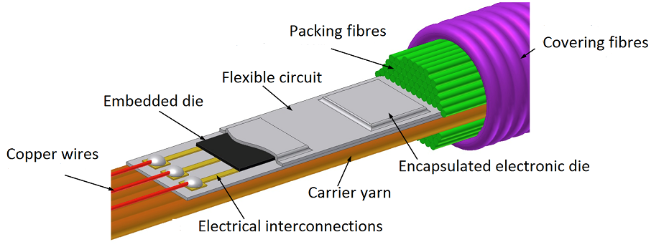
Fig. 1. Schematic of proposed e-yarn structure and cut away showing the embedded die.
Reliability and flexibility are two key factors for functional e-textiles [6] and the electronic chip packaging processes described in this paper aim to maximize the reliability of the packaged electronic chip whilst, at the same time, keeping the package as thin as possible to maximize the flexibility of the overall assembly.
In recent years, significant research has focused on electronic circuit packaging for flexible circuits. The flexibility of electronic circuit does not only involve the substrate, but also concerns the components and interconnections. The review of electronic packaging for system-in-foil by M.Koyuncu summarizes the state of the art in this topic [7]. Nowak et al investigated the mechanical properties of surface-mount device (SMD) interconnections made on flexible and rigid substrates [8]. In their investigation, the shear strength was measured with a tensile tester on three types of flexible substrate and two types of rigid substrate, and they found the mechanical properties of the joints strongly depend on the configuration of applied materials [8].
The three point bending test [9, 10] is a common method to test the flexibility and reliability of packaged electronic chips. Kim et al investigated the reliability of chip-in-flex and chip-on-flex packages in a dynamic bending environment using anisotropic conductive adhesive [11]. In their investigation the space under the chip was filled with anisotropic conductive adhesive. In comparison with non-conductive adhesives, anisotropic conductive adhesives provide reduced adhesion and flexibility and therefore this approach is more prone to failure [12]. The use of a top covering polyimide film is necessary to achieve suitable reliability under bending [10].
Wire bonded electronic packages use a non-conductive adhesive to attach the die to the substrate. In typical flip chip packaging, solder is used to make the electrical connection and non-conductive adhesive is applied as an under-fill. Under-fill is used to (a) reduce thermal stresses caused by the difference in the coefficient of thermal expansion between the silicon die and the substrate and, (b) increase the reliability of electronic packaging interconnections when mechanical forces and shock loads occur [13-16].
In this paper, simulations and experimental evaluation of a flexible electronic packaging method are performed in order to minimize the stress in the adhesive layer of a package designed for e-textiles. Simulations of shear load and bending have been used to investigate the influence of the different adhesives and substrate materials on the packaging stresses, and the simulation results have been experimentally verified. This work will enable the optimum adhesive and substrate material combination and thicknesses to be identified with confidence by simulation.
Section two of this paper introduces the electronic die packaging method as well as the shear load and bending simulations relating to the adhesive and substrate used. The experimental method for testing the packaged electronic chip is presented in section three. Section four covers the shear load and bending experimental test results to determine the optimum adhesive thickness and compares these with the simulation results to provide confidence in the simulation method. A new method to determine the adhesion strength of the adhesive is also presented in section four. Simulations determining optimum materials and thicknesses of substrate are presented in section five.

Electronic Packaging Method and Materials
Fig. 1 shows an idealized schematic in which the electronic die have been completely encapsulated using a thin top plastic layer. This packaging approach is under development within the research group. In order to experimentally validate the simulation techniques being used to optimize this package design, an Electronic Die on Plastic (EDOP) package has been investigated in this current work. The EDOP consists of three layers: the electronic die is mounted on a plastic substrate layer using an adhesive layer as shown in Fig. 2. Once the simulation processes have been validated, it can be applied with confidence to more complex package shown in Fig. 1.
A 3 dimensional ANSYS Finite element analysis (FEA) model has been used to simulate the EDOP package and to evaluate shear forces and bending stresses. Fig. 2 shows the model of the package. The three boundary conditions applied to the model for the shear force simulation are as shown. An external force is applied to the side surface of the die, the left and right ends of the substrate are fixed in all directions and the top and bottom surface of the substrate are fixed in the Z direction with the X and Y directions free to move. For the bending simulation, a three point bending model is used with an external force being applied to the center of the substrate layer on the opposite side to the electronic die. This avoids forces being applied directly to the die, which simplifies the experimental analysis. Fig. 3 shows the model used for the bending FEA simulation. The boundary conditions for the bending simulation are as follows: Parts “a” and “b” are fixed, and therefore the contact area between substrate and the fixed stand will be fixed. The external force is applied to part “c” in the negative Z direction. The contact area of the force applied at point “c” is 0.1 mm x 10 mm, and the contact area for each fixed stand is 1 mm x 10 mm. This replicates the dimension of the fixtures used in the test rig, which uses a probe with a flat tip to control the contact area. The boundary conditions in the simulation match the experimental rigs shown in Fig. 4. The element size was defined by specifying the number of elements along key dimensions of the model. The long edge (Y direction in Fig. 2) and short edge of the die and adhesive were divided into 10 and 5 elements respectively. The thickness of the die (Z direction) was divided into 5 elements whilst the adhesive has 3 elements through its thickness. The substrate has 20 elements along its length and 5 elements across its width and through its thickness. The ANSYS Multizone mesh setting was used to perform the mesh operation. To accommodate the different mesh sizes, two contacts were defined between the substrate and the adhesive and also between the adhesive and the die.

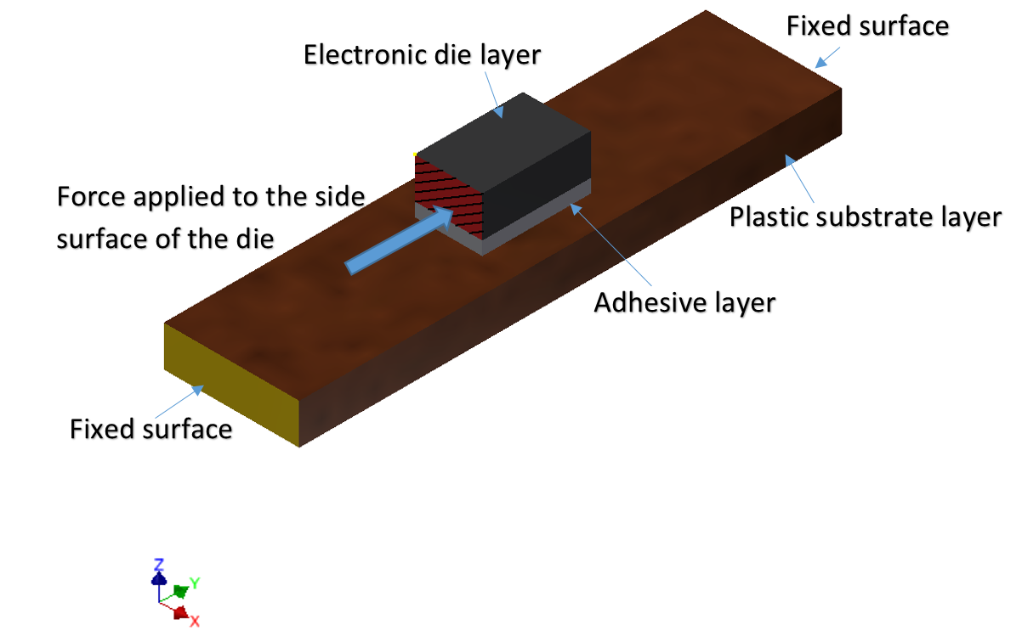
Fig. 2. Shear test model using ANSYS, external force applied to left edge of electronic die.
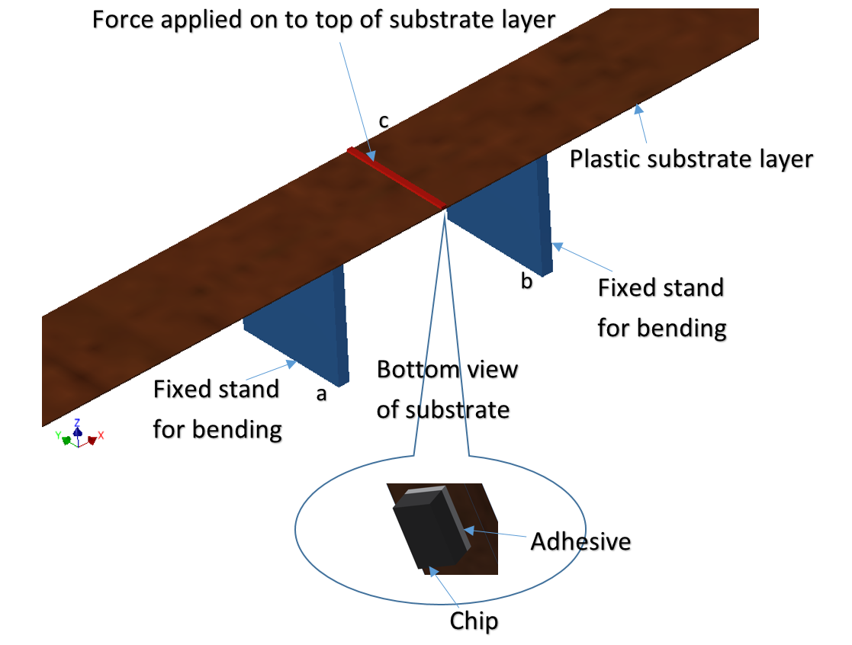
Fig. 3. Three points bending test model using ANSYS.
In both shear and bending simulations reliability is determined by observing the stresses in the different layers with the adhesive material being the most important. From maximum shear stress theory and maximum distortion energy theory [17], the maximum shear stress and von-Mises stress can be determined in order to evaluate the failure of ductile materials. Therefore the maximum shear stress and von-Mises stress in the adhesive and substrate layer have been analyzed in this paper.
Since circuit flexibility is of key importance in e-textiles, three under-fill adhesives (EP30AO, EP37-3FLF and Epo-Tek 301 2fl) and three highly flexible adhesive (Loctite 4860, Loctite 480 and Loctite 4902) have been simulated under shear load and bending conditions. The properties of the under-fill materials are shown in Table І. Three commonly used flexible substrate materials (Kapton, Mylar and PEEK) are also compared and the properties of these are given in Table ІІ.
Table I
Adhesive material properties from datasheets [18-20].
Under-fill  Adhesive | Young’s Modulus  (MPa) | CTE (k⁻¹) | Density  (gcm⁻³) | Tensile Strength (MPa)
EP30AO | 3447 | 0.000025 | 1.06 | 41
EP37-3FLF | 344 | 0.00009 | 1.05 | 35
Epo-Tek 301 2fl | 3664 | 0.000056 | 1.07 | ≥13.7
Loctite  4902 | 400 | 0.000425 | 1.06 | 16
Loctite  4860 | 430 | 0.0001 | 1.07 | ≥5
Loctite  480 | 2000 | 0.00008 | 1.1 | ≥1.8

Table II
Substrate material properties from datasheets [21-23].
Substrate  Material | Young’s Modulus  (MPa) | CTE (k⁻¹) | Density  (gcm⁻³) | Tensile Strength  (MPa)
PEEK | 3800 | 0.000026 | 1.32 | 110
Kapton | 2500 | 0.00002 | 1.42 | 231
Mylar | 3100 | 0.000017 | 1.39 | 138

Experimental Methods
To verify the simulation results, shear load [24] and bending experiments have been performed with samples mounted in a way that matches the boundary conditions used in the simulations as closely as possible. Fig. 4(a) shows the rig used for the shear load experiments. The force is applied to a platform located on top of a moveable stage which is mounted on a linear runner that enables the smooth application of the vertical force to the test EDOP package. The EDOP substrate is held in position by two clamps, which hold the substrate flat against the rig back plate. The edge of the stage is aligned to the side of the die thereby transferring the force to the assembled package. This is a block shear test method that replicates the ASTM D4501 testing standard [25].
The bending test rig is shown in Fig. 4(b). Again, the force is applied to the top platform and this is transferred via a probe to the underside of the substrate which is clamped at either end. This results in the downward force bending the substrate forming a 3 point bending test as shown. In both shear and bending experiments, an Instron Electroplus 1000 mechanical test machine was used to apply the external force to the platform. This has a dynamic load capacity of ±1000 N and a long-term static load capacity of ±710 N.
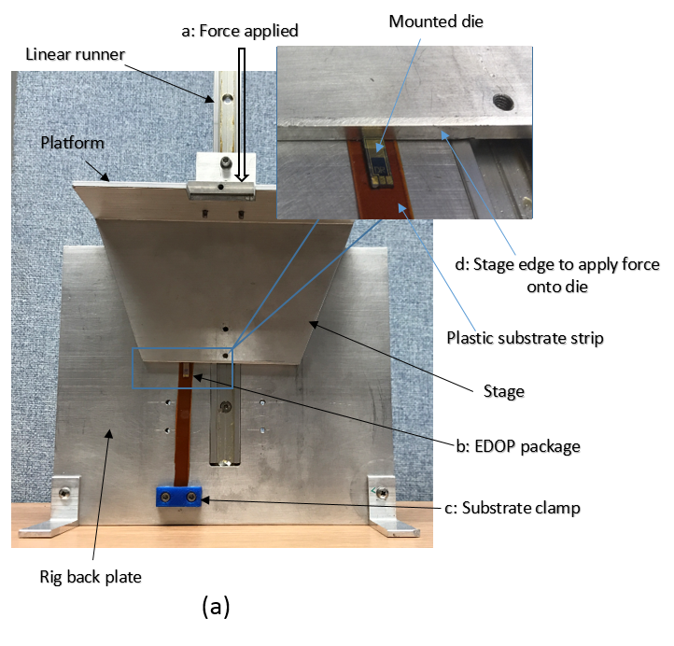
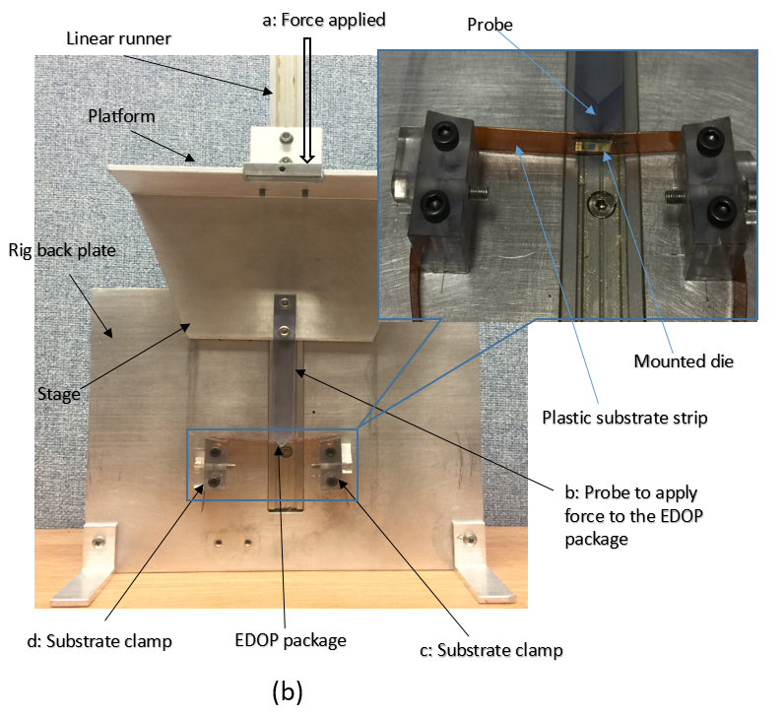

Fig. 4. Equipment for shear load and bending experiments, (a) EDOP package holder for shear load test; (b) EDOP package holder for bending test.

Validation of Shear Load and Bending Simulations
The shear load and bending experiments have been undertaken to determine the force at which the package fails, as a function of the thickness of the adhesive layer in the EDOP package. For each adhesive multiple samples (between 6 and 18, one sample at each thickness) were tested and the external force required to cause the EDOP package to fail is plotted in Figs. 5-10 versus adhesive thickness. All six under-fill adhesives have been tested in this way with different adhesive thicknesses being achieved by controlling the amount of adhesive dispensed. Each of these adhesives was tested with varying adhesive thickness in the samples and experimental results were then compared with the simulations. The geometry and material properties affect the coupling of the stress between the films and alter the position of neutral axis of the assembly. For every adhesive, there is an optimum thickness where the stress in the adhesive is minimised.
The experiment was conducted with a Kapton substrate 180 mm x 10 mm x 0.125 mm, and an 8 mm x 3.5 mm x 0.53 mm silicon die for shear or a smaller 2 mm x 2mm x 0.1 mm metal die for the bending case. The experimental and simulated evaluation of two different die sizes and materials enable a more in depth comparison between the experimental and simulation results providing greater confidence in the validation process. In each case, the length and width of the adhesive layer match the die dimension in the EDOP package.
The simulation results in this validation exercise consist of the stress in the adhesive for different thicknesses. At the optimum thickness the simulation results should indicate minimum stress in the adhesive compared with other thicknesses. For the experimental results, the maximum force required to break the package compared with other thicknesses will indicate the optimum thickness. The validation exercise compares the simulation result with the experimental result. The thicknesses of the adhesive layer is between 0.01 mm and 0.07 mm and a 20 N shear load and bending force is applied in the simulations.
Fig. 5 shows the simulation and experimental results for Loctite 4860. The simulation results for shear load and bending are shown in Fig. 5(a), which indicates the optimal thickness of adhesive is between 0.042 to 0.047 mm in both bending and shear cases. The experimental results are shown in Fig. 5(b) and this indicates that the optimal adhesive thickness of the Loctite 4860 layer in the shear load experiment is in the range 0.042 to 0.045 mm. For the bending experiment the optimal thickness is between 0.045 and 0.048 mm. The optimal thickness in both simulation and experimental results closely correlate and the optimum adhesive thickness shows good agreement, which indicates that at that thickness the stress in the adhesive layer is minimised. The fact the adhesive fails in-elastically and the simulation was performed elastically does not affect the agreement between the results – there is clearly an optimum adhesive thickness where the stress induced in the adhesive by the applied load is minimised. The small error between simulation and experiment is due in part to the tolerance in measuring the adhesive thickness. The thickness of the adhesive layer for each sample was determined by measuring the total thickness of the sample minus the thickness of the substrate and die. All thicknesses were measured using a digital micrometer with a tolerance of 0.002 mm
Both simulation and experimental results have indicated an optimum thickness exists for all adhesives tested. The comparison between simulation and experiment for Loctite 4902, Loctite 480, EP30AO, EP37-3FLF and Epo-Tek 301 2fl are shown in Fig. 6, 7, 8, 9 and 10 respectively. The optimum adhesive thickness for each material is shown in Table ІІІ.
Table III
Optimum thickness results for six adhesive materials.
Adhesive | Optimum thickness (mm) - simulation | Optimal thickness (mm) - experiment
Loctite 4860 | 0.042-0.047 | 0.042-0.048
Loctite 4902 | 0.04-0.045 | 0.042
Loctite 480 | 0.04 | 0.038-0.04
EP30AO | 0.047 | 0.047-0.049
EP37-3FLF | 0.05 | 0.048-0.05
Epo-Tek 301 2fl | 0.045-0.047 | 0.043-0.045

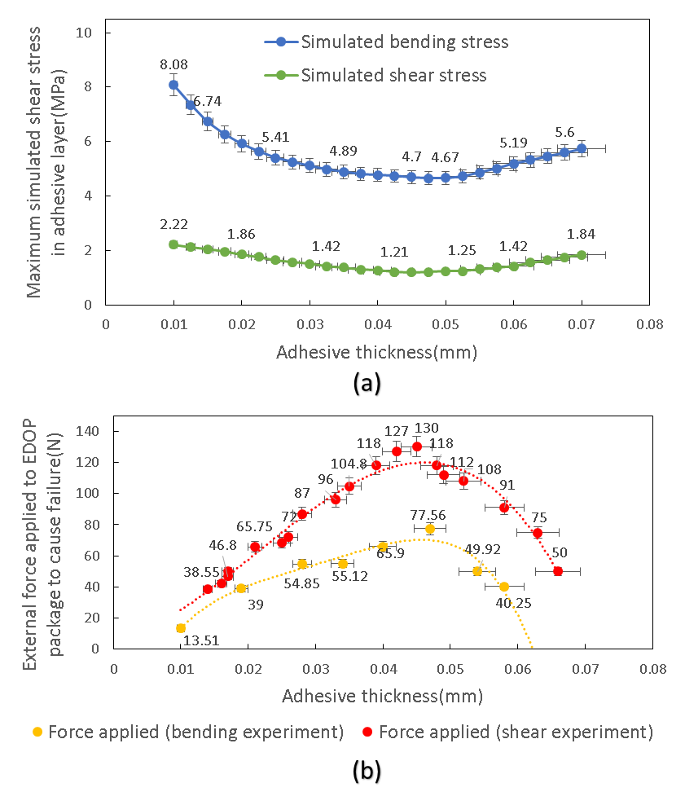
Fig. 5. Comparison of results for Loctite 4860, (a) simulated bending and shear stresses versus adhesive thickness (20 N force) (b) external force required to cause failure versus adhesive thickness.
In simulation, for the same adhesive thickness, the simulated shear stress in the EP30AO and Epo-Tek 301 2fl adhesive in shear and bending cases is much higher than for the Loctite 4902. However, in the shear and bending experiments, the force needed to break the EP30AO and Epo-Tek 301 2fl package is much higher than the Loctite 4902 package. This is because the EP30AO and Epo-Tek 301 2fl adhesives have much higher shear strength than Loctite 4902. So for the adhesives with similar shear strength, the smaller shear stress simulated in bending and shear cases shows improved stress performance.
These comparisons show very good correlation between the experimental and simulation results for both shear and bending cases for all materials and dimensions. This validation exercise provides a high level of confidence in the simulation approach and therefore this has been used to look further into the design of the EDOP package. These simulations are presented in section 5.
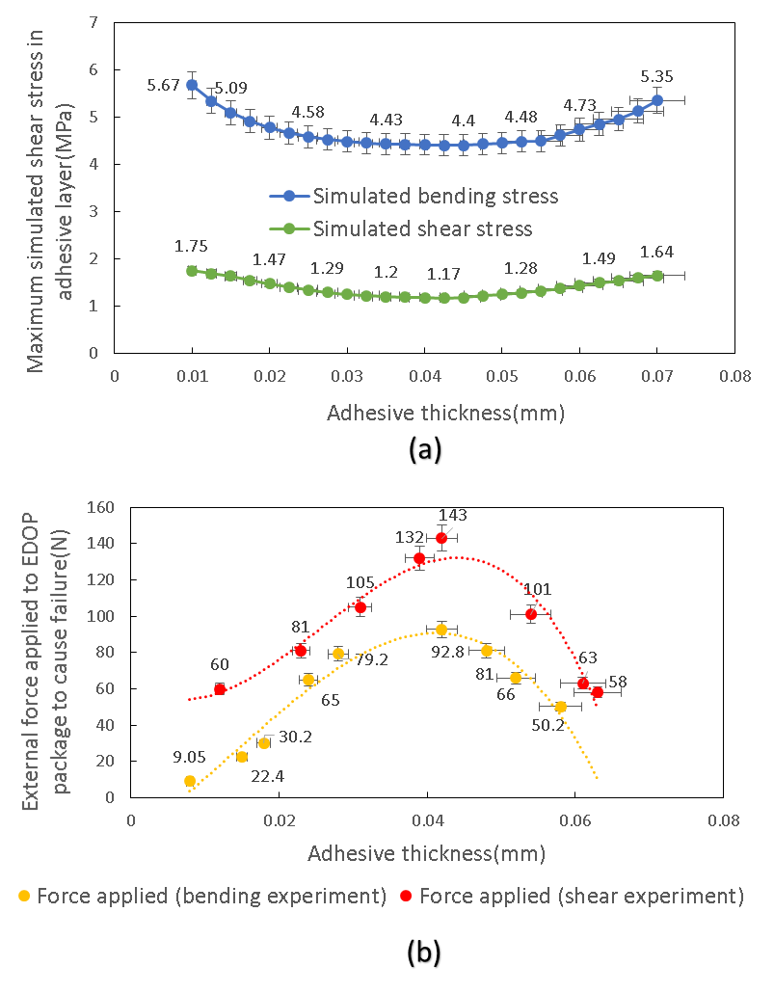
Fig. 6. Comparison of results for Loctite 4902, (a) simulated bending and shear stresses versus adhesive thickness (20 N force) (b) external force required to cause failure versus adhesive thickness.
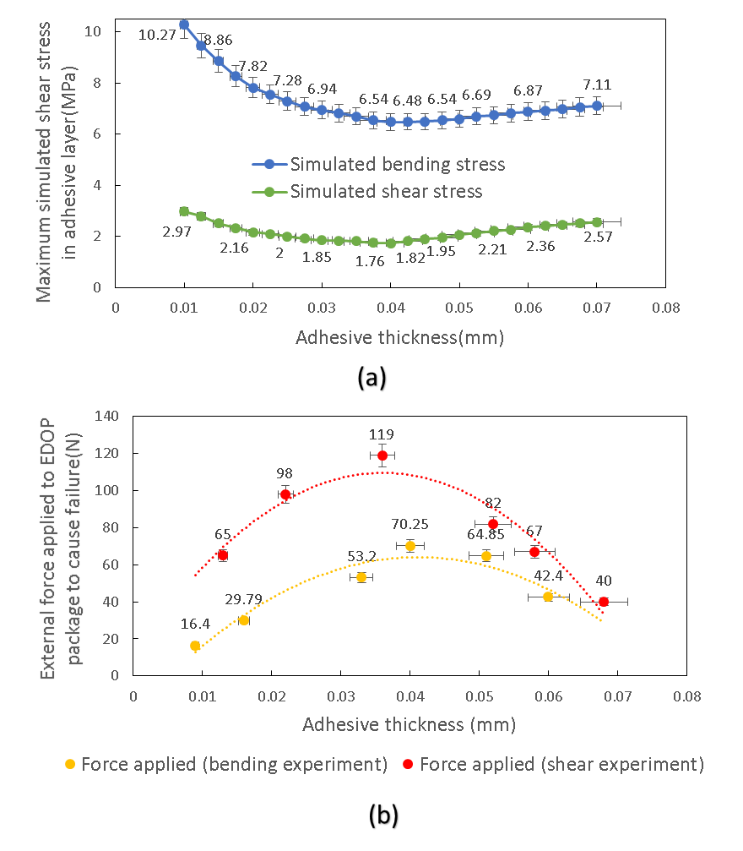
Fig. 7. Comparison of results for Loctite 480, (a) simulated bending and shear stresses versus adhesive thickness (20 N force) (b) external force required to cause failure versus adhesive thickness.
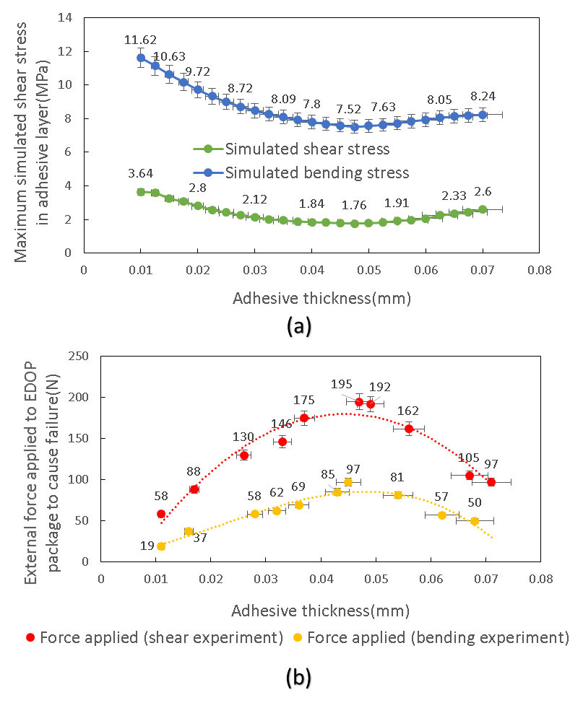
Fig. 8. Comparison of results for EP30AO, (a) simulated bending and shear stresses versus adhesive thickness (20 N force) (b) external force required to cause failure versus adhesive thickness.
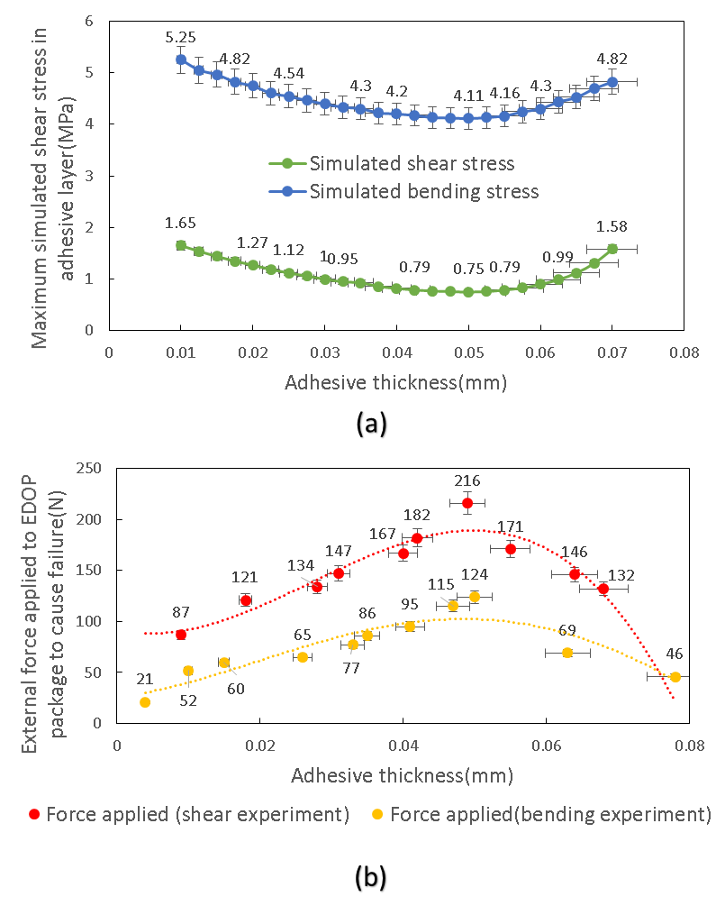
Fig. 9. Comparison of results for EP37-3FLF, (a) simulated bending and shear stresses versus adhesive thickness (20 N force) (b) external force required to cause failure versus adhesive thickness.
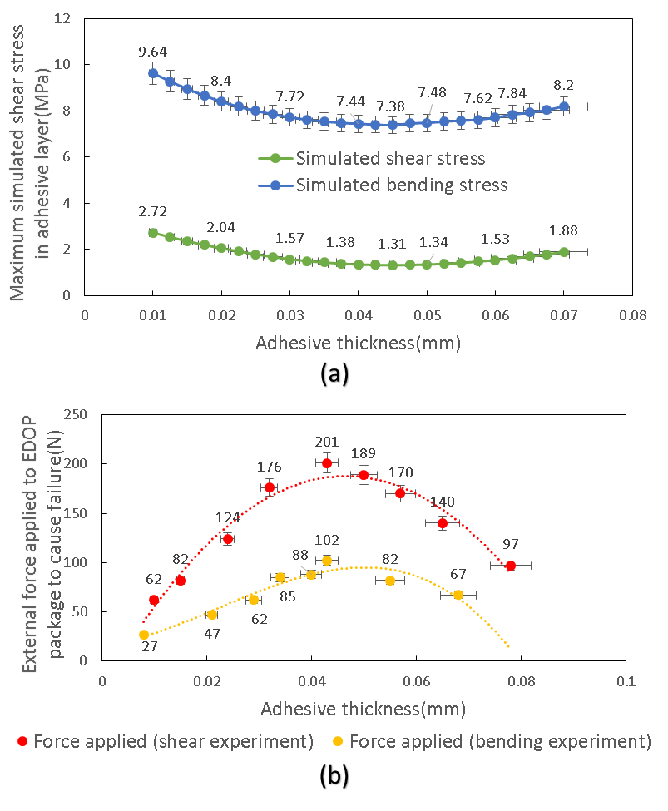
Fig. 10. Comparison of results for Epo-Tek 301 2fl, (a) simulated bending and shear stresses versus adhesive thickness (20 N force) (b) external force required to cause failure versus adhesive thickness.

Adhesive Strength
The magnitude of the experimental forces resulting in failure of the Loctite 480, Loctite 4860, Loctite 4902, EP30AO, EP37-3FLF and Epo-Tek 301 2fl adhesives during the shear test can be applied in the simulations to identify the practical shear strength of each adhesive. To do this, the failure force identified for each sample in the shear load experiment was applied in the simulation along with the adhesive thickness to determine the stress in the adhesive at the point each sample failed. The shear strength of the adhesive can be determined by averaging the simulated failure shear stresses from all the samples. The failure origin was found to be the corners of the die close to the location of the applied force. All shear stress values in the simulations are taken from the corners where the external the force was applied. The failure mode in both the shear and bending experiments indicated the adhesive failed at the chip/adhesive interface or within the adhesive itself
Fig. 11(a) shows how to use this approach to obtain the shear strength the 6 adhesives. For Loctite 4860, for example, the forces at which the package failed are 38.55 N, 42.5 N, 68.5 N, 96 N, 118 N, 108 N and 75 N for the adhesive at thicknesses of 14 µm, 16 µm, 25 µm, 33 µm, 48 µm, 52 µm and 63 µm respectively. The simulated shear strength in each instance is 8.75 MPa, 9.49 MPa, 6.96 MPa, 7.15 MPa, 6.93 MPa, 8.24 MPa and 7.75 MPa as shown in Fig. 11(a). The average shear strength of Loctite 4860 is 7.89MPa.
This approach has been applied to all the adhesives and the average shear strength of each adhesive when bonding silicon to Kapton is shown in Fig. 11(b). This simulated result shows that, of the six adhesives, the EP37-3FLF adhesive has the highest practical shear strength.

Shear Load and Bending Simulation Results
The simulations in this section were used to determine the influence of the adhesive, substrate material and substrate thicknesses on the stress present in the adhesive during bending and shear loading. This will enable the optimum under-fill and substrate material and thicknesses to be determined for each combination of materials. The length and width of the substrate is fixed at 180 mm x 10 mm for both simulations. A fixed size of 8 mm x 3.5 mm x 0.53 mm silicon die is used.
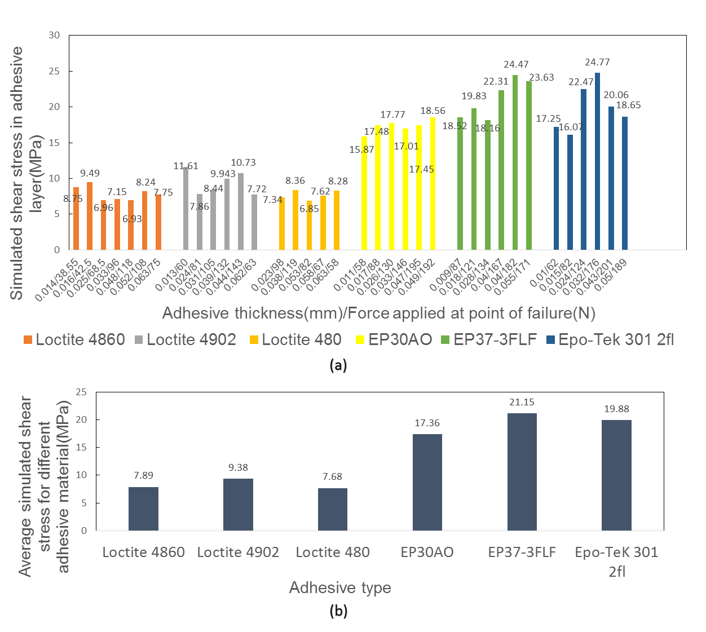
Fig. 11. (a) Shear strength in different thickness of six adhesives in simulation. (b) Shear strength comparison of the six adhesives.

Effect of Under-fill and Substrate Material
The six under-fill adhesives were simulated on each substrate material in turn and the stress induced in the adhesive and substrate layers determined. The best combination of substrate and adhesive materials for the EDOP package is identified by the lowest stress in the adhesive and substrate layers. Fig. 12, 13 and 14 show the maximum shear and Von-Mises stresses for the Kapton, Mylar and PEEK substrates respectively. The thickness of the substrate layer and adhesive layer is fixed at 0.125 mm and 0.05 mm respectively and the external force applied in the shear load and bending simulation is 20 N.
Of the six under-fill adhesives, the EP37-3FIF shows the lowest shear and Von-Mises stress in the adhesive layer under shear load and bending. The shear and Von-Mises stress in the substrate do not change significantly for each under-fill material.
With regard to the choice of substrate material, Kapton results in the lowest stress level in the adhesive layer and the substrate and when combined with the EP37-3FIF adhesive. Therefore this was identified as the best material combination.

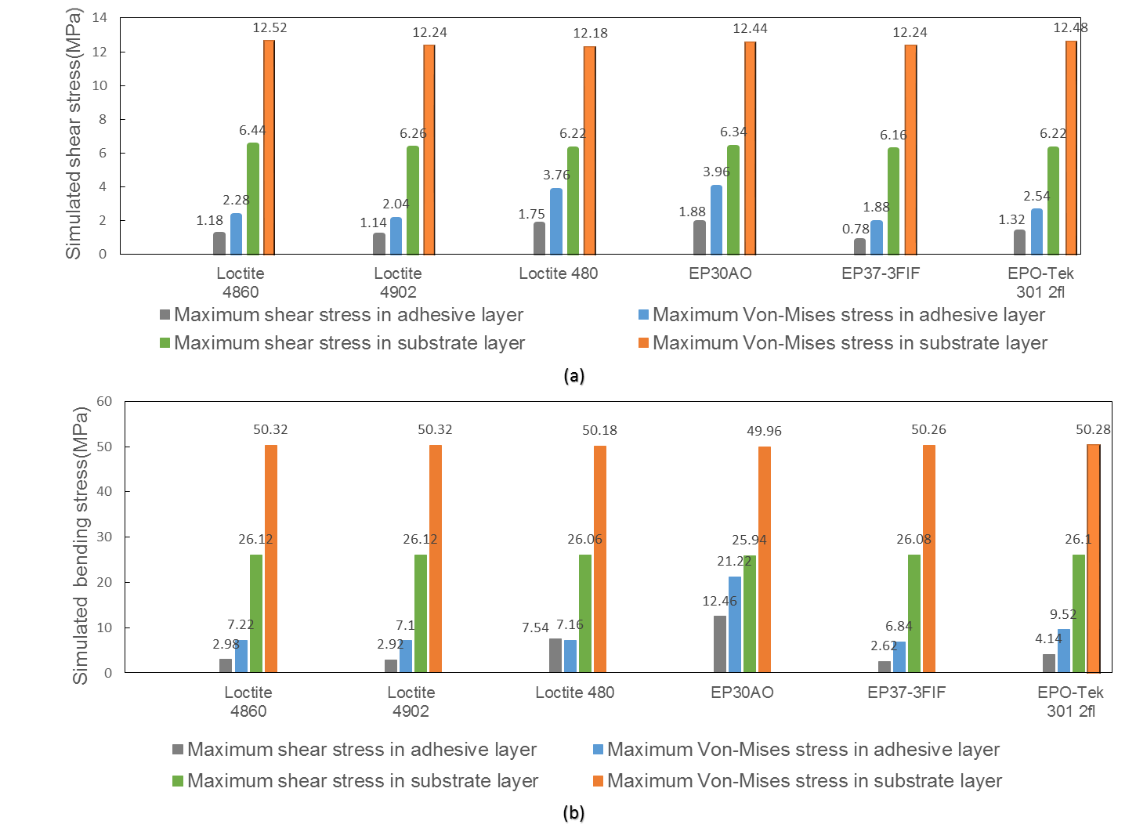
Fig. 12. Shear and von-Mises stress simulations to compare adhesives with a Kapton substrate, (a) shear load model, (b) bending model.

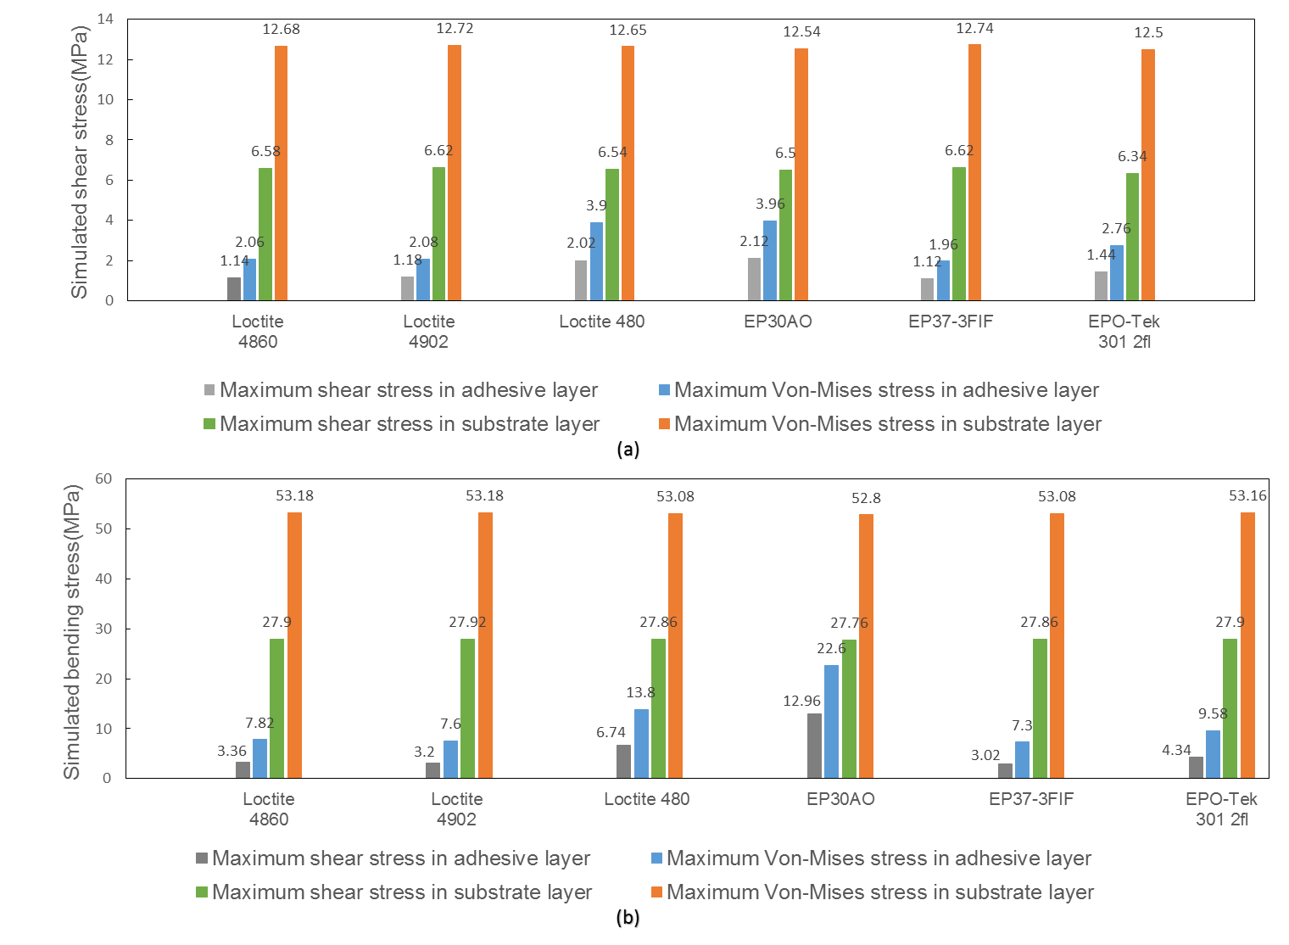
Fig. 13. Shear and von-Mises stress simulations to compare adhesives with a Mylar substrate, (a) shear load model, (b) bending model.

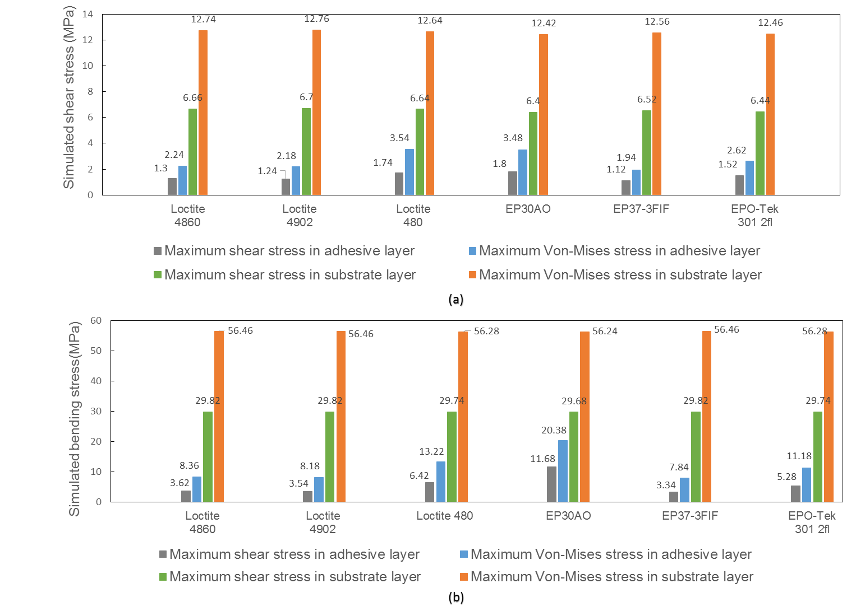
Fig. 14. Shear and von-Mises stress simulations to compare adhesives with a PEEK substrate, (a) shear load model, (b) bending model.

Effect of Substrate Thickness
This section presents the investigation into the effect of substrate thickness on the stress induced in the adhesive. The results are shown in Fig. 15. The adhesive used is EP37-3FIF and the optimum adhesive thickness of 0.05 mm is taken from the previous results and the thickness of the Kapton varied between 0.01 and 0.08 mm. The external force applied in the shear load and bending simulations is 20 N. A Kapton thickness of between 0.048 and 0.052 mm gives the lowest stress in the adhesive, as shown in Fig. 15.
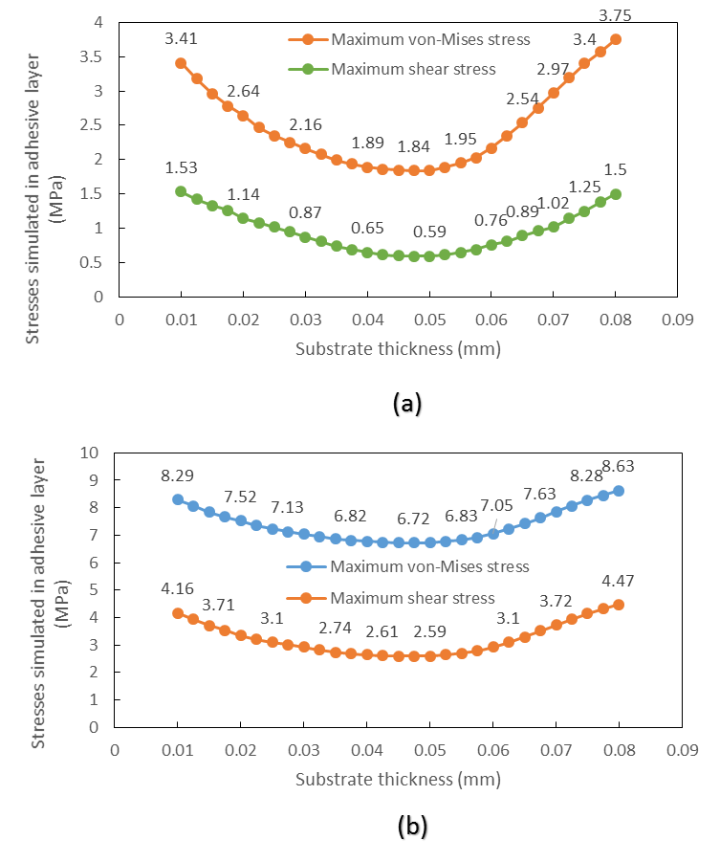
Fig. 15. Stress simulation 20 N applied load to determine the optimal thickness of the substrate layer, (a) shear stress and von-Mises stress against substrate thickness under shear, (b) shear stress and von-Mises stress against substrate thickness under bending.

Conclusions
This paper investigated the influence of the adhesive and substrate thickness and material on the stresses in the EDOP package. The different material combinations of the EDOP package of different adhesive materials (EP30AO, EP37-3FLF, Epo-Tek 301 2fl, Loctite 4902, Loctite 4860 and Loctite 480) and different substrate (Kapton, Mylar and PEEK) have been compared. A 0.048 to 0.052 mm thick Kapton substrate, and a 0.05 mm EP37-3FIF adhesive layer were identified as the optimum materials and thicknesses for the EDOP package. The simulation results show very good correlation with experimental results that gives a high level of confidence in this simulation approach. The method to determine the practical shear strength presented in section four can be used to determine the shear strength for any adhesive when combined with a specific material (such as Kapton or silicon). The simulations can now be used to improve the more complex package shown in Fig. 1 which has top plastic cover film to protect the die.

Acknowledgment
This research funded by Engineering and Physical Sciences Research Council project (EPSRC EP/M015149/1) “Novel manufacturing methods for functional electronic textiles (FETT)” https://www.fett.ecs.soton.ac.uk/.
Data published in this paper are available from the University of Southampton repository at 10.5258/SOTON/D0141.

references
1. E. Bonderover, and S. Wagner, "A Woven Inverter Circuit for e-Textile Applications". IEEE Electron Device Letters, 2004. 25(5): p. 295-297.
2. R. Bhattacharya, M. M. de Kok, and J. Zhou, "Rechargeable electronic textile battery". Applied Physics Letters, 2009. 95(22): p. 223305.
3. D. Meoli, T. May-Plumlee., "Interactive Electronic Textile Development: A Review of Technologies". Journal of Textile and Apparel, Technology and Management Spring 2002. 2(2): p. 1-11.
4. T. Martin, M. Jones, J. Edmison, T. Sheikh, and Z. Nakad, "Modeling and Simulating Electronic Textile Applications", ACM SIGPLAN/SIGBED conference on Languages, compilers, and tools for embedded systems, 2004: New York, NY, USA. p. 10-19.
5. C. Zysset, T. W. Kinkeldei, N. Munzenrieder, K. Cherenack, and G. Troster, "Integration Method for Electronics in Woven Textiles". IEEE Transactions on Components, Packaging and Manufacturing Technology, 2012. 2(7): p. 1107-1117.
6. R. B. Katragadda, and Y. Xu, "A novel intelligent textile technology based on silicon flexible skins". Sensors and Actuators A: Physical, 2008. 143(1): p. 169-174.
7. M. Koyuncu, E. Lorenz, and A. Zimmermann, "Advanced Interconnection Technologies for Flexible Organic Electronic Systems", Handbook of Flexible Organic Electronics; Materials, Manufacturing and Applications, Woodhead Publishing, 143-169, 2014.
8. D. Nowak, A. Dziedzic, Z. Żaluk, H. Roguszczak, and M. Węglarski, "Mechanical properties of SMD interconnections on flexible and rigid substrates". Soldering & Surface Mount Technology, 2016. 28(1): p. 27-32.
9. Y. S. Lai, T. H. Wang, H. H. Tsai, and M. H. R. Jen "Cyclic bending reliability of wafer-level chip-scale packages". Microelectronics Reliability, 2007. 47(1): p. 111-117.
10. K. Ilho, and L. Soon-Bok, "Reliability and Failure Analysis of Lead-Free Solder Joints for PBGA Package Under a Cyclic Bending Load". IEEE Transactions on Components and Packaging Technologies, 2008. 31(2): p. 478-484.
11. J. H. Kim, T. I. Lee., J. W. Shin, T. S. Kim, and K. W. Paik, "Ultra-Thin Chip-in-Flex (CIF) technology using Anisotropic Conductive Films (ACFs) for Wearable Electronics Applications", in Proc. 65th Electron. Compon. Technol. Conf. 2015. p. 714–718.
12. R. C. Benson, D. Farrar, and J. A. Miragliotta, "Polymer Adhesives and Encapsulants for Microelectronic Applications". Johns Hopkins Apl Technical Digest, 2008. 28(1): p. 58-71.
13. Y. C. Chan, M. O. Alam, K. C. Hung, H. Lu, and C. Bailey, "Effect of Underfill Entrapment on the Reliability of Flip-Chip Solder Joint". Journal of Electronic Packaging, 2004. 126(4): p. 541.
14. J. B. Nysaether, Z. H. Lai, and J. H. Liu, "Thermal Cycling Lifetime of Flip Chip On Board Circuits with Solder Bumps and Isotropically Conductive Adhesive Joints". Ieee Transactions on Advanced Packaging, 2000. 23(4): p. 743-749.
15. K. I. Loh, S. Chang, and E. S. Ibe, "Underfill Encapsulants and Edgebond Adhesive for Enhanceing of Board Level Reliability", in SMTA International Conference Proceedings. 2013. p. 978-0-9888873-0-5 ©2013.
16. J. W. Wan, W. J. Zhang, and D. J. Bergstrom, "Recent advances in modeling the underfill process in flip-chip packaging". Microelectronics Journal, 2007. 38(1): p. 67-75.
17. P. Sengupta, "Working Stress and Failure Theories A Simplified Approach". MET 301: Theories of failure.
18. Masterbond. EP30AO and EP37-3FLF datasheet [Online]. Available from: http://www.masterbond.com/.
19. E. Technology, Epo-Tek 301 2fl datasheet. [Online]. Available: http://www.epotek.com/site/administrator/components/com_products/assets/files/Style_Uploads/301-2FL.pdf.
20. Henkel. Datasheet for Loctite 4902, 4860 and 480. [Online] Available: www.na.henkel-adhesives.com/product-search-1554.htm.
21. Boedeker. PEEK (PolyEtherEtherKetone) Specifications. [Online] Available: http://www.boedeker.com/peek_p.htm?utm_source=google&utm_medium=cpc&utm_campaign=PEEK%20-%20International&utm_content=peek%20sheet&utm_term=%2Bpeek%20%2Bsheet&gclid=CO_ks6CM3tMCFaK37QodSXsP8Q.
22. Dupont Kapton HN polyimide film datasheet. [Online]. Available : http://www.dupont.com/content/dam/dupont/products-and-services/membranes-and-films/polyimde-films/documents/DEC-Kapton-HN-datasheet.pdf.
23. UKI, Mylar Polyester film datasheet [Online]. Available: http://dupontteijinfilms.com/wp-content/uploads/2017/01/Mylar_Electrical_Properties.pdf.
24. A. Singh, D.A.Horsley, M. B. Cohn, A. P. Pisano, and R. T. Howe, "Batch Transfer of Microstructures Using Flip-Chip Solder Bonding". Journal Microelectromech. Syst, Mar. 1999. 8(1): p. 27-33.
25. Standard Test Method for Shear Strength of Adhesive Bonds Between Rigid Substrates by the Block-Shear Method. [Online] Available : www.astm.org/Standards/D4501.htm.

Menglong Li received the B.Eng. degree in electronic engineering from University of Southampton, Southampton, UK in 2014. He is currently pursuing the Ph.D. degree with the department of Electronic and Computer Science, University of Southampton, Southampton, UK. His current interests include flexible electronic packaging method, screen printing, dispenser printing, ultra-thin chip fabrication, and reliability test of electronic packaging.

John Tudor received the Ph.D. degree in physics from the University of Surrey, Guildford, U.K. He is currently a Principal Research Fellow with the University of Southampton, Southampton, U.K. His current research interests include smart fabrics, screen printing, dispenser printing, MEMS, microsystems, energy harvesting, sensors, resonant sensors, inkjet printing, and wireless sensors.

Russel Torah received the Ph.D. degree in electronics from the University of Southampton, Southampton, U.K., in 2004. He is currently a Senior Research Fellow with the University of Southampton. His current research interests include smart fabric development but he also has extensive knowledge of energy harvesting, sensors, and transducers.

Steve Beeby received the Ph.D. degree from the University of Southampton, Southampton, U.K., in 1998. He is currently a Professor with the Department of Electronics and Computer Science, University of Southampton where he is Head of the Electronics and Electrical Engineering Group. He holds ten patents and has co-founded three companies. He has published 114 refereed journal papers and letters, 140 refereed conference papers, 5 review papers, 5 books, 11 chapters within books and he has an h-index of 43. His current research activities include e-textiles, energy harvesting and printed low temperature active materials for flexible and textile substrates.

Manuscript submitted for review June 29, 2017. This work was supported by Engineering and Physical Sciences Research Council under the project (EPSRC EP/M015149/1) “Novel manufacturing methods for functional electronic textiles (FETT)” https://www.fett.ecs.soton.ac.uk/. (Corresponding author: Menglong Li.) The authors are with the department of Electronic and Computer Science, University of Southampton, Southampton, UK (e-mail: ml1g12@soton.ac.uk).

