**In press, *Emotion***

An Appraisal Profile of Nostalgia

|  |  |
| --- | --- |
| Wijnand A.P. van Tilburg  King’s College London | Martin Bruder  University of Konstanz and German Institute for Development Evaluation |
| Tim Wildschut and Constantine Sedikides  University of Southampton | |
| Anja S. Göritz  University of Freiburg | |

Wijnand A.P. van Tilburg, Department of Psychology, King’s College London, London, United Kingdom; Martin Bruder, Zukunftskolleg and Department of Psychology, University of Konstanz, Konstanz, Germany, and German Institute for Development Evaluation (DEval), Bonn, Germany; Tim Wildschut and Constantine Sedikides, Centre for Research on Self and Identity, Psychology Department, University of Southampton, Southampton, United Kingdom; Anja Göritz, Department of Psychology, University of Freiburg, Freiburg, Germany. Corresponding author: Wijnand A.P. van Tilburg, Room 2.12, Addison House, Department of Psychology, Guy's Campus, King's College London, London, SE1 1UL, UK; Wijnand.van_Tilburg@kcl.ac.uk

Abstract

We aimed to (1) identify the cognitive appraisals underlying nostalgia, and (2) compare nostalgia with other emotions in terms of its appraisal profile. In Study 1, participants (*N* = 1,125) generated narratives. Next, they reported the level of nostalgia and 31 other emotions that these narratives elicited. Subsequently, participants evaluated the narrative events on several cognitive appraisals. Events that elicited nostalgia were pleasant, involved an irretrievable loss, felt psychologically distant, and were unique—an appraisal profile that differed from all other emotions. In Study 2 (*N* = 1,261), we experimentally varied these appraisals in a vignette paradigm and measured anticipated nostalgia and 10 other emotions. Participants anticipated most nostalgia when events were pleasant, involved irretrievable loss, were distant, and were unique—a profile shared only with longing. In Study 3 (*N* = 994), we used a guided autobiographical recall procedure in which we manipulated appraisals and measured the resultant emotions. Corroborating Studies 1-2, nostalgia was most intense for events that were pleasant, irretrievably lost, temporally distant, and unique. This appraisal profile was not shared by other emotions. Our findings delineate the distinguishing cognitive appraisal profile of nostalgia. Nostalgia occupies a special place in the pantheon of emotions.

*Keywords*: nostalgia, emotion, cognitive appraisal, affect, memory

An Appraisal Profile of Nostalgia

The last decade has witnessed a rise in psychological research on nostalgia (“a sentimental longing or wistful affection for the past;” *The New Oxford Dictionary of English*, 1998, p. 1266). Nostalgia exerts a considerable influence on psychological functioning (Sedikides, Wildschut, Routledge, Arndt, et al., 2015). Prior research, however, has typically isolated nostalgia to scrutinize its psychological signature. Our aim is to complement this literature by (1) identifying cognitive appraisals underlying nostalgia, and (2) comparing/contrasting nostalgia with other emotions in terms of its cognitive appraisal profile.

**Nostalgia**

Whereas nostalgia has historically been denounced as a demonic possession or cast as a psychiatric disorder (Batcho, 2013; Sedikides, Wildschut, & Baden, 2004), recent empirical findings rehabilitated its image by clarifying what nostalgia is and what it does. The emotion is typically triggered by discomforting states (e.g., loneliness, boredom, discontinuity between one’s past and one’s present; Sedikides, Wildschut, Routledge, & Arndt, 2015; Van Tilburg, Igou, & Sedikides, 2013; Zhou, Sedikides, Wildschut, & Gao, 2008), scents (Reid, Green, Wildschut, & Sedikides, 2015), and music or song lyrics (Cheung et al., 2013; Routledge et al., 2011; Stephan et al., 2015). Both content analyses of nostalgic narratives (Abeyta, Routledge, Roylance, Wildschut, & Sedikides, 2015; Holak & Havlena, 1998; Wildschut, Sedikides, Arndt, & Routledge, 2006) and analyses of laypersons’ prototypic conceptions of nostalgia (Hepper, Ritchie, Sedikides, & Wildschut, 2012) indicate that the emotion involves fond, self-relevant, and social recollections that are predominantly characterized by positive features (e.g., happy, warm) and to a lesser extent by negative ones (e.g., yearnful, sad). In addition, nostalgic narratives depict momentous events from one’s life—events that follow a redemptive trajectory (i.e., the narrator eventually overcomes challenge; Wildschut et al., 2006). Finally, nostalgia is experienced cross-culturally (i.e., in 18 cultures; Hepper et al., 2014) and across the life span (Hepper, Wildschut, Sedikides, Robertson, & Routledge, 2017).

Nostalgia affects how individuals regulate their current and future selves. For example, nostalgia increases empathy (Zhou, Wildschut, Sedikides, Shi, & Feng, 2012), strengthens social connectedness (Wildschut et al., 2006), promotes attachment security (Wildschut, Sedikides, Routledge, Arndt, & Cordaro, 2010), and mobilizes relationship goals (e.g., intentions to bond with friends and efficacy of doing so; Abeyta, Routledge, & Juhl, 2015). Furthermore, nostalgia bolsters self-esteem (Wildschut et al., 2006), augments the accessibility of the intrinsic (but not mundane) self-concept (Baldwin, Biernat, & Landau, 2015), raises authenticity (Baldwin & Landau, 2014; Stephan, Sedikides, & Wildschut, 2012), instills perceptions of youthfulness (Abeyta & Routledge, 2016), bestows meaning in life (Routledge et al., 2011; Sedikides & Wildschut, 2017), and buffers existential threats (Juhl, Routledge, Arndt, Sedikides, Wildschut, 2010; Routledge, Arndt, Sedikides, & Wildschut, 2008). Moreover, nostalgia is future-oriented (Sedikides & Wildschut, 2016a) in the sense that it fosters approach motivation (Stephan et al., 2014), optimism (Cheung et al., 2013), inspiration (Stephan, Sedikides, Wildschut, Cheung, Routledge, & Arndt, 2015), goal pursuit (Sedikides et al., 2017), and creativity (Van Tilburg, Sedikides, & Wildschut, 2015).

**Profiling Nostalgia**

The empirical study of nostalgia has occurred in relative isolation, a practice that limits understanding of how nostalgia is different from or similar to other emotions. Some theorists have equated nostalgia with unpleasantness. For example, Rosen (1975, p. 340) suggested that nostalgia is “a psychopathological condition affecting individuals who are uprooted, whose social contacts are fragmented, who are isolated and who feel totally frustrated and alienated,” perhaps confusing nostalgia with melancholy. Also, when Frost (1938, p. 801) labeled nostalgia as “immigrant psychosis” and Cox (1988) linked apparent symptoms of nostalgia (e.g., sadness, grief, loss of appetite) to immigrants, soldiers, seamen, or first-year boarding/university students, they were probably referring to homesickness. Although research has by now established that emotions such as melancholy and homesickness are not the same as nostalgia (Holak & Havlena, 1992; Thurber & Walton, 2007; for a review, see: Sedikides, Wildschut, Routledge, Arndt, et al., 2015), precisely howthese and other emotions differ from nostalgia is an open question. Furthermore, some emotions are likely to overlap partially with nostalgia. For example, nostalgia may share some features with *Sehnsucht*—longings for things in life that, when acquired, would secure a personal utopia (Scheibe & Freund, 2008; Scheibe, Freund, & Baltes, 2007). Similarly, the prominence of valued others in nostalgic narratives may to some extent make the nostalgizer feel beloved, tender, or loving (Wildschut et al., 2006, 2010; Zhou et al., 2008). Finally, nostalgia may resemble pride and gratitude in terms of pleasantness and approach/avoidance orientation (Van Tilburg, Wildschut, & Sedikides, 2017). In all, the status of nostalgia among emotions at large is unknown.

This lack of knowledge hampers a fuller understanding of psychological consequences potentially unique to nostalgia. For example, nostalgia is associated with approach motivation (Stephan et al., 2014), but so are anger (Carver & Harmon-Jones, 2009) and pride (Carver, Sinclair, & Johnson, 2010; Williams & DeSteno, 2008). Nostalgia inspires and propels creativity (Van Tilburg et al., 2015), but so do happiness (Pannells & Claxton, 2008) and admiration (Van de Ven, Zeelenberg, & Pieters, 2011). Nostalgia increases empathy (Zhou et al., 2012), but so do guilt (Leith & Baumeister, 1998) and gratitude (Bartlett & DeSteno, 2006). Furthermore, people perceive similarities between nostalgia and other positive self-relevant emotions, such as pride (Van Tilburg et al., 2017). Nostalgia, then, shares some psychological features with other emotions. But what are its unique features?

An obvious strategy to identify if, and to what extent, nostalgia can be differentiated from other emotions is to compare directly nostalgia to said emotions—for example, in terms of known characteristics of nostalgia. Such direct comparisons between nostalgia and other emotions, however, have rarely been made. Research that experimentally manipulated nostalgia—using autobiographical recall (Routledge et al., 2011), music (Barrett et al., 2010) or scents (Reid et al., 2015)—has contrasted induced nostalgia against a non-nostalgic control (e.g., ordinary autobiographical event; Cheung et al., 2013) or generic positive affect control (e.g., positive autobiographical event; Van Tilburg, Sedikides, & Wildschut, 2015). Although this research demonstrated that nostalgia differs—in causes, content, and consequences (Sedikides, Wildschut, Routledge, Arndt, et al., 2015)—from these controls, it remains to be seen whether nostalgia can be differentiated from other discrete emotions. We sought to redress this imbalance by investigating if, and to what degree, hallmarks of nostalgia compare to other emotions. We reasoned that, if nostalgia is rather indistinct from other emotions, then we should observe that hallmarks of nostalgia be shared with other emotions. Conversely, if nostalgia differs considerably from these other emotions, then we should observe few shared characteristics.

**Appraisals of Emotions**

A promising way to identify differences and similarities in the psychological profile of nostalgia and other emotions is to study cognitive appraisals—evaluations of an event or situation in which an emotion occurs (Frijda, 1988; 1993; Frijda, Kuipers, & Ter Schure, 1989; Scherer, 1997). In a componential view of emotions, appraisals describe the thoughts and situational interpretations (i.e., the cognitive component) of emotions. Appraisals prompt changes in other emotion components (e.g., motivation) and shape the way emotional reactions unfold (Sander, Grandjean, & Scherer, 2005; Scherer, 1999).

As a case in point, Scherer’s (2001) sequential check theory of emotion differentiation postulates that appraisals can be grouped into four themes, or “appraisal objectives”(p. 94): the perceived direct relevance of an event to the individual or reference group, the potential implications of the event for well-being and goal pursuit, how well a person can cope with or adjust to these implications, and the normative significance of the event (e.g., relevance to one’s self-concept or values). Each of these categories comprises several ‘checks’ or specific appraisals. For example, as part of determining the relevance of an event, individuals check whether an event will promote pleasure or pain, and this specific appraisal may influence whether they experience emotions characterized by stimulus approach (e.g., joy; Adams & Kleck, 2005) or avoidance (e.g., shame; Schmader & Lickel, 2006). As another example, individuals check whether there is discrepancy between an event and their prior expectations, and this appraisal distinguishes emotions such as despair (high discrepancy; Scherer, 2001) and boredom (very low discrepancy; Scherer, 2001). The specific outcomes of these appraisals correspond to discrete emotions.

Identifying emotion-specific patterns of cognitive appraisal helps to understand when a specific emotion is likely to unfold. That is, according to appraisal theory, an appraisal pattern constitutes a critical element of an emotion, and emotions can often be distinguished from one another based on their appraisal pattern (Ellsworth & Scherer, 2003; Fontaine, Scherer, Roesch, & Ellsworth, 2007; Lazarus, 1991; Roseman, 1996; Smith & Ellsworth, 1985; Weiner, 1980; Van Tilburg & Igou, 2016). Furthermore, the appraisals help to understand how emotions influence behavior. As an example, Lerner and Keltner (2001) reported that anger led to higher risk-taking than fear. The difference between these emotions on the appraisal of certainty explained their distinct effects on risk-taking: The appraised high certainty associated with anger (vs. fear) made participants behave in a riskier manner. Likewise, Lerner, Small, and Loewenstein (2004) found that, despite both being negative emotions, disgust and sadness differentially influenced the endowment effect (i.e., setting higher selling than buying prices). This difference derived from the distinct appraisal profiles of disgust and sadness. Disgust, which involves the “appraisal theme of being too close to an indigestible object or idea” (Lazarus, 1991, p. 337), eliminated the endowment effect (i.e., no differences in buying and selling prices). However, sadness, which involves the appraised desire to change a current situation, reversed the endowment effect (i.e., higher buying than selling prices). Taken together, these and other studies (De Hooge, Zeelenberg, & Breugelmans, 2007; Han, Lerner, & Keltner, 2007; Tangney, Miller, Flicker, & Barlow, 1996; Tracy & Robins, 2006; Silvia, 2005; Van Tilburg & Igou, 2012) underscore the relevance of appraisals for identifying differences among emotions.

**Potential Appraisals of Nostalgia**

Our primary objective was to sketch nostalgia’s appraisals profile. We identified potential appraisals associated with nostalgia by reviewing both the nostalgia and appraisal literature. We focused on appraisals related to the specific events associated with an emotion (e.g., pleasantness of the event) as well as more global mindsets—particular modes of information processing (Reggev, Hassin, & Maril, 2012)—that could characterize the emotion (e.g., perceived temporal continuity, rumination). Our search thus allowed for a broad assessment of similarities and differences among emotions without omitting potentially important cognitive features. Such a broad approach has been effective in prior explorations of cognitive emotion structures such as interest (Silvia, 2005) or shame, guilt, and embarrassment (Tangney et al., 1996).

Our next step, across studies, was to contrast nostalgia against other emotions on the selected appraisals. The relevant literature offers a range of candidate appraisals. Valence/pleasantness of the emotion-eliciting event is one of the most commonly studied appraisals (Fontaine et al., 2007; Posner, Russell, & Peterson, 2005; Russell, 1980; Smith & Ellsworth, 1985). The content of nostalgic events is more positive than negative, and being nostalgic is more pleasant than unpleasant (Hepper et al., 2012; Stephan et al., 2012; Wildschut et al., 2006). Consequently, the first nostalgia-relevant appraisal we selected was *pleasantness of the experience* (1).

Although nostalgia is predominantly pleasant (Cheung, Wildschut, & Sedikides, 2017; Stephan et al., 2012; Wildschut et al., 2006), it often features a reflection on past events that are forever lost (e.g., childhood experiences, youth), usually accompanied by a strong yearning for the past event or desire to relive the past (Abeyta, Routledge, Roylance, et al., 2015; Hepper et al., 2012; Sedikides, Wildschut, Routledge, Arndt, & Zhou, 2009). Therefore, two appraisals that may well characterize nostalgia are *irretrievable loss* (2) and *irreversible change* (3).

Many emotions revolve primarily around events in the present. For example, anger can stem from an immediate provocation (Denson, Pedersen, Friese, Hahm, & Roberts, 2011), disgust can be expressed towards a nearby contaminated object (Rozin, & Fallon, 1987), and boredom is experienced when being in an unchallenging situation (Van Tilburg & Igou, 2011). Nostalgia is a reflection on one’s past, and it entails revisiting it and longing for it (Sedikides, Wildschut, Arndt, & Routledge, 2008; Sedikides, Wildschut, Routledge, Arndt, et al., 2015). It is likely, then, that nostalgia is distinct from emotions that are less focused on the past and its scrutiny. This reasoning led us to formulate another appraisal: *desire to* *relive the event* (4)*.*

Nostalgic recollections consist mostly of atypical or momentous events (Batcho, 2007; Morewedge, 2013; Wildschut et al., 2006), suggesting that past events associated with nostalgia involve appraised *uniqueness of the event* (5). Also, nostalgia facilitates a sense of continuity between one’s past and present self (Davis, 1979; Sedikides et al., 2016)—defined as “the ability to perceive oneself as extending temporally backwards into the past and forwards into the future” (Sadeh & Karniol, 2012, p. 93), and likewise may make people feel that their present life and environment extends backwards in time (Kim & Wohl, 2015; Smeekes & Verkuyten, 2015). Accordingly, nostalgia may be distinguished from other emotions in terms of appraised *continuity in life* (6), *continuity of the self* (7), and *continuity in one’s environment* (8). In addition, nostalgia sometimes involves perceptions of the past as a bygone era (Hepper et al, 2012; Stephan et al., 2012; Wildschut et al., 2016), suggesting that nostalgia may be characterized by appraised *temporal distance* (i.e., the perceived distance in time between present and past; [9])*.* Finally, individuals who are inclined to worry may retrieve more unpleasant nostalgic recollections and brood over them (Verplanken, 2012). Consequently, nostalgia may involve *rumination* (“a method of coping with negative mood that involves self-focused attention;” Treynor, Gonzalez, & Nolen-Hoeksema, 2003, p. 247; [10]) and *reflection* (a “process […] in which individuals monitor the effectiveness of their strategic attempts at change;” Grant, 2001, p. 8; [11]).

**Overview**

We conducted three studies, implementing convergent approaches, to identify the appraisals underlying nostalgia and to compare this presumably unique appraisal profile to that of other emotions. In Study 1, we examined which appraisals are associated with nostalgia. Participants recalled and described a past event and then evaluated it in terms of the abovementioned 11 candidate appraisals. Based on factor analysis, we reduced these appraisals to five: pleasantness, irretrievable loss, temporal distance, uniqueness, reflection. Participants also indicated which emotions (including nostalgia) they experienced in response to the recalled event. This allowed us to test which appraisals characterized events that elicited high levels of nostalgia.

After gaining an initial descriptive profile of the appraisals that characterized nostalgia, we experimentally validated this profile in a second step. We zeroed in on the four appraisals that were particularly characteristic of nostalgia in Study 1: pleasantness, irretrievable loss, temporal distance, uniqueness. In Study 2, we provided participants with several hypothetical events that varied along these four appraisals. Next, participants indicated how they would feel in response to these events in terms of several emotions, including nostalgia.

We extended this experimental test in Study 3. Specifically, we adopted a guided autobiographical recall procedure in which participants retrieved personal events that varied on the four key appraisals. Subsequently, they reported how these events made them feel in regards to several emotions, including nostalgia.

**Study 1: Nostalgia’s Appraisal Profile**

In Study 1, we aimed to identify nostalgia’s appraisal profile and compare it to that of other emotions. Participants retrieved past events and rated them on a range of appraisal items. They also indicated what emotions—including nostalgia—the events elicited. These two pieces of information (i.e., appraisals and emotions associated with the events) allowed us to examine which appraisals characterized events high in nostalgia and whether this appraisal profile differed from that of other emotions.

We also aimed to find out if nostalgia is distinct from other emotions. Historically, nostalgia has been equated with other, usually negative, emotions (Batcho, 2013; Sedikides et al., 2004). Recent findings, however, indicate that nostalgia is an ambivalent or bittersweet, yet predominantly pleasant, emotion (Sedikides & Wildschut, 2016b; Sedikides, Wildschut, Routledge, Arndt, et al., 2015). Could it be that nostalgia simply represents a mix of other emotions? Alternatively, is nostalgia unique and distinct from other emotions? To address these questions, we explored the overlap between nostalgia and each of the included emotions. In particular, we examined what percentage of variance in nostalgia can be attributed to other emotions.

**Method**

**Participants and design.** We tested 1,523 participants from the WisoPanel (Göritz, 2014), an open access panel for academic studies in Germany (http://www.wisopanel.net/). The language of this and all other studies was German. We excluded 398 participants based on one or more of the following criteria: (a) writing nonsensical comments when instructed to describe a past event (e.g., “blah, blah, blah”), (b) being under 18 years of age, (c) declaring unfamiliarity with the concept of nostalgia, or (d) reporting poor German language skills. Exclusion resulted in a final sample of 1,125 participants. The sample consisted of 705 women and 420 men, aged between 18 and 90 years (*M* = 45.22, *SD* = 14.28), and residing in Germany (*N* = 1,081), Austria (*N* = 23), or Switzerland (*N* = 16; 5 undeclared). The sample encompassed a variety of educational levels, with eight participants having no educational degree, 114 with eight years of education, 329 with 10 years of education, 304 with 12-13 years of education, 342 with a university degree, and 28 with a Doctorate. Also, 730 participants were (self-)employed, 141 were students, 138 had retired, and 9 were stay-at-home parents; 58 participants were unemployed (49 undeclared).

**Materials and procedure.** Participants first recalled and described in detail a past event from their lives. We left it up to them to decide what kind of event this would be, in an effort to generate a relatively heterogeneous sample of events. Subsequently, participants evaluated a set of 22 appraisal items, presented in a random order. We created two items for each of the 11 candidate appraisal dimensions of nostalgia (e.g., “When I think back about this event, it makes me feel”; 1 = *pleasant*, 9 = *unpleasant*; see Table 1 for all items). Participants indicated how strongly they experienced each of 32 emotions (presented in random order separately for each participant) in response to the event that they retrieved (e.g., “I feel nostalgic;” 1 = *not at all*, 9 = *very strongly*; see Figure 1 for all emotions). Collection of demographic information concluded the study session. We analyzed the data with SPSS (version 22).

**Results[1]**

**Nostalgia’s distinctiveness.** First, we sought to find out whether nostalgia is relatively independent of other emotions. We tested, in particular, if nostalgia represents a mix of other emotions or not. We did so by examining how strongly nostalgia related to the other emotions. Zero-order correlations (Figure 1) revealed that nostalgia was most strongly (and positively) associated with longing, *r*(1124) = .42, *p* < .001, melancholy, *r*(1124) = .41, *p* < .001, homesickness, *r*(1124) = .31, *p* < .001, and gratitude, *r*(1124) = .30, *p* < .001. These initial findings suggest that nostalgia shares characteristics with other emotions. Importantly, however, the findings also indicate that none of these emotions correlated highly with nostalgia: nostalgia is relatively distinct.

We further examined whether nostalgia represented a mix of other emotions by regressing nostalgia on all of the other emotions and estimating the proportion of nostalgia’s variance that could be attributed to each. This regression analysis indicated that the total variance explained was moderate; 35% of the variance in nostalgia overlapped with one or more of the other emotions, *R*2 = .35, *F*(31,1093) = 18.73, *p* < .001. To contextualize this finding, in parallel analyses the proportion of explained variance was 45% for loneliness, 59% for gratitude, and 65% for anger. Thus, nostalgia is not a mere composite of other emotions.

Nostalgia shared 35% of variance with other emotions, but which ones? Twenty-three percent of nostalgia’s variance was shared with more than one other emotion. The remaining 12% of explained variance could be attributed to a specific other emotion (i.e., semi-partial associations). Specifically, melancholy uniquely explained 6% of the variance in nostalgia, *r*sp(1093) = .25. No other specific emotion explained more than 2% of variance in nostalgia.

**Appraisal profile.** To identify nostalgia’s appraisals, we examined the correlations between emotions and appraisals. Before turning to these analyses, however, we reduced the appraisal items into a smaller set of dimensions.

***Appraisal dimensions.*** Given the large number of appraisal items, we sought to reduce the number of variables of interest by exploring the underlying dimensional structure. For this purpose, we conducted an exploratory factor analysis with varimax rotation, which yielded five factors (Table 1). The first dimension pertained to pleasantness associated with the event (e.g., “When I think back about this event, it makes me feel [pleasant/unpleasant]”), with higher scores indicating that the event was less pleasant. The second dimension pertained to irretrievable loss (e.g., “I [can/cannot] handle it well that the event has passed”), with higher scores indicating greater difficulty in letting go of the past event. The third dimension represented temporal distance (e.g., “The event feels temporally [close/distant] to me”), with higher scores indicating greater temporal distance to the past event. The fourth dimension captured reflection (e.g., “When the memory comes to my mind, [I do not/I] again reflect on the feelings that I had”), with higher scores indicating a deeper reflection on the event. The fifth and final dimension referred to uniqueness (e.g., “The event was [unique/similar] to events that have happened often in my life]”), with higher scores indicating lower event uniqueness.

Overall, these five factors accounted for a substantial proportion of variance in the appraisal data (*R*2 = .65), and none of the items loaded on multiple factors with a weight greater than 0.40. These findings, along with the straightforward link between items and dimensions, suggest that the number of factors was appropriate. Accordingly, we extracted individual participant scores on the factors. To facilitate interpretation, we reversed the scores for pleasantness and uniqueness. Accordingly, higher scores indicated pleasantness, greater irretrievable loss, greater temporal distance, deeper reflection, and higher uniqueness.

***Correlations with appraisals.*** Correlations between nostalgia and the appraisal dimensions (Table 2) revealed that nostalgia was significantly associated with pleasantness appraisals, *r*(1124) = .36, 95%CI = [.31; .41], *p* < .001. We examined if other emotions differed from nostalgia in their correlations with pleasantness using William’s T2 test for dependent correlations (Steiger, 1980). In terms of its association with pleasantness, nostalgia was significantly different from all other emotions (*p*s < .003), except love, *t*(1122) = 0.040, *p* = .968, longing, *t*(1122) = 1.139, *p* = .255, being loved, *t*(1122) = 1.364, *p* = .173, awe, *t*(1122) = 1.447, *p* = .148, and tenderness, *t*(1122) = 1.494, *p* = .135.

Nostalgia had a small but significant positive association with irretrievable loss, *r*(1124) = .09, 95%CI = [.03, .15], *p* = .002. With regard to this association, nostalgia differed from all other emotions (*p*s < .001), except embarrassment, *t*(1122) = 1.639, *p* = .102, love, *t*(1122) = 1.671, *p* = .095, empathy, *t*(1122) = 1.856, *p* = .064, and tenderness, *t*(1122) = 1.858, *p* = .063.

Nostalgia had the highest (positive) correlation with appraised temporal distance of all emotions, although this correlation was small, *r*(1124) = .06, 95%CI = [.001, .12], *p* = .040. In terms of this relation, nostalgia differed from most other emotions (*p*s ≤ .044), but not disgust, embarrassment, homesickness, regret, shame, contempt, melancholy, self-pity, relaxation, or loneliness, *p*s ≥ .069.

Contrary to our expectation, nostalgia had only a small and non-significant correlation with appraised reflection, *r*(1124) = .03, 95%CI = [-.03; .09], *p* = .380. Regarding this correlation, nostalgia differed significantly from most other emotions (*p*s ≤ .019), but not relief, love, awe, tenderness, being loved, pride, homesickness, and gratitude, *p*s ≥ .078.

Finally, nostalgia was significantly correlated with high uniqueness, *r*(1124) =.12, 95%CI = [.06; .18], *p* < .001. In respect to this correlation, nostalgia differed significantly from several other emotions (*p*s ≤ .026), but not empathy, tenderness, love, relaxation, longing, melancholy, enthusiasm, gratitude, being loved, awe, relief, grief, joy, contentment, and pride, *p*s ≥ .060.

***Euclidean distances.***To quantify the similarities and differences between appraisal profiles, we calculated the Euclidean distance between nostalgia and each of the other emotions on the five appraisal dimensions (Figure 2). We calculated each Euclidean distance by taking the root of the summed squared differences in correlation coefficients of a target emotion versus nostalgia. The Euclidean distances reflect how strongly the appraisal profiles of the other emotions differ from that of nostalgia. We derived confidence intervals for the Euclidean distances and present this information in Supplementary Materials.

On balance, the appraisal profile of nostalgia was most similar (i.e., low Euclidean distance) to the profiles of positive emotions (i.e., tenderness, love, feeling beloved, awe) and most distinct from the profiles of negative emotions (i.e., anger, sadness, disappointment). Although the appraisal profile of nostalgia also resembled the profiles of homesickness and melancholy, this does not mean that nostalgia entails sadness, bitterness, or despair (Rosen, 1975). Indeed, the appraisal profile of nostalgia differed considerably from the profiles of sadness, bitterness, and despair. These results instead suggest that potential similarities between nostalgia and homesickness or melancholy are based on aspects other than unpleasantness. Specifically, the emotions group together, because they are among the few associated with relatively high temporal distance appraisals.

**Discussion**

Study 1 established that nostalgia is a distinct emotion characterized by appraisals of pleasantness, irretrievable loss, psychological distance, and uniqueness. These findings align broadly with the literature. Consistent with the appraised pleasantness, research indicates that nostalgia is a predominantly positive emotion (Holak & Havlena, 1992; Wildschut et al., 2006). Consistent with the irretrievable loss, research indicates that nostalgia prototypically involves a missing of past experiences (e.g., childhood, youth; Abeyta, Routledge, Roylance, et al., 2015; Hepper et al., 2012). Consistent with the appraised temporal distance, research indicates that nostalgia is evoked when pleasant but psychologically distant past events are brought closer to the present self (Sedikides, Wildschut, Routledge, & Arndt, 2015; Stephan et al., 2012). Finally, consistent with the appraised uniqueness, research indicates that nostalgia involves atypical or momentous events (Batcho, 2007; Morewedge, 2013).

In the past, melancholy and homesickness have been used as synonyms for nostalgia (Cox, 1988; Frost, 1938; Rosen, 1975). Our results show that these two emotions differ from nostalgia. Besides sharing a very modest proportion of unique variance with nostalgia, their appraisal profiles differed in several ways. Nostalgia was associated more strongly with pleasantness appraisals than either melancholy or homesickness. Melancholy, in particular, involved more reflection than nostalgia did. Besides homesickness and melancholy, emotions such as longing, feeling beloved, tenderness, love, pride, and gratitude—each of which has been associated with nostalgia or shares some key characteristics with it (Scheibe & Freund, 2008; Scheibe et al., 2007; Van Tilburg et al., 2017; Wildschut et al., 2010; Zhou et al., 2008)—yielded appraisal profiles that overlapped with some but not all characteristic appraisals of nostalgia. Collectively, these initial findings suggest that the appraisal profile of nostalgia is distinct from that of other emotions.

**Study 2: Manipulated Appraisals of Given Events**

Study 1 was an initial examination of nostalgia’s appraisal profile. Of the five appraisal dimensions identified in Study 1, four were significantly associated with nostalgia: pleasantness, irretrievable loss, temporal distance, uniqueness. Building on these findings, we manipulated these appraisal dimensions in Studies 2 and 3 to examine whether they evoked nostalgia. In Study 2, participants read hypothetical past events (e.g., “As a child, you went on a trip with your parents”) and then rated the emotions they would experience when recalling these events.

**Method**

**Participants and design.** We recruited 1,286 members of the WisoPanel (Göritz, 2014). Of these, we excluded 25 based on one or more of the following criteria: (a) being under 18 years of age, (b) reporting unfamiliarity with the concept of nostalgia, or (c) reporting poor German language skills. The final sample consisted of 1,261 individuals, comprising 748 women and 513 men, aged between 18 and 87 years (*M* = 43.94, *SD* = 14.45), and residing in Germany (*N* = 1,229), Austria (*N* = 19), or Switzerland (*N* = 11; 2 undeclared). Education levels varied, with 7 having received no educational degree, 141 with 8 years of education, 352 with 10 years of education, 358 with 12-13 years of education, 369 with a university degree, and 34 with a doctorate. Furthermore, 750 participants were (self-)employed, 205 were students, 149 had retired, 21 were stay-at-home parents, and 97 participants were unemployed (57 undeclared).

Participants read brief descriptions of eight events. We operationalized each of the four appraisal dimensions (i.e., pleasantness, irretrievable loss, temporal distance, uniqueness) with two event descriptions. These two descriptions depicted, respectively, high and low levels of the relevant appraisal dimension (e.g., “As a child you went on a trip with your parents. You have very [positive/negative] memories about the trip”). After reading each description, participants indicated the emotions that such memories would trigger. In addition to nostalgia, participants rated 10 comparator emotions (selected randomly from the set examined in Study 1). We thus implemented a 4 (appraisal dimension: pleasantness, irretrievable loss, temporal distance, uniqueness) × 2 (level: high, low) × 11 (emotion: nostalgia plus 10 comparator emotions) within-subjects design. For each participant, we randomly ordered the eight event descriptions with one restriction: Events with two levels of the same appraisal (e.g., a pleasant event and an unpleasant event) were always separated by at least three events that reflected other appraisals. We randomized the presentation order of the 11 emotions separately for each participant.

**Materials and procedure.** We provided participants with brief descriptions of eight events. These were as follows: pleasantness—“As a child you went on a trip with your parents. You have very [positive/negative] memories about the trip;” irretrievable loss—“A few years ago, a close friend moved out of your area of residence. You are [good/bad] in dealing with that;” temporal distance—“You were with your friends on holiday. This trip appears to you as if [it happened yesterday/it is a long time ago];” uniqueness—“You have achieved an outstanding performance in sports for which you are celebrated. That was [the only time/one of many times] that you had such an experience." After reading each description, participants rated their level of nostalgia and 10 comparator emotions (1 = *not at all*, 9 = *very strongly*). These emotions were: happiness, longing, shame, love, anger, sympathy, sadness, pride, disappointment, sorrow. We restricted the number of comparator emotions to avoid participant fatigue. Collection of demographic information concluded the study session. We analyzed the data with SPSS (version 22).

**Results**

**Full design.** We conducted a4 (appraisal dimension) × 2 (level) × 11 (emotion) within-subjects Analysis of Variance (ANOVA) on the emotion intensity ratings (1 = *not at all*, 9 = *very strongly*). Results revealed main effects of appraisal dimension, *F*(3, 3780) = 20.278, *p* < .001, $η_{p}^{2}$ = .016, and emotion, *F*(10, 12600) = 1784.188, *p* < .001, $η_{p}^{2}$ = .586, but not of level, *F*(1, 1260) = 0.189, *p* = .664, $η_{p}^{2}$ = .000. The Appraisal Dimension × Emotion interaction was significant, *F*(30, 37800) = 1099.032, *p* < .001, $η_{p}^{2}$ = .466, as were the Appraisal Dimension × Level interaction, *F*(3, 3780) = 352.729, *p* < .001, $η_{p}^{2}$ = .219, and the Level × Emotion interaction, *F*(10, 12600) = 352.729, *p* < .001, $η_{p}^{2}$ = .456. Crucially, all these effects were qualified by the Appraisal Dimension × Level × Emotion three-way interaction, *F*(30, 37800) = 660.999, *p* < .001, $η_{p}^{2}$ = .344. An in-depth description of these results is available upon request. Below, we probed this three-way interaction by testing the Level × Emotion interaction within each appraisal dimension. We then followed up by testing, within each appraisal dimension, the simple level main effect on intensity ratings of each emotion.

**Pleasantness.** To test the Level × Emotion interaction for pleasantness appraisals, weconducted a 2 (level: unpleasant vs. pleasant) × 11 (emotion) within-subjects ANOVA, with emotion intensity as the dependent variable. We obtained a significant Level × Emotion interaction, *F*(10, 12600) = 1836.691, *p* < .001, $η_{p}^{2}$ = .593. We probed this interaction by examining the simple effect of level (unpleasant vs. pleasant) separately for each emotion. As illustrated in Figure 3a, participants anticipated more nostalgia in response to a pleasant (*M* = 6.44, *SD* = 5.45) than unpleasant (*M* = 3.14, *SD* = 2.36) event, *t*(1261) = 38.718, *p* < .001, *d* = 1.090. Participants also anticipated more happiness, longing, love, and pride when faced with a pleasant than unpleasant event (all *p* < .001). However, participants anticipated more shame, anger, sympathy, sadness, disappointment, and sorrow when faced with an unpleasant than pleasant event (all *p* < .001).

**Irretrievable loss.** To investigate the Level × Emotion interaction for the irretrievable loss appraisal, we carried out a 2 (level: low vs. high irretrievable loss) × 11 (emotion) within-subjects ANOVA. This analysis yielded a significant Level × Emotion interaction, *F*(10, 12600) = 295.329, *p* < .001, $η_{p}^{2}$ = .190. As illustrated in Figure 3b, participants anticipated more nostalgia in response to high (*M* = 5.51, *SD* = 2.63) than low (*M* = 4.85, *SD* = 2.57) irretrievable loss, *t*(1261) = 8.875, *p* < .001, *d* = 0.250. Participants also anticipated more longing, love, anger, sorrow, sympathy, sadness, and disappointment (all *p* < .001) in response to high than low irretrievable loss. However, participants anticipated more happiness and pride in response to low than high irretrievable loss (both *p* < .001). The simple effect of irretrievable loss on shame was not significant (*p* = .802).

**Temporal distance.** A 2 (level: close vs. distant) × 11 (emotion) within-subjects ANOVA yielded a significant Level × Emotion interaction, *F*(10, 12600) = 192.113, *p* < .001, $η_{p}^{2}$ = .132. As illustrated in Figure 3c, participants anticipated more nostalgia for an event that was temporally distant (*M* = 5.74, *SD* = 2.58) than temporally close (*M* = 4.93, *SD* = 2.71), *t*(1260) = 10.017, *p* < .001, *d* = 0.282. Participants also anticipated more intense longing, shame, anger, sadness, disappointment, and sorrow in response to an event that was temporally distant than close (all *p* ≤ .001). Yet, participants anticipated more intense happiness, love, and pride in response to an event that was temporally close than distant (all *p* < .001). The simple effect of temporal distance on sympathy was not significant, *p* = .597.

**Uniqueness.** Finally, a 2 (level: common vs. unique) × 11 (emotion) within-subjects ANOVA revealed a significant Level × Emotion interaction, *F*(10,12600) = 57.948, *p* < .001, $η_{p}^{2}$ = .044. As illustrated in Figure 3d, participants anticipated more nostalgia for an event that was unique (*M* = 4.71, *SD* = 2.92) than common (*M* = 4.08, *SD* = 2.65), *t*(1260) = 7.872, *p* < .001, *d* = 0.222. Apart from sympathy (*p* = .761) other emotions were also significantly influenced by uniqueness level (all *p* ≤ .014): When the event was unique (compared to common), participants anticipated more intense longing, shame, anger, sadness, pride, disappointment, and sorrow, but less intense love.

**Supplementary analysis: Comparing nostalgia to longing.** High (compared to low) levels of pleasantness, irretrievable loss, temporal distance, and uniqueness increased the intensity of both nostalgia and longing. This raises the question whether these two emotions have distinct appraisal profiles. We tested this possibility with a 4 (appraisal dimension) × 2 (level) × 2 (emotion: nostalgia vs. longing) within-subjects ANOVA on emotion intensity ratings (nostalgia and longing columns in Figure 3a through 3d). The overall difference between the appraisal profiles of nostalgia and longing is indexed by the Appraisal Dimension × Level × Emotion three-way interaction. Given that longing is one of 10 possible comparator emotions, we used a Bonferroni-corrected α = .005 (.05/10).

The ANOVA produced significant main effects of emotion, *F*(1, 1260) = 22.695, *p* < .001, $η_{p}^{2}$ = .018, appraisal dimension, *F*(3, 3780) = 264.480, *p* < .001, $η_{p}^{2}$ = .173, and level, *F*(1, 1260) = 41.266, *p* < .001, $η_{p}^{2}$ = .032. The Appraisal Dimension × Emotion interaction was also significant, *F*(3, 3780) = 93.272, *p* < .001, $η_{p}^{2}$ = .068, as were the Appraisal Dimension × Level interaction, *F*(3, 3780) = 1042.790, *p* < .001, $η_{p}^{2}$ = .453, and the Level × Emotion interaction, *F*(1, 1260) = 16.544, *p* < .001, $η_{p}^{2}$ = .013. Most important, all these effects were qualified by the Appraisal Dimension × Level × Emotion interaction, *F*(3, 3780) = 56.881, *p* < .001, $η_{p}^{2}$ = .043. Notwithstanding their resemblance, the appraisal profiles of nostalgia and longing were distinct. An in-depth description of these results is available upon request.

**Discussion**

In Study 2, we examined whether pleasantness, irretrievable loss, temporal distance, and uniqueness appraisals increased participants’ anticipated nostalgia, among other emotions, in response to hypothetical events. Participants evaluated what emotions they expected to experience when recalling past events. We varied the descriptions of these past events to manipulate four appraisal dimensions. In line with the correlational results of Study 1, anticipated nostalgia increased in intensity when events were pleasant (vs. unpleasant), involved high (vs. low) irretrievable loss, appeared temporally distant (vs. close), and were unique (vs. common). Only longing featured a matching pattern, yet supplementary analyses demonstrated that the appraisal profiles of nostalgia and longing were distinct.

**Study 3: Manipulated Appraisals of Recalled Events**

In Study 1, we presented a correlational analysis of nostalgia’s appraisal profile based on events from participants’ lives. In Study 2, we used a within-subjects design to manipulate appraisals in a vignette paradigm with hypothetical events. In Study 3, we introduced additional methodological improvements. In particular, we (a) manipulated appraisals between-subjects rather than within-subjects, and (b) elicited actual events experienced by participants that involved specific appraisals. We continued seeking to identify nostalgia’s appraisal profile, and we did so by examining the impact of pleasantness, irretrievable loss, temporal distance, and uniqueness appraisals on the intensity of experienced nostalgia (relative to comparator emotions).

**Participants and design.** We recruited 1,025 members of the WisoPanel (Göritz, 2014). We excluded 31 persons based on one or more of the following criteria: (a) being under 18 years of age, (b) stating unfamiliarity with the construct of nostalgia, or (c) reporting poor German language skills. The final sample consisted of 994 persons, 613 of which were women and 381 men. Participants ranged in age from 18 to 88 years (*M* = 44.33, *SD* = 14.45), and residing in Germany (*N* = 952), Austria (*N* = 23), or Switzerland (*N* = 9; 10 undeclared). Education levels varied, with 8 having received no educational degree, 88 having received 8 years of schooling, 311 with 10 years of education, 263 with 12-13 years of education, 296 with a university degree, and 28 with a doctorate. In terms of occupations, 608 participants were (self-)employed, 148 were students, 121 had retired, 10 were stay-at-home parents, and 63 participants were unemployed (44 undeclared).

As in Study 2, we implemented a 4 (appraisal dimension: pleasantness, irretrievable loss, temporal distance, uniqueness) × 2 (level: high, low) × 11 (emotion: nostalgia plus 10 comparator emotions) design. However, whereas Study 2 featured a within-subjects design, Study 3 employed a multilevel design with three levels. To be precise, participants (level-3 units) recalled four autobiographical events (level-2 units), each associated with one of the four appraisal dimensions (i.e., pleasantness, irretrievable loss, temporal distance, uniqueness). For each appraisal dimension, we randomly assigned participants to recall an event that represented either a high or low level of that dimension (e.g., “Events differ in how far or close they feel. Please now remember an event that feels very [distant/close]”). Thus, we randomly determined the level (high, low) for each appraisal dimension, independently of the level for the other dimensions. After giving a description of each event, participants completed 11 ratings (level-1 units), each pertaining to a specific emotion triggered by the memory of the event. We randomized appraisal order separately for each participant. We also randomized the order of emotion ratings separately for each participant.

**Materials and procedure.** Participants recalled four events, each associated with one of four appraisals (pleasantness, irretrievable loss, temporal distance, uniqueness). They received instructions to retrieve a memory that was either high or low on the appraisal dimension. Participants gave a description of each event in a few words and rated (1 = *not at all*, 9 = *very strongly*) 11 emotions triggered by the memory of the event (nostalgia plus 10 comparator emotions; see Study 2). Finally, participants reported demographic information. We analyzed the data with SPSS (version 22).

**Results[2]**

**Full design.** We used a random intercept multilevel analysis to analyze the full design. This analysis specified three levels: Each participant (level 3) recalled four autobiographical events (level 2) and, for each event, completed 11 ratings (level 1). Our model included a random level-3 intercept for participants and a random level-2 intercept for autobiographical events (nested within participants). We treated appraisal dimension (pleasantness, irretrievable loss, temporal distance, uniqueness) and level (high, low) as level-2 fixed effects (i.e., these variables characterize the recalled autobiographical events). Finally, we treated emotion as a level-1 fixed effect (i.e., each rating pertained to one of the eleven emotions). Emotion intensity was the dependent variable. Results revealed main effects of appraisal dimension, *F*(3, 3968) = 23.448, *p* < .001, and emotion, *F*(10, 39680) = 676.656, *p* < .001, but not of level, *F*(1, 3968) = 2.530, *p* = .112. The Appraisal Dimension × Emotion interaction was significant, *F*(30, 39680) = 51.916, *p* < .001, as were the Appraisal Dimension × Level, *F*(3, 3968) = 128.236, *p* < .001, and Level × Emotion, *F*(10,39680) = 333.225, *p* < .001, interactions. Critically, all these effects were qualified by the Appraisal Dimension × Level × Emotion interaction, *F*(30, 39680) = 129.408, *p* < .001. An in-depth description of these results is available upon request.

Below, we probed the three-way interaction by testing the Level × Emotion interaction within each appraisal dimension. Subsequently, we tested, within each appraisal dimension, the simple level main effect on intensity ratings of each emotion. Given that these analyses considered the four appraisal dimensions separately, we could implement conventional mixed ANOVAs in which we treated appraisal level as a between-subjects variable and emotion as a within-subjects variable.

**Pleasantness.** To test the Level × Emotion interaction for pleasantness appraisals, weconducted a 2 (level: unpleasant vs. pleasant) × 11 (emotion) mixed ANOVA on intensity of experienced emotions, with level as a between-subjects factor and emotion as a within-subjects factor. We obtained a significant Level × Emotion interaction, *F*(10, 9920) = 637.355, *p* < .001, $η_{p}^{2}$ = .391. As displayed in Figure 4a, participants experienced more nostalgia in response to pleasant (*M* = 4.36, *SD* = 2.93) than unpleasant (*M* = 2.76, *SD* = 2.50) events, *t*(992) = 9.235, *p* < .001, *d* = 0.586. Pleasantness also influenced all other emotions (all *p* < .001): Participants felt more happiness, longing, love, and pride when events were pleasant than unpleasant, and they felt more shame, anger, sympathy, sadness, disappointment, and sorrow when events were unpleasant than pleasant.

**Irretrievable loss.** Weconducteda 2 (level: low vs. high irretrievable loss) × 11 (emotion) mixed ANOVA. This analysis yielded a significant Level × Emotion interaction, *F*(10, 9920) = 71.528, *p* < .001, $η_{p}^{2}$ = .067. As displayed in Figure 4b, events involving a high degree of irretrievable loss evoked more nostalgia (*M* = 5.37, *SD* = 2.30) than events involving a low degree of irretrievable loss (*M* = 3.70, *SD* = 2.70), *t*(992) = 9.264, *p* < .001, *d* = 0.588. Participants also felt more longing, love, sympathy, disappointment, and sorrow when irretrievable loss was high than low (all *p* < .001). However, participants reported more happiness and pride in response to low than high irretrievable loss (both *p* ≤ .008). The simple effects of irretrievable loss on shame (*p* = .133) and anger (*p* = .631) were not significant.

**Temporal distance.** A 2 (level: close vs. distant) × 11 (emotion) mixed ANOVA yielded a significant Level × Emotion interaction, *F*(10, 9920) = 7.464, *p* < .001, $η_{p}^{2}$ = .007. As displayed in Figure 4c, participants felt more nostalgic when they recalled events that were temporally distant (*M* = 4.73, *SD* = 2.73) than temporally close (*M* = 4.25, *SD* = 2.89), *t*(992) = 2.621, *p* = .009, *d* = 0.166. No other emotion showed this pattern. Participants experienced more intense happiness, love, pride, and longing when they recalled events that were temporally close than distant (all *p*s ≤ .050). The simple effects of temporal distance on sympathy, shame, anger, sadness, disappointment, and sorrow were not significant (all *p*s ≥ .068). It is noteworthy that temporally distant (vs. close) events elicited more nostalgia but less longing, further establishing the distinctiveness of these two emotions. This finding also implies that nostalgia and longing had different overall appraisal profiles. Indeed, a 4 (appraisal dimension) × 2 (level: close vs. distant) × 2 (emotion: nostalgia vs. longing) multilevel analysis revealed a significant Appraisal Dimension × Level × Emotion interaction, *F*(3, 3968) = 35.795, *p* < .001.

**Uniqueness.** Finally, a 2 (level: common vs. unique) × 11 (emotion) mixed ANOVA produced a significant Level × Emotion interaction, *F*(10, 9220) = 80.822, *p* < .001, $η_{p}^{2}$ = .075. As displayed in Figure 4d, participants felt more nostalgic in response to recalled events that were unique (*M* = 4.39, *SD* = 2.96) than common (*M* = 3.44, *SD* = 2.73), *t*(992) = 5.259, *p* < .001, *d* = 0.334. Participants also experienced more intense happiness, longing, love, sympathy, and pride after recalling unique than common events (all *p* ≤ .001). However, they experienced more shame, anger, sorrow, and disappointment in response to a common than unique event (all *p* ≤ .049). The simple effect of uniqueness on sadness was not significant (*p* = .882).

**Discussion**

In Study 3, we examined experimentally the impact of appraisals on felt nostalgia, and we did so on the basis of recalled events. Participants indicated the emotions they experienced after retrieving and describing events from memory that reflected either high or low levels of appraised pleasantness, irretrievable loss, temporal distance, and uniqueness. Consistent with the results of Studies 1 and 2, participants experienced more nostalgia when events were pleasant (vs. unpleasant), involved high (vs. low) irretrievable loss, were temporally distant (vs. close), and were unique (vs. common). None of the other emotions shared this appraisal profile.

**General Discussion**

Research on nostalgia has shed light on its psychological character and functions, but has done so by examining the emotion in isolation. We sought to situate nostalgia within the broader emotions literature by investigating its appraisal profile: to what extent is it unique? In particular, we sought to identify which appraisals characterize nostalgia relative to other emotions. Next, we tested how nostalgia is similar to or different from those comparator emotions.

**Summary and Interpretation of Findings**

In Study 1, we focused on the relation between nostalgia and 31 other emotions on the one hand and a broad range of appraisals on the other. Informed by the literature, we selected 11 appraisals potentially characteristic of nostalgia. In an unguided recall paradigm, participants described a past event and rated relevant appraisals as well as a range of emotions. After using factor analysis to narrow down the 11 appraisals into five distinct appraisal dimensions (pleasantness, irretrievable loss, temporal distance, uniqueness, reflection), we correlated each dimension with nostalgia and 31 other emotions. Nostalgia was associated with appraising events as pleasant, irretrievably lost, temporally distant, and unique. Nostalgia was unrelated to appraised reflection. Furthermore, nostalgia was largely independent of other emotions, indicating that nostalgia cannot be simply reduced to a subset of other emotions.

We continued our investigation using an experimental approach. Specifically, we manipulated the four appraisals derived from Study 1 (i.e., pleasantness, irretrievable loss, temporal distance, uniqueness) and examined their impact on nostalgia and other emotions. We did so using hypothetical events; that is, we varied systematically the appraisals that characterized these events. Participants indicated what emotions they anticipated in response to each event. Consistent with Study 1 findings, participants anticipated more nostalgia when the events were pleasant, irretrievably lost, temporally distant, and unique.

Study 3 introduced a crucial variation of Study 2. Rather than relying on vignettes, participants retrieved and described four events from their life. We adopted a structured autobiographical recall procedure. In particular, we instructed participants to recall and describe four autobiographical events, each associated with one of the four key appraisal dimensions (i.e., pleasantness, irretrievable loss, temporal distance, uniqueness). We randomly assigned participants to recall an event that represented either a low or high level of the relevant appraisal dimension. After retrieving each event, participants indicated how the memory of these events made them feel by rating the intensity of a range of emotions, including nostalgia. Again, participants experienced most nostalgia when the events were accompanied by appraisals of (high) pleasantness, irretrievable loss, temporal distance, and uniqueness.

Examinations of nostalgic narratives (Abeyta, Routledge, Roylance, et al., 2015; Holak & Havlena, 1998; Wildschut et al., 2006) reveal that the events associated with nostalgia are typically pleasant, a finding that resonates with research on lay conceptions of nostalgia (Hepper et al., 2012, 2014). Likewise, the finding that nostalgia is associated with appraising events as unique broadly corresponds with research showing that nostalgic events are atypical and momentous (Batcho, 2007; Morewedge, 2013; Wildschut et al., 2006).

The finding that the appraisal profile of nostalgia includes irretrievable loss is intriguing. According to Davis’ (1979) discontinuity hypothesis, nostalgia offers an opportunity to bridge psychologically the gap between the past and present self. Specifically, Davis speculated that nostalgia can help people to assimilate pleasant characteristics of the former self into the present self; yet nostalgia helps to distance from unpleasant features of the past self or can help people to reinterpret these in a positive light. In experimental tests of this hypothesis, Sedikides Wildschut, Routledge, and Arndt (2015) found that negative self-discontinuity (e.g., being cut off from family and friends) triggered nostalgia (Study 2). Nostalgia, in turn, augmented a heightened sense of self-continuity (Study 3). This heightened sense of self-continuity involved the perception that one was connected with one’s past self, and that important features of the self remained stable over time. Consistent with this prior work, people may use nostalgia to feel reconnected to an otherwise irretrievable loss, reflected in the current positive association between irretrievable loss and nostalgia.

**Nostalgia’s Appraisal Profile Relative to Other Emotions**

Our findings suggest that nostalgia involves appraisals of (high) pleasantness, irretrievable loss, temporal distance, and uniqueness. Besides aiming to identify what appraisals characterize nostalgia, a key objective of our research was to determine how nostalgia differs from, or is similar to, other emotions. Of particular interest were emotions that have either been historically confounded with nostalgia (melancholy, homesickness; Cox, 1988; Frost, 1938; Rosen, 1975) or are likely related to nostalgia due to shared characteristics (e.g., longing, feeling beloved, love, tenderness, pride, gratitude; Scheibe & Freund, 2008; Scheibe et al., 2007; Van Tilburg et al., 2017; Wildschut et al., 2010; Zhou et al., 2008). In terms of appraisal profile, nostalgia differs from these comparator emotions in several ways. For example, events that give rise to nostalgia are more pleasant than those that give rise to melancholy or homesickness (Study 1), and longing is more strongly associated with irretrievable loss and less strongly associated with temporal distance than nostalgia (Studies 2-3). A limitation of Studies 2-3 was that the set of comparators excluded some (but not all) emotions that bore a close resemblance to nostalgia in Study 1. Future research should compare nostalgia to other similar emotions, including tenderness, love, being loved, and awe.

**Direction of Causality between Appraisals and Subjective Feelings**

The appraisal measure of Study 1 used a mix of items referring to a retrieved event (e.g., “During the passing of the recalled event I felt [pleasant/unpleasant]”) and to the experience of bringing this event back to mind (e.g., “When I think back about this event, it makes me feel [pleasant/unpleasant]”). Including items related to how people feel about the recollection itself may obscure the causal relation between appraisal and emotion. Indeed, concerns about whether the appraisal precedes temporally the emotion or vice-versa have been raised (Frijda & Zeelenberg, 2001). Our research addressed such concerns. In Study 2, we manipulated appraisals in vignettes that we constructed without relying on participants’ actual memories. Thus, it is unlikely that participants’ emotions in response to these events causally affected the associated appraisals. Although Study 2 involved anticipated emotions only, the consistency of the findings in Study 2 with those of Studies 1 and 3 suggests that the appraisals served as antecedents to the emotions. Future empirical efforts will do well to examine more systematically the causal relations between nostalgia’s appraisals and its phenomenology.

**Appraisals, Mindsets, and Modes of Information Processing**

Some appraisals, such as pleasantness, arousal, or certainty, have received intense empirical attention (Posner et al., 2005; Scherer, 2001; Smith & Ellsworth, 1985). Different from these approaches, we examined appraisals based on the nostalgia literature, hence tailoring our investigation to the emotion that was central to our enquiry. We sought to be inclusive in our identification of nostalgia appraisals, mixing modes of information processing, and global mindsets (Reggev, Hassin, & Maril, 2012). We hope that our methodology offers researchers an exemplar for addressing similarities and differences among emotions.

**Concluding Remarks**

Based on appraisal theory’s proposal that specific appraisal patterns are markers for specific emotions (Ellsworth & Scherer, 2003; Fontaine et al., 2007; Lazarus, 1991; Roseman, 1996; Smith & Ellsworth, 1985), we sought to identify the appraisal pattern characteristic of nostalgia and to compare this pattern to that of other emotions. We found that nostalgia can be differentiated from other emotions based on its unique appraisal profile. Nostalgic events were appraised as pleasant, irretrievably lost, temporally distant, and unique. We obtained initial support for this unique appraisal profile in an exploratory study of 32 emotions, including nostalgia (Study 1). Two subsequent experimental studies confirmed these results for anticipated (Study 2) and actual (Study 3) emotions. Although unique, nostalgia’s appraisal profile bears some resemblance to positive emotions including tenderness, awe, love, feeling beloved, pride, and gratitude, as well as to longing and homesickness. Our findings establish for the first time how nostalgia compares to a range of other emotions, and what makes nostalgia distinct.

References

Abdi, H. (2007) The Bonferonni and Šidák corrections for multiple comparisons. In N. J. Salkind (Ed.), 2007, *Encyclopedia of Measurement and Statistics* (pp. 103-107). Thousand Oaks (CA): Sage.

Abeyta, A., & Routledge, C. (2016): Fountain of youth: The impact of nostalgia on youthfulness and implications for health. *Self and Identity, 15*, 356-369. doi:10.1080/15298868.2015.1133452

Abeyta, A. A., Routledge, C., & Juhl, J. (2015). Looking back to move forward: Nostalgia as a psychological resource for promoting relationship aspirations and overcoming relationship challenges. *Journal of Personality and Social Psychology, 109*, 1029-1044. doi:10.1037/pspi0000036

Abeyta, A., Routledge, C., Roylance, C., Wildschut, R. T., & Sedikides, C. (2015). Attachment-related avoidance and the social and agentic content of nostalgic memories. *Journal of Social and Personal Relationships, 32*, 406-413. doi:10.1177/0265407514533770

Adams, R. B. Jr., & Kleck, R. E. (2005). Effects of direct and averted gaze on the perception of facially communicated emotion. *Emotion, 5*, 3-11. doi:10.1037/1528-3542.5.1.3

Baldwin, M., Biernat, M., & Landau, M. J. (2015). Remembering the real me: Nostalgia offers a window to the intrinsic self. *Journal of Personality and Social Psychology*, *108*, 128-147. doi:10.1037/a0038033

Baldwin, M., & Landau, M. J. (2014). Exploring nostalgia’s influence on psychological growth. *Self and Identity, 13*, 162-177. doi:10.1080/15298868.2013.772320

Barrett, F. S., Grimm, K. J., Robins, R. W., Wildschut, T., Sedikides, C., & Janata, P. (2010). Music-evoked nostalgia: Affect, memory, and personality. *Emotion, 10*, 390-403. doi:10.1037/a0019006

Bartlett, M. Y., & DeSteno, D. (2006). Gratitude and prosocial behavior helping when it costs you. *Psychological science, 17*, 319-325. doi:10.1111/j.1467-9280.2006.01705.x

Batcho, K. I. (2007). Nostalgia and the emotional tone and content of song lyrics. *The American Journal of Psychology, 120*, 361-381.

Batcho, K. I. (2013). Nostalgia: The bittersweet history of a psychological concept. *History of Psychology, 16*, 165-176. doi:10.1037/a0032427

Carver, C. S., & Harmon-Jones, E. (2009). Anger is an approach-related affect: evidence and implications. *Psychological Bulletin, 135*, 183-204. doi:10.1037/a0013965

Carver, C. S., Sinclair, S., & Johnson, S. L. (2010). Authentic and hubristic pride: Differential relations to aspects of goal regulation, affect, and self-control. *Journal of Research in Personality, 44*, 698-703. doi:10.1016/j.jrp.2010.09.004

Cheung, W.-Y., Wildschut, T., & Sedikides, C. (2017). Autobiographical memory functions of nostalgia in comparison to rumination: Similarity and uniqueness. *Memory*. Online first publication. doi:10.1080/09658211.2017.1346129

Cheung, W. Y., Wildschut, T., Sedikides, C., Hepper, E. G., Arndt, J., & Vingerhoets, A. J. J. M. (2013). Back to the future: Nostalgia increases optimism. *Personality and Social Psychology Bulletin, 39*, 1484-1496. doi:10.1177/0146167213499187

Cox, J. L. (1988). The overseas student: Expatriate, sojourner, or settler? *Acta Psychiatrica Scandinavica, 78*, 179-184. doi:10.1111/j.1600-0447.1988.tb09019.x

Davis, F. (1979). *Yearning for yesterday: A sociology of nostalgia.* New York, NY: Free Press.

De Hooge, I. E., Zeelenberg, M., & Breugelmans, S. M. (2007). Moral sentiments and cooperation: Differential influences of shame and guilt. *Cognition and Emotion, 21*, 1025-1042. doi:10.1080/02699930600980874

Denson, T. F., Pedersen, W. C., Friese, M., Hahm, A., & Roberts, L. (2011). Understanding impulsive aggression: Angry rumination and reduced self-control capacity are mechanisms underlying the provocation-aggression relationship. *Personality and Social Psychology Bulletin, 37*, 850-862. doi:10.1177/0146167211401420

Ellsworth, P. C., & Scherer, K. R. (2003). Appraisal processes in emotion. In P. C. Ellsworth & K. R. Scherer (Eds.), *Handbook of affective sciences* (pp. 572-595) Oxford, UK: Oxford University Press.

Fontaine, J. R., Scherer, K. R., Roesch, E. B., & Ellsworth, P. C. (2007). The world of emotions is not two-dimensional. *Psychological Science, 18*, 1050-1057. doi:10.1111/j.1467-9280.2007.02024.x

Frijda N. H., & Zeelenberg, M. (2001). Appraisal: What is the dependent? In: K R. Scherer, A. Schorr, & T. Johnstone (Eds.), *Appraisal processes in emotion: Theory, methods, research* (pp. 141-155) New York, NY: Oxford University Press.

Frijda, N. H. (1988). The laws of emotion. *American Psychologist, 43*, 349–358. doi:10.1037/0003-066X.43.5.349

Frijda, N. H. (1993). The place of appraisal in emotion. *Cognition & Emotion, 7*, 357-387. doi:10.1080/02699939308409193

Frijda, N. H., Kuipers, P., & Ter Schure, E. (1989). Relations among emotion, appraisal, and emotional action readiness. *Journal of Personality and Social Psychology, 57*, 212–228. doi:10.1037/0022-3514.57.2.212

Frost, I. (1938). Homesickness and immigrant psychoses. *Journal of Mental Science, 84*, 801-847. doi:10.1192/bjp.84.352.801

Göritz, A. S. (2014). Determinants of the starting rate and the completion rate in online panel studies. In M. Callegaro, R. Baker, J. Bethlehem, A. S. Göritz, J. A. Krosnick, & P. J. Lavrakas (Eds.), *Online panel research: A data quality perspective* (S. 154-170). Chichester: Wiley. doi:10.1002/9781118763520.ch7

Grant, A. M. (2001). Rethinking: psychological mindedness: metacognition, self-reflection, and insight. *Behaviour Change, 18*, 8-17. doi:10.1375/bech.18.1.8

Han, S., Lerner, J. S., & Keltner, D. (2007). Feelings and consumer decision making: The appraisal-tendency framework. *Journal of Consumer Psychology, 17*, 158-168. doi:10.1016/S1057-7408(07)70023-2

Hepper, E. G., Ritchie, T. D., Sedikides, C., & Wildschut, T. (2012). Odyssey’s end: Lay conceptions of nostalgia reflect its original Homeric meaning. *Emotion, 12*, 102-119. doi:10.1037/a0025167

Hepper, E. G., Wildschut, T., Sedikides, C., Ritchie, T. D., Yung, Y.-F., Hansen, N., … & Zhou, X. (2014). Pancultural nostalgia: Prototypical conceptions across cultures. *Emotion, 14*, 733-747. doi:10.1037/a0036790

Hepper, E. G., Wildschut, T., Sedikides, C., Robertson, S., & Routledge, C. (2017). *The time capsule: Nostalgia shields wellbeing from limited time horizons*. Manuscript under review, University of Surrey.

Holak, S. L., & Havlena, W. J. (1992). Nostalgia: An exploratory study of themes and emotions in the nostalgic experience. *Advances in Consumer Research, 19,* 380-386.

Holak, S. L., & Havlena, W. J. (1998). Feelings, fantasies, and memories: An examination of the emotional components of nostalgia. *Journal of Business Research, 42,* 217-226. doi:10.1016/S0148-2963(97)00119-7

Jacoby, W. G., & Armstrong, D. A. (2014). Bootstrap confidence regions for Multidimensional Scaling solutions. *American Journal of Political Science, 58*, 264-278. doi:10.1111/ajps.12056

Juhl, J., Routledge, C., Arndt, J., Sedikides, C., & Wildschut, T. (2010). Fighting the future with the past: Nostalgia buffers existential threat. *Journal of Research in Personality, 44,* 309-314. doi:10.1016/j.jrp.2010.02.006

Kim, H. S., & Wohl, M. J. A. (2015). The bright side of feeling disconnected with the past self: Self-discontinuity (via nostalgia) increases readiness to change unhealthy behaviors. *Social Psychology and Personality Psychology Science, 6*, 229-237. doi:10.1177/1948550614549482

Lazarus, R. S. (1991). Progress on a cognitive-motivational-relational theory of emotion. *American Psychologist, 46*, 819-834. doi:10.1037/0003-066X.46.8.819

Leith, K. P., & Baumeister, R. F. (1998). Empathy, shame, guilt, and narratives of interpersonal conflicts: Guilt‐prone people are better at perspective taking*. Journal of Personality, 66*, 1-37. doi:10.1111/1467-6494.00001

Lerner, J. S., & Keltner, D. (2001). Fear, anger, and risk. *Journal of Personality and Social Psychology, 81*, 146-159. doi:10.1037/0022-3514.81.1.146

Lerner, J. S., Small, D. A., & Loewenstein, G. (2004). Heart strings and purse strings carryover effects of emotions on economic decisions. *Psychological Science, 15*, 337-341. doi:10.1111/j.0956-7976.2004.00679.x

Morewedge, C. K. (2013). It was a most unusual time: How memory bias engenders nostalgic preferences. *Journal of Behavioral Decision Making, 26*, 319-326. doi:10.1002/bdm.1767

*The New Oxford Dictionary of English*. (1998). (J. Pearsall, Ed.). Oxford, UK: Oxford University Press.

Pannells, T. C., & Claxton, A. F. (2008). Happiness, creative ideation, and locus of control. *Creativity Research Journal, 20*, 67-71. doi:10.1080/10400410701842029

Posner, J., Russell, J. A., & Peterson, B. S. (2005). The circumplex model of affect: An integrative approach to affective neuroscience, cognitive development, and psychopathology. *Development and Psychopathology, 17*, 715-734. doi:10.1017/S0954579405050340

Reid, C. A., Green, J. D., Wildschut, T., & Sedikides, C. (2015). Scent-evoked nostalgia. *Memory, 23*, 157-166. doi:10.1080/09658211.2013.876048

Reggev, N., Hassin, R. R., & Maril, A. (2012). When two sources of fluency meet one cognitive mindset. *Cognition, 124*, 256-260. doi:10.1016/j.cognition.2012.04.001

Roseman, I. J. (1996). Appraisal determinants of emotions: Constructing a more accurate and comprehensive theory. *Cognition and Emotion, 10*, 241-278. doi:10.1080/026999396380240

Rosen, G. (1975). Nostalgia: A “forgotten” psychological disorder. *Psychological Medicine, 5*, 340-354. doi:10.1017/S003329170005697X

Routledge, C., Arndt, J., Sedikides, C., & Wildschut, T. (2008). A blast from the past: The terror management function of nostalgia. *Journal of Experimental Social Psychology, 44*, 132–140. doi:10.1016/j.jesp.2006.11.001

Routledge C., Arndt, J., Wildschut, T., Sedikides, C., Hart, C. M., Juhl, J., Vingerhoets, A. J., & Scholtz, W. (2011). The past makes the present meaningful: Nostalgia as an existential resource. *Journal of Personality and Social Psychology, 101,* 638-652. [doi:10.1037/a0024292](http://dx.doi.org/10.1037/a0024292)

Routledge, C., Wildschut, T., Sedikides, C., Arndt, J., & Juhl, J. (2012). The power of the past: Nostalgia as a meaning-making resource. *Memory, 20,* 452-460.doi:10.1080/09658211.2012.677452

Rozin, P., & Fallon, A. E. (1987). A perspective on disgust. *Psychological Review, 94*, 23-41. doi:10.1037/0033-295X.94.1.23

Russell J.A. (1980). A circumplex model of affect. *Journal of Personality and Social Psychology, 39*, 1161-1178. doi:10.1037/h0077714

Sadeh, N., & Karniol, R. (2012). The sense of self-continuity as a resource in adaptive coping with job loss. *Journal of Vocational Behavior, 80*, 93-99. doi:10.1016/j.jvb.2011.04.009

Sander, D., Grandjean, D., & Scherer, K. R. (2005). A systems approach to appraisal mechanisms in emotion. *Neural Networks, 18*, 317-352. doi:10.1016/j.neunet.2005.03.001

Scheibe, S., & Freund, A. M. (2008) Approaching *Sehnsucht* (life longings) from a life-span perspective: The role of personal utopias in development. *Research in Human Development, 5*, 121-133. doi:10.1080/15427600802034868

Scheibe, S., Freund, A. M., & Baltes, P. B. (2007). Toward a developmental psychology of *Sehnsucht* (life longings): The optimal (utopian) life. *Developmental Psychology, 43*, 778-795. doi:10.1037/0012-1649.43.3.778

Scherer, K. R. (1997). The role of culture in emotion-antecedent appraisal. *Journal of Personality and Social Psychology, 73*, 902–922. doi:10.1037/0022-3514.73.5.902

Scherer, K. R. (2001). Appraisal considered as a process of multilevel sequential checking. In K. R. Scherer, A. Schorr, & T. Johnstone (Eds.), *Appraisal processes in emotion: Theory, methods, research* (pp. 92-120). Oxford, UK: Oxford University Press.

Schmader, T., & Lickel, B. (2006). The approach and avoidance function of guilt and shame emotions: Comparing reactions to self-caused and other-caused wrongdoing. *Motivation and Emotion, 3*0, 42-55. doi:10.1007/s11031-006-9006-0

Sedikides, C., Cheung, W.Y., Wildschut, T., Hepper, E. G., Baldursson, E., & Pedersen, B. (2017). Nostalgia motivates pursuit of important goals by increasing meaning in life. *European Journal of Social Psychology*. Advance online publication. doi:10.1002/ejsp.2318

Sedikides, C., & Wildschut, T. (2016a). Past forward: Nostalgia as a motivational force. *Trends in Cognitive Sciences, 20*, 319-321. doi:10.1016/j.tics.2016.01.008

Sedikides, C., & Wildschut, T. (2016b). Nostalgia: A bittersweet emotion that confers psychological health benefits. In J. Johnson & A. Wood (Eds.), *The Wiley handbook of positive clinical psychology* (pp. 25-136). Hoboken, NJ: Wiley.

Sedikides, C., & Wildschut, T. (2017). Finding meaning in nostalgia. *Review of General Psychology*. Advance online publication. doi:10.1037/gpr0000109

Sedikides, C., Wildschut, T., & Baden, D. (2004). Nostalgia: Conceptual issues and existential functions*.* In J. Greenberg, S. L. Koole, & T. Pyszczynski (Ed.), *Handbook of experimental existential psychology* (pp. 200-214). New York, NY: Guilford Press.

Sedikides, C., Wildschut, T., Cheung, W.-Y., Routledge, C., Hepper, E. G., Arndt, J., … & Vingerhoets, A. J. J. M. (2016). Nostalgia fosters self-continuity: Uncovering the mechanism (social connectedness) and the consequence (eudaimonic well-being). *Emotion, 16*, 524-539. doi:10.1037/emo0000136

Sedikides, C., Wildschut, T., Routledge, C., & Arndt, J. (2015). Nostalgia counteracts self-discontinuity and restores self-continuity. *European Journal of Social Psychology, 45*, 52-61. doi:10.1002/ejsp.2073

Sedikides, C., Wildschut, T., Routledge, C., Arndt, J., Hepper, E. G., & Zhou, X. (2015). To nostalgize: Mixing memory with affect and desire. *Advances in Experimental Social Psychology, 51*, 189-273. doi:10.1016/bs.aesp.2014.10.001

Sedikides, C., Wildschut, T., Routledge, C., Arndt, J., & Zhou, X. (2009). Buffering acculturative stress and facilitating cultural adaptation: Nostalgias as a psychological resource. In R. S. Wyer, Jr., C.-y. Chiu, & Y.-y. Hong (Eds.), *Understanding culture: Theory, research, and application* (pp. 361-378). New York, NY: Psychology Press.

Silvia, P. J. (2005). What is interesting? Exploring the appraisal structure of interest. *Emotion, 5*, 89-102. doi:10.1037/1528-3542.5.1.89

Stephan, E., Sedikides, C., & Wildschut, T. (2012). Mental travel into the past: Differentiating recollections of nostalgic, ordinary, and positive events. *European Journal of Social Psychology, 42*, 290-298. [doi:10.1002/ejsp.1865](http://dx.doi.org/10.1002/ejsp.1865).

Smeekes, A. N., & Verkuyten, M. J. A. M. (2015). The presence of the past: Identity continuity and group dynamics. *European Review of Social Psychology, 26*, 162-202. doi:10.1080/10463283.2015.1112653

Smith, C. A., & Ellsworth, P. C. (1985). Patterns of cognitive appraisal in emotion. *Journal of Personality and Social Psychology, 48*, 813-838. doi:10.1037/0022-3514.48.4.813

Steiger, J. H. (1980). Tests for comparing elements of a correlation matrix. *Psychological Bulletin, 87*, 245-251. doi:1980-08757-001

Stephan, E., Sedikides, C., & Wildschut, T. (2012). Mental travel into the past: Differentiating recollections of nostalgic, ordinary, and positive events. *European Journal of Social Psychology, 42*, 290-298. [doi:10.1002/ejsp.1865](http://dx.doi.org/10.1002/ejsp.1865).

Stephan, E., Sedikides, C., Wildschut, T., Cheung, W. Y., Routledge, C., & Arndt, J. (2015). Nostalgia-evoked inspiration: Mediating mechanisms and motivational implications. *Personality and Social Psychology Bulletin, 41*, 1395-1410. doi:10.1177/0146167215596985

Stephan, E., Wildschut, T., Sedikides, C., Zhou, X., He, W., Routledge, C., Cheung, W. Y., & Vingerhoets, A. J. J. M. (2014). The mnemonic mover: Nostalgia regulates avoidance and approach motivation. *Emotion*, *14*, 545-561*.* doi:10.1037/a0035673

Tangney, J. P., Miller, R. S., Flicker, L., & Barlow, D. H. (1996). Are shame, guilt, and embarrassment distinct emotions? *Journal of Personality and Social Psychology, 70*, 1256-1269. doi:10.1037/0022-3514.70.6.1256

Thurber, C. A. & Walton, E. A. (2007). Preventing and treating homesickness. *Pediatrics, 119*, 843-858. doi:10.1542/peds.2006-2781

Tracy, J. L., & Robins, R. W. (2006). Appraisal antecedents of shame and guilt: Support for a theoretical model. *Personality and Social Psychology Bulletin, 32*, 1339-1351. doi:10.1177/0146167206290212

Treynor, W., Gonzalez, R., & Nolen-Hoeksema, S. (2003). Rumination reconsidered: A psychometric analysis. *Cognitive Therapy and Research, 27*, 247-259. doi:10.1023/A:1023910315561

Van de Ven, N., Zeelenberg, M., & Pieters, R. (2011). Why envy outperforms admiration. *Personality and Social Psychology Bulletin, 37*, 784-795. doi:10.1177/0146167211400421

Van Tilburg, W. A. P., & Igou, E. R. (2011). On boredom and social identity: A pragmatic meaning-regulation approach. *Personality and Social Psychology Bulletin, 37*, 1679-1691. doi:10.1177/0146167211418530

Van Tilburg, W. A. P., & Igou, E. R. (2012). On boredom: Lack of challenge and meaning as distinct boredom experiences. *Motivation and Emotion, 36*, 181-194. doi:0.1007/s11031-011-9234-9

Van Tilburg, W. A. P., & Igou, E. R. (2016). Boredom begs to differ: Differentiation from other negative emotions. *Emotion*. doi:10.1037/emo0000233

Van Tilburg, W. A. P., Igou, E. R., & Sedikides, C. (2013). In search of meaningfulness: Nostalgia as an antidote to boredom. *Emotion, 13*, 450-461. doi:10.1037/a0030442

Van Tilburg, W. A. P., Sedikides, C., & Wildschut, T. (2015). The mnemonic muse: Nostalgia fosters creativity through openness to experience. *Journal of Experimental Social Psychology, 59*, 1-7.doi:10.1016/j.jesp.2015.02.002

Van Tilburg, W. A. P., Wildschut, T., & Sedikides, C. (2017). Nostalgia’s place among self-relevant emotions. *Cognition & Emotion*. Advance online publication. doi:10.1080/02699931.2017.1351331

Verplanken, B. (2012). When bittersweet turns sour: Adverse effects of nostalgia on habitual worriers. *European Journal of Social Psychology, 42*, 285-289. doi:10.1002/ejsp.1852

Weiner, B. (1980). A cognitive (attribution)-emotion-action model of motivated behavior: An analysis of judgments of help-giving. *Journal of Personality and Social Psychology, 39*, 186-200. doi:10.1037/0022-3514.39.2.186

Wildschut, T., Sedikides, C., Arndt, J., & Routledge, C. (2006). Nostalgia: Content, triggers, functions. *Journal of Personality and Social Psychology, 91*, 975-993. doi:10.1037/0022-3514.91.5.975

Wildschut, T., Sedikides, C., Routledge, C., Arndt, J., & Cordaro, F. (2010). Nostalgia as a repository of social connectedness: The role of attachment-related avoidance. *Journal of Personality and Social Psychology, 98*, 573-586. doi:10.1037/a0017597

Williams, L. A., & DeSteno, D. (2008). Pride and perseverance: the motivational role of pride. *Journal of Personality and Social Psychology, 94*, 1007-1017. doi:10.1037/0022-3514.94.6.1007

Zhou, X., Sedikides, C., Wildschut, T., & Gao, D. G. (2008). Counteracting loneliness on the restorative function of nostalgia. *Psychological Science, 19*, 1023-1029. doi:10.1111/j.1467-9280.2008.02194.x

Zhou, X., Wildschut, T., Sedikides, C., Chen, X., & Vingerhoets, A. J. J. M. (2012). Heartwarming memories: Nostalgia maintains physiological comfort. *Emotion, 12*, 678-684. doi:10.1037/a0027236

Zhou, X., Wildschut, T., Sedikides, C., Shi, K., & Feng, C. (2012). Nostalgia: The gift that keeps on giving. *Journal of Consumer Research, 39*, 39-50. doi:10.1086/662199

Table 1

*Appraisal Items and Factor Loadings (Study 1)*

|  |  |  |  |  |  |  |
| --- | --- | --- | --- | --- | --- | --- |
|  | | Factor | | | | |
| Candidate Appraisal | Item | 1 | 2 | 3 | 4 | 5 |
| Pleasantness of the experience | When I think back about this event, it makes me feel [pleasant/unpleasant]. | .84 |  |  |  |  |
|  | It is [pleasant/unpleasant] to think back of this event. | .88 |  |  |  |  |
| Irretrievable loss | I [can/cannot] handle it well that the event has passed. |  | .78 |  |  |  |
|  | I find it [easy/hard] to accept that the event has passed. |  | .78 |  |  |  |
| Continuity in life | My current life is [as good as/much worse than] as it was during the time. |  | .59 |  |  |  |
|  | In comparison to this memory aspects of my life have since then [not changed/changed]. |  | .56 |  |  |  |
| Continuity of the self | I recognize myself [entirely/not at all] in the event. |  |  |  |  |  |
|  | I am [still/no more] the same person as then. |  |  | .55 |  |  |
| Irreversible change | The event [has stayed in my thoughts/has really passed for me]. |  |  |  |  |  |
|  | The event has [still not/fully] ended for me. |  | -.47 |  |  |  |
| Continuity in one’s environment | My personal environment has since this event [stayed the same/changed]. |  |  | .46 |  |  |
|  | The time, in which the event occurred, [is/is not] part of my current life period for me. |  |  | .67 |  |  |

Table 1 *continued*

|  |  |  |  |  |  |  |  |  |  |  |  |  |
| --- | --- | --- | --- | --- | --- | --- | --- | --- | --- | --- | --- | --- |
|  | | | Factor | | | | | | | | | |
| Candidate Appraisal | | Item | 1 | | 2 | | 3 | | 4 | | 5 | |
| Temporal distance | | The event appears to me as it [appeared to me for the first time/has long passed]. | |  | |  | | .74 | |  | |  |
|  | | The event feels temporally [close/distant] to me. | |  | |  | | .80 | |  | |  |
| Uniqueness of the event | | [The event was unique/Similar events have happened often in my life] | |  | |  | |  | |  | | .63 |
|  | | Such an event will I likely [never experience/experience] again. | |  | |  | |  | |  | | .67 |
| Desire to relive the event | | If I could travel in time, I would [return/not return] to this event. | | .75 | |  | |  | |  | |  |
|  | | I would [like/not like] to experience the event again. | | .90 | |  | |  | |  | |  |
| Rumination | | When the memory comes to my mind, [I do not/I] think about why everything has turned out so badly. | |  | | .49 | |  | |  | |  |
|  | | When I think about the memory I can control my negative thoughts and feeling [well/not well]. | |  | | .58 | |  | |  | |  |
| Reflection | | When the memory comes to my mind, [I do not/I] again reflect on the feelings that I had. | |  | |  | |  | | .74 | |  |
|  | | I [analyze/do not analyze] the thoughts and feelings that I have in relation to this memory. | |  | |  | |  | | .80 | |  |
| Eigenvalue |  | | | 5.67 | | 3.55 | | 2.32 | | 1.52 | | 1.16 |

Table 2

*Zero-Order Correlations between Emotions and Appraisals (Study 1)*

|  |  |  |  |  |  |
| --- | --- | --- | --- | --- | --- |
|  | Appraisal Dimension | | | | |
| Emotion | Pleasantness | Irretrievable Loss | Distance | Reflection | Uniqueness |
| Nostalgia | **.36** | **.09** | **.06** | .03 | **.12** |
| Anger | **-.47** | **.36** | -.03 | **.19** | -.05 |
| Fear | **-.37** | **.44** | **-.07** | **.24** | -.02 |
| Disgust | **-.23** | **.22** | .04 | **.13** | **-.09** |
| Joy | **.67** | **-.27** | **-.11** | **-.16** | **.08** |
| Guilt | **-.28** | **.34** | -.02 | **.20** | -.04 |
| Pride | **.46** | **-.19** | **-.15** | -.03 | **.11** |
| Embarrassment | **-.26** | **.16** | .04 | **.14** | **-.08** |
| Gratitude | **.53** | **-.19** | **-.08** | -.06 | **.16** |
| Contempt | **-.38** | **.30** | .00 | **.17** | -.00 |
| Sympathy | **-.31** | **.27** | -.04 | **.20** | -.00 |
| Self-Pity | **-.20** | **.38** | .01 | **.21** | -.05 |
| Disappointment | **-.40** | **.44** | .00 | **.22** | -.01 |
| Homesickness | **.09** | **.28** | .02 | **.08** | .02 |
| Relief | **.18** | **-.23** | **-.10** | .02 | **.07** |
| Contentment | **.56** | **-.35** | **-.07** | **-.15** | **.08** |
| Shame | **-.26** | **.23** | .00 | **.18** | -.04 |
| Regret | **-.38** | **.30** | .01 | **.16** | -.02 |
| Longing | **.33** | **.30** | **-.10** | **.13** | **.07** |
| Despair | **-.33** | **.51** | **-.08** | **.20** | -.00 |
| Melancholy | **.08** | **.36** | .01 | **.18** | **.07** |
| Grief | **-.34** | **.46** | -.01 | **.23** | **.09** |
| Loneliness | **-.19** | **.45** | .00 | **.20** | -.02 |
| Bitter | **-.36** | **.50** | **-.07** | **.21** | -.00 |
| Enthusiasm | **.67** | **-.22** | **-.17** | **-.08** | **.06** |
| Sadness | **-.39** | **.52** | -.04 | **.22** | .05 |
| Love | **.36** | .02 | **-.17** | .04 | **.18** |
| Tenderness | **.41** | .01 | **-.15** | .06 | **.19** |
| Empathy | **-.15** | **.16** | **-.11** | **.23** | .04 |
| Awe | **.41** | **-.09** | **-.16** | .00 | **.16** |
| Relaxation | **.50** | **-.34** | -.02 | **-.13** | .04 |
| Beloved | **.41** | **-.12** | **-.12** | -.01 | **.16** |

*Note:* Correlations in boldface are significant (*p* < .05).

*Figure 1:* Zero-Order Correlations between Nostalgia and Comparator Emotions

**

*Note*: Dotted lines indicate the boundaries of the *p* ≤ .05 significance regions.

*Figure 2:* Euclidean Distance to the Appraisal Profile of Nostalgia for Comparator Emotions in Study 1.



*Note*: Higher scores indicate greater differences in appraisal profiles relative to nostalgia.

*Figure 3a:* Anticipated emotions following an unpleasant or pleasant event.

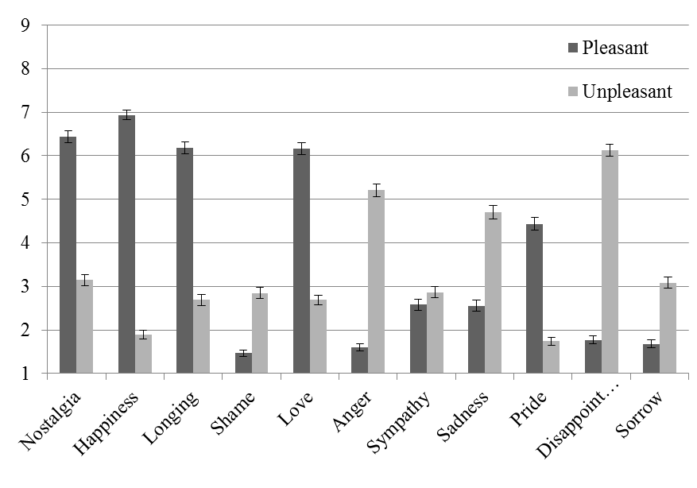

Note: Higher scores indicate greater intensity. Bars represent 95% confidence intervals.

*Figure 3b:* Anticipated emotions following an event with low or high irretrievable loss.

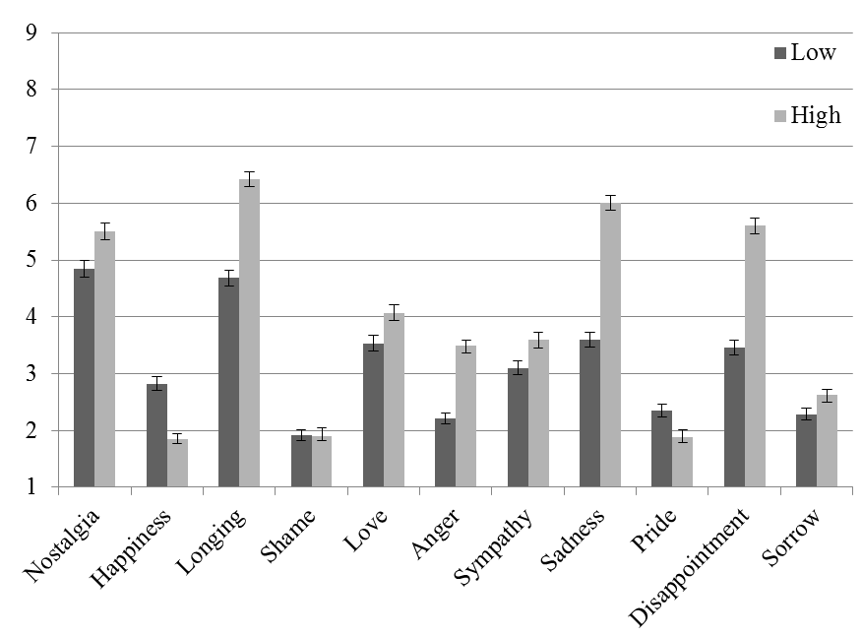

Note: Higher scores indicate greater intensity. Bars represent 95% confidence intervals.

*Figure 3c:* Anticipated emotions following a temporally close or distant event.

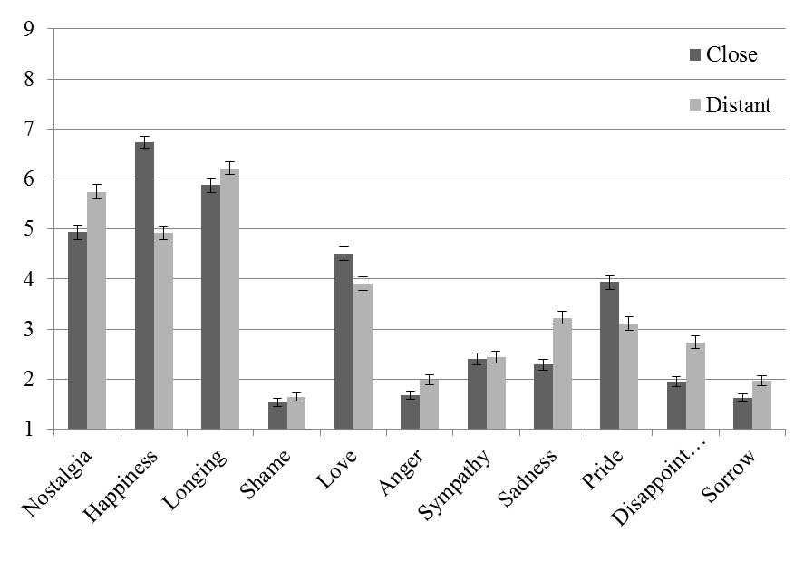

Note: Higher scores indicate greater intensity. Bars represent 95% confidence intervals.

*Figure 3d:* Anticipated emotions following a common or unique event.

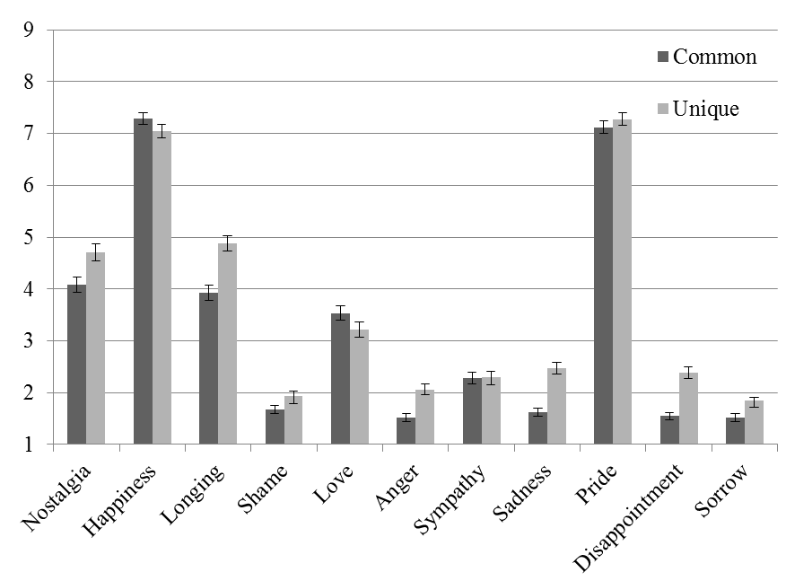

Note: Higher scores indicate greater intensity. Bars represent 95% confidence intervals.

*Figure 4a:* Experienced emotions following an unpleasant or pleasant event.

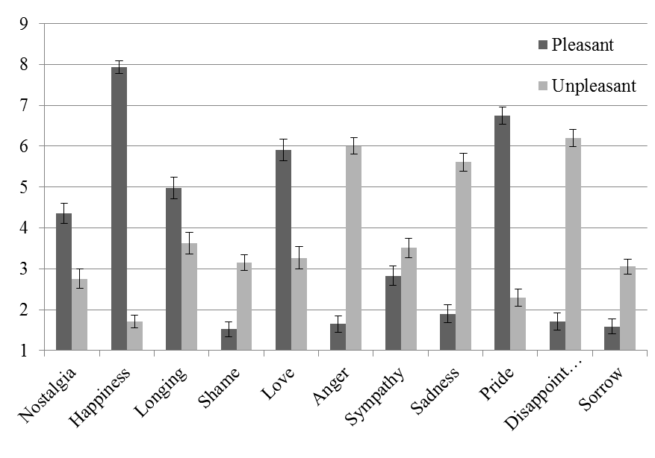

Note: Higher scores indicate greater intensity. Bars represent 95% confidence intervals.

*Figure 4b:* Experienced emotions following an event with low or high irretrievable loss.

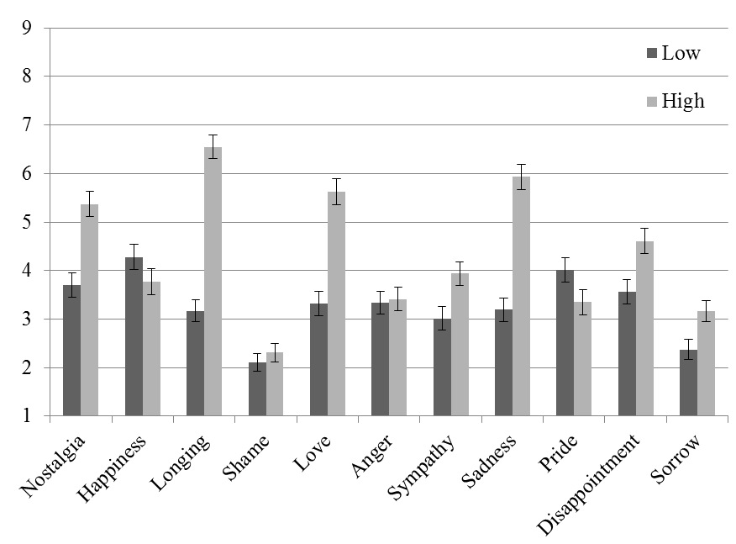

Note: Higher scores indicate greater intensity. Bars represent 95% confidence intervals.

*Figure 4c:* Experienced emotions following a temporally close or distant event.

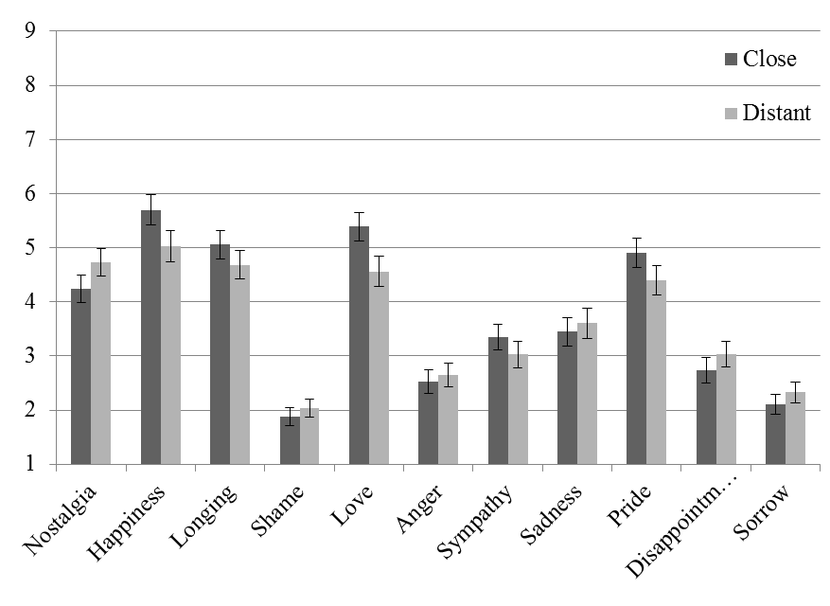

Note: Higher scores indicate greater intensity. Bars represent 95% confidence intervals.

*Figure 4d:* Experienced emotions following a common or unique event.

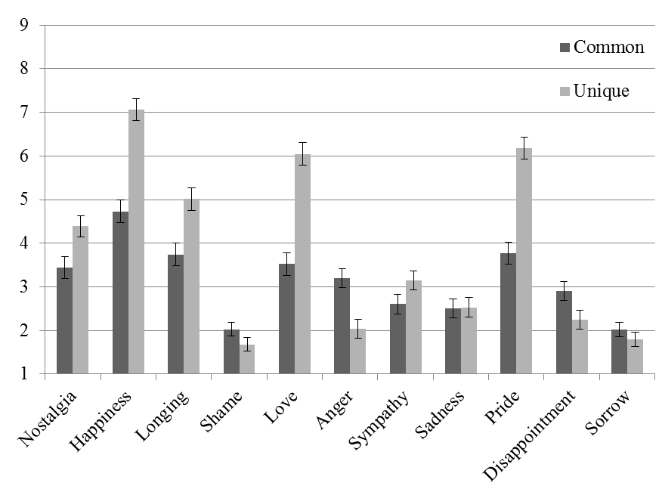

Note: Higher scores indicate greater intensity. Bars represent 95% confidence intervals.

1. The Supplementary Materials contain results after post-hoc corrections, which led to similar conclusions as the results without post-hoc correction.
2. The Supplementary Materials contain results after post-hoc corrections, which led to similar conclusions as the results without post-hoc correction.