Notice:
This document is the unedited Author’s version of a Submitted work that has been subsequently accepted for publication in Nano Letters copyright© American Chemical Society after peer review. To access the final edited and published work see http://pubs.acs.org/doi/abs/10.1021/acs.nanolett.7b05184
Probing Excitons, Trions and Dark Excitons in Monolayer WS₂ using Resonance Raman Spectroscopy
AUTHOR NAMES Liam P. McDonnell, ¹ Chung-Che Huang, ² Qingsong Cui, ² Dan W. Hewak², David C. Smith ^{1*}
AUTHOR ADDRESS. ¹ School of Physics and Astronomy, University of Southampton, Southampton SO17 1BJ, United Kingdom.² Optoelectronic Research Centre, University of Southampton SO17 1BJ, United Kingdom.
KEYWORDS. Two Dimensional Materials, Transition Metal Dichalcogenides, Temperature Dependent, Resonance Raman Spectroscopy
ABSTRACT
We present temperature dependent resonance Raman measurements on monolayer WS₂ for the temperature range 4K to 295K using excitation photon energies from 1.9eV to 2.15eV in ~7meV steps. These are analyzed to determine the resonance profiles of five previously assigned phonon based Raman peaks (A₁′, E′, 2ZA, LA, 2LA) and a previously unassigned peak at 485cm⁻¹ whose possible attributions are discussed. The resonance profiles obtained are fitted to a perturbation theory derived model and it is shown that both excitons and trions are required to explain the profiles. The model is used to separate the contribution of exciton-exciton, trion-trion and exciton-trion scattering to each of the Raman peaks at 4K. This separation allows the ratios of the rates of scattering involving the A₁′ and E′ phonons for each of the three types of scattering to be determined. The explanation of the multi-phonon Raman peaks requires the coupling of bright excitons and trions to large wavevector dark states. The fitting of the resonance Raman profiles for these Raman peaks demonstrates scattering of bright excitons to bright trions via these large wavevector dark states.
In terms of novel optical and optoelectronic physics, mono and few layer transition metal dichalcogenides (TMDC) are materials which just keep on giving ¹. In particular the large spin-orbit coupling and a lack of inversion symmetry in odd layer materials leads to optical control of spin states and reduced spin scattering leading to the possibility of valleytronics ^{2,3}. Extreme confinement and modified screening leads to large excitonic binding energies (~0.5-1 eV) and a series of well-defined, but non-hydrogen like, excitonic peaks within the absorption and emission spectra of the TMDCs ⁴. These same effects lead to a variety of more complex multi-particle excitations including trions ⁵ and biexcitons ⁶ which also contribute to the absorption and emission spectra. These stable multi-particle excitations are already leading to applications such as light emitting diodes which have been shown to exhibit both excitonic and trionic emission ^{7,8} depending on the injection bias. In addition to the bright multi-particle excitations, the extreme confinement and modified screening lead to a range of stable dark multi-particle excitations which despite their inability to couple directly to light are important to optoelectronic properties of the TMDCs. These states are dark due to a variety of selection rules. They include excitons with non-zero orbital angular momentum that lead to peaks within the two photon absorption spectra ⁹; S=1 dark excitons, which in WS₂ and WSe₂ are slightly lower in energy than the bright equivalent excitons, have recently been observed using optical spectroscopy in the presence of an in-plane magnetic field.^{10,11}; and non-zero center of mass momentum excitons including excitons from electrons and holes at different K points and electrons at the Λ point and holes at the K point ¹². These latter excitations have been shown to lead to temperature dependent quenching of photoluminescence ^{13,14} and to effect the excitonic linewidth¹².
A wide variety of optical spectroscopy techniques have been applied to the study of the TMDCs as each technique gives a slightly different insight into the materials. One widely applied technique is Raman spectroscopy ^{15–18}. Clearly Raman spectroscopy′s main application is the measurement of the phonon spectrum as a fingerprint for the number of layers within a flake ^{19,20}. However, the excitation photon energy dependence of the Raman spectra allows access to a much wider range of physics. For instance, resonance Raman spectra obtained with excitation photon energies tuned to a resonance at 2.81eV in MoSe₂ allow the observation of Davydov splitting of Raman peaks and the determination of the strength of interlayer mechanical coupling ²¹. The existence of two phonon and defect-allowed Raman scattering means that Raman spectroscopy is able to probe large-wavevector dark electronic states directly. Such effects have already been used to study the intervalley scattering of excitons by acoustic phonons in MoS₂ and provide insights into phonon dispersion ²². Most of the resonance Raman studies have been performed with relatively coarse excitation energy resolution, i.e. with discrete laser lines rather than continuously tunable laser sources. These studies are suitable for separating the resonances of the A and B excitons but not the contributions of excitons and trions to the individual resonances. In addition nearly all of these studies have been performed at room temperature ^{21,23–27}. The one exception to this is the work of Molas et al. ²⁸ which presents a resonance Raman study performed on monolayer WS₂ at 4K with a continuously tunable laser. This study presents Raman spectra obtained with the excitation laser light tuned to the exciton and trion photoluminescence peaks but does not extract the resonance profiles or fully separate scattering due to the two resonances. In this study we present measurements of the Raman spectra of monolayer WS₂ obtained across the temperature range 4K-295K with excitation photon energies in the range 1.9-2.15eV, across the A exciton resonance, with an excitation photon energy resolution of better than 7meV across the range. The resonance profiles obtained by fitting the spectra are modelled to extract a variety of information about bright and dark excitons and trions including the relative importance of various phonons to the intra and intervalley scattering of trions.

WS₂ flakes were produced using chemical vapor deposition onto a 290nm thick oxide coated silicon substrate. Growth was carried out in a quartz tube furnace with WO₃ (Alfa Aescar 99.998%) and sulfur powder (Alfa Aescar 99.9995%) as the precursors and Ar as the carrier gas with a flow rate of 30 sccm. The sulfur was loaded upstream from the WO₃ and substrate, in a low temperature region, and heated independently to 200Cº. The furnace temperature was initially ramped to 600 Cº with a ramp rate of 20 Cº /min for WS₂ growth the temperature was then increased to 900 Cº with a ramp rate of 5 Cº /min. The temperature was maintained for 15 minutes after which the furnace was cooled naturally to room temperature. Monolayer flakes were then identified via optical microscopy using the contrast difference between single and few layer samples (Figure 1). Flakes were confirmed as monolayer using AFM measurements of layer thickness (0.72nm) and Raman spectroscopy (difference in Raman shift²⁹ of $A_{1}^{'}$ and $E^{'}$ peaks of 61.1cm⁻¹). For maximum consistency the measurements presented in this paper were all performed on the flake shown in Figure 1(b) at the location indicated. The main results were confirmed by results measured at a second location on this flake and on a second flake (see SI). Raman spectra were measured on the sample at temperatures from 4K-295K with a continuous wave dye laser for laser energies in the range 1.9-2.15eV. The experiments were performed in back-scattering geometry using a Olympus LMPlan-IR x50 objective with NA 0.55 to focus the excitation and collect the Raman scattered light with a spot diameter 1.6 μm diameter. The incident laser power dependence of the Raman spectra was measured across the spectral and temperature ranges and the spectra obtained within the linear regime (see SI) with an incident power of 0.7mW. The absence of laser induced sample heating was further confirmed using measurements of the Stokes/Anti-Stokes ratio (see SI). The excitation and collected scattered light were both linearly polarized with the same polarization (vertical). Whilst circular polarization Raman measurements have been used to elucidate details of Raman scattering processes ¹⁸, the key results obtained from Raman scattering can be observed with linear polarized excitation and so this polarization was chosen for consistency with the bulk of the published literature ²⁷. To enable substrate related optical interference effects on the Raman intensity to be corrected, microreflectivity experiments were performed across the temperature range at the same location as the Raman spectra and a nearby uncovered area on the substrate (see SI). Using these measurements the optical effects due to the substrate were modelled and corrected for in line with standard published methods ^{25,27,30} (see SI for more details). The repeatability of measurements at a range of key excitation energies were monitored during each run and from run to run giving a repeatability of the Raman intensity of 9% (see SI for further details). Further experimental details can be found in the supplementary information.
Figure 1. (a) Raman spectra obtained for WS2 monolayer flake shown in (b) taken at 4K with laser energy 2.07eV. This shows six peaks attributed to WS2, see main text for attribution, plus a Si phonon peak (520cm-1) superposed on luminescence from the WS2. (b) Optical microscope image of triangular WS2 flake (edge length = 48m) with a few layer region (green small triangle) at its center. The location and size (1.6 micron diameter) of the excitation laser spot is shown by a white solid circle. The inset presents an AFM topography profile obtained from a scan normal to edge of the flake. The flake thickness obtained from the scan is 0.72nm ± 0.2nm.
A characteristic Raman spectrum obtained at 4K and 2.07eV laser energy is presented in Figure 1a. This spectrum shows six peaks associated with WS₂ plus a 520cm⁻¹ Si phonon peak, due to the substrate, superimposed on luminescence from the WS₂. The attribution of five of the six WS₂ peaks is well accepted within the literature. These are the defect activated longitudinal acoustic (LA) phonon peak at 174cm⁻¹, the two phonon 2ZA peak at 294cm⁻¹, the two LA phonon peak at 349cm⁻¹, the single phonon E′ peak at 356cm⁻¹ and the single phonon A₁′ peak at 417cm^{-1 15,28}. Whilst there have been suggestions in the literature that the 2ZA peak could be associated with a combination mode involving emission of one phonon and absorption of a second phonon, the fact that we observe this mode at 4K means that in line with the argument put forward by Zhang et al. ¹⁵ this cannot be the case. The sixth, new peak can be observed at 479cm⁻¹ and is broader than the other Raman peaks. Whilst this peak hasn′t yet been assigned, it has been clearly observed in WS₂ monolayer flakes by E. del Corro et al. ²⁶ at laser energies of 2.18 and 2.03eV. Based upon published density functional theory calculated WS₂ phonon dispersion relations ^{20,31}, which have successfully been used to interpret the established Raman peaks, it is clear that the unassigned peak cannot be a single phonon peak. Based upon the DFT phonon dispersion relations calculated by Berkdemir et al. ²⁰, which give the best fit to the measured shifts of already assigned peaks of all the published calculations, the most likely assignment for the 479cm⁻¹ peak is a two phonon Raman peak E′′(LO1)(M)+TA(M), although we cannot rule out E′′(TO1)(K)+ZA(K) or E′′(TO1)(K)+TA(K) as alternative assignments (see SI for more details).
In order to obtain the resonance profiles for each of the Raman peaks the six peaks were fitted to Lorentzian lineshapes with a quadratic background, to account for the luminescence, and their center energy, linewidth and spectral weight obtained. As expected, the center energy and linewidth were independent of excitation energy. In Figure 2 we present the excitation energy dependence of the spectral weight of the A₁′ peak, the resonance profile, across the full temperature range. As shown in Figure 2 at room temperature the resonance has the form of a single peak centered at 2.02eV. This is in line with all of the previously published resonance profiles for monolayer WS₂ which were all measured at room temperature. As the temperature decreases the Raman intensity increases significantly, by approximately a factor of ten at 4K, the central energy of the resonance increases and most importantly the resonance clearly develops structure.
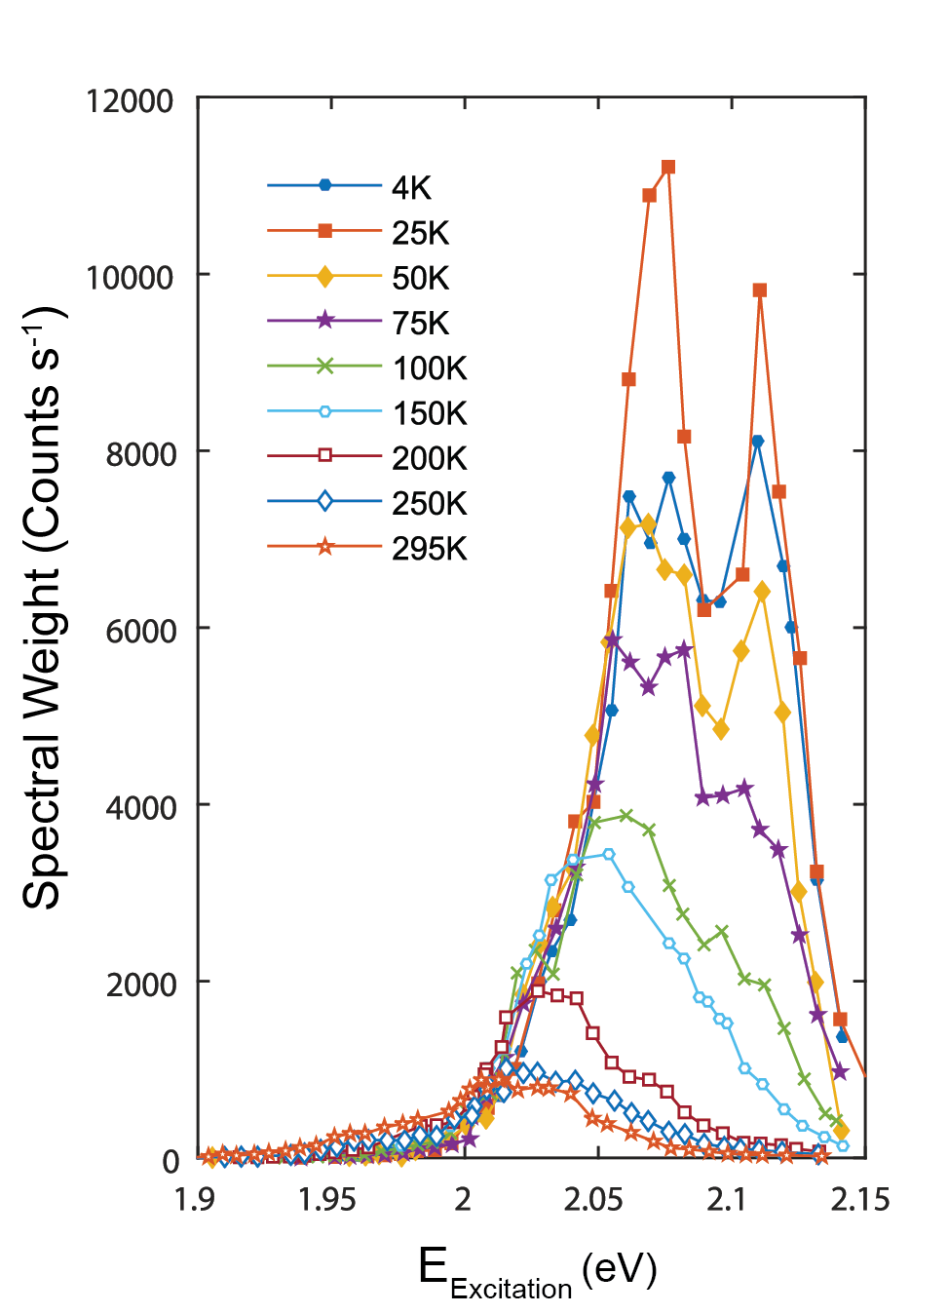
Figure 2 Resonance Raman profiles, spectral weight vs excitation photon energy, of the A₁′ mode at temperatures from 4K to 295K.
To better understand the resonance behavior we next fitted the resonance profile using the standard perturbation theory prediction for the leading order process responsible for single phonon Raman scattering shown in Figure 3a ^{32–34}, where${ \hat{H}}_{d}$ and ${\hat{H}}_{eph}$ represent the electric dipole and electron-phonon interaction Hamiltonians respectively. The ground state is denoted by $\left|\left.0\right\rangle \right.$and the intermediate electronic states are denoted as $\left|\left.i\right\rangle \right., \left|\left.j\right\rangle \right., \left|\left.k\right\rangle \right.$ whose energies are $E_{i,j,k}$ and broadening factors$Γ_{i,j,k}$. The energy of the incident and outgoing photons are denoted as $E_{1,2}$ respectively and the phonons involved in the scattering process have energies$E_{ph1,2}$. The Raman scattering process, represented by the Feynman diagram presented in Figure 3a, involves the sequential conversion of an incoming photon into an optically active (bright) electronic excitation, the scattering of this excitation by a phonon leading to a second, possibly identical, bright electronic excitation, and finally the conversion of this second electronic excitation into a photon. If there is more than one possible sequence of intermediate electronic states then the amplitudes for each of the possible processes (channels) are added leading to the possibility of interference effects³³. It is interesting to note that for a particular channel, i.e $\left|\left.i\right\rangle \right.$ and$\left|\left.j\right\rangle \right.$, the ratio of the amplitudes,$\sqrt{A} \left\langle \left.0\right|{\hat{H}}_{d}\right.\left|\left.i\right\rangle \left\langle \left.i\right|{\hat{H}}_{eph}\right.\left|\left.j\right\rangle \right.\right.\left\langle \left.j\right|{\hat{H}}_{d}\right.\left|\left.0\right\rangle \right.$, for different phonons is given solely by the ratio of the electron-phonon matrix elements allowing the relative rates of these processes to be determined.
In Figure 4 we present the results of fits to the 4K A₁′ resonance profile based upon a series of different scenarios for the electronic excitation involved in the Raman process. In Figure 4a we present the result of a fit assuming a single bright excitation is available. This fit clearly demonstrates that the two main peaks observed in the experimental resonance profiles can be explained by incoming and outgoing resonances with a single bright excitation. However, there is a low energy tail present in the experimental resonance profile this theory cannot explain. In order to try and fit this tail we introduce a second independent bright excitation leading to two channels for the Raman scattering, i.e. we exclude scattering between the two excitations. As shown in Figure 4b, whilst this does lead to additional weight in the resonance profile at lower energies this scenario still fails to fully fit the experimental results. In Figure 4c we present the results of a fit assuming two bright excitations and allowing scattering between the two excitations by the A₁′ phonon. The agreement with the experimental results is excellent.
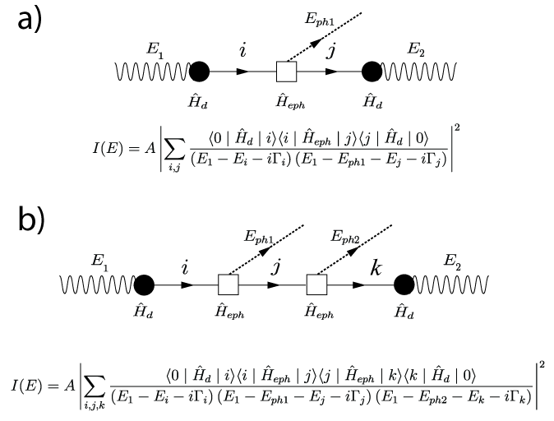
Figure 3 . Feynman diagram and perturbation theory expression for the intensity for a single phonon Raman process (a) and two phonon process (b).
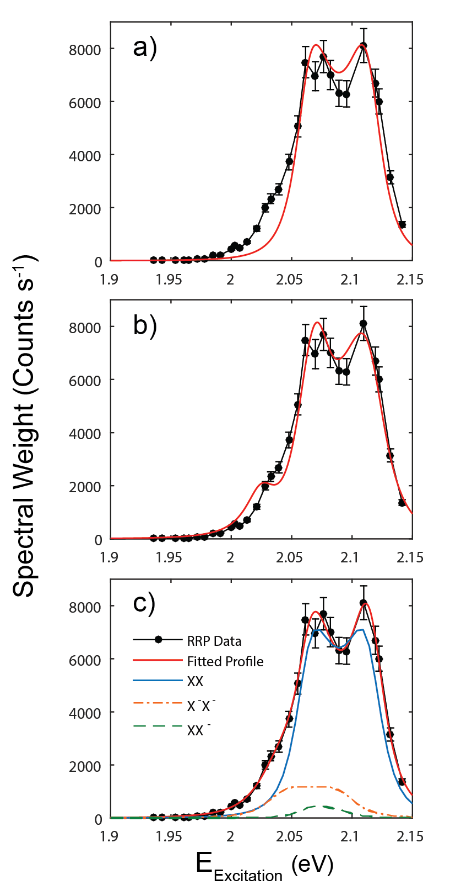
Figure 4 Resonance Raman profile for A₁′ peak at 4K compared to fits of perturbation theory predictions assuming a) a single optically active electronic excitation, b) two independent optically active excitations c) two optically active electronic excitations with scattering between the excitations by the A₁′ phonon. In (c) we present the magnitude squared of the contribution of each of three scattering channels which interfere to give the overall prediction. The best fit parameters obtained from the fit presented in (c) are presented in Figure 5. Error bars shown were obtained from repeatability measurements taken during experimental runs see SI.
There are a number of different candidates for the two bright excitations required to fit the resonance profiles including the A exciton, a trion based upon the A exciton, a biexciton formed from two A excitons and defect localized A excitons. Biexciton based Raman should be superlinear in excitation intensity however we observe a linear excitation intensity dependence thus we can reject the biexciton hypothesis. Whilst defect localized excitons are commonly seen in luminescence spectra ³⁵, particularly at low temperature, they have not been observed in reflectance and PLE ^{36,37}presumably because of their low oscillator strength. As Raman scattering is closer to PLE than luminescence in its dependence on oscillator strength and population we would expect defect localized excitons to make only a weak contribution to Raman scattering. Additionally, in general defect localized excitons lead to a band of luminescence which is significantly broader than the width of the A exciton luminescence ³⁵. In our case we observe the lower energy resonance is either of comparable or lower width than the upper resonance. For these two reasons we reject defect localized excitons. Thus we are left with the conclusion that the upper and lower energy resonances, at 2.064 and 2.038eV, are the A exciton and the A exciton based trion. The energy separation of these two resonances, 26 meV, is well within the range of published trion binding energies ^{4,38–40} and very close to that observed in other CVD grown WS₂ monolayer flakes ^{41,42}.
Having established the simplest model which could explain the 4K resonance profiles we next fitted the temperature dependent A₁′ resonance profiles with the same model. The best fit values for the fitting parameters obtained from these fits are shown in Figure 5. As shown in Figure 5b the energy of the exciton and trion resonances decrease with increasing temperature in line with predictions based upon the expected temperature dependence of the K bandgap^{43,44}. The linewidth of the exciton (Figure 5c) is observed to increase with increasing temperature in line with previously published PL and other data ¹⁴. On the other hand the trion linewidth is either constant or slightly decreasing with increasing temperature. There are no previous results on trion linewidth vs temperature with which to compare this observation. The most striking results are the temperature dependence of the amplitudes of the exciton-exciton (XX), trion-trion (X⁻X⁻) and exciton-trion (XX⁻) Raman channels shown in Figure 5a. Whilst the XX amplitude is only weakly dependent, decreasing by 40% from 4K to 295K, the X⁻X⁻ amplitude decreases by a factor of 22 over the same temperature range. There are conflicting reports in the literature on whether the trion oscillator strength is constant or decrease with increasing temperature. Zhang et al. ¹⁵ present temperature dependent PL data for temperatures in the range 5 to 363K which they fit to obtain the trion oscillator strength for the temperature range 5 to 150K. They conclude that the oscillator strength is constant with temperature up to 150K which is not in agreement with our results. On the other hand, Arora et al. ¹⁴ present the results of PLE measurements of the trion which they interpret as showing a very significant decrease in oscillator strength with increasing temperature; by a factor of at least ten from 4K to 300K which is in qualitative agreement with our results. We observe that the XX⁻ amplitude decreases more slowly than the X⁻X⁻ in line with the expectation that it should be proportional to the geometric average of the XX and X⁻X⁻ amplitudes (see SI for further details).
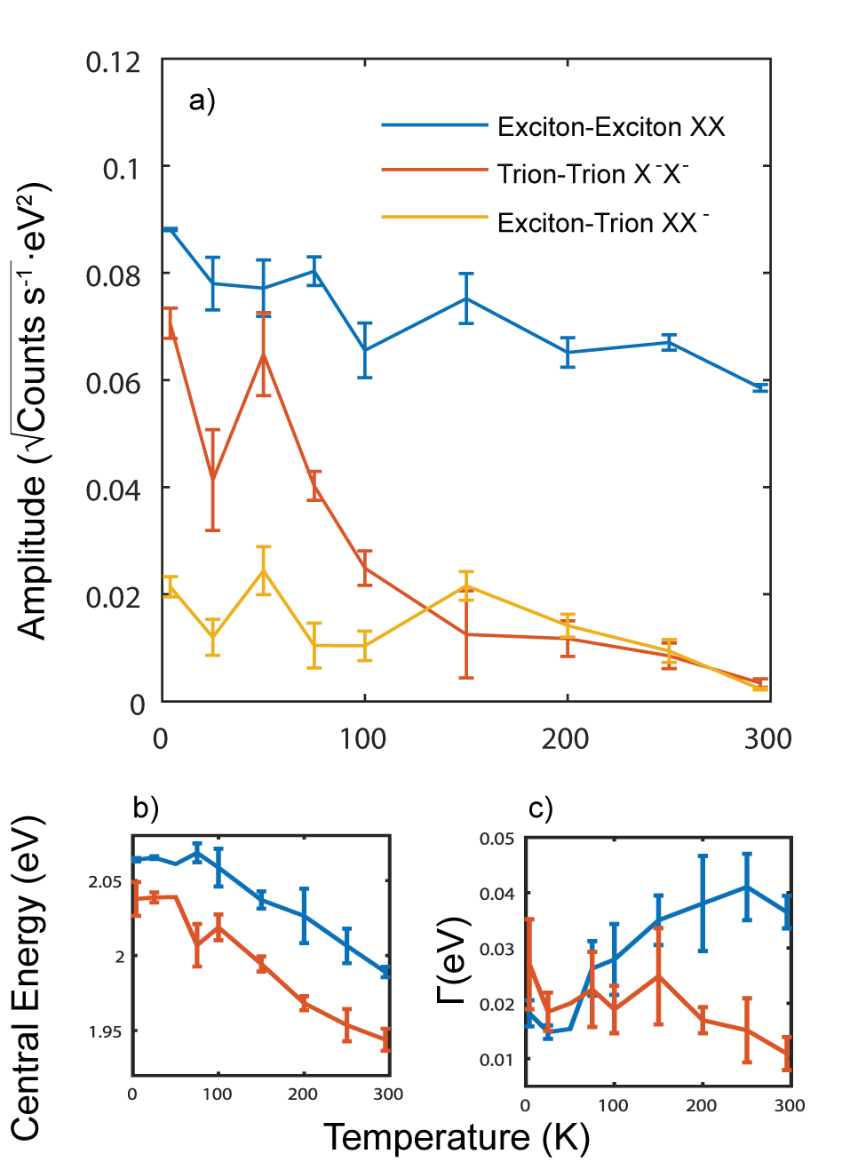
Figure 5 Best fit parameters obtained for the A₁′; mode as a function of temperature from 4K to 295K, after fitting with the three channel model. Panel a) shows the amplitude coefficients obtained for the three Raman channels corresponding to exciton-exciton, trion-trion, and exciton-trion scattering. Panel′s b and c then show the obtained central energy and linewidths for the two electronic excitations respectively. These are attributed as exciton (blue) and trion (orange).For all panels the error bars shown are the 95% confidence intervals obtained from the fitting process for the coefficients.
Having analysed the resonance profiles of the strongest, A₁′, Raman peak we next turn our attention to the other Raman peaks. In Figure 6 we present the 4K resonance profiles for the six WS₂ Raman peaks along with fits using the three channel model developed for the A₁′ phonon. The fits have been performed with exciton and trion parameters, energies and linewidths, fixed at those obtained from the A₁′ fits. i.e. allowing only the amplitude of the three channels to vary. As shown in Figure 6 the experimental resonance profiles for the different phonons differ significantly, e.g. the 2ZA resonance profile has much less weight at lower energies than the A₁′ resonance. Direct comparisons of the different profiles on the same graph are presented in the SI. Despite the differences in the experimental results they can all be fitted using the model developed for the A₁′ case just with different amplitudes for the three channels. The best fit values of the various amplitudes are shown in table 1.
Let us first consider the results of the fits to the single phonon Raman peaks for which the fitted model should be valid. In this case the ratios of the amplitudes for a specific channel, e.g. the XX channel, for two different phonons is solely determined by the ratio of the phonon scattering matrix elements, e.g.$\left.\left\langle i\right.\right|{\hat{H}}_{eph}\left|\left.j\right\rangle \right.$for the two phonons. As the rates of the respective phonon scattering processes are determined by the square of these matrix elements, we can thus determine the ratio of the scattering rates for different phonons scattering between the specified electronic excitations. Note that these scattering rates apply to a wide range of situations not just Raman scattering. Based upon the results of the fitting we can state that the ratio of the phonon scattering rates for the E′ and A₁′ phonons for exciton-exciton, exciton-trion and trion-trion scattering are similar at approximately 1:9. The agreement between these ratios is presumably a reflection of the similarities between excitons and trions. Whilst the result isn’t unexpected we believe this is the first experimental determination of the relative scattering rates for trion-trion and exciton-trion scattering for these phonons.
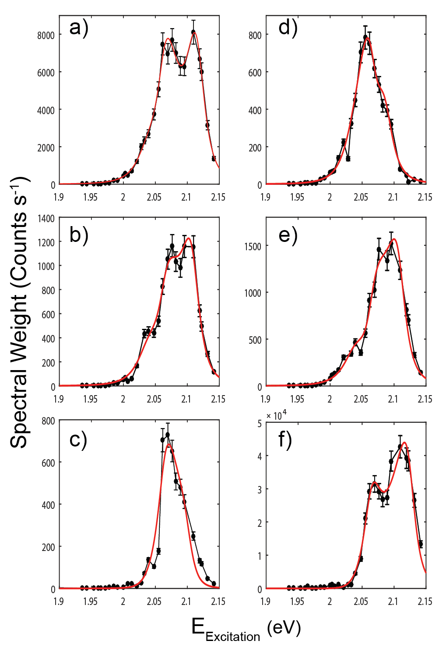
Figure 6 Resonance profiles for six observed Raman peaks fitted to the three channel perturbation theory. (a,b) show the fitted profiles for the single phonon peaks A₁′ and E′ respectively. (c-f) show the fitted profiles for the acoustic and two phonon modes 2ZA, LA, 2LA, and unassigned peak respectively. Error bars shown were obtained from repeatability measurements taken during experimental runs see SI.

Table 1 Amplitude coefficients obtained for all phonon modes at 4K, with errors corresponding to one standard deviation and given in units of${10}^{-3}\sqrt{Counts s^{-1}}∙{eV}^{2}$. These correspond to $\sqrt{A}\left\langle \left.0\right|{\hat{H}}_{d}\right.\left|\left.i\right\rangle \left\langle \left.i\right|{\hat{H}}_{eph}\right.\left|\left.j\right\rangle \right.\right.\left\langle \left.j\right|{\hat{H}}_{d}\right.\left|\left.0\right\rangle \right.$ in the perturbation predictions presented in Figure 3.
Raman Channel | Single Phonon |  | Defect and Two Phonon  Defect and Two Phonon
 | A₁′ | E′ | LA | 2ZA | 2LA | Unassigned
XX | 88.1 ±2.2 | 31.7±1.3 | 4.4±0.3 | 32.1±2.2 | 36±2.4 | 327±3.7
X⁻X⁻ | 70.6±2.8 | 24.0±1.7 | 7.3±1.9 | 19.5±1.5 | 36±3.9 | 62±3.9
XX⁻ | 21.4±1.9 | 7.5±1.1 | 11.6±0.9 | 37.8±1.6 | 12±2.2 | 103±3.0

Let us now consider resonance profiles of the defect assisted and two phonon peaks. The fact that these can be well fitted by the theory developed for single phonon Raman is somewhat surprising as the leading order process expected for these peaks, whose Feynman diagram is presented in Figure 3b, involves an additional large wavevector electronic excitation. The Raman scattering amplitude equation for a two phonon process is shown in Figure 3b and contains an additional electronic excitation denoted k with energy E_{k} and broadening factor Γ_{k}:
However, the single and two phonon predictions give the same result if the large wavevector electronic excitation involved is not strongly resonant; i.e. the scattering involves contributions from a continuum of virtual or real excitations. We can be confident that the additional intermediate states are large wavevector, and thus dark or semi-dark states, because this is required by the center shift and shape of the peaks. The fact that we require all three channels to fit the two-phonon and defect assisted peaks means that we can be confident that both excitons and trions can be scattered to large wavevector, dark or semi-dark, states and that at least some of the large wavevector states can couple to both excitons and trions.
In conclusion we have presented the results of a detailed experimental investigation of the resonance behavior of the E and A₁′ single phonon peaks, the defect assisted LA peak, the two-phonon 2LA and 2ZA peaks and one previously unassigned peak in the Raman spectra of monolayer WS₂ for excitation energies in the range 1.9 to 2.15eV and temperatures in the range 4K to 295K. We have proposed that the unassigned peak, which can also be observed in spectra published by E del Corro et al. is mostly likely a two-phonon peak involving a E′′ (M) +TA (M). Fitting the resonance profiles obtained from the Raman spectra requires two well defined intermediate electronic excitations be involved in the Raman process. The two electronic excitations have been shown to be the bright exciton and trion. The fitting allows us to separate the contributions of exciton-exciton, trion-trion and exciton-trion processes to the Raman intensity. In turn this allows us to quantify the relative rates of trion-trion and exciton-trion scattering by the A₁′ and E′ phonons for for the first time. We find that for trion-trion, exciton-exciton and exciton-trion scattering the ratio of the scattering rates for the E′ and A₁′ phonons are in the ratio 1:9. This is in agreement with the results of Carvalho et al.²⁷ for the exciton-exciton scattering process but extend these results to exciton-trion and trion-trion scattering. It seems likely that the close agreement between the scattering rate ratios for exciton-exciton and trion-trion scattering are due to the underlying similarities of these two excitations however further theoretical work would be required to fully understand these results. For defect assisted and two phonon Raman peaks we have established the role of trion-trion and exciton-trion channels for the first time. The leading order process responsible for these Raman peaks involves large-wavevector, dark or semi-dark, states. We can therefore conclude that phonons can couple bright trions to large wavevector trions or excitons with at least some of these states being able to couple, via the same phonons, to bright excitons as well.
Overall we believe these results demonstrate that Resonance Raman scattering studies have a lot to offer the study of few layer transition metal dichalcogenide materials. In particular Raman processes allow dark excitons and trions to be probed optically. However to get the best from these measurements they have to be done at cryogenic temperatures with sufficient excitation energy resolution to allow the resonances to be accurately fitted. Obvious extensions to this work which should bring interesting results are similar measurements performed at the B and C exciton resonances. In Molybdenum based materials the smaller spin-orbit energies in both the conduction and valance bands should modify the results reported here. Studies on gated samples should allow more details of the trion Raman to be determined. Finally, studies at higher excitation intensities may allow biexcitonic physics, including the possibility of dark biexcitons, to be probed.

ASSOCIATED CONTENT
Supporting Information: Details of repeat measurements on multiple flakes; details of Raman peak assignment; power linearity of the Raman intensity; Anti-Stokes Stokes Temperature measurements; Micro-reflectivity measurements; Raman enhancement factor calculations; experimental repeatability of the Raman intensity; a complete set of fitted resonance profiles for the A₁′ mode as a function of temperature; comparison of exciton-trion scattering amplitude to the geometric average of the exciton-exciton and trion-trion scattering amplitudes; comparison plots for 4K resonance profiles, and photoluminescence spectra at 4K and 295K. This material is available free of charge via the internet at https://pubs.acs.org
AUTHOR INFORMATION
Corresponding Author
*Email: D.C.Smith@soton.ac.uk
Notes
The authors declare no competing financial interest.
ACKNOWLEDGMENTS
This research was supported by the Engineering and Physical Sciences Council of the UK via Program Grants (EP/I033394/1 and EP/N035437/1) and through the Future Photonics Hub (EP/N00762X/1). L.M thanks EPSRC for a doctoral training Award.

REFERENCES

(1) Mak, K. F.; Shan, J. Nat. Photonics 2016, 10 (4), 216–226.
(2) Yao, W.; Xiao, D.; Niu, Q. Phys. Rev. B - Condens. Matter Mater. Phys. 2008, 77 (23), 1–7.
(3) Xiao, D.; Liu, G. Bin; Feng, W.; Xu, X.; Yao, W. Phys. Rev. Lett. 2012, 108 (19), 1–5.
(4) Chernikov, A.; Berkelbach, T. C.; Hill, H. M.; Rigosi, A.; Li, Y.; Aslan, O. B.; Reichman, D. R.; Hybertsen, M. S.; Heinz, T. F. Phys. Rev. Lett. 2014, 113 (7), 1–5.
(5) Mak, K. F.; He, K.; Lee, C.; Lee, G. H.; Hone, J.; Heinz, T. F.; Shan, J. Nat. Mater. 2013, 12 (3), 207–211.
(6) Mai, C.; Barrette, A.; Yu, Y. Nano Lett. 2013, 14 (1), 202–206.
(7) Ross, J. S.; Klement, P.; Jones, A. M.; Ghimire, N. J.; Yan, J.; G., M.; Taniguchi, T.; Watanabe, K.; Kitamura, K.; Yao, W.; Cobden, D. H.; Xu, X. Nat Nano 2014, 9 (4), 268–272.
(8) Withers, F.; Del Pozo-Zamudio, O.; Mishchenko, A.; Rooney, A. P.; Gholinia, A.; Watanabe, K.; Taniguchi, T.; Haigh, S. J.; Geim, a K.; Tartakovskii, a I.; Novoselov, K. S. Nat. Mater. 2015, 14 (3), 301–306.
(9) Schaibley, J. R.; Rivera, P.; Yu, H.; Seyler, K. L.; Yan, J.; Mandrus, D. G.; Taniguchi, T.; Watanabe, K.; Yao, W.; Xu, X. Nat. Commun. 2016, 7, 13747.
(10) Molas, M. R.; Faugeras, C.; Slobodeniuk, A. O.; Nogajewski, K.; Bartos, M.; Basko, D. M.; Potemski, M. 2D Mater. 2017, 4 (2), 021003.
(11) Zhang, X.-X.; Cao, T.; Lu, Z.; Lin, Y.-C.; Zhang, F.; Wang, Y.; Li, Z.; Hone, J. C.; Robinson, J. a.; Smirnov, D.; Louie, S. G.; Heinz, T. F. Nat. Nanotechnol. 2016, No. June, 1–7.
(12) Selig, M.; Berghäuser, G.; Raja, A.; Nagler, P.; Schüller, C.; Heinz, T. F.; Korn, T.; Chernikov, A.; Malic, E.; Knorr, A. Nat. Commun. 2016, No. May, 1–5.
(13) Zhang, X. X.; You, Y.; Zhao, S. Y. F.; Heinz, T. F. Phys. Rev. Lett. 2015, 115 (25), 1–6.
(14) Arora, A.; Koperski, M.; Nogajewski, K.; Marcus, J.; Faugeras, C.; Potemski, M. Nanoscale 2015, 7 (23), 10421–10429.
(15) Zhang, X.; Qiao, X.-F.; Shi, W.; Wu, J.-B.; Jiang, D.-S.; Tan, P.-H. Chem. Soc. Rev. 2015, 44 (9), 2757–2785.
(16) Mignuzzi, S.; Pollard, A. J.; Bonini, N.; Brennan, B.; Gilmore, I. S.; Pimenta, M. A.; Richards, D.; Roy, D. Phys. Rev. B - Condens. Matter Mater. Phys. 2015, 91 (19), 1–7.
(17) O’Brien, M.; McEvoy, N.; Hanlon, D.; Hallam, T.; Coleman, J. N.; Duesberg, G. S. Sci. Rep. 2016, 6 (August 2015), 19476.
(18) Chen, S. Y.; Zheng, C.; Fuhrer, M. S.; Yan, J. Nano Lett. 2015, 15 (4), 2526–2532.
(19) Lee, C.; Yan, H.; Brus, L. E.; Heinz, T. F.; Hone, J.; Ryu, S. ACS Nano 2010, 4 (5), 2695–2700.
(20) Berkdemir, A.; Gutiérrez, H. R.; Botello-Méndez, A. R.; Perea-López, N.; Elías, A. L.; Chia, C.-I.; Wang, B.; Crespi, V. H.; López-Urías, F.; Charlier, J.-C.; Terrones, H.; Terrones, M. Sci. Rep. 2013, 3, 1–8.
(21) Kim, K.; Lee, J. U.; Nam, D.; Cheong, H. ACS Nano 2016, 10 (8), 8113–8120.
(22) Carvalho, B. R.; Wang, Y.; Mignuzzi, S.; Roy, D.; Terrones, M.; Fantini, C.; Crespi, V. H.; Malard, L. M.; Pimenta, M. a. Nat. Commun. 2017, 8, 14670.
(23) Scheuschner, N.; Ochedowski, O.; Schleberger, M.; Maultzsch, J. Phys. Status Solidi Basic Res. 2012, 249 (12), 2644–2647.
(24) Soubelet, P.; Bruchhausen, A. E.; Fainstein, A.; Nogajewski, K.; Faugeras, C. Phys. Rev. B - Condens. Matter Mater. Phys. 2016, 93 (15), 1–9.
(25) Lee, J.-U.; Park, J.; Son, Y.-W. Y.-W.; Cheong, H. Nanoscale 2015, 7 (7), 3229–3236.
(26) Del Corro, E.; Botello-Méndez, A.; Gillet, Y.; Elias, A. L.; Terrones, H.; Feng, S.; Fantini, C.; Rhodes, D.; Pradhan, N.; Balicas, L.; Gonze, X.; Charlier, J.-C.; Terrones, M.; Pimenta, M. A. Nano Lett. 2016, 16 (4), 2363–2368.
(27) Carvalho, B. R.; Malard, L. M.; Alves, J. M.; Fantini, C.; Pimenta, M. A. Phys. Rev. Lett. 2015, 114 (13), 1–5.
(28) Molas, M. R.; Nogajewski, K.; Potemski, M.; Babiński, A. Sci. Rep. 2017, 7, 5036.
(29) Zhao, W.; Ghorannevis, Z.; Kumar, A. K. Nanoscale 2013, 5 (20), 9677–9683.
(30) Yoon, D.; Moon, H.; Son, Y. W.; Choi, J. S.; Park, B. H.; Cha, Y. H.; Kim, Y. D.; Cheong, H. Phys. Rev. B - Condens. Matter Mater. Phys. 2009, 80 (12), 1–6.
(31) Molina-Sánchez, A.; Wirtz, L. Phys. Rev. B - Condens. Matter Mater. Phys. 2011, 84 (15), 1–8.
(32) Jiang, J.; Saito, R.; Sato, K.; Park, J. S.; Samsonidze, G. G.; Jorio, a.; Dresselhaus, G.; Dresselhaus, M. S. Phys. Rev. B - Condens. Matter Mater. Phys. 2007, 75 (3), 1–10.
(33) Cardona, M. Light Scattering in Solids I; Springer Berlin Heidelberg, 1983.
(34) Yu, P.; Cardona, M. Fundamentals of Semiconductors; Springer Berlin Heidelberg, 2010.
(35) Shang, J.; Shen, X.; Cong, C.; Peimyoo, N.; Cao, B.; Eginligil, M. 2015, No. 1, 647–655.
(36) Molas, M. R.; Nogajewski, K.; Slobodeniuk, A. O.; Binder, J.; Bartos, M.; Potemski, M. 2017, 13128–13141.
(37) Jadczak, J.; Kutrowska-Girzycka, J.; Kapuściński, P.; Huang, Y. S.; Wójs, A; Bryja, L. Nanotechnology 2017, 28 (39), 395702.
(38) Plechinger, G.; Nagler, P.; Kraus, J.; Paradiso, N.; Strunk, C.; Schuller, C.; Korn, T. Phys. Status Solidi - Rapid Res. Lett. 2015, 9 (8), 457–461.
(39) Currie, M.; Hanbicki, A. T.; Kioseoglou, G.; Jonker, B. T. Appl. Phys. Lett. 2015, 106 (20).
(40) Mitioglu, A. A.; Plochocka, P.; Jadczak, J. N.; Escoffier, W.; Rikken, G. L. J. A.; Kulyuk, L.; Maude, D. K. 2013, 245403, 1–5.
(41) Kim, M. S.; Yun, S. J.; Lee, Y. H. Y. Y. H. Y.; Seo, C.; Han, G. H.; Kim, K. K.; Lee, Y. H. Y. Y. H. Y.; Kim, J. ACS Nano 2016, 10 (2), 2399–2405.
(42) McCreary, K. M.; Hanbicki, A. T.; Singh, S.; Kawakami, R. K.; Jernigan, G. G.; Ishigami, M.; Ng, A.; Brintlinger, T. H.; Stroud, R. M.; Jonker, B. T. Sci. Rep. 2016, 6 (1), 35154.
(43) O’Donnell, K. P.; Chen, X. Appl. Phys. Lett. 1991, 58 (25), 2924–2926.
(44) Ross, J. S.; Wu, S.; Yu, H.; Ghimire, N. J.; Jones, A. M.; Aivazian, G.; Yan, J.; Mandrus, D. G.; Xiao, D.; Yao, W. Nat. Commun. 2013, 4, 1474.

