Characterising the Land Surface Phenology of Africa using 500 m MODIS EVI
Abstract
Vegetation phenological studies at different spatial and temporal scales offer better understanding of the relationship between the global climate and the global distribution of biogeographical zones. These studies in the last few decades have focussed on characterising and understanding vegetation phenology and its drivers especially using satellite sensor data. Nevertheless, despite being home to 17% of the global forest cover, approximately 12% of the world’s tropical mangroves, and a diverse range of vegetation types, Africa is one of the most poorly studied regions in the world. There has been no study characterising land surface phenology (LSP) of the major land cover types in the different geographical sub-regions in Africa, and only coarse spatial resolution datasets have been used for continental studies. Therefore, we aim to provide seasonal phenological pattern of Africa’s vegetation and characterise the LSP of major land cover types in different geographical sub-regions in Africa at a medium spatial resolution of 500 m using MODIS EVI time-series data over a long temporal range of 15 years (2001 – 2015). The Discrete Fourier Transformation (DFT) technique was employed to smooth the time-series data and an inflection point-based method was used to extract phenological parameters such as start of season (SOS) and end of season (EOS). Homogeneous pixels from 12 years (2001 – 2012) MODIS land cover data (MODIS MCD12Q1) was used to describe, for the first time, the LSP of the major vegetation types in Africa. The results from this research characterise spatially and temporally the highly irregular and multi-annual variability of the vegetation phenology of Africa, and the maps and charts provide an improved representation of the LSP of Africa, which can serve as a pivot to filling other research gaps in the African continent.

Keywords
Climate; Land cover; Ground-based; Remote sensing; Vegetation.

- Introduction
The study of vegetation phenology, which deals with the timing of plant growth stages and their inter-annual variation, can increase our understanding of global climate-vegetation relationships, and in particular can be used to characterise the impact of climate change on terrestrial ecosystem (Chmielewski & Rötzer, 2001; Cleland et al., 2007; Richardson et al., 2013; Broich et al., 2014; Clinton et al., 2014). Consequently, the study of vegetation phenology has received increased attention in recent years, providing detailed characterisation of spatio-temporal changes in terrestrial biogeochemical cycles.

Ground-based observations of vegetation phenology, offer detailed and fine temporal resolution data for different vegetation types (Rodriguez-Galiano et al., 2015b). However, these observations are limited in spatial coverage (Studer et al., 2007). On the other hand, satellite-based remote sensing techniques, which measure land surface phenology (LSP) (defined “as the seasonal pattern of variation in vegetated land surfaces observed from remote sensing” (Friedl et al., 2006)), offer wide spatial coverage, and can monitor the inter-annual variability of vegetation dynamics in areas without ground data (Julien & Sobrino, 2009; Guan et al., 2013; Zhang et al., 2014; Rodriguez-Galiano et al., 2015a). These techniques also offer the capability of quantifying vegetation response to climate variability (Ma et al., 2008; Zhu et al., 2012; Broich et al., 2014; Guan et al., 2014b). Other advantages can be seen in studies covering ecosystem processes and diversity, for example, in studies of the phenology of bird communities from space (Cole et al., 2015), and understanding transhumance patterns (Butt et al., 2011; Brottem et al., 2014).

In the northern high latitude regions such as Europe and North America, numerous studies have detailed the characteristics of vegetation phenology at both fine and coarse temporal and spatial resolutions, either through ground-based measurements or by remote sensing techniques (Chmielewski & Rötzer, 2001; Zhang et al., 2004; Menzel et al., 2006; Ganguly et al., 2010; Wu et al., 2012; Jeganathan et al., 2014; Walker et al., 2014; Rodriguez-Galiano et al., 2015a). There are also robust ground-based observation networks in these regions. Examples of such networks are: the US National Phenology Network, the Woodland Trust, UK, International Phenological Gardens (IPG) in Europe and the German phenological network (Chmielewski et al., 2004; Graham et al., 2010; Boyd et al., 2011; Zhang et al., 2012; Menzel, 2013; Wolkovich et al., 2014).

In Africa, there have also been several phenological studies, both ground-based and satellite-based (Adole et al., 2016). However, despite being home to 17% of the world’s forest cover (Food and Agriculture Organization of the United Nations, 2010), approximately 12% of the world’s tropical mangroves (Giri et al., 2010; Donato et al., 2011), and with a diverse range of vegetation types (Figure 1), compared to other continents, the number of phenological studies in Africa is very limited (Adole et al., 2016). Similarly, unlike other regions, there are no phenological networks in Africa (Adole et al., 2016).

A recent systematic review by Adole et al. (2016) revealed that of 9,566 articles on vegetation phenology globally, only 130 focused on Africa. Moreover, despite the advances in LSP, particularly with the availability of fine spatial resolution data, and knowing that at coarser spatial resolutions phenological information may be misread (Fisher & Mustard, 2007), only 15 studies evaluated LSP at a continental scale using coarse spatial resolution (ranging from 1 to 8 km) data (Adole et al., 2016). Adole et al. (2016, Table 1) found that studies over longer periods used coarse spatial resolution datasets while those with a shorter duration of five years or less commonly used a spatial resolution of 1 km. Additionally, the temporal resolutions of most of these studies were relatively coarse (10 – 16 day), thereby increasing the potential for errors in vegetation phenology estimation (Zhang et al., 2009). Although the MODIS Land Cover Dynamics product (MCD12Q2) provides global LSP information at a spatial resolution of 500 m there are large uncertainties, and sometimes unrealistic LSP parameter values, associated with this product (Ganguly et al., 2010; Vintrou et al., 2012) and, thus, may not be reliable for detail characterisation of LSP. Also, this product which was last released in 2012 is not as recent as other MODIS data and does not benefit from the recent reprocessing of MODIS data products. Based on these findings, we have summarized the identified research gaps which are relevant to this below:

- There has been no study characterising LSP of the major land cover types in the different geographical sub-regions in Africa.
- At a continental scale, only coarse spatial resolution datasets ranging from 1 to 8 km have been used for LSP studies in Africa, and
- 10 – 16 day temporal resolution datasets were used with the exception of only two studies which used daily datasets, albeit at coarse spatial resolutions of 3 and 5 km (see Table 1).

In addition to the above highlighted gaps, Africa is known to have complex vegetation dynamics (Favier et al., 2012) and its vegetation types are very distinct in their responses to climatic factors, resulting in great variability in phenological patterns. Although there are generally two major maximum rainfall seasons in Africa (the June-to-August season in the northern latitudes and the December-to-February season in the southern latitudes) (Griffiths, 1971), the distribution of these seasons varies considerably across the continent. This can be seen in the rainfall seasons in the extreme north falling into the December-to-February season and southwestern Africa falling into the June-to-August season (Griffiths, 1971). Also, the Horn of Africa, which is greatly affected by the Inter-Tropical Convergence Zone (ITCZ) (Thompson, 1965), and the Guinea coast in West Africa exhibit a unique double peak or two seasonal rainfall patterns (Herrmann & Mohr, 2011; Liebmann et al., 2012). This variation in the climate of the different geographical sub-regions in Africa (see Figure 1) plays a significant role in the vegetation dynamics in these regions, hence the requirement to characterise LSP regionally.

In view of the above, it is apparent that there is a need to provide more detailed LSP information for the African continent. This detailed LSP information is likely to be very important in climate-vegetation modelling and can potentially help in increasing our understanding of carbon, energy and water cycles, characterisation of soil-vegetation-atmospheric feedbacks, and predictive phenology modelling. This would also aid in-depth monitoring of agricultural production and livestock management practices which would be unique to the different geographical regions in African farmlands and rangelands. Therefore, the aim was to characterise the spatial distribution of LSP in Africa using medium spatial and temporal resolution (500 m, 8-day) MODIS EVI time-series data with a long temporal range of 15 years (2001 – 2015). The specific objectives were to:

- establish a baseline of LSP over Africa at a fine spatial resolution of 500 m
- determine the latitudinal variation and inter-annual variability of LSP in Africa at a fine spatial resolution of 500 m compared to previous work.
(3) Using these data, characterise the LSP of the major land cover types in different geographical sub-regions in Africa, and
(4) demonstrate the advantages of the medium spatial resolution of 500 m.

Comprehensive ground-based validation of the LSP maps from this research is not possible presently due to the absence of a broad-scale ground-based observation network across the African continent. Therefore, comparisons were made between the estimated LSP and previous vegetation phenology studies, and the ground-based vegetation phenology data for the few areas for which data were available.
Table 1: Number of LSP studies in Africa undertaken at a continental scale with the Advanced Very High Resolution Radiometer (AVHRR), the Moderate-resolution Imaging Spectroradiometer (MODIS) and the Spinning Enhanced Visible and InfraRed Imager (SEVIRI) sensors.
Authors | Period | Temporal frequency | Sensor | Spatial Resolution (km) | Index | Research findings
Brown et al. (2010) | 1981 - 2008 | 15-day | AVHRR | 8 | NDVI | LSP is significantly affected by climate oscillations
Camberlin et al. (2007) | 1981 - 2000 | 15-day | AVHRR | 8 | NDVI | Significant correlation between annual NDVI values and rainfall variations
Guan et al. (2013) | 2000 - 2012 | 16-day | MODIS | 5 | EVI | Strong seasonality coupling between vegetation function and structure which is controlled by precipitation in tropical forest
Guan et al. (2014a) | 2007 - 2011 | Daily | SEVIRI | 3 | LAI | New algorithm that can be used to derive LSP across other carbon related datasets
Guan et al. (2014b) | 2000 - 2011 | Daily | MODIS | 5 | NDVI | Distinct responses of African savannas and deciduous woodlands LSP to rainy season
Jönsson & Eklundh (2002) | 1982 - 2000 | 10-day | AVHRR | 8 | NDVI | New algorithm for estimating LSP
Jönsson & Eklundh (2004) | 1998 - 2000 | 10-day | AVHRR | 8 | NDVI | TIMESAT programme for processing time-series of satellite data
Justice et al. (1989) | 1981 | 15-day | AVHRR | 8 | NDVI | Microwave polarization difference temperature (MPDT) relationship with NDVI seasonal variations
Linderman et al. (2005) | 2000 - 2004 | 16-day | MODIS | 1 | EVI | Interannual changes in vegetation activity not linked to shifts in phenology
McCloy & Tind (2011) | 1982 - 2008 | 15-day | AVHRR | 8 | NDVI | Changes in vegetation phenology overtime
Stroppiana et al. (2009) | 1990 - 2002 | 10-day | AVHRR | 8 | NDVI | A new anomaly indicator (AI) for abstract environmental status assessment and monitoring using phenological data
Vrieling et al. (2008) | 1981 - 2006 | 15-day | AVHRR | 8 | NDVI | Temporal trend analysis of crop phenology showing both positive and negative yield across Africa
Vrieling et al. (2011) | 1982 - 2006 | 15-day | AVHRR | 8 | NDVI | Understanding variability and trends in seasonal cumulated NDVI (cumNDVI) is important in characterising farming systems
Vrieling et al. (2013) | 1981 - 2011 | 15-day | AVHRR | 8 | NDVI | The variability and trend of length of growing period (LGP) in Africa
Zhang et al. (2005) | 2000 - 2003 | 16-day | MODIS | 1 | EVI | Vegetation green-up strongly dependent on rainfall seasonality in Africa

- Methodology
  - Data acquisition and pre-processing
    - MODIS land surface reflectance data
MODIS data, which are significantly improved in terms of spatial and spectral resolution, atmospheric corrections, cloud screening and sensor calibration (Soudani et al., 2008) compared to AVHRR, were acquired for this study. 16 years (18 Feb 2000 – 24 June 2016) of 44 MODIS/Terra Surface Reflectance 8-Day L3 Global 500 m SIN Grid V005 data (MOD09A1) tiles were downloaded from NASA’s LP DAAC (https://lpdaac.usgs.gov/). These data provide a long temporal record of a medium spatial resolution product. Apart from the seven spectral bands [bands 1 (620-670 nm), 2 (841-876 nm), 3 (459-479nm), 4 (545-565 nm), 5 (1230-1250 nm), 6 (1628-1652 nm), and 7 (2105-2155 nm)], this product has an additional 32-bit Quality Assurance (QA) layer which was used for quality assessment. To filter out residual atmospheric and sensor effects, only pixels with the highest quality of band 1 – 7 which had adjacency and atmospheric correction performed, and all possible corrections of MODIS land Quality Assessment (MODLAND QA), were retained. (see https://lpdaac.usgs.gov/sites/default/files/public/modis/docs/MODIS_LP_QA_Tutorial-3.pdf for details on the QA assessment procedures).

The Enhanced Vegetation Index (EVI), which overcomes the saturation problems of the Normalized Difference Vegetation Index (NDVI), especially in areas with large amounts of vegetative biomass (Huete et al., 2002), was selected as the vegetation index for use in this study. It was developed with the inclusion of the blue reflectance band (B) to correct for atmospheric and soil background influences (Huete et al., 2011; Rowhani et al., 2011), and is derived according to the following equation:

$$EVI=G*\frac{\left(NIR-Red\right)}{\left(L+NIR+C1*Red-C2*Blue\right)}$$

The coefficients of the EVI equation are L=1(canopy background adjustment factor); C1= 6 and C2 = 7.5 (aerosol correction factors); and G = 2.5 (gain factor) (Huete et al., 2002, 2011; Reed et al., 2009; Rowhani et al., 2011).

    - MODIS Land Cover Type data
To represent the land cover of Africa, 12 years (2001 – 2012) of 44 tiles MODIS/Terra Land Cover Type Yearly L3 Global 500 m SIN Grid V005 data (MCD12Q1) (h16v05 to h22v11) were downloaded from NASA’s LP DAAC (https://lpdaac.usgs.gov/). This product has five different land cover classification schemes. The 17-class International Geosphere Biosphere Programme (IGBP) global vegetation classification scheme, shown to be the best among the five schemes, was selected for this analysis (Scepan & Estes, 2001; Friedl et al., 2010) (see figure 1).

Figure 1: (a) Land cover map of Africa derived from the 500 m MODIS land cover type product (MCD12Q1) data for 2012, downloaded from NASA’s LP DAAC (https://lpdaac.usgs.gov/). (b) Map of Africa, showing the five different geographical sub-regions (Griffiths, 1971; United Nations, 2014).

  - Data analysis
    - LSP estimation
To begin LSP estimation, EVI data were stacked into 86 layers (Figure 2) (a layer being one composite EVI image), which defined a “cycle” to include two years (i.e., July of year 1 to June of year 3). This is to account for the non-uniform growing seasons across Africa, where start of season is much earlier in the northern latitudes compared to southern latitudes, ensuring that seasonal phenological parameters are estimated yearly.
Four steps were carried out to estimate LSP from the EVI time-series data (Figure 3).
(1) Removal of drop outs in the EVI time-series with a temporal moving average window
(2) Linear interpolation for gap filling (Dash et al., 2010)
(3) Data smoothing to further reduce residual noise in data using the inverse Discrete Fourier Transform (DFT)
(4) A search process to find the phenological parameters (e.g., minima in the smoothed time-series).
The Discrete Fourier Transform (DFT), a frequency-based smoothing technique was applied to the EVI time-series. This method undertakes a frequency decomposition of the temporal profile of a time-series using Fourier analysis and then reconstructs back to the temporal domain via an inverse Fourier transform, in the present case based on only the smoother components (Moody & Johnson, 2001; Atkinson et al., 2012). One major advantage of this technique is the minimal user input, as users need to specify only the number of harmonics required to reconstruct the time-series (Dash et al., 2010). It has been established that the first two harmonics can adequately represent annual or semi-annual cycles (Jakubauskas et al., 2001). Considering the bimodal seasonality and double cropping agricultural systems found in some parts of Africa, the first six harmonics, as used in Dash et al. (2010), were used to generate the smoothed time-series (Figure 2).

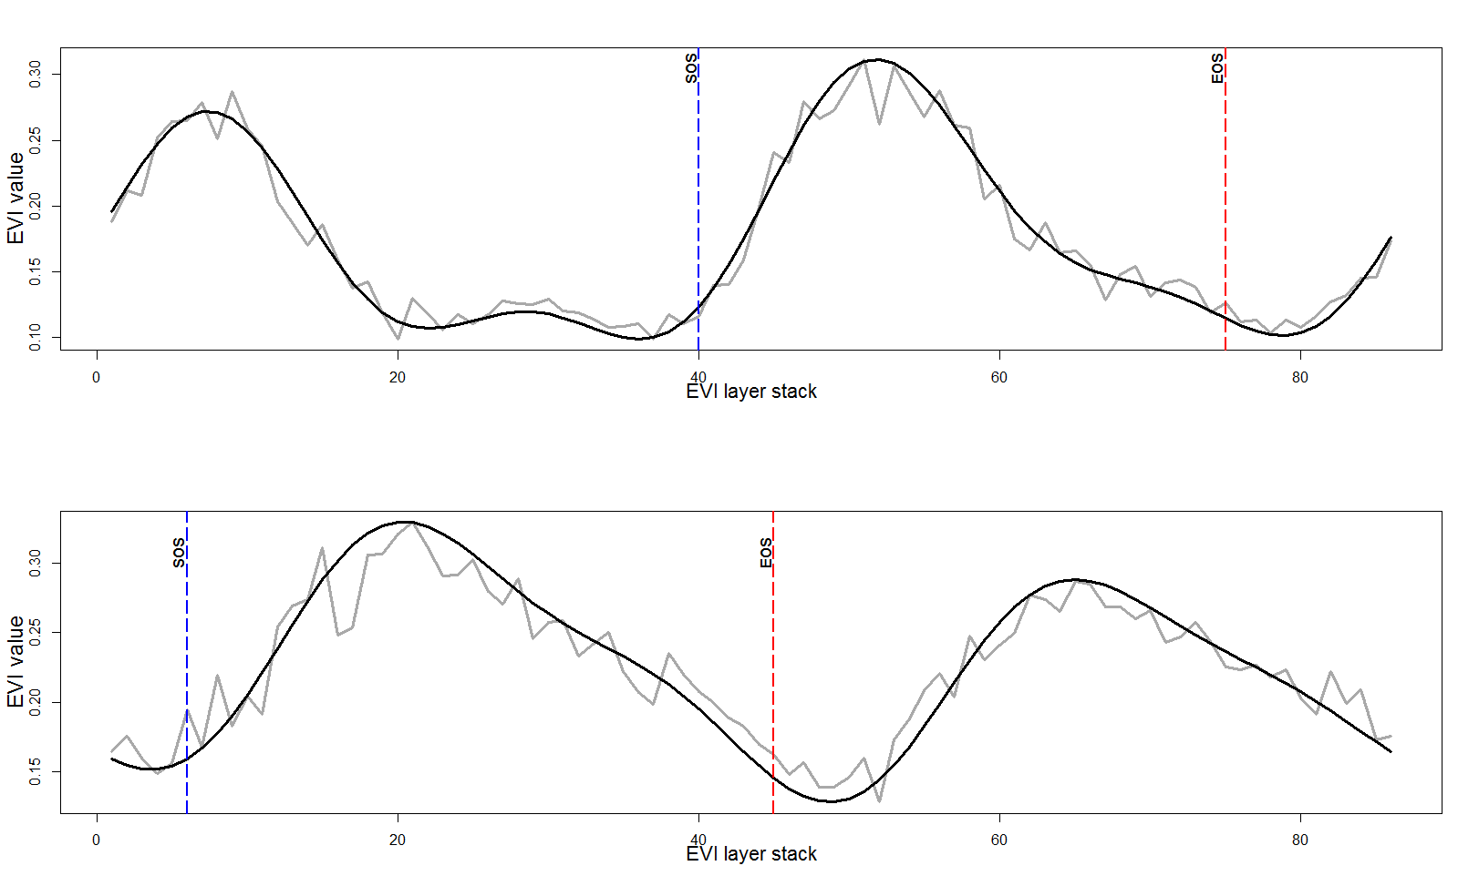
Figure 2: Example of pixels showing the smoothed temporal profile of an 86 layer-stacked EVI time-series in black superimposed on the raw EVI data in grey. Blue dotted lines are the SOS and red dotted lines are EOS estimated for each time-series.

Finally, LSP parameters were estimated using the inflection point method based on points of maximal curvature in the time-series (Figure 2) (Reed et al., 1994; Moulin et al., 1997; Zhang et al., 2001; Dash et al., 2010). We used an algorithm which departs at the maximum peak, and iteratively searches for valley points (change in derivative value) at the beginning of the growing cycle (Start of Season (SOS), i.e. a change in derivative value from positive to negative) and at the decaying end of the phenology cycle (End of Season (EOS), i.e. a change in derivative value from negative to positive) (Dash et al., 2010; Pastor-Guzman et al., 2018). The length of season (LOS) was determined as the difference between the estimated SOS and the EOS, converted to number of days. The median values for these parameters for the period of 2001 to 2015 were estimated and then converted to their corresponding Julian days (i.e. day of year (DOY)).
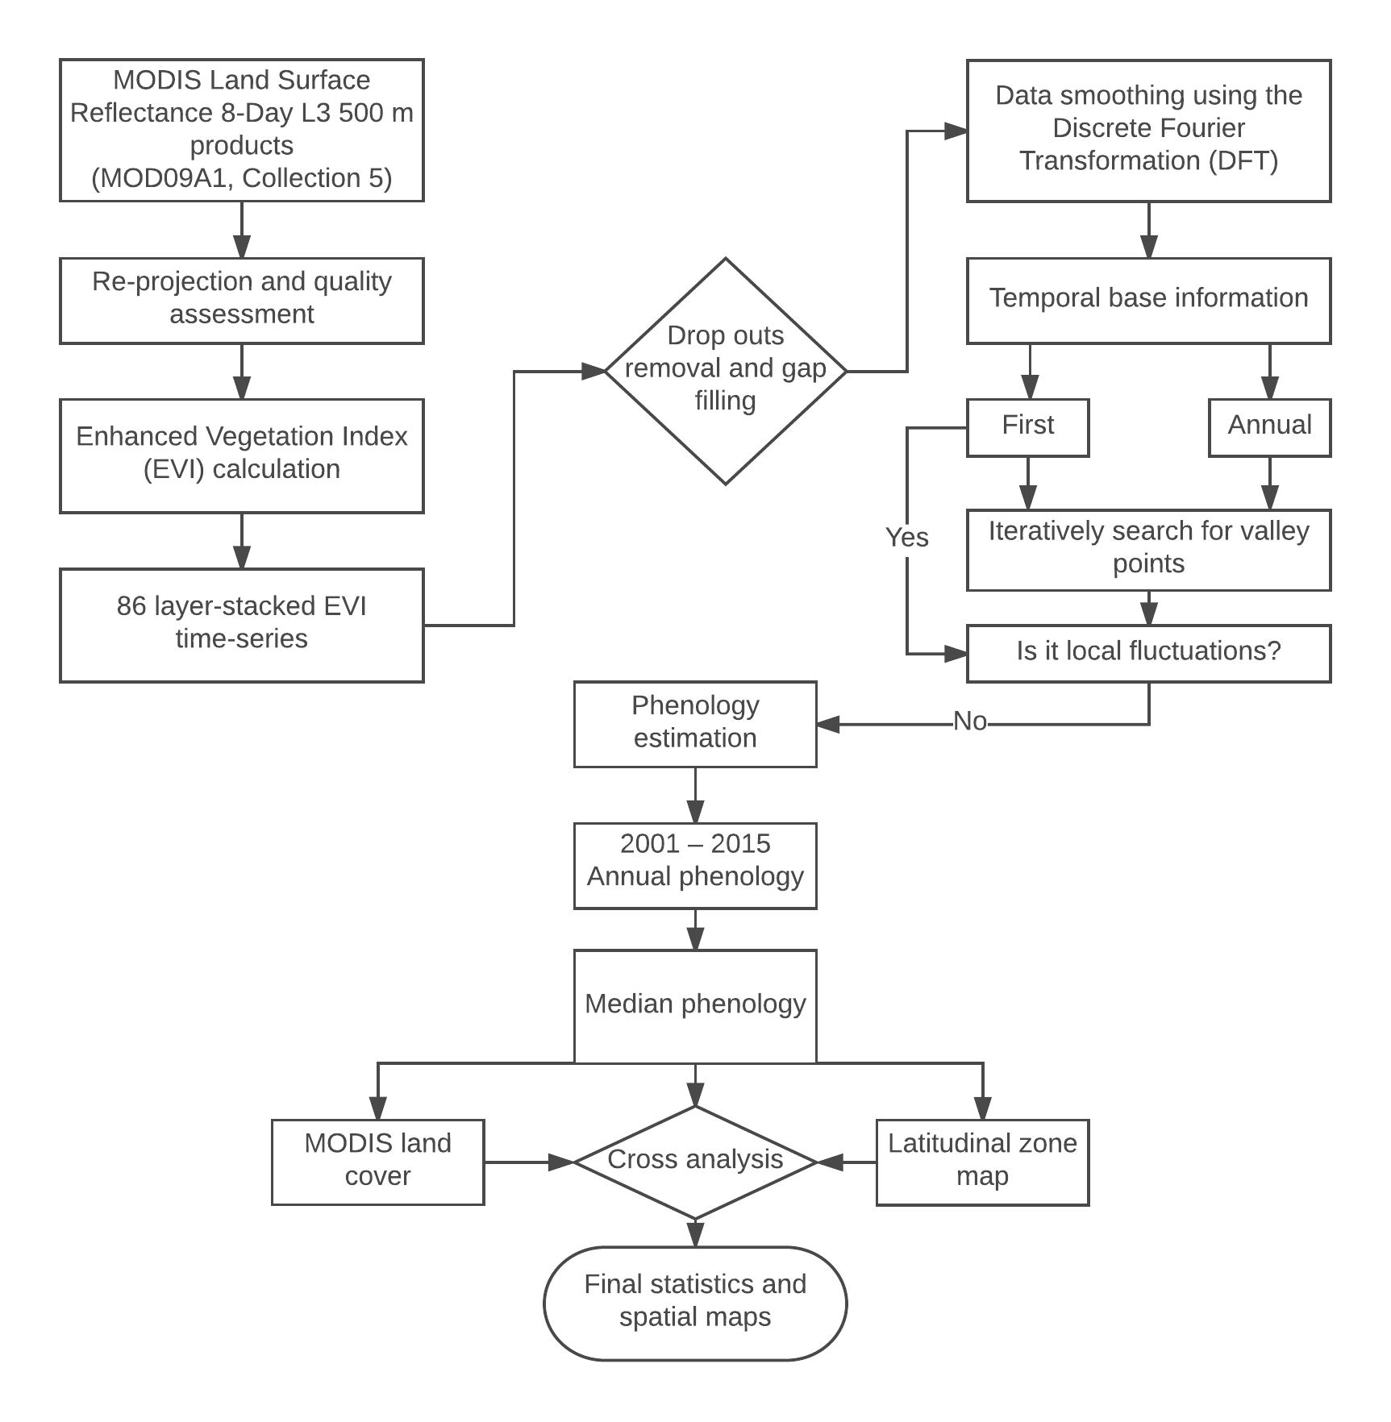
Figure 3: Schematic diagram illustrating the research methodology adopted in this study.

    - MODIS land cover masking
A further reclassification was carried out on the MODIS land cover 17-class International Geosphere Biosphere Programme (IGBP) global vegetation classification scheme, by merging classes with very similar phenological behaviour into broad vegetation classes. For example, evergreen needleleaf forest and evergreen broadleaf forest were merged together to give one class of “evergreen forest”. Pixels belonging to other land cover types that are not vegetation were masked out. Additionally, pixels which remained as the same class over the time-series of 12 years were extracted and used to mask the phenology estimates based on the geographical sub-regions in Africa.

  - Analysis of LSP
To analyse the variation in phenology with latitude, the majority (i.e. modal values) of LSP parameters were estimated per degree increase in latitude. Thereafter, a simple linear regression model was used to estimate the expected change in phenological parameter per degree increase in latitude (LSP parameters as the dependent variable and latitude as the independent variable) and the signiﬁcance of the models assessed.

To determine the inter-annual variability of LSP parameters over the entire time-series, the temporal standard deviation (STD) values for each LSP parameter in each pixel were estimated. A large magnitude of STD can reveal areas that have unstable seasons in Africa. Additionally, to quantify the spatial distribution of LSP parameters across Africa the percentage of pixels of LSP parameters belonging to each land cover type in the different geographical sub-regions was determined. Finally, to demonstrate the effect of spatial resolution, the STD of the SOS values were estimated with spatial resolutions of 1 km, 3 km, 5 km and 8 km obtained by image degradation (linear averaging).

- Results
  - Spatiotemporal variation in vegetation phenological parameters
Maps produced indicating the median start and end dates, as well as the length of the growing season for the study period 2001-2015 across Africa showed high variability throughout the continent (Figure 4). Between the latitudes of 0⁰ and 20⁰N which covers the Sahel, Sudan and Guinean regions of Africa, the beginning of the growing season (SOS) has a wide range between late February and early August with most SOS estimates occurring in late February and June. The end of the growing season in these regions falls between late November and the following February, with a long growing season of 150 – 310 days. These very long growing seasons have also been observed by Yan et al. (2016). However, some parts of Eastern Africa have SOS dates that are between August and October and EOS between late June and August of the following year. Further north, above 27⁰N, most SOS dates occurred between September and November. The corresponding EOS dates are between May and August. This can be attributed to the different seasonal rainfall patterns observed in the extreme north which begins around September with peaks in December and February (Griffiths, 1971; Liebmann et al., 2012). No clear seasonality was detected in most parts of Central Africa, due to the presence of very dense canopies of evergreen forest, and persistent cloud prohibited sufficient cloud free data collection.
In contrast to most areas in the north, for the south of Africa, between latitudes 0⁰ and 34⁰S, the majority of SOS dates fell between August and November and corresponding EOS dates between May-June and August of the following year. In the southwestern region, different SOS and EOS dates were observed; February to April for SOS and November to the following year February for EOS. This can be explained by the distinct rainfall pattern observed in this region (rainfall peaks in June to August) (Griffiths, 1971; Liebmann et al., 2012).
Bimodality was also observed in the Horn of Africa and some parts of Western Africa particularly in the coast of Guinea (Figure 5). This could be as a result of dual seasonal rainfall patterns, with peaks in April-May and October-November observed in these regions (Herrmann & Mohr, 2011; Liebmann et al., 2012) or artificial bimodality due to residual noise in the EVI data, especially where the bimodality lacks consistency in space and time. Vegetation growth for this second season starts between late August and November and ends between December and February. A shorter LOS of 112 – 144 days was also observed in the Horn of Africa for both the first and second seasons (see figure 4 and 5).

Figure 4: The median values of phenological patterns derived from MODIS EVI data. (a) Start of Season (SOS) and (b) median End of Season (EOS) shown in months; (c) median Length of Season (LOS) shown in number of days.

Figure 5: The median values of phenological patterns derived from MODIS EVI data. (a,b,c) median (a) start, (b) end and (c) length of season for areas with second seasonal cycle in Western Africa and (d,e,f) median (d) start, (e) end and (f) length of season for areas with second seasonal cycle in Eastern Africa.

  - Latitudinal gradient
The variability of the majority values of LSP parameters was observed across the African latitudinal gradient (Figure 6). Latitude had more influence on SOS and EOS in the northern part of Africa than in the south. Approximately 49% of SOS dates and 59% of EOS dates north of the equator can be explained by latitude (p<0.0001). A one degree increase in latitude will result in an approximately 5 days delay in SOS and 5 days advance in EOS dates (0.05 days km⁻¹) (see Table 2). However, the correlation between LOS and latitude was not significant (p=0.870).

Table 2: y-intercept, slope and coefficient of determination for linear regression between LSP parameters and latitude.
Latitude | y-intercept |  |  |  | Slope |  |  |  | R² |  |  |  | p (Sig.)
 | SOS | EOS | LOS |  | SOS | EOS | LOS |  | SOS | EOS | LOS |  | SOS | EOS | LOS
North | 104.019 | 320.978 | 216.349 |  | 5.118 | 5.511 | -0.185 |  | 0.485 | 0.590 | 0.001 |  | <0.0001 | <0.0001 | 0.870
South | 296.467 | 556.786 | 225.771 |  | 1.434 | 1.155 | -1.035 |  | 0.212 | 0.029 | 0.044 |  | 0.005 | 0.325 | 0.225

However, no significant relationship was observed between EOS and latitude south of the equator (R²= 0.029, p=0.325), while a relatively small correlation was observed between SOS and latitude (R²= 0.212, p=0.005).
For a specific land cover type, the latitudinal variation in the phenology also follows the same pattern as explained before (i.e. a very small phenology-latitude correlation in the Southern hemisphere, and a large dependence on latitude in the Northern hemisphere of Africa). However, this trend was interrupted at latitude 30⁰N northwards and latitude 31⁰S southwards. This could be because of the different climatic conditions operating in these regions (see section 3.1).

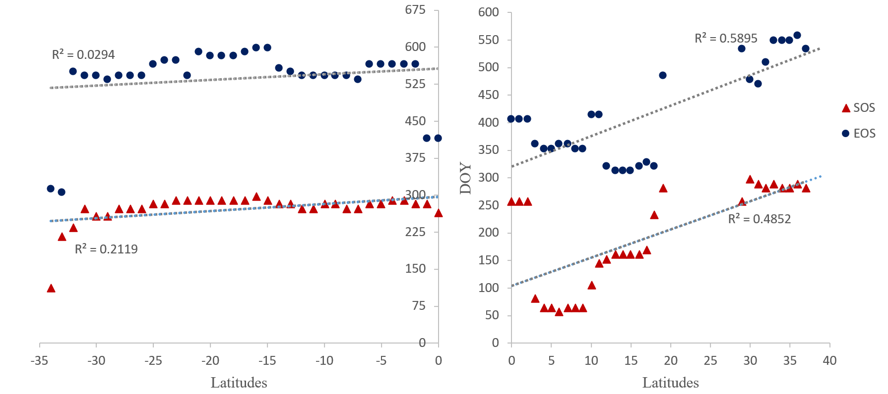Figure 6: Latitudinal variation in the LSP parameters, SOS and EOS, the left plot showing variation in the southern hemisphere and the right plot showing variation in the northern hemisphere.

  - Variability in LSP parameters
Across the whole of Africa the STD of all LSP parameters for 15 years ranges from 0 – 80 days. However, greater variability was observed in SOS compared to EOS and LOS, and this occurred mostly in the Sahelian region, and croplands (see Figure 6). Although representing less than 1% of the total number of pixels, some areas in Western Africa and the Horn of Africa, mainly croplands, produced very large standard deviations for SOS of up to 128 days. The same large standard deviation was observed for both EOS and LOS.
No significant inter-annual variability was observed for the evergreen and deciduous forest across Africa as standard deviation values were very small, of less than 10 days. The same observation was recorded for STD of SOS for shrublands and grasslands, with the exception of a few locations in Eastern and some parts of Western Africa that had SOS STD values of up to 128 days. Nevertheless, EOS and LOS for both land cover types had STD values ranging from 0 to 48 days and these were mainly in the Sahelian and eastern sub-regions. On the other hand, the STD of SOS for savannas (woody savannas/savannas) ranged from 0 to 40 days, and the number of days increased in EOS (0 to 48 days) and LOS (0 to 56 days).
Contrasting with the first season, no significant variability was observed in LSP for the entire second season, as STDs were very small, with values of less than a day.
Figure 7: Standard deviation of LSP parameters in number of days for the period of 2001 to 2015 for (a) SOS, (b) EOS, and (c) LOS.

  - Characterisation of the LSP of the major land cover types in different geographical sub-regions
The spatial and temporal variability of the vegetation phenological pattern in Africa is greatly influenced by different climatic factors (rainfall, temperature and insolation) in the geographical sub-regions, and vegetation type. Different patterns were observed in the LSP parameters across the six types of land cover based on the five geographical sub-regions in Africa (Figure 8).
Croplands/natural vegetation in Western Africa and some parts of Eastern Africa had over 70% of the SOS dates (homogeneous pixels) from late February to June (with over 36% occurring in June), and EOS between November and February. In geographical sub-regions south of the equator, there was an observed shift in SOS dates, occurring later between August to November, with their corresponding EOS dates between June and August. However, some locations in Northern Africa also exhibited similarly advanced SOS dates (see section 3.1 for explanation). When LOS is compared to other vegetation land cover types, croplands/natural vegetation had the longest growing season of approximately 12 months and these were mostly located in Western Africa.
One unique feature of croplands/natural vegetation is the bimodality observed in Eastern Africa. Although this was seen in very few pixels (see Figure 5), this nevertheless indicates double cropping activities made possible by bimodal rainfall regimes.
The phenologies of deciduous forest and evergreen forest are somewhat similar, especially in the southern regions of Africa, with both having growing seasons starting mostly between August and November, and ending mostly in January, June, July and August. The average LOS of both land cover types is 10 months. As expected with most land cover types, the spatial location influences the phenology of both forest types, as SOS dates are much earlier in Northern, Western Africa and parts of Eastern Africa.
Grasslands, unlike most other land cover types, exhibit very distinct SOS and EOS dates, occurring mainly in the month of June and November, respectively, for all geographical sub-regions in the north of Africa, while southern and some eastern grasslands have a diverse range of SOS and EOS dates. Shrublands also have very diverse SOS and EOS dates across the geographical sub-regions, especially Southern Africa, resulting in a wide range of LOS from 3 to 11 months. However, shrublands in Western Africa have a distinct LSP, with the growing season beginning in early June and mostly ending towards late November.
Woody savanna and savanna are very different from most land cover types. In Western Africa, their SOS dates were mainly in February and March, unlike grasslands, which have most SOS dates in June. Over 85% of the homogeneous pixels of the woody savanna/savanna land cover type have a growing season length between 9 to 10 months.

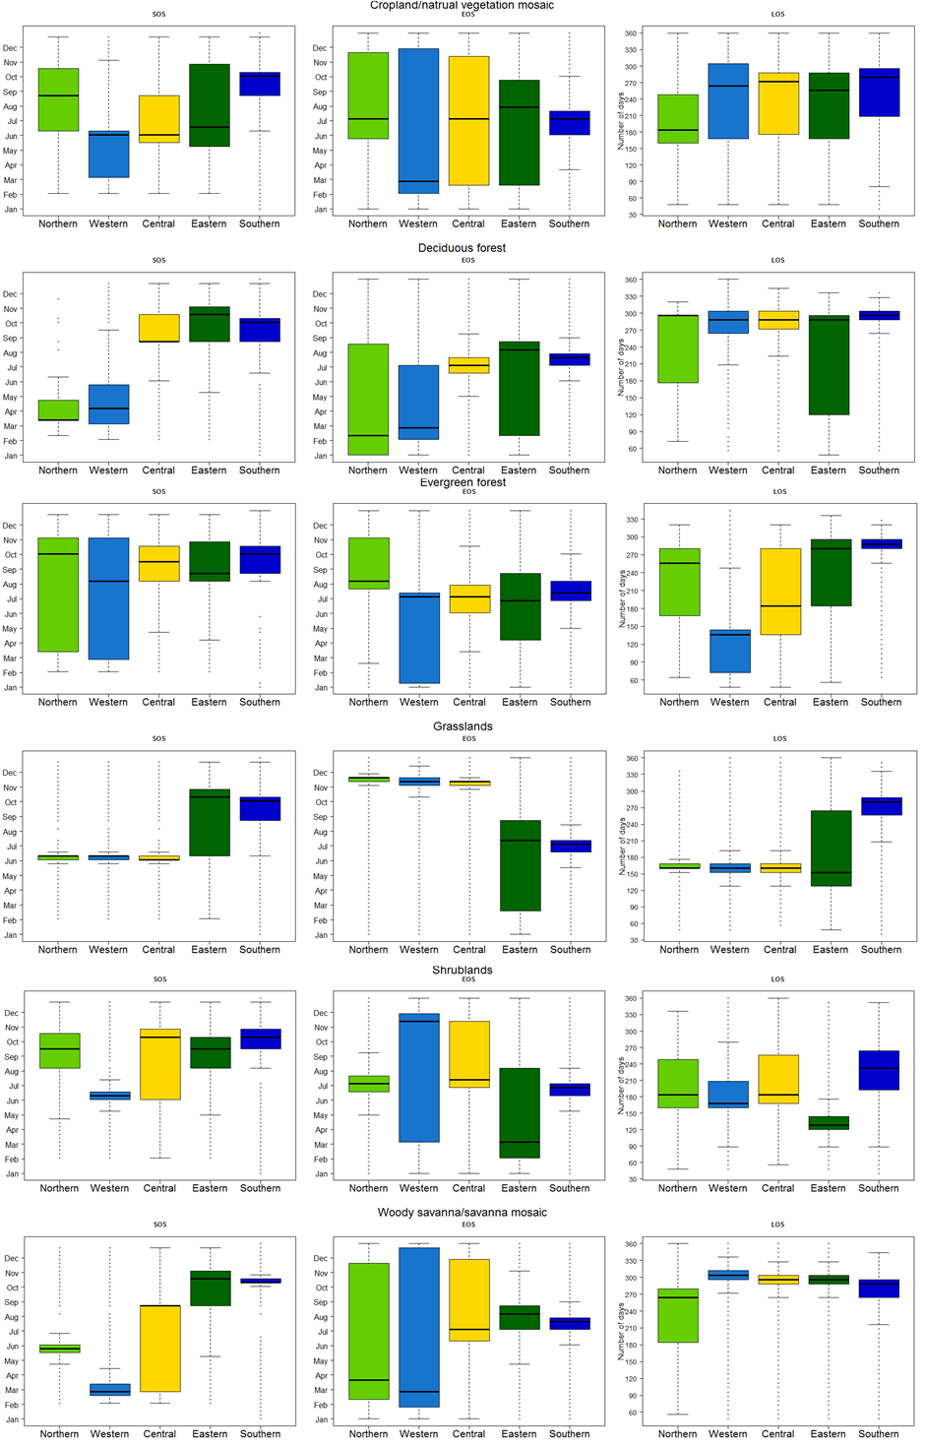 Figure 8: Box plots showing the distribution of pixels of LSP parameters in the six major land cover types based on five geographical sub-regions.

  - Heterogeneity of LSP parameters at coarse spatial resolutions
The effect of spatial resolution on LSP parameters is demonstrated in Table 3. The table shows the range of STD of SOS in grids of 8 km, 5 km, 3 km and 1 km, and the percentage of pixels having those values. 22% of the pixels with an 8 km resolution have STD values ranging from 37 – 180 (DOY). As expected, this number reduces as spatial resolution increases: 19% for 5 km, 16% for 3 km and 6% for 1 km. The reverse was observed for percentage of pixels with smaller STD values (i.e., the finer the spatial resolution the greater the number of pixels with smaller STD deviation values) (see Table 3).

Table 3: Percentage of pixels falling into different STD ranges shown for four different spatial resolutions of 8 km, 5 km, 3 km and 1 km.
STD (SOS) | 8000 m | 5000 m | 3000 m | 1000 m
0 - 18 | 62.69 | 67.36 | 74.29 | 89.86
19 - 36 | 15.77 | 13.99 | 10.20 | 4.58
37 - 54 | 5.27 | 4.44 | 3.64 | 0.98
55 - 72 | 3.43 | 2.95 | 2.43 | 0.35
73 - 90 | 3.48 | 3.00 | 2.46 | 0.60
91 - 108 | 3.98 | 3.41 | 2.81 | 0.93
109 - 126 | 4.17 | 3.59 | 2.88 | 1.60
127 - 144 | 1.06 | 1.10 | 1.12 | 0.88
145 - 162 | 0.11 | 0.12 | 0.14 | 0.18
163 - 180 | 0.02 | 0.03 | 0.03 | 0.04

- Discussion
The phenological pattern of vegetation across different land covers and across different African sub-regions is important in understanding the vegetation dynamics of different biomes especially in relation to climate changes. This research provides a detailed characterisation of the LSP of the major land cover types in Africa at a continental scale based on the different geographical sub-regions at the finest spatio-temporal resolution to-date.

  - Latitudinal variation in LSP
Latitude was found to have some controlling effect on phenological patterns which is consistent with results from previous studies (Zhang et al., 2005; Butt et al., 2011; Brottem et al., 2014; Guan et al., 2014b). The latitudinal variation in phenology across Africa revealed greater spatial variability at lower latitudes, that is, the Southern Hemisphere of the African continent. However, advances in SOS dates were observed as latitude increases, especially in the northern hemisphere (see Figure 3 & 5). Similar results were found in Seghieri et al.(2009); with the same coverage of shrubs in West Africa, leafing dates were earlier at lower latitudes when compared to leafing dates at higher latitudes. Also Guan et al. (2014b) and Zhang et al. (2005) showed that in Northern Africa LSP parameters were more correlated with latitude than in the Southern Hemisphere. This research, which used a much finer spatial resolution, not only confirms this phenology-latitude relationship but also provides the average rate of increase per one degree increase in latitude. This average rate of a 0.05 days km⁻¹ for both SOS and EOS is supported by previous studies: (0.12 days km⁻¹ and 0.05 days km⁻¹ for the period 2000 to 2003 in Zhang et al. (2005), 0.05 days km⁻¹ and 0.03 days km⁻¹ for the period 2000 to 2008 in Bobée et al. (2012) and 0.09 days km⁻¹ and 0.05 days km⁻¹ for the period 2000 to 2010 in Butt et al. (2011), respectively).
One major reason for this North-South discrepancy in response to latitudinal gradient is the climatic factors operational in these regions. The North is mostly controlled by the northwards movement of the Intertropical Convergence Zone (ITCZ) which migrates latitudinally defining the seasonality of rainfall in the northern region (Giannini et al., 2008). However, the south has multiple climatic factors at play: the east-west oriented component of the African ITCZ, the North Atlantic Oscillation index (NAO), the Pacific Decadal Oscillation (PDO) (Nicholson, 2001, 2003; Brown et al., 2010) and the Agulhas and Benguela current systems (Walker, 1990), each exerting their influence along the east-west to the south-west coasts.
The present results show that in some places in the African continent LSP does not vary linearly with latitude, and more importantly quantify the degree of variation.

  - Inter-annual variability
The broad spatial distribution of inter-annual variability of LSP demonstrated in this research is consistent with the outcomes from previous studies. Interesting is the different pattern of inter-annual variability shown by the different geographical sub-regions and the different land cover types. Inter-annual variability was greater in Eastern and some parts of Western Africa, which corresponds with some areas identified as hotspots of change by Linderman et al. (2005) (Figure 7). Most land cover types in these regions had a large STD representing inter-annual variability except for the evergreen and deciduous forest types. These vegetation types across Africa were found not to have significant changes in LSP parameters; a similar outcome was reported for vegetation activity by Linderman et al. (2005) for the period 2000 to 2004. In contrast, croplands had a large STD, with SOS having the largest values. This confirms results from previous studies of crop failures in the Sahelian region and Eastern Africa (Vrieling et al., 2013; Landmann & Dubovyk, 2014; Meroni et al., 2014). Similarly, shrublands and grasslands across Africa had moderately large STDs for EOS and LOS, but large STD for SOS in the Eastern and Western sub-regions. This implies that between 2001 and 2014, some factors may have affected the onset of growing season in these regions. Factors that could be responsible, and have been identified by previous studies are: human-induced land transformations (Landmann & Dubovyk, 2014), climatic factors like droughts and rainfall anomalies (Anyamba & Tucker, 2005; Meroni et al., 2014), and vegetation-type transitions occasioned by both climatic and human factors (Linderman et al., 2005; Mitchard et al., 2009).
Contrary to Vrieling et al. (2013), no heteroscedasticity was observed in LOS. Our results showed no relationship between the duration of LOS and STD values of LOS. Additionally, no significant relationship was detected between inter-annual variability and latitudinal gradient.

  - Comparison with ground-based studies
Owing to the absence of a comprehensive ground-based observation network in Africa and the very limited number of ground-based studies (Rutherford & Panagos, 1982; Childes, 1989; Seghieri et al., 2009; February & Higgins, 2016; Whitecross et al., 2017a,b), direct or indirect validation of the results of this study was not possible. Hence, a comparison was made with the limited existing literature on ground-based studies. In Western Africa, several species of shrubs and woodland savannah, and mosaic of crops and natural vegetation have been found to start leafing in February just before the rainy season, and in June during the rainy reason (Seghieri et al., 2009). This agrees well with our findings as results from our study in the same geographical locations showed SOS to begin in DOY 57 – 65 and DOY 161 - 169. This early onset of growing season before the rains has also been reported to occur in numerous evergreen and mostly woody plants in the African Sahel by Seghieri and Do (2012); Guan et al. (2014b) and Brandt et al. (2016). More recent studies have reported the ubiquitous nature of this pre-rain onset in southern Africa (Ryan et al., 2017; Whitecross et al., 2017a,b). Similarly, in Southern Africa, some species of savanna trees were found to begin their growing season and attain tree canopy fullness between October and November. These savanna trees were also found to have no leaves at the end of the dry season in October (February & Higgins, 2016; Whitecross et al., 2017a,b). Again, our results for the same geographical location are in agreement with these findings.
Increased air temperature and atmospheric vapour pressure/relative humidity, with scleromorphic features and access to deeper groundwater or stored water in plants have been proposed to be responsible for this early onset of greening (De Bie et al., 1998; Do et al., 2005; Seghieri et al., 2012).
Comparison was not possible with all the existing literature on ground-based studies due to the type of vegetation phenological parameters measured. For example, plant phenophases such as budding, shoot growth, flowering and fruiting measured by some studies (Chapman et al., 2005; Do et al., 2005; O’Farrell et al., 2007; Sekhwela & Yates, 2007; Yamagiwa et al., 2008; Wang’ondu et al., 2010, 2013; Seghieri et al., 2012; Polansky & Boesch, 2013) cannot be compared directly to onset of greenness or leaf emergence/leafing in remote sensing studies. Regardless of this limitation, the phenological patterns of major vegetation types from these ground-based studies are very similar to the results presented here. This limitation further drives home the need for more ground-based observations and a phenological network for the African continent.

  - Comparison with other remote sensing studies
The present results differ from most earlier remote sensing studies of LSP over Africa (Brown et al., 2010, 2012; Jacquin et al., 2010; Vrieling et al., 2013) which used a threshold method in estimating LSP parameters. In comparison, the present analysis detected SOS approximately 30 to 60 days earlier across Africa. Similarly, EOS was detected approximately 30 – 60 days later. Consequently, the present study produced longer LOS values of about 30 – 90 days. This supports the findings of Vrieling et al. (2008) and de Beurs & Henebry (2010), that threshold methods estimate SOS later and EOS earlier because the point of maximum curvature may be below the user-defined threshold.
On the other hand, the present results are in agreement with remote sensing studies (Zhang et al., 2005; Archibald & Scholes, 2007; Butt et al., 2011; Bobée et al., 2012; Brottem et al., 2014; Guan et al., 2014a,b; Ryan et al., 2014) that applied the inflection point or the function model fitting methods in estimating LSP. This consistency was very evident in the early green-up observed before the rainy seasons, especially in evergreen forest and woodlands (Archibald & Scholes, 2007; Guan et al., 2014b), and the distinct phenological pattern observed in the extreme northern and southern tips of Africa (Guan et al., 2014a).
While there exists strong agreement with previous studies, minor discrepancies of an estimated 5 – 20 days were observed. This could be the result of the different spatial resolution used in the studies. At coarser spatial resolutions, phenological parameters are usually averaged across an area that may have different vegetation types with distinct phenological patterns. This can be seen in the STDs of SOS with spatial resolutions of 1 km, 3 km, 5 km and 8 km. As the spatial resolution becomes finer, the STD in number of days reduces (see Table 3). This suggests that with a finer spatial resolution there is less conditional bias (under-estimating highs and over-estimating lows) from spatial averaging and aggregation.
Aside from the type of estimation technique and the spatial resolution of data, the smoothing techniques (Atkinson et al., 2012), sensor type (Atzberger et al., 2013) and the temporal resolution of data (Zhang et al., 2009) could also be responsible for such discrepancies between outcomes.

Conclusion
The LSP of the major vegetation types in Africa was described for the first time using homogeneous pixels from 12 years (2001 – 2012) MODIS land cover data (MODIS MCD12Q1) and EVI derived from the MODIS MOD09A1 product at a medium spatial resolution of 500 m and a high temporal frequency of 8-days. Indeed, the maps of LSP parameters (SOS, EOS, LOS) produced here represent the finest spatial resolution and most detailed maps of the phenology of Africa to-date. Additionally, the inter-annual variability of all LSP parameters for all of Africa was reported for the first time.
The well-known phenology-latitude relationship in Africa was quantified at an unprecedented fine resolution, with a greater correlation found in northern latitudes. Moreover, the dependence of the LSP parameters (SOS, EOS and LOS) on land cover type and geographical sub-region was analysed in detail (Figure 8), revealing a complex interaction between the three dimensions of vegetation timing, geographical location and land cover type.
The results reported here support previous studies while providing a more refined quantification with some significant variations to existing maps. The spatial detail (500 m) with which the LSP parameters are mapped here provides a platform to support further applied environmental research in the African continent. In particular, it is anticipated that the mapped outputs from this research will be important for ecosystem management and climate-related research and can be of value for further studies on climate change impacts and phenology-climate modelling.
While it was not possible to conduct an extensive empirical validation of the maps of LSP produced (due to the lack of a comprehensive African ground observation network measuring vegetation phenology), comparison of the results with the available ground-based studies published in the literature found close agreement. Moreover, the methods applied in this research to estimate LSP parameters have been applied widely and tested extensively in other studies, including through comparison with empirical ground data in those studies. Further studies should be undertaken to provide a comprehensive, continental scale validation of the LSP predictions across Africa when suitable ground data become available.

Acknowledgments
The authors would like to thank the Commonwealth Scholarship Commission in the UK for funding and support provided to Tracy Adole.

References
Adole, T., Dash, J. & Atkinson, P.M. (2016) A systematic review of vegetation phenology in Africa. Ecological Informatics, 34, 117–128.
Anyamba, A. & Tucker, C.J. (2005) Analysis of Sahelian vegetation dynamics using NOAA-AVHRR NDVI data from 1981–2003. Journal of Arid Environments, 63, 596–614.
Archibald, S. & Scholes, R.J. (2007) Leaf green-up in a semi-arid African savanna – separating tree and grass responses to environmental cues. Journal of Vegetation Science, 18, 583–594.
Atkinson, P.M., Jeganathan, C., Dash, J. & Atzberger, C. (2012) Inter-comparison of four models for smoothing satellite sensor time-series data to estimate vegetation phenology. Remote Sensing of Environment, 123, 400–417.
Atzberger, C., Klisch, A., Mattiuzzi, M. & Vuolo, F. (2013) Phenological Metrics Derived over the European Continent from NDVI3g Data and MODIS Time Series. Remote Sensing, 6, 257–284.
de Beurs, K.M. & Henebry, G.M. (2010) Spatio-Temporal Statistical Methods for Modelling Land Surface Phenology. Phenological Research: Methods for Environmental and Climate Change Analysis (ed. by I.L. Hudson) and M.R. Keatley), pp. 177–208. Springer Netherlands.
De Bie, S.E., Ketner, P., Paasse, M. & Geerlingt, C. (1998) Woody Plant Phenology in the West Africa Savanna. Journal of Biogeography, 25, 883–900.
Bobée, C., Ottlé, C., Maignan, F., De Noblet-Ducoudré, N., Maugis, P., Lézine, A.M. & Ndiaye, M. (2012) Analysis of vegetation seasonality in Sahelian environments using MODIS LAI, in association with land cover and rainfall. Journal of Arid Environments, 84, 38–50.
Boyd, D.S., Almond, S., Dash, J., Curran, P.J. & Hill, R.A. (2011) Phenology of vegetation in Southern England from Envisat MERIS terrestrial chlorophyll index (MTCI) data. International Journal of Remote Sensing, 32, 8421–8447.
Brandt, M., Hiernaux, P., Tagesson, T., Verger, A., Rasmussen, K., Diouf, A.A., Mbow, C., Mougin, E. & Fensholt, R. (2016) Woody plant cover estimation in drylands from Earth Observation based seasonal metrics. Remote Sensing of Environment, 172, 28–38.
Broich, M., Huete, A., Tulbure, M.G., Ma, X., Xin, Q., Paget, M., Restrepo-Coupe, N., Davies, K., Devadas, R. & Held, A. (2014) Land surface phenological response to decadal climate variability across Australia using satellite remote sensing. Biogeosciences, 11, 5181–5198.
Brottem, L., Turner, M.D., Butt, B. & Singh, A. (2014) Biophysical Variability and Pastoral Rights to Resources: West African Transhumance Revisited. Human Ecology, 42, 351–365.
Brown, M.E., de Beurs, K. & Vrieling, A. (2010) The response of African land surface phenology to large scale climate oscillations. Remote Sensing of Environment, 114, 2286–2296.
Brown, M.E., de Beurs, K.M. & Marshall, M. (2012) Global phenological response to climate change in crop areas using satellite remote sensing of vegetation, humidity and temperature over 26 years. Remote Sensing of Environment, 126, 174–183.
Butt, B., Turner, M.D., Singh, A. & Brottem, L. (2011) Use of MODIS NDVI to evaluate changing latitudinal gradients of rangeland phenology in Sudano-Sahelian West Africa. Remote Sensing of Environment, 115, 3367–3376.
Camberlin, P., Martiny, N., Philippon, N. & Richard, Y. (2007) Determinants of the interannual relationships between remote sensed photosynthetic activity and rainfall in tropical Africa. Remote Sensing of Environment, 106, 199–216.
Chapman, C. a., Chapman, L.J., Struhsaker, T.T., Zanne, A.E., Clark, C.J. & Poulsen, J.R. (2005) A long-term evaluation of fruiting phenology: importance of climate change. Journal of Tropical Ecology, 21, 31–45.
Childes, S.L. (1989) Phenology of nine common woody species in semi-arid, deciduous Kalahari Sand vegetation. Vegetatio, 79, 151–163.
Chmielewski, F.-M. & Rötzer, T. (2001) Response of tree phenology to climate change across Europe. Agricultural and Forest Meteorology, 108, 101–112.
Chmielewski, F.M., Müller, A. & Bruns, E. (2004) Climate changes and trends in phenology of fruit trees and field crops in Germany, 1961-2000. Agricultural and Forest Meteorology, 121, 69–78.
Cleland, E.E., Chuine, I., Menzel, A., Mooney, H. a & Schwartz, M.D. (2007) Shifting plant phenology in response to global change. Trends in ecology & evolution, 22, 357–65.
Clinton, N., Yu, L., Fu, H., He, C. & Gong, P. (2014) Global-Scale Associations of Vegetation Phenology with Rainfall and Temperature at a High Spatio-Temporal Resolution. Remote Sensing, 6, 7320–7338.
Cole, E.F., Long, P.R., Zelazowski, P., Szulkin, M. & Sheldon, B.C. (2015) Predicting bird phenology from space: satellite-derived vegetation green-up signal uncovers spatial variation in phenological synchrony between birds and their environment. Ecology and Evolution, 5, 5057–5074.
Dash, J., Jeganathan, C. & Atkinson, P.M. (2010) The use of MERIS Terrestrial Chlorophyll Index to study spatio-temporal variation in vegetation phenology over India. Remote Sensing of Environment, 114, 1388–1402.
Do, F.C., Goudiaby, V.A., Gimenez, O., Diagne, A.L., Diouf, M., Rocheteau, A. & Akpo, L.E. (2005) Environmental influence on canopy phenology in the dry tropics. Forest Ecology and Management, 215, 319–328.
Donato, D.C., Kauffman, J.B., Murdiyarso, D., Kurnianto, S., Stidham, M. & Kanninen, M. (2011) Mangroves among the most carbon-rich forests in the tropics. Nature Geoscience, 4, 293–297.
Favier, C., Aleman, J., Bremond, L., Dubois, M. a., Freycon, V. & Yangakola, J.M. (2012) Abrupt shifts in African savanna tree cover along a climatic gradient. Global Ecology and Biogeography, 21, 787–797.
February, E.C. & Higgins, S.I. (2016) Rapid leaf deployment strategies in a deciduous savanna. PLoS ONE, 11.
Fisher, J.I. & Mustard, J.F. (2007) Cross-scalar satellite phenology from ground, Landsat, and MODIS data. Remote Sensing of Environment, 109, 261–273.
Food and Agriculture Organization of the United Nations (2010) Global forest resources assessment 2010: Main report, Rome, Italy.
Friedl, M.A., Sulla-Menashe, D., Tan, B., Schneider, A., Ramankutty, N., Sibley, A. & Huang, X. (2010) MODIS Collection 5 global land cover: Algorithm refinements and characterization of new datasets. Remote Sensing of Environment, 114, 168–182.
Friedl, M.H., Henebry, G.M., Reed, B.C., Huete, A., White, M. a, Morisette, J., Nemani, R.R., Zhang, X., Myneni, R.B. & Friedl, M. (2006) Land Surface Phenology. A community white paper requested by NASA, April 10.
Ganguly, S., Friedl, M. a., Tan, B., Zhang, X. & Verma, M. (2010) Land surface phenology from MODIS: Characterization of the Collection 5 global land cover dynamics product. Remote Sensing of Environment, 114, 1805–1816.
Giannini, A., Biasutti, M., Held, I.M. & Sobel, A.H. (2008) A global perspective on African climate. Climatic Change, 90, 359–383.
Giri, C., Ochieng, E., Tieszen, L.L., Zhu, Z., Singh, A., Loveland, T., Masek, J. & Duke, N. (2010) Status and distribution of mangrove forests of the world using earth observation satellite data. Global Ecology and Biogeography, 20, 154–159.
Graham, E.A., Riordan, E.C., Yuen, E.M., Estrin, D. & Rundel, P.W. (2010) Public Internet-connected cameras used as a cross-continental ground-based plant phenology monitoring system. Global Change Biology, 16, 3014–3023.
Griffiths, J.F. (1971) Climates of Africa (World Survey of Climatology), Elsevier, Amsterdam-London-New York.
Guan, K., Medvigy, D., Wood, E.F., Caylor, K.K., Li, S. & Jeong, S. (2014a) Deriving Vegetation Phenological Time and Trajectory Information Over Africa Using SEVIRI Daily LAI. Geoscience and Remote Sensing, 52, 1113–1130.
Guan, K., Wolf, A., Medvigy, D. & Caylor, K. (2013) Seasonal coupling of canopy structure and function in African tropical forests and its environmental controls. Ecosphere, 4, 1–21.
Guan, K., Wood, E.F., Medvigy, D., Kimball, J., Ming Pan, K.K.C., Sheffield, J., Xu, X. & Jones, M.O. (2014b) Terrestrial hydrological controls on land surface phenology of African savannas and woodlands. Journal of Geophysical Research Biogeosciences, 119, 1652–1669.
Herrmann, S.M. & Mohr, K.I. (2011) A continental-scale classification of rainfall seasonality regimes in Africa based on gridded precipitation and land surface temperature products. Journal of Applied Meteorology and Climatology, 50, 2504–2513.
Huete, A., Didan, K., Leeuwen, W. Van, Miura, T. & Glenn, E. (2011) MODIS vegetation indices. Land remote sensing and global environmental change (ed. by B. Ramachandran), C.O. Justice), and M.J. Abrams), pp. 579–602. Springer New York, Springer New York.
Huete, A., Didan, K., Miura, T., Rodriguez, E.., Gao, X. & Ferreira, L.. (2002) Overview of the radiometric and biophysical performance of the MODIS vegetation indices. Remote Sensing of Environment, 83, 195–213.
Jacquin, A., Sheeren, D. & Lacombe, J.P. (2010) Vegetation cover degradation assessment in Madagascar savanna based on trend analysis of MODIS NDVI time series. International Journal of Applied Earth Observation and Geoinformation, 12, 3–10.
Jakubauskas, M.E., Legates, D.R. & Kastens, J.H. (2001) Harmonic analysis of time - series AVHRR NDVI data. Photogrammetric engineering and remote sensinghotogrammetric engineering and remote sensing, 67, 461–470.
Jeganathan, C., Dash, J. & Atkinson, P.M. (2014) Remotely sensed trends in the phenology of northern high latitude terrestrial vegetation, controlling for land cover change and vegetation type. Remote Sensing of Environment, 143, 154–170.
Jönsson, P. & Eklundh, L. (2002) Seasonality extraction by function fitting to time-series of satellite sensor data. IEEE Transactions on Geoscience and Remote Sensing, 40, 1824–1832.
Jönsson, P. & Eklundh, L. (2004) TIMESAT - A program for analyzing time-series of satellite sensor data. Computers and Geosciences, 30, 833–845.
Julien, Y. & Sobrino, J. a. (2009) Global land surface phenology trends from GIMMS database. International Journal of Remote Sensing, 30, 3495–3513.
Justice, C.O., Townshend, J.R.G. & Choudhury, B.J. (1989) Comparison of AVHRR and SMMR data for monitoring vegetation phenology on a continental scale. International Journal of Remote Sensing, 10, 1607–1632.
Landmann, T. & Dubovyk, O. (2014) Spatial analysis of human-induced vegetation productivity decline over eastern Africa using a decade (2001-2011) of medium resolution MODIS time-series data. International Journal of Applied Earth Observation and Geoinformation, 33, 76–82.
Liebmann, B., Bladé, I., Kiladis, G.N., Carvalho, L.M. V, Senay, G.B., Allured, D., Leroux, S. & Funk, C. (2012) Seasonality of African precipitation from 1996 to 2009. Journal of Climate, 25, 4304–4322.
Linderman, M., Rowhani, P., Benz, D., Serneels, S. & Lambin, E.F. (2005) Land-cover change and vegetation dynamics across Africa. Journal of Geophysical Research D: Atmospheres, 110, 1–15.
Ma, X., Huete, A., Yu, Q., Coupe, N.R., Davies, K., Broich, M., Ratana, P., Beringer, J., Hutley, L.B., Cleverly, J., Boulain, N. & Eamus, D. (2008) Spatial patterns and temporal dynamics in savanna vegetation phenology across the North Australian Tropical Transect. Remote Sensing of Environment, 5, 97–115.
McCloy, K.R. & Tind, S.L. (2011) Mapping Changes in Plant Phenology across Eurasia, Africa, North and South America from Time Series Image Data. Journal of Maps, 7, 391–408.
Menzel, A. (2013) Plant phenological “fingerprints.” Phenology: An integrative environmental science, pp. 335–350. Springer, Dordrecht.
Menzel, A., Sparks, T.H., Estrella, N., Koch, E., Aaasa, A., Ahas, R., Alm-Kübler, K., Bissolli, P., Braslavská, O., Briede, A., Chmielewski, F.M., Crepinsek, Z., Curnel, Y., Dahl, Å., Defila, C., Donnelly, A., Filella, Y., Jatczak, K., Måge, F., Mestre, A., Nordli, Ø., Peñuelas, J., Pirinen, P., Remišová, V., Scheifinger, H., Striz, M., Susnik, A., Van Vliet, A.J.H., Wielgolaski, F.E., Zach, S. & Zust, A. (2006) European phenological response to climate change matches the warming pattern. Global Change Biology, 12, 1969–1976.
Meroni, M., Verstraete, M.M., Rembold, F., Urbano, F. & Kayitakire, F. (2014) A phenology-based method to derive biomass production anomalies for food security monitoring in the Horn of Africa. International Journal of Remote Sensing, 35, 2472–2492.
Mitchard, E., Saatchi, S., Gerard, F., Lewis, S. & Meir, P. (2009) Measuring Woody Encroachment along a Forest–Savanna Boundary in Central Africa. Earth Interactions, 13, 1–29.
Moody, A. & Johnson, D.M. (2001) Land-Surface Phenologies from AVHRR Using the Discrete Fourier Transform. Remote Sensing of Environment, 75, 305–323.
Moulin, S., Kergoat, L., Viovy, N. & Dedieu, G. (1997) Global-scale assessment of vegetation phenology using NOAA/AVHRR satellite measurements. Journal of Climate, 10, 1154–1170.
Nicholson, S. (2003) Comments on “The South Indian Convergence Zone and Interannual Rainfall Variability over Southern Africa” and the Question of ENSO ’ s Influence on Southern Africa. Journal of Cllimate, 16, 555–562.
Nicholson, S.E. (2001) Climatic and environmental change in Africa during the last two centuries. Climate Research, 17, 123–144.
O’Farrell, P.J., Donaldson, J.S. & Hoffman, M.T. (2007) The influence of ecosystem goods and services on livestock management practices on the Bokkeveld plateau, South Africa. Agriculture, Ecosystems and Environment, 122, 312–324.
Pastor-Guzman, J., Dash, J. & Atkinson, P.M. (2018) Remote sensing of mangrove forest phenology and its environmental drivers. Remote Sensing of Environment, 205, 71–84.
Polansky, L. & Boesch, C. (2013) Long-term Changes in Fruit Phenology in a West African Lowland Tropical Rain Forest are Not Explained by Rainfall. Biotropica, 45, 434–440.
Reed, B.C., Brown, J.F., VanderZee, D., Loveland, T.R., Merchant, J.W. & Ohlen, D.O. (1994) Measuring phenological variability from satellite imagery. Journal of Vegetation Science, 5, 703–714.
Reed, B.C., Schwartz, M.D. & Xiao, X. (2009) Remote Sensing Phenology: Status and the way forward. Phenology of Ecosystem Processes (ed. by A. Noormets), pp. 231–246. Springer New York, New York, NY.
Richardson, A.D., Keenan, T.F., Migliavacca, M., Ryu, Y., Sonnentag, O. & Toomey, M. (2013) Climate change, phenology, and phenological control of vegetation feedbacks to the climate system. Agricultural and Forest Meteorology, 169, 156–173.
Rodriguez-Galiano, V., Dash, J. & Atkinson, P. (2015a) Characterising the Land Surface Phenology of Europe Using Decadal MERIS Data. Remote Sensing, 7, 9390–9409.
Rodriguez-Galiano, V.F., Dash, J. & Atkinson, P.M. (2015b) Intercomparison of satellite sensor land surface phenology and ground phenology in Europe. Geophysical Research Letters, 42, 2253–2260.
Rowhani, P., Linderman, M. & Lambin, E.F. (2011) Global interannual variability in terrestrial ecosystems: sources and spatial distribution using MODIS-derived vegetation indices, social and biophysical factors. International Journal of Remote Sensing, 32, 5393–5411.
Rutherford, M.C. & Panagos, M.D. (1982) Seasonal woody plant shoot growth in Burkea africana - Ochna pulchra savanna. South African Journal of Botany, 1, 104–116.
Ryan, C.M., Williams, M., Grace, J., Woollen, E. & Lehmann, C.E.R. (2017) Pre-rain green-up is ubiquitous across southern tropical Africa: implications for temporal niche separation and model representation. New Phytologist, 213, 625–633.
Ryan, C.M., Williams, M., Hill, T.C., Grace, J. & Woodhouse, I.H. (2014) Assessing the phenology of southern tropical Africa: A comparison of hemispherical photography, scatterometry, and optical/NIR remote sensing. IEEE Transactions on Geoscience and Remote Sensing, 52, 519–528.
Scepan, J. & Estes, J.E. (2001) Thematic validation of global land cover data sets-procedures and interpretation methods. Geoscience and Remote Sensing Symposium, 2001. IGARSS ’01. IEEE 2001 International, 3, 1119–1121 vol.3.
Seghieri, J., Carreau, J., Boulain, N., De Rosnay, P., Arjounin, M. & Timouk, F. (2012) Is water availability really the main environmental factor controlling the phenology of woody vegetation in the central Sahel? Plant Ecology, 213, 861–870.
Seghieri, J. & Do, F. (2012) Phenology of woody species along the climatic gradient in west tropical Africa. Phenology and Climate Change (ed. by X. Zhang), pp. 143–178. IntechOpen, Rijeka, Croatia.
Seghieri, J., Vescovo, A., Padel, K., Soubie, R., Arjounin, M., Boulain, N., de Rosnay, P., Galle, S., Gosset, M., Mouctar, A.H., Peugeot, C. & Timouk, F. (2009) Relationships between climate, soil moisture and phenology of the woody cover in two sites located along the West African latitudinal gradient. Journal of Hydrology, 375, 78–89.
Sekhwela, M.B.M. & Yates, D.J. (2007) A phenological study of dominant acacia tree species in areas with different rainfall regimes in the Kalahari of Botswana. Journal of Arid Environments, 70, 1–17.
Soudani, K., le Maire, G., Dufrêne, E., François, C., Delpierre, N., Ulrich, E. & Cecchini, S. (2008) Evaluation of the onset of green-up in temperate deciduous broadleaf forests derived from Moderate Resolution Imaging Spectroradiometer (MODIS) data. Remote Sensing of Environment, 112, 2643–2655.
Stroppiana, D., Boschetti, M., Brivio, P.A., Carrara, P. & Bordogna, G. (2009) A fuzzy anomaly indicator for environmental monitoring at continental scale. Ecological Indicators, 9, 92–106.
Studer, S., Stöckli, R., Appenzeller, C. & Vidale, P.L. (2007) A comparative study of satellite and ground-based phenology. International Journal of Biometeorology, 51, 405–414.
Thompson, B.W. (1965) The Climate of Africa, Oxford University Press.
United Nations (2014) United Nations Statistics Division- Geographical region and composition. http://millenniumindicators.un.org/unsd/methods/m49/m49regin.htm.
Vintrou, E., Bégué, A., Baron, C., Seen, D. Lo, Alexandre, S. & Traoré, S. (2012) Analysing MODIS phenometrics quality on cropped land in West Africa. Proceedings of the First Sentinel-2 Preparatory Symposium (ed. by L. Ouwehand), pp. 42–48. Frascati, Italy.
Vrieling, A., de Beurs, K.M. & Brown, M.E. (2011) Variability of African farming systems from phenological analysis of NDVI time series. Climatic Change, 109, 455–477.
Vrieling, A., De Beurs, K.M. & Brown, M.E. (2008) Recent trends in agricultural production of Africa based on AVHRR NDVI time series. Proceedings of SPIE - The International Society for Optical Engineering, 7104, 1–10.
Vrieling, A., De Leeuw, J. & Said, M.Y. (2013) Length of growing period over africa: Variability and trends from 30 years of NDVI time series. Remote Sensing, 5, 982–1000.
Walker, J.J., de Beurs, K.M. & Wynne, R.H. (2014) Dryland vegetation phenology across an elevation gradient in Arizona, USA, investigated with fused MODIS and landsat data. Remote Sensing of Environment, 144, 85–97.
Walker, N.D. (1990) Links between South African summer rainfall and temperature variability of the Agulhas and Benguela Current systems. Journal of Geophysical Research, 95, 3297.
Wang’ondu, V.W., Kairo, J.G., Kinyamario, J.I., Mwaura, F.B., Bosire, J.O., Dahdouh-Guebas, F. & Koedam, N. (2010) Phenology of Avicennia marina (Forsk.) Vierh. in a disjunctly-zoned mangrove stand in Kenya. Western Indian Ocean Journal of Marine Science, 9, 135–144.
Wang’ondu, V.W., Kairo, J.G., Kinyamario, J.I., Mwaura, F.B., Bosire, J.O., Dahdouh-Guebas, F. & Koedam, N. (2013) Vegetative and reproductive phenological traits of Rhizophora mucronata Lamk. and Sonneratia alba Sm. Flora: Morphology, Distribution, Functional Ecology of Plants, 208, 522–531.
Whitecross, M.A., Witkowski, E.T.F. & Archibald, S. (2017a) Assessing the frequency and drivers of early-greening in broad-leaved woodlands along a latitudinal gradient in southern Africa. Austral Ecology, 42, 341–353.
Whitecross, M.A., Witkowski, E.T.F. & Archibald, S. (2017b) Savanna tree-grass interactions: A phenological investigation of green-up in relation to water availability over three seasons. South African Journal of Botany, 108, 29–40.
Wolkovich, E.M., Cook, B.I. & Davies, T.J. (2014) Progress towards an interdisciplinary science of plant phenology: Building predictions across space, time and species diversity. New Phytologist, 201, 1156–1162.
Wu, C., Gonsamo, A., Chen, J.M., Kurz, W. a., Price, D.T., Lafleur, P.M., Jassal, R.S., Dragoni, D., Bohrer, G., Gough, C.M., Verma, S.B., Suyker, A.E. & Munger, J.W. (2012) Interannual and spatial impacts of phenological transitions, growing season length, and spring and autumn temperatures on carbon sequestration: A North America flux data synthesis. Global and Planetary Change, 92–93, 179–190.
Yamagiwa, J., Basabose, A.K. & Kaleme, K.P. (2008) Phenology of Fruits Consumed By a Sympatric Population of Gorillas and Chimpanzees in Kahuzi- Biega National Park , Democratic Republic of Congo. Human Evolution, Suppl.39, 3–22.
Yan, D., Zhang, X., Yu, Y., Guo, W. & Hanan, N.P. (2016) Characterizing land surface phenology and responses to rainfall in the Sahara desert. Journal of Geophysical Research G: Biogeosciences, 2243–2260.
Zhang, X., Friedl, M.A. & Schaaf, C.B. (2009) Sensitivity of vegetation phenology detection to the temporal resolution of satellite data. International Journal of Remote Sensing, 30, 2061–2074.
Zhang, X., Friedl, M.A., Schaaf, C.B. & Strahler, A.H. (2004) Climate controls on vegetation phenological patterns in northern mid‐and high latitudes inferred from MODIS data. Global Change Biology, 10, 1133–1145.
Zhang, X., Friedl, M.A., Schaaf, C.B., Strahler, A.H. & Liu, Z. (2005) Monitoring the response of vegetation phenology to precipitation in Africa by coupling MODIS and TRMM instruments. Journal of Geophysical Research D: Atmospheres, 110, 1–14.
Zhang, X., Friedl, M., Tan, B., Goldberg, M. & Yu, Y. (2012) Long-Term Detection of Global Vegetation Phenology from Satellite Instruments. Phenology and Climate Change, 297–320.
Zhang, X., Hodges, J.C.F., Schaaf, C.B., Friedl, M.A., Strahler, A.H. & Gao, F.G.F. (2001) Global vegetation phenology from AVHRR and MODIS data. IGARSS 2001 Scanning the Present and Resolving the Future Proceedings IEEE 2001 International Geoscience and Remote Sensing Symposium Cat No01CH37217, 5, 7031–7033.
Zhang, X., Tan, B. & Yu, Y. (2014) Interannual variations and trends in global land surface phenology derived from enhanced vegetation index during 1982-2010. International Journal of Biometeorology, 58, 547–564.
Zhu, W., Tian, H., Xu, X., Pan, Y., Chen, G. & Lin, W. (2012) Extension of the growing season due to delayed autumn over mid and high latitudes in North America during 1982-2006. Global Ecology and Biogeography, 21, 260–271.

