ORIGINAL RESEARCH
WHOLE-BRAIN RADIOTHERAPY OR AUTOLOGOUS STEM CELL TRANSPLANTATION AS CONSOLIDATION STRATEGIES AFTER HIGH-DOSE METHOTREXATE-BASED CHEMOIMMUNOTHERAPY IN PATIENTS WITH PRIMARY CNS LYMPHOMA: RESULTS OF THE SECOND RANDOMIZATION OF THE INTERNATIONAL EXTRANODAL LYMPHOMA STUDY GROUP-32 TRIAL

Andrés J. M. Ferreri, MD¹, Kate Cwynarski, MD², Elisa Pulczynski, MD³, Christopher P. Fox, MD⁴, Elisabeth Schorb, MD⁵, Paul La Rosée, MD^{6§}, Mascha Binder, MD^{7§}, Alberto Fabbri, MD⁸, Valter Torri, MD⁹, Eleonora Minacapelli, MD¹⁰, Monica Falautano, MD¹⁰, Fiorella Ilariucci, MD¹¹, Achille Ambrosetti, MD^{12§}, Alexander Roth, MD¹³, Claire Hemmaway, MD¹⁴, Peter Johnson, MD^{15§}, Kim M. Linton, PhD¹⁶, Tobias Pukrop, MD^{17§}, Jette Sønderskov Gørløv, PhD¹⁸, Monica Balzarotti, MD¹⁹, Georg Hess, MD²⁰, Ulrich Keller, MD^{21§}, Stephan Stilgenbauer, MD^{22§}, Jens Panse, MD²³, Alessandra Tucci, MD²⁴, Lorella Orsucci, MD²⁵, Francesco Pisani, MD²⁶, Alessandro Levis, MD²⁷, Stefan W. Krause, MD^{28§}, Hans J. Schmoll, MD²⁹, Bernd Hertenstein, MD³⁰, Mathias Rummel, MD³¹, Jeffery Smith, MD³², Michael Pfreundschuh, MD³³, Giuseppina Cabras, MD³⁴, Francesco Angrilli, MD³⁵, Maurilio Ponzoni, MD^{36§}, Martina Deckert, MD^{37§}, Letterio S. Politi, MD³⁸, Jürgen Finke, MD⁵, Michele Reni, MD³⁹, Franco Cavalli, MD^{40§}, Emanuele Zucca, MD⁴⁰, Gerald Illerhaus, MD⁴¹ for the International Extranodal Study Group (IELSG)*

¹Unit of Lymphoid Malignancies, Dept. of Onco-Hematology, ¹⁰Dept. of Neurology, ³⁶Ateneo Vita-Salute San Raffaele University, Pathology Unit, ³⁸Unit of Neuroradiology, and ³⁹Dept. of Oncology; IRCCS San Raffaele Scientific Institute, Milano, Italy; ²RFH/UCLH, London, UK; ³Aarhus University Hospital, Aarhus, Denmark; ⁴Nottingham University Hospitals NHS Trust, Nottingham, UK; ⁵Uniklinik Freiburg, Freiburg, Germany; ⁶Schwarzwald-Baar-Klinikum, Villingen-Schwenningen, Germany; ⁷Uke Universitätsklinikum Hamburg- Eppendorf, Hamburg, Germany; ⁸Azienda Ospedaliera Università Senese, Siena, Italy; ⁹IRCCS Istituto di Ricerche Farmacologiche Mario Negri, Milano, Italy; ¹¹Azienda Ospedaliera Arcispedale Santa Maria Nuova IRCCS, Reggio Emilia, Italy; ¹²Dipartimento di Medicina, Sezione di Ematologia, Università di Verona, Verona Italy; ¹³Universitatsklinikum Essen, Essen, Germany; ¹⁴Queen’s Hospital, Romford, UK; ¹⁵Medical Oncology Unit, Southampton General Hospital, Southampton, UK; ¹⁶The Christie Hospital NHS Foundation Trust, Manchester, UK; ¹⁷Georg-August-Universität, Göttingen, Germany; ¹⁸Rigshospitalet, Copenhagen, Denmark; ¹⁹Istituto Clinico Humanitas, Milano Rozzano, Italy; ²⁰J. Gutenberg Universität, Mainz, Germany; ²¹Technische Universität München, München, Germany; ²²Dept. of Internal Medicine III, Ulm University, Ulm, Germany; ²³Department of Oncology, Hematology, Hemostaseology and Stem Cell Transplantation, University Hospital Aachen, Aachen, Germany; ²⁴Spedali Civili, Brescia, Italy; ²⁵AOU Città Della Salute e Della Scienza di Torino, Turin, Italy; ²⁶Hematology and Stem Cell Transplantation Unit, Istituto Nazionale dei Tumori Regina Elena, Roma, Italy; ²⁷A.O. Santi Antonio e Biagio e Cesare Arrigo, Alessandria, Italy; ²⁸Universitätsklinikum Erlangen, Erlangen, Germany; ²⁹Martin-Luther Universität, Halle / Saale, Germany; ³⁰Klinikum Bremen-Mitte, Bremen, Germany; ³¹Klinikum Der Justus-Liebig-Universität, Giessen, Germany; ³²University Hospital Aintree, Liverpool, UK; ³³Universitätsklinik Des Saarlandes, Homburg, Germany; ³⁴Division of Hematologia, Ospedale Oncologico, Cagliari, Italy; ³⁵Ospedale Civile S. Spirito, Pescara, Italy; ³⁷Institute of Neuropathology, University of Cologne, Cologne, Germany; ⁴⁰Istituto Oncologico Della Svizzera Italiana, Bellinzona, Switzerland; ⁴¹Uniklinik Stuttgart, Stuttgart, Germany.
§These coauthors are full professors.

Running title: Consolidation with WBRT or ASCT in PCNSL

Correspondence to: Andrés J. M. Ferreri, MD
Unit of Lymphoid Malignancies
Department of Onco-Hematology
IRCCS San Raffaele Scientific Institute
Via Olgettina 60, 20132 - Milan, Italy
Phone: 0039-02-26437649
Fax: 0039-02-26437625
E-mail: ferreri.andres@hsr.it

*A complete list of the IELSG32 study investigators is provided in the Supplementary Material (Appendix p2).
Unit of Lymphoid Malignancies, Department of Onco-Hematology (A J M Ferreri MD), Dept. of Neurology (E Minacapelli MD, M Falautano MD), Ateneo Vita-Salute San Raffaele University (Prof M Ponzoni MD), Pathology Unit (Prof M Ponzoni), Unit of Neuroradiology (L S Politi MD), and Department of Medical Oncology (M Reni MD), IRCCS San Raffaele Scientific Institute, Milan, Italy; Royal Free Hospital/University College London Hospital, London, UK (K Cwynarski MD); Aarhus University Hospital, Aarhus, Denmark (E Pulczynski MD); University Hospitals NHS Trust, Nottingham, UK (C P Fox MD); Uniklinik Freiburg, Freiburg, Germany (E Schorb MD, J Finke MD); Universitätsklinikum Jena, Jena, Germany (P La Rosée MD); Uke Universitätsklinikum Hamburg-Eppendorf, Hamburg, Germany (Prof M Binder MD); Azienda Ospedaliera Università Senese, Siena, Italy (A Fabbri MD); IRCCS Istituto di Ricerche Farmacologiche Mario Negri, Milan, Italy (V Torri MD); Azienda Ospedaliera Arcispedale Santa Maria Nuova IRCCS, Reggio Emilia, Italy (F Ilariucci MD); Dipartimento di Medicina, Sezione di Ematologia, Università di Verona, Verona, Italy (Prof A Ambrosetti MD); Universitatsklinikum Essen, Essen, Germany (A Roth MD); Queen’s Hospital, Romford, UK (C Hemmaway MD); Medical Oncology Unit, Southampton General Hospital, Southampton, UK (Prof P Johnson MD); The Christie Hospital NHS Foundation Trust, Manchester, UK (K M Linton PhD); Georg-August-Universität, Göttingen, Germany (Prof T Pukrop MD); Rigshospitalet, Copenhagen, Denmark (J Sønderskov Gørløv PhD); Istituto Clinico Humanitas, Milano Rozzano, Italy (M Balzarotti MD); J Gutenberg Universität, Mainz, Germany (G Hess MD); Technische Universität München, Munich, Germany (Prof U Keller MD); Department of Internal Medicine III, Ulm University, Ulm, Germany (Prof S Stilgenbauer MD); University Hospital Aachen, Medical Faculty, RWTH Aachen University, Aachen, Germany (J Panse MD); Spedali Civili, Brescia, Italy (A Tucci MD); AOU Città Della Salute e Della Scienza di Torino, Turin, Italy (L Orsucci MD); Hematology and Stem Cell Transplantation Unit, Istituto Nazionale dei Tumori Regina Elena, Rome, Italy (F Pisani MD); A.O. Santi Antonio e Biagio e Cesare Arrigo, Alessandria, Italy (A Levis MD); Universitätsklinikum Erlangen, Erlangen, Germany (Prof S W Krause MD); Martin-Luther Universität, Halle (Saale), Germany (H J Schmoll MD); Klinikum Bremen-Mitte, Bremen, Germany (B Hertenstein MD); Klinikum Der Justus-Liebig-Universität, Giessen, Germany (M Rummel MD); University Hospital Aintree, Liverpool, UK (J Smith MD); Universitätsklinik Des Saarlandes, Homburg, Germany (M Pfreundschuh MD); Ospedale Oncologico, Cagliari, Italy (G Cabras MD); Ospedale Civile S. Spirito, Pescara, Italy (F Angrilli MD); Institute of Neuropathology, University Hospital of Cologne, Cologne, Germany (Prof M Deckert MD); Istituto Oncologico Della Svizzera Italiana, Bellinzona, Switzerland (Prof F Cavalli MD, E Zucca MD); and Uniklinik Stuttgart, Stuttgart, Germany (G Illerhaus MD).

SUMMARY
Background: IELSG32 is an international randomized phase II trial with two key questions in patients with newly diagnosed primary CNS lymphoma (PCNSL). Results of the first randomization have demonstrated that MATRix (methotrexate, cytarabine, thiotepa, rituximab) is the induction combination associated with significantly better outcome. Herein, we report the results of the second randomization that addresses the efficacy of myeloablative chemotherapy supported by autologous stem cell transplantation (ASCT), as an alternative to whole-brain irradiation (WBRT), as consolidation after high-dose methotrexate-based chemoimmunotherapy.
Methods: HIV-negative patients (18-70 years) with newly-diagnosed PCNSL were randomly assigned to receive four courses of methotrexate-cytarabine (arm A), plus rituximab (arm B) or plus rituximab and thiotepa (arm C). Patients with responsive or stable disease after induction treatment, with adequate autologous peripheral blood stem cell collection and without persistent iatrogenic side effects were eligible for the second randomization between WBRT (arm D) and BCNU-thiotepa conditioned/ASCT (arm E). A permuted blocks randomized design was adopted for both randomizations, and a computer-generated randomization list was within each stratum. No blinding after assignment to intervention was adopted. Primary endpoint was 2-year progression-free survival (PFS), with induction arm and induction-chemotherapy response as stratification parameters. To demonstrate a 2-year PFS improvement from 65% (P0) to 85% (P1), 52 patients/arm (one-sided; α 5%; power 95%) were required. Consolidation treatment would be considered effective if ≥40 out of 52 patients in each arm were progression-free survivors at 2 years. Analyses were performed on modified intention-to-treat bases. Effects of treatments on cognitive functions and QoL were assessed with the IPCG tests panel and EORTC-QLQ. This study is registered in the clinicaltrials.gov registry, number NCT01011920.
Findings: Accrual was completed in August 2014: 219 of 227 enrolled patients (53 centers; five countries) were assessable; 122 patients (36 patients in arm A, 35 in arm B and 51 in arm C) were eligible for the second randomization; four patients refused the randomization; 118 patients were thus randomized (59 patients/arm) and constitute the study population (median age 57 years; range 18-70; IQR 51-63).
Both WBRT and ASCT were active and resulted in significant improvement in complete remission rate: from 54% after induction to 95% (95%CI: 90-100) after consolidation in arm D(WBRT), and from 53% to 93% (95%CI: 87-99) in arm E(ASCT). After a median follow-up of 40 months (range 24-76; IQR 32-49), there were 20 events in arm D(WBRT), and 25 in arm E(ASCT). WBRT and ASCT were both effective, and achieved the pre-determined efficacy threshold of at least 40 progression-free survivors at 2 years among both the first 52 arm-D and 52 arm-E patients. There were no significant differences in PFS between WBRT and ASCT, with a 2-year PFS of 80% (95%CI=70-90%) and 69% (95%CI= 59-79%) (p= 0·17; HR=1·50, 95%CI=0·83-2·71), respectively. Forty-two patients randomized to arm D(WBRT) and 37 randomized to arm E(ASCT) are alive, with 2-year OS of 85% (95%CI:75-95%) and 71% (95%CI:60-82%) (p=0·12), respectively.
Both consolidation therapies were well tolerated. Grade-4 non-hematological toxicity was uncommon; as expected, hematological toxicity was more common in arm E(ASCT). There were two toxic deaths (infections), both in arm E(ASCT). Neuropsychological tests showed a significant impairment of attention/executive functions after WBRT, whereas patients treated with ASCT exhibited improvement in most cognitive functions and QoL.
Interpretation: WBRT and ASCT are both feasible and effective as consolidation therapies after high-dose-methotrexate-based chemoimmunotherapy in patients ≤70 years with PCNSL. The risks and implications of cognitive impairment after WBRT should be considered at the time of therapeutic decision.
Funding: Agenzia Italiana del Farmaco, Cancer Research UK, Oncosuisse, Swiss National Science Foundation.

Key words: brain lymphoma, primary CNS lymphoma, radiotherapy, autologous stem cell transplantation, cognitive functions.

INTRODUCTION
Primary central nervous system lymphoma (PCNSL) is an aggressive neoplasm with a peculiar clinical behavior, characterized by high chemo- and radio-sensitivity with, however, a high rate of relapse, and rare cases of dissemination outside the CNS. Despite recent therapeutic progress and an apparent improvement in survival figures¹, outcome for patients with PCNSL remains poor, with 5- and 10-year survival proportions of 20-30% and 10-20%, respectively²⁻⁴, and a substantial discrepancy in therapeutic results reported in clinical trials and observed in routine practice⁴. Clinical research in this field is predominantly focused on the identification of new active agents and combinations to increase efficacy and tolerability of induction chemotherapy and on the improvement of consolidation strategies, optimizing tolerability of radiotherapy or addressing valid alternatives to whole-brain irradiation (WBRT). The IELSG32 trial addressed these important clinical goals⁵. This is an international randomized phase II trial with two key clinical questions investigated with two sequential randomizations. The first question focused on the potential clinical benefit of adding rituximab ± thiotepa to the methotrexate-cytarabine combination backbone; this has been assessed by a first randomization addressing methotrexate-cytarabine combination (arm A), the same combination plus rituximab (arm B) and the combination of methotrexate-cytarabine-rituximab plus thiotepa (arm C - called MATRix regimen). The results of the first randomization have shown that the MATRix regimen is associated with significantly better outcome⁶. In fact, MATRix (arm C) has been significantly more active, with a complete remission rate of 23%, 31% and 49% for arms A, B and C, and an overall response rate of 53%, 74% and 87%, respectively⁶. Importantly, MATRix has been associated with significantly better progression-free survival (PFS) and overall survival (OS), with a 2-year PFS of 36% for arm A, 46% for arm B and 61% for arm C, and a 2-year OS of 42%, 56% and 69%, respectively. These results have been achieved without an increased risk of severe toxicity; grade-4 hematological toxicity has been more frequent in MATRix arm, but infective complications have been similar in the three arms, with rare cases of severe non-hematological side effects and interruptions due to toxicity⁶. This trial has provided the highest level of evidence supporting a new standard chemoimmunotherapy in this field, and is in line with data from recent single-arm phase II trials reporting encouraging results with the addition of alkylating agent and rituximab to the induction regimen⁷⁻⁹.
The second question of the IELSG32 trial addresses the efficacy of high-dose chemotherapy supported by autologous stem cell transplantation (HDC/ASCT), as an alternative to WBRT, as consolidation treatment. The principal reason to avoid WBRT in PCNSL management is the risk of severe neurotoxicity observed in patients treated with chemo-radiotherapy¹⁰. However, the impact of WBRT on cognitive functions have only been assessed in a small number of monoinstitutional studies^{8,9}, and, despite the recommendation to use a panel of neuropsychological tests established by the International PCNSL Collaborative Group¹¹, a consensus on the most reliable neuropsychological tests and timing for assessment is still lacking. HDC/ASCT is the most investigated alternative to WBRT as consolidation therapy¹² although no data from randomized trials has been available to date. A number of small studies have reported high efficacy of HDC/ASCT, predominantly using thiotepa-based conditioning regimens, with acceptable tolerability¹². However, many unanswered questions remain; in particular, the impact of HDC/ASCT on cognitive functions, which has been explored in a single prospective trial without a suitable control group⁸. Identification of the best candidates for upfront ASCT is also unclear. In current practice, first-line consolidation with HDC/ASCT has typically been reserved for young patients with chemosensitive lymphoma, preserved cognitive functions, and without relevant comorbidity. However, patients with such characteristics represent a selected subset of the PCNSL population. To date, a formal comparison of WBRT and ASCT as consolidation after high-dose-methotrexate-based induction in patients with newly diagnosed PCNSL has not been reported.
Herein, we report the results of the second randomization of the IELSG32 trial addressing efficacy of WBRT and ASCT as consolidation therapy in 118 assessable patients with PCNSL and stable or responsive disease after high-dose-methotrexate-based induction. Importantly, the impact of these approaches on cognitive functions and quality of life (QoL) was also prospectively addressed.

PATIENTS AND METHODS
Trial Design and Study group
This is a multicenter, open label, randomized phase II trial, with a double randomization. Selection criteria were: 1) histologically-proven diagnosis of B-cell non-Hodgkin lymphoma; 2) disease exclusively localized in the CNS, cranial nerves and/or eyes; 3) no previous treatment; 4) measurable disease; 5) age 18-70 years; 6) ECOG performance status score ≤3 (≤2 for patients aged 66-70). Patients with prior organ transplant or other forms of immunosuppression, with HBV, HCV and/or HIV infections, or other malignancies were excluded. Diagnostic histopathological material of all registered cases were referred for central review. Written informed consent was obtained from each patient once eligibility was confirmed and after patient’s review of the protocol contents. This trial conformed to the Declaration of Helsinki and was approved by the IRBs of the participating institutions.
Staging work-up and pre-treatment tests were performed within 14 days before the start of treatment⁶. Risk groups were defined according to the IELSG score¹³. At the first randomization, eligible patients were allocated to receive three different chemo(immuno)therapy combinations as induction phase (see details in Appendix p3), with an allocation ratio of 1:1:1 (Fig. 1)⁶. Patients with complete remission (CR), partial response (PR) or stable disease (SD) after induction treatment, with adequate autologous peripheral blood stem cell (APBSC) collection and without persistent iatrogenic side effects (e.g., prolonged cytopenias, impaired liver or renal function, neurological sequelae) were eligible for the second randomization addressing WBRT and HDC/ASCT. Patients in PR or SD were admitted to the second randomization on the basis of data from prior ASCT trials in these patient cohorts showing an improvement of CRR from 31% after induction to 85% after ASCT^{14,15}; a similar effect has been reported after post-chemotherapy WBRT¹⁶. APBSC were collected after the second chemotherapy course in patients without progressive disease (PD). CD34+ cells were collected, processed and stored according to conventional guidelines, with the objective of harvesting ≥5 x 10⁶ CD34+ cells/kg of body weight. Patients with insufficient APBSC harvest were excluded from the second randomization, treated with WBRT and considered evaluable for the first randomization endpoints. Patients who experienced PD at any time were referred for salvage therapy.

Second Randomization and Consolidation Arms (D & E)
Second randomization between WBRT (arm D) and HDC/ASCT (arm E) was performed after response assessment following the 4th induction course. Sequence generation, type of randomization and implementation were the same for both randomizations; a customized, web-based database was set up for registration, randomization, monitoring, local data entry, and central data management by an external group of informatics and statistics experts (Mario Negri Institute, Milano, Italy). We used electronic clinical research forms. Treatment was randomly allocated in a 1:1 ratio with a permuted blocks (of size 4) randomized design, stratified by induction arm (A vs. B vs. C) and response to induction (CR vs. PR/SD). In order to guarantee balance among groups of homogeneous risk, a computer-generated randomization list (IELSG, Bellinzona, Switzerland) was generated within each strata to preserve allocation concealment. Because of the nature of the interventions, patients were not masked to assigned treatment. Investigators who gave treatment were concealed to randomization sequence as they knew the treatment to be given to the patients only after receiving access to the web-based platform. Investigators who assessed outcomes and analyzed results were not masked to treatment allocation.
Consolidation WBRT (photons of 4-10 MeV; five fractions/week; fraction size 180 cGy) started within 4 weeks from the last induction course. Whole-brain was irradiated by two opposite lateral fields including the first two cervical vertebras and the posterior two thirds of the orbits with 36 Gy, with the addition of a 9 Gy tumour-bed boost in patients in PR; orbits were shielded after 30 Gy (after 36 Gy in the case of intraocular disease). HDC/ASCT conditioning regimen consisted of BCNU 400 mg/m², day -6 and thiotepa 5 mg/kg, every 12 hours, days -5 & -4 (Appendix p4) followed by APBSC reinfusion.

Toxicity, cognitive functions and response assessment
Treatment side effects were graded according to the NCI-NCIC CTC version 3·0¹⁷. The worst toxicity per organ, per patient was considered. Brain MRI without and with contrast was performed less than 7 days prior to chemo(immuno)therapy and repeated to assess response after the 2nd and 4th chemo(immuno)therapy courses (arms A-C) and after consolidation (arms D-E). Response assessment following the second randomization was performed at 45 days from radiation conclusion and at 30 and 90 days from ASCT. Response definition followed the IPCG response criteria¹⁸. The maximum response recorded from treatment start was considered for analyses. All MRI exams regarding target lesions were centrally reviewed; the central radiology reviewer was blinded both to treatment assignment and to local response assessment. Randomization and therapeutic decisions were based on local investigator assessment.
After end of treatment, the disease was assessed every three months for the first two years, every six months during the 3rd, 4th and 5th years and every year thereafter. After PD, patients were followed every three months for survival, and returned to the previous follow-up schedule in the case of second remission.

Effects of treatments on cognitive functions and quality of life
The impact of treatment on cognitive functions was assessed by a panel of neuropsychological tests currently used by the IPCG¹¹ (Appendix p5), and the Mini-mental Status Examination (MMSE) scale. Effects of treatments on quality of life (QoL) were assessed by the EORTC-QLQ; herein we report changes in global QoL, whereas detailed results of changes in each QoL parameter will be reported elsewhere. These tests were performed at trial registration (baseline), after consolidation completion and every six months thereafter; the test batteries were administered by experienced neuropsychologists. Effects on cognitive functions and QoL were analyzed on the per-protocol population; only patients who completed the planned treatment, did not experience lymphoma relapse and had available information for baseline, post-treatment and at least two assessments per test at one and two years of follow-up were assessable. Results of neuropsychological tests were centrally collected and revised; data were analysed by the trial statistician and results of the statistical analyses were interpreted by the chair neuropsychologists.
The consequences of treatments on cognitive functions and QoL over time were divided into immediate and late effects. Early effects relate to the impact of treatment on tumor regression and functional improvement, and were analyzed estimating the difference (delta value) between neuropsychological tests scores at baseline and after treatment, per each patient, grouped by consolidation arm, and comparing groups by t test. Late effects relate to the impact of treatment on cognitive functions, mostly expressed as cognitive decline or improvement after years of follow-up; these effects were analyzed estimating the delta value between scores of neuropsychological tests performed after treatment and after two years of follow-up, per patient, grouped by consolidation arm, and comparing groups by t test.

Statistical considerations
The primary endpoint at the second randomization was the 2-year PFS. The maximum 2-year PFS rate considered of low interest was 65%¹⁶ (P0) and the minimum 2-year PFS rate considered of interest was 85% (P1). In order to detect such a difference, 52 patients per arm were required (one-sided test, type I error 5%, power 95%), and a sample size for trial registration was estimated to be more than 200 patients. Consolidation arm would be considered effective if 40 or more patients were progression-free survivors at two years (pre-determined efficacy threshold). All randomly assigned patients were considered for primary analyses, with the exception of patients who post-hoc objectively did not meet the eligibility criteria at the time of randomisation (ie, the analysis was done by modified intention-to-treat- ITT). It should be noted that no formal comparison was planned between arms D and E, and the randomized active control arm (arm D) was used for calibration purposes.
Toxicity, OS, relapse rates, and neurotoxicity were the secondary end-points. Survival curves were generated using the Kaplan-Meier method. PFS and OS were estimated according to Revised Response Criteria for Malignant Lymphoma¹⁹. Time zero for PFS analysis was the date of trial registration; results of an additional analysis of PFS where time zero was the date of the second randomization was included in supplementary material (Appendix p6). Duration of follow-up was calculated as the period between dates of trial registration and last visit among survivor patients eligible for the second randomization. Comparisons of survival curves were performed through the log-rank test. The impact of clinical variables (gender, IELSG risk score, number of lesions, induction arm and consolidation arm) on PFS was analyzed using the Cox proportional hazards model. The statistical analysis was done in a blinded manner. All the probability values were two-sided. All analyses were carried out using the Statistica 10·0 statistical package for Windows (Statsoft Inc, 2011, Tulsa, OK, USA) and SAS® 9.4 version. This study is registered as an International Standard Randomized Controlled Trial with ClinicalTrials.gov number NCT01011920.

Role of the funding source
The IELSG32 is an academic trial, thus, it was performed without commercial funding. Academic grant sources were Agenzia Italiana del Farmaco, Cancer Research UK, Oncosuisse, Swiss National Science Foundation. Neither the sponsor (The International Extranodal Lymphoma Study Group) nor the grant providers had any role in the design, data collection, analysis, results interpretation, writing of the report, and in the decision to submit the paper for publication. The corresponding author, had full access to all data in the study and, together with the Study Board, had the final responsibility for the decision to submit for publication.

RESULTS
Study Population
Two hundred and twenty-seven patients were recruited at 53 Centres from five countries between February 19th 2010 and August 27th 2014 (list of participating centres is provided in the Appendix p2). The trial was ended after accrual completion. The database lock for the present analysis was July 31, 2016. Seventy-five patients were randomly allocated to arm A, 74 to arm B, and 78 to arm C (Fig. 1); eight patients were excluded due to misdiagnosis, systemic lymphoma or concomitant cancer. Study population and results after first randomization have been previously reported⁶. After induction, 122 patients (36 patients in arm A, 35 in arm B and 51 in arm C) were eligible for the second randomization (Fig. 1); four patients refused the randomization, and, thus, 118 (97%) of the 122 eligible patients were referred to randomization and constitute the study population of the present report (Table 1). The median age of patients undergoing the second randomization was 57 years (range 18-70; IQR 51-63), with 17 (14%) patients being ≥65 years old. With the exception of a higher male prevalence in arm D(WBRT), distribution of clinical features was well balanced between the two arms (Table 1); 15 (13%) patients had high IELSG risk, four (3%) had ocular disease and 20 (17%) had meningeal disease. Median time point of the second randomization relative to the first randomization was 3.45 months (range: 2.53-6.15; IQR: 2.99-3.88) for the whole series, which was 3.12, 3.68 and 3.56 respectively for arms A, B and C. There were six protocol violations during consolidation: four patients randomly allocated to arm D(WBRT) refused irradiation and were treated with ASCT and two patients randomly allocated to arm E(ASCT) were treated with WBRT according to physician’s decision (Fig. 1); five patients (two in arm D and three in arm E) refused consolidation. Therefore, per-protocol groups consisted of 55 patients treated with WBRT and 58 with ASCT.

Activity and Efficacy (primary endpoint)
Both WBRT and ASCT were active and resulted in a remarkable increase in CR rate achieved after induction therapy. Thirty-two patients (54%; 95%CI=42-66%) in CR after induction and 27 patients in PR were randomized to arm D(WBRT); 24 of 27 patients in PR/SD achieved a CR after WBRT, with a total of 56 patients in CR after irradiation (CRR=95%; 95%CI=90-100%). Similarly, 31 patients (53%; 95%CI=41-65%) in CR after induction and 28 patients in PR/SD were randomized to arm E(ASCT); 24 of 28 patients in PR/SD achieved a CR after ASCT, with a total of 55 patients in CR after transplantation (CRR=93%; 95%CI=87-99%). The three patients with residual disease after consolidation did not receive additional treatment and experienced progressive disease within 6 months from randomization.
At a median follow-up of 40 (range 24-76; IQR 32-49) months, there were 20 events in arm D(WBRT) (relapse after responsive or stable disease in 16 patients, early PD in two, death while relapse-free in two), and 25 events in arm E(ASCT) (relapse after responsive or stable disease in 18 patients, early PD in two, death due to toxicity in two, death while relapse-free in three) (Appendix p10). Importantly, WBRT and ASCT were both effective as the pre-determined efficacy threshold among the first 104 randomized patients (52 patients/arm) was achieved, with 40 progression-free survivors at 2 years in arm D(WBRT) and 40 in arm E(ASCT). There were no significant differences in PFS between arms D and E; on ITT basis (Fig. 2A), the 2-year PFS was 80% (95%CI=70-90%) for 59 arm-D patients and 69% (95%CI= 59-79%) for 59 arm-E patients (p= 0·17; HR=1·50, 95%CI=0·83-2·71); per protocol (Fig. 2B), the 2-year PFS was 76% (95%CI=65-87%) for 55 patients treated with WBRT and 75% (95%CI=64-86%) for 58 patients treated with ASCT (p= 0·62; HR=1·16, 95%CI=0·62-2·17). ITT analysis stratified by induction arm produced similar results (HR=0·71, 95%CI=0·39-1·28). Per-protocol multivariate analysis adjusted by induction arm and by prognostic factors and performed on intention to treat bases showed that IELSG risk score, number of lesions and induction arm were associated with PFS (Table 2).
At progression or relapse (n=38), lymphoma involved the primary site of disease in 92% of cases (Appendix p10). Twenty-nine patients received salvage therapy; the distribution and efficacy of salvage therapy were similar between arms. Overall, 81 (69%) of the 118 randomized patients are alive: 44 (75%) in arm D(WBRT) and 37 (63%) in arm E(ASCT). Four (<2%) patients were lost to follow-up whilst disease free at 5-7 months. Causes of death per arm are reported in Appendix p10. According to the consolidation arm, the 2-year OS was 85% (95%CI=75-95%) and 71% (95%CI=60-82%) respectively for arms D and E (Fig. 2C) (p=0·12; HR=1·67; 95%CI=0·86-3·23). Per protocol, the 2-year OS was 82% (95%CI=72-92%) for 55 patients treated with WBRT and 77% (95%CI=67-87%) for 58 patients treated with ASCT (Fig. 2D; p=0·91; HR=1·03; 95%CI=0·52-2·05).
An exploratory analysis performed on the whole series after updated follow-up showed that arm C (MATRix regimen) was significantly more effective than the other two induction arms, both in terms of PFS and OS (Appendix p7). An analysis limited to patients treated with MATRix regimen and consolidated by WBRT (n=23) or ASCT (n=24) showed a 4-year OS of 85% (95%CI=71-99%) and 83% (95%CI=69-97%) (p= 0·39). Additional exploratory analyses showed that patients aged 18-59, 60-64 and 65-70 years had similar survival figures (Appendix p8), and that WBRT and ASCT were associated with similar PFS curves in the subgroup of patients with positive CSF cytology examination at trial registration (Appendix p9). The latter is an interesting issue considering that CSF dissemination at diagnosis may be a major limitation for the use of consolidative WBRT in PCNSL patients.

Feasibility and Tolerability
Feasibility and toxicity were analyzed on per-protocol population. Both consolidation therapies were well tolerated. As expected, hematological toxicity was more common among patients treated with HDC/ASCT (Table 3); grade-4 non-hematological toxicity was uncommon, occurring in ≤5% of patients. Acute neurotoxicity was grade≤3, and more common among irradiated patients (18% vs. 7%; p= 0·089). There were two toxic deaths after consolidation, both were due to infections and occurred one and two months after ASCT in patients treated with arm-A and arm-B induction. There were nine late lymphoma-unrelated deaths, five after WBRT and four after ASCT (Appendix p10). In detail, two patients, one per arm, died of septic complications during salvage therapy; there were seven late deaths in relapse-free patients, four were caused by infective complications at 12-33 months of follow-up, and three of them (brain aspergillosis, pneumoniae, Ramsay-Hunt syndrome) occurred after WBRT. Other causes of death were acute erythroid leukemia diagnosed at 5 years from ASCT, neurological decline in a relapse-free patient at 9 months from ASCT, and a case of sudden death in a patient relapse-free at one year from WBRT. Among the subgroup of 16 randomized patients ≥65 years old, WBRT (n=11) was well tolerated with a single case of transient grade-4 toxicity (neutropenia); as expected, ASCT (n=5) was invariably associated with grade-4 neutropenia and thrombocytopenia, with a single case of death due to infection at one year of follow-up.

Cognitive functions assessment at baseline and after treatment
Fifty-seven (50%) of the 113 patients receiving consolidation (per protocol; 30 treated with WBRT and 27 treated with ASCT) were assessable for effects of consolidation strategies on cognitive functions and QoL. Distribution of clinical features in these two subgroups was similar to those of the whole study population, and there were no significant differences between arms (Appendix p11). Full neuropsychological assessment was not conducted on the other randomized patients because: 33 patients experienced lymphoma relapse (16 patients after WBRT and 17 after ASCT), seven died of toxicity or unrelated causes while relapse free (three after WBRT and four after ASCT), five refused neuropsychological tests (two after WBRT and three after ASCT), and 11 had incomplete neuropsychological assessments (four after WBRT and seven after ASCT). Pre-morbid IQ estimation by NART test showed a mean value ± standard error of 100 ± 7 for WBRT patients and 105 ± 8 for ASCT patients (p= 0·40). Neuropsychological tests performed after treatment conclusion showed a rapid improvement in the majority of assessed cognitive functions and QoL (Fig. 3). The analysis of delta values between post-treatment and baseline scores showed a significant improvement of attention/executive functions (Trail Making Test A, Trail Making Test B, Trail Making Test B-A, Phonemic Verbal Fluency) and visuo-constructive abilities (Rey Complex Figure Copy Test) in patients treated with ASCT (Fig. 3).

Late effects of treatments on cognitive functions and QoL
Differences between neuropsychological test scores recorded immediately after treatment and at two years of follow-up were analyzed as a parameter of effect of treatment on cognitive functions and QoL. The median duration of the interval between these two assessments was the same (28 months) for patients treated with WBRT (range 21-31; IQR 23-29) or with ASCT (range 23-32; IQR 25-29). A significant impairment of some attention/executive functions (WCST number of categories completed, WCST total error, WCST perseveration error) among patients treated with WBRT was recorded (Fig. 4), which contrasted with a significant improvement in these attention/executive functions, memory (Rey Auditory Verbal Learning Test - Delayed Recall) and QoL figures in patients treated with ASCT.

DISCUSSION
To our knowledge, this is the first reported international randomized trial addressing different consolidation strategies in patients with newly-diagnosed PCNSL treated with high-dose-methotrexate-based induction chemoimmunotherapy. This international trial demonstrates that both WBRT and ASCT are feasible and effective consolidation approaches in this setting. Although both strategies were well tolerated, we detected significant impairment of some attention/executive functions in patients treated with WBRT, whereas patients treated with ASCT exhibited improvement in QoL and most of the cognitive functions assessed. Notably, with the benefit of longer follow-up, the present analysis confirms that the MATRix regimen is significantly more effective than the other two induction arms, with a higher but manageable hematological toxicity. Importantly, patients with lymphoma responsive to MATRix combination followed by WBRT or ASCT had a 4-year OS over 80%, which represents an excellent life expectancy for these high-risk patients.
This trial exhibits a few limitations. First, open-label design may have introduced an evaluation bias, with a potential unbalanced assessment of efficacy or tolerability between arms; however, this is an intrinsic limitation of every trial addressing WBRT and HDC/ASCT in the field of PCNSL. Second, the trial was not prospectively designed for direct comparison of the consolidation therapies; the second randomization of the trial was designed to demonstrate that WBRT and/or HDC/ASCT are feasible and effective consolidation options in PCNSL patients, and not to demonstrate the superiority of one arm on the other. With this limitation, this is an important achievement as having two equally effective consolidation therapies would allow personalization of treatment based on different parameters related to the patient, lymphoma and induction tolerance. Third, it should be recognized that 27% of patients responsive to induction therapy were not eligible for the second randomization due to insufficient APBSC collection, prolonged side effects or severe neurological worsening despite evident tumor regression. However, these figures reflect everyday practice, and, importantly, correspond with the estimates made when defining the sample size; the recruitment of more than 200 patients to result in at least 52 patients per arm at the second randomization. Half of registered patients (47% in arm A, 51% in arm B and 64% in arm C) proceeded to consolidation, which is a much lower proportion than has been achieved in other trials exploring HDC/ASCT, with rates up to 82%^{8,26}. This is mostly due to different patient selection according to age and performance status, the main prognostic factors in PCNSL. In prior studies, which have focused on HDC/ASCT, the oldest registered patients were 65-67 years^{8,26}, whereas upper age limit was 70 years in the present trial, with 16% of patients being older than 65 years. Importantly, ECOG performance status ≥2 was recorded only in 0-19% of patients in prior studies^{8,26} and in 34% of IELSG32 patients. These figures confirm that results from single-arm studies and randomized trials should be compared with caution. Four, six (5%) patients received a different consolidation therapy to that assigned, and another five patients refused consolidation. However, these limitations in the adherence to protocol, occurring in 9% of randomized patients, compare well with previously published randomized trials, where major protocol violations have affected up to 30% of registered patients, with up to 34% of patients refusing consolidation WBRT^{20,21}. Protocol adherence in 91% of randomized patients suggests that the effect of a potential patient selection bias, if any, is negligible, and reinforces the reliability of the study conclusions.
The choice of WBRT and ASCT as consolidation therapies in the present trial is based on two main factors. On one hand, WBRT has historically been the most commonly used consolidation therapy both in young and elderly patients with newly-diagnosed PCNSL. The results of the G-PCNSL-SG-1 randomized trial challenged the inclusion of WBRT in the IELSG32 trial. The G-PCNSL-SG-1 study addressed the role of consolidation WBRT both in PCNSL patients who achieved a CR after high-dose-methotrexate-based induction and in patients who did not²⁰. Overall, WBRT was associated with improved PFS and unchanged OS; however, this non-inferiority study failed to prove its primary hypothesis and showed poor protocol adherence and low statistical power²¹. Consequently, some authorities have concluded that the G-PCNSL-SG1 trial does not provide conclusive information on the effect of WBRT, thus justifying the use of this therapy as the comparator in a randomized trial²². Available evidence suggests that irradiated volume should include the whole brain²³ and the posterior two-thirds of the orbits and the first two spine segments²⁴, and that reduced doses to the whole brain are associated with similar survival figures than doses over 40 Gy^{9,25}, with acceptable neurotolerability⁹. The outstanding survival figures of arm-D(WBRT) patients in the IELSG32 trial (Fig. 4) support this decision, and are in line with monoinstitutional studies suggesting that reduced radiation doses are associated with similar survival to doses over 40 Gy^{9,25}. On the other hand, HDC/ASCT is the most commonly investigated alternative to WBRT in PCNSL patients¹². Uncontrolled prospective trials have reported encouraging results²⁶, with acceptable toxicity, and suggested preservation of cognitive functions⁸. Thiotepa-based conditioning regimens have been associated with higher activity and efficacy^{8,26} than the BEAM (BCNU, etoposide, cytarabine, melphalan) combination^{27,28}, which has been explained by a putative low bioavailability in the CNS of the drugs at the doses adopted²⁹. Moreover, the combination of BCNU and thiotepa has been associated with better tolerability^{26,30}. Thus, radiation fields/doses and the ASCT conditioning regimen investigated in the IELSG32 trial were selected according to available clinical data, and the present analysis demonstrates the feasibility and high efficacy of these consolidation approaches.
Both WBRT and ASCT were associated with good tolerability, and grade-4 non-haematological toxicity was uncommon in both arms. Importantly, the observed grade-3 gastrointestinal toxicity and mucositis and grade-4 haematological toxicity were expected after HDC/ASCT. The two deaths due to toxicity occurred after ASCT; however, this 3% transplantation-related mortality compares favourably with the 13-14% reported in trials for patients up to 70 years old and conditioned with thiotepa-busulfan ± cyclophosphamide^{31,32}, and the 9% mortality reported in a trial enrolling patients up to 67 years using thiotepa-busulfan-cyclophosphamide conditioning⁸. Importantly, there were five late deaths after ASCT (Appendix p10), two of them after salvage treatment, with a non-relapse mortality of 5%. This is in line with the 4% reported in the above-mentioned phase II trial performed on a younger series⁸, and compares favourably with the 24-39% reported in prior phase II trials enrolling patients up to 70 years old^{31,32}.
This is the first trial addressing the effect of treatment on cognitive functions in PCNSL patients in a randomized setting. However, results should be interpreted with caution as like prior studies^{10,33}, only relapse-free patients were considered for cognitive analyses potentially resulting in a favorable patient selection. Moreover, complete neuropsychological assessment in the present trial was available in 73% of relapse-free survivors and the methodology applied is associated with intrinsic, unavoidable limitations; for example, differences in scores in some tests between consolidation arms both at baseline and after induction chemotherapy. In particular, neurocognitive status was not assessed after chemoimmunotherapy because the interval between the last induction course and consolidation was usually short, during which patients performed several exams to define tumor response and ASCT suitability; thus, changes in psychological tests performed in that period may reflect an episodic condition related to that stressful period rather than a real effect of treatment on cognitive functions. Importantly, a potential learning effect due to the periodical repetition of tests can not be excluded; this effect may be reduced by using parallel test versions, which were not used in this trial to avoid the risk of comparability impairment. Moreover, the effect of treatments on cognitive functions may be underestimated since neuropsychological scores of up to 2 years of follow-up were considered; the decline in cognitive function and QOL may become more evident after a longer follow up. Notwithstanding these potential limitations, the similar proportion of assessed patients per arm (54% and 47%) and the absence of significant differences between assessed subgroups (Appendix p11) suggest that potential methodological biases, if any, impacted both consolidation arms similarly. The IPCG neuropsychological tests¹¹ showed that most cognitive functions improved immediately after treatment, with significant differences in favour of patients treated with ASCT in cognitive flexibility, attention shifting, visuo-constructive abilities, and visuospatial configuration. Interestingly, these are cognitive functions related in a large part to the frontal lobes, which is the structure most commonly affected by PCNSL³; thus, rapid tumour regression may explain the early reestablishment of these functions. Moreover, a progressive improvement in most of the assessed cognitive functions and QoL parameters was recorded in the first 2 years of follow-up in patients treated with ASCT, which is in line with a previous single-arm phase II trial where 16 progression-free patients treated with chemoimmunotherapy and ASCT were assessed with similar tests⁸. Conversely, a progressive decline in some attention/execution functions were observed in patients treated with WBRT, which is in line with other studies performed in PCNSL patients^{10,33}. Lacking of changes in MMSE should be taken into account with caution considering the low sensitivity of this test in PCNSL patients¹¹. A retrospective series of patients treated with chemotherapy alone or with chemo-radiotherapy and evaluated with a similar panel of neuropsychological tests showed significantly worse scores in most cognitive tests, including selective attention, motor speed, set-shifting, verbal learning, delayed recall, and recognition memory, in irradiated patients, which were associated with a negative impact on QoL¹⁰. In another retrospective study on PCNSL survivors treated with four different strategies, one incorporating WBRT and three without WBRT, mean scores in attention/executive function and motor skills were lower in irradiated patients and were associated with poorer QoL outcomes³³. In the IELSG32 trial, severity of cognitive decline after WBRT seems to be lower than previously reported^{10,33}, which may be explained in different ways. First, in prior studies^{10,33}, patients were not randomly assigned to treatment type, and a cross-sectional design was used, where pretreatment baseline evaluation was lacking; moreover, one of the studies considered only 8 irradiated patients³³. These limitations did not allow authors to investigate the specific contribution of disease and treatment side effects to cognitive outcome. Second, the median follow-up of irradiated patients was longer in prior studies than in the IELSG32 trial (71 vs. 40 months), with a potential contribution of more delayed effects on cognitive impairment. Third, and more important, radiation doses were different in these studies; in the IELSG32 trial, the WBRT dose was 36 Gy, whereas median delivered dose was 45 Gy in one of the prior studies³³, and 67% of patients received ≥45 Gy in the other¹⁰. In contrast to the latter study, the use of dose-reduced WBRT (23 Gy) as consolidation after high-dose-methotrexate–based induction at the same institution, resulted in stable cognitive functions for up to 2 years⁹. Thus, findings of the IELSG32 trial and prior studies suggest that radiation dose is proportionately associated with risk of neurotoxicity, whereas the relationship between radiation dose reduction and efficacy remains to be defined.
An ongoing randomized phase II trial called “PRECIS” is addressing WBRT and ASCT as consolidation therapy in patients with newly-diagnosed PCNSL. Despite similarities in background and endpoints, the IELSG32 and PRECIS trials have relevant differences in design and patient selection¹². In particular, in the PRECIS trial, the upper age limit is 60 years, the conditioning regimen consists of thiotepa-busulfan-cyclophosphamide, and randomization was performed at trial registration. Final results of the PRECIS trial are awaited, but preliminary data appear consistent with our data³⁴, and suggest that both WBRT and ASCT are effective consolidation therapies. After a median follow-up of 33 months, the 2-year PFS was 63% after WBRT and 86% after ASCT, whereas the 2-year OS was the same (86%) for both arms³⁴. Although comparisons between the results of these two trials should take into account these relevant differences, both trials will provide valuable conclusions on the role of ASCT and its impact on cognitive functions and QoL.
In conclusion, the IELSG32 trial was conducted in 53 centers of five countries, covering an extensive geographical area, which favors results generalizability, and provides a high level of evidence in this field. For the first time, a randomized trial demonstrates a significant improvement in OS with a new therapeutic approach, leading us to recommend the MATRix regimen as chemoimmunotherapy induction for patients younger than 71 years with newly diagnosed PCNSL and as the control arm for future randomized trials. Importantly, both WBRT and ASCT were feasible and effective as consolidation after high-dose-methotrexate-based induction, and after MATRix in particular. For such patients, the effects of treatments on cognitive functions and QoL should be considered at the time of therapeutic decision.
RESEARCH IN CONTEXT
Evidence before the IELSG32 trial
We searched PubMed between 1990 and 2015, for prospective trials investigating the treatment of patients with newly diagnosed primary CNS lymphoma. We used the search terms “central nervous system”, "CNS", “lymphoma”, “primary CNS lymphoma”, “PCNSL” and “brain lymphoma”. Publications in non-English languages with abstracts in English were also considered. Abstract only data from international meetings during the last three years were considered.
The level of evidence in this field is still low; literature is mostly constituted by single-arm phase II trials including ≤65 patients and only three randomized trials (an additional randomized trial focused on elderly patients was excluded). The reviewed literature supports a treatment for patients with PCNSL including chemotherapy induction followed by one consolidation therapy among whole-brain irradiation (WBRT), high-dose chemotherapy supported by autologous stem cell transplantation (ASCT) or non-myeloablative chemotherapy. The analysis of the first randomization of the IELSG32 trial has demonstrated that a combination of high doses of methotrexate and cytarabine plus thiotepa and rituximab (MATRix regimen) is significantly more active and effective than methotrexate-cytarabine ± rituximab combinations, with an important positive effect on overall survival. Other single-arm phase II trials have assessed combinations containing methotrexate, an alkylating agent and rituximab, but these therapies are currently used in limited geographical areas, and their routine use is not supported by a randomized study. At least four ongoing randomized trials are investigating different approaches as alternative to WBRT as consolidation strategy for patients with PCNSL. The main reason to avoid WBRT in PCNSL management is the risk of severe neurotoxicity reported in a few, mono-institutional studies. Different alternatives have been proposed, with ASCT being the most investigated strategy. A number of studies suggesting high efficacy of HDC/ASCT, with acceptable tolerability, mostly using thiotepa-based conditioning regimens, have been reported. However, many unanswered questions remain, in particular, the effect of ASCT on cognitive functions, and the best candidates for upfront ASCT. In current practice, generally only young patients, without relevant comorbidity, with preserved cognitive functions, and chemo-sensitive lymphoma are referred to ASCT as part of first-line treatment. Patients with such characteristics are a selected subset of PCNSL population. In prospective trials, the proportion of patients who are successfully referred to ASCT oscillated between 46% and 81%, with higher rates among young patients. To date, a formal comparison of WBRT and ASCT as consolidation after high-dose-methotrexate-based induction is pending.

Added value of the IELSG32 trial
This is the largest randomized trial comparing different induction chemotherapy combinations in patients with primary CNS lymphoma, and, importantly, is the first trial demonstrating a significant benefit on overall survival of a new treatment in this field. The addition of rituximab and thiotepa to conventional methotrexate-cytarabine combination (MATRix regimen) was associated with significantly improved response and survival rates, with only a minor increase in hematological toxicity, but without higher rates of severe complications. The analysis of the second randomization of the IELSG32 trial demonstrates that both WBRT and ASCT are feasible, safe, active, and effective as consolidation after high-dose-methotrexate-based induction, and after MATRix in particular. The analysis of validated panel of IPCG neuropsychological tests suggests a potential impairment of specific cognitive functions after WBRT, which should be considered at the time of therapeutic decision.

Implications of all the available evidence
Combined with existing evidence, the results of the IELSG32 trial demonstrate that the combination of an alkylating agent (thiotepa), two antimetabolites (methotrexate and cytarabine) and rituximab significantly improves outcome in patients aged 70 years or younger with newly-diagnosed primary CNS lymphoma. Both WBRT and ASCT are safe, active, and effective consolidation therapies, with a potential impairment of specific cognitive functions after WBRT. Accordingly, MATRix combination followed by ASCT should be considered as the new standard treatment for these patients, and the control arm for future randomized trials. From a methodological stand point, the IELSG32 trial is a model that demonstrates that multi-national, well-designed, well-conducted randomized trials are feasible, can reach the accrual goal in a reasonable time frame, and represents the most important route to progress in the field of primary CNS lymphoma.
CONFLICT OF INTEREST
We declare no competing interests.

DISCLOSURE OF RESULTS BEFORE PUBLICATION
Preliminary results have been published as meeting abstract and reported as oral presentation at the 58th Annual Meeting of the American Society of Hematology, Dec 3-6, 2016, San Diego, USA: A.J.M. Ferreri, K. Cwynarski, E. Pulczynski, C.P. Fox, E. Schorb, P. La Rosée, M. Binder, A. Fabbri, V. Torri, E. Minacapelli, M. Falautano, F. Ilariucci, A. Ambrosetti, A. Roth, C. Hemmaway, P. Johnson, K. Linton, T. Pukrop, J. Sonderskov Gorlov, M. Balzarotti, G. Hess, U. Keller, S. Stilgenbauer, J. Panse, A. Tucci, L. Orsucci, F. Pisani, A. Levis, S. Krause, H.J. Schmoll, B. Hertenstein, M. Rummel, J. Smith, M. Pfreundschuh, G. Cabras, F. Angrilli, M. Ponzoni, M. Deckert, L.S. Politi, J. Finke, M. Reni, F. Cavalli, E. Zucca, G. Illerhaus. Effects on Survival and Neurocognitive Functions of Whole-Brain Radiotherapy (WBRT) and Autologous Stem Cell Transplantation (ASCT) as Consolidation Options After High-Dose Methotrexate-Based Chemoimmunotherapy in Patients with Newly Diagnosed Primary CNS Lymphoma (PCNSL): Results of the Second Randomization of the IELSG32 Trial. Blood 128 (22): abstract #511, 2016.

Preliminary results have been published as meeting abstract and reported as oral presentation at the 43rd Annual Meeting of the European Society for Blood and Marrow Transplantation, Mar 26-29, 2016, Marseille, France: A.J.M. Ferreri, K. Cwynarski, E. Pulczynski, C.P. Fox, E. Schorb, P. La Rosée, M. Binder, A. Fabbri, V. Torri, E. Minacapelli, M. Falautano, F. Ilariucci, A. Ambrosetti, A. Roth, C. Hemmaway, P. Johnson, K. Linton, T. Pukrop, J. Sonderskov Gorlov, M. Balzarotti, G. Hess, U. Keller, S. Stilgenbauer, J. Panse, A. Tucci, L. Orsucci, F. Pisani, A. Levis, S. Krause, H.J. Schmoll, B. Hertenstein, M. Rummel, J. Smith, M. Pfreundschuh, G. Cabras, F. Angrilli, M. Ponzoni, M. Deckert, L.S. Politi, J. Finke, M. Reni, F. Cavalli, E. Zucca, G. Illerhaus. Autologous Stem Cell Transplantation (ASCT) or Whole-Brain Radiotherapy (WBRT) as Consolidation Strategies After High-Dose Methotrexate-Based Chemoimmunotherapy in Patients with Newly Diagnosed Primary CNS Lymphoma (PCNSL): Results of the IELSG32 Randomized Phase II Trial. Biology of Blood and Marrow Transplantation 27 (3 – Suppl): abstract #71, 2017.

ACKNOWLEDGMENTS
The IELSG32 is an academic trial, thus, it was performed without commercial funding. It was supported in part by grants from the Agenzia Italiana del Farmaco (Ricerca Indipendente – FARM99FS3Y), Cancer Research UK, Oncosuisse (KLS 02399-02-2009), and the Swiss National Science Foundation (31003B_132924). The trial chairpersons guarantee the integrity, accuracy, completeness of data analyses and adherence to protocol. The trial had an independent, international DSMB. The chairpersons wrote the manuscript; they have not been paid to write the article.
The authors are indebted to our patients and their families for their generous commitment.
We appreciate the excellent technical assistance of National Datamanger and Study Coordinator Offices of Modena, Alessandria and Milano (Fondazione Italiana Linfomi; Italy), Freiburg (Germany), Southampton (UK), Aarhus (Denmark), and Bellinzona (Switzerland) as well as the IELSG secretariat for sponsoring the trial.
We also acknowledge haematologists, oncologists, neuro-radiologists, radiation oncologist, pathologists, and psychologists from the 53 participating centres for the sustained scientific collaboration.

FIGURE LEGENDS
Figure 1: CONSORT flow diagram of the IELSG32 trial.
*Per protocol, the 12 patients who experienced prolonged side effects or suffered severe neurological worsening despite evident tumor regression were considered not eligible for the second randomization. The latter condition may be explained by prolonged exposure of CNS tissues to tumor cells with consequent irreversible damage.
§Leukapheresis was not performed in eight patients due to patient’s refusal or protocol violation.
MTX= methotrexate; araC= cytarabine; WBRT= whole-brain radiotherapy; HDC/ASCT= high-dose chemotherapy supported by autologous stem cell transplantation.

Figure 2. Progression-free survival curves of randomized patients divided according to consolidation arm on intention-to-treat (A) and per-protocol (B) populations. Overall survival curves of randomized patients divided according to consolidation arm on intention-to-treat (C) and per-protocol (D) populations. Subgroups are called “arm D” and “arm E” in intention-to-treat analyses, and “WBRT” and “ASCT” in per-protocol analyses.

Figure 3: Changes in cognitive functions assessed immediately after treatment.
Bars represents the mean values of the differences between scores of neuropsychological tests performed at baseline and after treatment. Bars on the right side of zero indicate function improvement, bars on the left side indicate impairment. Differences can be positive or negative, but signs of some bars were changed (from negative to positive and vice versa) to improve visual interpretation, and are indicated with “*”. “p” values reported between parentheses close to the names of the addressed neuropsychological tests regard significant difference between patients treated with WBRT (blue bars) or ASCT (green bars). Some bars are truncated at 12 for clearness.

Figure 4. Changes in cognitive functions assessed at two years of follow-up.
Bars represents the mean values of the differences between scores of neuropsychological tests performed immediately after treatment and at two years of follow-up. Bars on the right side of zero indicate function improvement, bars on the left side indicate impairment. Differences can be positive or negative, but signs of some bars were changed (from negative to positive and vice versa) to improve visual interpretation, and are indicated with “*”. “p” values reported between parentheses close to the names of the addressed neuropsychological tests regard significance difference between patients treated with WBRT (blue bars) or ASCT (green bars). Some bars are truncated at 12 for clearness.
Figure 1
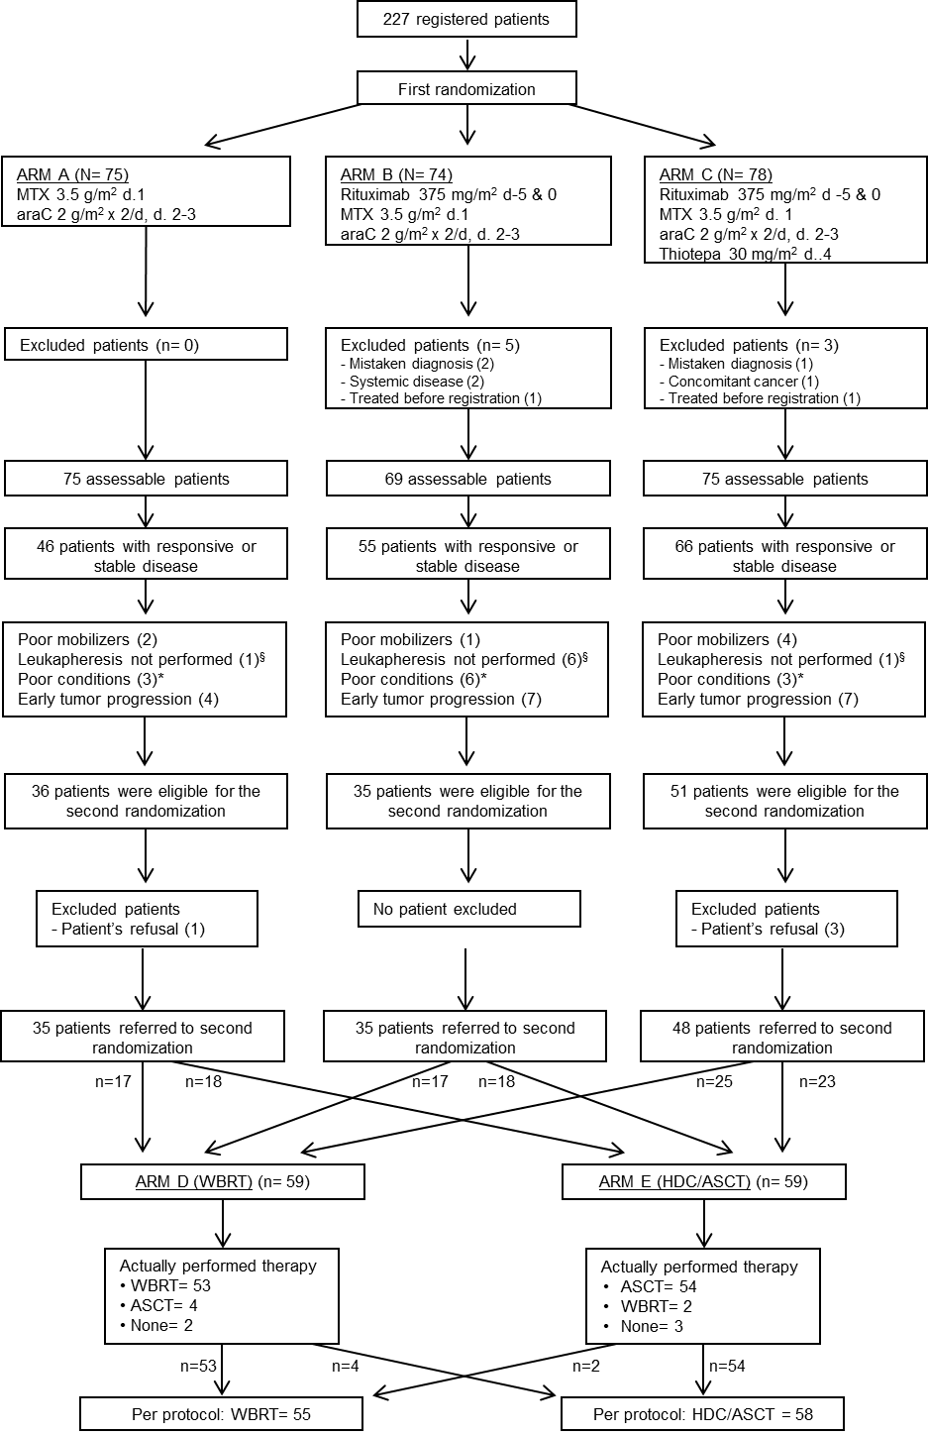

Figure 2
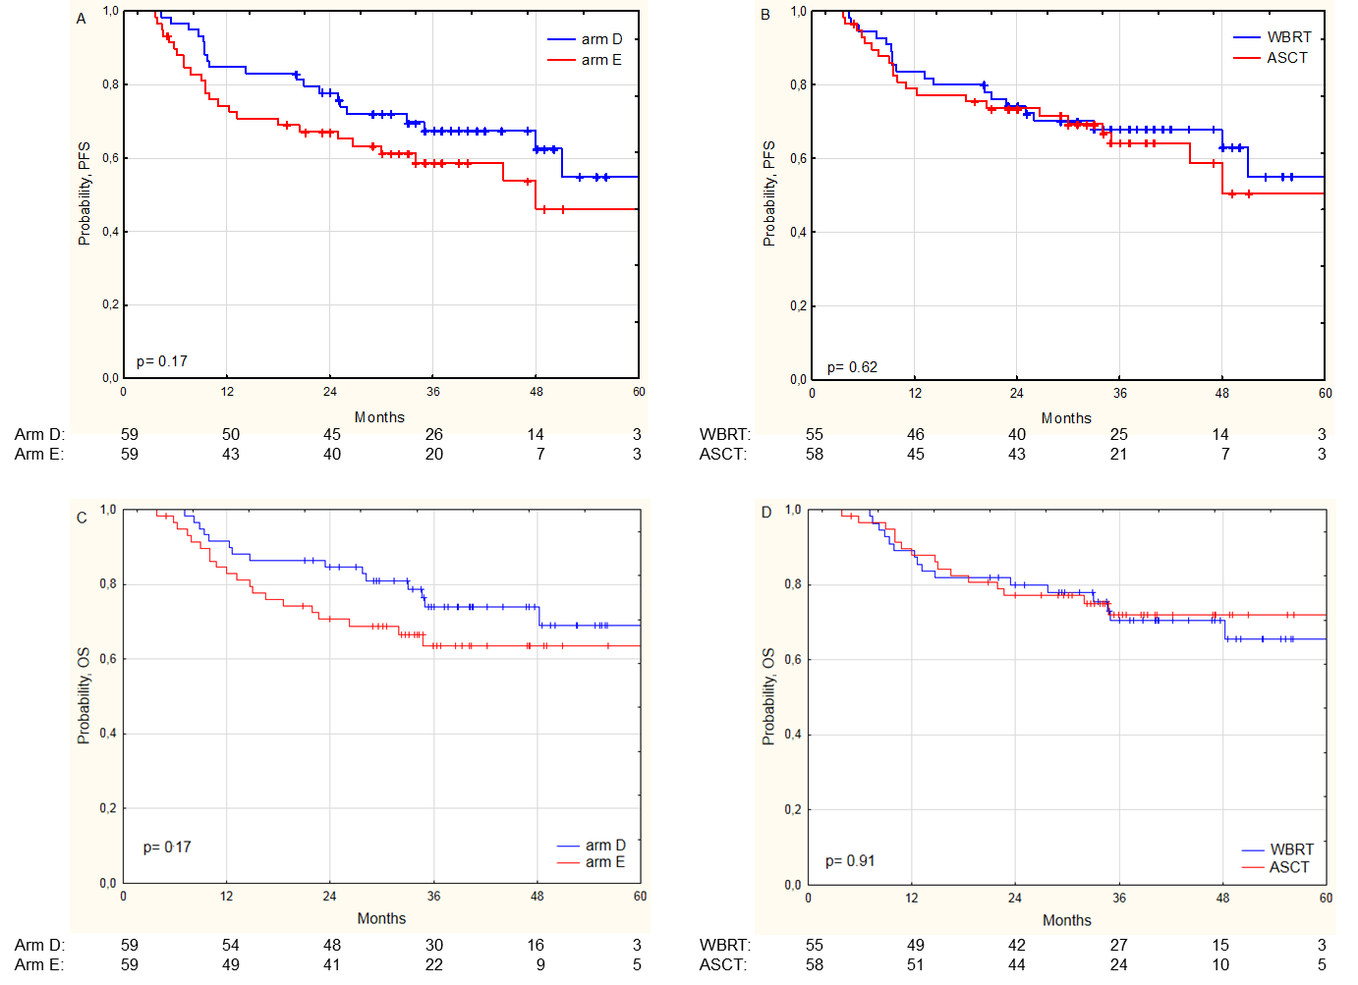

Figure 3
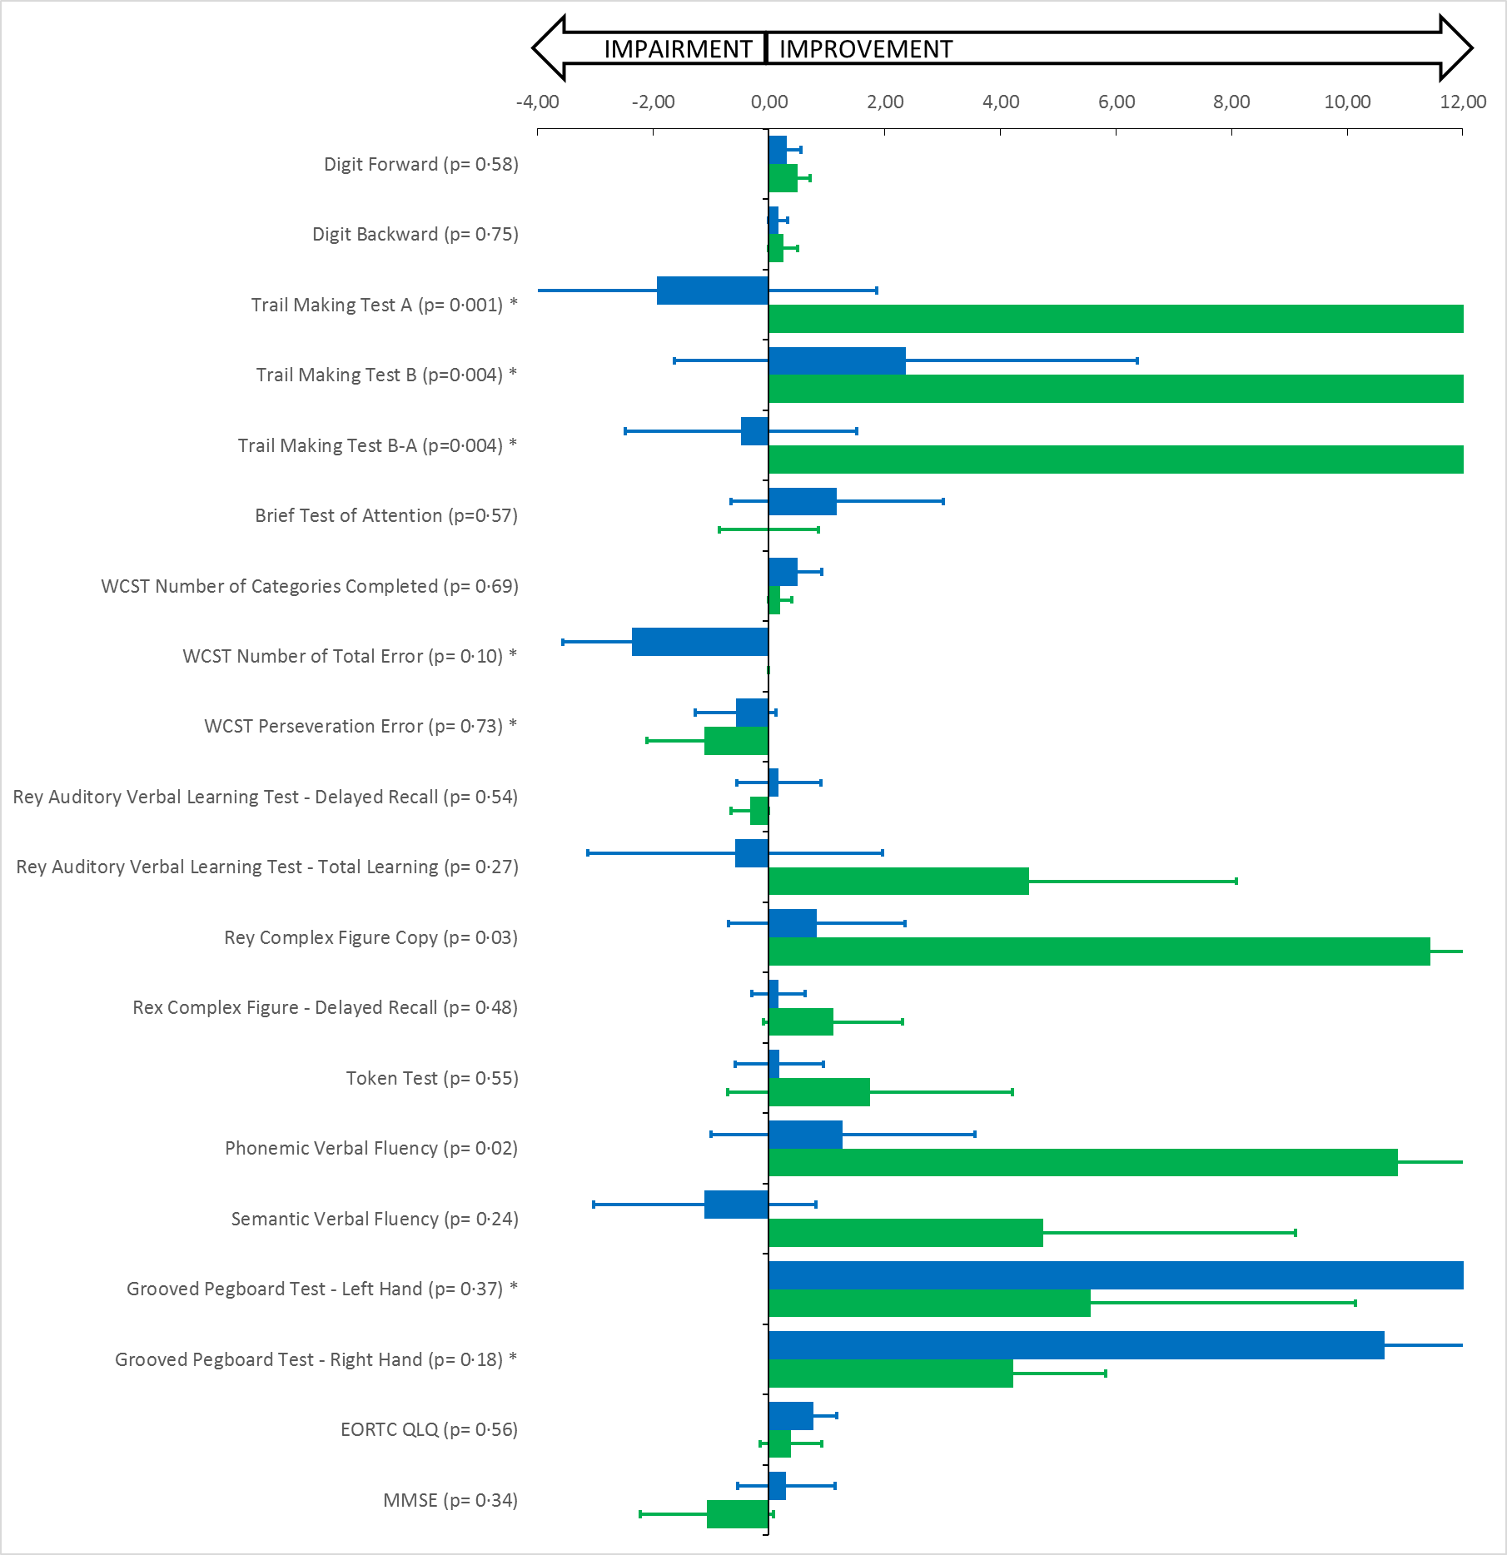

Figure 4
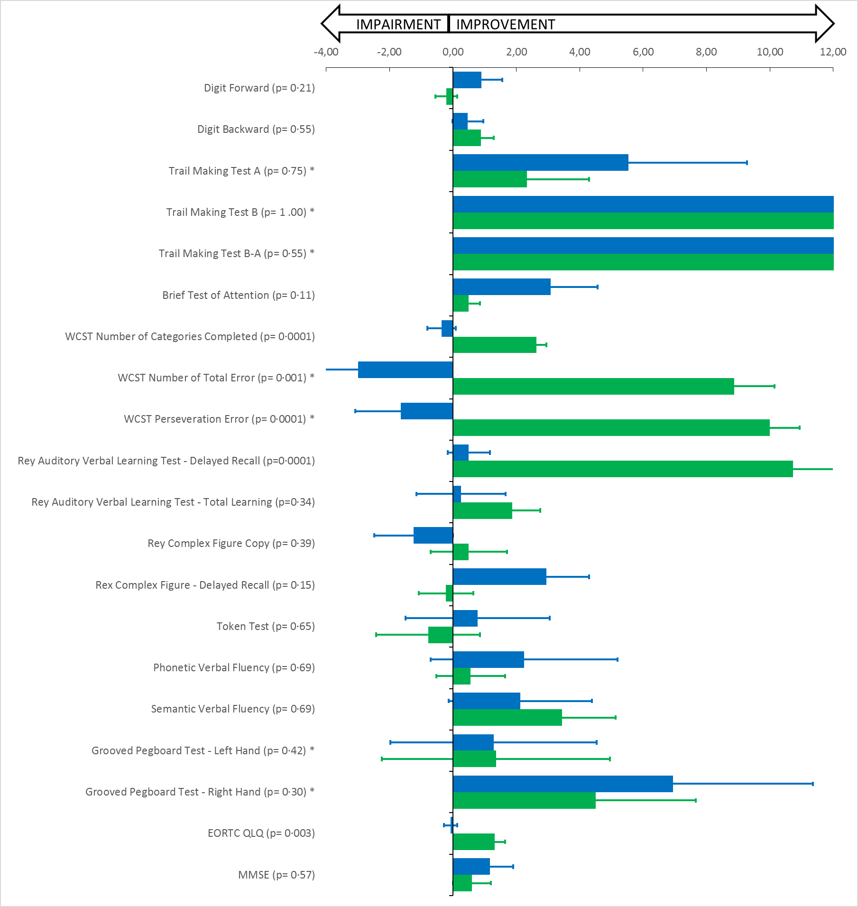
Table 1. Patient characteristics according to consolidation arm
 | Arm D (n= 59) | Arm E (n= 59) | p value
Median age (range; IQR) | 58 (18-70; 51-63) | 58 (26-70; 51-60) | 0·89
Males | 41 (69%) | 30 (51%) | 0·038
Females | 18 (31%) | 29 (49%)
ECOG PS >1 | 11 (19%) | 20 (34%) | 0·060
Increased LDH | 21 (36%) | 26 (44%) | 0·34
Deep lesions | 49 (83%) | 43 (73%) | 0·18
Increased CSF protein | 42 (71%) | 35 (59%) | 0·17
Low IELSG risk | 9 (15%) | 15 (25%) | 0·17
Intermediate IELSG risk | 43 (73%) | 36 (61%) | 0·17
High IELSG risk | 7 (12%) | 8 (14%) | 0·78
Intraocular disease§ | 1 ( 2%) | 3 ( 5%) | 0·31
Meningeal involvement† | 9/43 (21%) | 11/46 (24%) | 0·73
Multiple lesions | 31 (53%) | 34 (58%) | 0·57

ECOG PS= Eastern Cooperative Oncology Group Performance status score: LDH= lactate dehydrogenase; CSF= cerebrospinal fluid; IELSG= International Extranodal Lymphoma Study Group; DLBCL= diffuse large B-cell lymphoma.
§All patients with intraocular lymphoma had concomitant brain lesions.
†Denominators are the number of assessed patients.

Table 2. Multivariable Cox model analysis performed on intention to treat bases
PFS | Subgroups | Hazard  ratio | 95%  lower CI | 95%  upper CI | p
Gender | female vs. male | 1·75 | 0·92 | 3·30 | 0·084
IELSG risk group | low vs. intermediate  low vs. high | 0·48  0·40 | 0·24  0·12 | 0·96  1·31 | 0·038  0·131
Number of lesions | single vs. multiple | 2·19 | 1·14 | 4·22 | 0·018
Induction arm | A vs. C  B vs. C | 0·48  0·65 | 0·24  0·29 | 0·99  1·42 | 0·046  0·282
Consolidation arm | D vs. E | 0·73 | 0·40 | 1·36 | 0·331

PFS= progression-free survival.

Table 3. Feasibility and toxicity according to consolidation therapy (per protocol)
Therapy WBRT (n= 55) ASCT (n=58)
Grade | 1-2 | 3 | 4 | 5 | 1-2 | 3 | 4 | 5
Neutropenia | 3 ( 5%) | 1 (2%) | 3 (5%) | 0 (0%) | 2 ( 3%) | 5 ( 9%) | 51 (88%) | 0 (0%)
Thrombocytopenia | 0 ( 0%) | 1 (2%) | 1 (2%) | 0 (0%) | 2 ( 3%) | 4 ( 7%) | 52 (90%) | 0 (0%)
Anaemia | 7 (13%) | 2 (4%) | 0 (0%) | 0 (0%) | 21 (36%) | 17 (29%) | 2 ( 3%) | 0 (0%)
FN/infections | 0 ( 0%) | 1 (2%) | 0 (0%) | 0 (0%) | 1 ( 2%) | 12 (21%) | 3 ( 5%) | 2 (3%)
Hepatotoxicity | 3 ( 5%) | 1 (2%) | 0 (0%) | 0 (0%) | 15 (26%) | 3 ( 5%) | 1 ( 2%) | 0 (0%)
Nephrotoxicity | 2 ( 4%) | 0 (0%) | 0 (0%) | 0 (0%) | 6 (10%) | 0 ( 0%) | 0 ( 0%) | 0 (0%)
Cardiotoxicity | 0 ( 0%) | 0 (0%) | 0 (0%) | 0 (0%) | 5 ( 9%) | 1 ( 2%) | 0 ( 0%) | 0 (0%)
Coagulopathy/DVT | 2 ( 4%) | 0 (0%) | 3 (5%) | 0 (0%) | 6 (10%) | 1 ( 2%) | 0 ( 0%) | 0 (0%)
Gastrointestinal | 8 (15%) | 0 (0%) | 0 (0%) | 0 (0%) | 24 (41%) | 11 (19%) | 0 ( 0%) | 0 (0%)
Mucositis | 2 ( 4%) | 0 (0%) | 0 (0%) | 0 (0%) | 15 (26%) | 12 (21%) | 3 ( 5%) | 0 (0%)
Erythema | 7 (13%) | 0 (0%) | 0 (0%) | 0 (0%) | 0 ( 0%) | 0 ( 0%) | 0 ( 0%) | 0 (0%)
Acute neurotoxicity | 7 (13%) | 3 (5%) | 0 (0%) | 0 (0%) | 4 ( 7%) | 0 ( 0%) | 0 ( 0%) | 0 (0%)

Adverse events of grade 1 or 2 occurring in ≥10% of patients and all grade 3-5 events are reported. Denominator is the number of treated patients.
FN= febrile neutropenia; DVT= deep venous thrombosis (including pulmonary embolism).

AUTHOR CONTRIBUTIONS SECTION
AJMF, KC, EP, JF, MR, FC, EZ, and GI contributed to literature search, study design, data analysis and interpretation, and writing and approval of manuscript.
VT performed statistical analysis and contributed to study design and writing and approval of manuscript.
EM and MF performed centralized analysis of neuropsychological tests, results interpretation and approval of the manuscript.
KC, EP, CPF, ES, PLR, MB, AF, FI, AA, AR, CH, PJ, KML, TP, JSG, MB, GH, UK, SS, JP, AT, LO, FP, AL, SWK, HJS, BH, MR, JS, MP, GC, and FA contributed to patient registration and treatment, data collection, data interpretation, and writing and approval of the manuscript.
MP and MD performed central pathology review and contributed to data interpretation, writing and approval of manuscript.
LSP performed central radiology review and contributed to data interpretation, writing and approval of manuscript.

REFERENCES
1. Shiels MS, Pfeiffer RM, Besson C, et al. Trends in primary central nervous system lymphoma incidence and survival in the U.S. Br J Haematol 2016; 174(3): 417-24.
2. Batchelor TT. Primary central nervous system lymphoma. Hematology Am Soc Hematol Educ Program 2016; 2016(1): 379-85.
3. Ferreri AJ, Reni M, Pasini F, et al. A multicenter study of treatment of primary CNS lymphoma. Neurology 2002; 58(10): 1513-20.
4. Zeremski V, Koehler M, Fischer T, Schalk E. Characteristics and outcome of patients with primary CNS lymphoma in a "real-life" setting compared to a clinical trial. Ann Hematol 2016; 95(5): 793-9.
5. Ferreri AJ, Illerhaus G, Zucca E, Cavalli F, International Extranodal Lymphoma Study Group. Flows and flaws in primary central nervous system lymphoma. Nat Rev Clin Oncol 2010; 7(8): doi:10.1038/nrclinonc.2010.9,c1; author reply doi:10:1038/nrclinonc.2010.9-c2.
6. Ferreri AJ, Cwynarski K, Pulczynski E, et al. Chemoimmunotherapy with methotrexate, cytarabine, thiotepa, and rituximab (MATRix regimen) in patients with primary CNS lymphoma: results of the first randomisation of the International Extranodal Lymphoma Study Group-32 (IELSG32) phase 2 trial. Lancet Haematol 2016; 3(5): e217-27.
7. Rubenstein JL, Hsi ED, Johnson JL, et al. Intensive chemotherapy and immunotherapy in patients with newly diagnosed primary CNS lymphoma: CALGB 50202 (Alliance 50202). J Clin Oncol 2013; 31(25): 3061-8.
8. Omuro A, Correa DD, DeAngelis LM, et al. R-MPV followed by high-dose chemotherapy with TBC and autologous stem-cell transplant for newly diagnosed primary CNS lymphoma. Blood 2015; 125(9): 1403-10.
9. Morris PG, Correa DD, Yahalom J, et al. Rituximab, methotrexate, procarbazine, and vincristine followed by consolidation reduced-dose whole-brain radiotherapy and cytarabine in newly diagnosed primary CNS lymphoma: final results and long-term outcome. J Clin Oncol 2013; 31(31): 3971-9.
10. Correa DD, Shi W, Abrey LE, Deangelis LM, Omuro AM, Deutsch MB, Thaler HT. Cognitive functions in primary CNS lymphoma after single or combined modality regimens. Neuro Oncol 2012; 14(1): 101-8.
11. Correa D, Maron L, Harder H, et al. Cognitive functions in primary central nervous system lymphoma: literature review and assessment guidelines. Ann Oncol 2007; 18: 1145-51.
12. Ferreri AJ, Illerhaus G. The role of autologous stem cell transplantation in primary central nervous system lymphoma. Blood 2016; 127(13): 1642-9.
13. Ferreri AJ, Blay JY, Reni M, et al. Prognostic scoring system for primary CNS lymphomas: the International Extranodal Lymphoma Study Group experience. J Clin Oncol 2003; 21(2): 266-72.
14. Illerhaus G, Muller F, Feuerhake F, Schafer AO, Ostertag C, Finke J. High-dose chemotherapy and autologous stem-cell transplantation without consolidating radiotherapy as first-line treatment for primary lymphoma of the central nervous system. Haematologica 2008; 93(1): 147-8.
15. Illerhaus G, Marks R, Ihorst G, et al. High-dose chemotherapy with autologous stem-cell transplantation and hyperfractionated radiotherapy as first-line treatment of primary CNS lymphoma. J Clin Oncol 2006; 24(24): 3865-70.
16. Ferreri AJ, Reni M, Foppoli M, et al. High-dose cytarabine plus high-dose methotrexate versus high-dose methotrexate alone in patients with primary CNS lymphoma: a randomised phase 2 trial. Lancet 2009; 374: 1512-20.
17. Trotti A, Colevas AD, Setser A, et al. CTCAE v3.0: development of a comprehensive grading system for the adverse effects of cancer treatment. Semin Radiat Oncol 2003; 13(3): 176-81.
18. Abrey LE, Batchelor TT, Ferreri AJ, et al. Report of an international workshop to standardize baseline evaluation and response criteria for primary CNS lymphoma. J Clin Oncol 2005; 23(22): 5034-43.
19. Cheson BD, Pfistner B, Juweid ME, et al. Revised response criteria for malignant lymphoma. J Clin Oncol 2007; 25(5): 579-86.
20. Thiel E, Korfel A, Martus P, et al. High-dose methotrexate with or without whole brain radiotherapy for primary CNS lymphoma (G-PCNSL-SG-1): a phase 3, randomised, non-inferiority trial. Lancet Oncol 2010; 11(11): 1036-47.
21. Ferreri AJ, Deangelis L, Illerhaus G, O'Neill BP, Reni M, Soussain C, Yahalom J. Whole-brain radiotherapy in primary CNS lymphoma. Lancet Oncol 2011; 12(2): 118-9.
22. DeAngelis LM. Radiotherapy: has the role of WBRT in primary CNS lymphoma been settled? Nat Rev Clin Oncol 2011; 8(4): 196-8.
23. Lai R, Rosenblum MK, DeAngelis LM. Primary CNS lymphoma: a whole-brain disease? Neurology 2002; 59(10): 1557-62.
24. Ferreri AJ, Blay JY, Reni M, et al. Relevance of intraocular involvement in the management of primary central nervous system lymphomas. Ann Oncol 2002; 13(4): 531-8.
25. Ferreri AJ, Verona C, Politi L, Chiara A, Perna L, Villa E, Reni M. Consolidation radiotherapy in primary CNS lymphomas: impact on outcome of different fields and doses in patients in complete remission after upfront chemotherapy. Int J Radiat Oncol Biol Phys 2011; 80(1): 169-75.
26. Illerhaus G, Kasenda B, Ihorst G, et al. High-dose chemotherapy with autologous haemopoietic stem cell transplantation for newly diagnosed primary CNS lymphoma: a prospective, single-arm, phase 2 trial. Lancet Haematol 2016; 3(8): e388-97.
27. Abrey LE, Moskowitz CH, Mason WP, et al. Intensive methotrexate and cytarabine followed by high-dose chemotherapy with autologous stem-cell rescue in patients with newly diagnosed primary CNS lymphoma: an intent-to-treat analysis. J Clin Oncol 2003; 21(22): 4151-6.
28. Colombat P, Lemevel A, Bertrand P, et al. High-dose chemotherapy with autologous stem cell transplantation as first-line therapy for primary CNS lymphoma in patients younger than 60 years: a multicenter phase II study of the GOELAMS group. Bone Marrow Transplant 2006; 38(6): 417-20.
29. Wiebe VJ, Smith BR, DeGregorio MW, Rappeport JM. Pharmacology of agents used in bone marrow transplant conditioning regimens. Crit Rev Oncol Hematol 1992; 13(3): 241-70.
30. Kasenda B, Schorb E, Fritsch K, Finke J, Illerhaus G. Prognosis after high-dose chemotherapy followed by autologous stem-cell transplantation as first-line treatment in primary CNS lymphoma--a long-term follow-up study. Ann Oncol 2012; 23(10): 2670-5.
31. Montemurro M, Kiefer T, Schuler F, et al. Primary central nervous system lymphoma treated with high-dose methotrexate, high-dose busulfan/thiotepa, autologous stem-cell transplantation and response-adapted whole-brain radiotherapy: results of the multicenter Ostdeutsche Studiengruppe Hamato-Onkologie OSHO-53 phase II study. Ann Oncol 2007; 18(4): 665-71.
32. Alimohamed N, Daly A, Owen C, Duggan P, Stewart DA. Upfront thiotepa, busulfan, cyclophosphamide, and autologous stem cell transplantation for primary CNS lymphoma: a single centre experience. Leuk Lymphoma 2012; 53(5): 862-7.
33. Doolittle ND, Korfel A, Lubow MA, et al. Long-term cognitive function, neuroimaging, and quality of life in primary CNS lymphoma. Neurology 2013; 81(1): 84-92.
34. Houillier C, Taillandier L, Lamy T, et al. Whole Brain Radiotherapy (WBRT) Versus Intensive Chemotherapy with Haematopoietic Stem Cell Rescue (IC + HCR) for Primary Central Nervous System Lymphoma (PCNSL) in Young Patients: An Intergroup Anocef-Goelams Randomized Phase II Trial (PRECIS). Blood 2016; 128 (22): Abstract #782.

