Novel Non-Destructive Inspection of the STAR Additively Manufactured Resistojet

Introduction
Surrey Satellite Technology Limited (SSTL) has used a low power hot gas system known as a resistojet since 2002, which uses either Butane or Xenon as propellant. This system has flown on 20 spacecraft including the European GPS Galileo Testbed GIOVE-A validation satellite. This low cost and relatively low temperature resistojet significantly improves the performance of traditional cold gas propulsion systems. A collaborative development programme between the University of Southampton and Surrey Satellite Technologies Limited (SSTL) is currently proceeding to develop a Super-high Temperature Additive-manufactured Resistojet (STAR), which nearly doubles current ISP performance. The STAR is designed to increase the stagnation temperature of the propellant to approximately 3,000 K. Multiphysics models predict the total thruster efficiency to be in the range of 65-90%, resulting in an ISP for xenon propellant above 80s. The intricate design of the resistojet, as well as the high temperatures involved present significant design, manufacturing and materials challenges. The University of Southampton have identified novel solutions to these issues in a research programme that includes electrothermal simulations, additive manufacturing, performance testing and ultimately the validation of a breadboard model thruster.

Discussion
The paper presents the design, manufacturing and postproduction analysis of a novel high-temperature spacecraft resistojet heat exchanger manufactured through selective laser melting to validate the manufacturing approach. The work includes the analysis of critical features of a heat exchanger with integrated converging-diverging nozzle as a single piece element. The metrology of the component is investigated using optical analysis and profilometry to verify the integrity of components. A novel process of high-resolution micro-Computed Tomography (CT) is applied as a tool for volumetric non-destructive inspection and conformity since the complex geometry of the thruster does not allow internal examination.
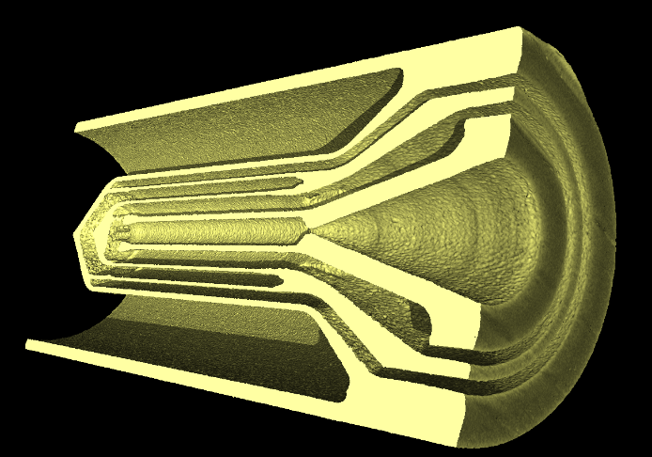
Figure 1: Reconstructed 3D image of the Heat Exchanger from CT scans
The CT volume data is utilised to determine a surface mesh on which a novel performed coordinate measurement technique is applied for nominal/actual comparison and wall thickness analysis. A thin-wall concentric tubular heat exchanger design is determined to meet dimensional accuracy requirements through nominal/actual comparison analysis.

Conclusion
The work indicates the production of fine structures with feature sizes below 200 μm in 316L stainless via selective laser melting is feasible and opens up new possibilities for the future developments in multiple industries. The paper will also include the non-destructive inspection of Inconel and refractory alloys via the same method.

Bibliography
Romei, F., Grubišić, A., Gibbon, D. Performance Testing and Evaluation of High Temperature Xenon Resistojet Prototype Manufactured by Selective Laser Melting. 35th IEPC, Atlanta, Georgia, USA, 0CT. 2017

