Feedback of the third interlaboratory exercise organised on wheat in the framework of the OBT working group.

Abstract:

Organically bound tritium (OBT) has become of increasing interest within the last decade, with a focus on its behaviour and also its analysis, which are both important to assess tritium distribution in the environment and dose consequences. After the first OBT International Workshop which was held in France in May 2012, an international working group was created. The expected benefits are the following: remove or reduce uncertainty in OBT analysis results, provide better OBT model validation data and better public dose results, increase the number of potential measuring OBT laboratories, validate all of the stages of the procedures based on a larger population and more statistically significant results, and investigate the feasibility of CRM’s and RM’s production. In this framework, three OBT exercises were organised; the 1st one on potatoes was conducted in 2013 by the Canadian National Laboratories (former AECL) with about 20 participating labs from around the world, the 2nd one on a sediment was organised in 2014 by GAU Radioanalytical (University of Southampton) on a sediment with again about 20 participating labs and the third one on wheat was organised in 2015 by the Commissariat à l’énergie atomique (CEA) with about 25 participating labs.

The method used for OBT determination, the results and the conclusions issuing from the 3rd exercise, which were presented during the 5th workshop on OBT and its analysis (Le Mans -France, 4th to 7th of October 2016), are discussed in this paper.

Keywords: Organically Bound Tritium analysis, Environmental samples, Interlaboratory exercises

# Introduction:

Tritium has a number of anthropogenic sources which account for the dominant proportion of the global tritium inventory (Belot et al., 1996; Guétat et al., 2008; Lebaron-Jacobs et al., 2009). Anthropogenic tritium sources include fallout from nuclear weapons testing, nuclear reactors, future fusion reactors, fuel reprocessing plants, heavy water production facilities and commercial production for medical diagnostics, radiopharmaceuticals, luminous paints, sign illumination, self-luminous aircraft, airport runway lights, luminous dials and others (ASN, 2010). All these licensed nuclear facilities are releasing tritium in the environment where it can exist in several forms, such as gaseous (HT, HTO, CH3T), liquid (HTO or tritiated organic molecules [TOM] in solutions) or after integration in environmental samples as Tissue Free Water Tritium (TFWT) or organically bound tritium (OBT) which can become incorporated into living organisms (vegetables, animals, humans) (Kim et al., 2013). OBT is often subdivided into exchangeable OBT (E-OBT), bound to oxygen and nitrogen atoms into the material, and non-exchangeable OBT (NE-OBT), bound to carbon atoms into the material and tightly held by the organic structure (Diabate and Strack, 1993; Guénot and Bélot, 1984). However, other definitions are proposed depending on the field of expertise of the users such as X atom-bound tritium (XBT) and Carbon-bound tritium (CBT) (Baumgartner 2009). As a consequence of the lack of consensus, the analytical procedures developed (Method 384) and standardised (XP M 60824) for tritium fractions determination focus on TFWT and OBT without considering exchangeable and non-exchangeable fractions

Given this complexity and the probability of increasing concentrations it is necessary to be able to accurately determine the various species of tritium in the environment for public and regulatory assurance. It was already done for TFWT which is part of the environmental monitoring program since the late 1990’s but not for OBT..Therefore, OBT has become of increasing interest within the last decade (CSNC 2010, ASN 2010, Galeriu et al 2013)., with a focus on its behaviour and also its analysis, which are important to assess tritium distribution and fate in the environment ( Baglan et al, 2013, Boyer et al. 2009, Kim et al. 2013, Melintescu and Galeriu 2017). After the first OBT International Workshop which was held in France in May 2012, an international working group was created. The main reasons of this creation were the necessity to validate analytical labs skills for tritium fractions analysis, including OBT, and that there are currently no Certified Reference Materials (CRM’s) or Reference Materials (RM’s) relating to OBT (Baglan et al 2013). Therefore, it was decided to organise exercises where OBT activity concentration should be determined on a regular basis on environmental samples. As additional constraints it was asked to collect additional sample to investigate CRM’s or RM’s production. From that, the expected benefits are the following: remove or reduce uncertainty in OBT analysis results, provide better OBT model validation data and better public dose results. Other potential benefits ate to increase the number of potential OBT laboratories, and to validate all of the stages of the procedures based on a larger population and more statistically significant results.

As a result, three OBT exercises were organised between 2013 and 2016:

* the 1st one on potatoes was conducted in 2013 by the Canadian National Laboratories (former AECL) with about 20 participating labs from around the world (Kim et al 2015; Baglan et al 2015),
* the 2nd one on sediment was organised in 2014 by Southampton University (GAU) on a sediment with again about 20 participating labs (Warwick et al submitted).
* The 3rd one was organised in 2015 by the CEA with about 25 participating labs. The chosen matrix was wheat due to the relative easiness of sampling at a 50 kg scale. It was chosen to collect about 50 kg of wheat to obtain enough dry material to organise the exercise and also to investigate its use as reference material (RM) through regular activity concentration checking on the next five to ten years.

Homogenized samples aliquots of about 300 g were distributed to each participant to realise this 3rd exercise. Labs results were evaluated using NF ISO 13528 recommendations (section 2.4) and an analysis of variance (ANOVA) as in the 1st exercise (CETAMA 2008, 2010 and 2013, Baglan et al 2015).

The results of the 3rd exercise are satisfactory while almost all the labs were able to determine OBT activity concentration in combustion water and or for dehydrated material with values answering to the criteria defined in international standards and or used by the IRSN (Institut de Radioprotection et Sureté Nucléaire) in France for analytical lab certification (NF ISO 13528, NF EN ISO/CEI 17043, [www.irsn.fr/prestations_et_formations/Missions_de_servcice_public/intercomparaisons-mesures](http://www.irsn.fr/prestations_et_formations/Missions_de_servcice_public/intercomparaisons-mesures)).

# Material and Method

In this exercise gathering labs from America, Asia and Europe, wheat was used as intercomparison material. To facilitate sample delivery, only dehydrated material was sent worldwide. Therefore, this exercise encompassed only the determination of the OBT activity concentration.

## Sample preparation and distribution:

Fifty kilograms of wheat grains were harvested, frozen and freeze-dried over about 21 days. Completely dried wheat was homogenized without grinding before packaging. The homogenized wheat samples were packed under vacuum, placing about 300 g of sample in each bag. The samples were distributed to each participant.

The average dehydrated to fresh mass ratio of the wheat (with two times its associated standard deviation) was determined equal to 0.91 ± 0.02 (water content of about 10 %) by the organising lab.

## Participants:

Twenty seven international laboratories (Table1) were registered for this exercise dealing with OBT analysis but one sample was blocked at the custom level and finally destroyed. The labs having received the samples were randomly numbered from 1 to 26.

Table 1: Labs registered to participate in the 3rd inter-laboratory exercise

|  |  |
| --- | --- |
| Country | Lab |
| Belgium | SCK-CEN |
| Canada | Canadian Nuclear Safety Commission |
|  | Canadian National Laboratories **(2 labs)** |
|  | Ontario Power Generation |
|  | University of Ottawa |
| China | Suzhou Nuclear Power research Institute |
| France | Commissariat à l’énergie atomique – Marcoule |
|  | CEA/DEN - Cadarache |
|  | AREVA NC - La Hague |
|  | Commissariat à l’énergie atomique - Bruyères le Châtel (organiser) |
|  | Commissariat à l’énergie atomique – Valduc **(2 labs)** |
|  | Subatech Smart - Nantes |
|  | Institut de *Radioprotection et de Sureté Nucléaire – Orsay **(2 techniques)** |
|  | Electricité de France - Avoine |
|  | Eichrom industries - Rennes |
| Japan | Radioisotope Centre – Kyushu University **(2 labs)** |
| Korea | Korea Atomic Energy Research Institute – Daejon |
| Romania | ICIT Rm Tritium Lab - Valcea |
|  | Environmental control Lab – Cernavoda NPP |
| Spain | CIEMAT - Madrid |
| Swiss republic | Institut de Radiophysique- Lausanne |
| United Kingdom | Analytical Services AMEC - Warrington |
|  | GAU Radioanalytical - Southampton |

Apart, these twenty six labs, twenty two have sent their results. Four labs provided results only for the OBT activity concentration in combustion water (Bq.L-1 of combustion water), seven labs sent results only for the OBT activity concentration in the dehydrated material (Bq.kg-1 of dehydrated material) and eleven contributed both combustion water and dehydrated material.

## Sample treatment

The general scheme to extract TFWT or OBT from an environmental matrix is summarised on Figure 1.



Figure 1: TFWT and OBT analytical scheme for environmental matrixes (mass spec. = mass spectrometry)

The sample having been dehydrated before dispatching; only OBT was analysed. For OBT analysis, in the lab that used a mass spectrometry technique (Jean Baptiste et al 2010), the dehydrated samples were introduced in a container which was sealed under vacuum before measurement. For the labs which are measuring tritium activity concentration by liquid scintillation counting (LSC), three main types of combustion devices were used, tubular oven of different diameters (12 labs), combustion bomb (6 labs) and Oxydiser (3 labs). The scintillation cocktails used were Monophase® S, for those working with an Oxydiser, whereas others were using cocktails with close compositions. UltimaGold LLT was used by 14 labs, Goldstar by 3 labs and OptiPhase HiSafe 3 by 1 lab. Liquid scintillation counters that were used to determined OBT activity concentrations are from the TRICARB family (6 labs), Quantulus 1220 (12 labs) and ALOKA LB5 (1 lab). At this point, depending on their analytical procedure labs provide results directly in Bq.kg-1 of dehydrated material or first in Bq.L-1 of combustion water before conversion in Bq.kg-1 of dehydrated material (section 3-4; Baglan et al 2015)

All labs were asked to perform 5 replicates for each activity concentration determination to facilitate the associated statistical treatment.

## Statistical treatment

Sample homogeneity and stability were checked and validated, before sample delivery during the summer 2015 for homogeneity and before data treatment during the summer 2016 for stability (NF ISO 13528, NF EN ISO/CEI 17043).

Two approaches were used to evaluate the results issuing from the 3rd exercise; the recommandations of the NF ISO 13528 dedicated to data treatment which is based on robust estimators, and the one previously used that was based on an analysis of variance (ANOVA) for which observed values of measurement series have to be normally distributed and free of outliers. To characterise the distribution, Q-Q plot, Shapiro Wilk and Anderson Darling test were used. The presence of outliers was checked by using Grubbs, Dixon and Cochran tests. The Cochran test compares the highest individual variance with the sum of the variances for all the groups. The test statistic C is the ratio of the largest variance to the sum of the variances. The critical value (Ccrit) is based on the number of groups and the number of replicates in each group. If C is larger than Ccrit, then the group can be classed as an outlier.

NF ISO 13528 approach:

This standard is used both to demonstrate that the results obtained by participating labs do not exhibit evidence of unacceptable level of bias and also to determine the assigned value and its standard uncertainty. In the framework of the OBT international group, the consensus value from participants is used as assigned value. When participating labs results are used to determine the consensus value, the assigned value X is the robust average of the results reported by all the participants. The standard uncertainty uX on the assigned values is estimated following relation 1 [R1]

 [R1]

where s* is the robust standard deviation and p the number of participating labs.

ANOVA approach:

The objective of the following calculations is to estimate the standard deviations for intermediate precision (sr) and reproducibility (sR) conditions. Intermediate precision implies that the measurements are performed by the same lab with the same instrument using a single method within a short time period to obtain results under conditions as similar as possible. Reproducibility conditions occur when any of these conditions change: lab, instrument, method variant, time frame, or any other cause of variability. The results obtained can therefore be used to calculate the standard deviation of intermediate precision (sr) (or intralaboratory reproducibility), which measures the scattering of the results obtained for five independent tests by each laboratory, and the standard deviation of interlaboratory reproducibility (sR), which measures the scattering of the mean results obtained by all the laboratories. Moreover, the intermediate precision (r) and reproducibility (R) limits were determined using relation 2 [R2] and 3 [R3] respectively.

r = ksr [R2]

R = ksR [R3]

## Presentation of the results

### NF ISO 13528 approach:

Lab data evaluation is performed using several parameters, percentage difference (D%) which is an indicator of lab bias [R4], z-score (z) which underlines the position of the lab value regarding those from the other participants [R5] and the zeta-score ()which indicates the consistency of each lab uncertainty budget [R6].

 [R4]

 [R5]

 [R6]

with :

x: result (or average of the results) reported by a participant

X: assigned value

ux: standard uncertainty of the result

uX: standard uncertainty of the assigned value

sz: the standard deviation of the proficiency testing.

For each parameter the acceptance criteria are defined in Table 2. In this work where the assigned values are consensus values, the robust standard deviation s* calculated by using the A algorithm, described in the NF ISO 13528, is taken as the standard deviation of the proficiency testing (sz).

Table 2: Acceptance criteria used to evaluate lab data for the 3rd interlaboratory exercise

|  |  |  |  |
| --- | --- | --- | --- |
| parameter | accepted | doubtful | rejected |
| D% | D% < 15 % | 15 % < D% < 20 % | D% > 20% |
| z-score | z < 2 | 2 < z < 3 | z > 3 |
| zeta-score |  < 2 | 2 <  < 3 |  > 3 |

### ANOVA approach:

The graphical presentation of the results is illustrated on the graph herebelow (Figure 2) with the dashed line corresponding to the overall mean ($\overset{̿}{x}$) whereas the dotted lines correspond to the mean plus or minus two times the reproducibility standard deviation ($\overset{̿}{x} ±2s_{R}$) *i.e.* the area where 95% of lab values should be distributed. When deviation from the reproducibility criteria occurs it means that the lab value is not consistent with those from the other participants and that questions on the way samples are treated are necessary.

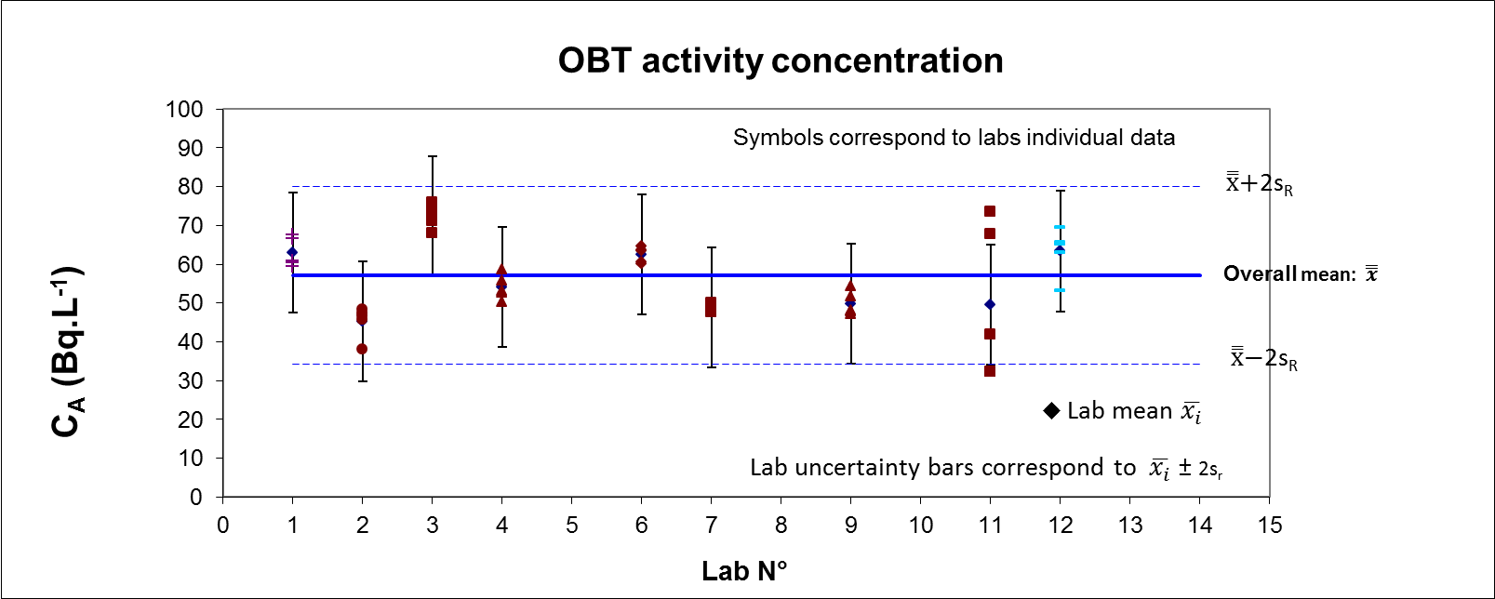

Figure 2: Graphical presentation of the results

For each lab both individual replicates and mean values are reported on the graph with error bars corresponding to two times the repeatability standard deviation ($\overset{̿}{x} ±2s_{r}$), *i.e,* the range where the probability to find lab data is of 95%. When deviation from the intermediate precision criteria occurs it means that the experimental dispersion of the data within the lab could be too high and that the source of variation between replicates has to be checked.

# Results and discussion

Before any evaluation from lab results, sample homogeneity was checked in September 2015 and in September 2016. These results were also used to check for sample stability over the year between dispatching of the sample and exploitation of the data.

## Sample homogeneity and stability

In September 2015 the mean activity concentration with its associated expended uncertainty was CA ± UCA = 71 ± 6 Bq.L-1 of combustion water. In September 2016 the mean activity concentration, without any decay correction (about 5 % on a year) was CA ± UCA = 69 ± 5 Bq.L-1 of combustion water. From these two results we saw that the sample was stable over one year.

The standard deviation chosen to assess (σ) was based on the results obtained for the first exercise on potatoes (Baglan et al. 2015). During this exercise, relative repeatability limit was 9.2 % for an activity concentration in combustion water of about 275 Bq.L-1. The activity concentration level to asses being about 70 Bq.L-1 in this 3rd exercise, the homogeneity criteria was defined as 9 % of the activity concentration level observed in the wheat sample; that is to say σ = 6.3 Bq.L-1. To fulfil homogeneity criteria, the between sample standard deviation ss should be lower than 0.3σ (= 1.9 Bq.L-1). The value of ss being of 0.98 and 1.35 in September 2015 and September 2016 respectively, the material was considered homogeneous.

In this exercise, all of the labs have performed five replicate analysis to determine the OBT activity concentration in the combustion water or for the dehydrated sample. With all lab results expressed in the appropriate units, the statistical treatment was performed. Results will be given first for combustion water and second for the dehydrated material considering both NF ISO 13528 and ANOVA approach. Prior to presenting the activity concentration results, all of the preliminary statistical testing ran to verify the normality of the distribution and to identify outliers will be discussed.

## Normality:

Before to investigating the data obtained by the participating labs using ANOVA statistical technique, the normality of the distribution was checked first for lab individual data for both combustion water and dehydrated material results using Origin 2016™ software. Since the lab individual data being normally distributed their means were used to check that the distributions of the results were also normal for both combustion water and dehydrated material using graphical method or classical tests to assess normality (Shapiro Wilk and Anderson Darling). The criteria to fulfil are: the closeness between data points and Henry’s straight line for the graphical method; a calculated value (Wcalc) higher than the critical value (Wc) when using Shapiro Wilk test and a calculated value (Acalc) lower than the critical value (Ac) when using Anderson Darling test

Activity concentration determinations in combustion water have been performed by fifteen labs (section 2.2). The Q-Q plot indicates a departure from normality when the highest value is considered (Figure 3a) which is confirmed for n = 15 and  = 0.05 by the Shapiro Wilk (Wcalc = 0.675 and Wc = 0.881) and Anderson Darling (Acalc = 1.718 and Ac = 0.752) tests.

When the highest value is discarded, the Q-Q plot is consistent with a normal distribution (Figure 3b) which is confirmed for n = 14 and  = 0.05 by the Shapiro Wilk (Wcalc = 0.892 and Wc = 0.874) and Anderson Darling (Acalc = 0.493 and Ac = 0.752) tests. .

|  |  |
| --- | --- |
| Figure 3-a: All data. | Figure 3-b: After discarding the highest activity concentration value. |
| Figure 3: Participating lab mean determined in combustion water vs calculated one for normality checking (Q-Q plot). | |

Activity concentration determinations for dehydrated material have been performed by eighteen labs (section 2.2). The Q-Q plot indicates a departure from normality when the two highest values are considered (Figure 4a) which is confirmed for n = 18 and  = 0.05 by the Shapiro Wilk (Wcalc = 0.784 and Wc = 0.897) and Anderson Darling (Acalc = 1.45 and Ac = 0.752) tests.

When the two highest values are discarded, the Q-Q plot is consistent with a normal distribution (Figure 4b) which is confirmed for n = 16 and  = 0.05 by the Shapiro Wilk (Wcalc = 0.942 and Wc = 0.887) and Anderson Darling (Acalc = 0.446 and Ac = 0.752) tests.

|  |  |
| --- | --- |
| Figure 4-a: All data. | Figure 4-b: After discarding the two highest activity concentration values. |
| Figure 4: Participating lab mean determined in dehydrated material vs calculated one for normality checking (Q-Q plot). | |

The two highest values which have to be discarded for observing a normal distribution are those obtained when using an Oxydiser™ for determining OBT activity concentration in the dehydrated wheat sample. This result does not indicate any analytical problem but, it only confirms that, in dehydrated material, such an analytical tool is not well suited for activity below 20 to 50 Bq kg-1 .

The normality of the distribution of data being met, all the remaining values were used to check for outliers in lab mean values (Dixon and Grubbs) or between lab variance (Cochran) before performing the ANOVA test.

## Combustion water

Fifteen labs have provided OBT activity concentration in combustion water (section 2.2). Their results will be discussed using both the NF ISO 13528 and the ANOVA approaches.

### NF ISO 13528 approach

Both X and uX are calculated using the robust algorithm described in NF ISO 13528 standard with the following result: X ± 2s* = 68.9 ± 4.6 Bq.L-1 (or kg-1 for those which are weighing the measured aliquot). Among the entire dataset (Table 3), only lab 9 results showed a bias (23 % overestimation and z-score of about 7 and zeta –scores of about 5).

Table 3: Lab mean activity concentration (CA), D% and z scores values. The mean activity concentrations (CA) are provided in Bq.L-1 (or Bq.kg-1) of combustion water. Zeta scores are not provided in table 3 while calculated for each replicate (zeta-score consistency is “good” if for each replicate the zeta-score is below 2, “possible deviation” means that for two replicates at least the value is over 2 and “check your results” indicates that two values are over 3).

|  |  |  |  |  |  |
| --- | --- | --- | --- | --- | --- |
| Lab N° | CA (Bq.L-1) | D (%) | z-score | z score consistency | zeta score consistency |
| 1 | - | - | - | - |  |
| 2 | - | - | - | - |  |
| 3 | 70.5 | 2% | 0.68 | accepted | good |
| 4 | 70.3 | 2% | 0.60 | accepted | good |
| 5 | 67.6 | -2% | -0.57 | accepted | good |
| 6 | - | - | - | - | - |
| 7 | - | - | - | - | - |
| 8 | 65.2 | -5% | -1.6 | accepted | Possible deviation |
| 9 | 84.7 | 23% | 6.7 | rejected | check your results |
| 10 | 68.5 | -1% | -0,16 | accepted | good |
| 11 | - | - | - | - | - |
| 12 | 70.8 | 3% | 0.80 | accepted | good |
| 13 | 67.9 | -1% | -0.41 | accepted | good |
| 14 | 67.5 | -2% | -0.61 | accepted | good |
| 15 | 68.7 | 0.3% | -0.08 | accepted | good |
| 16 | - | - | - | - | - |
| 17 | - | - | - | - | - |
| 18 | - | - | - | - | - |
| 19 | 68.4 | -1% | -0.21 | accepted | good |
| 20 | 64.5 | -6% | -1.9 | accepted | good |
| 21 | - | - | - | - | - |
| 22 | 70.2 | 2% | 0.54 | accepted | good |
| 23 | 69.1 | 0.4% | 0.10 | accepted | good |
| 24 | - | - | - | - | - |
| 25 | - | - | - | - | - |
| 26 | 70.5 | 2% | 0.67 | accepted | good |

Two of the zeta scores of lab 8 are over three due to a high dispersion of the determined activity concentration with almost constant relative uncertainty. Three other labs should keep an eye on their uncertainty budget. Indeed, lab 5, 13 and 23 provided low relative combined uncertainty of about 3.5 % which is in the range of the one provided on reference solutions.

### ANOVA approach

In addition to the normality of the distribution, both lab mean and lab variance values were checked for outliers.

The lab mean values summarised in Table 3, without considering lab 9 which corresponds to the highest value discarded to assess the normality of the distribution, were used to check for outliers. Any other outlier is set in evidence by using Dixon and Grubbs test on this data set.

To check for homoscedasticity, a Cochran’s test was performed on the variance observed in the other participating labs (Table 4).

Table 4: Lab variance obtained on five determinations of the activity concentration for combustion water



The Cochran test performed on Table 4 data indicates that lab 8 variance is too high. Lab 15 variance is much smaller than lab 8, one but remains much higher than those from the other labs. Therefore, after discarding lab 8, the lab 15 result becomes also an outlier.

For all the participating labs, the results obtained during this exercise are summarized in Figure 5.

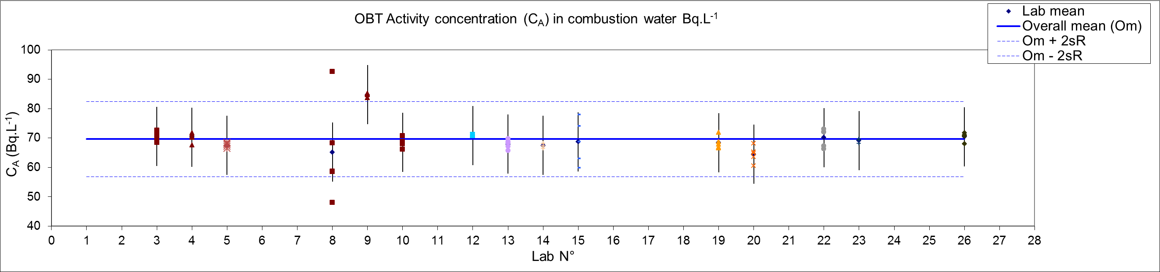

Figure 5: Activity concentration in Bq.L-1 of combustion water (all participants)

The graphical display available using the ANOVA without discarding outliers confirms that the mean activity concentration value from lab 9 is too high and that the dispersion observed on lab 8 replicates is too high but it does not allow making the same observation for lab 15. Indeed, for this lab (lab 15) all the replicate values remain in the range corresponding to the mean value ± twice the intermediate precision standard deviation.

After discarding labs 8 and 9, the results for the combustion water are presented in Figure 6 where the dispersion of lab 15 values is higher than the dispersion of all other participants. Lab 15 was not discarded because it did not impact on the overall mean. Moreover, the reproducibility standard deviation increases only slightly (from 4.8 to 5.9) and remains very low with regards to the activity concentration level that was assessed in this OBT exercise.

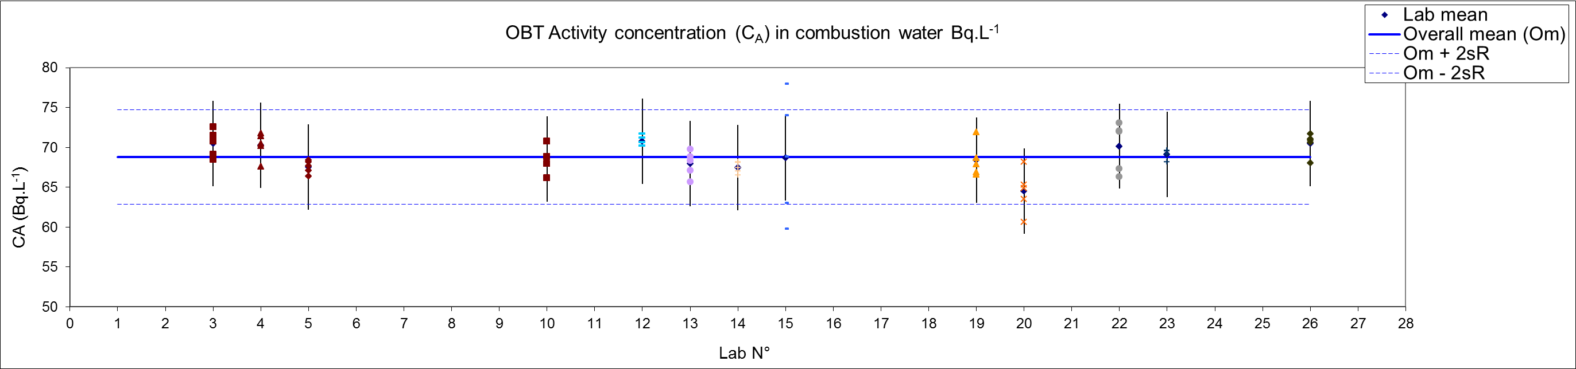

Figure 6: Activity concentration in Bq.L-1 of combustion water for all participating labs except labs 8 and 9.

After discarding the outliers, the overall mean value (with its associated reproducibility standard deviation k = 2) is: m ± 2sR = 68.8 ± 4.8 Bq.L-1 (or kg-1 for those which are weighing the measured aliquot).

Both approaches lead to mean values which are similar confirming that they could be used simultaneously or separately. The main advantage of using both is that the displayed information complete each other.

### Consensus value

When participating labs results are used to determine the consensus value, the assigned value X is the robust average of the results reported by all the participants (NF ISO 13528). The standard uncertainty uX of the assigned values is estimated with relation 1 [R1].

Using this definition gives the following assigned OBT activity concentration value in combustion water:

Awater-comb = 68.9 ± 1.4 Bq.L-1 of combustion water

When considering lab means (Table 3), after discarding lab 9 value who is clearly an outlier, it shows that all values are closed to the consensus value as the z score are below 2. In addition, for a consensus value of 68.9 Bq.L-1 of combustion water, the min value is 64.5, *i.e.,* a relative deviation of – 6.4 % and the max value is 70.8, *i.e.,* a relative deviation of 2.7 %. These values are far below the ± 15 % criteria proposed in Table 2, demonstrating the improvement in skills for OBT determination in environmental matrixes amongst the participating analytical labs since the first exercise in 2012 where the overall mean value (with its associated reproducibility standard deviation k = 2) of the 20 participants was: m ± 2sR = 280 ± 60 Bq.L-1 (or kg-1 for those which are weighing the measured aliquot), ie, a far higher dispersion of lab data for an activity concentration four times higher. Moreover, the only lab with a zeta score over 3 was the one exhibiting the highest variance of the participating labs being classed as an outlier by using Cochran test

## Hydrogen percentage and water equivalent factor

To convert the activity concentration value from Bq.L-1 of combustion water to Bq.kg-1 of dry wheat (dehydrated material), an water equivalent factor (WEF) or an experimental value of the hydrogen weight percentage (%H) could be used.

The water equivalent factors are provided in L of water obtained per kg of dry weight, their values vary little among the various plant categories (IAEA 2010) with values around 0.5.

The average hydrogen percentage for the wheat sample (with two times its associated standard deviation) was determined to be 6.51 ± 0.10 % by the organiser. The relation used to convert the tritium activity concentration measured in combustion water (CA) to the one in Bq.kg-1 of dehydrated wheat (Cd) is given hereafter (R7):

 (R7)

And the associated expanded uncertainty, given in relation 8 (R8):

 (R8)

Experimental hydrogen percentages were determined by seven additional labs. The values obtained were ranging from 6.5% to 6.9% with a mean value of 6.75%. The relative standard deviation (k=2) observed on the hydrogen percentage is 15% with individual relative uncertainties in the vicinity of 3 %. Concerning hydrogen percentage determination, both analytical procedure and uncertainty budget should be investigated. It should be noted that two labs have been using tabulated values of 6.51 and 6.72.

## Dehydrated wheat

Eighteen labs have provided OBT activity concentration in Bq.kg-1 of dehydrated wheat (section 2.2). Seven labs determine directly the activity concentration value on the dehydrated sample, mainly those using technique where it’s difficult to assess the amount of combustion water used mixed with the scintillating cocktail(Oxydiser, mass spectrometry, pyroliser). Eleven labs convert the activity concentration determined in the combustion water to those present in the dehydrated material. Their results will be discussed using both the NF ISO 13528 and the ANOVA approaches.

### NF ISO 13528 approach

Both X and uX are calculated using the robust algorithm described in NF ISO 13528 standard with the following result: X ± 2s* = 41 ± 6 Bq.kg-1. Among the entire results (Table 5), those for lab 2 and 21 show a z-score value over 2. However, both labs are using an Oxydiser M307 designed for sample size in the gram range leading, for this intercomparison sample, to handle activity concentration that are closed to the detection limit . Therefore, the observed deviation is probably due to poor counting statistic than to the analytical procedure itself. For lab 7, the mean value is within an acceptable range (z-score below 2; Table 5) but there are clearly two populations in their results, one in the 25 Bq.kg-1 of dehydrated sample range and one in the 50 Bq.kg-1 of dehydrated sample range (Figure 7). Therefore, a deeper look at lab 7 analytical procedure is in progress to improve lab precision.

Table 5: Lab mean activity concentration (Cd), D% and z scores values. The mean activity concentrations (CA) are provided in Bq.kg-1 of dehydrated material. Zeta scores are not provided in this table while calculated for each replicate (zeta-score consistency is “good” if for each replicate the zeta-score is below 2, “possible deviation” means that for two replicates at least the value is over 2 and “check your results” indicates that two values are over 3).

|  |  |  |  |  |  |
| --- | --- | --- | --- | --- | --- |
| Lab N° | Cd (Bq.kg-1) | D (%) | z-score | z score consistency | zeta score consistency |
| 1 | 37.6 | -9% | -1.2 | accepted | good |
| 2 | 55.0 | 34% | 4.6 | rejected | good |
| 3 | 39.5 | -4% | -0.54 | accepted | good |
| 4 | - | - | - | - |  |
| 5 | - | - | - | - |  |
| 6 | - | - | - | - |  |
| 7 | 37.4 | -9% | -1.3 | accepted | good |
| 8 | 39.58 | -4% | -0.51 | accepted | possible deviation |
| 9 | - | - | - | - |  |
| 10 | 41.4 | 1% | 0.10 | accepted | good |
| 11 | - | - | - | - |  |
| 12 | 42.6 | 4% | 0.49 | accepted | good |
| 13 | - | - | - | - |  |
| 14 | 39.4 | -4% | -0.57 | accepted | good |
| 15 | 39.2 | -5% | -0.64 | accepted | good |
| 16 | 44.62 | 9% | 1.2 | accepted | good |
| 17 | - | - | - | - |  |
| 18 | 41.81 | 2% | 0.23 | accepted | good |
| 19 | 42.52 | 3% | 0.47 | accepted | good |
| 20 | 37.90 | -8% | -1.1 | accepted | good |
| 21 | 52.20 | 27% | 3.7 | rejected | good |
| 22 | 42.88 | 4% | 0.59 | accepted | good |
| 23 | 42.00 | 2% | 0.30 | accepted | good |
| 24 | - | - | - | - |  |
| 25 | 39.22 | -5% | -0.63 | accepted | good |
| 26 | 41.77 | 2% | 0.22 | accepted | good |

Like for activity concentration expressed for combustion water, two of the zeta scores of lab 8 are over 3. This was due to a high dispersion of the determined activity concentration with almost constant relative uncertainty.

Four other labs should keep an eye on their uncertainty budget, lab 3 and 20 provide lower relative uncertainty compared to those for combustion water which following relation [R8] is clearly impossible, . Lab 12 gives an uncertainty which looks higher than the one obtained by combining those provided on hydrogen percentage and activity concentration determined on combustion water. Lab 23 provides a relative combined uncertainty of about 3.0 % which is in the range of the one provided on reference solutions.

### ANOVA approach

For all the participating labs, the results obtained during this exercise are summarized in Figure 4.

In addition to the normality of the distribution, both lab mean and lab variance values were checked for outliers.

The lab mean values summarised in Table 5, without considering lab 2 and 21 which corresponds to the two highest values discarded to assess the normality of the distribution, were used to check for outliers. Any other outlier was set in evidence by using Dixon and Grubbs test on this data set.

To check for homoscedasticity, a Cochran’s test was performed on the variance observed in the other participating labs (Table 6).

Table 6: Lab variances obtained on five determinations of the activity concentration in the dehydrated material.



The Cochran test performed on Table 6 data indicates that lab 7 variance is too high and confirms that lab 8 variance, as observed on combustion water (Table 4], was too high. Therefore theses values will not be used in the overall mean and reproducibility standard deviation estimation.

Aiming to visualize the reason leading to reject some data using the statistical test described in this paper, the graphical display was first plotted for all the participating labs. The results obtained during this exercise are gathered on Figure 7.

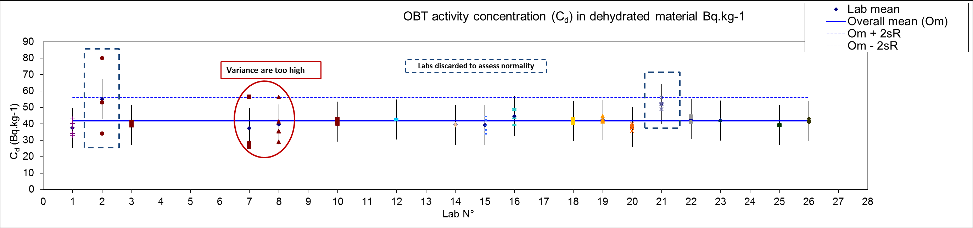

Figure 7: Activity concentration in Bq.kg-1 of dehydrated wheat for all participating labs

The graphical display available using the ANOVA approach confirms that the dispersions from lab 7 and 8 measurement are too large. The labs (Lab 2 and 21) which were using an Oxydiser worked with a small sample size (about 1 g) and therefore seeing activity concentrations that were very close to their detection limit) were also not considered hereafter to meet the criteria of normal distribution of the data. After discarding all of these values, the data for the remaining labs are presented in Figure 8.

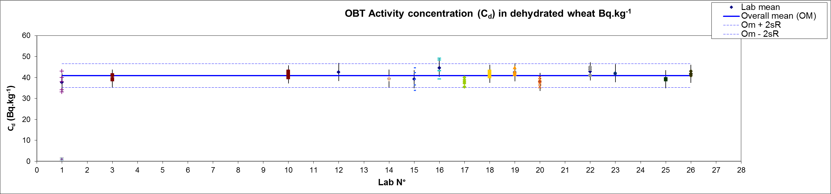

Figure 8: Activity concentration in Bq.kg-1 of dehydrated wheat for the selected labs

Bases on these data, the overall mean value (with its associated reproducibility standard deviation k = 2) is: m ± 2sR = 41 ± 6 Bq.kg-1.

In any case, as for combustion water, both approaches lead to mean and standard deviation values which are similar, confirming that they could be used simultaneously or separately. The main advantage of using both is that the displayed information complete each other.

### Consensus value

When participating labs results are used to determine the consensus value, the assigned value X is the robust average of the results reported by all the participants. The standard uncertainty uX of the assigned values is estimated with relation 1 [R1].

Using this definition gives the following assigned OBT activity concentration value in dehydrated wheat:

Adry-wheat = 41.1 ± 1.8 Bq.kg-1 of dehydrated wheat

When considering lab means (Table 5), discarding lab 2 and 21 values which could deviate, it shows that all values are close to the consensus value. Indeed, for the consensus value of 41.1 Bq.kg-1 of dehydrated material, the min and max value are 37.3 and 44.6 with a relative deviation of – 9 % and +9 % respectively. These values are far below the ± 15 % criteria proposed in Table 2, demonstrating an improvement in the OBT determination in environmental matrixes skills of the participating analytical labs since the first exercise in 2012 where the overall mean value (with its associated reproducibility standard deviation k = 2) of the 20 participants was: m ± 2sR = 140 ± 50 Bq.kg-1, *i.e.*, a far higher dispersion of lab data for an activity concentration about four times higher.

# Conclusion

The results obtained during the exercise are very encouraging by combining a large international participation with an important reduction of results dispersion even with a much lower activity concentration. Indeed, relative standard deviation for activity concentration determined in combustion water is decreased from a factor of 2 whereas activity concentration itself decreases from a factor of 4 regarding the first exercise. When focusing on dehydrated wheat the situation is a little bit different with a higher dispersion due to the use by several labs of an analytical tool at the detection limit level. Anyway, the relative standard deviation is of the same order of magnitude as in the first exercise with a 4 times lower activity concentration.

Moreover, following the recommendations of the first exercise, five replicates of the activity concentration determinations are performed by the participating labs which makes easier the statistical treatment. In addition, this exercise was the opportunity to demonstrate the stability of the sample over a one year period.

This result which could be considered as simple is also of importance in the objective to prepare and to validate the use of environmental matrixes as Certified Reference Material (CRM’s) or Reference Materials (RM’s) for tritium fractions determination. Anyway, this study should be continued during the next five to ten years to complete the validation process.

At this point a question arises: what will be the consequences for the tritium labs of the uncertainty calculated on the consensus value following NF ISO 13528 (R1) recommendations? Indeed, during this exercise, the p lab data were very close to the reference value with a relative deviation always below 6 %. Therefore, robust standard deviation (s*) is also small leading to a very low relative standard uncertainty (~ 2 %). Considering the numerous stages to perform OBT analysis and liquid scintillation counting performances for such activity concentrations (around 70 Bq.L-1) individual lab relative uncertainties are over 5 %. Thus, the use of the remaining sample as QC (quality control) sample, RM (Reference Material) or CRM (Certified Reference Material) should be very tricky when considering the very narrow confidence interval and classical analytical validation criteria (En, D,..).

In addition, the investigation on the conversion factor (WEF or hydrogen percentage) impact which are not started at the time should be started. The next exercise, organised by Romania, could give an opportunity to dig a little bit more on this specific topic.

Acknowledgements: The authors want to thanks Aurélie Ritt and Marjorie Galliot for their help in the dehydration and packaging stages which make this work possible. Thank you also to all the exercise participants.

**References**

ASN (2010) Livre Blanc du Tritium. Autorité de Sureté Nucléaire, Paris.

Baglan N., Kim S. B., Cossonnet C., Croudace I. W., Fournier M., Galeriu D., Warwick P. E., Momoshima N. and Ansoborlo E. (2013) Organically Bound Tritium (OBT) behaviour and analysis: Outcomes of the seminar held in Balaruc les Bains in May 2012. *Radioprotection,* **48**, 127.

Baglan N., Kim S. B., Cossonnet C., Croudace I. W., Fournier M., Galeriu D., Warwick P. E., Momoshima N. and Ansoborlo E. (2015) Organically bound tritium analysis in environmental samples. *Fusion science and technology*, **67** (2), 250-253.

Baumgartner, F., Yankovich, T.L., Kim, S.B., 2009. Logistic analysis of OBT dynamics. Health Phys. 97 (6), 572.

Belot Y., Roy M., Métivier H. (1996) Le tritium : de l’environnement à l’homme. EDP (Les Ulis)

Boyer C., Vichot I., Fromm M., Losset Y., Tatin-Froux F., Guetat P., Badot P.M., (2009). Tritium in plants: a review of current knowledge. Environ. Exp. Bot. **67**, 34.

CETAMA (2008), Circuit intercomparaison 2005-2008, Analyse du tritium organiquement lié dans une matrice herbe, Commission d’ETAblissement des Méthodes d’Analyse - DEN/DCRP/CETAMA/NT/2008/05.

CETAMA (2010), Circuit intercomparaison 2009-2012, Analyse du tritium organiquement lié dans une matrice herbe, Commission d’ETAblissement des Méthodes d’Analyse - DEN/DCRP/CETAMA/NT/2010/03.

CETAMA (2013), Méthode 384 : Analyse du tritium dans les matrices environnementales. Commission d’ETAblissement des Méthodes d’Analyse - DEN/DRCP/CETAMA/NT/2013/03.

CNSC 2010. Tritium Studies. Canadian Nuclear Safety Commission. http://www.nuclearsafety.gc.ca/eng/readingroom/tritium/tritium_studies.cfm.

Diabate S., Strack S.,(1993). Organically bound tritium. Health Physics **65** (6), 698.

Galeriu D., Melintescu A., Strack S., Atarashi-Andoh M., Kim S. B. (2013) *J. Environmental Radioactivity,* **118**, 40.

Guénot, J., Bélot, Y., 1984. Assimilation of 3H in photosynthesizing leaves exposed to HTO. Health Physics **47** (6), 849.

Guétat P., Douche C., Hubinois J.C. (2008) Le tritium et l’environnement : sources, mesures et transferts. *Radioprotection.* **43**, 547.

IAEA (2010) Handbook of parameter values for the prediction of radionuclide transfer in terrestrial and freshwater environment Technical Reports Series n° 472

Jean-Baptiste, P., Fourre, E., Dapoigny, A., Baumier, D., Baglan, N., Alanic, G., (2010) 3He mass spectrometry for very low-level measurement of organic tritium inenvironmental samples. J. Environ. Radioact. **101**, 185.

Kim S. B., Baglan N., Davis P. A. (2013) Current understanding of organically bound tritium (OBT) in the environment. *J. Environmental Radioactivity,* **126**, 83.

Kim S. B., Olfert J., Baglan N., St-Amant N., Carter B., Clark I. and Buccur C. (2015) Canadian inter-laboratory organically bound tritium (OBT) analysis exercise. *J. Environmental Radioactivity,* **150**, 236.

Lebaron-Jacobs L., Garnier-Laplace J., Lopez B., Adam-Guillermin C., Dublineau I., Roussel-Debet S., Antonelli C., Fievet B., Bailly du Bois P., Masson M. (2009), Chapitre 30 Tritium, in Toxicologie nucléaire environnementale et humaine p 575, Lavoisier (Paris).

Melintescu A. and Galeriu D. (2017) Uncertainty of current understanding regarding OBT formation in plants. J. of environmental radioactivity, **167**, 134.

NF ISO 13528, Statistical methods for use in proficiency testing by laboratory intercomparison.

NF EN ISO/CEI 17043, General requirements for proficiency testing.

Warwick P. E., Croudace I. W., Marsh R. M., Baglan N. and Kim S. B., A new reference material for tritium organic molecules in sediment: results of an international intercomparison exercise. submitted

XP M 60-824, Measurement of radioactivity in the environment — Determination of tritium activity in the environment — Test method for the analysis of tritium in free water and organically bound tritium in environmental matrices.