Notice:
This document is the unedited Author’s version of a Submitted work that has been subsequently accepted for publication in Nano Letters copyright© American Chemical Society after peer review. To access the final edited and published work see
10.1021/acs.nanolett.7b04330

Exploration of the smallest diameter tin nanowires achievable with electrodeposition; sub 7 nm Sn nanowires produced by electrodeposition from a supercritical fluid
Philip N. Bartlett,*[a] Richard Beanland,[c] Jennifer Burt,[a] Mahboba M. Hasan,[a] Andrew L. Hector,[a] Reza J. Kashtiban,[c] William Levason,[a] Andrew Lodge,[a] Samuel Marks,[c] Jay Naik,[b] Akhtar Rind,[b] Gillian Reid,[a] Peter W. Richardson,[a] Jeremy Sloan,[c] David C. Smith*[b]
[a] Chemistry, University of Southampton, Highfield, Southampton SO17 1BJ, UK;
[b] Physics and Astronomy, University of Southampton, Highfield, Southampton SO17 1BJ, UK.
[c] Department of Physics, University of Warwick, Coventry, CV4 7AL, UK

Keywords: Nanowire, electrodeposition, mesoporous, template, anodic alumina
Electrodeposition of Sn from supercritical difluoromethane has been performed into anodic alumina templates with pores down to 3 nm in diameter and into mesoporous silica templates with pores of diameter 1.5 nm. Optimized deposits have been characterized using X-ray diffraction, scanning electron microscopy, scanning transmission electron microscopy (bright field, high angle annular dark field and energy dispersive X-ray elemental mapping). Crystalline 13 nm diameter Sn nanowires have been electrodeposited in symmetric pore anodic alumina. Direct transmission electron microscopy evidence of sub 7 nm Sn nanowires in asymmetric anodic alumina has been obtained. These same measurements present indirect evidence for electrodeposition through 3 nm constrictions in the same templates. A detailed transmission electron microscopy study of mesoporous silica films after Sn deposition is presented. These indicate that it is possible to deposit Sn through the 1.5 nm pores in the mesoporous films, but that the nanowires formed are not stable. Suggestions of why this is the case and how such extreme nanowires could be stabilized are presented.
The fact that it is possible to modify the physical properties of materials by forming them into a sufficiently small diameter wire is beyond doubt. What constitutes sufficiently small depends on the material and the physical property, but commonly the threshold is in the nanoscale regime. For single nanowire optical lasers¹ photon confinement is associated with nanowires of 100-200 nm diameter. Electrodeposited Sn nanowires have 1D like superconducting properties for nanowires of diameter less than 40 nm.² Predictions suggest that Bi nanowires with diameters of less than 10nm should have a thermoelectric figure of merit (ZT) greater than 1.³ Other predictions suggest that Sn nanowires should undergo a semimetal to semiconductor phase transitions at a threshold diameter of ~3 nm.⁴.
The scientific and technological interest in nanowires has led to the development of many highly successful techniques for their production, however, there is still plenty of scope for developing new methods; particularly for the production of sub 10 nm nanowires such as those that would be required to test some of the predictions about such small diameter nanowires which have not yet been fully established.³⁻⁴. Templated electrodeposition has some significant advantages for the production of nanowires,⁵ however nearly all electrodeposited nanowires have diameters greater than 10 nm even though suitable templates exist. Why is this? The commonly used templates of anodic alumina and track etch polycarbonate membranes, are not easily produced with pores smaller than 10 nm and 20 nm respectively. However, a number of routes to mesoporous silica based electrodes⁶ with pores in the 1-10 nm diameter range exist and these electrodes have been shown to have practical electroanalytical applications.⁷ Despite this, there are only three published papers where such templates have been used to electrodeposit nanowires which have been imaged directly. Wang et al. ⁸ electrodeposited Pd nanowires from aqueous solution with diameters in the range 4-8 nm (average 7 nm) as determined by TEM imaging. The same group later⁹ electrodeposited Co nanowires from aqueous solution with diameters in the range 3-10 nm. Finally, we have previously demonstrated¹⁰ the electrodeposition from a supercritical fluid of 3 nm diameter Cu nanowires. It is interesting to speculate why there are so few reports of mesoporous silica templated electrodeposited nanowires considering the wider interest in small diameter nanowires. One possibility is that there have been few attempts. Another is that there have been many, apparently unsuccessful attempts which have not been reported. A third possibility is that because characterization requires high resolution TEM meaning it has been difficult for groups to obtain definitive evidence. In this paper we set out to explore what are the smallest diameter tin nanowires that we can electrodeposit from a supercritical fluid using a combination of anodic alumina and mesoporous silica templates. We present evidence that it is possible to electrodeposit 1.5nm diameter Sn nanowires however wires of diameters less than ~6 nm are unstable in the existing templates
The electrodeposition experiments set out in this paper were performed using reagents, systems and methods which have been already been shown to be able to deposit a wide range of main-group materials onto planar electrodes, including Sn.¹¹ Briefly, electrodeposition is performed in a high pressure vessel using a standard three electrode arrangement with a platinum gauze counter electrode and a platinum wire pseudo reference electrode. The supporting electrolyte 100 mM [N^{n}Bu₄]Cl and reagent 10 mM [N^{n}Bu₄][SnCl₃] are dissolved in supercritical CH₂F₂ at ~18 MPa and 359 K; conditions that have previously been shown to correspond to a single homogenous supercritical phase.¹¹ As a reference for later experiments, cyclic voltammograms (CVs) were measured (see supplementary information (SI) and Fig 3) and electrodeposition was performed using 1 cm² flat Au and TiN substrates from the same sources used to prepare the Au-backed AAO and mesoporous silica on TiN templates. The electrodeposited Sn films were high purity, by EDX [SI], and polycrystalline, by XRD [SI].
In order to test the suitability of the supercritical electrolyte bath for the deposition of larger diameter nanowires, 50 µm thick AAO membranes [Synkera Ltd] with nominally 55 nm and 13 nm diameter pores were prepared with a Cr/Au electrode layer by thermal evaporation; ~3 nm of Cr followed by >200 nm of Au. The Au-coated membranes were made into electrodes by connecting to a steel wire with silver epoxy and insulating the back surface with a standard epoxy; see SI for details. Sn was potentiostatically electrodeposited into the membranes at a potential of -1 V vs. Pt. After washing in dichloromethane, the films were cleaved and observed in a FEGSEM (Fig 1). As can be seen in Fig 1a, cross-sections of the films were shown to contain a large number of long Sn nanowires. For some membranes the nanowires were then freed from the membrane by etching the anodic alumina in 1% vol. HF. FEGSEM images of freed nanowires are shown in Fig 1b. In addition, the as-deposited membranes were studied by X-ray diffraction (Fig 1c). ϑ-2ϑ diffractograms with the diffraction vector normal to the film show sharp, strong diffraction features which can be associated with tetragonal Sn. The relative strength of the 200 diffraction peak and the narrow peak width observed in pole figures measured for the 200 diffraction indicate that the Sn nanowires predominately grow with the <200> aligned along the nanowire.
With a view to exploring the minimum diameter nanowires which it was possible to produce in anodic alumina templates using our method, we purchased asymmetric AAO membranes from Synkera. These membranes are formed by anodizing most of the membrane using conditions which produce larger diameter pores (~100 nm) and then switching to conditions which cause the formation of a thin (~1 µm) layer of much smaller, but more irregular, branched nanopores (Fig 2). The asymmetric membranes were purchased with nominal small pore diameters of 3 nm. The membranes were prepared as electrodes by evaporation of metal onto the small pore side of the membrane and electrodeposition of Sn was performed using the standard conditions. TEM lamellas were prepared from these samples using FIB milling and imaged using STEM and STEM EDX (Fig 2). As shown in Fig 2, there is significant Sn deposition in the narrower pore region leading to deposition in most of the parent large pores. For these membranes to act as filters with a nominal pore diameter of 3 nm requires that access to the larger pores though the thin pore region contains at least one constriction of close to 3 nm diameter in the majority of the thin pore sections through which the Sn must have grown. Whilst it is not possible to identify these constrictions in the TEM images, it is possible to observe sections of nanowire with diameters sub 10 nm. In Fig 2b we have 6.3 nm and 8.3 nm diameter nanowire sections with aspect ratios of approximately 4:1 produced by electrodeposition.
Whilst achieving pores less than 3 nm in anodic alumina is difficult, mesoporous silica films on conducting tin oxide films with pores of ≈1.5 nm suitable for electrodeposition are relatively easy to produce by a number of routes.^{6c, 8-9} It has been shown that such films can be used as size selective molecular filters which indicates that they can be produced without electrochemically important defects in the films¹². Unfortunately, at the potential required for Sn deposition and deposition of other reactive materials, the conducting tin oxide films are not stable. Therefore, we have previously developed mesoporous silica films on TiN with the pores aligned perpendicular to the substrate¹³ using a modification of the electrochemically assisted surfactant alignment (EASA) route developed by Walcarius. We have shown that the silica films contain pores which are aligned nearly perpendicular to the film without significant interconnection using TEM¹³. We have characterized the films using ellipsometric porosimetry demonstrating a high pore accessibility (measured porosity 38%) and determined the pore diameter to be 1.4 nm which is within error the same as the pore diameter determined from STEM images¹⁴. These films were further optimized to reduce defects at a range of scales to ensure that the largest possible fraction of the finished electrodes is only accessible via the ≈1.5 nm pores (see ESI). We estimate, using a combination of SEM and TEM imaging, that more than 95% of the electrode is covered by mesoporous silica with ≈1.5 nm pores. The details of this optimization process and the final optimized method for producing the films are given in the SI. A range of TEM images of the films can be seen in Figs 4-6.
In order to assess the electrochemical accessibility of the ≈1.5 nm pores, voltammograms were recorded in 5 mM ferrocene methanol (FcMeOH) solution in 0.1 M NaNO₃ on a TiN electrode before and after coating with mesoporous silica (Fig 3a). On the bare TiN electrode the FcMeOH shows quasi-reversible voltammetry as expected. After coating with mesoporous silica, but before removal of the cetyltrimethylammonium bromide (CTAB) surfactant from the pores, the voltammetry is clearly distorted, showing a peak for oxidation on the forward scan, but only a small reduction peak on the return scan. The same behavior has been reported by Walcarius^{6c} in similar experiments. Finally, after removal of the surfactant the quasi-reversible voltammetry of FcMeOH returns with very similar current density to the original uncoated electrode, confirming that the FcMeOH is able to diffuse through the 1.5 nm pores to react at the underlying TiN surface.
Fig 3b shows voltammograms for [SnCl₃]⁻ recorded at bare and mesoporous silica coated TiN electrodes in sc CH₂F₂. In both cases we see a clear nucleation loop, with a nucleation overpotential of ~0.4 V, for deposition of Sn on the TiN. In both cases the current rises to a plateau at negative potentials. In the case of the bare TiN electrode, this plateau shows significant noise due to convection in the cell.¹⁵ For the mesoporous silica-coated electrode the voltammetry follows the expected pattern with a peak on the cathodic scan at around -1.8 V as the tin complex within the template is consumed and then a plateau at lower current density on the return cycle corresponding to diffusion of the tin complex across the mesoporous silica film. As expected, the convection in the bulk solution now has much less effect and the plateau current density is correspondingly lower. In both cases there is a small stripping peak on the return scan at around -0.25 V. Note that the double layer charging current densities at anodic potentials are very similar for both electrodes, again indicating that the mesoporous silica still allows access to the TiN surface.
Initial attempts to electrodeposit Sn into the mesoporous silica electrodes led to facile growth of Sn across most of the substrates. We explored a range of potentiostatic and pulsed deposition sequences and found the best results with a regime involving pulses of 9 ms at -3 V and 1 ms at +2 V. FEGSEM images of a mesoporous substrate after deposition using this pulse regime for 5, 10 and 20 secs are presented in Fig 4, along with an image of a control sample. The images of the control sample show ~100 nm diameter spheres of mesoporous silica on a mesoporous silica film with a pillow-like morphology (Fig 4f) across most of the sample. After electrodeposition has been performed on the films (Fig 4b-h) new features appear, including small faceted crystals and nanoparticles, which can be shown to be Sn by EDX. With increasing deposition time (Fig 4b-d) the number and average size of particles of Sn increase as expected. Whilst it is possible to find electrodeposited Sn associated with obvious defects in the mesoporous silica film (Fig 4e, g), individual few tens of nanometer diameter Sn particles sitting on continuous mesoporous silica film are also clearly evident (Fig 4h). A possible mechanism leading to the formation of the Sn nanoparticles is that they form on top of a Sn nanowire which has grown through the mesoporous film, however this cannot be verified from the FEGSEM images.
In order to further investigate the electrodeposited samples, we prepared TEM samples by scraping flakes from the film using a scalpel blade and transferring them to a TEM grid. As shown in Fig 4f, the scraped flakes cleave cleanly at the TiN-mesoporous silica interface. ADF-STEM and other TEM images of a representative example of one of the scraped flakes are presented in Fig 5. In these images individual mesopores in the silica films can be clearly identified. These are oriented close to perpendicular to the film in hexagonally ordered domains approximately 50-250 nm across. On top of the film are a significant number of nanoparticles with diameters from 5 to 40 nm. For the flake shown in Fig 5a there are ~60 nanoparticles in a film area of 0.5 µm². EELS spectra taken on these particles show a strong Sn signal (Fig 5f). These nanoparticles are not observed on the control sample. However, on both the control (Fig 5d) and electrodeposited films there is also a ubiquitous Sn EELS signal whose intensity correlates with domains of contrast in the EM images. These domains are not correlated with the underlying mesoporous silica and as they appear in the control sample, it seems highly likely they are some form of Sn residue from the electrodeposition bath.
Whilst individual mesopores are resolved in the image, there are no obvious filled pores in the images shown in Fig 5, despite the fact that electrodeposited Sn is definitely present. Therefore, we undertook a more detailed analysis of the images to address the question of whether any Sn nanowires were present. A plausible reason why nanowires might not be immediately obvious is that all nanowires have filled the pores in which they are formed leading to particles, nanoscale or larger, above them. Whilst particles larger than the electron penetration depth will fully obscure any nanowires beneath them, as shown in Fig 6, it is possible to observe features associated with the mesoporous silica through nanoparticles with diameters ≤40 nm. Whilst it is possible to observe features of the mesoporous substrate through the nanoparticles in the raw images presented in Fig 6 (left column), we used simple brightness and contrast adjustment (Fig 6 central column) to improve the ability to observe details beneath the nanoparticle. However, this results in scarifying, losing pixels with medium and lower brightness (Fig 6 middle column). We found that unsharp masking gave the best results. This standard background removal technique¹⁶ effectively subtracts an average local contrast from each pixel, enhancing small sharp features. As can be seen from Fig 6, empty silica mesopores are clearly visible beneath the Sn particles after the application of the unsharp masking protocol and there are no sign of stalks attached to Sn particles in any of the ~200 nanoparticles we examined in detail. In case the Sn nanoparticles have been dislodged from any parent nanowire we also carefully checked images of all of the uncovered nanopores in the flake presented in Fig 5a and found no evidence of Sn nanowires. In addition to the results presented here, we undertook a large number of other TEM studies of flakes from several samples and in none of these images we did find evidence for Sn nanowires present in the samples observed despite clear evidence of Sn deposits on all of the flakes.
The failure to observe Sn nanowires within the mesoporous silica is extremely perplexing. We have clear evidence that electrochemistry involving the Sn reagent occurs as readily on mesoporous silica coated electrodes as on the bare TiN electrodes, i.e. that the Sn reagent is undergoing an electrochemical reaction at the bottom of mesopores. There are no reasonable mechanisms for an indirect electrochemical reaction and so Sn atoms must being deposited at the bottom of the pores. We observe Sn nanoparticles across the mesoporous electrodes, including on top of regions of mesoporous film which TEM images prove have no holes in the film larger than the mesopores and these are only observed after electrodeposition. In order for these to grow, electrons must be transported from the TiN to the Sn by a continuous conducting path. However nanowires are not observed in the TEM images post-deposition. These two observations can be reconciled if Sn nanowires are formed during the growth but are unstable due to their high surface area and hence, post-growth the Sn atoms in the nanowires retract into the nanoparticles. Behavior like this has been observed by Toimil-Molares et al.¹⁷ for Cu nanowires of diameter approximately 20 nm held in a TEM at 773 K. This same behavior may also be responsible for the discontinuous nature of some of the Sn nanowires observed in the TEM image of the few nanometre diameter pores in AAO shown in Fig 2b. In the context of this possible mechanism, it is interesting to note that the bulk melting point of Sn (505 K) is much less than that of Cu (1273 K), Co (1763 K) and Pd (1823 K); the three materials where the presence of nanowires has been confirmed after electrodeposition into mesoporous silica. The suppression of melting points of nanoscale objects is well known¹⁸, however, it is difficult to make predictions of the expected melting point for any Sn nanowires we deposit due to uncertainties in pore well geometry and Sn-silica surface energies.
In conclusion, the application of electrodeposition from a supercritical fluid to the production of high quality crystalline Sn nanowires in AAO templates with pores down to 13 nm has been demonstrated. TEM images of sub 7 nm Sn nanowires in asymmetric AAO membranes produced by the same technique have been presented. The fact that a high fraction of the larger pores in the asymmetric AAO membranes have been filled is indirect evidence that supercritical fluid electrodeposition can be used to deposit through 3 nm diameter pores. It has been demonstrated that even with 1.5 nm pores, in mesoporous silica, Sn electrochemistry is clearly observed at the bottom of the pores and using a pulsed electrodeposition technique it is possible to deposit Sn nanoparticles on top of defect-free regions of the template. However, despite repeated and careful attempts, no TEM evidence of 1.5 nm diameter electrodeposited Sn nanowires has been found. The evidence strongly suggests that electrodeposition has produced sub 2 nm diameter Sn nanowires, but that the nanowires are not stable in this template. One avenue for producing a substrate which could stabilize such small nanowires would be to investigate substrates with pores which start larger and narrow to 1.5 nm, producing a deposit which mechanically constrains any electrodeposited Sn to stay in the smallest pore region. Another approach would be to consider engineering the surface energy of the templates, by choice of material or surface functionalization, to thermodynamically stabilize the nanowires.
FIGURES
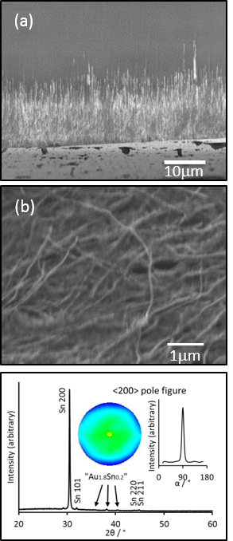

Figure 1. (a) FEGSEM image of a cleaved 13 nm Au coated AAO membrane after potentiostatic electrodeposition of Sn at -1 V vs. Pt, charge passed 128 mC, showing the Sn nanowire growth front, (b) FEGSEM image of nanowires after dissolution of AAO membrane in 1% vol HF in water, (c) ϑ-2ϑ X-ray diffractogram with the diffraction vector normal to the AAO film, of 13 nm AAO membrane after Sn deposition, along with pole figure and rocking curve for <200> diffraction peak.
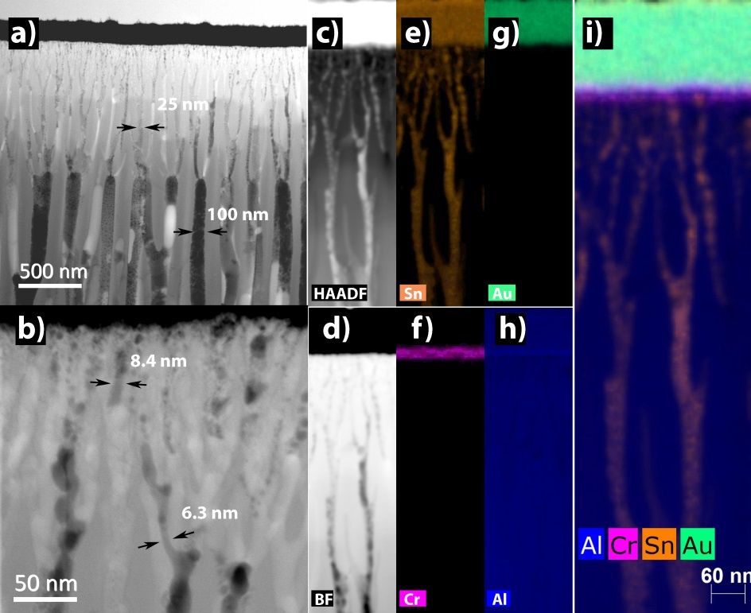
Figure 2. Figure caption. STEM and STEM EDX images of FIB cut cross-sections of a 3 nm asymmetric AAO membrane after Sn electrodeposition. (a) Image showing the metal electrode (top of image), small and large pore regions of the membrane. (b) Higher magnification image of small pore region next to metal electrode (top of image) showing 6.3 nm and 8.1 nm diameter Sn nanowire regions. (c) –(i) images of a region of small pores near the metal electrode using different modes. (c) High Angle Angular Dark Field. (d) Bright Field. (e-h) EDX STEM maps of various elements Sn, Cr, Au and Al. (i) Composite elemental map obtained by combining (e), (f), (g) and (h). The discontinuities observable in some nanowires are due to the FIB sectioning cutting through pores which are not all fully aligned parallel to the cross-section.
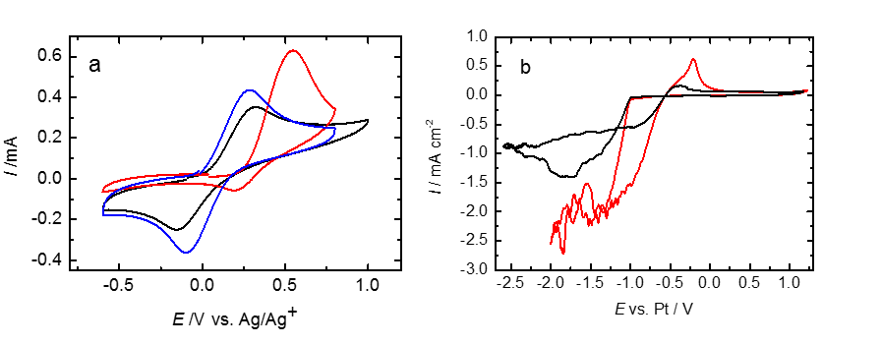
Figure 3. (a) The voltammetry recorded at 250 mV s⁻¹ for 5 mM FcMeOH in 0.1 M NaNO₃. Black curve; blank TiN electrode; Red curve: mesoporous silica coated TiN electrode before removal of surfactant; Blue curve: mesoporous silica coated TiN electrode after removal of the CTAB surfactant by washing with 0.1 M HCl in ethanol. (b) Voltammograms recorded at 50 mV s⁻¹ for 2 mM [N^{n}Bu₄][SnCl₃] and 50 mM [N^{n}Bu₄]Cl in scCH₂F₂ at 17.2 MPa and 358 K. Red line: bare TiN electrode; Black line: mesoporous silica coated TiN electrode.
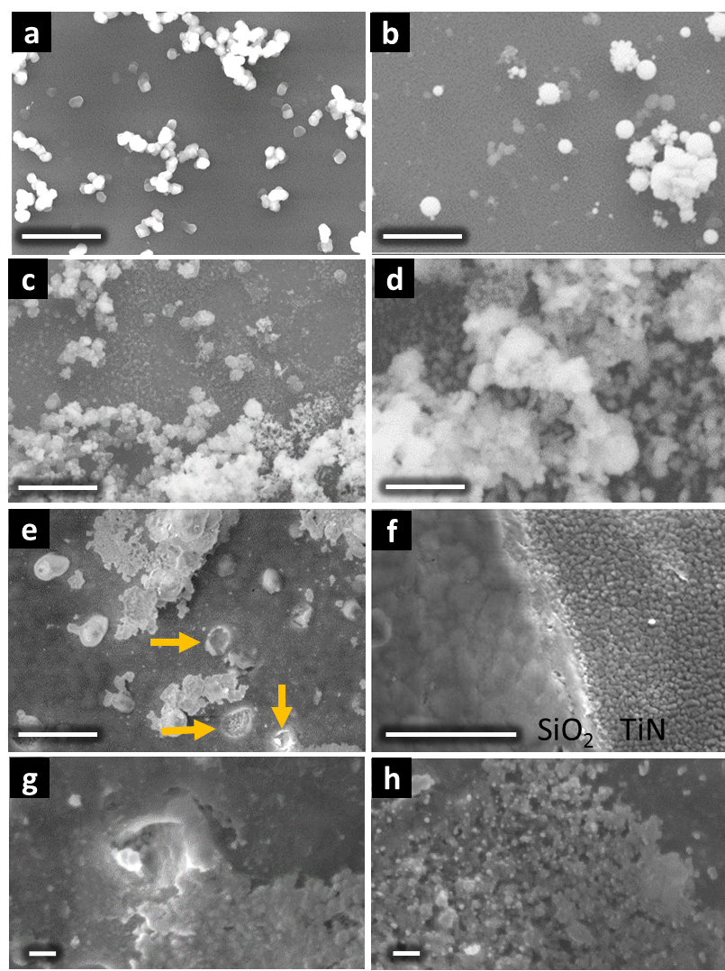
Figure 4. FEGSEM images of mesoporous silica on TiN substrates with and without Sn electrodeposition (scale bars correspond to 1 micron in a-f and 100 nm in g and h). (a) Control sample (no electrodeposition) showing 100 nm diameter silica spheres sat on a mesoporous silica film whose characteristic morphology is shown in (f). (b) Sample after 5 s electrodeposition. The SEM images show additional features, including faceted crystals and nanoparticles of diameter of a few tens of nanometers. EDX measurements indicate these are Sn. (c) Sample after 10 s electrodeposition. (d) Sample after 20 s electrodeposition. (e) Image of 20 s sample showing defects in the mesoporous silica film (arrows). (f) Image of 20 s sample after being scraped to produce flakes for TEM images. Image has been taken at the boundary between the scraped (right) and unscraped (left) regions. The left region shows morphology characteristic of a mesoporous silica film and the right region shows morphology characteristic of a bare TiN substrate. (g) Higher magnification image of 20 s sample showing defects in mesoporous silica film with electrodeposited Sn in its vicinity. (h) Higher magnification image of 20 s sample showing electrodeposited Sn including isolated 15-30 nm Sn nanoparticles on mesoporous silica.
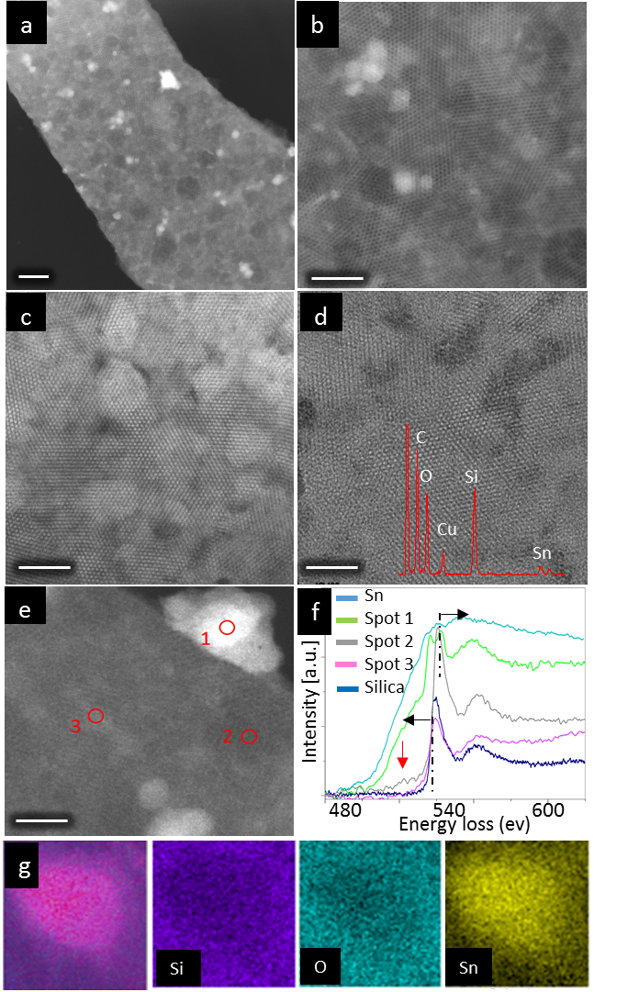
Figure 5. (a) ADF-STEM of flake from mesoporous electrode after Sn electrodeposition for 10 s [scale bar 100 nm]. (b) Higher magnification ADF-STEM image of same flake. [scale bar 50 nm] (c) STEM-BF of same flake. [scale bar 50 nm] (d) TEM-BF of with a flake from a control sample exposed to Sn electrolyte without deposition with overlaid EDS spectrum. [scale bar 50 nm] (e) ADF-STEM image of particle and mesoporous film with areas for EELS analysis marked. (f) EELS spectra of marked regions shown on (e), fresh mesoporous silica and a Sn reference spectrum from EELS atlas (light blue). (g) EDS-STEM of a particle showing composite map overlaid on ADF image, Si, O and Sn elemental maps respectively.
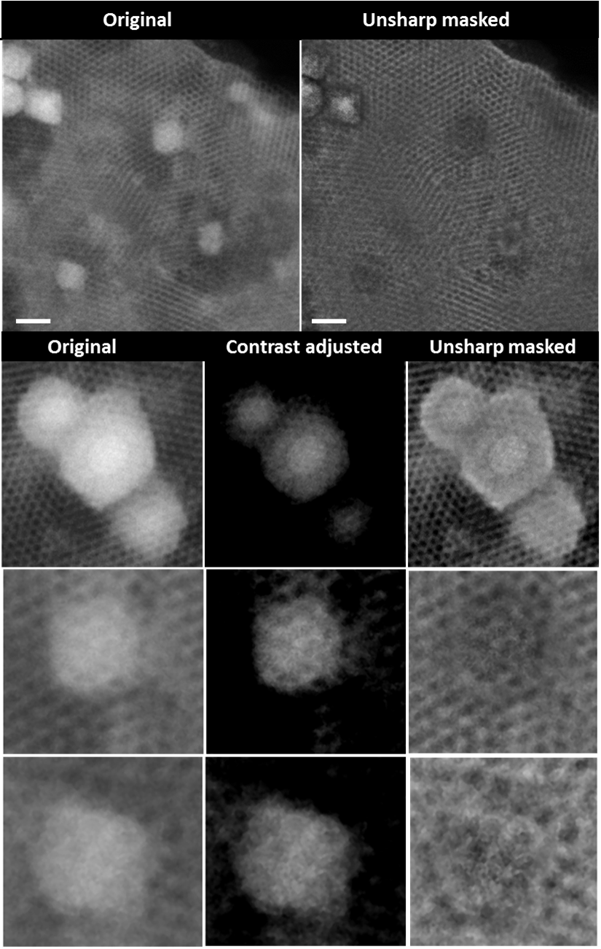
Figure 6. Original ADF-STEM micrograph of Sn loaded silica (top left) flake and the same area after applying unsharp mask (top right) [Scale bar 20 nm]. Unprocessed ADF-STEM of Sn particles (left column), same particles after manual contrast adjustment (middle column) and applying unsharp mask (right column).

ASSOCIATED CONTENT
Supporting Information. A word document containing additional information concerning the experimental details and additional characterization is provided. This contains; (i) Methods for electrode preparation; (ii) Cyclic voltammograms at standard conditions on uncoated Au and TiN substrates; (iii) SEM images and EDX analysis of Sn films electrodeposited on Au and TiN flag substrates; (iv) XRD of films on flag substrates showing polycrystalline nature; (v) the results of a study of optimisation of mesoporous silica films used as templates; (vi) Further TEM images of mesoporous silica films after Sn deposition.
AUTHOR INFORMATION
Corresponding Author
*E-mail: pnb@southampton.ac.uk
*E-mail: D.C.Smith@soton.ac.uk
Present Addresses
†If an author’s address is different than the one given in the affiliation line, this information may be included here.
Author Contributions
The manuscript was written through contributions of all authors. All authors have given approval to the final version of the manuscript.
ACKNOWLEDGMENT
This work is part of the Supercritical Fluid Electrodeposition project, a multidisciplinary collaboration of British universities investigating the fundamental and applied aspects of SCFs funded by a Programme grant from the EPSRC (EP/I013394/1). This work has also been supported by the EPSRC Programme Grant, Advanced Devices by Electroplating (ADEPT - EP/N0354371/1). The authors also thank EPSRC for funding the Smartlab diffractometer under EP/K00509X/1 and EP/K009877/1. P.N.B. gratefully acknowledges receipt of a Wolfson Research Merit Award. The authors thank Dr. Josephine Corsi for editorial support.

NOTES
The authors declare no competing financial interest. The dataset for this article is available from the University of Southampton at DOI: 10.5258/SOTON/D0396

​
​
REFERENCES
1. Duan, X. F.; Huang, Y.; Agarwal, R.; Lieber, C. M., Single-nanowire electrically driven lasers. Nature 2003, 421 (6920), 241-245.
2. Tian, M. L.; Wang, J. G.; Kurtz, J. S.; Liu, Y.; Chan, M. H. W.; Mayer, T. S.; Mallouk, T. E., Dissipation in quasi-one-dimensional superconducting single-crystal Sn nanowires. Phys. Rev. B 2005, 71 (10).
3. Lin, Y. M.; Sun, X. Z.; Dresselhaus, M. S., Theoretical investigation of thermoelectric transport properties of cylindrical Bi nanowires. Phys. Rev. B 2000, 62 (7), 4610-4623.
4. Ansari, L.; Fagas, G.; Colinge, J. P.; Greer, J. C., A Proposed Confinement Modulated Gap Nanowire Transistor Based on a Metal (Tin). Nano Lett. 2012, 12 (5), 2222-2227.
5. Cao, G. Z.; Liu, D. W., Template-based synthesis of nanorod, nanowire, and nanotube arrays. Adv. Colloid Interface Sci. 2008, 136 (1-2), 45-64.
6. (a) Attard, G. S.; Glyde, J. C.; Goltner, C. G., Liquid-Crystalline Phases as Templates for the Synthesis of Mesoporous Silica. Nature 1995, 378 (6555), 366-368; (b) Bolger, C. T.; Farrell, R. A.; Hughes, G. M.; Morris, M. A.; Petkov, N.; Holmes, J. D., Pore Directionality and Correlation Lengths of Mesoporous Silica Channels Aligned by Physical Epitaxy. ACS Nano 2009, 3 (8), 2311-2319; (c) Walcarius, A.; Sibottier, E.; Etienne, M.; Ghanbaja, J., Electrochemically assisted self-assembly of mesoporous silica thin films. Nat. Mater. 2007, 6 (8), 602-608.
7. Walcarius, A., Mesoporous materials and electrochemistry. Chem. Soc. Rev. 2013, 42 (9), 4098-4140.
8. Wang, D. H.; Zhou, W. L.; McCaughy, B. F.; Hampsey, J. E.; Ji, X. L.; Jiang, Y. B.; Xu, H. F.; Tang, J. K.; Schmehl, R. H.; O'Connor, C.; Brinker, C. J.; Lu, Y. F., Electrodeposition of metallic nanowire thin films using mesoporous silica templates. Adv. Mater. 2003, 15 (2), 130-+.
9. Luo, H. M.; Wang, D. H.; He, J. B.; Lu, Y. F., Magnetic cobalt nanowire thin films. J. Phys. Chem. B 2005, 109 (5), 1919-1922.
10. Ke, J.; Su, W. T.; Howdle, S. M.; George, M. W.; Cook, D.; Perdjon-Abel, M.; Bartlett, P. N.; Zhang, W. J.; Cheng, F.; Levason, W.; Reid, G.; Hyde, J.; Wilson, J.; Smith, D. C.; Mallik, K.; Sazio, P., Electrodeposition of metals from supercritical fluids. Proc. Natl. Acad. Sci. U. S. A. 2009, 106 (35), 14768-14772.
11. Bartlett, P. N.; Burt, J.; Cook, D. A.; Cummings, C. Y.; George, M. W.; Hector, A. L.; Hasan, M. M.; Ke, J.; Levason, W.; Pugh, D.; Reid, G.; Richardson, P. W.; Smith, D. C.; Spencer, J.; Suleiman, N.; Zhang, W. J., A Versatile Precursor System for Supercritical Fluid Electrodeposition of Main-Group Materials. Chemistry-a European Journal 2016, 22 (1), 302-309.
12. Vila, N.; Andre, E.; Ciganda, R.; Ruiz, J.; Astruc, D.; Walcarius, A., Molecular Sieving with Vertically Aligned Mesoporous Silica Films and Electronic Wiring through Isolating Nanochannels. Chem. Mater. 2016, 28 (8), 2511-2514.
13. Robertson, C.; Beanland, R.; Boden, S. A.; Hector, A. L.; Kashtiban, R. J.; Sloan, J.; Smith, D. C.; Walcarius, A., Ordered mesoporous silica films with pores oriented perpendicular to a titanium nitride substrate. Phys. Chem. Chem. Phys. 2015, 17 (6), 4763-4770.
14. Robertson, C.; Lodge, A. W.; Basa, P.; Carravetta, M.; Hector, A. L.; Kashtiban, R. J.; Sloan, J.; Smith, D. C.; Spencer, J.; Walcarius, A., Surface modification and porosimetry of vertically aligned hexagonal mesoporous silica films. RSC Adv. 2016, 6 (114), 113432-113441.
15. Bartlett, P. N.; Branch, J., The voltammetry of decamethylferrocene and coboltacene in supercritical difluoromethane (R32). J. Electroanal. Chem. 2016, 780, 282-289.
16. Russ, J. C., Image Processing Handbook. 6th Edition ed.; CRC Press: Boca Raton, FL, 2011.
17. Toimil-Molares, M. E.; Rontzsch, L.; Sigle, W.; Heinig, K. H.; Trautmann, C.; Neumann, R., Pipetting Nanowires: In Situ Visualization of Solid-State Nanowire-to-Nanoparticle Transformation Driven by Surface Diffusion-Mediated Capillarity. Adv. Funct. Mater. 2012, 22 (4), 695-701.
18. Nanda, K. K.; Sahu, S. N.; Behera, S. N., Liquid-drop model for the size-dependent melting of low-dimensional systems. Phys. Rev. A 2002, 66 (1).

