Scapular Kinematics in Professional Wheelchair Tennis Players
Martin B. Warner PhD^{1,3,9}, David Wilson MSc^{1,9}, Markus O. Heller PhD^{2,3,9}, Dan Wood MSc⁴, Peter Worsley^{1,3} PhD, Sarah Mottram^{1,5,9} MSc, Nick Webborn MB^{6,9}, DirkJan Veeger PhD⁷, Mark Batt MB BChir DM^{8,9}
¹Faculty of Health Sciences, University of Southampton, Southampton, UK
²Faculty of Engineering and the Environment, University of Southampton, Southampton, UK
³Institute for Life Sciences, University of Southampton, Southampton, UK
⁴English Institute of Sport, Bisham Abbey, Bisham, UK
⁵Movement Performance Solutions, Bristol, UK
⁶The Sussex Centre for Sport and Exercise Medicine, University of Brighton, Eastbourne, UK
⁷Department of Human Movement Sciences, Vrije Universiteit, Amsterdam, Netherlands
⁸Nottingham University Hospitals, Nottingham, UK
⁹Arthritis Research UK Centre for Sport, Exercise and Osteoarthritis

Corresponding author
Dr Martin Warner
Faculty of Health Sciences
University of Southampton
Southampton
SO17 1BJ
United Kingdom
email: m.warner@soton.ac.uk

Abstract word count: 248
Main text word count: 3975

Abstract
Background
Participating in wheelchair tennis increases the demands placed on the shoulder and could increase the risk of developing shoulder pain and injury that might be associated with differences in scapular kinematics. The aim of the study was to examine the presence of shoulder pain and scapular kinematics in professional wheelchair tennis players.
Method
Scapular kinematics were obtained in 11 professional wheelchair tennis players, 16 people with shoulder impingement and 16 people without shoulder impingement during humeral elevation and lowering. Clinical examination of the wheelchair tennis players was undertaken using the Wheelchair Users Shoulder Disability Index (WUSPI) and clinical signs of shoulder impingement.
Findings
The WUSPI questionnaire (mean = 28 SD 13.8) demonstrated wheelchair tennis participants experienced little shoulder pain and clinical examination revealed negative impingement tests. Wheelchair tennis players had greater scapular posterior tilt during humeral elevation (3.9° SE 1.71; P = 0.048) and lowering (4.3° SE 1.8; P = 0.04) on the dominant compared to non-dominant side. The dominant scapulae of wheelchair tennis players were significantly (P = 0.014) more upwardly rotated (21° SD 6.7) than the scapulae of people with shoulder impingement (14.1° SD 7.0) during scapular plane humeral elevation.
Interpretation
This first study of scapular kinematics in professional wheelchair tennis athletes demonstrated bilateral asymmetries and differences to able-bodied participants with shoulder impingement. Understanding the role of sport participation on shoulder function in wheelchair users would assist in the development of preventative and treatment exercise programmes for wheelchair users at risk of shoulder injury and pain.

Keywords
Scapula; kinematics; wheelchair; tennis

Introduction
Taking part in sports like wheelchair tennis places demands on the shoulder beyond those experienced in activities of daily living, particularly as the shoulder is the essential link to transfer energy from the core to the periphery. The scapula plays an important role in this sequence of energy transfer allowing force to be applied through the kinetic chain to the racquet by providing a stable base for the muscles that control arm movement. Alteration in the movements of the scapula can alter its function within the kinetic chain and lead to diminished performance or injury (Kibler, 1995). In particular, excessive scapular internal rotation and downward rotation during athletic movements can increase the potential for shoulder impingement (Ludewig and Cook, 2000, Kibler and McMullen, 2003).
Shoulder injuries are common in able-bodied tennis players (Pluim et al., 2006, Winge et al., 1989, Burkhart et al., 2003, Richardson, 1983, Bylak and Hutchinson, 1998, Elliott, 2006, Hjelm et al., 2010, Hjelm et al., 2012), and are typically a result of repeated micro-trauma events (Kibler and Safran, 2005). A factor associated with shoulder injuries is an observable alteration in the position and movement of the scapula in relation to the thorax, termed scapular dyskinesis (Warner et al., 1992). Able-bodied tennis players with scapular dyskinesis exhibit reduced sub-acromial space when compared to tennis players without dyskinesia (Silva et al., 2011). Bilateral asymmetries of increased scapular internal rotation and anterior tilt have also been observed in the injured shoulder of able-bodied tennis players suggesting a link between the positioning of the scapula and injury (Burkhart et al., 2003). Similar bilateral asymmetries in the resting position of the scapula, however, have also been observed between the dominant and non-dominant sides in asymptomatic able-bodied overhead athletes (Oyama et al., 2008). This suggests that participation in overhead physical activity causes asymptomatic adaptations to scapular kinematics.
It has been reported that 30% to 72% of people with spinal cord injuries (SCI) experience shoulder pain which is often chronic in nature (Irwin et al., 2007). It is generally hypothesised that pain results from the greater demands placed on the shoulder through wheelchair use (Chow and Levy, 2011). Wheelchair propulsion generates a relatively low intensity internal joint force compared to weight relief and chair transfer tasks (Morrow et al., 2010, Drongelen et al., 2005b). However, the frequency of performing wheelchair propulsion leads to high exposure of forces within the shoulder joint and is a possible risk factor for developing shoulder overuse injuries (Veeger et al., 2002, Drongelen et al., 2005b, Drongelen et al., 2005a). Moreover, during manual wheelchair propulsion the scapular position has been reported as being in a high degree of internal rotation and anterior tilt (Morrow et al., 2011), placing the glenohumeral joint at an increased risk of sub-acromial impingement.
What is less clear is the role of sports participation on shoulder and upper limb function and injuries in wheelchair users. Shoulder injuries are the most commonly reported injuries accounting for 17% to 72% of all injuries observed during the Paralympics and Winter Paralympics games (Willick et al., 2013, Webborn and Emery, 2014). However, physical activity has been suggested to have a protective effect on the shoulder (Chow and Levy, 2011) and it has been shown that even a simple exercise programme improved the symptoms of shoulder pain in wheelchair users (Curtis et al., 1999). In wheelchair users the relationship between injury risk and participation in regular physical activity is unclear as previous research has either found a higher risk of injury when participating in sport (Curtis and Dillon, 1985), neither an increased or decreased risk of injury (Finley and Rodgers, 2004), or a reduced risk of injury (Fullerton et al., 2003).
Considering the potential increased risk of acute shoulder injuries in wheelchair tennis players in combination with less opportunity for recovery, due to the reliance on the shoulder for daily wheelchair use and performing activities of daily living, it is likely that wheelchair tennis players are at high risk of shoulder pain. The presence of shoulder pain may be accompanied by movement dysfunction of the scapula, an association observed in both non-athletic wheelchair users and able-bodied tennis players (Silva et al., 2011, Morrow et al., 2011). The aim of the study was to determine whether professional wheelchair tennis players experienced shoulder pain and whether this was associated with kinematic alterations in scapular function. Changes in scapular function exist between those with and without shoulder pain (Lawrence et al., 2014), by comparing scapular function of wheelchair tennis players to able-bodied participants with and without shoulder pain it will be possible to determine whether the presence or absence of pain is related to orientation of the scapula during humeral elevation and lowering. In addition, able-bodied participants were chosen to remove confounding factors associated with wheelchair use (e.g. disability, length of time of wheelchair use) that might influence scapular kinematics. The hypotheses of the study are as follows, wheelchair tennis players will self-report shoulder pain, wheelchair tennis players will test positive for signs of impingement, bilateral differences in scapular kinematics will be present in the wheelchair tennis players, differences in scapular kinematics will exist between wheelchair tennis players and able-bodied people with and without shoulder impingement.

- Methods

Participants
Eleven professional wheelchair tennis players were recruited from the United Kingdom. Inclusion criteria for the wheelchair tennis group were that they must play competitive wheelchair tennis at national or international level as their full-time occupation and be over 16 years of age. Participants were excluded if they had suffered traumatic shoulder injury that required surgical intervention and/or systemic inflammatory disease. Demographic details of type of disability, length of time using a wheelchair, wheelchair use per day, hours spent playing tennis per week, and hours spent training unrelated to tennis were recorded. The study was reviewed and approved by the Faculty of Health Sciences Research Ethics Committee at the University of Southampton. The comparison to able-bodied participants with and without shoulder impingement was achieved by a re-analysis of previously published data (Worsley et al., 2013), which included a group of 16 young adults with shoulder pain and at least two positive signs of impingement (impingement group) and 16 participants with no shoulder pain (control group). The kinematic data collection and analysis protocols (described below) were identical between the wheelchair tennis players and the participants with and without shoulder impingement.

Clinical assessment of wheelchair tennis players
Wheelchair tennis participants were asked to complete the Wheelchair Users Shoulder Pain Index (WUSPI) (Curtis et al., 1995), a self-reported measure of shoulder pain experienced by participants in the seven days prior to data collection. A qualified musculoskeletal physiotherapist undertook bilateral clinical assessment for signs of impingement which included the Neers (Neer and Welsh, 1977), Hawkins-Kennedy (Hawkins and Kennedy, 1980), Empty Can (Jobe and Moynes, 1982), and painful-arc tests (Hermann and Rose, 1996). The physiotherapist was blind to hand dominance at the time of undertaking the clinical assessment.

Kinematic analysis of shoulder function
Kinematics of the wheelchair tennis players’ thorax, scapula, humerus and forearm were obtained using passive markers fixed to the skin that were tracked by a Vicon (Vicon Motion Systems, Oxford, UK) optical motion capture system consisting of ten T160 cameras operating at 100Hz. The valid and reliable acromion marker cluster technique (Warner et al., 2012, Warner et al., 2015, Karduna et al., 2001, van Andel et al., 2009), where a cluster of reflective markers is attached to the posterior acromion, was employed to obtain dynamic measurements of the scapula during humeral movement. The between session reliability error of the acromion marker cluster has been previously established as 7.3°, 4.4° and 2.5° for internal rotation, upward rotation and posterior tilt respectively during sagittal plane humeral elevation and 7.2°, 4.3° and 1.8° for internal rotation, upward rotation and posterior tilt respectively during scapular plane humeral elevation (Warner et al., 2015).
Retroreflective markers were attached to the thorax at the sternal notch, xiphoid process, C7 and T8 vertebrae following International Society of Biomechanics guidelines (Wu et al., 2005). A cluster of markers on the humerus, and ulna and radial styloids were also attached bilaterally (Warner et al., 2015). A calibration wand was used to determine the location of the scapula (acromion angle, medial spine of the scapula and the inferior angle) and humeral (lateral and medial epicondyles) anatomical landmarks with respect to the marker clusters (Warner et al., 2015). Participants performed a circumduction motion to functionally determine the glenohumeral joint centre.
The wheelchair tennis participants were asked to complete three repetitions of humeral elevation and lowering in the sagittal, scapular and frontal plane in random order whilst seated in their wheelchair tennis chair. The high wheel camber and close proximity of top of the wheel to the chair allowed participants to hold their arm by their side in a neutral position unobstructed. The sagittal plane was defined as the plane in which participants elevated their arm straight out in front of them (0° of humeral abduction) and the frontal plane was defined as the plane in which participants elevated their arm out to the side (90° of humeral abduction). The scapular plane was defined at approximately 30° anterior to the frontal plane. The same investigator provided instructions to participants and demonstrated the correct plane of elevation prior to data collection. Participants were asked to complete the elevation and lowering phases in a controlled manner aiming to accomplish each phase of the movement (elevation and lowering) in three seconds. If participants notably raised or lowered their arm in a different plane the trial was discarded and an additional trial captured.
Kinematic data for the control and impingement groups previously obtained were collected in the same manner as described above (Warner et al., 2015). However, kinematic data were only collected for the dominant or affected arm and participants only elevated their arm to 90° of humeral elevation. The investigator, whose reliability has previously been established (Warner et al., 2015), attached markers and calibrated anatomical landmarks in the present study and performed kinematic data collection in the previous study (Worsley et al., 2013).

Kinematic data analysis
Joint kinematics for the thorax, scapula and humerus were determined through defining local coordinate systems for each rigid body segment following the guidelines of the International Society of Biomechanics (Wu et al., 2005). The glenohumeral joint centre was determined as the pivot point of the helical axis between the humerus and scapula during the circumduction manoeuvre (Veeger, 2000). The orientation of the scapula with respect to the thorax was determined through Euler angle decomposition following a rotation sequence of internal (+ve) / external rotation (-ve) (Y), upward (+ve) /downward (-ve) rotation (X) and posterior (+ve) / anterior (-ve) tilt (Z). The orientation of the humerus with respect to the thorax was determined through a rotation sequence of plane of elevation (Y), angle of elevation (X), angle of axial rotation (Y) (Doorenbosch et al., 2003).
Wheelchair tennis players’ kinematic data were divided into the elevation and lowering phases and the orientation of the scapula with respect to the thorax was obtained at 5° increments from the start of the movement phase to the end. Due to differences in the resting posture of the humerus and known increases in measurement error when using the acromion marker cluster at higher humeral elevation angles (Warner et al., 2012), scapular kinematics were only analysed between 20° and 120° of humeral elevation. The orientations of the scapula at rest prior to arm elevation, at 90° humeral elevation and at rest following arm lowering were obtained to enable direct comparison to the control and impingement group.

  - Statistical Analysis
Data were analysed using Statistical Package for Social Sciences (SPSS) (IBM Corporation, New York, USA), version 22, software with significance levels set at 5%. Data were normally distributed with equal variance, therefore, parametric statistics were used for analysis. Bilateral differences in scapular kinematics within the wheelchair tennis group were assessed at 30°, 60°, 90° and 110° of humeral elevation (Lawrence et al., 2014), using a repeated measures ANOVA with two main effects of side (2 levels, dominant and non-dominant) and humeral elevation angle (4 levels). The repeated measures ANOVA was repeated for each phase (elevation and lowering) and plane (sagittal, scapular and frontal) of humeral elevation. A one-way ANOVA with main effect of group (3 levels) was used to compare scapular orientation at rest, 90° of humeral elevation and at rest following the lowering phase of humeral elevation between the dominant arm of the wheelchair tennis players, dominant arm of the control group and affected side of the impingement group. Post-hoc analysis was carried out using Tukey Honest Significant Difference method for pairwise comparisons. The one-way ANOVA and Post-hoc analysis was repeated to examine differences between the non-dominant arm of the wheelchair tennis players, dominant arm of the control group and affected side of the impingement group.

Results
The disabilities of the young, predominantly male, wheelchair tennis participants included six spinal cord injuries ranging from C6 through to T11, two osteogenesis imperfecta, one cerebral palsy, one transverse myelitis and one Perthes disease (Table 1). The control participants were predominantly male (n = 11) of mean age 22.0 SD 3.1 years, the impingement group were also predominantly male (n = 11) of mean age 26.4 SD 1.6 years (Table 1).

TABLE 1: Participant demographics of the wheelchair tennis, control and impingement participants. Values expressed as mean (standard deviation).
 | Wheelchair Tennis  (n = 11) | Control*  (n = 16) | Impingement*  (n = 16)
Gender | 8 Male, 3 Female | 11 Male, 5 Female | 11 Male, 5 Female
Age (years) | 26.5 (6.7) | 22.0 (3.1) | 24.6 (1.6)
Weight (kg) | 69.8 (13.2) | 72.3 (8.8) | 72.7 (10.1)
Wheelchair use (years) | 15.3 (6.4)
Wheelchair use per day (hours) | 9.6 (3.4)
Spent playing tennis per week (hours) | 12.6 (6.9)
Non-tennis specific training per week (hours) | 5.3 (2.2)
Hand dominance | 9 Right, 2 Left | 16 Right
Side of impingement |  |  | 16 Right
*Re-analysis of data from (Worsley et al., 2013)

The impingement tests revealed that only one wheelchair tennis participant had a positive Hawkins-Kennedy test on their right (dominant) side. This participant was not excluded from the analysis as the specificity of the Hawkins-Kennedy has been to be low (Calis et al., 2000), and a positive result of this test in isolation is not sufficient to diagnose the participant as having shoulder impingement. The remaining wheelchair tennis players showed no signs of shoulder impingement with negative Neer, Hawkins-Kennedy, Empty Can and Painful Arc tests. Self-reported pain using the WUSPI was low with an average WUSPI score of 28 SD 13.8, and a range from 15 to 58. Two participants reported that they had previously experienced pain as a result of shoulder impingement on their dominant arm. Both participants were free from pain at the time of data collection and reported negative tests for impingement.
Bilateral kinematic analysis of the wheelchair tennis players showed a significant difference between the dominant and non-dominant side for scapular posterior tilt during scapular plane humeral elevation in the elevation (P=0.048) and lowering (P=0.04) phases (Figure 1). The scapula on the dominant side was on average 3.9° (standard error = 1.71) and 4.3° (standard error = 1.8) more posteriorly tilted than the non-dominant across the entire humeral elevation and lowering phases respectively. The scapula on the dominant side was on average more externally rotated by 6.3° (standard error = 3.4) and 5.9° (standard error = 3.3) across the entire elevation and lowering phases respectively compared to the non-dominant scapula (Figure 2), however, this difference was not statistically significant.
There were no significant differences in upward rotation between the dominant and non-dominant sides in wheelchair tennis players during humeral elevation in the sagittal (Elevation phase: mean difference = -0.64° standard error = 2.2, P = 0.778. Lowering phase: mean difference = -1.05° standard error = 1.85, P = 0.584), scapular (Elevation phase: mean difference = -0.68° standard error = 1.76, P = 0.707. Lowering phase: mean difference = -0.99° standard error = 1.63, P = 0.558) or frontal planes (Elevation phase: mean difference = -1.96° standard error = 1.79, P = 0.30. Lowering phase: mean difference = -2.68° standard error = 1.75, P = 0.157).
There was a significant main effect of group when comparing the wheelchair tennis players’ dominant side to that of the able-bodied groups with and without impingement. Differences were found for scapular upward rotation at 90° of humeral elevation in the sagittal (P = 0.025) and scapular plane (P = 0.025). Post-hoc analysis revealed the wheelchair tennis players’ dominant side was significantly (P = 0.024) more upwardly rotated (21.3° SD 6.7) than the impingement group (14.1° SD 7.0) at 90° of humeral elevation in the sagittal plane (Figure 3) and significantly (P = 0.014) more upwardly rotated (21.0° SD 6.0) than the impingement group (14.1° SD 5.9) at 90° of humeral elevation in the scapular plane (Figure 4).
When comparing the wheelchair tennis players’ non-dominant side to that of the able-bodied groups with and without impingement there were significant main effects of group. During sagittal plane humeral elevation there was a significant difference for scapular upward rotation (P = 0.013) and posterior tilt (P = 0.009) at 90° of humeral elevation and upward rotation (P = 0.039) at rest following the humeral lowering phase. During scapular plane humeral elevation there was a significant difference for scapular internal rotation (P = 0.01), upward rotation (P = 0.009) and posterior tilt (P = 0.001) at 90° of humeral elevation and upward rotation (P = 0.025) at rest following the humeral lowering phase. Post-hoc analysis revealed the non-dominant scapulae of the wheelchair tennis players were significantly (P = 0.012) more upwardly rotated (21.8° SD 5.9) than the impingement group (14.2° SD 7.0) at 90° of humeral elevation in the sagittal plane and wheelchair tennis players were significantly (P = 0.042) more upwardly rotated (-0.02° SD 6.8) at rest following the phase compared to the impingement group (-6.4° SD 7.6) (Figure 3). The non-dominant scapulae of the wheelchair tennis players were significantly (P = 0.007) less posteriorly tilted (-9.6° SD 7.7) than the able-bodied group without impingement (-0.7° SD 6.5) at 90° humeral elevation in the sagittal plane (Figure 3). During scapular plane humeral elevation at 90° humeral elevation the non-dominant scapulae of the wheelchair tennis players were significantly (P = 0.032) more internally rotated (36.3° SD 6.8) than the able-bodied group without impingement (28.8° SD 6.0) and significantly (P 0.001) more anteriorly tilted (-7.8° SD 6.7) than the without impingement group (2.6° SD 8.2) (Figure 4). The wheelchair tennis players non-dominant scapulae were significantly (P = 0.007) more upwardly rotated (21.4° SD 5.8) than the impingement group (14.1 ° SD 5.9) at 90° of humeral elevation and significantly (P = 0.037) more upwardly rotated (-7.8° SD 6.7) than the impingement group (-5.0° SD 5.1) at rest following the humeral lowering phase in the scapular plane (Figure 4). The differences observed between groups are beyond the observed reliability measurement error of acromion marker cluster.

4. Discussion
The present study is the first to examine scapular kinematics in professional wheelchair tennis players and found bilateral asymmetries and differences to participants with and without shoulder pain. The present study also examined the presence of shoulder pain in professional wheelchair tennis players and found no evidence of self-reported shoulder pain and few clinical signs of shoulder impingement. This result is somewhat surprising given the high prevalence of shoulder injuries reported during disability sports (Webborn and Emery, 2014), the high prevalence of shoulder pain in non-athletic wheelchair users (Irwin et al., 2007), and the prevalence of shoulder injuries in able-bodied tennis players (Pluim et al., 2006).
The bilateral comparison of scapular kinematics in wheelchair tennis players observed in this study showed the dominant-side was more posteriorly tilted than the non-dominant side. This is in contrast to observations asymptomatic able-bodied tennis players where the dominant side was more anteriorly tilted (Oyama et al., 2008). The increase in posterior tilt may increase subacromial space, reducing the risk of developing impingement, and may account for the absence of pain and impingement observed. The possible cause for this increased in posterior tilt could be due to the requirements of the sport. Wheelchair tennis players have limited use of their pelvis and lower body to help generate force and as a result racquet velocity is lower during the serve compared to able-bodied tennis players (Reid et al., 2007). During the wheelchair tennis serve the scapula may tilt posteriorly to a greater extent, compared to able-bodied players, in order to overcome the limitations of reduced lower limb and pelvic motion. The repetitive nature of performing the tennis serve may then lead to habitual asymmetries in scapular function. In addition, the reduced inertial force, as a result of the lower racquet velocity, may not lead to the same asymmetrical adaptations observed in able-bodied tennis players as there is less demand on the shoulder when accelerating and decelerating the arm and racquet.
The training programme of the wheelchair tennis players assessed in the current study includes exercises aimed at actively performing external rotation, posterior tilt, and upward rotation, to avoid the protracted nature of the shoulder observed in wheelchair users (Morrow et al., 2011). Such dedicated training may increase the movement potential of the scapula and provide greater movement variability of the scapula relative to the participant’s overall functional ability, as has been shown in participants with shoulder impingement (Worsley et al., 2013, Savoie et al., 2015), resulting in a reduced risk of shoulder pathology. Further studies investigating the movement potential and variability of the shoulder during constrained and dynamic functional tasks and how this could be related to the presence, or absence, of shoulder pain and pathology in both athletic and non-athletic wheelchair users are warranted. It should be noted though that differences in scapular orientation between prescribed humeral movements, as those described in the present study, and functional movements have been described in the literature (Amasay and Karduna, 2009). Whether the observed differences in scapular orientation found in this study are representative of scapular function whilst playing wheelchair tennis thus remains to be determined. An analysis of scapular kinematics during wheelchair tennis serves and returns would help to further elucidate the mechanisms of shoulder function and its relationship to shoulder pain.
The studied cohort of professional wheelchair tennis players demonstrated an absence of shoulder pain and signs of impingement, contrary to the expected outcome based on the presence of shoulder injuries and pain in able-bodied tennis players and non-athletic wheelchair users. Reduced upward rotation, external rotation and posterior tilt of the scapula are thought to reduce sub-acromial space and place the glenohumeral joint at risk of impingement and subsequent shoulder pain (McClure et al., 2006, Ludewig and Cook, 2000, Borstad and Ludewig, 2002, Lin et al., 2011, Hébert et al., 2002, Lukasiewicz et al., 1999). The results of the present study revealed that the scapula of the dominant arm in wheelchair tennis players was significantly more upwardly rotated than in able-bodied participants with shoulder impingement. Based on the premise that reduced scapular upward rotation is associated with impingement (Lawrence et al., 2014), the observed greater amount of upward rotation may account for the absence of shoulder impingement within this sample of wheelchair athletes. The non-dominant scapula of the wheelchair tennis players, however, was more internally rotated and anteriorly tilted than the control group. Along with a reduced upward rotation, increased internal rotation and anterior tilt are suggested as possible mechanisms of shoulder impingement thus suggesting the non-dominant side is at risk of impingement. There was, however, an absence of shoulder pain and signs of impingement in the non-dominant shoulder. The kinematic differences observed in this study are, therefore, not pathological and confirm that asymmetries in scapular kinematics exist and need to be considered when undertaken clinical assessment and providing treatment a wheelchair tennis population.

  - Study Limitations
There are a number of limitations to the present study. Firstly, the small sample size and heterogeneity of the wheelchair tennis players precludes generalisability of results to the larger population of wheelchair tennis athletes. The disabilities of the studied sample are wide ranging, some of which may include a loss neurological control of the shoulder, thus affecting scapular function. Due to the size of the population it would not be possible to adequately control for the effects of disability on shoulder function. Additional studies conducted in other professional wheelchair tennis teams from other countries would increase the size of the available population and help determine whether the results of this study are cohort specific. Whilst we included cohorts of able bodied persons both with and without impingement, the inclusion of a matched control group consisting of non-athletic wheelchair users would allow greater understanding of whether asymmetries in scapular kinematics are related to wheelchair tennis or whether the asymmetries are more generally observed in wheelchair users. The dominant and non-dominant shoulders of the wheelchair tennis players were only compared to unilateral data of the able-bodied groups. Whilst a comparison to the non-dominant and unaffected side of the able-bodied participants would have been beneficial it is likely that similar differences would exist as there is little bilateral difference in scapular kinematics in participants with no shoulder complaints (Yano et al., 2010), and unilateral impingement can result in bilateral adaptations to scapular kinematics (Hébert et al., 2002).

- Conclusions
Our cohort of professional wheelchair tennis players reported an absence of shoulder pain and impingement which may be related to the increased posterior tilt on the dominant side compared to the non-dominant during humeral elevation and lowering and increased upward rotation when compared to able-bodied persons with shoulder impingement. These findings are in contrast to non-athletic wheelchair users where pain is often present and associated with decreased posterior tilt, suggesting sport participation and/or the specific training programme utilised by the athletes may have protective benefits against shoulder impingement for wheelchair tennis athletes.

Acknowledgements
This study was supported by the Arthritis Research UK Centre for Sport, Exercise and Osteoarthritis (Grant reference 20194); and the University of Southampton’s Annual Adventures in Research award scheme. The authors would like to thank and acknowledge the support provided by Vicon Motion Systems for the loan of motion capture equipment.

REFERENCES
AMASAY, T. & KARDUNA, A. R. 2009. Scapular kinematics in constrained and functional upper extremity movements. Journal of Orthopaedic & Sports Physical Therapy, 39, 618-627.
BORSTAD, J. D. & LUDEWIG, P. M. 2002. Comparison of scapular kinematics between elevation and lowering of the arm in the scapular plane. Clinical Biomechanics, 17, 650-9.
BURKHART, S. S., MORGAN, C. D. & KIBLER, W. B. 2003. The disabled throwing shoulder: spectrum of pathology. Part 1: pathoanatomy and biomechanics. Arthroscopy, 19, 404-420.
BYLAK, J. & HUTCHINSON, M. R. 1998. Common sports injuries in young tennis players. Sports Med, 26, 119-32.
CALIS, M., AKGUN, K., BIRTAINE, M., KARACAN, I., CALIS, H. & TUZUN, F. 2000. Diagnostic values of clinical diagnostic tests in subacromial impingement syndrome. Annals of Rheumatic Diseases, 59, 44-47.
CHOW, J. W. & LEVY, C. E. 2011. Wheelchair propulsion biomechanics and wheerers' quality of life: an exploratory review. Disability and Rehabilitation: Assisitve Technology, 6, 365-377.
CURTIS, K. A. & DILLON, D. A. 1985. Survey of Wheelchair Athletic Injuries: Common Patterns and Prevention. International Medical Society of Paraplegia, 23, 170-175.
CURTIS, K. A., ROACH, K. E., APPLEGATE, E. B., AMAR, T., BENBOW, C. S., GENECCO, T. D. & GUALANO, J. 1995. Development of the Wheelchair User's Shoulder Pain Index (WUSPI). Paraplegia, 33, 290-3.
CURTIS, K. A., TYNER, T. M., ZACHARY, L., LENTELL, G., BRINK, D., DIDYK, T., GEAN, K., HALL, J., HOOPER, M., KLOS, J., LESINA, S. & PACILLAS, B. 1999. Effect of a standard exercise protocol on shoulder pain in long-term wheelchair users. Spinal Cord, 37, 421-9.
DOORENBOSCH, C. A. M., HARLAAR, J. & VEEGER, H. E. J. 2003. The globe system: an unambiguous description of shoulder positions in daily life movements. Journal of Rehabilitation Research and Development, 40, 147-156.
DRONGELEN, S., WOUDE, L. H., JANSSEN, T. W., ANGENOT, E. L., CHADWICK, E. K. & VEEGER, D. J. 2005a. Gleonhumeral contact forces and muscle forces evaluated in wheelchair-related activities if daily living in able-bodied subjects versus subjects with paraplegia and tetraplegia. Archives of Physcial Medicine and Rehabilitation, 86, 1434-1440.
DRONGELEN, S., WOUDE, L. H., JANSSEN, T. W., ANGENOT, E. L., CHADWICK, E. K. & VEEGER, D. J. 2005b. Mechanical load on the upper extremity during wheelchair activities. Archives of Physical Medicine and Rehabilitation, 86, 1214-1220.
ELLIOTT, B. 2006. Biomechanics and tennis. British Journal of Sports Medicine, 40, 392-396.
FINLEY, M. A. & RODGERS, M. M. 2004. Prevalence and identification of shoulder pathology in athletic and nonathletic wheelchairs users with shoulder pain: A pilot study. Journal of Rehabilitation Research & Development, 41, 365-402.
FULLERTON, H. D., BORCKARDT, J. J. & ALFANO, A. P. 2003. Shoulder pain: a comparison of wheelchair athletes and nonathletic wheelchair users. Med Sci Sports Exerc, 35, 1958-61.
HAWKINS, R. J. & KENNEDY, J. C. 1980. Impingement syndrome in athletes. Am J Sports Med, 8, 151-8.
HERMANN, B. & ROSE, D. W. 1996. Stellenwert von Anamnese und klinischer Untersuchung beim degenerativen Impingement-Syndrom im Vergleich zu operativen Befunden - eine prospektive Studie. Z Orthop Unfall, 134, 166-170.
HJELM, N., WERNER, S. & RENSTROM, P. 2010. Injury profile in junior tennis players: a prospective two year study. Knee Surg Sports Traumatol Arthrosc, 18, 845-50.
HJELM, N., WERNER, S. & RENSTROM, P. 2012. Injury risk factors in junior tennis players: a prospective 2-year study. Scand J Med Sci Sports, 22, 40-8.
HÉBERT, L. J., MOFFET, H., MCFADYEN, B. J. & DIONNE, C. E. 2002. Scapular behaviour in shoulder impingement syndrome. Archives of Physical Medicine and Rehabilitation, 83.
IRWIN, R. W., RESTREPO, J. A. & SHERMAN, A. 2007. Musculoskeletal pain in persons with spinal cord injury. Topics in Spinal Cord Injury Rehabilitation, 13, 43-57.
JOBE, F. W. & MOYNES, D. R. 1982. Delineation of diagnostic criteria and a rehabilitation program for rotator cuff injuries. Am J Sports Med, 10, 336-9.
KARDUNA, A. R., MCCLURE, P. W., MICHENER, L. A. & SENNETT, B. 2001. Dynamic measurements of three-dimensional scapular kinematics: a validation study. Journal of Biomechanical Engineering, 123, 184-191.
KIBLER, W. B. 1995. Biomechanical analysis of the shoulder during tennis activities. Clin Sports Med, 14, 79-85.
KIBLER, W. B. & MCMULLEN, J. 2003. Scapular dyskinesis and its relation to shoulder pain. Journal of the Amercian Academy of Orthopaedic Surgeons, 11, 142-151.
KIBLER, W. B. & SAFRAN, M. 2005. Tennis injuries. Med Sport Sci, 48, 120-37.
LAWRENCE, R. L., BRAMAN, J. P., LAPRADE, R. F. & LUDEWIG, P. M. 2014. Comparison of 3-Dimensional Shoulder Complex Kinematics in Individuals With and Without Shoulder Pain, Part 1: Sternoclavicular, Acromioclavicular, and Scapulothoracic Joints. The Journal of orthopaedic and sports physical therapy, 44, 636-A8.
LIN, J. J., HSIEH, S. C., CHENG, W. C., CHEN, W. C. & LAI, Y. 2011. Adaptive patterns of movement during arm elevation test in patients with shoulder impingement syndrome. Journal of Orthopaedic Research, 29, 653-657.
LUDEWIG, P. M. & COOK, T. M. 2000. Alterations in shoulder kinematics and associated muscle activity in people with symptoms of shoulder impingement. Physical Therapy, 80, 276-91.
LUKASIEWICZ, A. C., MCCLURE, P. W., MICHENER, L. A., PRATT, N. & SENNETT, B. 1999. Comparison of 3-dimensional scapular position and orientation between subjects with and without shoulder impingement. Journal of Orthopaedic & Sports Physical Therapy, 29, 574-586.
MCCLURE, P. W., MICHENER, L. A. & KARDUNA, A. R. 2006. Shoulder function and 3-dimensional scapular kinematics in people with and without shoulder impingement syndrome. Physical Therapy, 86, 1075-1090.
MORROW, M. M. B., HURD, W. J., KAUFMAN, K. R. & AN, K. N. 2010. Shoulder demands in manual wheelchair users across a spectrum of actitivies. Journal of Electromyography and Kinesiology, 20.
MORROW, M. M. B., KAUFMAN, K. R. & AN, K. N. 2011. Scapula kinematics and associated impingement risk in manual wheelchair users during propulsion and a weight relief lift. Clinical Biomechanics, 26, 352-357.
NEER, C. S., 2ND & WELSH, R. P. 1977. The shoulder in sports. Orthop Clin North Am, 8, 583-91.
OYAMA, S., MYERS, J. B., WASSINGER, C. A., RICCI, D. R. & LEPHART, S. M. 2008. Asymmetric resting scapular posture in healthy overhead athletes. Journal of Athletic Training, 43, 565-570.
PLUIM, B. M., STAAL, J. B., WINDLER, G. E. & JAYANTHI, N. 2006. Tennis injuries: occurrence, aetiology, and prevention. Br J Sports Med, 40, 415-23.
REID, M., ELLIOTT, B. & ALDERSON, J. 2007. Shoulder joint kinetics of the elite wheelchair tennis serve. British Journal of Sports Medicine, 41, 739-744.
RICHARDSON, A. B. 1983. Overuse syndromes in baseball, tennis, gymnastics, and swimming. Clinical Sports Medicine, 2, 379-390.
SAVOIE, A., MERCIER, C., DESMEULES, F., FRÉMONT, P. & ROY, J.-S. 2015. Effects of a movement training oriented rehabilitation program on symptoms, functional limitations and acromiohumeral distance in individuals with subacromial pain syndrome. Manual Therapy, 20, 703-708.
SILVA, R. T., HARTMANN, L. G., DE SOUZA LAURNO, C. F. & ROCHA, B. 2011. Clinical and ultrasonographic correlation between scapular dyskinesia and subacromial space measurement among junior elite tennis players. British Journal of Sports Medicine, 44, 407-410.
VAN ANDEL, C. J., VAN HUTTEN, K., EVERSDIJK, M., VEEGER, D. J. & HARLAAR, J. 2009. Recording scapular motion using an acromion marker cluster. Gait and Posture, 29, 123-128.
VEEGER, H. E. J. 2000. The position of the rotation center of the glenohumeral joint. Journal of Biomechanics, 33, 1711-1715.
VEEGER, H. E. J., ROZENDAAL, L. A. & VAN DER HELM, F. C. T. 2002. Load on the shoulder in low intensity wheelchair propulsion. Clinical Biomechanics, 17, 211-218.
WARNER, J. J., MICHELI, L. J., ARSLANIAN, L. E., KENNEDY, L. E. & KENNEDY, R. 1992. Scapulothoracic motion in normal shoulders and shoulder glenohumeral instability and impingement syndrome. A study using Moire topographic analysis. Clinical Orthopedic Related Research, 285, 191-199.
WARNER, M. B., CHAPPELL, P. & STOKES, M. J. 2015. Measurement of Dynamic Scapular Kinematics Using an Acromion Marker Cluster to Minimize Skin Movement Artifact. Journal of Visualized Experiments, e51717-e51717.
WARNER, M. B., CHAPPELL, P. H. & STOKES, M. J. 2012. Measuring scapular kinematics during arm lowering using the acromion marker cluster. Human Movement Science, 31, 386-396.
WEBBORN, N. & EMERY, C. 2014. Descriptive epidemiology of Paralympic sports injuries. Paralympic Sports Medicine and Science, 6, S18-S22.
WILLICK, S., WEBBORN, N., EMERY, C., BLAUWET, C. A., PIT-GROSHEIDE, P., STOMPHORST, J., VAN DE VLIET, P., MARQUES, N. A. P., MARTINEZ-FERRER, J. O., JORDAAN, E., DERMAN, W. & SCHWELLNUS, M. 2013. The epidemiology of injuries at the London 2012 Paralympic Games. British Journal of Sports Medicine, 47, 426-432.
WINGE, S., JORGENSEN, U. & LASSEN NIELSEN, A. 1989. Epidemiology of injuries in Danish championship tennis. Int J Sports Med, 10, 368-71.
WORSLEY, P., WARNER, M. B., MOTTRAM, S. L., GADOLA, S. D., VEEGER, H. E. J., HERMANS, H. J., MORRISSEY, D., LITTLE, P., COOPER, C., CARR, A. & STOKES, M. J. 2013. Motor control retraining exercises for shoulder impingement: effects on function, muscle activation, and biomechanics in young adults. Journal of Shoulder and Elbow Surgery, 22, e11-e19.
WU, G., VAN DER HELM, F. C. T., VEEGER, H. E. J., MAKHSOUS, M., ROY, P. V., ANGLIN, C., NAGELS, J., KARDUNA, A. R., MCQUADE, K., WANG, X., WERNER, F. W. & BUCHHOLZ, B. 2005. ISB recommendation on definitions of joint coordinate systems of the various joints for the reporting of human joint motion - Part II: shoulder, elbow, wrist and hand. Journal of Biomechanics, 38, 981-992.
YANO, Y., HAMADA, J., TAMAI, K., YOSHIZAKI, K., SAHARA, R., FUJIWARA, T. & NOHARA, Y. 2010. Different scapular kinematics in healthy subjects during arm elevation and lowering: Glenohumeral and scapulothoracic patterns. Journal of Shoulder and Elbow Surgery, 19, 209-215.

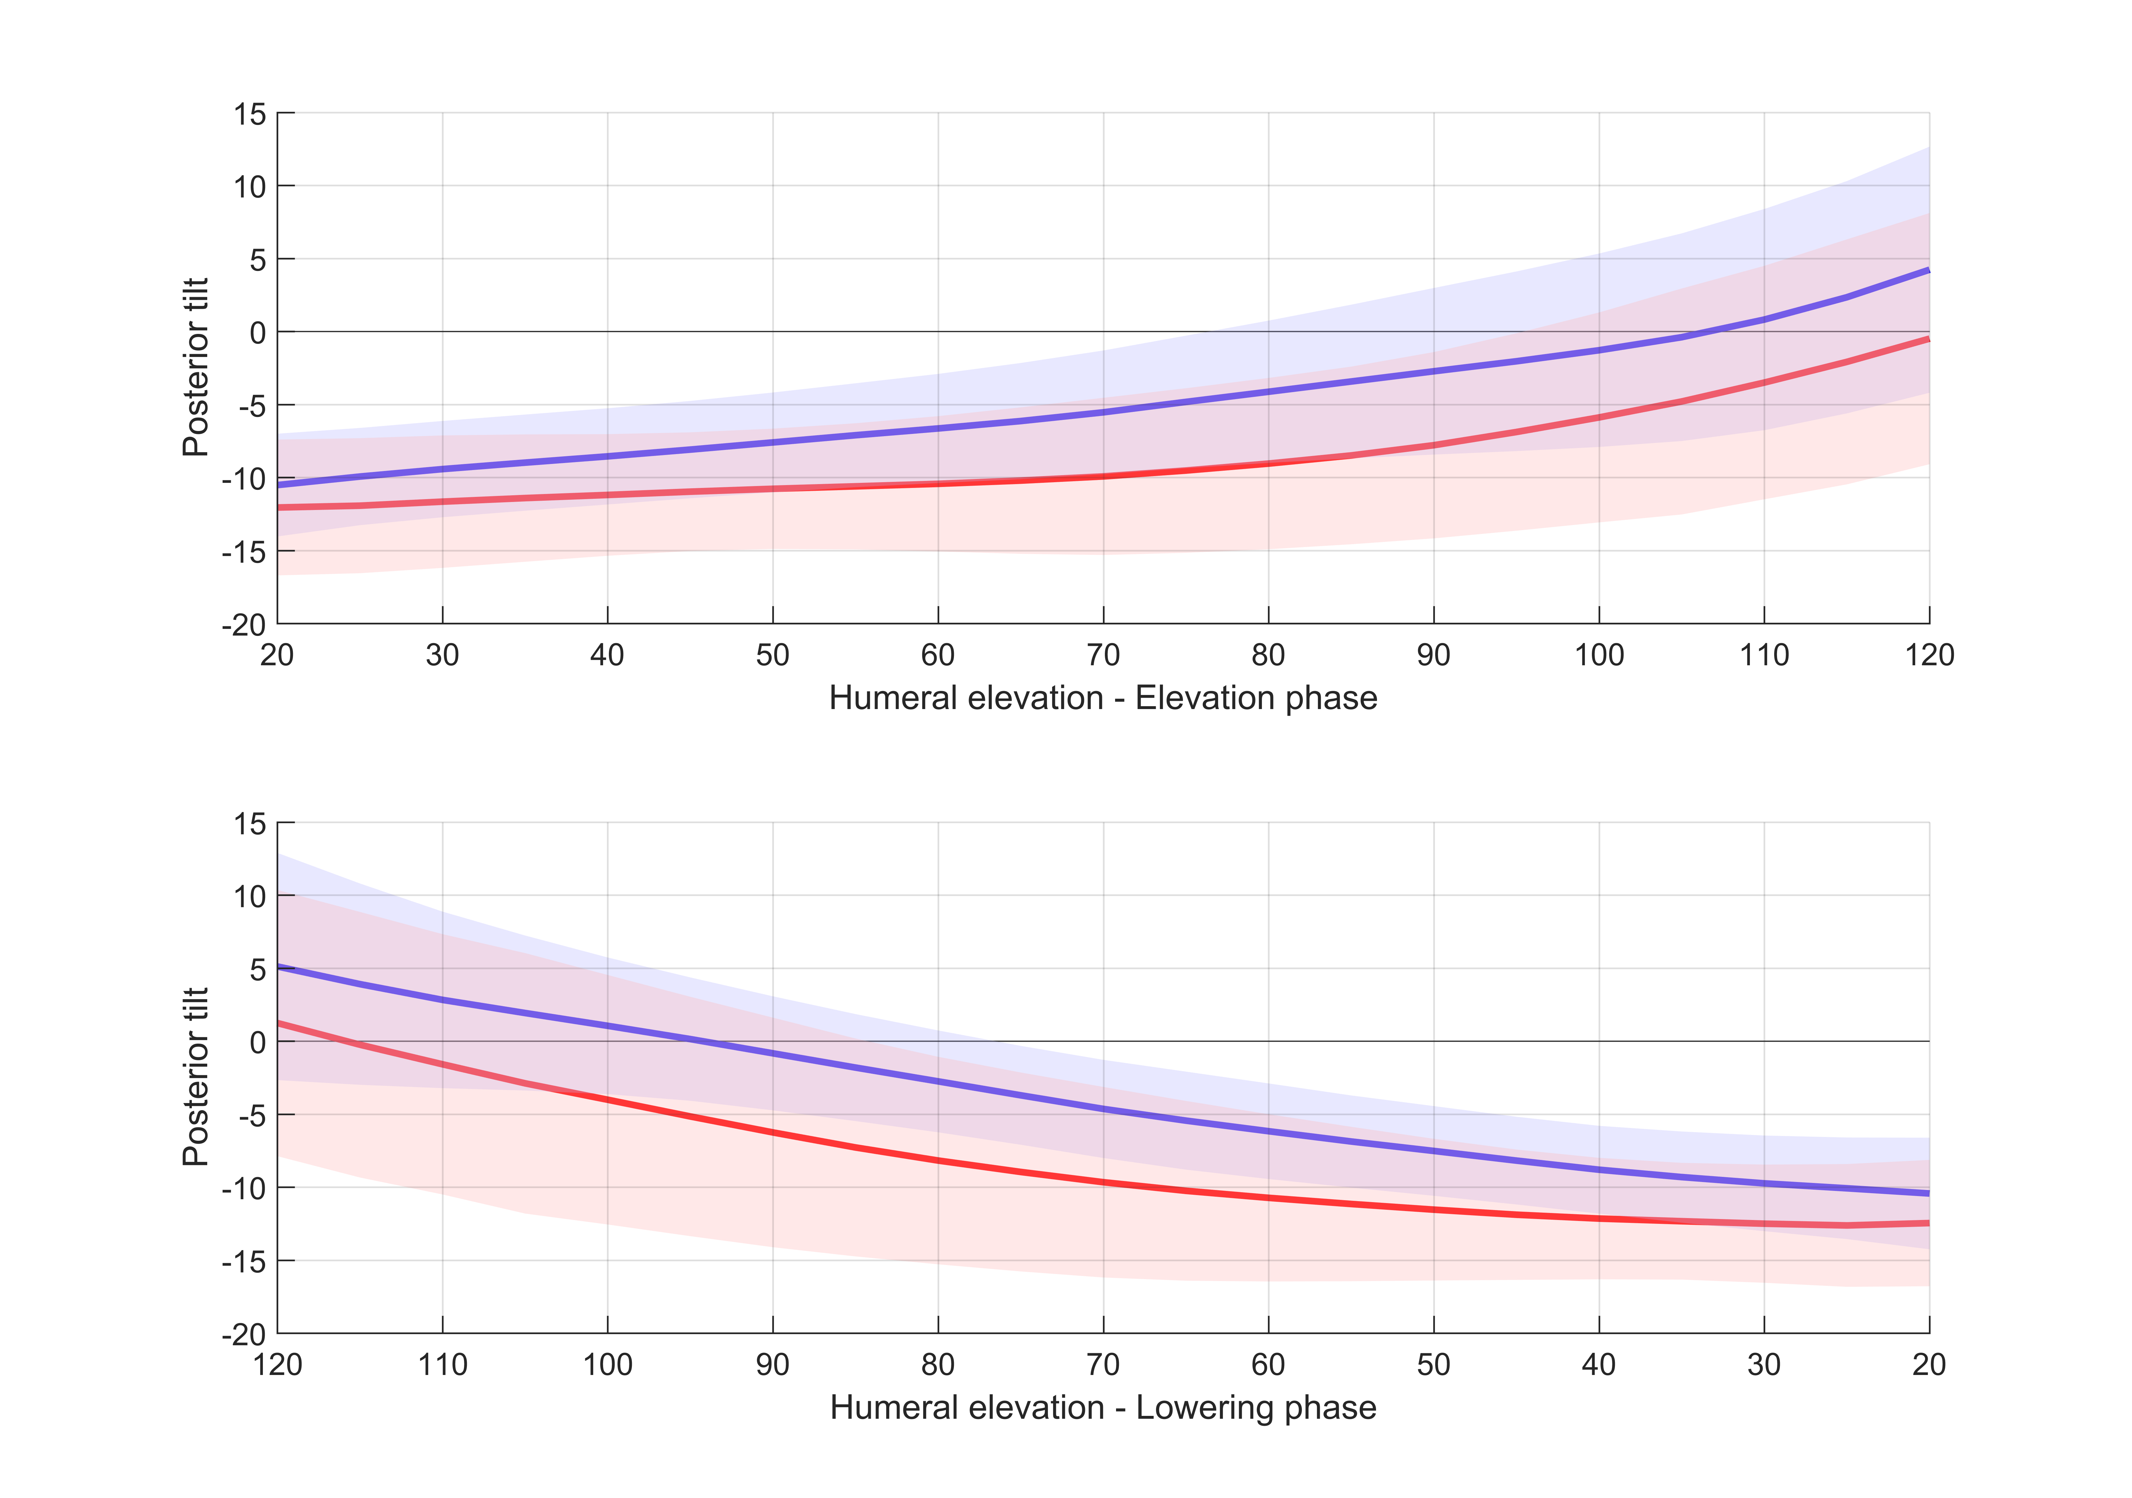

FIGURE 1. Degrees of scapular posterior tilt (+ve) during humeral elevation and lowering in the scapular plane for the dominant (blue) and non-dominant (red) sides. Significant difference in posterior tilt exists between the dominant and non-dominant side.

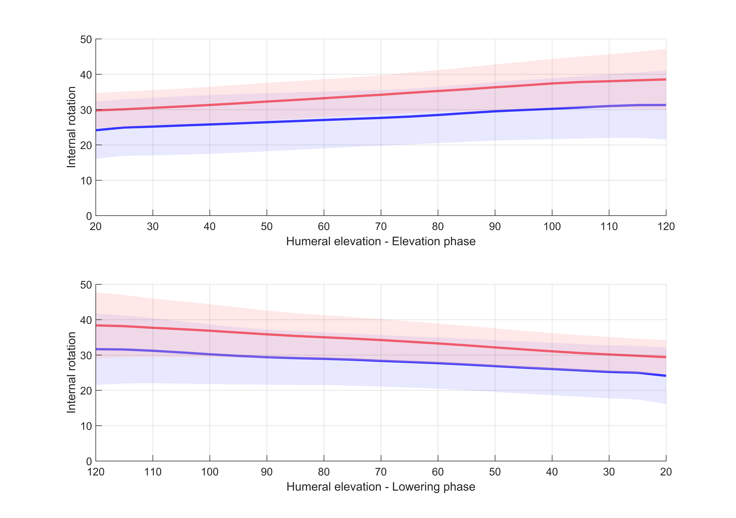

FIGURE 2. Degrees of scapular internal rotation (+ve) during humeral elevation and lowering in the scapular plane for the dominant (blue) and non-dominant (red) sides. There was no significant difference in internal rotation between the dominant and non-dominant sides.

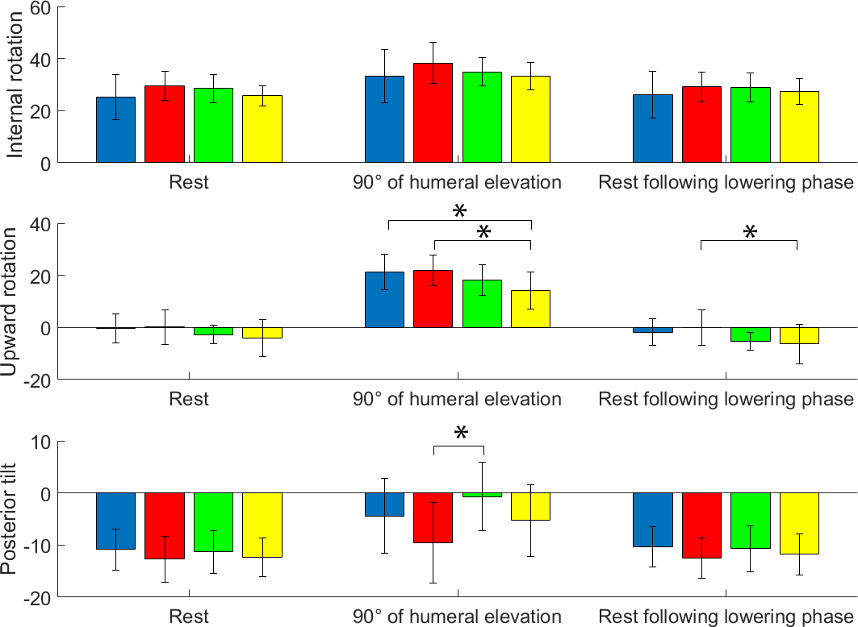
FIGURE 3: Scapular kinematics (degrees) during sagittal plane humeral elevation at rest, 90° of humeral elevation and at rest following the lowering phase for the dominant (blue) and non-dominant (red) scapulae of the wheelchair tennis players, control group (green) and impingement group (yellow). * indicates significant difference at P < 0.05 between groups.

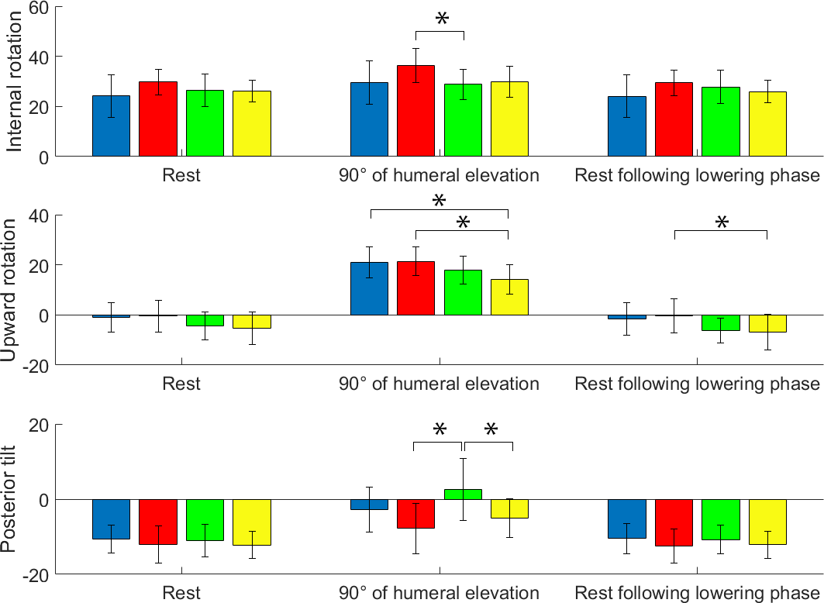
FIGURE 4: Scapular kinematics (degrees) during scapular plane humeral elevation at rest, 90° of humeral elevation and at rest following the lowering phase for the dominant (blue) and non-dominant (red) scapulae of the wheelchair tennis players, control group (green) and impingement group (yellow). * indicates significant difference at P < 0.05 between groups.

