A 2500-year climate and environmental record inferred from subfossil chironomids from Lugu Lake, southwestern China

Jie Chang^{1,2}, Enlou Zhang^{1*}, Enfeng Liu^{1,3}, Weiwei Sun¹, Pete G. Langdon⁴, James Shulmeister²

Affiliation:
- State Key Laboratory of Lake Science and Environment, Nanjing Institute of Geography and Limnology, Chinese Academy of Sciences, 73 East Beijing Road, Nanjing 210008, Jiangsu, China. China
- School of Earth and Environmental Sciences, The University of Queensland, Australia
- College of Geography and Environment, Shandong Normal University, China
- Geography and Environment, University of Southampton, Southampton, UK

*Corresponding author: elzhang@niglas.ac.cn

Key Words:
Subfossil chironomids, southwestern China, catchment erosion, sediment geochemistry, monsoon precipitation, human impact

Abstract

We present a sediment record from Lugu Lake, a large and deep alpine lake in southwestern China, spanning the last c.2500 cal yr BP. This multi-proxy study focussed on subfossil chironomids but also included analyses of chemical elements using inductively coupled plasma-atomic emission spectrometry (ICP-AES), magnetic susceptibility, total organic carbon (TOC), total nitrogen (TN) and grain size. The chironomid assemblage is dominated by Procladius, Tanytarsus gracilentus-type and Polypedilum nubeculosum-type throughout the core. The record reveals that these chironomid taxa responded to two periods of catchment erosion between c.1700-1100 cal yr BP and c.1920 A.D. to the present. We provide evidence which suggests that the recent erosion episode is caused by human activities; however, the earlier event (c.1700-1100 cal yr BP) is likely related to increased regional precipitation, possibly linked to the strengthening of the Indian summer monsoon in the late Holocene. It is notable that the chironomids, through their varied ecologies, are able to detect the human induced changes as well as natural climate changes, for instance, enhanced precipitation. Coupling palaeoecological studies using chironomids with more traditional catchment erosion indicators is thus a powerful tool for reconstructing past environmental and climate change.

Introduction

Reconstructing past regional precipitation variability is a key to understanding the evolution and impact of global climate systems such as the Asian summer monsoon from sub-decadal to multi-millennial time scales. In the past decades, numerous paleoclimatic records have been derived based on a diverse range of natural archives for these purposes, including but not limited to stalagmites, marine, lake and peatbog sediments and tree-rings (Morrill et al. 2003; Overpeck et al. 1996; Wang et al. 2010a). The Yunnan Plateau (23-28°N, 97-105°E, Fig. 1a), southwest China, lies in the southern extension of the Tibetan Plateau and contains a large number of high altitude mountain lakes. A few of these lakes have continuous organic records which extend back to c.50 ka. Some of these lake sediment records have been reviewed in Hodell et al. (1999), Overpeck et al. (1996), Wang et al. (2010b) and Cook and Jones (2012). Recently, more high-resolution and absolute-dated records have emerged from the northern and central part of Yunnan Plateau (Chen et al. 2014a; Chen et al. 2014b; Chen et al. 2014c; Cook et al. 2011; Wang et al. 2017; Wang et al. 2014; Xiao et al. 2014; Zhang et al. 2017a; Zhang et al. 2016; Zhang et al. 2017c) (Fig. 1a). These studies have improved our understanding of the long-term relationship of the regional precipitation change and the Indian Ocean Summer Monsoon over a multi-millennial time scale in southwestern China. There is however, still a dearth of studies that focus on developing proxies that can be used for separating local and regional events. This is critical to better interpret the regional records in the context of the Asian monsoon variability and to avoid confusion with local environmental impacts.

To achieve a more comprehensive understanding of the response of lake sediment archives to local and regional forcing, a suite of proxies are required to disentangle potentially complex histories. In this study, we use chironomids (Diptera: Chironomidae), non-biting midges, which are widely distributed in all permanent and semi-permanent terrestrial water bodies (Armitage et al. 1995). The species distribution and life cycles of chironomid larvae are controlled by a range of limnic conditions (Brooks et al. 2007; Walker 1995). Consequently, quantitative transfer functions based on chironomid taxon assemblages have been developed for reconstructing a range of parameters, including summer air temperatures (Chang et al. 2015; Heiri et al. 2011; Lotter et al. 1999), lake trophic status (Brooks et al. 2001; Langdon et al. 2006; Woodward and Shulmeister 2006; Zhang et al. 2006), water depth (Cwynar et al. 2012; Engels and Cwynar 2011), pH (Rees and Cwynar 2010) and salinity (Zhang et al. 2007). Recently, a chironomid-based temperature transfer function has been developed and applied for SW China (Chang et al. 2017; Zhang et al. 2017a; Zhang et al. 2017b). These studies have advanced our knowledge on the chironomid distribution and the controlling environmental variables in the region. In addition, chironomids have also been demonstrated to be effective indicators for human-induced impact. For instance, they respond to changes of substrate and nutrient status that were induced by soil erosion. Because this response is indirect, a multi-proxy approach is often employed in such studies notably from Northern Europe, east Africa and southern China (Eggermont and Verschuren 2003; Potito et al. 2014; Taylor et al. 2017; Zhang et al. 2011; Zhang et al. 2012). Occasionally, they have also been applied as a proxy to indirectly reconstruct regional precipitation (e.g. in northern China (Wang et al. 2016) and southern Chile (Massaferro and Brooks 2002)).

This study presents the record of chironomids, grain size and geochemical analyses from Lugu Lake sediment covering the last 2500 years. Previous work from Lugu Lake had focused on chironomids from more contemporary sediments (Guo et al. 2013; Zhang et al. 2013b), lipid biomarkers (Li et al. 2017), diatoms, C:N ratio and pollen-based climate reconstructions (Wang et al. 2017; Wang et al. 2014). Here, we used multi-variate statistical analyses to study the chironomid responses to local environmental changes at the catchment level. We then compared this record to regional paleoclimatic reconstructions to interpret the possible links to human-induced environmental impact and natural climate variability such as regional precipitation changes.

Materials and methods

Study site

Lugu Lake (27°41–27°45N, 100°45–100°50E, 2690 m a.s.l.) is a natural and relatively large alpine lake in Yunnan Province, southwestern China (Fig. 1a). The lake has a semi-closed basin with a maximum water depth of 93.5 m and a mean depth of 40.3 m. It has a surface area of 48.45 km², and a catchment drainage area of 171.4 km² (Fig. 1b). Lugu Lake is located in the catchment of the Yalong River (a branch of the Yangtze River), and the modern catchment characteristics, water quality measurements and vegetation composition have been summarized in a few past studies (Guo et al. 2013; Wang et al. 2014; Zhang et al. 2013a; Zhang et al. 2013b). In general, the lake has been impacted by widespread logging between the 1950s and 1980s, followed by tourism impact in the past 20 years. Lugu Lake is located in a region which is under strong influence of Indian Summer Monsoon. The climate in this area is atypical sub-tropical due to its high elevation despite the sub-tropical latitude (27 °S). Based on interpolating climate data from regional stations, the mean annual air temperature at Lugu Lake is approximately 12.8°C and the annual precipitation is approximately 1000 mm (Böhner 1994; Böhner 2006). The area has distinct dry and wet seasons where 80–90% of precipitation occurs between May and October each year.

A 95-cm sediment core was recovered at the water depth of 64 m, close to the centre of Lugu Lake in July, 2007 (Fig. 1b). This was achieved using an UWITEC gravity corer. The sediment core was sub-sampled at 0.5 cm contiguous intervals and packaged onsite. The sub-samples have been stored in a refrigerator (at 4 °C) until laboratory analysis.

Sediment core chronology of Lugu Lake

Freeze-dried and powdered sediment samples were weighed and prepared for dating purposes. Caesium-137 (¹³⁷Cs) activity was measured by emissions at 662 keV using an Ortec HPGe GWL series well-type coaxial low background intrinsic germanium detector from the top 15 cm. Six samples of fossil plant fragments were taken from the depths of 18, 30, 42, 60, 85 and 92 cm for Accelerator Mass Spectrometry (AMS) radiocarbon dating at the Rafter Radiocarbon Laboratory at the Institute of Geological and Nuclear Sciences, New Zealand. The AMS ¹⁴C dates were calibrated to calendar years before present (0 cal. yr BP = AD 1950) using CALIB 7.1 with IntCal 13 calibration dataset (Reimer et al. 2013). ¹³⁷Cs and the AMS ¹⁴C dating results were used in combination to produce the final chronological model in the Clam 2.2 software (Blaauw, 2010) (Fig. 1c).

Chironomid sample analysis

All sediment pre-treatment, sample preparation and sample analyses were performed in the laboratories at the State Key Laboratory of Lake Science and Environment, Nanjing Institute of Geography and Limnology (NIGLAS). Chironomid samples were prepared at every 4 cm interval throughout the 95 cm sediment core using 1 cubic centimetre of sediment, following the protocol described in Brooks et al. (2007). Sediment samples were deflocculated in a warm (c.70 °C) water bath with 10% solution of potassium hydroxide (KOH) for 20 minutes and subsequently sieved with a 90 µm mesh-size sieve. Sieved residues were stored in distilled water and chironomid head capsules were hand-picked under a dissection microscope at 50 × magnification using fine forceps. All head capsules were mounted in a solution of Hydromatrix after a minimum of 50 counts was reached. The chironomid species were then identified following regional and northern hemisphere diagnostic keys (Andersen et al. 2013; Brooks et al. 2007; Oliver 1981; Tang 2006; Wiederholm 1983).

Sediment multi-proxy analyses

Samples were prepared for magnetic susceptibility (MS), grain size, metal elements, total organic carbon (TOC) and total nitrogen (TN) analyses where sub-samples were taken at every 0.5 cm interval for each analysis. For MS analysis, about 0.1 g of freeze-dried samples were placed in an 8 ml polystyrene pot that had been acid washed. The MS values (χ_{lf}) were then measured at 0.47 kHz using a Bartington MS2 Meter for each sample (Dearing 1994; Oldfield and Richardson 1990). Grain size distribution of the samples was measured using a Malvern Instruments Mastersizer-2000. The grain size preparation method involved 1 g of freeze-dried sediment samples being pre-treated with c. 20 ml of 5% H₂O₂ to remove organic matter and then with 10 ml of 10% HCl to remove carbonates. Deionized water was added and kept for 24 hours to wash off acidic ions. Approximately 10 ml of 0.05 M (NaPO₃)₆ was subsequently added to the treated samples and they were placed in an ultrasonic bath for 15 min before measuring grain size. Approximately 0.1 g of freeze-dried and ground samples were completely digested with HF-HCl-HNO₃-HClO₄ and prepared for the determination of metal elements (Al and Ti). Elemental concentrations were measured using inductively coupled plasma-atomic emission spectrometry (ICP-AES) (Liu et al. 2012; McQuaker et al. 1979). A similar amount (c. 0.1 g) of freeze-dried and homogenized samples were pre-treated with 10% HCl to remove carbonate, and subsequently freeze-dried and ground for TOC and TN analyses. Both measurements were conducted by combusting the samples using a Euro EA3000 Elemental Analyzer.

Statistical methods

Several ordination analyses were performed using the CANOCO version 4.5 program package (ter Braak and Šmilauer 2002) to explore the changes in subfossil chironomid species assemblages in Lugu Lake and to determine which variable(s) (MS, grain size fraction < 4, Al and Ti, TOC, TN) explained a significant proportion of the temporal variation in the chironomid assemblages. We focus on the clay and fine silt fraction of the grain sizes because it shows the most variation of all fractions. We selected Al and Ti in this study because both of these elements are critical components of the continental soil in southwestern China (Ji et al. 2004), though it is likely that they show similar pattern. MS and grain sizes, TOC and TN of the sediment also vary similarly. However, they were all selected for the multi-variate analyses with the chironomid data because we aim to test which of these variables have a more direct and stronger influence on chironomid species variation through time.

Geochemical proxy data were log10 (x+1) transformed, and chironomid and grain size data were square-root transformed prior to the ordination analyses. Detrended Correspondence Analysis (DCA) (Hill and Gauch 1980) with detrending by segments was applied to explore the major temporal patterns of chironomid assemblage variation and to determine the gradient lengths. The result showed that the gradient length of DCA axis 1 was 1.12 standard deviation (SD) suggesting that either a linear or unimodal approach could be applied (ter Braak and Šmilauer, 2002).

We then performed a series of Redundancy Analysis (RDAs) using a manual selection option by including six parameters (MS, grain sizes fraction < 4 µm, Al, Ti, TOC and TN) as explanatory variables to identify which ones explained significant variance in the chironomid species (with species data square-root transformed and down-weighting of rare species) and the distribution of chironomid samples along the ordination gradients. The significance of each variable was tested using the Monte Carlo permutation tests (999 unrestricted permutations). The significance level was adjusted by applying a ‘One Step’ Bonferroni correction (García 2004).

Results

Chronology

The ¹³⁷Cs dating results show that at 9 cm depth, there is a peak in ¹³⁷Cs activity. This is assumed to correspond with the 1963–1964 maximum fallout in the atmosphere from nuclear bomb testing (Appleby 2001). The age-depth model was therefore developed based on a ¹³⁷Cs date of 1963 AD and six calibrated AMS ¹⁴C dates by fitting a smooth-spline model (Blaauw 2010) (Fig. 1c). The 95-cm core has a basal age of c.2500 cal yr BP and the sedimentation rate has an average of c. 2.5 cm per 100 years and a rapid increase is observed for the last c.200 years (Fig. 1c).

Chironomid taxa in Lugu Lake and other proxies

Thirteen non-rare chironomid taxa (i.e. occurred in more than 2 samples and with an overall abundance of larger than 2%, i.e. N and N2 > 2) were identified in this 2500-year Lugu Lake core (Fig. 2). All samples yield a total count of over 50 chironomid head capsules with a maximum count of 276 reached at the depth of 21 cm (c.260 cal yr BP). The chironomid assemblage is dominated by Procladius, Tanytarsus gracilentus-type and Polypedilum nubeculosum-type throughout the record. These three taxa reached a maximum abundance of 86% (c.1900 cal yr BP), 25% and 34% (both at c.1300 cal yr BP), respectively. A few other taxa such as Chironomus plumosus-type, Dicrotendipes nervosus-type and Harnischia are abundant between c.1900 and c.1100 cal yr BP (Fig. 2). Based on changes in chironomid stratigraphy, the record is divided into three zones (Table 1) using the cluster analysis (Grimm 1987). The results of magnetic susceptibility, the content of clay and fine silt (grain size fraction < 4 µm) and sand (grain size fraction > 63 µm), concentrations of Ti and Al, TOC and TN are presented in Fig 3a-g and also described in Table 1.

Ordination results

The DCA analysis performed on the chironomid data show that the first two DCA axes explained 16.9 and 10.4% of the chironomid assemblage variance respectively. The DCA axis 1 sample score (Fig. 2) shows high values between 2500 and 1700 cal yr BP (chironomid zone 1) and in the last 1100 years (chironomid zone 3) while low values prevail between 1700 and 1100 cal yr BP (chironomid zone 2). Changes in abundance of two chironomid taxa: Procladius and Tanytarsus gracilentus-type are significantly correlated with the chironomid DCA axis 1 sample score (p < 0.005, r = 0.82 and r = -0.82, respectively) (Fig. 2).

The RDA revealed that 37.7 and 12.2 % of variance of the chironomid samples were explained by the first and second axes respectively by all six variables while 35.2 and 10.3% of variance were explained by three remaining significant and independent variables: MS, TN and Al (Fig. 4). Among these variables, TN alone independently explained the largest percent (33.8 %) of variance and is the main variable dominating the RDA axis 1. RDA axis 2 was co-dominated by MS and Al. The RDA tri-plot (Fig. 4) shows that chironomid assemblage of samples were divided into three groups: samples from the last 40 years (the first three samples represent the top 9 cm) were strongly controlled by RDA axis 2 (MS and Al); samples between c.1700 and 1100 cal yr BP (sample code from 11 to 17) were co-driven by both RDA axes; the rest of the samples were strongly controlled by RDA axis 1 (Fig. 4). The full RDA results are presented in Table 2.

Discussion

Multi-proxy indicators for catchment erosion at Lugu Lake

Both Ti and Al are stable elements derived from terrestrial source and therefore have been widely used as indicators for catchment erosion in lake sediment records (Croudace and Rothwell 2015; Sergeeva 1983). In addition, magnetic susceptibility has also been shown to be an effective proxy for soil erosion (Oldfield and Richardson 1990; Oldfield et al. 2003). In the monsoon-influenced regions of southern China, these proxies (particularly Ti) are commonly applied to infer the strength and intensity of monsoonal precipitation (Haug et al. 2001; Zhang et al. 2017c). Generally speaking, Ti and Al are bonded to mineral particles (including clay and fine silt) and during high rainfall period, there were increased washings into the lake basin thus the increase in values of Ti, Al, fraction of clay and fine silt (while the fraction of sands is consistent), and magnetic susceptibility was expected (Fig. 3a-c and f-g). This is evident between c.1700 and 1100 cal yr BP of the record.

A separate study was conducted by Zhang et al (2013b) with a focus on the most recent 120 years of this site. The detailed chironomid stratigraphy and geochemical data presented for the last century suggests that the rapid increase in human-induced landscape change, including the change of agricultural practices and deforestation, had caused significant catchment erosion into Lugu Lake and chironomids had responded rapidly to such change (Zhang et al. 2013b). This is supported particularly by the increase of Ti (with a maximum of 13 mg/g) and magnetic susceptibility (with a maximum of 349 × 10⁻⁸ m³/kg) values in the top layers of the sediment (i.e. since 1920s A.D.) in this record. A few paleoecological records from SW China suggest a long history of human occupation (a minimum of 2000 years) in central Yunnan Province, for instance, at Xingyun Lake (Chen et al. 2014a; Wu et al. 2015). However, there is limited recorded evidence of thousands-year long human activities around lakes from further north and higher altitude (close to 3000 m.s.l. and above) of Yunnan, from Lugu Lake (Wang et al. 2017) or nearby sites (Chang et al. 2017; Chen et al. 2014b; Xiao et al. 2014; Zhang et al. 2017a). Instead, evidence suggests human occupation on the Yunnan Plateau intensified in the past 250-500 cal yr BP (Wang et al. 2017; Whitmore et al. 1994). The implication is that the increased erosion in the late Holocene (c.1700-1100 cal yr BP) at this site is most likely driven by natural climate variability.

The different responses of chironomids to catchment soil erosion

Regional and local environmental change such as continuously increasing soil erosion can affect the community structure of chironomids (Smol et al. 2006; Walker 1995). Such shifts can be abrupt and these changes can be demonstrated from northern Europe (Axford et al. 2009; Langdon et al. 2010a; Taylor et al. 2017), East Africa (Eggermont and Verschuren 2003), North and South America (Araneda et al. 2013; Campbell et al. 2009), the Mediterranean (Brisset et al. 2013) and southern China (Cao et al. 2014; Zhang et al. 2011). The chironomid assemblage changes coincide with the change in geochemical and sedimentological erosion indicators from the Lugu Lake record. Both the erosion events recognized at c.1700-1100 cal yr BP and in the last century were characterised by a reduction in Procladius and an expansion in Tanytarsus species, including the increase in Tanytarsus mendax-type since 1970s (Zhang et al., 2013) and Tanytarsus gracilentus-type from c.1700 to 1100 cal yr BP (Fig 2). It is also observed that the concentration of chironomid head capsules declines from both events and this could either be due to a reduction in production (less food source) or an increase in sedimentation rates (i.e. less chironomids per relative sample amount).

More fine sediment eroded into a lake has been demonstrated to have a substantial influence on benthic chironomids (Höss et al. 1999; Palmer et al. 1996). The increase of clay and fine silt in the substrate could cause a fall in oxygen availability to chironomids living at the bottom of the lake by clogging the void space in the lakebed sediments and reducing oxygen penetration (Nogaro et al. 2006). The Lugu Lake record was characterized by the rapid decrease in the population of Procladius during c.1700-1100 cal yr BP and the last century. Unlike most of the species of the subfamily Chironominae, Tanypodinae family (e.g. Procladius) does not usually use haemoglobin for oxy-regulation (Osmulski and Leyko 1986; Ramakrishnan 2002). Therefore, low oxygen conditions could largely affect the growth of Procladius, or cause them to migrate to shallower parts of the lake during these periods. Conversely, select taxa from the subfamily Chironominae, notably Tanytarsus gracilentus-type, Chironomus plumosus-type, Dicrotendipes nervosus-type, which are well-known for having stronger ability to survive in low oxygen concentrations by utilising haemoglobin (Brodersen et al. 2004), all increased in their relative abundance.

It is noteworthy that Polypedilum nubeculosum-type showed an increase in abundance during c.1700 and 1100 cal yr BP (Fig 2) but declined since the onset of the severe erosion in the 1970s (Fig 4 in Zhang et al. (2013b)), suggesting the responses of chironomids to the two separate events are not identical. Polypedilum nubeculosum-type typically occurs in the littoral of meso-eutrophic lakes (Brooks et al. 2007) and can be associated with macrophytes (Langdon et al. 2010b). This suggests that the increased abundance of Polypedilum nubeculosum-type may be a response to increased nutrients in the lake, presumably exported from the catchment through enhanced soil erosion. The decline in head capsule abundance at the same period may therefore relate to a period of relatively enhanced sediment accumulation (not discernible from the radiocarbon derived age model) (Fig. 1c), which would be consistent with an increase in lake productivity. It is notable that this phase lasted c.600 years, but thereafter the chironomid community returned to its pre-erosion state. In other words, it was able to recover and the lake ecosystem showed some resilience to a persistent change over a multi-centennial timescale. Polypedilum nubeculosum-type is also known as bottom collector-gatherers. Their reduction during the recent high erosion period is possibly due to the loss of favourable habitats as the substrate may be difficult to enter when there was a large amount of both fine silt/clay and sands loaded. However during the earlier event (c.1700-1100 cal yr BP) the erosion may not have been severe enough to cause the loss of microhabitat for collector-gathers, and instead this taxon increased its abundance during this period maybe also due to their ability to adapt to low oxygen conditions. We noted that the shift to the dominance of the Tanytarsus morphotypes in the assemblage during the two erosion events may be because of they are filter-feeders and were readily adapted to new habitats.

The RDA results (Fig. 4) demonstrate these lines of interpretation well, where samples from c.1700-1100 cal yr BP showed a stronger relationship with RDA axis 1 (driven by lake productivity indicators), though influenced by RDA axis 2 (driven by soil erosion indicators), and samples from the last century are strongly dominated by RDA axis 2 (soil erosion indicators). In summary, the evidence from c.1700-1100 cal yr BP is indicative of a climate impact, rather than a human impact, which tend to have longer-lasting impacts on lake ecosystems, and often result in lakes being unable to recover to their pre-impact state (Folke et al. 2004; Scheffer et al. 2001).

Paleoclimate inferences from the Lugu Lake record of the last 2500 years

We compared Lugu Lake record with the local and regional climate reconstructions (Fig. 5A-C) to further reconcile the possible drivers for the c.1700-1100 cal yr BP changes as increasing of regional rainfall was suspected. The Lugu Lake record reassembles the pollen concentration changes (Fig. 5C) at the site and the precipitation record based on a pollen transfer function from Xingyun Lake, in central Yunnan Province (Fig. 5B) (Chen et al. 2014a; Lu et al. 2011; Wang et al. 2017). Moreover, we observed that the timing of the peaks of both the reconstructed rainfall at Xingyun Lake (Fig. 5A) and chironomid indicated catchment erosion at Lugu Lake (Fig. 5D-F) are coincident with the broad and gradual increase of tree pollen percentages at Lugu Lake since c. 1700 cal yr BP (Fig. 5C). This confirms that wet conditions were likely prevailed, which supported tree growth rather than forest clearance induced erosion around the catchment during this period. These also correspond well with the inferred strengthening or resuming of the Indian summer monsoon since c.1400-1200 cal yr BP (Fleitmann et al. 2003), suggesting that the catchment erosion at Lugu Lake during this period is likely due to a stronger monsoon-induced increased regional precipitation. While the trends of these pollen-based reconstructions are similar in timing to chironomid-inferred erosion, the match is not precise. This is however, unsurprising because usually pollen (especially trees) has a lagged response to the change of climatic conditions while chironomids, which are aquatic invertebrates with short life cycles responding instantaneously. We noted also that yet only a few reconstructions (e.g. Chen et al. 2014a; Wang et al. 2017) from the region recorded the increase of monsoonal precipitation during c.1700 and 1100 cal yr BP, thus more records are required to elucidate a regional pattern and to further relate this change to a global scaled event.

Conclusions

A multi-proxy record with a special focus on chironomids from a deep, alpine lake, Yunnan Province spanning the past c.2500 years was developed. The record was divided into three zones from c.2500 yr BP until 1920 AD based on the changes in three dominant chironomid taxa: Procladius, Tanytarsus gracilentus-type and Polypedilum nubeculosum-type. The chironomid variability and geochemical data from Lugu Lake together show two major catchment erosion events that occurred during c.1700-1100 cal yr BP and the last century. Both events change the chironomid assemblage in the record. The paleoclimate data and documented history suggest that the erosion which occurred in the last century was caused by human activities and it was more severe than the event of c.1700-1100 cal yr BP. We provide further evidence that the c.1700-1100 catchment erosion at Lugu Lake is likely due to the regional precipitation increase in southwestern China, which may be linked to the strengthening of the Indian summer monsoon in the late Holocene. The results demonstrated that chironomids from Lugu Lake responded strongly and instantly to catchment soil erosion and the response of some taxa, such as Polypedilum nubeculosum-type, could be used to differentiate the strong/weaker erosion events.

Acknowledgements
Financial support for field work and sample analyses of this work was provided through the Program of Global Change and Mitigation (2016YFA0600502), the National Basic Technological Research of China (2014FY110400) and the National Natural Science Foundation of China (No. 41302277, 41572337). J. Chang also received the General Financial Grant from the China Postdoctoral Science Foundation (No. 2017M610359). We thank X.D. Yang, Q. Wang and Y.L. Li for field assistance.

Figure and Table captions and legends
Fig. 1. (a) Locations of Lugu Lake, southwestern China (red triangle) and the key paleorecords discussed in the texts: Dongge Cave (1), Qunf Cave (2), Xingyun Lake (3), Tiancai Lake (4), Heihai Lake (5), Shudu Lake (6), Wuxu Lake (7), Tengchongqinghai (TCQH) (8) and Erhai Lake (9). The direction of the Indian summer monsoon (ISM), East Asian summer monsoon (EASM) are marked in orange arrows. (b) Lake bathymetry and coring site (red triangle). (c) The age-depth model constructed based on ¹³⁷Cs dating and six calibrated AMS radiocarbon dates (blue dots) for the 95 cm sediment core of Lugu Lake.

Fig. 2. The abundance of major chironomid taxa (%) presented in the Lugu Lake record over the past c.2500 years. Three major zones are determined based on the compositional shift in chironomid assemblage (solid horizontal lines). Total count of head capusles (sum of hcs) and and the DCA first axis score are shown in black solid lines in two separate panels on the right side.

Fig. 3. The variability of selected physical and geochemical proxies plotted against the chronology from the sediment core of Lugu Lake covering the last 2500 years: (a) and (b) show the concentration of chemical elements Titanium (Ti) and Aluminium (Al); (c) magnetic susceptibility (MS); (d) total organic carbon (TOC); (e) total nitrogen (TN); (f) percentage (%) of fine silt and clay sediments with grain sizes smaller than 4 µm; (g) percentage (%) of sands with grain sizes larger than 63 µm.

Fig. 4. RDA tri-plot with 25 chironomid samples, 13 main chironomid taxa and six selected environmental variables (total organic carbon: TOC; total nitrogen: TN; fraction of fine silt and clay: GS < 4 µm; concentrations of chemical elements: Al, Ti and magnetic susceptibility: MS) included. Solid circles indicate samples from the two identified erosion events where sample code 1-3 represent the top ~10 cm (the last century) and sample code 12-17 show samples from 65-45 cm (1700-1100 cal yr BP); open circles indicate the rest 16 samples; closed triangle represents 13 main chironomid taxa present over c. 2500 cal yr BP in Lugu Lake sediment.

Fig. 5. Comparison of the Lugu Lake paleoclimate proxies with the regional Asian summer monsoon precipitation records spanning the last c.2500 years. (A) Pollen-based precipitation reconstruction from Xingyun Lake, central Yunnan Province (Chen et al., 2014a). (B) Total pollen concentration (Wang et al. 2017) and (C) tree pollen percentages (Wang et al. 2017) of Lugu Lake (D) the abundance (%) of Procladius, (E) the abundance (%) of Tanytarsus gracilentus-type and (F) chironomid DCA first axis sample score analysed from this record.

Table. 1. Description of the changes in chironomid taxa, geochemical and physical proxies (Titanium (Ti), Aluminium (Al), magnetic susceptibility (MS), Total organic carbon (TOC), Total nitrogen (TN) and grain sizes (GS)) throughout the three divided zones as shown in Fig 2 and 3.

Table. 2. Summary statistics for the redundancy analysis using all six environmental variables (Titanium (Ti), Aluminium (Al), magnetic susceptibility (MS), Total organic carbon (TOC), Total nitrogen (TN) and grain sizes (GS)), 13 main chironomid taxa and 25 samples over c. 2500 cal yr BP from Lugu Lake.

References:
Andersen, T. J., P. S. Cranston & J. H. Epler, 2013. The larvae of Chironomidae (Diptera) of the Holarctic Region – Keys and diagnoses. Scandinavian Entomology, Sweden, pp.1-573, Sweden.
Appleby, P. G., 2001. Chronostratigraphic Techniques in Recent Sediments. In Last, W. M. & J. P. Smol (eds) Tracking Environmental Change Using Lake Sediments: Basin Analysis, Coring, and Chronological Techniques. Springer Netherlands, Dordrecht, 171-203.
Araneda, A., P. Jana, C. Ortega, F. Torrejón, S. Bertrand, P. Vargas, N. Fagel, D. Alvarez, A. Stehr & R. Urrutia, 2013. Changes in sub-fossil chironomid assemblages in two Northern Patagonian lake systems associated with the occurrence of historical fires. Journal of Paleolimnology 50(1):41-56 doi:10.1007/s10933-013-9703-0.
Armitage, P. D., L. C. Pinder & P. S. Cranston, 1995. The habitats of chironomid larvae. In Armitage, P. D., L. C. Pinder & P. S. Cranston (eds) The Chironomidae: Biology and ecology of non-biting midges. Springer, Netherlands, 107-133.
Axford, Y., Á. Geirsdóttir, G. H. Miller & P. G. Langdon, 2009. Climate of the Little Ice Age and the past 2000 years in northeast Iceland inferred from chironomids and other lake sediment proxies. Journal of Paleolimnology 41(1):7-24 doi:10.1007/s10933-008-9251-1.
Blaauw, M., 2010. Methods and code for ‘classical’ age-modelling of radiocarbon sequences. Quaternary Geochronology 5(5):512-518 doi:http://dx.doi.org/10.1016/j.quageo.2010.01.002.
Böhner, J., 1994. Circulation and representativeness of precipitation and air temperature in the southeast of the Qinghai-Xizang Plateau. GeoJournal 34(1):55-66 doi:10.1007/bf00813970.
Böhner, J., 2006. General climatic controls and topoclimatic variations in Central and High Asia. Boreas 35(2):279-295 doi:10.1111/j.1502-3885.2006.tb01158.x.
Brisset, E., C. Miramont, F. Guiter, E. J. Anthony, K. Tachikawa, J. Poulenard, F. Arnaud, C. Delhon, J.-D. Meunier, E. Bard & F. Suméra, 2013. Non-reversible geosystem destabilisation at 4200 cal. BP: Sedimentological, geochemical and botanical markers of soil erosion recorded in a Mediterranean alpine lake. The Holocene 23(12):1863-1874 doi:doi:10.1177/0959683613508158.
Brodersen, K. P., O. Pedersen, C. Lindegaard & K. Hamburger, 2004. Chironomids (Diptera) and oxy-regulatory capacity: An experimental approach to paleolimnological interpretation. Limnology and Oceanography 49(5):1549-1559 doi:10.4319/lo.2004.49.5.1549.
Brooks, S. J., H. Bennion & H. J. B. Birks, 2001. Tracing lake trophic history with a chironomid–total phosphorus inference model. Freshwater Biology 46(4):513-533 doi:10.1046/j.1365-2427.2001.00684.x.
Brooks, S. J., P. G. Langdon & O. Heiri, 2007. The Identification and Use of Palaearctic Chironomidae Larvae in Palaeoecology. Quaternary Research Association, London, UK.
Campbell, B. D., R. J. Haro & W. B. Richardson, 2009. Effects of Agricultural Land Use on Chironomid Communities: Comparisons Among Natural Wetlands and Farm Ponds. Wetlands 29(3):1070-1080 doi:10.1672/08-141.1.
Cao, Y., E. Zhang, P. G. Langdon, E. Liu & J. Shen, 2014. Chironomid-inferred environmental change over the past 1400 years in the shallow, eutrophic Taibai Lake (south-east China): Separating impacts of climate and human activity. The Holocene 24(5):581-590 doi:doi:10.1177/0959683614522308.
Chang, J. C., J. Shulmeister & C. Woodward, 2015. A chironomid based transfer function for reconstructing summer temperatures in southeastern Australia. Palaeogeography, Palaeoclimatology, Palaeoecology 423:109-121 doi:http://dx.doi.org/10.1016/j.palaeo.2015.01.030.
Chang, J. C., E. Zhang, E. Liu & J. Shulmeister, 2017. Summer temperature variability inferred from subfossil chironomid assemblages from the south-east margin of the Qinghai–Tibetan Plateau for the last 5000 years. The Holocene.
Chen, F., X. Chen, J. Chen, A. Zhou, D. U. O. Wu, L. Tang, X. Zhang, X. Huang & J. Yu, 2014a. Holocene vegetation history, precipitation changes and Indian Summer Monsoon evolution documented from sediments of Xingyun Lake, south-west China. Journal of Quaternary Science 29(7):661-674 doi:10.1002/jqs.2735.
Chen, X., Y. Li, S. Metcalfe, X. Xiao, X. Yang & E. Zhang, 2014b. Diatom response to Asian monsoon variability during the Late Glacial to Holocene in a small treeline lake, SW China. The Holocene 24(10):1369-1377 doi:doi:10.1177/0959683614540951.
Chen, X. M., F. Chen, A. Zhou, X. Huang, L. Tang, D. Wu, X. Zhang & J. Yu, 2014c. Vegetation history, climatic changes and Indian summer monsoon evolution during the Last Glaciation (36,400–13,400 cal yr BP) documented by sediments from Xingyun Lake, Yunnan, China. Palaeogeography, Palaeoclimatology, Palaeoecology 410:179-189 doi:http://dx.doi.org/10.1016/j.palaeo.2014.05.027.
Cook, C. G. & R. T. Jones, 2012. Palaeoclimate dynamics in continental Southeast Asia over the last ~ 30,000 Cal yrs BP. Palaeogeography, Palaeoclimatology, Palaeoecology 339–341:1-11 doi:https://doi.org/10.1016/j.palaeo.2012.03.025.
Cook, C. G., R. T. Jones, P. G. Langdon, M. J. Leng & E. Zhang, 2011. New insights on Late Quaternary Asian palaeomonsoon variability and the timing of the Last Glacial Maximum in southwestern China. Quaternary Science Reviews 30(7–8):808-820 doi:http://dx.doi.org/10.1016/j.quascirev.2011.01.003.
Croudace, I. W. & R. G. Rothwell, 2015. Micro-XRF Studies of Sediment Cores: Applications of a non-destructive tool for the environmental sciences. Springer Netherlands.
Cwynar, L. C., A. B. H. Rees, C. R. Pedersen & S. Engels, 2012. Depth distribution of chironomids and an evaluation of site-specific and regional lake-depth inference models: a good model gone bad? Journal of Paleolimnology 48(3):517-533 doi:10.1007/s10933-012-9628-z.
Dearing, J., 1994. Environmental magnetic susceptibility. Using the Bartington MS2 system Kenilworth, Chi Publ.
Eggermont, H. & D. Verschuren, 2003. Impact of soil erosion in disturbed tributary drainages on the benthic invertebrate fauna of Lake Tanganyika, East Africa. Biological Conservation 113(1):99-109 doi:https://doi.org/10.1016/S0006-3207(02)00353-1.
Engels, S. & L. C. Cwynar, 2011. Changes in fossil chironomid remains along a depth gradient: evidence for common faunal thresholds within lakes. Hydrobiologia 665(1):15-38 doi:10.1007/s10750-011-0601-z.
Fleitmann, D., S. J. Burns, M. Mudelsee, U. Neff, J. Kramers, A. Mangini & A. Matter, 2003. Holocene Forcing of the Indian Monsoon Recorded in a Stalagmite from Southern Oman. Science 300(5626):1737-1739 doi:10.1126/science.1083130.
Folke, C., S. Carpenter, B. Walker, M. Scheffer, T. Elmqvist, L. Gunderson & C. S. Holling, 2004. Regime Shifts, Resilience, and Biodiversity in Ecosystem Management. Annual Review of Ecology, Evolution, and Systematics 35(1):557-581 doi:10.1146/annurev.ecolsys.35.021103.105711.
García, L. V., 2004. Escaping the Bonferroni iron claw in ecological studies. Oikos 105(3):657-663 doi:10.1111/j.0030-1299.2004.13046.x.
Grimm, E. C., 1987. CONISS: a FORTRAN 77 program for stratigraphically constrained cluster analysis by the method of incremental sum of squares. Computers & Geosciences 13(1):13-35 doi:http://dx.doi.org/10.1016/0098-3004(87)90022-7.
Guo, X., A. P. Potito, L. Luo & D. W. Beilman, 2013. Twentieth century human and climate impacts on a large mountain lake in southwest China. Hydrobiologia 718(1):189-206 doi:10.1007/s10750-013-1615-5.
Haug, G. H., K. A. Hughen, D. M. Sigman, L. C. Peterson & U. Röhl, 2001. Southward Migration of the Intertropical Convergence Zone Through the Holocene. Science 293(5533):1304-1308 doi:10.1126/science.1059725.
Heiri, O., S. J. Brooks, H. J. B. Birks & A. F. Lotter, 2011. A 274-lake calibration data-set and inference model for chironomid-based summer air temperature reconstruction in Europe. Quaternary Science Reviews 30(23–24):3445-3456 doi:http://dx.doi.org/10.1016/j.quascirev.2011.09.006.
Hill, M. O. & H. G. Gauch, 1980. Detrended correspondence analysis: An improved ordination technique. Vegetatio 42(1):47-58 doi:10.1007/bf00048870.
Hodell, D. A., M. Brenner, S. L. Kanfoush, J. H. Curtis, J. S. Stoner, S. Xueliang, W. Yuan & T. J. Whitmore, 1999. Paleoclimate of Southwestern China for the Past 50,000 yr Inferred from Lake Sediment Records. Quaternary Research 52(3):369-380 doi:10.1006/qres.1999.2072.
Höss, S., M. Haitzer, W. Traunspurger & C. E. W. Steinberg, 1999. Growth and fertility of Caenorhabditis elegans (nematoda) in unpolluted freshwater sediments: Response to particle size distribution and organic content. Environmental Toxicology and Chemistry 18(12):2921-2925 doi:10.1002/etc.5620181238.
Ji, H., S. Wang, Z. Ouyang, S. Zhang, C. Sun, X. Liu & D. Zhou, 2004. Geochemistry of red residua underlying dolomites in karst terrains of Yunnan-Guizhou Plateau. Chemical Geology 203(1):1-27 doi:http://dx.doi.org/10.1016/j.chemgeo.2003.08.012.
Langdon, P. G., M. J. Leng, N. Holmes & C. J. Caseldine, 2010a. Lacustrine evidence of early-Holocene environmental change in northern Iceland: a multiproxy palaeoecology and stable isotope study. The Holocene 20(2):205-214 doi:doi:10.1177/0959683609354301.
Langdon, P. G., Z. O. E. Ruiz, K. P. Brodersen & I. D. L. Foster, 2006. Assessing lake eutrophication using chironomids: understanding the nature of community response in different lake types. Freshwater Biology 51(3):562-577 doi:10.1111/j.1365-2427.2005.01500.x.
Langdon, P. G., Z. O. E. Ruiz, S. Wynne, C. D. Sayer & T. A. Davidson, 2010b. Ecological influences on larval chironomid communities in shallow lakes: implications for palaeolimnological interpretations. Freshwater Biology 55(3):531-545 doi:10.1111/j.1365-2427.2009.02345.x.
Li, J., L. Kong, H. Yang, Q. Wang, X. Yang, J. Shen & C. Zhao, 2017. Temperature variations since 1750 CE inferred from an alpine lake in the southeastern margin of the Tibetan Plateau. Quaternary International 436, Part A:37-44 doi:https://doi.org/10.1016/j.quaint.2016.12.016.
Liu, E., J. Shen, G. F. Birch, X. Yang, Y. Wu & B. Xue, 2012. Human-induced change in sedimentary trace metals and phosphorus in Chaohu Lake, China, over the past half-millennium. Journal of Paleolimnology 47(4):677-691 doi:10.1007/s10933-012-9592-7.
Lotter, A. F., I. R. Walker, S. J. Brooks & W. Hofmann, 1999. An intercontinental comparison of chironomid palaeotemperature inference models: Europe vs North America. Quaternary Science Reviews 18(6):717-735 doi:http://dx.doi.org/10.1016/S0277-3791(98)00044-4.
Lu, H., N. Wu, K.-b. Liu, L. Zhu, X. Yang, T. Yao, L. Wang, Q. Li, X. Liu, C. Shen, X. Li, G. Tong & H. Jiang, 2011. Modern pollen distributions in Qinghai-Tibetan Plateau and the development of transfer functions for reconstructing Holocene environmental changes. Quaternary Science Reviews 30(7–8):947-966 doi:https://doi.org/10.1016/j.quascirev.2011.01.008.
Massaferro, J. & S. J. Brooks, 2002. Response of chironomids to Late Quaternary environmental change in the Taitao Peninsula, southern Chile. Journal of Quaternary Science 17(2):101-111 doi:10.1002/jqs.671.
McQuaker, N. R., D. F. Brown & P. D. Kluckner, 1979. Digestion of environmental materials for analysis by inductively coupled plasma-atomic emission spectrometry. Analytical Chemistry 51(7):1082-1084 doi:10.1021/ac50043a071.
Morrill, C., J. T. Overpeck & J. E. Cole, 2003. A synthesis of abrupt changes in the Asian summer monsoon since the last deglaciation. The Holocene 13(4):465-476 doi:doi:10.1191/0959683603hl639ft.
Nogaro, G., F. Mermillod-Blondin, F. FranÇOis- Carcaillet, J.-P. Gaudet, M. Lafont & J. Gibert, 2006. Invertebrate bioturbation can reduce the clogging of sediment: an experimental study using infiltration sediment columns. Freshwater Biology 51(8):1458-1473 doi:10.1111/j.1365-2427.2006.01577.x.
Oldfield, F. & N. Richardson, 1990. Lake Sediment Magnetism and Atmospheric Deposition. Philosophical Transactions of the Royal Society of London B, Biological Sciences 327(1240):325-330 doi:10.1098/rstb.1990.0069.
Oldfield, F., R. Wake, J. Boyle, R. Jones, S. Nolan, Z. Gibbs, P. Appleby, E. Fisher & G. Wolff, 2003. The late-Holocene history of Gormire Lake (NE England) and its catchment: a multiproxy reconstruction of past human impact. The Holocene 13(5):677-690 doi:doi:10.1191/0959683603hl654rp.
Oliver, D. R., 1981. Chapter 29. Chironomidae. In McAlpine, J. F., B. V. Peterson, G. E. Shewell, H. J. Teskey, J. R. Vockeroth & D. M. Wood (eds) Manual of Nearctic Diptera. vol 27. Agriculture Canada Monograph, Canada, 423–458.
Osmulski, P. & W. Leyko, 1986. Structure, function and physiological role of chironomus haemoglobin. Comparative Biochemistry and Physiology Part B: Comparative Biochemistry 85(4):701-722 doi:http://dx.doi.org/10.1016/0305-0491(86)90166-5.
Overpeck, J., D. Anderson, S. Trumbore & W. Prell, 1996. The southwest Indian Monsoon over the last 18 000 years. Climate Dynamics 12(3):213-225 doi:10.1007/bf00211619.
Palmer, M. A., P. Arensburger, A. P. Martin & D. W. Denman, 1996. Disturbance and patch-specific responses: the interactive effects of woody debris and floods on lotic invertebrates. Oecologia 105(2):247-257 doi:10.1007/bf00328554.
Potito, A. P., C. A. Woodward, M. McKeown & D. W. Beilman, 2014. Modern influences on chironomid distribution in western Ireland: potential for palaeoenvironmental reconstruction. Journal of Paleolimnology 52(4):385-404 doi:10.1007/s10933-014-9800-8.
Ramakrishnan, S., 2002. The Role of Recombination in the Evolution of Globin Genes in Chironomus Riparius, vol 290. University of Wisconsin-Milwaukee, Wisconsin, USA, pp. 290.
Rees, A. B. H. & L. C. Cwynar, 2010. A test of Tyler’s Line – response of chironomids to a pH gradient in Tasmania and their potential as a proxy to infer past changes in pH. Freshwater Biology 55(12):2521-2540 doi:10.1111/j.1365-2427.2010.02482.x.
Reimer, P. J., E. Bard, A. Bayliss, J. W. Beck, P. G. Blackwell, C. B. Ramsey, C. E. Buck, H. Cheng, R. L. Edwards & M. Friedrich, 2013. IntCal13 and Marine13 Radiocarbon Age Calibration Curves 0–50,000 Years cal BP. Radiocarbon 55(4):1869-1887.
Scheffer, M., S. Carpenter, J. A. Foley, C. Folke & B. Walker, 2001. Catastrophic shifts in ecosystems. Nature 413(6856):591-596.
Sergeeva, L. V., 1983. Trace element associations as indicators of sediment accumulation in lakes. Hydrobiologia 103(1):81-84 doi:10.1007/bf00028432.
Smol, J. P., H. J. Birks & W. M. Last, 2006. Tracking Environmental Change Using Lake Sediments: Volume 4: Zoological Indicators. Springer Netherlands.
Tang, H. Q., 2006. Biosystematic study on the chironomid larvae in China (Diptera: Chironomidae). Ph.D, Nankai University, Tianjin, China.
Taylor, K. J., A. P. Potito, D. W. Beilman, B. Ghilardi & M. O’Connell, 2017. Impact of early prehistoric farming on chironomid communities in northwest Ireland. Journal of Paleolimnology 57(3):227-244 doi:10.1007/s10933-017-9942-6.
ter Braak, C. J. F. & P. Šmilauer, 2002. CANOCO Reference Manual and Cano-Draw for Windows User's Guide: Software for Canonical Community Ordination (Version 4.5),. Microcomputer Power, Ithaca.
Walker, I., 1995. Chironomids as indicators of past environmental change. In Armitage, P. D., P. S. Cranston & L. C. V. Pinder (eds) The Chironomidae: Biology and ecology of non-biting midges. Springer Netherlands, Dordrecht, 405-422.
Wang, H., S. J. Brooks, J. Chen, Y. Hu, Z. Wang, J. Liu, Q. Xu & F. Chen, 2016. Response of chironomid assemblages to East Asian summer monsoon precipitation variability in northern China since the last deglaciation. Journal of Quaternary Science 31(8):967-982 doi:10.1002/jqs.2921.
Wang, Q., X. Yang, N. J. Anderson & X. Dong, 2017. Direct versus indirect climate controls on Holocene diatom assemblages in a sub-tropical deep, alpine lake (Lugu Hu, Yunnan, SW China). Quaternary Research 86(1):1-12 doi:10.1016/j.yqres.2016.03.003.
Wang, Q., X. Yang, N. J. Anderson, E. Zhang & Y. Li, 2014. Diatom response to climate forcing of a deep, alpine lake (Lugu Hu, Yunnan, SW China) during the Last Glacial Maximum and its implications for understanding regional monsoon variability. Quaternary Science Reviews 86:1-12 doi:http://dx.doi.org/10.1016/j.quascirev.2013.12.024.
Wang, Y., X. Liu & U. Herzschuh, 2010a. Asynchronous evolution of the Indian and East Asian Summer Monsoon indicated by Holocene moisture patterns in monsoonal central Asia. Earth-Science Reviews 103(3–4):135-153 doi:https://doi.org/10.1016/j.earscirev.2010.09.004.
Wang, Y. B., X. Liu & U. Herzschuh, 2010b. Asynchronous evolution of the Indian and East Asian Summer Monsoon indicated by Holocene moisture patterns in monsoonal central Asia. Earth-Science Reviews 103(3–4):135-153 doi:https://doi.org/10.1016/j.earscirev.2010.09.004.
Whitmore, T. J., M. Brenner, D. R. Engstrom & S. Xueliang, 1994. Accelerated soil erosion in watersheds of Yunnan Province, China. Journal of Soil and Water Conservation 49(1):67-72.
Wiederholm, T. (ed) 1983. Chironomidae of the Holarctic region. Keys and diagnoses. Part 1 Larvae. Scandinavian Entomology Ltd.
Woodward, C. A. & J. Shulmeister, 2006. New Zealand chironomids as proxies for human-induced and natural environmental change: Transfer functions for temperature and lake production (chlorophyll a). Journal of Paleolimnology 36(4):407-429 doi:10.1007/s10933-006-9009-6.
Wu, D., A. Zhou, J. Liu, X. Chen, H. Wei, H. Sun, J. Yu, J. Bloemendal & F. Chen, 2015. Changing intensity of human activity over the last 2,000 years recorded by the magnetic characteristics of sediments from Xingyun Lake, Yunnan, China. Journal of Paleolimnology 53(1):47-60 doi:10.1007/s10933-014-9806-2.
Xiao, X., S. G. Haberle, J. Shen, X. Yang, Y. Han, E. Zhang & S. Wang, 2014. Latest Pleistocene and Holocene vegetation and climate history inferred from an alpine lacustrine record, northwestern Yunnan Province, southwestern China. Quaternary Science Reviews 86:35-48 doi:http://dx.doi.org/10.1016/j.quascirev.2013.12.023.
Zhang, E., A. Bedford, R. Jones, J. Shen, S. Wang & H. Tang, 2006. A subfossil chironomid-total phosphorus inference model for lakes in the middle and lower reaches of the Yangtze River. Chinese Science Bulletin 51(17):2125-2132 doi:10.1007/s11434-006-2062-8.
Zhang, E., Y. Cao, P. Langdon, Q. Wang, J. Shen & X. Yang, 2013a. Within-lake variability of subfossil chironomid assemblage in a large, deep subtropical lake (Lugu lake, southwest China). Journal of Limnology 72(1):117-126.
Zhang, E., J. Chang, Y. Cao, W. Sun, J. Shulmeister, H. Tang, P. G. Langdon, X. Yang & J. Shen, 2017a. Holocene high-resolution quantitative summer temperature reconstruction based on subfossil chironomids from the southeast margin of the Qinghai-Tibetan Plateau. Quaternary Science Reviews 165:1-12 doi:https://doi.org/10.1016/j.quascirev.2017.04.008.
Zhang, E., J. Chang, Y. Cao, H. Tang, P. Langdon, J. Shulmeister, R. Wang, X. Yang & J. Shen, 2017b. A chironomid-based mean July temperature inference model from the south-east margin of the Tibetan Plateau, China. Clim Past 13(3):185-199 doi:10.5194/cp-13-185-2017.
Zhang, E., R. Jones, A. Bedford, P. Langdon & H. Tang, 2007. A chironomid-based salinity inference model from lakes on the Tibetan Plateau. Journal of Paleolimnology 38(4):477-491 doi:10.1007/s10933-006-9080-z.
Zhang, E., P. Langdon, H. Tang, R. Jones, X. Yang & J. Shen, 2011. Ecological influences affecting the distribution of larval chironomid communities in the lakes on Yunnan Plateau, SW China. Fundamental and Applied Limnology 179(2):103-113 doi:10.1127/1863-9135/2011/0179-0103.
Zhang, E., H. Tang, Y. Cao, P. Langdon, R. Wang, X. Yang & J. Shen, 2013b. The effects of soil erosion on chironomid assemblages in Lugu Lake over the past 120 years. International Review of Hydrobiology 98(3):165-172 doi:10.1002/iroh.201301468.
Zhang, E., Y. Wang, W. Sun & J. Shen, 2016. Holocene Asian monsoon evolution revealed by a pollen record from an alpine lake on the southeastern margin of the Qinghai–Tibetan Plateau, China. Clim Past 12(2):415-427 doi:10.5194/cp-12-415-2016.
Zhang, E., C. Zhao, B. Xue, Z. Liu, Z. Yu, R. Chen & J. Shen, 2017c. Millennial-scale hydroclimate variations in southwest China linked to tropical Indian Ocean since the Last Glacial Maximum. Geology 45(5):435-438 doi:10.1130/g38309.1.
Zhang, E., B. Zheng, Y. Cao, G. Gao & J. Shen, 2012. The effects of environmental changes on chironomid fauna during the last century in Bosten Lake, Xinjiang, NW China. Fundamental and Applied Limnology 180(4):299-307 doi:10.1127/1863-9135/2012/0324.

Figure 1
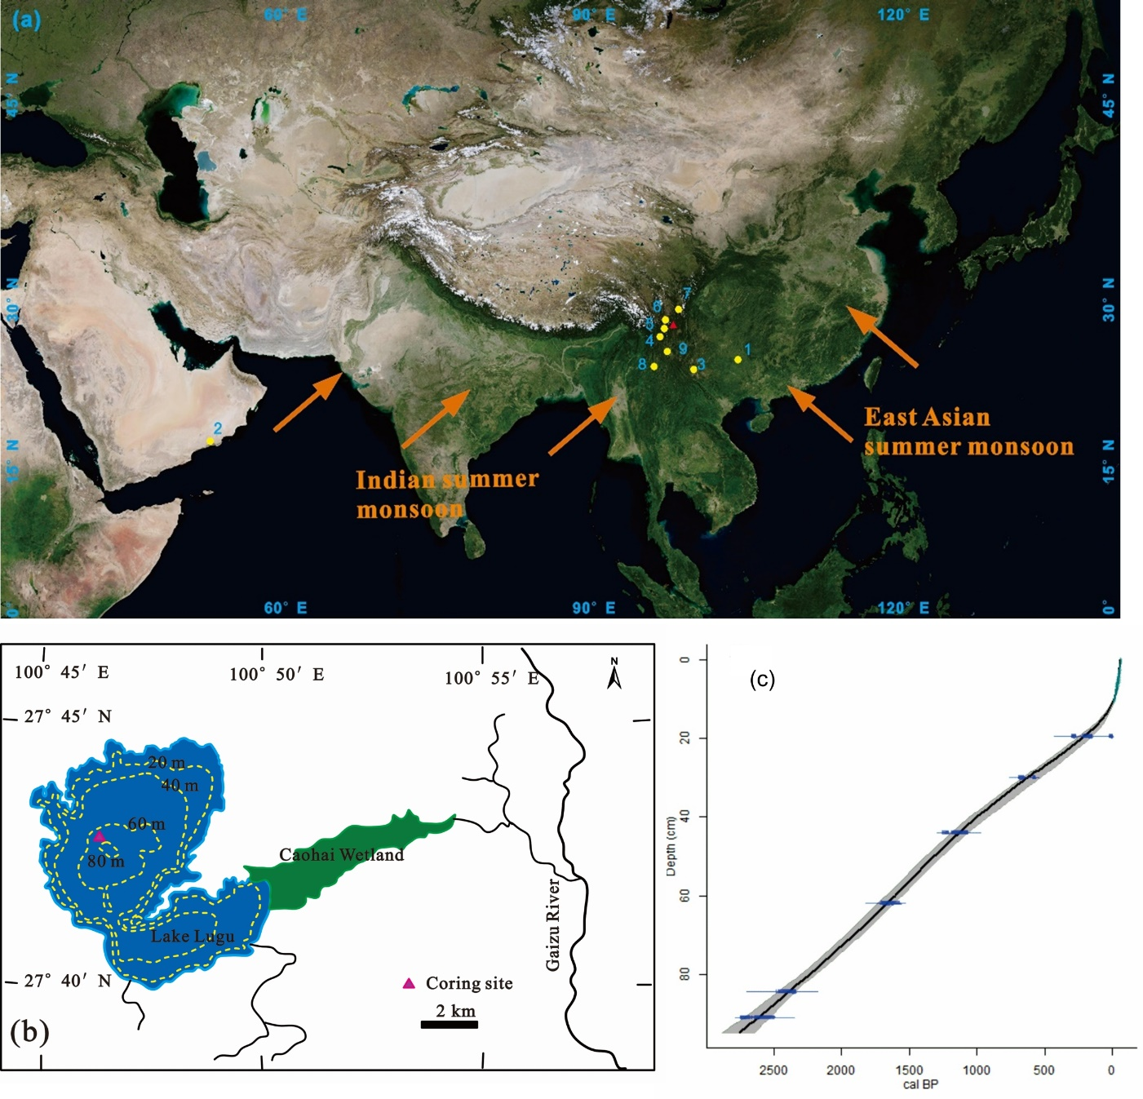

Figure 2
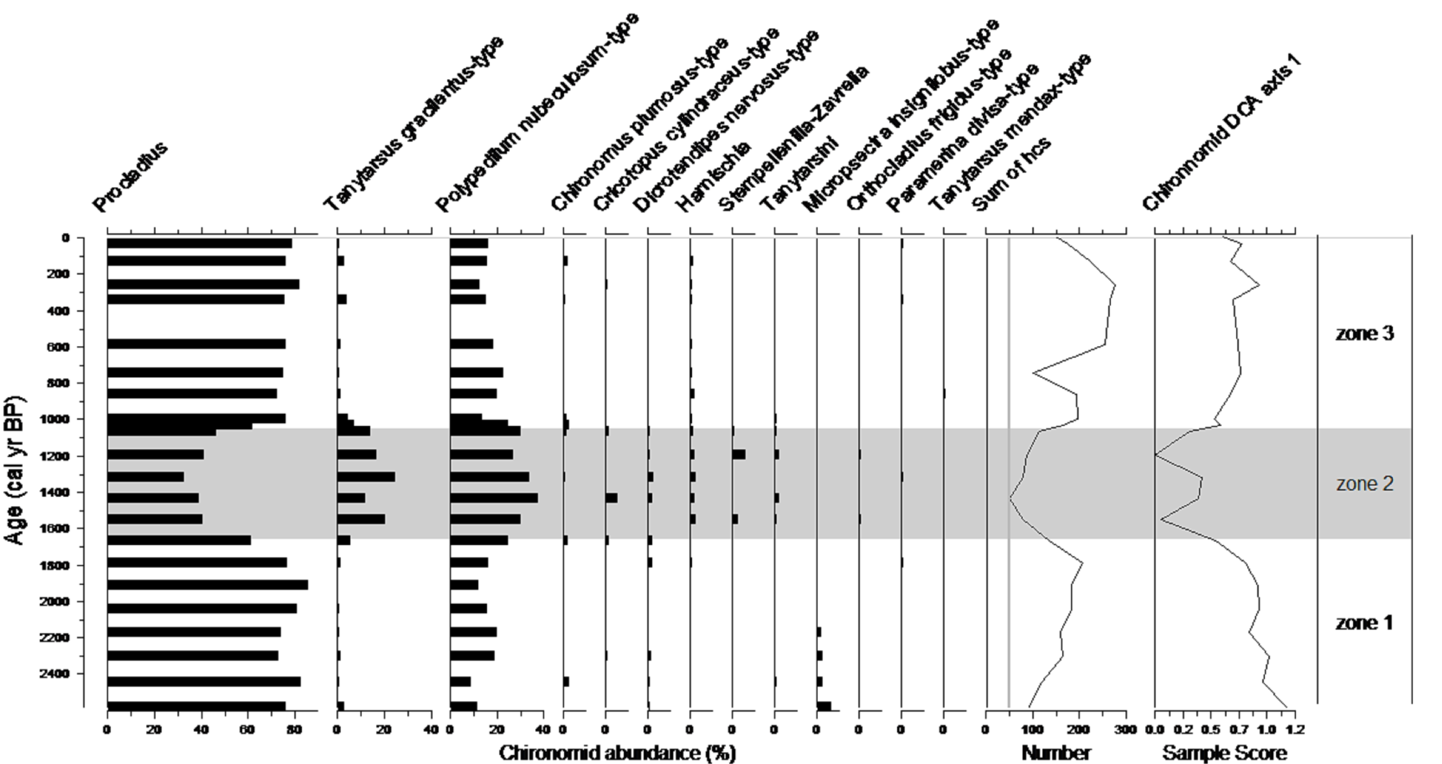

Figure 3
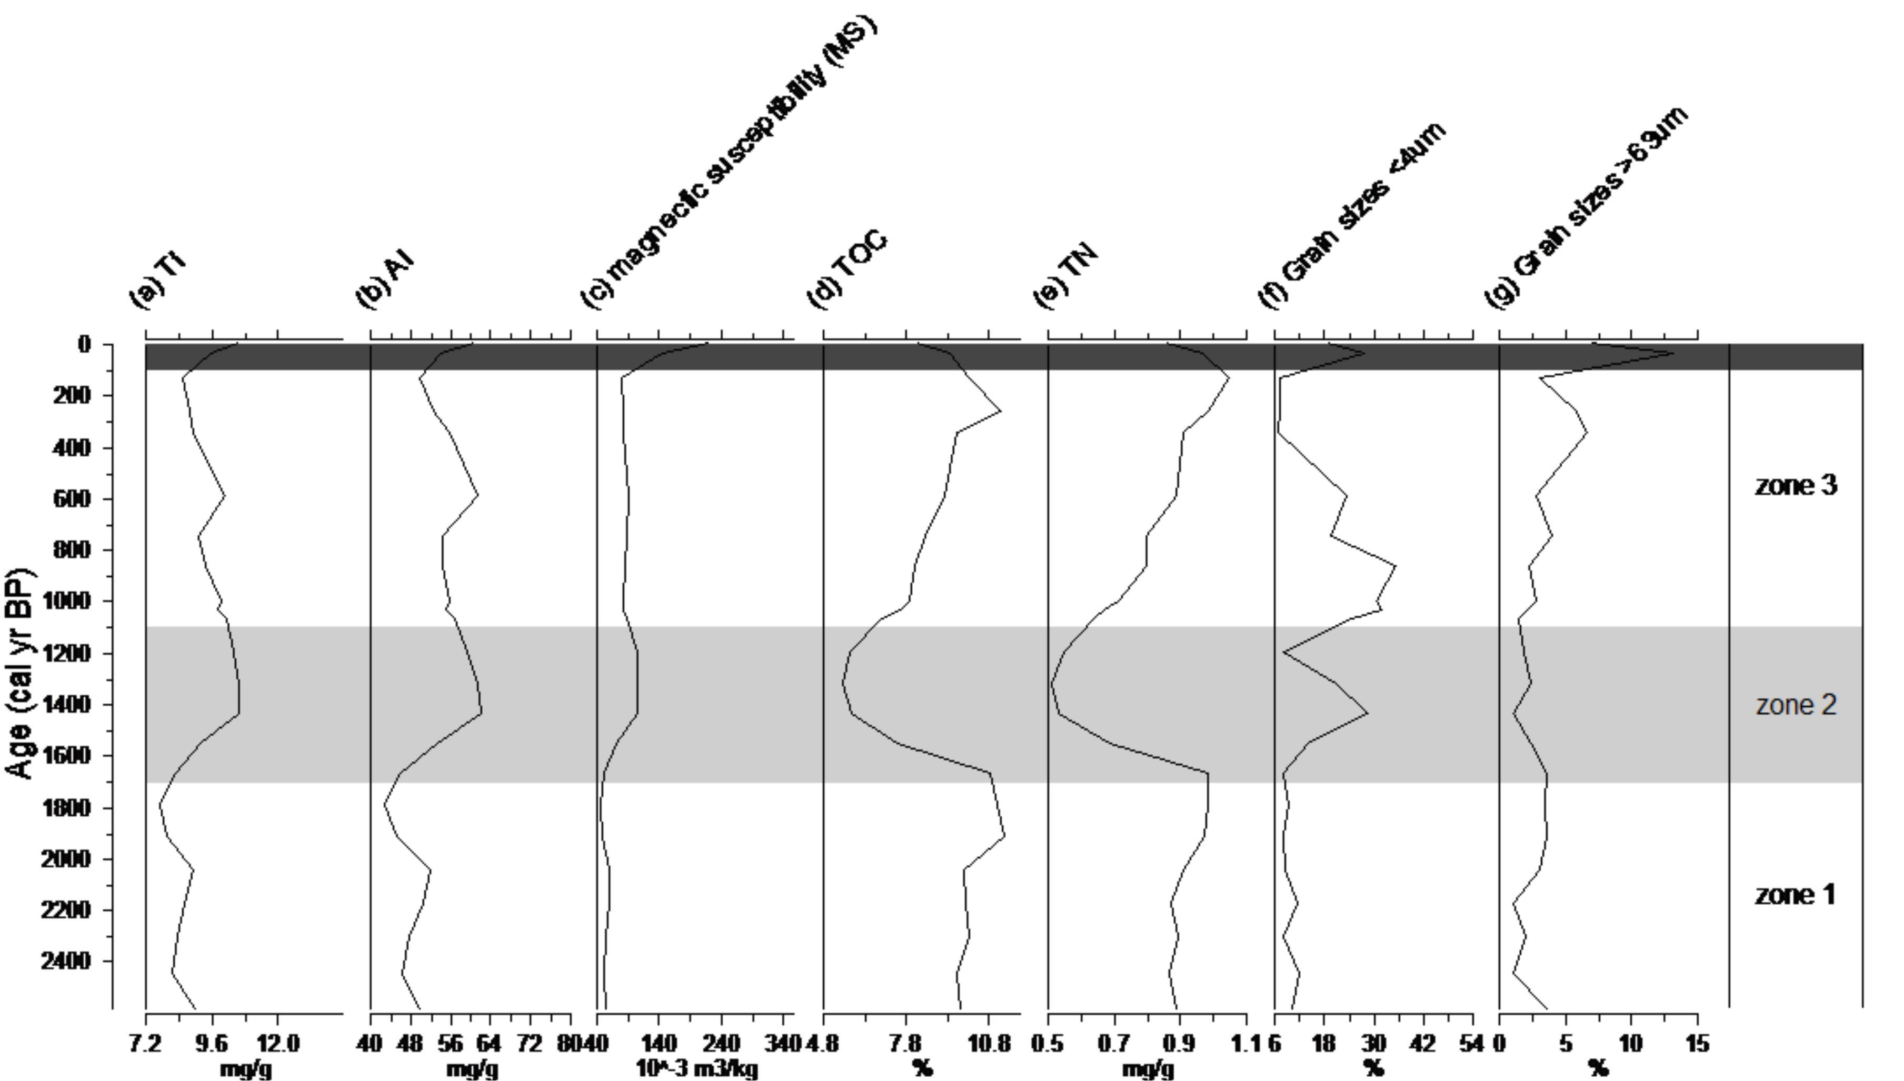

Figure 4
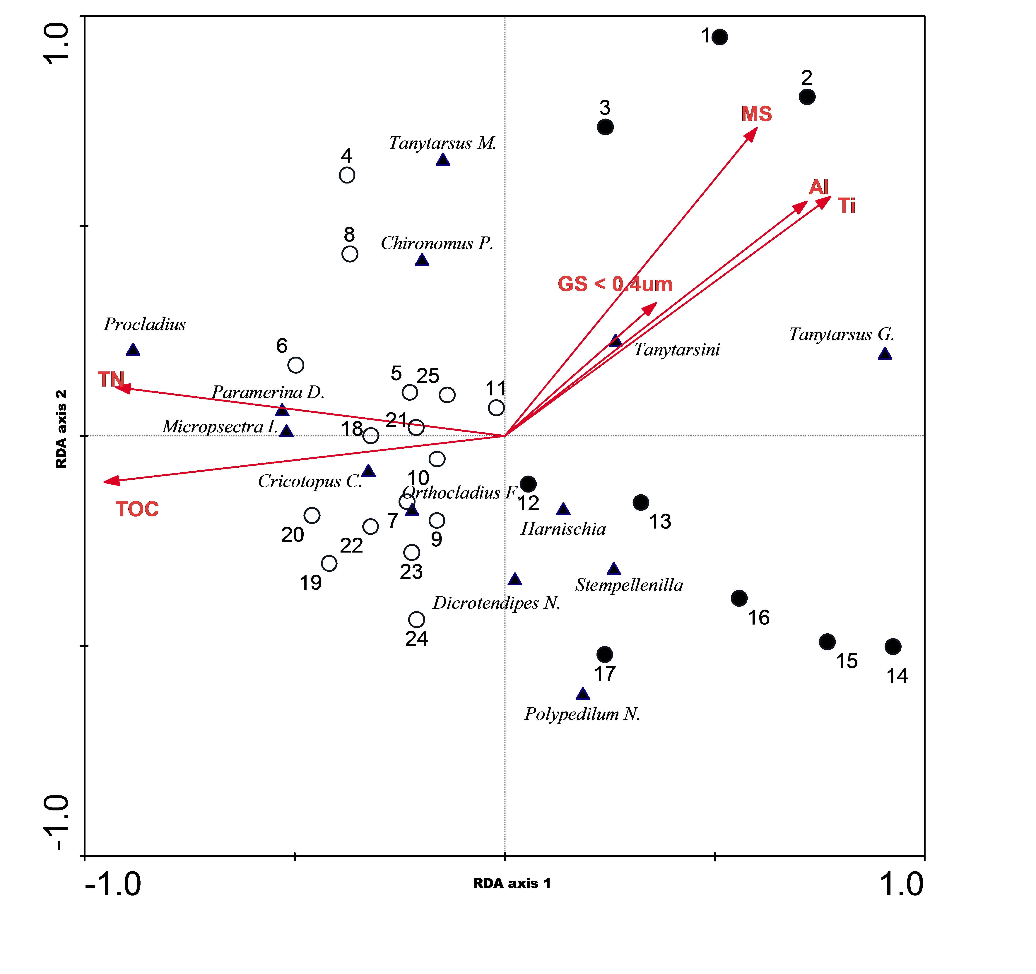

Figure 5
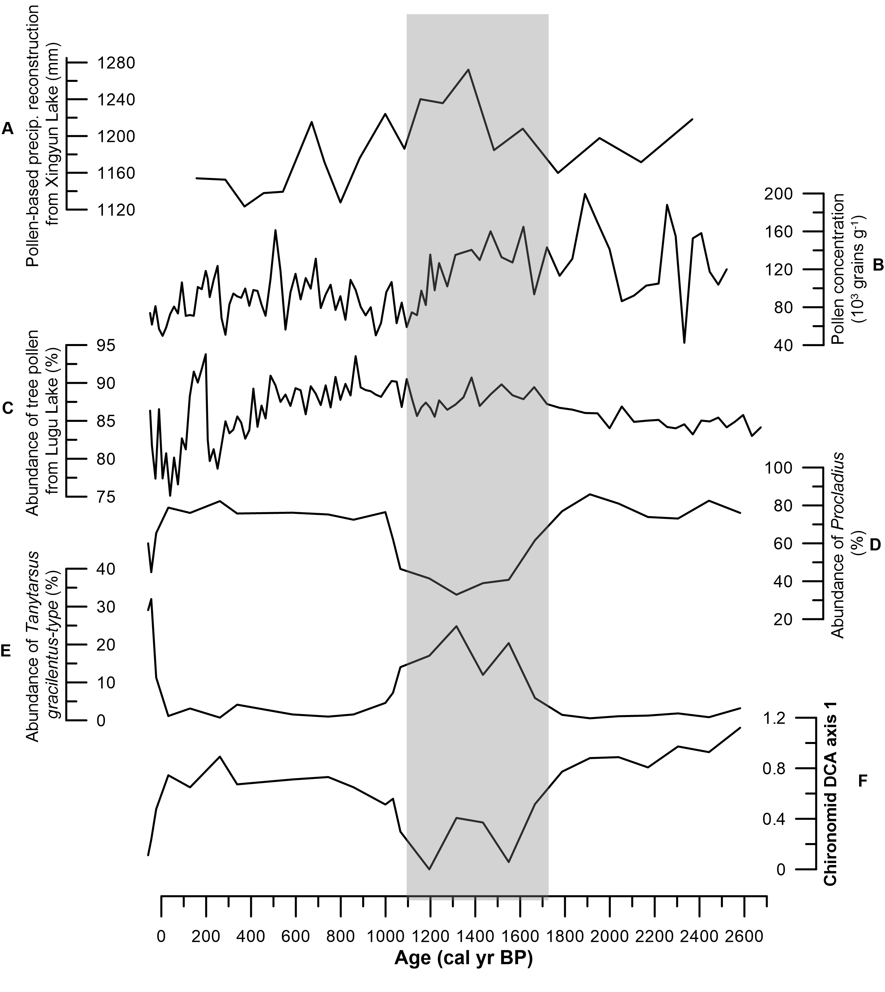

Zone and time period | Description of chironomids | Ti, Al and magnetic susceptibility (MS) | TOC and TN | Grain sizes
Zone 1  (95-66 cm)  c.2500 – 1700 cal yr BP | - High abundance of Procladius (average of 78%)  - The second most abundant taxon was Polypedilum nubeculosum-type (average of 15%)  - All other taxa appeared at low levels  - DCA axis 1 score was relatively high ( average of 0.86) | - Ti and Al showed a significant and positive correlation  - They both showed a stable low level (with an average of 8 mg/g for Ti and 47 mg/g for Al)  - MS values were low | - TOC and TN were strongly and positively correlated  - Their concertation remained relatively high and stable with an average of 10% of TOC and 1 mg/g of TN | - The fractions of clay/fine silt and sands were both at low levels with an average of 9.7% and 2.5% respectively
Zone 2  (62-41 cm)  c.1700 – 1100 cal yr BP | - A rapid decrease in Procladius (from an average of 78% to 46%)  - A large increase in Polypedilum nubeculosum-type (from 15% to 30%)  - A distinct increase in Tanytarsus gracilentus-type (from 1.5% to 15%)  - All other taxa appeared more regularly but all with an average abundance of less than 5%.  - DCA axis 1 score largely declined (from 0.86 to 0.23) | - A marked increase was shown since c.1700 cal yr BP and both elements reached their peak level (11 mg/g for Ti and 62 mg/g for Al) at around 1400 cal yr BP  - MS increased steadily | - Both dropped rapidly since c.1700 cal yr BP  - Both reached their minimum values (5.5 % of TOC and 0.51 mg/g of TN) at c.1300 cal yr BP. | - The fine silt/clay fraction at c.1400 cal yr BP increased to 28% followed by a decline  - The fine silt/clay fraction increased again from c.1000 cal yr BP  - Changes in the fraction of sands were relatively minor
Zone 3  (40-1 cm)  c.1100 cal yr BP – present | - Similar to Zone 1  - An re-expansion of Procladius which increased to 75%  - Polypedilum nubeculosum-type dropped back to 17%, similar level to Zone 1  - Tanytarsus gracilentus-type dropped back to 3%  - All other taxa stayed below 5%  - DCA axis 1 score recovered to similar level as zone 1 with an average of 0.68 (excluding the top 3 samples) | - A gradual decrease in the concentration of both elements was followed  - They both remained at stable levels (average 9 mg/g for Ti and 55 mg/g for Al) from c.1100 cal yr BP- c.1920s A.D.  - Al, Ti and MS all increased to historical highest levels in the last c.100 years | - A slow recovery was shown since c.1100 cal yr BP for both until c.1920 AD  - A rapid drop occurred in the top section of the core (i.e. the last c.100 years). | - The fraction of fine silt/clay remained was at a relatively high level (average of 27%) between c.1000-580 cal yr BP  - It declined with variability between 580-130 cal yr BP  - Both sands and fine silt/clay fractions increased largely at the beginning of 1920s AD
Table 1.
Table 2
Axes | 1 | 2 | 3 | 4 | Total variance
Eigenvalues | 0.377 | 0.122 | 0.027 | 0.013 | 1
Species-environment correlations | 0.928 | 0.729 | 0.592 | 0.57
Cumulative percentage variance of species data | 37.7 | 49.9 | 52.6 | 53.8
of species-environment relation | 68.5 | 90.6 | 95.5 | 97.8
Variable | Coefficients |  | Correlations |  | Inflation
 | Axis 1 | Axis 2 | Axis 1 | Axis 2 | Factor
magnetic susceptibility (MS) | -0.08 | 0.19 | 0.56 | 0.54 | 14.4
clay and fine silt content (GS < 4 um) | -0.36 | 0.10 | 0.33 | 0.23 | 1.8
TOC | -1.18 | 0.59 | -0.88 | -0.08 | 42.9
TN | 0.03 | 0.77 | -0.86 | 0.09 | 31.1
Al | -0.54 | -0.76 | 0.67 | 0.41 | 24.5
Ti | 0.60 | 2.15 | 0.72 | 0.42 | 45.3

